Enhanced Persistence of Ural Blocking under Strong Positive AO: The Role of North Atlantic Storm Tracks and PV Dynamics
Ho-Young Ku,ª Hayeon Noh,^{b} Muyin Wang,^{c,d} James Overland,^{d} Seong-Joong Kim,^{e,f} and Baek-Min Kim^{a*}
ªDivision of Earth Environmental System Sciences Major of Environmental Atmospheric Sciences, Pukyong National University, Busan, South Korea
^{b}Climate and Environmental Research Institute, Korea Institute of Science and Technology, Seoul, Republic of Korea
^{c}Cooperative Institute for Climate, Ocean, and Ecosystem Studies, University of Washington, Seattle, WA, USA
^{d}NOAA/Pacific Marine Environmental Laboratory, Seattle, WA, United States of America
^{e}Office of Vice President, Korea Polar Research Institute, Incheon, South Korea
^{f}KOPRI School, University of Science and Technology, Incheon, South Korea
Corresponding author: Baek-Min Kim, baekmin@pknu.ac.kr

Supplementary material

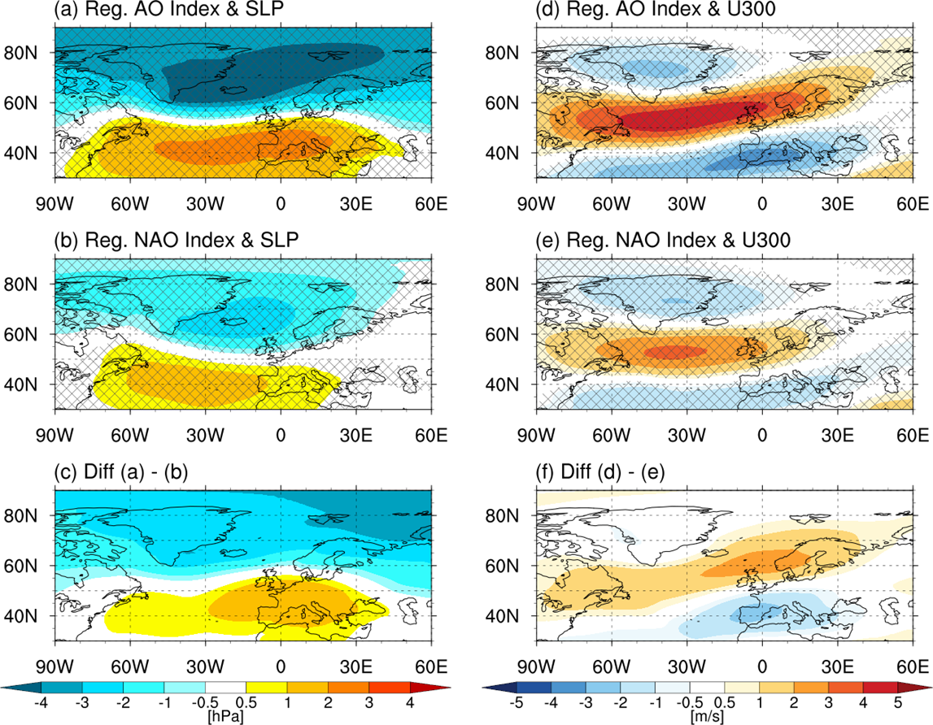
Figure S1. Regression maps of (a–c) sea level pressure (SLP, hPa) and (d–f) zonal wind at 300 hPa (U300, m s⁻¹) onto the Arctic Oscillation (AO) index (a, d) and the North Atlantic Oscillation (NAO) index (b, e) for DJF during 1982–2023, based on daily data.

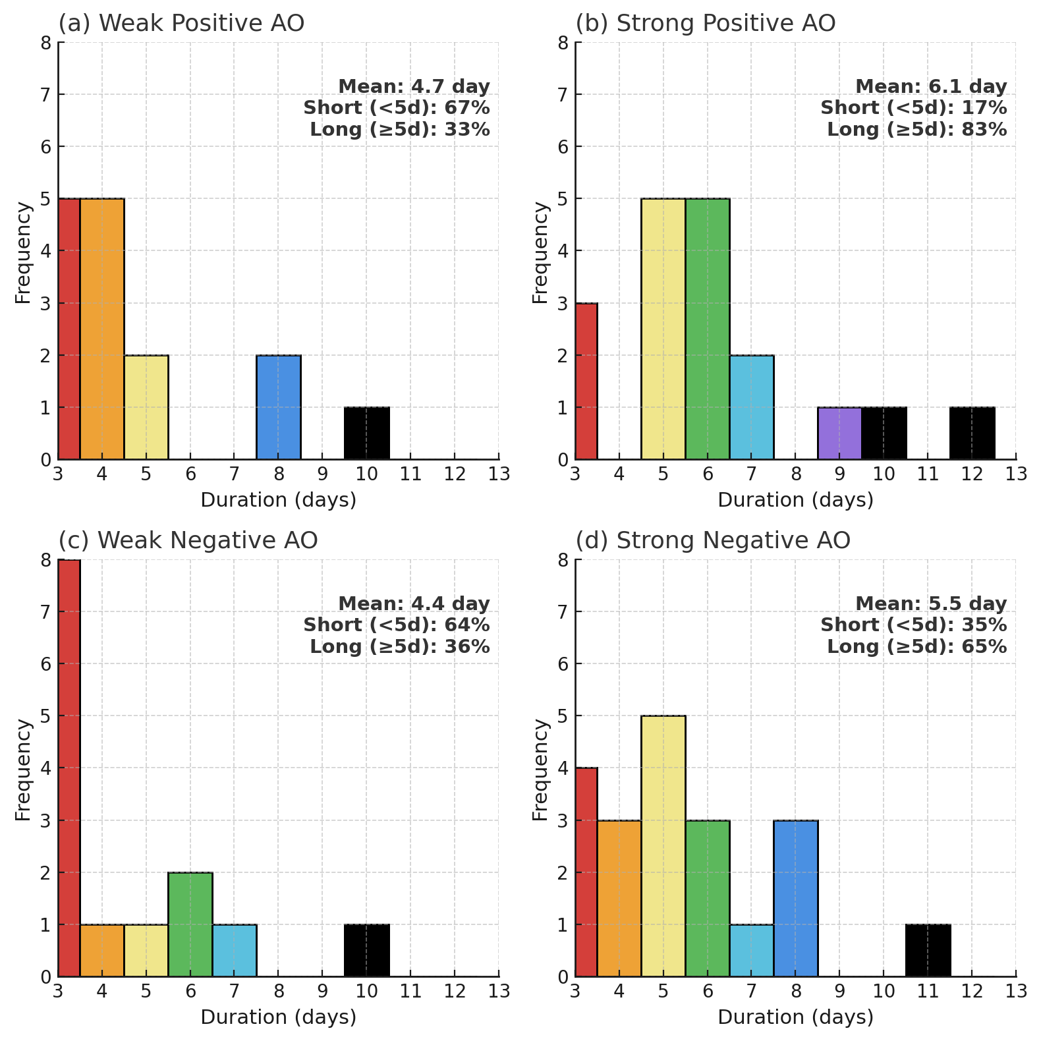
Figure S2. Distribution of UB duration under different AO conditions. Histograms show the frequency of Ural blocking duration for (a) weak positive AO, (b) strong positive AO, (c) weak negative AO, and (d) strong negative AO. Each panel indicates the mean duration and the proportion of short (<5 days) and long (≥5 days) events. Longer-lasting UB events are more frequent under strong positive AO conditions. AO groups are defined based on the averaged AO index from 7 to 3 days before UB onset: strong positive AO (AO > 1), weak positive AO (0 < AO ≤ 1), weak negative AO (−1 ≤ AO < 0), and strong negative AO (AO < −1).
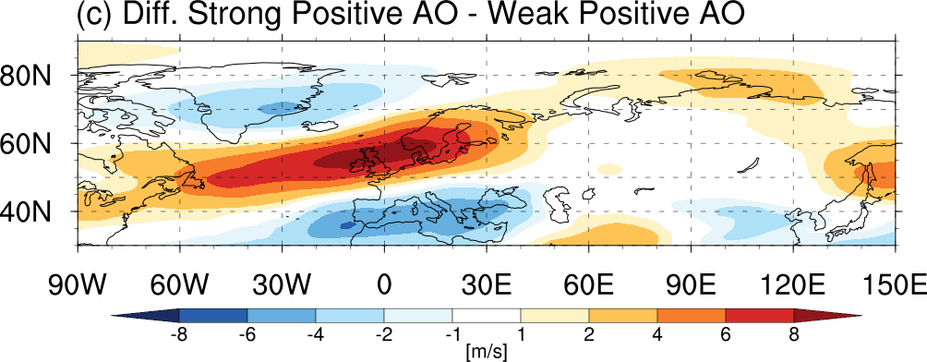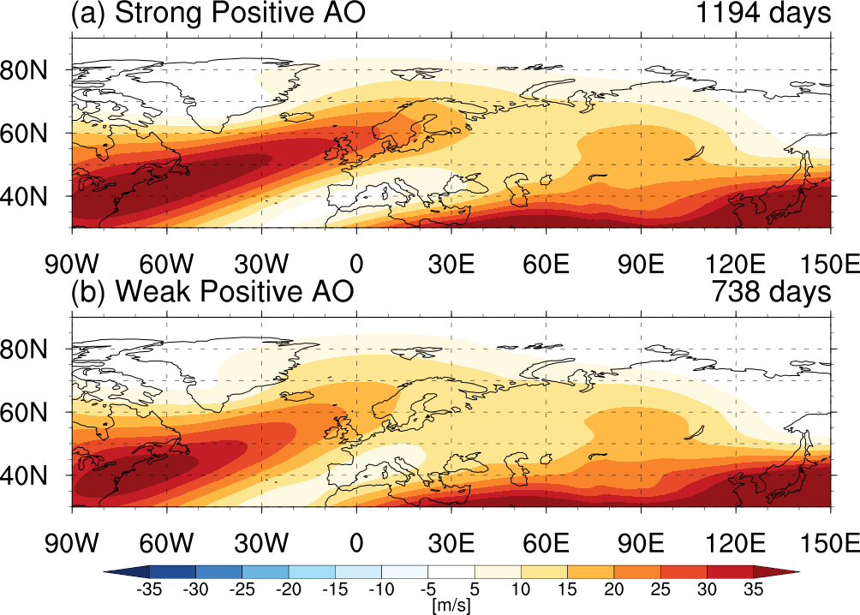

Figure S3. Composite analysis of 300-hPa zonal wind (U wind, m/s) under different positive AO conditions: (a) strong positive AO days (AO index > 1; 1194 days) and (b) weak positive AO days (0 < AO index ≤ 1; 738 days). (c) Difference between strong and weak positive AO composites (a - b). Shading indicates wind speed in m/s.
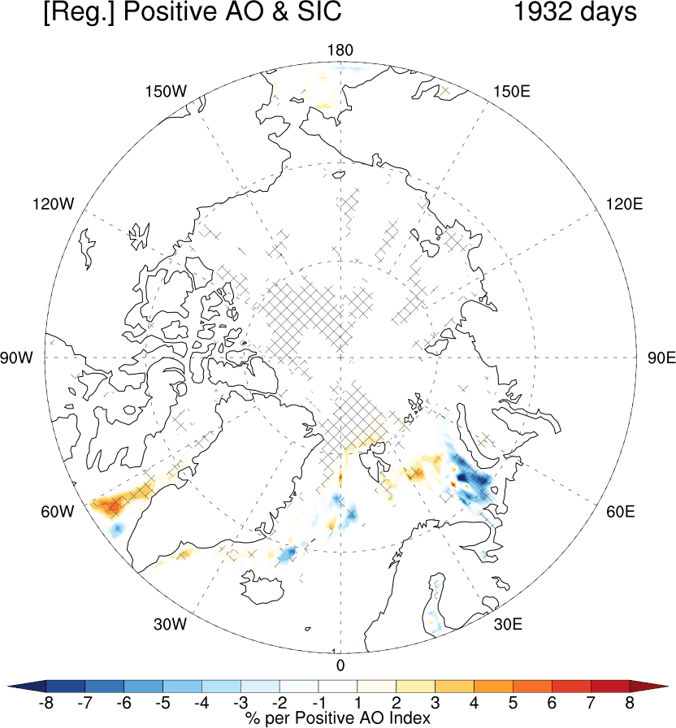
Figure S4. Regression of sea ice concentration (SIC, %) onto the positive AO index for AO > 0 days (1932 days). Shading indicates the percentage change in SIC per unit increase in the AO index. Cross-hatched areas denote regions where the regression is not statistically significant at the 95% confidence level.

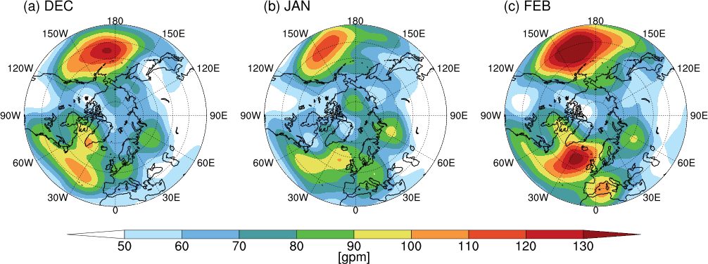
Figure S5. Monthly standard deviation of 500-hPa geopotential height (Z500) anomalies (gpm) from 1982 to 2023 for (a) December (DEC), (b) January (JAN), and (c) February (FEB).

