Soluble Epoxide Hydrolase Inhibitory Constituents from the Heartwood of Toxicodendron vernicifluum: Isolation, Kinetic Characterization, Molecular Modeling, and Quantitative Analysis

Jang Hoon Kim¹, Jae-Young Cheon², Jin Yu¹, Yong-Goo Kim¹, Sung Yeon Kim¹, Kyong-Hwan Bang¹, Jin Tae Jeong¹, Hyun-Ju Jung^{2,}*, Ik Soo Lee^{3,}*

¹Department of Herbal Crop Research, National Institute of Horticultural & Herbal Science, RDA, Eumsung, Chungbuk, 27709, Republic of Korea
²Department of Oriental Pharmacy and Wonkwang-Oriental Medicines Research Institute, Wonkwang University, Sinyong-dong, Iksan 570-749, Republic of Korea
³Km Covergence Research Division, Korea Institute of Oriental Medicine, Daejeon, 34054, Republic of Korea

*Co-corresponding authors
knifer48@kiom.re.kr(I.S. Lee), Tel.: +82-42-868-9462, Fax: +82-42-868-9471
hyun104@wku.ac.kr, Tel.: +82-63-850-6814, Fax: +82-63-850-6814

[M+H]⁺

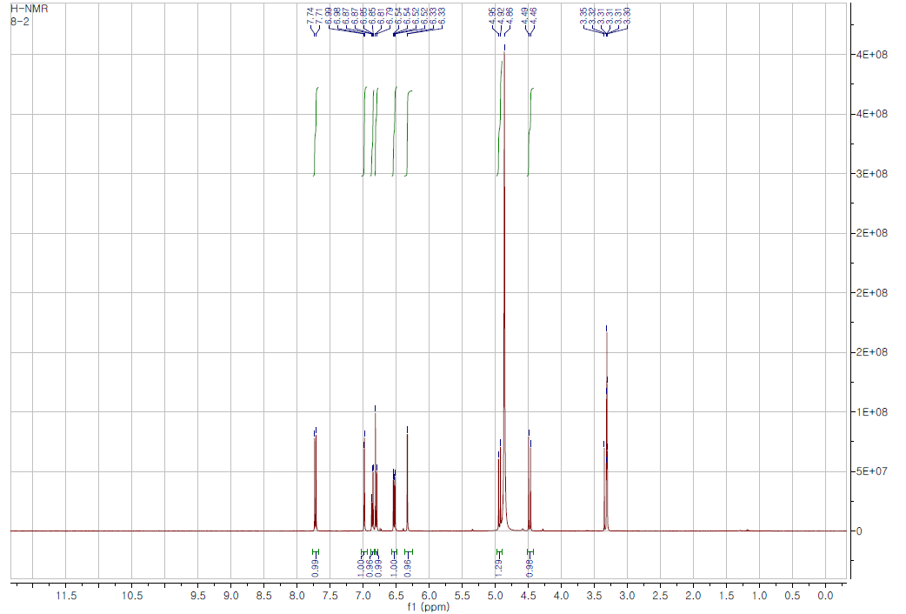
¹H-NMR
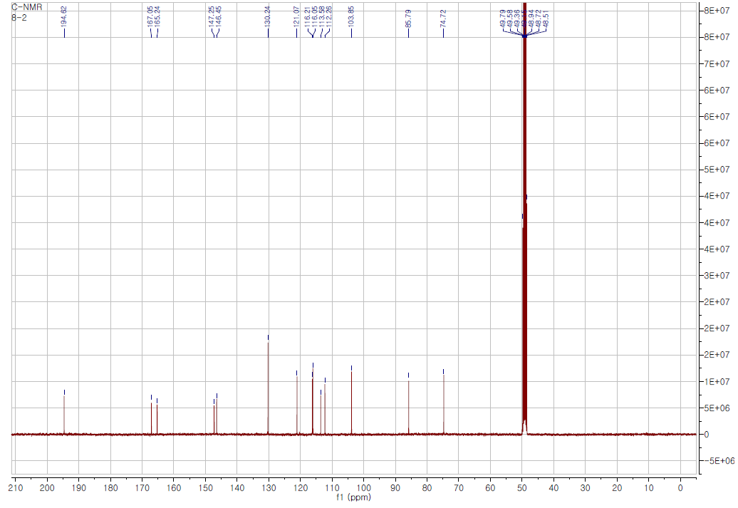
¹³C-NMR
Figure S1. Mass and ¹H-/ ¹³C-NMR spectra of compound 1 (300MHz, MeOD-d₄)

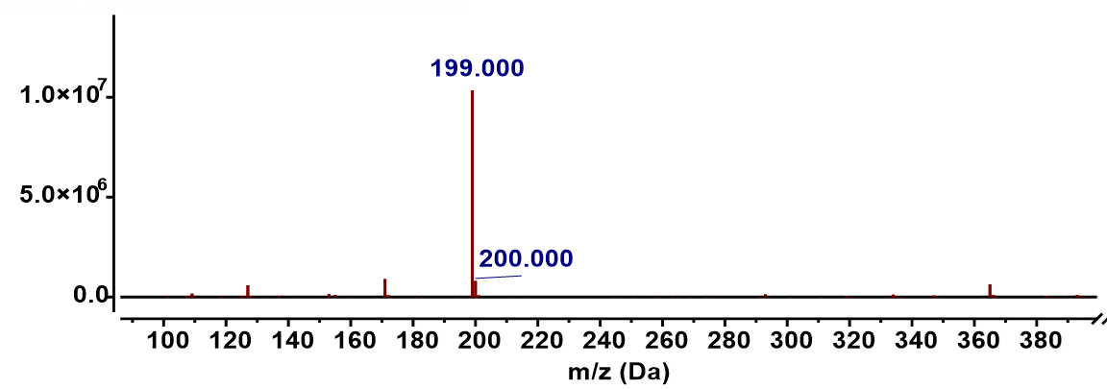
[M+H]⁺

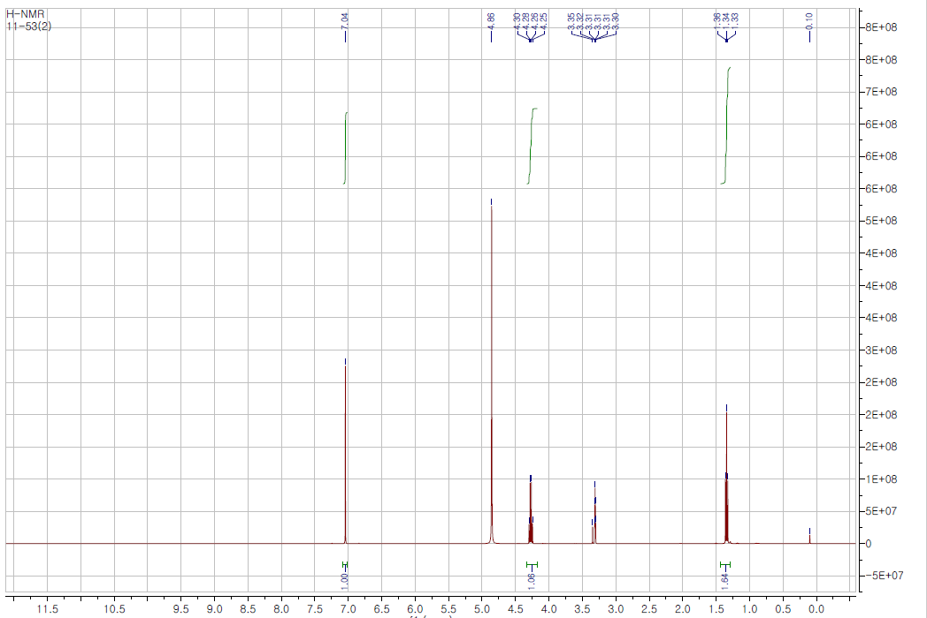
¹H-NMR
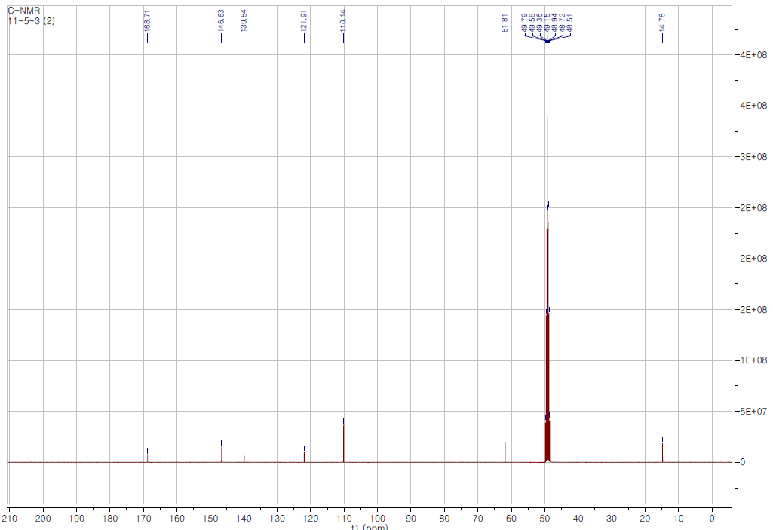
¹³C-NMR
Figure S2. Mass and ¹H-/ ¹³C-NMR spectra of compound 2 (300MHz, MeOD-d₄)

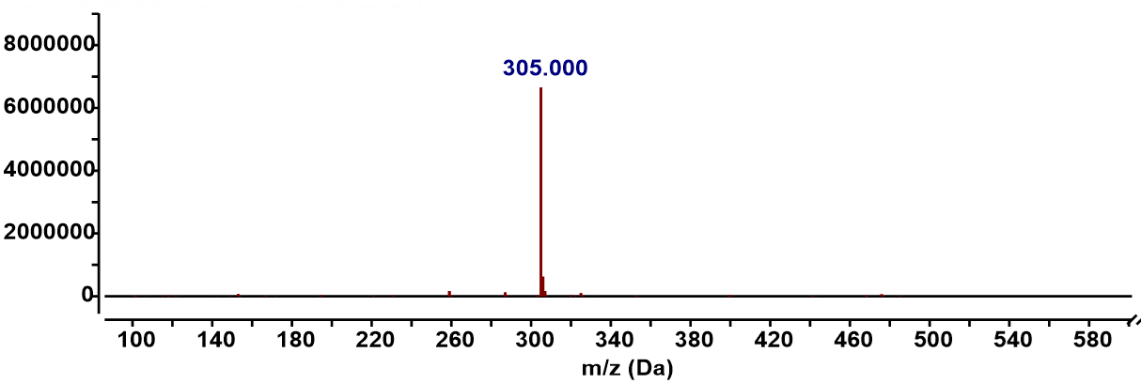
[M+H]⁺

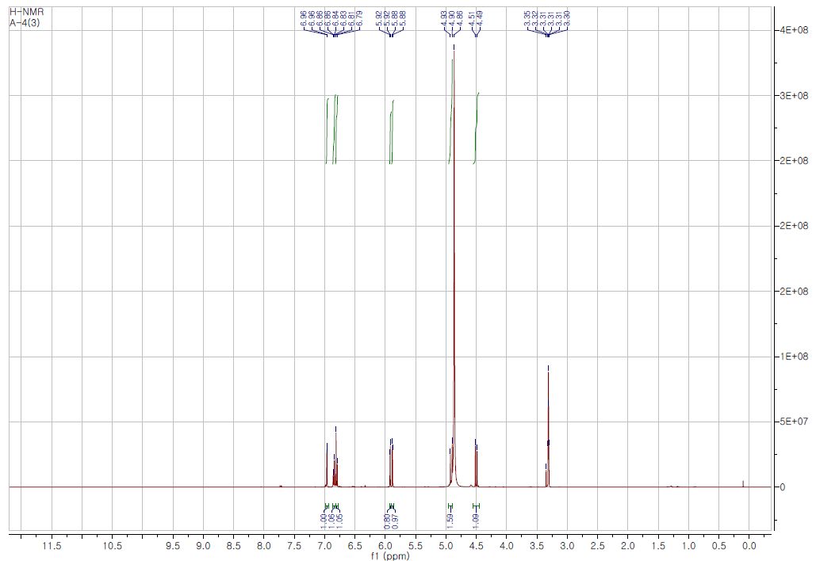
¹H-NMR
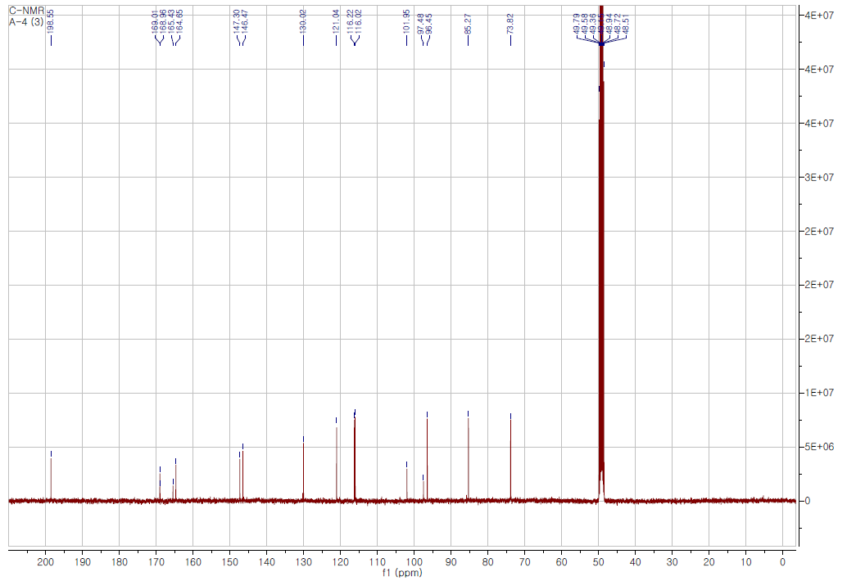
¹³C-NMR
Figure S3. Mass and ¹H-/ ¹³C-NMR spectra of compound 3 (300MHz, MeOD-d₄)

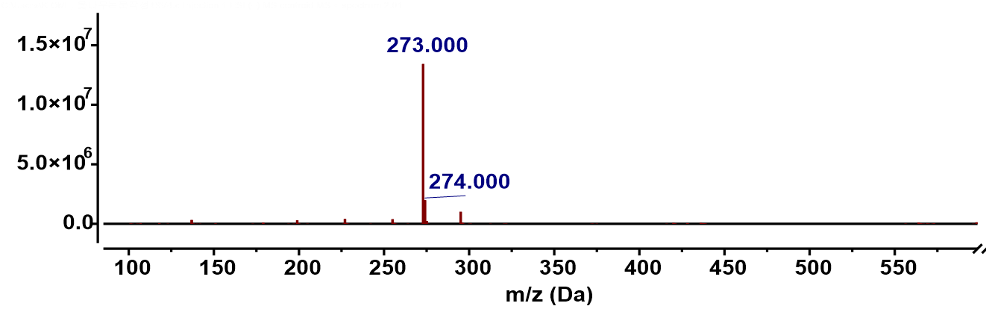
[M+H]⁺

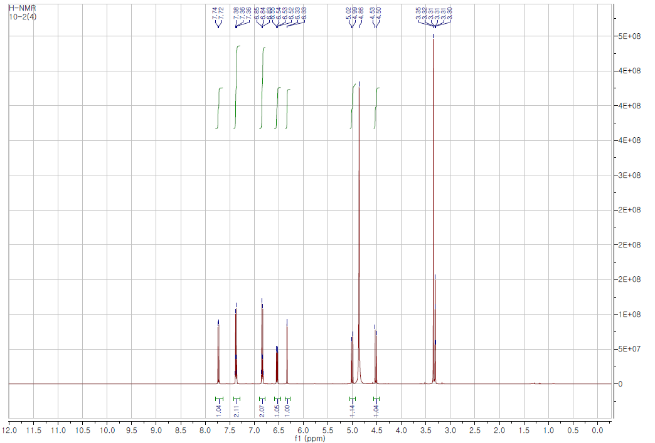
¹H-NMR
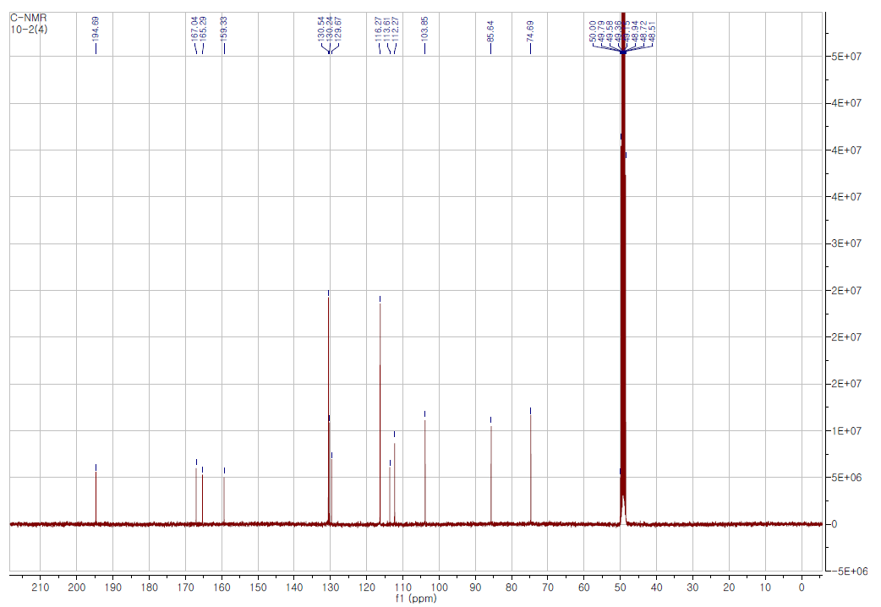
¹³C-NMR
Figure S4. Mass and ¹H-/ ¹³C-NMR spectra of compound 4 (300MHz, MeOD-d₄)

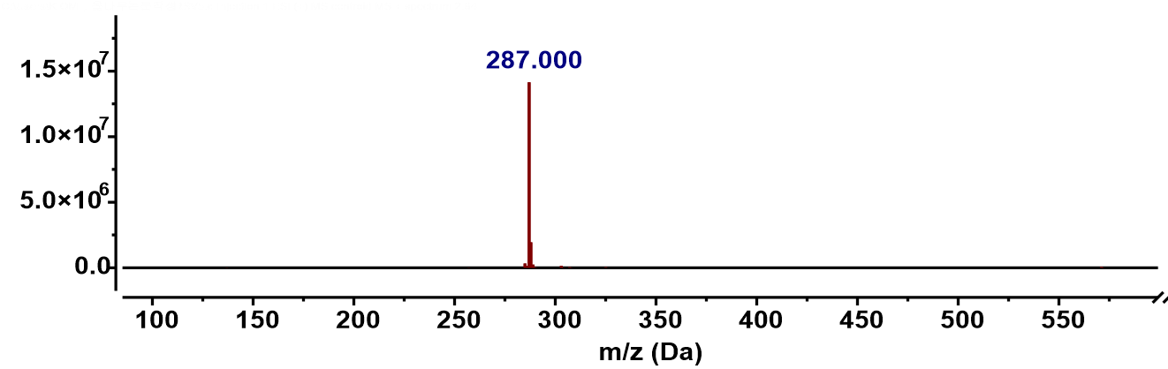
[M+H]⁺

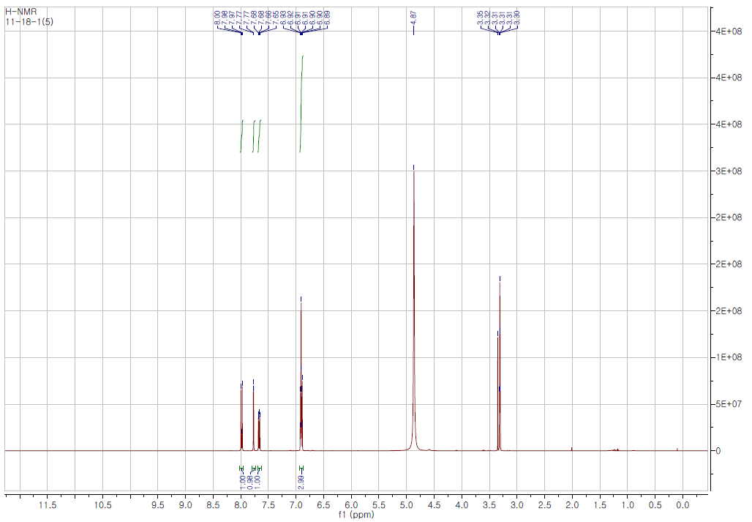
¹H-NMR
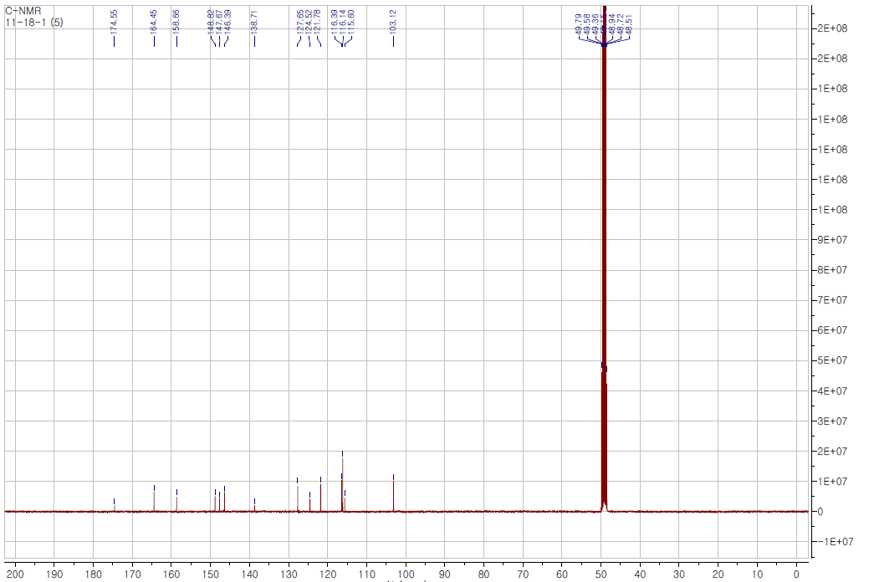
¹³C-NMR
Figure S5. Mass and ¹H-/ ¹³C-NMR spectra of compound 5 (300MHz, MeOD-d₄)

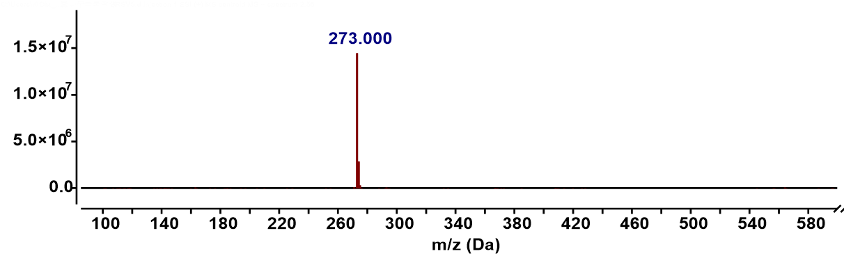
[M+H]⁺

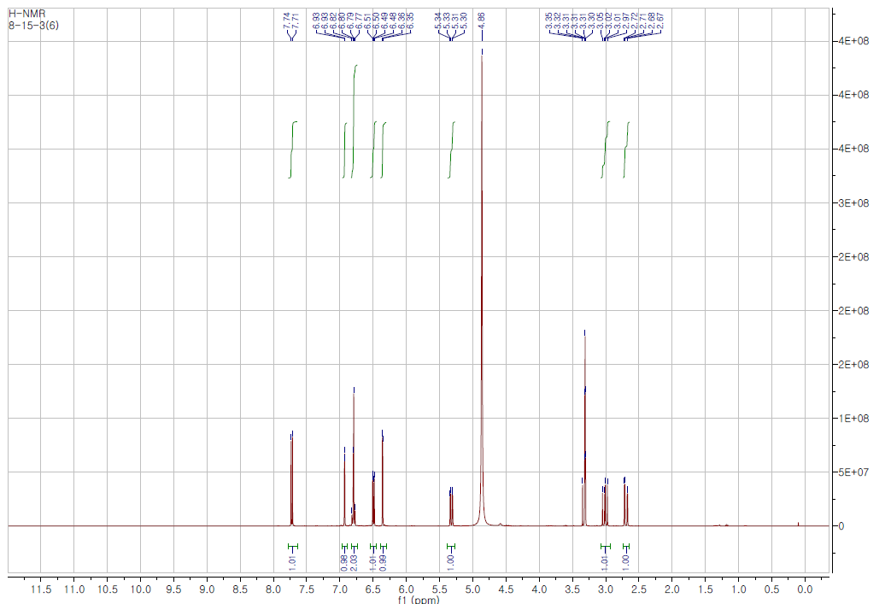
¹H-NMR
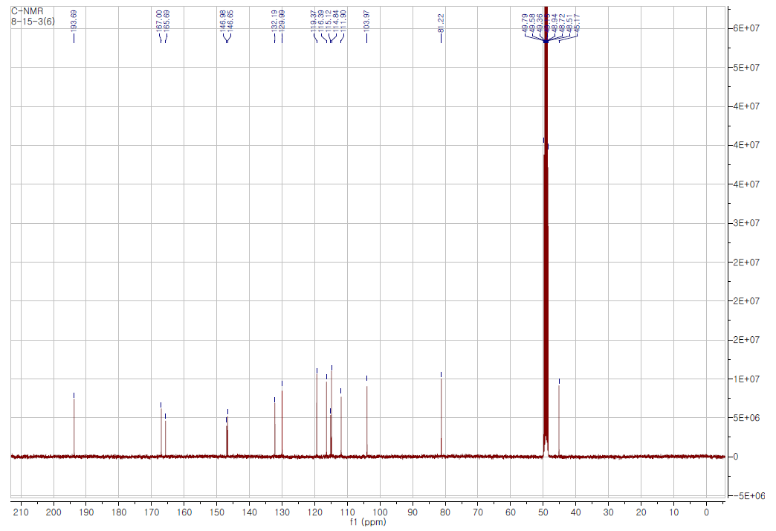
¹³C-NMR
Figure S6. Mass and ¹H-/ ¹³C-NMR spectra of compound 6 (300MHz, MeOD-d₄)

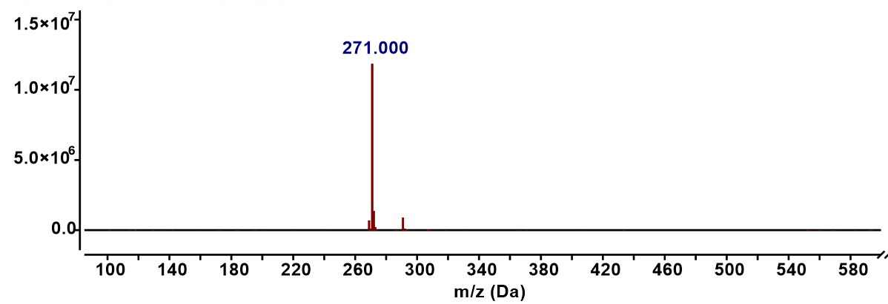
[M+H]⁺

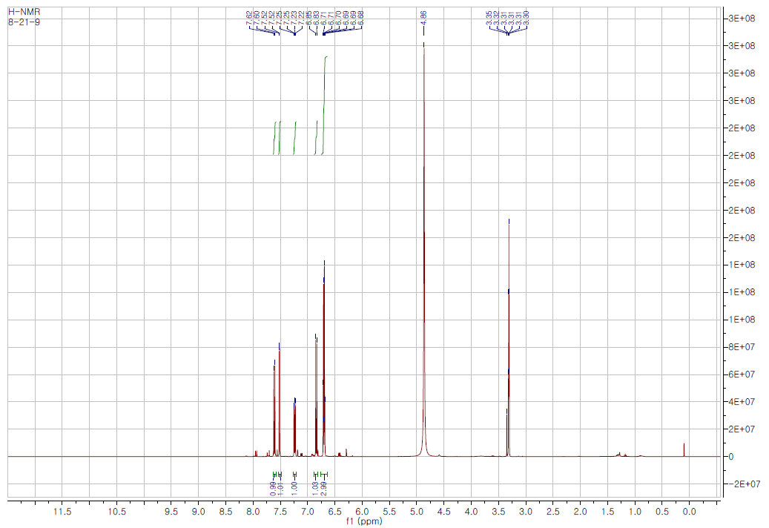
¹H-NMR
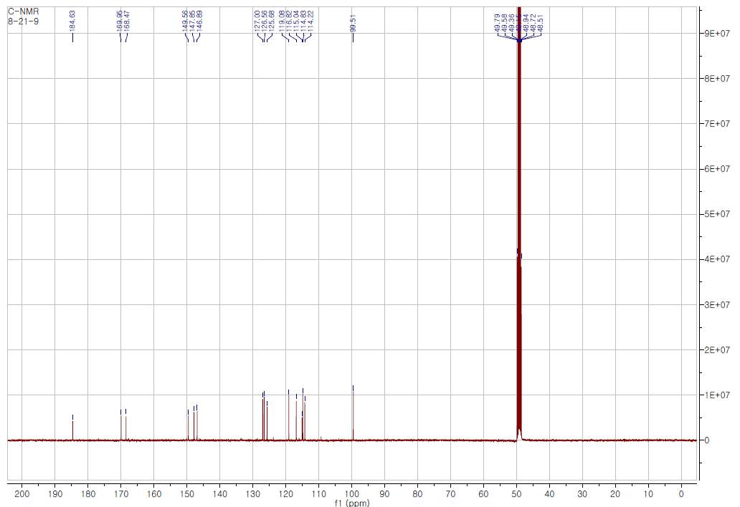
¹³C-NMR
Figure S7. Mass and ¹H-/ ¹³C-NMR spectra of compound 7 (300MHz, MeOD-d₄)

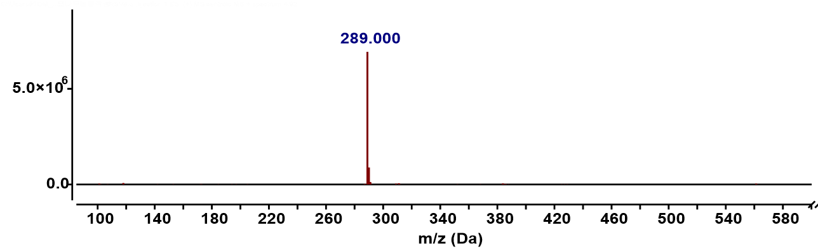
[M+H]⁺

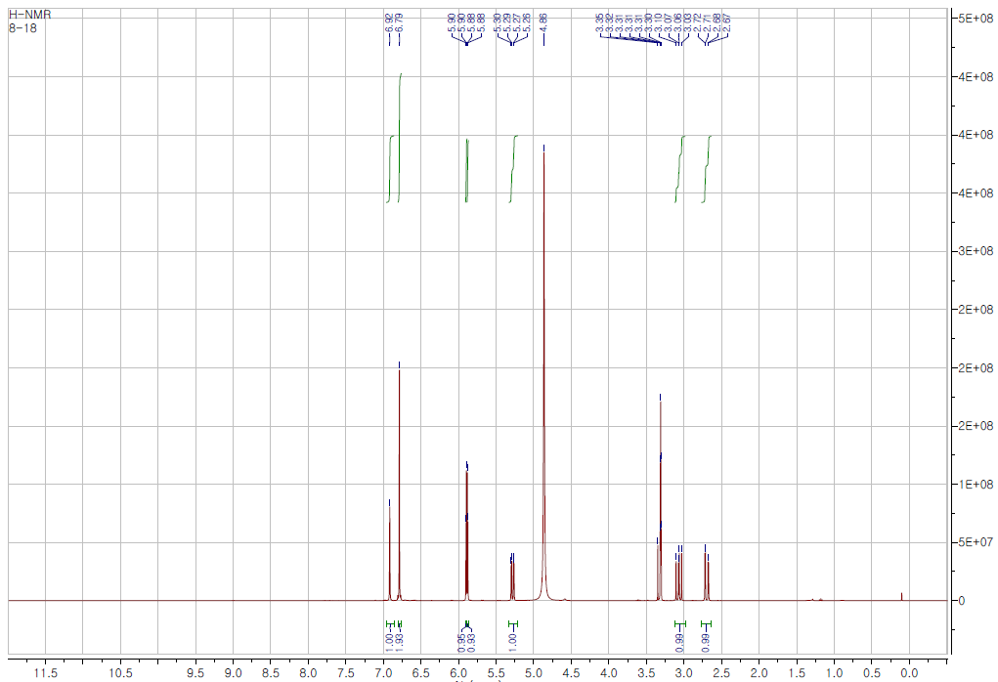
¹H-NMR
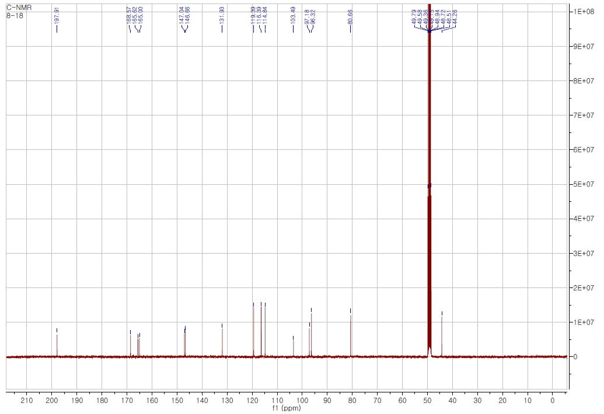
¹³C-NMR
Figure S8. Mass and ¹H-/ ¹³C-NMR spectra of compound 8 (300MHz, MeOD-d₄)

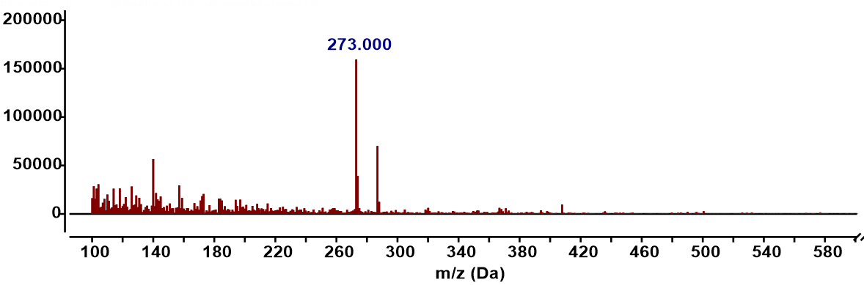
[M+H]⁺
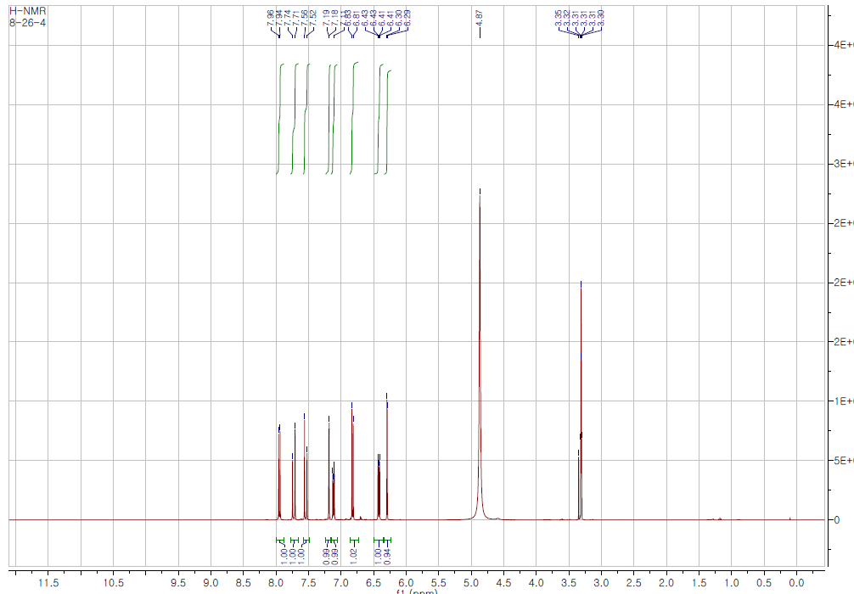
¹H-NMR
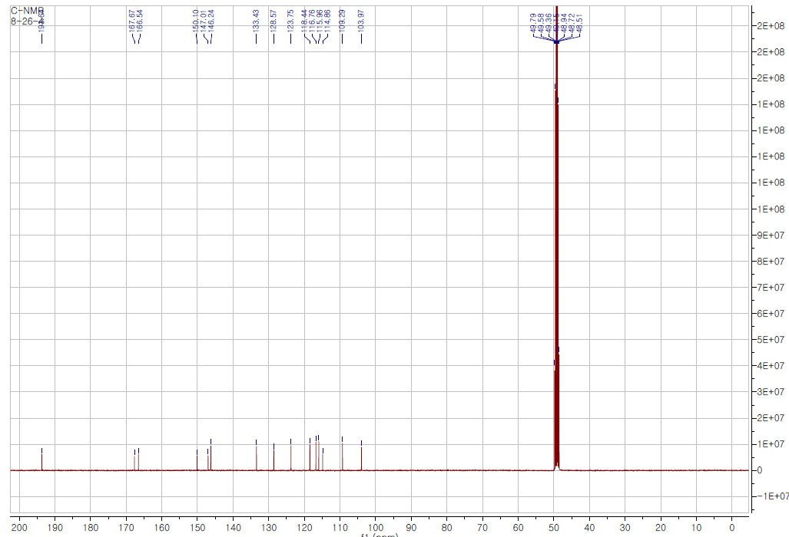
¹³C-NMR
Figure S9. Mass and ¹H-/ ¹³C-NMR spectra of compound 9 (300MHz, MeOD-d₄)

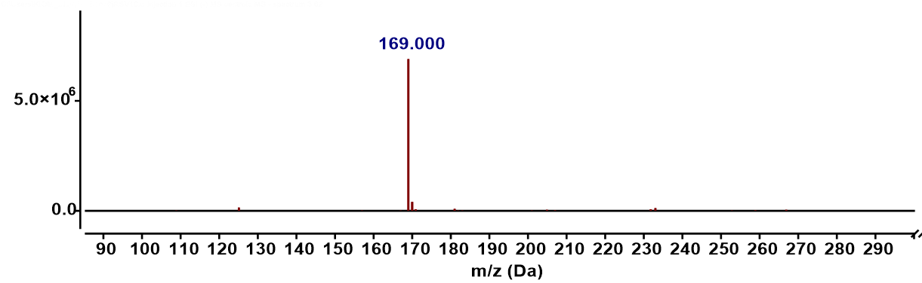
[M–H]–

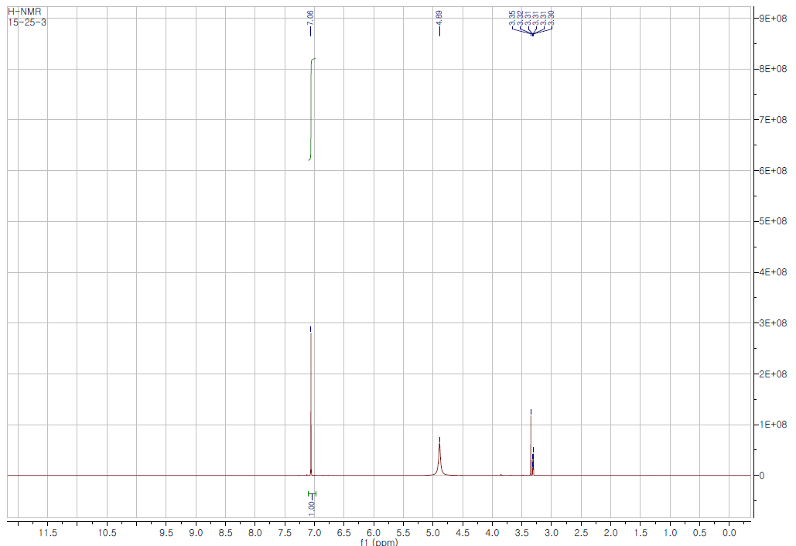
¹H-NMR
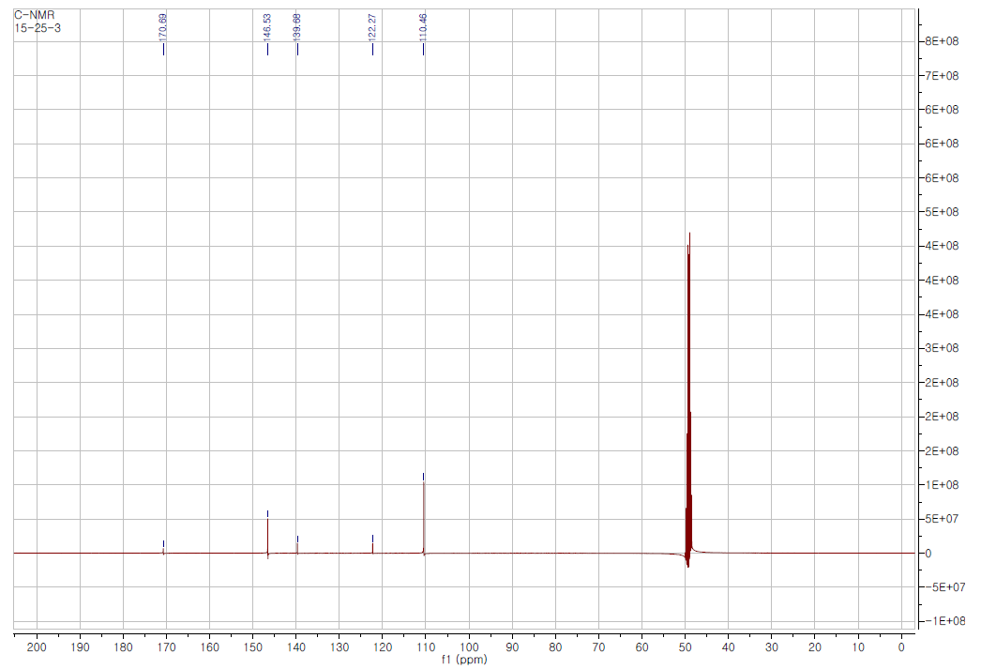
¹³C-NMR
Figure S10. Mass and ¹H-/ ¹³C-NMR spectra of compound 10 (300MHz, MeOD-d₄)

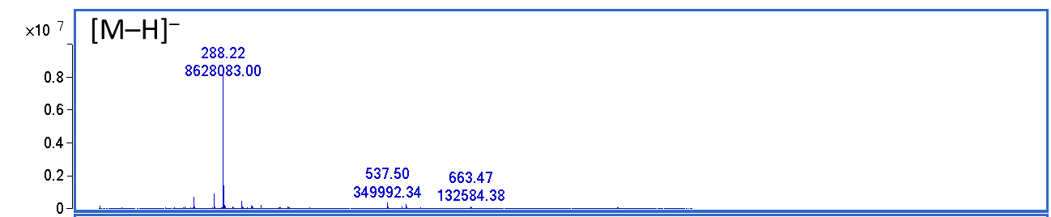
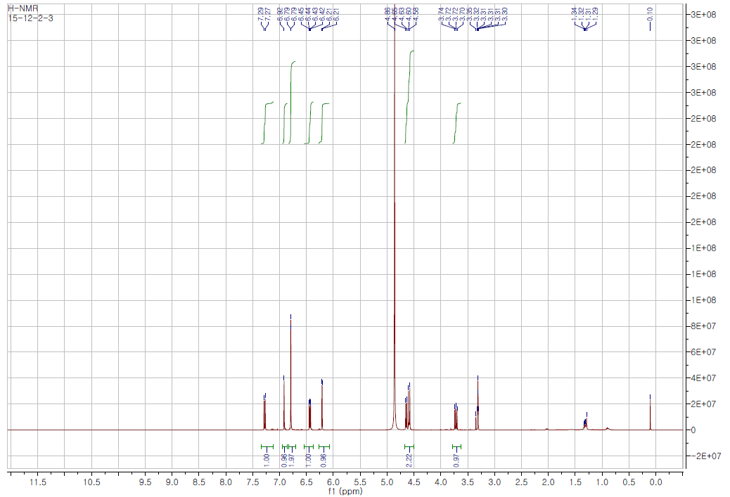
¹H-NMR
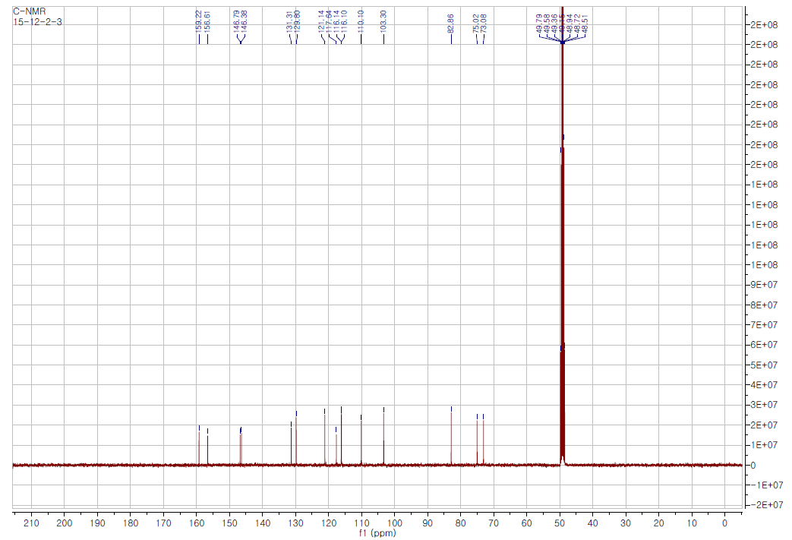
¹³C-NMR
Figure S11. Mass and ¹H-/ ¹³C-NMR spectra of compound 11 (300MHz, MeOD-d₄)

