Supplementary Material
Table S1. Original reliability of the Interpersonal Reactivity Index (IRI)
​Empathy (IRI)​
​ | Cronbach’s α​
Ft | 0.68
PT | 0.56
PD | 0.58
EC | 0.42
IRI | 0.67
Table S1. Show the original reliability of IRI: Interpersonal Reactivity Index. Ft: Fantasy; PT: Perspective Taking; PD: Personal Distress; EC: Emotional Concern.
Table S2. Exploratory factor analysis for IRI
 | F1 | F2 | F3
IRI01 | 0.34 | -0.01 | 0.12
IRI02 | 0.03 | 0.32 | 0.07
IRI03INV | 0.00 | -0.00 | -0.38
IRI04INV | 0.18 | -0.00 | -0.30
IRI05 | 0.65 | 0.11 | 0.20
IRI06 | 0.13 | 0.09 | 0.62
IRI07INV | 0.10 | 0.05 | -0.06
IRI08 | 0.27 | 0.43 | -0.16
IRI09 | 0.07 | 0.51 | -0.05
IRI10 | 0.11 | 0.13 | 0.43
IRI11 | 0.07 | 0.44 | -0.13
IRI12INV | 0.28 | 0.01 | -0.22
IRI13INV | -0.05 | 0.05 | 0.01
IRI14INV | 0.02 | 0.09 | -0.14
IRI15INV | -0.06 | 0.02 | -0.37
IRI16 | 0.68 | -0.04 | 0.08
IRI17 | -0.00 | 0.10 | 0.32
IRI18INV | 0.03 | 0.09 | -0.20
IRI19INV | 0.05 | -0.41 | 0.12
IRI20 | 0.03 | 0.60 | 0.20
IRI21 | 0.30 | 0.48 | -0.16
IRI22 | 0.14 | 0.45 | 0.30
IRI23 | 0.69 | 0.14 | 0.08
IRI24 | 0.25 | -0.23 | 0.41
IRI25 | 0.05 | 0.37 | -0.00
IRI26 | 0.59 | 0.16 | 0.02
IRI27 | 0.15 | -0.16 | 0.52
IRI28 | 0.05 | 0.43 | -0.12

Table S2. Show the Exploratory Factor Analysis based on three factors with a cut-point criterion of 0.4 to be included in each factor.
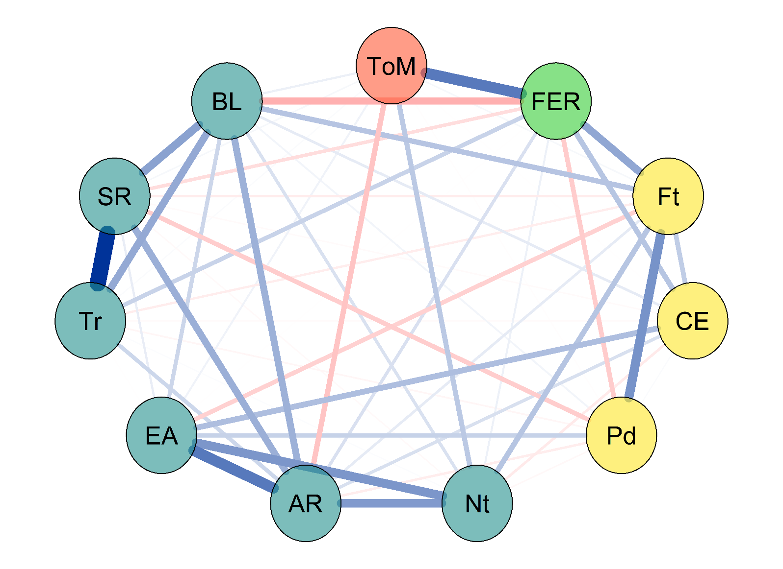
Figure S1. Unregularised Partial Correlation Network.
Figure S1. Depicts the unregularized partial correlation between interoceptive awareness and social cognition dimensions. Each circle represents a node, the set of observed variables evaluated in scales; edges represent the association between nodes; the colour blue and red represent the positive and negative association, respectively; the thickness of the edges represents the association strength. Nt= Noticing; AR= Attention regulation; EA=Emotional Awareness; SR=Self-regulation; BL=Body Listening; Tr=Trusting; FER=Facial Emotion-Recognition; ToM=Theory of Mind; PD=Personal Distress; Ft= Fantasy; CE=Cognitive empathy.
Figure S2. The bootstrapped interval between any pair of edges.
Figure S2. Represents the sample value: red line, bootstrapped 95% intervals: shaded area, and average bootstrapped value (black line) of edge weights.

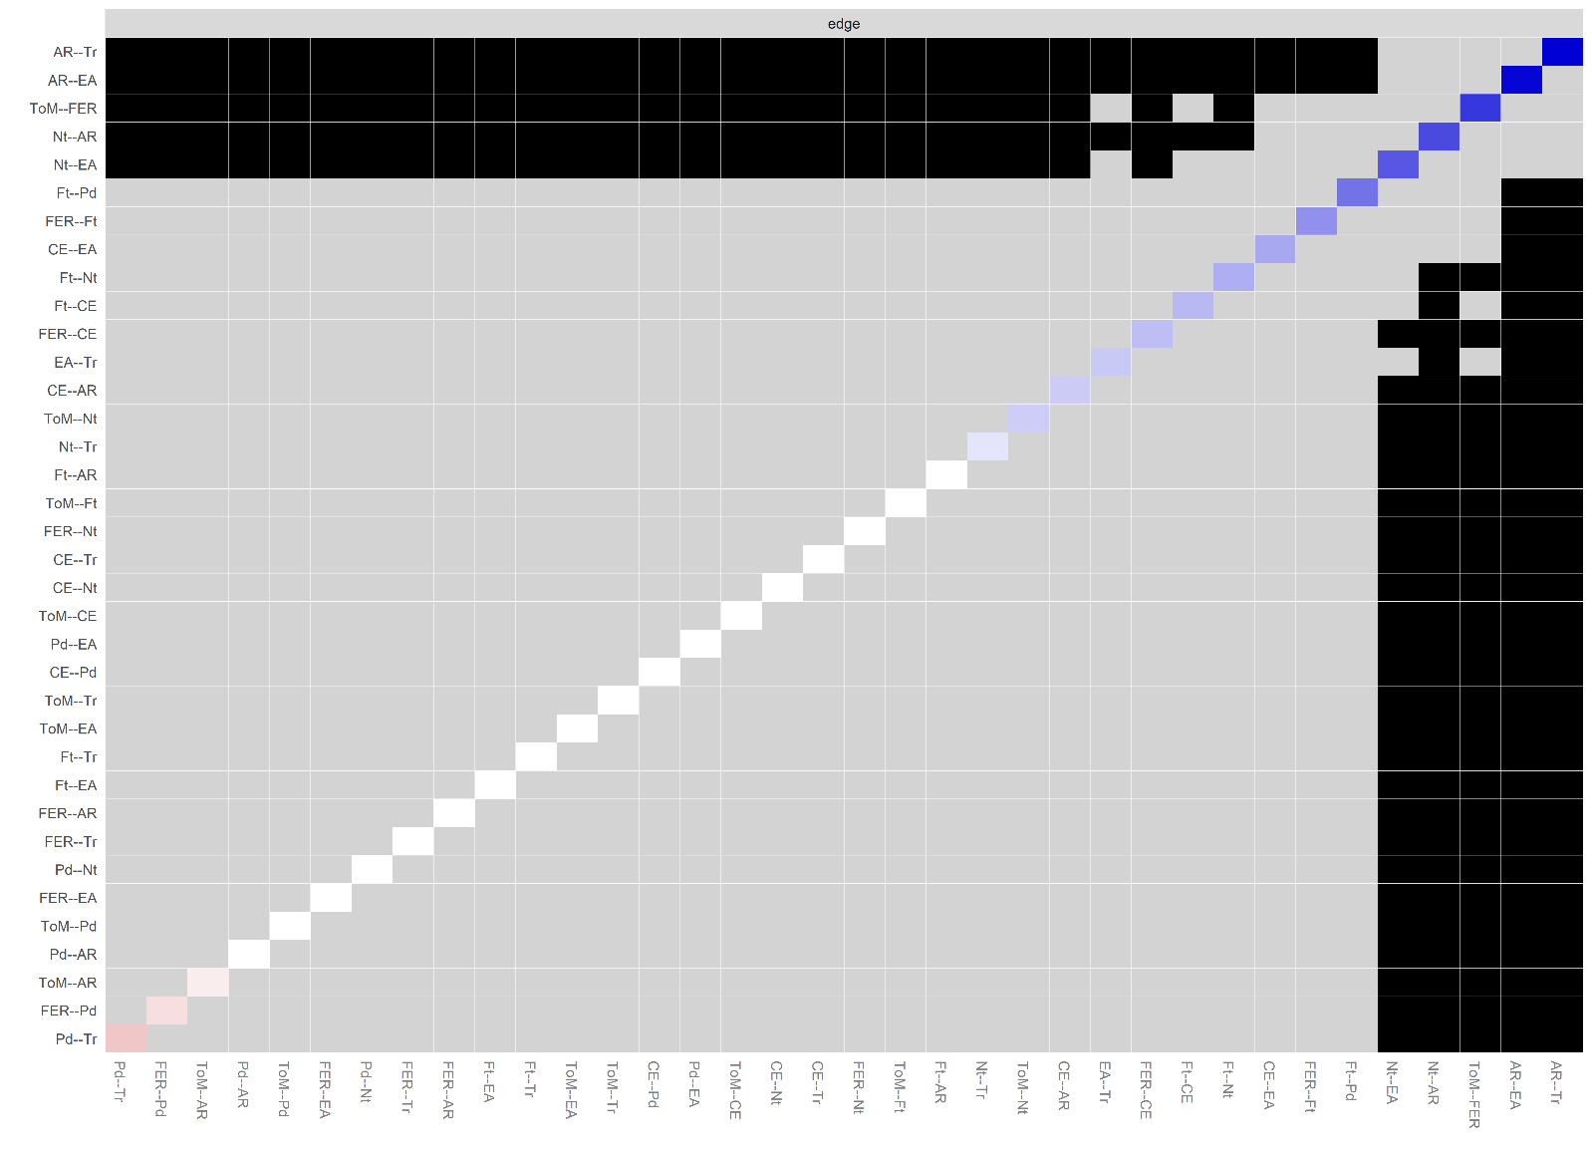
Figure S3. The bootstrapped interval between any pair of edges.
Figure S3. The presence of zero within the 95% bootstrapped interval between any pair of edges, as depicted by grey squares, determines whether the edges are distinct (dark squares) or not. The diagonal represents the original edge's magnitude, with red denoting negative values, blue indicating positive values, and the intensity of colour reflecting absolute values (greater saturation indicating stronger edges).

Figure S4. Case-dropping bootstrap analysis
Figure S4. The outcomes of the case-dropping bootstrap analysis reveal the mean correlation between centrality assessed in the entire sample and betweenness, closeness, expected influence, and strength estimated on a randomly selected subset while preserving varying proportions of cases (ranging from 90% to 10%). The shaded region represents the 95% bootstrapped confidence intervals for correlation estimates. Elevated values signify enhanced stability in centrality estimates.

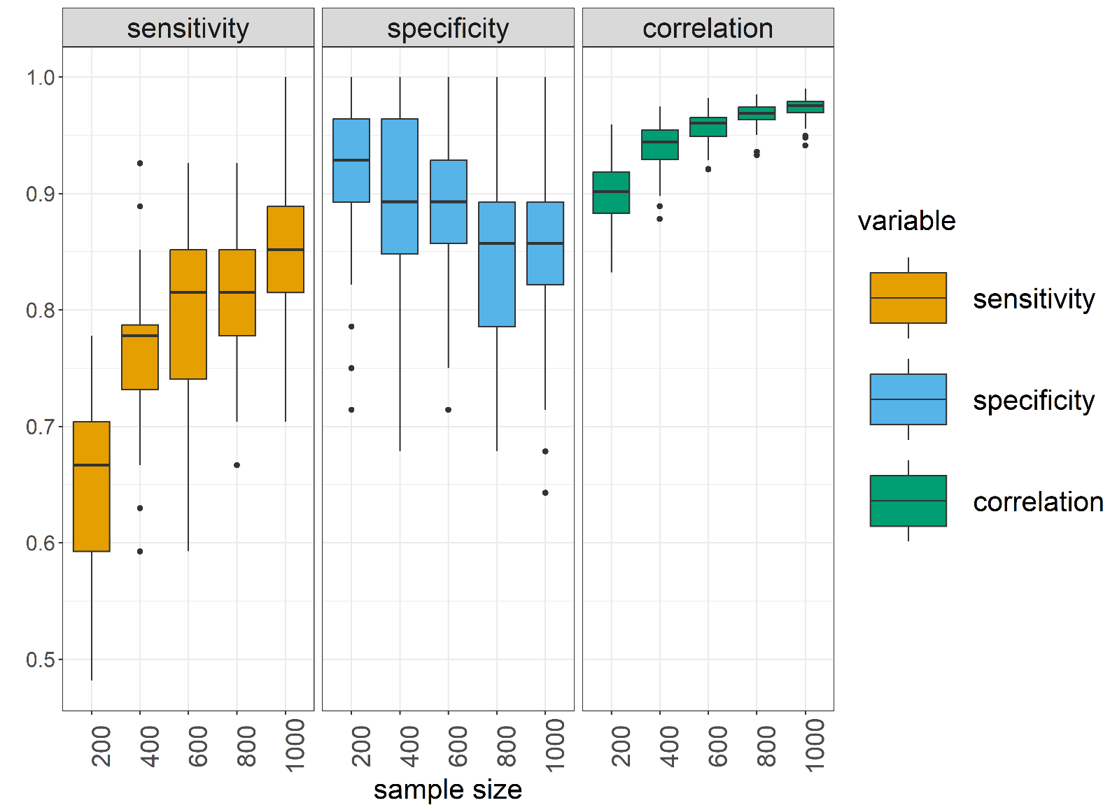
Figure S5. Reproducibility of the Interoceptive-Social Cognition Network.
Figure S5. The anticipated reproducibility of the Interoceptive-Social Cognition network is evaluated through Projected Replicability. The Replication Simulator creates numerous datasets based on an estimated network to evaluate the anticipated sensitivity (likelihood of including edges that are truly present in the generating network) and specificity (likelihood of excluding edges that are truly absent in the generating network), along with the expected correlation between edge weights in two replication datasets generated from the network.

