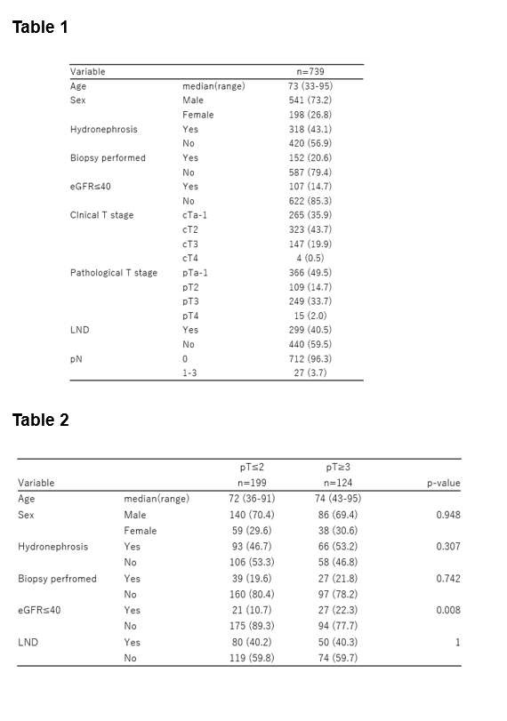
Table captions
Table 1 Baseline characteristics of 739 patients with cTa–4N0M0 UTUC treated with RNU

Table 2 Baseline characteristics of patients with cT2 disease according to pathological T stage (≤pT2 vs. ≥pT3)

