Supplementary figure and table
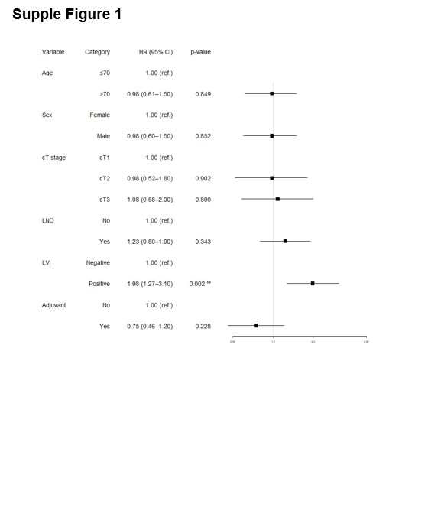

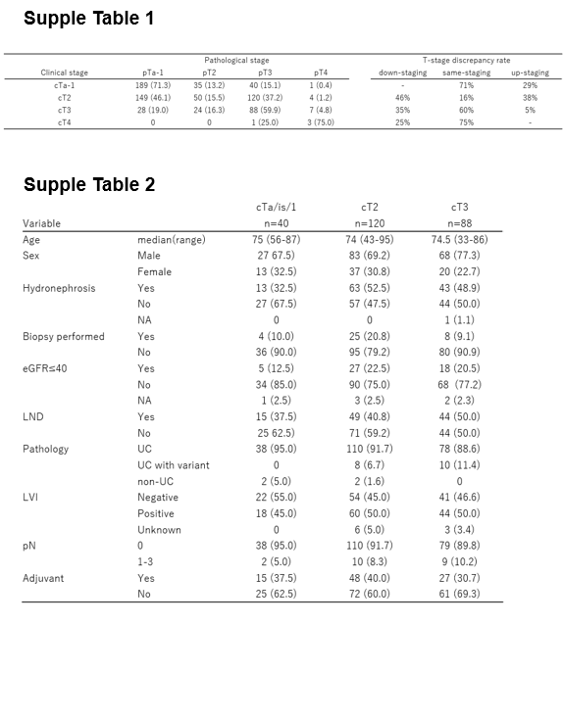

Supplementary figure and table captions
Supplementary Fig. 1 Multivariate Cox regression analysis for metastasis-free survival (MFS) in patients with pT3 disease

Supplementary Table 1 Correlation between clinical and pathological T stages in upper tract urothelial carcinoma

Supplementary Table 2 Baseline characteristics of patients with pT3 disease according to clinical T stage

