Supplementary Information for:

Equilibrium Climate Sensitivity dependence on changing climate, geography, and ocean heat transport

in Climate Dynamics

Julia Campbell¹ & Christopher J. Poulsen²

¹University of Michigan, (Earth and Environmental Sciences), Ann Arbor, (MI), USA
²University of Oregon, (Earth Sciences), Eugene, (OR), USA

Corresponding author: Julia Campbell (juliacam@umich.edu)

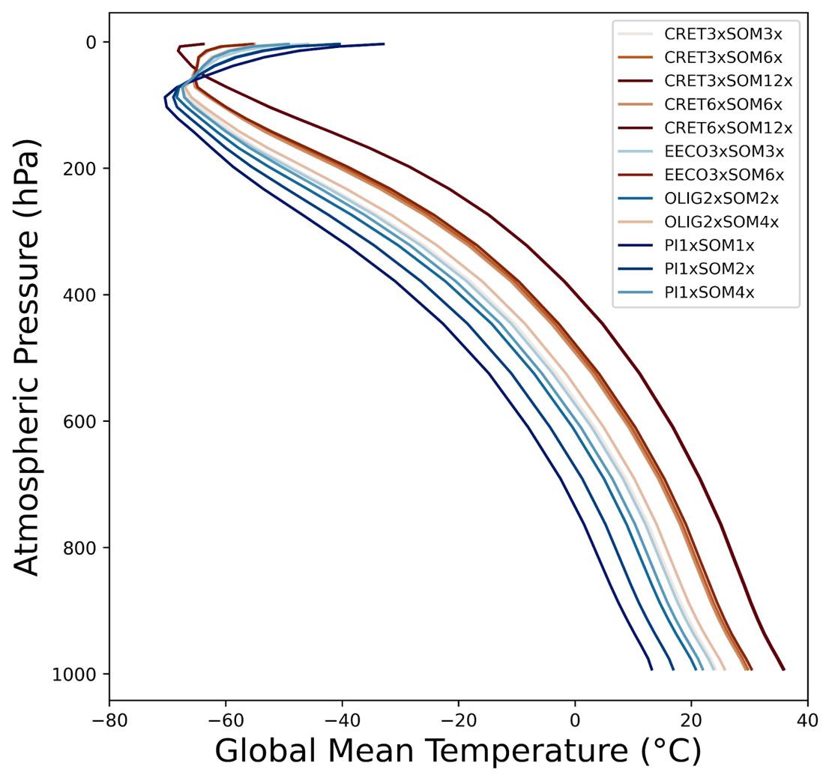
Fig. S1 The lapse rate for each climate simulation. The hotter simulations exhibit higher global mean temperatures at each pressure level until ~100 hPa and have an increased tropopause height. The atmospheric pressure from the simulations is a hybrid level at the midpoint

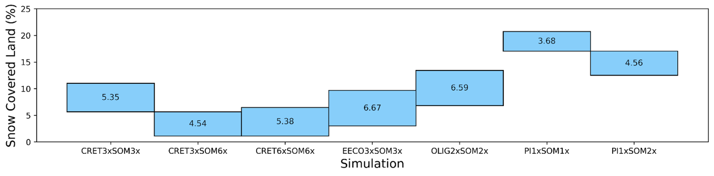
Fig. S2 The change in snow covered land with doubled CO₂ for each simulation. The top end of the bar represents the percent of snow-covered land with original CO₂, and the bottom end of the bar represents the percent of snow covered land with doubled CO₂. The value in the middle of each bar represents the difference in percent of snow covered land with doubled CO₂

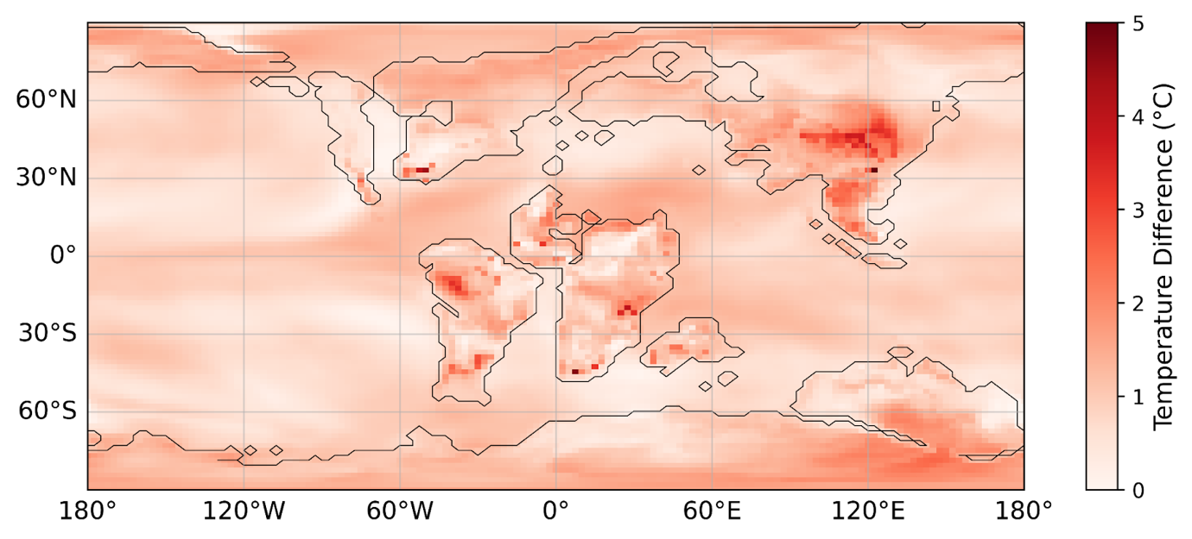

Fig. S3 The change in mean annual surface temperature with doubled CO₂ of the stronger OHT simulation minus the weaker OHT simulation. The stronger OHT simulation experiences a greater increase in surface temperature than the weaker OHT simulation globally. The ECS is 6.66°C and 5.77°C for the stronger and weaker OHT simulations, respectively

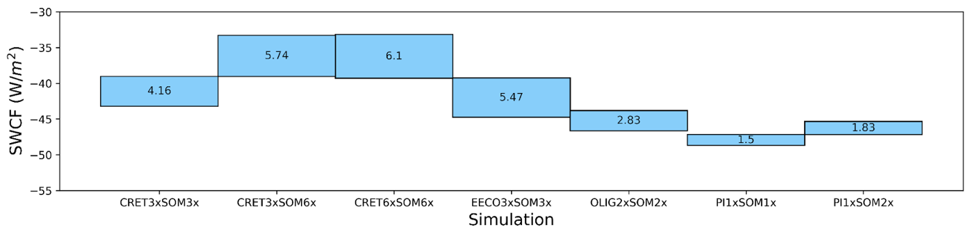
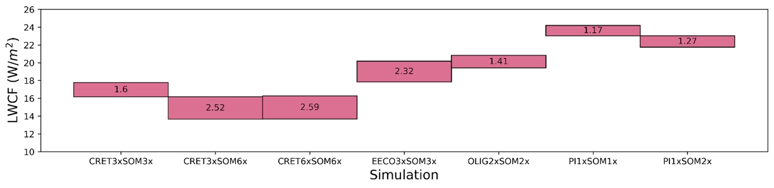

Fig. S4 The change in global shortwave cloud forcing with doubled CO₂ and global longwave cloud forcing with doubled CO₂. Both forcings are reduced with doubled CO₂ but SWCF is a negative forcing and LWCF is a positive forcing, so for SWCF the bottom edge of the bar represents the global SWCF with original CO₂, and for LWCF the top edge of the bar represents the global LWCF with original CO₂. The value in the middle of each bar represents the difference in SWCF and LWCF with doubled CO₂

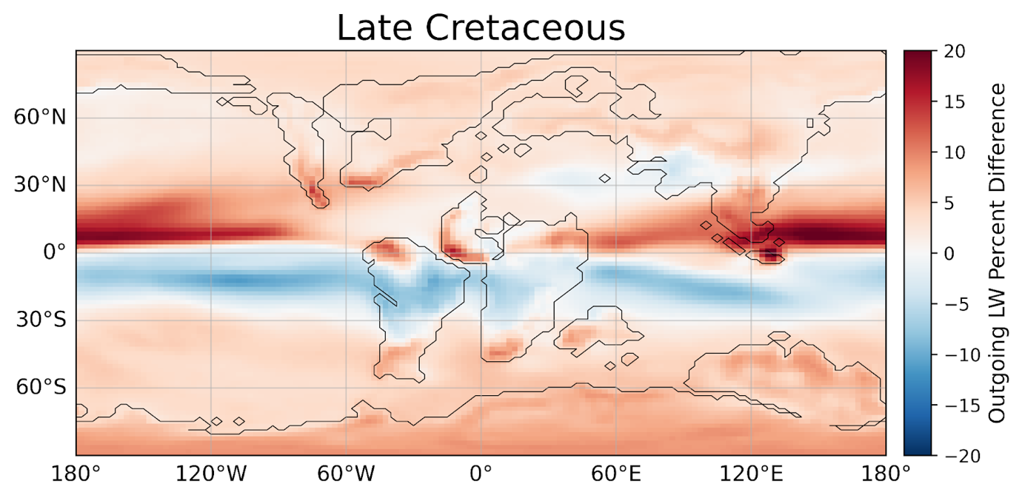

Fig. S5 Outgoing longwave radiation percent difference (CRET6xSOM12x - CRET6xSOM6x) in order to emphasize lowered albedo in Antarctica. As there is no land ice, and very little sea ice, the lowered albedo is likely caused by a reduction in snow cover and lower, reflective cloud cover

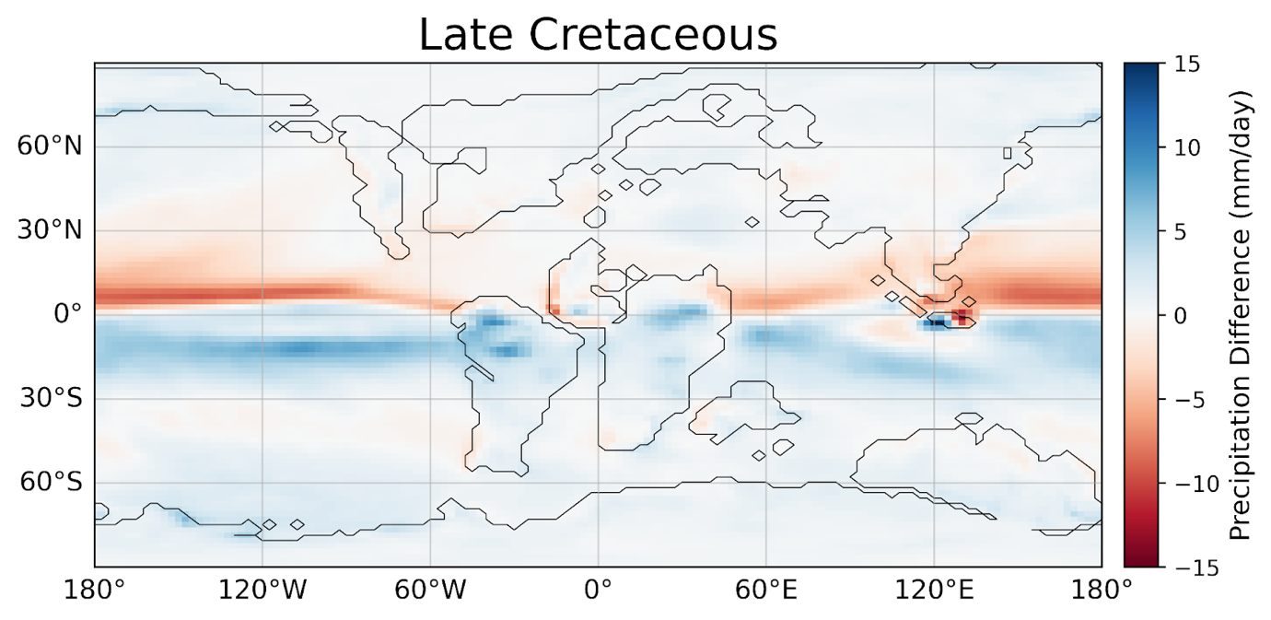

Fig. S6 Precipitation difference (CRET6xSOM12x - CRET6xSOM6x) to show a southern shift in the ITCZ, not apparent in other time slices, resulting in lower monsoonal activity in southeast Asia, which may indicate lower cloud cover and enhanced warming

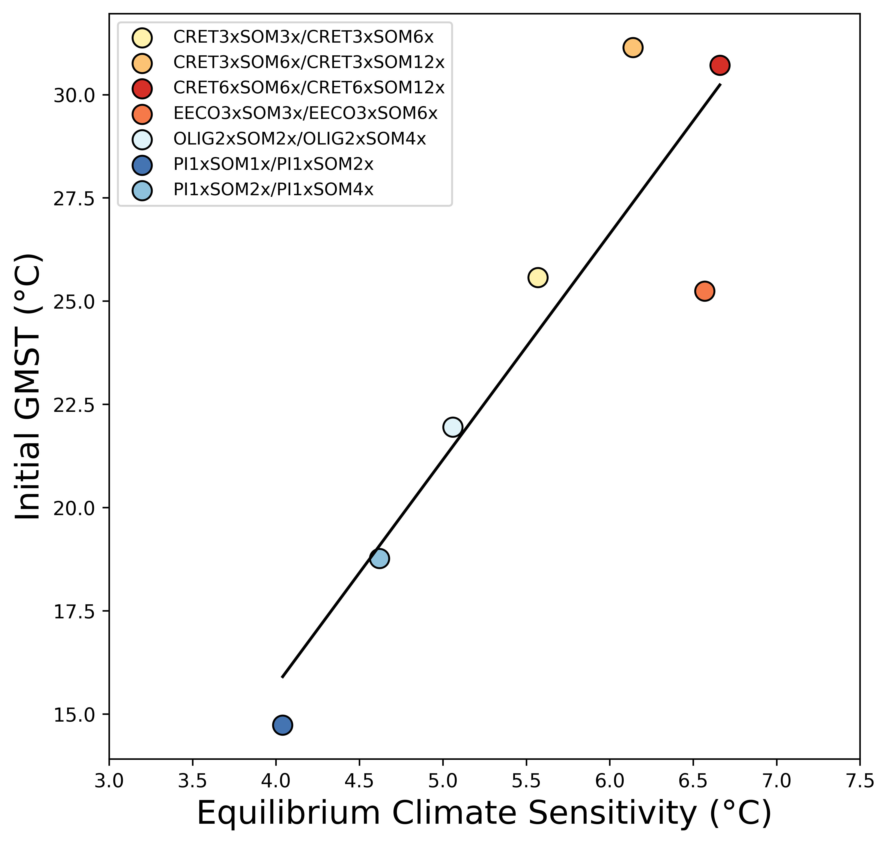

Fig. S7 The relationship between ECS and initial GMST for each climate state

