Supplementary Information

Intraseasonal variability of global land monsoon precipitation and recent change
Fei Liu^{1*}, Bin Wang^{2*}, Yu Ouyang³, Hui Wang¹, Shaobo Qiao¹, Guosen Chen⁴, and Wenjie Dong¹
¹School of Atmospheric Sciences Sun Yat-Sen University, Key Laboratory of Tropical Atmosphere-Ocean System Ministry of Education, and Southern Marine Science and Engineering Guangdong Laboratory, Zhuhai 519082, China
²Department of Atmospheric Sciences and International Pacific Research Center, University of Hawaii at Manoa, Honolulu, HI 96822, USA
³Shanxi Meteorological Observatory, Xi’an 710014, China
⁴Earth System Modeling Center and Climate Dynamics Research Center, Nanjing University of Information Science & Technology, Nanjing 210044, China

*To whom correspondence should be addressed. Fei Liu, liufei26@mail.sysu.edu.cn and Bin Wang, wangbin@hawaii.edu

Supplementary Table 1. Precipitation variance explained by the first two leading EOF modes for high-frequency (HF; 8-20 day) and low-frequency (LF; 20-70 day) ISVs over each regional monsoon.
 | SA | EA | NAM | NAF | AU | SAM | SAF
8-20 EOF1 (%) | 11.4 | 8.3 | 8.8 | 9.2 | 9.0 | 8.4 | 7.2
8-20 EOF2 (%) | 7.8 | 6.6 | 5.9 | 5.6 | 7.3 | 6.3 | 6.6
20-70 EOF1 (%) | 22.6 | 11.6 | 10.4 | 8.8 | 18.5 | 17.0 | 10.6
20-70 EOF2 (%) | 9.8 | 8.5 | 7.6 | 5.9 | 9.1 | 6.3 | 9.3

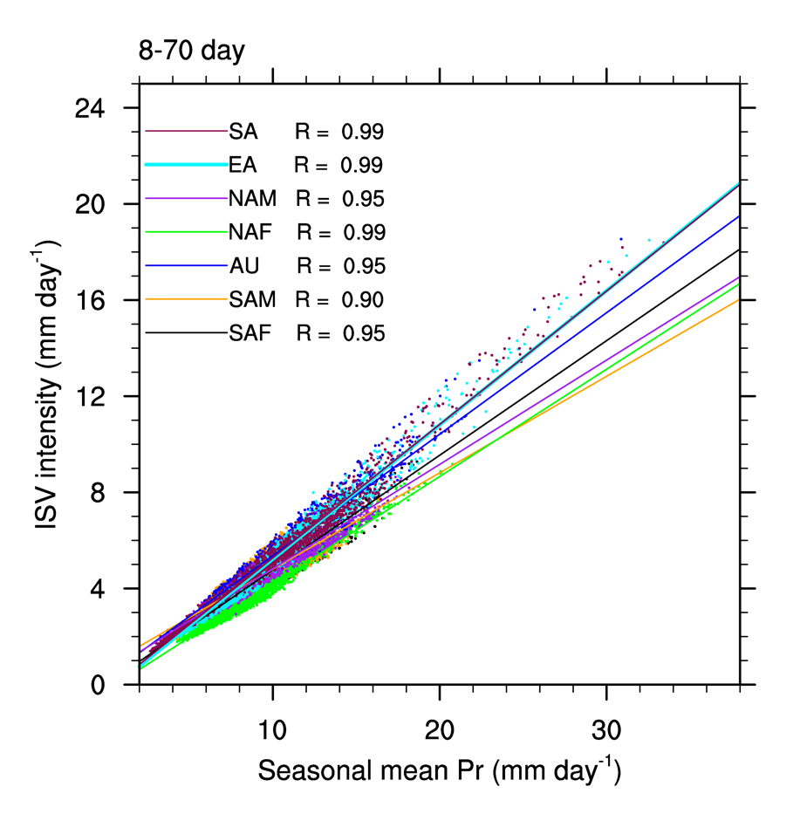
Supplementary Figure 1 | Spatial distributions of intraseasonal variability (ISV) intensity and seasonal-mean precipitation over land monsoon regions. Scatter plot of ISV intensity (mm day⁻¹) versus seasonal-mean precipitation (mm day⁻¹) on each grid of land monsoon regions for summers (MJJAS for NH and NDJFM for SH) of 1979-2018. ISV intensity is defined by the standard deviation of 8-70-day filtered precipitation anomaly. Linear regression lines with significant correlation coefficient (R) are shown as solid lines with different colors for South Asian (SA), East Asian (EA), North American (NAM), northern African (NAF), South American (SAM), and South African (SAF) monsoons.

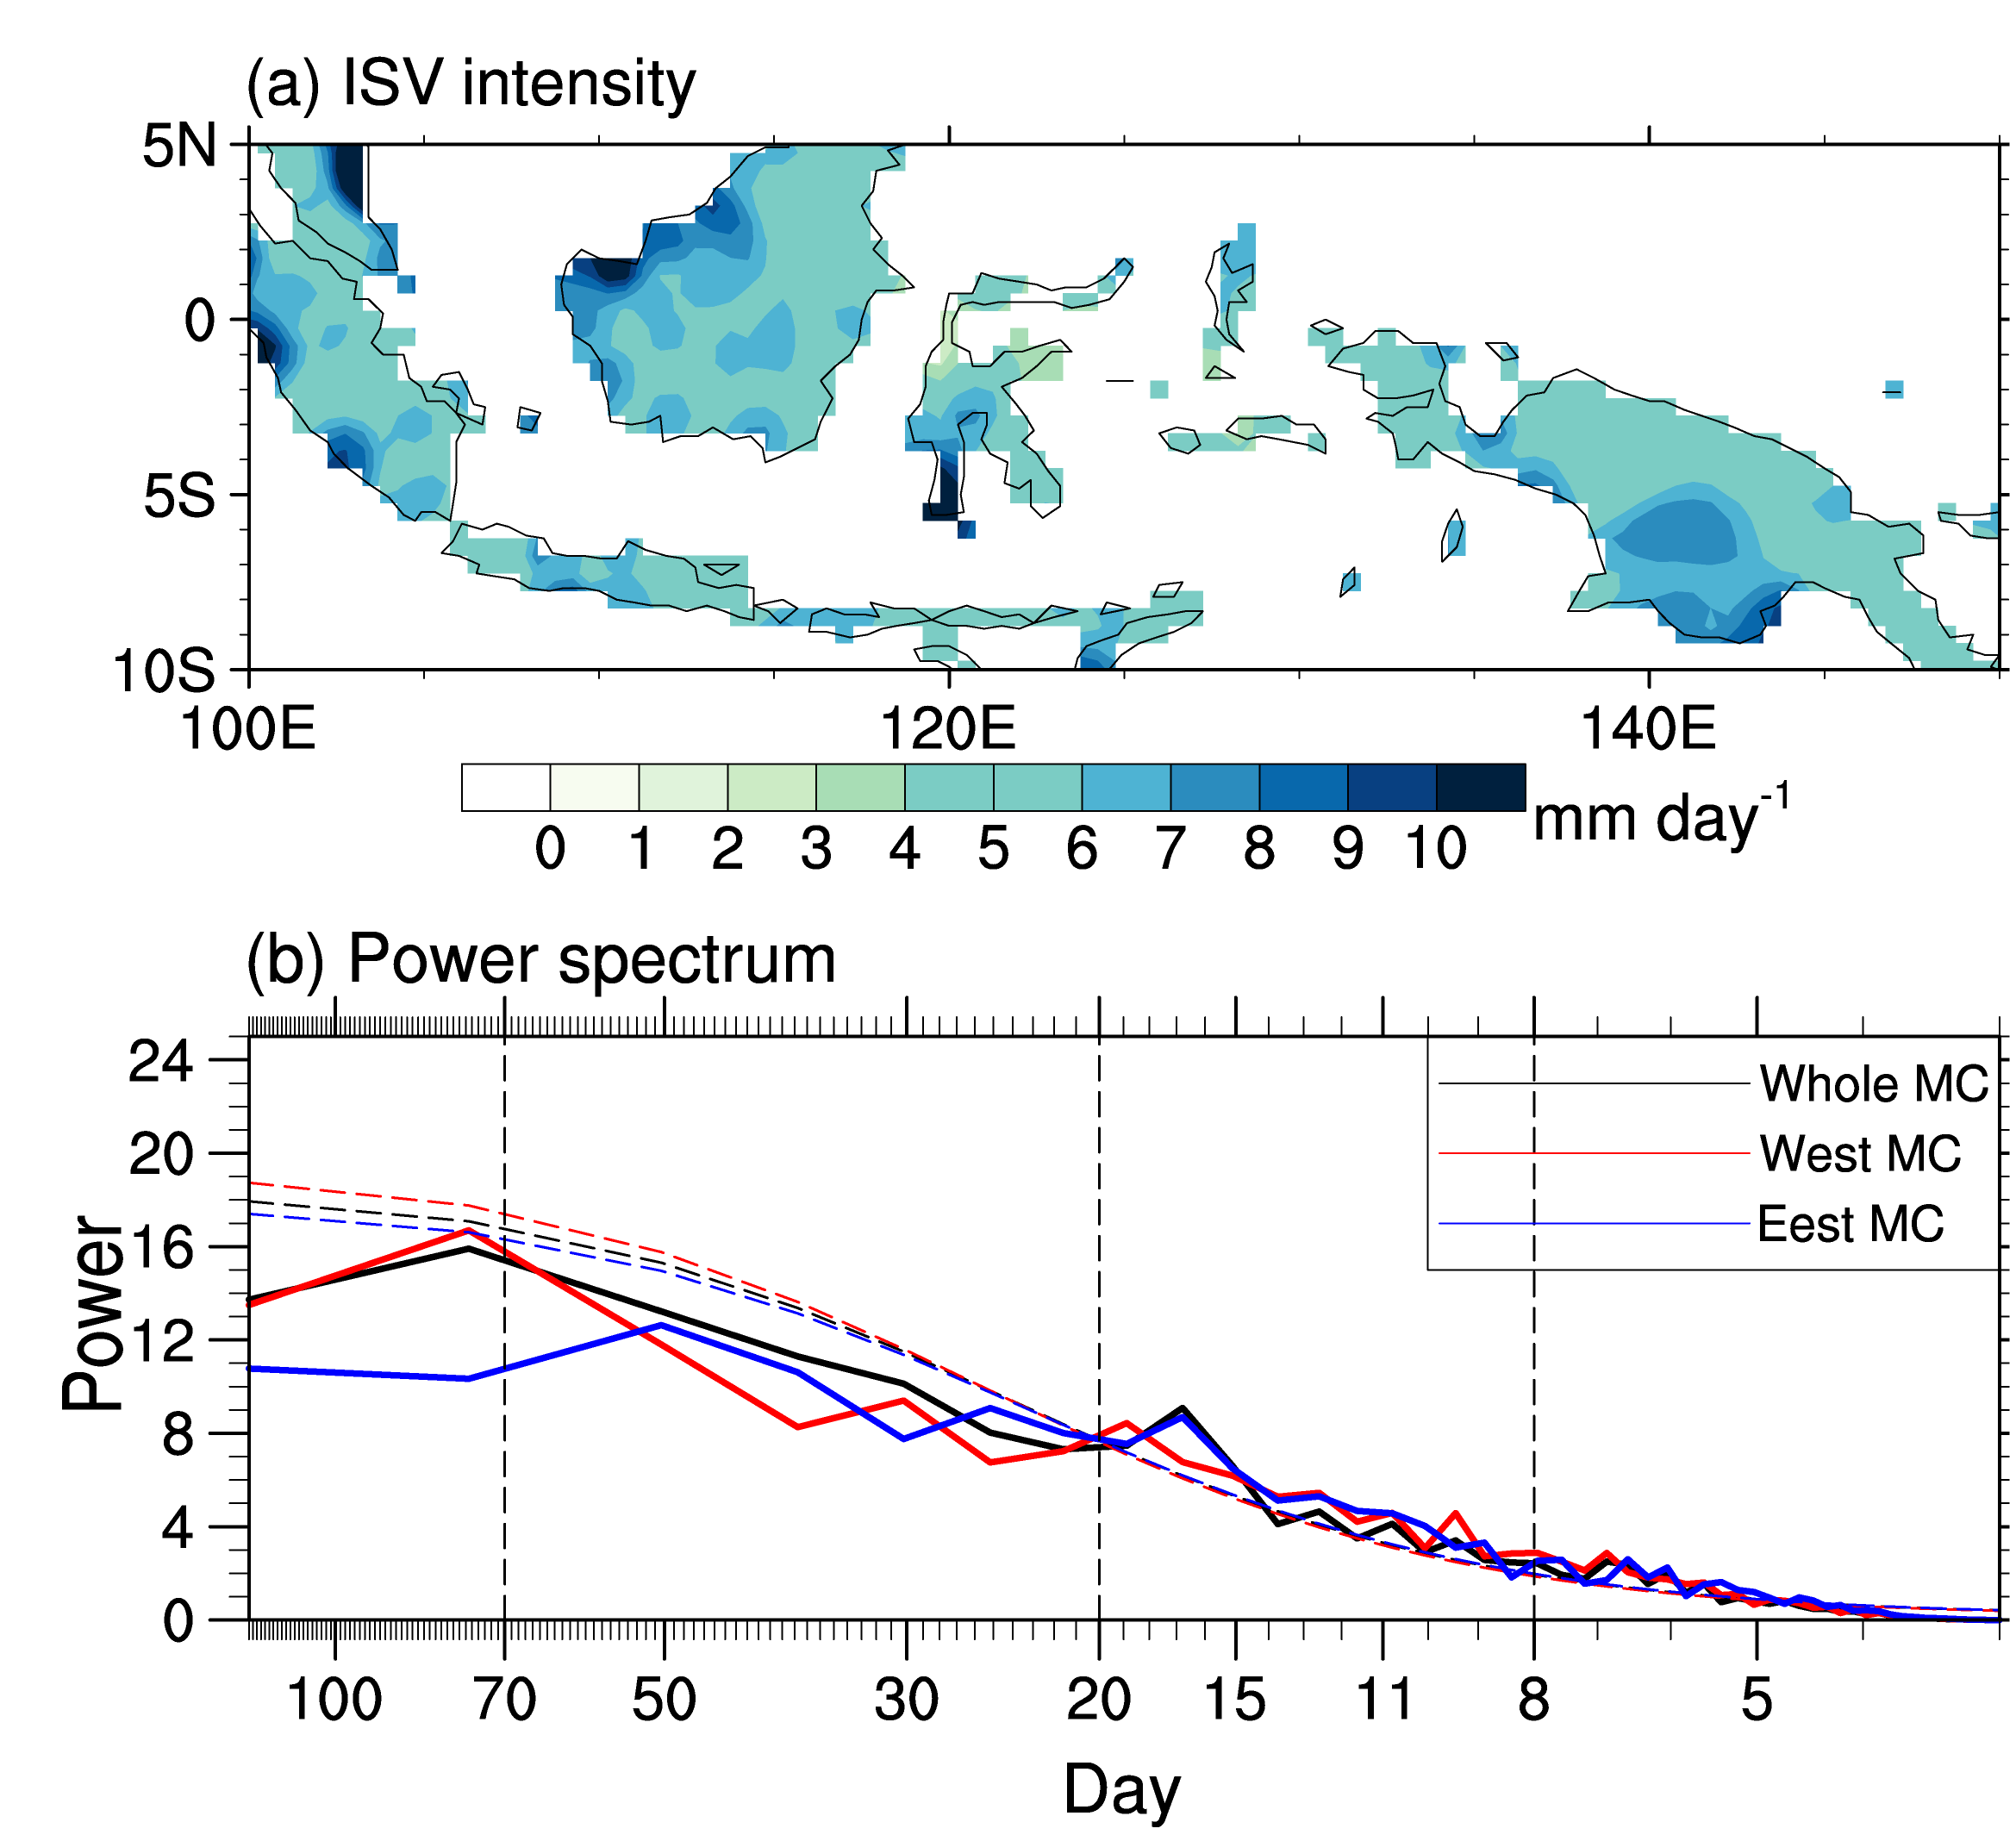
Supplementary Figure 2 | ISV of the Maritime Continent rainfall during Austral summers of 1979-2018. a Austral summer (November to March) ISV intensity (mm day⁻¹) defined by the standard deviation of 8-70-day bandpass-filtered precipitation anomalies over the Maritime Continent. b The power spectra of the 3-day running mean austral summer precipitation anomalies (mm day⁻¹) averaged over the Maritime Continent (100º-150ºE; 10ºS-5ºN). Daily climatology is removed to obtain the anomalies. Dashed lines denote the corresponding 90% confidence levels. Power spectra for the western Maritime Continent (Redline; 100º-125ºE; 10ºS-5ºN) and eastern Maritime Continent (Blue line; 125º-150ºE; 10ºS-5ºN) are also shown.
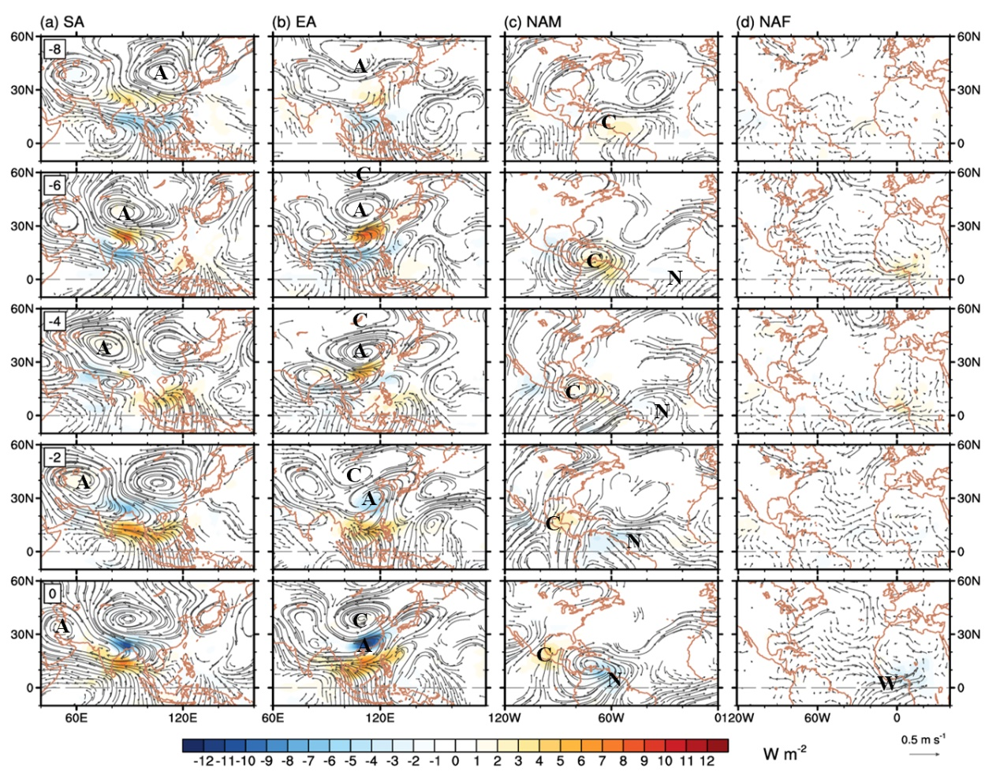
Supplementary Figure 3 | Origins for 8-20-day ISVs of NH summer monsoons. Lagged regression maps of 8-20-day filtered OLR (shading; W m⁻²) and 200-hPa wind (vector; m s⁻¹) anomalies onto PC1 during summers of 1979-2018 for a South Asian (SA), b East Asian (EA), c North American (NAM), and 850-hPa wind anomalies for d northern African (NAF) monsoons. Only OLR and wind anomalies significant at the 90% confidence levels are shown. Letter A tracks the center of the anomalous anticyclone; C, the cyclone; N, The northerly; and W, the westerly.

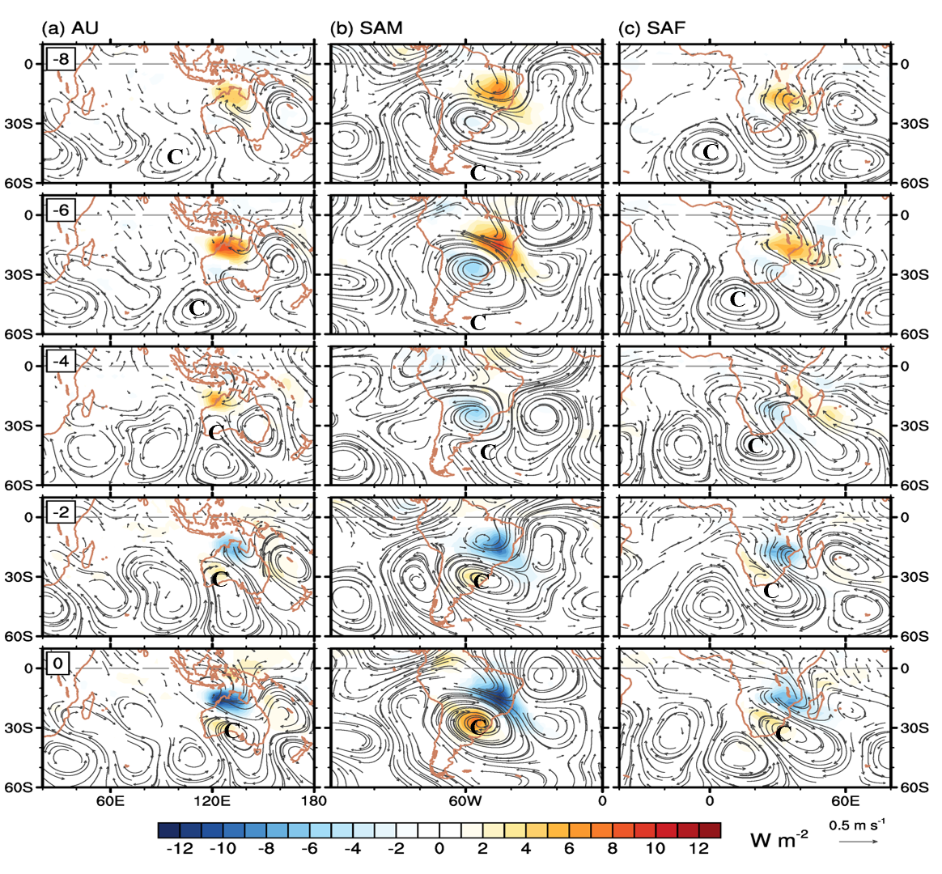
Supplementary Figure 4 | Origins for 8-20-day ISVs of SH summer monsoons. Same as Supplementary Fig. S3, except showing 200-hPa wind anomalies for three SH monsoons: a Australian (AU), b South American (SAM), and c South African (SAF) monsoons.

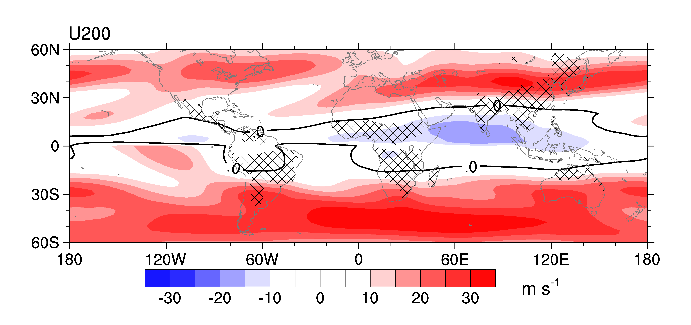
Supplementary Figure 5 | Climatological upper-level westerly (1979-2018). Local-summer mean 200-hPa zonal wind (contour; m s⁻¹). Cross-hatching marks the global land monsoon region, and the dark line denotes the zero zonal wind.

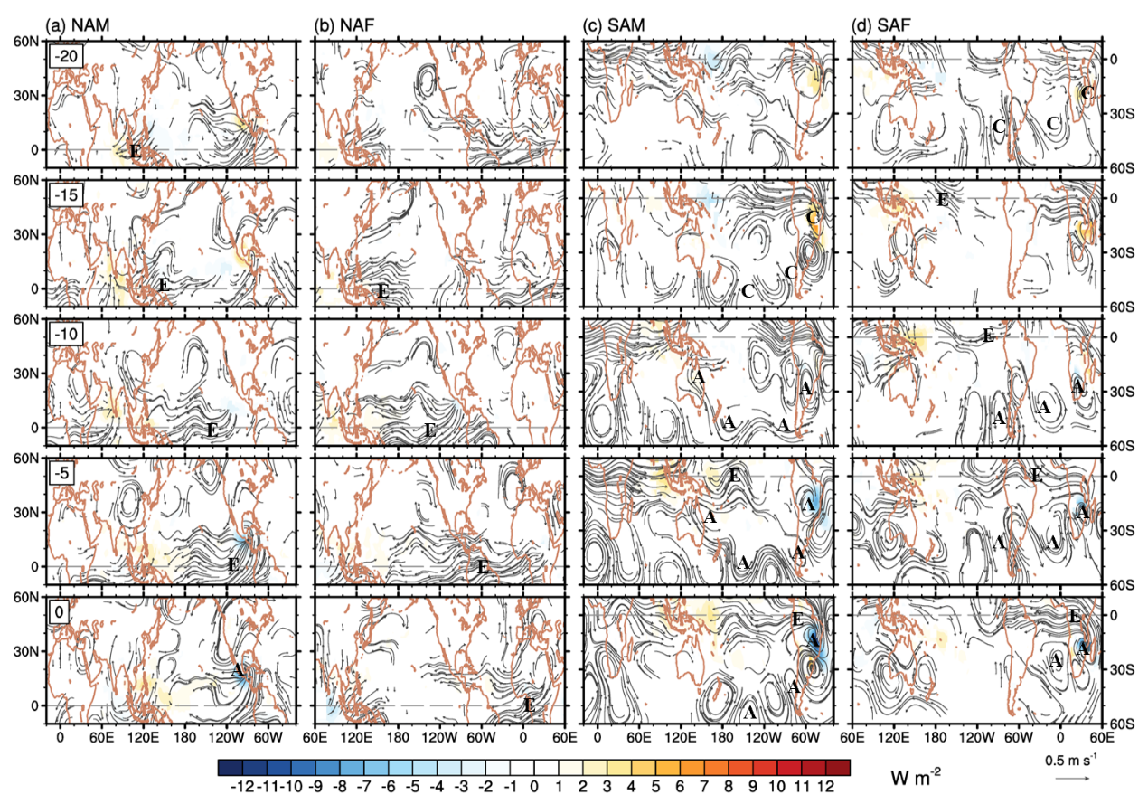
Supplementary Figure 6 | Origins for 20-70-day ISVs of American and African summer monsoons. Lagged regression maps of 20-70-day filtered OLR (shading; W m⁻²) and 200-hPa wind (vector; m s⁻¹) onto PCs during summers of 1979-2018 for a NAM, b NAF, c SAM, and d SAF monsoons. Only OLR and wind anomalies significant at the 90% confidence levels are shown. Letter A tracks the center of the anomalous anticyclone; C, the cyclone, and E, the easterly.

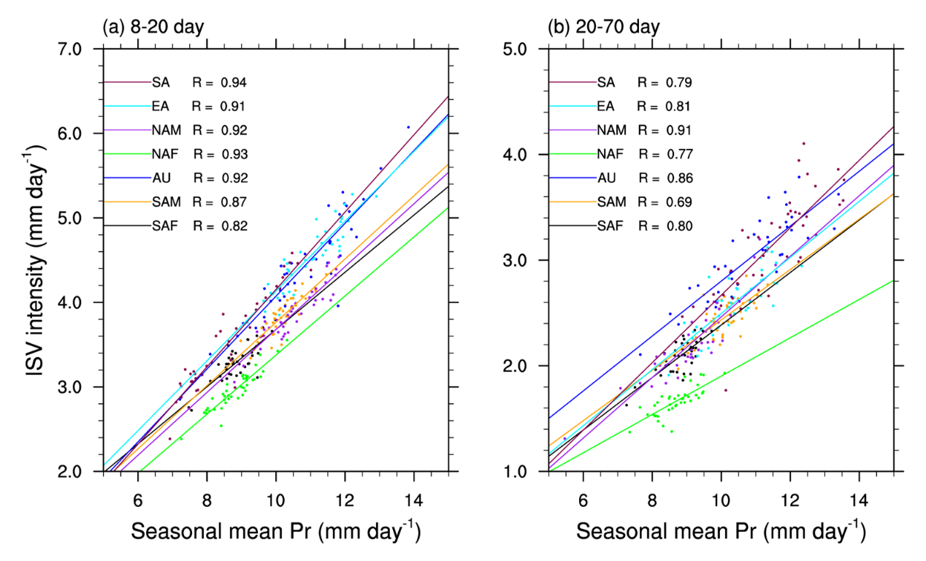
Supplementary Figure 7 | Relationship of year-to-year changes between ISV intensity and seasonal-mean precipitation. Scatter plot of ISV intensity (mm day⁻¹) versus seasonal-mean precipitation averaged over the wet region with EOF anomaly above 0.05 mm day⁻¹ in Fig. 4 over individual monsoons for a 8-20-day and b 20-70-day ISVs. ISV intensity is defined by the standard deviation of regional-averaged precipitation anomaly for each summer from 1979 to 2018. Linear regression lines with significant (p<0.01) correlation coefficient (R) are shown by solid lines with different colors for individual monsoons.

