Extended data figures
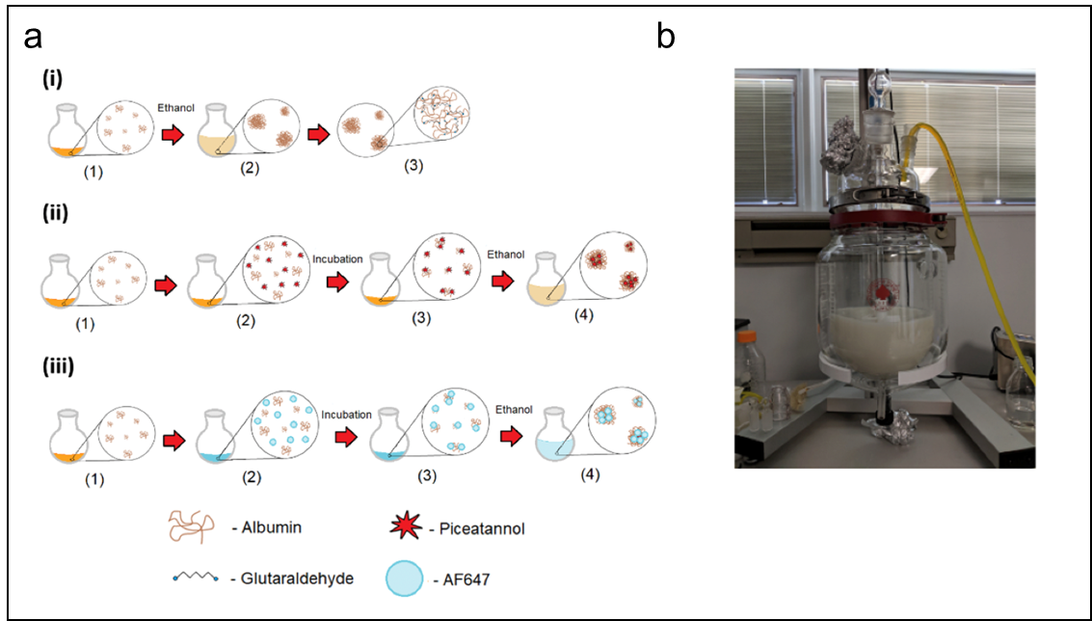

Extended data figure 1. Human serum albumin (HSA)-based nanoparticles for targeted drug delivery. Albumin nanoparticle (ANP) were synthesized (a) using a solvent desolvation technique by controlled addition of ethanol to albumin solutions (i). Piceatannol ANP (PANP) were synthesized by incubating albumin solutions with piceatannol prior to desolvation (ii), and dye functionalized ANP/PANP were formed by addition of dye prior to desolvation (iii). (b) Piceatannol was loaded into ANP with encapsulation efficiency of 4.5-5% as measured by LC-MS/MS. ANP size, polydispersity, zeta potential and encapsulation efficiency were found to remain constant as reaction volume was scaled up from 4.5mL to 3 liters.

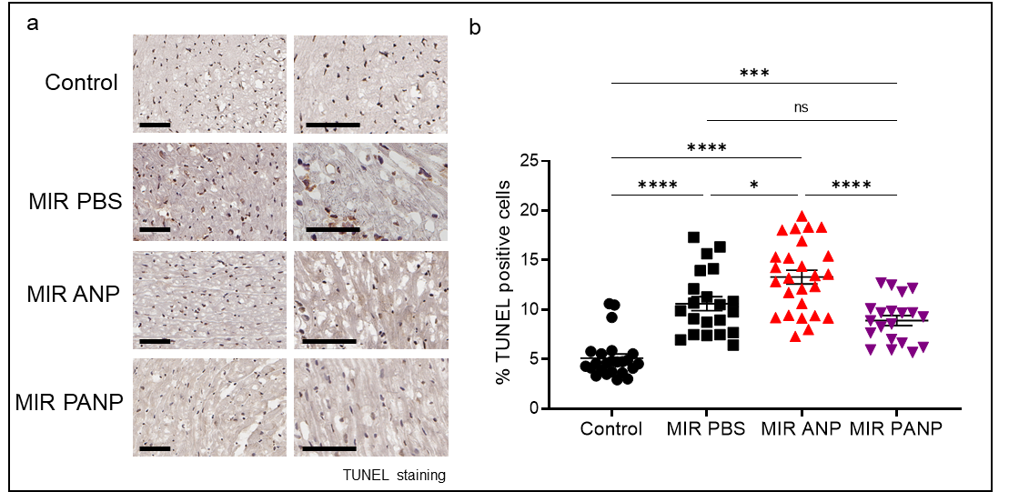Extended data figure 2. TUNEL staining. Cardiomyocyte death was markedly reduced by PANP treatment post IR. Histological sections of heart from control, or mice subjected to MIR treated with ANP or PANP were processed for TUNEL staining. (a) Representative microscopy images. (b) Quantification of TUNEL positive cell percentage in each field of view by using Aperio Image Scope system (Leica). ***p< 0.0005; ****p< 0.00005 (One-way Anova followed by Tukey’s multiple comparison test in GraphPad Prism). Representative data shows different fields of view from 3 independent experiments.

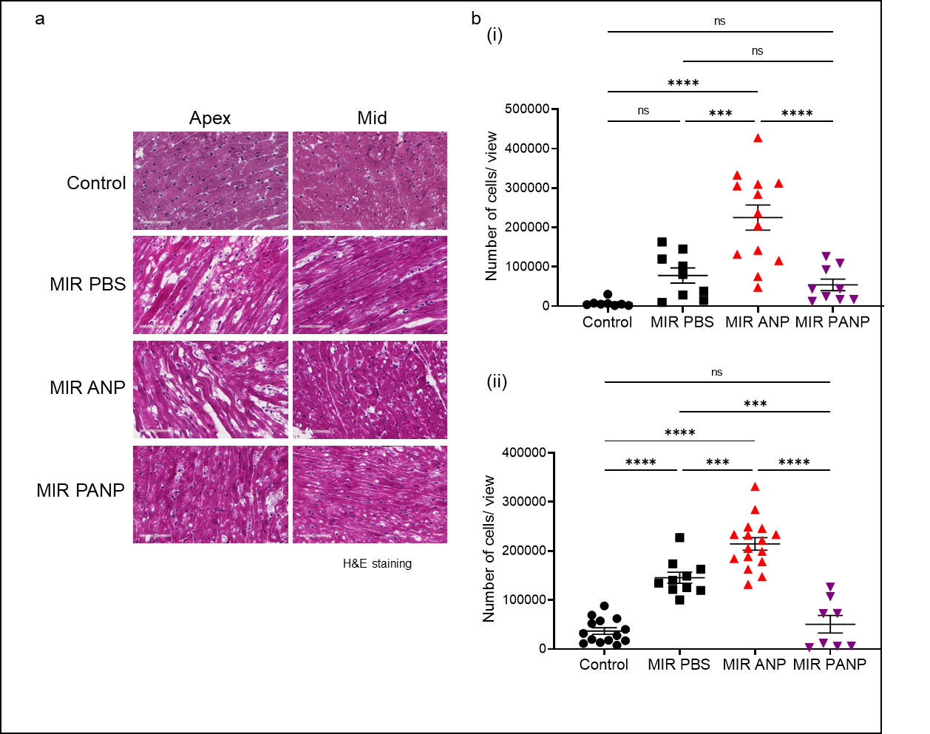

Extended data figure 3. PANP treatment post IR reduces cardiac myofiber disorganization. Histological sections of heart from control or mice subjected to IR treated with ANP or PANP were stained for Hematoxylin and Eosin. (a) Representative images of mid-myocardial and apex sections (scale bar represents 60µm). (b) Blinded quantification of cellularity from mid (i) and apex (ii) regions in each field of view using Aperio Image Scope system (Leica). ****p< 0.00005 (One-way Anova followed by Tukey’s multiple comparison test in GraphPad Prism). Representative data includes different fields of view from 3 independent experiments.

