Supplements
Supplement 1: Additional information on the SPD is described here. The procedure follows that of Hirose et al. (2021), except for the definition of near-nadir (nn) angles. The objective is to estimate precipitation discrepancies arising from differences in the number (N) of undetected shallow storms and the estimated average precipitation intensities ($\overline{R_{s}}$) at various incidence angles. As shown in Eq. (S1), $\overline{R_{s}}$ is calculated based on the surface precipitation rates for each storm-top height, land or ocean classification (lo), and stratiform or convective precipitation types (sc). Considering the influence of ground clutter, most precipitation undetected within the blind zone is assumed to occur when the precipitation peak lies at or below 2.5 km. In this study, the SPD correction effect, or simply the SPD effect, represents the positive contribution of SPD supplementary processing, as in Hirose et al. (2021).

$SPD=\frac{\sum_{i=1}^{49}{\sum_{h=surf}^{2.5km}{\sum_{k=lo/sc}{\left[N\left(i,h,k\right)-N\left(nn,h,k\right)\right]\overline{R_{s}}(nn,h,k)}}}}{49\sum_{h=surf}^{top}{\sum_{k=lo/sc}{N\left(nn,h,k\right)}\overline{R_{s}}\left(nn,h,k\right)}}$ (S1)

Supplement 2: As an example of regions where extremely weak precipitation predominates, Fig. S1 presents the probability density distribution of precipitation observed by tipping-bucket rain gauges and by Rolwaling’s automatic weather stations (AWSs), which were installed in high-altitude areas of the Himalayas. The AWSs were deployed by Fujita at an elevation of 4,806 m (Fujita 2021), while the rain gauges were installed by Fujinami in the high-altitude region near the Rolwaling Valley, at elevations between 1,001 and 4,183 m (Fujinami et al. 2022; Hirata et al. 2023). Each AWS recorded data at a resolution of 0.1 mm h⁻¹. Compared to integer-resolution data, the recorded precipitation duration increased by approximately threefold, with this difference attributed to rainfall intensities of 0.5 mm h⁻¹ or less. The frequency of precipitation occurrence ranged from 5.4% to 15.7%. The AWS statistics shown in this figure are based on summer and winter data collected from May 2016 to November 2018, while the other six datasets are derived from 0.2-mm-resolution rain gauges using data collected between June and September 2019. The lowest recorded precipitation intensities were approximately 0.09–0.11 mm h⁻¹. The 100% value per 0.1 mm h⁻¹ bin in this context can be interpreted as approximately 20% per bin. At these high-altitude sites, precipitation occurs primarily during the summer season (Fujinami et al. 2023). Unlike in low-altitude regions with higher precipitation, the contribution of extremely weak precipitation is particularly prominent in these areas.
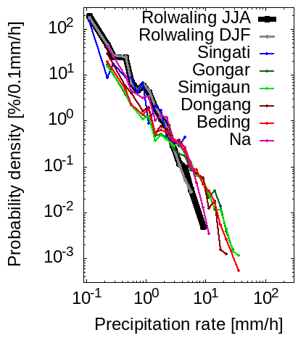
Fig. S1. Probability density function of precipitation based on in situ observational data from the Himalayas. The statistics were compiled using the methodology described in Section 2.4.
Supplement 3: Snow dominates in high-latitude and high-altitude regions, accounting for 99% of precipitation samples obtained in the Antarctic Ocean and Greenland (Fig. S2a). Sensitivity effects were estimated based on near-nadir data. However, the determination of the phase at the CFB level using data from all angles of incidence revealed the existence of angle-of-incidence dependence, as illustrated in Fig. S2b. There are latitudinal bands where the phase converges around 0 °C only near the scan edge, and in these regions, the proportion of snowfall samples increases by more than 10%. In particular, there is a difference of about 20% in coastal and mountainous areas at high latitudes. Conversely, despite slightly higher temperatures at the CFB level near nadir, more snowfall is detected near nadir in some regions, such as Hudson Bay. This corresponds to the fact that snowfall in those regions is concentrated at extremely low altitudes where it can only be observed directly below.
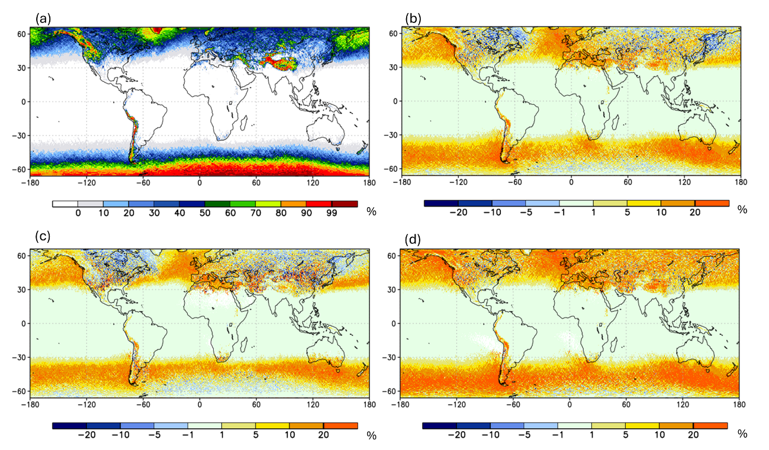
Figure S2. (a) Fraction of snow samples observed near nadir by GPM DPR during 2015–2022. (b) Difference of all-angle relative to near-nadir observations. (c, d) Same as (b), but for shallow and non-shallow storms, classified by a storm-top height threshold of 2.5 km.

Supplement 4: Reference information on the GPCP precipitation time series is provided here. The averaging period and spatial domain of the GPCP V3.2 data used in Fig. S3 are consistent with those in Fig. 11. Data published through the end of 2023 were used. This figure displays quarterly averages starting from March–May 1998. The characteristic excess precipitation associated with the 1997–1998 El Niño event (Adler et al. 2018) is also apparent in other composite datasets, such as GSMaP_MVK. At higher latitudes, precipitation peaks in summer, but the amplitude decreases during the latter half of the period.
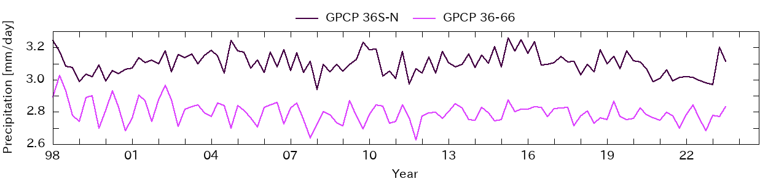
Fig. S3. Temporal variations in area-weighted average GPCP V3.2 precipitation for regions below 36° latitude (36°S–36°N) and regions above 36° latitude (36°–66°S/N).

