Spatially-resolved humidity sensing by capacitive-CMOS arrays

Suman Kundu^{1,2}*, Kai Betlem^{1,2}, Tao Shen^{1,2}, Peter G Steeneken², Frans P Widdershoven^{1,3}, Murali K Ghatkesar²*
- Department of Microelectronics, Faculty of Electrical Engineering, Mathematics and Computer Science, TU Delft, Netherlands
- Department of Precision and Microsystems Engineering, Faculty of Mechanical Engineering, TU Delft, Netherlands
- NXP Semiconductors, Technology & Operations/CTO office, High Tech Campus 46, Eindhoven, Netherlands
Email: S.Kundu@tudelft.nl, M.K.Ghatkesar@tudelft.nl

Table T1. Performance comparison of state-of-the-art electrically readout humidity sensor arrays and CMOS-based humidity sensors
Sl. No. | Ref. | Sensing principle | Sensing materials | Humidity range  (% RH) | CMOS  Compatibility | Response time  (s) | Recovery time  (s) | Number of sensing elements | Spatial resolution  (in X-Y plane)
1 | ACS Appl. Mater. Interfaces 2017, 9, 44593−44601 | Impedance variation | Photoreduced graphene oxide | 11-95 | No | 1.8 | 11.5 | 4 × 4 sensing matrix | > 1 cm *
2 | ACS Appl. Mater. Interfaces 2019, 11, 21840−21849 | Current variation | Printing  paper and flexible conductive adhesive tape | 7.2-91.5 | No | 19 | 472 | 4 × 4 sensing matrix | > 1 cm *
3 | Small 2019, 15, 1902801 | Current variation | MoO₃ nanosheet | 0-100 | No | 0.5 | 2 | 10 × 10 sensing matrix | > 0.5 cm *
4 | Adv. Mater. 2023, 35, 2304420 | Resistance variation | WO₃ Nanowires | 11-95 | No | 1.5 | 15.2 | 4 × 4 sensing matrix | > 1 cm *
5 | Sens. Actuators B Chem. 2021, 344, 130219 | Impedance variation | Graphitic carbon nitride/polyethylene oxide | 11-97 | No | 2.2 | 3 | 4 × 4 sensing matrix | > 1 cm *
6 | ACS Nano, 2020, 14, 9, 10966–10975 | Resistance variation | ZnIn₂S₄ nanosheets | 30-90 | No | 1 | 22 | 6 × 6  and 18-pixel sensor array | 2 cm
7 | Adv. Mater. 2012, 24, 1969–1974 | Resistance variation | VS₂ ultrathin nanosheets | 0-100 | No | 30–40 | 12–50 | 6 × 6 sensing matrix | > 0.5 cm *
8 | Adv. Mater. 2015, 27, 1370–1375 | Resistance variation | Reduced graphene oxide ultrathin films | 4.3-75.7 | No | 4 | 10 | 10 × 10 sensing matrix | > 0.5 cm *
9 | IEEE J. Solid-State Circuits 2013, 48(10), 2469-2477 | Capacitance variation | Polyimide | 30-100 | Yes | - | - | 1 | Not applicable
10 | IEEE Sens. J. 2013, 13(3), 900-908 | Capacitance variation | Polyimide | 20-70 | Yes | 180 | - | 1 | Not applicable
11 | IEEE Sens. J. 2011, 11(11), 2986-2992 | Capacitance variation | Polyimide | 12-90 | Yes | 25 | 24 | 1 | Not applicable
12 | IEEE Sens. J. 2025, 25(13), 24181-24191 | Capacitance variation | Epoxy molding compound | 10-90 | Yes | 42 | 43 | 1 | Not applicable
12 | Sci. Rep. 2015, 5, 17374 | Current variation | Graphene ink | 10-80 | Yes | ~6–16 | ~60–300 s | 1 | Not applicable
13 | This work | Capacitance variation | Carbon black ink | 5-87 | Yes | 0.5 | 0.6 | 32 × 32 sensing pixels each in 3 matrices | ~ 10 µm**
*Estimated values from the images of fabricated sensor arrays. **The highest spatial resolution in the X-Y plane is determined by the pixel-pitch in the Matrices 2, 3 which is 10 µm, whereas in Matrix 1 it is 15 µm.

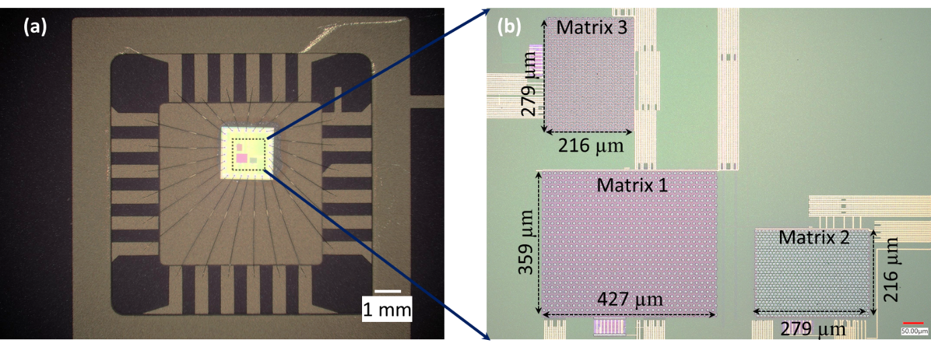
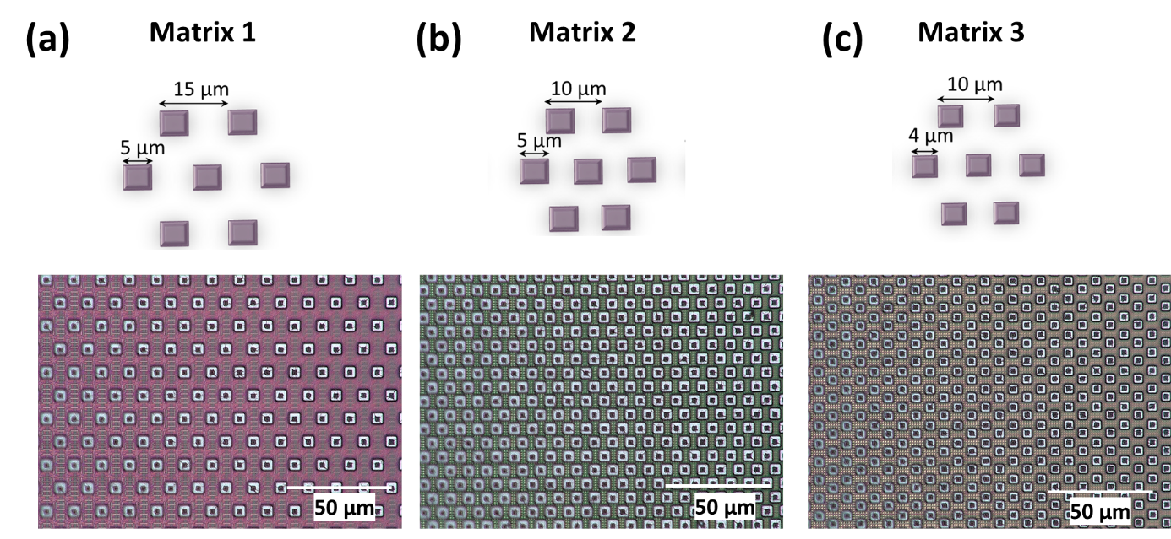
Figure S1. (a) Image of the CMOS chip containing the PCS arrays. (b) Optical microscopic image of the three matrices with their respective dimensions.

Figure S2. The schematic representation of the dimensions of the electrodes and spacing between them in the (a) Matrix 1, (b) Matrix 2 and (c) Matrix 3. Corresponding high-magnification optical microscopy images of the sensor pixels of each matrix (1, 2, and 3) are shown below.

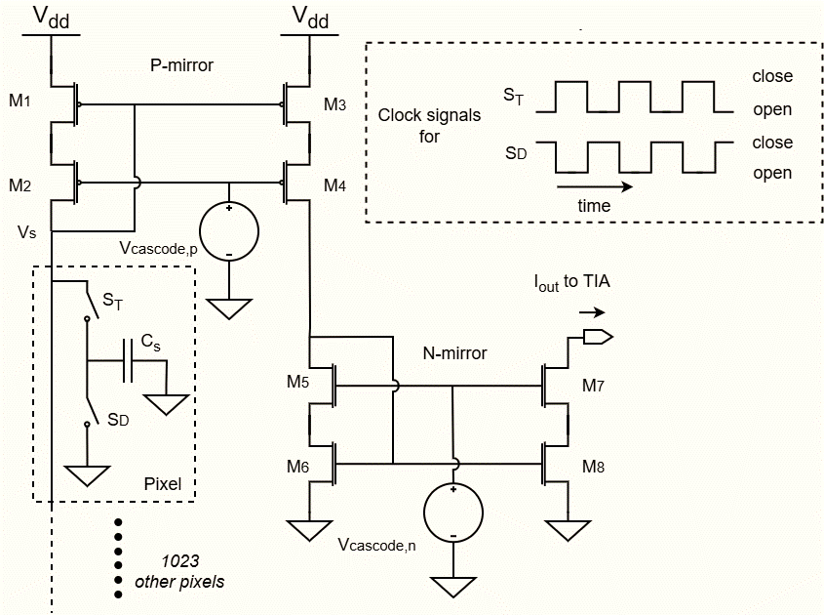
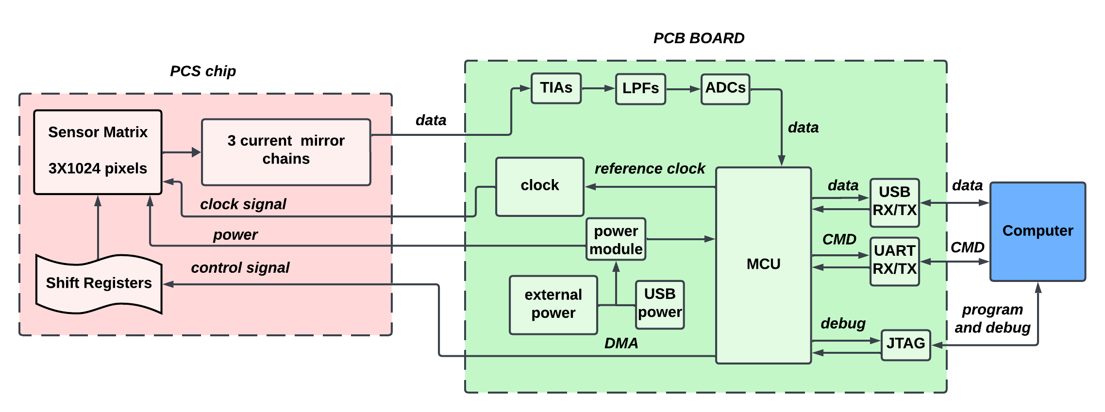
Figure S3. The read-out circuit for the capacitive sensor pixels. The non-overlapping clock signals (dashed box) control the switches S_{T} and S_{D} for alternately opening and closing. In each matrix, 1 pixel is selected for sensing while the other 1023 pixels are grounded. The average sense currents of the 3 selected pixels are multiplied by 100 by 3 on-chip chains of a 10x PMOS current mirror and a 10x NMOS current mirror, converted into voltages by 3 off-chip Transimpedance Amplifiers (TIAs), and digitized by 3 12-bit Analog to Digital Converters (ADCs) (see Fig. S4). The resulting 3 digital codes are read in parallel by a microcontroller and transferred to a computer over a USB link. This process is repeated by scanning though the 1024 pixels of the 3 arrays in parallel.

Figure S4. Simple block diagram of the circuits in the PCS chip and measurement board for data recording from the PCS sensor pixels. The recorded data are then analyzed in real-time using a computer.

Note 1: Low-cost desktop inkjet printer for functionalization of the PCS arrays
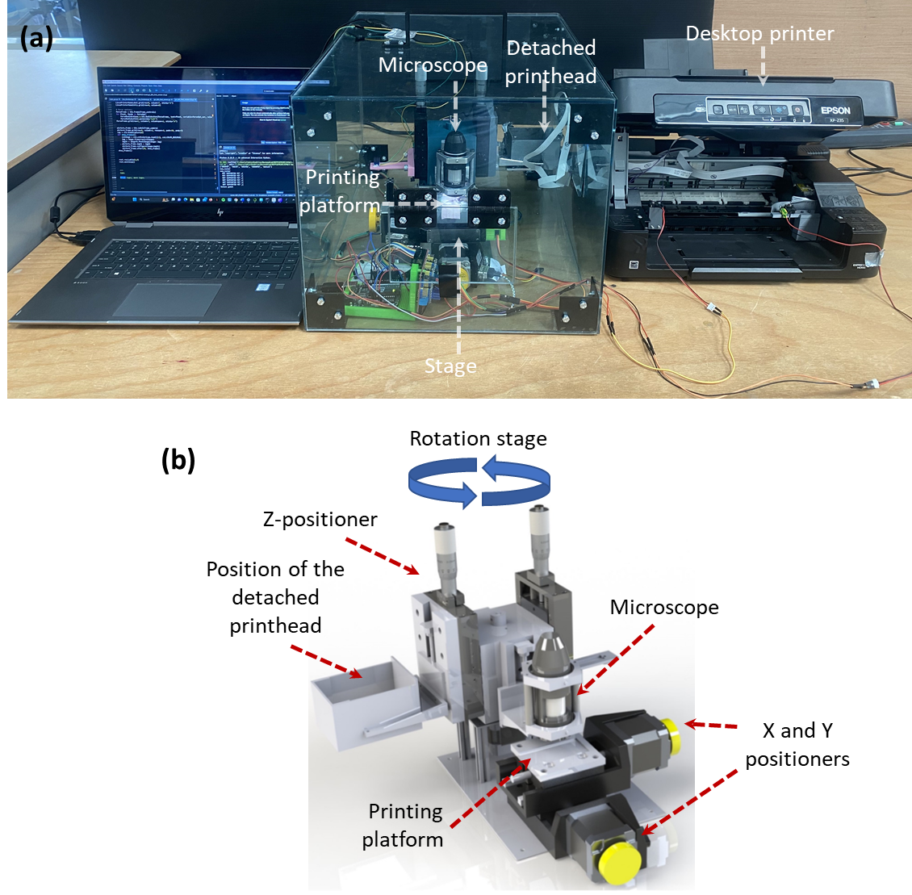
To precisely functionalize the sensor pixels with functional materials, we employed a custom-built drop-on-demand inkjet-printing platform, adapted from a low-cost consumer desktop printer (Epson XP-235) as shown in Fig. 1e and Fig. S5. The printer’s printhead was detached and mounted on a rotation stage capable of switching between the printing position and a camera for printed-droplet inspection (Fig. 1e, Fig. S5). The complete setup consisted of a computer, desktop printer control unit, an external printhead mounted on a rotating stage, and the printing-platform with the two automated micro-positioning stages in both X and Y directions. The rotating stage, driven by a stepper motor, aligned the printhead or camera above the substrate, while the linear stages at the printing-platform enabled substrate movement with micrometer precision (see Fig. S5). The printhead height relative to the substrate can be adjusted manually using a separate z-micropositioner. The individual nozzles of the printhead were controlled through the printer command language using a Python-based graphical user interface (GUI) developed in our earlier work¹. Printing commands were then executed through the GUI, which allowed control over droplet size: large (~6.3 pL), medium, and small (~3 pL), deposition location, and the number of droplets per spot. To optimize the printing process, we repetitively deposited a 3×3 grid of large-size black ink droplets (~6.3 pL) on a glass slide while varying the printhead height between 1.5 and 5.5 mm (Fig. S6). At an optimized height of 2.5 mm, the droplets were consistently circular, with an average diameter of 75.3 ± 10.5 µm, a circularity index of 0.92 ± 0.03, and a well-maintained inter-droplet pitch of 200 µm (Fig. S6). Printing at other heights resulted in irregular droplet morphology and significantly reduced circularity. We also tested printing multiple droplets on the same spot which demonstrated the highly precise and accurate printing with the developed setup. The coated-area increased from 4816 to 6835 µm² as the droplet count rose from 1 to 5, owing to the larger material volume, while circularity remained mostly unaffected (see Fig. S6). Based on these results, a printhead height of 2.5 mm was used for all subsequent experiments.

Figure S5. (a) Optical image of the modified desktop inkjet printer set-up. (b) 3D schematic of the rotation stage along with the printing platform. The printhead was detached from the printer and connected along with the rotation stage. Motorized X, Y µ-positioners were used for precise control of printing position. The height of the printhead from the printing platform was controlled by a manual Z-positioner. The other Z-positioner on the rotating stage (at right, not marked) was used for counter balance to remove slack in the rotation.

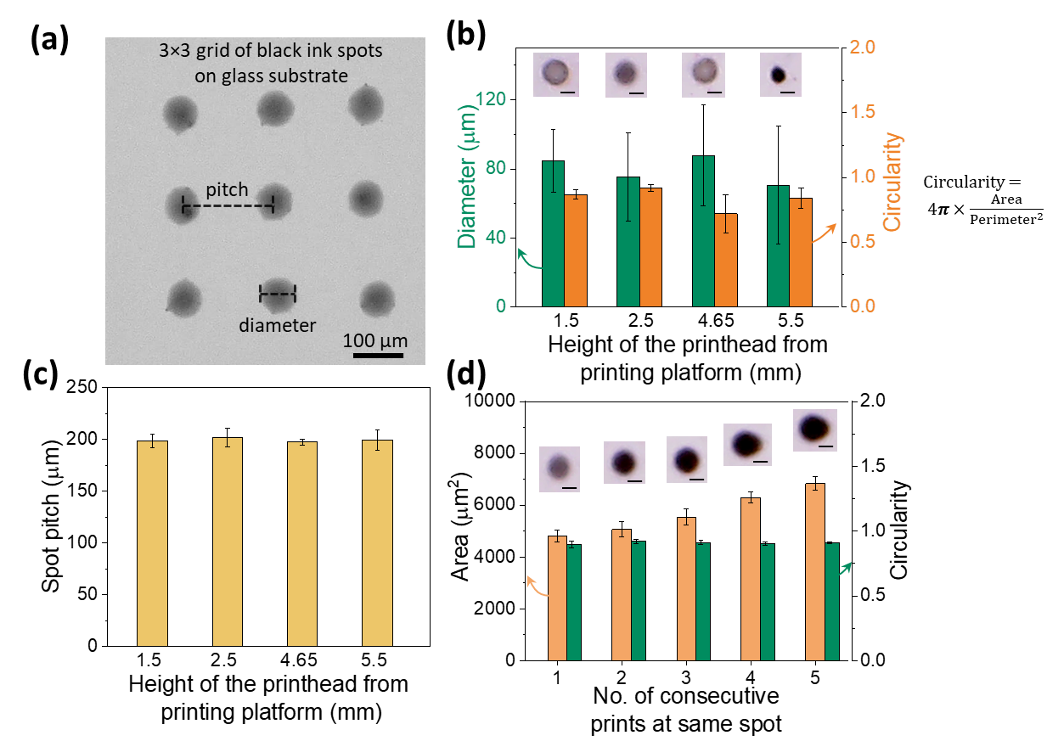
Figure S6. Optimization of the printing process. (a) Optical-microscopic image of the 3×3 grid of large-sized carbon black ink droplets (of volume ~6.3 pL) printed on top of a glass substrate. (b) The diameter and circularity of the printed droplets at different heights of printhead from the printing platform (glass substrate). The equation for calculating circularity is shown at right. The representative optical microscopic images of the printed droplets are shown inside. The scale-bar of the inset images is 50 µm. (c) The pitch of the printed droplets in 3×3 grid at different printhead heights. X and Y printer pitches were kept constant at 200 µm. (d) Area and circularity of printed spots in the 3×3 grid after consecutive prints at the same position. The insets show optical microscopic images of the spot at corresponding consecutive prints. The scale bar of each inset image is 50 µm.

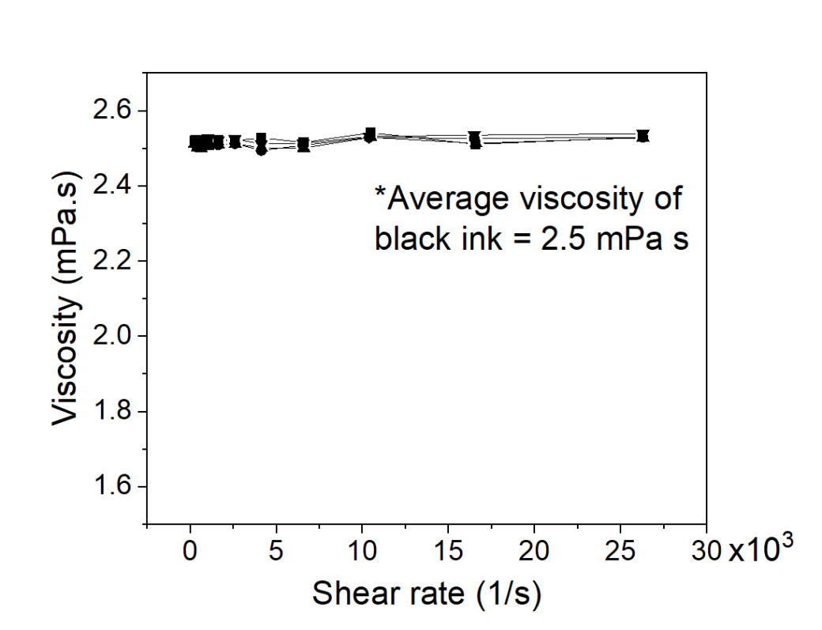
Figure S7. Viscosity of the black ink² containing carbon black particles. The average viscosity of the ink was measured to be around 2.5 mPa s in the shear-rate range of 250-26300 s⁻¹.
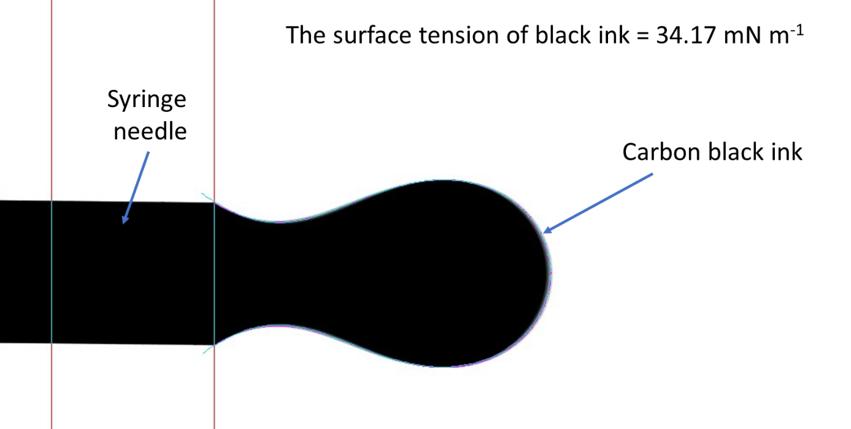

Figure S8. The interfacial surface tension of the carbon black ink was measured at ambient using a goniometer (OCA 25, Dataphysics) and the value was 34.17 mN m⁻¹. The figure shows the snapshot from the instrument exhibiting the microscopic image of the carbon black ink droplet (of volume 11.7 µL) formed at a tip of a needle to calculate the interfacial surface tension. The camera was rotated 90° anticlockwise while capturing the image.

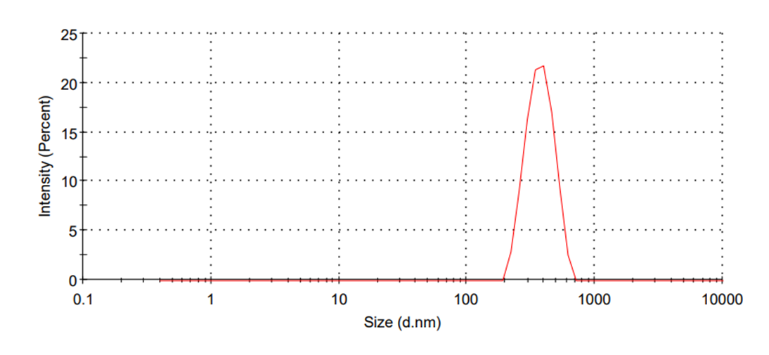
Figure S9. Dynamic light scattering (DLS) measurements of carbon black ink demonstrating the size distribution of the carbon black particles. The average hydrodynamic size of the carbon black particles was 379 nm. The measurements were performed using Zetasizer Nano instrument.
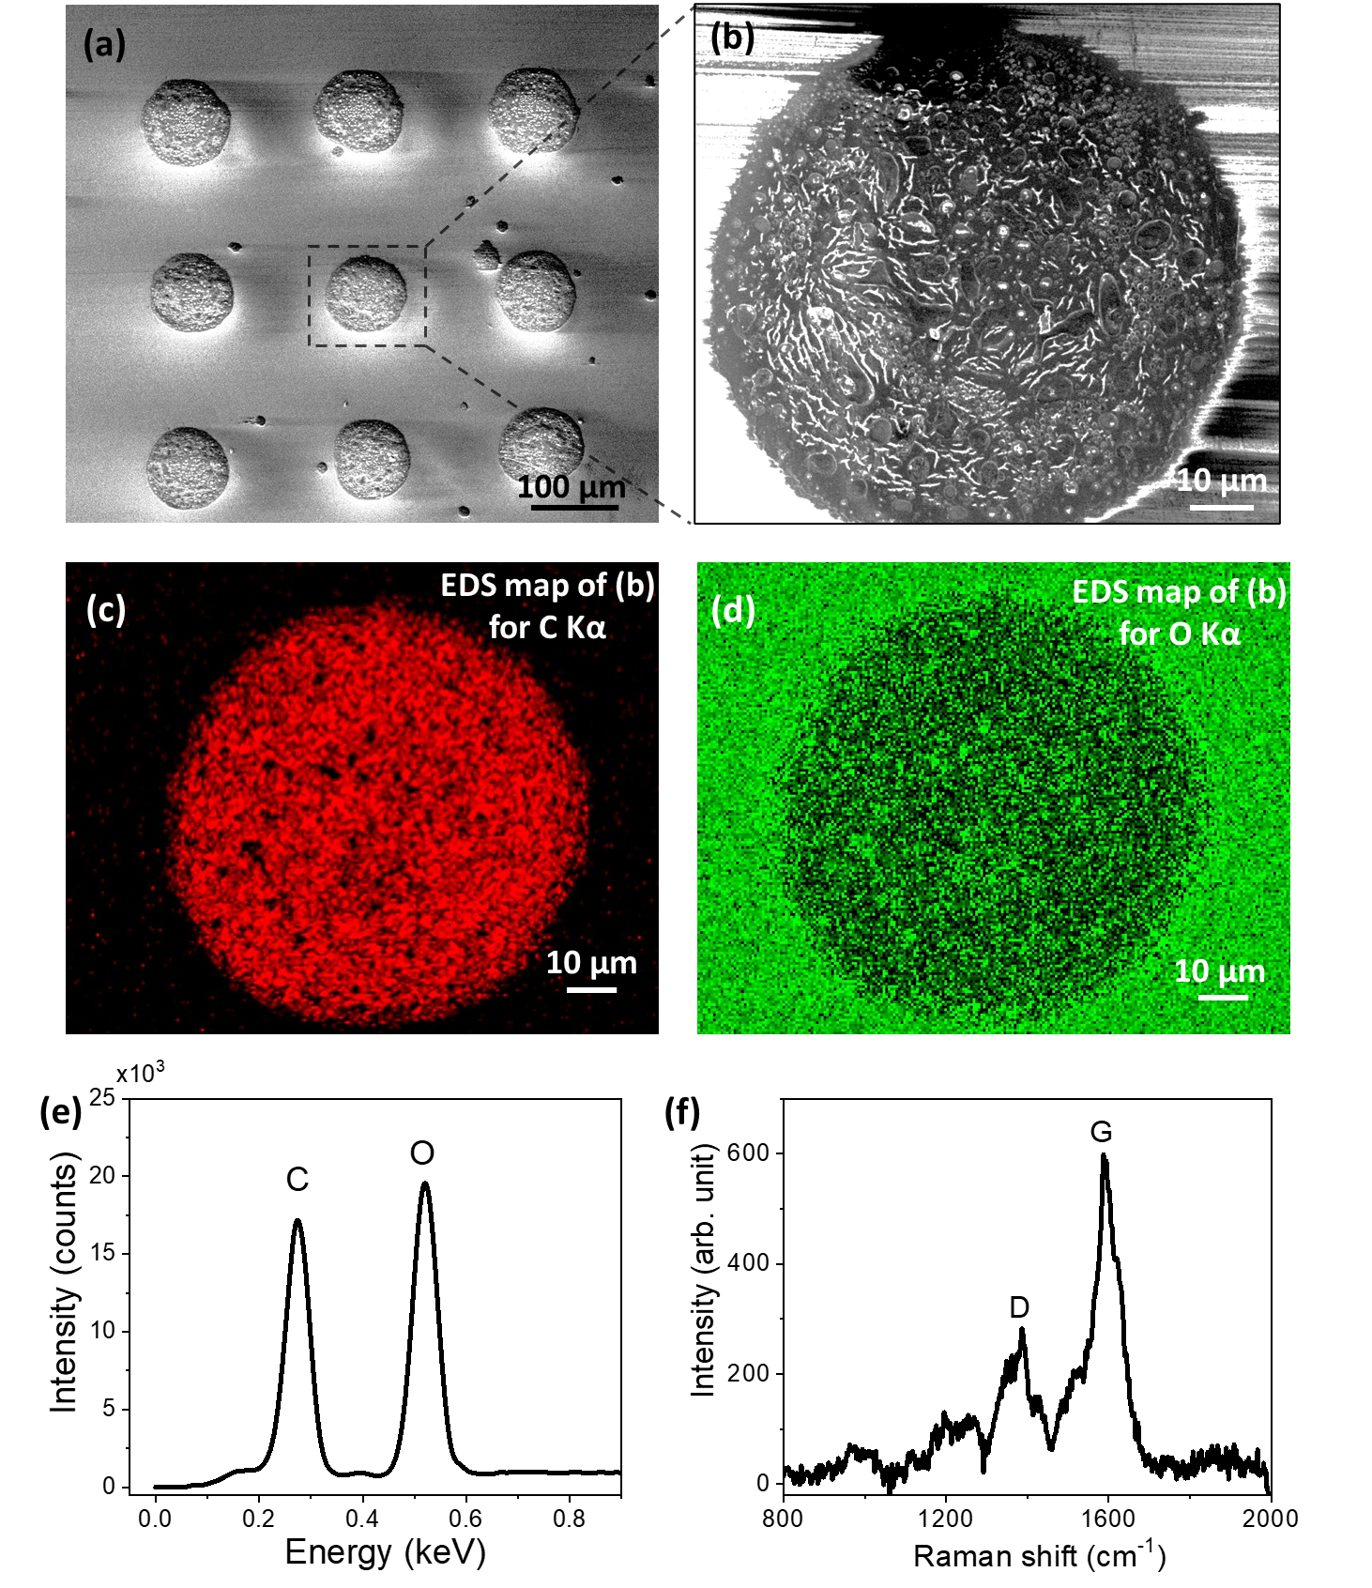
Figure S10. (a) Scanning electron microscopy image of the 3×3 printed droplets of carbon black ink on glass substrate. (b) Zoomed-in image of an individual droplet. Energy dispersive X-ray spectroscopy (EDS) mapping of the black ink (c) for C Kα, and (d) for O Kα. (e) EDS profile of the printed carbon black ink confirming the presence of oxygen. (f) Raman spectrum of the printed droplet exhibiting the D and G peaks of carbon black present in the ink. A pronounced D band is a characteristic of structural defects and surface disorder in carbon.

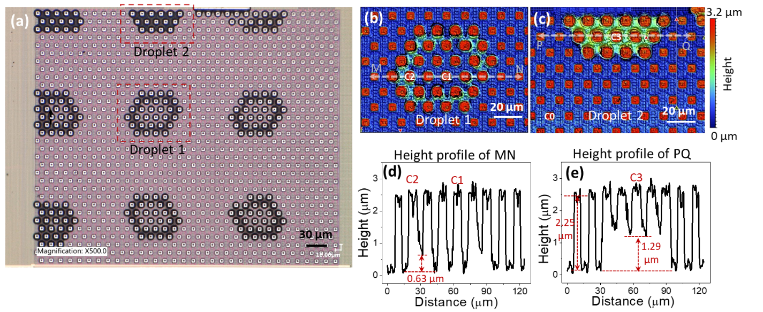
Figure S11. (a) Optical microscopy image of the 3×3 grid of the black ink droplets (volume ~6.3 pL) with an inter-droplet pitch of 150 µm printed on the PCS array. The optical profilometry of the (b) droplet 1 and (c) droplet 2 covered pixels of the PCS array. (d), (e) show the height profiles of lines MN and PQ as depicted in (b), (c) respectively. The thickness of the ink at C2 (0.63 µm) and C3 (1.29 µm) pixels are shown inside (d), and (e), respectively. The depth of an empty trench from the top of the pillar: 2.25 µm is indicated inside (e).
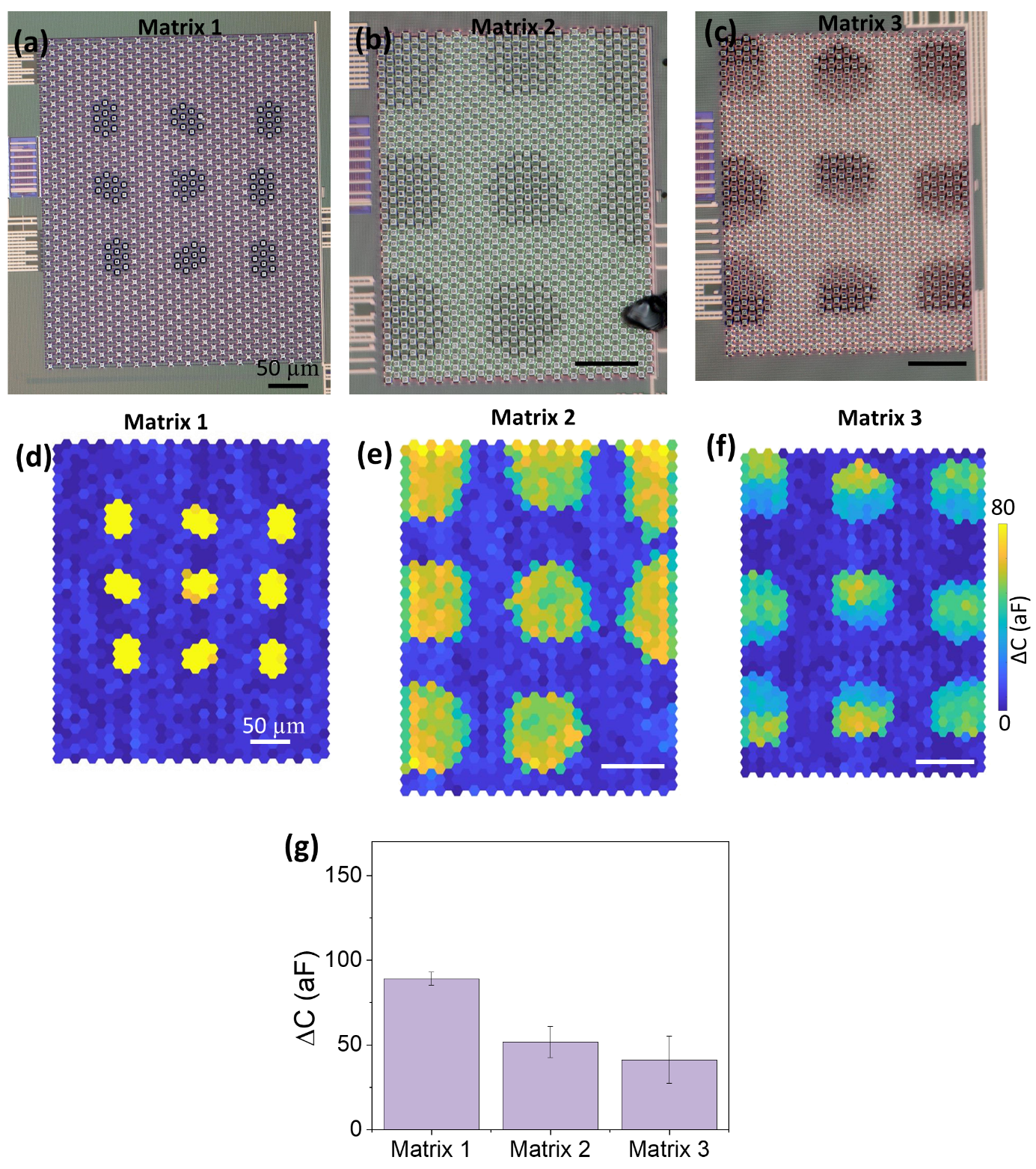
Figure S12. Optical microscopy images of the 3×3 grid of the small-size (3 pL) carbon black ink droplets with an inter-droplet pitch of 100 µm printed on the (a) Matrix 1, (b) Matrix 2 and (c) Matrix 3 of another chip. Corresponding 2D capacitance maps of carbon black ink-functionalized Matrices are shown in d, e and f, respectively. (g) Change in capacitance values for sensor pixels of the corresponding matrices after carbon black deposition. Scale bars in b-f represent 50 µm. The capacitance scale bar for d-f is shown to the right of f.

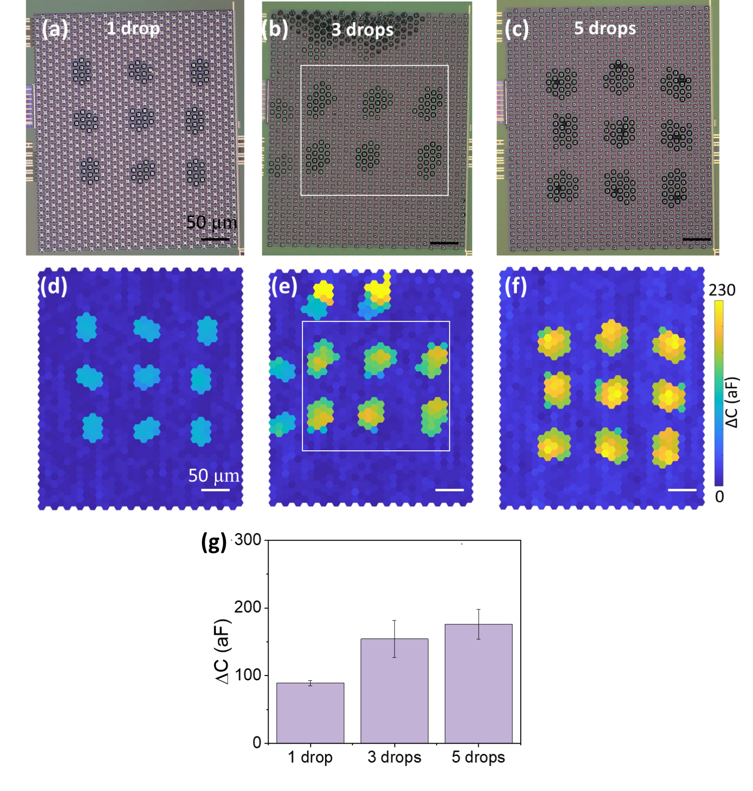
Figure S13. Optical microscopy images of the 3×3 grid of the small-size carbon black ink droplets with an inter-droplet pitch of 100 µm printed on the Matrix 1 with (a) 1, (b) 3 and (c) 5 drops repeatedly printed on the same spots. Corresponding 2D capacitance maps of carbon black ink-functionalized Matrix 1 are shown in d, e and f, respectively. (g) Capacitance increment in the sensor pixels functionalized by repeated printing of carbon black droplets. Scale bars in b-f represent 50 µm. The capacitance scale bar for d-f is shown to the right of f.

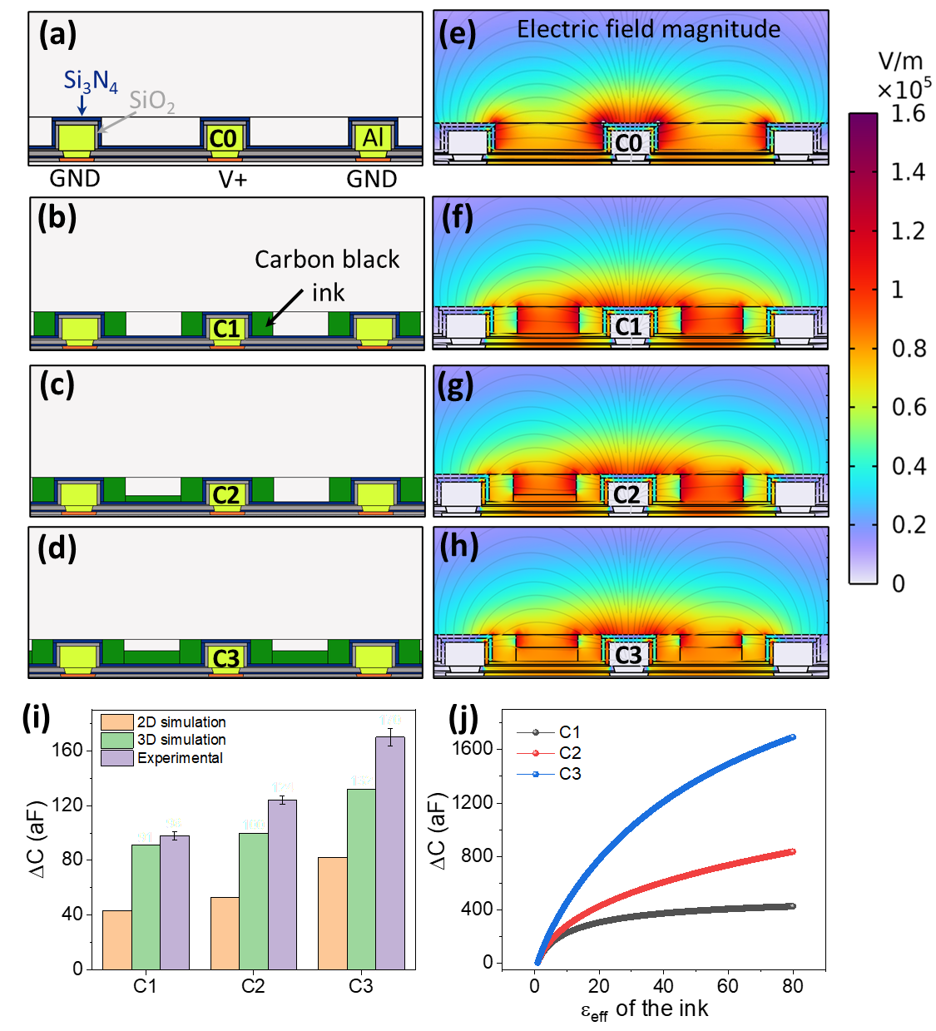
Note 2: Simulations of capacitance change with functionalization
Figure S14. Simulation results: capacitance change of PCS pixels after carbon-black deposition. (a-d) 2D COMSOL models of pixels C0, C1, C2, and C3, corresponding to positions marked in Fig. 1f. Note the variation in the green-colored regions emulating carbon-ink deposition as observed in Fig 1f. The effect of ink on top of the electrode is ignored. (e-h) Simulated electric field magnitude distributions for the respective pixels, using ε_{eff} = 2.5 as an effective relative permittivity of carbon black³ in dry nitrogen. The readers should ignore the black horizontal (boundary) lines inside the trenches. (i) Capacitance changes of pixels C1-C3 obtained from 2D and 3D simulations, compared with experimental values. The error bars correspond to the standard deviation data from 3 number of capacitors. (j) Capacitance response of pixels C1-C3 as a function of the effective relative permittivity (ε_{eff} = 1-80) of the deposited carbon black, which can depend on the air humidity.
To further investigate the capacitive behavior of the PCS platform, finite element simulations were performed for pixels C0, C1, C2, and C3 using the Electrostatics Module of COMSOL Multiphysics. These simulations allowed us to predict the capacitance changes for different configurations of carbon black deposition (Fig. 1f). The geometries of the sensor electrodes and ink configurations were modelled according to parameters extracted from SEM (Fig. 1c, d), optical microscopic (Fig. 1) and profilometry (Fig. S11) images. A stationary study of electrostatics physics was applied in the simulations using the following relations:
$$∇·D=ρ_{V}$$
$$E=-∇V$$
$$D=ε_{0}ε_{r}E$$
where the D is the displacement field, E is the electric field, V is the voltage potential, $ε_{0}$ is the vacuum permittivity, $ε_{r}$ is the relative permittivity of the material, and $ρ_{V}$ is the space charge density.
Three boundary conditions are mainly applied for the simulations: 1) the charge at the boundary is zero, which means no displacement field can penetrate the boundary, 2) the surface potential of the central electrode is 0.9 V, and 3) the surface potential of the surrounding electrodes is zero, consistent with the circuit’s operation.
The finite element analysis can give results of electric potential distribution and electric field intensity distribution. Thus, we can calculate the total electric energy as:
$W_{e}=\frac{1}{2}\int{ε_{0}ε_{r}\left|\vec{E}\right|.\left|\vec{E}\right|}dA$, where, dA is a volume integral.
Combining with the equation of energy stored inside a capacitor:
$W_{e}=\frac{1}{2}C{\left(V_{1}-V_{2}\right)}^{2}$, where $V_{1}=0.9 V and V_{2 }=0 V$
The capacitance of the structure can be then estimated as:
$C$= $\frac{1}{{\left(V_{1}-V_{2}\right)}^{2}}\int{ε_{0}ε_{r }}\left|\vec{E}\right|.\left|\vec{E}\right|dA$
Simulations were performed using the cross-section of a sensor unit, with capacitance values normalized per unit length (F m⁻¹). Given the electrode geometry, one central electrode surrounded by six ground electrodes arranged hexagonally. The total capacitance was calculated by multiplying the simulated value by 3.
The electric field distributions for pixels C0-C3 are shown in Fig. S14e-h. In the reference pixel (C0), the electric field was strongest within the empty trenches, while deposition of carbon black redistributed the field inside the deposited material. The calculated capacitances for C1-C3 were compared against C0 to obtain the contribution of the deposited material only. In the actual circuit, additional layers from the CMOS process contribute to parasitic capacitance. However, since these underlying structures remain unaffected by surface ink deposition, the parasitic contribution is constant and does not influence the measured ΔC. Both 2D and 3D simulations confirmed that capacitance increased with larger deposition volumes, consistent with experimental results (Fig. S14i). The differences between simulated and measured capacitance values can be attributed to uncertainties in material parameters during modelling. These measurements were carried out by assuming the $ε_{r}$ of the carbon black to be 2.5³.
To predict the influence of water adsorption on carbon black, we varied the effective relative permittivity ($ε_{eff}$) of the deposited ink from 1 to 80 in the simulations (Fig. S14j). The results revealed an increase in capacitance with increasing $ε_{eff}$ across all three cases (C1-C3), with the magnitude of enhancement being more pronounced for pixels with larger ink deposition. For the C1, C2, and C3 pixels, the predicted capacitance increments reached 424, 835, and 1695 aF, respectively, when $ε_{eff}$ was set to 80. These simulation results further motivated us to perform in-depth experimental measurements by exposing the PCS chip to controlled external humidity levels.

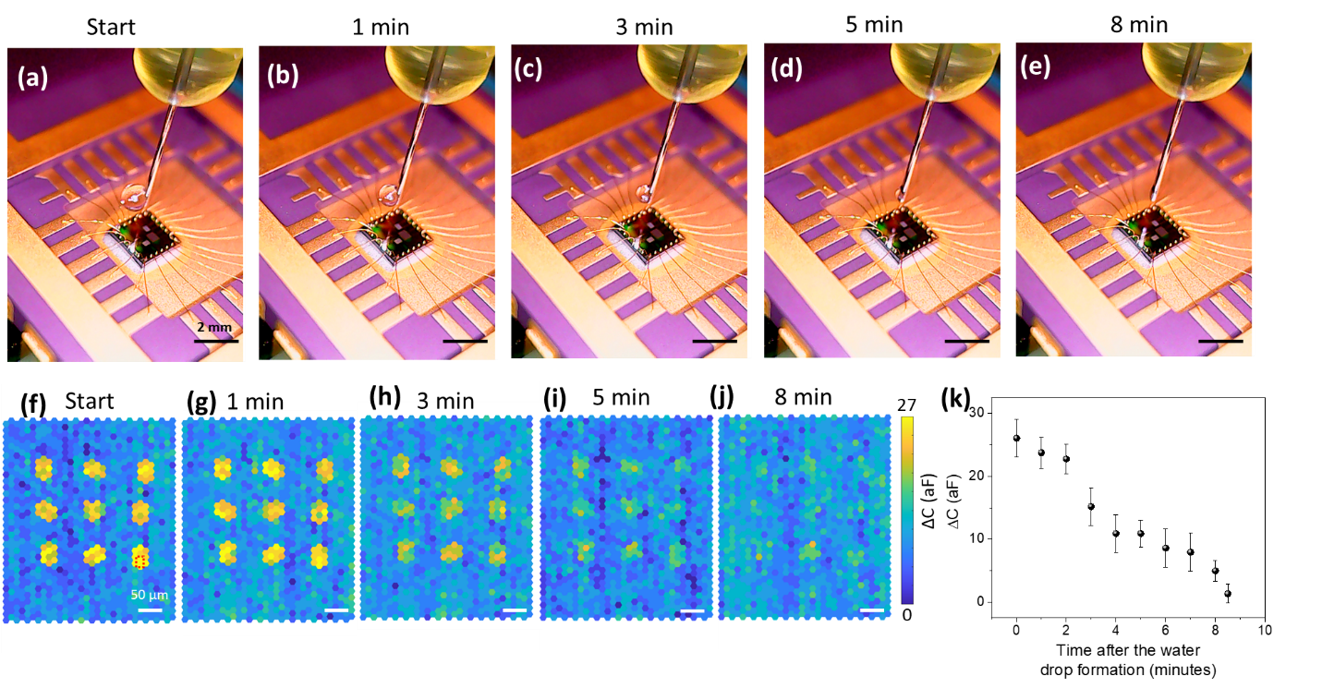
Figure S15. (a-e) Optical microscopy images showing the evaporation of a microliter-sized water droplet, formed at the tip of a needle and positioned at a constant height of 0.5 mm above the carbon black-functionalized PCS chip. Images were recorded over a time span of 0-8 minutes, as indicated above each panel, illustrating the progressive reduction in droplet size during evaporation. (f-j) Corresponding 2D capacitance maps of carbon black-functionalized Matrix 1, recorded at the same time intervals. (k) Capacitance response of a carbon black-coated pixel (marked in f with red dashed box) over a period of 0-8.5 minutes after the water droplet formation. Scale bars in b-e represent 2 mm. Scale bars in g-j represent 50 µm. The capacitance scale bar for f-j is shown to the right of j.

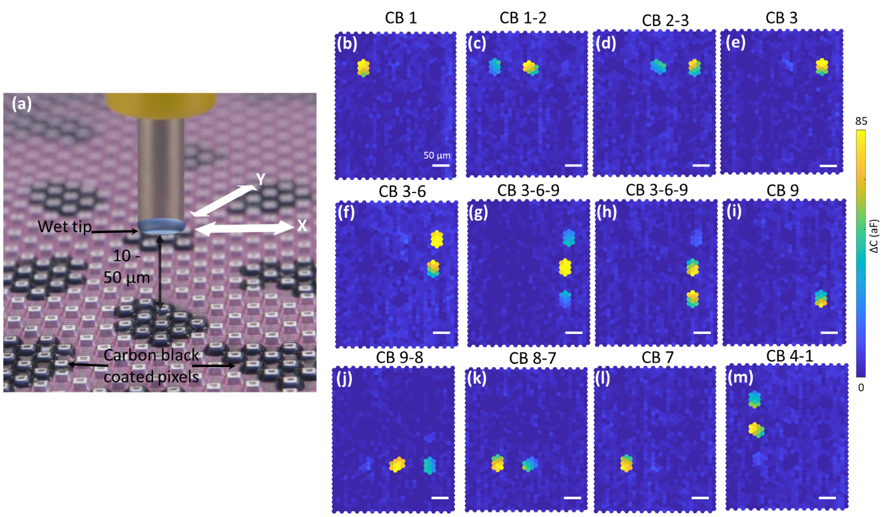
Figure S16. (a) Schematic illustration of the setup with the wet tip positioned in close proximity (10-50 µm) above the carbon black coated pixels of the PCS array. The X-Y positions of the tip was varied to place the wet tip directly above the individual carbon black droplets which were printed with 100 µm pitch as shown in Fig. 3k. (b-m) Dynamic responses of individual droplet-activated pixels when the wet tip was placed directly above them at a constant height of 10 µm. Scale bars in c-m represent 50 µm. The capacitance scale bar for c-m is shown at the right.
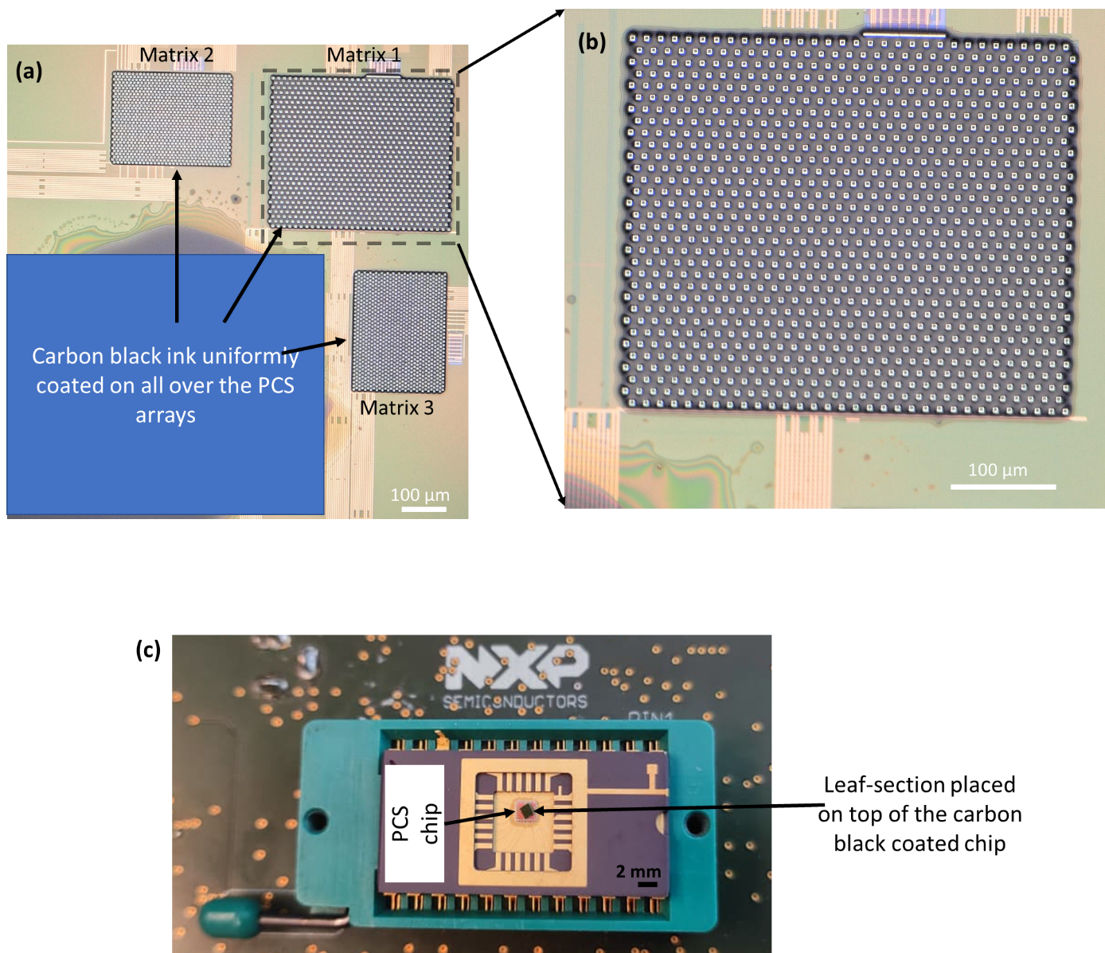
Figure S17. (a) Optical microscopic images of the carbon black ink uniformly coated over the PCS arrays by drop-casting method. (b) Zoomed-in microscopy image of the Matrix 1 further demonstrating the uniform distribution of the ink over the array. (c) The photograph showing the leaf-section placed on top of the carbon black ink-coated chip.

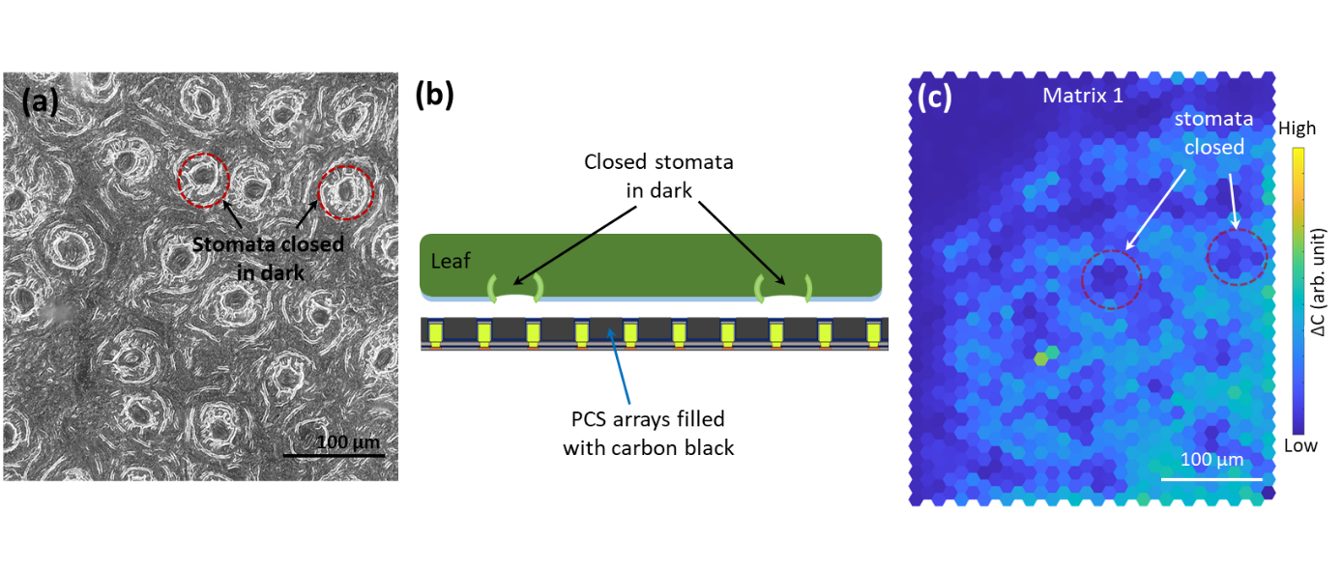
Figure S18. (a) Optical microscopy image of the gel-mold replicating the leaf surface structures which was stored in dark. (b) Schematic showing a small section of the leaf was placed on the PCS array which is completely filled with carbon black ink, with leaf’s back side facing the sensor pixels. (c) Capacitance response from Matrix 1 when the leaf was positioned on top of the PCS array.

References
- Waasdorp, Rick, Oscar van den Heuvel, Floyd Versluis, Bram Hajee, and Murali Krishna Ghatkesar. "Accessing individual 75-micron diameter nozzles of a desktop inkjet printer to dispense picoliter droplets on demand." RSC advances 8, no. 27 (2018): 14765-14774. https://doi.org/10.1039/C8RA00756J
- EPSON black ink (c13t298140) Materials Safety Data Sheet. https://epsonemear.a.bigcontent.io/v1/static/c13t298140_en_55
- Xu, Renliang, Chifei Wu, and Haiyan Xu. "Particle size and zeta potential of carbon black in liquid media." Carbon 45, no. 14 (2007): 2806-2809. https://doi.org/10.1016/j.carbon.2007.09.010

