SUPPLEMENTARY MATERIAL

Title: Endocrine-disrupting chemicals and gestational weight gain: A systematic review and meta-analysis

Authors: Ana González-Ruiz^{1,2,3,‡}, Àngels Bretó-López^{3,‡}, Mónica Ballesteros⁴, Albert Guarque⁴, Ana Megia⁴, Pablo Gago-Ferrero², Giulia Gionchetta², Montse Marquès^{2*}

¹ Institut d’Investigació Sanitària Pere Virgili (IISPV), Carrer Dr. Mallafrè Guasch 4, 43005, Tarragona, Spain.
² Institute of Environmental Assessment and Water Research (IDAEA-CSIC), Carrer Jordi Girona 18-26, 08034, Barcelona, Spain.
³ Universitat Rovira i Virgili, Laboratory of Toxicology and Environmental Health, Department of Basic Medical Sciences, Faculty of Medicine and Health Sciences, Carrer Sant Llorenç 21, 43201, Reus, Spain.
⁴ Hospital Universitari de Tarragona Joan XXIII, Carrer Dr. Mallafrè Guasch 4, 43005, Tarragona, Spain.

‡These authors contributed equally to this work.

*Author for correspondence: Montse Marquès (montse.marques@idaea.csic.es)

INDEX

Supplementary Material

Section S1. Keywords and search strategy.
Section S2. Combining subgroup means and standard deviations.
Section S3. Combining regression coefficients (β) and standard errors.
Section S4. Results of Egger’s tests, Sensitivity analyses (Loo), and metaregression for PFAS.
Figure S1. Funnel plot PFAS exposure and gestational weight gain (GWG).
Figure S2a. Forest plot PFAS low BMI.
Figure S2b. Forest plot PFAS high BMI.
Section S5. Results of Egger’s tests, Sensitivity analyses (Loo), and metaregression for phthalates.
Figure S3. Funnel plot phthalates exposure and gestational weight gain (GWG).
Figure S4a. Forest plot phthalates low BMI.
Figure S4b. Forest plot phthalates high BMI.

Section S1. Keywords and search strategy
Pubmed (articles retrieved: 1140)
(“edc”[All Fields] OR “edcs”[All Fields] OR “endocrine disrupting chemical”[All Fields] OR “endocrine disrupting chemicals”[All Fields] OR “endocrine disrupting compound”[All Fields] OR “endocrine disrupting compounds”[All Fields] OR “endocrine disruption”[All Fields] OR “endocrine disruptor”[All Fields] OR “endocrine disruptor agent”[All Fields] OR “endocrine disruptors”[All Fields] OR “endocrine disruptors”[MeSH Terms] OR “environmental disruptor”[All Fields] OR “environmental disruptors”[All Fields] OR “environmental endocrine disruptor”[All Fields] OR “environmental endocrine disruptor chemicals”[All Fields] OR “environmental endocrine disruptor compounds”[All Fields] OR “environmental endocrine disruptors”[All Fields] OR “environmental endocrine modulators”[All Fields] OR “hormonal disruptor”[All Fields] OR “hormonal disruptors”[All Fields] OR “xenoestrogen”[All Fields] OR “xenoestrogens”[All Fields]) AND (“pregnancies”[All Fields] OR “pregnancy”[All Fields] OR “pregnancy”[MeSH Terms] OR “pregnant woman”[All Fields] OR “pregnant women”[All Fields] OR “pregnant women”[MeSH Terms]) AND (“adipogenesis”[MeSH Terms] OR “adipogenesis”[All Fields] OR “adipose tissue”[All Fields] OR “adipose tissue”[MeSH Terms] OR “adiposities”[All Fields] OR “adiposity”[All Fields] OR “adiposity”[MeSH Terms] OR “anthropometric”[All Fields] OR “anthropometrics”[All Fields] OR “anthropometries”[All Fields] OR “anthropometry”[All Fields] OR “anthropometry”[MeSH Terms] OR “bmi”[All Fields] OR “bmi trajectories”[All Fields] OR “bmi trajectory”[All Fields] OR “bmis”[All Fields] OR “body composition”[All Fields] OR “body composition”[MeSH Terms] OR “body compositions”[All Fields] OR “body fat”[All Fields] OR “body fats”[All Fields] OR “body mass”[All Fields] OR “body mass index”[All Fields] OR “body mass index”[MeSH Terms] OR "body mass indexes"[All Fields] OR “body mass indices”[All Fields] OR “body mass trajectories”[All Fields] OR “body mass trajectory”[All Fields] OR “body masses”[All Fields] OR “body size”[All Fields] OR “body size”[MeSH Terms] OR “body sizes”[All Fields] OR “body weight”[All Fields] OR “body weight”[MeSH Terms] OR “body weight changes”[MeSH Terms] OR “body weight changes”[All Fields] OR “body weights”[All Fields] OR “gestational weight gain”[All Fields] OR “gestational weight gain”[MeSH Terms] OR “maternal weight”[All Fields] OR “maternal weights”[All Fields] OR “metabolic disorder”[All Fields] OR “metabolic disorders”[All Fields] OR “mother weight”[All Fields] OR “mothers weight”[All Fields] OR “mothers weights”[All Fields] OR “pregnancy outcome”[All Fields] OR “pregnancy outcome”[MeSH Terms] OR “pregnancy outcomes”[All Fields] OR "waist circumference"[All Fields] OR “waist circumference”[MeSH Terms] OR “waist circumferences”[All Fields] OR “weight”[All Fields] OR “weight gain”[All Fields] OR “weight gain”[MeSH Terms] OR “weight gains”[All Fields] OR “weight increase”[All Fields] OR “weight increases”[All Fields] OR “weight status”[All Fields] OR “weights”[All Fields] OR “weights and measures”[All Fields] OR “weights and measures”[MeSH Terms])
Scopus (articles retrieved: 2115)
( ( TITLE-ABS-KEY ( edc ) OR TITLE-ABS-KEY ( edcs ) OR TITLE-ABS-KEY ( endocrine AND disrupting AND chemical ) OR TITLE-ABS-KEY ( endocrine AND disrupting AND chemicals ) OR TITLE-ABS-KEY ( endocrine AND disrupting AND compound ) OR TITLE-ABS-KEY ( endocrine AND disrupting AND compounds ) OR TITLE-ABS-KEY ( endocrine AND disruption ) OR TITLE-ABS-KEY ( endocrine AND disruptor ) OR TITLE-ABS-KEY ( endocrine AND disruptor AND agent ) OR TITLE-ABS-KEY ( endocrine AND disruptors ) OR TITLE-ABS-KEY ( environmental AND disruptor ) OR TITLE-ABS-KEY ( environmental AND disruptors ) OR TITLE-ABS-KEY ( environmental AND endocrine AND disruptor ) OR TITLE-ABS-KEY ( environmental AND endocrine AND disruptor AND chemicals ) OR TITLE-ABS-KEY ( environmental AND endocrine AND disruptor AND compounds ) OR TITLE-ABS-KEY ( environmental AND endocrine AND disruptors ) OR TITLE-ABS-KEY ( environmental AND endocrine AND modulators ) OR TITLE-ABS-KEY ( hormonal AND disruptor ) OR TITLE-ABS-KEY ( hormonal AND disruptors ) OR TITLE-ABS-KEY ( xenoestrogen ) OR TITLE-ABS-KEY ( xenoestrogens ) ) ) AND ( ( TITLE-ABS-KEY ( pregnancies ) OR TITLE-ABS-KEY ( pregnancy ) OR TITLE-ABS-KEY ( pregnant AND woman ) OR TITLE-ABS-KEY ( pregnant AND women ) ) ) AND ( ( TITLE-ABS-KEY ( adipogenesis ) OR TITLE-ABS-KEY ( adipose AND tissue ) OR TITLE-ABS-KEY ( adiposities ) OR TITLE-ABS-KEY ( adiposity ) OR TITLE-ABS-KEY ( anthropometric ) OR TITLE-ABS-KEY ( anthropometrics ) OR TITLE-ABS-KEY ( anthropometries ) OR TITLE-ABS-KEY ( anthropometry ) OR TITLE-ABS-KEY ( bmi ) OR TITLE-ABS-KEY ( bmi AND trajectories ) OR TITLE-ABS-KEY ( bmi AND trajectory ) OR TITLE-ABS-KEY ( bmis ) OR TITLE-ABS-KEY ( body AND composition ) OR TITLE-ABS-KEY ( body AND compositions ) OR TITLE-ABS-KEY ( body AND fat ) OR TITLE-ABS-KEY ( body AND fats ) OR TITLE-ABS-KEY ( body AND mass ) OR TITLE-ABS-KEY ( body AND mass AND index ) OR TITLE-ABS-KEY ( body AND mass AND indexes ) OR TITLE-ABS-KEY ( body AND mass AND indices ) OR TITLE-ABS-KEY ( body AND mass AND trajectories ) OR TITLE-ABS-KEY ( body AND mass AND trajectory ) OR TITLE-ABS-KEY ( body AND masses ) OR TITLE-ABS-KEY ( body AND size ) OR TITLE-ABS-KEY ( body AND sizes ) OR TITLE-ABS-KEY ( body AND weight ) OR TITLE-ABS-KEY ( body AND weight AND changes ) OR TITLE-ABS-KEY ( body AND weights ) OR TITLE-ABS-KEY ( gestational AND weight AND gain ) OR TITLE-ABS-KEY ( maternal AND weight ) OR TITLE-ABS-KEY ( maternal AND weights ) OR TITLE-ABS-KEY ( metabolic AND disorder ) OR TITLE-ABS-KEY ( metabolic AND disorders ) OR TITLE-ABS-KEY ( mother AND weight ) OR TITLE-ABS-KEY ( mothers AND weight ) OR TITLE-ABS-KEY ( mothers AND weights ) OR TITLE-ABS-KEY ( pregnancy AND outcome ) OR TITLE-ABS-KEY ( pregnancy AND outcomes ) OR TITLE-ABS-KEY ( waist AND circumference ) OR TITLE-ABS-KEY ( waist AND circumferences ) OR TITLE-ABS-KEY ( weight ) OR TITLE-ABS-KEY ( weight AND gain ) OR TITLE-ABS-KEY ( weight AND gains ) OR TITLE-ABS-KEY ( weight AND increase ) OR TITLE-ABS-KEY ( weight AND increases ) OR TITLE-ABS-KEY ( weight AND status ) OR TITLE-ABS-KEY ( weights ) OR TITLE-ABS-KEY ( weights AND measures ) ) )
Cochrane (articles retrieved: 26)
((edc):ti,ab,kw OR (edcs):ti,ab,kw OR (endocrine disrupting chemical):ti,ab,kw OR (endocrine disrupting chemicals):ti,ab,kw OR (endocrine disrupting compound):ti,ab,kw OR (endocrine disrupting compounds):ti,ab,kw OR (endocrine disruption):ti,ab,kw OR (endocrine disruptor):ti,ab,kw OR (endocrine disruptor agent):ti,ab,kw OR (endocrine disruptors):ti,ab,kw OR MeSH descriptor: [Endocrine Disruptors] explode all trees OR (environmental disruptor):ti,ab,kw OR (environmental disruptors):ti,ab,kw OR (environmental endocrine disruptor):ti,ab,kw OR (environmental endocrine disruptor chemicals):ti,ab,kw OR (environmental endocrine disruptor compounds):ti,ab,kw OR (environmental endocrine disruptors):ti,ab,kw OR (environmental endocrine modulators):ti,ab,kw OR (hormonal disruptor):ti,ab,kw OR (hormonal disruptors):ti,ab,kw OR (xenoestrogen):ti,ab,kw OR (xenoestrogens):ti,ab,kw) AND ((pregnancies):ti,ab,kw OR (pregnancy):ti,ab,kw OR MeSH descriptor: [Pregnancy] explode all trees OR (pregnant woman):ti,ab,kw OR (pregnant women):ti,ab,kw OR MeSH descriptor: [Pregnant Women] explode all trees) AND ((adipogenesis):ti,ab,kw OR MeSH descriptor: [Adipogenesis] explode all trees OR (adipose tissue):ti,ab,kw OR MeSH descriptor: [Adipose Tissue] explode all trees OR (adiposities):ti,ab,kw OR (adiposity):ti,ab,kw OR MeSH descriptor: [Adiposity] explode all trees OR (anthropometric):ti,ab,kw OR (anthropometrics):ti,ab,kw OR (anthropometries):ti,ab,kw OR (anthropometry):ti,ab,kw OR MeSH descriptor: [Anthropometry] explode all trees OR (bmi):ti,ab,kw OR (bmi trajectories):ti,ab,kw OR (bmi trajectory):ti,ab,kw OR (bmis):ti,ab,kw OR (body composition):ti,ab,kw OR MeSH descriptor: [Body Composition] explode all trees OR (body compositions):ti,ab,kw OR (body fat):ti,ab,kw OR (body fats):ti,ab,kw OR (body mass):ti,ab,kw OR (body mass index):ti,ab,kw OR MeSH descriptor: [Body Mass Index] explode all trees OR (body mass indexes):ti,ab,kw OR (body mass indices):ti,ab,kw OR (body mass trajectories):ti,ab,kw OR (body mass trajectory):ti,ab,kw OR (body masses):ti,ab,kw OR (body size):ti,ab,kw OR MeSH descriptor: [Body Size] explode all trees OR (body sizes):ti,ab,kw OR (body weight):ti,ab,kw OR MeSH descriptor: [Body Weight] explode all trees OR (body weight changes):ti,ab,kw OR MeSH descriptor: [Body Weight Changes] explode all trees OR (body weights):ti,ab,kw OR (gestational weight gain):ti,ab,kw OR MeSH descriptor: [Gestational Weight Gain] explode all trees OR (maternal weight):ti,ab,kw OR (maternal weights):ti,ab,kw OR (metabolic disorder):ti,ab,kw OR (metabolic disorders):ti,ab,kw OR (mother weight):ti,ab,kw OR (mothers weight):ti,ab,kw OR (mothers weights):ti,ab,kw OR (pregnancy outcome):ti,ab,kw OR MeSH descriptor: [Pregnancy Outcome] explode all trees OR (pregnancy outcomes):ti,ab,kw OR (waist circumference):ti,ab,kw OR MeSH descriptor: [Waist Circumference] explode all trees OR (waist circumferences):ti,ab,kw OR (weight):ti,ab,kw OR (weight gain):ti,ab,kw OR MeSH descriptor: [Weight Gain] explode all trees OR (weight gains):ti,ab,kw OR (weight increase):ti,ab,kw OR (weight increases):ti,ab,kw OR (weight status):ti,ab,kw OR (weights):ti,ab,kw OR (weights and measures):ti,ab,kw OR MeSH descriptor: [Weights and Measures] explode all trees)
Section S2. Combining subgroup means and standard deviations
When studies reported results separately for overweight and obese participants, combined means and standard deviations were calculated as follows, based on weighted formulas according to subgroup sample sizes:
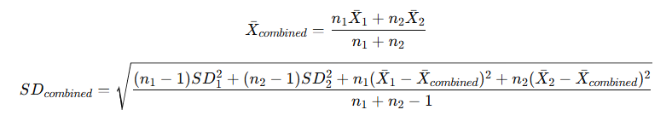
where: n₁ and n₂ are the sample sizes of the subgroups, X₁ and X₂ are their means, and SD₁ and SD₂ are their standard deviations. These formulas ensure that both within-group variability and between-group differences in means are appropriately represented in the pooled estimate.

Section S3. Combining regression coefficients (β) and standard errors
To obtain pooled estimates across studies, individual regression coefficients (β_{i}​) and their standard errors (SE_{i}​) were combined using a fixed-effects meta-analysis model, following inverse-variance weighting. The combined β-coefficient (β_{combined}​) was calculated as:
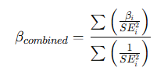
and its standard error as:
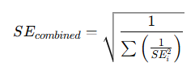
The corresponding 95% confidence interval (CI) was computed as:
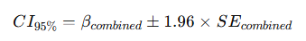
Section S4. Results of Egger’s tests, sensitivity analysis (leave-one-out) and BMI group meta-regression for PFAS global analysis

S4.1. Regression Test for Funnel Plot Asymmetry
Model: mixed-effects meta-regression model
Predictor: standard error
Test for Funnel Plot Asymmetry: z = -0.996, p = 0.319
Limit Estimate (as sei -> 0): b = 0.814 (CI: -0.733, 2.362)
* For individual PFAS compounds, Egger’s test was not performed when the number of studies was <10, as statistical power is insufficient to detect asymmetry in small samples.

S4.2. Results for leave-one-out study on PFAS
Study_Left_Out | Pooled_ES | CI_Lower | CI_Upper | I²
None (All included) | 0.08 | -0.48 | 0.64 | 0.99
3 - Kinkade, C. W., et al. (2023) | 0.49 | 0.08 | 0.91 | 0.99
16 - Ashley-Martin, J., et al. (2016) | -0.01 | -0.68 | 0.65 | 0.99
19 - Jaacks, L.M., et al. (2016) | 0.05 | -0.62 | 0.73 | 0.99
20 - Romano, M.E., et al. (2021) | -0.23 | -0.79 | 0.32 | 0.99
9 - Marks, K.J., et al. (2019) | 0.11 | -0.61 | 0.84 | 0.99
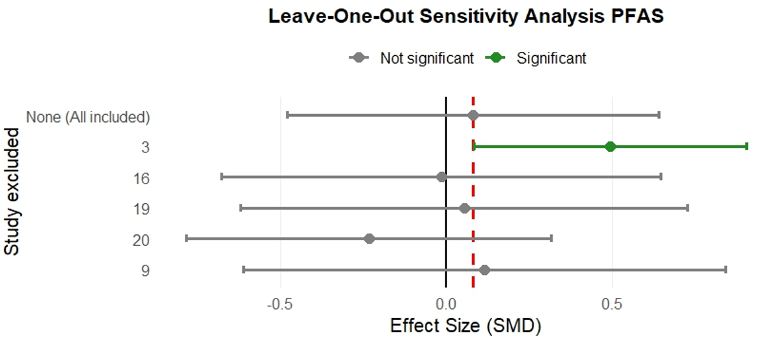

S4.3. Meta-Regression Test for BMI groups influence
logLik | deviance | AIC | BIC | AICc
-88.55 | 177.09 | 183.09 | 187.67 | 183.89

tau² (estimated amount of residual heterogeneity): 10.5164 (SE = 2.5583)
tau (square root of estimated tau² value): 3.2429
I² (residual heterogeneity / unaccounted variability): 99.93%
H² (unaccounted variability / sampling variability): 1350.81

Model Results
 | estimate | se | zval | pval | ci.lb | ci.ub
intrcpt | -1.199 | 0.766 | -1.565 | 0.117 | -2.699 | 0.302
BMI_Group_num | 1.607 | 1.083 | 1.485 | 0.138 | -0.514 | 3.729
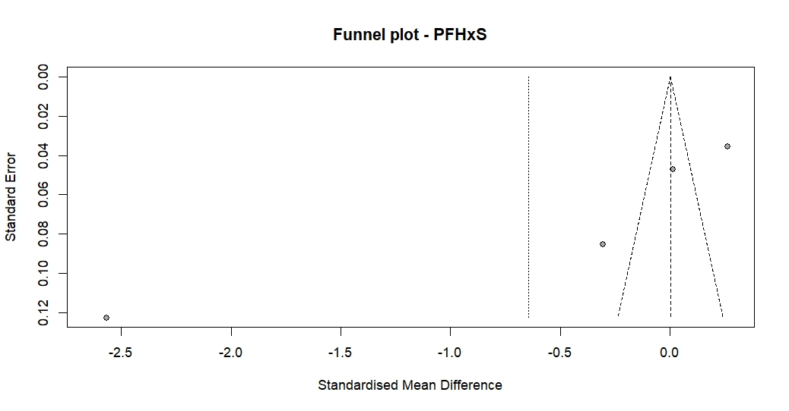
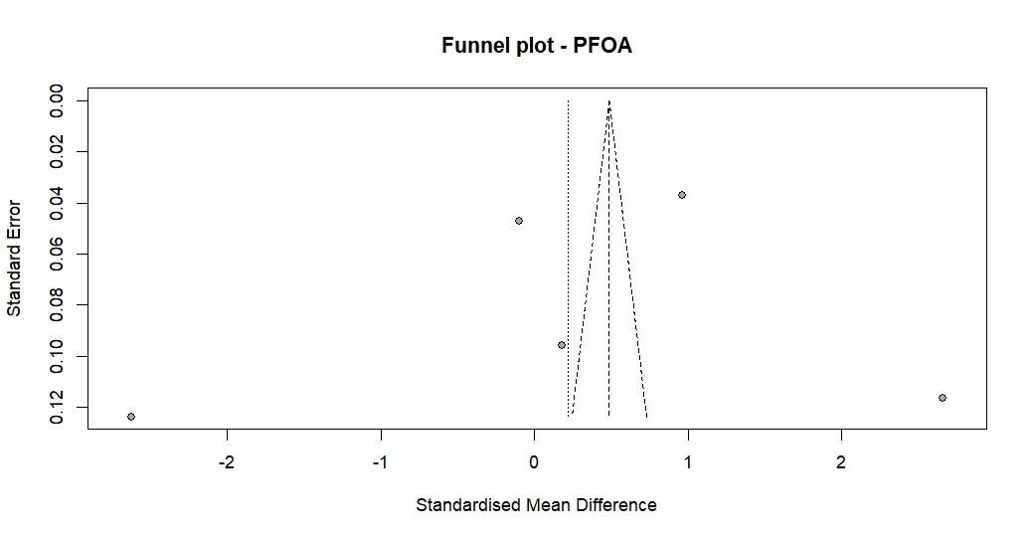
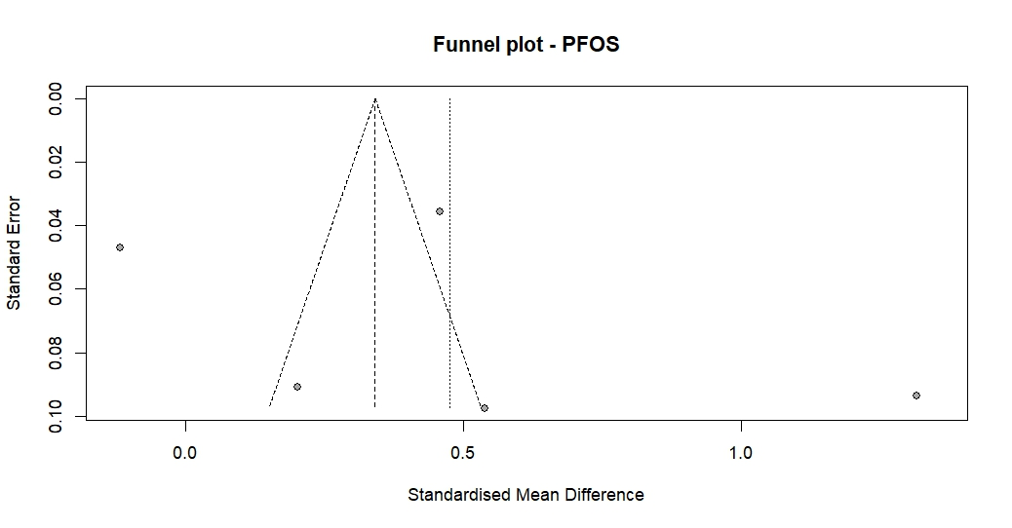
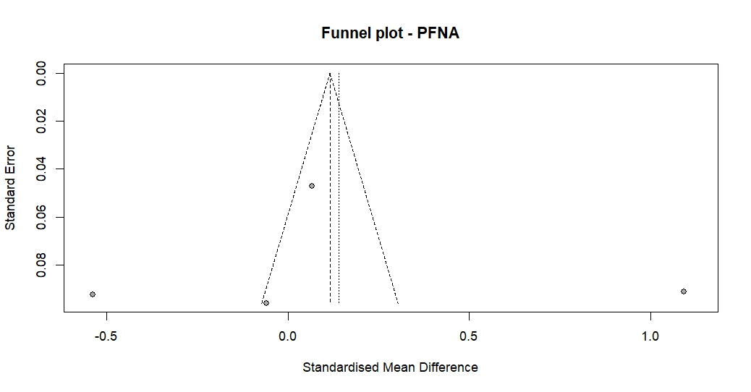

Figure S1. Funnel plot of individual studies evaluating the association between maternal PFAS exposure and gestational weight gain (GWG). Each plot represents one compound, and each dot represents a study, plotted against its standard error. The observed asymmetry and points outside the confidence region likely reflect the high heterogeneity and limited number of studies per compound, rather than publication bias. Significant codes: 0 (***), 0.001 (**), 0.01 (*) 0.05 (.), 0.1 ( ), 1

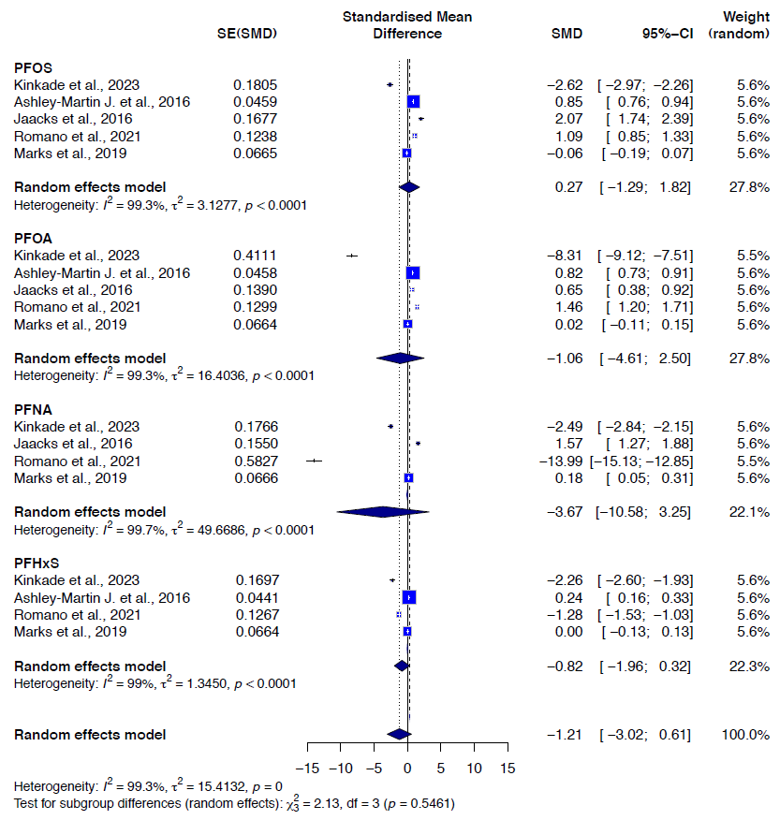

Figure S2a. Results from the subgroup analysis on the low BMI (< 25 kg/m²) for PFAS compounds. Random-effects meta-analysis evaluates the association between maternal PFAS exposure and gestational weight gain (GWG).

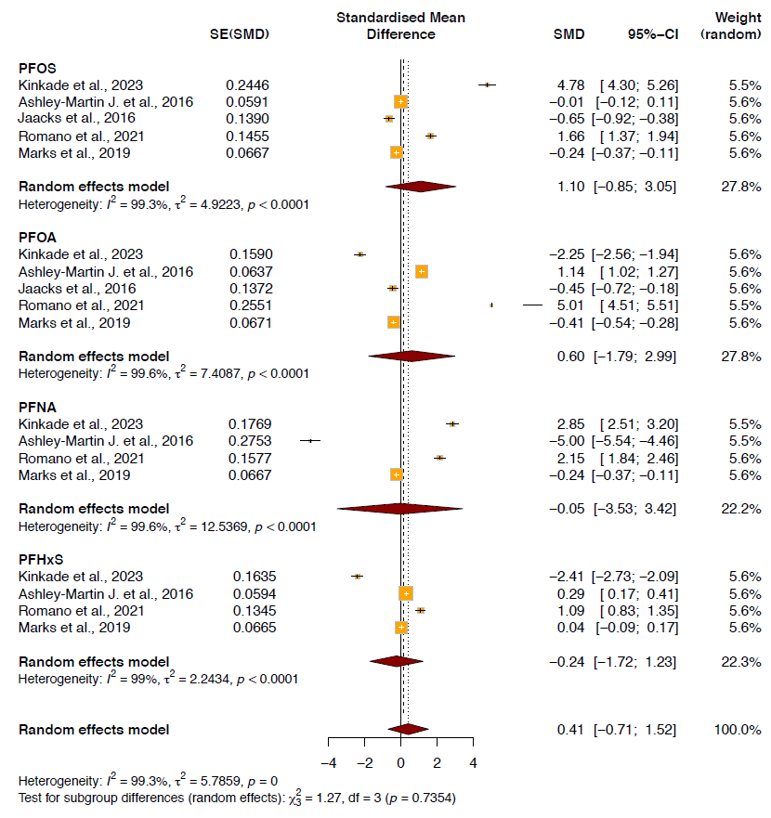

Figure S2b. Results from the subgroup analysis on the high BMI group (≥ 25 kg/m²) for PFAS compounds. Random-effects meta-analysis evaluates the association between maternal PFAS exposure and gestational weight gain (GWG).

Section S5. Results of Egger’s tests, sensitivity analysis, and BMI groups meta-regression and for Phthalates global analysis

S5.1. Regression Test for Funnel Plot Asymmetry
Model: mixed-effects meta-regression model
Predictor: standard error
Test for Funnel Plot Asymmetry: z = 0.568, p = 0.570
Limit Estimate (as sei -> 0): b = -0.438 (CI: -6.9633, 6.085)
* For individual phthalates, Egger’s test was not performed when the number of studies was <10, as statistical power is insufficient to detect asymmetry in small samples.
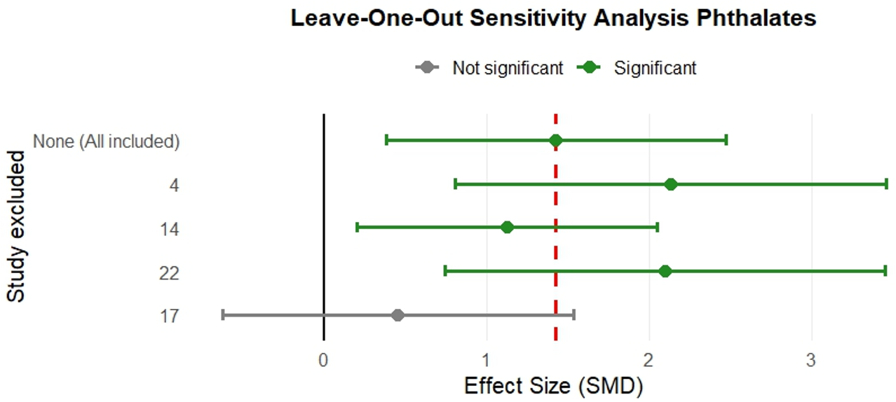
S5.2. Results for leave-one-out study on phthalates
Study_Left_Out | Pooled_ES | CI_Lower | CI_Upper | I²
None (All included) | 1.43 | 0.38 | 2.47 | 0.99
4 - Pacyga, D.C., et al. (2023) | 2.13 | 0.81 | 3.46 | 0.99
14 - Philips, E.M., et al. (2020) | 1.12 | 0.20 | 2.05 | 0.99
22 - Boyer, T.M., et al. (2023) | 2.10 | 0.74 | 3.45 | 0.99
17 - Gao, H., et al. (2021) | 0.45 | -0.62 | 1.53 | 0.99

S5.3. Meta-Regression Test for BMI groups influence
logLik | deviance | AIC | BIC | AICc
-60.73 | 121.46 | 127.46 | 130.73 | 128.79

tau² (estimated amount of residual heterogeneity): 14.527 (SE = 4.388)
tau (square root of estimated tau² value): 3.811
I² (residual heterogeneity / unaccounted variability): 99.91%
H² (unaccounted variability / sampling variability): 1171.01

Model Results
 | estimate | se | zval | pval | ci.lb | ci.ub
intrcpt | 1.747 | 1.101 | 1.586 | 0.112 | -0.411 | 3.906
BMI_Group | -0.148 | 1.557 | -0.095 | 0.924 | -3.201 | 2.904
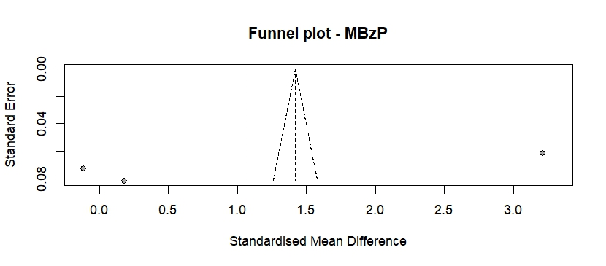
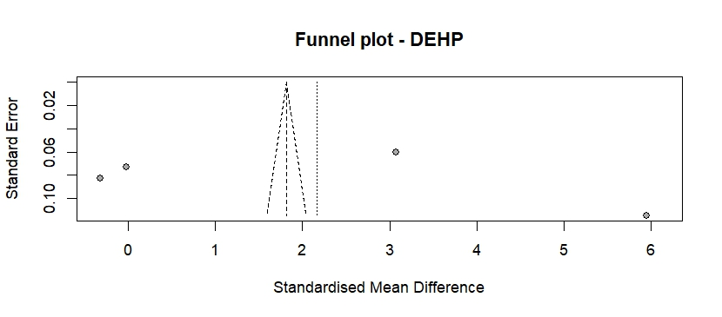
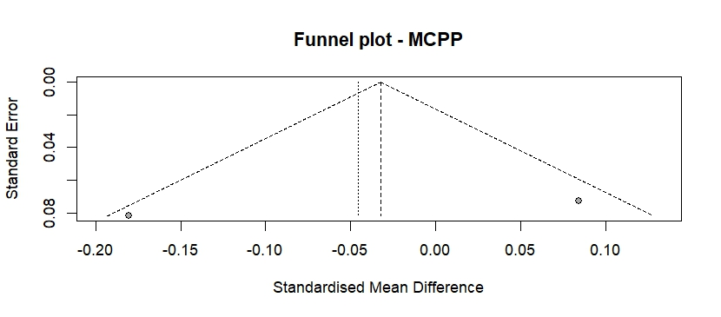
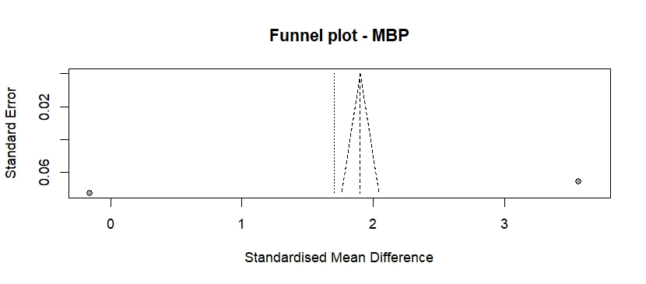
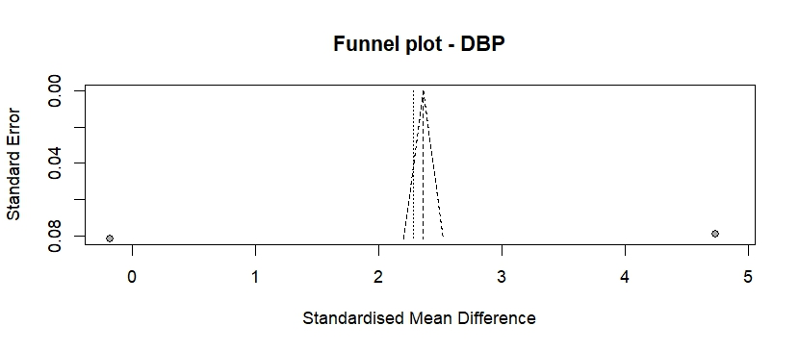
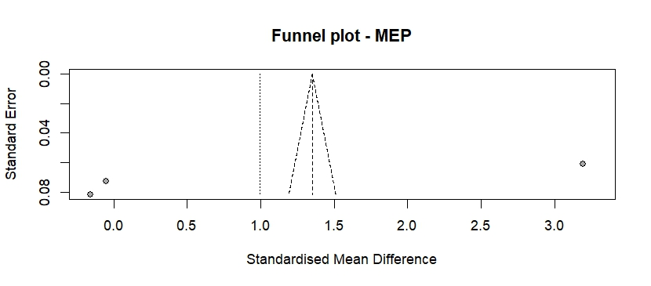
Figure S3. Funnel plot of studies evaluating the association between maternal phthalates exposure and gestational weight gain (GWG). Each plot represents one compound, and each dot represents a study, plotted against its standard error. The observed asymmetry and points outside the confidence region likely reflect the high heterogeneity and limited number of studies per compound, rather than publication bias. Significant codes: 0 (***), 0.001 (**), 0.01 (*) 0.05 (.), 0.1 ( ), 1

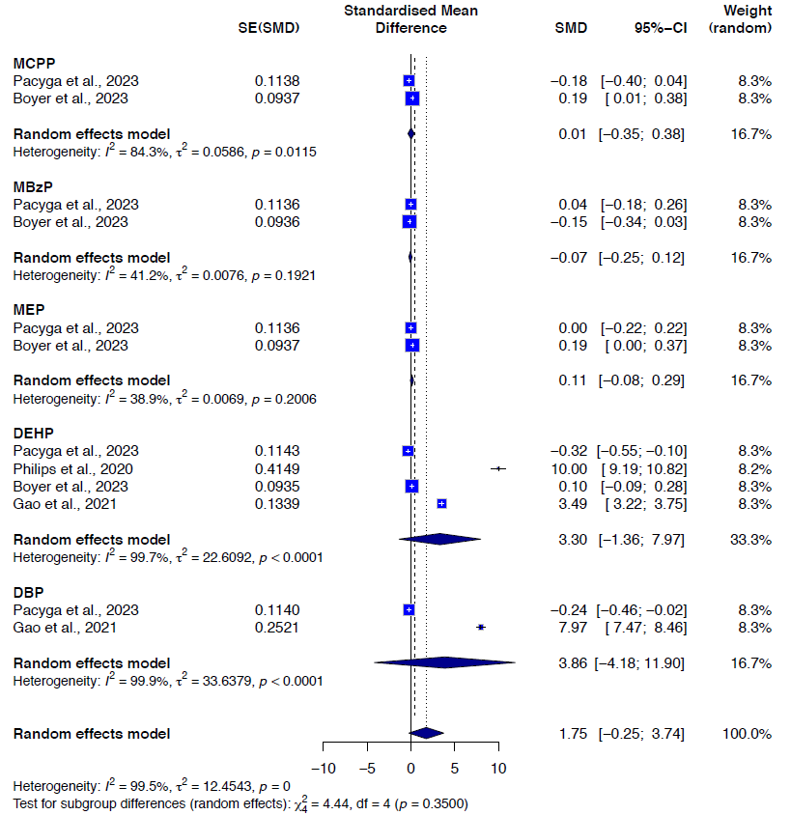

Figure S4a. Results from the subgroup analysis on the low BMI (< 25 kg/m²) for phthalates compounds. Random-effects meta-analysis evaluates the association between maternal PFAS exposure and gestational weight gain (GWG).

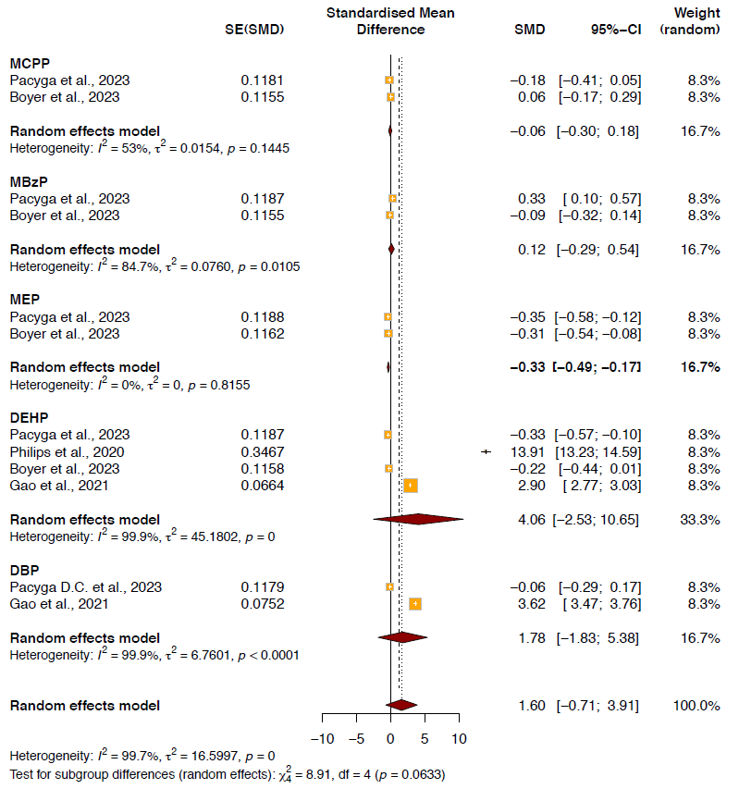

Figure S4b. Results from the subgroup analysis on the high BMI group (≥ 25 kg/m²) for phthalates compounds. Random-effects meta-analysis evaluates the association between maternal PFAS exposure and gestational weight gain (GWG).

