Supplemental Online Material-Reviewed (SOM-R)
Two additional hypotheses were assessed for purposes that are beyond the scope of the present manuscript, but are reported here for the sake of transparency:
- Based on prior research from the PM literature, we suspected that forgetting would be worse when there was a mismatch between the location where intentions were initially formed and where they were to be retrieved, so we manipulated the locations where the cell phone was taken from the participant (inside or outside of the testing room); the tracker was given to the participant in the opposite location; the locations were counterbalanced across participants.
- Does walking through a doorway trigger retrieval of the intentions? Based on prior research from the event-segmentation literature, we hypothesized that the location where participants would stop to remember to ask for their cell phone back or return the tracker would cluster around doorways (Radvansky & Copeland, 2006).

Supplemental Methods and Analyses: In order to analyze the data using a less stringent/categorical definition of memory success that may be more sensitive to differences between conditions, we computed the distance from the location in the lab where the tasks were to be remembered and the location where the participant actually did stop to ask for their phone or return the tracker. How far the person traveled before they remembered is a proxy to capture the degree of forgetting using a continuous measure. When the participant truly forgot and had to be stopped before leaving the building, the maximum distance from the target location was recorded. This distance traveled measure also allowed a more fine-grained assessment of a potential difference in memory performance when there was either a match or mismatch between the locations where the intentions were formed and to be retrieved. However, this measure was not normally distributed and square-root transformation failed to correct for non-normality. Therefore, we refrained from analyzing these data and exercised caution with interpreting them.

We manipulated where the items were encoded, so that we could measure forgetting when there was either a match or mismatch between where they encoded the intention and where it was to be retrieved and performed. The heat maps and lab layout/floorplans in Figure 3 show where participants stopped to ask for their phone back or return the tracker in each of the four conditions, with warmer colors reflecting more participants. Although some research has shown that PM forgetting was worse when there was a mismatch between the location where intentions were initially formed and where they were to be retrieved (McDaniel, Robinson-Riegler, & Einstein, 1998; Nowinski & Dismukes, 2005; Henry et al., 2020), there was not a clear difference in the clustering of where most people retrieved the intention when there was a match or mismatch between where the intention was formed and where it was to be enacted. There also was not a clear clustering around any of the doorways that people walked through. There was clustering around the exit of the building because this is where we stopped the participants who forgot before they left the building. To quantify performance for analysis, we computed the distance from where participants were to perform their intentions and where they actually stopped and remembered—or where we stopped them before they left the lab. This confirmed what the heat maps show, that there was no difference in whether there was a match or mismatch between encoding or retrieval.
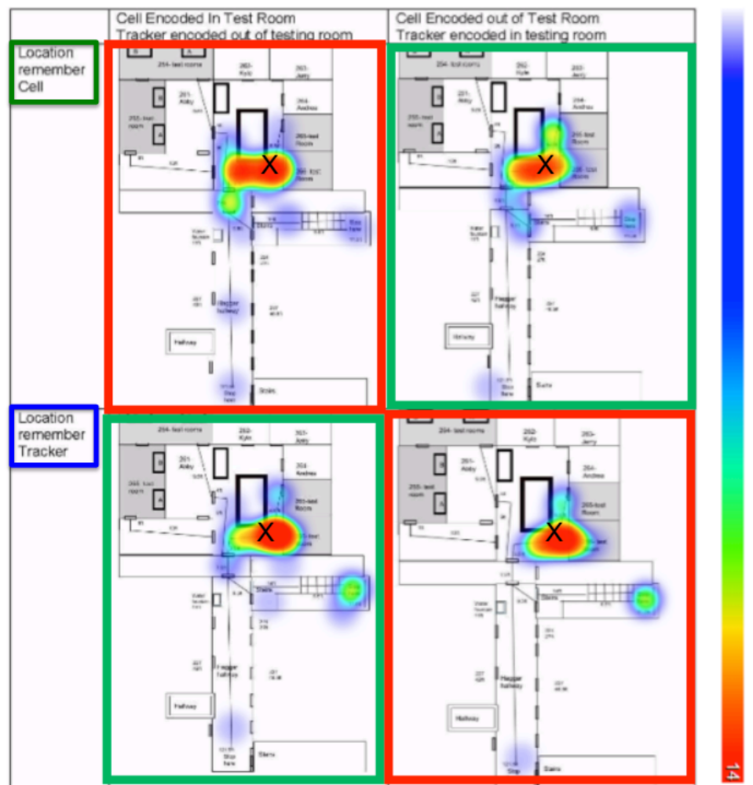
Supplemental Figure 1. Overview of the lab layout and the locations where participants remembered to retrieve their cell phone or return the experimenter’s activity tracker in the four conditions where there was a match (green border) or mismatch (red border) between the locations where the intentions were encoded and where they were to be retrieved and performed (X marks the spot). (Heatmap for lab 2 is presented in the Supplemental Figure 1.)

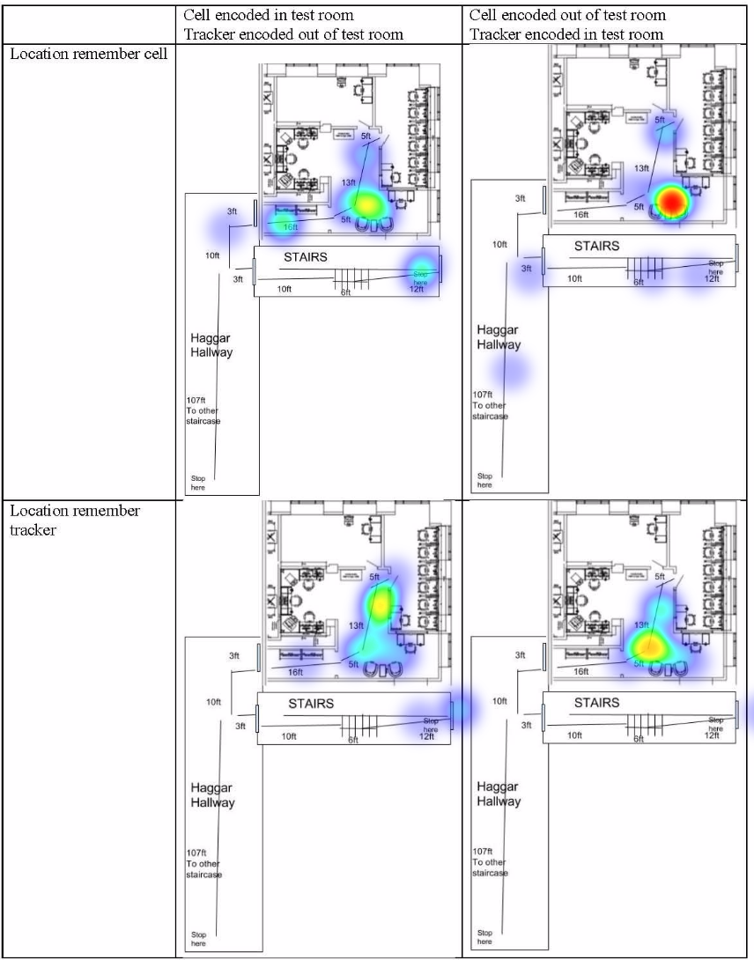

Supplemental Figure 2. Floorplan and Heatmap distribution of distances traveled before remembering cell phone and tracker for Lab 2. Highlighted in green is when there was an encoding-retrieval match, and in red is an encoding-retrieval mismatch.

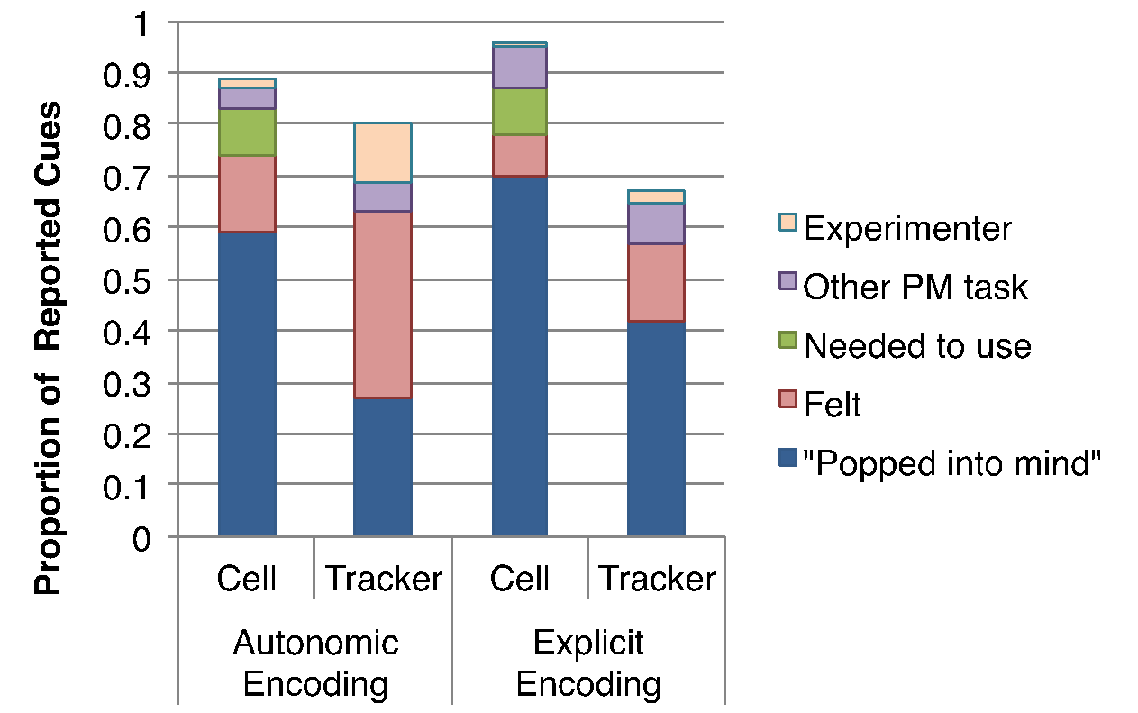
Supplemental Figure 3. Proportions of the different types of cues that participants said caused them to remember to retrieve their cell phone or return the tracker in the autonomic and explicit encoding conditions.

Supplemental Table 1. Proportions (and Ns) of participants who forgot to retrieve their cell or return the tracker either before leaving the building or before leaving the lab in the Autonomic and Explicit encoding conditions; the remaining participants correctly remembered inside the lab.
 | Forgot | Left the lab, remembered later
Cell
Autonomic (n=108) | 0.074 (8) | 0.194 (21)
Explicit (n=84) | 0.048 (4) | 0.048 (4)
Tracker
Autonomic (n=108) | 0.176 (19) | 0.037 (4)
Explicit (n=84) | 0.179 (15) | 0.012 (1)

Supplemental Table 2. Numbers of participants who forgot both the cell and tracker, forgot one but remembered the other item, or remembered both items in the Autonomic and Explicit encoding conditions.
 |  | Forgot Tracker | Remember Tracker
Autonomic Encoding | Forgot Cell | 1 | 7
Autonomic Encoding | Remember Cell | 18 | 82
Explicit Encoding | Forgot Cell | 2 | 2
Explicit Encoding | Remember Cell | 13 | 67

Supplemental Discussion:
There was also no difference in forgetting rates when there was a match vs. mismatch between the location where the intentions were formed and where they were to be retrieved. Previous research has shown that PM performance is enhanced when there is a match between the type of cognitive processing at encoding and retrieval (e.g., McDaniel et al., 1998). We suspected that this phenomenon, which reflects the broader principles of ‘encoding specificity’ and ‘transfer-appropriate-processing’, would also be true when there was a match vs. mismatch in the physical locations where the intentions were encoded and where they were to be retrieved. A match in the environmental contexts between encoding and retrieval, such as between a classroom where learning and testing occurs, has long been known to facilitate retrospective memory (Smith, 1979). With regards to PM, both researchers and laypersons report anecdotal evidence for this phenomenon, such as when an intention to get something from the kitchen is formed while sitting on the couch in the living room, but cannot be retrieved while inside the kitchen, yet does come back to mind upon returning to the living room. While such anecdotes may be common and reflect a fundamental principle of memory, we did not find evidence for an effect of a match/mismatch of the encoding and retrieval context on PM performance in this study. This may be because the context shift from encoding the intention in the lab vs. inside the testing room and retrieving it before leaving the lab was rather minimal.
Based on event segmentation theory and evidence that walking through a doorway affects memory updating and consolidation (Radvansky et al., 2011; Radvansky, & Zacks, 2017), we hypothesized that the context shift of walking through the doorway of the lab may have been a potent cue that affected PM retrieval. The rationale is that events are cognitively segmented by changes in physical boundaries, and such event segmentation plays a fundamental role in memory encoding, consolidation, and retrieval. We thought that, because the intentions were formed inside the lab, physically crossing the boundary (the doorway) would result in memory updating processes that may have cued the need to consolidate memory of the events that occurred inside the lab and begin the encoding and consolidation of a new, temporally and spatially segregated memory of the new event (traveling from the lab to accomplish one’s next goal, e.g., going to the cafeteria for lunch). When participants forgot to retrieve their phone or return the tracker inside the lab, we thought that “spontaneous” retrieval would occur when they passed through the doorway. That is, when PM intentions are autonomically encoded and retained at a latent level, we hypothesized that participants would be signaled that they were leaving an object of value in (or taking one from) the location inside the previous event boundary. We expected to see that the locations where participants stopped and turned to ask the experimenter for their phone back or return the tracker would cluster around the doorway of the lab, and perhaps especially in the autonomic encoding condition. However, as seen in the heat maps of the lab and building floor plans, we found no evidence of such spontaneous retrievals clustering around the doorway. Again, we suspect that this may be because the strength of the context shift of moving from inside the testing room in the lab to the hallway to exit the building was insufficient to systematically elicit spontaneous retrieval at that precise location across participants.
Anecdotally, the phenomenon of forgetting an intended action (e.g., turning off an appliance), but then retrieving the intention shortly after leaving one’s home is a commonly reported PM error. What signals cue such spontaneous retrieval at that particular time and location? Intuitively, it seems like there is a clear role of event boundaries and the act of entering vs. exiting physical locations in triggering PM retrieval, especially for PM target locations that should cue retrieval and initiation of PM intentions associated with the beginning or end of a target event. Although we did not find evidence to support these hypotheses in the current study, we think this is an important area to be addressed by future PM research and we propose the current and related designs as potentially fruitful methods to address such questions.

Supplemental References
Henry, J. D., Terrett, G., Grainger, S. A., Rose, N. S., Kliegel, M., Bugge, M., ... & Rendell, P. G. (2020). Implementation intentions and prospective memory function in late adulthood. Psychology and Aging, 35(8), 1105.
McDaniel, M. A., Robinson-Riegler, B., & Einstein, G. O. (1998). Prospective remembering: Perceptually driven or conceptually driven processes?. Memory & Cognition, 26(1), 121-134.
Nowinski, J. L., & Dismukes, K. (2005). Effects of ongoing task context and target typicality on prospective memory performance: The importance of associative cueing. Memory, 13(6), 649-657.
Radvansky, G. A., Krawietz, S. A., & Tamplin, A. K. (2011). Walking through doorways causes forgetting: Further explorations. Quarterly Journal of Experimental Psychology, 64(8), 1632-1645.
Radvansky, G. A., & Zacks, J. M. (2017). Event boundaries in memory and cognition. Current Opinion in Behavioral Sciences, 17, 133-140.
Smith, S. M. (1979). Remembering in and out of context. Journal of Experimental Psychology: Human Learning and Memory, 5(5), 460.

