Supplementary Material

Invasion dynamics of antimicrobial-resistant E. coli in river biofilms: impacts on the resistome, microbiomes, and horizontal gene transfer

Gionchetta G^{1, 2*#}, Lee J^{1, 3*}, Hansen O¹, Beck K¹, Bürgmann H¹
¹ Eawag, Swiss Federal Institute of Aquatic Science and Technology, 6047 Kastanienbaum, Switzerland
² Department of Environmental Chemistry, Institute of Environmental Assessment and Water Research (IDAEA), Spanish Council of Scientific Research (CSIC), 08034 Barcelona, Spain
³ University of Calgary, Departments of Microbiology, Immunology, and Infectious Diseases & Biological Sciences, 3330 Hospital Dr NW, T2N 4N1, Calgary, Alberta (Canada)
*Joint first authors
#corresponding author: giulia.gionchetta@idaea.csic.es
Keywords: Antibiotic resistance, antibiotic resistance genes, disturbance, mobile genetic elements, diversity, pollution
Running title: Invasion effects on biofilm resistomes

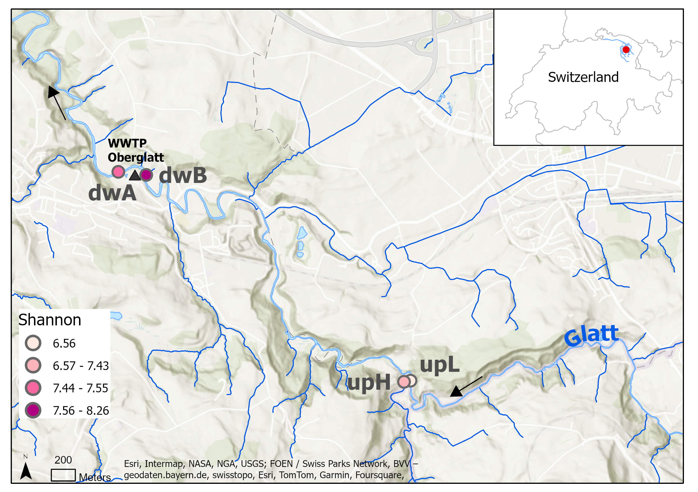
Fig. S1 Map of the sites chosen for biofilm collection and deployment of exposure units along the Glatt River. The four locations were selected based on differences in the microbial diversity of natural epilithic biofilms (Shannon index in the figure legend) and consisted of: two upstream locations with low and high diversity (i.e., upL and upH, with coordinates 47.39815N 9.23268E and 47.39809N 9.23198E, respectively) and two downstream locations before and after (i.e., dwB and dwA, 47.41404N 9.20399E and 47.41433N 9.20092E, respectively) the Oberglatt wastewater treatment plant (WWTP). The black arrow indicates the flow direction.
Supplementary Information (SI)

SI1. Raising and harvesting riverine biofilm in situ
At each site (Fig. S1) we anchored two concrete biofilm raising platforms in the river, covered by stainless steel chambers that allowed water flow but kept out ambient light and larger debris (Fig. S2A). Each platform held eight exposure units (Fig. S2B), each vertically holding nine sterilized glass slides that allowed the biofilm to grow on both sides (Fig. S2C).
Biofilm was allowed to colonize the glass slides over the course of five weeks in May 2022. Following the colonization period, all 16 exposure units were retrieved from each river location and transported back to the laboratory in sterilized plastic containers submerged in river water. Upon arrival, they were immediately installed in the previously assembled experimental flumes (Fig. S3A).

SI2. Flume construction and setup
The flumes consisted of PVC boxes (400 × 191 × 100 mm; wall strength 1 cm) with 20 mm diameter pipe adapters at both the inlet and outlet (Fig. S3A). For each flume, one sterile 4.8 mm internal diameter silicon tube (Baoding Shenchen Precision Pump Co., Ltd., China) running through a LabV1-II model peristaltic pump with four model YZ1515X pump heads (Baoding Shenchen Precision Pump Co., Ltd., China), was attached to the inlet adaptor and run into a sterilized 5-L barrel (FAIE-Versand Schweiz GmbH, Switzerland).
Another silicon tube with the same dimensions was run from the outlet adaptor back into the same barrel to create a continuous flow system (Fig. S3A). The peristaltic pump was set to maintain a flow of 100 mL/min, minimizing turbulence and facilitating homogeneous water distribution within the flume. A total of 6.5 L of sterile-filtered water (0.45 μm glass Fiber membrane filters, Millipore, Ireland) collected from each river site was added to each flume and 1.5 L was added to each 5-L barrel (8 L total volume).
Upon transport to the laboratory three exposure units (3 x 9 slides) were deployed in each of the flumes and acclimatization to laboratory conditions was immediately started at 20°C and continuous recirculating flow. Each week, 10% (800 mL) of the water circulating in the flume system was renewed (river water obtained fresh each week, filtered and kept at 4°C until use). After one week of acclimatization, the experimental treatments and sampling were started as detailed below (Fig. S3B).
SI3. Preparation of the model invader E. coli MG1655 (CM2372)
A non-pathogenic E. coli MG1655 ΔLacZY strain possessing a native conjugative IncPα plasmid pG527 donor of nptII resistant gene, was grown overnight at 37°C on a shaker table operating at 160 rpm in three falcon tubes each with 10 mL of Luria-Bertani (LB) broth containing 50 µg/mL of kanamycin. The IncPα plasmid confers resistance to Kanamycin, Tetracycline and Streptomycin. After overnight incubation, one millilitre of the pre-inoculum was transferred to four Erlenmeyer flasks containing 100 mL of LB broth and again incubated overnight under the same conditions.
The next day, the cell cultures were centrifuged (4000xg for 15 minutes) and resuspended with NaCl (0.9%) saline and the OD600 was adjusted to 1.0 to obtain 10⁹ colony-forming units (CFU/mL). Each flume received an aliquot of ARB-E. coli MG1655 inoculum to achieve a final concentration of 10⁷ cells/mL in the 8 L of water in the flume system. The cell density was verified by plating serial dilutions.
The correct OD600 value was determined in preliminary experiments plating serial dilutions, which established that the OD600 value of 1.0 corresponded to 10⁹ CFU/mL for our ARB-E. coli inoculum.

A)
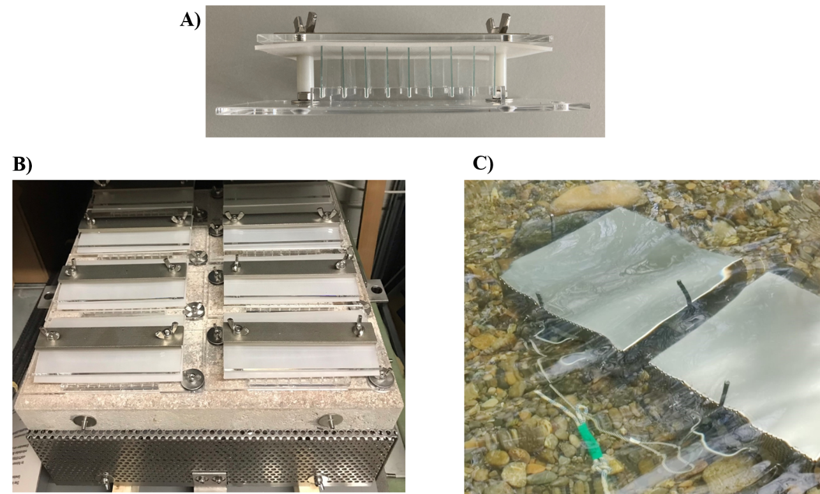
B) | C)
Fig. S2 Biofilm raising platforms and exposure units. A) Two concrete platforms covered by stainless-steel lids and containing 8 exposure units apiece were placed in each of the sampling locations along the Glatt River for 5 weeks to allow the formation of a stable heterotrophic biofilm community. The heavy platforms and rebar anchors served to anchor the units in place under any flow condition, and the stainless-steel lids served to reduce the phototrophic growth, while the perforated front and back allowed water flow but kept out larger debris. B) Eight exposure units docked on one of the concrete platforms that were deployed in the river. Perforation of the steel lid is visible at the bottom. C) Side view of an exposure unit holding 9 vertically fixed sterilized glass slides on which biofilm can colonize.

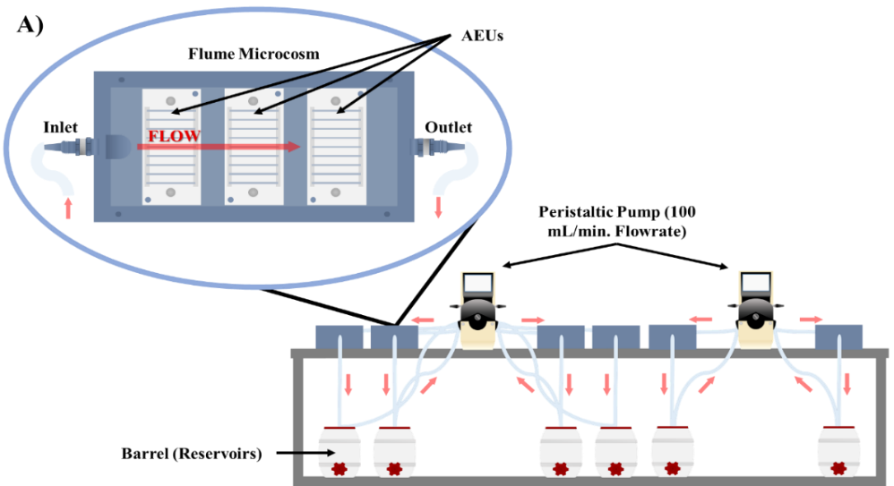
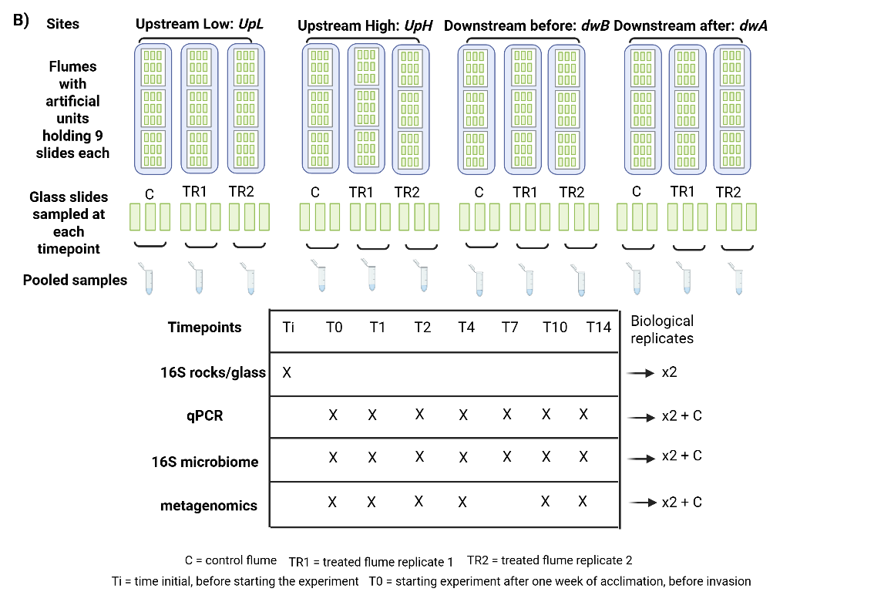
3 flumes per site x 4 sites = 12 flumes (sketch shows setup for 2 locations)
Fig. S3 Flume experiments. A) Diagram of the experimental set-up. Two pumps were used to circulate filtered water at 100 mL/min through six covered flumes to mimic natural flow conditions during the acclimation period (one week) and the experiment (2 weeks). The closed and covered recirculation systems prevent cross-contamination and dispersion of the genetically modified invader organisms between systems. B) Schematic overview of the experimental design and analysis. Each flume held 3 exposure units, each with 9 vertically fixed glass microscopic slides holding river-grown biofilm parallel to the flow direction. The experiment consisted of 12 flumes, 3 per sampling location (one control and 2 flumes treated with the E. coli invasion). Sample to characterize rock and glass slide microbiomes were obtained prior to starting the experiment. During the experiment, glass slides were harvested for DNA extraction just before and on the indicated days after invasion and analysed as shown.
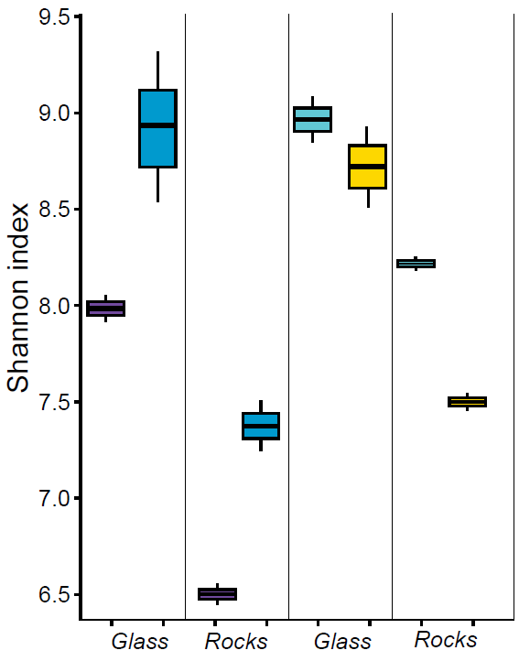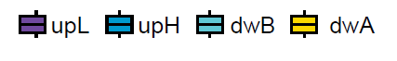
Fig. S4. Boxplot showing alpha diversity (Shannon index) calculated for biofilms samples collected in situ prior the laboratory experiment from natural rocks (Rocks) and grown on glass-slide (Glass) in exposure units at the same location.

A) | 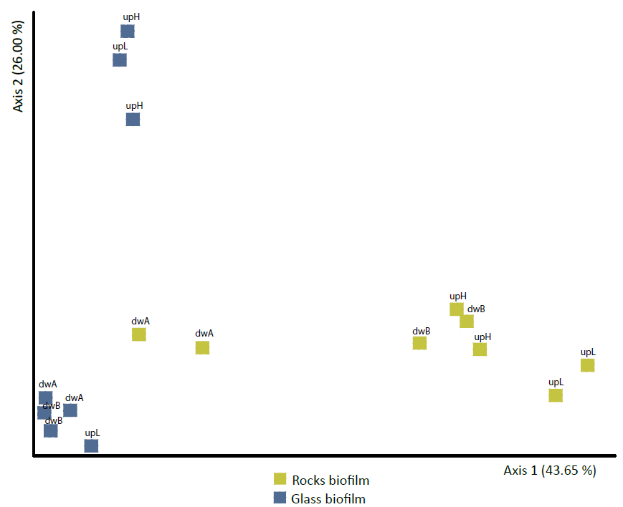
B) | 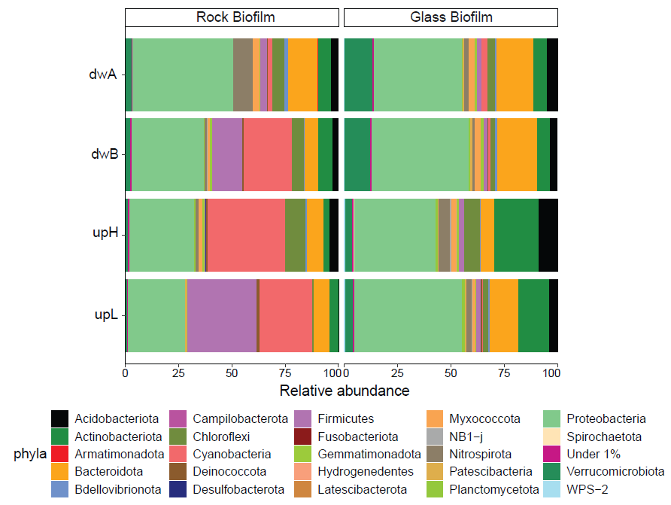
Fig. S5 Analysis of the community composition of biofilms grown on artificial glass substrate and natural biofilm growing underneath rocks collected in situ 5 weeks prior the laboratory experiment. Labels identify the sampling sites as upstream low and high diversity (upL; upH) and downstream sites before and after WW impact (dwB; dwA). A) Ordination plot shown principal coordinate analysis (PCoA) based on weighted Unifrac distance. The differences between sites and substrate were assessed through permutation analysis (PERMANOVA), followed by pairwise tests by substrate: p-value = 0.004 and by site: p-value = 0.521). Color indicates the growth substrate. B) Phylum level composition of biofilm samples. For each sample, all phyla with less than 1% relative abundance were clustered as “Under 1%” (magenta) to reduce complexity.
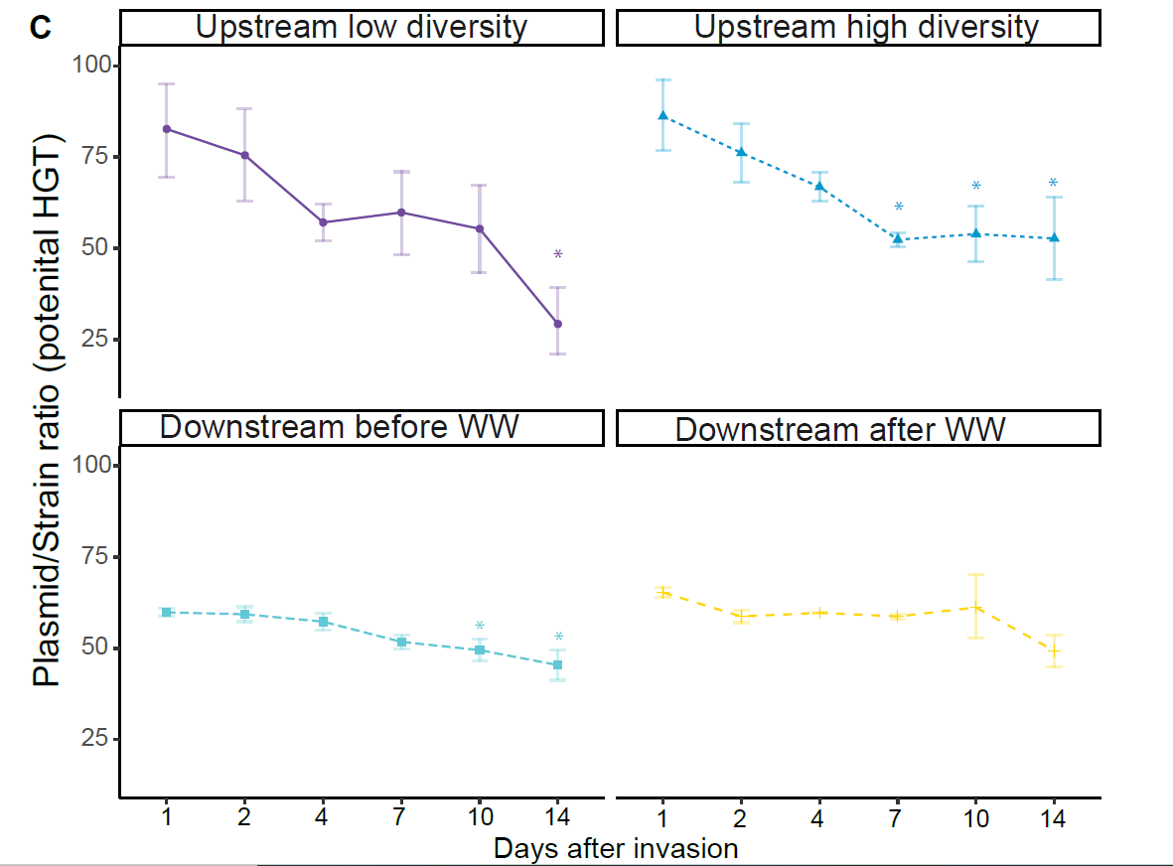

Fig. S6 Plasmid-to-genome ratio calculated from qPCR quantification of the plasmid and chromosomal markers as proxy for potential horizontal gene transfer, (HGT). Error bars denote the standard deviation associated with the average of replicate biofilm samples for each time point. One-way ANOVA applied for both replicates and each invaded biofilm followed by pairwise t-test comparison (Benjamini-Hochberg correction) between time points. Asterisks denote significant differences between day 1 and other time-points. The four sites are defined as upstream high- and low diversity (upH and upL), and the downstream sites before and after the wastewater treatment plant (dwA and dwB).
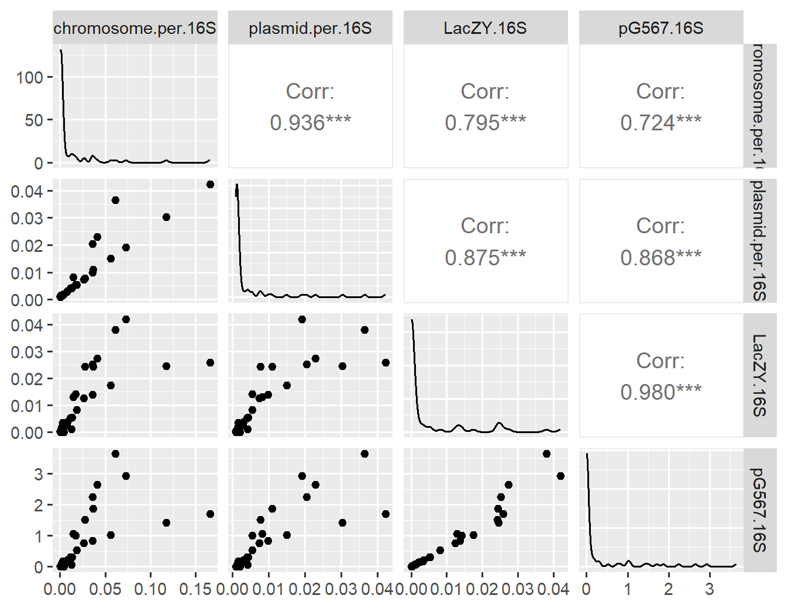
Fig. S7 Correlation analysis between quantitatively measured relative abundances (using qPCR, normalized to bacterial 16S rRNA gene qPCR), and bioinformatically calculated relative abundances from metagenome analysis (in reads per 16S rRNA gene) for ARB-E. coli chromosome (LacZY.16S and chromosome. per16S, respectively), and plasmid sequences (pG567.16S and plasmid.per.16S, respectively). Below the diagonal: Scatterplots. Above diagonal: Correlation coefficient and significance (*** p< 0.01), diagonal: density plots.

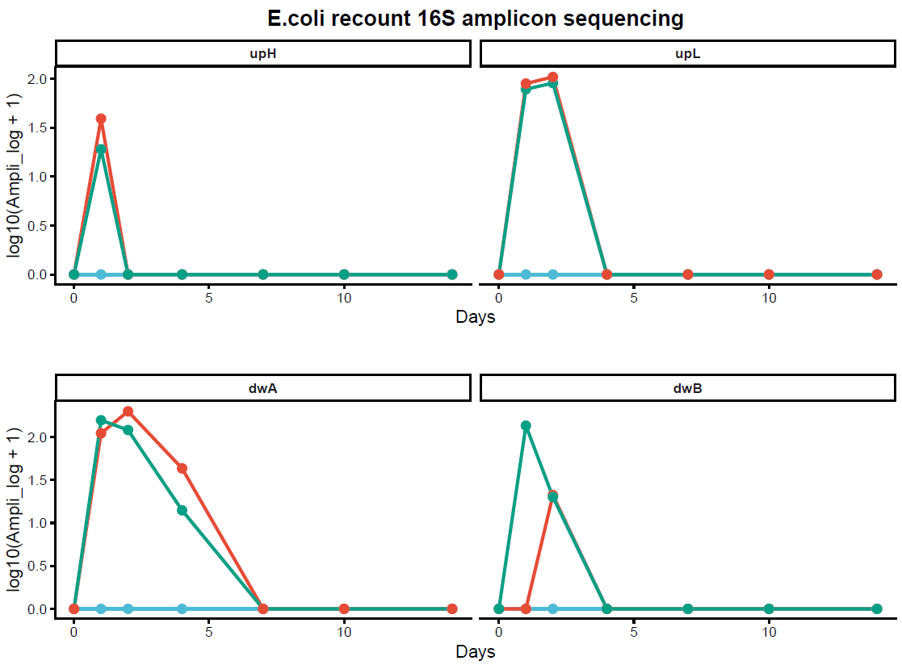
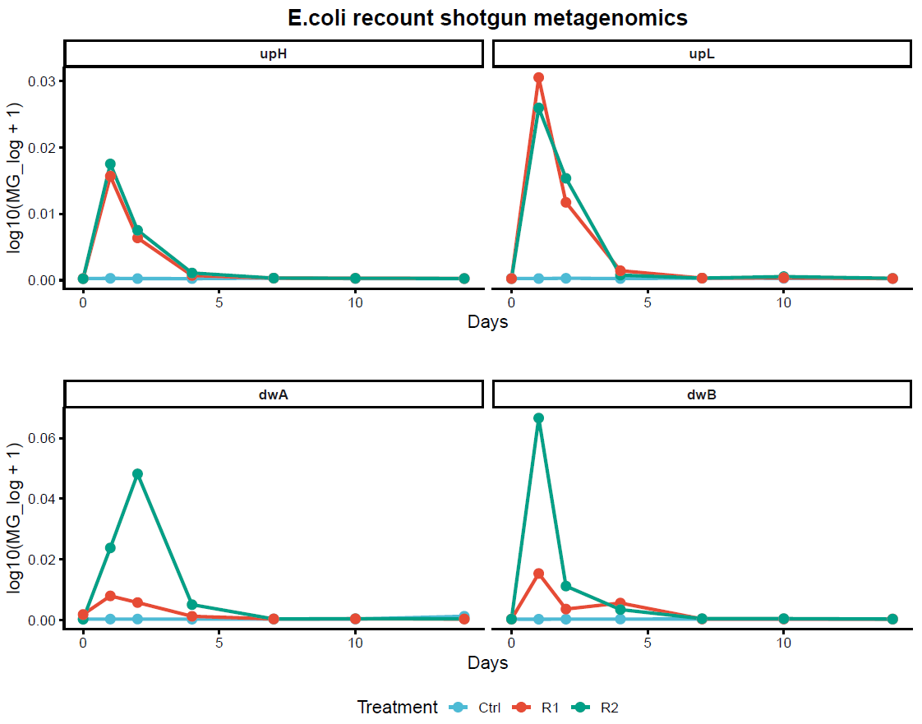
Fig. S8 Temporal dynamics of the log-transformed sequences identified as E. coli based on 16S rRNA gene sequencing data (log10(Ampli_log+1)) and based on metagenomics (log10(MG_log+1)). The four sites are defined as upstream high and low diversity (upH and upL), and the downstream sites before and after the wastewater treatment plant (dwA and dwB). Color indicates replicates (replicate 1: R1, dark red. Replicate 2: R2, green) and controls (Ctrl, light blue).
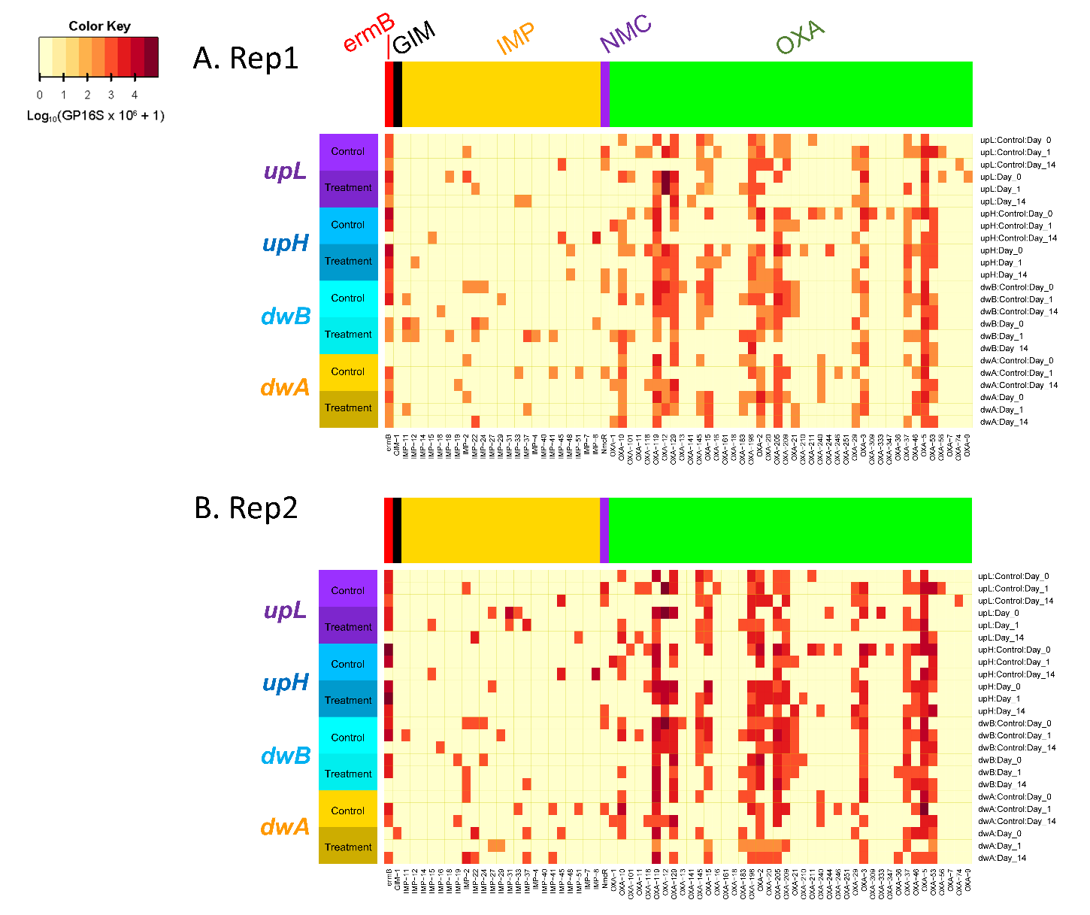
Fig. S9 Heatmap for five ARG groups of clinical concern (4 carbapenamases and 1 macrolide-lincosamide-streptogramin resistance genes) identified in indigenous biofilms, for both replicates (A for replication 1; B for replication 2). Group designations are ermB = erythromycin resistance gene ermB, GIM = German imipenemase, a metallo-β-lactamase (MBL) gene, IMP = Imipenemase (IMP), a type of metallo-β-lactamase (MBL), NMX = New Delhi metallo-β-lactamase–like gene group (NMX), OXA = OXA-type β-lactamase resistance genes.
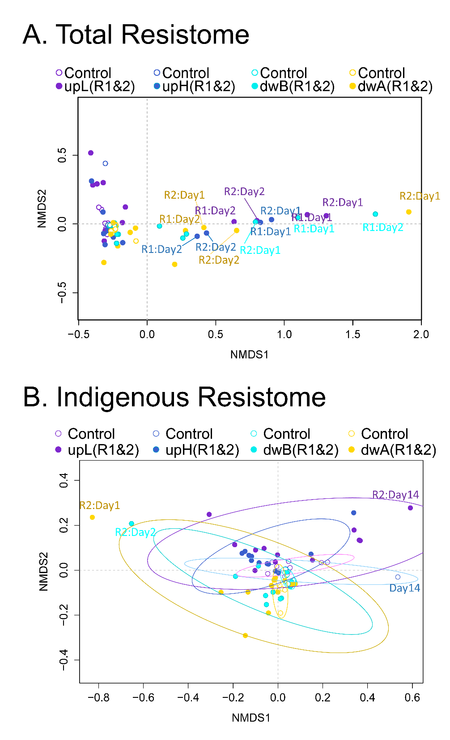
Fig. S10 Non-metric multidimensional scaling (NMDS) ordination plot with treatment and control samples, visualizing dissimilarities in (A) total ARGs identified in this study (stress = 0.034); (B) indigenous ARGs (stress = 0.059), where both invaded biofilms and controls were shown altogether. Color indicates biofilm origin. Empty circles indicate controls, filled circles indicate samples subject to E. coli invasion. R1 indicates replicate 1; R2 denotes replicate 2, Day indicates days after invasion.

