Supplementary Information for:
Active flow-driven DNA remodeling generates millimeter-scale mechanical oscillations

Maya Levanon¹, Noa S. Goldberg¹, Dvir Cohen², Eran Bouchbinder¹, Ram M. Adar², Alexandra M. Tayar^{1*}.
¹Chemical and Biological Physics Department, Weizmann Institute of Science, Rehovot 7610001, Israel.
²Department of Physics, Technion - Israel Institute of Technology, Haifa 32000, Israel.
*e-mail : alexandra.tayar@weizmann.ac.il

This PDF file includes:
Methods
Supplementary text
SI references
Figures S1-S20
Video captions

Methods
Tubulin purification and labeling: Tubulin was purified from bovine brain by two successive cycles of polymerization and depolymerization as described previously ^{1–5}. Briefly, polymerization was performed in M2B buffer (80 mM K-PIPES, 2 mM MgCl₂, 1 mM EGTA; pH 6.8) supplemented with Guanosine triphosphate (GTP, 100 mM; Aaron Chemicals, AR00I7U9). Following purification, tubulin was flash-frozen in liquid nitrogen and stored at -80 °C.
For subsequent use, purified tubulin was either recycled through one additional polymerization/depolymerization cycle or labeled with Alexa Fluor 647 NHS ester (Thermo Fisher, A20006) at a 13-fold molar excess of dye relative to tubulin. Recycled and labeled tubulin were flash-frozen in liquid nitrogen and stored at -80 °C.
Microtubules polymerization: Microtubules (MTs) were polymerized from purified tubulin at 8 mg mL⁻¹ in M2B buffer supplemented with 20 mM dithiothreitol (DTT) and 10 mM guanosine-5′-(α,β-methyleno)triphosphate (GMPCPP; Jena Bioscience), a non-hydrolysable GTP analogue. Reactions were incubated at 37 °C for 30 min to initiate polymerization and then at room temperature (RT) for 5 h to allow growth. Polymerized MTs were flash-frozen in liquid nitrogen and stored at -80 °C. For labeled MTs, 2-5 mol% Alexa Fluor 647 labeled tubulin was mixed with unlabeled tubulin prior to polymerization ¹.
Kinesin purification: A dimeric kinesin construct comprising the N-terminal motor domain of Drosophila melanogaster kinesin-1 (residues 1-401) fused to the 87-amino acid Biotin Carboxyl Carrier Protein (BCCP) from Escherichia coli acetyl-CoA carboxylase (K401-BCCP, Addgene plasmid #15960) was expressed in the presence of biotin (24 mg mL⁻¹; Sigma-Aldrich, B4639) and purified using nickel-affinity chromatography, then dialyzed into M2B buffer supplemented with Adenosine triphosphate (ATP, $10 μM$). Aliquots were flash-frozen in liquid nitrogen and stored at -80 °C ^{1,6}.
Kinesin-streptavidin motor clusters: Purified biotinylated kinesin was clustered with tetrameric streptavidin ¹ (SA; Sigma-Aldrich, S4762). SA and kinesin were mixed at a 1:2 (v/v) ratio (SA:kinesin) in M2B containing 1 mM DTT, yielding final concentrations of ~0.47 mg mL⁻¹ kinesin and 0.12 mg mL⁻¹ SA. The mixture was incubated on ice for 30 min to allow cluster formation and flash frozen in liquid nitrogen ¹.
λ DNA concatenation: λ DNA (NEB, N3011L, bacteriophage lambda cI857ind1 Sam7) was concatenated by ligating cohesive ends with T4 DNA ligase (NEB, M0202L, 10,000 units/ml). Reactions contained 350 ng/µl DNA (~11.7 nM), T4 DNA ligase (M0202L), in 1x ligation buffer (NEB B0202SVIAL, 50 mM Tris-HCl, 10 mM MgCl₂, 1 mM ATP, 10 mM DTT, pH 7.5@25˚C). To control the length distribution, a CY-5 labeled capping oligonucleotide (IDT, HPLC purified) was added at concentrations range 0-117 nM. Sequence with internal modification: GGGCGGCGACCT-Cy5-GGGTTGTCTCCTCTGATAGC. Ligation mixes were incubated in an Eppendorf Master cycler X50: 15 min at 25 °C, 10 h at 15 °C, then enzyme deactivation for 20 min at 65 °C. Products were kept at room temperature and used within 1 day. Before use, the ligated DNA samples were mixed by pipetting at least 30 times to improve solution homogeneity. To avoid degradation of the cohesive ends over repeated thawing and freezing rounds, the λ DNA solution was mixed by pipetting at least 50 times using a 1000 µL tip, aliquoted to working volume of 10 µL and kept at -20 ˚C. Before use, the DNA was mixed by pipetting and the concentration was measured using a spectrophotometer (DeNovix, DS-11FX). If needed, DNA volume in the concatenation reaction was adjusted to ensure a DNA concentration of 350 ng/µl.
Gel electrophoresis and DNA length distribution analysis: Concatenated DNA lengths were estimated by pulsed-field gel electrophoresis (PFGE) on 1% agarose (Sigma-Aldrich, A2929 or Lonza, SeaKem LE Agarose 50004) in 1x TAE buffer (40 mM Tris, 20 mM acetic acid, 1 mM EDTA) ⁷. For each DNA solution, three replicates were loaded (0.5 µL; 175 ng) mixed with 0.5x loading dye (Thermo Scientific). A λPFG ladder (NEB, N0341S) served as the size standard. Gels were run on a CHEF-DR III at 5.5 V cm⁻¹, 14 °C for 20 h with a ramp from 1-90s. After electrophoresis, gels were stained in EtBr/0.25x TAE for 60 min and imaged on a Typhoon FLA 9500 (532 nm and 647nm) or UVITEC Essential V6. Band fluorescence was used to estimate size distribution (band intensity normalized to total lane intensity). Reported values are mean ± standard deviation across the three replicates.
λ DNA concentration scan: Commercial λ-DNA (500 ng/µL) was concentrated by centrifugal ultrafiltration (Amicon Ultra, 50 kDa MWCO) prior to mixing with the active gel to reach target concentrations >225 ng/µL. Samples were spun at 1,000-2,200 x g (up to ~4 h), with mixing and concentration measurements using a spectrophotometer (DeNovix, DS-11FX) between spins. Filtration was continued until the desired concentration was reached. The final retentate volume was not predetermined and varied by sample. Integrity was verified by PFGE of a small aliquot alongside the unconcentrated stock to confirm no mechanical damage was done due to shear.
Poly-ethylen glycol (PEG) stock solution: A 10% (w/v) PEG-100 kDa (Sigma-Aldrich, 181986) stock was prepared in M2B buffer by vortex. PEG did not fully dissolve and formed visible aggregates. The stock was stored at RT and vortexed at maximum speed for at least 5 minutes before use. If needed, PEG aggregates were resuspended by pipetting with a 1000 µL tip, before proceeding with vortex mixing.
Polyacrylamide-coated glass slides coating
Glass slides (No. 1.5) were cleaned by boiling in ethanol for 5-10 min, rinsing three times in DDW, then boiling in 3% (v/v) Hellmanex solution for 10 min and rinsing three times in DDW. After cleaning, slides were dried and immersed for 15 min in a freshly prepared silane-coupling solution (1% acetic acid and 0.5% 3-(trimethoxysilyl)propyl methacrylate (Sigma-Aldrich, 440159), in ethanol), then rinsed three times in DDW and dried. To form the polyacrylamide brush, slides were placed in a 2% acrylamide solution (diluted from 40% acrylamide solution, (Bio-Rad, 1610140) degassed after dilution) supplemented with 0.035% (v/v) N,N,N′,N′-tetramethylethylenediamine (Sigma-Aldrich, T9281)) and 0.07% (w/v) ammonium persulfate (Sigma-Aldrich, A3678). Slides were stored in the acrylamide polymerization solution at room temperature for up to 3 months, and for at least 5 days before use. Immediately before use, slides were rinsed with DDW.
Flow channel fabrication: Channels were built from parafilm ^{1,8}. A Parafilm spacer was cut, using silhouette 2.0, to the desired geometry and was placed between two polyacrylamide-coated slides, warmed to ~70 °C, and the top slide was gently pressed to seal.
Microtubules-DNA composite active mix: Concatenated λ-DNA was mixed with active fluid containing MTs (1.6 mg mL⁻¹), ATP (1.667 mM), SYBR Green I (1x), kinesin-streptavidin motor clusters (267 nM kinesin), an antioxidant cocktail (Trolox 2.1 mM; glucose 3.4 mg mL⁻¹; DTT 5.7 mM; glucose oxidase 230 µg mL⁻¹; catalase 40 µg mL⁻¹), an ATP-regeneration system (PEP 27.6 mM; PK/LDH 2.9% v/v) in M2B^{1,4,9}. Depending on the experiment, KSA and DNA concentrations were varied, unless noted otherwise, DNA was 70 ng µL⁻¹.
Sample reproducibility: To improve sample reproducibility, several steps were taken:
- To avoid degradation of the cohesive ends over repeated thawing and freezing rounds, the λ DNA solutions was mixed by pipetting at least 50 times using a 1000 µL tip and aliquoted to working volume (10 µL). Before use, the DNA was mixed by pipetting and the concentration was measured. If needed, DNA volume in the concatenation reaction was adjusted to ensure a DNA concentration of 350 ng/ul.
- Ligated DNA samples were mixed by pipetting at least >30 times before use, to improve solution homogeneity.
- Samples were highly sensitive to PEG conditions. Prior to use, the 100 kDa PEG solution was gently mixed with a 1000 µL pipette tip to resuspend aggregates, followed by vigorous vortexing at top speed for over 5 minutes.
Tracer particles preparation: For particle tracking, 2 µm fluorescent latex beads (Sigma Aldrich, L4530) were passivated with PLL-PEG coating: 0.2 mg mL⁻¹ PLL-PEG (SuSoS, PLL(20)-g[3.5]- PEG(2)) was dissolved in 10 mM HEPES and stored at 4˚C for 1-2 weeks. Beads were diluted to 1.2% (v/v) in a 1% (v/v) PLL-PEG solution and incubated on a rotating platform for 60 min, mixed every 20 minutes by brief sonication (2-3 seconds, 3x. Sonication must be brief to avoid damaging the beads) ¹⁰. After 60 minutes, beads were washed by centrifuging (5140 xg, 5 min) twice and resuspend in 10 mM HEPES (final stock concentration 2% v/v). Finally, beads were added to the active-elastic composite at 6.5% of the stock solution (v/v). For these assays, DNA labeling with SYBR Green was removed to avoid spectral overlap with the bead fluorescence.
Data Acquisition: Fluorescence time-lapse imaging was performed on a Nikon Ti2 microscope with ORCA-Fusion CMOS camera (C14440-20UP/C15440-20UP). Large areas were acquired as multi-position tiles and stitched in FIJI (Grid/Collection Stitching).
- Wide field: MT and DNA were imaged with a 4x/0.20 NA objective (Nikon CFI Plan Apo 4x). High-magnification datasets used a 25x Si-oil/1.05 NA objective (CFI Plan). Frame interval: 3-8 seconds.
- 3D volumes: Spinning-disk confocal (Crest Optics X-Light V3), 25x Si-oil/1.05 NA objective (Nikon CFI Plan Apo Lambda S 25XC Sil). Frame interval between z-stacks: 3 seconds (Fig. 2C) or 60 seconds (Fig. 2A, B).
- Particle tracking: Single-plane spinning-disk with 10x/0.45 NA (CFI Plan Apo Lambda D 10x). Frame interval 6 seconds. The focal plane was set away from the surfaces to avoid surface-adhered beads.
Data Analysis: Velocity fields were obtained by particle image velocimetry (PIV) on MT/DNA fluorescence time-lapses using PIVlab (MATLAB) using 16x16-52x52 μm² bins. For each time step, a velocity matrix was computed from consecutive frames. PIV results from the MT and DNA channels were consistent at low magnifications (<10x), showing no significant differences within measurement error (Fig. S6). Analyses shown were performed on MT fluorescence time-lapses.
Maximum speed estimate: For every PIV interrogation region we computed the temporal speed trace and applied a median filter to suppress outliers. The sample maximum velocity magnitude was defined as the 95th percentile of all filtered speed values pooled over time and space.
3D datasets: For spinning-disk confocal image stacks, we generated a maximum-intensity z-projection at each time point and applied the same PIV pipeline to the projected images.
Supplementary Text
Correlation length and average velocity magnitude analysis: The velocity-velocity correlation length, $ξ_{v},$ was estimated by calculating the velocity-velocity correlation function $C_{vv}$. From PIV fields $\vec{v}(\vec{r},t)$, we computed the orientation and space-averaged, normalized correlation
$$C_{vv}\left(\vec{r},t\right)={〈\frac{\vec{v}\left({\vec{r}}_{0},t\right)⋅\vec{v}\left({\vec{r}}_{0}+\vec{r},t\right)}{v^{2}\left({\vec{r}}_{0},t\right)}〉}_{{\vec{r}}_{0},θ}$$
such that $C_{vv}\left(\vec{r}=0,t\right)=1$. Within a single vortex, the velocity-velocity correlation function, $C_{vv}\left(\vec{r},t\right)$ is positive at small separations due to co-rotation and becomes negative at larger separations corresponding to opposite, counter-rotating sides. We treat the entire vortex as a single correlated structure and fit only the initial decay of $C_{vv}\left(\vec{r},t\right)$ from $r=0$ to the first minimum using an exponential using an exponential function with an offset, allowing for negative values:
$C_{vv}\left(\vec{r},t\right)=a⋅exp\left(-\frac{\vec{r}}{ξ_{v}}\right)-C_{0}$,
where $ξ_{v}$ is the correlation length and $C_{0}∈\left[0, 1.2\right]$ allows negative values. Before fitting, we performed a moving average over $r$ to smooth the function, and a median filter (Fig. S18). The fit is restricted to the monotonic decay region in $C_{vv}\left(\vec{r},t\right)$, and accepted for $R^{2}>0.9$.
For consistency, we analyzed the non-normalized covariance $\tilde{C_{vv}} \left(\vec{r},t\right)$ and extracted the spatial average of the velocity magnitude by calculating the non-normalized velocity-velocity correlation function:
$\tilde{C_{vv}} \left(\vec{r},t\right)={〈\vec{v} \left({\vec{r}}_{0},t\right)∙\vec{v} \left({\vec{r}}_{0}+\vec{r},t\right)〉}_{{\vec{r}}_{0},θ}$,
and fitting it as
$$\tilde{C_{vv}} \left(\vec{r},t\right)=v⋅exp\left(-\frac{\vec{r}}{ξ_{v}}\right)-C.$$
We report the mean speed as $v$.
Oscillation Period analysis: We defined the oscillation interval as the time window beginning at the onset of sustained amplitude growth, following initial increase in amplitude and ending at the decay of oscillatory behavior. Within this window, we analyzed $v_{x}(t)$ and $v_{y}\left(t\right)$separately for each PIV interrogation region. Time traces were smoothed using a 30-second moving average and subsequently detrended by removing the DC component. The power spectrum was computed using the Fast Fourier Transform (FFT), and dominant frequency was identified from the maximal peak; if two nearby peaks of similar power appeared, we chose the higher frequency, and if two well-separated peaks of comparable power were present, the window was discarded. The resulting spatial map of frequencies was then averaged across windows to obtain the sample frequency along each axis. The two axes yielded similar values
Spatial kinetic energy spectrum: To analyze the scale-dependent distribution of kinetic energy, we computed the two-dimensional (2D) power spectrum of the instantaneous velocity field. Velocity magnitudes $|v(\vec{r})|$ were obtained from PIV measurements, and the Fast Fourier Transform (FFT) was applied to each frame to compute $|v(k)|$ in Fourier space. The power spectrum was then calculated as:
$$E\left(\vec{k}\right)=\frac{L_{x} L_{y}}{2} {\left|v\left(\vec{k}\right)\right|}^{2},$$
where $L_{x}$ and $L_{y}$ are the dimensions of the field of view. To obtain the one-dimensional radial energy spectrum, we averaged $E\left(\vec{k}\right)$ over the angular coordinate $θ_{k}$ in Fourier space and multiplied by $k$ to account for radial weighting. The resulting spectra were averaged over 10-minute time intervals to increase the statistics. To facilitate comparison, each spectrum was normalized by the energy of the lowest-energy mode, $E_{min}$.
Particle tracking: Trajectories and displacement fields were obtained by particle tracking velocimetry (PTV) of fluorescent tracer beads ¹. Particles were segmented using size and fluorescence-intensity thresholds, then linked frame-to-frame to yield positions $\vec{x}(t)$ and displacements $Δ\vec{x}$
Intensity variance: We quantified DNA network dynamics by measuring frame-by-frame spatial heterogeneity in the fluorescence intensity, $I(\vec{r},t)$, of an intercalating DNA dye (Fig. 1). For each time point $t$, the intensity field was extracted from the fluorescence channel, and spatial intensity variance was computed over the full image domain. We quantified spatial heterogeneity using the normalized variance of the intensity:
$\tilde{var}(t)=\frac{{〈I^{2}〉}_{\vec{r}}-{{〈I〉}_{\vec{r}}}^{2}}{{〈I〉}_{\vec{r}}}$.
where ${\left\langle ⋅\right\rangle }_{\vec{r}}$ denotes a spatial average over all pixels in the frame at time $t$. This metric captures second-order spatial fluctuations in signal intensity while minimizing sensitivity to uniform shifts in intensity caused by photobleaching, drift in illumination, or dye concentration variability. Larger $\tilde{var}$ correspond to enhanced spatial heterogeneity and are indicative of network coarsening or structure formation, while low values reflect homogenization or network dissolution.
Network thickness estimation: From 3D confocal volume we quantified the DNA network thickness over time (Fig. 2B). For each time point the field was tiled to 65x65μm² in plane regions. In each region we extracted the z-axial DNA fluorescent profile $I\left(z\right)$ and fitted to a Gaussian:
$I\left(z\right)\sim exp\left(\frac{{\left(z-μ\right)}^{2}}{2σ^{2}}\right)$.
The local thickness was defined as $2σ$ and fits with $R^{2}>0.6$ were retained for each time point, and the estimated error is the standard deviation of $2σ$ values. To smooth the data, we performed a 15-minute moving average.
Vortex trajectory detection: To quantify vortex advection in the oscillatory regime, PIV velocity fields were temporally averaged over 1-4 minutes, reducing frame-to-frame noise. The vorticity was calculated as $ω_{xy}=\frac{1}{2}\left(\frac{dv_{y}}{dx}-\frac{dv_{x}}{dy}\right)$. We then defined a normalized vorticity $\tilde{ω}=ω_{xy}/\left|v\right|$, were $v$is the local velocity. We identified candidate vortex cores as locations where the vorticity exceeded the 60th percentile of the field of view. To confirm these were vortices centers, potential cores had to show sign reversals of $v_{x}$ along the short axis y and of $v_{y}$ along the long axis x, consistent with circulation around a core. We visually inspected these locations and linked confirmed cores across frames by nearest-neighbor association to construct vortex trajectories (Fig. 3, S11).

Theoretical model for the emergence of oscillations in a viscoelastic active fluid
Our goal here is to discuss a minimal model that gives rise to the two results presented in the main text and discussed therein in relation to experimental observations, i.e., that the velocity correlation length $ξ_{v}$ increases significantly with the viscoelastic relaxation time $τ_{ve}$, until it saturates at the geometric length (system size) $W$ and the subsequent emergence of large-scale oscillations, with a period $T$. It is important to note that we do not model directly the dependence on the experimentally controlled DNA length $L_{DNA}$. Instead, we assume that once it becomes comparable with the DNA-free velocity correlation length, a viscoelastic polymeric network forms. This infers a sharp increase in the viscoelastic to the strain alignment time scales ratio, $τ_{VE}/τ_{R}$, and an increase in the DNA contribution to the long-time viscosity $η$. We show below how this drastic change in the rheology of the system, modeled on the macroscopic level as an active nematic gel, can rationalize the experimental observations.
- A two-dimensional active gel model
We model the suspension of MTs, kinesin motors, and DNA polymers as an active nematic gel^{11,12}. The theory is formulated at the (macroscopic, coarse-grained) hydrodynamic level, considering the long-time and large-scale evolution of three continuum fields: a viscoelastic stress tensor $σ^{el}$ accounting for the deformation of the DNA polymers, the director field $\vec{n}$ of the MTs, and the center-of-mass velocity $\vec{v}$.
We focus on the 2D in-plane dynamics of 3D system in view of the system’s geometry that satisfies $H≪W,L$. As noted in the main text, this effective description gives rise to a hydrodynamic force density $-Γ\vec{v}$ , where $Γ$ is an associated friction-like coefficient and $\vec{v}$ refers hereafter to the in-plane velocity, which corresponds to the experimentally measured velocity. The effective friction-like force density appears in the 2D force balance equation, which in the limit of low Reynolds numbers (i.e., when fluid inertia is negligible) takes the form
$$Γ\vec{v}=∇⋅σ,$$ | (1)
where $σ$ is the total 2D (in-plane) stress tensor. For reasons to be made clear soon, we take the two-dimensional curl of Eq. (1), leading to
$$∂_{xx}σ_{yx}-∂_{yy}σ_{xy}+∂_{xy}\left(σ_{yy}-σ_{xx}\right)-Γ\left(∂_{x}v_{y}-∂_{y}v_{x}\right)=0$$ | (2)
in components representation (where $x$ and $y$ are the Cartesian coordinates). Eq. (2) is our basic force balance equation. Our next goal is to explain the different contributions to the total stress $σ$, which will also clarify how it depends on the basic fields in the problem, i.e., $σ^{el}$ ,$\vec{n}$ and $\vec{v}$.
We consider five contributions to $σ$, which can be written as$σ=σ^{vis}+σ^{a}+σ^{lc}+σ^{el}-PI$. Here, $σ^{vis}$ is a viscous stress emerging from the flow of the solvent and MTs (without the DNA), $σ^{a}$ is the active stress emerging from the activity of kinesin motors (acting on the MTs bundles), $σ^{lc}$is the passive liquid-crystalline stress and $σ^{el}$ is one of our fundamental fields discussed above, corresponding to the viscoelasticity associated with the DNA polymers. Finally, $P$ is the pressure that enforces incompressibility and $I$ is the identity tensor. Note that the pressure is already eliminated when Eq. (2) is considered, due to applying the two-dimensional curl to Eq. (1). We discuss each one of the first three contributions separately. First, we introduce the strain-rate tensor, which can be expressed in components form as $v_{ij}=\frac{1}{2}\left(∂_{i}v_{j}+∂_{j}v_{i}\right)$ (it is also known as the rate-of-deformation tensor). Here and elsewhere, $i,j$ denote in-plane Cartesian coordinates, i.e., $i=x,y$ and $j=x,y$. The viscous stress $σ^{vis}$ is then expressed in components form as $σ_{ij}^{vis}=2η_{0}v_{ij}$, where $η_{0}$ is the fluid viscosity due to the solvent and MTs (without the DNA). The active (extensile) nematic stress is given as $σ_{ij}^{a}=-αn_{i}n_{j}$, with the magnitude $α>0$. To describe the passive liquid-crystalline stress tensor, we introduce the molecular vector field $\vec{h}$ ¹³, which can be expressed in components form as $h_{i}=h_{∥}n_{i}+K∇^{2}n_{i}$, where $K$ is the Frank elastic constant within a one-constant approximation and $h_{∥}$ is a Lagrange multiplier that enforces $\left|\vec{n}\right|=1$, assuming that the system is deep in the nematic phase. In terms of $\vec{h}$, the passive liquid-crystalline stress is $σ_{ij}^{lc}=\frac{1}{2}\left(n_{i}h_{j}-h_{i}n_{j}\right)+\frac{ν}{2}\left(n_{i}h_{j}+h_{i}n_{j}\right)$. The first term is the antisymmetric stress due to rotations of the director, while the second is the contribution of shear alignment involving a coupling constant $ν$. Taken together, the total stress can be expressed in components form as
$$σ_{ij}=2η_{0}v_{ij}-αn_{i}n_{j}+\frac{1}{2}\left(n_{i}h_{j}-h_{i}n_{j}\right)+\frac{ν}{2} \left(n_{i}h_{j}+h_{i}n_{j}\right)+σ_{ij}^{el}-Pδ_{ij} .$$ | (3)
Note that in Eq. (3) we neglect higher-order nonlinear terms of the Ericksen stress that scale as $∂_{i}n_{k}∂_{j}n_{k}$ (13), where the summation convention of repeated indices is used hereafter. Using Eq. (3) inside Eq. (2), force balance is fully expressed in terms of $\vec{v}$, $\vec{n},$ and $σ^{el}$. To close the model, we now specify the time evolution of the director $\vec{n}$ and the viscoelastic stress $σ^{el}$. In the inertia-less limit considered here, the velocity $\vec{v}$has no independent dynamics and is determined instantaneously by Eq. (2). The DNA polymers endow the gel with transient elasticity, so it behaves as a viscoelastic fluid. To linear order, the DNA’s contribution follows a Maxwell model:
$$\left(1+τ_{ve}∂_{t}\right)σ_{ij}^{el}=2ηv_{ij} ,$$ | (4)
with the characteristic relaxation time $τ_{VE}$ and long-time viscosity $η$ that includes contributions from the DNA polymers and should therefore be distinguished from $η_{0}$. At short times $t≪τ_{VE}$, this model corresponds to an elastic solid with a shear modulus $G=η{/τ}_{VE}$ , whereas at long times $t≫τ_{VE}$, it describes a viscous fluid. Note that in Eq. (4) we restrict ourselves to an isotropic rheology characterized by a single relaxation time and viscosity. More involved, nonlinear rheologies can be considered ^{14–17}.
The director field $\vec{n}$ describes the orientational order of the MTs and defines the principal axes of the active stress. We consider systems deep in the nematic phase, such that the director dynamics follow
$$D_{t}n_{i}=\frac{h_{i}}{γ}-νv_{ij}n_{j}-\frac{1}{τ_{R}}\frac{σ_{ij}^{el}}{G} n_{j} .$$ | (5)
The left-hand-side of Eq. (5) is the co-rotational derivative,$D_{t}n_{i}≡∂_{t}n_{i}+v_{j}∂_{j}n_{i}+ω_{ij}n_{j}$, with the vorticity tensor$ω_{ij}=\frac{1}{2}\left(∂_{i}v_{j}-∂_{j}v_{i}\right)$. The first term on the right-hand-side (RHS) describes rotational relaxation with rotational viscosity $γ$. The second term on the RHS corresponds to shear alignment. The last term represents strain–director coupling, characterized by the rotation time $τ_{R}$, where $σ_{ij}^{el}/2G$ is the (visco)elastic strain tensor associated with the DNA polymers (further discussed below). This is the simplest, minimal coupling between the director and strain tensor, which suffices to explain the experimentally observed phenomena, as shown below. This is a dissipative coupling, either with the activity or with the viscoelastic stress, whose reciprocal term (coupling the rheology of the viscoelastic stress with the molecular field) is negligible ¹⁸. More general couplings have been proposed for active gels ^{16,19,20} and for active and passive nematic elastomers ^{21,22}.
Eq. (2), once Eq. (3) is substituted in it, together with Eqs. (4-5), constitute the model to be analyzed below.
  - A scalar representation
One can use incompressibility, expressed as $∇⋅\vec{v}=0$ (or alternatively $\sum_{i}{v_{ii}}=0$, the strain-rate tensor is traceless), to further simplify the mathematical formulation. Specifically, to express the velocity field in terms of a scalar field, we introduce the stream function $ψ$, defined as $v_{x}=∂_{y}ψ, v_{y}=-∂_{x}ψ$. Eq. (4) implies that $σ^{el}$ is also a traceless tensor, i.e., it is purely deviatoric. Under these conditions, within a linearized theory, one has $σ^{el}=2Gε$, where $ε$ is a deviatoric strain tensor describing the deformation associated with the DNA polymeric degrees of freedom (the polymeric network), expressed in components form as $ε_{ij}=\frac{1}{2}\left(∂_{i}u_{j}+∂_{j}u_{i}\right)$, where $\vec{u}$ is the displacement field of the polymeric network. The similarity with the traceless strain-rate tensor is evident, implying that we can likewise introduce the scalar field $Ψ$, defined as $u_{x}=∂_{y}Ψ , u_{y}=-∂_{x}Ψ$. It allows to express the elastic tensor field $σ^{el}$ in terms of the scalar field $Ψ$.
In terms of $ψ$ and $Ψ$, Eq. (4) can be rewritten in scalar form as
$\left(1+τ_{VE}∂_{t}\right)Ψ=τ_{VE}ψ.$. | (6)
Moreover, since the director $\vec{n}$ is a unit vector, we can express it in terms of the angle $θ$ relative to the $x$ axis as $\vec{n}=\cos{θ}\hat{x}+\sin{θ}\hat{y}$ ($\hat{x}$ and $\hat{y}$ are Cartesian unit vectors in the $x$ and $y$ directions, respectively). With this representation, all appearances of $\vec{n}$ can be expressed in terms of the (scalar) angle $θ$. Consequently, the model can be formulated in terms of the scalar fields $ψ$, $θ$ and $Ψ$ instead of $\vec{v}$, $\vec{n}$ and $σ^{el}$. This scalar representation is used next.
- Linear stability analysis and additional simplifications
The equations above have a stationary and homogeneous steady state, given by $θ=θ_{0}$ and $ψ=ψ_{0}$. While this oriented quiescent state is not realized in the experiments, the analysis of the linearized equations around it is insightful with regards to the observed dynamics. This has been demonstrated in the theory of active turbulence, where the characteristic length scale of the linear nematic instability emerges as the typical vortex size in the chaotic, turbulent state ^{23–25}.
Following a similar approach, we consider the homogeneous $ψ=θ=Ψ=0$ state and introduce small perturbations to the three fields $\vec{χ}=(ψ,θ,Ψ)$ of the form$\vec{χ}=δ\vec{χ}\exp\left(i\vec{q}⋅\vec{r}+Ωt\right)$. Here, the components of $δ\vec{χ}$ are the small perturbation amplitudes, $\vec{q}= q(\cos{ϕ}\hat{x}+\sin{ϕ}\hat{y})$ is the wavevector,$q$ is the wavenumber, and the real (imaginary) parts of $Ω$ describe the growth/decay rate (frequency). We linearize the equations with respect to $δ\vec{χ}$, leading to $M⋅δ\vec{χ}=0$. A nontrivial solution for the latter exists when $det\left(M\right)=0$, leading to the stability spectrum (also known as the “dispersion relation”).
The full calculation of the stability spectrum is given in section 4 of the theory. Here, we focus on a simplified version, using $η≫η_{0}$ and $ν=0$, where the former assumes that the active gel viscosity is dominated by the DNA contribution. Consistent with this assumption, experiments show that long DNA polymers cause a ~5-fold reduction in the mean velocity before a network forms (Fig. S8). This indicates that an unentangled DNA suspension leads to a measurable increase in viscosity, which is expected to rise substantially once a network forms, owing to the slow viscoelastic relaxation ($η=Gτ_{ve}$). We set $ν=0$ because DNA-free MT-kinesin active gels are governed by a bend instability. Taking $ν=0$ leaves this mechanism unchanged. In this limit, the director does not rotate under shear but simply rotates with the local vorticity (the $ω_{ij}n_{j}$ term in the co-rotational derivative of Eq. (5)). Furthermore, considering Eq. (5) at long times $t≫τ_{VE}$, the ratio $τ_{VE}/τ_{R}$ plays a similar role to $ν$ in the director dynamics. Therefore, we assume that the shear alignment at long times is dominated by $τ_{VE}/τ_{R}$.
Under these simplifying assumptions, we arrive at the quadratic equation
$$τ_{VE}Ω^{2}=-μ\left(q\right)Ω-k\left(q\right) ,$$ | (7)
with
$$μ\left(q\right)=1+q^{2}\left[l_{h}^{2}+τ_{VE}\left(\frac{K}{γ}-\frac{α}{2Γ}\cos{2ϕ}\right)+τ_{VE}\frac{K}{4Γ}q^{2}\right]$$ | (8)
$$k\left(q\right)=q^{2}\left[\frac{K}{γ}\left(1+q^{2}l_{h}^{2}\right)+\frac{1}{Γ}\left(\frac{τ_{VE}}{τ_{R}}\cos{2ϕ}-\frac{1}{2}\right)\left(α\cos{2ϕ}-\frac{K}{2}q^{2}\right)\right] ,$$ | (9)
where $l_{h}=\sqrt{η/Γ}$ is a hydrodynamic screening length. Equation (7) can be interpreted as the equation of motion of a damped harmonic oscillator, with an effective friction coefficient $μ\left(q\right)$ and spring constant $k\left(q\right)$. Note that $μ\left(q\right)$ is dimensionless and $k\left(q\right)$ is of inverse time dimension. The equation is solved by the following spectrum

$$Ω\left(q\right)=-\frac{μ\left(q\right)}{2τ_{VE}}±\sqrt{{\left[\frac{μ\left(q\right)}{2τ_{VE}}\right]}^{2}-\frac{k\left(q\right)}{τ_{VE}}} .$$ | (10)
Below we identify a parameter range in which the linear stability spectrum $Ω\left(q\right)$ and its dependence on the viscoelastic relaxation time $τ_{VE}$, give rise to distinct dynamic regimes consistent with the experimental observations. To be precise, we relate the experimental findings to two linear instabilities:
- A stationary (non-oscillatory) instability at short viscoelastic times: the system is unstable in the limit $τ_{VE}→0$, where the spectrum is purely real and there exists a band of wavenumbers $Re\left[Ω\left(q\right)\right]>0$ and $Im\left[Ω\left(q\right)\right]=0$ over $0<q<q_{c}$. The instability occurs for small wavenumbers and persists until a critical $q=q_{c}$, which we relate to the correlation length $ξ_{v}∼1/q_{c}$. We show below that the correlation length increases with the long-time viscosity $η$ and with the timescale ratio $τ_{VE}/τ_{R}$.
- An oscillatory (Hopf) instability at long relaxation times: the system undergoes a Hopf bifurcation for sufficiently large relaxation times. This instability, which features $Re\left[Ω\left(q\right)\right]>0$ and $Im\left[Ω\left(q\right)\right]≠0$ over some $q$'s range, requires transient elasticity and can be thought of as an “elastomeric instability”¹⁹. Here, the range of wavenumbers for which $Re\left[Ω\left(q\right)\right]>0$ includes the smallest available wavenumber $q_{0}≡π/W$and the characteristic frequency of large-scale oscillations is set by $Im\left[Ω\left(q_{0}\right)\right]$ .
Our analysis below aims at identifying the linear instabilities and their associated spatial and temporal characteristics, and at comparing the resulting characteristic scales with experimental observations across the different dynamical regimes. We emphasize that the homogenous reference state is not realized in the experiments, and that the observed dynamics cannot be fully captured by the linearized theory.
- Analysis of the stability spectrum in view of the experimental observations
Next, we analyze the spectrum $Ω\left(q\right)$ in Eq. (10), with $μ(q)$ and $k\left(q\right)$ in Eqs. (8-9) respectively. To set the stage for the analysis, we begin by reviewing the DNA-free case, similar to that of active turbulence ^{24,25}. Next, we analyze the effect of DNA as $τ_{VE}/τ_{R}$ and $η$ increase. Finally, we discuss the oscillatory instability that occurs for larger relaxation times. As the relaxation time increases with the experimentally controlled polymer length, the analysis structure reflects the dynamical regimes in three scenarios with increasing characteristic polymer length.
  - The DNA-free, active turbulence regime
In the absence of DNA, the viscoelastic relaxation time vanishes, $τ_{VE}→0$, such that $Ω\left(q\right)=-k\left(q\right)/μ\left(q\right)$ is real (i.e., $Im\left[Ω\left(q\right)\right]=0)$. In this case, we have $μ\left(q\right)=1+q^{2}l_{h}^{2}>0$ for all wavenumbers $q$. A non-oscillatory instability would emerge once$k\left(q\right)=q^{2}\left[\frac{K}{γ}μ\left(q\right)-\frac{1}{2Γ}\left(α\cos{2ϕ}-\frac{1}{2}Kq^{2}\right)\right]<0$. It is evident that for large enough $q, k\left(q\right)$ is positive (recall that $K,γ,Γ$ and $α$ are all positive parameters), such that the instability is limited to large length scales.
The leading-order expansion of $k(q)$ near $q=0$ is quadratic and the pre-factor is negative for
$$\tilde{Γ}≡\frac{2ΓK}{γα} <\cos{2ϕ}≤1 .$$ | (11)
Note that the above-defined dimensionless friction $\tilde{Γ}$ can also be expressed as $\tilde{Γ}=2Γl_{a}^{2}/γ$in terms of the active length $l_{a}≡\sqrt{K/α}$. While isolated active nematics are always unstable on large scales (11), friction sets a threshold for instability, surpassed for sufficiently large activity $α$ ¹¹. The instability first emerges in the $ϕ=0$ direction, corresponding to a bend instability. The inequality in Eq. (11) is a necessary condition for the emergence of active turbulence in the DNA-free system. Since the latter is experimentally observed, we assume hereafter that this condition is satisfied.
The instability persists in a range of wavenumbers $0≤q≤q_{c}$, where the critical wavevector is given by
$$q_{c}^{2}l_{a}^{2}=2\frac{1-\tilde{Γ}}{1+4η/γ} .$$ | (12)
We evaluate the most unstable direction by setting the angle of the wavevector $ϕ =0$, which maximizes the destabilizing active term. This result can be generalized for different scenarios of momentum transfer in the $z$-direction ²⁵.
Typical stability spectra for $τ_{VE}→0$ in the stable and unstable cases are depicted in Fig. S19. The instability is characterized by two wavenumbers, which can generally be related to the velocity correlation length $ξ_{v}: q_{c}$ and the fastest growing mode, for which $Re\left[Ω\left(q\right)\right]$ is maximal. In what follows, we identify the velocity correlation length as $ξ_{v}∼1/q_{c}$. This is motivated by results for frictionless active turbulent systems, where the fastest growing mode is $q=0$ and $q_{c}$ is the only remaining length scale, as well as experiments on active nematics with external dissipation, where $1/q_{c}$ matches the measured correlation length ²⁵. This indicates that the wavelength-selection mechanism is nonlinear.
  - The first instability: the correlation length grows with the viscoelastic timescale
Since DNA polymers introduce viscoelasticity, we examine how the spectrum $Ω(q)$ in Eq. (10) depends on a finite and small $τ_{VE}/τ_{R}$. By analyzing Eqs. (8-9), we find that the linear instability picture discussed above for $τ_{VE}/τ_{R}=0$persists for finite small $τ_{VE}/τ_{R}$ values, where the range of instability $0<q<q_{c}$ shrinks with increasing $τ_{VE}/τ_{R}$, while still having $Im\left[Ω\left(q\right)\right]=0$.
We calculate explicitly $q_{c}$ in Section 4 below and present here the result in a simplified form. We compare $q_{c}$ with the value $q_{c}^{'}$ obtained in the limit $τ_{VE}=0$, with a finite viscosity $η'$ before a network is formed. Comparing the correlation lengths $q_{c}$ and $q_{c}^{'}$yields
$${\left(\frac{q_{c}^{'}}{q_{c}}\right)}^{2}=\frac{η}{η^{'}}f(τ_{ve}/τ_{R}) ,$$ | (13)
where we have defined the function
$$f\left(x\right)=\left\{\begin{aligned}{\left(1-\frac{2x}{1-\tilde{Γ}}\right)}^{-1} , &x≤1/4 \\ {\left(1-\frac{1-\frac{1}{8x}}{1-\tilde{Γ}}\right)}^{-1}, &x>1/4 \end{aligned}\right. .$$ | (14)
Notably, the function $f\left(x\right)$ is monotnoically increasing and has a pole at a finite $x$. Here, increasing $τ_{VE}/τ_{R}$ drives a sharp decrease of $q_{c}$, inferring an increase of the instability length scale ¹⁸. The pre-factor $η/η'$ captures the calming effect of the increased viscosity due to network formation ^{16,19}. As $τ_{VE}/τ_{R}$ and $η$ grow, $q_{c}$eventually reaches $q_{0}$. Identifying $ξ_{v}∼1/q_{c}$, we conclude that the velocity correlation length rises until it saturates at the system size $ξ_{v}∼W$, as discussed in the main text (Fig. S19).
In the experiments, the velocity correlation length sharply increases (by an order of magnitude) over a narrow range of DNA length $L_{DNA}$ values, from the active turbulence value $ξ_{0}≪W$ to the system size $W$ (Fig. 3C). As stated above, we interpret the growth in the correlation length to be the increase of $τ_{VE}/τ_{R}$ and $η$ once $L_{DNA}/ξ_{0}$ becomes of order unity, when a polymeric network forms. Upon further increasing $L_{DNA}$, oscillations emerge on a scale $ξ_{v}∼W$ (Fig. 3C). As explained earlier, we are therefore interested in the properties of the spectrum $Ω\left(q\right)$ as $τ_{VE}$ is further increased.
  - The second instability: the existence of large-scale oscillations
As the stabilizing $τ_{VE}/τ_{R}$ and $η$ further increase, $k\left(q\right)$ becomes positive for all $q$’s accessible to the system, and the homogeneous state $ψ=θ=Ψ=0$ is stable. The range of $τ_{VE}/τ_{R}$ over which this holds depends on other parameters, notably the timescale ratio $τ_{0}/τ_{R}$, where $τ_{0}\left(q_{0}\right)≡Γ/(αq_{0}^{2})$ is a friction-related active timescale, relevant for active dynamics on the system scale $∼1/q_{0}$ (note that $τ_{0}(q_{0})$ identifies with $τ_{a}$ defined in the caption of Fig. S19 for $1/q_{0}=l_{a}$). Viewing Eq. (7) as a damped harmonic oscillator, a positive spring constant $k(q)$ allows for oscillations given a sufficiently low friction coefficient (the spectrum has an imaginary part for ${\left[μ/\left(2τ_{ve}\right)\right]}^{2}-k/τ_{VE}<0 )$. The question is, therefore, how does the $μ$ term vary with increasing $τ_{VE}$?
Interestingly, as $τ_{VE}$ increases, $μ$ not only decreases, but can become negative, inferring an oscillatory instability (Hopf bifurcation). This instability is possible due to the transient elasticity of the system provided by the polymeric degrees of freedom and was referred to as an “elastomeric instability” in ¹⁹. Moreover, $μ$ becomes negative only if the coefficient of $τ_{VE}q^{2}$in Eq. (8) becomes negative, which exactly coincides with the condition for the emergence of active turbulence in Eq. (11), which is satisfied in our system.
The onset of the oscillatory instability (a Hopf bifurcation) is mathematically expressed as $μ\left(q\right)=0$ and $k\left(q\right)>0$. It is evident from Eq. (8) that if $μ(q)$ becomes negative, it first happens at a finite $q$. The onset of the oscillatory instability is demonstrated in Fig. S20. With increasing $τ_{VE}$, more wavenumbers become unstable until at some point $q_{0}$ undergoes an oscillatory instability, with a frequency $ω=Im\left(Ω\right)=\sqrt{k\left(q_{0}\right)/τ_{VE}}$. The value of $τ_{VE}=τ_{c}$ for which $μ\left(q_{0}\right)=0$ is given by
$$\frac{τ_{c}}{τ_{0}}=4\frac{1+q_{0}^{2}l_{h}^{2}}{2\left(1-\tilde{Γ}\right)-q_{0}^{2}l_{a}^{2}} .$$ | (15)
It is important to note that we expect the hydrodynamic screening length $l_{h}=\sqrt{η/Γ}$ to increase as the polymeric network forms. In fact, as stated in the main text, we expect it to grow in this regime such that it is larger than the system size $W$ over the entire range the latter is varied on (Fig. 4). That is, in the oscillations regime we expect the following length scale separation $l_{a}≪W≪l_{h}$.
Using the condition $μ\left(q_{0}\right)=0$, we obtain an oscillatory instability on the system scale, with a frequency
$$ω^{2}=\frac{1}{τ_{0}}\left[\frac{K}{2γ}q_{0}^{2}\left(1-\frac{1}{2}q_{0}^{2}l_{a}^{2}\right)+\left(\frac{1}{τ_{R}}-\frac{1}{2τ_{VE}}\right)\left(1-\frac{1}{2}q_{0}^{2}l_{a}^{2}\right)\right] .$$ | (16)
We retain lowest-order terms in $q_{0}l_{a}≪1$ and consider $τ_{VE}≫τ_{R}$, assuming that we are well beyond the first instability ($k\left(q\right)>0$ for all $q$). These yield
$$ω≈\frac{1}{\sqrt{τ_{0}τ_{R} }}∼\frac{1}{W}\sqrt{\frac{α}{Γτ_{R}}} .$$ | (17)
The instability is demonstrated in Fig. S20. The frequency above reveals a characteristic timescale (oscillations period) $T∼W\sqrt{Γτ_{R}/α}$. In the manuscript, we compare this timescale with the measured large-scale oscillations period at a fixed $L_{DNA}$, while varying system size $W$ and level of activity $α$.
The origin of the oscillations is as follows: the extensile active stress, featuring the timescale $τ_{0}$, deforms the polymer network and tends to align it with the director. The director, however, lags behind and rotates away due to strain alignment over the timescale $τ_{R}$ , providing an effective restoring force. Alternatively, this alignment behavior of the director and the network can be thought of as a non-reciprocal interaction, which can generically lead to oscillations ²⁶. We note that even below the strict onset of the oscillatory instability, we have $\left|Re\left[Ω\left(q_{0}\right)\right]\right|≪Im\left[Ω\left(q_{0}\right)\right]$ (with $Re\left[Ω\left(q_{0}\right)\right]<0$), which implies that decaying oscillations can persist for long times, and hence possibly be observed.
  - Summary of the analysis
The minimal and simple model we presented features two linear instabilities, whose onset depends on the viscoelastic timescale $τ_{VE}$ ¹⁸. In the absence of DNA, $τ_{VE}→0$, and with sufficiently large activity, a non-oscillatory instability gives rise to active turbulence (Eq. 11). In the presence of DNA at small $τ_{VE}/τ_{R}$ values, the instability persists. In this regime, increasing viscoelasticity stabilizes the system, leading to a decrease in $q_{c}$ and hence an increase in $ξ_{v}$. For sufficiently large $τ_{VE}/τ_{R}$ values, an oscillatory instability emerges, giving rise to a characteristic oscillation at the system size. Between these limits, the model predicts an intermediate linearly stable window, which may not be realized experimentally given the possible sharp increase in $τ_{VE}$ as the DNA network forms (for $L_{DNA}$ comparable with the correlation length in the absence of DNA, $ξ_{0}$).
It is interesting that the same minimal and simple model reveals, in a unified manner, two instabilities as a function of $τ_{VE}$, whose properties appear to be related to the much more complicated experimental system. Moreover, the necessary condition for the emergence of the two instabilities is the very same one (the inequality in (11), expressed in terms of $\tilde{Γ}$). The latter highlights the important role of the dimensionless combination of parameters lumped into $\tilde{Γ}$, revealing the interplay between activity ($α$), effective friction ($Γ$), nematic elasticity ($K$) and rotational viscosity ($γ$). The dimensional ratio $α/Γ$ also plays a central role in the emerging oscillations, as seen in Eq. (17).
- Full derivation of the stability spectrum and analysis of the correlation length
  - Derivation of the stability spectrum
We consider small perturbations of the fields $\vec{χ}=(Ψ,θ,ψ)$ of the form $\vec{χ}=δ\vec{χ}\exp{(i\vec{q}⋅\vec{r}+Ωt)}$, as described above. Linearizing Eq. (2) yields
$$\left(Γ+η_{0}q^{2}\right)ψ_{1}=-Gq^{2}Ψ_{1}+\left[\left(α+\frac{νK}{2}q^{2}\right)\cos{2ϕ}-\frac{K}{2}q^{2}\right]θ_{1}+\frac{ν}{2}h_{∥}\sin{2ϕ},$$ | (18)
while projecting Eq. (5) parallel and perpendicular to $n_{α}$ yields
$$\left(Ω+\frac{K}{γ}q^{2}\right)θ_{1}=\frac{q^{2}}{2}\left(1-ν\cos{2ϕ}\right)ψ_{1}-\frac{q^{2}}{τ_{R}}\cos{2ϕ}Ψ_{1},$$ | (19)
$$h_{∥}=-\frac{γ}{2}q^{2}\sin{2ϕ}\left(\frac{2}{τ_{R}}Ψ_{1}+νψ_{1}\right).$$ | (20)
These equations can be written in matrix form as $M⋅δ\vec{χ}=0$, where $M$ is the dynamic matrix. A nontrivial solution for $δ\vec{χ}$ is obtained for $\det\left(M\right)$=0. This leads to the quadratic Eq. (7), with
$$μ\left(q\right)=1+\frac{K}{γ}τ_{VE}q^{2}+\frac{q^{2}}{D}\left[η+\frac{νγ}{2}⋅\frac{τ_{VE}}{τ_{R}}\sin^{2}{2ϕ}+\frac{C}{2}τ_{VE}\left(ν\cos{2ϕ}-1\right)\right],$$ | (21)
$$k\left(q\right)=\frac{Kq^{2}}{γ}+\frac{q^{2}}{D}\left[C\left(\frac{1}{2}\left(ν\cos{2ϕ}-1\right)+\frac{τ_{VE}}{τ_{R}}\cos{2ϕ}\right)+Kq^{2}\left(\frac{η}{γ}+\frac{ν}{2}\frac{τ_{VE}}{τ_{R}}\sin^{2}{2ϕ}\right)\right],$$ | (22)
where we have defined the functions
$$C=α\cos{2ϕ}+\frac{K}{2}q^{2}\left(ν\cos{2ϕ}-1\right),$$ | (23)
$D=Γ+\left(η_{0}+\frac{γ}{4}ν^{2}\sin^{2}{2ϕ}\right)q^{2}$. | (24)
This reduces to Eqs. (8-9) by focusing on $ν=0$ and $η≫η_{0}$, as discussed above. In this regime, the friction term dominates over the MT viscosity $Γ≫η_{0} q^{2}$, while the same does not hold for the long-time gel viscosity, allowing for large values of $l_{h}^{2}=η/Γ$.
  - Analysis of the correlation length
The first instability relates to the scenario of $k\left(q\right)<0, μ\left(q\right)>0$. It originates from activity, specifically a sufficiently large active stress term $∼α\cos{2ϕ}$, and persists for small wavenumbers $0≤q<q_{c}$. We solve for $q_{c}$ and find that
$$q_{c}=\frac{\cos{2ϕ}\left(\frac{1}{2}-\frac{τ_{VE}}{τ_{R}}\cos{2ϕ}\right)-\frac{1}{2}\tilde{Γ}}{\frac{1}{4}-\frac{1}{2}\frac{τ_{VE}}{τ_{R}}\cos{2ϕ}+R}.$$ | (25)
Here, we have denoted the ratio between shear and rotational viscosities as $R=η/γ$.
As an angle-independent value of $q_{c}$, we set the angle $ϕ$ of the wavevector such that it maximizes the destabilizing term in $k\left(q\right)$. This yields $ϕ=0$ for $τ_{VE}/τ_{R}<1/4$ (related to pure bend instability) and $\cos{2ϕ}=τ_{R}/4τ_{VE}$ for $τ_{VE}/τ_{R}≥1/4$, combining bend and splay.
To better relate our results to experimental measurements, we compare the critical wavevector $q_{c}$ with the one obtained in the limit $τ_{ve}=0$, denoted by $q_{c}^{'}$, as discussed above. We find that
$${\left(\frac{q_{c}^{'}}{q_{c}}\right)}^{2}=\left[\frac{R+1/4}{R^{'}+1/4}-Δ\left(τ_{VE}/τ_{R}\right) \right] f\left(τ_{VE}/τ_{R}\right)$$ | (26)
where we have defined the functions,
$Δ\left(x\right)=\left\{\begin{aligned}\frac{x}{2R^{'}+1/2} , &x≤1/4 \\ \frac{1/4}{2R^{'}+1/2} , &x>1/4\end{aligned}\right. f\left(x\right)=\left\{\begin{aligned}{\left(1-\frac{2x}{1-\tilde{Γ}}\right)}^{-1} , &x≤1/4 \\ {\left(1-\frac{1-\frac{1}{8x}}{1-\tilde{Γ}}\right)}^{-1}, &x>1/4. \end{aligned}\right.$. | (27)
Notably, the function $f\left(x\right)$ has a pole, which implies a diverging critical wavelength. The value of $x=τ_{VE}/τ_{R}$ where this takes place depends on the value of $\tilde{Γ}<1$ (the bound is implied by the emergence of active turbulence for $τ_{VE}=0$, Eq. (11)). For $\tilde{Γ}≥1/2$, we find a pole at $x=(1-\tilde{Γ})/2$ and for $\tilde{Γ}≤1/2$ , at $x={\left(8\tilde{Γ}\right)}^{-1}$.
The result of Eq. (26) is simplified, assuming that $R,R^{'}≫ 1$, which is feasible for $γ≈η_{0}$. In this case, $Δ\left(x\right)≪1$ and $(R+1/4)/(R'+1/4)≈R/R^{'}≈η/η'$. This yields the compact result in Eq. (13).

References
1. A. M. Tayar, L. M. Lemma, Z. Dogic, Assembling Microtubule-Based Active Matter. Methods in Molecular Biology 2430, 151–183 (2022).
2. T. Sanchez, D. Welch, D. Nicastro, Z. Dogic, Cilia-like beating of active microtubule bundles. Science (1979) 333, 456–459 (2011).
3. T. Sanchez, D. T. N. Chen, S. J. Decamp, M. Heymann, Z. Dogic, Spontaneous motion in hierarchically assembled active matter. Nature 491, 431–434 (2012).
4. G. Henkin, S. J. DeCamp, D. T. N. Chen, T. Sanchez, Z. Dogic, Tunable dynamics of microtubule-based active isotropic gels. Philosophical Transactions of the Royal Society A: Mathematical, Physical and Engineering Sciences. 372 (2014).
5. M. Castoldi, A. V. Popov, Purification of brain tubulin through two cycles of polymerization- depolymerization in a high-molarity buffer. Protein Expression and Purification 32, 83–88 (2003).
6. D. S. Martina, R. Fathib, T. J. Mitchisonc, J. Gellesa, FRET measurements of kinesin neck orientation reveal a structural basis for processivity and asymmetry. Proceedings of the National Academy of Sciences USA 107, 5453–5458 (2010).
7. J. Herschleb, G. Ananiev, D. C. Schwartz, Pulsed-field gel electrophoresis. Nature Protocols 2007 2:3 2, 677–684 (2007).
8. P. Chandrakar, M. Varghese, S. A. Aghvami, A. Baskaran, Z. Dogic, G. Duclos, Confinement Controls the Bend Instability of Three-Dimensional Active Liquid Crystals. Physics Review Letters 125, (2020).
9. A. M. Tayar, M. F. Hagan, Z. Dogic, Active liquid crystals powered by force-sensing DNA-motor clusters. Proceedings of the National Academy of Sciences 118 (2021).
10. A. Azioune, M. Storch, M. Bornens, M. Théry, M. Piel, Simple and rapid process for single cell micro-patterning. Lab Chip 9, 1640–1642 (2009).
11. M. C. Marchetti, J. F. Joanny, S. Ramaswamy, T. B. Liverpool, J. Prost, M. Rao, R. A. Simha, Hydrodynamics of soft active matter. Review of Modern Physics 85, 1143 (2013).
12. J. Prost, F. Jülicher, J. F. Joanny, Active gel physics. Nature Physics 2014 11:2 11, 111–117 (2015).
13. P.-G. de Gennes, J. Prost, The physics of liquid crystals (international series of monographs on physics). Oxford University Press, USA, 0–20 (1995).
14. S. T. Milner, Dynamical theory of concentration fluctuations in polymer solutions under shear. Physics Review E 48, 3674 (1993).
15. H. Pleiner, D. Svenšek, H. R. Brand, Hydrodynamics of active polar systems in a (Visco)elastic background. Rheologica Acta 2016 55:10 55, 857–870 (2016).
16. E. J. Hemingway, A. Maitra, S. Banerjee, M. C. Marchetti, S. Ramaswamy, S. M. Fielding, M. E. Cates, Active viscoelastic matter: From bacterial drag reduction to turbulent solids. Physics Review Letters 114, (2015).
17. R. M. Adar, J. F. Joanny, Permeation Instabilities in Active Polar Gels. Physics Review Letters 127, (2021).
18. S. Liu, S. Shankar, M. C. Marchetti, Y. Wu, Viscoelastic control of spatiotemporal order in bacterial active matter. Nature 590, 80–84 (2021).
19. E. J. Hemingway, M. E. Cates, S. M. Fielding, Viscoelastic and elastomeric active matter: Linear instability and nonlinear dynamics. Physics Review E 93, (2016).
20. S. Fürthauer, D. J. Needleman, M. J. Shelley, R. M. Adar, J.-F. ‚ Ois Joanny, Active-gel theory for multicellular migration of polar cells in the extra-cellular matrix. New Journal of Physics 24, (2022).
21. Mark. Warner, E. M. Terentjev, Liquid crystal elastomers. 407 (2007).
22. A. Maitra, S. Ramaswamy, Oriented Active Solids. Physics Review Letters 123, (2019).
23. L. Giomi, Geometry and topology of Turbulence in active nematics. Physics Review X 5, (2015).
24. R. Alert, J. F. Joanny, J. Casademunt, Universal scaling of active nematic turbulence. Nature Physics 16, 682–688 (2020).
25. B. Martínez-Prat, R. Alert, F. Meng, J. Ignés-Mullol, J. F. Joanny, J. Casademunt, R. Golestanian, F. Sagués, Scaling Regimes of Active Turbulence with External Dissipation. Physics Review X 11, 031065 (2021).
26. M. Fruchart, R. Hanai, P. B. Littlewood, V. Vitelli, Non-reciprocal phase transitions. Nature 2021 592, 363–369 (2021).

Supplementary Figures
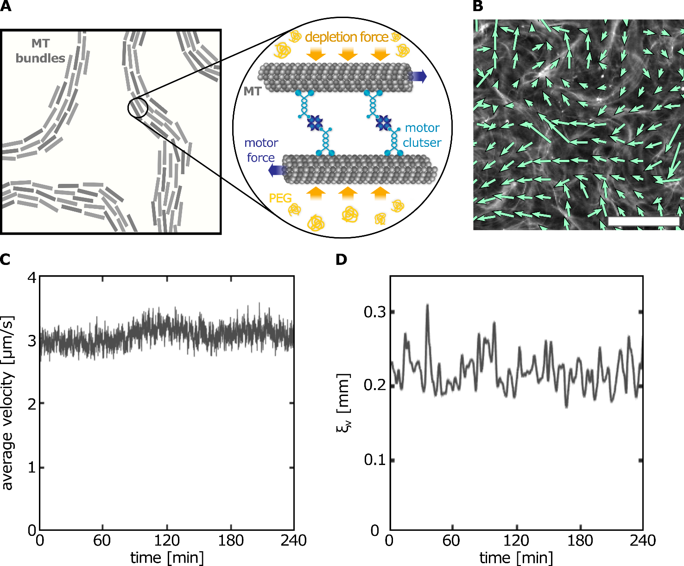
Figure S1: (A) Schematic of a DNA-free MT-kinesin active fluid. Left: PEG-bundled MT filaments. Right: kinesin-streptavidin motor clusters generating shear by sliding antiparallel MTs filaments. (B) Fluorescence image of an active MT fluid, overlaid with the PIV velocity field (Methods). Scalebar, $200 µm$. (C) Field average velocity magnitude within the field of view of $2 mm x 3.8 mm$ versus time. (D) Velocity-velocity correlation length $ξ_{v}$ versus time.

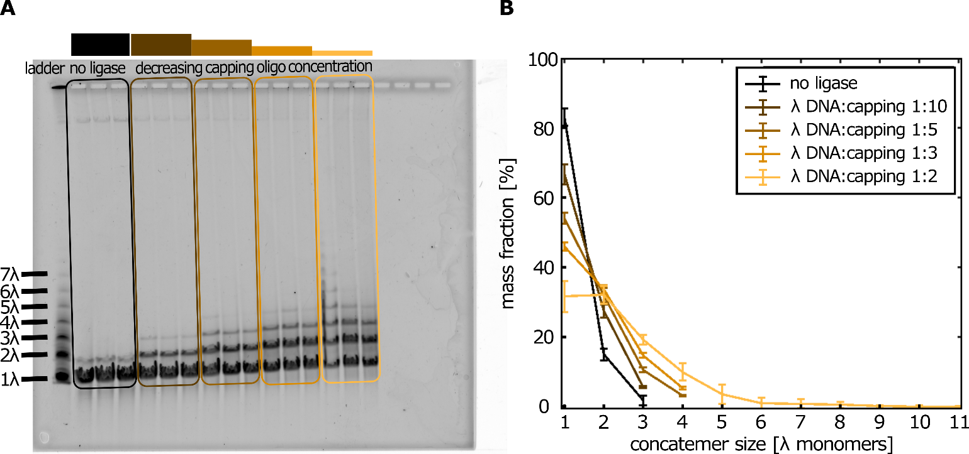
Figure S2: (A) Representative agarose DNA gel in PFGE of λ DNA samples concatenated under varying conditions. Lanes 1-16 from left to right: 1. Ladder (NEB). 2-4. λ DNA incubated at $C_{DNA}=350 ng/μl$ without DNA ligase (negative control). 5-7, λ DNA concatenated at $350 ng/μl$ ($\sim 17 nM$λ DNA monomers) with capping oligo at a 10:1 (capping: DNA molar ratio). 8-10, 5:1 molar ratio. 11-13, 3:1 molar ratio. 14:16, 2:1 molar ratio. (B) Quantification of polymer length distributions by mass fraction at each length, based on fluorescence intensity normalized by the total intensity. Error bars represent the standard deviation across three replicate gel lanes per condition.

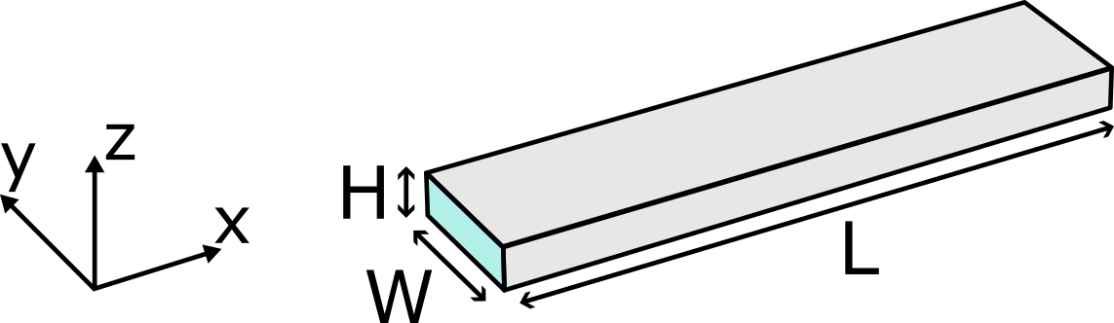
Figure S3: Schematic of the flow-channel geometry. Unless otherwise stated, the dimensions are $H=0.13 mm$, $W= 2 mm$,$L=22 mm$ such that $H≪W≪L$.

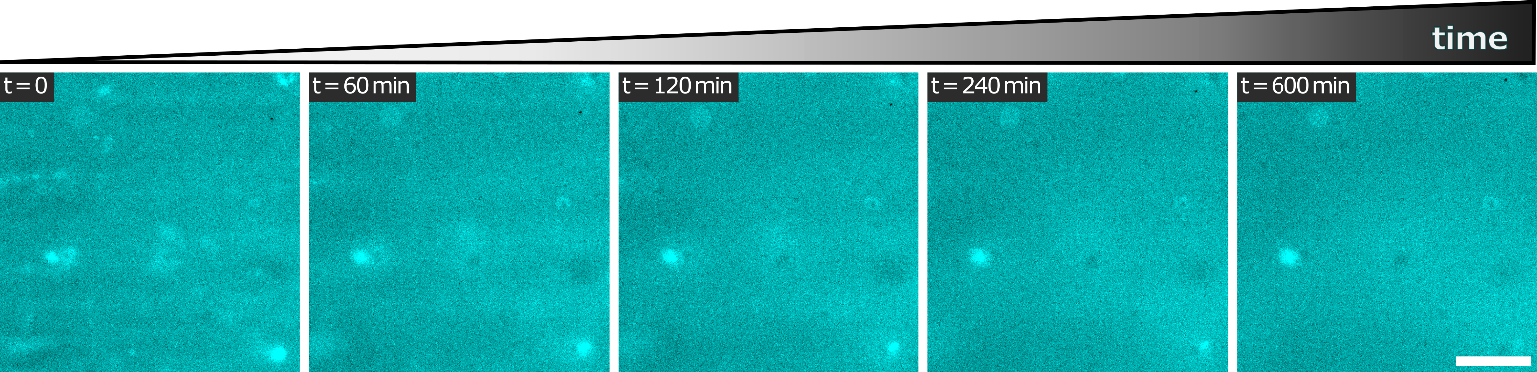
Figure S4: Time-lapse fluorescent images of concatenated λ-DNA labeled with SYBR Green at $C_{DNA}=70 ng/μl$ $L_{DNA}≈40 μm$, in 1% PEG solution, in the absence of MT and kinesin motor clusters. Scale bar, $250 µm$.

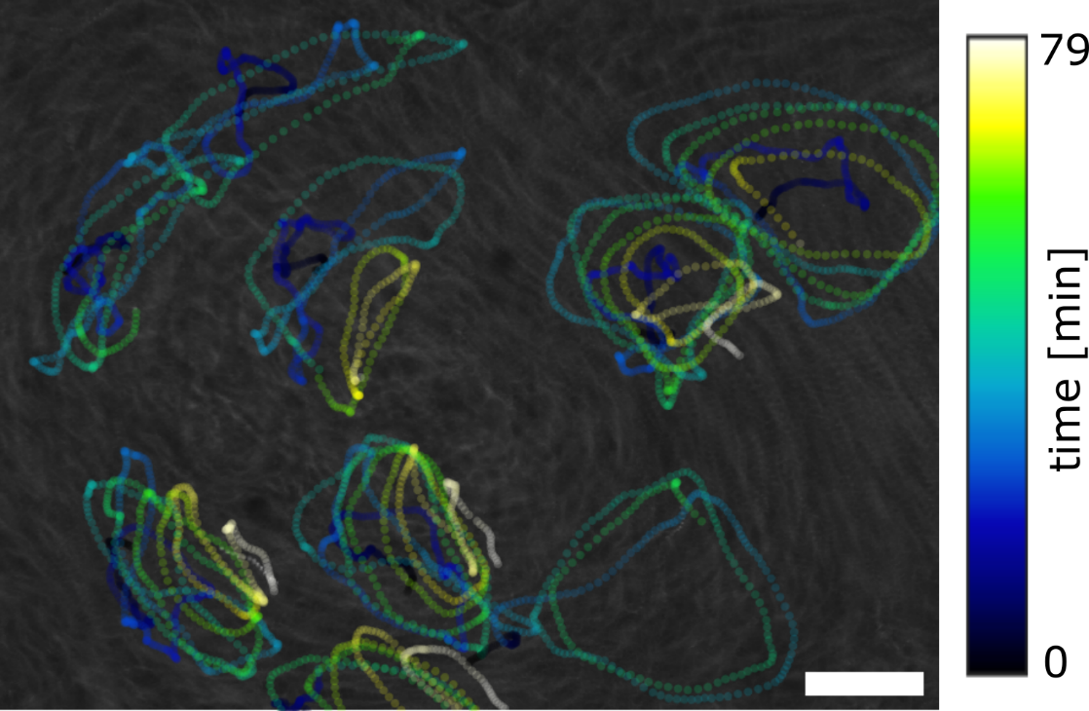
Figure S5: 80 min time-projection of $2 μm$ tracer-particle trajectories from the experiment in Fig. 1G, overlaid on a 90-s time projection of MTs (gray). Scale bar, $250 μm$.

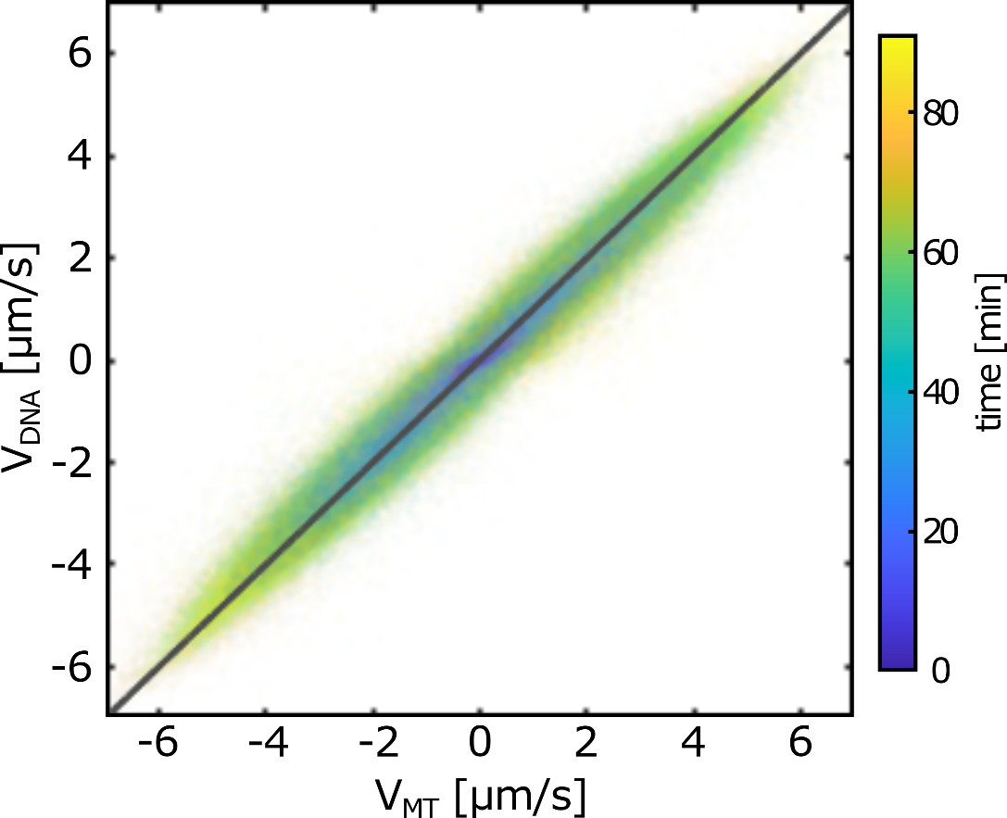
Figure S6: DNA velocity as a function of MT velocity. Gray line indicates a slope of 1. Each data point is the mean velocity within 67x67 μm² region of interest at one time point (color-coded). Both $v_{x}$ and $v_{y}$ components are plotted on the same graph.

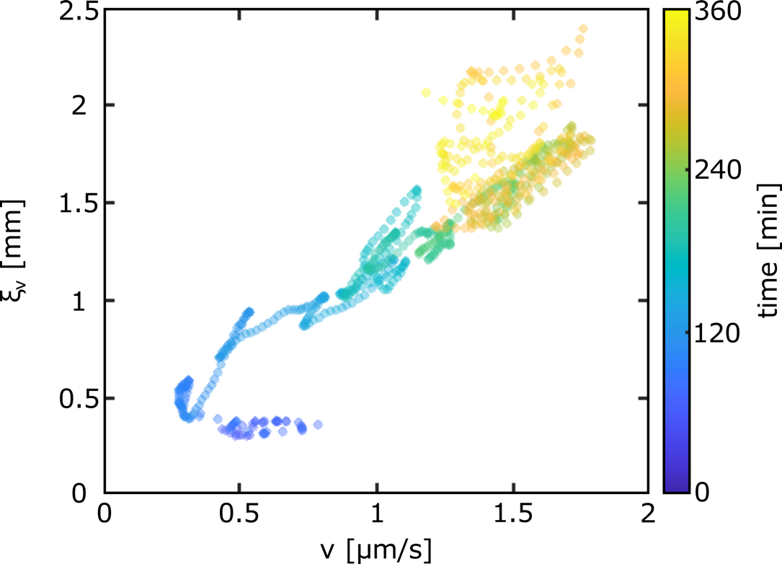
Figure S7: Velocity-velocity correlation length $ξ_{v}$ as a function of velocity magnitude over the entire field of view $〈v〉$. Each point is a time point from the data shown in Fig. 2D. Color encodes experiment time.

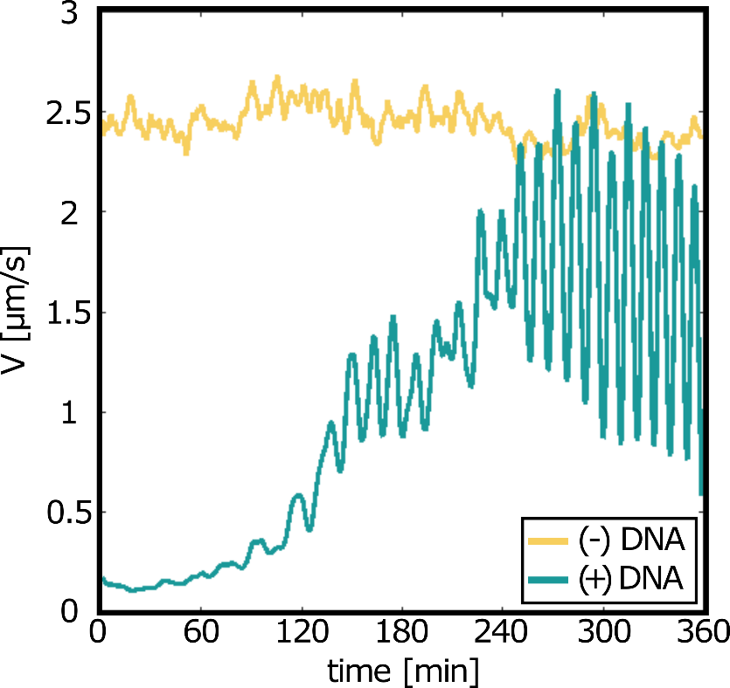
Figure S8: Mean velocity magnitude averaged over the field of view as a function of time, for active fluid samples with (+, green) and without (-, yellow) DNA. + DNA samples were at a concentration of $C_{DNA}=70 ng/μL$.

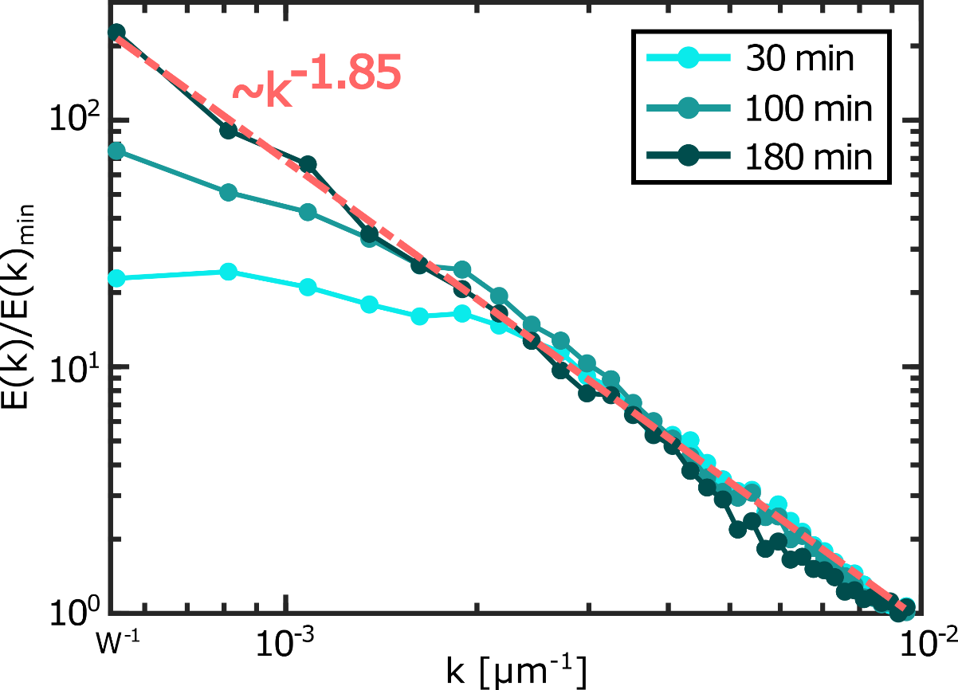
Figure S9: Normalized kinetic energy spectrum as a function of wavenumber $k$, at $t=30, 100, 180min$ (see legend). Spectra are computed from the velocity fields and normalized by each spectrum minimum kinetic energy. The confinement-imposed cutoff appears as $k≈W^{-1}$, corresponding to the inverse channel width. Over an intermediate $k$-range the spectra follow a power law $E\left(k\right)∝k^{-1.85}$.

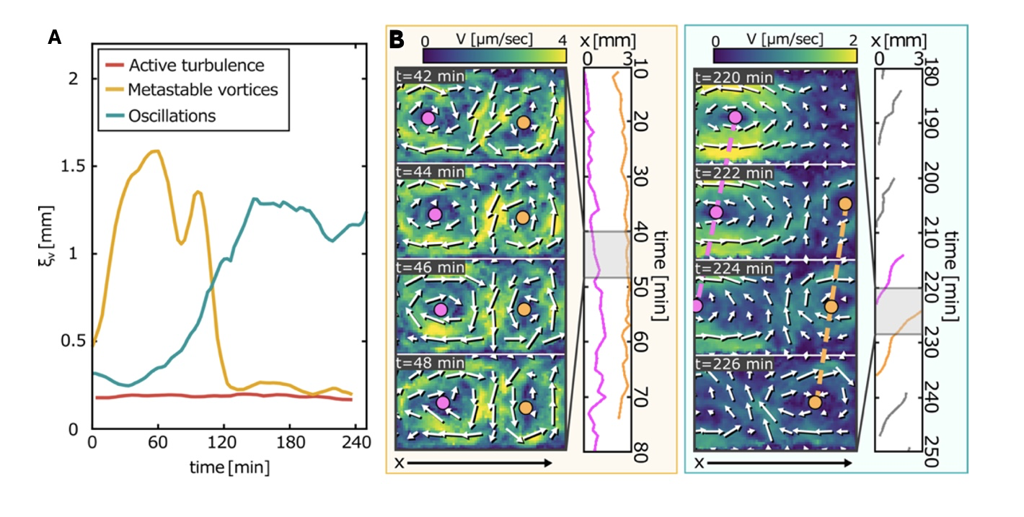
Fig S10: (A)Examples of velocity-velocity correlation length as a function of time for the flows described in (Fig 3C). (B) Time lapse of velocity magnitude heat maps in the metastable vortices (yellow) and oscillatory (blue) regimes, overlaid with arrow indicating the velocity vector fields. Vortex centers are indicated on image. Right insets: vortex center position as a function of time at different time points. Colored tracks correspond to vortex trajectories shown in the heatmaps. A complementary plot of vortex velocity over time is presented in Fig. S11.

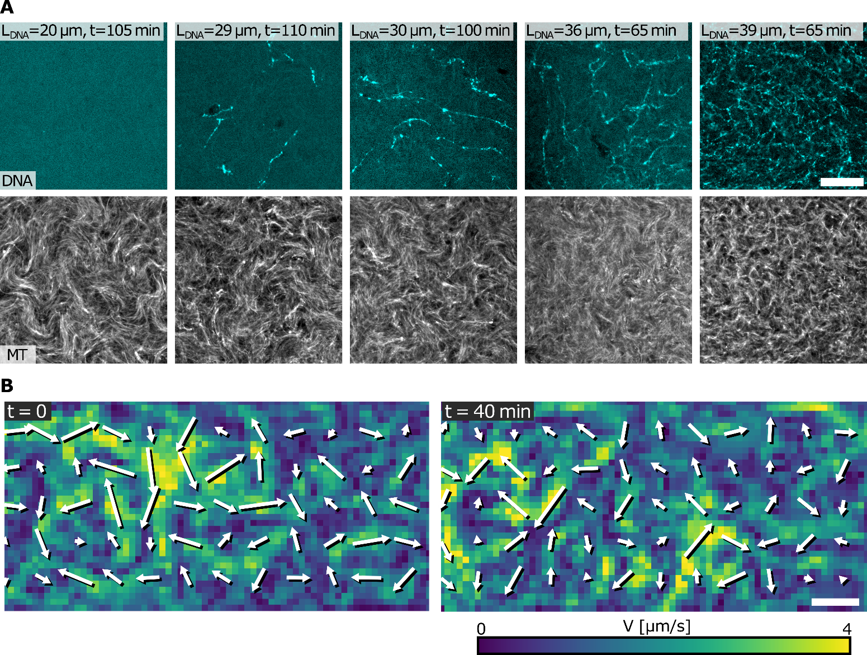
Figure S11: (A) Representative fluorescence microscopy micrographs showing DNA network organization at different average DNA contour lengths. The DNA concentration was fixed at $70 ng/μl$. A simultaneous image shows MT (gray) organization at the same time point. Scale bar, $250 μm$. (B) Velocity magnitude heatmaps and velocity fields of short DNA embedded in a MT active gel. The mean DNA contour length is $L_{DNA}≈27 μm$ and the DNA concentration is $C_{DNA}=70 ng/μl$.

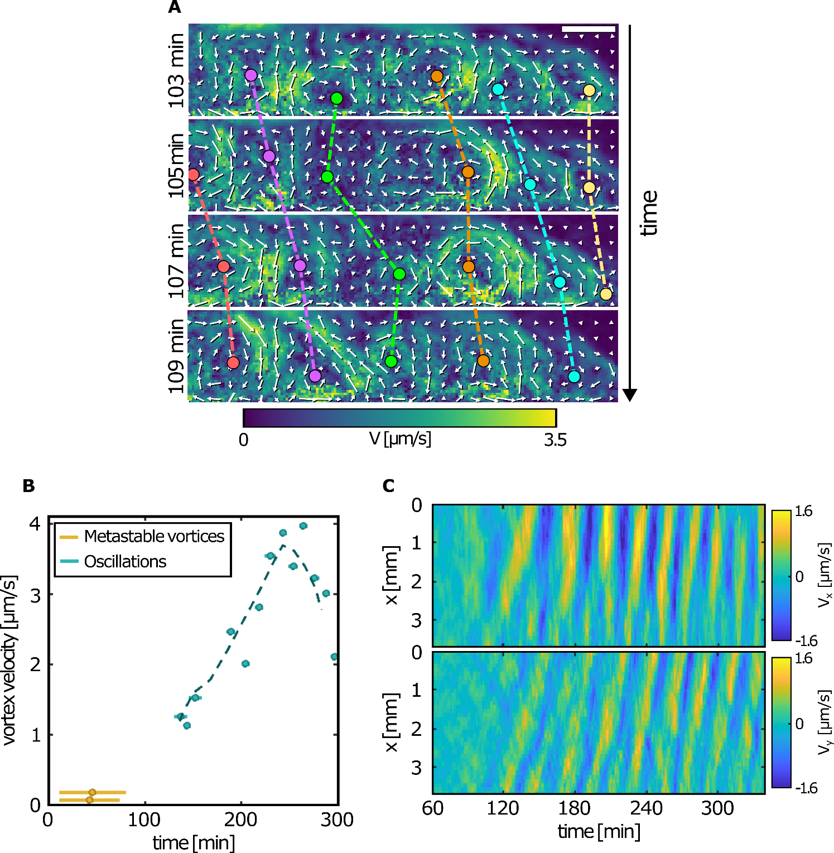
Figure S12: (A) Heatmap of the velocity magnitude versus time, highlighting large-scale vortex dynamics. Vortex centers (colored circles) and their trajectories (dashed lines) are overlaid. $C_{DNA}=70 ng/μl$, $L_{DNA}≈40μm$. Scalebar, $1 mm$. (B) Vortex-center velocity magnitude over time for the standing-vortex state (yellow) and the traveling vortex in the oscillation regime (green). Velocities were obtained from linear fits of the vortex center position versus time. Error bars indicate the tracking intervals of vortices. (C) Space-time plots of the velocity $v_{x}$ and $v_{y}$ in the traveling vortices regime.
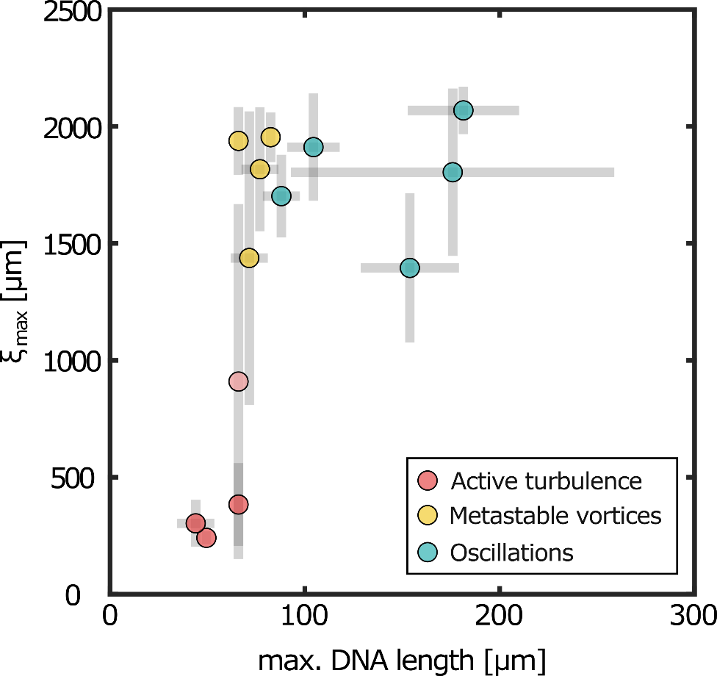
Figure S13: Maximal velocity-velocity correlation length as a function of maximal polymer length in the DNA distribution. Complementary to Fig. 3C.

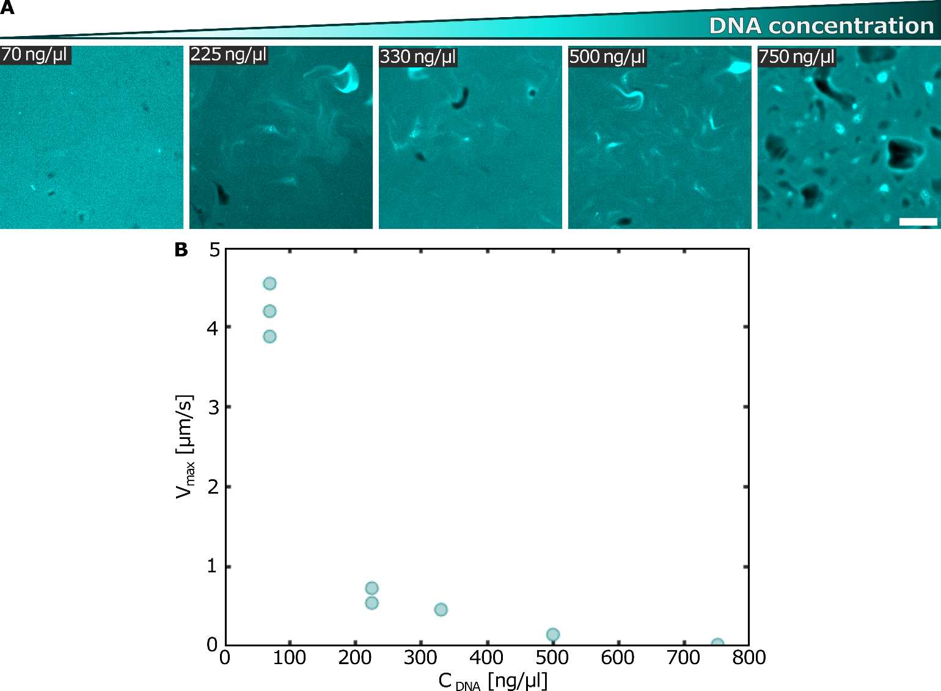
Figure S14: (A) Fluorescence images of λ-DNA in the active fluid, $L_{DNA}=15 μm$, at varying DNA concentrations. Dark domains indicate regions of reduced dye intercalation at high local DNA density. Scale bar, $250 μm$. (B) Maximal velocity magnitude as a function of λ DNA concentration.

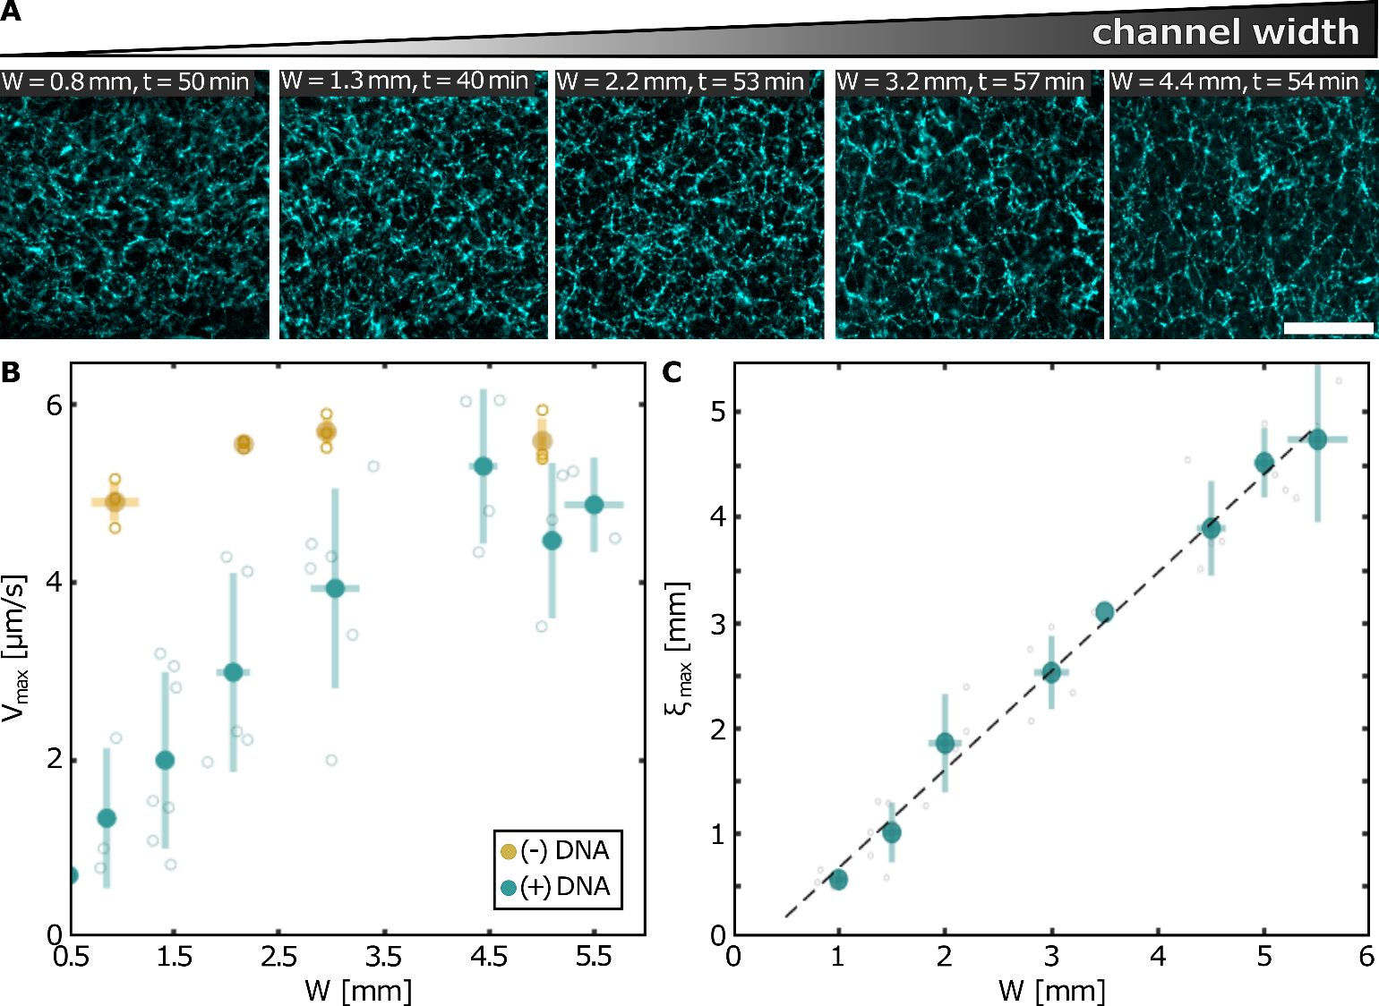
Figure S15: (A) Fluorescent images of DNA network morphologies at varying channel widths, $W$ at DNA concentration $C_{DNA}=70 ng/μl$, and $L_{DNA}=40μm$. Scale bar, $250 μm$. (B) Maximum velocity magnitude as a function of channel width, $W$, with (+) and without (-) DNA. Individual experiment scatter shown as empty markers. (C) Velocity-velocity correlation length as a function of channel width. Error bars represent standard deviation of channel width and correlation length measurements over three repeats. Individual experiments shown as gray empty markers.

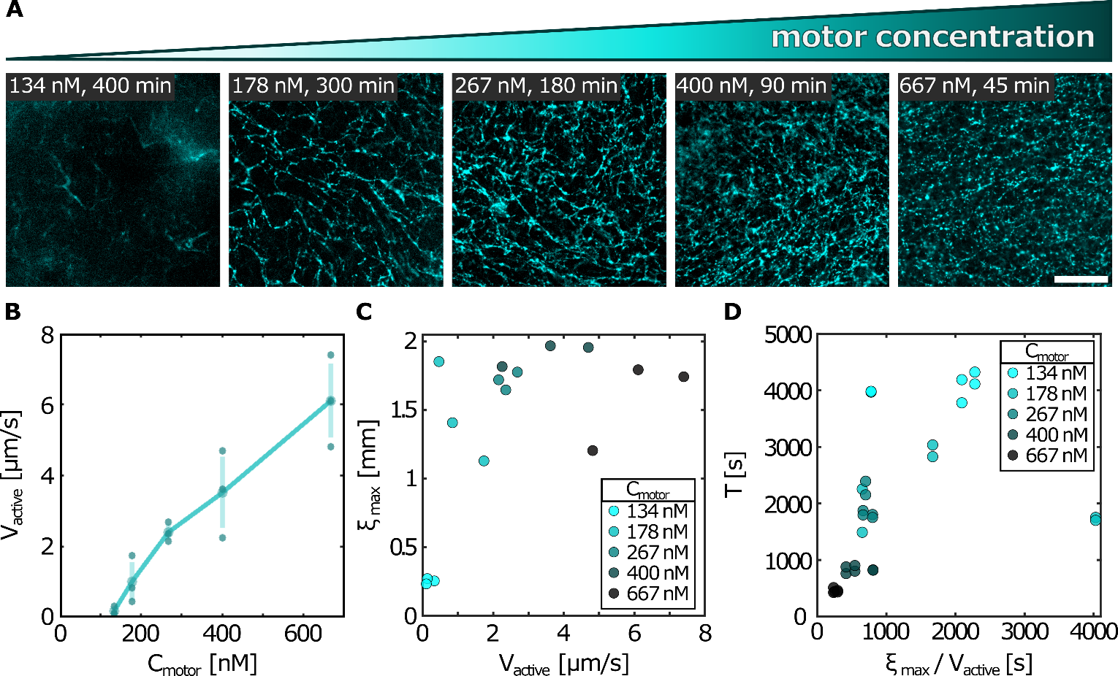
Figure S16: (A) Fluorescence images of the DNA network at varying motor concentrations. DNA concertation is $C_{DNA}=70 ng/μL$ and DNA contour length is $L_{DNA}≈40μm$. Images chosen to capture a formed network. Scale bar, $250μm$. (B) Maximal local velocity magnitude as a function of motor concentration. Filled markers denote individual experiments, and vertical error bars show the standard deviation over three repeats per condition. (C) Maximal velocity-velocity correlation length $ξ_{max}$ as a function of maximal local velocity. Markers color-coded by motor concentration. (D) Oscillation period $T$ as a function of advection timescale.

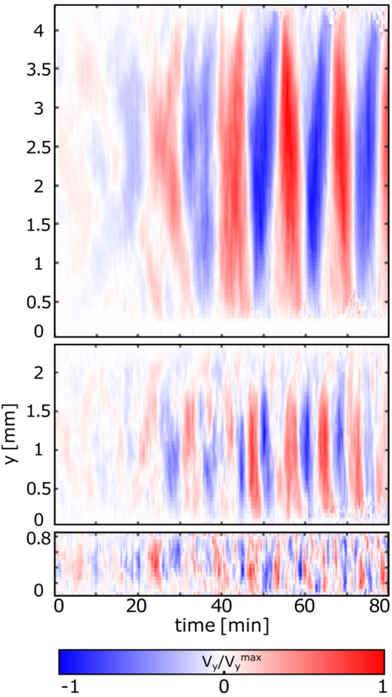
Figure S17: Space-time plots of the transverse velocity component $v_{y}$ along the short axis of the channel, $y$, sampled along the channel short axis $y$ different channel widths. Complementary to Fig. 4B.

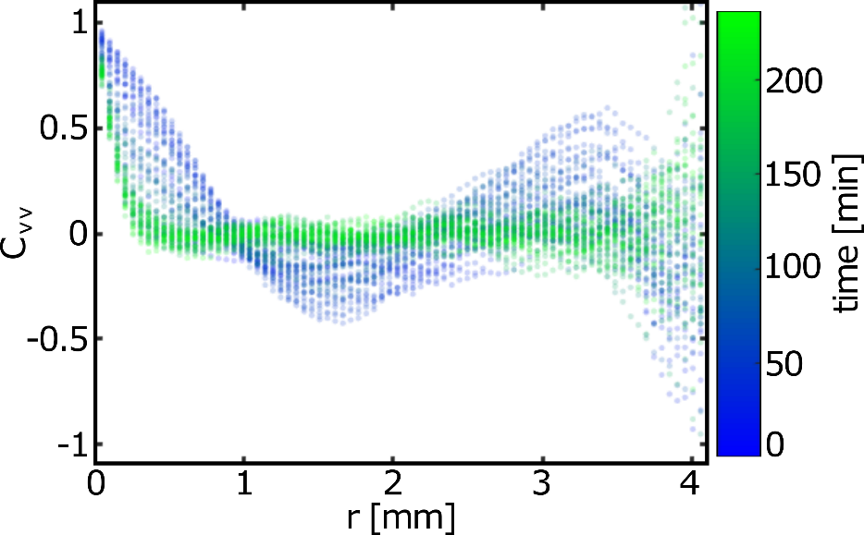
Figure S18: Velocity-velocity correlation function as a function of distance $r$, at different times. DNA concentration $C_{DNA}=70 ng/μl$, average DNA contour length $L_{DNA}≈40 μm$.

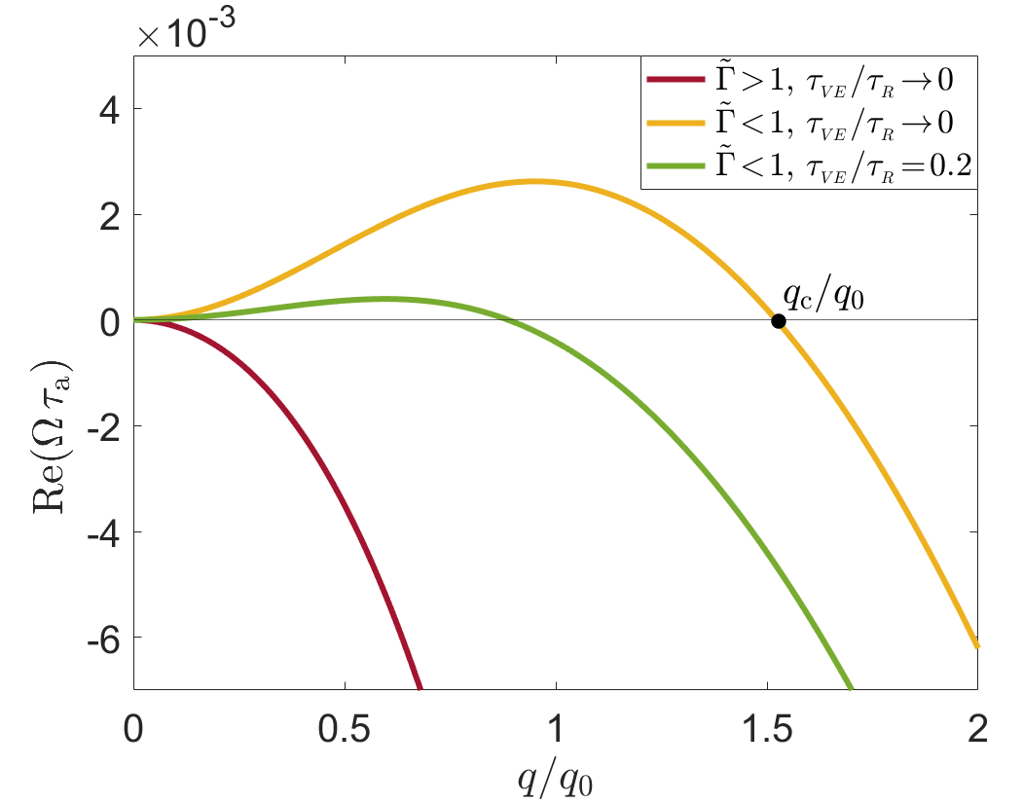
Figure S19: The stationary (non-oscillatory) instability. The real part of the stability spectrum $Ω(q)$ of Eq. (10), $Re\left(Ωτ_{a}\right)$ (multiplied by $τ_{a}=Γl_{a}^{2}/α$), is plotted vs. $q/q_{0}$ (with $q_{0}≡π/W$, where $W$ is the system size) for vanishing and relatively small $τ_{VE}/τ_{R}$ values (and setting $ϕ=0$). For the entire range of $q$’s, the imaginary part of $Ω\left(q\right)$ vanishes, $Im\left[Ω\left(q\right)\right]=0$, and is not plotted. The bottom (red) curve corresponds to $\frac{τ_{VE}}{τ_{R}}={10}^{-7}$ (i.e. vanishing viscoelasticity) and $\tilde{Γ}=2>1$ . The latter does not satisfy the inequality in (11) and indeed the system is stable for all $q$’s in this case, $Re\left[Ω\left(q\right)\right]<0$ . The upper (yellow) curve corresponds to the same parameters as of the red curve, except that $\tilde{Γ}=0.4<1$, this time satisfying the inequality in (11). As predicted, in this case a continuous range of unstable modes, corresponding to $0<q<q_{c}$, emerge (featuring $Re\left[Ω\left(q\right)\right]>0 , q_{c}/q_{0}$ is marked by the filled circle). The middle (green) curve corresponds to the same parameters as of the yellow curve, except that $τ_{VE}/τ_{R}=0.2$is finite, i.e., a viscoelastic response exists. As predicted, viscoelasticity tends to stabilize the system, leading to a shrinking instability range and hence to a growing length scale. The value of $τ_{VE}/τ_{R}$ has been selected such that $q_{c}≃q_{0}$, implying that the only unstable mode corresponds to $q_{0}$ (i.e., to the system size, recall that the wavenumber accessible to the finite systems satisfy $q>q_{c}$.) The parameters used in all curves are $q_{0}l_{a}=π/20$ , $l_{h}/l_{a}=5$, and $τ_{R}/τ_{a}=10$ .

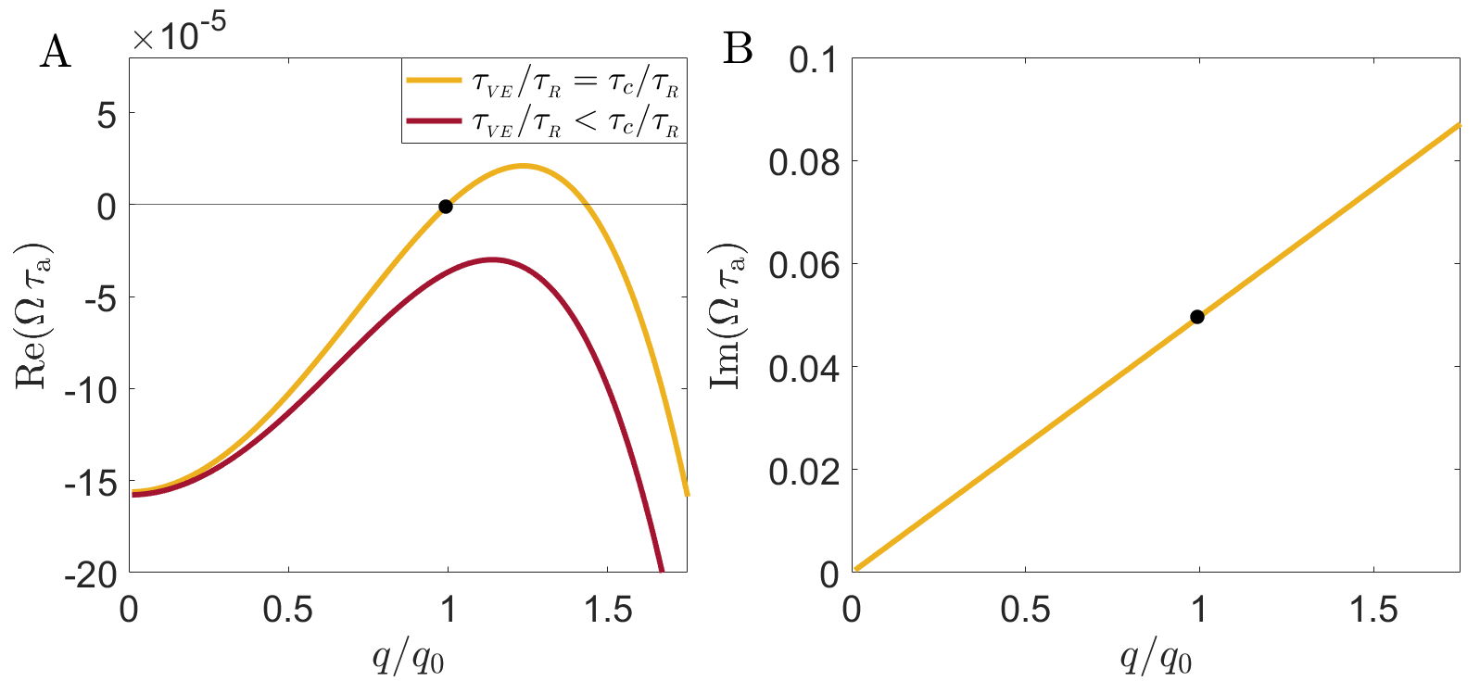
Figure S20: The oscillatory (Hopf) instability. (A) $Re\left(Ωτ_{a}\right)$ vs. $q/q_{0}$ as in Fig. S19, except that we use larger $τ_{VE}/τ_{R}$values and set a larger $l_{h}/l_{a}=30$, according to the expected length scale separation $l_{a}≪W≪l_{h}$, see text. The red curve is slightly below the onset of instability, corresponding to $τ_{VE}=0.99τ_{c}$ where $τ_{VE}=τ_{c}$ corresponds to the value for which $q_{0}$ becomes unstable (see sup text). The latter is marked by a filled circle on the yellow curve plotted for${ τ}_{VE}=τ_{c}$. The onset of instability occurs between the two curves. (B) $Im\left(Ωτ_{0}\right)$ vs $q/q_{0}$ for $τ_{VE}=τ_{c}$ , demonstrating the oscillatory nature of the instability. The filled circle marks the frequency of oscillations at the system scale, i.e., at $q=q_{0}$ , see text.

Suplementary Videos Captions:
Video S1: Time-averaged (90 s) fluorescence intensity projection of labeled microtubules overlaid with tracer particle trajectories in a mixed MT-DNA active composite (microtubules shown in gray, tracers in yellow). DNA concentration: $C_{DNA}=70ng/μl,$ kinesin motor concentration $C_{motor}=267nM$. The video corresponds to the data shown in Fig. 1C, D. Time stamp indicates elapsed time since the start of acquisition. Scalebar, $400μm$.
Video S2: DNA fluorescence intensity time-lapse in the active-turbulent state. Mean $L_{DNA}≈23μm$, kinesin motor concentration$: C_{motor}=267nM$. Time stamp indicates the time since beginning of acquisition. Scalebar, $500μm$.
Video S3: MT fluorescence intensity time-lapse in the same MT-DNA active composite shown in Video S2, captured in the active-turbulent state. Experimental concentrations as in Video S2. Scalebar, $500μm$.
Video S4: DNA fluorescence intensity time-lapse forming metastable vortices. Mean $L_{DNA}≈30μm$, kinesin motor concentration$: C_{motor}=267nM$. Time stamp indicates the time since beginning of acquisition. Scalebar, $500 μm$.
Video S5: MT fluorescence intensity time-lapse in the same MT-DNA active composite shown in Video S4, forming metastable vortices. Experimental concentrations as in Video S4. Scalebar, $500μm$.
Video S6: DNA fluorescence intensity time-lapse in the oscillations state. Mean $L_{DNA}≈58μm$, kinesin motor concentration$: C_{motor}=267nM$. Time stamp indicates the time since beginning of acquisition. Scalebar, $500μm$.
Video S7: MT fluorescence intensity time-lapse in the same a MT-DNA active composite shown in Video S6, in the oscillations state. Experimental concentrations as in video S6. Scalebar, $500μm$.

