Supplementary Material 1. Participant Demographics (N = 27)
Characteristic | n | % | Mean Age (SD) | Age Range
Total | 27 | 100 | 15.37 (0.90) | 14-17
Gender
Female | 15 | 55.6 | 15.33 (0.82) | 14-16
Male | 12 | 44.4 | 15.42 (1.00) | 14-17
Focus Group Discussion (FGD)
FGD1, Female | 8 | 29.6 | 15.00 (0.93) | 14-16
FGD2, Female | 7 | 25.9 | 15.57 (0.53) | 15-16
FGD3, Male | 6 | 22.2 | 15.33 (1.21) | 14-17
FGD4, Male | 6 | 22.2 | 15.67 (0.82) | 14-16

Supplementary Material 2. Distribution of student responses across subthemes and categories within overarching themes.

Supplementary Material 3. Coding tree of eSHEPP illustrating overarching themes and subthemes
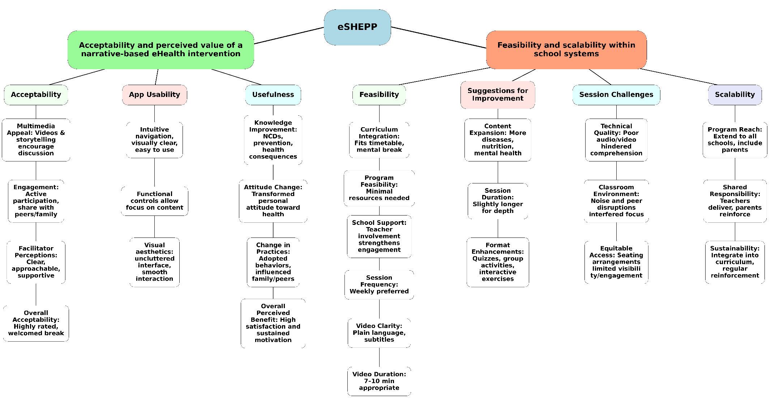s

