Country | ISO Code | PPCA Status | OECD Status | Coal Share 2015 | GDPpc 2015  ($1000) | Prob. 2015 | Prob. 2025 | Prob. 2045
Afghanistan | AFG | - | Non-OECD | 0.05 | 1.37 | 0.26 | 0.32 | 0.36
Angola | AGO | PPCA | Non-OECD | 0 | 6.12 | 0.42 | 0.44 | 0.44
Albania | ALB | PPCA | Non-OECD | 0 | 8.33 | 0.47 | 0.53 | 0.66
Argentina | ARG | - | Non-OECD | 0.02 | 15.18 | 0.61 | 0.76 | 0.91
Australia | AUS | - | OECD | 0.63 | 41.72 | 0.37 | 0.89 | 0.99
Austria | AUT | PPCA | OECD | 0.08 | 39.42 | 0.91 | 0.97 | 0.99
Burundi | BDI | - | Non-OECD | 0.1 | 0.42 | 0.19 | 0.31 | 0.35
Belgium | BEL | PPCA | OECD | 0.06 | 36.14 | 0.9 | 0.95 | 0.99
Burkina Faso | BFA | - | Non-OECD | 0.1 | 1.27 | 0.21 | 0.33 | 0.39
Bangladesh | BGD | - | Non-OECD | 0.02 | 1.78 | 0.3 | 0.05 | 0.36
Bulgaria | BGR | - | OECD | 0.46 | 13.73 | 0.1 | 0.54 | 0.9
Bosnia & Herzegovina | BIH | - | Non-OECD | 0.64 | 8.89 | 0.02 | 0.01 | 0.71
Brazil | BRA | - | Non-OECD | 0.05 | 11.81 | 0.49 | 0.61 | 0.75
Botswana | BWA | - | Non-OECD | 0.96 | 14.95 | 0.01 | 0.01 | 0.8
Central African Republic | CAF | - | Non-OECD | 0.1 | 0.8 | 0.2 | 0.31 | 0.35
Canada | CAN | PPCA | OECD | 0.1 | 38.23 | 0.9 | 0.96 | 0.98
Switzerland | CHE | PPCA | OECD | 0 | 41.48 | 0.95 | 0.97 | 0.99
Chile | CHL | - | OECD | 0.37 | 15.66 | 0.18 | 0.53 | 0.92
China | CHN | - | Non-OECD | 0.7 | 10.47 | 0.02 | 0.1 | 0.54
Colombia | COL | - | OECD | 0.12 | 9.64 | 0.34 | 0.4 | 0.68
Costa Rica | CRI | PPCA | OECD | 0 | 11.97 | 0.56 | 0.65 | 0.81
Czechia | CZE | - | OECD | 0.53 | 26.64 | 0.19 | 0.86 | 0.99
Germany | DEU | PPCA | OECD | 0.44 | 36.56 | 0.51 | 0.88 | 0.98
Denmark | DNK | PPCA | OECD | 0.25 | 36.74 | 0.76 | 0.95 | 0.98
Dominican Republic | DOM | - | Non-OECD | 0.13 | 10.45 | 0.34 | 0.34 | 0.66
Spain | ESP | PPCA | OECD | 0.19 | 29.34 | 0.69 | 0.88 | 0.93
Ethiopia | ETH | PPCA | Non-OECD | 0 | 1.09 | 0.31 | 0.32 | 0.38
Finland | FIN | PPCA | OECD | 0.13 | 34.2 | 0.83 | 0.93 | 0.98
Fiji | FJI | PPCA | Non-OECD | 0.05 | 4.68 | 0.32 | 0.41 | 0.51
France | FRA | PPCA | OECD | 0.02 | 33.07 | 0.89 | 0.93 | 0.97
United Kingdom | GBR | PPCA | OECD | 0.23 | 35.61 | 0.76 | 0.95 | 0.98
Guinea | GIN | - | Non-OECD | 0.1 | 1.06 | 0.2 | 0.35 | 0.53
Gambia | GMB | - | Non-OECD | 0.1 | 1.75 | 0.21 | 0.35 | 0.44
Greece | GRC | PPCA | OECD | 0.43 | 27.5 | 0.32 | 0.89 | 0.95
Guatemala | GTM | - | Non-OECD | 0.21 | 5.21 | 0.16 | 0.15 | 0.4
Hong Kong SAR China | HKG | - | Non-OECD | 0.65 | 47.29 | 0.46 | 0.99 | 1
Honduras | HND | - | Non-OECD | 0.01 | 4.17 | 0.36 | 0.37 | 0.48
Croatia | HRV | PPCA | OECD | 0.21 | 17.82 | 0.4 | 0.63 | 0.82
Hungary | HUN | PPCA | OECD | 0.19 | 19.5 | 0.46 | 0.79 | 0.92
Indonesia | IDN | - | Non-OECD | 0.56 | 5.18 | 0.03 | 0.02 | 0.41
India | IND | - | Non-OECD | 0.75 | 4.35 | 0.01 | 0.03 | 0.36
Ireland | IRL | PPCA | OECD | 0.26 | 38.78 | 0.78 | 0.96 | 0.99
Israel | ISR | PPCA | OECD | 0.45 | 28.45 | 0.31 | 0.92 | 0.98
Italy | ITA | PPCA | OECD | 0.16 | 28.17 | 0.7 | 0.89 | 0.95
Japan | JPN | - | OECD | 0.33 | 34.58 | 0.62 | 0.78 | 0.97
Kazakhstan | KAZ | - | Non-OECD | 0.72 | 14.02 | 0.02 | 0.72 | 0.91
Kyrgyzstan | KGZ | - | Non-OECD | 0.13 | 2.45 | 0.19 | 0.19 | 0.39
Cambodia | KHM | - | Non-OECD | 0.48 | 2.37 | 0.03 | 0 | 0.01
South Korea | KOR | - | OECD | 0.43 | 31.93 | 0.41 | 0.82 | 1
Laos | LAO | - | Non-OECD | 0.05 | 3.06 | 0.29 | 0 | 0.01
Liberia | LBR | - | Non-OECD | 0.1 | 0.49 | 0.19 | 0.31 | 0.36
Liechtenstein | LIE | PPCA | Non-OECD | 0 | 234.47 | 1 | 1 | 1
Sri Lanka | LKA | - | Non-OECD | 0.34 | 5.89 | 0.09 | 0.08 | 0.64
Lesotho | LSO | - | Non-OECD | 0.1 | 1.36 | 0.21 | 0.34 | 0.42
Lithuania | LTU | PPCA | OECD | 0 | 17.71 | 0.69 | 0.81 | 0.93
Luxembourg | LUX | PPCA | OECD | 0 | 81.67 | 1 | 1 | 1
Latvia | LVA | PPCA | OECD | 0 | 15.64 | 0.64 | 0.78 | 0.92
Morocco | MAR | - | Non-OECD | 0.56 | 4.78 | 0.03 | 0.04 | 0.7
Madagascar | MDG | - | Non-OECD | 0.1 | 0.89 | 0.2 | 0.17 | 0.33
Mexico | MEX | PPCA | OECD | 0.11 | 14.76 | 0.47 | 0.63 | 0.84
Marshall Islands | MHL | PPCA | Non-OECD | 0 | 6.47 | 0.43 | 0.43 | 0.42
North Macedonia | MKD | PPCA | Non-OECD | 0.58 | 9.81 | 0.03 | 0.08 | 0.8
Mali | MLI | - | Non-OECD | 0.1 | 1.23 | 0.21 | 0.32 | 0.36
Myanmar (Burma) | MMR | - | Non-OECD | 0.02 | 1.27 | 0.29 | 0.31 | 0.41
Montenegro | MNE | PPCA | Non-OECD | 0.5 | 9.52 | 0.05 | 0.17 | 0.71
Mongolia | MNG | - | Non-OECD | 0.93 | 5.78 | 0 | 0 | 0.04
Mauritania | MRT | - | Non-OECD | 0.1 | 2.07 | 0.22 | 0.36 | 0.45
Malawi | MWI | - | Non-OECD | 0.1 | 0.93 | 0.2 | 0 | 0.24
Malaysia | MYS | - | Non-OECD | 0.42 | 14.99 | 0.13 | 0.38 | 0.92
Niger | NER | - | Non-OECD | 0.42 | 0.71 | 0.04 | 0.31 | 0.34
Niue | NIU | PPCA | Non-OECD | 0 | 9.67 | 0.51 | 0.51 | 0.51
Netherlands | NLD | PPCA | OECD | 0.39 | 41.86 | 0.7 | 0.92 | 0.99
New Zealand | NZL | PPCA | OECD | 0.04 | 28.65 | 0.83 | 0.89 | 0.95
Panama | PAN | - | Non-OECD | 0.07 | 14.17 | 0.51 | 0.62 | 0.94
Peru | PER | PPCA | Non-OECD | 0.01 | 9.87 | 0.5 | 0.65 | 0.87
Philippines | PHL | - | Non-OECD | 0.45 | 3.64 | 0.04 | 0.07 | 0.46
Papua New Guinea | PNG | - | Non-OECD | 0.05 | 2.84 | 0.29 | 0.3 | 0.5
Poland | POL | - | OECD | 0.81 | 20.64 | 0.03 | 0.34 | 0.92
North Korea | PRK | - | Non-OECD | 0.21 | 1.31 | 0.12 | 0.18 | 0.31
Portugal | PRT | PPCA | OECD | 0.29 | 21.76 | 0.38 | 0.82 | 0.91
Romania | ROU | - | OECD | 0.28 | 12.4 | 0.21 | 0.67 | 0.81
Russia | RUS | - | Non-OECD | 0.15 | 16.94 | 0.46 | 0.71 | 0.93
Rwanda | RWA | - | Non-OECD | 0.1 | 1.31 | 0.21 | 0.33 | 0.39
Senegal | SEN | PPCA | Non-OECD | 0 | 1.8 | 0.33 | 0.33 | 0.41
Singapore | SGP | - | Non-OECD | 0.01 | 58.49 | 0.99 | 1 | 1
Sierra Leone | SLE | - | Non-OECD | 0.1 | 0.93 | 0.2 | 0.32 | 0.37
El Salvador | SLV | PPCA | Non-OECD | 0 | 7.31 | 0.45 | 0.48 | 0.6
Somalia | SOM | - | Non-OECD | 0.1 | 0.65 | 0.2 | 0.3 | 0.3
Serbia | SRB | - | Non-OECD | 0.76 | 11.76 | 0.02 | 0.06 | 0.59
Slovakia | SVK | PPCA | OECD | 0.13 | 24.61 | 0.67 | 0.87 | 0.97
Slovenia | SVN | - | OECD | 0.3 | 28.64 | 0.53 | 0.8 | 0.97
Sweden | SWE | PPCA | OECD | 0.01 | 39.89 | 0.94 | 0.97 | 0.99
Chad | TCD | - | Non-OECD | 0.1 | 1.42 | 0.21 | 0.32 | 0.38
Thailand | THA | - | Non-OECD | 0.19 | 9.32 | 0.24 | 0.49 | 0.86
Tajikistan | TJK | - | Non-OECD | 0.02 | 2.03 | 0.31 | 0.27 | 0.45
Turkey | TUR | - | OECD | 0.29 | 12.98 | 0.21 | 0.21 | 0.86
Tuvalu | TUV | PPCA | Non-OECD | 0 | 5.44 | 0.41 | 0.4 | 0.39
Taiwan | TWN | - | Non-OECD | 0.47 | 22.92 | 0.2 | 0.8 | 0.99
Uganda | UGA | - | Non-OECD | 0.1 | 1.32 | 0.21 | 0.33 | 0.39
Ukraine | UKR | - | Non-OECD | 0.35 | 7.16 | 0.1 | 0.44 | 0.73
Uruguay | URY | PPCA | Non-OECD | 0 | 15.04 | 0.63 | 0.75 | 0.91
United States | USA | - | OECD | 0.34 | 46.25 | 0.82 | 0.97 | 1
Uzbekistan | UZB | - | Non-OECD | 0.04 | 3.11 | 0.3 | 0.29 | 0.53
Vietnam | VNM | - | Non-OECD | 0.3 | 3.77 | 0.1 | 0.03 | 0.39
Vanuatu | VUT | PPCA | Non-OECD | 0.05 | 5.33 | 0.34 | 0.42 | 0.54
South Africa | ZAF | - | Non-OECD | 0.93 | 10.22 | 0.01 | 0.37 | 0.79
Zimbabwe | ZWE | - | Non-OECD | 0.47 | 0.43 | 0.03 | 0 | 0.24
Table SF1. List of the 41 current PPCA members and the 62 non-participating nations which had >1% coal-power-shares in 2015 (Coal Share 2015). The PPCA column distinguishes the two categories. Both inputs to the logit model, i.e. 2015 coal-power-shares and GDP per capita (in nominal 2005 USD), are shown, along with returned accession probabilities in 2015, 2025, and 2045 (Prob.year). Rows in bold indicate new PPCA signees since the Jewell et al., (2019) study.

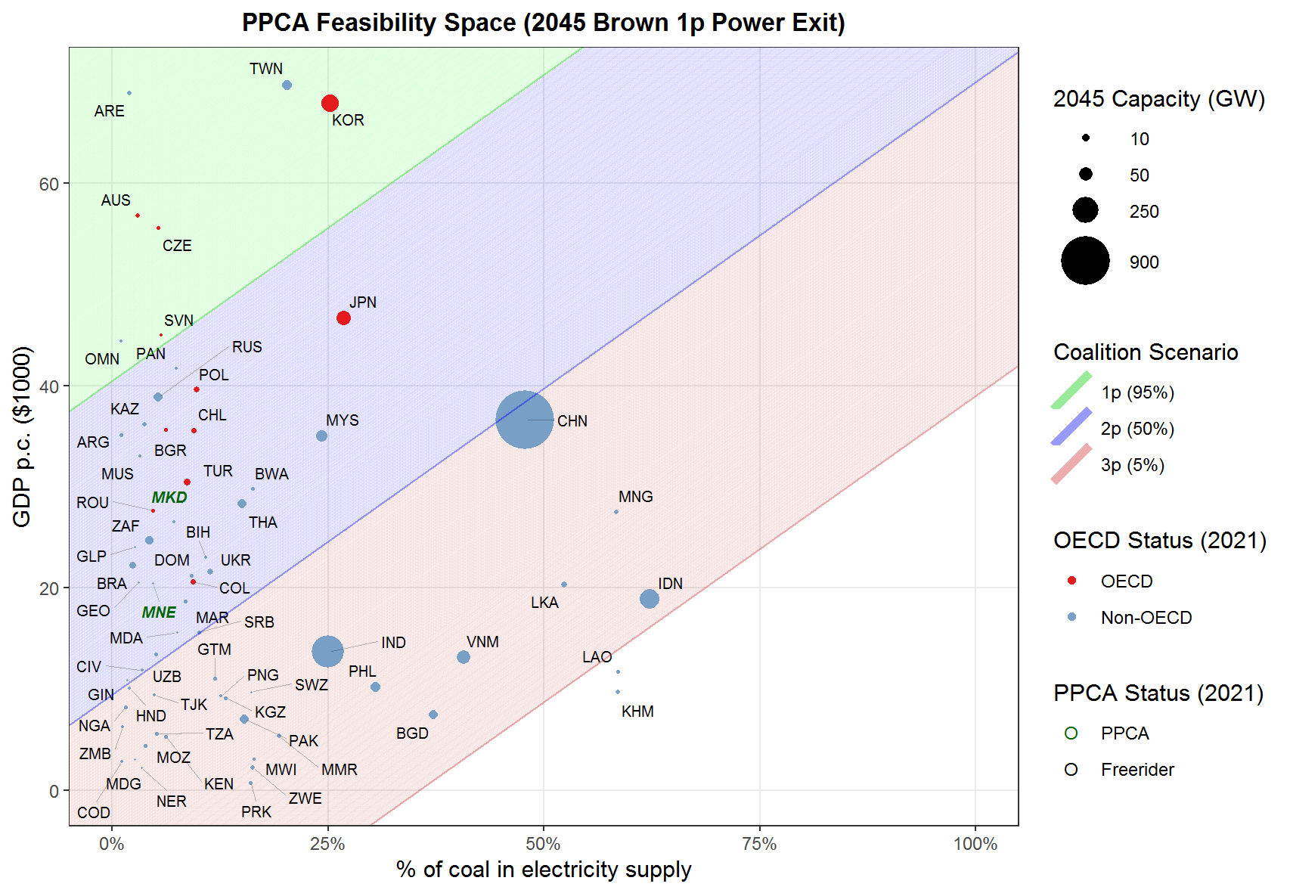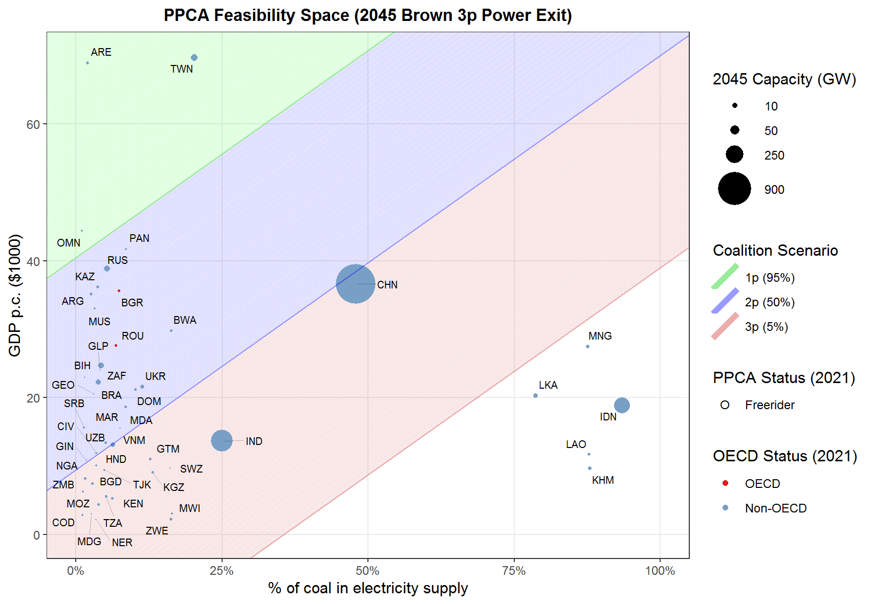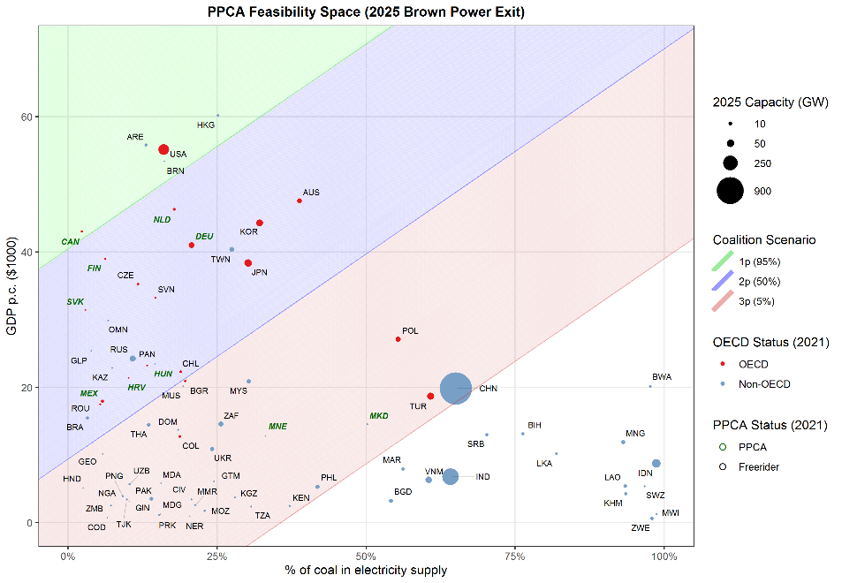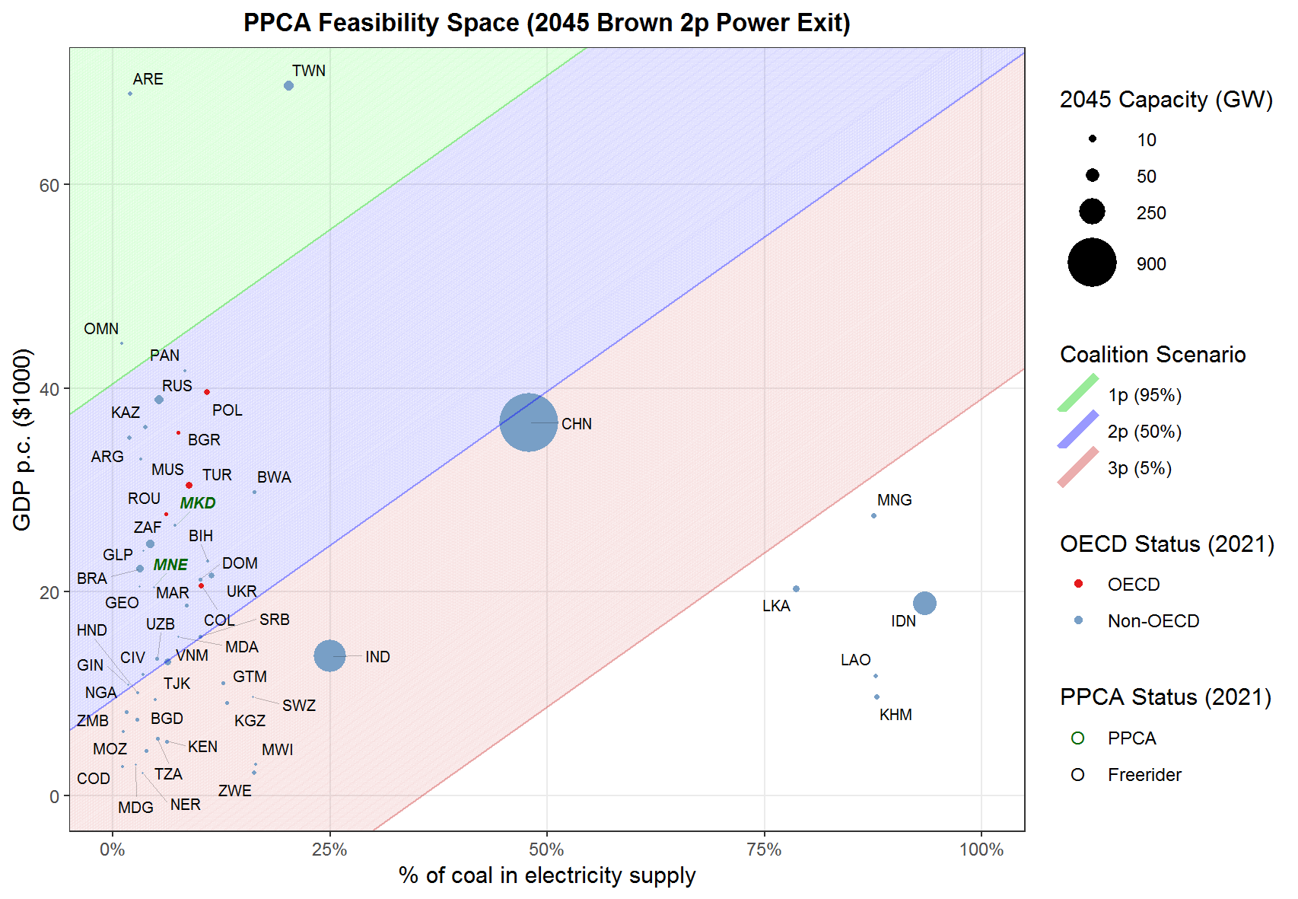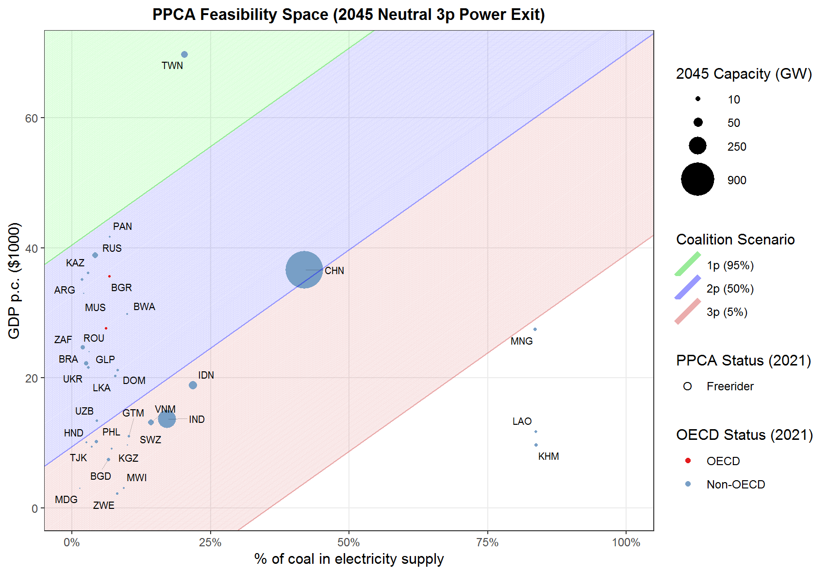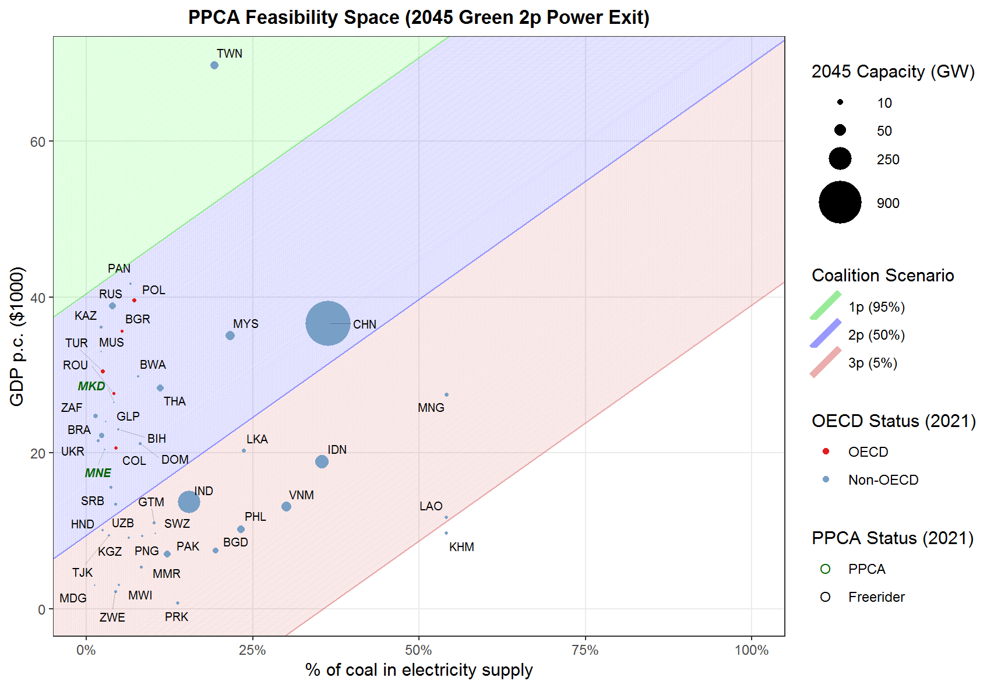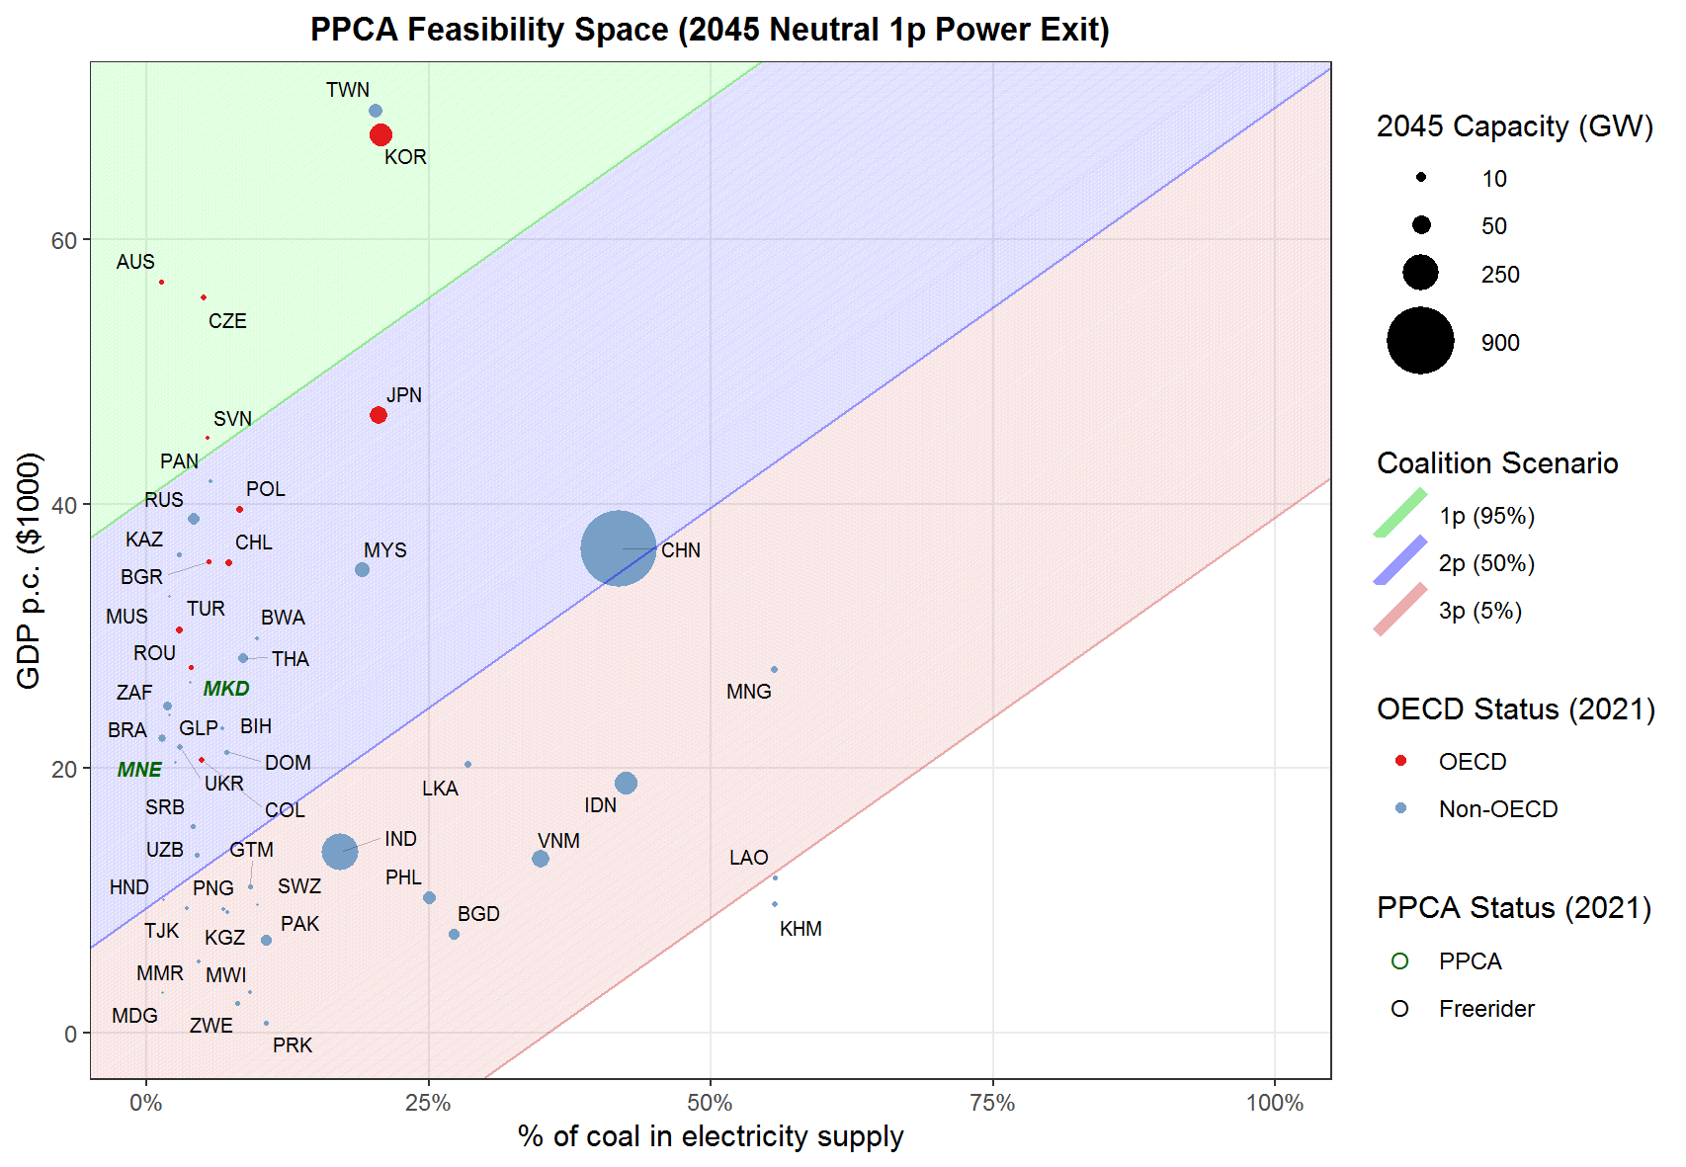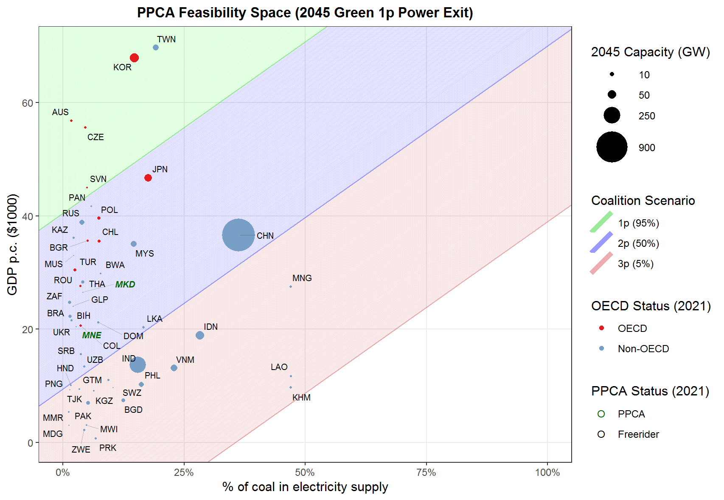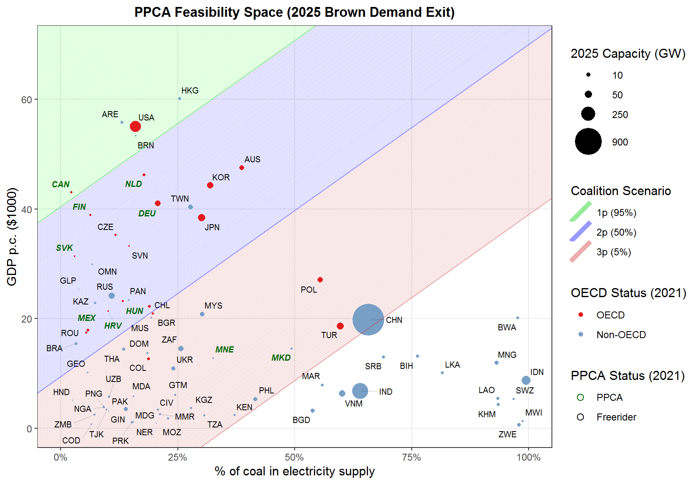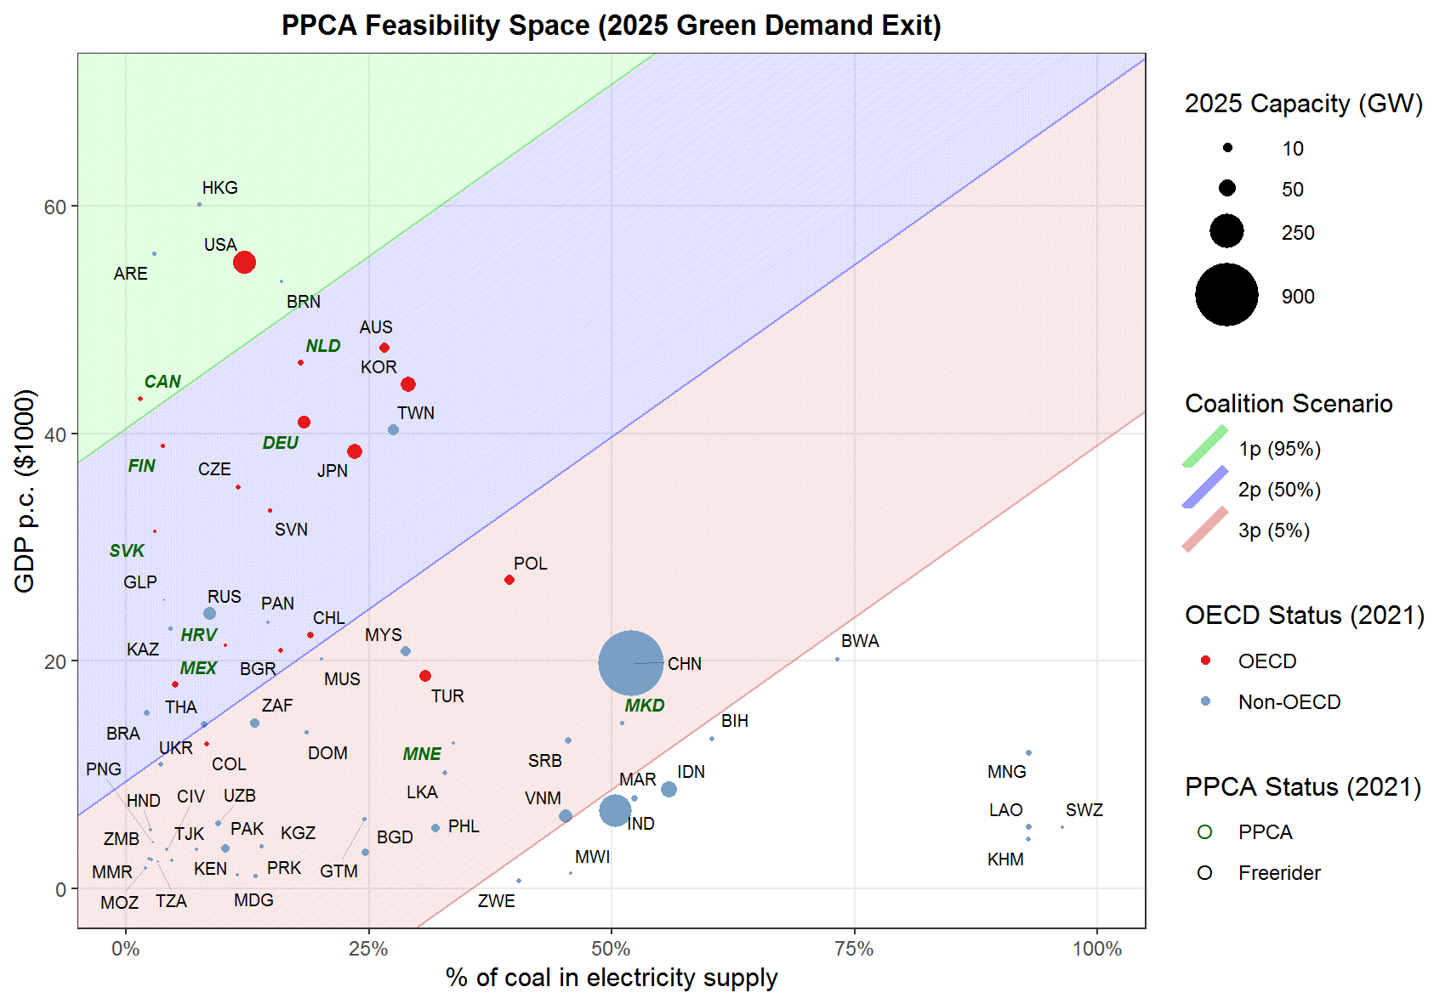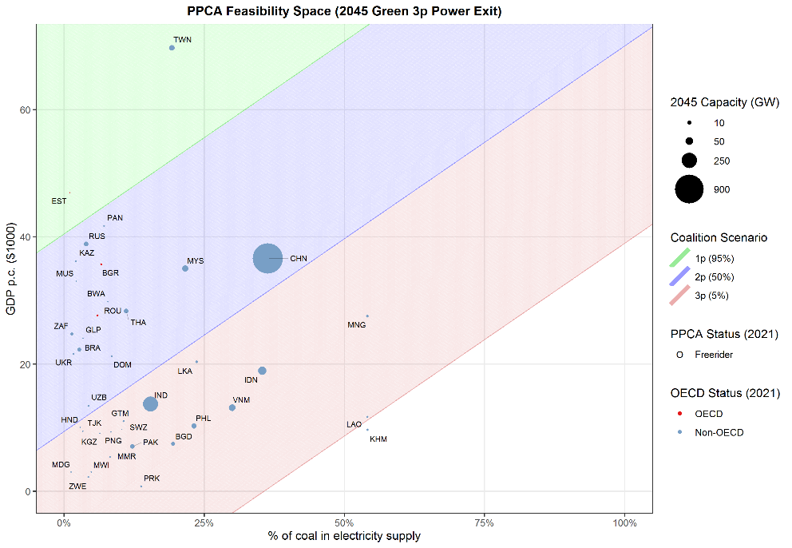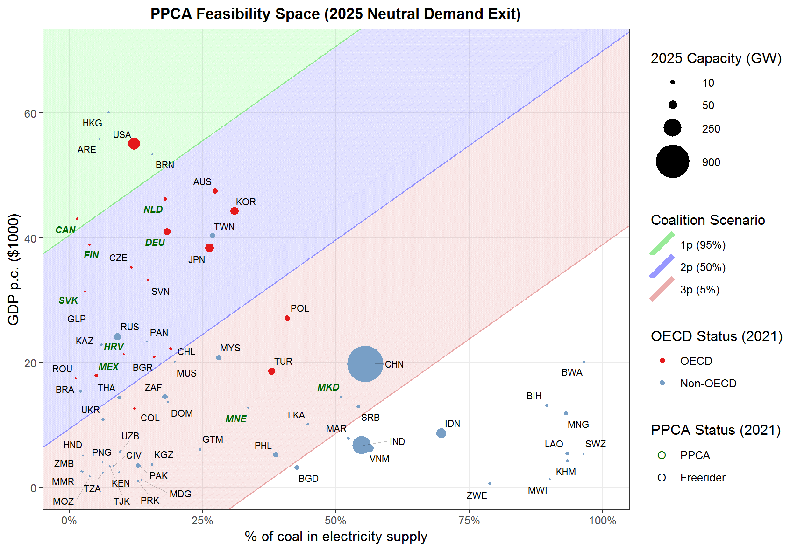
c)
d)
b)
a)
h)
f)
g)
e)
l)
j)
k)
i)
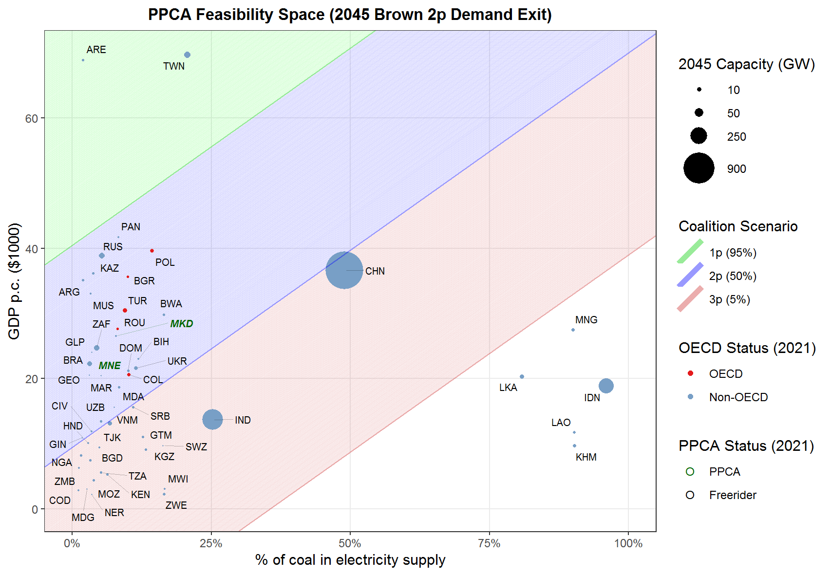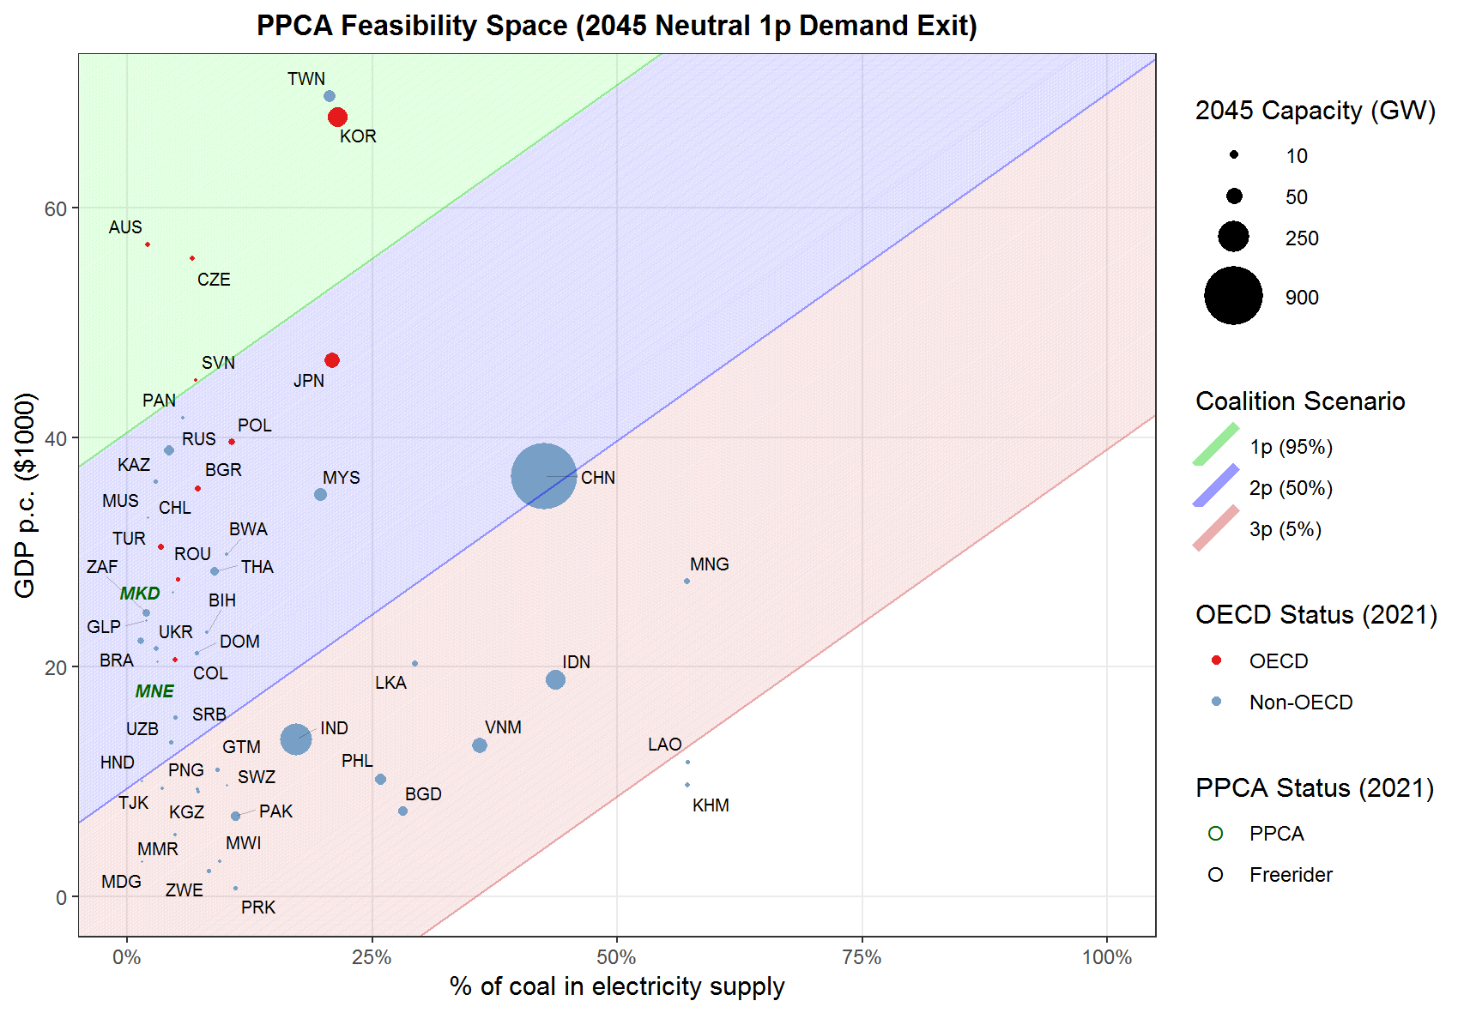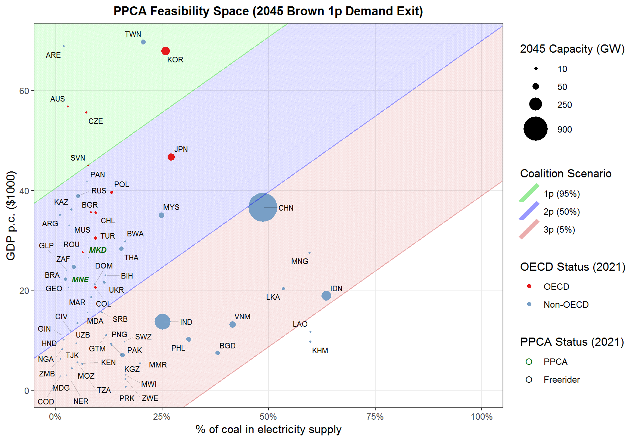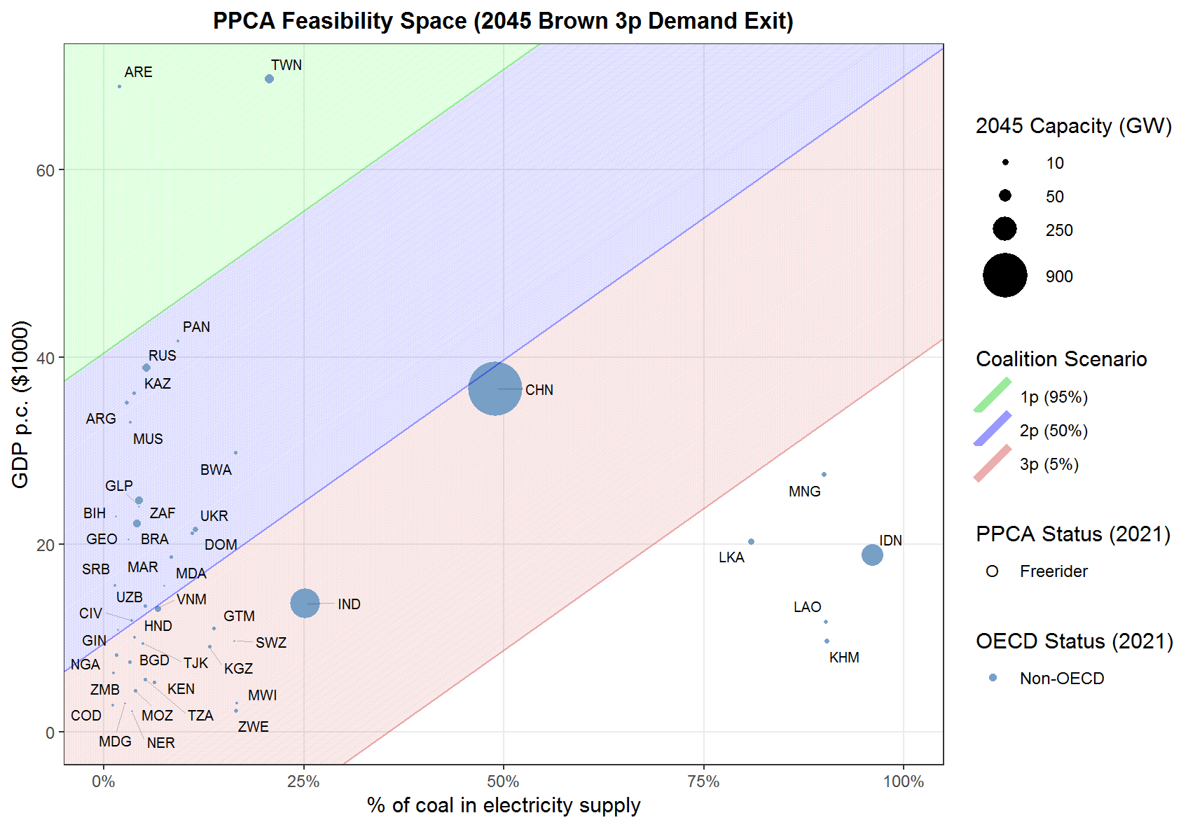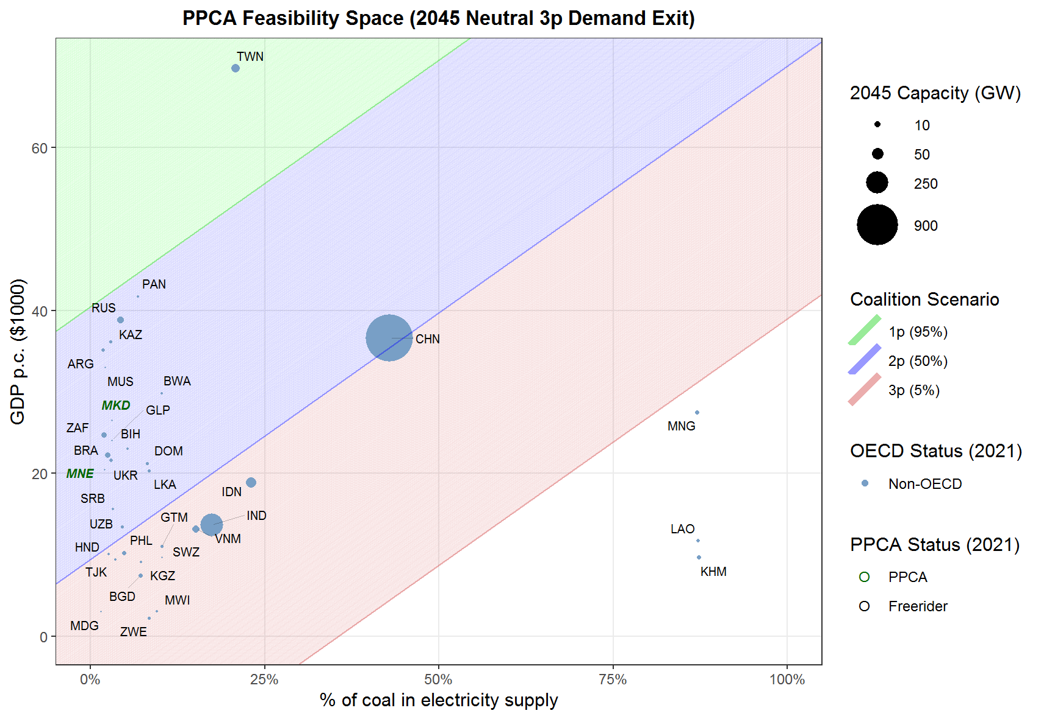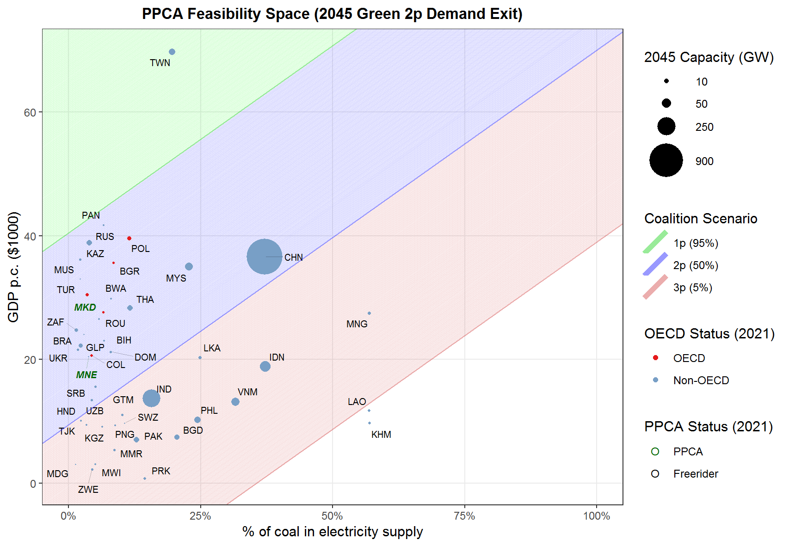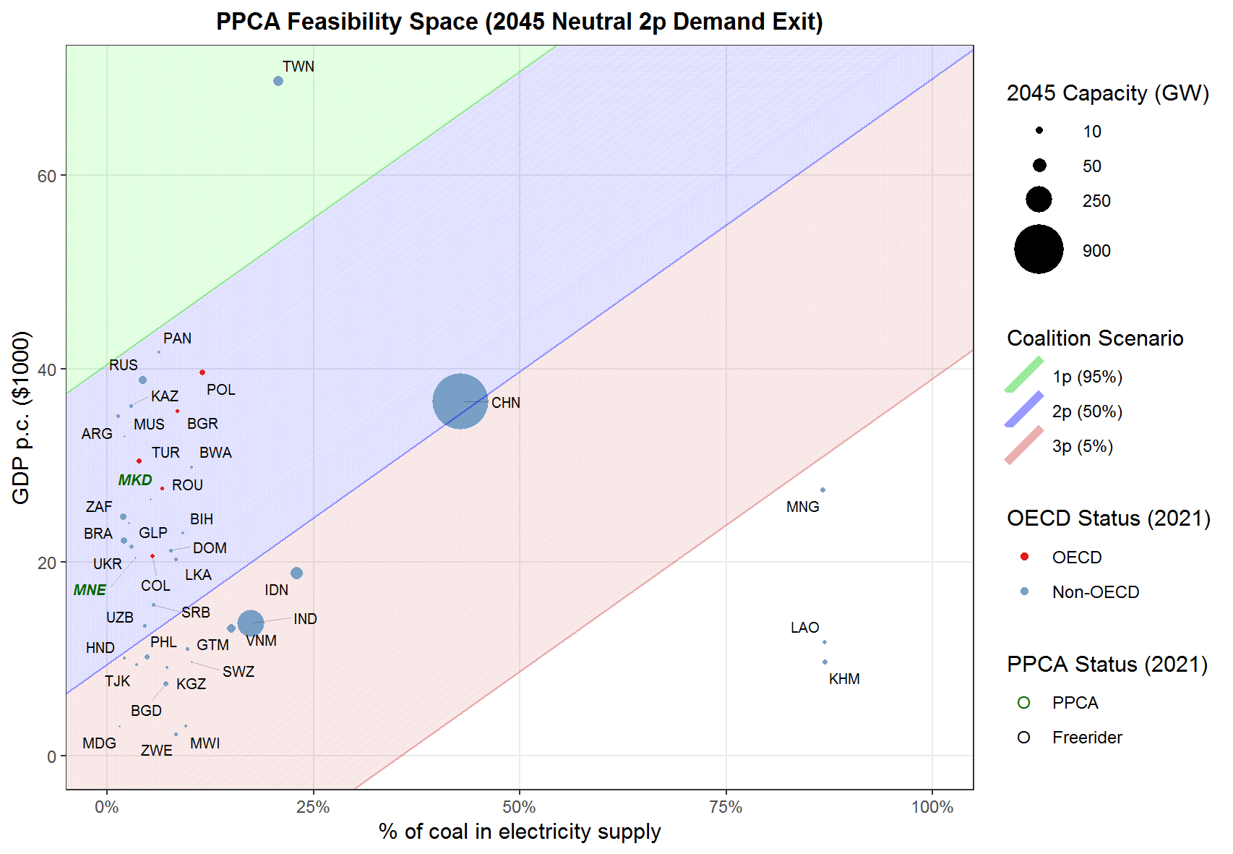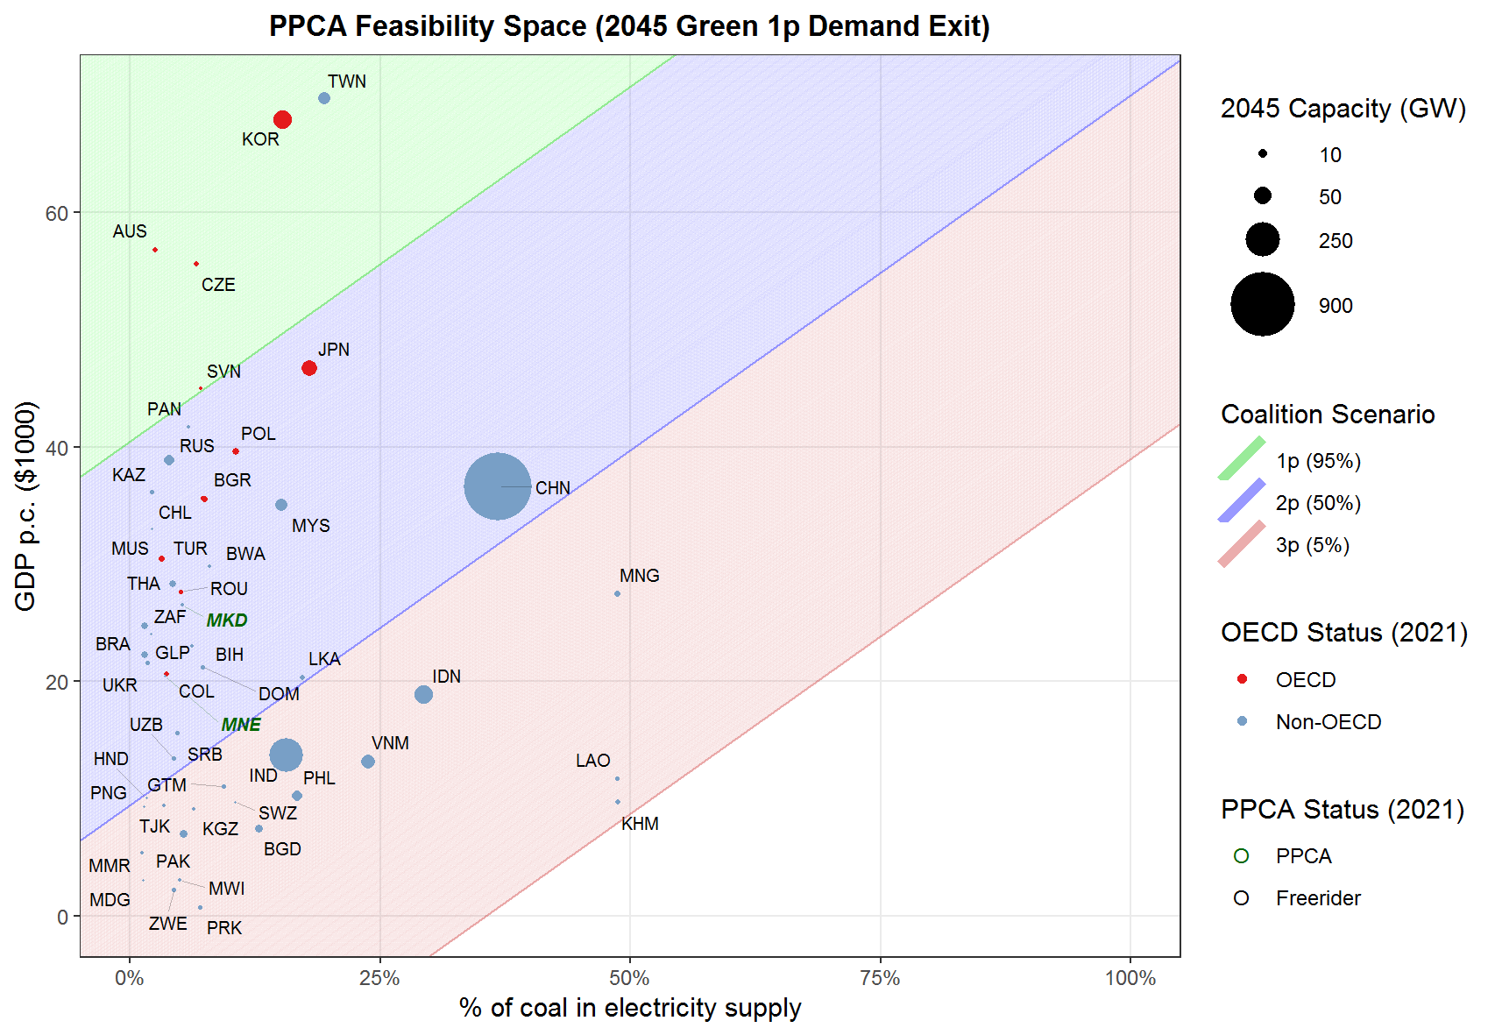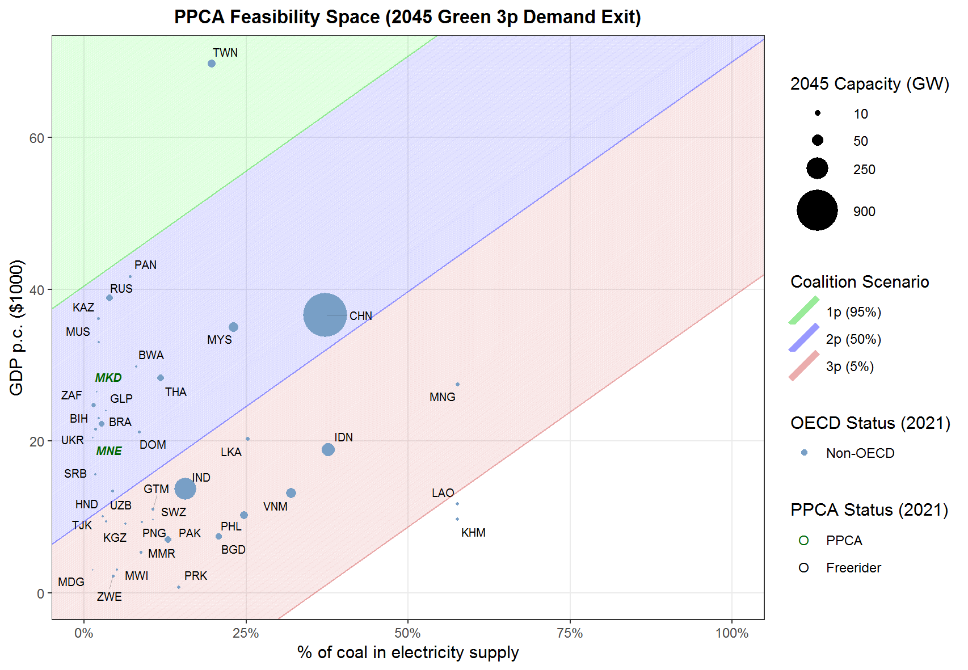
o)
p)
n)
m)
t)
r)
s)
q)
u)
Figure SF1. Coalition scenarios returned by CoaLogit for power-exit (a-i) and demand-exit (j-u) policy scenarios. Includes the 2025 OECD accession stage (a-b; j-l) and 2045 non-OECD stage (c-I; m-u) for each policy scenario following each Covid recovery.

a)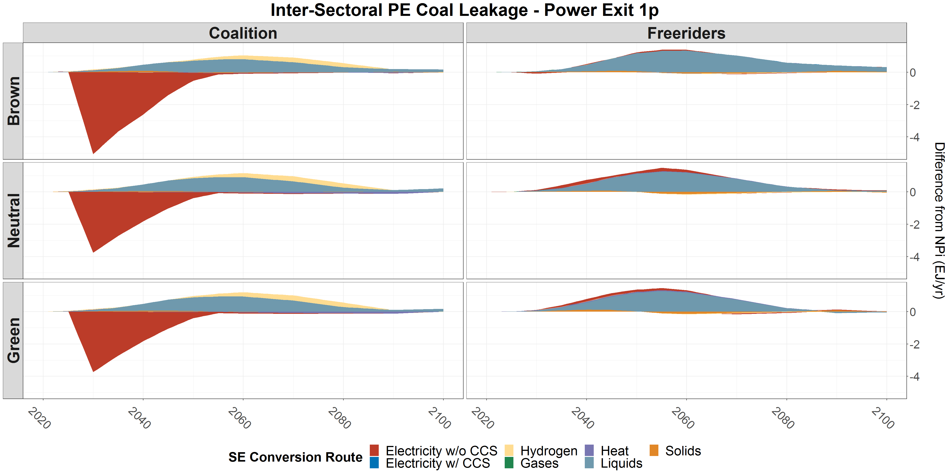
b) 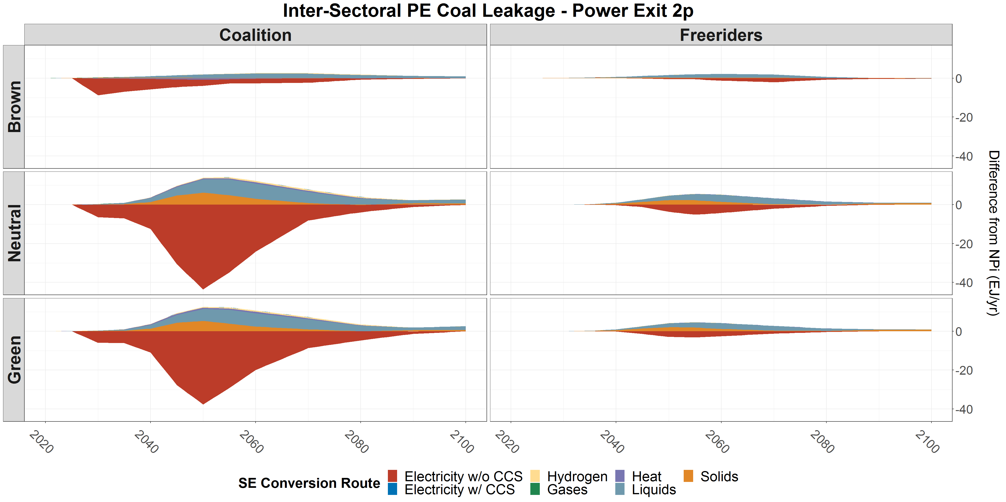
c) 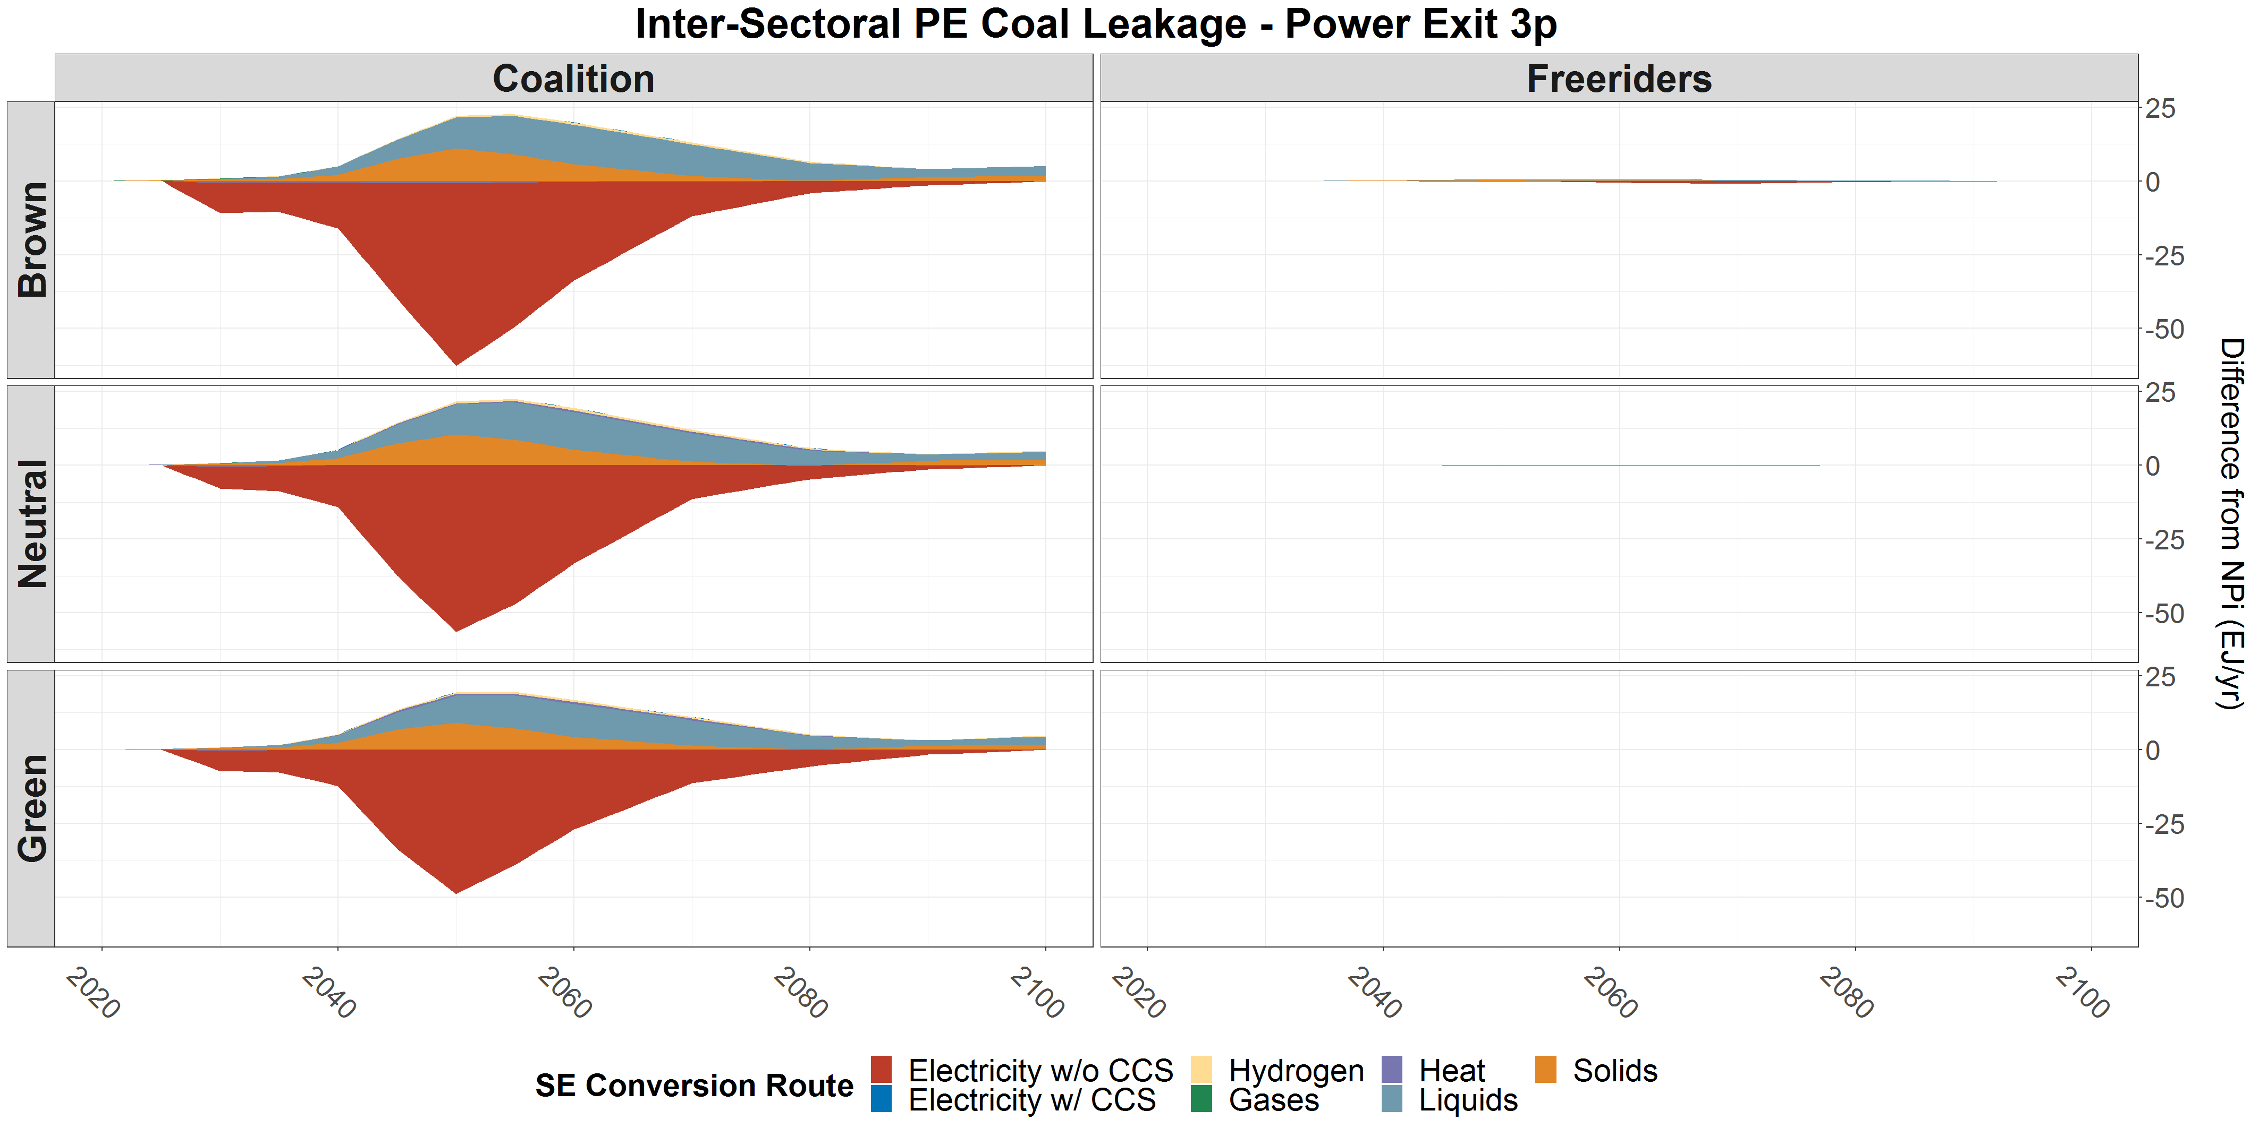
d) 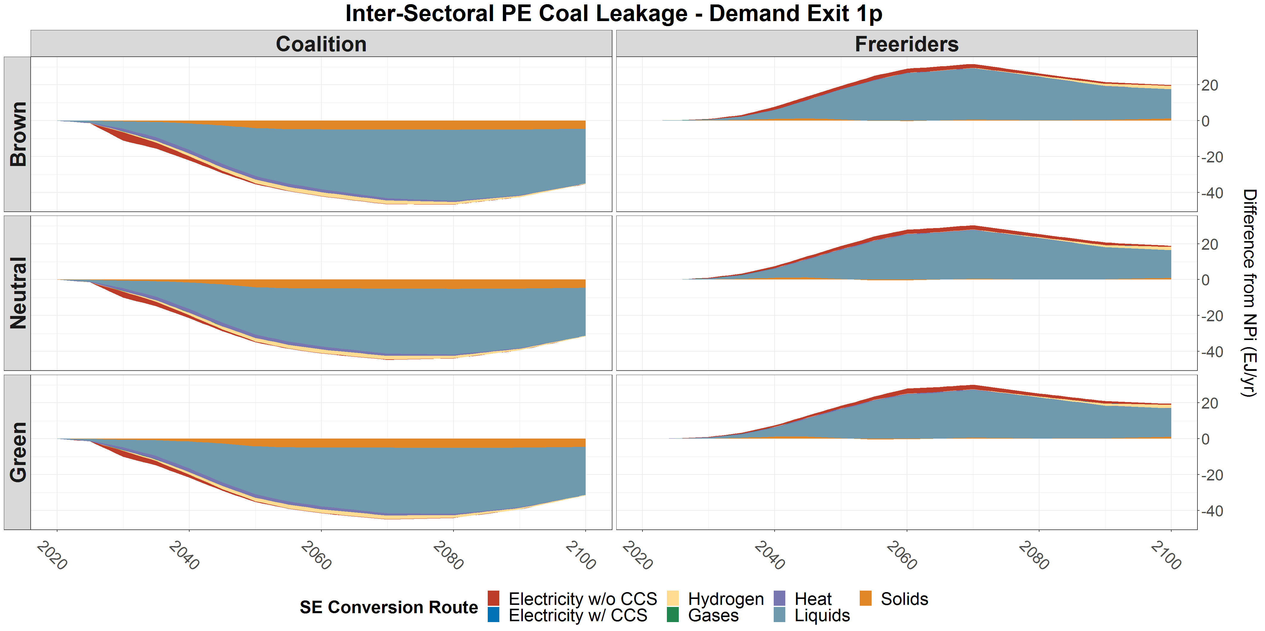
e) 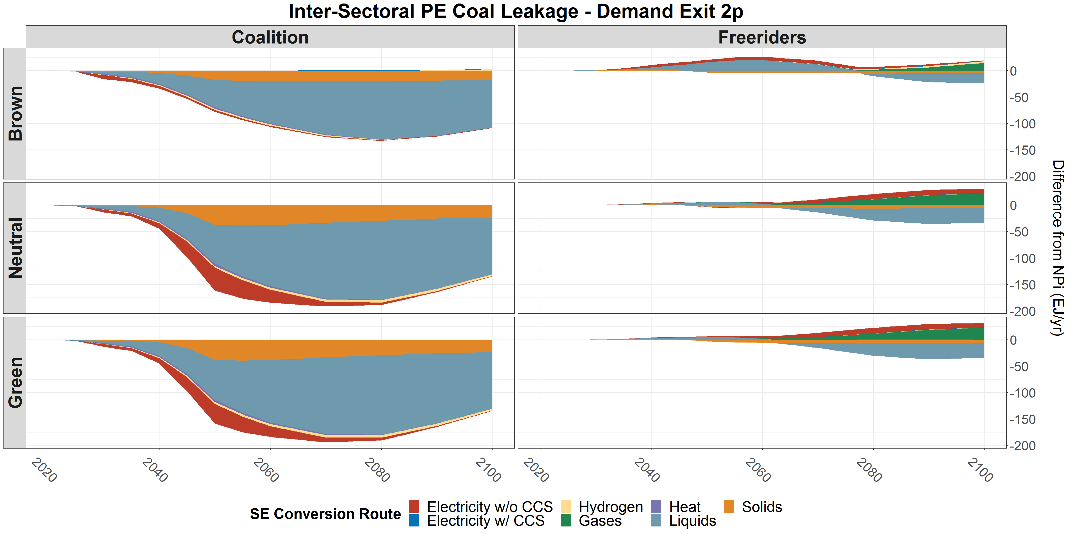
f) 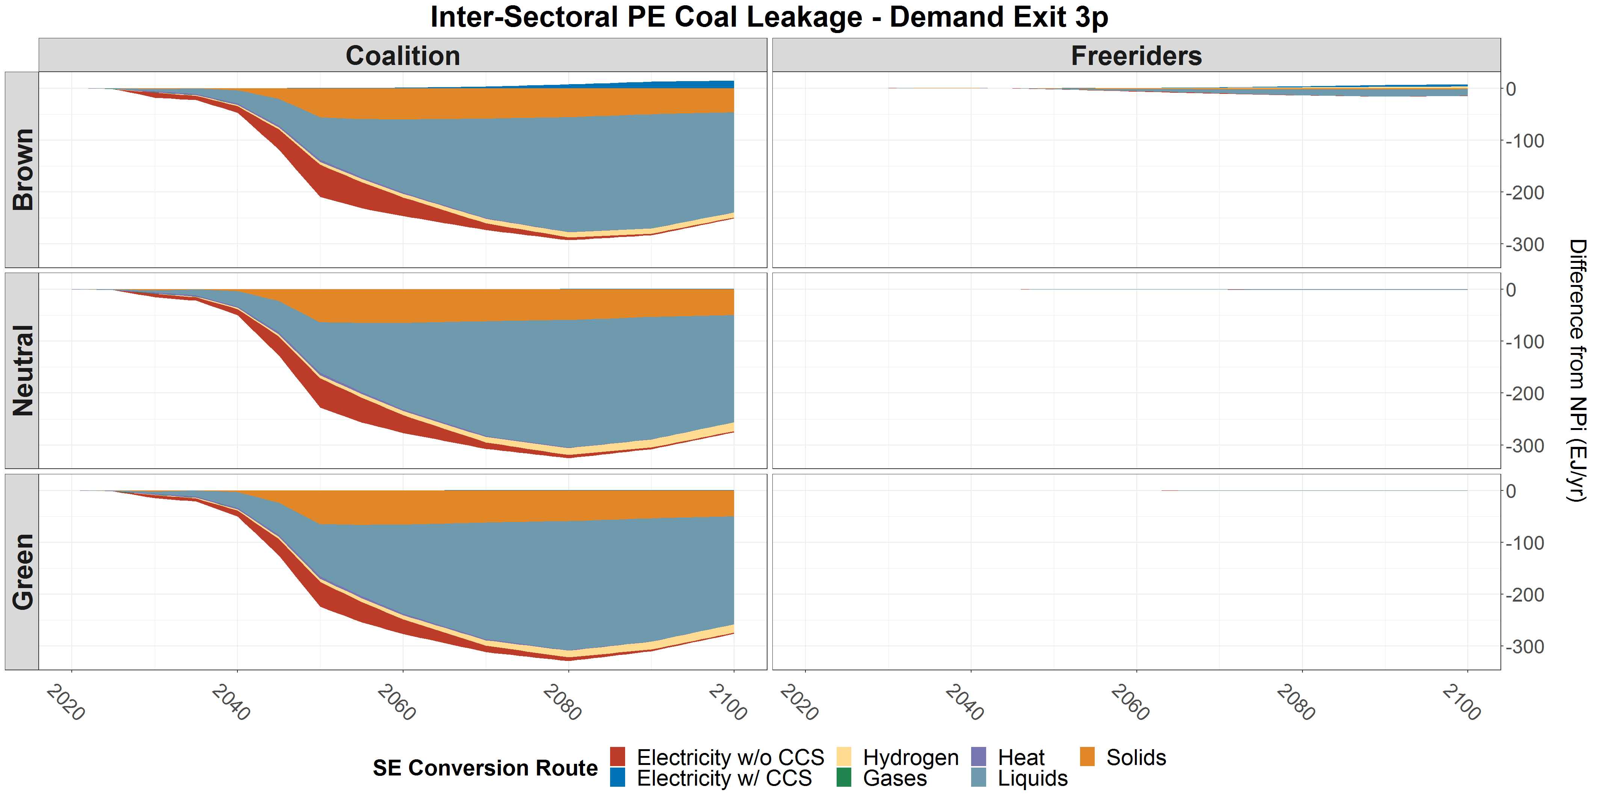
Figure SF2. Coal market response to power-exit (a-c) and demand-exit (d-f) policy scenarios. Note that the y-scales vary significantly.

- 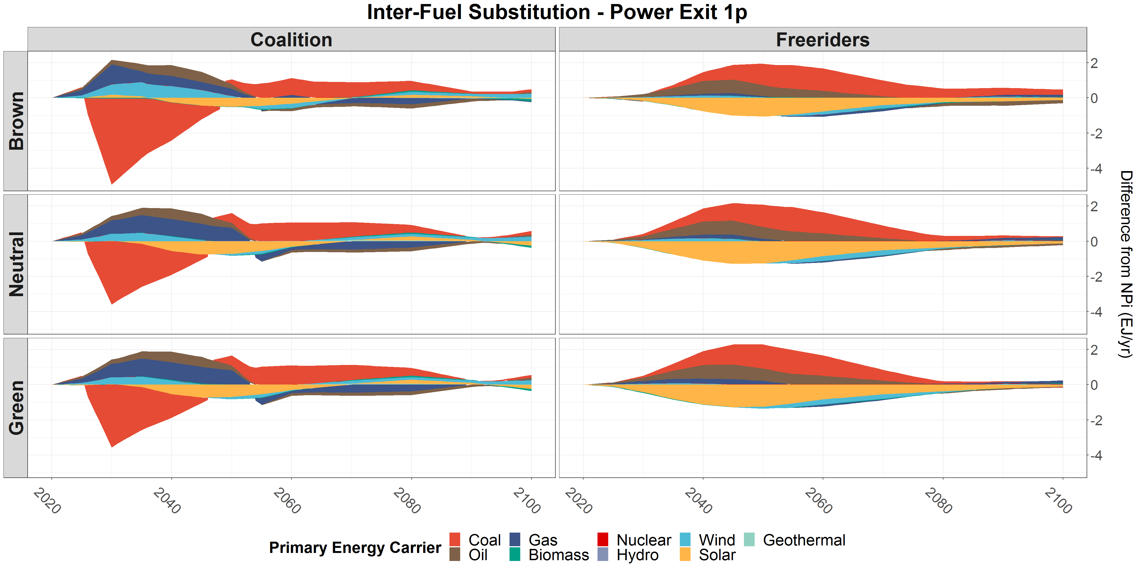
- 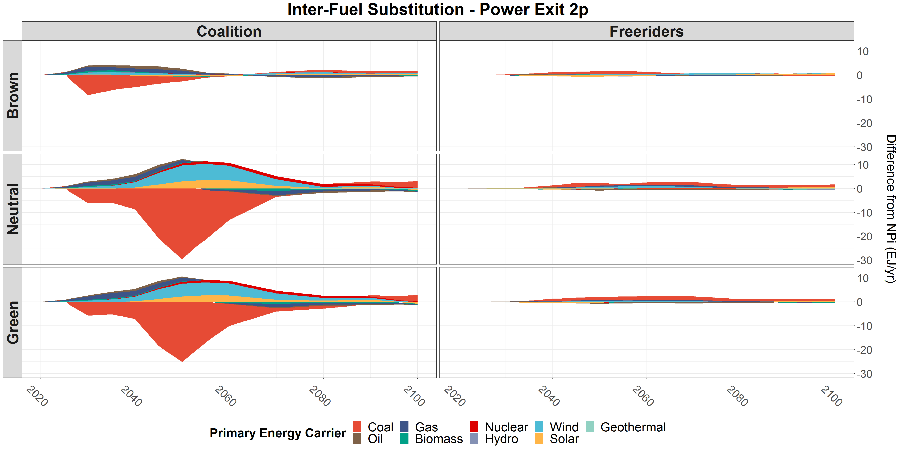
- 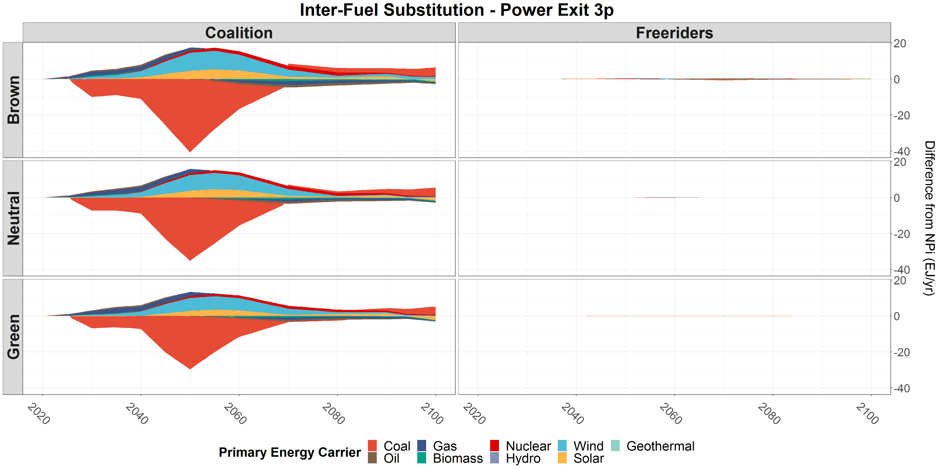
- 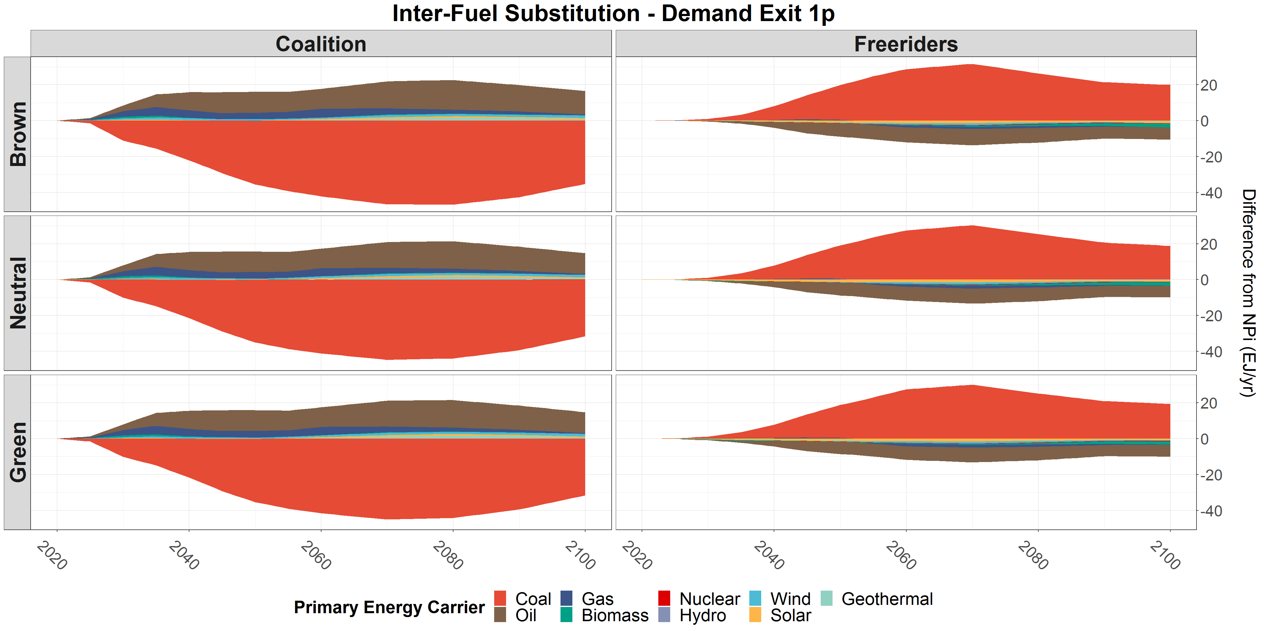
- 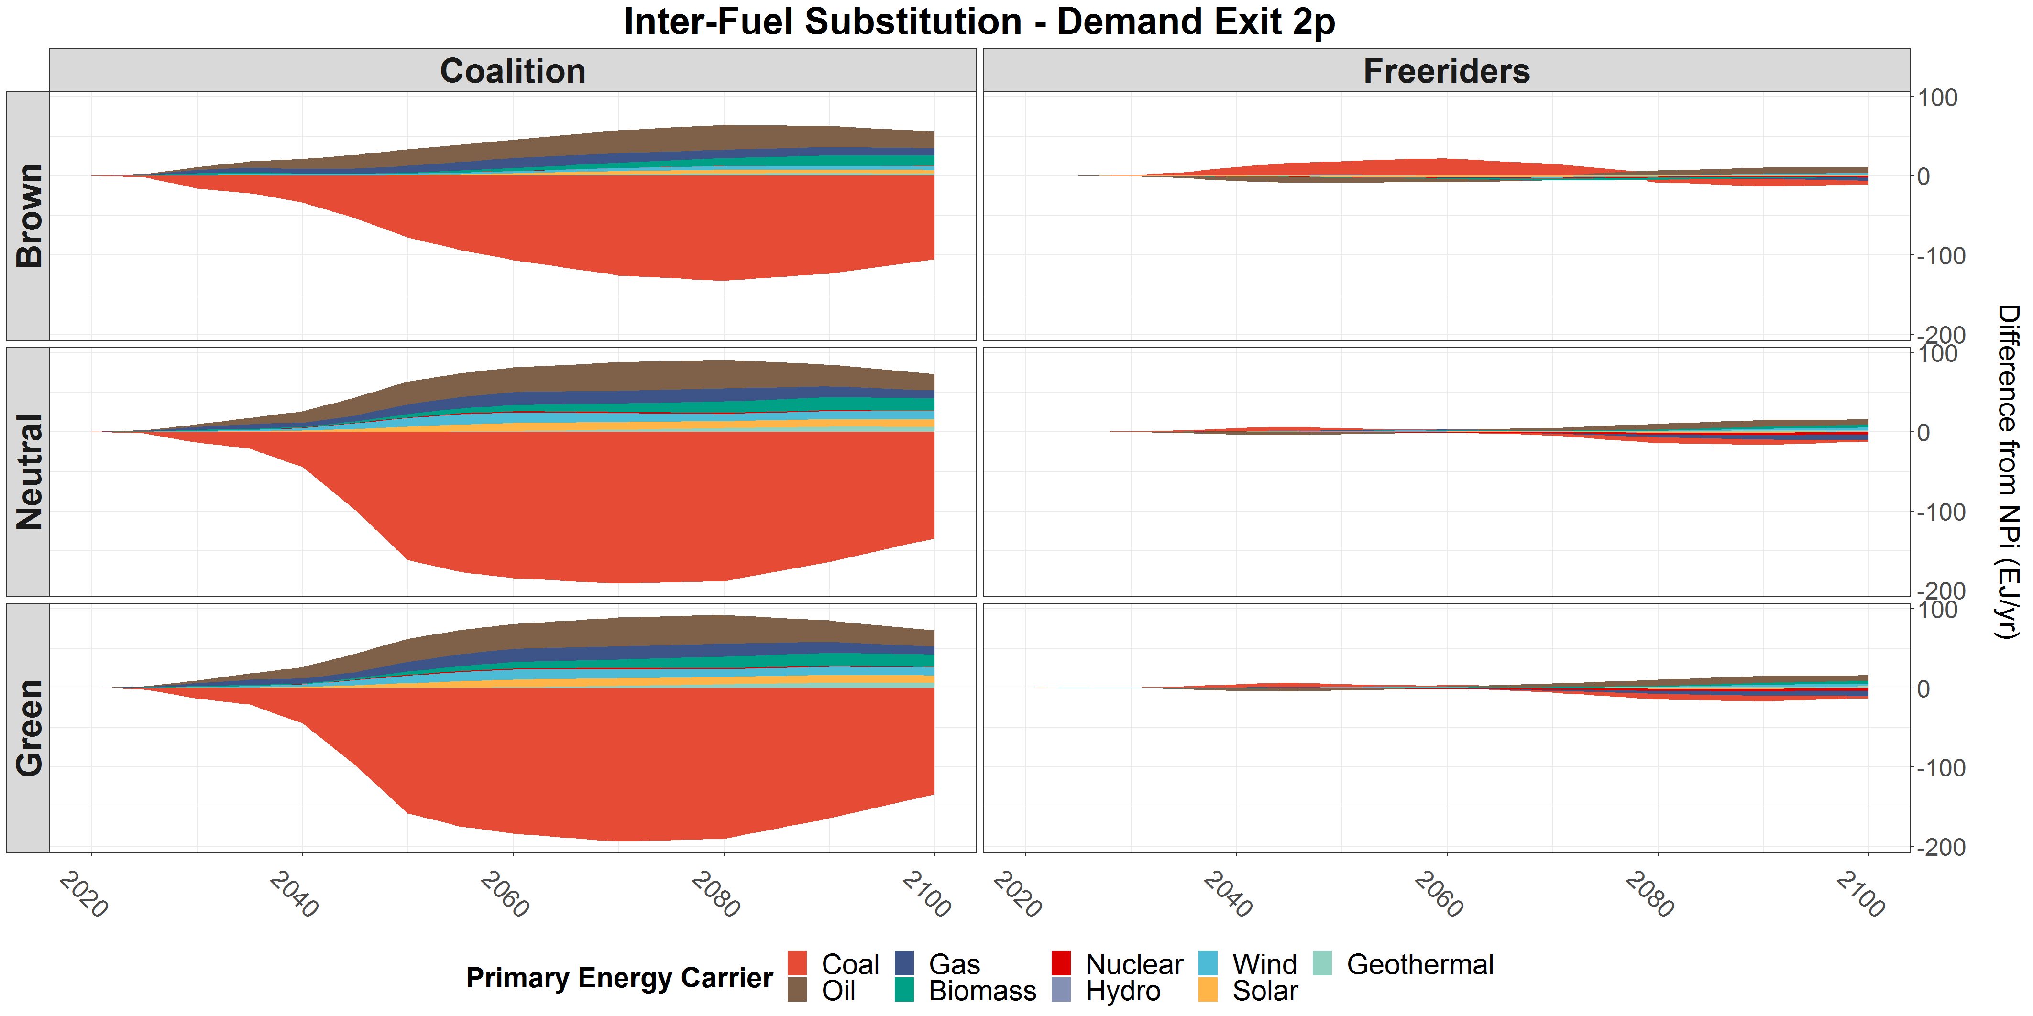
- 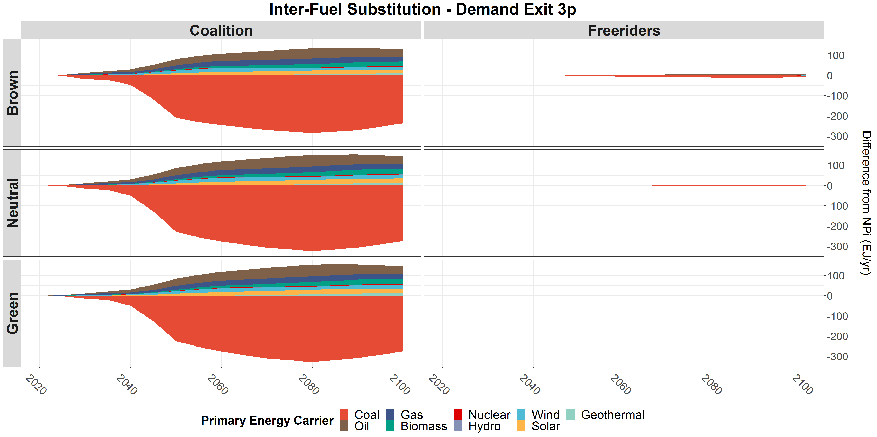
Figure SF3. Energy system response to all power-exit (a-c) and demand-exit (d-f) policy scenarios. Note that the y-scales vary significantly.

- 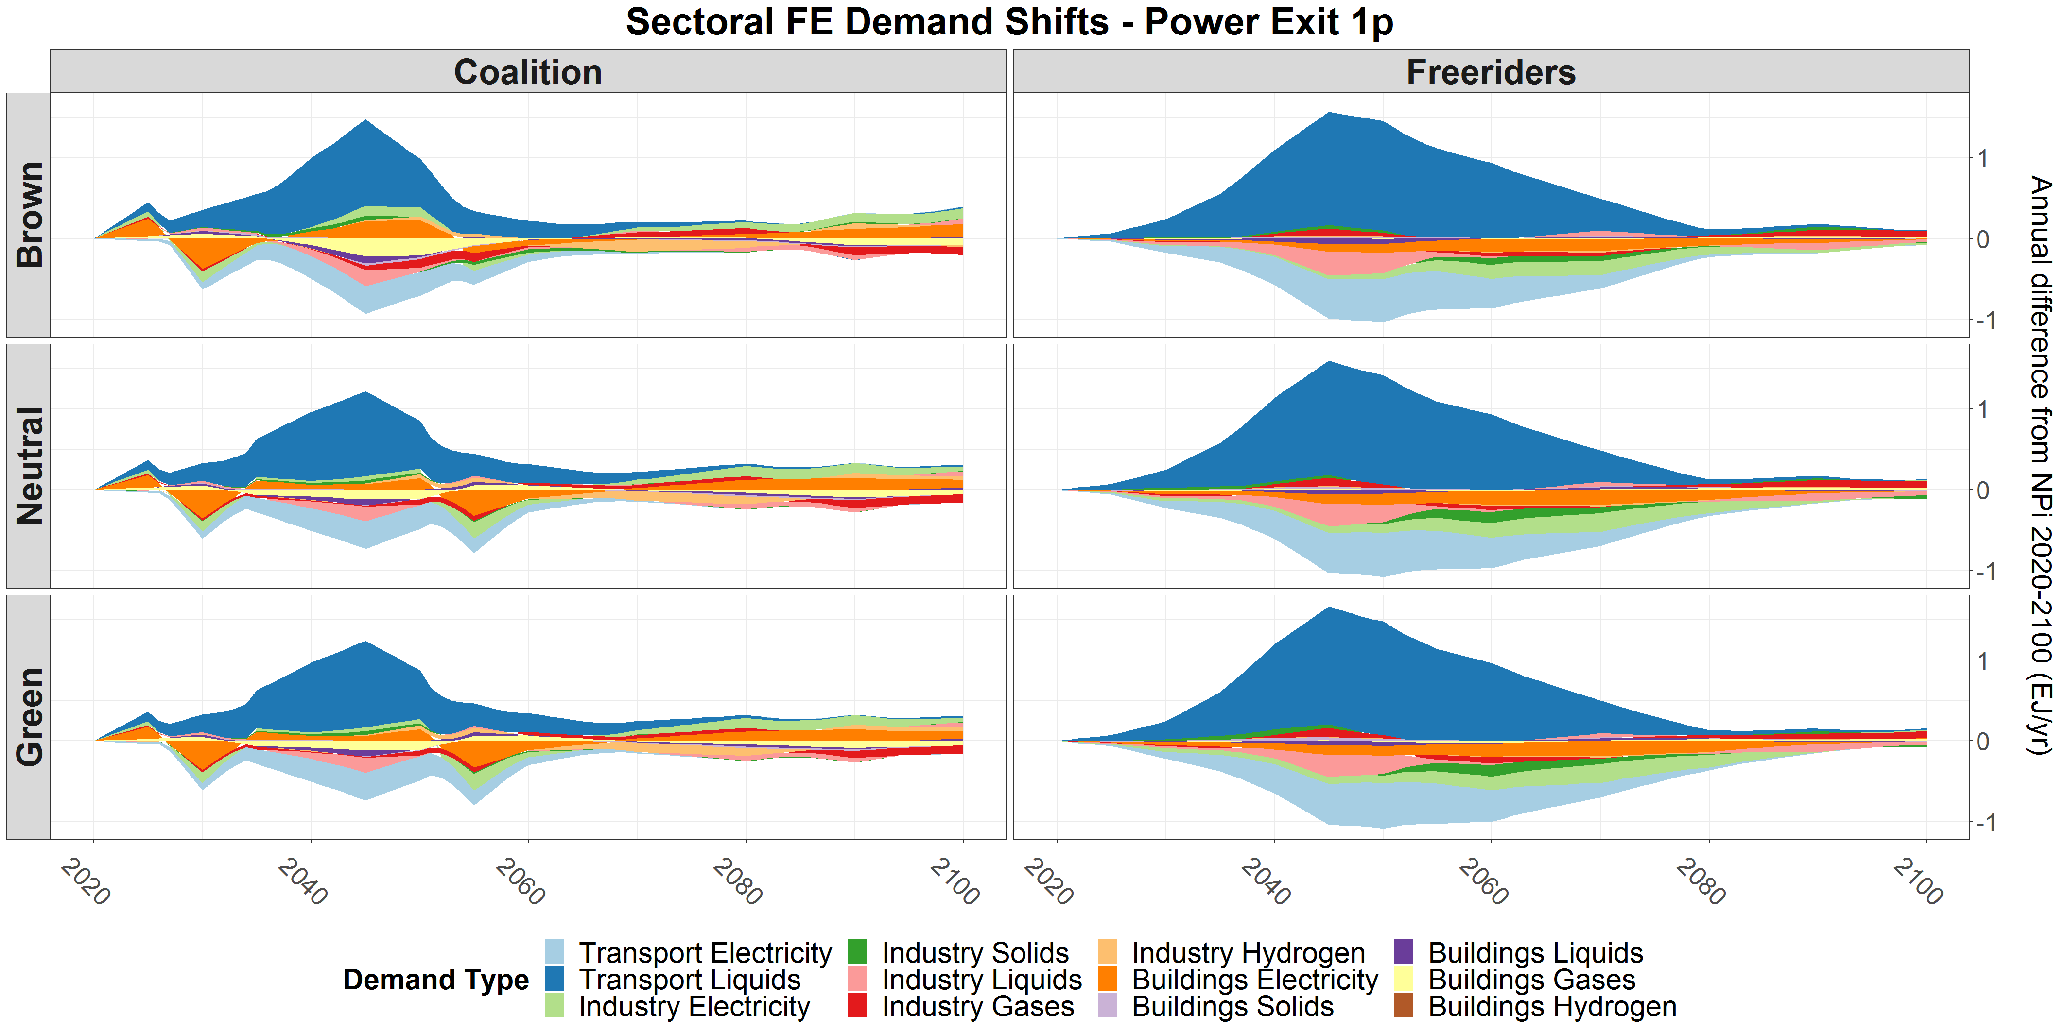
- 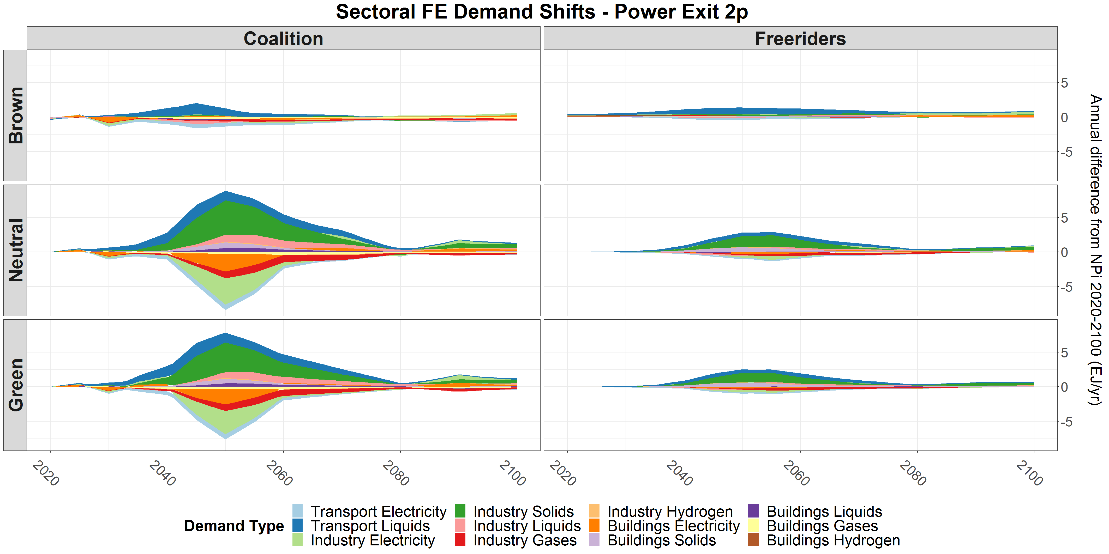
- 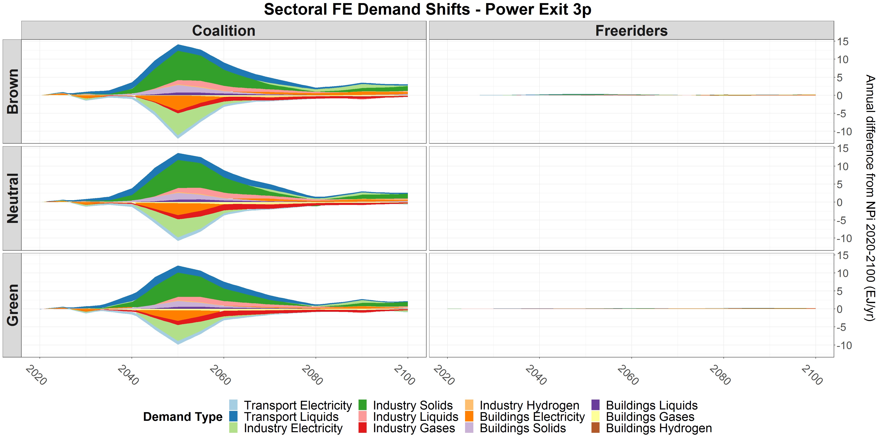
- 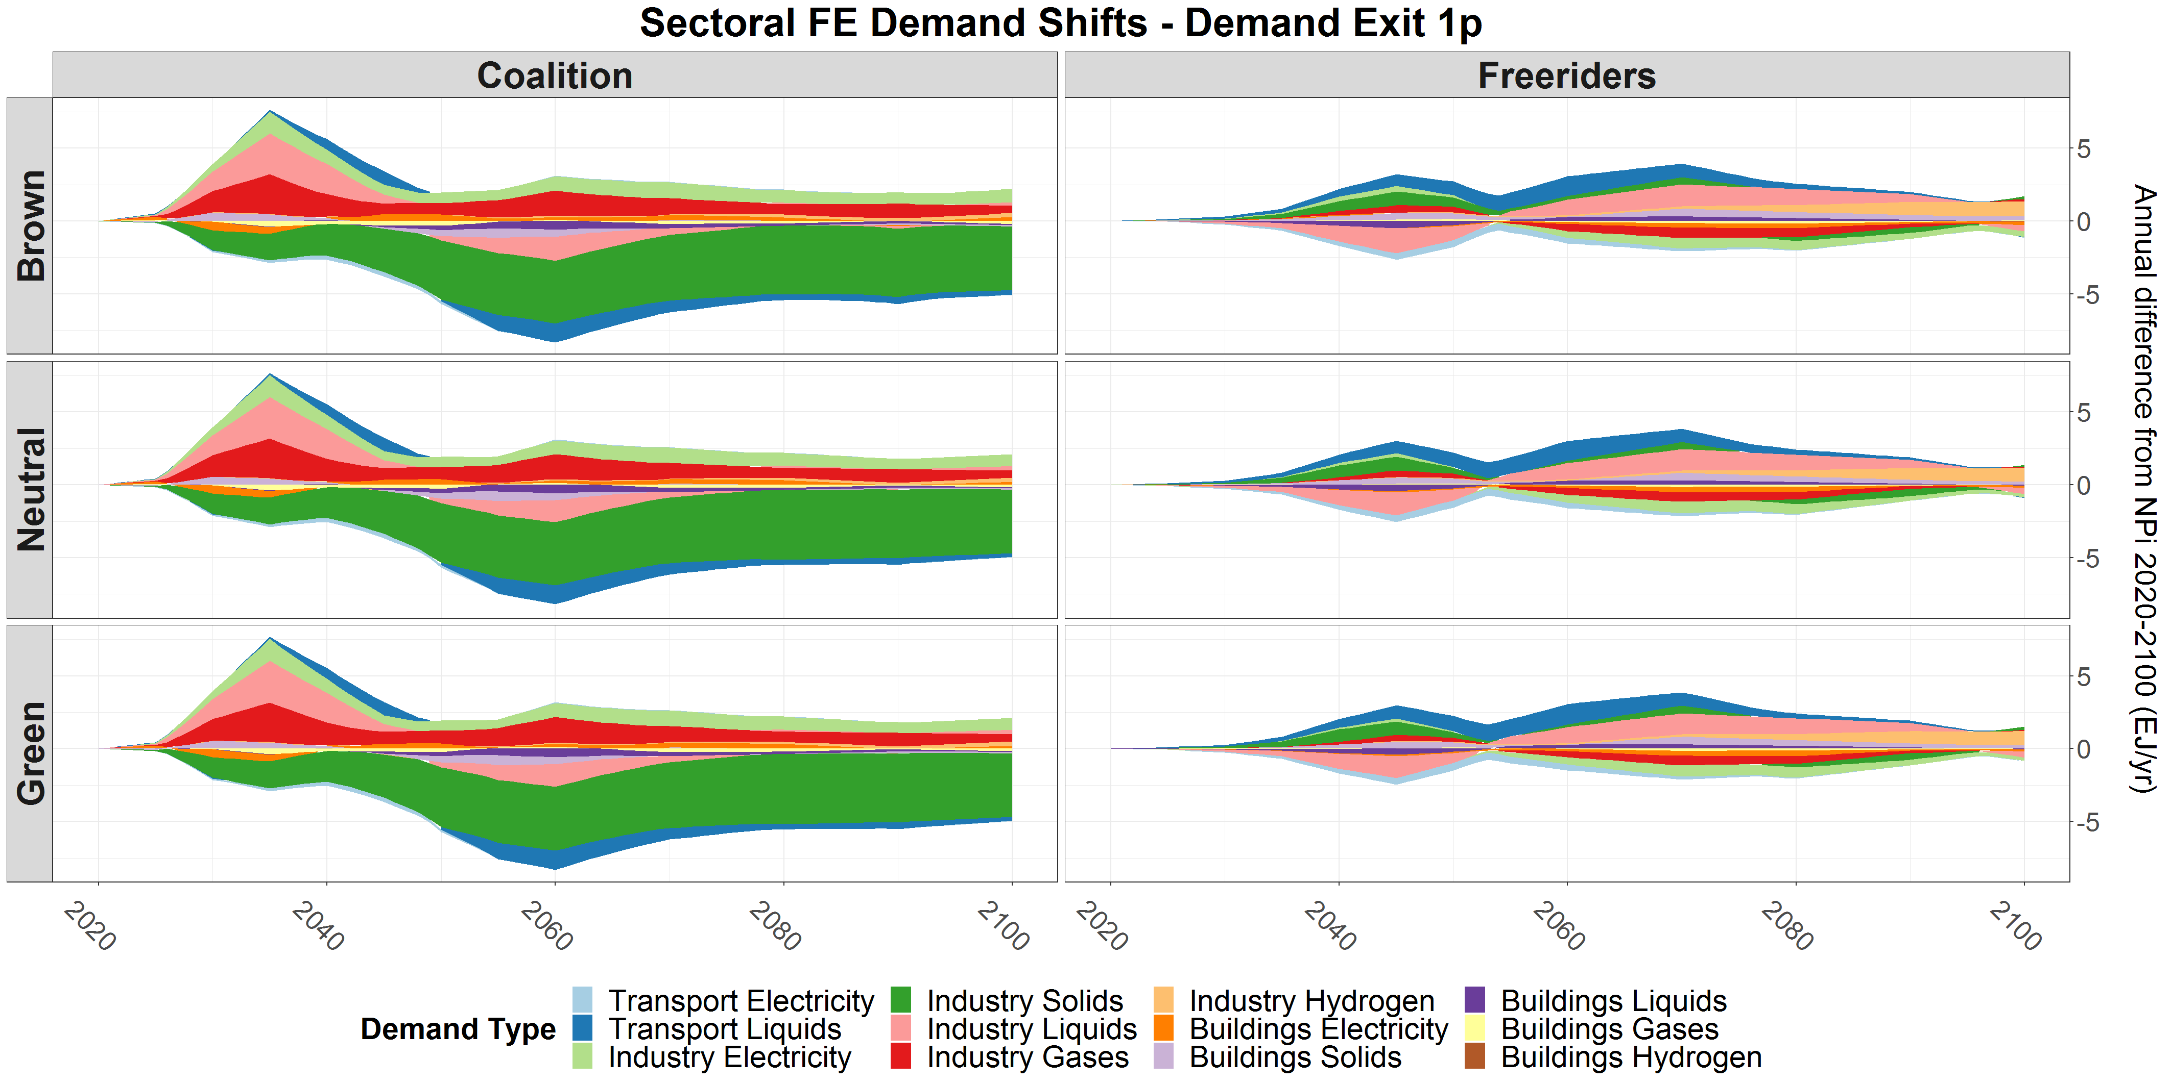
- 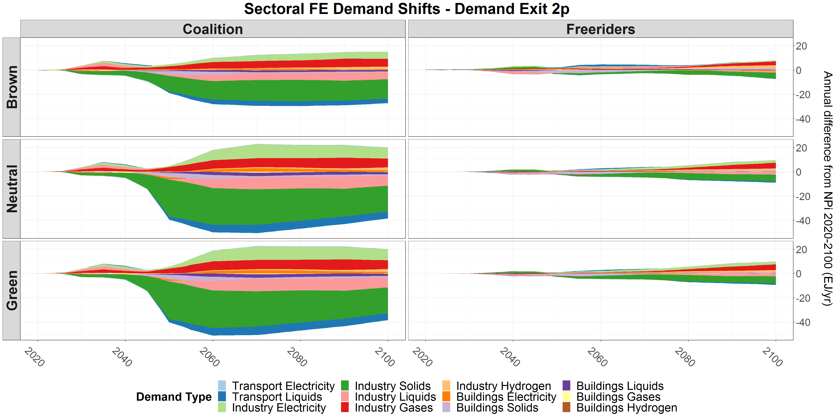
- 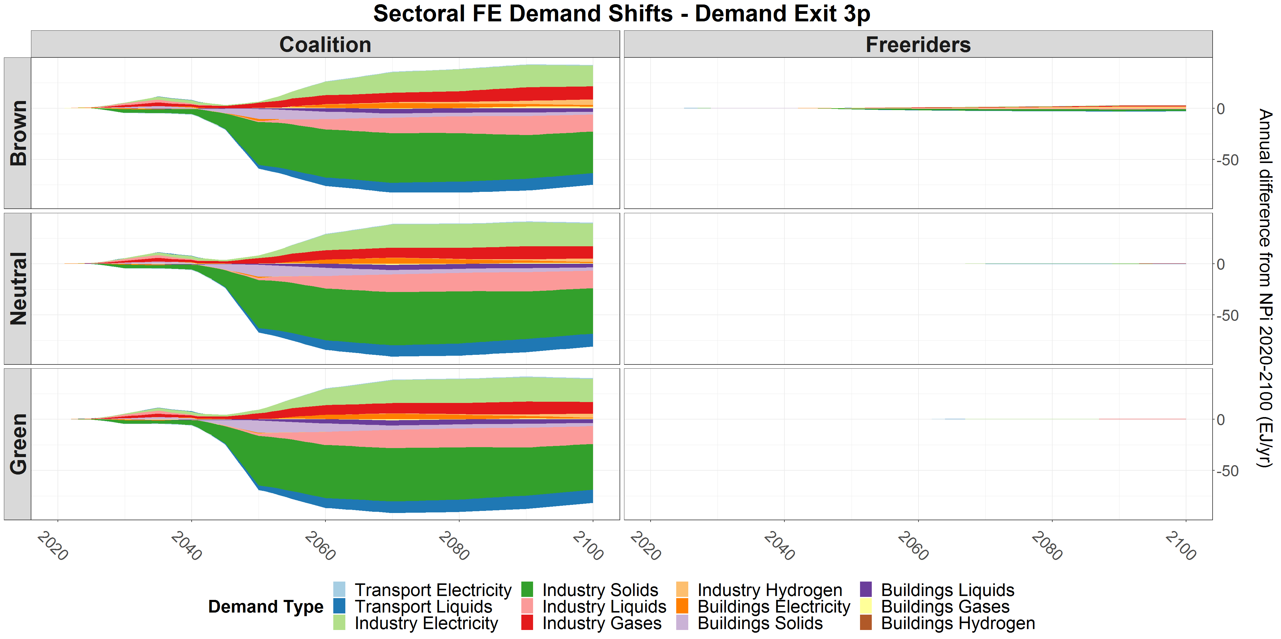
Figure SF4. Impacts of the power-exit (a-c) and demand-exit (d-f) policy scenarios on final energy (FE) consumption in each sector. Not shown are gases and hydrogen use in transport, and heat used in industry and buildings. Note that the y-scales vary significantly.

