Methods
The foundational question of dynamic policy evaluation (DPE) concerns the coevolution of domestic energy politics with global energy systems. We emulate this interdependency in the context of the coal phase-out by coupling REMIND, a multi-regional, forward-looking, deterministic global energy systems model, with COALogit, a country-level, empirical, probabilistic coalition-forming logistic regression model. The soft-linkage enables simulation of bottom-up policy adoption with staged accession and inter- and intra-regionally-fragmented ambition in long-term energy-economy scenarios. A detailed model description is available in Baumstark et al. (2021)¹.
Based on national coalition accession, COALogit informs coal phase-out adoption and stringency in each REMIND region (Figure M1) in a given period, effecting global energy sector transformations in that REMIND scenario. Policy feedback effects on future policy uptake are quasi-endogenised by iterating the REMIND-COALogit sequence (Figure M4) in successive periods. In the context of coal phase-out policies, REMIND captures feedbacks through its representation of international, inter-sectoral, and inter-fuel leakage effects, as well as changes in technological learning (Figure 1).
REMIND-COALogit integration (Figure M2) is made possible by the latter’s reliance on energy-economic variables – GDP and the share of coal in electricity generation (coal-power-share) – computed endogenously by the former. Generally, a limiting factor of modeling co-evolutionary transformation pathways is the dearth of historical climate policy observations upon which empirical models can be constructed. The PPCA provides a real-world policy basis which enables logit model calibration and precise policy timing in REMIND. The REMIND-COALogit model and DPE are described in detail below.

REMIND Model
REMIND is a global, multi-regional energy-economy general equilibrium model linking a Ramsey-type macroeconomic growth model with a bottom-up technologically-detailed energy system model¹ which accounts for greenhouse gas (GHG) emissions from all human activities, including land use and forestry (Figure M2). The model is implemented in GAMS and solved by CONOPT. The model configuration in this study considers twelve world regions (Figure M1) and solves for interdependent regional and global equilibria. Regions individually optimize intertemporal welfare by allocating economic output to capital investments, consumption, energy system costs, and inter-regional trade of energy resources and composite goods. However, these solutions are contingent upon global market prices, which are adjusted between each iteration of the Nash solution algorithm until an international economic equilibrium is found, i.e. all trade markets are balanced in all periods of the model horizon 2005-2150 (5-year periods until 2060, 10-year until 2110, 20-year until 2150; henceforth, any mention of years refer to these time-steps unless otherwise specified).
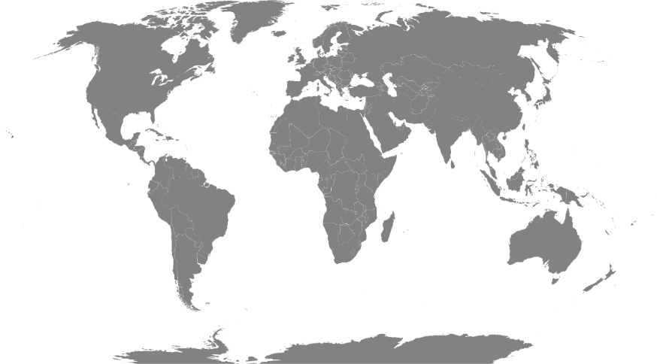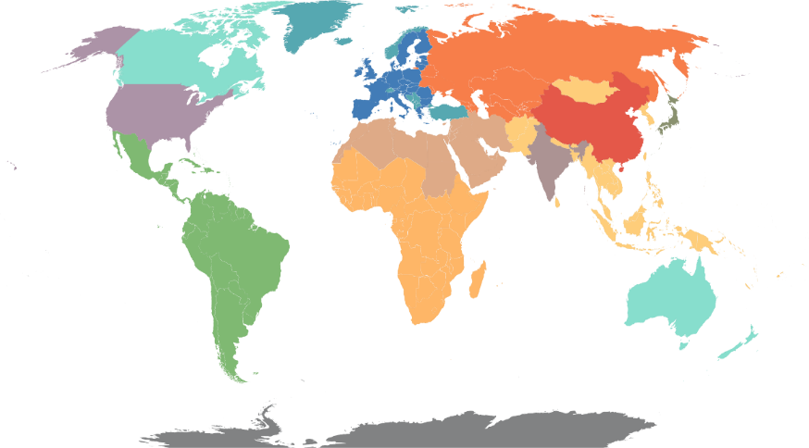
Figure M1. REMIND world regions in the default 12-region configuration used in this study.
Canada, Aus, NZ
China
India
Japan
Latin America
MENA
Other Asian States
Former Soviet Union
Sub-Saharan Africa
USA
EU27+UK
Non-EU Europe

Coal Demand Representation
Final energy is demanded by REMIND regions as a factor of production in accordance with macroeconomic assumptions (e.g. GDP and population) given by the Shared Socioeconomic Pathway (SSP) convention². To satisfy final energy needs, regions demand coal based on cost competition with other energy carriers and the existing energy capital stock¹. Coal primary energy (PE) can be converted into electricity, solid energy, liquids, gases, heat, and hydrogen through various transformation technologies with disparate conversion efficiencies. In the electricity sector, coal power plants are categorized into pulverized coal (PC), coal-fired combined heat and power (CCHP), and integrated gasification combined-cycle (IGCC) technologies. Additionally, carbon capture and storage (CCS) is possible for PC (PCC) and IGCC (IGCCC) plants, as well as oxy-fuel combustion (PCO). Other secondary energy conversion routes are only represented by a single technology, e.g. coal-to-hydrogen or coal-to-liquids (CtL) via Fischer-Tropsch, which are the only other processes with CCS available.

Coal Supply Representation
Regions are endowed with coal deposits graded by extraction costs, which increase within each grade as reserves are depleted according to a cumulative extraction cost curve³. In the original formulation, these parametric curves are grade-specific and time-dependent – viz. costs decline with fossil fuel sector investment and the associated technological change – but for typical REMIND simulations, resource extraction dynamics are simplified using an emulator. The representation used in the present study is parametrized in accordance with the complex model’s behavior given SSP2 assumptions⁴. Coal grades are not differentiated by physical properties, i.e. metallurgical coal (met-coal) is indistinct from high-cost thermal coal at the PE level. Emissions accounting has greater sectoral granularity, e.g. the emissions from steel or cement manufacturing are derived based on the assumption that each subsector in each region maintains its historical mix of final energy carriers.
Fossil extraction is also subject to short-term decline and increase rates between time-steps, representative of geophysical, infrastructural, and institutional inertia⁴. Extracted resources not consumed within the producing region are exported to the world market, a global pool of quantities with price vectors that reflect the aggregate supply and demand and are adjusted between iterations until a Walrasian equilibrium is achieved¹. Thus, a phase-out of demand in one region increases the supply available for other regions in the near-term, as the equilibrium solution requires the surplus in each resource market to fall below a negligible threshold in each period, but also shifts the long-run equilibrium price downward.

Policy Representation and Analysis

Policy Evaluation
In policy evaluation mode, climate and energy policies can be prescribed to REMIND with uniform or differentiated stringency across regions, periods, sectors, etc., to analyse the energy, climate and economic impacts. Any comprehensive or piecemeal combination of carbon pricing instruments, technology- or fuel-specific taxes or subsidies, or activity-specific constraints or incentives can be implemented through a variety of levers. DPE and SPE are subcategories of PEA, as policies and their stringencies are prescribed – albeit objectively and grounded in real-world developments – rather than endogenously derived by the model. DPE then relies on the assumption that strong empirical models of policy feasibility remain valid over time to endogenise the fragmentation and staggering of policy prescription as a function of prospective variables computed by REMIND.
In the present analysis, the reductions of total CO₂ emissions and coal use in various SPE and DPE scenarios are compared with the optimal and necessary levels derived by CEA benchmark scenarios. Coal phase-out policies and their timing, as defined by the PPCA, are implemented by constraining secondary energy (SE) production in power-exit scenarios and emissions variables in demand-exit scenarios. Each region is permitted up to a certain share of its total cumulative SE electricity production or CO₂ emissions that can come from coal during each PPCA phase-out stage (i.e. 2030-2050 when only OECD nations are constrained, and 2050-2100 when all coalition members must implement the policy). The share is defined by COALogit and reflects the specific countries which adopt the policy within each REMIND region. We constrain cumulative rather than annual variables to afford the model flexibility as to the speed of phase-outs and the timing of leakage.

Cost-effectiveness analysis
CEA scenarios begin with a known environmental goal, viz. a climate stabilization target, and translate it to a model constraint. Most typically in REMIND, the Paris temperature targets are converted into cumulative carbon budgets which must be satisfied by the welfare-optimal solution⁵. This can be achieved through any mitigation strategy, and the model has full flexibility as to when, where and how to abate, barring any additional exogenous constraints. Cost effectiveness implies that marginal abatement costs are equalised across time, countries, and sectors⁶. The CEA scenarios in this study are implemented by assigning each region a starting carbon price level and date, then allowing the prices to endogenously converge over time up to the level of marginal abatement cost to adhere to the remaining budget. By default, inter-regional emissions permit trading is enabled.

Reference and Benchmark scenarios
The baseline reference for our analyses imposes only currently implemented national policies (NPi) on the energy system, such as the European Union’s emissions trading scheme (EU ETS) and various technology-specific efficiency mandates, energy consumption taxes, and minimum share requirements, e.g. the EU Energy and Climate package for 2030. To emulate weak yet dynamic climate policy ambition⁷, carbon prices begin at zero in non-EU regions and increase gradually to reach a global convergence point of $12.50 per ton of CO₂ in 2100. The PPCA-DPE scenarios described below implement the coal exit policies on top of this weak policy backdrop, hence free-riders follow the same modest carbon price trajectory and technological policies as the reference case. For purposes of comparison, we also compute a scenario that implements the NDCs via the conventional PEA mode, as well as three scenarios with carbon budgets imposed in the conventional CEA mode.
These budgets are standardized to values reported in the IPCC’s Special Report on Global Warming of 1.5ºC⁸. The 1.5ºC scenario imposes a cumulative 2011-2100 carbon budget of 900 GtCO₂, corresponding to a 67% probability of staying below 1.5ºC in 2100 and a 50% likelihood of remaining below 1.5ºC in the time-step of peak emissions (2045). The Hi-1.5C scenario limits emissions to 1100 GtCO₂ and leads to a 50% likelihood of global mean temperature below 1.5ºC in 2100 but allows a small overshoot such that the peak period temperature may slightly exceed 1.6ºC. The well-below 2ºC (WB-2C) scenario constrains REMIND to 1350 GtCO₂ and implies a >67% probability of remaining below 2ºC throughout the century.

Interactions between policies and energy system
The REMIND model endogenously represents important feedback mechanisms which can be induced by coal phase-out policies. The feedback mechanisms relevant to the present study are those where the coal phase-out policies lead to changes in coal use in unregulated countries or sectors and therefore have an impact on emissions or change a country’s decision with regards to coalition accession. For one, decreased coal demand elicits downward price pressure in coal markets and greater cost-competitiveness of coal-fueled technologies, provoking carbon leakage effects through international trade of coal, a well-studied consequence of freeriding⁹. The present study deems this extra-coalition coal leakage, and furthermore examines intra-coalition coal leakage, referring to increased coal-based emissions from unregulated sectors of coalition members in response to piecemeal policy adoption. A heavy emphasis is placed on shifts of coal into non-electric applications, which we deem inter-sectoral coal leakage. Both intra- and extra-coalition coal leakage undermine the effectiveness of coal phase-out policies, and the latter also reduces the likelihood with which free-riders ultimately accede.
Technological learning – particularly of solar photovoltaics (costs decline 20.7% per doubling of cumulative capacity), wind turbines (10.8%), electric vehicles (10%), and grid storage (10%) – mediates two additional feedback mechanisms. First, there is a potential positive technological spill-over effect. Coal phase-outs in PPCA countries can trigger increased domestic renewable energy deployment to substitute the short-fall of coal-fired electricity, accelerating learning-by-doing effects of renewable alternatives. This lowers costs globally, promoting diffusion into non-member countries and potentially displacing coal in their power sectors.
Second, there is a potential negative spillover effect. Coal phase-outs may cause electricity prices to increase in some regions due to restrained electricity supply. This can discourage end-use electrification and, consequently, retard technological learning of burgeoning technologies such as electric vehicles. This negative feedback may, in turn, decelerate learning-by-doing in renewable energy generation and storage technologies, improving the prospects for fossil-fueled technologies. Depending on the relative strength of positive and negative spillover effects, global coal use can increase or decrease, thus affecting the effectiveness of phase-out policies. Furthermore, DPE completes the policy feedback loop by capturing the effect of these endogenous system responses on the propensity of free-riders to adopt the policy.
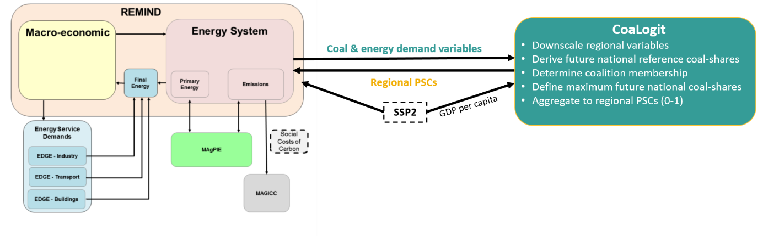Figure M2. Depiction of the REMIND-COALogit coupled-model framework with a brief description of COALogit functions, inputs, and outputs. Table M4 lists all the specific variables passed from REMIND to COALogit, which vary by scenario. PSC derivation is also scenario-dependent, as shown in equations 1-2 and 5-11. The REMIND schematic (from Baumstark et al.¹) includes some pre-existing interfaces for context and illustration of model structure. The coupling routines vary from iterative co-optimization (REMIND-MAgPIE) to ex-post calculations (MAGICC), but none are identical to the REMIND-COALogit soft-link.

COALogit Model

Determinants of PPCA Feasibility
Jewell et al. (2019) performed a multi-variate statistical analysis to investigate the significance of eleven independent variables from prior coal phase-out literature in explaining national accession to the PPCA¹⁰. The study reported a best-fit parsimonious logistic regression explaining current PPCA membership with (low) domestic coal-power-shares, a proxy for policy cost, and (high) Functioning of Government Index (FoG) scores, indicative of a state’s relative institutional capacity¹⁰. The overall best-fit model described three additional factors, including a positive correlation to GDP per capita (GDPpc), which had high covariance with FoG. The authors thus deemed GDPpc, which is, like coal-power-shares, prospectively quantifiable via accepted methods², highly suitable for our dynamisation of their findings. This dynamic feasibility space (DFS) of the PPCA represents the core of COALogit.

Coalition Accession Probabilities
The logit model is trained by providing the glm function of the stats R package¹¹ with real-world PPCA adoption among countries with at least a 1% coal-power-share in 2015 as the observed outcome variable and their GDPpc and coal-power-shares in 2015 as the independent variables. Eq. (1) defines the empirical relationship modeled between a nation’s likelihood of PPCA membership and the predictor variables.
$$\left(1\right) p\left(Y=1\right)=\frac{e^{β_{0}+β_{1}x+β_{2}y}}{1+e^{β_{0}+β_{1}x+β_{2}y}}$$
where:
p(Y=1) = probability of PPCA membership,
β_{i} = fitted model parameters (Table M1),
x = coal-power-share,
y = GDP per capita.
Parameter | Estimate | Std. error | Z-score | p-value | 95% CI
β_{o} | -0.896 | 0.390 | -2.298 | 0.021577 | [-1.660; -0.132]
β₁ | -5.747 | 1.726 | -3.329 | 0.000872 | [-9.131; -2.363]
β₂ | 0.095 | 0.022 | 4.257 | 2.08e⁻⁵ | [0.051; 0.138]
Table M1. Estimates and uncertainty ranges of the logit model coefficients corresponding to Equation (1). β₁ and β₂ describe the linear correlation of the log-odds of PPCA accession to coal-power-share and GDPpc, respectively, while β₀ is the intercept, i.e. H₀. The 103 observations (2015 data) used for model calibration are shown in Table SF1, along with the predicted accession probabilities of those countries.

Table M1 reports the estimates of the parameters – which are of the expected sign and significant in comparison to the null model H₀ – that describe the proportionality between each independent variable and the log-odds (logit) of any nation becoming a member. The calibrated model, represented by Eq. (2), is then used to infer the probability of each of the 249 ISO 3166-1 countries joining the coalition in a given period.
$$\left(2\right) ln{\frac{p_{\hat{n}}(t)}{1-p_{\hat{n}}(t)}= β_{0}+ β_{1}x_{C,\hat{n}}(t)+ β_{2}y_{\hat{n}}(t)}$$
where:
$\hat{n}$ = nation of analysis,
$p_{\hat{n}}$ = national probability of coalition accession,
t = time (refers to REMIND time-steps in our analyses),
$x_{C,\hat{n}}$ = national coal-power-share,
$y_{\hat{n}}$ = national GDP per capita.
In order to preserve consistency with REMIND v2.1¹, the present study does not use identical historical databases^{12–14} as those used in Jewell et al. (2019). The data vintage is also one year prior to the original model’s, and eleven more countries have acceded to the PPCA since the previous study (Table SF1). Nonetheless, we find a statistically significant, well-fitting and accurately predictive relationship between dependent and independent variables, suggesting that the model is reasonably robust. Table M2 displays several measures of model performance, and Figure M3 shows the logistic calibration curves and various fit metrics describing the predictive performance in future periods.

Model Performance Metric | Value
p-value | 4.45e⁻⁹
Pseudo R² (adj. McFadden) | 0.271
Residual standard error | 0.980
Log Loss | 0.466
Predictive accuracy (bootstrap AUC) | 87.71% (SE=3.72%)
Table M2. Statistical metrics describing the logit model’s significance, goodness-of-fit, and prediction quality.
a)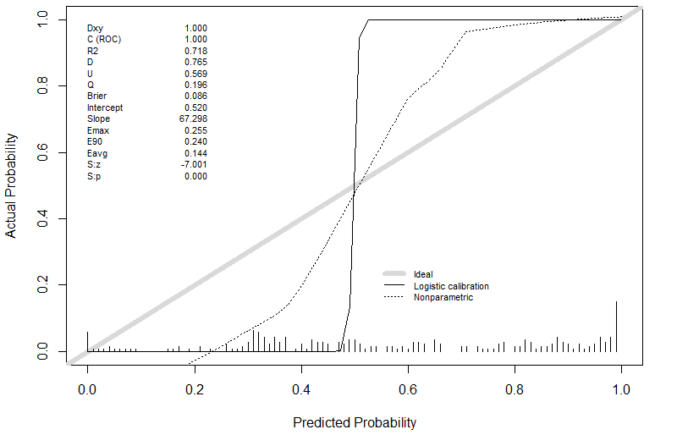
b) 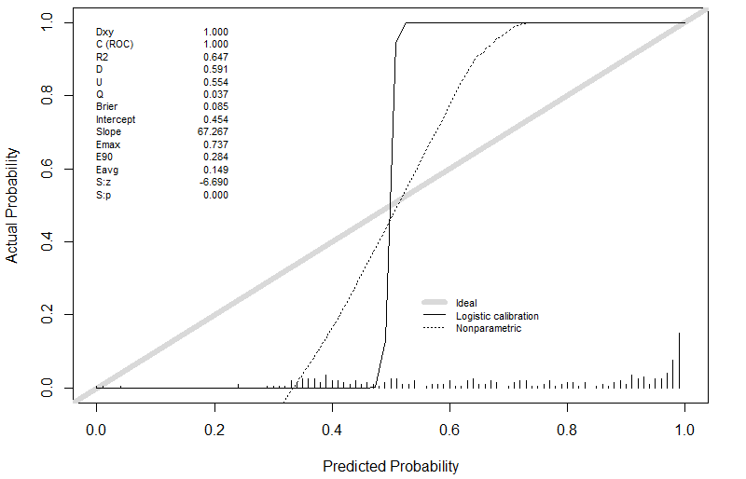
Figure M3. Logistic calibration curve for the validation of predicted national accession probabilities in 2025 (a) and 2045 (b). Generated using the val.prob() function of the rms R-package¹⁶. Dxy = Somers’ D, R2 = Nagelkerke-Cox-Snell-Maddala-Magee pseudo-R² index, D = discrimination index, U = unreliability index, Q = quality index, Emax/90/avg = maximum/0.9 quantile/average absolute difference in predicted and loess-calibrated probabilities, S:z = Spiegelhalter’s Z-score for calibration accuracy, S:p = two-tailed p-value for S:z. Both (a) and (b) are specific to the neutral Covid recovery.

Coalition Scenarios
In this study, we translate this output into operational assumptions for REMIND policy scenarios by defining probability thresholds of coalition accession. The three thresholds, as defined in Table M3, are represented as linear relationships in Figure 2 between GDPpc and coal-power-share, along which the probability of coalition accession is constant. In a given scenario, the postulated threshold can be interpreted as a socio-political ‘tipping point’^{17,18}. That is, any country which reaches a sufficiently high GDPpc and sufficiently low coal-power-share – and thus an accession probability above the threshold value – before the PPCA-imposed phase-out deadline is considered an irreversible member of the coalition. The coal exit policy is then exclusively applied to these nations in the subsequent (or ‘downstream’) REMIND scenario.

Coalition Threshold | Probability | Slope | Intercept
1p | 95% | 60.6 | 40.5
2p | 50% | 60.6 | 9.4
3p | 5% | 60.6 | -21.6
Table M3. Definition of the linear relationships between GDPpc and coal-power-share at the coalition threshold probabilities. These lines, as seen in Figure 2, have the general form y = mx + b, where y is GDPpc and x is coal-power-share.
Coalition membership in this study only implies that a country imposes a national coal phase-out policy along the lines prescribed by the PPCA. Membership is not subject to a monitoring and sanctioning mechanism, hence there are no issues with compliance and enforcement. Furthermore, the coalition is not a club because membership does not provide exclusive access to a club good from which non-members are excluded.

REMIND-COALogit Model Coupling

PPCA Declaration
Here, we define the soft-link created between REMIND and COALogit to model the PPCA coal phase-out with the DPE approach. The PPCA declaration, though non-binding, defines clear targets for its members: OECD and EU (OECD henceforth) member nations are expected to observe a 2030 phase-out of unabated coal-fired electricity while all other countries (non-OECD henceforth) are afforded until 2050. For the purposes of this study, we assume that all PPCA signatories will comply with the prescribed deadlines, despite e.g. Germany’s domestic plans for a delayed phase-out by 2033-2038.
To simulate coalition accession of OECD countries, we use COALogit to identify which OECD nations lie above each threshold in the 2025 REMIND time-step, representing a five-year period ending in June 2027. Any prospective member is assumed to have decided by then whether they will observe the 2030 phase-out. Similarly, we define non-OECD coalition scenarios by comparing non-OECD countries to the thresholds in the 2045 model period, 6/2042–6/2047. Table M4 details how the logit model receives its country-level independent variables in either case.

COALogit inputs and outputs
The implementation of REMIND-COALogit requires the downscaling of the relevant variables in Eq. (2), as derived by REMIND simulations, for all countries in future periods. Downscaling here means that, for instance, the future development of coal use in REMIND regions must be disaggregated to the country level so that the COALogit model can derive the accession of individual nations to the PPCA coalition. The country-level results are later re-aggregated to the level of REMIND regions in order to define constraints that are used in a subsequent, downstream REMIND run.
Consequently, COALogit performs three core functions: (i) reading in REMIND results and downscaling them to the national level, (ii) logit analysis to define coalition membership scenarios, and (iii) derivation of regional policy stringency coefficients (PSCs) that are used as constraints in REMIND (Figure M2). First, COALogit intakes regional variables for total energy demand as well as coal-fired and total electricity generation from the ‘upstream’ REMIND scenario, i.e. a preceding counterfactual scenario in which the coalition was either only partially formed or not yet modeled (Figure M4). COALogit then downscales and divides the variables to derive country-level coal-power-shares.
Second, the logit model determines coalition scenarios for the specified time-step using the derived national coal-power-shares and GDPpc from the SSP2 projections¹⁴. Third, the cumulative coal-power-shares from the PPCA-defined phase-out year until 2100 are calculated for all countries and set to zero in coalition members. PSCs are derived by aggregating the cumulative coal-power-shares to the regional level, and these are exported to a REMIND-readable file for use in the downstream scenario. Figure M4 illustrates the sequential iterations between REMIND and COALogit required to model each DPE-PPCA scenario.

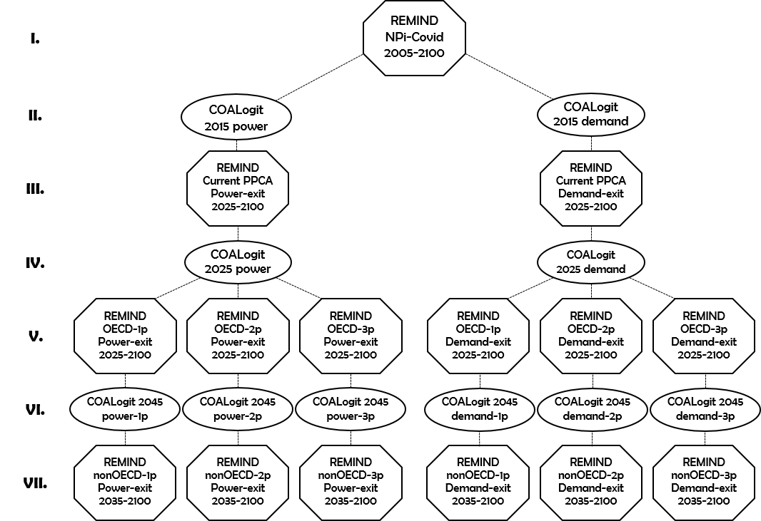
Figure M4. Flow chart of simulations with REMIND-COALogit. Each instance of the automated REMIND-COALogit DPE cascade flows along a dotted line from the NPi scenario (upstream) to one of six possible downstream PPCA scenarios. The Roman numerals here correspond to each step in the sequence, and numerals are used throughout the text refer back to this figure. The year displayed in each instance of COALogit indicates the time-step in which the logit analysis is performed to determine the policy-adopting coalition in the downstream REMIND scenario. The range of years shown in each REMIND run denotes the optimization horizon for that scenario (all prior periods are fixed to the upstream scenario). This simulation cascade is run for each Covid recovery scenario, giving a total of 18 DPE-PPCA scenarios.

Power-exit scenario cascade
A single PPCA scenario consists of four REMIND runs with a COALogit run between each, all executed in an automated sequence (Figure M4). (I.) The starting point of a PPCA scenario cascade is always an NPi reference case. (II.) COALogit regionally downscales the relevant NPi variables (Table M4) to derive the PSCs for current real-world OECD and non-OECD PPCA members, respectively. (III.) These PSCs are read into the downstream ‘Current PPCA’ REMIND scenario, which is the SPE scenario of the PPCA (see Table 1). Historical developments (2005-2020) in all scenarios of the cascade are fixed to NPi. The optimization horizon then begins in the 2025 time-step for ‘Current-PPCA’ and ‘OECD-xp’ – where ‘xp’ is a placeholder for the 1p, 2p, and 3p coalition scenarios – and in the 2035 period for ‘nonOECD-xp’.
(IV.) ‘COALogit 2025’ derives 1p, 2p, and 3p OECD coalition scenarios (Figure 2b) based on accession probabilities calculated by Eq. (2) using historical data extrapolation and 2025 variables computed by the ‘Current PPCA’ simulation (now the upstream scenario). Logically, the near-term actions of the current PPCA may influence the energy landscape in freeriding OECD nations and increase or decrease their probabilities of acceding. Likewise, analysis of non-OECD countries is forestalled because the actions of the OECD coalitions may, in turn, affect their decisions in the following two decades. ‘COALogit 2025’ then returns OECD PSCs for each coalition scenario. (V.) These are fed downstream to the ‘OECD-xp’ REMIND scenarios, which enforce the 2030 phase-out policy.
(VI.) Each ‘OECD-xp’ scenario calls a separate instance of ‘COALogit 2045’, such that each coalition scenario represents a unique and consistent degree of optimism, e.g. the 50%-probable OECD-2p can only lead to nonOECD-2p and not the 5%-probable nonOECD-3p. Each of these non-OECD coalitions is formed by logit analysis of 2045 ‘OECD-xp’ variables (Table M4) and assigned a PSC accordingly. (VII.) The ‘nonOECD-xp’ scenarios are fixed to ‘OECD-xp’ through 2030, preventing premature anticipation of the policy by the newly-defined non-OECD members but also affording them sufficient lead-time for adherence. Both the OECD and non-OECD phase-outs are enforced during this final scenario’s 2035-2100 optimization horizon. The ‘nonOECD-xp’ REMIND runs are therefore complete DPE-PPCA scenarios containing all the information accrued throughout the cascade.

Demand-exit cascade
Additionally, we consider an alternate interpretation of PPCA accession: a commitment by national governments to phase all unabated coal consumption out of the economy in accordance with the PPCA’s timeline. This reflects the assumption that PPCA members truly represent a coalition-of-the-willing, or are at least predisposed to accept further responsibilities. This demand-exit policy scenario extends the PPCA phase-out timeline to all coal-consuming technologies in all economic sectors except the iron and steel industry, which is permitted a 10-year grace period. This is intended to represent techno-institutional inertia, given that steelmaking is considered a particularly difficult industrial process to decarbonize¹⁹, and that high-grade metallurgical coal is a significantly higher-value commodity than thermal coal. Hence, the demand-exit scenario with only current coalition membership (i.e. ‘Current-PPCA’) is a hypothetical PEA rather than a SPE.
(I.) The same starting point (NPi) and sequence progression applies to demand-exit policy scenarios, but the coal phase-out constraints and the variables exchanged between REMIND and COALogit (Table M4) differ. (II.) ‘COALogit 2015’ provides (III.) ‘Current-PPCA’ with six PSCs – three for the OECD phase-out and three for the non-OECD phase-out. (IV) ‘COALogit 2025’ generates three PSCs for each (V.) ‘OECD-xp’ scenario, and (VI.) ‘COALogit 2045 xp’ feeds three more PSCs to its corresponding (VII.) ‘nonOECD-xp’ scenario. The relevant calculations performed throughout both the power- and demand-exit cascades are detailed below.

REMIND-COALogit Interface
This section provides a full technical account of the procedures and assumptions, and the rationales for each, involved in our coupling routine. Each subsection presents the general logic and formulae as they pertain to particular steps of the flow chart in Figure M4, and Table M4 details the sourcing and flow of information exchanged along the cascade.

OECD national coal-power-shares derivation (IV.)
In the 2025 COALogit instance, country-level coal-fired power generation is calculated based on the coal power capacities extrapolated from GCPT data¹³ (Appendix I). These are multiplied by the national 2025 utilization rates, which are in turn extrapolated from historical data¹² such that all countries linearly converge to a long-term assumption of 50% utilization by the 2035 period. Eq. (3) describes the linear extrapolation starting from 2015, the base period of our analyses.
$$\left(3\right) μ_{\hat{n}}\left(t\right)=μ_{\hat{n}}\left(t_{0}\right)+ \frac{0.5-μ_{\hat{n}}\left(t_{0}\right)}{2035-t_{o}} \left(t-t_{0}\right)$$
$$for t_{0}<t<2035$$
where:
$μ_{\hat{n}}$ = national utilization rate,
t₀ = 2015.
Some regions in REMIND are equal to countries (India, Japan, and the USA). For these countries, total electricity generation in all periods is taken directly from the upstream scenario. Other REMIND regions are aggregates of 3 to 54 nations, hence projected electricity generation must be downscaled. Disaggregation weights for total power generation are assigned to each nation according to the ratio of its base-period electricity generation¹² adjusted for population change¹⁴ to the region‘s, generally assuming constant per-capita electricity demand in the future. National coal-power-shares in 2025 are thus calculated as the ratio of extrapolated bottom-up coal power generation values and disaggregated top-down total electricity production figures.

Non-OECD national coal-power-shares derivation (VI.)
To extrapolate national coal-power-shares from multinational REMIND regions in the 2045 instance of COALogit, we employ a different downscaling routine, grounded in the assumption that the relative difference between a region’s coal-power-share and those of its member nations remains constant. First, national coal-power-shares in 2030 are downscaled from the upstream REMIND scenario (OECD-xp, see Figure M4) by assuming its percentage above or below its region’s coal-power-share remains unchanged from 2025. This is represented by Eq. (4).
$$\left(4\right) x_{\hat{n}}\left(t\right)=\left\{\begin{aligned}x_{\hat{n}}\left(t-∆t\right)+\frac{x_{\hat{n}}\left(t-∆t\right)-x_{R}\left(t-∆t\right)}{1-x_{R}\left(t-∆t\right)}∙\left(1-x_{R}\left(t\right)\right) , if x_{R}\left(t\right)≥x_{R}\left(t-∆t\right) \\ x_{\hat{n}}\left(t-∆t\right)-\frac{x_{R}\left(t-∆t\right)-x_{\hat{n}}\left(t-∆t\right)}{x_{R}\left(t-∆t\right)}∙x_{R}\left(t\right) , if x_{R}\left(t\right)<x_{R}\left(t-∆t\right)\end{aligned}\right.$$
$$for t≥2030$$where:
$t-∆t$ = previous period analysed ($∆t$ varies between 5 and 15 years),
R = REMIND region containing nation $\hat{n}$.
Country-level coal power generation in 2030 is then calculated by multiplying total national electricity generation by coal-power-share. However, OECD coalition members, as defined in the 2025 COALogit instance, must have zero coal electricity generation. Their just-derived coal electricity values are thus counterfactual and must be redistributed to other nations in the region. Eq. (5) describes this process.
$$\left(5\right) {\tilde{seel}}_{C,\hat{n}}\left(t\right)= \left\{\begin{aligned}0, if \hat{n}∈M_{R} \\ {\hat{seel}}_{C,\hat{n}}\left(t\right)+\frac{{\hat{seel}}_{G,\hat{n}}\left(t\right)}{\sum_{n∈F_{R}}{{\hat{seel}}_{G,n}\left(t\right)}}∙\sum_{n∈M_{R} }{{\hat{seel}}_{C,n}\left(t\right)}, if \hat{n}∈F_{R} \end{aligned}\right.$$
$$for t≥2030$$where:
${\tilde{seel}}_{C,\hat{n}}$ = national coal electricity after accounting for OECD phase-out,
${\hat{seel}}_{C,\hat{n}}$ = counterfactual national coal electricity downscaled from upstream REMIND scenario,
${\hat{seel}}_{G,\hat{n}}$ = total national electricity generation downscaled from upstream REMIND scenario,
n = each nation within region R,
M_{R} = OECD coalition members in region R,
F_{R} = freeriding nations in region R.
Finally, with the OECD phase-out reflected in the national coal power generation values, coal-power-shares are recalculated for 2030. National coal-power-shares in 2045 can then be derived through Eq. (4) using 2030 as the previous period, and these values are used in Eq. (2) to derive non-OECD coalition accession probabilities.

Power-exit Policy Stringency Coefficients (IV. & VI.)
The need for PSCs is also to address the spatial mismatch between REMIND and COALogit. Not only are multinational REMIND regions often divided between coalition members and free-riders, but some contain both OECD and non-OECD countries, so policy adoption is likely staggered and non-uniform within a single region. These coefficients encode the country-level granularity of coalition membership as a maximum share of electricity generation which can come from unabated coal power plants in each region from (i) 2030-2100 for the OECD coal exit and (ii) 2050-2100 for the non-OECD PPCA target in the downstream REMIND scenario.
Policy enforcement within REMIND – and thus PSC derivation by COALogit – is conditional upon the coalition members’ proportion of the region’s future coal power demand and energy market in the counterfactual upstream REMIND scenario. Hence, Eq. (4) is repeated for all time-steps between 2030 and 2100 to derive counterfactual national coal power generation, and total PE must be downscaled to the national level for the same periods. An analogous principle is used in the PE disaggregation procedure as in the electricity downscaling routine, except weights are anchored by base-year PE consumption rather than electricity production.
The specific conditions upon which policy enforcement depends are that a region must contain at least two coalition members in the current accession stage, and these acceding nations must comprise over 20% of each of the region’s cumulative PE and coal-fired electricity demand from the phase-out date until 2100 in the upstream scenario. These conditions are based on cumulative values to properly weight the expected future significance of emerging economies.
For the multinational regions that meet these criteria, PSCs are formulated by dividing the free-riders’ counterfactual coal power generation by the region’s total electricity generation in the upstream REMIND scenario. Eq. (6) shows how PSCs are derived for regions that meet the criteria but still contain free-riders. To enable leakage into the region’s freeriding contingent during the downstream REMIND simulation, we include a multiplier which exogenously permits these free-riders to generate 50% more coal-fired electricity than they did in the upstream scenario.
$$\left(6\right) {PSC}_{R,α}= \frac{\sum_{t=t_{α}}^{2100}{\sum_{n∈F_{R}}{{\hat{seel}}_{C,n}(t)}}}{\sum_{t=t_{α}}^{2100}{\sum_{n∈R}{{\hat{seel}}_{G,n}(t)}}} ∙ L \\ for t_{α}=\left\{\begin{aligned}2030, if α=OECD \\ 2050, if α=nonOECD\end{aligned}\right.$$
where:
PSC_{R,α} = policy stringency coefficient for region R in the current accession stage α,
L = intra-regional coal leakage allowance = 1.5.
Meanwhile, in regions consisting primarily of free-riding countries, and thus do not fulfill the minimum membership criteria, the potential for coal leakage is unbounded; they are assigned a PSC of one, i.e. 100% of their electricity generation in the subsequent REMIND scenario can be coal-fired in theory. On the other hand, if all countries in a region enter the coalition, then the region is assigned a PSC of zero, signaling a full-fledged phase-out in the downstream REMIND scenario. Only this phase-out case and the unconstrained case may apply to single-nation regions. Any region which consists solely of OECD-PPCA nations is assigned a PSC of 0 in both the OECD and non-OECD phases, while a region whose member states all accede during the non-OECD stage are assigned PSC_{OECD} = 1 and PSC_{nonOECD} = 0.

Power-exit policy implementation (V. & VII.)
We model the verbatim PPCA declaration (i.e. power-exit policy) in REMIND by restricting the share of total electricity production from coal-fired power plants without CCS. The sum of electricity generated by REMIND’s unabated PC, IGCC, and CCHP plants from the policy start year until 2100 in each region is constrained to a PSC-defined fraction of the total regional electricity generated in that timespan. Equation (7) describes this constraint, unique to power-exit scenarios.
$$\left(7\right)\sum_{t=t_{α}}^{2100}{{\check{seel}}_{R,U}(t)}≤{PSC}_{R,α}\left(\sum_{t=t_{α}}^{2100}{{\check{seel}}_{R,G}(t)}\right)$$
where:
${\check{seel}}_{R,U}$ = unabated coal-fired electricity generation in downstream scenario,
${\check{seel}}_{R,G}$= electricity generation in downstream (relative to PSC derivation) scenario.
Note that REMIND scenarios which model the non-OECD phase-out include both the OECD and non-OECD constraints on regions with nonzero PSCs for both stages. Coal power generation from 2050-2100 is ultimately bounded by the more stringent of the two, but a region is theoretically free to deplete its entire 2030-2100 allowance within the 2030-2050 timespan.

Demand-exit PSCs (IV. & VI.)
The demand-exit policies are implemented for qualifying regions (based on analogous criteria to power-exit enforcement) through a three-step process. First, the share of total CO₂ that can be emitted by non-solid coal conversion technologies are assigned a PSC by COALogit from 2030 (2050) through 2100 in the OECD (non-OECD). Second, CO₂ emissions from coal solids used for non-metallurgical purposes, e.g. cement production, are restricted by a separate PSC over the same periods. Third, CO₂ emissions from coal-based metallurgy are assigned a third PSC, applicable from 2040 (2060) to 2100.
First, the relevant numerators are downscaled by the same technique as introduced by Eqs. (4)-(5); simply replace seel with the emi variables of interest (Tables M4+5). Next, total regional CO₂ emissions from the upstream REMIND scenario are downscaled according to the same disaggregation weights as used for PE downscaling. The PSCs are derived according to Eqs. (8)-(10) for qualifying regions.
$$\left(8\right) {PSC}_{{R,α}_{c}}= \frac{\sum_{t={t_{α}}_{c}}^{2100}{\sum_{n∈F_{R}}{\left({\hat{emi}}_{n,\overline{c}}(t)- {\hat{emi}}_{n,\overline{s}}(t)\right)}}}{\sum_{t={t_{α}}_{c}}^{2100}{{\hat{emi}}_{R,E}(t)}} ∙ L$$
$$\left(9\right) {PSC}_{{R,α}_{s}}= \frac{\sum_{t={t_{α}}_{s}}^{2100}{\sum_{n∈F_{R}}{\left({\hat{emi}}_{n,\overline{s}}(t)- {\hat{emi}}_{n,m}(t)\right)}}}{\sum_{t={t_{α}}_{s}}^{2100}{{\hat{emi}}_{R,E}(t)}} ∙ L$$
$$\left(10\right) {PSC}_{{R,α}_{m}}= \frac{\sum_{t={t_{α}}_{m}}^{2100}{\sum_{n∈F_{R}}{{\hat{emi}}_{n,m}(t)}}}{\sum_{t={t_{α}}_{m}}^{2100}{{\hat{emi}}_{R,E}(t)}} ∙ L$$
$if α= \left\{\begin{aligned}OECD, then {t_{α}}_{c}{{, t}_{α}}_{s}=2030, {t_{α}}_{m}=2040 \\ nonOECD, then {t_{α}}_{c}{{, t}_{α}}_{s}=2050, {t_{α}}_{m}=2060 \end{aligned}\right.$
where:
${\hat{emi}}_{n}$= CO₂ emissions of each nation in R, downscaled from the upstream scenario,
E = all energy end-use activities,
c = non-solids coal end-uses,
$\overline{c}$ = all coal end-uses,
s = non-metallurgical coal solids end-uses,
$\overline{s}$ = coal solids end-uses,
m = metallurgical coal solids end-uses (i.e. iron and steel manufacturing).
The criteria for PSC derivation apply to each of the demand-exit PSCs individually, and regions that do not satisfy the condition(s) are assigned PSC(s) of zero. This implies that there may be scenarios in which, for example, a region’s met-coal emissions are constrained (i.e. ${PSC}_{R,α_{m}}$ > 0) but its non-solids coal emissions are not (i.e. ${PSC}_{R,α_{c}}$ = 0), because its members constitute over 20% of the region’s steel production but under 20% of the overall coal consumption. Regions that exclusively contain coalition members are assigned ε for all three PSCs, meanwhile.

Demand-exit policy implementation (V. & VII.)
The PSCs enter REMIND in a series of corresponding equations that enforce the demand-exit policy. Eq. (11) illustrates how the non-solids coal and non-metallurgical coal solids elements of the policy are implemented by controlling different sets of technologies, just like the power-exit. Eq. (12) shows the additional assumption used to isolate the emissions from metallurgical coal, namely that the share of coal in a region’s solid energy consumption is uniform across all sectors.
$$\left(11\right)\sum_{t=t_{α_{j}}}^{2100}{{\check{emi}}_{R,j}(t)}≤{PSC}_{R,α_{j}}\left(\sum_{t=t_{α_{j}}}^{2100}{{\check{emi}}_{R,E}(t)}\right)$$
$$\left(12\right)\sum_{t=t_{α_{m}}}^{2100}{\left({\check{emi}}_{R,m}(t) ∙ \frac{{\check{FE}}_{R,\overline{s}}(t)}{{\check{FE}}_{R,S}(t)}\right)}≤{PSC}_{R,α_{m}}\left(\sum_{t=t_{α_{m}}}^{2100}{{\check{emi}}_{R,E}(t)}\right)$$
where:
j = {c, s},
${\check{emi}}_{R}$= regional CO₂ emissions variable in downstream scenario,
${\check{FE}}_{R}$= regional final energy production variable in downstream scenario,
S = all solid final energy production.

 |  | COALogit Instance
 | COALogit Input (usage) | Current/2015 (II.) | OECD/2025 (IV.) | Non-OECD/2045 (VI.)
All Scenarios | GDP per capita (logit) | 2015 data, Institute for Health Metrics and Evaluation (IHME)²⁰ | 2025 SSP2 projections¹⁴ | 2045 SSP2 projections
All Scenarios | Coal-fired power generation (logit) | 2015 data, IEA¹² | Extrapolated data from  2021 GCPT¹³ (capacity) &  2015 IEA (utilization rates) | 2045 OECD-PPCA-xp variable, downscaled by routine (a)
All Scenarios | Total electricity generation (logit) | 2015 data, IEA | 2025 Current-PPCA variable, downscaled by (b) | 2045 OECD-PPCA-xp variable, downscaled by (b)
All Scenarios | Population (weighting) | 2020-2100 SSP2 projections | 2020-2100 SSP2 projections | 2020-2100 SSP2 projections
All Scenarios | Total PE demand (weighting) | 2015 data, IEA | 2015 data, IEA | 2015 data, IEA
All Scenarios | Total PE demand (PSC condition) | 2030-2100 NPi variable, downscaled by (c) | 2030-2100 Current-PPCA variable, downscaled by (c) | 2050-2100 OECD-PPCA-xp variable, downscaled by (c)
Power-exit | Coal-fired power generation (PSC) | 2030-2100 NPi variable, downscaled by (d) | 2030-2100 Current-PPCA variable, downscaled by (d) | 2050-2100 OECD-PPCA-xp variable, downscaled by (d)
Power-exit | Total electricity generation (PSC) | 2030-2100 NPi variable, downscaled by (b) | 2030-2100 Current-PPCA variable, downscaled by (b) | 2050-2100 OECD-PPCA-xp variable, downscaled by (b)
Demand-exit | Total CO₂ emissions (PSC) | 2030-2100 NPi variable, downscaled by (c) | 2030-2100 Current-PPCA variable, downscaled by (c) | 2050-2100 OECD-PPCA-xp variable, downscaled by (c)
Demand-exit | Coal CO₂ emissions (PSC) | 2030-2100 NPi variable, downscaled by (e) | 2030-2100 Current-PPCA variable, downscaled by (e) | 2050-2100 OECD-PPCA-xp variable, downscaled by (e)
Demand-exit | Coal solids CO₂ emissions (PSC) | 2030-2100 NPi variable, downscaled by (f) | 2030-2100 Current-PPCA variable, downscaled by (f) | 2050-2100 OECD-PPCA-xp variable, downscaled by (f)
Demand-exit | Met-coal CO₂ emissions (PSC) | 2040-2100 NPi variable, downscaled by (g) | 2040-2100 Current-PPCA variable, downscaled by (g) | 2060-2100 OECD-PPCA-xp variable, downscaled by (g)
Table M4. Delineation of input variables to each COALogit instance and their sources. Roman numerals refer to Figure M4. Bold text indicates the upstream REMIND scenario which computed the variable. The ‘xp’ in OECD-PPCA-xp is a placeholder for the coalition scenarios 1p, 2p, and 3p, which each initiate a unique COALogit run. See Table M5 for the definition of downscaling routines (a)-(g).

 | Downscaling routine description
(a) | Eqs. (4)-(5) – i.e. assume all countries’ coal-power-shares remain a constant % above or below regional level from 2025 forward, then account for the OECD coal phase-out.
(b) | Assume per-capita electricity generation remains constant at historical levels^{iii}.
(c) | Assume per-capita PE demand remains constant at historical levels.
(d) | Eq. (4) only – i.e. counterfactual coal power generation, indicative of reference demand.
(e) | Eqs. (4)-(5), except [seel_{C} := emi_{c}]; [seel_{G} := emi_{E}]; and $x=\frac{{emi}_{c}}{{emi}_{E}}$
(f) | Eqs. (4)-(5), except [seel_{C} := emi_{s}]; [seel_{G} := emi_{E}]; and $x=\frac{{emi}_{s}}{{emi}_{E}}$
(g) | Eqs. (4)-(5), except [seel_{C} := emi_{m}]; [seel_{G} := emi_{E}]; and $x=\frac{{emi}_{m}}{{emi}_{E}}$
Table M5. Delineation of all downscaling routines required for the REMIND-COALogit coupling interface. The lettered rows correspond to the letters in Table M4.

Covid-19 recovery programs
The final dimension of our scenario analysis considers the near-term uncertainties associated with the Covid-19 shock²¹. This interruption of electricity demand and project construction cycles is an opportune moment for governments to reassess power sector investment options, and to wield their power as a financier, underwriter, and/or regulator. These decisions have wide-ranging near- and long-term consequences, including severe respiratory health implications²² which may be of greater sociopolitical relevance than before the pandemic. We assess the potential path-dependencies^{23–25} of PPCA dynamics and outcomes to different near-term trajectories of coal power capacity. These are derived by first calculating detailed national-level historical statistics using plant-level data, and then applying stylized global assumptions (Table A1) to extrapolate future trend scenarios (Figure A1).
We name these scenarios green (G), neutral (N), and brown (B) Covid recoveries, in ascending order of the global coal power generation in 2025. The neutral recovery assumes that the Covid crisis has no effect on the average lifespans of coal plants nor the historical completion rates of projects in each phase of the development pipeline. The green and brown recoveries, meanwhile, are designed to capture the ‘reasonable’ – not the maximum – range of Covid-induced changes to those statistics.
Unlike the other two dimensions, these stylized exogenous constraints are independent of the PPCA and thus also apply to the reference NPi and NDC scenarios. Hence, each of the three NPi-Covid baselines (NPi-G, NPi-N, and NPi-B) initiates its own two scenario cascades, one for each policy interpretation (Figure M4), and all scenarios within these two cascades are fixed to the same 2025 coal power generation level. Importantly, the Covid-19 dimension can have direct impacts on the energy system as well as feed-forward effects on the growth of the coalition, indirectly affecting scenario outcomes.

References
1. Baumstark, L. et al. REMIND2.1: Transformation and innovation dynamics of the energy-economic system within climate and sustainability limits. Geoscientific Model Development Discussions 1–50 (2021) doi:10.5194/gmd-2021-85.
2. Dellink, R., Chateau, J., Lanzi, E. & Magné, B. Long-term economic growth projections in the Shared Socioeconomic Pathways. Global Environmental Change 42, 200–214 (2017).
3. Bauer, N. et al. Global fossil energy markets and climate change mitigation – an analysis with REMIND. Climatic Change 136, 69–82 (2016).
4. Bauer, N. et al. Assessing global fossil fuel availability in a scenario framework. Energy 111, 580–592 (2016).
5. Rogelj, J. et al. Mitigation pathways compatible with 1.5°C in the context of sustainable development. in Special Report on the impacts of global warming of 1.5 °C (Intergovernmental Panel on Climate Change, 2018).
6. Stern, N. The Economics of Climate Change. American Economic Review 98, 1–37 (2008).
7. Roelfsema, M. et al. Taking stock of national climate policies to evaluate implementation of the Paris Agreement. Nat Commun 11, 2096 (2020).
8. Allen, M. et al. Summary for Policymakers. In: Global Warming of 1.5 °C an IPCC special report. (2018).
9. Arroyo-Currás, T. et al. Carbon leakage in a fragmented climate regime: The dynamic response of global energy markets. Technological Forecasting and Social Change 90, Part A, 192–203 (2015).
10. Jewell, J., Vinichenko, V., Nacke, L. & Cherp, A. Prospects for powering past coal. Nat. Clim. Chang. 9, 592–597 (2019).
11. R Core Team. R: A language and environment for statistical computing. https://www.R-project.org/ (2019).
12. IEA. World Energy Balances and Statistics (Database). https://www.iea.org/classicstats/relateddatabases/worldenergystatisticsandbalances/ (2017).
13. Global Energy Monitor. Global Coal Plant Tracker January 2021. EndCoal.org https://endcoal.org/global-coal-plant-tracker/ (2021).
14. Fricko, O. SSP2: A middle of the road scenario for the 21st century. Global Environmental Change This Special Issue. (2016).
15. McFadden, D. Quantitative Methods for Analyzing Travel Behavior of Individuals: Some Recent Developments. (1977).
16. Harrell Jr., F. E. rms: Regression Modeling Strategies. (2021).
17. Bond, K., Fulton, M. & Hobley, A. The political tipping point: Why the politics of energy will follow the economics. (2019).
18. Otto, I. M. et al. Social tipping dynamics for stabilizing Earth’s climate by 2050. Proc Natl Acad Sci USA 201900577 (2020) doi:10.1073/pnas.1900577117.
19. Edelenbosch, O. Y. et al. Comparing projections of industrial energy demand and greenhouse gas emissions in long-term energy models. Energy 122, 701–710 (2017).
20. Institute for Health Metrics and Evaluation (IHME). Gross Domestic Product (GDP) Estimates by Country 1950-2015. http://ghdx.healthdata.org/record/ihme-data/gross-domestic-product-gdp-estimates-country-1950-2015 (2019).
21. Hepburn, C., O’Callaghan, B., Stern, N., Stiglitz, J. & Zenghelis, D. Will COVID-19 fiscal recovery packages accelerate or retard progress on climate change? (2020).
22. Vohra, K. et al. Global mortality from outdoor fine particle pollution generated by fossil fuel combustion: Results from GEOS-Chem. Environmental Research 195, 110754 (2021).
23. Fouquet, R. Path dependence in energy systems and economic development. Nature Energy 1, 16098 (2016).
24. Seto, K. C. et al. Carbon Lock-In: Types, Causes, and Policy Implications. Annu. Rev. Environ. Resour. 41, 425–452 (2016).
25. Unruh, G. C. Understanding carbon lock-in. Energy Policy 28, 817–830 (2000).

As of its status in 2018, viz. we do not model here the 2021 ‘Fit for 55’ proposal by the EU Commission.
Along with GDPpc, the other two were coal production per capita and the share of coal in total final energy consumption. The latter was found to have high covariance with coal-power-share (~0.6 correlation factor).
Likelihood-ratio test results showed a correlation factor of ~0.8 between GDPpc (on a purchasing power parity basis) and FOG, the highest found for any two variables.
An adjusted McFadden pseudo-R² value between 0.2 and 0.4 is considered an excellent fit¹⁵.
Countries with zero coal power capacity in the base year are assigned their REMIND region’s aggregate utilization rate.
Special cases of countries with low base-year electrification and a declining population are instead assumed to keep their total electricity generation constant at base-year levels. This prevents negative weights.
Special cases of countries with low base-year PE and a declining population are instead assumed to keep their total PE constant at base-year levels.

