Appendix

Post-COVID Coal Power Capacity Scenarios
This Appendix describes the methodology employed to extrapolate historical country-level coal power capacity data to generate bottom-up scenarios for 2025, the REMIND model period immediately following the COVID-19 crisis. The intention is to estimate an uncertainty range – not a projection – of the aggregate effect of national COVID recovery programs on near-term trajectories for the global coal power sector. REMIND takes these stylized scenarios – neutral, green, and brown recoveries – as various starting points for the energy system. Our analysis aims to determine the sensitivity – or path-dependency – of long-term scenario results to these initial conditions.

Data Procurement
The Global Energy Monitor’s Global Coal Plant Tracker¹ (GCPT) is an open source database with coverage of effectively all coal power plants larger than 30 MW, currently operating or not, dating back to 1927. The data used for this study is from the January 2021 release. The publicly disseminated ‘Summary Statistics’ report existing and planned capacity by country, categorized by status into ‘Operating’, ‘Announced’, ‘Pre-permit’, ‘Permitted’, ‘Under Construction’, ‘Shelved’, ‘Mothballed’, ‘Cancelled’ and ‘Retired’ assets. Additional datasets, distributed to mailing list subscribers and freely available upon request, contain information at the individual plant level, such as plant age, year of retirement or planned retirement, conversion efficiency and lifetime emissions. A separate plant-level datasheet which provides semi-annual updates to plant status since 2014 was received upon request.

Data Manipulation
All GCPT data is read into R using the readGCPT function, part of the mrremind² package developed by the Potsdam Institute for Climate Impact Research. The function is used to consolidate historical capacity data into specialized array format (magclass³ objects) and to calculate national mean plant lifespans, project completion rate of each pipeline phase, and scenarios for future capacity and associated emissions. National plant lifespans are calculated as the mean age at which power plants in each country are retired, weighted by the megawatt-capacity of the plant. The GCPT plant-level datasheet provides 100% coverage of the retirement age of retired plants and 99.9% coverage of their capacities.
The calculation of phase-specific national project completion rates is – to our knowledge – a novelty of this study. This consists of several steps. First, a plant-level datasheet tracking the lifecycle stage of each asset is parsed to compile transition flows, i.e. the number of plants which changed from announced to operating, from permitted to canceled or from construction to shelved to operating, for example. In total, 36 flow permutations are tracked and aggregated to the country level. Second, these flows are used to compute the rates with which projects in each phase have been cancelled or shelved in each country. Importantly, since shelved construction projects are much more likely to eventually reach completion than shelved pre-permit projects, we derive the cancellation rates of shelved projects specific to each previous stage of development.
Third, a significant fraction of the coal pipeline can be found in developing nations with a nascent coal power industry, hence their historical project data are either unreliable or nonexistent. Thus, we calculate the weighted mean cancellation and shelving rates of each of REMIND’s 12 world regions (Figure M1), and any nation with over 50% of its entire coal history in the planning phases are assigned their region’s value. Finally, national completion rates are calculated by subtracting the phase-specific cancellation and shelving rates from 100%.

 | Announced |  | Pre-permit |  | Permitted |  | Construction |  | Shelved
Region | Capacity (GW) | Comp. Rate | Capacity (GW) | Comp. Rate | Capacity (GW) | Comp. Rate | Capacity (GW) | Comp. Rate | Capacity (GW) | Comp. Rate
Canada, AUS, New Zealand | 2.0 | 70.9% | 1.0 | 0.0% | 0.0 | 7.2% | 0.0 | 7.2% | 2.2 | 0.0%
China | 57.4 | 28.1% | 48.2 | 51.4% | 53.2 | 72.0% | 88.1 | 91.6% | 38.8 | 5.9%
EU-28 | 0.0 | 26.3% | 0.5 | 24.1% | 0.1 | 76.9% | 1.2 | 95.3% | 0.0 | 4.7%
Former Soviet Union | 0.8 | 44.9% | 1.0 | 73.5% | 0.0 | 32.5% | 1.0 | 94.4% | 2.8 | 6.4%
India | 6.0 | 20.0% | 13.9 | 26.0% | 9.4 | 37.5% | 36.6 | 83.9% | 36.8 | 10.6%
Japan | 0.0 | 49.2% | 1.2 | 65.0% | 1.3 | 70.1% | 7.3 | 100.0% | 0.0 | 7.2%
Latin America | 1.4 | 36.4% | 0.7 | 0.0% | 2.0 | 25.2% | 0.0 | 96.9% | 1.0 | 15.2%
MENA | 0.0 | 37.1% | 0.0 | 0.0% | 0.0 | 81.6% | 2.4 | 91.5% | 17.5 | 0.0%
Non-EU Europe | 6.0 | 44.8% | 11.6 | 35.0% | 6.0 | 49.8% | 2.0 | 100.0% | 3.9 | 0.9%
Other Asian States | 34.4 | 33.3% | 37.2 | 70.8% | 14.5 | 92.3% | 36.0 | 99.6% | 32.8 | 4.1%
Sub-Saharan Africa | 8.3 | 35.7% | 2.5 | 22.3% | 3.0 | 47.6% | 4.9 | 98.8% | 16.2 | 0.0%
USA | 0.0 | 7.2% | 0.0 | 0.0% | 0.0 | 0.0% | 0.0 | 6.0% | 0.0 | 0.0%
World | 116.3 | 31.6% | 117.8 | 51.7% | 89.4 | 68.3% | 179.7 | 92.3% | 151.9 | 5.2%
Table A1. Size of the coal pipeline by project cycle phase and the historical completion rates of each phase, aggregated to the REMIND regional level. Completion rates are calculated based on projects that were constructed, canceled, or shelved between 2014 and 2020.

 | Shelving Rates
Region | Announced | Pre-permit | Permitted | Construction
Canada, AUS, New Zealand | 0% | 44% | 15% | 5%
China | 12% | 16% | 20% | 7%
EU-28 | 34% | 25% | 0% | 0%
Former Soviet Union | 18% | 0% | 0% | 5%
India | 28% | 25% | 12% | 3%
Japan | 2% | 0% | 0% | 0%
Latin America | 11% | 12% | 33% | 3%
MENA | 36% | 0% | 0% | 13%
Non-EU Europe | 10% | 11% | 2% | 0%
Other Asian States | 21% | 14% | 4% | 0%
Sub-Saharan Africa | 41% | 53% | 37% | 1%
USA | 18% | 0% | 0% | 0%
World | 16% | 18% | 13% | 3%
Table A2. Shelving rates of projects in each pipeline phase. Any country that did not shelve any projects in a particular phase is assigned its region’s value, and any region without shelved projects in a certain phase is assigned the global weighted average.

Post-COVID Capacity Scenarios
A set of assumptions, summarized in Table A3, are overlaid on the historical values computed above to extrapolate 2025 capacity scenarios. In short, the MW capacity in each of the pipeline phases are multiplied by the country’s phase-specific completion rate and added to the operating capacity in 2020. Meanwhile, all plants which reach its nation’s historical mean lifespan will be subtracted from the 2020 operating capacity. Additionally, any plants with a planned retirement date of 2027 or earlier will also be considered retired.
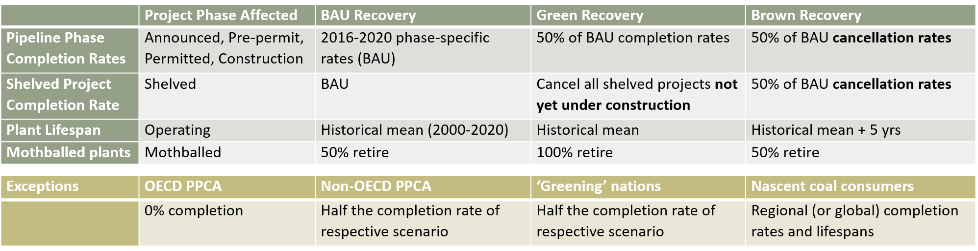
Table A3. Assumptions used for the extrapolation of historical coal power plant and project data to post-COVID scenarios.

Neutral Recovery
The neutral scenario represents a case in which governments on aggregate do not reconsider their national energy plans in their COVID recovery stimulus packages. In terms of coal-fired power plants, this corresponds to a perfect continuation of national historical mean plant lifespans, and of pre-pandemic completion, cancellation, and shelving rates of the project pipeline in each country (Tables A1-2). The future shelving of projects, and the ultimate completion of these plants, is modeled by first applying the shelving rates in Table A2 to each pipeline phase and then multiplying by the completion rate of shelved plants from Table A1. Furthermore, half of the currently mothballed plants are assumed to retire.
There are some exceptions to this rule of thumb. In order to achieve their 2030 phase-out target, PPCA members in the OECD and EU are assumed to complete 0% of their remaining pipelines. All other current PPCA members are assumed to cut their historical completion rates in half and to cancel all shelved plants. These assumptions also apply to countries which have already announced plans to cancel large coal projects via press briefings. Specifically, these ‘green-leaning nations’ are the Philippines, Spain, Bangladesh, Egypt, Pakistan, Australia, South Korea and Vietnam.

Green Recovery
The more optimistic green scenario envisions a world in which national governments account for the detrimental long-term climate, financial, health, and/or environmental consequences of new coal power plants in their COVID-recovery plans. Therefore, national project completion rates of all phases fall to 50% of the historical (and neutral scenario) rates. Moreover, all mothballed plants are assumed to retire, and shelved projects which have not yet entered the construction phase are assumed to be cancelled. National plant retirement ages remain at the historical capacity-weighted mean, reflecting the assertion that early retirements are politically more difficult than prospective project cancellations⁴. OECD and EU members of the PPCA will again be assumed to cancel all projects, while all other PPCA members and green-leaning nations will be assumed to cut their completion rates to 25% of historical rates.

Brown Recovery
The brown scenario depicts a more cynical outlook in which national governments turn toward coal power as seemingly ‘safe and proven’ energy investments to lift the economy out of crisis. The recovery package thereby reduces the cancellation rate of all pipeline projects by 50% and increases the lifespan of coal stations by five years above the national historical capacity-weighted mean. OECD and EU PPCA members are unaffected by this global movement, while other PPCA members and green-leaning nations are assumed to complete a larger share of their projects than in the neutral case but still at half the rate of the rest of the world.
 | Implied Emissions (GtCO₂)
REMIND Region | Green | Brown | Literature
Canada, AUS, NZ | 1.9 | 2.9 | 2.5
China | 68.7 | 107.0 | 184.2
EU-28 | 7.9 | 10.9 | 7.4
Former Soviet Union | 4.3 | 6.4 | 3.2
India | 31.5 | 45.6 | 46.3
Japan | 5.0 | 7.0 | 6.6
Latin America | 2.1 | 2.9 | 3.2
MENA | 0.9 | 1.7 | 4.0
Non-EU Europe | 4.7 | 8.8 | 7.4
Other Asian States | 20.3 | 32.9 | 43.2
Sub-Saharan Africa | 1.6 | 4.6 | 8.4
USA | 13.9 | 19.4 | 6.3
World | 163 | 250 | 323
Table A4. The amount of CO₂ that would be emitted from coal power plants by REMIND region from varied near-term trajectories. Implied emissions are calculated using plant-level estimates of heat rates (technology-specific) and emissions factors (based on coal quality) given by the GCPT database¹. See Table 2 for implied emissions from the neutral Covid recovery scenario. Literature = globally-uniform assumptions commonly used in the literature, i.e. 40-year lifespans and 100% pipeline completion.
 | Coal Power Capacity (GW)
Region | Brown | Green | Neutral | Literature
Canada, AUS, NZ | 22 | 15 | 15 | 18
China | 1307 | 982 | 1069 | 1307
EU-28 | 63 | 50 | 51 | 58
Former Soviet Union | 49 | 30 | 33 | 24
India | 327 | 231 | 258 | 281
Japan | 52 | 39 | 45 | 51
Latin America | 19 | 14 | 15 | 20
MENA | 10 | 5 | 6 | 10
Non-EU Europe | 58 | 29 | 36 | 44
Other Asian States | 241 | 158 | 199 | 251
Sub-Saharan Africa | 43 | 15 | 22 | 45
USA | 132 | 98 | 99 | 48
Global | 2322 | 1666 | 1849 | 2157
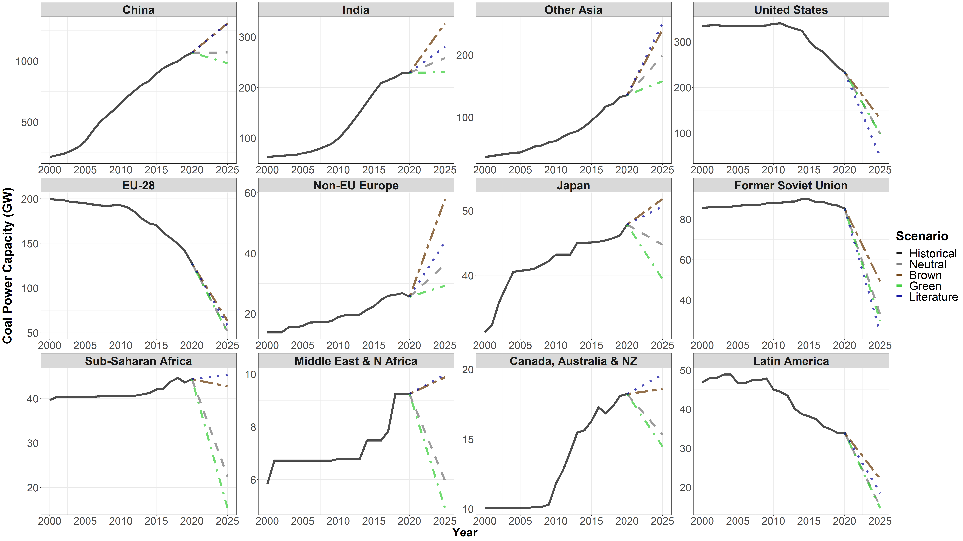
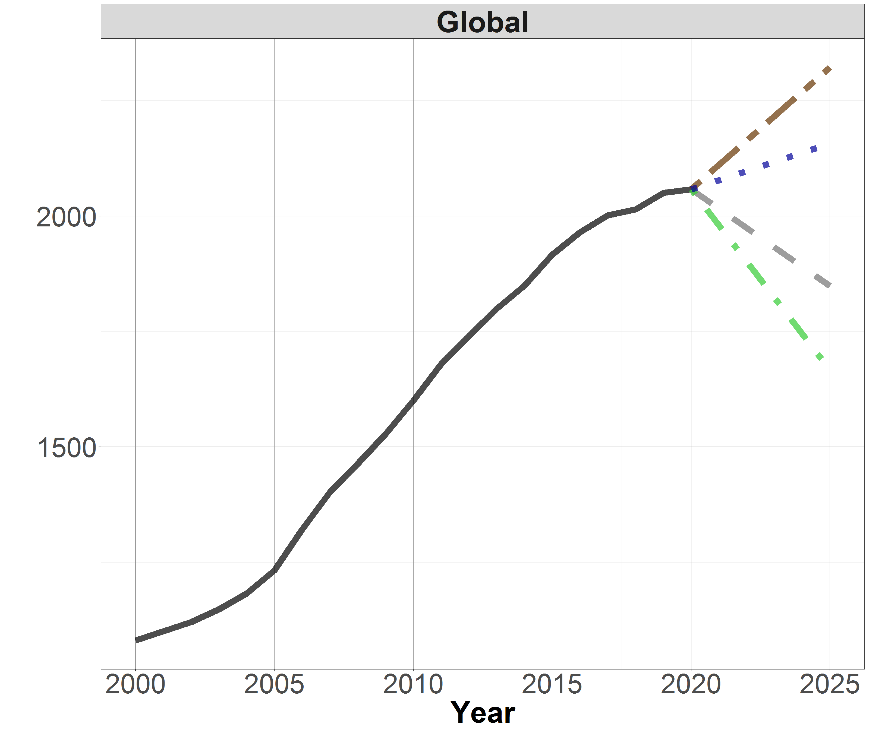
Figure A1. Historical coal power capacity in GW from 2000-2020 and near-term scenarios extrapolated with varied assumptions, aggregated to REMIND regions and globally.

Historical Capacity
Historical values are derived from the GCPT at the country level by working backwards from the January 2021 operating capacity. The GCPT summary statistics track annual capacity additions and retirements from 2000 on. Plants added (retired) in each year were subtracted from (added to) the previous year’s capacity value.
Mothballings are only tracked from 2014 onward. Since there were no mothballed plants at the end-of-year 2014 according to the GCPT, any currently mothballed plants are added to all years 2000-2014. From 2015-2020, these plants were added to the 2020 value during operating years. Currently operating and retired plants which were mothballed or operating in previous years were subtracted and added accordingly.

References
1. Global Energy Monitor. Global Coal Plant Tracker January 2021. EndCoal.org https://endcoal.org/global-coal-plant-tracker/ (2021).
2. Baumstark, L. et al. mrremind: MadRat REMIND Input Data Library. (Zenodo, 2020). doi:10.5281/zenodo.4309197.
3. Dietrich, Jan Philipp et al. magclass: Data Class and Tools for Handling Spatial-Temporal Data. (Zenodo, 2020). doi:10.5281/ZENODO.1158580.
4. Jakob, M. et al. The future of coal in a carbon-constrained climate. Nat. Clim. Chang. 10, 704–707 (2020).

The 2025 time-step in REMIND is a 5-year period representing the average of years 2023-2027.
Data on the fate of mothballed plants is too scarce and uncertain to derive historical rates.

