Supplementary Appendix

Jinbo Hu, M.D., Ph.D., ^{1,2*} Yang Hu, S.M., Sc.D. ^{1*} Ellen Hertzmark, MA.,³ Chen Yuan, ScD., ⁴ Gang Liu, Ph.D., ^{1,5} Meir J. Stampfer, M.D., Dr.P.H., ^{1,5,6} Eric B. Rimm, Sc.D., ^{1,5,6} Frank B. Hu, M.D., Ph.D., ^{1,5.6} Molin Wang, Ph.D., ^{6,7} Qi Sun, M.D., Sc.D. ^{1,5,6,9}

* Drs. Jinbo Hu and Yang Hu contributed equally to this article as first authors.

¹ Department of Nutrition, Harvard TH Chan School of Public Health, 665 Huntington Avenue, Boston, MA, USA.
² Department of Endocrinology, the First Affiliated Hospital of Chongqing Medical University, Chongqing, China.
³ Department of Global Health and Population, Harvard T.H. Chan School of Public Health, Boston, MA, USA.
⁴ Department of Medical Oncology, Dana-Farber Cancer Institute and Harvard Medical School, Boston, MA, USA.
⁵ Department of Nutrition and Food Hygiene, Hubei Key Laboratory of Food Nutrition and Safety, Ministry of Education Key Laboratory of Environment and Health, School of Public Health, Tongji Medical College, Huazhong University of Science and Technology, Wuhan, China.
⁵ Department of Epidemiology, Harvard TH Chan School of Public Health, 665 Huntington Avenue, Boston, MA, USA.
⁶ Channing Division of Network Medicine, Department of Medicine, Brigham and Women’s Hospital and Harvard Medical School, 181 Longwood Avenue, Boston, MA, USA.
⁷ Department of Biostatistics, Harvard T. H. Chan School of Public Health, Boston, MA, USA.
⁹Joslin Diabetes Center, One Joslin Place, Boston, MA, USA

Word count of manuscript: 2839
Total number of figures: 2

Reprint requests and correspondence:
Correspondence to: Qi Sun
e-mail: qisun@hsph.harvard.edu (ORCID 0000-0002-8480-1563)
Department of Nutrition, Harvard T.H. Chan School of Public Health, 665 Huntington Ave., Boston, MA 02115.

Catalogue for Supplementary Tables and Figures

Supplementary Methods
Supplementary Table 1S. Characteristics of Women and Men with Incident Diabetes at Diagnosis
Supplementary Figure1S. Trajectories of Weight Change since Diabetes Diagnosis, among Participants with or without Incident Diabetes.
Supplementary Figure 2S. Associations between Weight Change Proportion and Risk of Cause-Specific Mortality.
Supplementary Table 2S. Diabetes Related Symptoms and Risks of All-Cause and Cause-Specific Mortality.
Supplementary Table 3S. Association between Weight Change and Mortality, according to Lifestyle 4-year Before Diagnosis of Diabetes (cycle: i-2).
Supplementary Table S4. Association between Categorized Weight Change and Risk of All-Cause or Cause-Specific Mortality, According to Predicted Lean Body Mass Before Diagnosis of Diabetes.

Supplementary Methods
Study Population
The NHS was initiated in 1976 when 121,700 female registered nurses aged 30-55 years completed a questionnaire inquiring about their demographics, medical history, lifestyle, and other information. The HPFS started in 1986, when 51,529 US male health professionals aged 40-75 years were enrolled and responded to a similar questionnaire. In both cohorts, follow-up questionnaires were administered biennially to update medical history and lifestyle, and the cumulative response rate during follow-up exceeded 90%. In 1980 for NHS and 1986 for HPFS, a validated food frequency questionnaire was first administered, and diet was updated every 2-4 years thereafter.¹⁻⁴
Assessment of Diet
We used a modified Alternate Healthy Eating Index (AHEI) score without alcohol intake to assess the quality of diet. A higher score of AHEI indicated greater intake of vegetables, fruit, whole grains, nuts and legumes, long-chain (n-3) fats, poly-unsaturated fatty acids, and lower intake of sugar-sweetened beverages and fruit juice, red meat and processed meat, trans fat, sodium.
Assessment of Covariates
Hypertension, hypercholesterolemia, menopausal status (NHS only), use of vitamin supplements, aspirin, antihypertensive drugs and anti-hypercholesterolemia drugs were self-reported at baseline and biennial questionnaires. Family history of diabetes, cancer and myocardial infarction were also assessed using the questionnaires.
Assessment of Mortality
For cause-specific mortality, we used the International Classification of Diseases (ICD), 8th Revision for NHS to classify deaths as due to cardiovascular disease (ICD-8 codes 390-459), cancer (ICD-8 codes 140-207), or other causes; and 9th for HPFS to classify deaths as due to CVD (ICD-9 codes 390-459), cancer (ICD-9 codes 140-208), or other causes.
Statistical Analysis
In the analysis of weight change trajectories, we set the fixed baseline at 1980 for NHS and 1986 for HPFS for diabetes-free participants. As for diabetes patients, year 0 was defined as the return date of last questionnaire immediately preceding diabetes diagnosis; year 2 was the questionnaire cycle immediately after diabetes diagnosis; year 4 was the following biennial questionnaire, and so on. The absolute value of weight change at year i (i=2, 4, 6,…, 26) was calculated as: (body weight at year i) – (body weight at year 0). The weight change proportion at year i (i=2, 4, 6,…, 26) was calculated as: ([body weight at year i] – [body weight at year 0]) / [body weight at year 0]. Briefly, in the NHS, for example, for patients who developed diabetes between 1980-1982, we set the year 0 to 1980, and we re-set 1982 as year 0 for diabetes patients diagnosed between 1982-1984, and so on. For diabetes-free participants, the year 0 was set at 1980, year 2 at 1982, and so on. The longest possible duration of follow-up was 32 years, and we used 26-year follow-up data to delineate the trajectories of weight change because the number of eligible diabetes cases decreased to <1% of the total sample size, leading to unstable estimates.
In the multiple generalized linear model, we included the baseline calendar year, time since baseline, an interaction variable between time since baseline and diabetes status, and other covariates including age, sex, ethnicity, history of hypertension, current anti-hypercholesterolemia medication use, family history of diabetes, family history of myocardial infarction, current aspirin use, current multivitamin use, AHEI score, physical activity, alcohol consumption and smoking status. In Cox models for analyses of mortality risk, multivariate analyses considered age, sex, ethnicity, history of hypertension, current antidiabetic medication use, current antihypertensive medication use, hypercholesterolemia, current anti-hypercholesterolemia medication use in the questionnaire cycle right after diabetes diagnosis, family history of diabetes, family history of myocardial infarction, current aspirin use, current multivitamin use, diabetes duration and lifestyle score before diabetes diagnosis.
Supplementary Tables and Figures
Supplementary Table 1S. Characteristics of Women and Men with Incident Diabetes at the year 0.

 | NHS |  | HPFS
 | (n=8767) |  | (n=2495)
Age (yr) | 62.4±9.2 |  | 63.2±8.8
White race (%) | 96.0 |  | 92.1
Body mass index (kg/m²) | 31.2±6.1 |  | 29.1±4.7
Hypertension (%) | 71.7 |  | 58.0
Antihypertensive drugs user (%) | 52.3 |  | 40.2
Physical activity (MET-hr/wk) | 1.4±2.3 |  | 2.7±4.9
Alternate Healthy Eating Index Score ‡ | 45.4±12 |  | 48.0±11.2
Alcohol intake (g/day) | 3.6±8.1 |  | 9.9±14.5
Current smoker (%) | 10.8 |  | 5.4
Hypercholesterolemia (%) | 58.4 |  | 52.4
Anti-hypercholesterolemia drugs user (%) | 27.3 |  | 24.4
Multivitamin use (%) | 50.8 |  | 53.0
Aspirin use (%) | 49.8 |  | 54.9
Family history of diabetes (%) | 46.7 |  | 44.6
Family history of cancer (%) | 13.1 |  | 36.2
Family history of myocardial infarction (%) | 28.7 |  | 32.5
Reported weight loss as a symptom of diabetes (%)§ | 7.5 |  | 9.7

* The study included participants with incident Diabetes from the Nurses’ Health Study (NHS, 1980-2012) and Health Professionals Follow-up Study (HPFS, 1986-2016). Values are mean±standard deviation for continuous variables; percentages for categorical variables, and are standardized to the age distribution of the study population.
§: The percentage is the number of participants who reported weight loss as a symptom of diabetes divide by the total number of patients with incident type 2 diabetes.

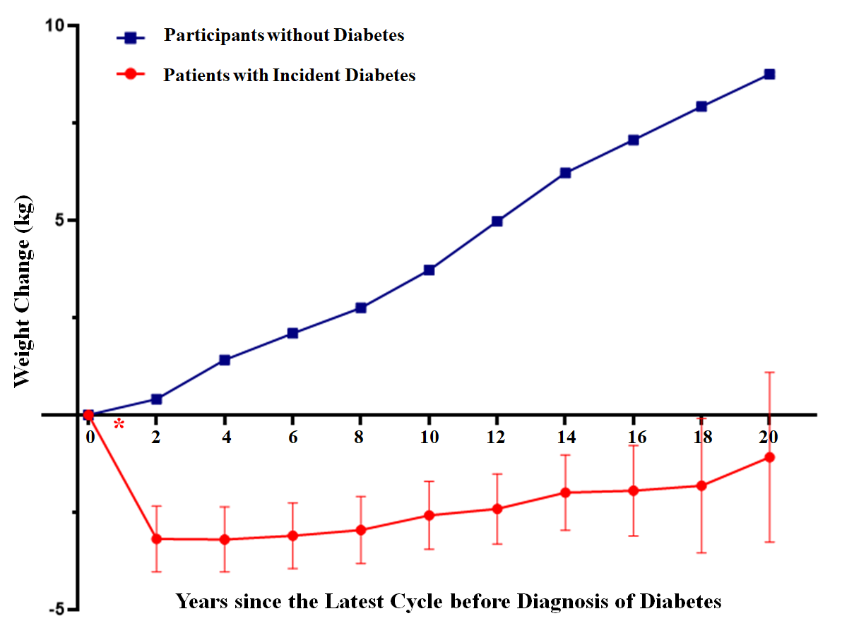

Supplementary Figure1S. Trajectories of Weight Change since Diabetes Diagnosis, among Participants with or without Incident Diabetes.
In patients with incident diabetes, body weight at the time-point ‘0’ was defined as the time-point at diagnosis of diabetes, which was recorded on the Supplementary Diabetes Questionnaire of NHS and HPFS. Body weight at the time-point ‘2’ was defined as the latest cycle after diabetes diagnosis. In participants without diabetes, body weight at the time-point ‘0’ was defined as the cohort baseline (1980 for NHS and 1986 for HPFS), and the time-point ‘2’ was 2 years after baseline, and so on. Body weight at time-point ‘0’ was set as the reference, and body weight reported at time-point of 2, 4, …, 20 years were sequentially used as biennial weight. We stopped updating the trajectory since the number of participants at follow-up is lowered to <1% of the baseline in diabetes group.
We used a marginal model of generalized estimating equations with independence working variance matrix to calculate the least squares means of weight change at multiple time points in comparison with that at year 0. The model included the baseline calendar year, time since baseline, an interaction variable between time since baseline and diabetes status, and other covariates. Values of weight change are mean ± standard error.

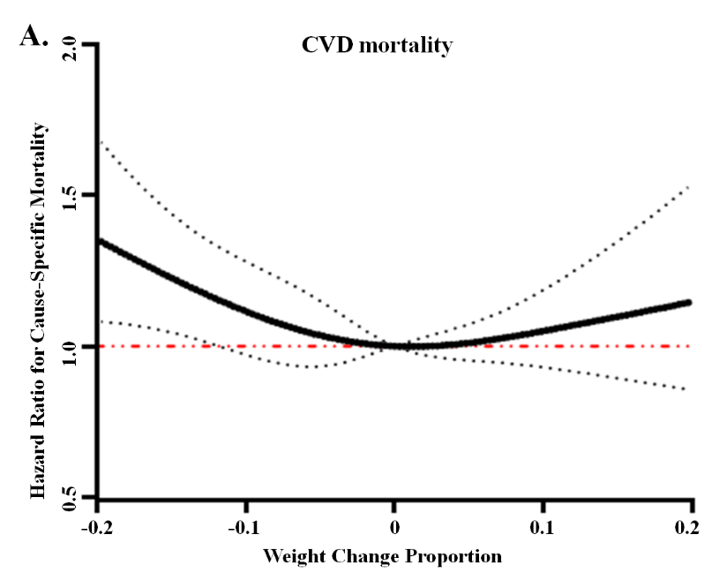
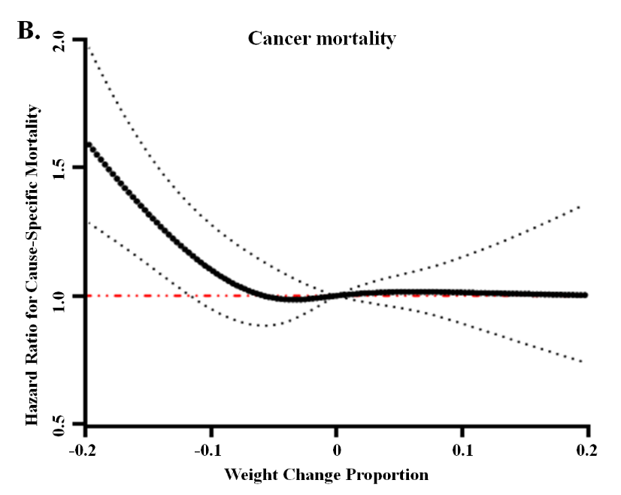
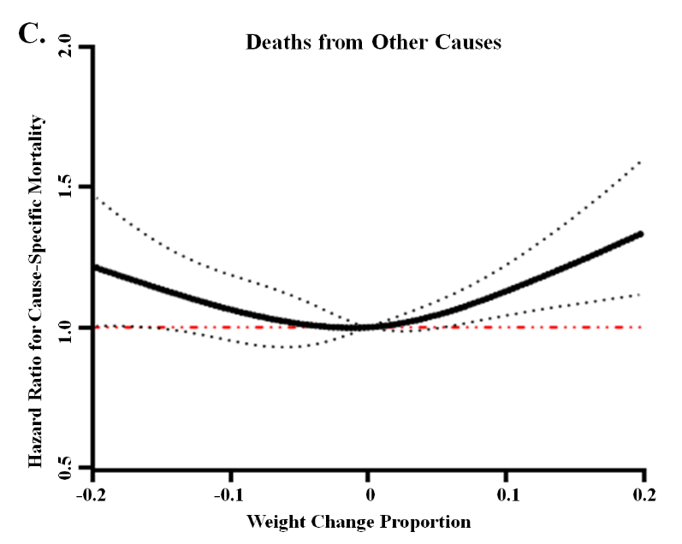
Supplementary Figure 2S. Associations between Weight Change Proportion and Risk of Cause-Specific Mortality.
Relationship between percentage weight change and risk of CVD, cancer related and other-cause mortality showed Panel A, B and C respectively. Weight change was evaluated from the latest cycle before diabetes diagnosis to the latest cycle after diabetes diagnosis. The percentage weight change was calculated as ([weight after diagnosis] – [weight before diagnosis]) / [weight before diagnosis]. All of these effects were based on the multivariate model, which adjusted for age, sex, ethnicity, history of hypertension, current antidiabetic medication use, current antihypertensive medication use, hypercholesterolemia, current anti-hypercholesterolemia medication use in the questionnaire cycle right after diabetes diagnosis, family history of diabetes, family history of myocardial infarction, current aspirin use, current multivitamin use, diabetes duration and lifestyle score before diabetes diagnosis.. Dotted lines represent 95% confidence intervals.

Supplementary Table 2S. Diabetes Related Symptoms and Risks of All-Cause and Cause-Specific Mortality.
 | Person-year | All-Cause Mortality |  |  | CVD mortality |  |  | Cancer mortality |  |  | Deaths from Other Causes
 | Person-year | Case | HR (95% CI) |  | Case | HR (95% CI) |  | Case | HR (95% CI) |  | Case | HR (95% CI)
Number of reported symptoms *
No reported symptom | 32166 | 1008 | 1.00 (ref) |  | 278 | 1.00 (ref) |  | 286 | 1.00 (ref) |  | 444 | 1.00 (ref)
Reported 1 symptom | 8924 | 385 | 1.29 (1.14, 1.45) |  | 115 | 1.38 (1.10, 1.72) |  | 98 | 1.20 (0.95, 1.51) |  | 172 | 1.28 (1.07, 1.54)
Reported 2 symptoms | 8044 | 353 | 1.37 (1.21, 1.56) |  | 105 | 1.48 (1.17, 1.86) |  | 88 | 1.21 (0.94, 1.54) |  | 160 | 1.43 (1.18, 1.72)
Reported more than 3 symptoms | 6236 | 237 | 1.38 (1.19, 1.60) |  | 71 | 1.48 (1.13, 1.94) |  | 61 | 1.20 (0.91, 1.60) |  | 105 | 1.44 (1.15, 1.79)
Weight loss as a symptom †
Reported no symptom of weight loss | 52400 | 1860 | 1.00 (ref) |  | 530 | 1.00 (ref) |  | 495 | 1.00 (ref) |  | 835 | 1.00 (ref)
Reported weight loss as a symptom | 5416 | 227 | 1.18 (1.02, 1.35) |  | 73 | 1.37 (1.06, 1.76) |  | 61 | 1.18 (0.90, 1.55) |  | 93 | 1.06 (0.85, 1.32)
* Diabetes related symptoms included ketoacidosis, coma, unintended weight loss, unusual hunger, unusual thirst, unusual frequency of urination. Participants who reported a physician’s diagnosis of diabetes on any of the biennial questionnaires were mailed a validated supplementary questionnaire regarding diagnostic tests, symptoms, and hypoglycemic therapy. †Weight loss as a symptom: Participants who reported a symptom of weight loss in the supplementary questionnaire were considered as positive symptom of weight loss, and participants who reported no weight loss were considered as no symptom of weight loss, while participants who did not fill out this part were considered as missing data. All of these effects were based on the multivariate model. Multivariate adjustment: adjusted for age, sex, ethnicity, history of hypertension, current antidiabetic medication use, current antihypertensive medication use, hypercholesterolemia, current anti-hypercholesterolemia medication use in the questionnaire cycle right after diabetes diagnosis, family history of diabetes, family history of myocardial infarction, current aspirin use, current multivitamin use, diabetes duration and lifestyle score before diabetes diagnosis.
We conducted a secondary analysis among 9,085 cases of incident T2D patients (6,681 from NHS and 2,404 from HPFS) who answered the question of whether or not they experienced weight loss as a symptom at diabetes diagnosis. Compared with participants who did not report weight loss as a symptom, those who reported this symptom lost more weight: -3.46±0.11 vs. -2.07±0.05 kg (P<0.001) or as weight change proportion, -4.1% ± 0.1% vs. -2.3% ± 0.1% (P<0.001). In addition, patients who had the symptom of weight loss had a 18% (95% CI: 2% to 35%) higher all-cause mortality, 37% (95% CI: 6% to 76%) higher CVD mortality, while the association with cancer mortality or death from other causes was not significant (HR 1.18, 95% CI 0.90 to 1.55 for cancer mortality; HR 1.06, 95% CI 0.85 to 1.32 for death from other causes) higher risk of (see Supplementary Table 2S above). In addition, T2D patients who reported having one or more symptoms exhibited higher total and cause-specific mortality than patients who did not report any symptom.

Supplementary Table 3S. Association between Weight Change and Mortality, according to Lifestyle 4-year Before Diagnosis of Diabetes (cycle: i-2).
 | HR (95% CI) |  |  | HR (95% CI)
Healthy Lifestyle Score: 0-1 |  |  | Healthy Lifestyle Score: 0-1
Stable weight (weight change within ±5%) | 1.00 (reference) |  | No weight loss symptom | 1.00 (reference)
Moderate weight loss (5% ≤ loss <10%) | 0.99 (0.88, 1.12) |  | Weight loss symptom | 1.33 (1.12, 1.57)
Major weight loss (loss ≥10%) | 1.22 (1.08, 1.38)
Weight gain (gain ≥ 5%) | 1.00 (0.88, 1.14)
Healthy Lifestyle Score: 2 |  |  | Healthy Lifestyle Score: 2
Stable weight (weight change within ±5%) | 1.00 (reference) |  | No weight loss symptom | 1.00 (reference)
Moderate weight loss (5% ≤ loss <10%) | 1.12 (0.98, 1.29) |  | Weight loss symptom | 1.07 (0.86, 1.32)
Major weight loss (loss ≥10%) | 1.18 (1.02, 1.37)
Weight gain (gain ≥ 5%) | 1.09 (0.93, 1.27)
Healthy Lifestyle Score: 3-4 |  |  | Healthy Lifestyle Score: 3-4
Stable weight (weight change within ±5%) | 1.00 (reference) |  | No weight loss symptom | 1.00 (reference)
Moderate weight loss (5% ≤ loss <10%) | 1.00 (0.81, 1.24) |  | Weight loss symptom | 1.22 (0.87, 1.71)
Major weight loss (loss ≥10%) | 1.17 (0.92, 1.49)
Weight gain (gain ≥ 5%) | 1.15 (0.90, 1.48)
Overall lifestyle was evaluated on the basis of healthy lifestyle score: for each healthy lifestyle, the participant received 1 point if he or she met the criterion for the healthy category, or 0 points otherwise. The sum of the 4 factors constituted a final healthy lifestyle score (number of low-risk factors) of 0, 1, 2, 3, or 4 (higher score for a healthier lifestyle). Multivariate analyses were adjusted for age, sex, ethnicity, history of hypertension, current antidiabetic medication use, current antihypertensive medication use, hypercholesterolemia, current anti-hypercholesterolemia medication use in the questionnaire cycle right after diabetes diagnosis, family history of diabetes, family history of myocardial infarction, current aspirin use, current multivitamin use, diabetes duration and lifestyle score before diabetes diagnosis.

Supplementary Table S4. Association between Categorized Weight Change and Risk of All-Cause or Cause-Specific Mortality, According to Predicted Lean Body Mass Before Diagnosis of Diabetes.
 | All-Cause Mortality |  | CVD mortality |  | Cancer mortality |  | Deaths from Other Causes
 | HR (95% CI) |  | HR (95% CI) |  | HR (95% CI) |  | HR (95% CI)
Predicted Low Lean Mass (Tertile1: 0-41kg)
Stable weight (weight change within ±5%) | 1.00 (reference) |  | 1.00 (reference) |  | 1.00 (reference) |  | 1.00 (reference)
Moderate weight loss (5% ≤ loss <10%) | 1.11 (0.95, 1.30) |  | 1.09 (0.79, 1.51) |  | 1.50 (1.05, 2.13) |  | 1.00 (0.81, 1.23)
Major weight loss (loss ≥10%) | 1.18 (1.00, 1.41) |  | 1.42 (1.01, 2.01) |  | 1.25 (0.81, 1.92) |  | 1.07 (0.85, 1.34)
Weight gain (gain ≥ 5%) | 0.88 (0.74, 1.04) |  | 1.15 (0.83, 1.61) |  | 0.84 (0.55, 1.28) |  | 0.80 (0.64, 1.01)
Predicted Median Lean Mass (Tertile2: 41-54kg)
Stable weight (weight change within ±5%) | 1.00 (reference) |  | 1.00 (reference) |  | 1.00 (reference) |  | 1.00 (reference)
Moderate weight loss (5% ≤ loss <10%) | 0.93 (0.83, 1.04) |  | 0.90 (0.72, 1.12) |  | 0.92 (0.71, 1.19) |  | 0.96 (0.82, 1.13)
Major weight loss (loss ≥10%) | 1.17 (1.04, 1.31) |  | 1.11 (0.89, 1.40) |  | 1.07 (0.82, 1.40) |  | 1.25 (1.06, 1.46)‡
Weight gain (gain ≥ 5%) | 1.07 (0.95, 1.22) |  | 1.03 (0.81, 1.32) |  | 0.92 (0.69, 1.22) |  | 1.17 (0.98, 1.38)
Predicted High Lean Mass (Tertile3: >54kg)
Stable weight (weight change within ±5%) | 1.00 (reference) |  | 1.00 (reference) |  | 1.00 (reference) |  | 1.00 (reference)
Moderate weight loss (5% ≤ loss <10%) | 1.17 (0.98, 1.39) |  | 1.29 (0.94, 1.77) |  | 1.01 (0.69, 1.47) |  | 1.15 (0.89, 1.47)
Major weight loss (loss ≥10%) | 1.16 (0.95, 1.43) |  | 1.21 (0.83, 1.76) |  | 1.46 (0.98, 2.17) |  | 1.01 (0.75, 1.35)
Weight gain (gain ≥ 5%) | 1.14 (0.90, 1.45) |  | 1.16 (0.75, 1.80) |  | 1.28 (0.79, 2.06) |  | 1.09 (0.77, 1.56)
Multivariate analyses adjusted for age, sex, ethnicity, history of hypertension, current antidiabetic medication use, current antihypertensive medication use, hypercholesterolemia, current anti-hypercholesterolemia medication use in the questionnaire cycle right after diabetes diagnosis, family history of diabetes, family history of myocardial infarction, current aspirin use, current multivitamin use, diabetes duration and lifestyle score before diabetes diagnosis. Predicted lean body mass in men= (−14.729*intercept) + (-0.071*age [years]) + (0.210*height [cm])+(0.468*weight [kg]) + (0 if race is white) + (1.821 if race is black) + (−0.784 if other race); predicted lean body mass in women = (−14.292*intercept) + (-0.046*age [years]) + (0.201*height [cm])+(0.347*weight [kg]) + (0 if race is white) + (1.128 if race is black) + (−0.384 if other race).
Predicted lean body mass was calculated based on our previous report: Lee DH, Keum N, Hu FB, et al. Development and validation of anthropometric prediction equations for lean body mass, fat mass and percent fat in adults using the National Health and Nutrition Examination Survey (NHANES) 1999-2006. Br J Nutr 2017;118:858-66.
Reference

1. Li Y, Schoufour J, Wang DD, et al. Healthy lifestyle and life expectancy free of cancer, cardiovascular disease, and type 2 diabetes: prospective cohort study. BMJ 2020;368:l6669.
2. Liu G, Li Y, Hu Y, et al. Influence of Lifestyle on Incident Cardiovascular Disease and Mortality in Patients With Diabetes Mellitus. J Am Coll Cardiol 2018;71:2867-76.
3. Tobias DK, Pan A, Jackson CL, et al. Body-mass index and mortality among adults with incident type 2 diabetes. N Engl J Med 2014;370:233-44.
4. Hu Y, Zong G, Liu G, et al. Smoking Cessation, Weight Change, Type 2 Diabetes, and Mortality. N Engl J Med 2018;379:623-32.

