SUPPORTING INFORMATION
Dispiro-indanedione hybrid of parthenin induces p53-independent apoptosis and suppresses tumor progression in colorectal cancer models
Manzoor Ahmed^{ab1}, Diljeet Kumar ^{ab1}, Chetan Paul Singh^{bc}, Samriti Dograª, Diksha Manhas^{ab}, Yogesh P. Bharitkar^{bc}, Ramajayan Pandian^{ab}, Sanket K Shukla^{ab*}, Zabeer Ahmed^{ab*}
ªPharmacology Division, Indian Institute of Integrative Medicine, Canal Road, Jammu-180001, India.
^{b}Academy of Scientific and Innovative Research (AcSIR), Ghaziabad-201002, India.
^{c}Natural Products & Medicinal Chemistry Division. CSIR-Indian Institute of Integrative Medicine, Canal Road, Jammu-180001, India.
¹Authors contributed equally

*Corresponding Authors:

Zabeer Ahmed, PhD

Director,

Director office, Canal Road, near CID office,

CSIR-Indian Institute of Integrative Medicine,

Jammu-180001, Jammu and Kashmir, India.
Tel. +91-191-2584999, 2585222; Fax: 911912586333
Email: zahmed@iiim.res.in

Sanket. K. Shukla, PhD

Sr. Technical Officer & Assistant Professor
Room No. 108, Pharmacology Division, Canal Road, near CID office,
CSIR-Indian Institute of Integrative Medicine,
Jammu-180001, Jammu and Kashmir, India.
Tel. +911912585006 ext204, Fax: +911912586333
Email: Sanket.shukla@iiim.res.in

Groups | Liver Function Test |  |  | Metabolic Function Test |  |  |  |  | Kidney Function Test
 | ALT  U/L | AST  U/L | TB  mg/dl | TP  g/dl | ALB  g/dl | GLB  mg/dl | TG  mg/dl | CHL  mg/dl | CR  mg/dl | Urea  mg/dl | BUN  mg/dl
Normal  control | 41.40  ±  8.50 | 85.80  ±  5.00 | 0.18  ±  0.08 | 6.24  ±  0.53 | 2.47  ±  0.18 | 3.2  ±  0.35 | 101.15  ±  7.95 | 114.00  ±  5.00 | 0.18  ±  0.01 | 45.20  ±  4.10 | 19.12  ±  2.38
Vehicle control | 43.20  ±  6.50 (ns) | 87.20  ±  4.00 (ns) | 0.19  ±  0.06 (ns) | 6.4  ±  0.63 (ns) | 2.56  ±  0.18 (ns) | 3.4  ±  0.31 (ns) | 108.9  ±  4.2 (ns) | 115.0  ±  3.2 (ns) | 0.20  ±  0.02 (ns) | 49.20  ±  3.10 (ns) | 21.4  ±  2.6 (ns)
50 mg/kg b.w | 48.43  ±  4.80 (ns) | 94.67  ±  6.34 (*) | 0.21  ±  0.06 (ns) | 6.07  ±  0.19 (ns) | 2.19  ±  0.07 (ns) | 3.78  ±  0.12 (ns) | 113.67  ±  6.12 (ns) | 124.00  ±  3.51 (*) | 0.29  ±  0.02 (*) | 52.07  ±  1.27 (ns) | 24.94  ±  0.59 (*)
300 mg/kg b.w | 45.50  ±  5.60 (ns) | 88.60  ±  3.50 (ns) | 0.19  ±  0.09 (ns) | 6.38  ±  0.09 (ns) | 2.10  ±  0.04 (*) | 3.58  ±  0.14 (ns) | 120.65  ±  2.85 (*) | 119.50  ±  8.50 (ns) | 0.24  ±  0.03 (ns) | 48.70  ±  1.50 (ns) | 25.55  ±  0.70 (*)
2000mg/kg b.w | 43.05  ±  3.25 (ns) | 91.55  ±  4.45 (ns) | 0.20  ±  0.05 (ns) | 6.27  ±  0.10 (ns) | 2.64  ±  0.03 (ns) | 3.50  ±  0.07 (ns) | 116.70  ±  3.30 (*) | 118.0  ±  6.00 (ns) | 0.22  ±  0.01 (ns) | 51.45  ±  2.1 (ns) | 23.30  ±  0.21 (ns)

Table S1 (a): Changes in biochemical parameters in male Swiss Albino mice, following acute toxicity exposure. The tables present the corresponding effects observed in male mice. Data are presented as mean ± standard error of the mean (SEM, n = 3). All serum biochemical parameters were compared with the control group using one-way ANOVA followed by Dunnett’s post hoc test; no significant changes were observed among the groups (ns, P>0.05, *P ≤ 0.05).

Groups | Liver Function Test |  |  | Metabolic Function Test |  |  |  |  | Kidney Function Test
Groups | ALT  U/L | AST  U/L | TB  mg/dl | TP  g/dl | ALB  g/dl | GLB  mg/dl | TG  mg/dl | CHL  mg/dl | CR  mg/dl | Urea  mg/dl | BUN  mg/dl
Normal control | 37.4  ±  2.50 | 77.6  ±  8.4 | 0.15  ±  0.04 | 5.4  ±  0.63 | 2.31  ±  0.23 | 3.16  ±  0.54 | 123.5  ±  11.4 | 98.00  ±  12.00 | 0.23  ±  0.02 | 35.40  ±  2.90 | 17.5  ±  1.5
Vehicle control | 41.20  ±  2.7 (ns) | 80.20  ±  5.3 (ns) | 0.16  ±  0.06 (ns) | 5.8  ±  0.71 (ns) | 2.56  ±  0.27 (ns) | 3.4  ±  0.39 (ns) | 122.9  ±  14.2 (ns) | 108.0  ±  6.2 (ns) | 0.22  ±  0.01 (ns) | 39.5  ±  2.10 (ns) | 19.4  ±  1.6 (ns)
50 mg/kg b.w | 45.43  ±  3.10 (*) | 84.67  ±  6.34 (ns) | 0.22  ±  0.06 (ns) | 6.4  ±  0.21 (*) | 2.79  ±  0.07 (*) | 3.78  ±  0.24 (ns) | 128.67  ±  11.12 (ns) | 114.00  ±  7.51 (ns) | 0.28  ±  0.02 (ns) | 42.17  ±  1.7 (ns) | 23.4  ±  1.89 (*)
300 mg/kg b.w | 42.50  ±  2.60 (ns) | 82.60  ±  3.50 (ns) | 0.18  ±  0.09 (ns) | 6.24  ±  0.06 (ns) | 2.70  ±  0.04 (ns) | 3.58  ±  0.28 (ns) | 134.6  ±  8.85 (ns) | 112.0  ±  9.50 (ns) | 0.26  ±  0.04 (ns) | 38.50  ±  1.9 (ns) | 22.75  ±  0.90 (ns)
2000 mg/kg b.w | 40.05  ±  1.25 (ns) | 81.55  ±  4.45 (ns) | 0.20  ±  0.04 (ns) | 6.07  ±  0.28 (ns) | 2.44  ±  0.05 (ns) | 3.50  ±  0.37 (ns) | 133.40  ±  10.4 (ns) | 107.2  ±  5.7 (ns) | 0.23  ±  0.02 (ns) | 40.15  ±  2.1 (ns) | 20.70  ±  0.65 (ns)

Table S1 (b): Changes in biochemical parameters in female Swiss Albino mice, following acute toxicity exposure. The tables present the corresponding effects observed in female mice, allowing for a comparative analysis between sexes regarding the impact of the treatment. Data are presented as mean ± standard error of the mean (SEM, n = 3). All serum biochemical parameters were compared with the control group using one-way ANOVA followed by Dunnett’s post hoc test; no significant changes were observed among the groups (ns, P>0.05, *P ≤ 0.05).

Figure S1: Body weight changes in control and treated groups over the study duration, indicating the effect of treatment on overall health. Data are presented as mean ± SEM (n=5). Statistical significance was demonstrated at, ns P > 0.05.
Figure S2: Feed and water intake for control and treated groups, illustrating consumption patterns that may correlate with treatment effects. Data are presented as mean ± SEM (n=5). Statistical significance was demonstrated at, ns P > 0.05.

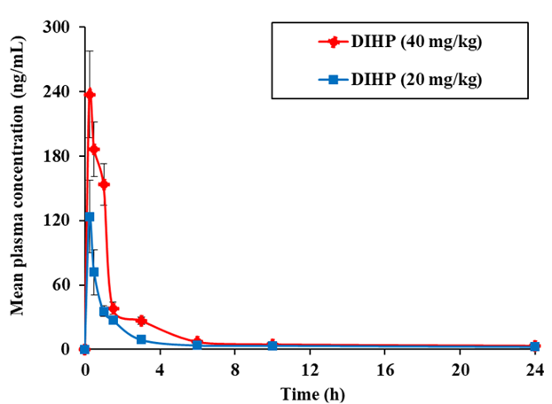
Figure S3: Comparative mean plasma concentration vs. time profile of DIHP after oral administration at 20 mg/kg and 40 mg/kg in BALB/c mice. Data are presented as mean ± SEM (n=5).

