Supplementary Information

Supplementary Figures

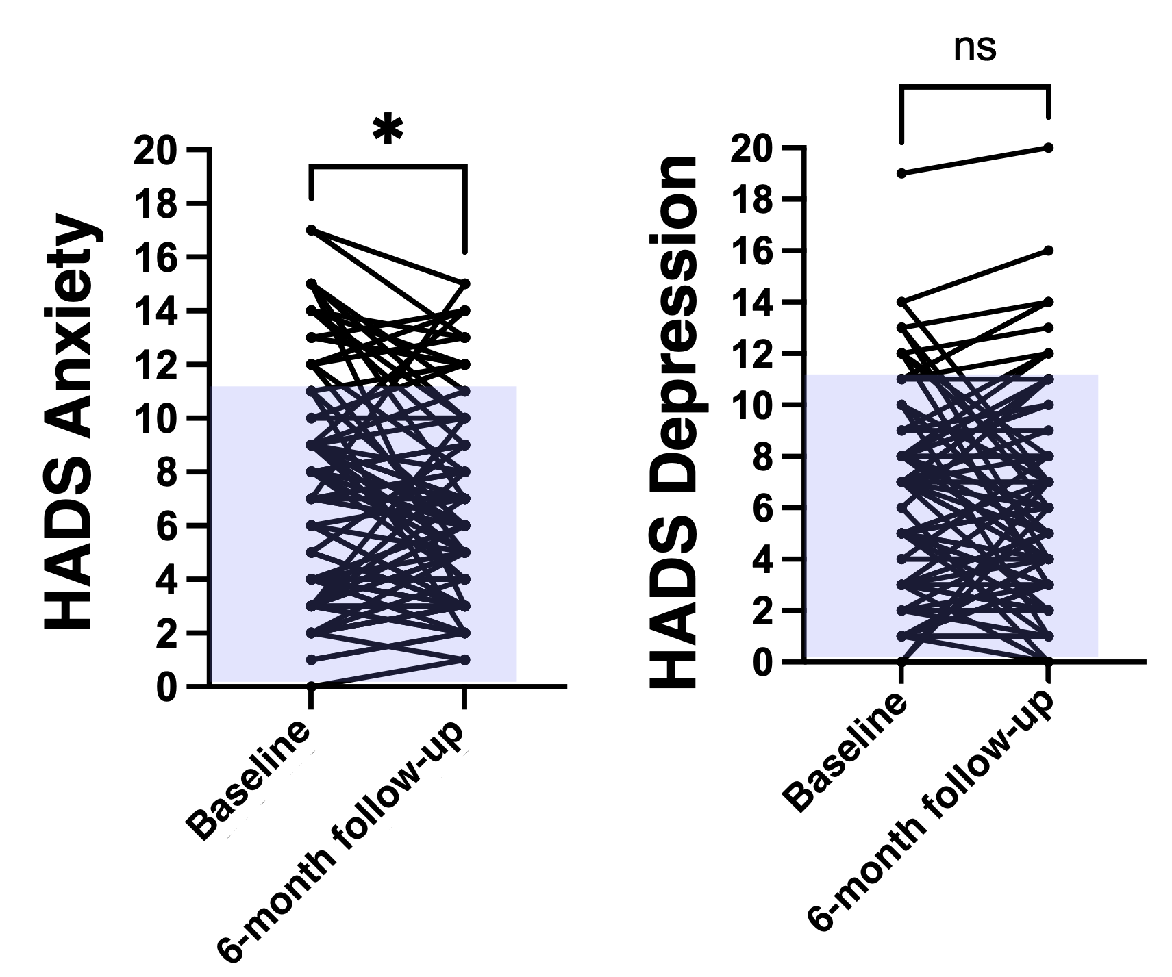
Figure S1. Change in parental anxiety and depression symptoms (HADS) from Baseline to Follow-up (N = 91). Anxiety scores decreased significantly from Baseline (mean = 7.32) to Follow-up (mean = 6.54), p = 0.036, whereas depression scores remained stable (Baseline mean = 6.25; Follow-up mean = 5.96), p = 0.888. The blue shaded area represents scores below the clinical threshold, with HADS scores ≥11 indicating clinical significance.

Figure S2. Radar chart showing responses of the five parents who reported slightly worsened, or greatly worsened skills in at least one child-focused domain of the questionnaire. Each line represents the responses of one parent (Parent 1–5) across the 12 child-focused question of the questionnaire. Responses were recoded: -3 (Greatly worsened), -2 (Worsened), -1 (Slightly worsened), 0 (Unchanged), 1 (Slightly improved), 2 (Improved), 3 (Greatly improved). The red area indicates negative perceptions.
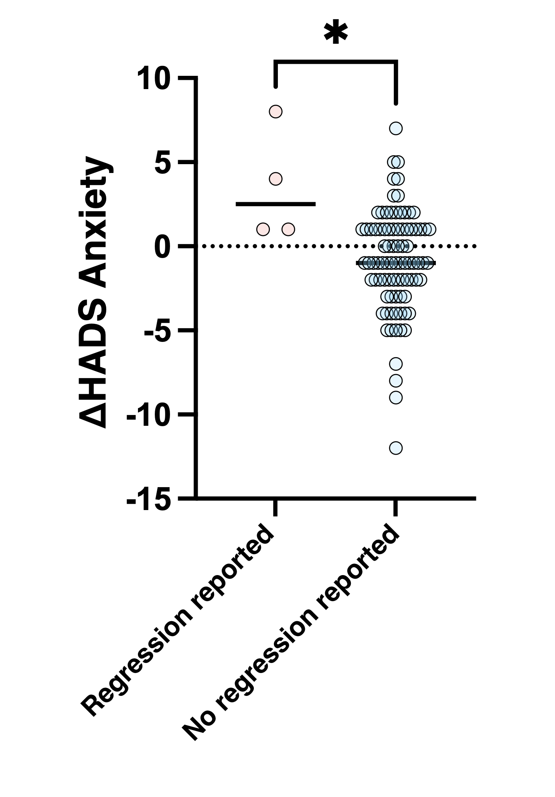
Figure S3. Change in parental anxiety symptoms (HADS) from Baseline to Follow-up. Comparison between parents who reported regression in at least one child-focused domain over the last six months (N = 5) and parents who did not report any regression. One parent in the regression group did not complete the HADS, resulting in four data points instead of five. HADS = Hospital Anxiety and Depression Scale; Δ = HADS Anxiety Score at Follow-up – HADS Anxiety Score at Baseline.

Figure S4. Scree plot of eigenvalues from Principal Component Analysis. The plot shows eigenvalues (y-axis) for each component (x-axis). An elbow is visible at the third component, supporting the retention of three factors for rotation and interpretation.

Figure S5. Spearman correlations between the 3 factors

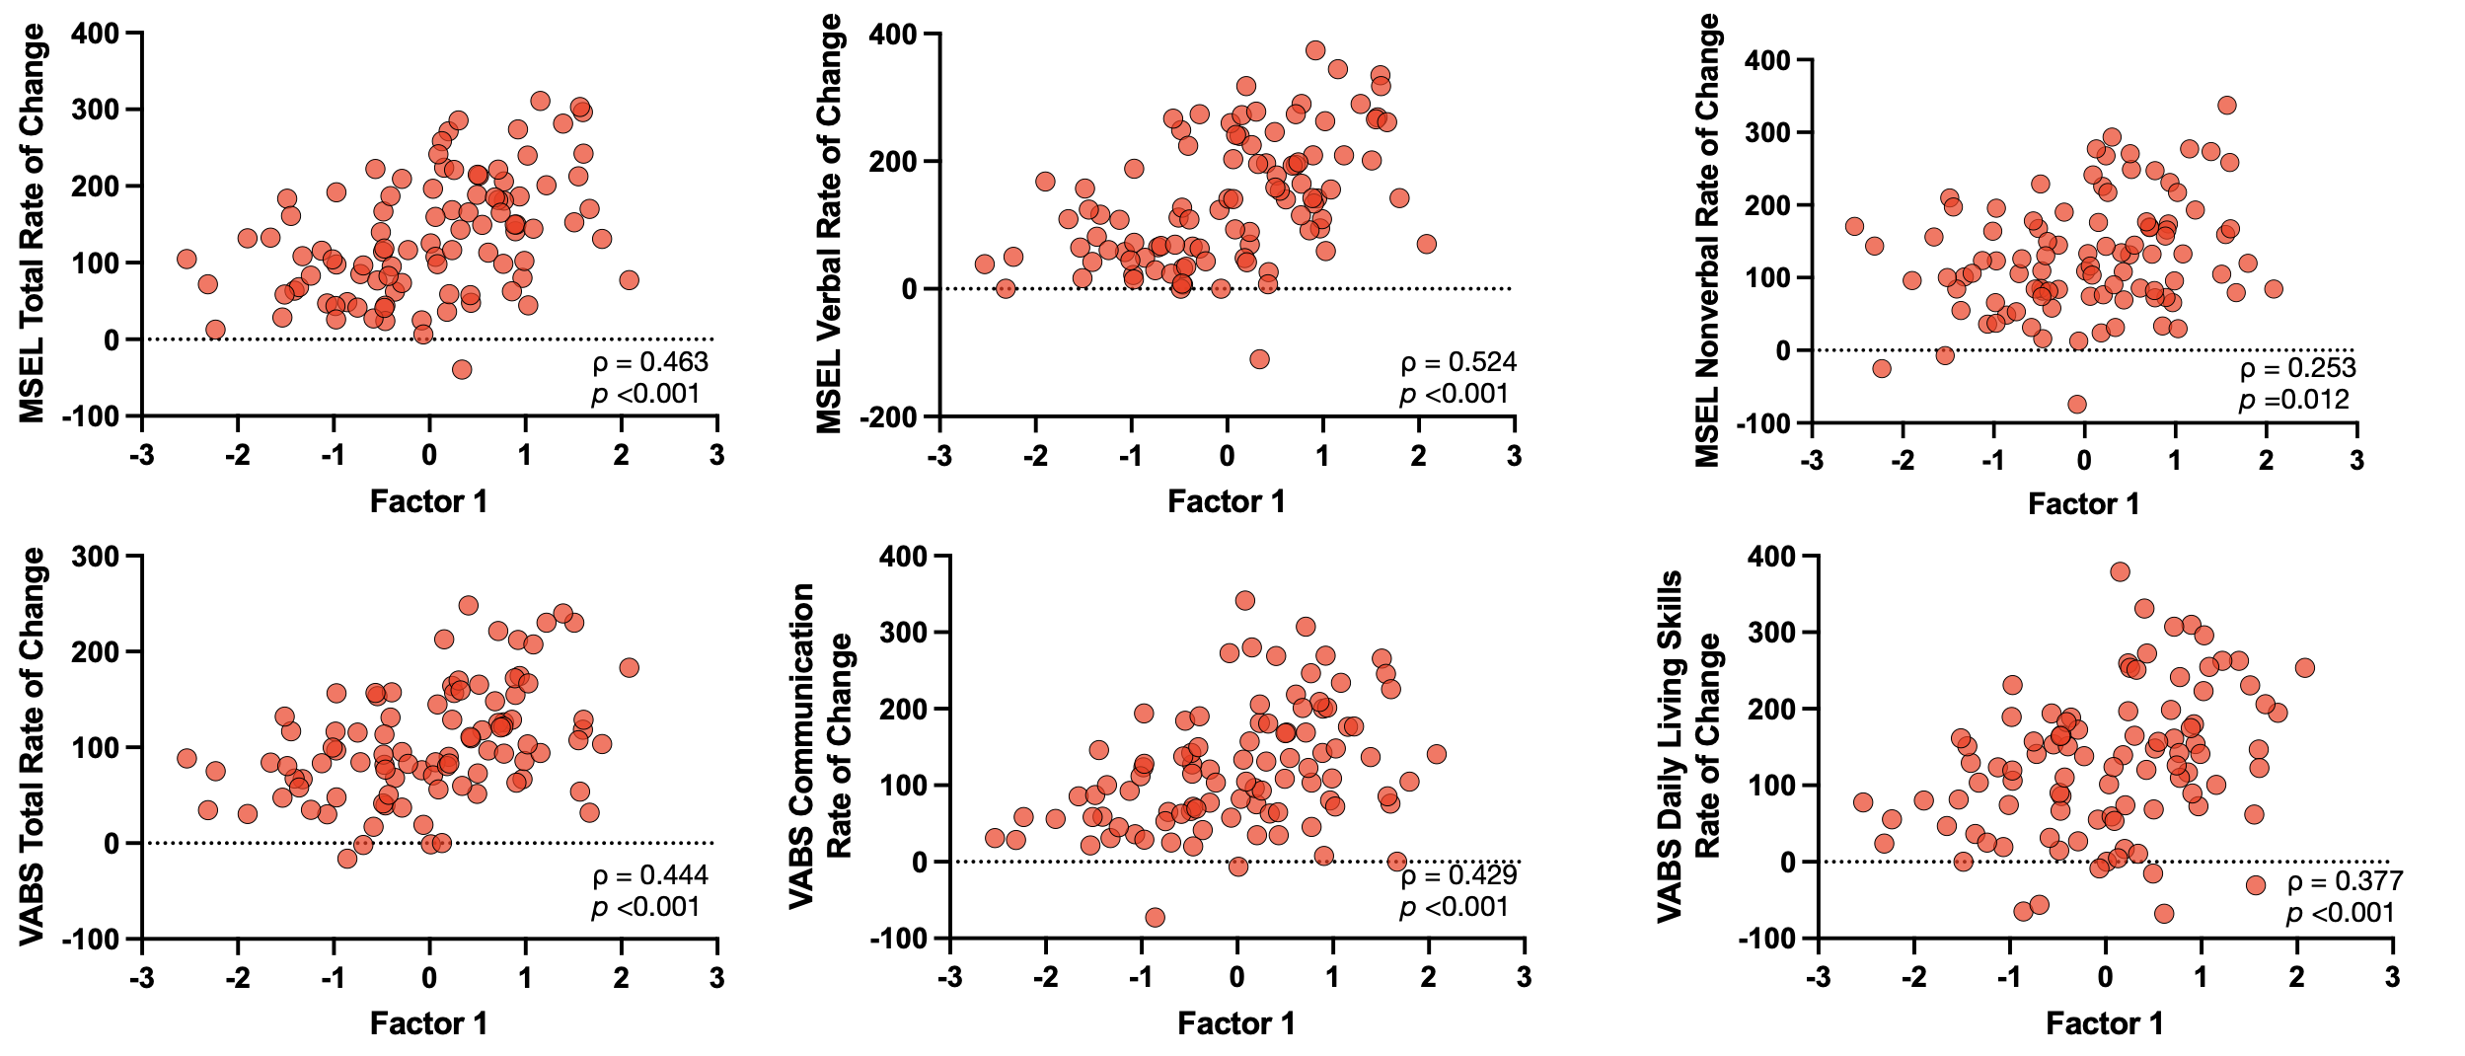
Figure S6. Significant Spearman correlations between Factor 1 (Social Communication) and the clinical variables.

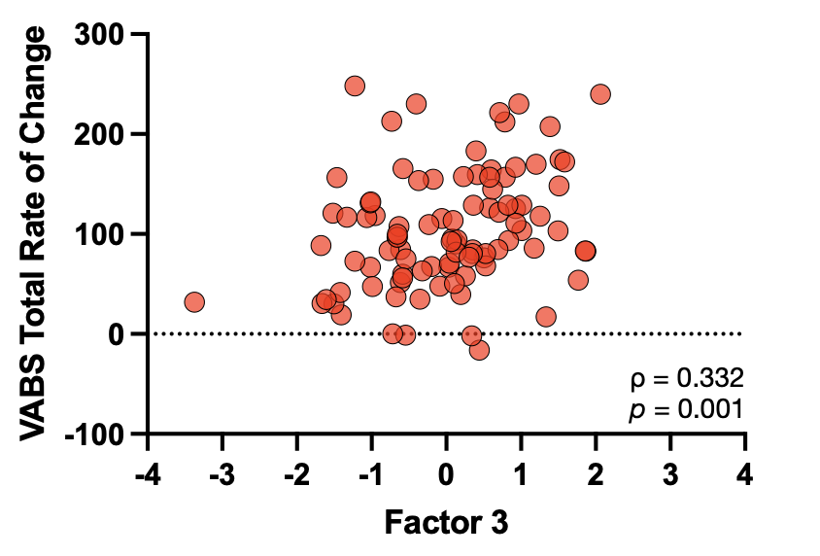
Figure S7. Significant Spearman correlation between Factor 3 (Nonverbal Social Engagement) and VABS-II Total Rate of Change.

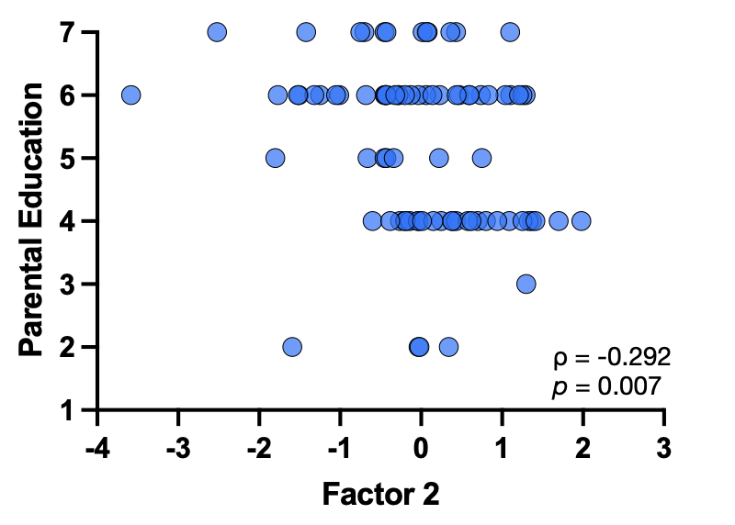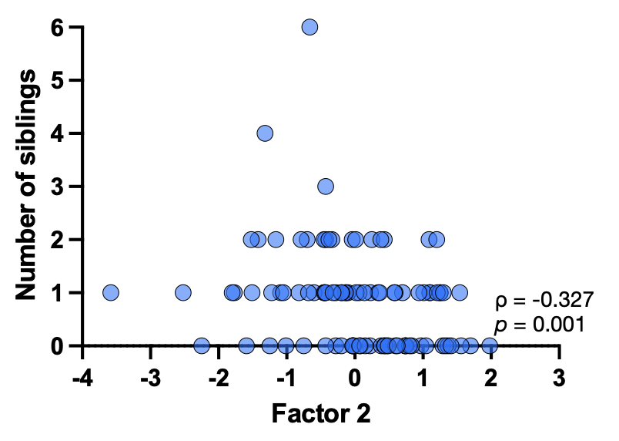
Figure S8. Significant Spearman correlation between Factor 2 (Positive Parental Experience) and parental education, as well as the number of siblings.
Supplementary Tables

Table S1. Distribution of responses to each questionnaire child-focused item across response options, with column totals.
 | Greatly worsened | Worsened | Slightly worsened | Unchanged | Slightly improved | Improved | Greatly improved | Total
Time spent alone | 0 | 0 | 0 | 6 | 21 | 53 | 23 | 103
Eye contact | 0 | 0 | 0 | 3 | 23 | 47 | 31 | 104
Preferential relationships | 1 | 0 | 0 | 29 | 27 | 30 | 13 | 100
Social reciprocity with children | 1 | 0 | 0 | 16 | 36 | 36 | 15 | 104
Social reciprocity with parents | 0 | 0 | 0 | 5 | 21 | 52 | 26 | 104
Play | 0 | 0 | 1 | 18 | 21 | 47 | 17 | 104
Restricted interests | 0 | 0 | 1 | 4 | 26 | 48 | 25 | 104
Repetitive behaviors | 1 | 0 | 2 | 16 | 33 | 38 | 13 | 103
Non-verbal communication | 0 | 0 | 0 | 1 | 18 | 53 | 32 | 104
Verbal communication | 0 | 0 | 0 | 6 | 28 | 32 | 38 | 104
Autonomy | 0 | 0 | 0 | 4 | 24 | 52 | 24 | 104
Attention | 0 | 0 | 1 | 2 | 25 | 49 | 27 | 104
Eye contact | 0 | 0 | 0 | 3 | 23 | 47 | 31 | 104
Time spent alone | 0 | 0 | 0 | 6 | 21 | 53 | 23 | 103

Table S2. Distribution of responses to each questionnaire child-focused item across response options, with column totals.
 | Yes, enormously | Yes, a lot | Yes, a little | No | Total
Perceptions of people surrounding the family | 12 | 37 | 34 | 18 | 101
Positive impact on family life | 24 | 31 | 21 | 8 | 104
Positive impact on mood, work and social relationships | 27 | 39 | 22 | 6 | 104
Handling tough times | 20 | 44 | 35 | 5 | 104
Establishing rapport and communicating with your child | 34 | 51 | 18 | 1 | 104
Understanding child needs | 37 | 45 | 21 | 1 | 104
Positive impact on mood, work and social relationships | 27 | 39 | 22 | 6 | 104

Table S3. Wilcoxon signed-rank test for the 18 items of the questionnaire. N represents the total number of responses for each item in the sample of 104 participants. n refers to the number of non-zero responses included in the analysis.
 | Wilcoxon Signed Rank Test |  |  |  |  | Effect size
 | W | N | n | Z | p | r
Time spent alone | 4753 | 103 | 97 | 8.551 | <0.0001 | 0.868
Eye contact | 5151 | 104 | 101 | 8.725 | <0.0001 | 0.868
Preferential relationships | 2427 | 100 | 71 | 6.584 | <0.0001 | 0.781
Social reciprocity with children | 3755 | 104 | 88 | 7.477 | <0.0001 | 0.797
Social reciprocity with parents | 4950 | 104 | 99 | 8.638 | <0.0001 | 0.868
Play | 3718 | 104 | 86 | 7.955 | <0.0001 | 0.858
Restricted interests | 5022 | 104 | 100 | 8.585 | <0.0001 | 0.859
Repetitive behaviors | 3595 | 103 | 87 | 7.115 | <0.0001 | 0.763
Non-verbal communication | 5356 | 104 | 103 | 8.810 | <0.0001 | 0.868
Verbal communication | 4851 | 104 | 98 | 8.595 | <0.0001 | 0.868
Autonomy | 5050 | 104 | 100 | 8.682 | <0.0001 | 0.868
Attention | 5226 | 104 | 102 | 8.678 | <0.0001 | 0.859
Perceptions of people surrounding the family | 3486 | 101 | 83 | 7.913 | <0.0001 | 0.869
Positive impact on family life | 4656 | 104 | 96 | 8.507 | <0.0001 | 0.868
Positive impact on mood, work and social relationships | 4851 | 104 | 98 | 8.595 | <0.0001 | 0.868
Handling tough times | 4950 | 104 | 99 | 8.638 | <0.0001 | 0.868
Establishing rapport and communicating with your child | 5356 | 104 | 103 | 8.810 | <0.0001 | 0.868
Understanding child needs | 5356 | 104 | 103 | 8.810 | <0.0001 | 0.868
Time spent alone | 4753 | 103 | 97 | 8.551 | <0.0001 | 0.868

Table S4. P-values of the Spearman correlation matrix fro the 18 questionnaire items. Bold p-values indicate survival after Bonferroni correction.
 | Perceptions of people surrounding the family | Positive impact on family life | Positive impact on mood. work and social relationships | Handling tough times | Establishing rapport and communicating with your child | Understanding child needs | Attention | Autonomy | Non-verbal communication | Verbal communication | Reduction of repetitive behaviors | Broadening of interests | Play | Social reciprocity with parents | Social reciprocity with children | Eye contact | Preferential relationships | Time spent alone
Perceptions of people surrounding the family |  | <0.001 | <0.001 | <0.001 | <0.001 | 0.001 | 0.133 | 0.127 | 0.277 | <0.001 | 0.046 | 0.001 | 0.172 | 0.003 | 0.061 | 0.063 | 0.257 | 0.045
Positive impact on family life |  |  | <0.001 | <0.001 | <0.001 | <0.001 | <0.001 | 0.135 | 0.185 | 0.188 | 0.095 | <0.001 | 0.133 | 0.029 | 0.038 | <0.001 | 0.002 | 0.003
Positive impact on mood. work and social relationships |  |  |  | <0.001 | <0.001 | <0.001 | 0.019 | 0.082 | 0.146 | 0.148 | 0.086 | 0.002 | 0.154 | 0.001 | 0.011 | 0.002 | 0.007 | <0.001
Handling tough times |  |  |  |  | <0.001 | <0.001 | 0.001 | 0.002 | 0.02 | 0.003 | <0.001 | <0.001 | 0.003 | <0.001 | 0.001 | <0.001 | <0.001 | <0.001
Establishing rapport and communicating with your child |  |  |  |  |  | <0.001 | 0.002 | <0.001 | 0.005 | <0.001 | 0.001 | <0.001 | 0.017 | <0.001 | 0.002 | 0.001 | <0.001 | <0.001
Understanding child needs |  |  |  |  |  |  | <0.001 | <0.001 | <0.001 | <0.001 | <0.001 | <0.001 | 0.001 | <0.001 | 0.043 | <0.001 | 0.003 | <0.001
Attention |  |  |  |  |  |  |  | <0.001 | 0.008 | <0.001 | 0.004 | <0.001 | <0.001 | 0.004 | <0.001 | 0.001 | <0.001 | <0.001
Autonomy |  |  |  |  |  |  |  |  | <0.001 | <0.001 | 0.001 | 0.005 | <0.001 | <0.001 | <0.001 | 0.005 | <0.001 | <0.001
Non-verbal communication |  |  |  |  |  |  |  |  |  | 0.015 | <0.001 | 0.099 | 0.008 | <0.001 | <0.001 | <0.001 | <0.001 | <0.001
Verbal communication |  |  |  |  |  |  |  |  |  |  | 0.038 | <0.001 | <0.001 | <0.001 | 0.001 | 0.380 | 0.002 | 0.002
Reduction of repetitive behaviors |  |  |  |  |  |  |  |  |  |  |  | 0.002 | 0.003 | 0.017 | 0.010 | <0.001 | 0.004 | 0.001
Broadening of interests |  |  |  |  |  |  |  |  |  |  |  |  | <0.001 | <0.001 | 0.001 | <0.001 | 0.003 | <0.001
Play |  |  |  |  |  |  |  |  |  |  |  |  |  | <0.001 | <0.001 | 0.001 | <0.001 | <0.001
Social reciprocity with parents |  |  |  |  |  |  |  |  |  |  |  |  |  |  | <0.001 | <0.001 | <0.001 | <0.001
Social reciprocity with children |  |  |  |  |  |  |  |  |  |  |  |  |  |  |  | <0.001 | <0.001 | <0.001
Eye contact |  |  |  |  |  |  |  |  |  |  |  |  |  |  |  |  | <0.001 | <0.001
Preferential relationships |  |  |  |  |  |  |  |  |  |  |  |  |  |  |  |  |  | <0.001
Time spent alone

Principal component analysis

Principal component analysis (PCA) was performed on the 18 questionnaire items. Kaiser's criterion (eigenvalues > 1) suggested five components, but this method often overestimates factor numbers (Zwick & Velicer, 1986). The scree plot (Figure S4) showed a clearer break after the third component, supporting a three-factor solution. Thus, we re-ran PCA retaining three factors.

Table S5. Factor loadings of the 18 questionnaire items in the sample without missing data (n=97).
Questionnaire item | Factor 1 (38.35%) | Factor 2 (11.57%) | Factor 3 (8.07%)
Verbal communication | 0.841 |  | -0.156
Autonomy | 0.798 |  | 0.123
Play | 0.596 | 0.125 | 0.263
Social reciprocity with parents | 0.490 | -0.102 | 0.336
Attention | 0.430 | -0.224 | 0.153
Reduction of repetitive behaviors | 0.304 | -0.293 | 0.129
Positive impact on mood, work and social relationships | -0.233 | -0.846 | 0.119
Positive impact on family life | -0.256 | -0.843 | 0.168
Handling tough times | 0.140 | -0.706 | 0.129
Perceptions of people surrounding the family | 0.125 | -0.703 | -0.187
Establishing rapport and communicating with your child | 0.284 | -0.647
Understanding child needs | 0.449 | -0.554
Broadening of interests | 0.316 | -0.479
Preferential relationships |  |  | 0.850
Social reciprocity with children |  |  | 0.821
Eye contact |  | -0.235 | 0.704
Time spent alone | 0.143 | -0.143 | 0.640
Non-verbal communication | 0.340 | 0.121 | 0.468
Eigenvalues | 6.90 | 2.08 | 1.45
% of variance | 38.35 | 11.57 | 8.07

Table S6. Spearman correlations between the 3 factors
 | Factor 1 | Factor 2 | Factor 3
Factor 1 | 1.00 | 0.266** | 0.443***
Factor 2 | 0.266** | 1.00 | 0.315**
Factor 3 | 0.443*** | 0.315** | 1.00
Note: *p<0.05, **p<0.01, ***p<0.001

