Appendix
Appendix A
Table A.1 -- Basic Information
1. Your gender:
male
female
2. Your age:
Under 18 years old
18-25 years old
26-35 years old
36-45 years old
46-55 years old
Over 55 years old
3. Your level of education:
High school and below
College diploma
undergraduate college
Master's degree or above
4. Your profession:
student
Administrative/public institution employees
Enterprise employees
liberal professions
other
5. Please rate your python level: [Single choice question]
low
Medium to low
secondary
Medium to high
high

Table A.2 -- Knowledge Test
1.Which of the following functions can print information output on the screen
print()
int()
random()
input()
2. Python programs use () for commenting
#
，
;
[]
3. The output result of print (7) # 777 is
7
77
777
7777
4.The print() function can use single or double quotation marks when outputting text [True or False]
True
False
5.Use () to distinguish code hierarchy when writing code
Indent (blank)
semicolon
comma
6. Variables are used to specify or store data [True or False]
True
False
7. The first character of variable naming cannot be ()
capital
Lowercase letters
The number of '_' underscores
8.What is the statement to assign Python to the variable My love
My love=Python
My love==Python
Python=My love
Python=My love
9. Two variables can directly exchange their values [True or False]
True
False
10. Boolean type has only two values: True and False [True or False]
True
False
11. If name=True, then print (int (name)) value
1
0
True
False
12. The result of printing ('a '>'z') is
False
True
1
0
13.If V1 and V2 are assigned True and False respectively, then the value of V1++V2 is（
True
False
1
0
14. The result of printing (1 > 2)*3+(2==3) is
3
0
1
4
15. If a="year" and b="month", how to exchange the values of a and b
b=a, temp=b, a=temp
temp=b, a=temp, b=a
temp=b, b=a, a=temp
a=b, temp=a, b=temp

Table A.3 -- Manipulation Test Questions and Screening
C1:Has this platform designed competitive gamification elements (such as PK, leaderboard, Passing levels, badges, etc.)
Yes
No
C2：Has this platform been designed with cooperative gamification elements, （such as: Teaming up with each other and providing support, Awakening progress, community etc.）
Yes
No
C3：What is your questionnaire number
1
7
14
21
Q2_5 This platform has a lot of content, please choose 2 directly for this question [scale question]

Table A.4 – Specific questions in manipulation checks
Q1_Competitive Gamification Perception:
" Did this platform include competitive gamification elements (e.g., PK, leaderboard, badges)?"
Yes
No
Q2_Cooperative Gamification Perception:
" Did this platform include cooperative gamification elements (e.g., team-based learning, reminders, community support)?"
Yes
No

Table A.5 – Variable Measurement Problem Scale
1.Perceived Challenge
1.1 When I first used this learning platform, I found it very easy.
[Strongly disagree, strongly agree]
 1 2 3 4 5 6 7
1.2 This learning platform involves too much content, making it difficult for me to grasp the key points.
[Strongly disagree, strongly agree]
1 2 3 4 5 6 7
1.3The Python courses on the platform are difficult for me.
[Strongly disagree, strongly agree]
1 2 3 4 5 6 7
1.4The tests or issues involved in the platform are too difficult.
[Strongly disagree, strongly agree]
1 2 3 4 5 6 7
1.5 I believe that by using this platform for a period of time, I can learn the content well.
[Strongly disagree, strongly agree]
1 2 3 4 5 6 7
1.6 I think I must work hard in order to learn the content on the platform well.
[Strongly disagree, strongly agree]
1 2 3 4 5 6 7
2. Perceived Attention
2.1 Some of the content on this platform caught my attention
[Strongly disagree, strongly agree]
1 2 3 4 5 6 7
2.2 The content involved in this platform is too abstract for me to focus on
[Strongly disagree, strongly agree]
1 2 3 4 5 6 7
2.3 This learning experience made me feel dull and uninteresting
[Strongly disagree, strongly agree]
1 2 3 4 5 6 7
2.4 This platform has sparked my interest in learning
[Strongly disagree, strongly agree]
1 2 3 4 5 6 7
2.5During the learning process, I often daydream [scale]
[Strongly disagree, strongly agree]
1 2 3 4 5 6 7
2.6During the learning process, I was very focused [scale]
[Strongly disagree, strongly agree]
1 2 3 4 5 6 7
3. Cognitive participation
3.1 I wholeheartedly strive to learn as many basic Python concepts and knowledge as possible
[Strongly disagree, strongly agree]
1 2 3 4 5 6 7
3.2 I wholeheartedly strive to improve my Python skills [scale]
[Strongly disagree, strongly agree]
1 2 3 4 5 6 7

Table A.6 – Realism checks
Q1:To what extent do you think the platform you used resembles a real online learning platform?
[Strongly disagree, strongly agree]
1 2 3 4 5 6 7
Q2: How realistic were the tasks and interactions in the learning platform?
[Strongly disagree, strongly agree]
1 2 3 4 5 6 7

Appendix B
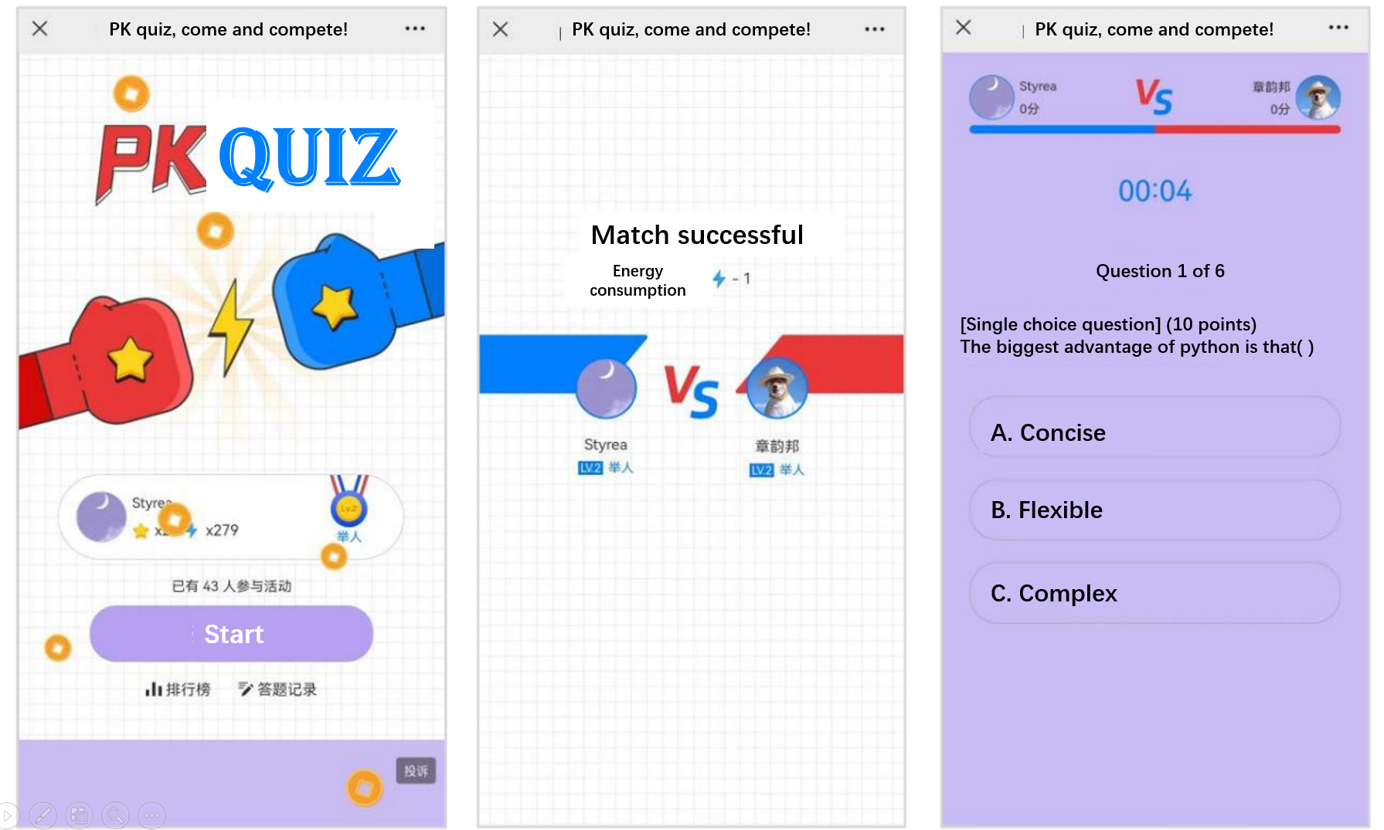
Figure B.1-- PK Battle
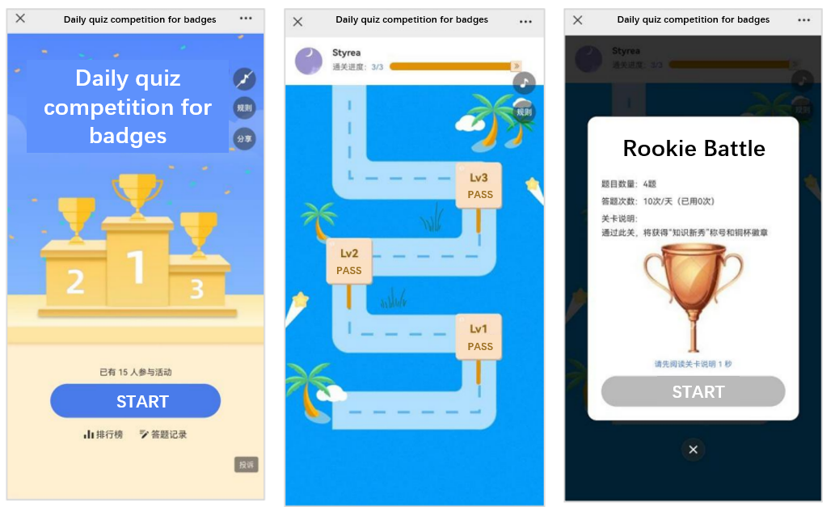
Figure B.2 -- Winning Badge by Passing Levels
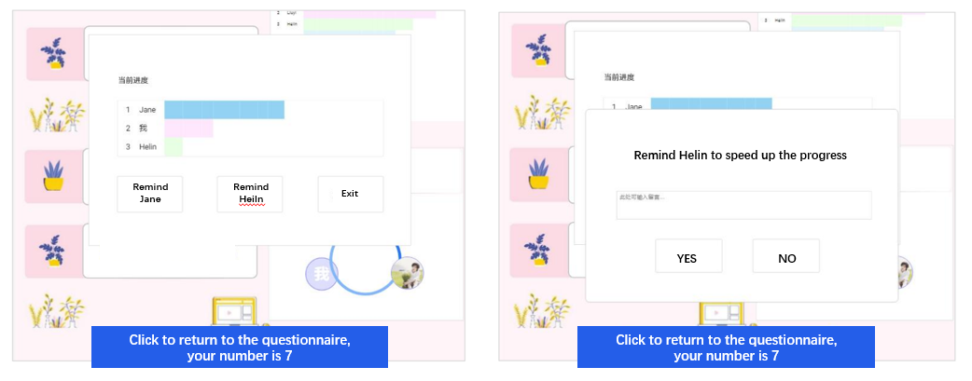
Figure B.3 -- Progress Reminder
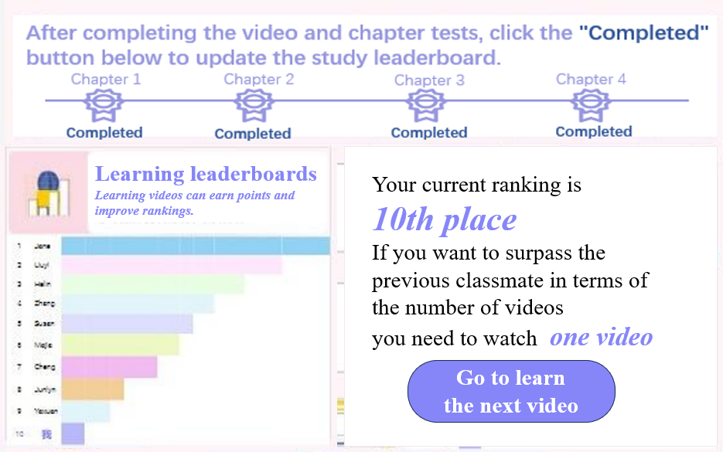
Figure B.4 -- Learning leaderboards

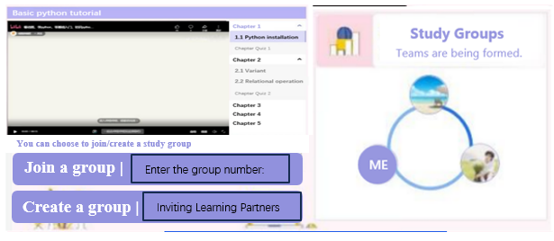
Figure B.5 -- Group invitations

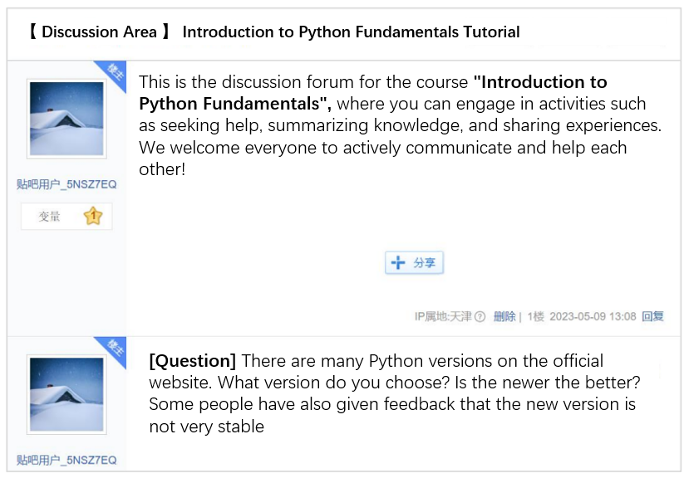
Figure B.6 -- Community Interaction

Appendix C
Pre-experiment and manipulation check
Prior to the main experiment, a small-scale pre-experiment was carried out to test the experimental manipulation effectively influenced the variables and that the scale items functioned as intended. This allowed for timely adjustments to the experimental method and scale revisions. Students recruited from in the school and through social media platforms participated in the pre-experiment, yielding 60 valid responses.
To test the success of the experimental manipulation, a single-factor ANOVA test was performed utilizing SPSS software. The presence or absence of a specific gamification design element represented the factor, while participants' responses (yes/no) regarding the presence/absence of the corresponding gamification design constituted the dependent variable. The results of this analysis are presented in Table 3 and Figure 9.

Table C.1 – Manipulation Check of the Gamification Design in Pre-experiment
Gamification Design |  | Mean Square | F | Significance
competitive gamification design | Intergroup | 8.817 | 88.676 | .000
competitive gamification design | Within a group | 0.099
competitive gamification design | Total
Cooperative Gamification Design | Intergroup | 4.817 | 37.923 | .000
Cooperative Gamification Design | Within a group | 0.127
Cooperative Gamification Design | Total

Figure C.1 -- Manipulation Check of the Gamification Design in Pre-experiment

The single-factor ANOVA test produced significant results for all tests, with significance levels all below 0.05. This finding indicates that the experiment effectively manipulated the independent variables, namely the competitive gamification design and the cooperative gamification design.

