Low-tortuosity Ion Transport Channels of Anion-exchange Membranes for Water electrolysis and Fuel cells
Siwen Lu, Jie Liu, Yiran Li, Shiqi Peng, Xiaojun Sun, Ziliang Li, Li Gao, Xuehua Ruan, Xiaobin Jiang, Xiaopeng Zhang, Xiaoming Yan*, and Gaohong He*
State Key Laboratory of Fine Chemicals, R&D Center of Membrane Science and Technology, School of Chemical Engineering, Ocean and Life, Dalian University of Technology, Panjin, Liaoning,China, 124221
E-mail: yanxiaoming@dlut.edu.cn (Dr. Xiaoming Yan); hgaohong@dlut.edu.cn (Dr. Gaohong He)

1. Supplementary figures
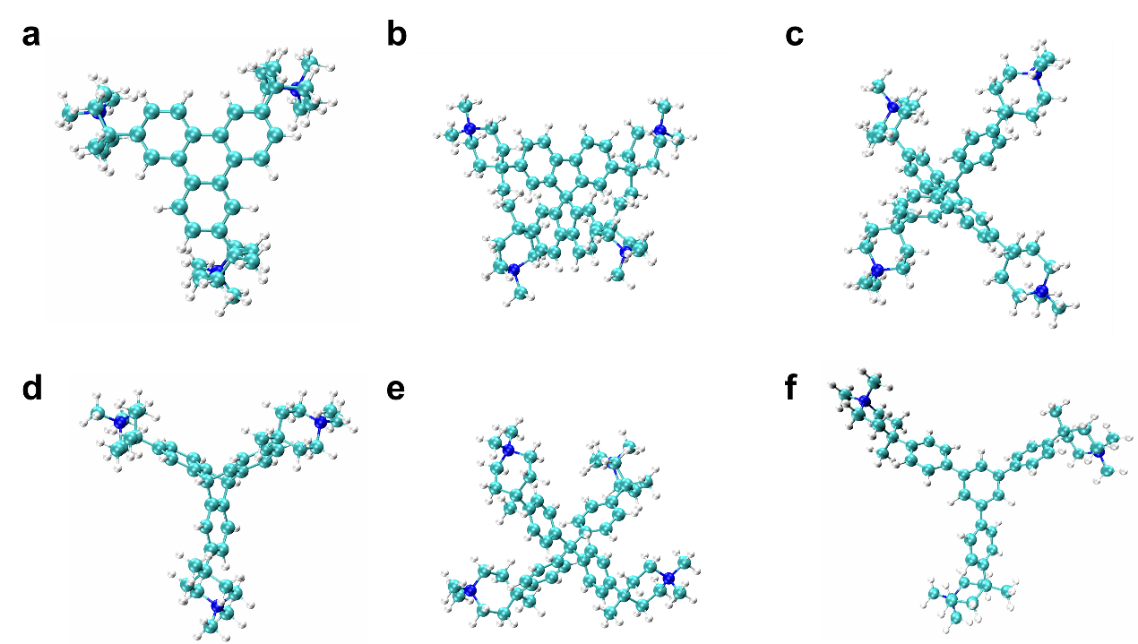
Supplementary Fig. 1 Structure of branched clusters. a QATYP. b QASFP. c QADFP. d QATCP. e QATMP. f QATBP.

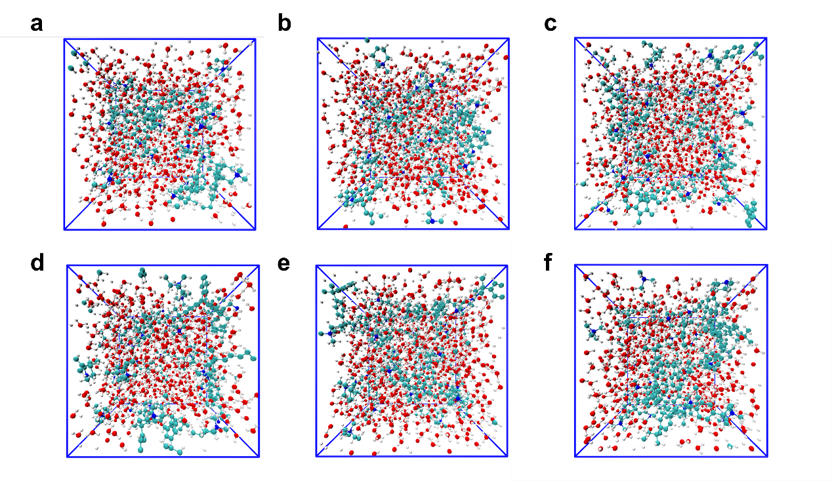
Supplementary Fig. 2 Boxes of branched clusters and water molecules. a QATYP. b QASFP. c QADFP. d QATCP. e QATMP. f QATBP. 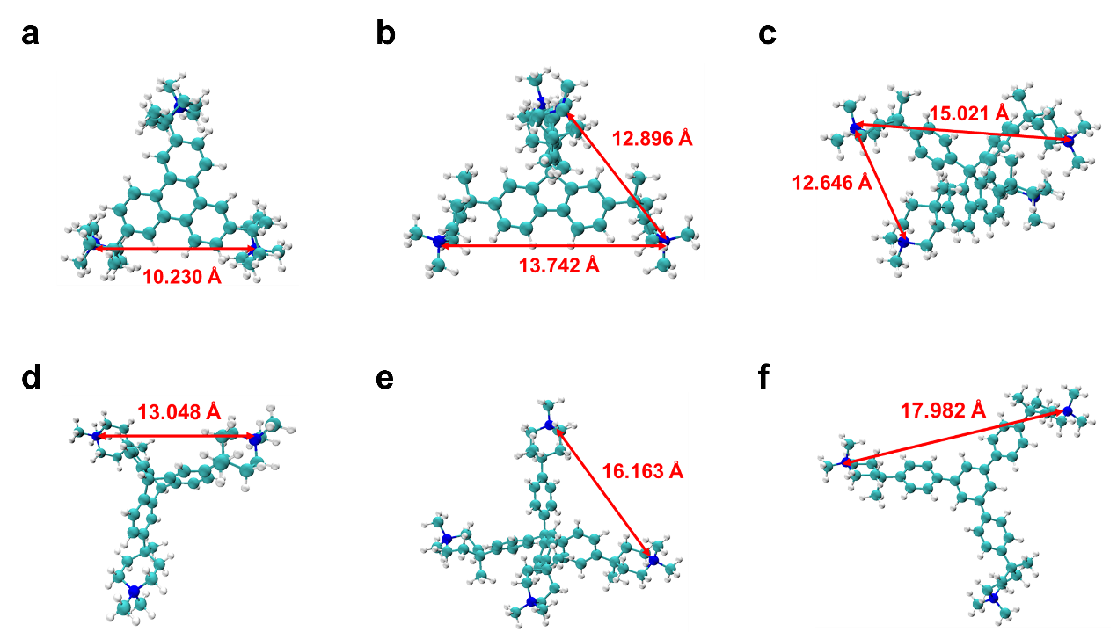
Supplementary Fig. 3 Inter-group distances in branched micro-clusters. a QATYP. b QASFP. c QADFP. d QATCP. e QATMP. f QATBP.

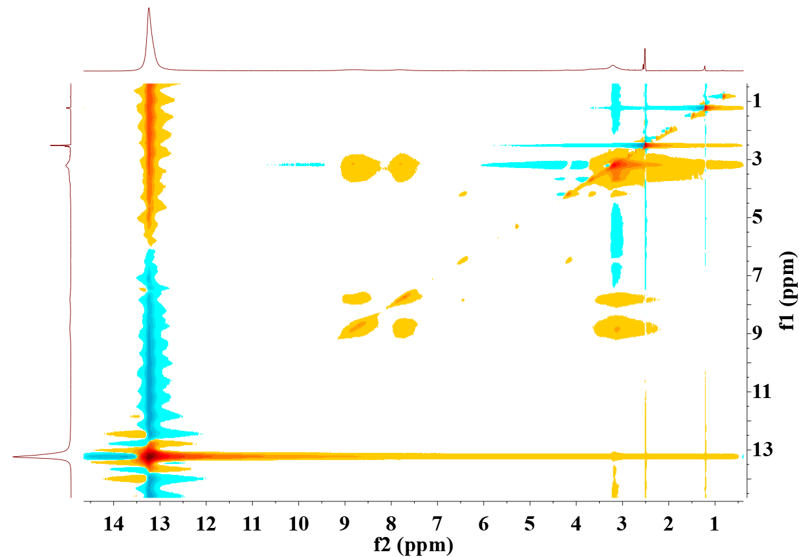
Supplementary Fig. 4 ¹H-NMR NOESY spectrum of QATYP.

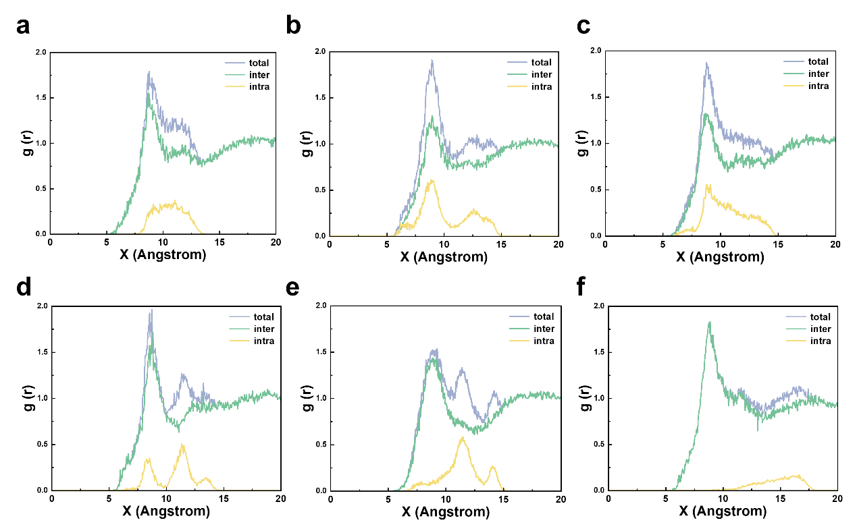
Supplementary Fig. 5 RDF_{N-N} of branched micro-clusters. a QATYP. b QASFP. c QADFP. d QATCP. e QATMP. f QATBP.

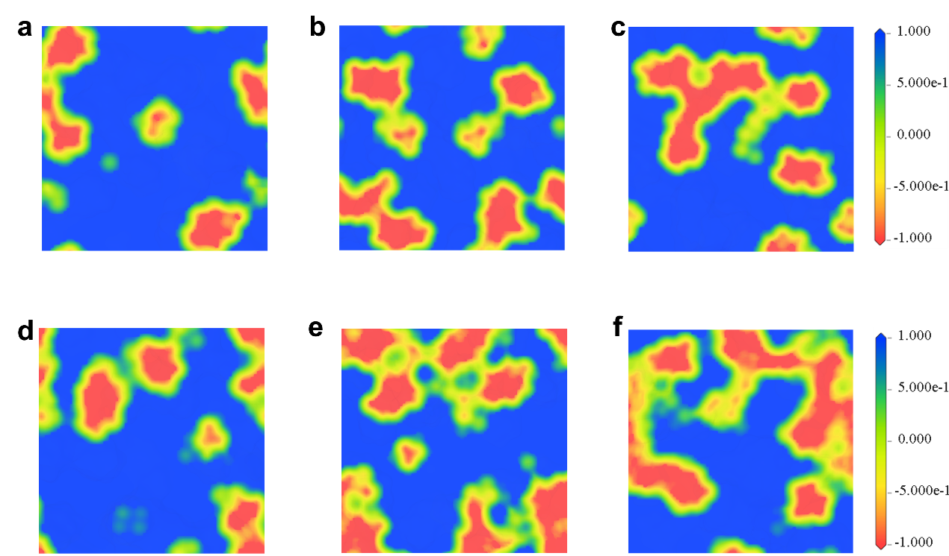
Supplementary Fig. 6 Structural density analysis of branched clusters. a QATYP. b QASFP. c QADFP. d QATCP. e QATMP. f QATBP.

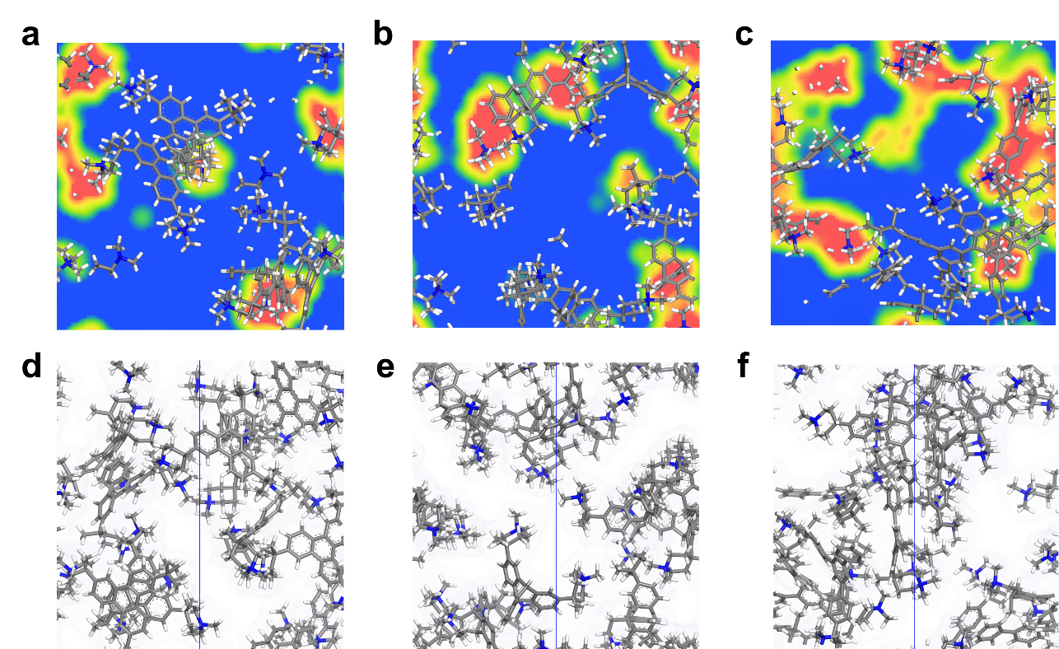
Supplementary Fig. 7 Cross-sectional view of branched clusters (number of branching sites = 3). a, d QATYP. b, e QATCP. c, f QATBP.

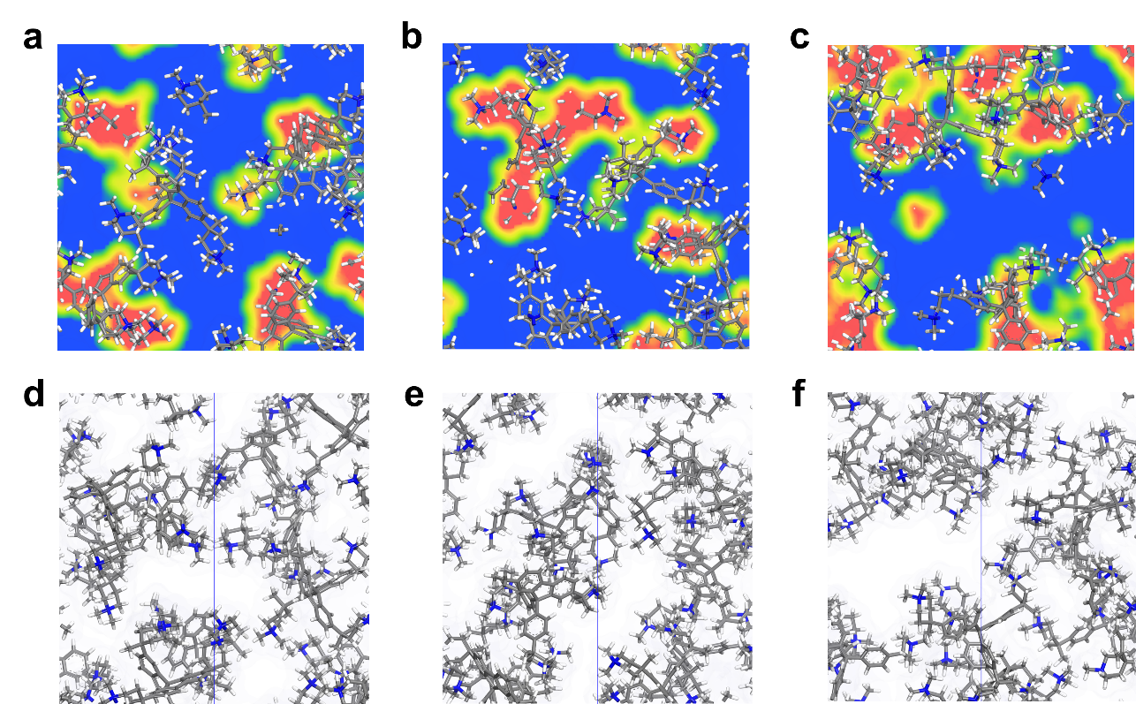
Supplementary Fig. 8 Cross-sectional view of branched clusters (number of branching sites = 4). a, d QASFP. b, e QADFP. c, f QATMP.

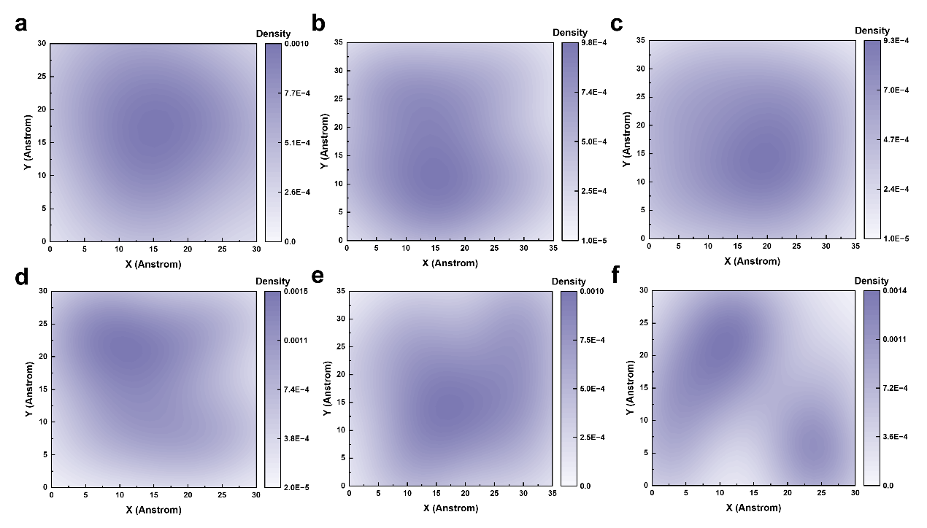
Supplementary Fig. 9 OH- 2D concentration distribution of branched clusters. a QATYP. b QASFP. c QADFP. d QATCP. e QATMP. f QATBP.

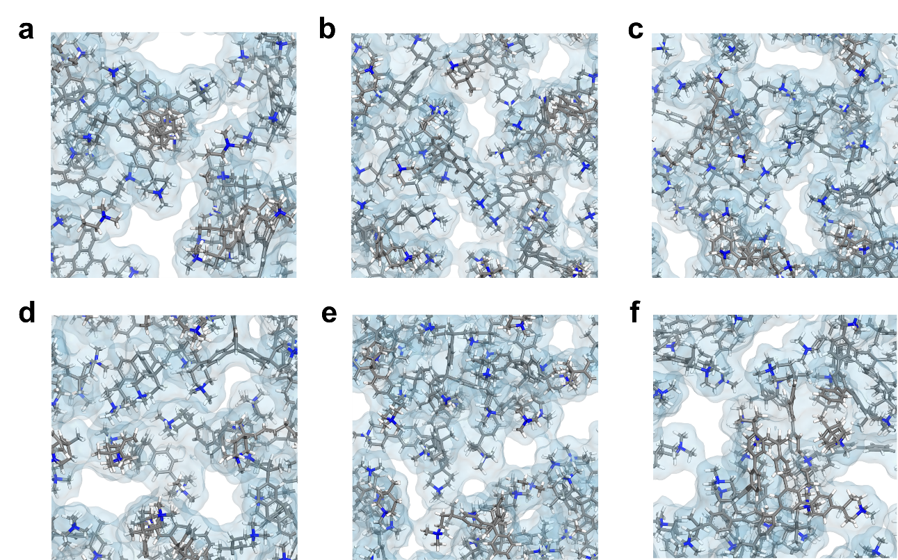
Supplementary Fig. 10 Ion transport channel morphology of branched clusters. a QATYP. b QASFP. c QADFP. d QATCP. e QATMP. f QATBP.

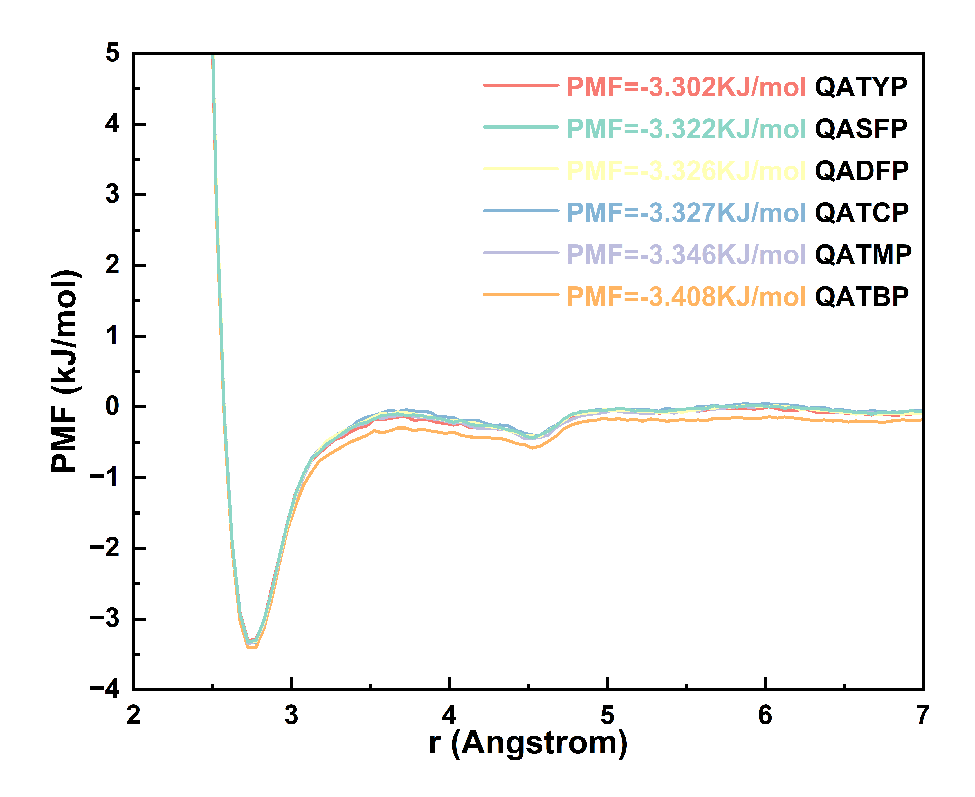
Supplementary Fig. 11 PMF of different branched clusters.
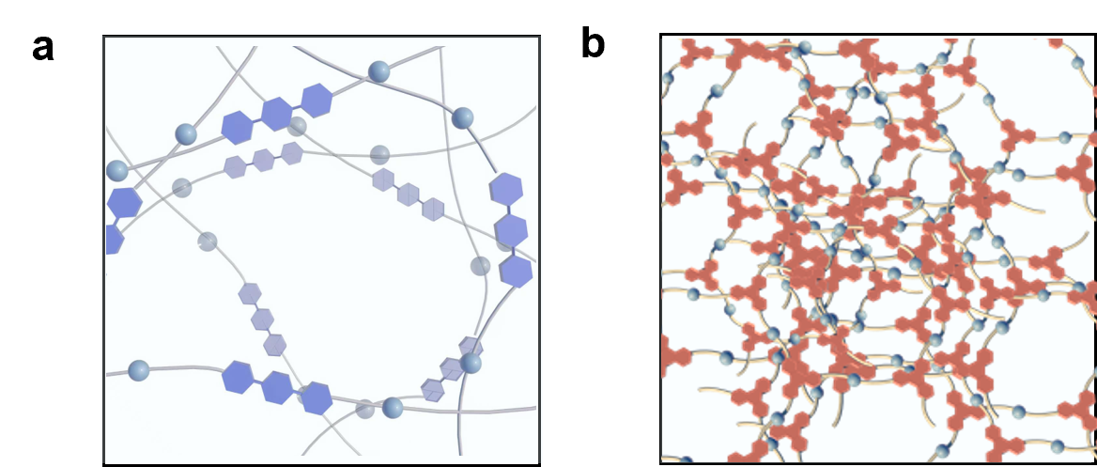
Supplementary Fig. 12 Schematic graph of QAPPT and QATYP. a QAPPT. b QATYP.
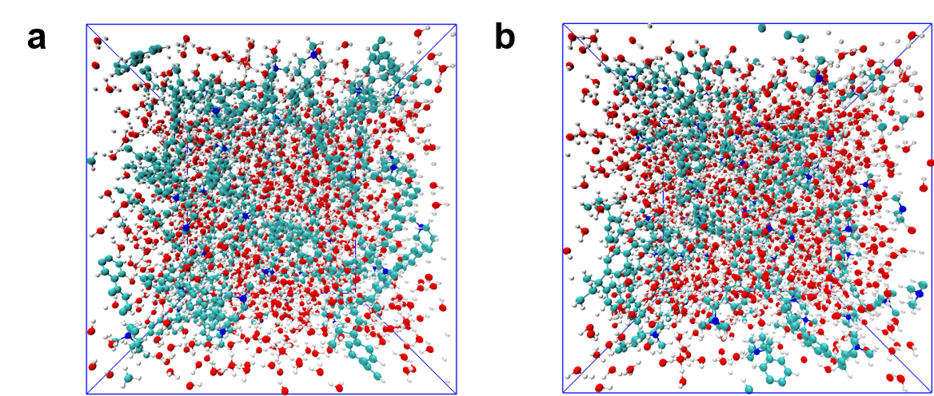
Supplementary Fig. 13 Boxes of QAPPT and QATYP and water molecules. a QAPPT. b QATYP.

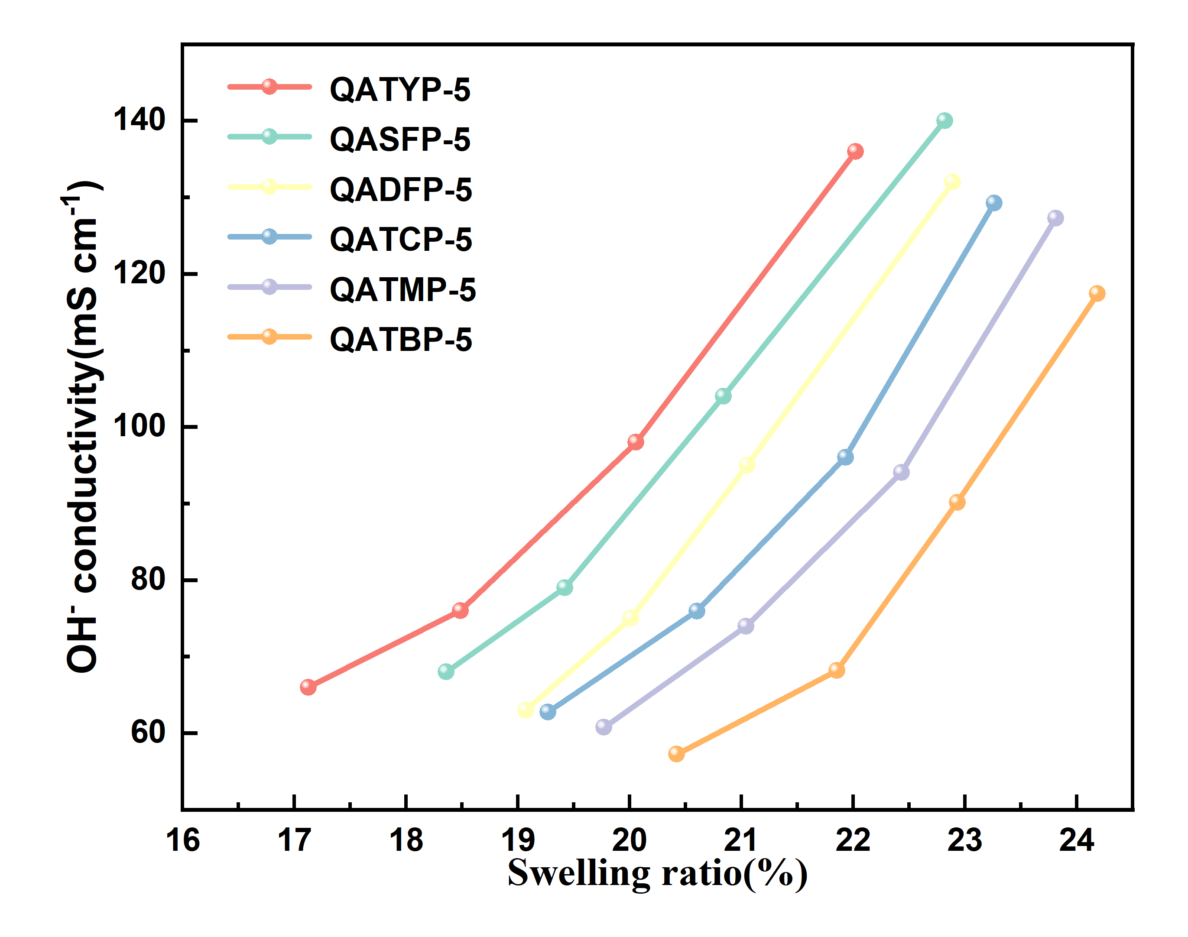
Supplementary Fig. 14 SR-dependent conductivity of different membranes.
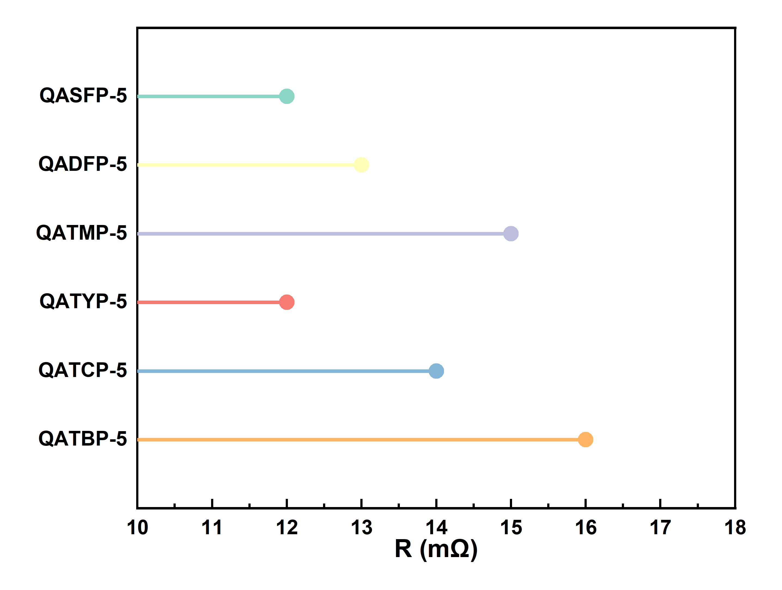 Supplementary Fig. 15 Resistance of different membranes.
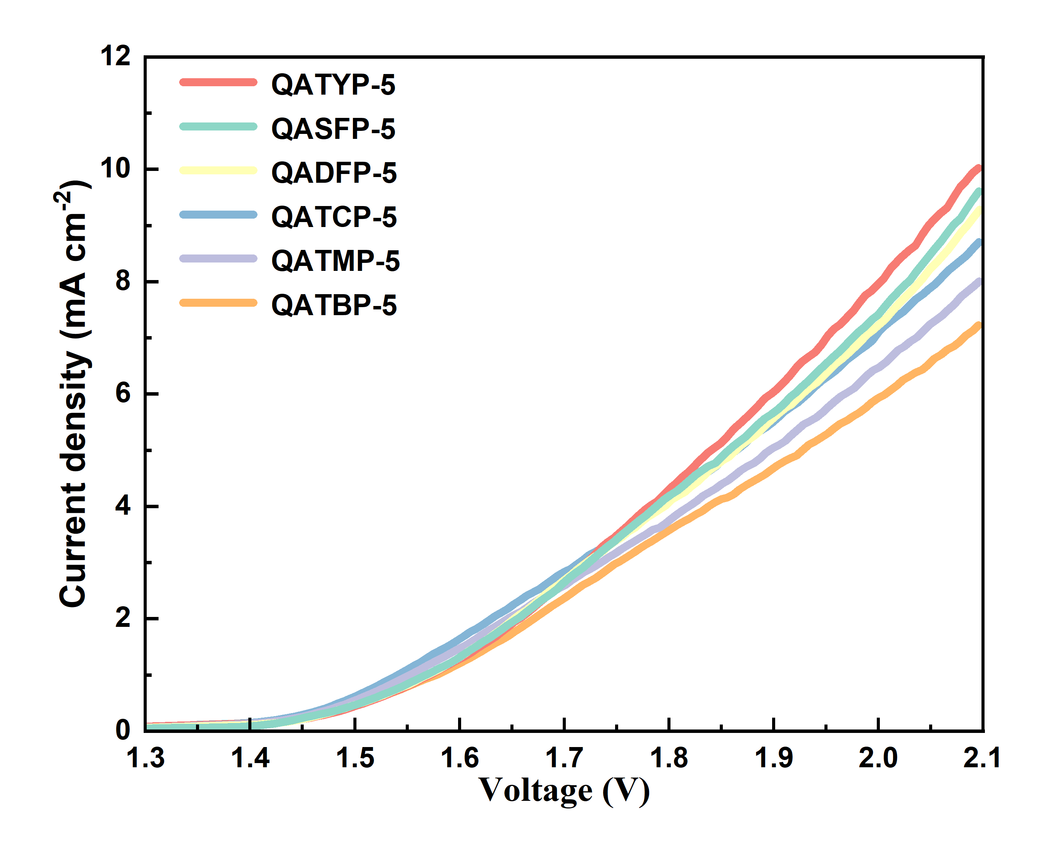
Supplementary Fig. 16 AEMWE tests of different membranes.
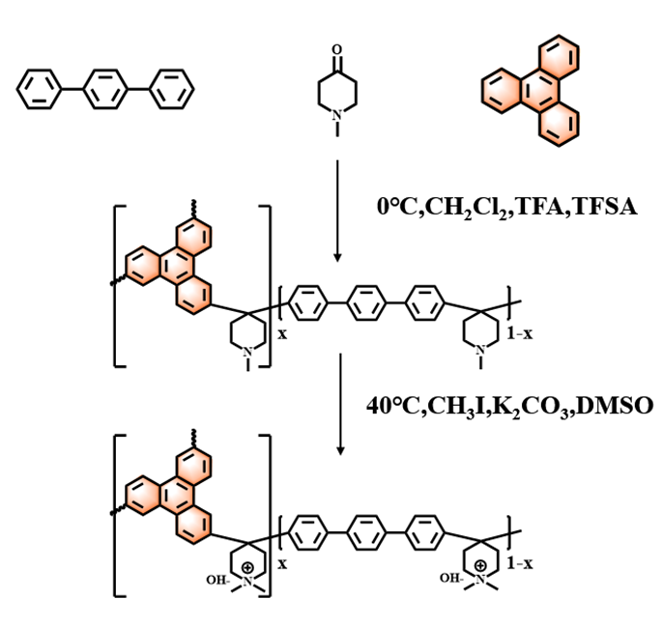
Supplementary Fig. 17 Synthesis route of PTYP-x and QPTYP-x.

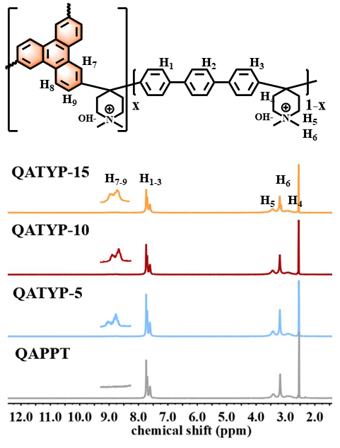
Supplementary Fig. 18 ¹H-NMR of QAPPT and QPTYP-x.

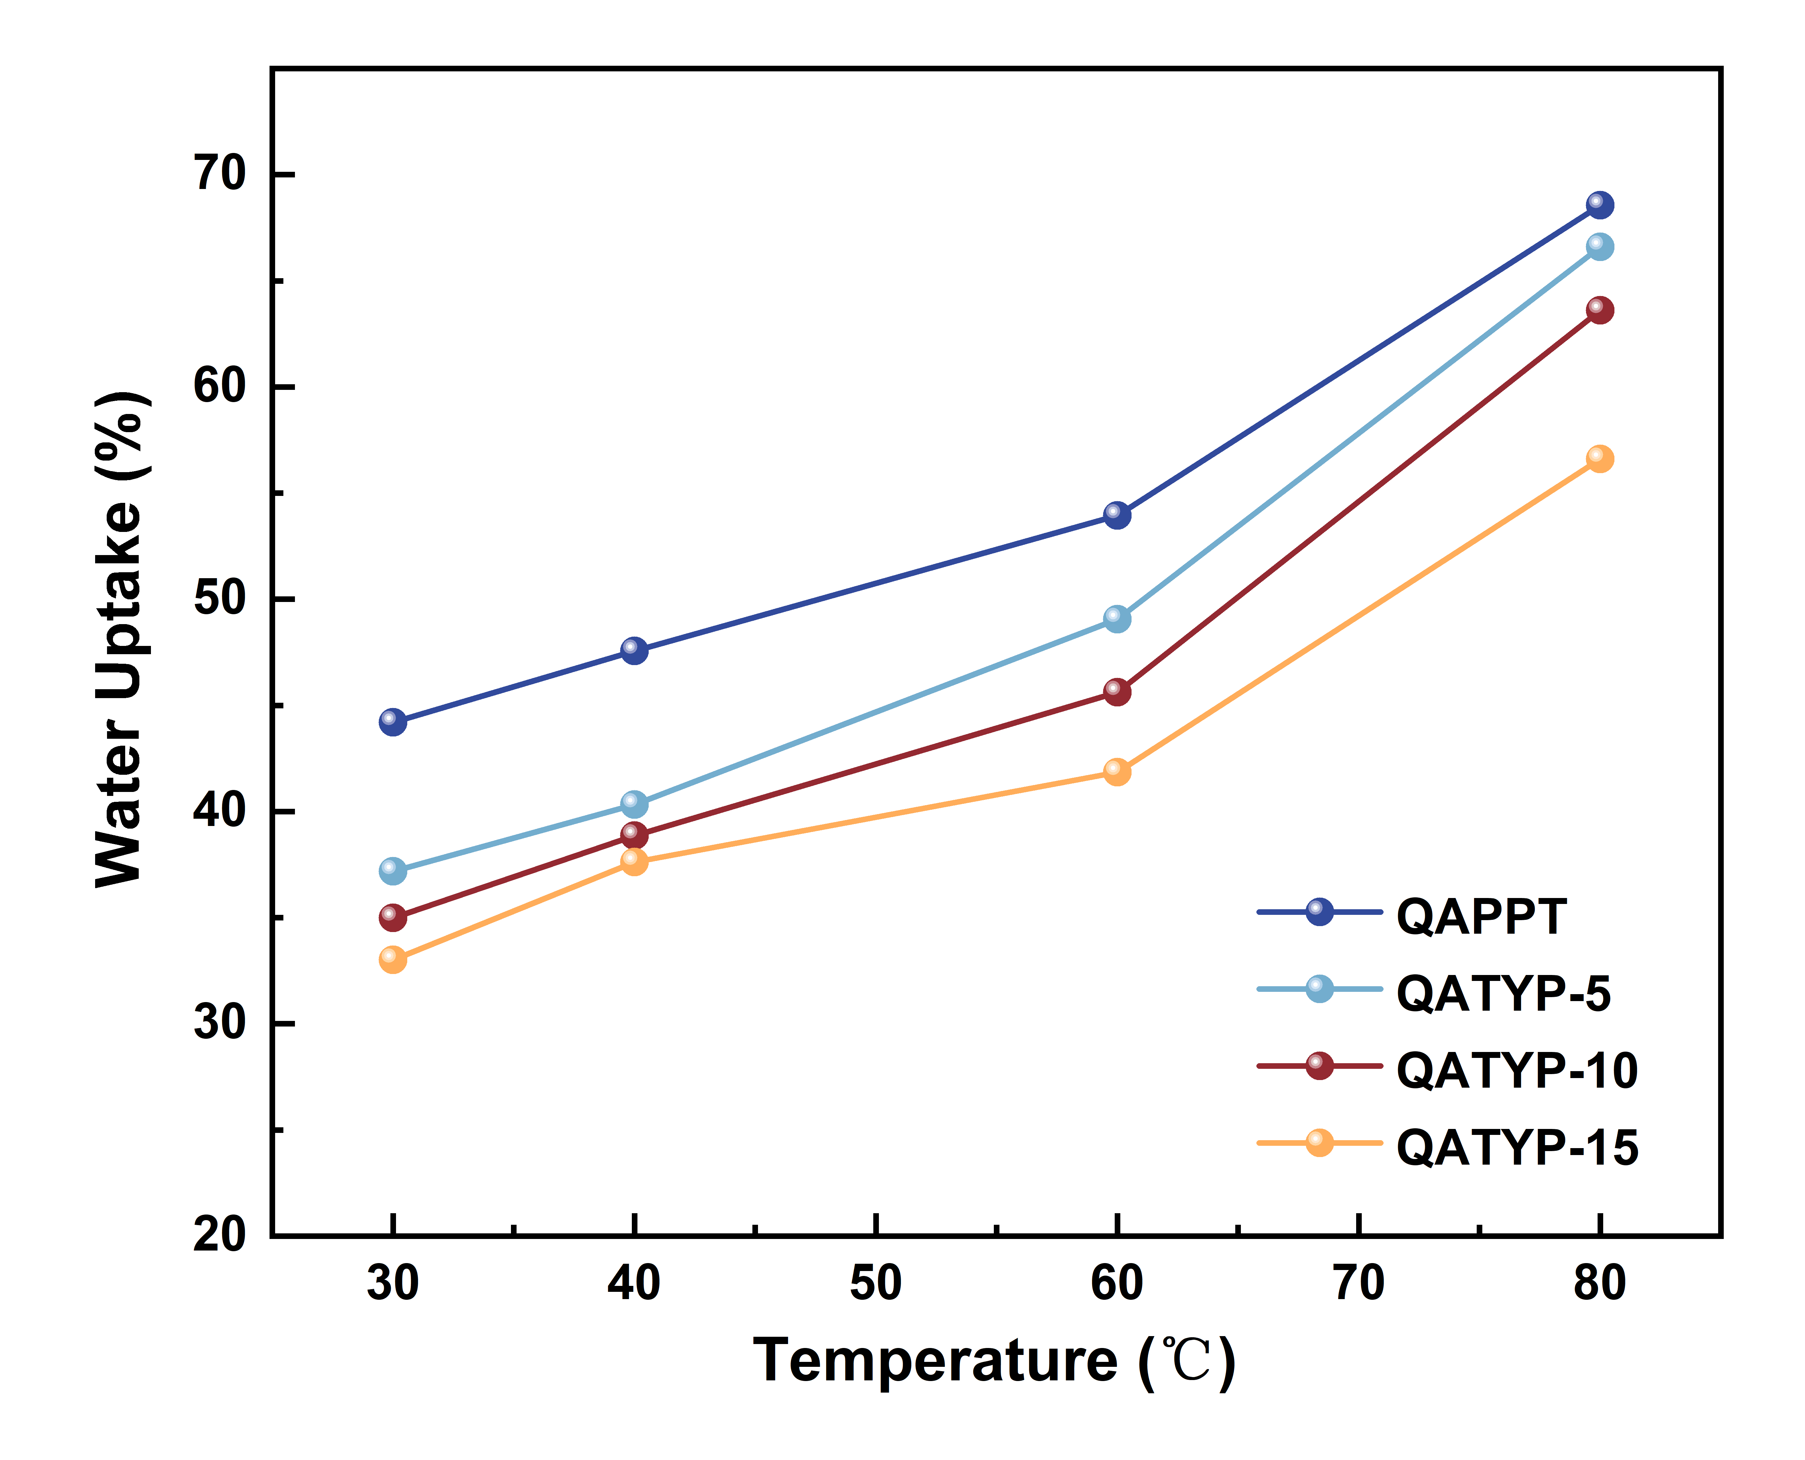
Supplementary Fig. 19 WU of QAPPT and QPTYP-x.
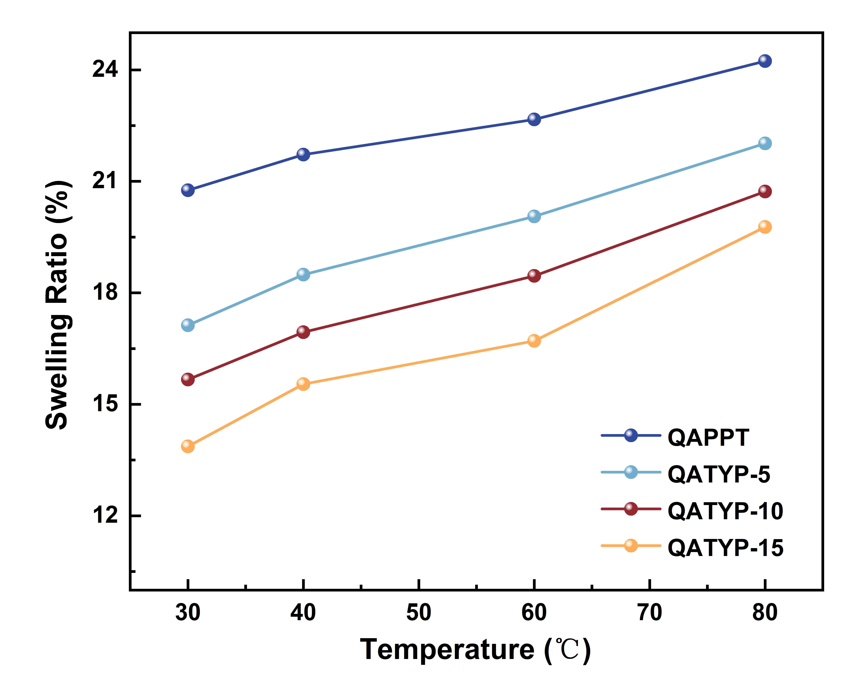
Supplementary Fig. 20 SR of QAPPT and QPTYP-x.

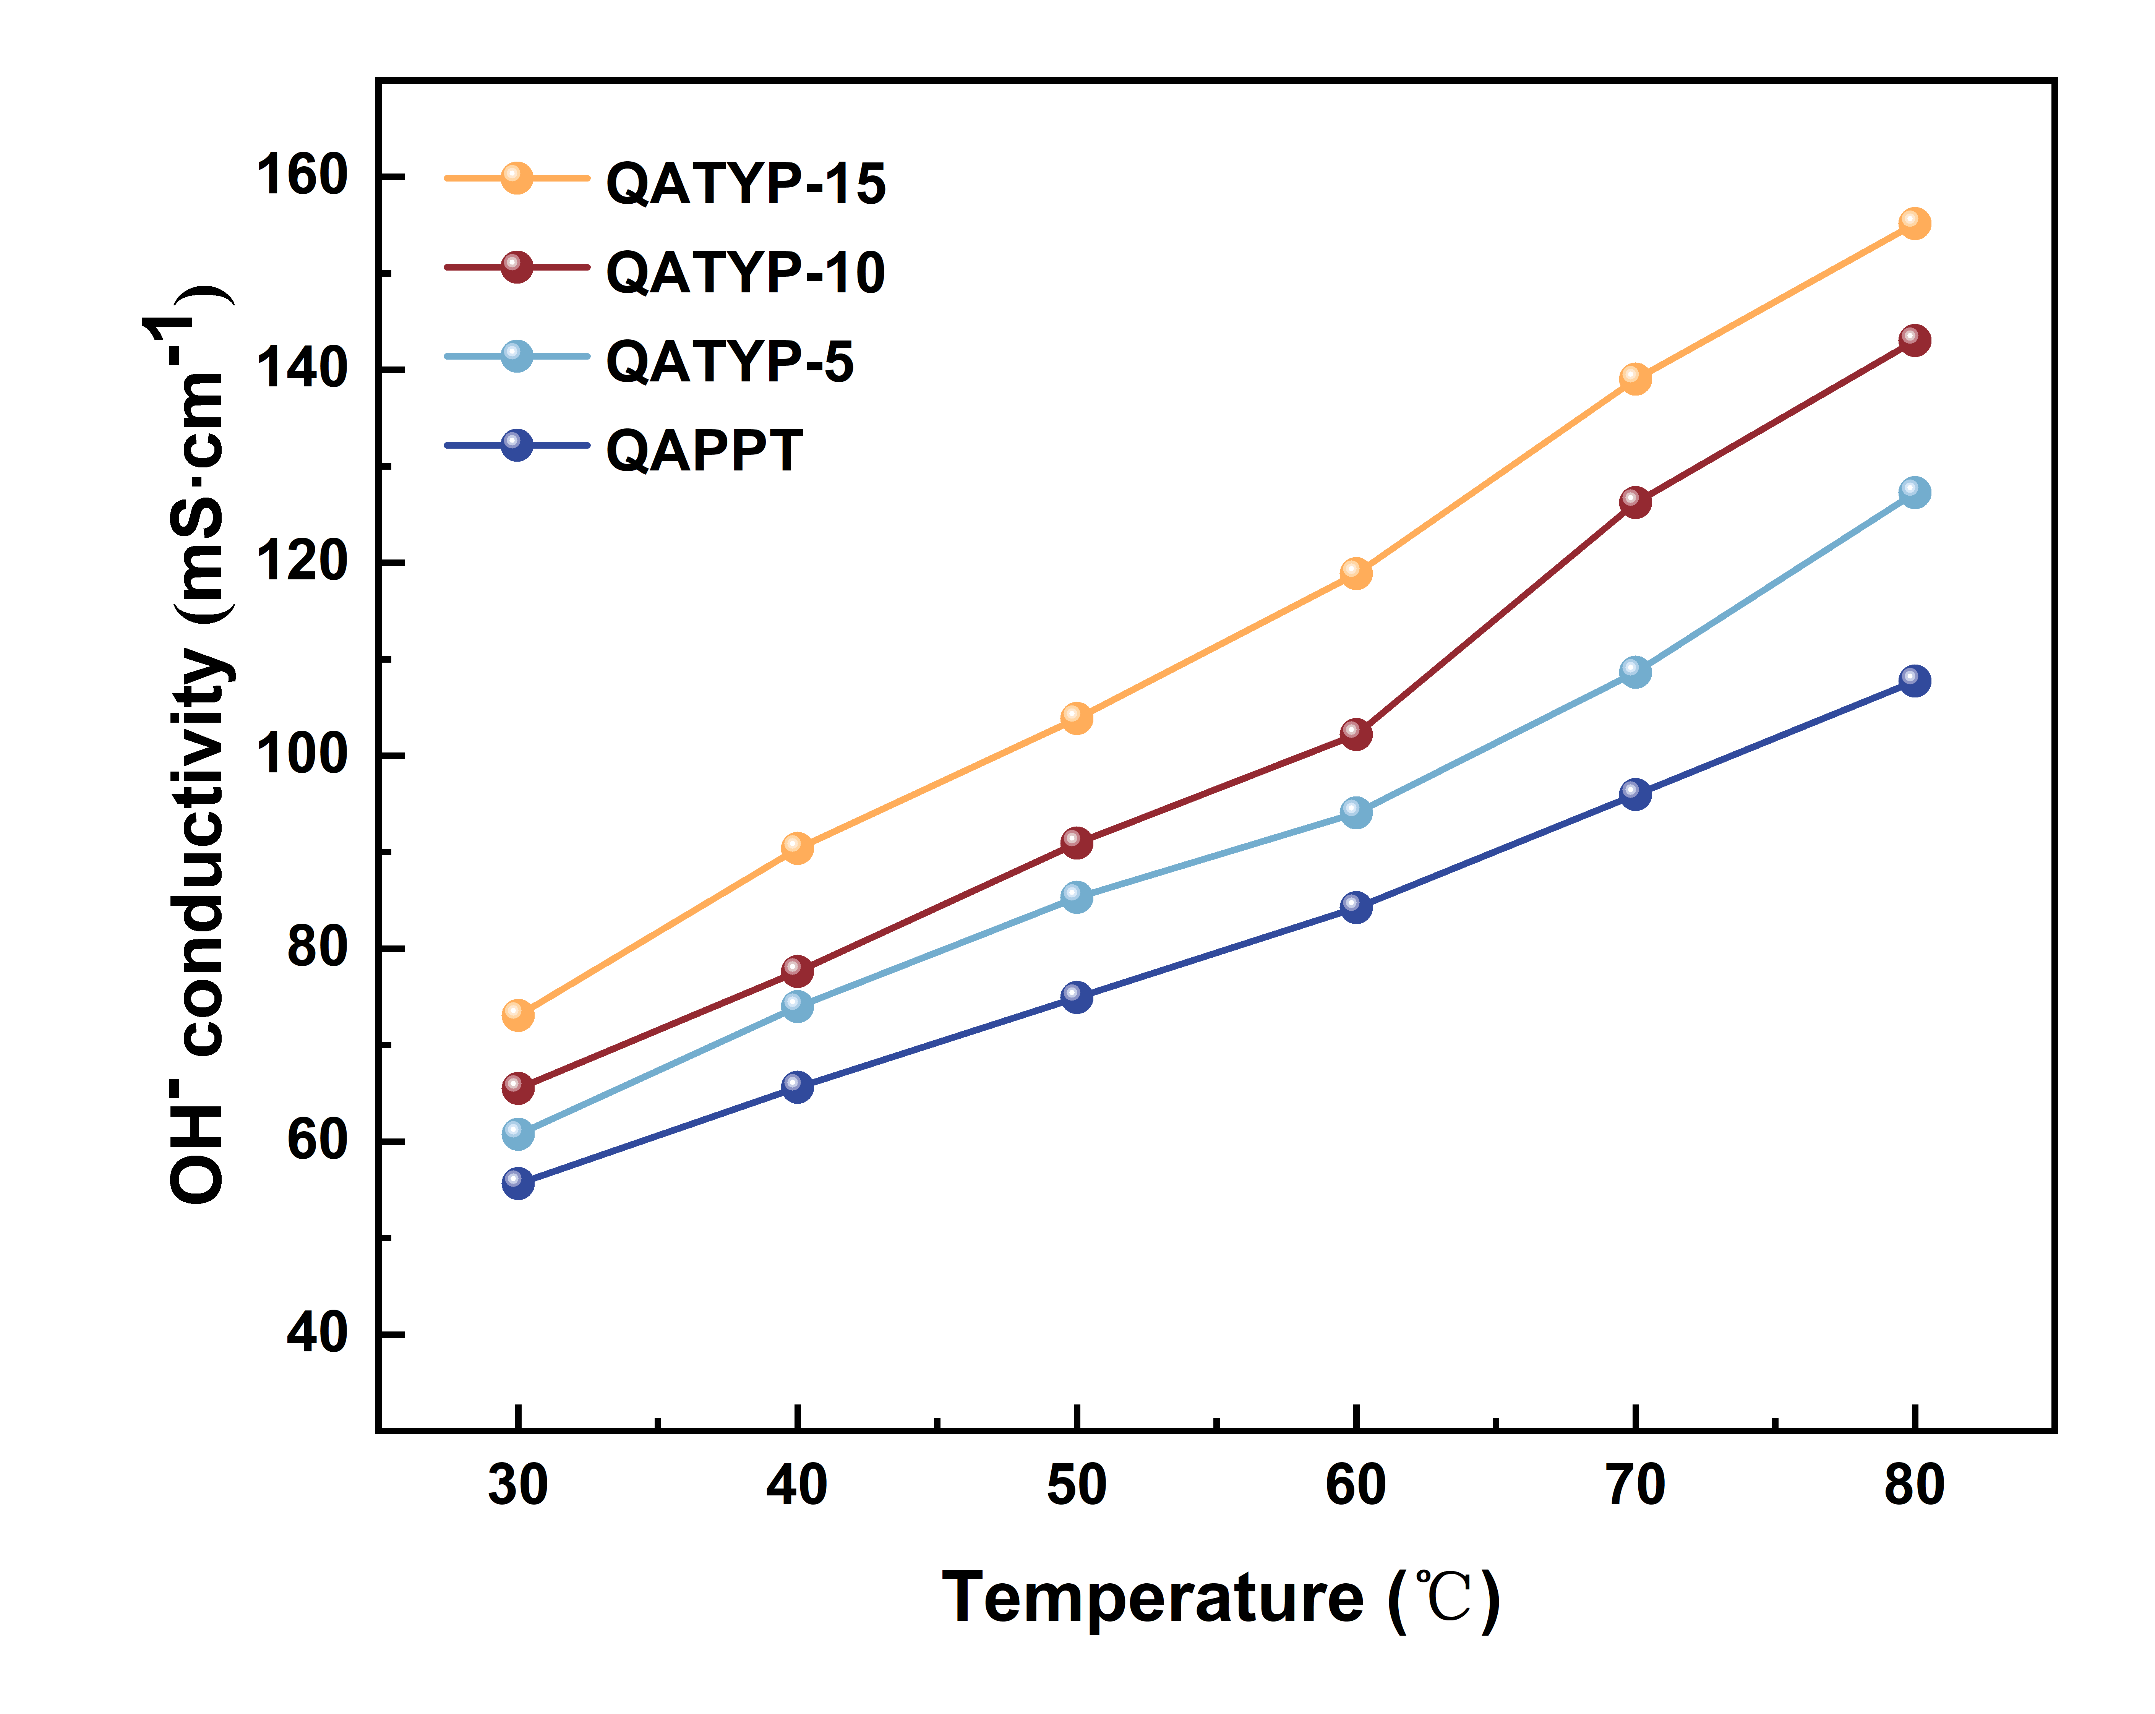
Supplementary Fig. 21 Conductivity of QAPPT and QPTYP-x.
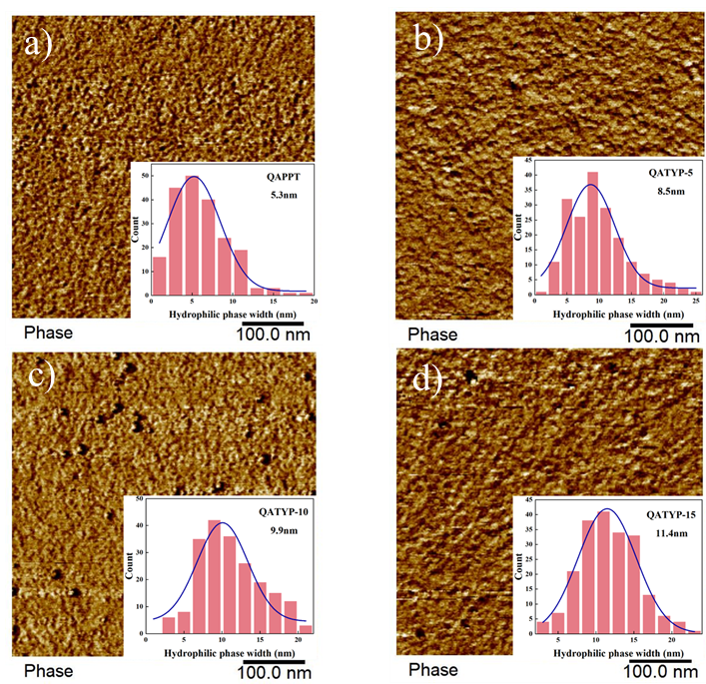
Supplementary Fig. 22 AFM images of QAPPT and QATYP. a QAPPT. b QATYP-5.
c QATYP-10. d QATYP-15.
Supplementary Fig. 23 g(r)N-H2O of QAPPT at different hydration numbers.

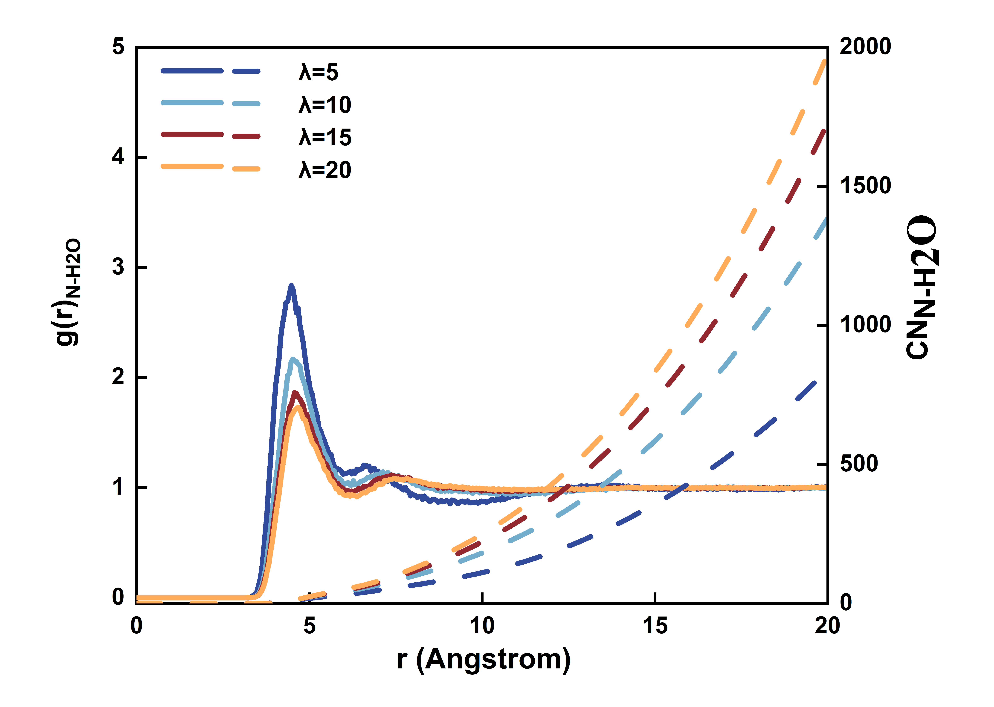
Supplementary Fig. 24 g(r)N-H2O of QATYP-15 at different hydration numbers.

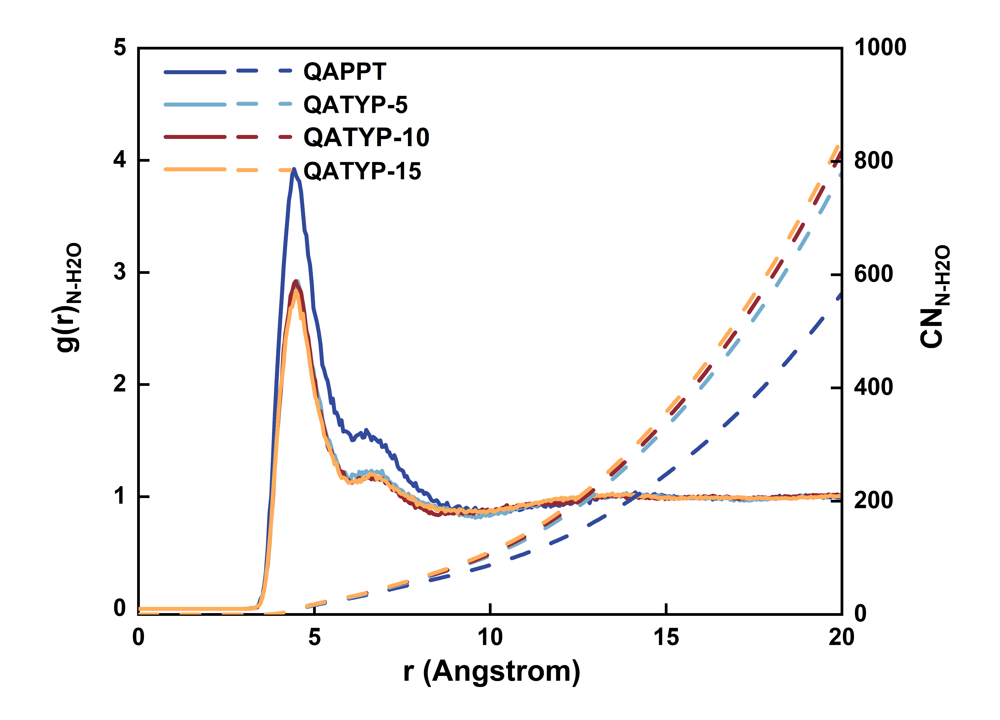
Supplementary Fig. 25 g(r)N-H2O of QAPPT and QATYP-x at λ=5.

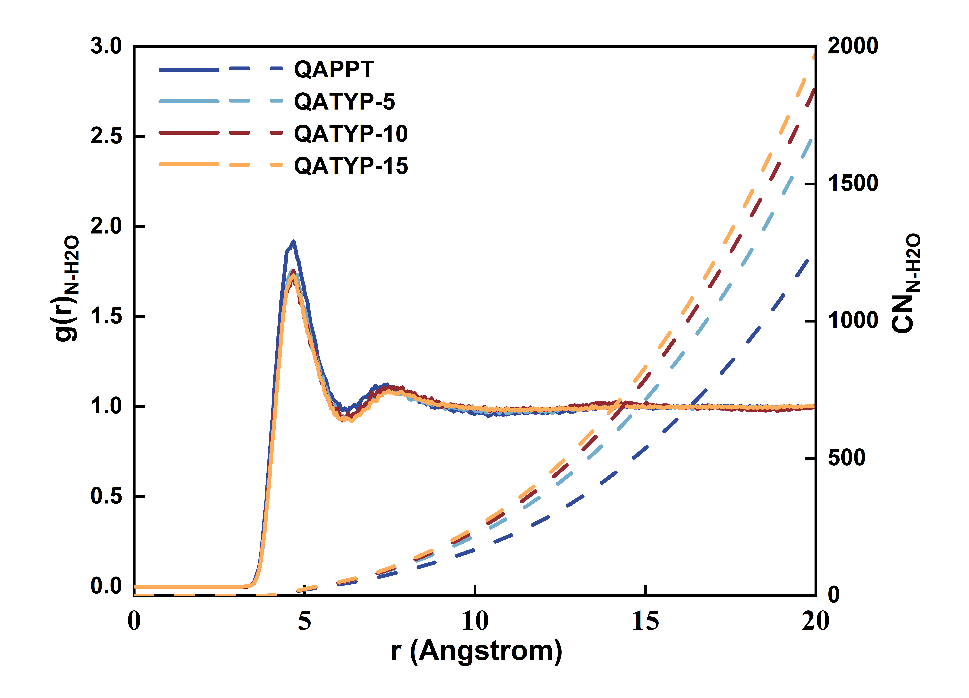
Supplementary Fig. 26 g(r)N-H2O of QAPPT and QATYP-x at λ=20.
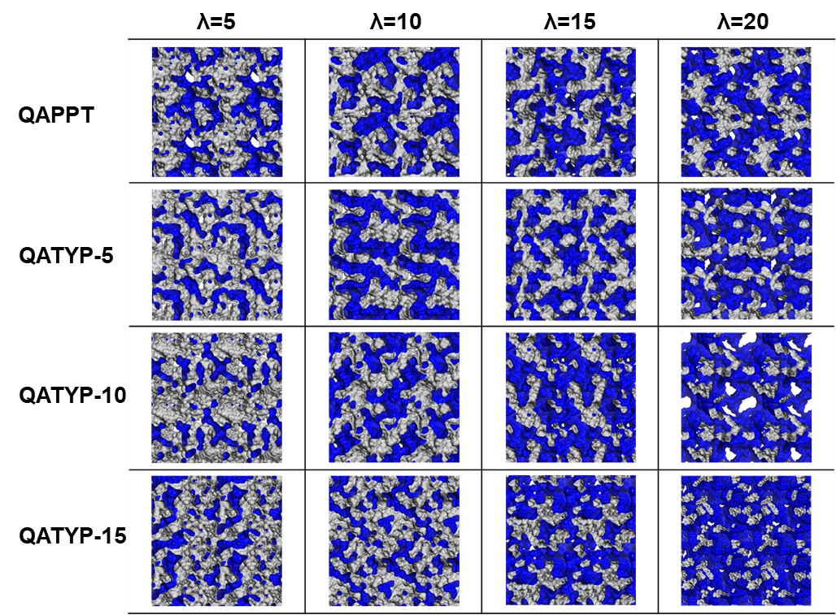
Supplementary Fig. 27 Hydroxide ion channel morphology simulation of QAPPT and QATYP-x at different hydration numbers.
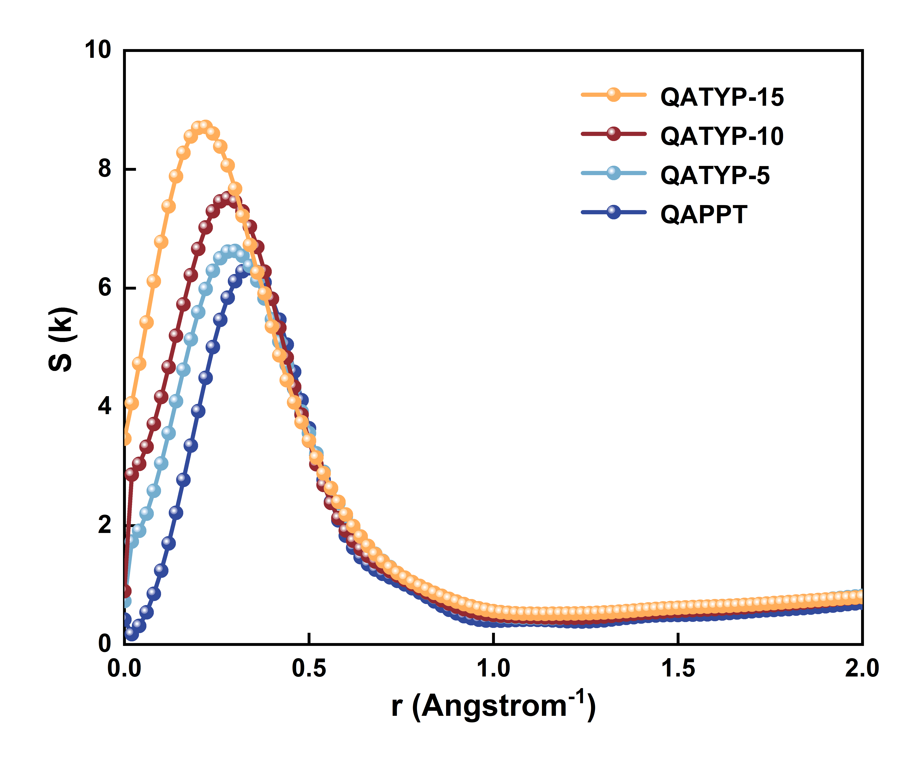
Supplementary Fig. 28 Static structure factor of QAPPT and QATYP-x.
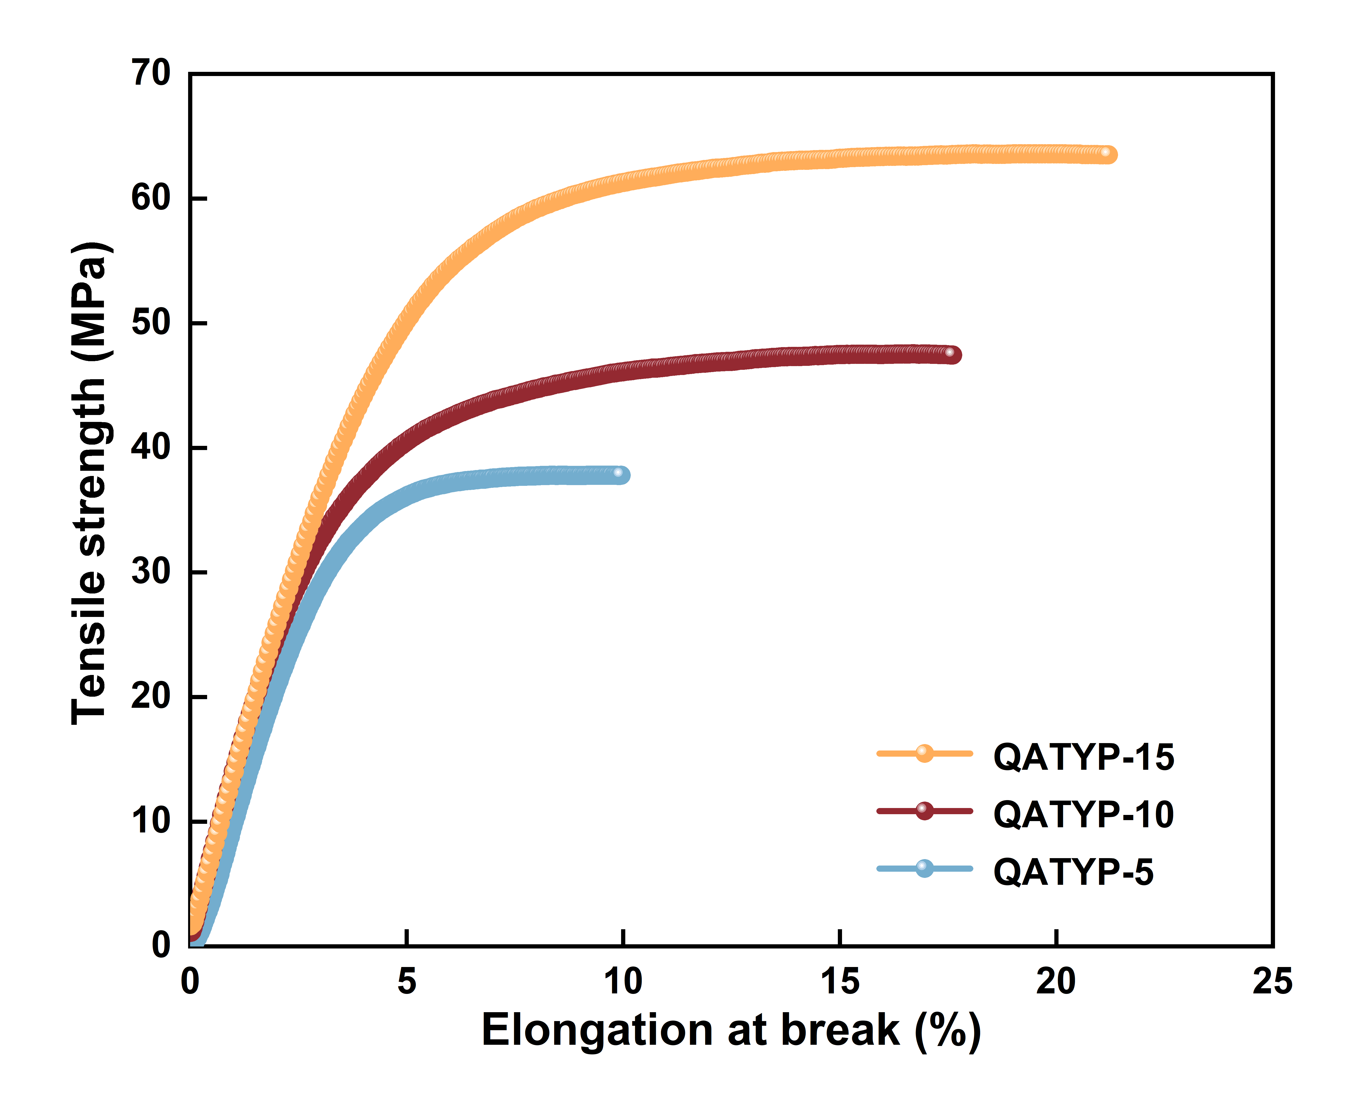
Supplementary Fig. 29 Mechanical properties of QATYP-x.
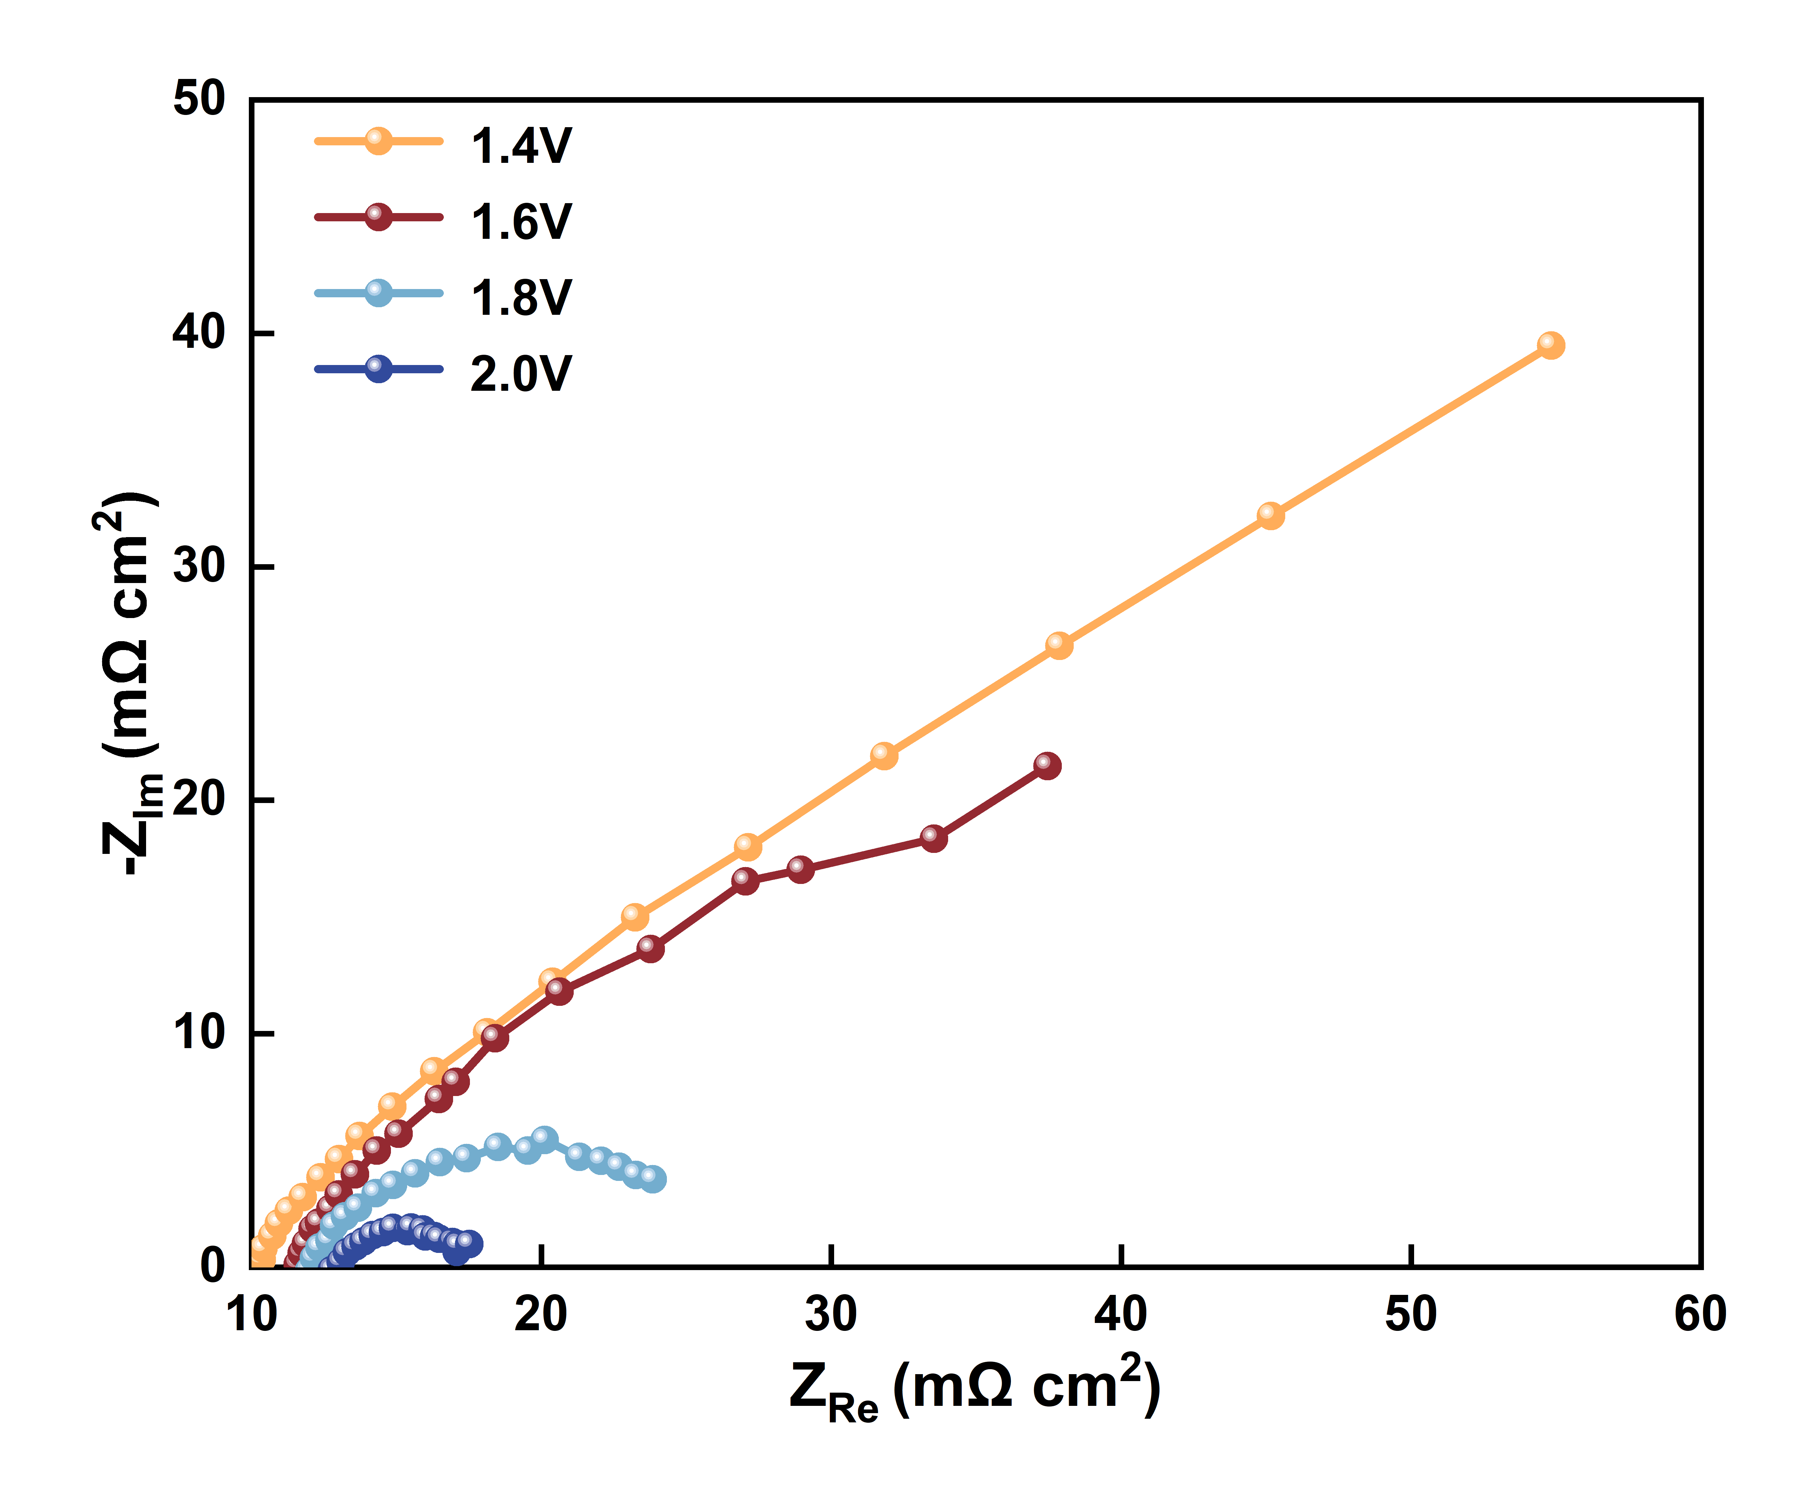
Supplementary Fig. 30 EIS of QATYP-15 at 60℃.

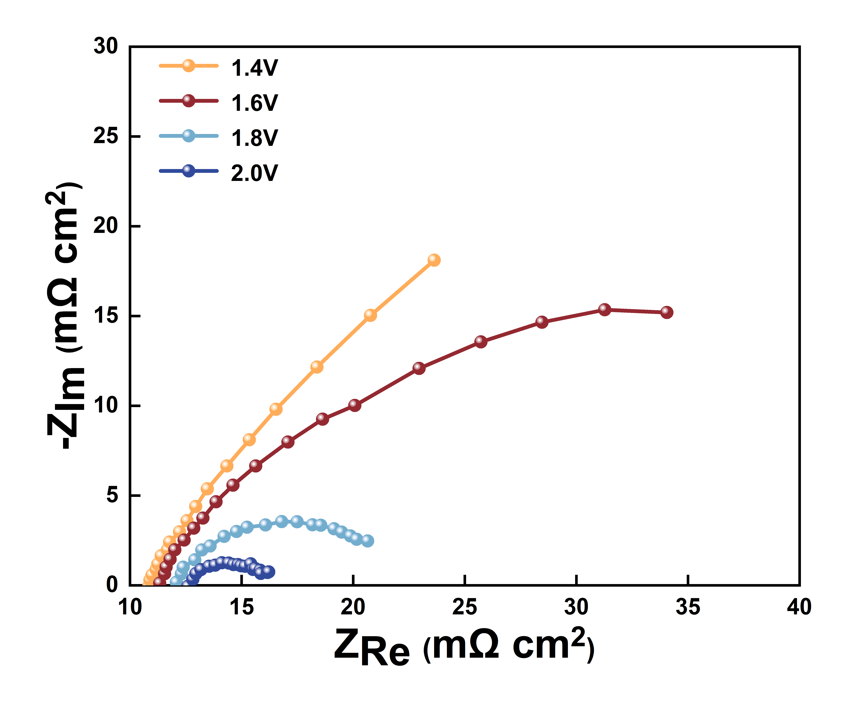
Supplementary Fig. 31 EIS of QATYP-15 at 80℃.
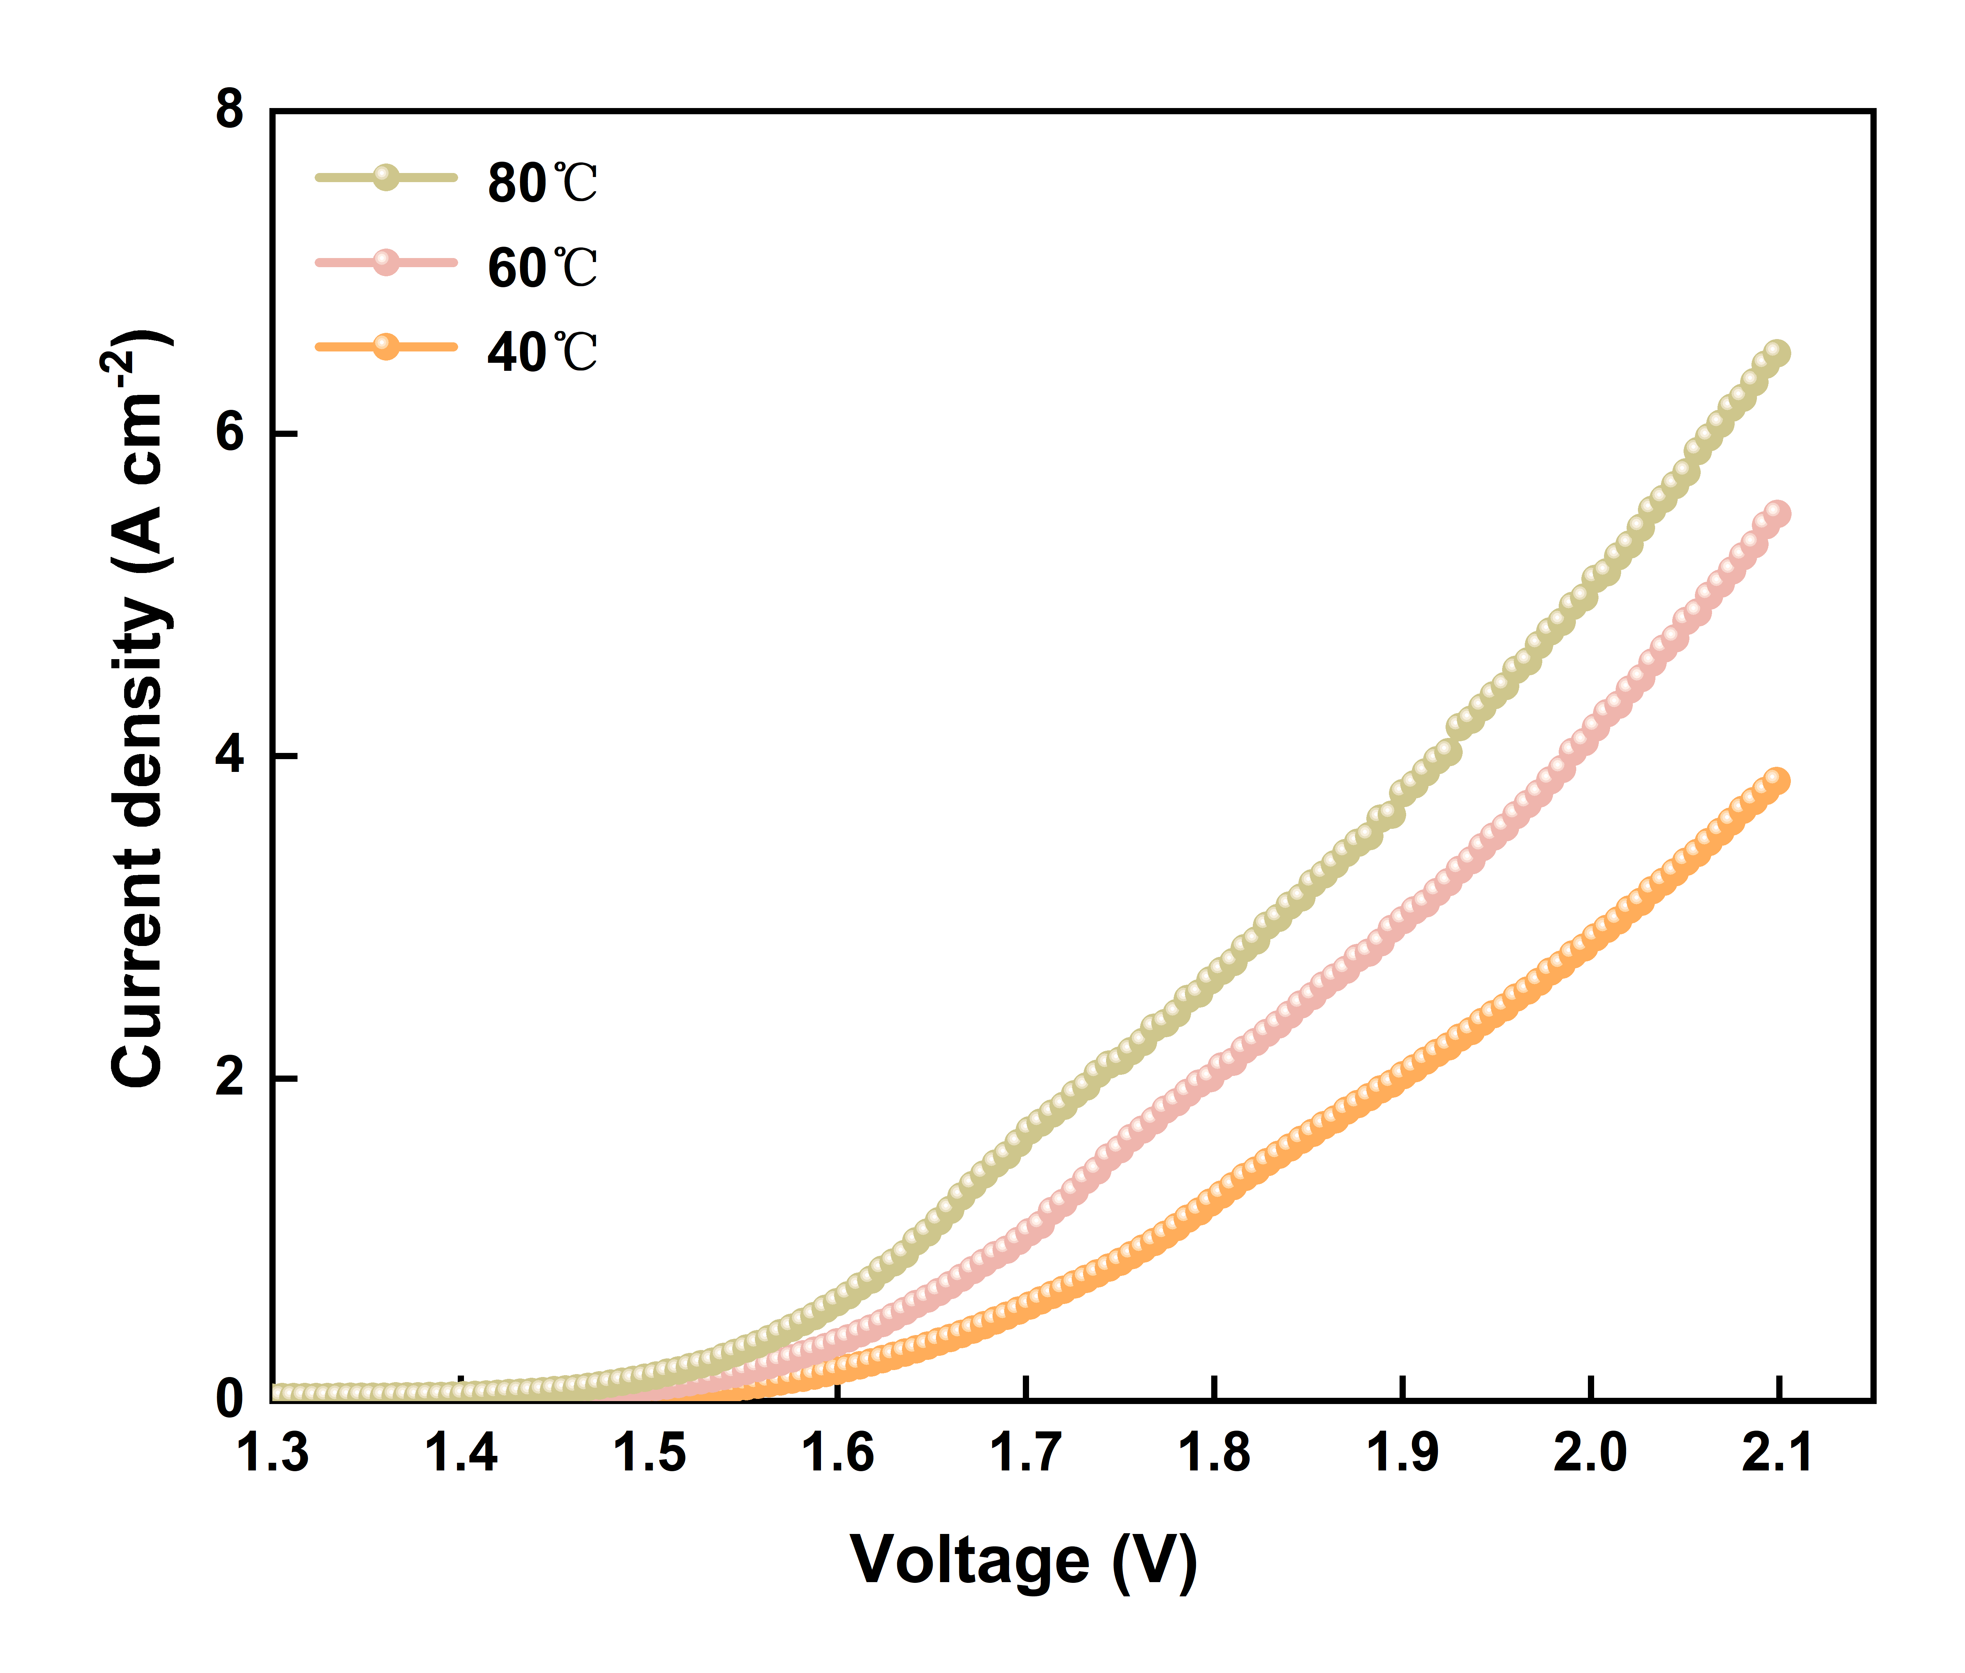
Supplementary Fig. 32 I-V curves of QATYP-15 at 0.1M KOH.
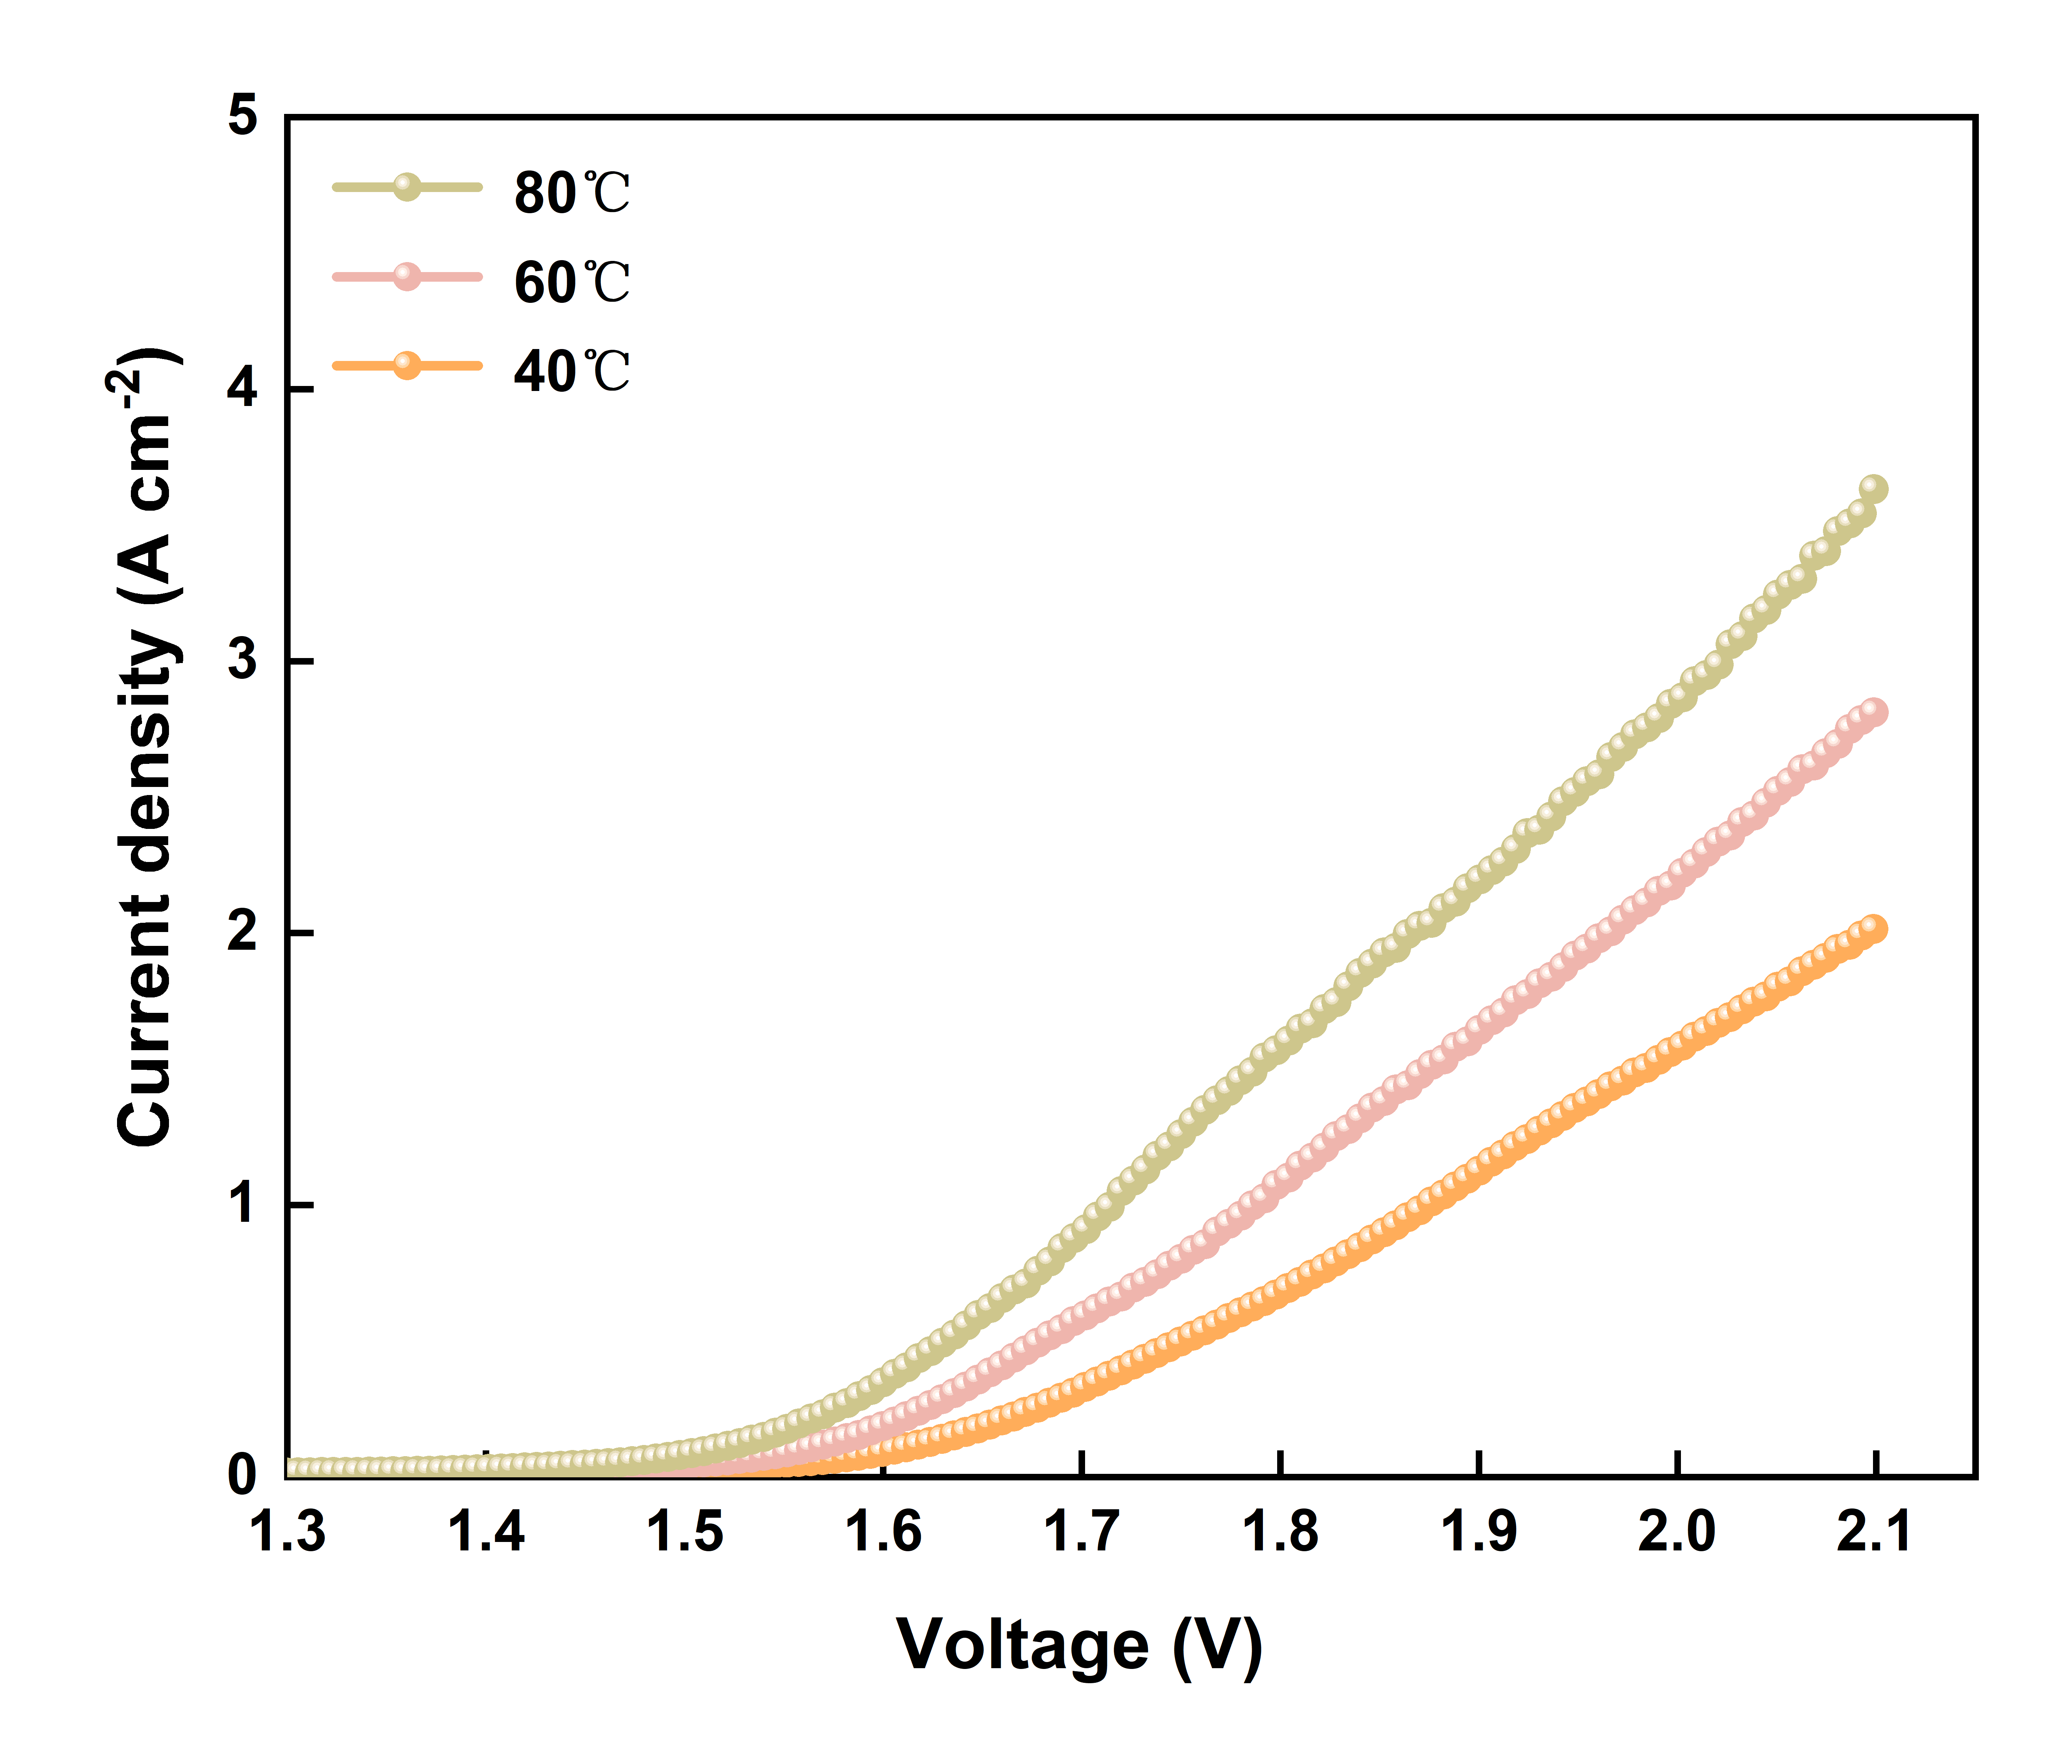
Supplementary Fig. 33 I-V curves of QATYP-15 at 0.01M KOH.
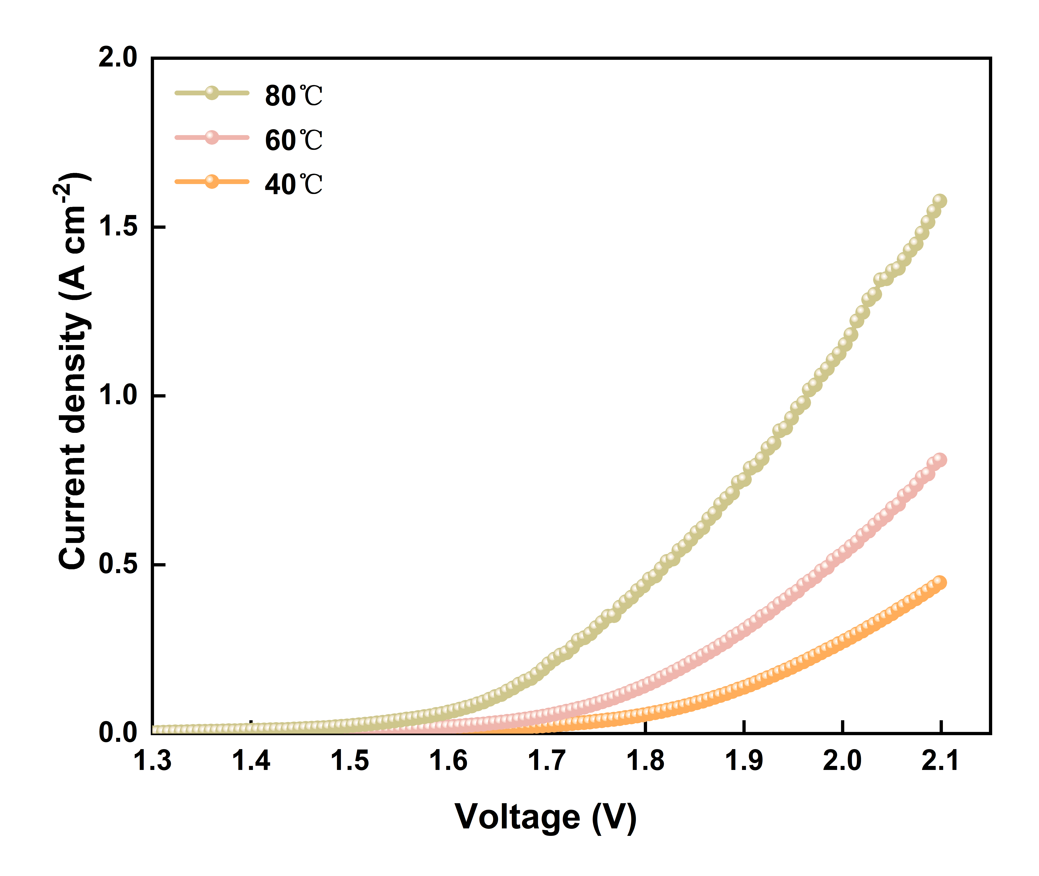
Supplementary Fig. 34 I-V curves of QATYP-15 at pure water.

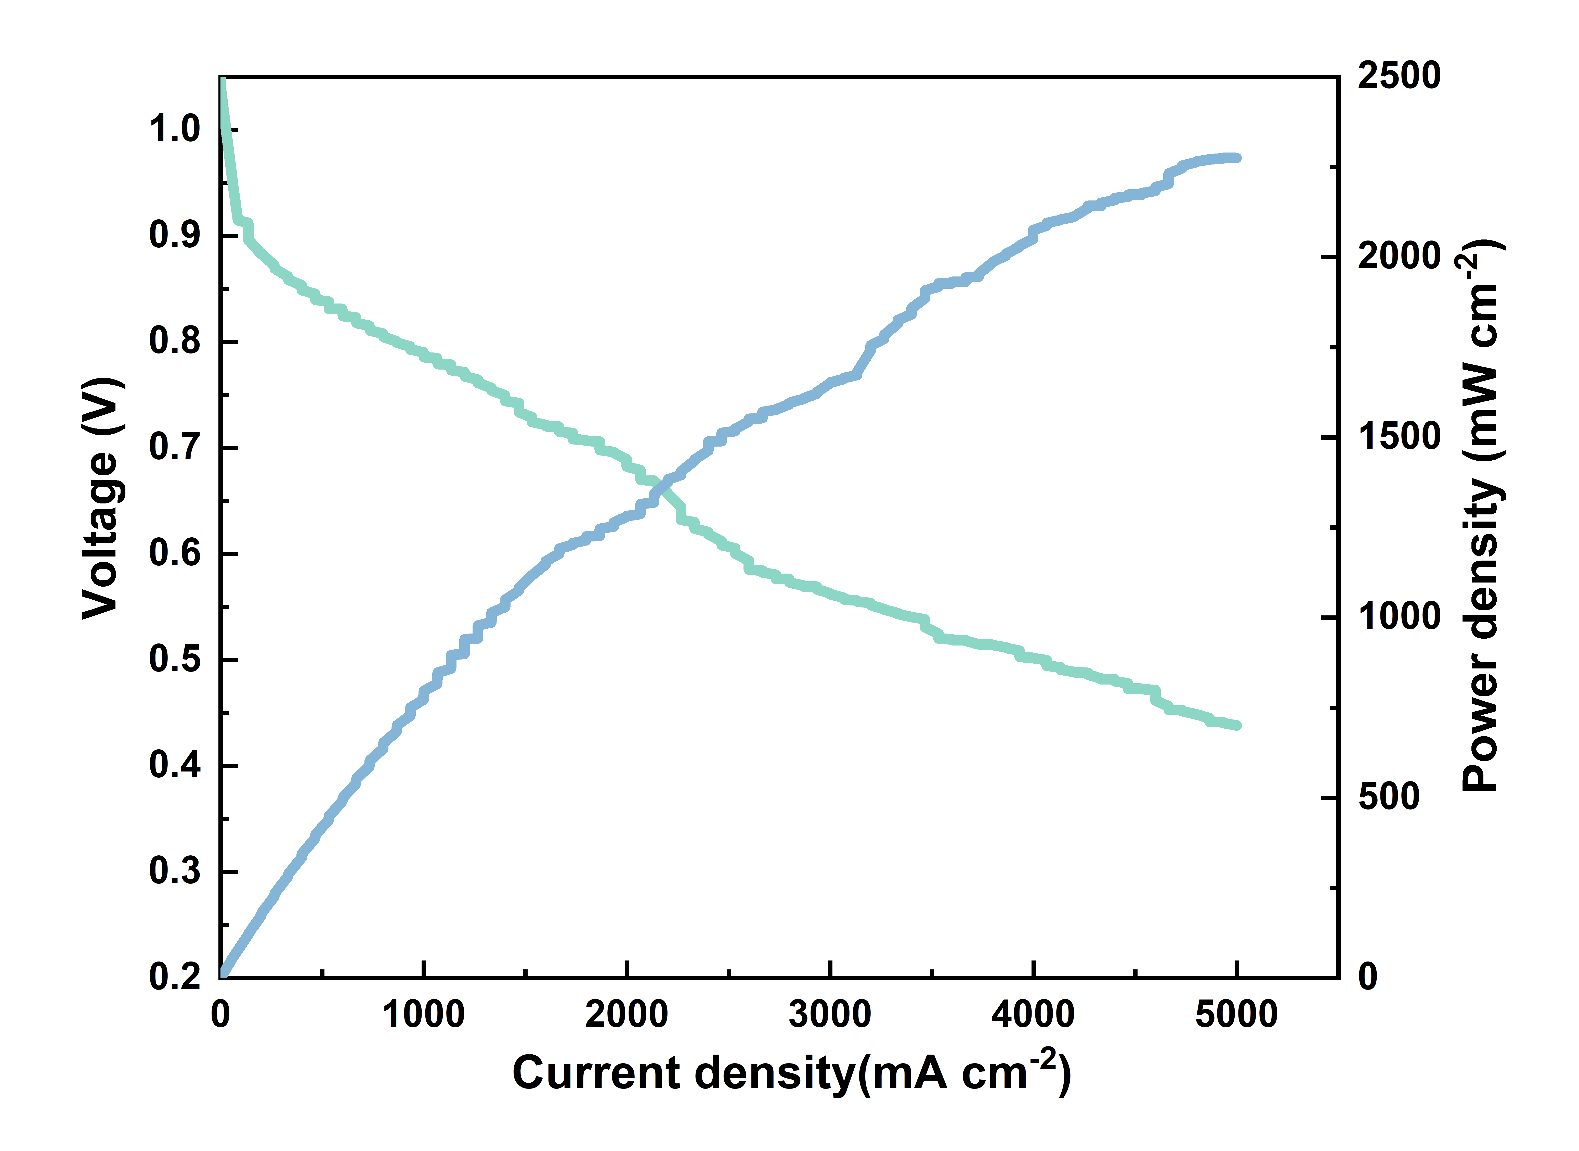
Supplementary Fig. 35 AEMFC performance of QATYP-15 at 80 ℃ with 1.5 bar back pressure, A/C for 75%/100% RH.

