Supplementary information

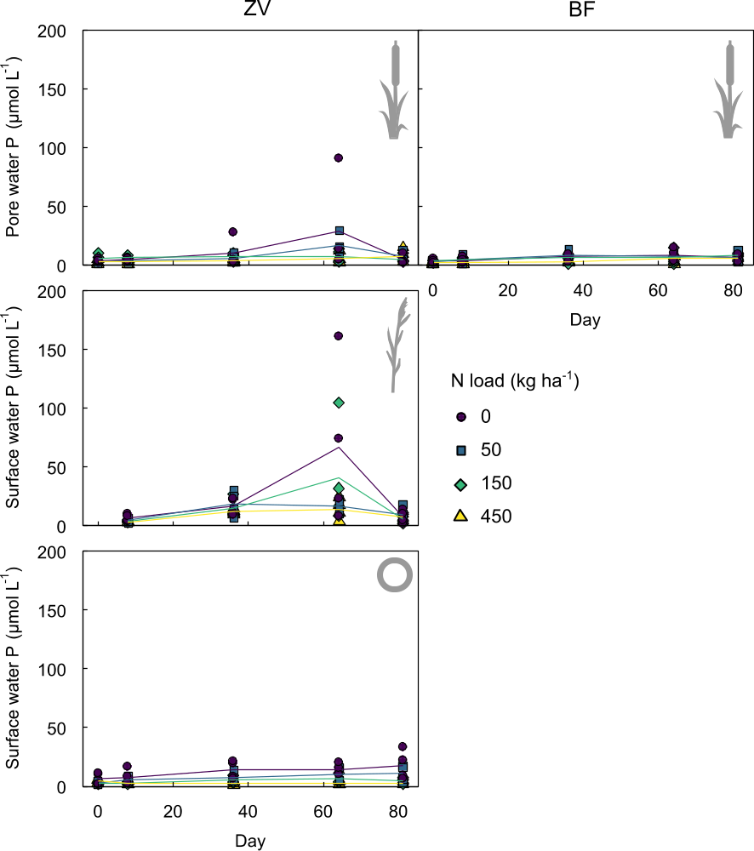
Fig. S1 P concentrations in in surface water over time for different N loads. Left panels: ZV soil, right panel: BF soil. Markers indicate individual mesocosms and can overlap. Lines indicate average trends.

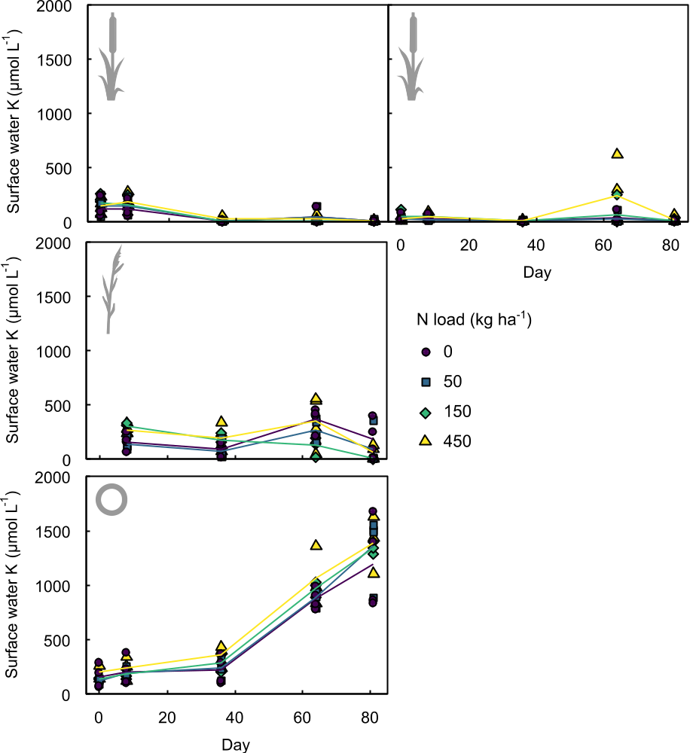
Fig. S2 K concentrations in in surface water over time for different N loads. Left panels: ZV soil, right panel: BF soil. Markers indicate individual mesocosms and can overlap. Lines indicate average trends.

Table S1 Student t-test output of table 1 – Soil characteristics.

 | t | df | p
H₂O-pH | -5.06 | 6 | 0.002311
C:N | 7.8188 | 6 | 0.000231
organic matter (%) | 0.7008 | 6 | 0.5097
wet bulk density (g FW l⁻¹ FW) | 5.6634 | 6 | 0.001303
dry bulk density (g DW l⁻¹ FW) | 4.2346 | 6 | 0.005472
NaCl-extractable NO3 (μmol l⁻¹ FW) | -0.34637 | 6 | 0.7409
NaCl-extractable NH4+ (μmol l-1 FW) | 2.9468 | 6 | 0.02572
H₂O-extractable K (μmol l⁻¹ FW) | -1.6162 | 6 | 0.1572
H₂O-extractable P (μmol l⁻¹ FW) | 2.7499 | 6 | 0.03329
H₂O-extractable Fe (μmol l⁻¹ FW) | 8.9252 | 6 | 0.00011
Olsen-P (µmol l⁻¹ FW) | 5.2694 | 6 | 0.001884
Total-N (mmol l⁻¹ FW) | -1.4093 | 6 | 0.2084
Total-K (mmol l⁻¹ FW) | -8.8854 | 6 | 0.000113
Total-P (mmol l⁻¹ FW) | -2.7883 | 6 | 0.03165

Table S2 Anova outputs of table 2 – biomass nutrient sequestration.
Aboveground | Typha | Df | Sum Sq | Mean Sq | F value | Pr(>F) | Sign
biomass | N_LOAD | 3 | 239.5 | 79.85 | 7.972 | 0.000737 | ***
 | LOCATION | 1 | 208.2 | 208.23 | 20.789 | 0.000127 | ***
 | N_LOAD:LOCATION | 3 | 23.2 | 7.73 | 0.772 | 0.520999
 | Residuals | 24 | 240.4 | 10.02
 | Phragmites | Df | Sum Sq | Mean Sq | F value | Pr(>F) | Sign
 | N_LOAD | 3 | 67.38 | 22.46 | 7.485 | 0.00438 | **
 | Residuals | 12 | 36.01 | 3.001
 | Zegveld | Df | Sum Sq | Mean Sq | F value | Pr(>F) | Sign
 | PLANT | 1 | 273.72 | 273.72 | 27.312 | 2.35E-05 | ***
 | N_LOAD | 3 | 216.41 | 72.14 | 7.198 | 0.00131 | **
 | PLANT:N_LOAD | 3 | 39.54 | 13.18 | 1.315 | 0.29251
 | Residuals | 24 | 240.53 | 10.02
NUE | Typha | Df | Sum Sq | Mean Sq | F value | Pr(>F) | Sign
 | LOCATION | 1 | 112 | 112.1 | 0.581 | 0.453477
 | N_LOAD | 3 | 6243 | 2081.1 | 10.778 | 0.000112 | ***
 | LOCATION:N_LOAD | 3 | 539 | 179.8 | 0.931 | 0.440842
 | Residuals | 24 | 4634 | 193.1
 | Phragmites | Df | Sum Sq | Mean Sq | F value | Pr(>F) | Sign
 | N_LOAD | 3 | 1406 | 468.6 | 0.94 | 0.452
 | Residuals | 12 | 5980 | 498.4
N sequestration | Typha | Df | Sum Sq | Mean Sq | F value | Pr(>F) | Sign
 | LOCATION | 1 | 123.5 | 123.48 | 10.544 | 0.00343 | **
 | N_LOAD | 3 | 669.1 | 223.02 | 19.043 | 1.54E-06 | ***
 | LOCATION:N_LOAD | 3 | 45 | 15.01 | 1.282 | 0.30311
 | Residuals | 24 | 281.1 | 11.71
 | Phragmites | Df | Sum Sq | Mean Sq | F value | Pr(>F) | Sign
 | N_LOAD | 3 | 210.1 | 70.04 | 6.192 | 0.00873 | **
 | Residuals | 12 | 135.7 | 11.31
 | Zegveld | Df | Sum Sq | Mean Sq | F value | Pr(>F) | Sign
 | N_LOAD | 3 | 565.1 | 188.36 | 11.565 | 6.94E-05 | ***
 | PLANT | 1 | 64.2 | 64.19 | 3.941 | 0.0587 | .
 | N_LOAD:PLANT | 3 | 164.1 | 54.7 | 3.358 | 0.0354 | *
 | Residuals | 24 | 390.9 | 16.29
P sequestration | Typha | Df | Sum Sq | Mean Sq | F value | Pr(>F) | Sign
 | LOCATION | 1 | 4.517 | 4.517 | 11.215 | 0.00267 | **
 | N_LOAD | 3 | 2.203 | 0.734 | 1.824 | 0.16979
 | LOCATION:N_LOAD | 3 | 0.431 | 0.144 | 0.357 | 0.78456
 | Residuals | 24 | 9.665 | 0.403
 | Phragmites | Df | Sum Sq | Mean Sq | F value | Pr(>F) | Sign
 | N_LOAD | 3 | 0.9674 | 0.3225 | 3.649 | 0.0445 | *
 | Residuals | 12 | 1.0604 | 0.0884
 | Zegveld | Df | Sum Sq | Mean Sq | F value | Pr(>F) | Sign
 | N_LOAD | 3 | 2.169 | 0.723 | 1.782 | 0.177408
 | PLANT | 1 | 6.4 | 6.4 | 15.777 | 0.000565 | ***
 | N_LOAD:PLANT | 3 | 0.244 | 0.081 | 0.201 | 0.894836
 | Residuals | 24 | 9.735 | 0.406
K sequestration | Typha | Df | Sum Sq | Mean Sq | F value | Pr(>F) | Sign
 | LOCATION | 1 | 362 | 362 | 21.274 | 0.000111 | ***
 | N_LOAD | 3 | 48.6 | 16.2 | 0.952 | 0.431431
 | LOCATION:N_LOAD | 3 | 17.9 | 6 | 0.351 | 0.788846
 | Residuals | 24 | 408.3 | 17
 | Phragmites | Df | Sum Sq | Mean Sq | F value | Pr(>F) | Sign
 | N_LOAD | 3 | 32470 | 10823 | 8.975 | 0.00216 | **
 | Residuals | 12 | 14472 | 1206
 | Zegveld | Df | Sum Sq | Mean Sq | F value | Pr(>F) | Sign
 | N_LOAD | 3 | 109.3 | 36.42 | 2.241 | 0.10943
 | PLANT | 1 | 309.4 | 309.41 | 19.036 | 0.00021 | ***
 | N_LOAD:PLANT | 3 | 16 | 5.32 | 0.328 | 0.80546
 | Residuals | 24 | 390.1 | 16.25

Table S3 Anova outputs of table 3 – plant nutrient content.
%N | Typha | Df | Sum Sq | Mean Sq | F value | Pr(>F) | Sign
 | N_LOAD | 3 | 4.522 | 1.5073 | 12.753 | 3.48E-05 | ***
 | LOCATION | 1 | 0.137 | 0.1365 | 1.155 | 0.293
 | N_LOAD:LOCATION | 3 | 0.17 | 0.0568 | 0.481 | 0.699
 | Residuals | 24 | 2.837 | 0.1182
 | Phragmites | Df | Sum Sq | Mean Sq | F value | Pr(>F) | Sign
 | N_LOAD | 3 | 1.71 | 0.5701 | 1.468 | 0.273
 | Residuals | 12 | 4.661 | 0.3884
 | Zegveld | Df | Sum Sq | Mean Sq | F value | Pr(>F) | Sign
 | PLANT | 1 | 2.327 | 2.3274 | 10.969 | 0.00292 | **
 | N_LOAD | 3 | 2.698 | 0.8992 | 4.238 | 0.01543 | *
 | PLANT:N_LOAD | 3 | 0.962 | 0.3206 | 1.511 | 0.23707
 | Residuals | 24 | 5.092 | 0.2122
%P | Typha | Df | Sum Sq | Mean Sq | F value | Pr(>F) | Sign
 | LOCATION | 1 | 0.00173 | 0.00173 | 0.724 | 0.403
 | N_LOAD | 3 | 0.01151 | 0.003837 | 1.607 | 0.214
 | LOCATION:N_LOAD | 3 | 0.00388 | 0.001294 | 0.542 | 0.658
 | Residuals | 24 | 0.05732 | 0.002388
 | Phragmites | Df | Sum Sq | Mean Sq | F value | Pr(>F) | Sign
 | N_LOAD | 3 | 0.005278 | 0.001759 | 1.114 | 0.382
 | Residuals | 12 | 0.018946 | 0.001579
 | Zegveld | Df | Sum Sq | Mean Sq | F value | Pr(>F) | Sign
 | N_LOAD | 3 | 0.00684 | 0.002279 | 0.888 | 0.462
 | PLANT | 1 | 0.0062 | 0.006196 | 2.413 | 0.133
 | N_LOAD:PLANT | 3 | 0.00535 | 0.001785 | 0.695 | 0.564
 | Residuals | 24 | 0.06162 | 0.002567
%K | Typha | Df | Sum Sq | Mean Sq | F value | Pr(>F) | Sign
 | LOCATION | 1 | 2.038 | 2.0376 | 10.29 | 0.00377 | **
 | N_LOAD | 3 | 1.621 | 0.5402 | 2.728 | 0.0663 | .
 | LOCATION:N_LOAD | 3 | 0.522 | 0.174 | 0.879 | 0.46596
 | Residuals | 24 | 4.752 | 0.198
 | Phragmites | Df | Sum Sq | Mean Sq | F value | Pr(>F) | Sign
 | N_LOAD | 3 | 0.5501 | 0.18336 | 3.722 | 0.0422 | *
 | Residuals | 12 | 0.5912 | 0.04927
 | Zegveld | Df | Sum Sq | Mean Sq | F value | Pr(>F) | Sign
 | N_LOAD | 3 | 0.824 | 0.2746 | 1.585 | 0.219
 | PLANT | 1 | 0.569 | 0.5691 | 3.286 | 0.0824 | .
 | N_LOAD:PLANT | 3 | 1.246 | 0.4154 | 2.398 | 0.0929 | .
 | Residuals | 24 | 4.157 | 0.1732
N:P | Typha | Df | Sum Sq | Mean Sq | F value | Pr(>F) | Sign
 | LOCATION | 1 | 3.98 | 3.98 | 1.311 | 0.263
 | N_LOAD | 3 | 116.61 | 38.87 | 12.802 | 3.39E-05 | ***
 | LOCATION:N_LOAD | 3 | 9.8 | 3.27 | 1.076 | 0.378
 | Residuals | 24 | 72.87 | 3.04
 | Phragmites | Df | Sum Sq | Mean Sq | F value | Pr(>F) | Sign
 | N_LOAD | 3 | 59.64 | 19.88 | 1.538 | 0.255
 | Residuals | 12 | 155.08 | 12.92
 | Zegveld | Df | Sum Sq | Mean Sq | F value | Pr(>F) | Sign
 | PLANT | 3 | 78.71 | 26.24 | 3.385 | 0.0345 | *
 | N_LOAD | 1 | 87.47 | 87.47 | 11.287 | 0.0026 | **
 | N_LOAD:PLANT | 3 | 46.97 | 15.66 | 2.02 | 0.1379
 | Residuals | 24 | 186 | 7.75
N:K | Typha | Df | Sum Sq | Mean Sq | F value | Pr(>F) | Sign
 | LOCATION | 1 | 1.108 | 1.1084 | 4.79 | 0.038586 | *
 | N_LOAD | 3 | 7.385 | 2.4616 | 10.638 | 0.000122 | ***
 | LOCATION:N_LOAD | 3 | 0.145 | 0.0483 | 0.209 | 0.889407
 | Residuals | 24 | 5.553 | 0.2314
 | Phragmites | Df | Sum Sq | Mean Sq | F value | Pr(>F) | Sign
 | N_LOAD | 3 | 0.4364 | 0.1455 | 0.705 | 0.567
 | Residuals | 12 | 2.4775 | 0.2065
 | Zegveld | Df | Sum Sq | Mean Sq | F value | Pr(>F) | Sign
 | PLANT | 3 | 2.942 | 0.9807 | 4.876 | 0.0087 | **
 | N_LOAD | 1 | 1.079 | 1.079 | 5.365 | 0.0294 | *
 | N_LOAD:PLANT | 3 | 0.66 | 0.22 | 1.094 | 0.3708
 | Residuals | 24 | 4.827 | 0.2011
C:N | Typha | Df | Sum Sq | Mean Sq | F value | Pr(>F) | Sign
 | LOCATION | 1 | 43.8 | 43.8 | 1.441 | 0.242
 | N_LOAD | 3 | 1280.4 | 426.8 | 14.054 | 1.71E-05 | ***
 | LOCATION:N_LOAD | 3 | 80.8 | 26.9 | 0.887 | 0.462
 | Residuals | 24 | 728.8 | 30.4
 | Phragmites | Df | Sum Sq | Mean Sq | F value | Pr(>F) | Sign
 | N_LOAD | 3 | 333.6 | 111.2 | 2.258 | 0.134
 | Residuals | 12 | 591 | 49.25
 | Zegveld | Df | Sum Sq | Mean Sq | F value | Pr(>F) | Sign
 | PLANT | 3 | 627.3 | 209.1 | 6.176 | 0.002907 | **
 | N_LOAD | 1 | 689.3 | 689.3 | 20.359 | 0.000144 | ***
 | N_LOAD:PLANT | 3 | 289.9 | 96.6 | 2.854 | 0.058359 | .
 | Residuals | 24 | 812.6 | 33.9

Table S4 Anova outputs for table 4 - N budget.
t0
Soil extractable | Typha | Df | Sum Sq | Mean Sq | F value | Pr(>F) | Sign
 | LOCATION | 1 | 0.004791 | 0.004791 | 10.113 | 0.00403 | **
 | N_LOAD | 3 | 0.000009 | 0.000003 | 0.006 | 0.9993
 | LOCATION:N_LOAD | 3 | 0.000059 | 0.00002 | 0.041 | 0.98855
 | Residuals | 24 | 0.01137 | 0.000474
 | Zegveld | Df | Sum Sq | Mean Sq | F value | Pr(>F) | Sign
 | N_LOAD | 3 | 2.31E-05 | 7.7E-06 | 0.461 | 0.711
 | PLANT | 2 | 1.49E-05 | 7.48E-06 | 0.447 | 0.643
 | N_LOAD:PLANT | 6 | 3.49E-05 | 5.83E-06 | 0.349 | 0.906
 | Residuals | 34 | 0.000568 | 1.67E-05
Pore water | Typha | Df | Sum Sq | Mean Sq | F value | Pr(>F) | Sign
 | LOCATION | 1 | 8.37E-05 | 8.37E-05 | 5.572 | 0.0267 | *
 | N_LOAD | 3 | 8.9E-06 | 2.96E-06 | 0.197 | 0.8972
 | LOCATION:N_LOAD | 3 | 5.86E-05 | 1.96E-05 | 1.301 | 0.297
 | Residuals | 24 | 0.000361 | 1.5E-05
 | Zegveld | Df | Sum Sq | Mean Sq | F value | Pr(>F) | Sign
 | N_LOAD | 3 | 3.36E-05 | 1.12E-05 | 0.885 | 0.459
 | PLANT | 2 | 1.28E-05 | 6.42E-06 | 0.508 | 0.606
 | N_LOAD:PLANT | 6 | 1.72E-05 | 2.86E-06 | 0.226 | 0.965
 | Residuals | 34 | 0.00043 | 1.26E-05
t1
Belowground | Typha | Df | Sum Sq | Mean Sq | F value | Pr(>F) | Sign
biomass | LOCATION | 1 | 0.001545 | 0.001545 | 4.253 | 0.0502 | .
 | N_LOAD | 3 | 0.001885 | 0.000628 | 1.73 | 0.1876
 | LOCATION:N_LOAD | 3 | 0.001847 | 0.000616 | 1.695 | 0.1946
 | Residuals | 24 | 0.008716 | 0.000363
 | Phragmites | Sum | Sq | Mean | Sq | F | value
 | N_LOAD | 3 | 4.22E-05 | 1.41E-05 | 2.437 | 0.115
 | Residuals | 12 | 6.92E-05 | 5.77E-06
Surface water | Typha | Df | Sum Sq | Mean Sq | F value | Pr(>F) | Sign
 | LOCATION | 1 | 5.94E-06 | 5.94E-06 | 1.173 | 0.2895
 | N_LOAD | 1 | 4E-05 | 1.33E-05 | 2.631 | 0.0732 | .
 | LOCATION:N_LOAD | 1 | 1.2E-05 | 4.01E-06 | 0.792 | 0.5103
 | Residuals | 24 | 0.000122 | 5.06E-06
 | Zegveld | Df | Sum Sq | Mean Sq | F value | Pr(>F) | Sign
 | N_LOAD | 3 | 0.007224 | 0.002408 | 53.85 | 5.26E-13 | ***
 | PLANT | 1 | 0.007336 | 0.003668 | 82.05 | 9.74E-14 | ***
 | N_LOAD:PLANT | 3 | 0.012368 | 0.002061 | 46.1 | 6.39E-15 | ***
 | Residuals | 24 | 0.00152 | 0.000045
Pore water | Typha | Df | Sum Sq | Mean Sq | F value | Pr(>F) | Sign
 | LOCATION | 1 | 4.01E-05 | 4.01E-05 | 3.428 | 0.0776 | .
 | N_LOAD | 3 | 0.000144 | 4.78E-05 | 4.086 | 0.019 | *
 | LOCATION:N_LOAD | 3 | 0.000101 | 3.35E-05 | 2.865 | 0.0599 | .
 | Residuals | 22 | 0.000258 | 1.17E-05
 | Zegveld | Df | Sum Sq | Mean Sq | F value | Pr(>F) | Sign
 | N_LOAD | 3 | 0.006366 | 0.002122 | 22.43 | 6.51E-08 | ***
 | PLANT | 2 | 0.014484 | 0.007242 | 76.56 | 1.02E-12 | ***
 | N_LOAD:PLANT | 6 | 0.014809 | 0.002468 | 26.09 | 7.86E-11 | ***
 | Residuals | 31 | 0.002932 | 0.000095
Soil extractable | Typha | Df | Sum Sq | Mean Sq | F value | Pr(>F) | Sign
 | LOCATION | 1 | 0.001244 | 0.001244 | 2.401 | 0.138
 | N_LOAD | 3 | 0.001688 | 0.000563 | 1.086 | 0.379
 | LOCATION:N_LOAD | 3 | 0.000765 | 0.000255 | 0.492 | 0.692
 | Residuals | 19 | 0.009842 | 0.000518
 | Zegveld | Df | Sum Sq | Mean Sq | F value | Pr(>F) | Sign
 | N_LOAD | 3 | 0.01305 | 0.00435 | 2.868 | 0.0536 | .
 | PLANT | 2 | 0.07933 | 0.03966 | 26.152 | 3.22E-07 | ***
 | N_LOAD:PLANT | 6 | 0.02529 | 0.00422 | 2.779 | 0.0293 | *
 | Residuals | 29 | 0.04398 | 0.00152
Net N loss | Typha | Df | Sum Sq | Mean Sq | F value | Pr(>F) | Sign
 | LOCATION | 1 | 0.1053 | 0.1053 | 19.809 | 0.000274 | ***
 | N_LOAD | 3 | 1.3424 | 0.4475 | 84.149 | 3.73E-11 | ***
 | LOCATION:N_LOAD | 3 | 0.0044 | 0.0015 | 0.277 | 0.841436
 | Residuals | 19 | 0.101 | 0.0053
 | Zegveld | Df | Sum Sq | Mean Sq | F value | Pr(>F) | Sign
 | N_LOAD | 3 | 1.5915 | 0.5305 | 104.181 | 1.25E-15 | ***
 | PLANT | 2 | 0.0246 | 0.0123 | 2.419 | 0.107
 | N_LOAD:PLANT | 6 | 0.0478 | 0.008 | 1.565 | 0.193
 | Residuals | 29 | 0.1477 | 0.0051

Table S5 Anova output for table 5 - P budget.
t0
Soil extractable | Typha | Df | Sum Sq | Mean Sq | F value | Pr(>F) | Sign
 | LOCATION | 1 | 0.000336 | 0.000336 | 7.164 | 0.0132 | *
 | N_LOAD | 3 | 0.000121 | 4.04E-05 | 0.86 | 0.475
 | LOCATION:N_LOAD | 3 | 0.000115 | 3.84E-05 | 0.818 | 0.4966
 | Residuals | 24 | 0.001126 | 4.69E-05
 | Zegveld | Df | Sum Sq | Mean Sq | F value | Pr(>F) | Sign
 | N_LOAD | 3 | 3.71E-06 | 1.24E-06 | 0.56 | 0.645
 | PLANT | 2 | 9.5E-07 | 4.74E-07 | 0.214 | 0.808
 | N_LOAD:PLANT | 6 | 5.23E-06 | 8.72E-07 | 0.394 | 0.878
 | Residuals | 34 | 7.53E-05 | 2.21E-06
Pore water | Typha | Df | Sum Sq | Mean Sq | F value | Pr(>F) | Sign
 | LOCATION | 1 | 0.000371 | 0.000371 | 7.986 | 0.00935 | **
 | N_LOAD | 3 | 0.000121 | 4.04E-05 | 0.87 | 0.47038
 | LOCATION:N_LOAD | 3 | 0.000115 | 3.84E-05 | 0.827 | 0.49202
 | Residuals | 24 | 0.001114 | 4.64E-05
 | Zegveld | Df | Sum Sq | Mean Sq | F value | Pr(>F) | Sign
 | N_LOAD | 3 | 3.88E-06 | 1.29E-06 | 0.601 | 0.619
 | PLANT | 2 | 9.4E-07 | 4.69E-07 | 0.218 | 0.805
 | N_LOAD:PLANT | 6 | 5.65E-06 | 9.41E-07 | 0.437 | 0.849
 | Residuals | 34 | 7.31E-05 | 2.15E-06
t1
Belowground | Typha | Df | Sum Sq | Mean Sq | F value | Pr(>F) | Sign
biomass | LOCATION | 1 | 0.000178 | 0.000178 | 4.253 | 0.0502 | .
 | N_LOAD | 3 | 0.000217 | 7.23E-05 | 1.73 | 0.1876
 | LOCATION:N_LOAD | 3 | 0.000213 | 7.09E-05 | 1.695 | 0.1946
 | Residuals | 24 | 0.001003 | 4.18E-05
 | Phragmites | Df | Sum Sq | Mean Sq | F value | Pr(>F) | Sign
 | N_LOAD | 3 | 0.002699 | 0.0009 | 2.437 | 0.115
 | Residuals | 12 | 0.00443 | 0.000369
Surface water | Zegveld | Df | Sum Sq | Mean Sq | F value | Pr(>F) | Sign
 | N_LOAD | 3 | 1.38E-07 | 4.59E-08 | 1.832 | 0.16
 | PLANT | 2 | 6.99E-08 | 3.5E-08 | 1.395 | 0.262
 | N_LOAD:PLANT | 6 | 2.62E-07 | 4.37E-08 | 1.741 | 0.142
 | Residuals | 34 | 8.53E-07 | 2.51E-08
 | Typha | Df | Sum Sq | Mean Sq | F value | Pr(>F) | Sign
 | LOCATION | 1 | 4.93 | 4.93 | 0.379 | 0.544
 | N_LOAD | 3 | 10.06 | 3.354 | 0.258 | 0.855
 | LOCATION:N_LOAD | 3 | 38.35 | 12.784 | 0.983 | 0.417
 | Residuals | 24 | 312.12 | 13.005
Pore water | Typha | Df | Sum Sq | Mean Sq | F value | Pr(>F) | Sign
 | LOCATION | 1 | 0.000419 | 0.000419 | 14.687 | 0.000907 | ***
 | N_LOAD | 3 | 3.51E-05 | 1.17E-05 | 0.41 | 0.747714
 | LOCATION:N_LOAD | 3 | 3.23E-05 | 1.08E-05 | 0.377 | 0.770439
 | Residuals | 22 | 0.000628 | 2.86E-05
 | Zegveld | Df | Sum Sq | Mean Sq | F value | Pr(>F) | Sign
 | N_LOAD | 3 | 5.64E-06 | 1.88E-06 | 1.768 | 0.174
 | PLANT | 2 | 3.13E-05 | 1.57E-05 | 14.715 | 3.21E-05 | ***
 | N_LOAD:PLANT | 6 | 1.42E-06 | 2.36E-07 | 0.222 | 0.967
 | Residuals | 31 | 3.3E-05 | 1.06E-06
Soil extractable | Typha | Df | Sum Sq | Mean Sq | F value | Pr(>F) | Sign
 | LOCATION | 1 | 0.000257 | 0.000257 | 8.268 | 0.00969 | **
 | N_LOAD | 3 | 8.25E-05 | 2.75E-05 | 0.885 | 0.46643
 | LOCATION:N_LOAD | 3 | 6.22E-05 | 2.08E-05 | 0.668 | 0.58219
 | Residuals | 19 | 0.00059 | 3.11E-05
 | Zegveld | Df | Sum Sq | Mean Sq | F value | Pr(>F) | Sign
 | N_LOAD | 3 | 7.7E-06 | 2.57E-06 | 0.815 | 0.4959
 | PLANT | 2 | 4.6E-05 | 2.3E-05 | 7.305 | 0.0027 | **
 | N_LOAD:PLANT | 6 | 8.73E-06 | 1.45E-06 | 0.462 | 0.8303
 | Residuals | 29 | 9.13E-05 | 3.15E-06
Net P loss | Typha | Df | Sum Sq | Mean Sq | F value | Pr(>F) | Sign
 | LOCATION | 1 | 0.002928 | 0.002928 | 10.633 | 0.00358 | **
 | N_LOAD | 3 | 0.001391 | 0.000464 | 1.684 | 0.19944
 | LOCATION:N_LOAD | 3 | 0.000461 | 0.000154 | 0.557 | 0.64865
 | Residuals | 22 | 0.006058 | 0.000275
 | Zegveld | Df | Sum Sq | Mean Sq | F value | Pr(>F) | Sign
 | N_LOAD | 3 | 0.002046 | 0.000682 | 5.268 | 0.00471 | **
 | PLANT | 2 | 0.013928 | 0.006964 | 53.792 | 8.31E-11 | ***
 | N_LOAD:PLANT | 6 | 0.000279 | 0.000047 | 0.36 | 0.89876
 | Residuals | 31 | 0.004013 | 0.000129

