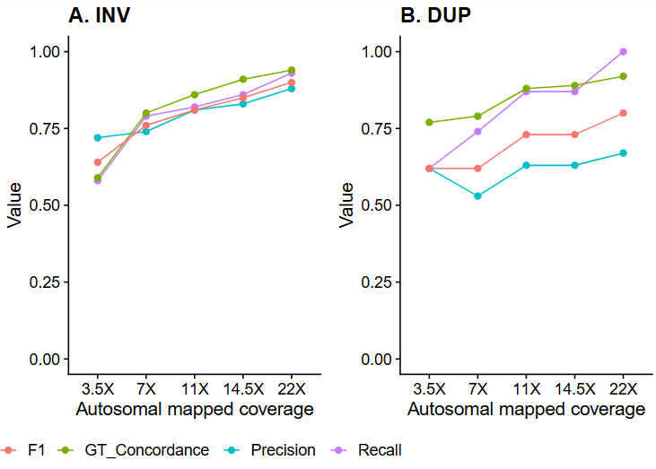
Supplementary material S2. Benchmarking statistics (Recall, Precision, F1 and genotype concordance) for A) inversions (INV) and B) duplications (DUP) detected in each scale-back read depth compared to a “truth set” of SV that showed Mendelian consistency in the full- sequencing depth of 45X.

