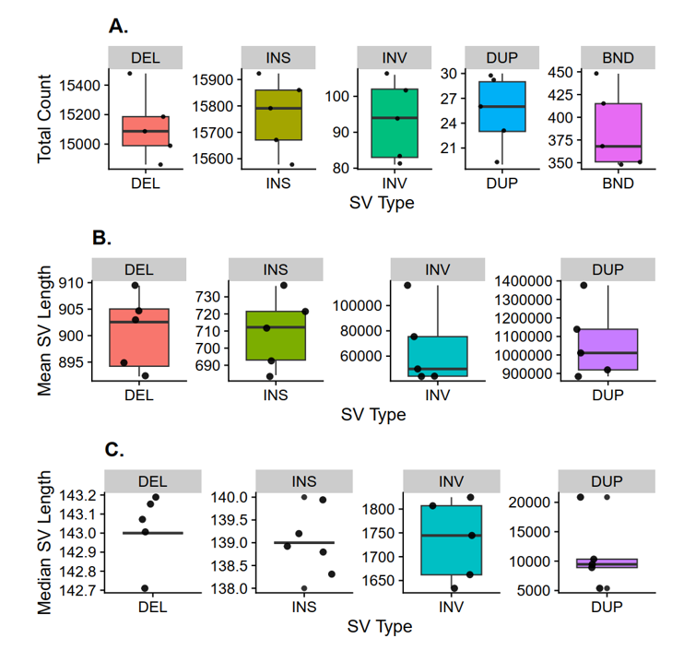
Supplementary Material S1. Boxplots showing summary statistics for different types of structural variant (SV) discovered in the full-scale read coverage of five individuals before merge and joint calling (where each dot represents one individual)). (A) Total number of SVs per animal. (B) Mean SV length per animal. (C) Median SV length per animal. SV types included deletions (DEL) insertions (INS), inversions (INV), duplications (DUP) and translocation/break-ends (BND).

