Supplementary Materials for
A Dissection of the Topographic Effects from Eurasia and North America on the Isentropic Meridional Mass Circulation in Northern Winter

Yueyue Yu^{1,2}, Rongcai Ren*^{2,1}, Xin Xia², Ruxue Liang¹, Jian Rao^{1,3}
¹Key Laboratory of Meteorological Disaster, Ministry of Education (KLME)/Joint International Research Laboratory of Climate and Environment Change (ILCEC)/Collaborative Innovation Center on Forecast and Evaluation of Meteorological Disasters (CIC-FEMD) /NUIST-UoR International Research Institute, Nanjing University of Information Science and Technology, Nanjing, China
²State Key Laboratory of Numerical Modeling for Atmospheric Sciences and Geophysical Fluid Dynamics (LASG), Institute of Atmospheric Physics, Chinese Academy of Sciences, Beijing, China
³Fredy and Nadine Herrmann Institute of Earth Sciences, Hebrew University of Jerusalem, Israel

Contents of this file
Figures S1 to S3
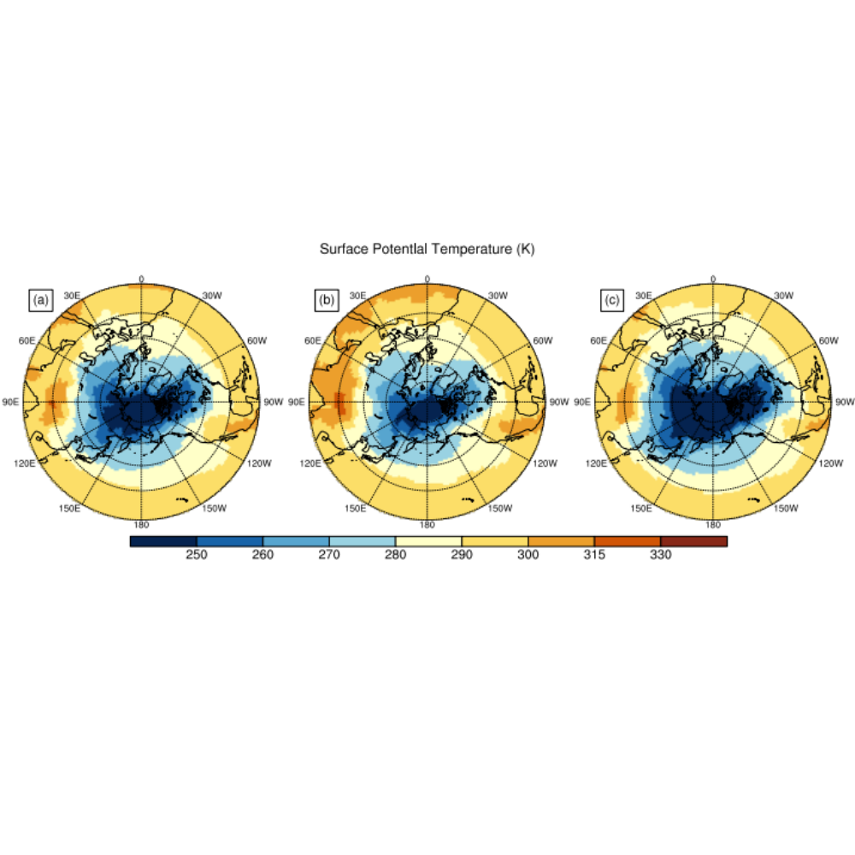
Figure S1. Surface potential temperature (units: K): (a) average, (b) upper 10 percentile, (c) lower 10 percentile.
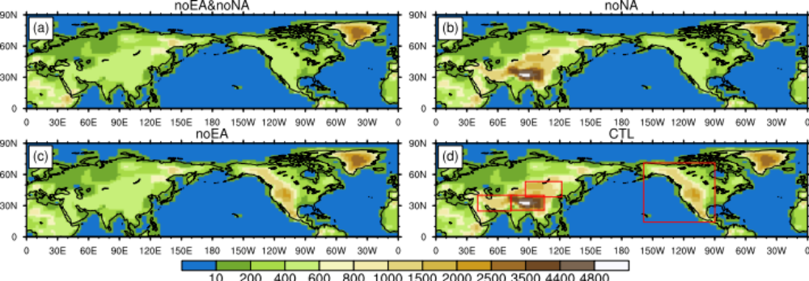
Figure S2. Topography maps of surface geopotential height (units: m) for the four numerical experiments: (a) noEA&noNA; (b) noNA; (c) noEA; and (d) CTL. Red rectangular boxes in panel (d) indicate the regions where the surface above 500m is flattened in the experiments.
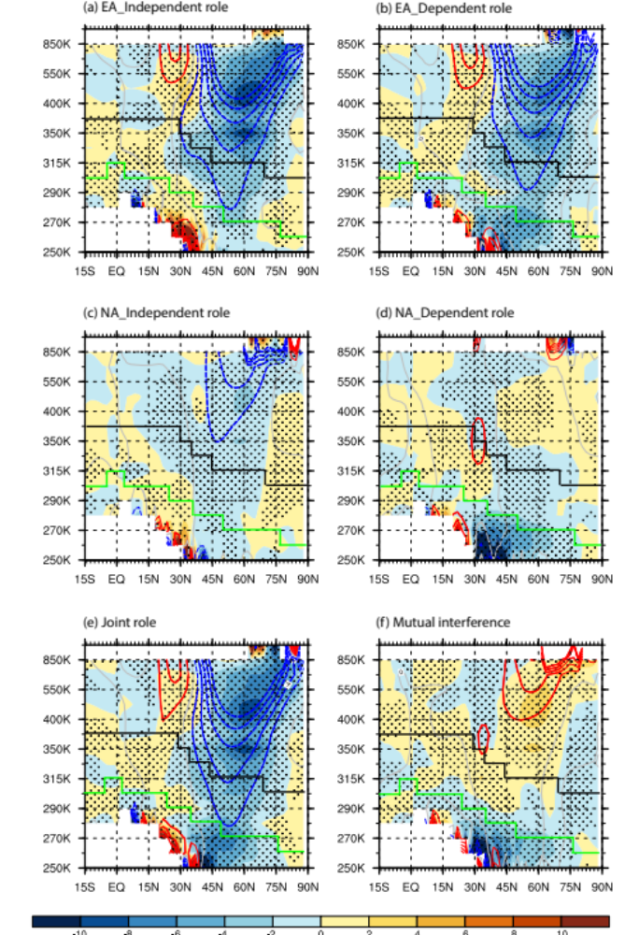
Figure S3. Difference among four experiments of the winter climatology of mass weighted mean eady growth rate (units: 10 ⁻⁶ s⁻¹, shadings) and zonal wind velocity (units: m s⁻¹, contours) in various latitudes and isentropic layers: (a) independent and (b) dependent effect of EA; (c) independent and (d) dependent effect of NA; (e) joint effect of EA and NA, and their mutual interference [(b) minus (a) or (d) minus (c)]. Dotted areas and thickened contours mark the 95% confidence level from a Student’s t-test. Black and green curves respectively indicate the climatological mean isentrope nearest to the tropopause and the isentrope separating the CB and WB of the meridional mass circulation as shown in Fig. 1b.

