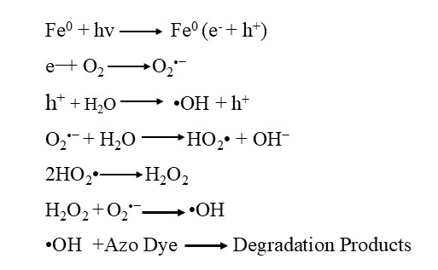
Scheme 1: Mechanism for dyes degradation
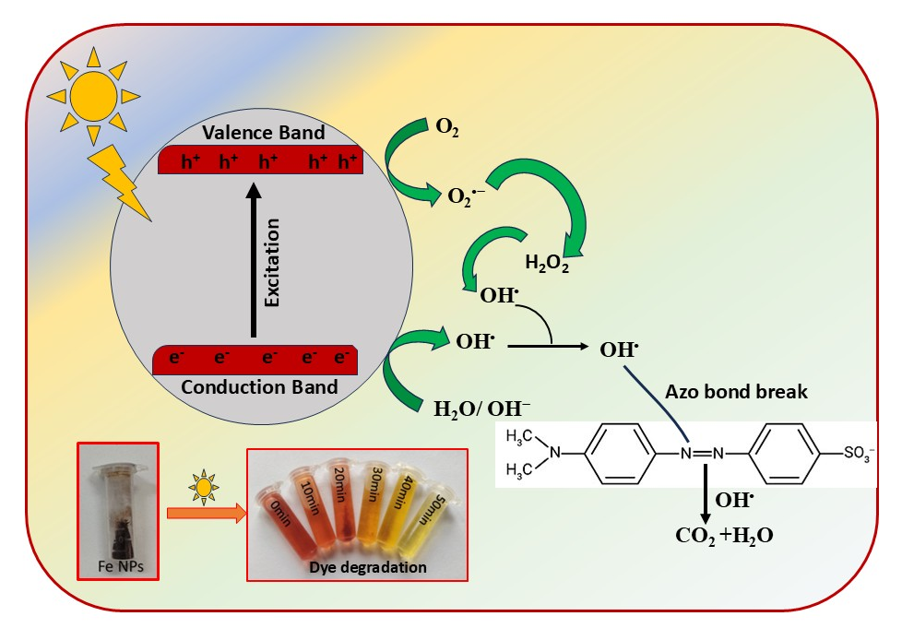Scheme 2: Pictorial representation showing mechanism for Azo dye degradation

