Supplementary information

Additional file 1. Fig. S1. related to figure 1.
Systemic glucose, insulin and lipid homeostasis in iNOS^{-/-} mice. Systemic IR analysis in WT and iNOS^{-/-} mice. (A) Intraperitoneal glucose tolerance test (GTT), (B) Area under the curve (AUC) calculated from IPGTT data, (C) Fasting blood glucose levels, (D) Fasting serum insulin levels, (E) Index of insulin resistance, HOMA-IR, (F) Intraperitoneal insulin tolerance test (ITT), (G) AUC calculated from ITT, (H) Index of insulin sensitivity, QUCIKI, (I) Serum total cholesterol (TC), (J) Serum triglycerides (TG), (K) Intraperitoneal pyruvate tolerance test (PTT), (L) AUC calculated from PTT, (M) Serum low density lipoprotein (LDL), (N) Serum non-esterified free fatty acids (NEFA) and (O) Serum high density lipoprotein (HDL). Data are represented as mean ± SEM (n≥6). *p<0.05, **p<0.01, ***p<0.001, ****p<0.0001 vs WT.
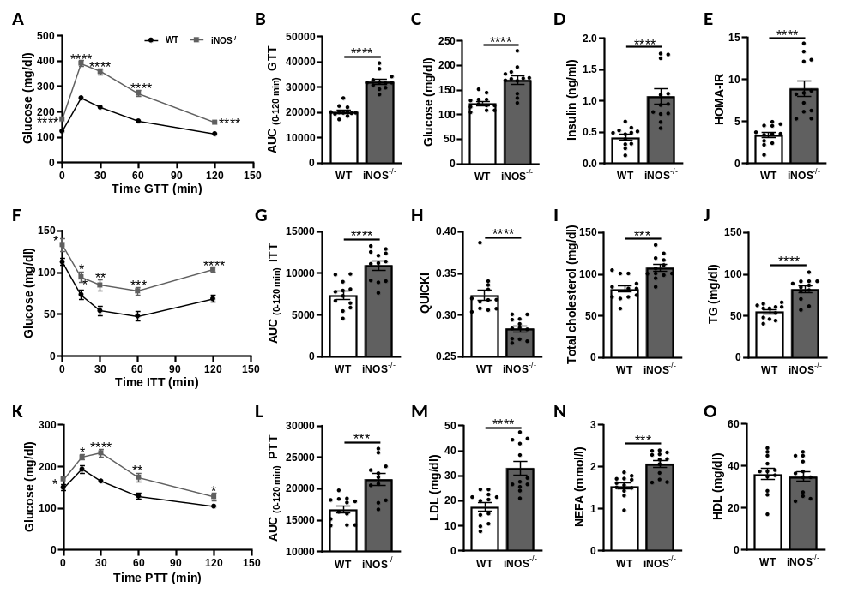

Additional file 2. Fig. S2. related to figure 2 and 3.
Vancomycin-induced gut microbiota modulation and associated serum metabolites in WT mice. Serum metabolomic analysis and gut microbiota analysis in untreated and vancomycin treated WT mice. (A) PCA score plot of metabolomic analysis in untreated and vancomycin treated WT mice in ESI (+) mode. Heat map of differential metabolites found by metabolomics analysis in WT with and without vancomycin treatment related to (B) Vitamins and hormones metabolism, (C) Nucleic acids metabolism, (D) Miscellaneous/ microbiota derived metabolites, (E) PCA plot of gut microbiota analysis in untreated and vancomycin treated WT mice based on Bray-Curtis distance. Heat map of differential metabolites found by metabolomics analysis in WT with and without vancomycin treatment related to (F) Carbohydrate metabolism and (G) Amino acids metabolism. (H) Differentially abundant microbiota at the phylum, family and genus level. (I) Heat map of differential metabolites found by metabolomics analysis in WT with and without vancomycin treatment related to lipid metabolism. Data are represented as mean ± SEM (n≥6). *p<0.05, **p<0.01, ***p<0.001, ****p<0.0001 vs WT.

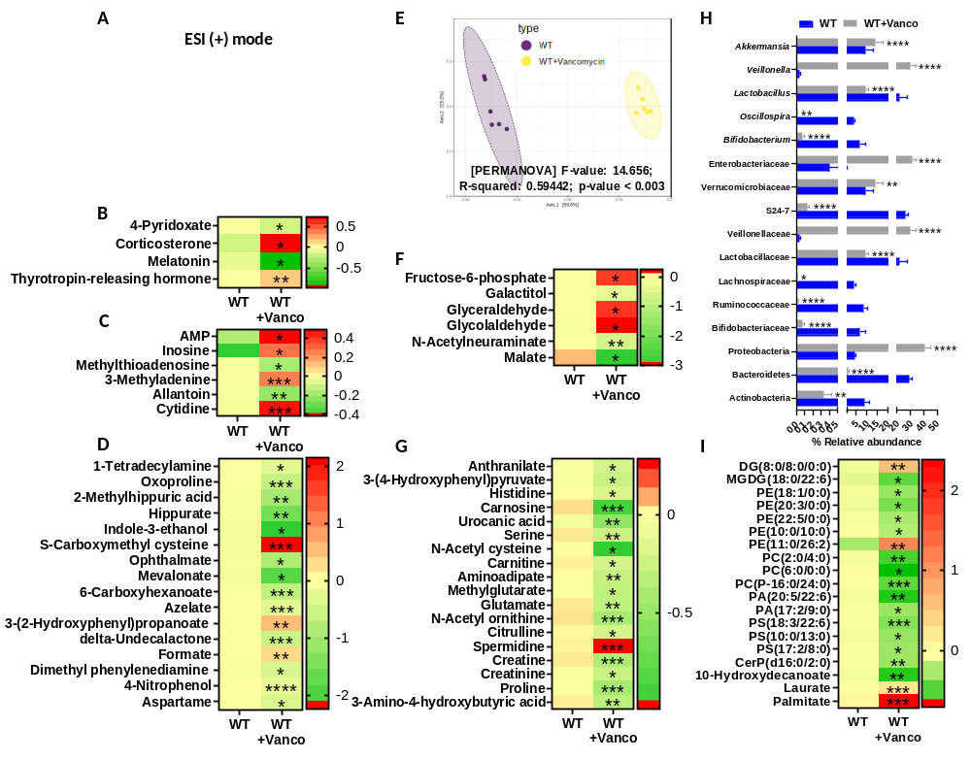

Additional file 3. Fig. S3. related to figure 2.
Antibiotic cocktail-induced modulation of gut microbiota rescue iNOS^{-/-} mice from systemic IR and dyslipidemia. Gut microbiota analysis in untreated and Abx treated iNOS^{-/-} mice. α-diversity indices in stool samples (A) Observed, (B) Shannon, (C) Simpson and (D) Chao1 index. (E) PCA plot based on Bray-Curtis distance. (F) Differentially abundant microbiota at the phylum, family and genus level. Systemic IR analysis in Abx treated and untreated WT and iNOS^{-/-} mice. (G) Intraperitoneal glucose tolerance test (GTT), (H) Area under the curve (AUC) calculated from IPGTT data, (I) Intraperitoneal insulin tolerance test (ITT), (J) AUC calculated from ITT (K) Intraperitoneal pyruvate tolerance test (PTT), (L) AUC calculated from PTT, (M) Fasting blood glucose levels and (N) Fasting serum insulin levels. Indices of insulin sensitivity (O) HOMA-IR and (P) QUCIKI. Serum lipids (Q) Total cholesterol (TC), (R) Triglycerides (TG), (S) Low density lipoprotein (LDL) and (T) Non-esterified free fatty acids (NEFA). Data are represented as mean ± SEM (n≥6). *p<0.05, **p<0.01, ***p<0.001, ****p<0.0001 between indicated groups. #p<0.05, ##p<0.01, ###p<0.001 and ####p<0.0001 vs iNOS^{-/-}.

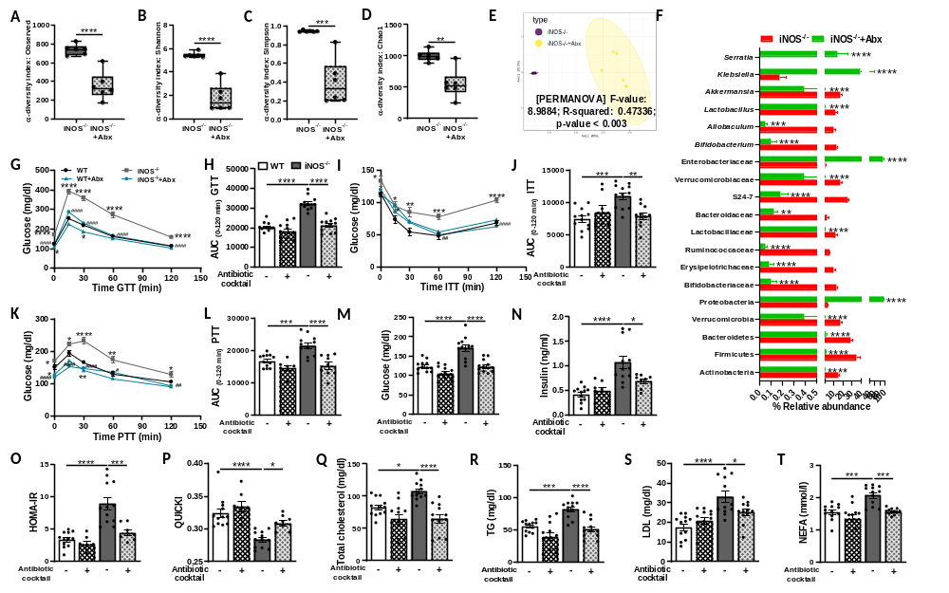

Additional file 4. Fig. S4. related to figure 3.
Antibiotic cocktail-induced alterations in serum metabolites in iNOS^{-/-} mice. Serum metabolomic analysis in in untreated and Abx treated iNOS^{-/-} mice in ESI (+) mode. (A) PCA score plot and (B) Volcano plot of differential metabolites between iNOS^{-/-} mice with or without Abx treatment. Red in volcano plot indicates significantly up-regulated metabolites, green indicates the down-regulated metabolites, and grey shows no significant difference. Heat map of differential metabolites found by metabolomics analysis in iNOS^{-/-} mice with and without Abx treatment related to (C) Miscellaneous/ microbiota derived metabolites, (D) Carbohydrate metabolism, (E) Amino acid metabolism, (F) Vitamins, hormones and bile acids metabolism, (G) Lipid metabolism and (H) Nucleic acids metabolism. Data are represented as mean ± SEM (n≥6). *p<0.05, **p<0.01, ***p<0.001, ****p<0.0001 vs iNOS^{-/-}.

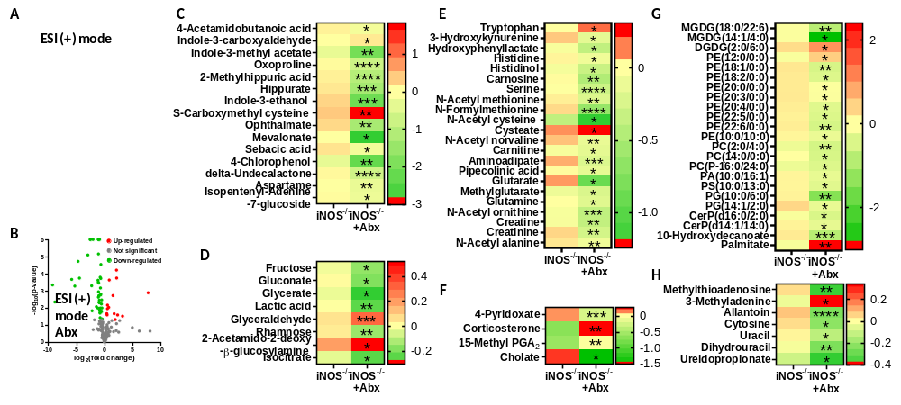

Additional file 5. Fig. S5. related to figure 2 and 3.
Antibiotic cocktail-induced gut microbiota modulation and associated serum metabolites in WT mice. Serum metabolomic analysis and gut microbiota analysis in untreated and Abx treated WT mice. (A) PCA score plot of metabolomic analysis in untreated and Abx treated WT mice in ESI (+) mode. Heat map of differential metabolites found by metabolomics analysis in WT with and without Abx treatment related to (B) Vitamins, hormones and bile acids metabolism, (C) Carbohydrate metabolism, (D) Nucleic acids metabolism, (E) Miscellaneous/ microbiota derived metabolites. (F) PCA plot of gut microbiota analysis in untreated and Abx treated WT mice based on Bray-Curtis distance. (G) Heat map of differential metabolites found by metabolomics analysis in WT with and without Abx treatment related to amino acids metabolism. (H) Differentially abundant microbiota at the phylum, family and genus level. (I) Heat map of differential metabolites found by metabolomics analysis in WT with and without Abx treatment related to lipid metabolism. Data are represented as mean ± SEM (n≥6). *p<0.05, **p<0.01, ***p<0.001, ****p<0.0001 vs WT.

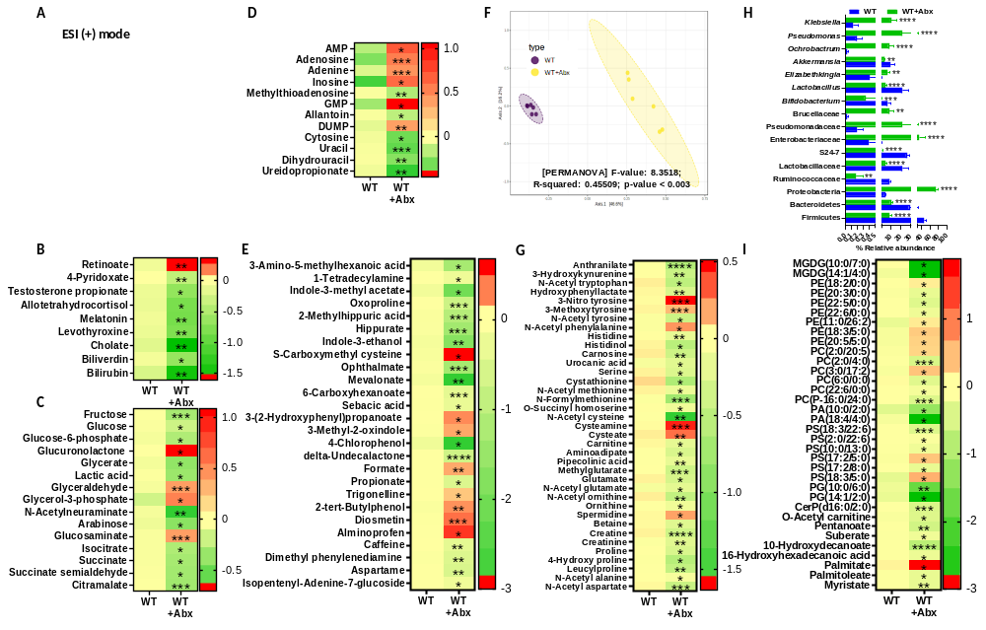

Additional file 6. Fig. S6. related to figure 2.
Effect of antibiotics on gross parameters in insulin resistant iNOS^{-/-} mice. (A) Body weight curve from the initiation (0 week) to study termination (4 weeks), (B) Area under the curve (AUC) calculated from the gradual change in the body weight, (C) Whole body fat mass and lean mass (%), (D) Weekly food consumption from study initiation (0 week) to study termination (4 weeks) and (E) Average food consumption per day during the study period, (F) Body mass index (BMI), (G) Relative tissue weights and (H) Relative intestine length. Data are represented as mean ± SEM (n≥6). *p<0.05, **p<0.01, ***p<0.001 and ****p<0.0001 between indicated groups and *p<0.05, **p<0.01 vs WT in the body weight curve.

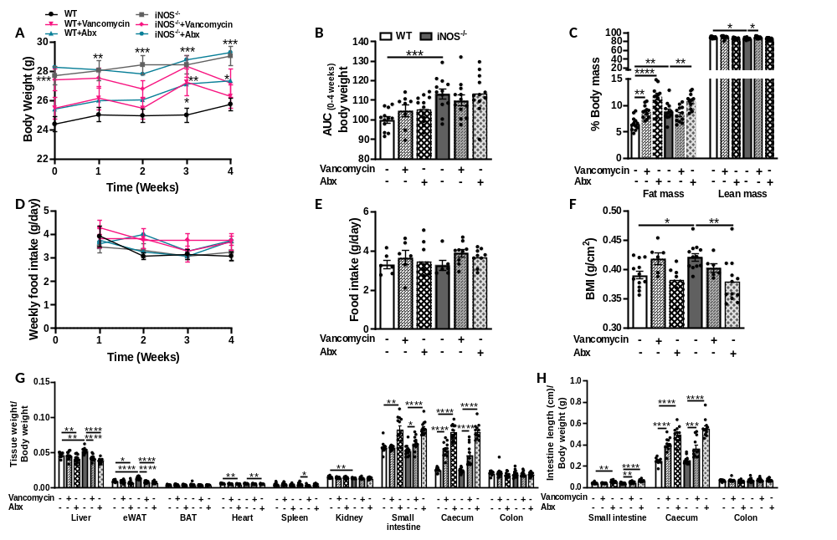

Additional file 7. Fig. S7. related to figure 4.
Improvement in the disrupted lipid and glucose homeostasis in liver in iNOS^{-/-} mice following treatment with antibiotic cocktail. Hepatic lipid levels in WT and iNOS^{-/-} mice with and without Abx treatment (A) TC, (B) TG and (C) FFA. (D) Hepatic glycogen levels with or without insulin stimulation in WT and iNOS^{-/-} mice with and without Abx treatment. Hepatic mRNA expression analysis of genes involved in (E) Gluconeogenesis, (F) Lipid synthesis, (G) Lipid oxidation, (H) Lipid uptake and (I) Lipid efflux. Data are represented as mean ± SEM (n≥6). *p<0.05, **p<0.01, ***p<0.001, ****p<0.0001 between indicated groups.

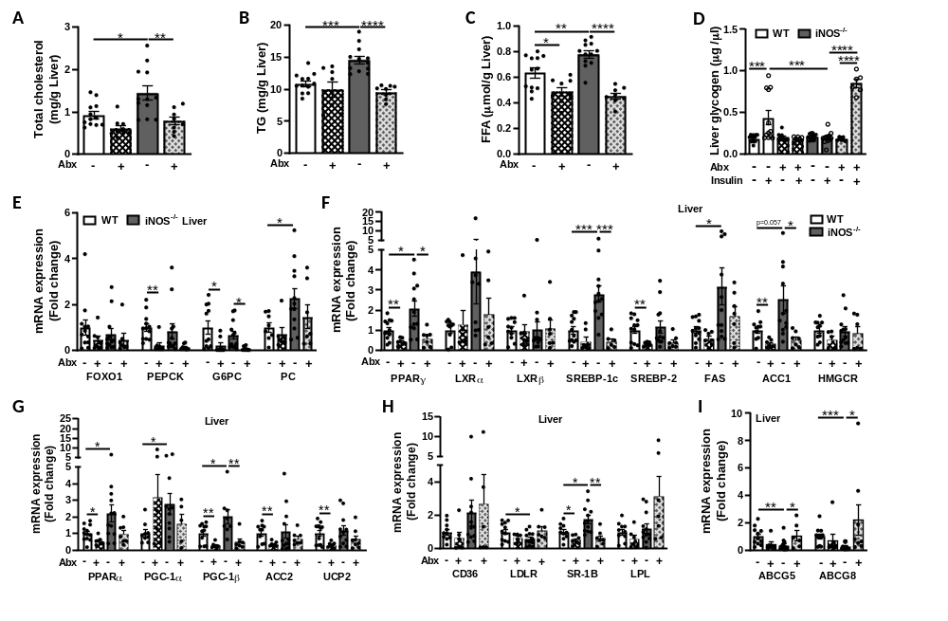

Additional file 8. Fig. S8. related to figure 5.
Improvement in the disrupted lipid and glucose homeostasis in adipose tissue and intestine in iNOS^{-/-} mice following treatment with antibiotic cocktail. Adipose tissue mRNA expression analysis of genes involved in (A) Gluconeogenesis, (B) Glucose homeostasis, (C) Lipid synthesis, (D) Lipid oxidation and (E) Lipid uptake. Intestinal tissue mRNA expression analysis of genes involved in (F) Lipid synthesis, (G) Lipid uptake and (H) Lipid efflux. Data are represented as mean ± SEM (n≥6). *p<0.05, **p<0.01, ***p<0.001, ****p<0.0001 between indicated groups.

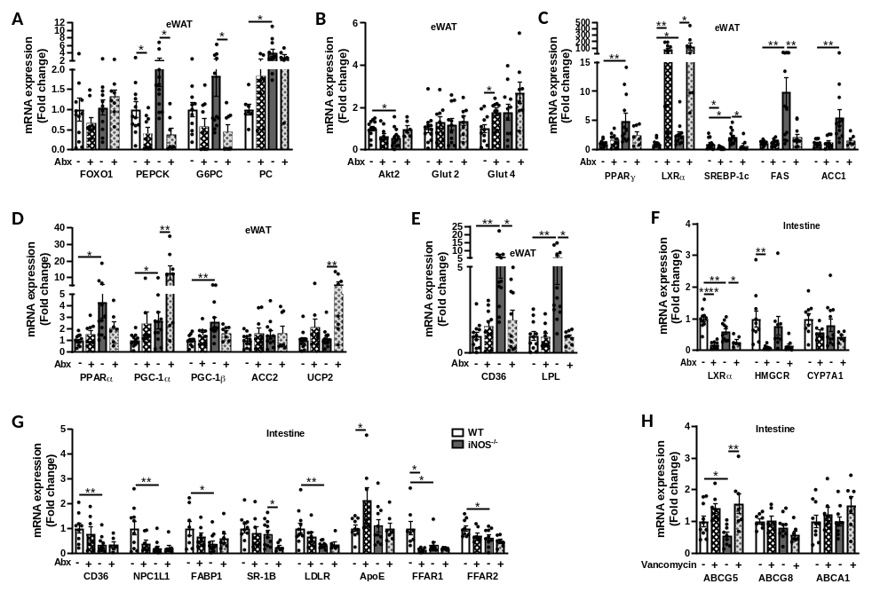

Additional file 9. Fig. S9. related to figure 5.
Gut barrier functionality and NO homeostasis in the insulin resistant iNOS^{-/-} mice upon antibiotics treatment. Histological analysis (A) Small intestinal tissue sections stained with Alcian blue-nuclear fast red for detection of goblet cells and morphology, (B) Percent Alcian blue stained area in small intestinal tissue and (C) Intestinal villi length. Histological analysis (D) Colonic tissue sections stained with Alcian blue-nuclear fast red for detection of goblet cells and morphology, (E) % Alcian blue stained area in colon tissue and (F) Colonic crypt length. (G) Intestinal permeability as measured via FITC-dextran oral gavage assay showing FITC-dextran concentration in serum. (H) mRNA expression analysis of tight junctions, mucins and antimicrobial peptide in small intestine. Total nitrite levels in (I) Serum, (J) Liver, (K) Adipose tissue and (L) Intestine. NOS isoforms mRNA expression analysis in (M) Liver, (N) White adipose tissue and (O) Small intestine. Scale bars, 100 µm. Data are represented as mean ± SEM (n≥6). *p<0.05, **p<0.01, ***p<0.001, ****p<0.0001 between indicated groups.

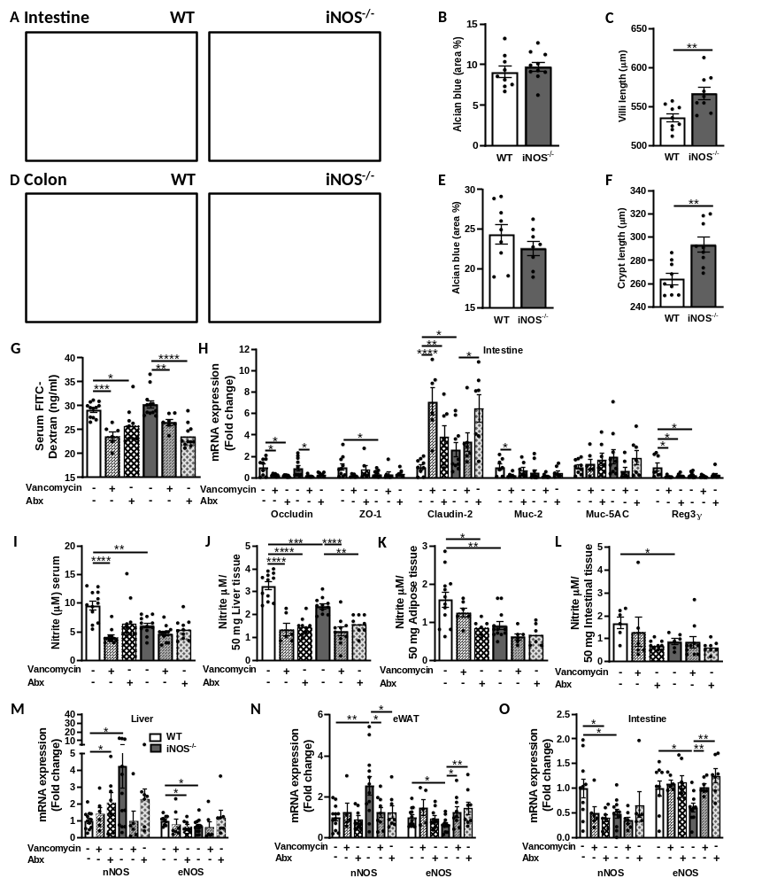

Additional file 10. Fig. S10. related to figure 6.
Association of serum metabolites with metabolic biomarkers upon antibiotics treatment in iNOS^{-/-} mice. Heat map of correlation analysis between metabolic biomarkers and serum metabolites in WT and iNOS^{-/-} mice treated with antibiotics- vancomycin or Abx along with untreated controls based on Pearson’s correlation coefficients related to (A) Nucleic acids and carbohydrate metabolism, vitamins, cofactors, hormones and bile acids, (B) Miscellaneous/ microbiota derived metabolites. *p<0.05, **p<0.01, ***p<0.001, ****p<0.0001 represent significant correlations between metabolic biomarker and serum metabolite. Green color represents negative and red positive correlations.

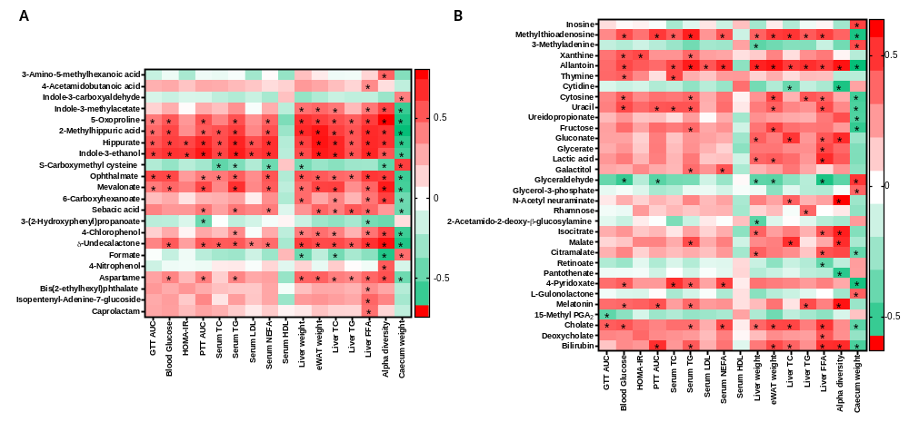

Additional file 11. Fig. S11. related to figure 7.
Association of altered gut microbiome by antibiotics with metabolic parameters in iNOS^{-/-} mice. Heat map of Pearson’s correlation coefficients between changes in different metabolic parameters and taxa at family level caused by gut microbiota modulation by vancomycin and Abx in WT and iNOS^{-/-} mice. *p<0.05, **p<0.01, ***p<0.001, ****p<0.0001 represent significant correlations between metabolic biomarker and bacterial taxa. Blue color represents negative and red positive correlations.

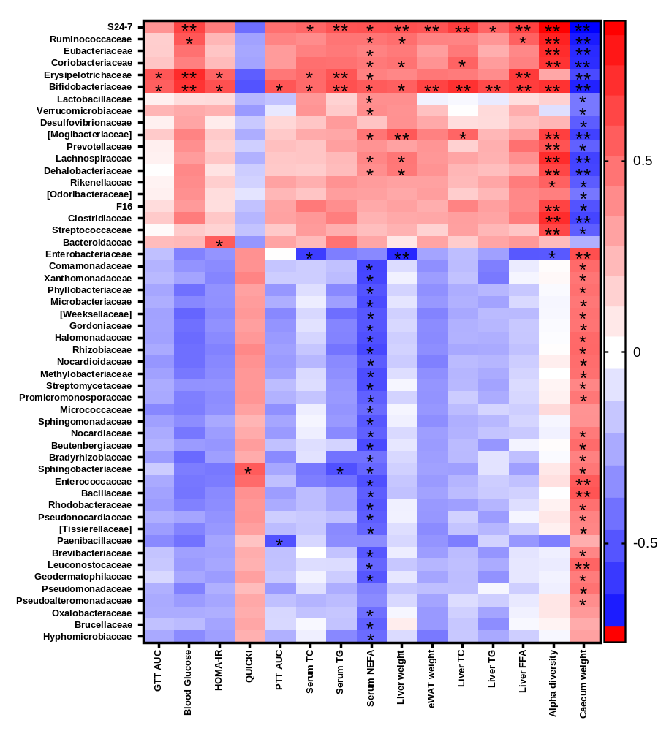

Table S1: Primer sequences used for gene expression analysis using qPCR.

Gene | Forward primer sequence (5'-3') | Reverse primer sequence (5'-3')
NOS isoforms
eNOS | CAACGCTACCACGAGGACATT | CTCCTGCAAAGAAAAGCTCTGG
nNOS | CCAACCCAACGTCATTTCTG | CATAGCTGAGGTCTACCAGG
Gluconeogenesis
PEPCK | TCTCTGATCCAGACCTTCCAA | GAAGTCCAGACCGTTATGCAG
G6PC | AAGCCAACGTATGGATTCCG | ACAGCAATGCCTGACAAGACT
PC | GGGATGCCCACCAGTCACT | CATAGGGCGCAATCTTTTTGA
FOXO1 | AAGAGCGT GCCCTACTTCAA | TGCT GT GAAGGGACAGATTG
Glucose homeostasis
Glut 2 | CCCTGGGTACTCTTCACCAA | GCCAAGTAGGATGTGCCAAT
Glut 4 | AAAAGTGCCTGAAACCAGAG | TCACCTCCTGCTCTAAAAGG
Akt2 | AAAAAGTGGCTCTGGTGTGTG | GGCATTCTGCTACAGAGAAATTG
Lipid homeostasis
SREBP-1c | GGAGCCATGGATTGCACATT | CCTGTCTCACCCCCAGCATA
SREBP-2 | GCGTTCTGGAGACCATGGA | ACAAAGTTGCTCTGAAAACAAATCA
FAS | GGCATCATTGGGCACTCCTT | GCTGCAAGCACAGCCTCTCT
ACC1 | GGACAGACTGATCGCAGAGAAAG | TGGAGAGCCCCACACACA
HMGCR | CTTGTGGAATGCCTTGTGATTG | AGCCGAAGCAGCACATGAT
PPARγ | AGTGGAGACCGCCCAGG | GCAGCAGGTTGTCTTGGATGT
LXRα | GCTCTGCTCATTGCCATCAG | TGTTGCAGCCTCTCTACTTGGA
LXRβ | AAGCAGGTGCCAGGGTTCT | TGCATTCTGTCTCGTGGTTGT
ACC2 | GGGCTCCCTGGATGACAAC | GCTCTTCCGGGAGGAGTTCT
PPARα | GTCCTCAGTGCTTCCAGAGG | GGTCACCTACGAGTGGCATT
PGC-1α | AACCACACCCACAGGATCAGA | TCTTCGCTTTATTGCTCCATGA
PGC-1β | CGCTCCAGGAGACTGAATCCAG | CTTGACTACTGTCTGTGAGGC
UCP2 | CAGCCAGCGCCCAGTACC | CAATGCGGACGGAGGCAAAGC
CYP7A1 | GCTAAGACGCACCTCGTGAT | AGGGCTCCTGATCATTTGAA
Lipid uptake and lipolysis
CD36/FAT | GCAAAACGACTGCAGGTCAAC | TGGTCCCAGTCTCATTTAGCCA
FABP1 | TGCACCACCAACTGCTTAGC | AGCTCAGGGATGA CCTTGCC
SR-1B | GGCTGCTGTTTGCTGCG | GCTGCTTGATGAGGGAGGG
ApoE | AACCGCTTCTGGGATTACCT | CAGTGCCGTCAGTTCTTGTG
LPL | AAGGTCAGAGCCAAGAGAAGCA | CCAGAAAAGTGAATCTTGACTTGGT
LDLR | GCATCAGCTTGGACAAGGTGT | GGGAACAGCCACCATTGTTG
NPC1L1 | TTGCCTTGACCTCTGGCTTAG | AGGGCGGATGAATCTGTGC
FFAR1 | TGGCTAGTTTCATAAACCCGG | TCCCAAGTAGCCATGGACCAGT
FFAR2 | TGTTCAGTTCCCTCAATGCCA | CAGGATTGCGGATCAGTAGCA
Lipid efflux
ABCG5 | TGGATCCAACACCTCTATGCTAAA | GGCAGGTTTTCTCGATGAACTG
ABCG8 | TGCCCACCTTCCACATGTC | ATGAAGCCGGCAGTAAGGTAGA
ABCA1 | CGTTTCCGGGAAGTGTCCTA | GCTAGAGATGACAAGGAGGATGGA
Intestinal homeostasis
Reg3γ | TTCCTGTCCTCCATGATCAAA | CATCCACCTCTGTTGGGTTC
Occludin | ATGTCCGGCCGATGCTCTC | TTTGGCTGCTCTTGGGTCTGTAT
Claudin-2 | GTCATCGCCCATCAGAAGAT | ACTGTTGGACAGGGAACCAG
ZO-1 | ACCCGAAACTGATGCTGTGGATAG | AAATGGCCGGGCAGAACTTGTGTA
Mucin-2 | GGGAGGGTGGAAGTGGCATTGT | TGCTGGGGTTTTTGTGAATCTC
Mucin-5AC | CACCATCTCTACAACCCAAACT | TGAGGTCCAGGTCTTTGTGTCT
Housekeeping genes
18S rRNA | GCAATTATTCCCCATGAACG | GGCCTCACTAAACCATCCAA
RPLP0 | ACCTCCTTCTTCCAGGCTTT | CCCACCTTGTCTCCAGTCTTT

