Supplementary Information

Apple scion cultivars regulate the rhizosphere microbiota of scion/rootstock combinations
Xiaofen Chai, Xiaona Wang, Hui Li, Xuefeng Xu, Ting Wu, Xinzhong Zhang, Yi Wang † and Zhenhai Han†
College of Horticulture, China Agricultural University, Beijing 100193, P. R. China

Addresses:
No.2 Yuanmingyuan West Road, Haidian, Beijing, 100193 P. R. China

† Corresponding author
Name: Zhenhai Han, Yi Wang
E-mail: rschan@cau.edu.cn
wangyi@cau.edu.cn

Table S1 Information about rootstock genotype selected in this study.
Table S2 Plant traits of different apple scion/rootstock combinations.
Table S3 Two-way ANOVA (analysis of variance) on plant traits and explanatory of scion cultivar, rootstock genotype and their interaction. Explanatory variables deemed statistically significant are bolded.
Table S4 Non-structural carbohydrates in leaves and root of 14 rootstock-scion combinations.
Table S5 Two-way ANOVA (analysis of variance) on non-structural carbohydrates and explanatory of scion cultivar, rootstock genotype and their interaction. Explanatory variables deemed statistically significant are bolded.
Table S6 Two-way ANOVA (analysis of variance) on rhizosphere soil chemical characteristics and explanatory of scion cultivar, rootstock genotype and their interaction. Explanatory variables deemed statistically significant are bolded.
Table S7 Number of sequences, OTUs counts and diversity indices in the rhizosphere of grafted plants.
Table S8 Two-way ANOVA results for dominant bacterial phyla with scion cultivar, rootstock genotype, and their interaction as explanatory variables. Taxon abundances were arcsine-transformed prior to ANOVAs.
Table S9 Two-way ANOVA results for dominant bacterial genera with scion cultivar, rootstock genotype, and their interaction as explanatory variables. Taxon abundances were arcsine-transformed prior to ANOVAs.
Fig. S1 Sampling scheme. Rhizosphere soil were collected from different apple scion-rootstock combinations growing in the same orchard at Changping District (Beijing, China), and subjected to the same disease control and soil management practices for fertilization, irrigation. Four replicates per combination were collected. Unvegetated bulk soil samples (n=4) have been also sampled as control reference.
Fig. S2 Soil chemical characteristics of rhizosphere soil from different scion/rootstock combinations and bulk soil. Values shown are the average of four soil samples from each combination, and values above the respective means are colored red, values below the mean are colored blue. Different letters indicate significant differences among rootstocks grafted on the same apple scion cultivar. Asterisks indicate significant differences between rhizosphere soil and bulk soil. Significance levels are as follows * P < 0.05. SOM: Soil organic matter, AN: Alkali-hydrolyzable N, AP: Available P, AK: Available K.
Fig. S3 Pair-wise post hoc test comparison using PERMANOVA on the Bray-Curtis similarity matrices in the bacterial community to measure effect of scion cultivar and rootstock genotype on rhizosphere bacterial beta diversity.
Fig. S4 PCoA of weighted UniFrac distances reveals that scion cultivar is a major source of bacterial community variation in the different scion/rootstock combinations.
Fig. S5 Relative abundance of different bacterial taxation in the rhizosphere soil from different scion/rootstock combinations. (a) The relative abundance of dominant bacterial phyla among rootstock genotypes. (b) The relative abundance of dominant bacterial genera among rootstock genotypes. Asterisks denote significant differences in abundance among rootstock genotypes. * P < 0.05, ** P < 0.01, *** P < 0.001.
Fig. S6 Relative abundance of the predicted gene of metagenome related to KEGG pathways at level 1 and 2. The terms given on the left are KEGG pathways annotation at level 1 and level 2 (from left to right). * P < 0.05, ** P < 0.01.
Table S1
Rootstock Genotype | Abbreviation | Rootstock Germplasm | Population origin | Scion Vigor | Tolerance |  |  |  | Root System
 |  |  |  |  | Drought | Wet soil | Salt | Cold | Root System
Malus baccata (Ledeb.) Borkh. | M.baccata | Wild Species | Shanxi | High | Low | High | Low | High | Semi-superficial
Malus hupehensis (Pamp.) Rehder. | M.hupehensis | Wild Species | Shandong | High | Medium | High | Low | Low | Semi-deep
Malus sieversii (Ledeb.) Roem. | M.sieversii | Wild Species | Xinjiang | High | High | Low | High | High | Semi-deep
Malus micromalus Mak. | M.micromalus | Wild Species | Hebei | High | Medium | Low | Medium | Medium | Semi-deep
Malus robusta (Carr.) Rehd. | M.robusta | Wild Species | Hebei | Medium | Medium | Medium | High | Low | Semi-deep
Malus prunifolia (Willd.) Borkh. | M.prunifolia | Wild Species | Shaanxi | Medium | High | High | High | High | Semi-deep
Malus xiaojinensis Cheng et Jiang. | M.xiaojinensis | Wild Species | Beijing | High | High | High | High | High | Semi-deep

Table S2
Apple rootstocks | Plant height (m) |  |  | Trunk circumference (cm) |  |  | SPAD value
Apple rootstocks | Fuji | Golden delicious |  | Fuji | Golden delicious |  | Fuji | Golden delicious
M.baccata | 4.81±0.25 a | 4.55±0.44 ab |  | 36.18±3.70 a | 32.58±1.02 ab |  | 60.76±1.30 a | 56.89±1.05 a
M.hupehensis | 4.89±0.11 a | 4.58±0.25 ab |  | 39.23±3.03 a | 34.50±1.50 a |  | 60.78±0.82 a | 56.73±1.30 a
M.sieversii | 5.00±0.16 a | 4.75±0.18 ab |  | 42.40±2.28 a | 36.05±2.07 a |  | 57.50±0.82 b | 55.72±0.52 a
M.micromalus | 5.14±0.19 a | 4.23±0.30 ab |  | 42.85±1.89 a | 32.53±1.21 ab |  | 60.33±0.66 a | 55.93±0.99 a
M.robusta | 4.56±0.20 a | 4.85±0.15 a |  | 38.13±2.38 a | 34.13±1.21 ab |  | 56.73±1.40 b | 55.83±0.38 a
M.prunifolia | 5.26±0.12 a | 3.88±0.38 ab |  | 41.83±1.15 a | 26.85±2.60 bc |  | 59.10±0.62 ab | 56.54±1.02 a
M.xiaojinensis | 3.22±0.39 b | 3.71±0.48 b |  | 23.48±2.44 b | 24.23±4.43 c |  | 59.12±0.41 ab | 56.57±0.78 a
Note: Different letters indicate significant differences among rootstocks grafted on the same apple scion cultivar.
Table S3
Response variable | Explanatory variable | DF | R² | F | P-value
Plant height | Scion | 1 | 2.618 | 10.621 | 0.002
 | Rootstock | 6 | 0.080 | 0.324 | 0.895
 | Interaction | 6 | 0.685 | 2.780 | 0.032
Trunk circumference | Scion | 1 | 644.600 | 34.606 | 9.97E-07
 | Rootstock | 6 | 29.240 | 1.570 | 0.193
 | Interaction | 6 | 40.066 | 2.151 | 0.081
SPAD value | Scion | 1 | 115.661 | 34.205 | 6.56E-07
 | Rootstock | 6 | 7.697 | 2.276 | 0.054
 | Interaction | 6 | 3.336 | 0.986 | 0.447

Table S4
 | Rootstock  genotype | Starch (mg kg⁻¹ DW) |  |  | Fructose (mg kg⁻¹ DW) |  |  | Sorbitol (mg kg⁻¹ DW) |  |  | Glucose (mg kg⁻¹ DW) |  |  | Sucrose (mg kg⁻¹ DW)
 | Rootstock  genotype | Fuji | Golden  Delicious |  | Fuji | Golden  Delicious |  | Fuji | Golden  Delicious |  | Fuji | Golden  Delicious |  | Fuji | Golden  Delicious
Leaf
 | M.baccata | 11.78±0.34 ab | 17.85±1.20 a |  | 1.94±0.31 a | 2.66±0.28 ab |  | 46.57±3.53 b | 15.35±0.97 b |  | 6.35±1.26 a | 7.90±1.02 a |  | 5.33±0.38 a | 0.65±0.11 b
 | M.hupehensis | 12.30±0.40 a | 17.78±0.68 a |  | 1.33±0.33 ab | 2.78±0.22 ab |  | 54.05±2.52 ab | 22.38±2.10 ab |  | 5.38±1.24 a | 8.45±0.45 a |  | 4.77±0.84 ab | 1.45±0.38 a
 | M.sieversii | 10.93±0.28 b | 19.60±0.79 a |  | 1.59±0.32 a | 4.29±0.50 a |  | 49.21±1.60 b | 29.59±2.42 a |  | 7.04±1.03 a | 9.68±0.88 a |  | 3.77±0.16 ab | 1.21±0.15 a
 | M.micromalus | 11.93±0.40 a | 19.50±0.40 a |  | 0.60±0.10 b | 3.37±0.57 ab |  | 51.57±9.27 ab | 25.31±1.20 ab |  | 5.92±1.63 a | 9.22±1.05 a |  | 5.15±1.05 ab | 1.87±0.21 a
 | M.robusta | 12.78±0.23 a | 18.33±0.72 a |  | 1.60±0.14 a | 2.16±0.41 b |  | 53.54±1.50 ab | 24.82±5.26 ab |  | 5.72±0.95 a | 8.62±0.37 a |  | 2.65±0.45 b | 0.60±0.06 b
 | M.prunifolia | 13.03±0.21 a | 20.60±0.47 a |  | 1.62±0.27 a | 4.27±0.34 a |  | 68.39±2.39 a | 28.51±3.97 a |  | 5.64±1.13 a | 9.12±1.58 a |  | 3.98±0.30 ab | 1.18±0.33 a
 | M.xiaojinensis | 12.50±0.18 a | 19.05±0.73 a |  | 2.49±0.38 a | 2.25±0.30 b |  | 63.14±1.96 ab | 38.76±4.29 a |  | 6.58±0.70 a | 5.88±0.24 a |  | 5.73±1.18 a | 2.18±0.89 a
Root
 | M.baccata | 9.87±0.31 ab | 8.88±0.28 ab |  | 5.39±0.35 a | 3.46±0.33 ab |  | 5.28±1.07 ab | 1.64±0.14 c |  | 4.77±0.29 a | 4.22±0.31 a |  | 8.19±0.68 ab | 2.64±0.60 b
 | M.hupehensis | 9.29±0.19 ab | 8.36±0.17 ab |  | 5.72±0.26 a | 3.19±0.34 ab |  | 6.18±0.41 ab | 3.41±0.87 bc |  | 3.83±0.15 a | 3.22±0.06 b |  | 12.11±1.65 a | 3.62±0.90 a
 | M.sieversii | 11.63±0.76 a | 10.47±0.69 a |  | 4.31±0.88 ab | 4.18±0.54 a |  | 6.87±0.69 a | 6.31±0.58 a |  | 3.36±0.30 a | 4.26±0.33 a |  | 3.48±0.53 c | 2.35±0.66 ab
 | M.micromalus | 7.17±0.82 b | 6.45±0.74 b |  | 3.59±0.45 ab | 3.18±0.47 ab |  | 5.61±0.24 ab | 4.46±0.26 ab |  | 4.09±0.27 a | 4.85±0.31 a |  | 4.25±0.98 bc | 2.73±0.54 ab
 | M.robusta | 8.49±1.49 ab | 7.64±1.34 ab |  | 3.23±0.55 ab | 2.46±0.38 ab |  | 6.61±1.17 a | 3.74±0.31 bc |  | 3.49±0.56 a | 4.42±0.34 a |  | 6.68±0.91 ab | 3.70±0.32 a
 | M.prunifolia | 6.89±0.64 b | 6.20±0.58 b |  | 3.07±0.76 b | 4.13±0.57 a |  | 4.84±1.10 ab | 6.47±0.65 a |  | 3.24±0.45 a | 3.16±0.25 b |  | 6.59±0.67 bc | 3.95±0.54 a
 | M.xiaojinensis | 2.42±0.45 c | 2.18±0.40 c |  | 3.74±0.72 b | 1.98±0.39 b |  | 2.51±0.32 b | 1.91±0.37 c |  | 4.43±0.68 a | 4.62±0.12 a |  | 2.70±0.50 c | 0.57±0.07 b
Note: Different letters indicate significant differences among rootstocks grafted on the same apple scion cultivar.
Table S5
 |  | Leaf |  |  |  |  | Root
Response variable | Explanatory variable | DF | R² | F | p-value |  | DF | R² | F | p-value
Starch | Scion cultivar | 1 | 0.514 | 586.200 | 2.69E-26 |  | 1 | 27.840 | 2.289 | 0.139
 | Rootstock genotype | 6 | 0.003 | 3.060 | 0.014 |  | 6 | 11.306 | 0.930 | 0.473
 | Interaction | 6 | 0.002 | 2.713 | 0.026 |  | 6 | 14.425 | 1.186 | 0.335
Fructose | Scion cultivar | 1 | 1.394 | 71.036 | 1.42E-10 |  | 1 | 7.337 | 6.778 | 0.013
 | Rootstock genotype | 6 | 0.079 | 4.020 | 0.003 |  | 6 | 3.407 | 3.148 | 0.019
 | Interaction | 6 | 0.141 | 7.174 | 2.60E-05 |  | 6 | 3.329 | 3.075 | 0.021
Sorbitol | Scion cultivar | 1 | 13.547 | 2.951 | 0.093 |  | 1 | 29.225 | 14.319 | 0.001
 | Rootstock genotype | 6 | 2.624 | 0.572 | 0.750 |  | 6 | 8.510 | 4.170 | 0.004
 | Interaction | 6 | 3.250 | 0.708 | 0.645 |  | 6 | 7.536 | 3.693 | 0.008
Glucose | Scion cultivar | 1 | 0.343 | 15.818 | 2.70E-04 |  | 1 | 0.600 | 1.432 | 0.239
 | Rootstock genotype | 6 | 0.011 | 0.505 | 0.801 |  | 6 | 2.097 | 5.002 | 0.001
 | Interaction | 6 | 0.020 | 0.909 | 0.498 |  | 6 | 1.048 | 2.500 | 0.048
Sucrose | Scion cultivar | 1 | 11.168 | 49.465 | 1.30E-08 |  | 1 | 165.994 | 62.300 | 2.30E-09
 | Rootstock genotype | 6 | 0.419 | 1.855 | 0.112 |  | 6 | 24.182 | 9.076 | 1.18E-05
 | Interaction | 6 | 0.628 | 2.781 | 0.023 |  | 6 | 15.749 | 5.911 | 4.36E-04

Table S6
Response Variable | Explanatory Variable | DF | F-value | P-value
pH | Scion Cultivar | 1 | 63.919 | 5.69E-10
 | Rootstock Genotype | 6 | 18.436 | 2.35E-10
 | Interaction | 6 | 2.411 | 0.043
SOM | Scion Cultivar | 1 | 27.234 | 5.22E-06
 | Rootstock Genotype | 6 | 4.29 | 0.0018
 | Interaction | 6 | 1.935 | 0.097
AN | Scion Cultivar | 1 | 0.612 | 0.438
 | Rootstock Genotype | 6 | 4.554 | 0.0012
 | Interaction | 6 | 7.643 | 1.39E-05
AP | Scion Cultivar | 1 | 8.538 | 0.006
 | Rootstock Genotype | 6 | 7.418 | 1.88E-05
 | Interaction | 6 | 3.809 | 0.004
AK | Scion Cultivar | 1 | 10.78 | 0.0021
 | Rootstock Genotype | 6 | 2.253 | 0.056
 | Interaction | 6 | 0.941 | 0.476

Table S7
Sample ID | Scion cultivar | Rootstock genotype | Sequences | OTUs Counts | Chao1 | Phylogenetic diversity | Shannon
Apple Rhizosphere 1 | Fuji | M.baccata | 63635 | 2958 | 4675.74 | 273.17 | 9.29
Apple Rhizosphere 2 | Fuji | M.baccata | 138681 | 2727 | 4208.89 | 244.68 | 9.19
Apple Rhizosphere 3 | Fuji | M.baccata | 90431 | 3173 | 4847.51 | 278.11 | 9.67
Apple Rhizosphere 4 | Fuji | M.baccata | 61344 | 3219 | 4910.26 | 289.56 | 9.86
Apple Rhizosphere 5 | Fuji | M.hupehensis | 76016 | 3367 | 5039.14 | 296.43 | 9.92
Apple Rhizosphere 6 | Fuji | M.hupehensis | 128635 | 3134 | 4875.28 | 276.76 | 9.54
Apple Rhizosphere 7 | Fuji | M.hupehensis | 82467 | 2972 | 4928.81 | 266.82 | 9.41
Apple Rhizosphere 8 | Fuji | M.hupehensis | 139957 | 2765 | 4312.23 | 246.93 | 9.16
Apple Rhizosphere 9 | Fuji | M.sieversii | 79892 | 3124 | 4952.45 | 278.76 | 9.26
Apple Rhizosphere 10 | Fuji | M.sieversii | 102793 | 3081 | 4677.07 | 271.60 | 9.05
Apple Rhizosphere 11 | Fuji | M.sieversii | 60473 | 2910 | 4679.49 | 267.35 | 8.77
Apple Rhizosphere 12 | Fuji | M.sieversii | 26334 | 3078 | 4769.85 | 281.70 | 9.43
Apple Rhizosphere 13 | Fuji | M.micromalus | 55287 | 3180 | 5150.28 | 291.16 | 9.57
Apple Rhizosphere 14 | Fuji | M.micromalus | 76638 | 3137 | 4821.70 | 278.98 | 9.65
Apple Rhizosphere 15 | Fuji | M.micromalus | 97461 | 2928 | 4536.42 | 263.49 | 9.40
Apple Rhizosphere 16 | Fuji | M.micromalus | 75749 | 3302 | 5052.44 | 292.33 | 9.84
Apple Rhizosphere 17 | Fuji | M.robusta | 71305 | 2972 | 4734.04 | 271.55 | 9.35
Apple Rhizosphere 18 | Fuji | M.robusta | 60589 | 3135 | 4675.47 | 277.27 | 9.76
Apple Rhizosphere 19 | Fuji | M.robusta | 40137 | 3067 | 5022.97 | 275.63 | 9.50
Apple Rhizosphere 20 | Fuji | M.robusta | 34625 | 3160 | 4955.12 | 287.07 | 9.78
Apple Rhizosphere 21 | Fuji | M.prunifolia | 54841 | 3308 | 5281.61 | 293.47 | 9.83
Apple Rhizosphere 22 | Fuji | M.prunifolia | 94352 | 2892 | 4550.76 | 264.51 | 8.95
Apple Rhizosphere 23 | Fuji | M.prunifolia | 48659 | 3298 | 4933.50 | 289.78 | 9.63
Apple Rhizosphere 24 | Fuji | M.prunifolia | 65111 | 2935 | 4698.71 | 267.69 | 8.91
Apple Rhizosphere 25 | Fuji | M.xiaojinensis | 47436 | 2834 | 4474.48 | 259.01 | 8.90
Apple Rhizosphere 26 | Fuji | M.xiaojinensis | 109881 | 2653 | 4169.43 | 240.30 | 8.48
Apple Rhizosphere 27 | Fuji | M.xiaojinensis | 81952 | 2988 | 4682.44 | 277.29 | 8.75
Apple Rhizosphere 28 | Fuji | M.xiaojinensis | 125636 | 3161 | 4955.18 | 277.46 | 9.61
Apple Rhizosphere 29 | Golden Delicious | M.baccata | 149423 | 3110 | 4813.11 | 275.23 | 9.31
Apple Rhizosphere 30 | Golden Delicious | M.baccata | 68529 | 2970 | 4639.83 | 270.58 | 8.78
Apple Rhizosphere 31 | Golden Delicious | M.baccata | 100313 | 3332 | 5184.48 | 304.78 | 10.01
Apple Rhizosphere 32 | Golden Delicious | M.baccata | 113527 | 3452 | 5201.91 | 297.07 | 10.00
Apple Rhizosphere 33 | Golden Delicious | M.hupehensis | 39714 | 3224 | 4788.12 | 287.52 | 9.61
Apple Rhizosphere 34 | Golden Delicious | M.hupehensis | 47161 | 3224 | 4793.75 | 281.63 | 9.36
Apple Rhizosphere 35 | Golden Delicious | M.hupehensis | 55418 | 3193 | 4774.63 | 279.12 | 9.68
Apple Rhizosphere 36 | Golden Delicious | M.hupehensis | 33940 | 3160 | 4931.35 | 283.24 | 9.64
Apple Rhizosphere 37 | Golden Delicious | M.sieversii | 48937 | 3315 | 5126.36 | 293.72 | 9.99
Apple Rhizosphere 38 | Golden Delicious | M.sieversii | 27945 | 3313 | 4951.42 | 289.12 | 9.94
Apple Rhizosphere 39 | Golden Delicious | M.sieversii | 44160 | 3386 | 5459.98 | 296.34 | 9.93
Apple Rhizosphere 40 | Golden Delicious | M.sieversii | 58956 | 3450 | 5137.26 | 299.31 | 10.04
Apple Rhizosphere 41 | Golden Delicious | M.micromalus | 49268 | 2769 | 4384.83 | 254.48 | 8.09
Apple Rhizosphere 42 | Golden Delicious | M.micromalus | 68445 | 3341 | 5090.22 | 297.32 | 9.97
Apple Rhizosphere 43 | Golden Delicious | M.micromalus | 48087 | 3188 | 4917.08 | 286.64 | 9.81
Apple Rhizosphere 44 | Golden Delicious | M.micromalus | 51741 | 3241 | 5001.00 | 288.22 | 9.97
Apple Rhizosphere 45 | Golden Delicious | M.robusta | 43752 | 3027 | 4749.03 | 268.28 | 9.07
Apple Rhizosphere 46 | Golden Delicious | M.robusta | 50869 | 3290 | 5223.57 | 299.26 | 9.92
Apple Rhizosphere 47 | Golden Delicious | M.robusta | 50916 | 3309 | 5056.16 | 297.77 | 9.96
Apple Rhizosphere 48 | Golden Delicious | M.robusta | 30771 | 3244 | 4709.63 | 287.23 | 9.98
Apple Rhizosphere 49 | Golden Delicious | M.prunifolia | 46306 | 3343 | 5072.04 | 297.09 | 9.72
Apple Rhizosphere 50 | Golden Delicious | M.prunifolia | 51747 | 3355 | 4997.56 | 292.42 | 9.89
Apple Rhizosphere 51 | Golden Delicious | M.prunifolia | 45792 | 3352 | 5086.70 | 299.00 | 10.02
Apple Rhizosphere 52 | Golden Delicious | M.prunifolia | 47609 | 3147 | 4742.59 | 283.08 | 9.80
Apple Rhizosphere 53 | Golden Delicious | M.xiaojinensis | 60706 | 3258 | 4919.75 | 291.82 | 9.98
Apple Rhizosphere 54 | Golden Delicious | M.xiaojinensis | 50327 | 3391 | 5093.67 | 295.55 | 9.99
Apple Rhizosphere 55 | Golden Delicious | M.xiaojinensis | 48177 | 3219 | 5014.49 | 286.47 | 9.87
Apple Rhizosphere 56 | Golden Delicious | M.xiaojinensis | 35579 | 3231 | 4934.68 | 289.16 | 9.91

Table S8
Bacterial Phyla | Explanatory Variable | DF | F-value | P-value
Proteobacteria | Scion cultivar | 1 | 5.981 | 0.019
 | Rootstock genotype | 6 | 1.274 | 0.29
 | Interaction | 6 | 0.852 | 0.538
Acidobacteria | Scion cultivar | 1 | 28.314 | < 0.001
 | Rootstock genotype | 6 | 1.229 | 0.311
 | Interaction | 6 | 1.499 | 0.202
Actinobacteria | Scion cultivar | 1 | 27.353 | < 0.001
 | Rootstock genotype | 6 | 2.787 | 0.023
 | Interaction | 6 | 4.268 | 0.002
Chloroflexi | Scion cultivar | 1 | 3.541 | 0.067
 | Rootstock genotype | 6 | 0.252 | 0.956
 | Interaction | 6 | 1.467 | 0.213
Firmicutes | Scion cultivar | 1 | 9.972 | 0.003
 | Rootstock genotype | 6 | 0.252 | 0.956
 | Interaction | 6 | 2.523 | 0.036
Bacteroidetes | Scion cultivar | 1 | 0.463 | 0.500
 | Rootstock genotype | 6 | 0.667 | 0.676
 | Interaction | 6 | 2.479 | 0.038
Saccharibacteria | Scion cultivar | 1 | 0.001 | 0.973
 | Rootstock genotype | 6 | 2.77 | 0.023
 | Interaction | 6 | 1.117 | 0.369
Gemmatimonadetes | Scion cultivar | 1 | 100.248 | < 0.001
 | Rootstock genotype | 6 | 1.283 | 0.286
 | Interaction | 6 | 0.603 | 0.726
Planctomycetes | Scion cultivar | 1 | 4.952 | 0.031
 | Rootstock genotype | 6 | 1.072 | 0.394
 | Interaction | 6 | 3.029 | 0.015
Verrucomicrobia | Scion cultivar | 1 | 14.88 | < 0.001
 | Rootstock genotype | 6 | 2.913 | 0.018
 | Interaction | 6 | 2.13 | 0.07
Nitrospirae | Scion cultivar | 1 | 24.698 | < 0.001
 | Rootstock genotype | 6 | 3.505 | 0.007
 | Interaction | 6 | 0.61 | 0.721

Table S9
Bacterial genera | Explanatory Variable | DF | F-value | P-value
Pseudomonas | Scion cultivar | 1 | 0.546 | 0.464
 | Rootstock genotype | 6 | 1.181 | 0.335
 | Interaction | 6 | 5.063 | 0.001
Bacillus | Scion cultivar | 1 | 9.585 | 0.003
 | Rootstock genotype | 6 | 0.106 | 0.995
 | Interaction | 6 | 2.060 | 0.079
Steroidobacter | Scion cultivar | 1 | 9.541 | 0.004
 | Rootstock genotype | 6 | 4.213 | 0.002
 | Interaction | 6 | 3.109 | 0.013
Pseudarthrobacter | Scion cultivar | 1 | 4.599 | 0.038
 | Rootstock genotype | 6 | 1.326 | 0.267
 | Interaction | 6 | 6.221 | < 0.001
Streptomyces | Scion cultivar | 1 | 64.156 | < 0.001
 | Rootstock genotype | 6 | 4.206 | 0.002
 | Interaction | 6 | 5.023 | 0.001
RB41 | Scion cultivar | 1 | 23.900 | < 0.001
 | Rootstock genotype | 6 | 0.746 | 0.616
 | Interaction | 6 | 0.767 | 0.600
Sphingopyxis | Scion cultivar | 1 | 47.558 | < 0.001
 | Rootstock genotype | 6 | 2.953 | 0.017
 | Interaction | 6 | 3.855 | 0.004
Rhizobium | Scion cultivar | 1 | 26.833 | < 0.001
 | Rootstock genotype | 6 | 0.730 | 0.628
 | Interaction | 6 | 1.510 | 0.199
Acidibacter | Scion cultivar | 1 | 3.044 | 0.088
 | Rootstock genotype | 6 | 2.822 | 0.021
 | Interaction | 6 | 3.223 | 0.011
Bradyrhizobium | Scion cultivar | 1 | 25.907 | < 0.001
 | Rootstock genotype | 6 | 3.461 | 0.007
 | Interaction | 6 | 3.37 | 0.008

Fig. S1
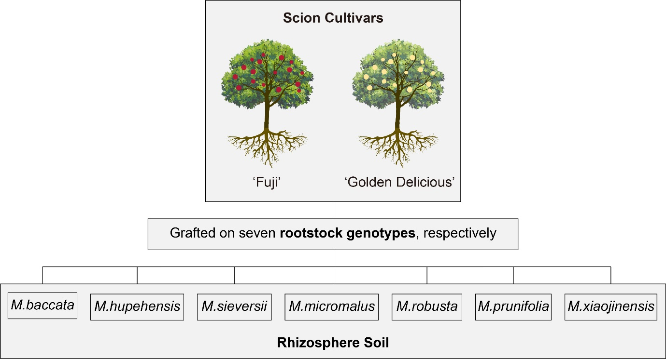

Fig. S2
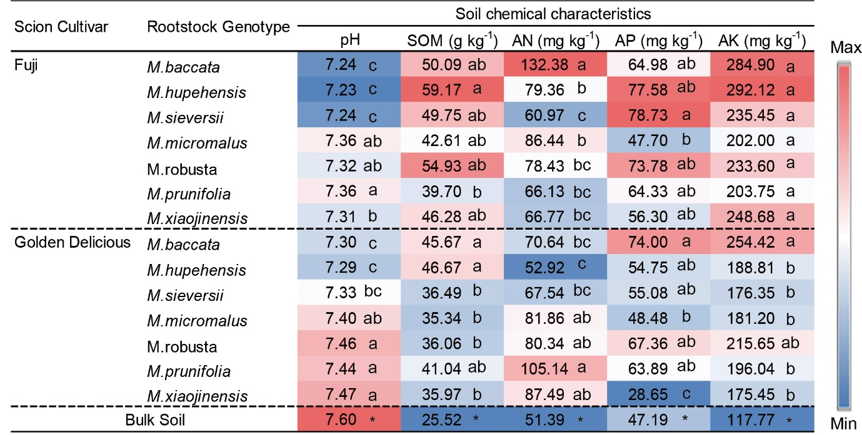

Fig. S3
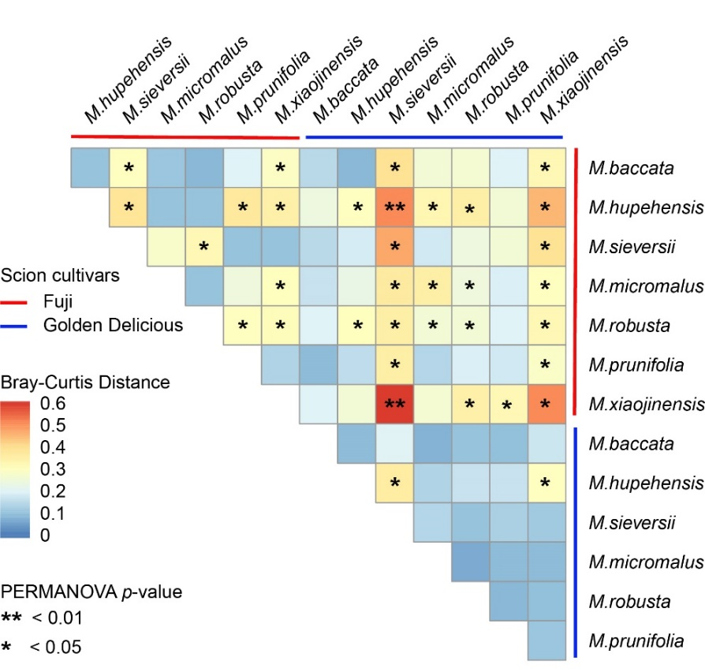
Fig. S4
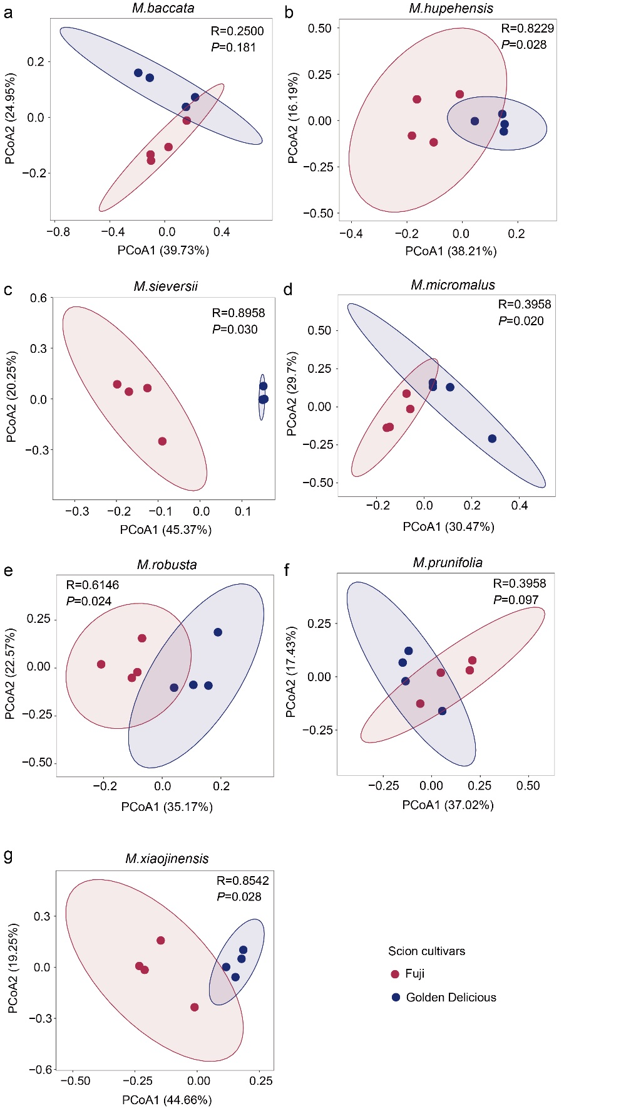

Fig. S5
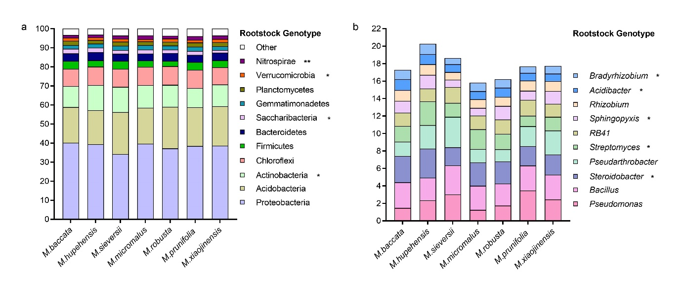

Fig. S6
