Figure S1. ESRD patients had a different β diversity (Bray-Curtis distance metrics) compared to the general population at different taxonomy levels in the discovery cohort and validation cohort
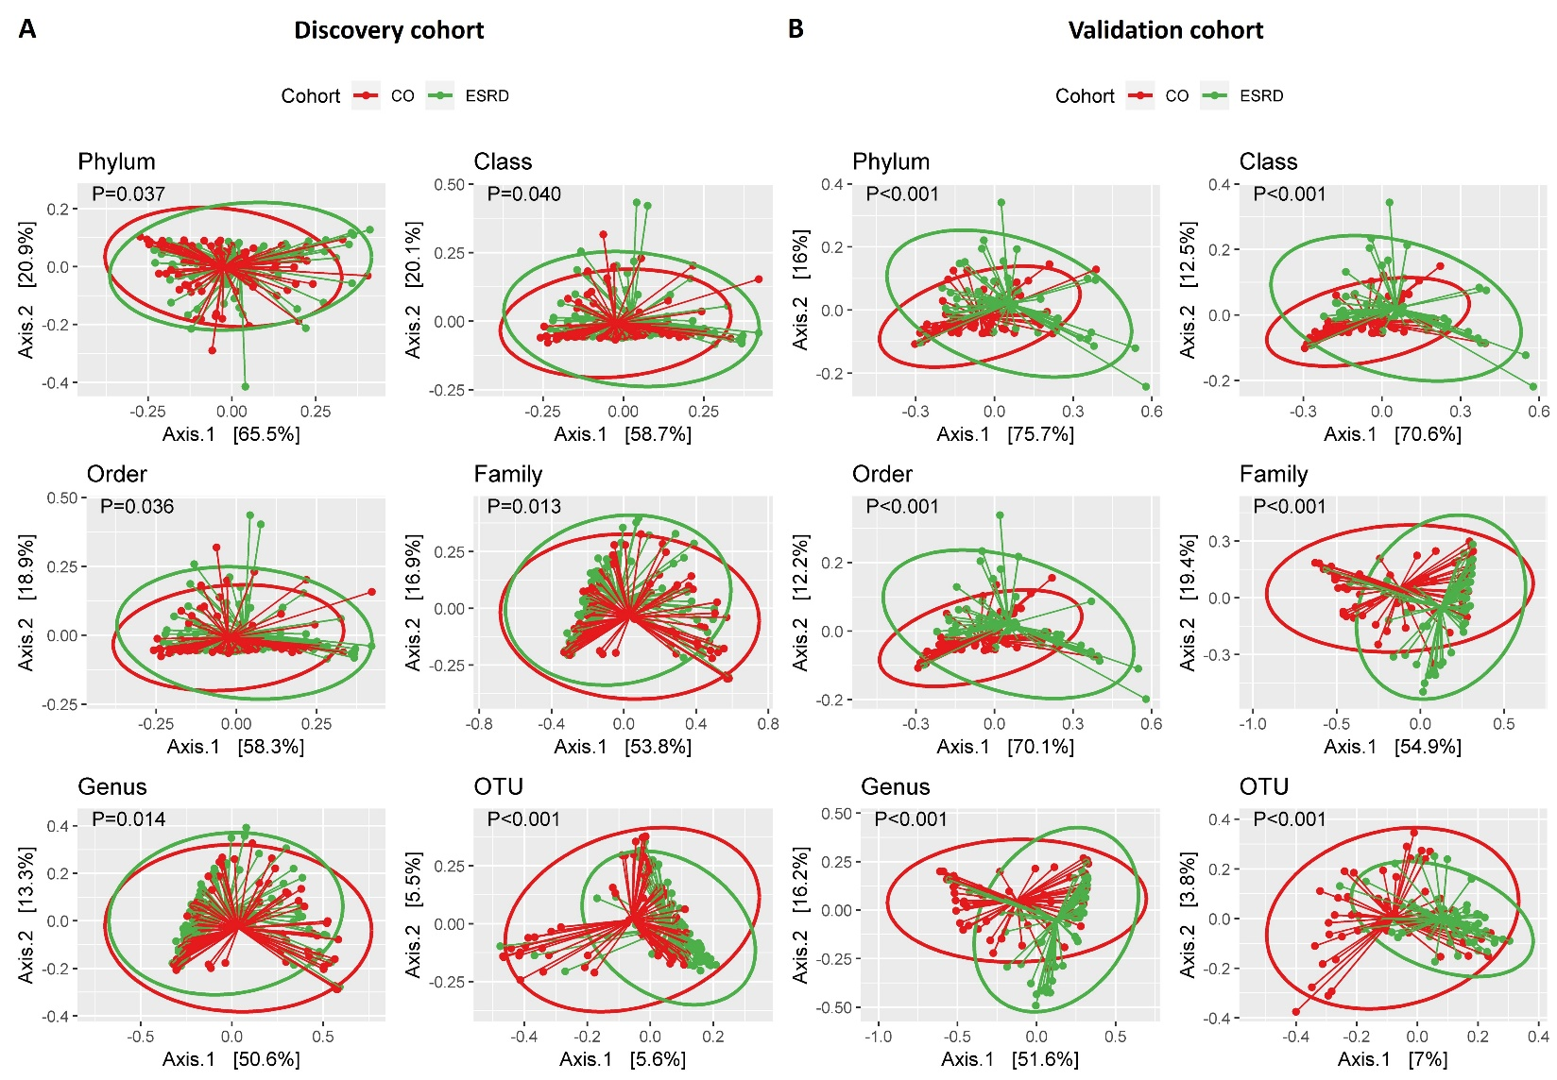
Figure S2. Fecal microbiota composition profiles and the top microbial relative abundance difference between ESRD and control subjects at different taxonomy levels in the discovery cohort. The selected different taxonomy was presented. (A) Phylum level (B) Class level (C) Order level (D) Family level (E) Genus level (F) Species level
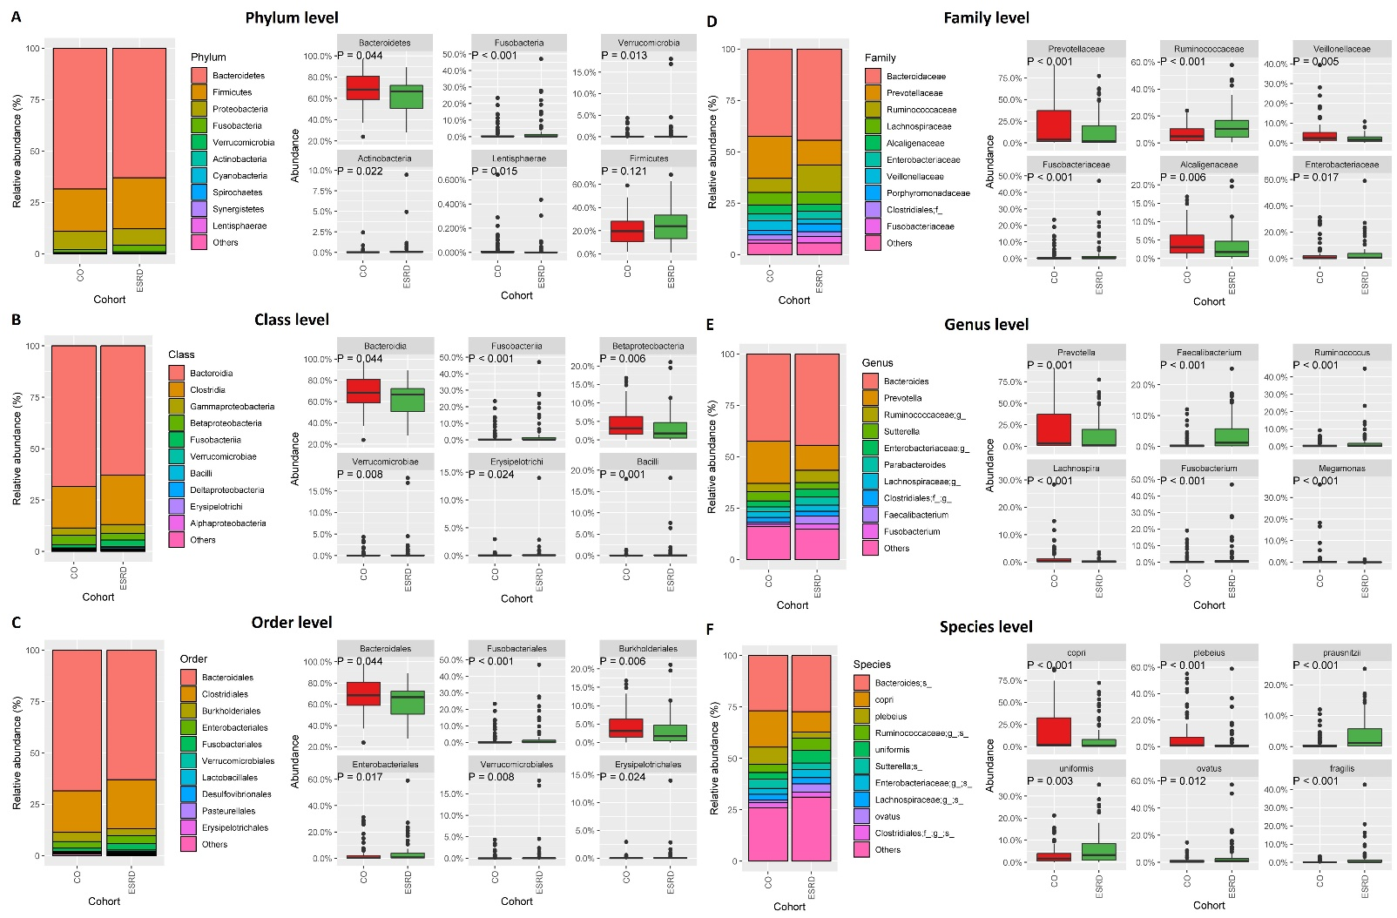
Figure S3. LEfSe analysis with linear discriminant analysis (LDA) scores representing microbial differences between groups at different taxonomy levels in the discovery cohort. Green indicates taxa enriched in the ESRD group and red indicates taxa enriched in the control group
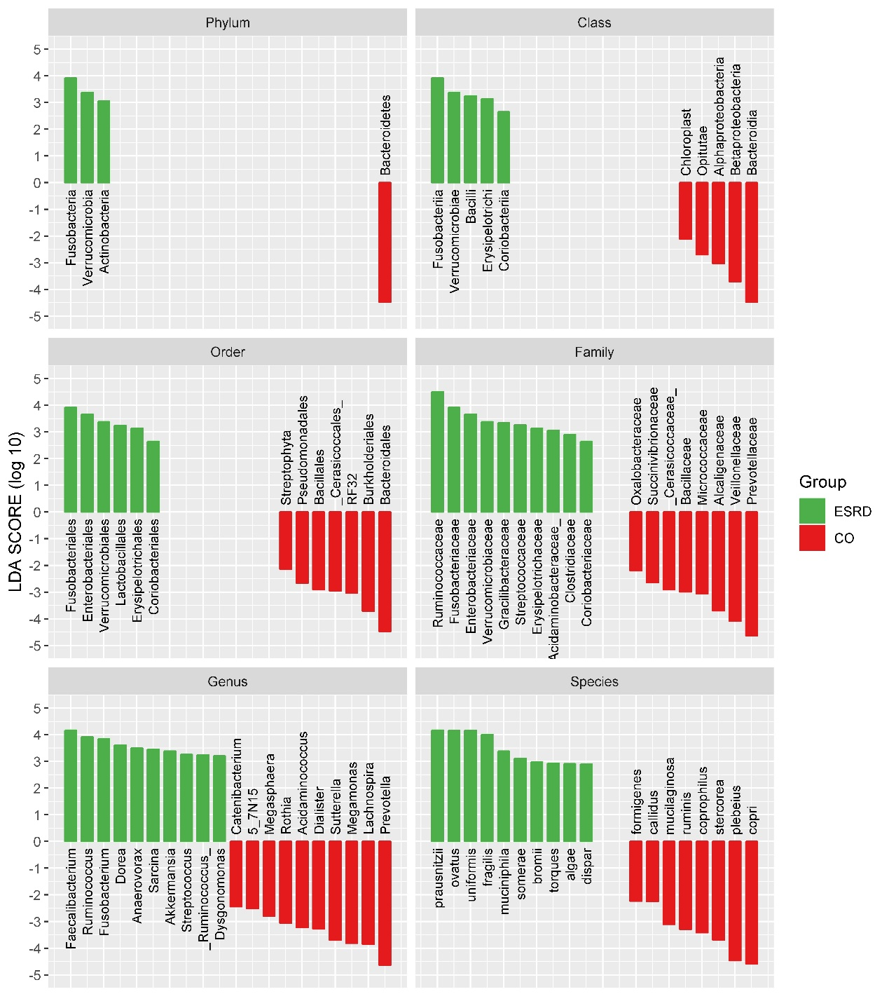

Figure S4. The microbial dysbiosis index (MDI) between ESRD patients and control subjects across different taxonomy levels. The differentiate accuracy of MDI between ESRD patients and control subjects across different taxonomy levels in the discovery cohort and confirmed the differentiate accuracy of MDI in the validation cohort

Figure S5. Enrichment analysis was performed to identify gene functions of differential abundances in gut microbiota between ESRD patients and control subjects. Functional classification of the predicted metagenome content of the microbiota of ESRD using clusters of Orthologous Groups (COG) in the discovery cohort and validation cohort. Significance was considered for an adjusted P<0.05.
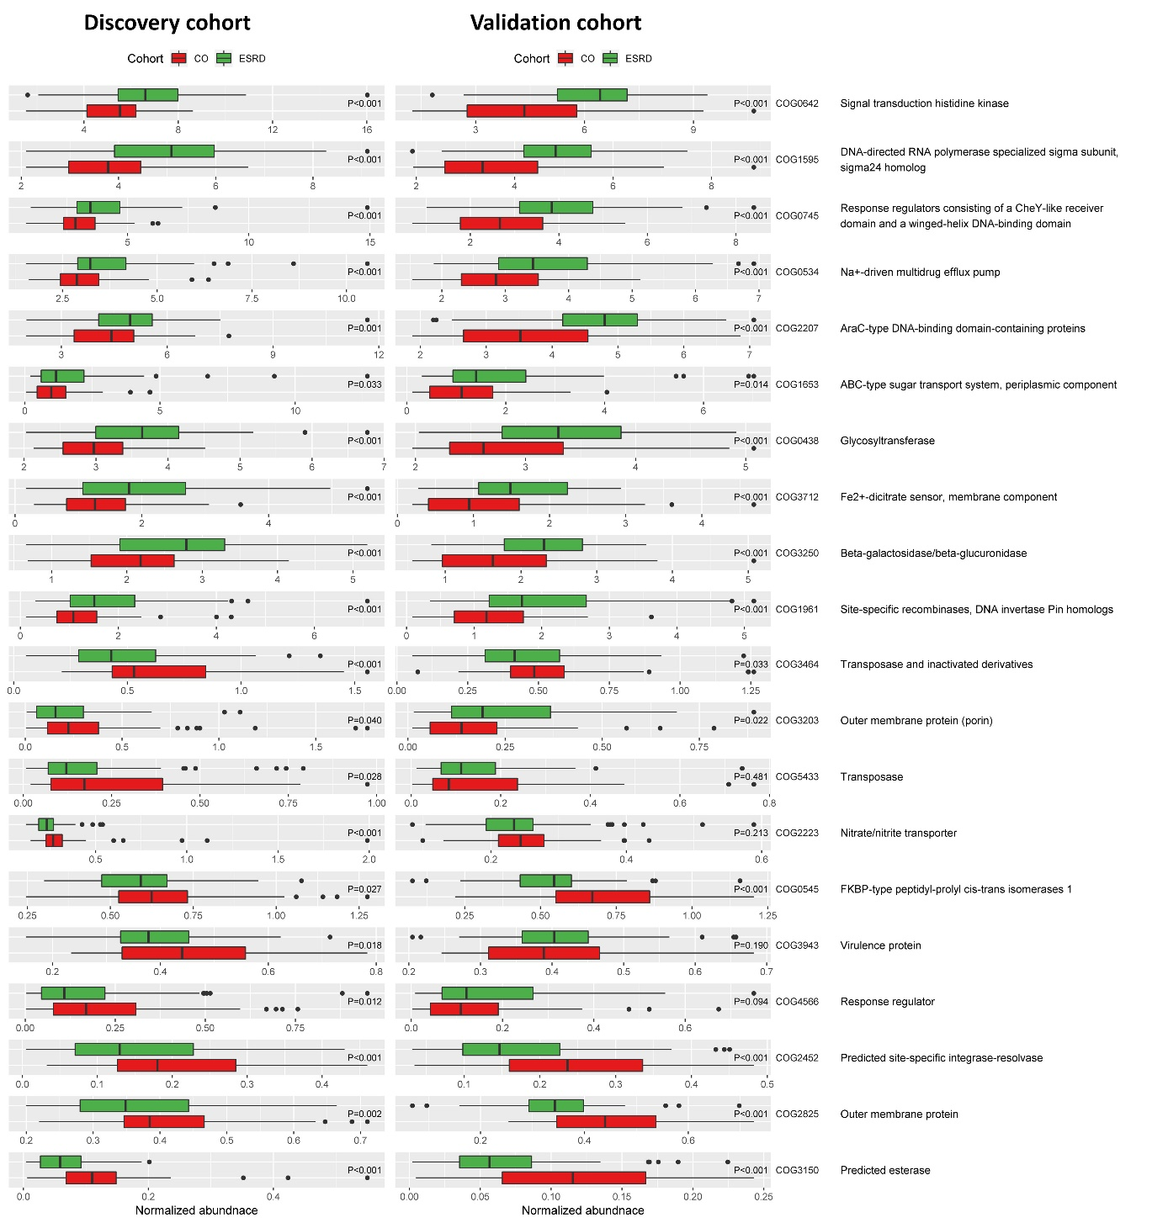

Figure S6. Enrichment analysis was performed to identify gene functions of differential abundances in gut microbiota between ESRD patients and control subjects. Functional classification of the predicted metagenome content of the microbiota of ESRD using the Kyoto Encyclopedia of Genes and Genome (KEGG) in the discovery cohort and validation cohort. Significance was considered for an adjusted P<0.05.
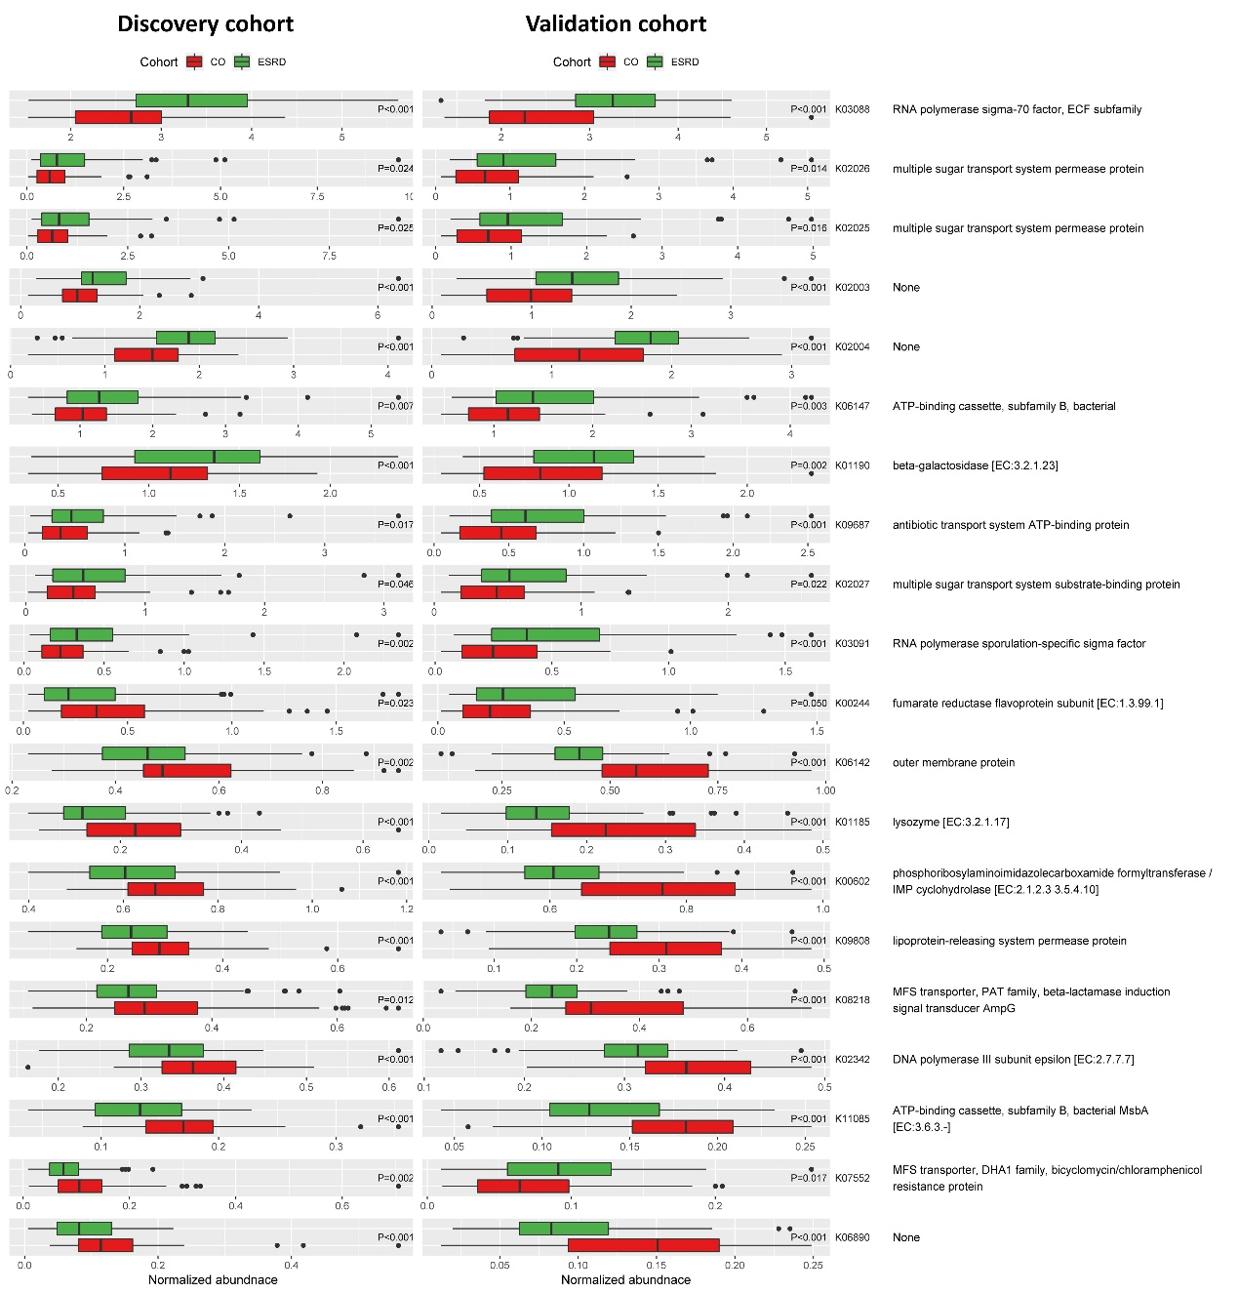

Figure S7. Normalized protein catabolic rate (nPCR) and alpha diversity relationship in the discovery cohort. The alpha diversity difference was evaluated between nPCR >1.2 and ≦1.2 g/kg per day.
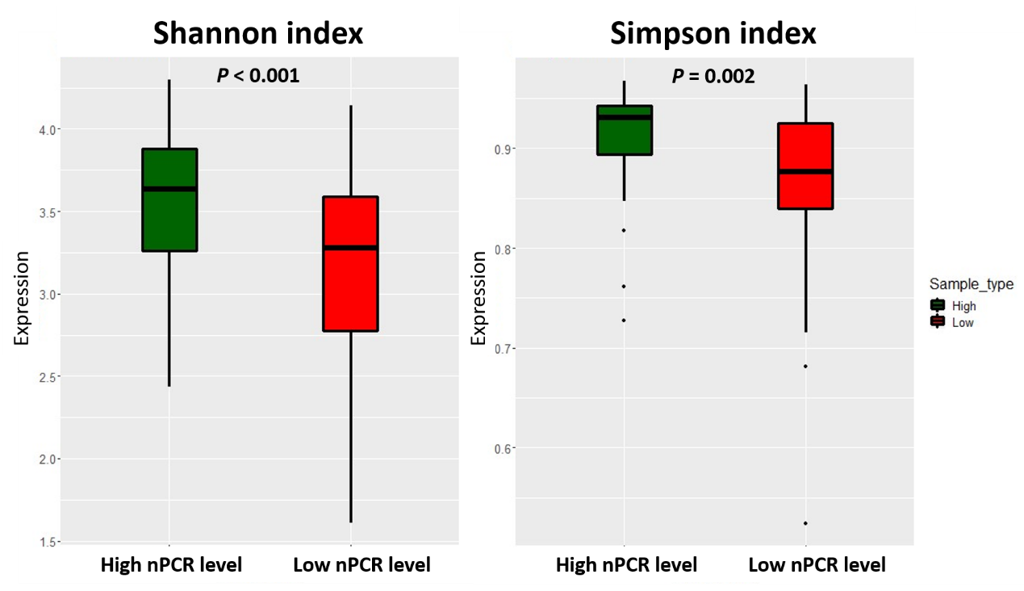

Table S1. The specifically increased taxa in ESRD patients using LEfSe analysis
Rank | Taxonomy | LDA SCORE (log 10) | P value
Phylum | Bacteria/Fusobacteria | 3.920103 | 0.0000691
Phylum | Bacteria/Verrucomicrobia | 3.383386 | 0.0134167
Phylum | Bacteria/Actinobacteria | 3.054974 | 0.0217006
Class | Bacteria/Fusobacteria/Fusobacteriia | 3.920103 | 0.0000691
Class | Bacteria/Verrucomicrobia/Verrucomicrobiae | 3.383824 | 0.0077437
Class | Bacteria/Firmicutes/Bacilli | 3.24738 | 0.001018
Class | Bacteria/Firmicutes/Erysipelotrichi | 3.141399 | 0.023859
Class | Bacteria/Actinobacteria/Coriobacteriia | 2.650478 | 0.0291007
Order | Bacteria/Fusobacteria/Fusobacteriia/Fusobacteriales | 3.920103 | 0.0000691
Order | Bacteria/Proteobacteria/Gammaproteobacteria/Enterobacteriales | 3.663546 | 0.0166552
Order | Bacteria/Verrucomicrobia/Verrucomicrobiae/Verrucomicrobiales | 3.383824 | 0.0077437
Order | Bacteria/Firmicutes/Bacilli/Lactobacillales | 3.23963 | 0.0084307
Order | Bacteria/Firmicutes/Erysipelotrichi/Erysipelotrichales | 3.141399 | 0.023859
Order | Bacteria/Actinobacteria/Coriobacteriia/Coriobacteriales | 2.650478 | 0.0291007
Family | Bacteria/Firmicutes/Clostridia/Clostridiales/Ruminococcaceae | 4.509364 | 0.0001515
Family | Bacteria/Fusobacteria/Fusobacteriia/Fusobacteriales/Fusobacteriaceae | 3.920116 | 0.0000644
Family | Bacteria/Proteobacteria/Gammaproteobacteria/Enterobacteriales/Enterobacteriaceae | 3.663546 | 0.0166552
Family | Bacteria/Verrucomicrobia/Verrucomicrobiae/Verrucomicrobiales/Verrucomicrobiaceae | 3.383824 | 0.0077437
Family | Bacteria/Firmicutes/Clostridia/Clostridiales/Gracilibacteraceae | 3.342979 | 0.0235943
Family | Bacteria/Firmicutes/Bacilli/Lactobacillales/Streptococcaceae | 3.258525 | 0.0022361
Family | Bacteria/Firmicutes/Erysipelotrichi/Erysipelotrichales/Erysipelotrichaceae | 3.141399 | 0.023859
Family | Bacteria/Firmicutes/Clostridia/Clostridiales/Acidaminobacteraceae | 3.056344 | 0.0435423
Family | Bacteria/Firmicutes/Clostridia/Clostridiales/Clostridiaceae | 2.907775 | 0.0002242
Family | Bacteria/Actinobacteria/Coriobacteriia/Coriobacteriales/Coriobacteriaceae | 2.650478 | 0.0291007
Genus | Bacteria/Firmicutes/Clostridia/Clostridiales/Ruminococcaceae/Faecalibacterium | 4.172362 | 0.0000006
Genus | Bacteria/Firmicutes/Clostridia/Clostridiales/Ruminococcaceae/Ruminococcus | 3.916102 | 0.000949
Genus | Bacteria/Fusobacteria/Fusobacteriia/Fusobacteriales/Fusobacteriaceae/Fusobacterium | 3.84715 | 0.0000522
Genus | Bacteria/Firmicutes/Clostridia/Clostridiales/Lachnospiraceae/Dorea | 3.605967 | 0.0000001
Genus | Bacteria/Firmicutes/Clostridia/Clostridiales/Mogibacteriaceae/Anaerovorax | 3.4941 | 0.0435423
Genus | Bacteria/Firmicutes/Clostridia/Clostridiales/Clostridiaceae/Sarcina | 3.457268 | 0.0128686
Genus | Bacteria/Verrucomicrobia/Verrucomicrobiae/Verrucomicrobiales/Verrucomicrobiaceae/Akkermansia | 3.383824 | 0.0077437
Genus | Bacteria/Firmicutes/Bacilli/Lactobacillales/Streptococcaceae/Streptococcus | 3.257598 | 0.0030936
Genus | Bacteria/Firmicutes/Clostridia/Clostridiales/Lachnospiraceae/Ruminococcus | 3.235997 | 0.0024538
Genus | Bacteria/Bacteroidetes/Bacteroidia/Bacteroidales/Porphyromonadaceae/Dysgonomonas | 3.203687 | 0.0435423
Genus | Bacteria/Fusobacteria/Fusobacteriia/Fusobacteriales/Fusobacteriaceae/Cetobacterium | 3.063004 | 0.0000981
Genus | Bacteria/Firmicutes/Clostridia/Clostridiales/Lachnospiraceae/Blautia | 3.058698 | 0.0000002
Genus | Bacteria/Bacteroidetes/Bacteroidia/Bacteroidales/Paraprevotellaceae/CF231 | 2.881444 | 0.0435423
Genus | Bacteria/Proteobacteria/Deltaproteobacteria/Desulfovibrionales/Desulfovibrionaceae/Desulfovibrio | 2.748763 | 0.0001765
Genus | Bacteria/Firmicutes/Clostridia/Clostridiales/Lachnospiraceae/Lachnobacterium | 2.675704 | 0.0035147
Genus | Bacteria/Proteobacteria/Gammaproteobacteria/Enterobacteriales/Enterobacteriaceae/Plesiomonas | 2.659065 | 0.016778
Genus | Bacteria/Actinobacteria/Coriobacteriia/Coriobacteriales/Coriobacteriaceae/Eggerthella | 2.547738 | 0.0049035
Genus | Bacteria/Firmicutes/Clostridia/Clostridiales/Lachnospiraceae/Epulopiscium | 2.504292 | 0.0182707
Genus | Bacteria/Firmicutes/Erysipelotrichi/Erysipelotrichales/Erysipelotrichaceae/Eubacterium | 2.460558 | 0.0202149
Genus | Bacteria/Firmicutes/Clostridia/Clostridiales/Clostridiaceae/Clostridium | 2.441898 | 0.0003566
Genus | Bacteria/Synergistetes/Synergistia/Synergistales/Synergistaceae/Cloacibacillus | 2.375512 | 0.0064462
Genus | Bacteria/Actinobacteria/Coriobacteriia/Coriobacteriales/Coriobacteriaceae/Adlercreutzia | 2.369857 | 0.0499937
Genus | Bacteria/Firmicutes/Bacilli/Lactobacillales/Streptococcaceae/Lactococcus | 2.322076 | 0.024907
Species | Bacteria/Firmicutes/Clostridia/Clostridiales/Ruminococcaceae/Faecalibacterium/prausnitzii | 4.172179 | 0.0000006
Species | Bacteria/Bacteroidetes/Bacteroidia/Bacteroidales/Bacteroidaceae/Bacteroides/ovatus | 4.158188 | 0.0116526
Species | Bacteria/Bacteroidetes/Bacteroidia/Bacteroidales/Bacteroidaceae/Bacteroides/uniformis | 4.158142 | 0.0033153
Species | Bacteria/Bacteroidetes/Bacteroidia/Bacteroidales/Bacteroidaceae/Bacteroides/fragilis | 4.011899 | 0.0000003
Species | Bacteria/Verrucomicrobia/Verrucomicrobiae/Verrucomicrobiales/Verrucomicrobiaceae/Akkermansia/muciniphila | 3.383824 | 0.0077437
Species | Bacteria/Fusobacteria/Fusobacteriia/Fusobacteriales/Fusobacteriaceae/Cetobacterium/somerae | 3.1049 | 0.0000981
Species | Bacteria/Firmicutes/Clostridia/Clostridiales/Ruminococcaceae/Ruminococcus/bromii | 2.984 | 0.0228212
Species | Bacteria/Firmicutes/Clostridia/Clostridiales/Lachnospiraceae/Ruminococcus/torques | 2.933836 | 0.0114322
Species | Bacteria/Proteobacteria/Gammaproteobacteria/Alteromonadales/Shewanellaceae/Shewanella/algae | 2.915685 | 0.0435423
Species | Bacteria/Firmicutes/Clostridia/Clostridiales/Veillonellaceae/Veillonella/dispar | 2.895515 | 0.0295813
Species | Bacteria/Proteobacteria/Gammaproteobacteria/Enterobacteriales/Enterobacteriaceae/Plesiomonas/shigelloides | 2.693849 | 0.016778
Species | Bacteria/Firmicutes/Clostridia/Clostridiales/Lachnospiraceae/Blautia/producta | 2.638195 | 0.0000001
Species | Bacteria/Actinobacteria/Coriobacteriia/Coriobacteriales/Coriobacteriaceae/Eggerthella/lenta | 2.530905 | 0.0038118
Species | Bacteria/Firmicutes/Clostridia/Clostridiales/Lachnospiraceae/Ruminococcus/gnavus | 2.447187 | 0.0000001
Species | Bacteria/Actinobacteria/Actinobacteria/Bifidobacteriales/Bifidobacteriaceae/Bifidobacterium/longum | 2.404243 | 0.033939
Species | Bacteria/Firmicutes/Bacilli/Lactobacillales/Lactobacillaceae/Lactobacillus/mucosae | 2.235501 | 0.0319161
Species | Bacteria/Bacteroidetes/Bacteroidia/Bacteroidales/Bacteroidaceae/Bacteroides/acidifaciens | 2.148846 | 0.0000896
Species | Bacteria/Actinobacteria/Coriobacteriia/Coriobacteriales/Coriobacteriaceae/Collinsella/stercoris | 2.136292 | 0.0000005
Species | Bacteria/Firmicutes/Clostridia/Clostridiales/Clostridiaceae/Clostridium/perfringens | 2.025368 | 0.0046645
Species | Bacteria/Firmicutes/Erysipelotrichi/Erysipelotrichales/Erysipelotrichaceae/Eubacterium/dolichum | 2.018457 | 0.0010037

Table S2. The full results of GMM enrichment analysis. The GMM enrichment analysis was performed in discovery and validation cohorts contrasting to their respective matched healthy groups. Significance (P value) was tested by a two-tailed Wilcoxon test and adjusted by false-discovery rate correction.
 |  | Discovery cohort |  | Validation cohort
GMM No. | Name | P value | FDR-adjusted P value | P value | FDR-adjusted P value
MF0001 | arabinoxylan degradation | 0.270574 | 0.339074 | 0.011993 | 0.015575
MF0002 | fructan degradation | 0.676185 | 0.695042 | 0.006705 | 0.009061
MF0003 | pectin degradation I | 0.287692 | 0.356019 | 0.009441 | 0.012422
MF0004 | pectine degradation II | 0.035884 | 0.0725 | 0.000454 | 0.000797
MF0005 | starch degradation | 0.523459 | 0.563287 | 0.002221 | 0.003266
MF0006 | lactose degradation | 0.000301 | 0.001987 | 0.002347 | 0.003401
MF0007 | lactose and galactose degradation | 0.011762 | 0.034248 | 0.021305 | 0.026969
MF0008 | maltose degradation | 0.00357 | 0.013593 | 3.78E-07 | 3.43E-06
MF0009 | melibiose degradation | 0.006796 | 0.021026 | 0.037881 | 0.047351
MF0010 | sucrose degradation I | 0.012907 | 0.03637 | 0.014441 | 0.018514
MF0011 | sucrose degradation II | 0.006339 | 0.02092 | 1.56E-07 | 3.43E-06
MF0012 | trehalose degradation | 0.443506 | 0.490012 | 0.005573 | 0.007635
MF0013 | allose degradation | 0.005677 | 0.019381 | 0.001123 | 0.001782
MF0014 | arabinose degradation | 0.000568 | 0.003122 | 7.7E-05 | 0.000188
MF0015 | fructose degradation | 0.14423 | 0.211384 | 0.003948 | 0.005483
MF0016 | fucose degradation | 0.000275 | 0.001948 | 3.67E-07 | 3.43E-06
MF0017 | galactose degradation | 0.018048 | 0.045814 | 0.124779 | 0.146798
MF0018 | mannose degradation | 0.131158 | 0.199764 | 0.986784 | 0.986784
MF0019 | rhamnose degradation | 0.01415 | 0.037861 | 0.000162 | 0.000325
MF0020 | ribose degradation | 0.004975 | 0.017592 | 1.79E-06 | 1.19E-05
MF0021 | xylose degradation | 0.00074 | 0.003796 | 4.62E-07 | 3.85E-06
MF0022 | galacturonate degradation I | 0.017573 | 0.045782 | 1.6E-06 | 1.14E-05
MF0024 | phenylalanine degradation | 0.090318 | 0.151551 | 2.71E-05 | 9.04E-05
MF0025 | tryptophan degradation | 0.002273 | 0.009377 | 2.43E-07 | 3.43E-06
MF0026 | tyrosine degradation I | 0.103344 | 0.167563 | 0.000199 | 0.000368
MF0027 | tyrosine degradation II | 0.681001 | 0.695042 | 0.37401 | 0.402161
MF0028 | aspartate degradation I | 0.226175 | 0.290796 | 0.053288 | 0.065787
MF0029 | aspartate degradation II | 0.006597 | 0.021026 | 0.001101 | 0.001782
MF0030 | glutamate degradation I | 0.034177 | 0.071067 | 0.442778 | 0.466082
MF0031 | glutamate degradation II | 4.62E-06 | 0.000458 | 1.12E-06 | 8.58E-06
MF0032 | glutamate degradation III | 0.205449 | 0.267624 | 0.001237 | 0.001933
MF0033 | alanine degradation I | 0.14973 | 0.211384 | 0.000757 | 0.001304
MF0034 | alanine degradation II | 2.02E-05 | 0.000473 | 3.29E-05 | 0.000103
MF0035 | glycine degradation | 0.029223 | 0.065752 | 6.4E-05 | 0.000173
MF0036 | isoleucine degradation | 0.034457 | 0.071067 | 3.51E-06 | 1.95E-05
MF0037 | leucine degradation | 0.357124 | 0.420897 | 2.92E-05 | 9.41E-05
MF0038 | methionine degradation I | 0.585109 | 0.622858 | 0.947171 | 0.966501
MF0039 | methionine degradation II | 0.027793 | 0.065071 | 0.001443 | 0.002219
MF0040 | proline degradation | 0.008763 | 0.02629 | 0.000106 | 0.00024
MF0041 | valine degradation | 0.074665 | 0.129681 | 1.03E-05 | 4.04E-05
MF0042 | asparagine degradation | 0.831297 | 0.831297 | 0.89126 | 0.918824
MF0043 | cysteine biosynthesis/homocysteine degradation | 0.04015 | 0.077939 | 1.05E-05 | 4.04E-05
MF0044 | cysteine degradation I | 0.000106 | 0.001045 | 0.001123 | 0.001782
MF0045 | cysteine degradation II | 0.104939 | 0.167563 | 0.081012 | 0.096443
MF0046 | glutamine degradation I | 1.18E-05 | 0.000473 | 2.99E-07 | 3.43E-06
MF0047 | glutamine degradation II | 0.000814 | 0.003796 | 1.39E-05 | 5.15E-05
MF0048 | serine degradation | 0.024479 | 0.059108 | 0.000162 | 0.000325
MF0049 | threonine degradation I | 6.45E-05 | 0.000912 | 3.46E-07 | 3.43E-06
MF0050 | threonine degradation II | 0.000156 | 0.001283 | 1.34E-07 | 3.43E-06
MF0051 | arginine degradation I | 0.504375 | 0.548715 | 0.328404 | 0.356961
MF0052 | arginine degradation II | 0.163181 | 0.2213 | 7.02E-05 | 0.000176
MF0053 | arginine degradation III | 0.09829 | 0.162178 | 0.30039 | 0.333767
MF0054 | arginine degradation IV | 5.01E-05 | 0.000827 | 3.46E-07 | 3.43E-06
MF0055 | arginine degradation V | 0.445465 | 0.490012 | 0.00108 | 0.001782
MF0056 | histidine degradation | 0.000534 | 0.00311 | 1.05E-05 | 4.04E-05
MF0057 | lysine degradation I | 0.001455 | 0.006262 | 1.94E-06 | 1.21E-05
MF0058 | lysine degradation II | 0.063146 | 0.117003 | 3.71E-05 | 0.000112
MF0059 | anaerobic fatty acid beta-oxidation | 0.649936 | 0.677301 | 6.86E-05 | 0.000176
MF0060 | glycerol degradation I | 0.147879 | 0.211384 | 0.000166 | 0.000326
MF0061 | glycerol degradation II | 0.000133 | 0.001193 | 3.46E-07 | 3.43E-06
MF0062 | glycerol degradation III | 2.39E-05 | 0.000473 | 0.000185 | 0.000356
MF0063 | glyoxylate bypass | 0.023655 | 0.058547 | 6.25E-05 | 0.000173
MF0064 | triacylglycerol degradation | 0.013226 | 0.03637 | 0.647335 | 0.674307
MF0065 | Bifidobacterium shunt | 0.000843 | 0.003796 | 0.000189 | 0.000358
MF0066 | Entner-Doudoroff pathway | 1.8E-05 | 0.000473 | 6.45E-06 | 3.07E-05
MF0067 | glycolysis (preparatory phase) | 0.110699 | 0.172378 | 0.000941 | 0.001596
MF0068 | glycolysis (pay-off phase) | 0.151599 | 0.211384 | 0.003308 | 0.00466
MF0069 | NADH:ferredoxin oxidoreductase | 0.147692 | 0.211384 | 0.008925 | 0.011899
MF0070 | pentose phosphate pathway (oxidative phase) | 9.22E-05 | 0.001028 | 5.66E-06 | 2.98E-05
MF0071 | pentose phosphate pathway (non-oxidative branch) | 0.245667 | 0.311808 | 0.167459 | 0.192481
MF0072 | pyruvate dehydrogenase complex | 0.004875 | 0.017592 | 1.38E-07 | 3.43E-06
MF0073 | pyruvate:ferredoxin oxidoreductase | 0.036764 | 0.072793 | 0.212069 | 0.23828
MF0074 | pyruvate:formate lyase | 9.34E-05 | 0.001028 | 3.17E-07 | 3.43E-06
MF0075 | acetate to acetyl-CoA | 0.0339 | 0.071067 | 0.000106 | 0.00024
MF0076 | 4-aminobutyrate degradation | 0.061301 | 0.116708 | 9.26E-05 | 0.00022
MF0077 | formate conversion | 0.379887 | 0.437312 | 6.28E-06 | 3.07E-05
MF0078 | lactaldehyde degradation | 0.000776 | 0.003796 | 0.000136 | 0.000289
MF0079 | lactate consumption I | 0.374557 | 0.436248 | 0.000318 | 0.000568
MF0080 | lactate consumption II | 0.06382 | 0.117003 | 7.19E-06 | 3.27E-05
MF0081 | methanol conversion | 0.190095 | 0.254316 | 2.29E-06 | 1.34E-05
MF0082 | putrescine degradation | 0.077935 | 0.133026 | 2.17E-05 | 7.77E-05
MF0084 | succinate conversion to propionate | 0.142702 | 0.211384 | 0.000108 | 0.00024
MF0085 | urea degradation | 0.437659 | 0.490012 | 6.25E-05 | 0.000173
MF0086 | acetyl-CoA to acetate | 0.028263 | 0.065071 | 0.439503 | 0.466082
MF0087 | acetyl-CoA to crotonyl-CoA | 0.111437 | 0.172378 | 5.18E-05 | 0.000152
MF0088 | butyrate production I | 0.29716 | 0.358766 | 0.000274 | 0.000498
MF0089 | butyrate production II | 0.073599 | 0.129681 | 0.001499 | 0.002271
MF0090 | ethanol production I | 0.032809 | 0.071067 | 2.65E-05 | 9.04E-05
MF0092 | lactate production | 0.000207 | 0.00158 | 6.86E-05 | 0.000176
MF0093 | propionate production I | 0.070771 | 0.127388 | 0.000124 | 0.00027
MF0094 | propionate production II | 0.003045 | 0.012057 | 8.79E-06 | 3.82E-05
MF0095 | propionate production III | 0.333593 | 0.397901 | 0.061228 | 0.074669
MF0096 | succinate production | 0.787406 | 0.795441 | 0.001527 | 0.00228
MF0097 | homoacetogenesis | 0.196187 | 0.258967 | 0.973571 | 0.983405
MF0098 | hydrogen metabolism | 0.420386 | 0.478371 | 0.002867 | 0.004095
MF0100 | methanogenesis from carbon dioxide | 0.156032 | 0.214544 | 0.167319 | 0.192481
MF0101 | nitrate reduction (dissimilatory) | 0.294123 | 0.358766 | 0.000142 | 0.000296
MF0102 | sulfate reduction (dissimilatory) | 0.603323 | 0.635415 | 0.070984 | 0.085522
MF0103 | mucin degradation | 0.000461 | 0.002851 | 0.188794 | 0.214539

