Title: Epigenetic regulation of fruit shape determination by JAGGED gene in Capsella rubella

Authors: Tian-Feng Lü^{1,2,3#}, Xiao-Yu Chen^{1,2,3,4#}, Nicola Trozzi^{5#}, Wen He^{1,2,3,4}, Quan Yuan^{1,2,3,4}, Yu Han⁶, Li-Min Lu^{1,2,3,4}, Chao-Bin Li^{1,2,3,4}, Jie Cheng^{1,2,3,4}, Adrien Sicard⁷, Yao Zhang^{1,2,3,4}, Ya-Nan Su⁸, Yan-Jun Zan^{9,10}, Michael Lenhard¹¹, Hong-Zhi Kong^{1,2,3,4}, Mateusz Majda⁵, Lars Østergaard¹² and Yang Dong^{1,2,3,4}*

Supplementary Fig. 1-Fig. 6

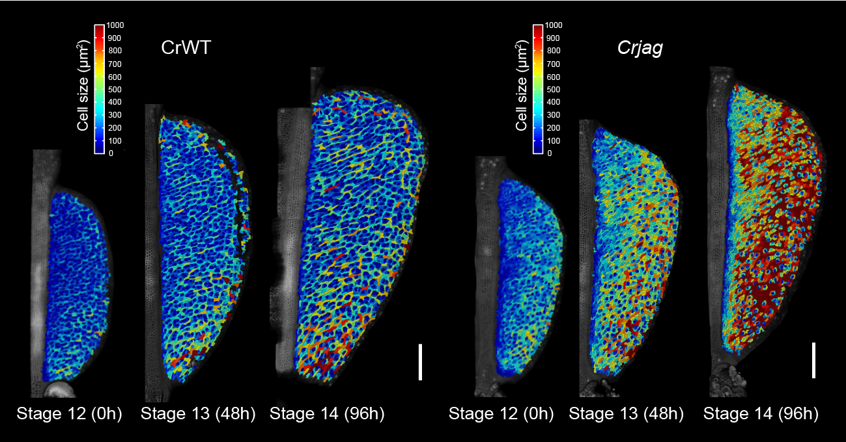
Supplementary Fig. 1 Heatmaps of cell sizes in the CrWT and Crjag fruit obtained from live-cell imaging analysis (second replicate)
Quantitative depiction of valve development using heatmaps of cell sizes in the CrWT (left panel) and Crjag (right panel) fruit during 96 h of time-lapse live-cell imaging analysis, corresponding to developmental stages 12, 13 and 14 (0 h, 48 h and 96 h, respectively). Cell size is quantified by cell area (μm²). In total, 13,086 and 8,389 cells were segmented for CrWT and Crjag fruits, respectively. Scale bars, 200 μm.

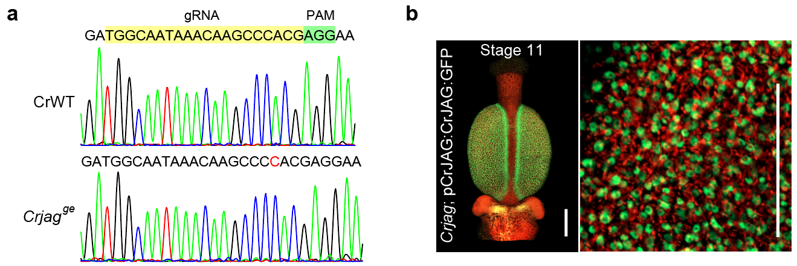
Supplementary Fig. 2 Genotyping of the Crjag^{ge} allele and expression of CrJAG:GFP proteins in the fruits
a, Sequencing results of the Crjag^{ge} allele. The single base insertion is indicated by a red letter. The guide RNA and PAM sequences are shaded in yellow and green, respectively. b, Confocal images of a stage-11 fruit from the Crjag;pCrJAG:CrJAG:GFP complemented line showing the expression and nuclear localization of the CrJAG:GFP proteins. Scale bars, 500 μm (b, left panel) and 50 μm (b, right panel)

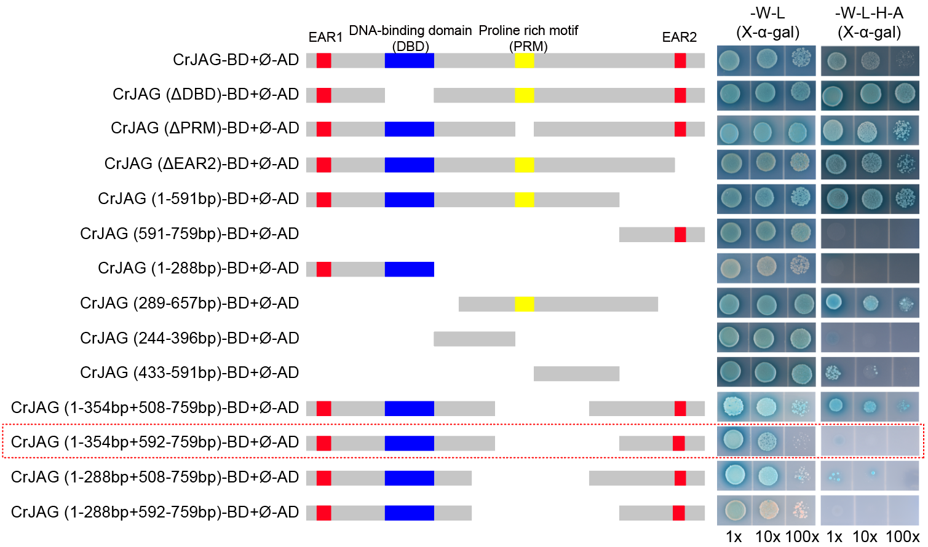
Supplementary Fig. 3 Schematic illustrations of the CrJAG protein deletions to minimize the autoactivation activity
The red box with dashed lines indicates the CrJAG proteins (1-354 bp + 592-759 bp) used in the Y2H library screening and protein-protein interaction test shown in Figure 3a and 3d.

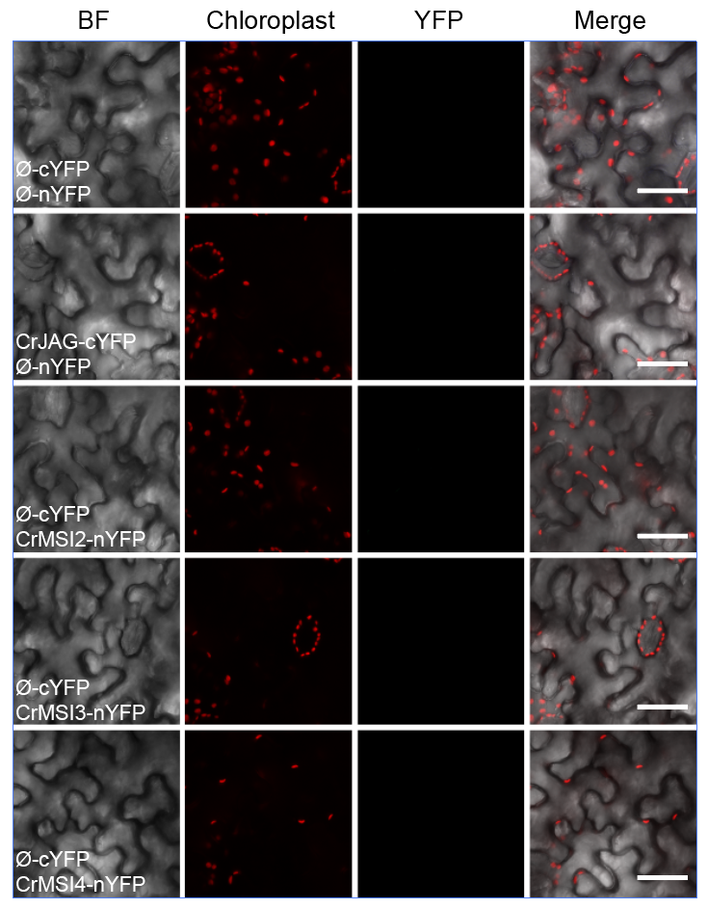
Supplementary Fig. 4 Control experiment of the BiFC analysis
Negative control experiment of BiFC experiment shown in Fig. 3e. Scale bars represent 50 μm.

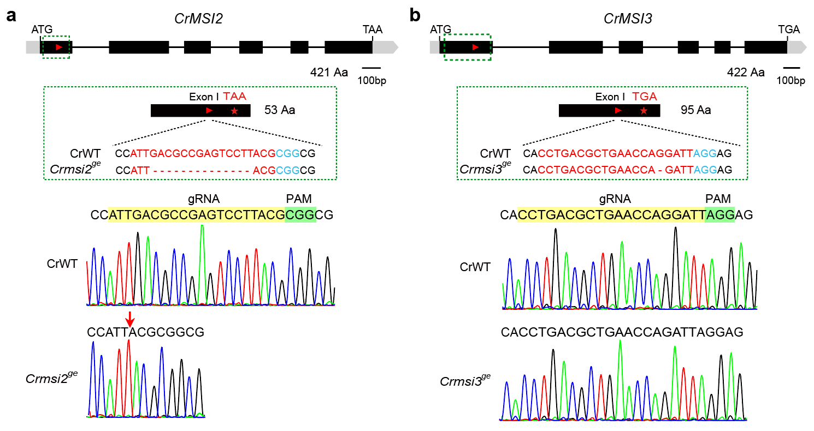
Supplementary Fig. 5 Generation of Crmsi^{ge} mutant by CRISPR/Cas9
a, Molecular characterization of the Crmsi2^{ge} mutant generated by CRISPR/Cas9. The Crmsi2^{ge} mutant was resulted from a 14-bp deletion in exon 1, which disrupts the reading frame and generates a 53 aa truncated protein. b, Molecular characterization of the Crmsi3^{ge} mutant generated by CRISPR/Cas9. The Crmsi3^{ge} mutant resulted from a 1-bp deletion in exon 1, which causes a frameshift and results in a truncated protein with 95 aa. In a,b, the red triangles indicate the gRNA target sites. The guide RNA and PAM sequences were indicated by red and blue characters, respectively.

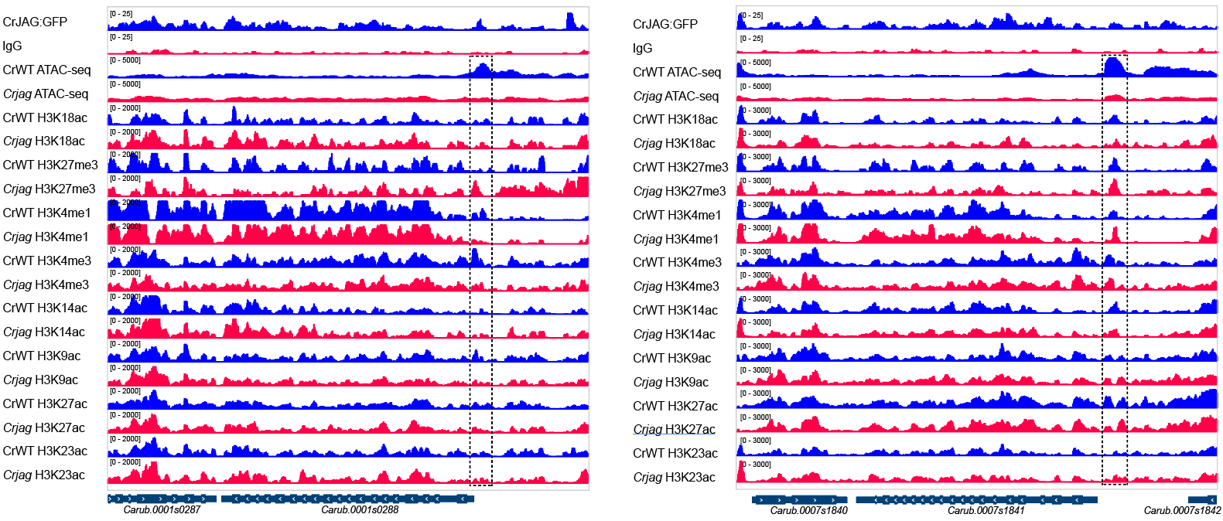
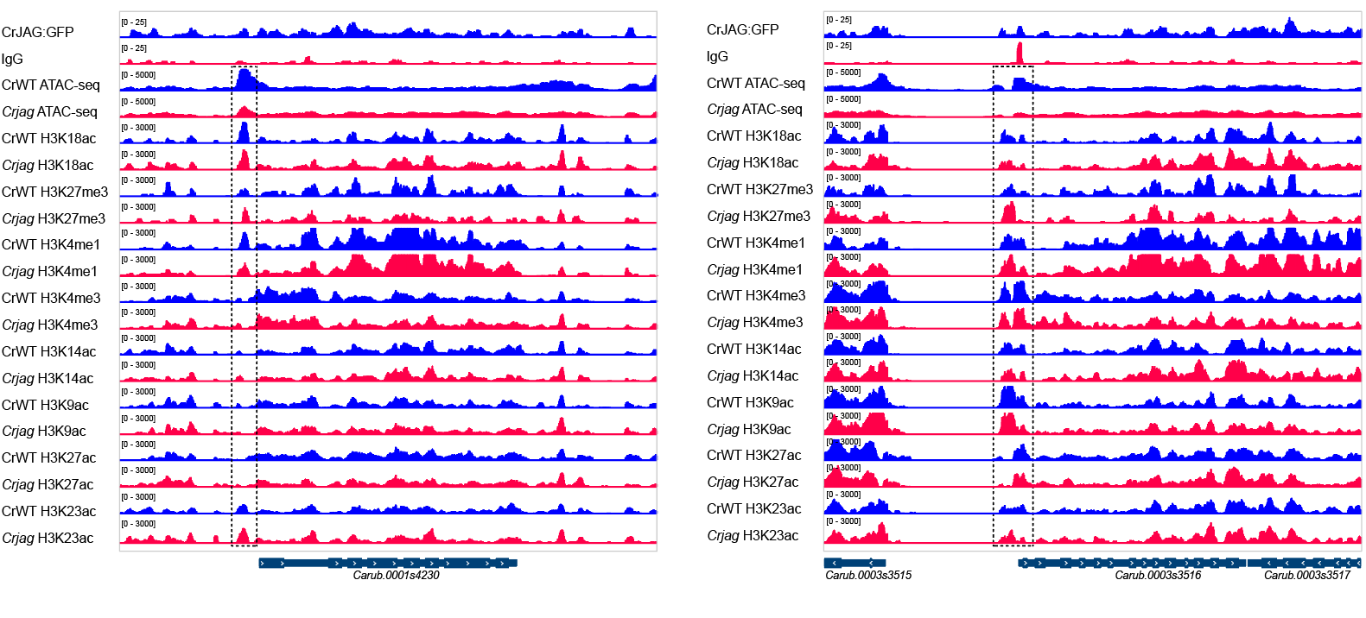
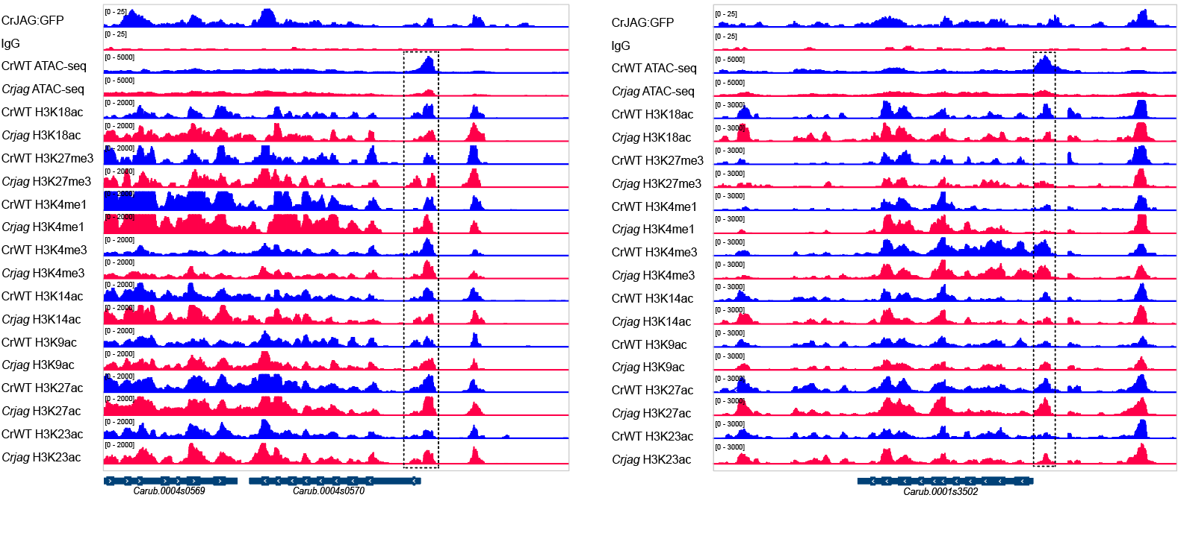
Supplementary Fig. 6 Epigenetic modification landscape of the 10 cell-cycle related genes identified in this study
The reciprocal epigenetic modification pattern—decreased H3K18ac coupled with increased H3K27me3—is evident at the Carub.0001s0599, Carub.0001s3502, and Carub.0004s0570/CrAUR2 loci. Dashed rectangles mark the regulatory regions where altered chromatin accessibility was detected.

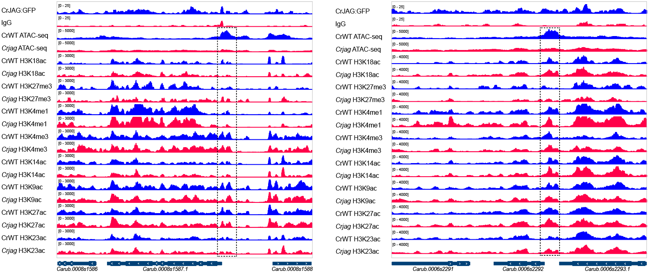
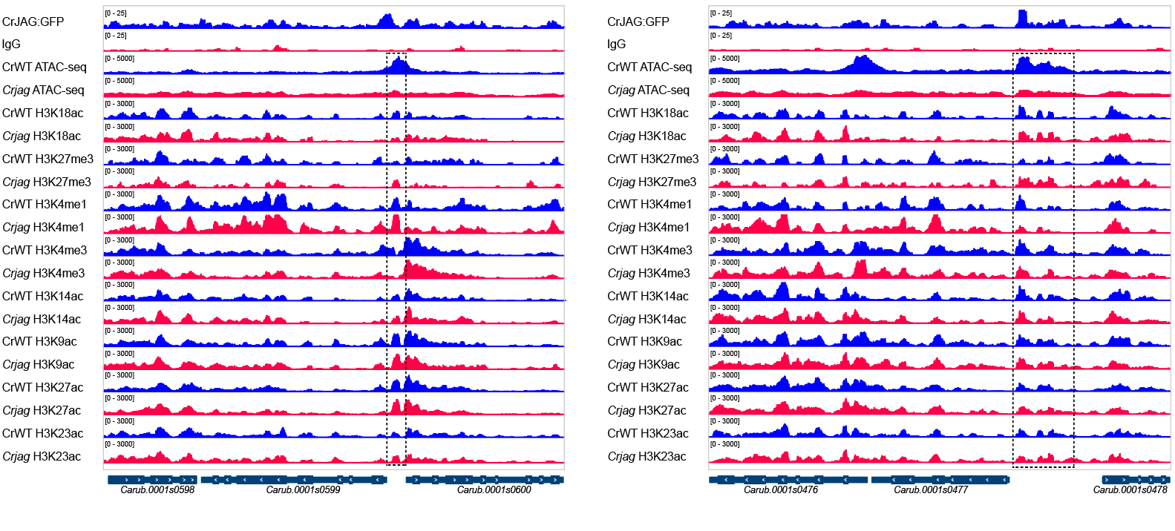
Supplementary Fig. 6 Epigenetic modification landscape of the 10 cell-cycle related genes identified in this study (Continued)
The reciprocal epigenetic modification pattern—decreased H3K18ac coupled with increased H3K27me3—is evident at the Carub.0001s0599, Carub.0001s3502, and Carub.0004s0570/CrAUR2 loci. Dashed rectangles mark the regulatory regions where altered chromatin accessibility was detected.

