Building characteristics of building samples
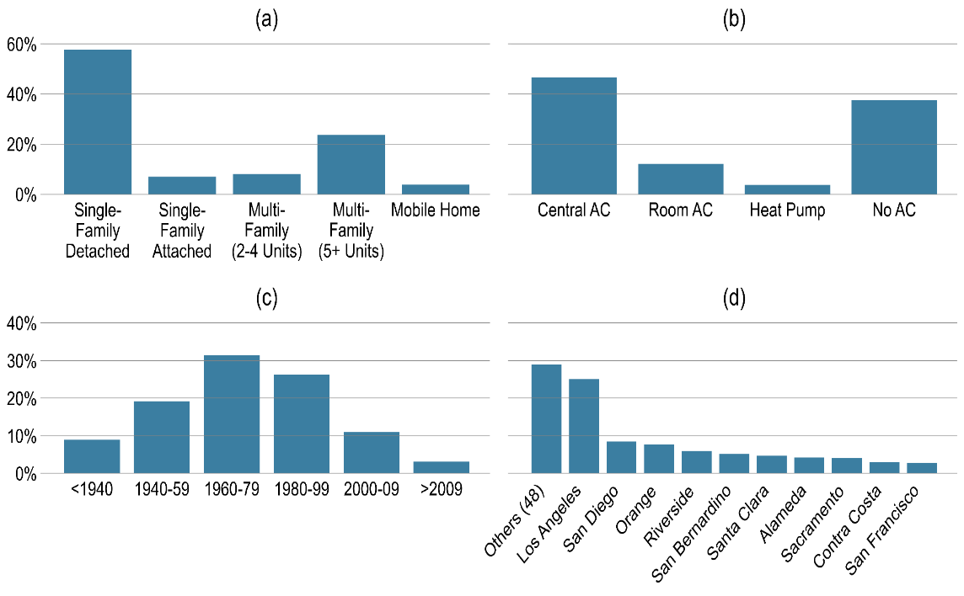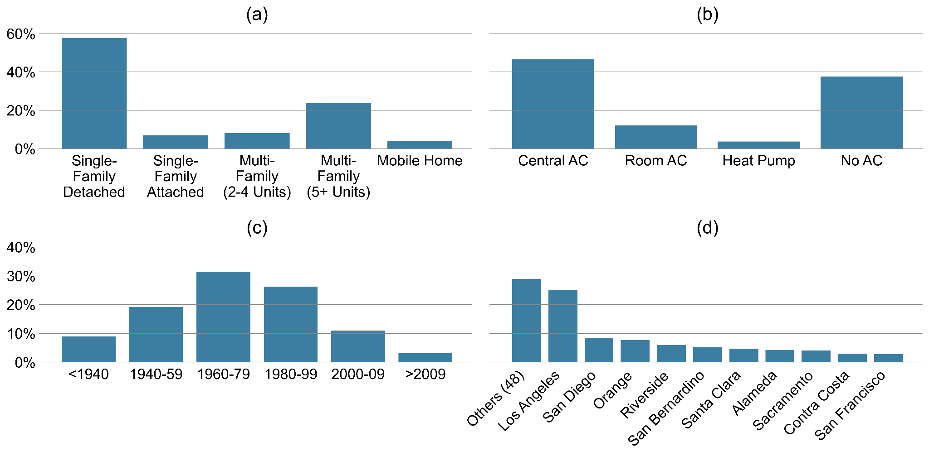
Figure S1. Vertical bar graphs derived from ResStock data illustrating key characteristics of dwelling units in the sample. The graphs detail the distribution across (a) housing types, (b) HVAC cooling system types, (c) construction years, and (d) geographic distribution by county. Subplot (d) displays the counties in descending order, starting with the top ten and grouping the remaining counties.
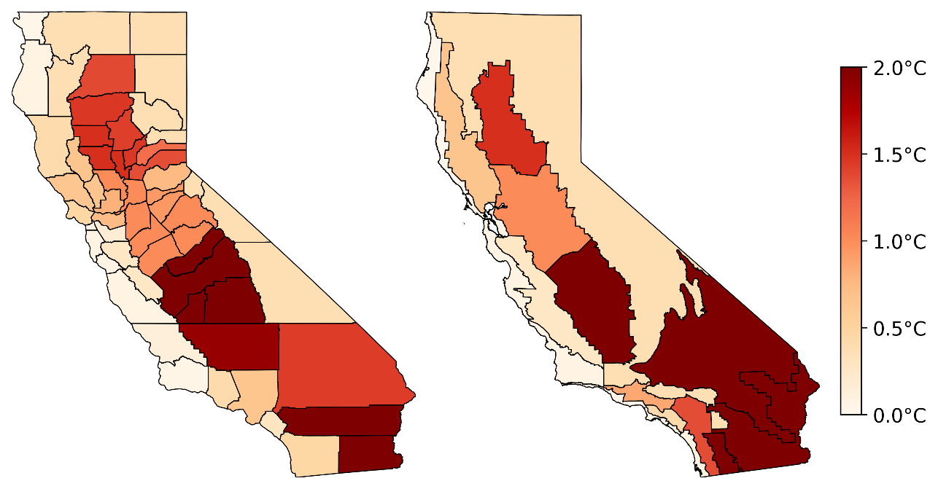
Figure S2. Outdoor overheating degree at the 26 °C threshold, defined as cumulative temperature exceedance above 26°C normalized by cooling-season hours.
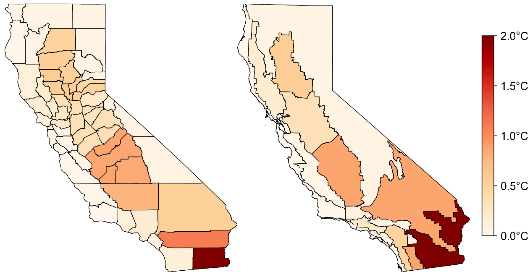
Figure S3. Outdoor overheating degree at the 30 °C threshold, defined as cumulative temperature exceedance above 30 °C normalized by cooling-season hours.
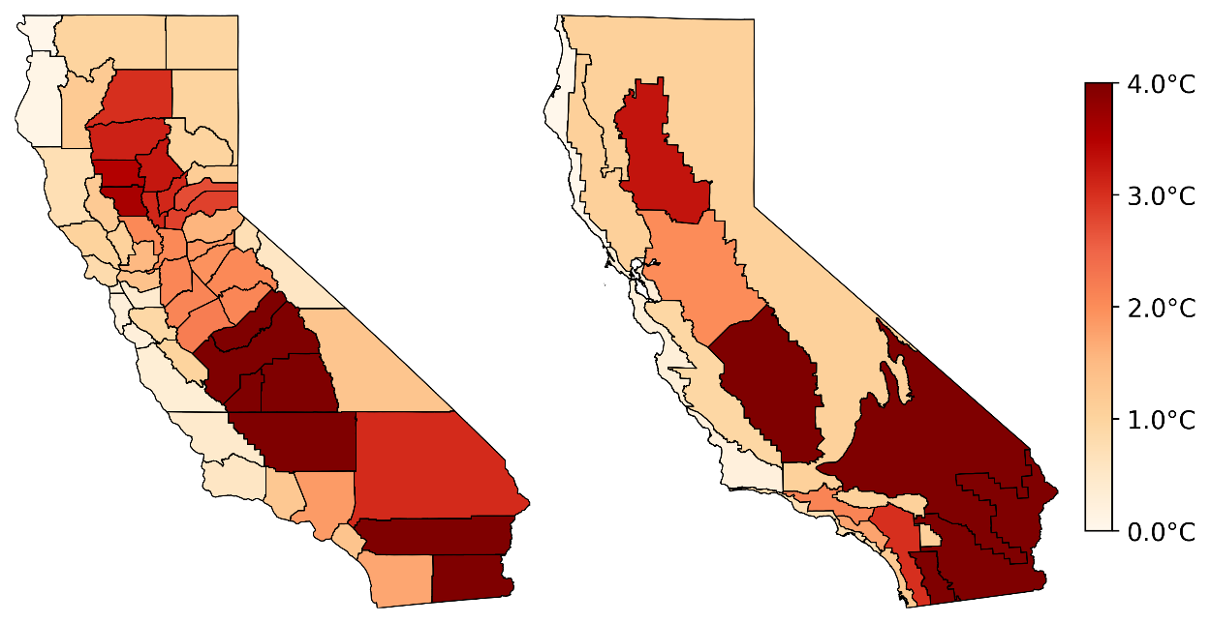
Figure S4. Indoor overheating degree at the 26 °C threshold under the low-emission pathway in the 2050s. Maps show the average intensity of indoor temperature exceedance above 30 °C across California’s counties (left) and CEC climate zones (right) for homes without air conditioning. Results are based on model simulations for the cooling season (May–October).
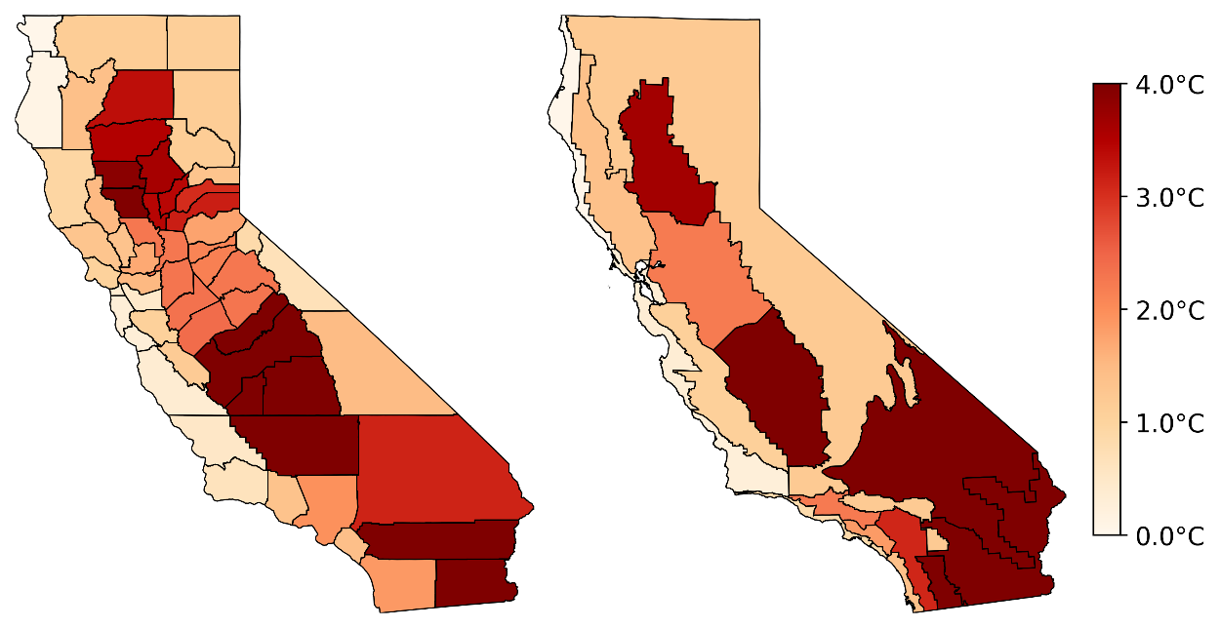
Figure S5. Indoor overheating degree at the 26 °C threshold under the high-emission pathway in the 2050s.
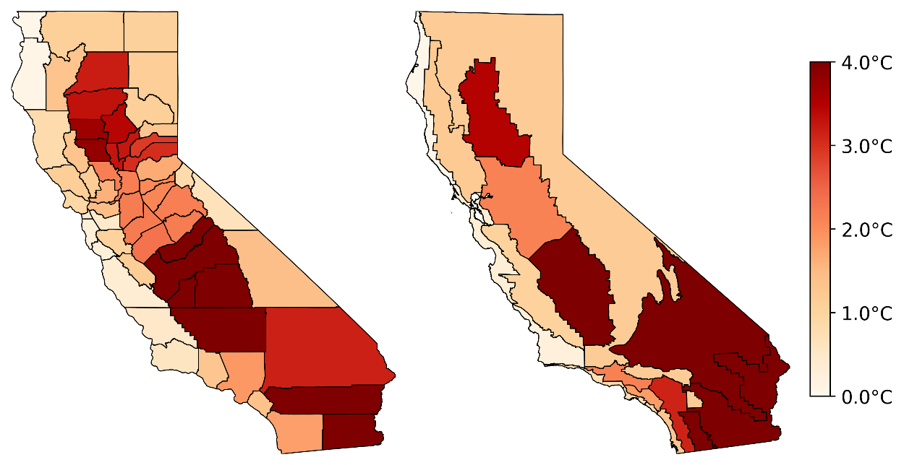
Figure S6. Indoor overheating degree at the 26 °C threshold under the low-emission pathway in the 2050s.
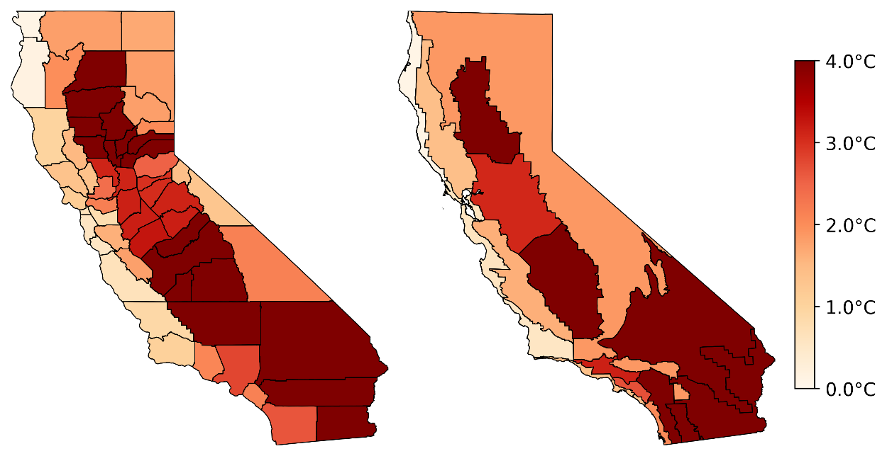
Figure S7. Indoor overheating degree at the 26 °C threshold under the high-emission pathway in the 2080s.
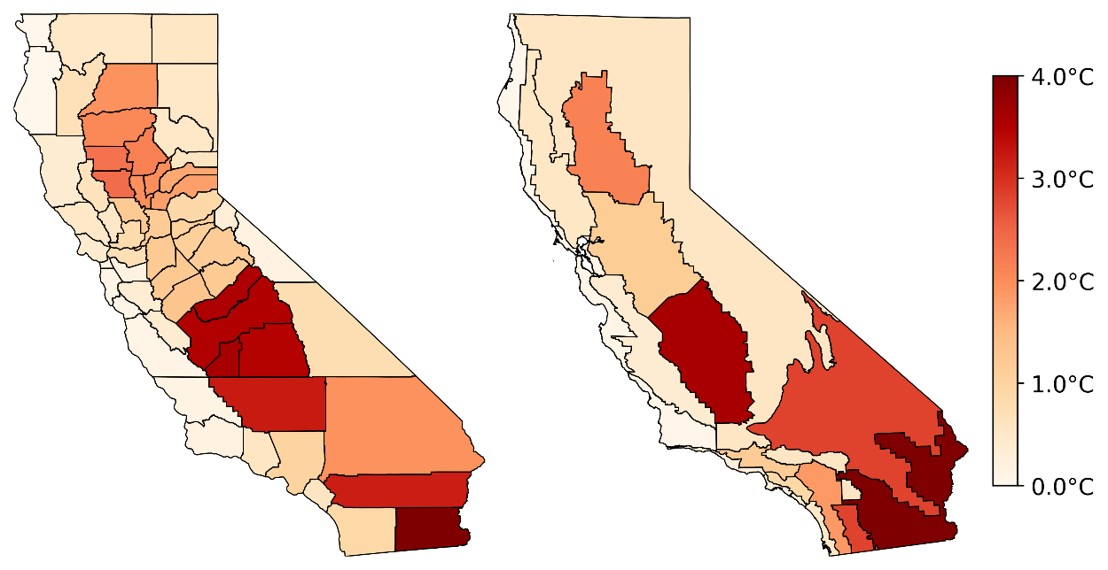
Figure S8. Indoor overheating degree at the 28 °C threshold under the low-emission pathway in the 2050s.
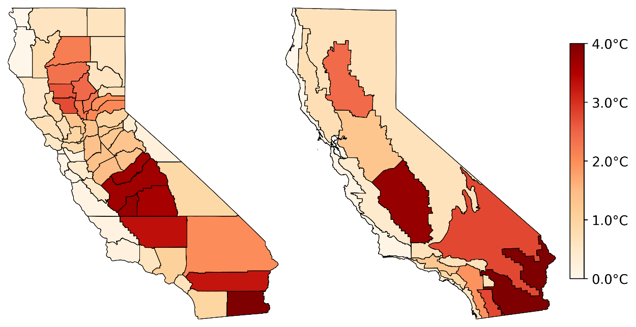
Figure S9. Indoor overheating degree at the 28 °C threshold under the high-emission pathway in the 2050s.
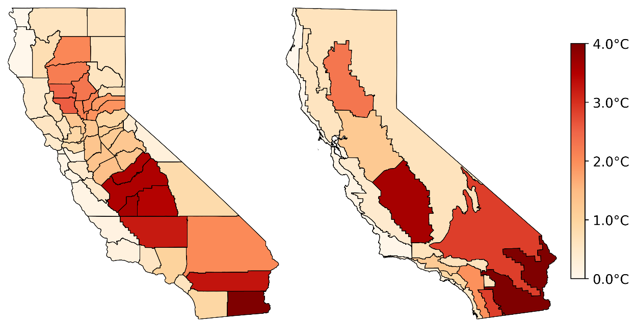
Figure S10. Indoor overheating degree at the 28 °C threshold under the low-emission pathway in the 2080s.
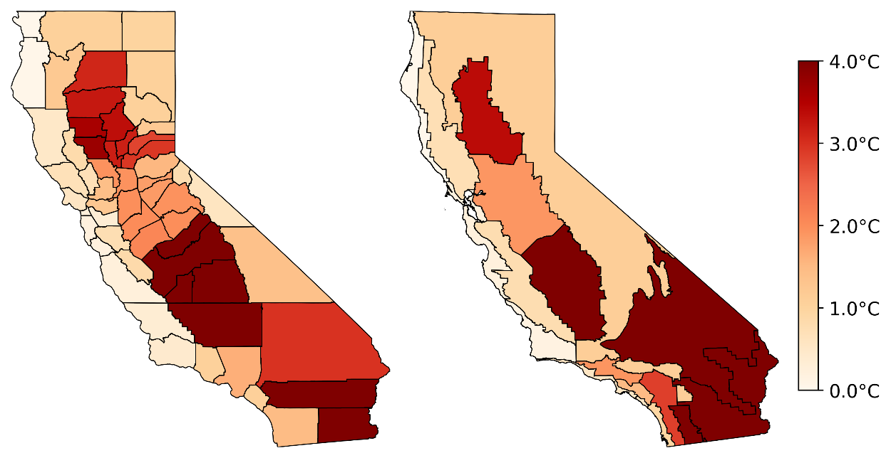
Figure S11. Indoor overheating degree at the 28 °C threshold under the high-emission pathway in the 2080s.

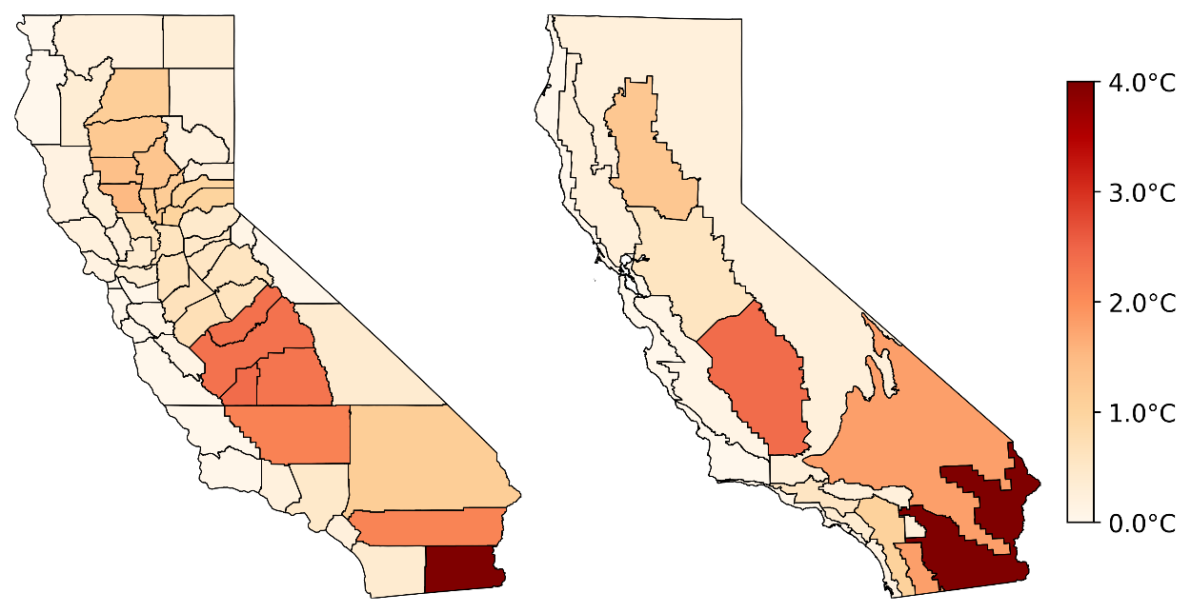
Figure S12. Indoor overheating degree at the 30 °C threshold under the low-emission pathway in the 2050s.
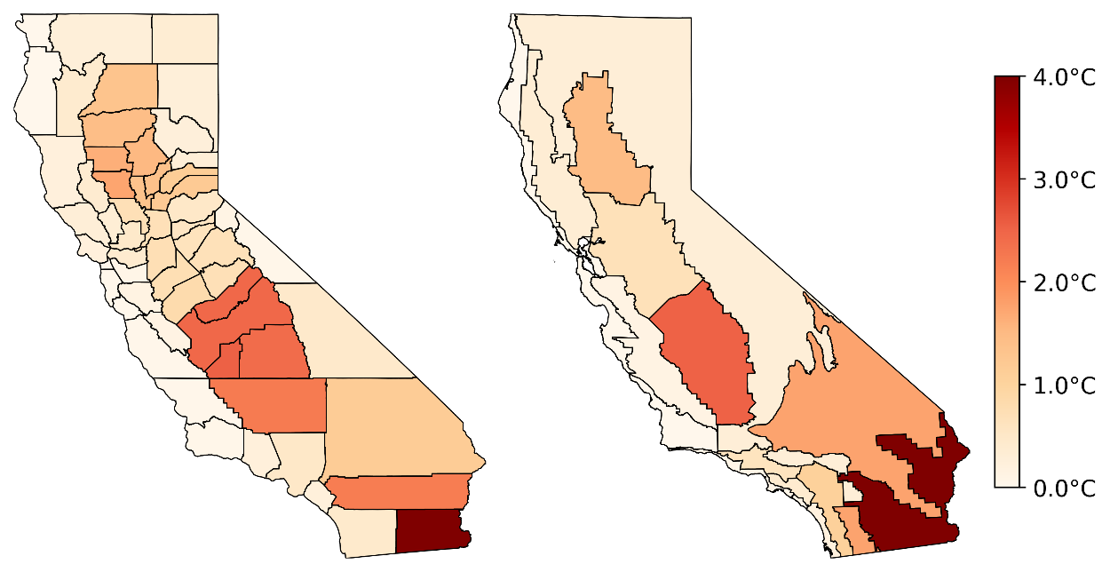
Figure S13. Indoor overheating degree at the 30 °C threshold under the high-emission pathway in the 2050s.
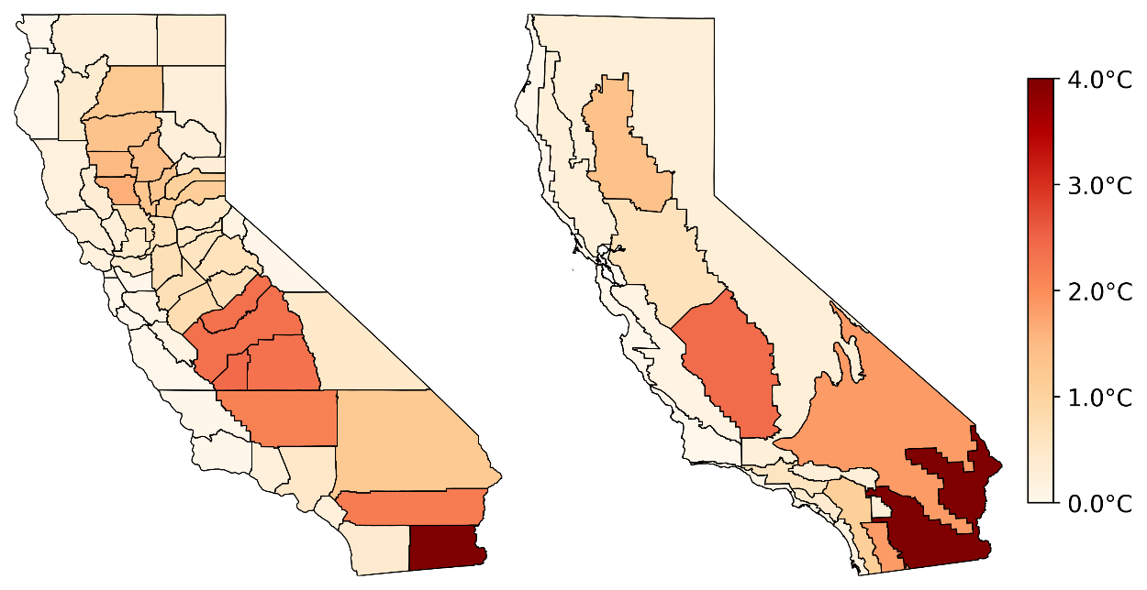
Figure S14. Indoor overheating degree at the 30 °C threshold under the low-emission pathway in the 2080s.
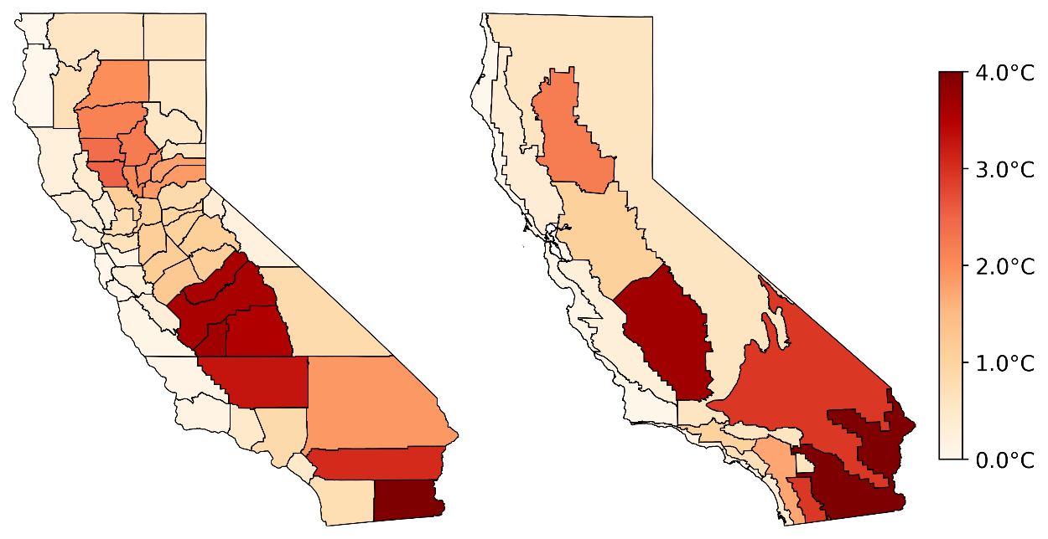
Figure S15. Indoor overheating degree at the 30 °C threshold under the high-emission pathway in the 2080s.

Evaluation and Validation of Cooling Demand Estimates
We validated statewide residential cooling electricity consumption generated by our simulation against empirical estimates from the 2019 California Residential Appliance Saturation Study (RASS)¹ published by the California Energy Commission (CEC). The 2019 RASS reported that average annual electricity use per household was 6,174 kWh, of which approximately 13% (≈ 800 kWh) was attributed to air conditioning (AC). Our modeled estimate of average annual cooling electricity consumption for California’s residential stock under the current CEC climate baseline was 872 kWh per household, within 9% of the RASS-derived value. This close agreement indicates that the modeling framework reliably reproduces aggregate residential cooling demand.
We estimated the coincident statewide residential AC peak load using the framework in Equations (1) and (2). Equation (1) defines the non-coincident upper bound, as the sum of each building model’s maximum load across the simulated year. Equation (2) converts this non-coincident total into a coincident statewide peak, by applying a coincidence factor (CF) and scaling to the full residential stock.
$P_{NC}= \sum_{i=1}^{n}{\max{(P_{i}\left(h\right))}}∙(\frac{N_{t}}{N_{s}})$ (1)
$P_{C}= P_{NC}∙CF$(2)
where i is the index for the building sample,
$P_{i}(h$) is the hourly AC power at hour h (W),
$P_{NC}$is the non-coincident statewide peak (W),
$N_{s}$ is the total number of simulated building models (i.e., the sample size),
$N_{t}$ is the total number of dwelling units in the California residential building stock.
$P_{C}$is the coincident statewide peak (W),
$CF∈(0, 1]$ is the coincidence factor.
As there are no well-established CF values for California residential cooling demand, we used past empirical studies and state modeling frameworks to derive realistic CF values. Appliance-level metering in Fresno and Sacramento² suggested that only ~35–45% of potential residential AC load operates concurrently at the system peak, given that only ~70–75% of units were on, and the realized concurrency was ~40–60% of installed capacity. While the non-coincident AC peak load from our simulation was ~17 GW, applying a CF of 0.44 (upper range of 0.3–0.45) gives a coincident peak that matches the legacy statewide AC peak estimates of ~7.5 GW³.
Additionally, we evaluated the representativeness of simulated peak cooling demand by benchmarking against system-level observations from the California Independent System Operator (CAISO). CAISO reported that the system peaks ranged from mid-40 GW (~45 GW in September 2023) to over 50 GW (~52 GW in September 2022), across all major end-use sectors, reflecting contributions from all major end-use sectors, including residential, commercial, industrial, and transportation⁴. To approximate the residential cooling component at these system peaks, we assumed (i) a residential share of system load at peak of 0.35 and (ii) an AC share of residential load at peak of 0.45, consistent with prior load-shape analyses and metering studies⁵. Applying Equation (3) yielded an estimated coincident residential AC peak of 7–8 GW. This alignment between modeled cooling peak load and system-level benchmarks supports the representativeness of our modeling framework in capturing the magnitude of cooling-driven peaks in California residential buildings.
$P_{AC, res}= P_{sys, peak}∙S_{res} ∙S_{AC, peak}$ (3)
where $P_{sys, peak}$ is the system peak demand (MW),
$S_{res}∈(0, 1]$ is the Residential share of system load at peak,
$S_{AC, peak}∈(0, 1]$ is AC share of residential load at peak,
$P_{AC, res}$ is the residential AC coincident peak load (MW).
Estimation of AC Installation Costs
Estimated costs for installing central air conditioning systems in U.S. homes vary considerably depending on system size, efficiency, and whether new ductwork is needed. On the lower end, HVAC.com⁶ reports an average installation cost of approximately US $5,750, including both equipment and labor. Mid-range estimates from HomeWyse⁷ place typical installation costs between US $7,410 and $8,797 for standard residential setups as of October 2025. For larger homes or higher-efficiency systems, costs rise substantially. According to This Old House⁸, whole-home central AC installations often range from US $10,000 to $15,000, with premium systems exceeding US $20,000. Similarly, Angi⁹ estimates that full HVAC system replacements, including new ductwork, can range from US $8,500 to $19,200, depending on system configuration and installation complexity.

References
1. Palmgren, C., Ramirez, B., Goldberg, M., & Williamson, C. (2021). 2019 California Residential Appliance Saturation Study (RASS): Consultant Report. California Energy Commission. Publication Number: CEC-200-2021-005-PO.
2. Treidler, B., & Modera, M. P. (1994). Peak Demand Impacts of ResidentialAir-Conditioning Conservation Measures.
3. Proctor, J. (2005). Air Conditioning, Peak Demand, And Public Goods Funds. Proctor Engineering Group, Ltd. San Rafael, CA. https://www.proctoreng.com/dnld/D101.pdf.
4. California Independent System Operator. California ISO Peak Load History 1998 through 2023. https://www.caiso.com/documents/californiaisopeakloadhistory.pdf.
5. Fred Coito and Mike Rufo (2003). California statewide residential sector energy efficiency potential study. https://www.calmac.org/publications/Res_EE_Potential_Study_V1.pdf?u.
6. HVAC.com (2025). Central AC Installation Cost Guide. Retrieved from: https://www.hvac.com/residential/hvac-installation-cost/.
7. HomeWyse (2025). Cost to Install Central Air Conditioning. Retrieved from: https://www.homewyse.com/services/cost_to_install_central_air_conditioning.html.
8. This Old House (2025). How Much Does HVAC Installation Cost? Retrieved from: https://www.thisoldhouse.com/heating-cooling/reviews/hvac-installation-cost.
9. Angi (2025). HVAC Replacement & Installation Cost Guide. Retrieved from: https://www.angi.com/articles/how-much-does-hvac-installation-cost.htm

