Supplementary Materials for

Large Carbonate Reservoir in Mars’ Crust
Eva L. Scheller, Michael Tice, Tanja Bosak, Robin Wordsworth, Joel Hurowitz, Benjamin P. Weiss

Corresponding author: eschelle@stanford.edu

The PDF file includes:

Supplementary Text
Figs. S1 to S7
Table S1

Supplementary text

Details on CRISM orbital carbonate absorption bands

To robustly detect carbonate minerals from orbit, both the 2.3-2.35 µm and the 2.5-2.55 µm absorption band need to be present in the infrared spectra. Whenever carbonate is observed on the ground, the corresponding areas in orbital spectra typically show absorptions in the 2.30–2.35 µm range (Fig. 1, Table, supplement Fig. S1-S2). This absorption band coincides with the absorptions due to Fe/Mg-OH stretches of a variety of phyllosilicate minerals, which are much more abundant on Mars’ surface than carbonate (2). Therefore, a singular 2.3-2.35 µm absorption is not sufficient to confirm the presence of carbonate minerals. The 2.5-2.55 µm absorption is more elusive and is only observed in areas with high concentrations of carbonate minerals (Fig. 1). This is likely due to the major absorption from H₂O at 3 µm whose left edge can obscure the 2.50-2.55 µm absorption (e.g., 81). Alternatively, the 2.5-2.55 µm feature region may be dominated by typically flat spectral signatures from dust, rock coatings and other minerals mixed with the carbonate. Other vibrational modes of carbonate minerals are less pronounced for Fe/Mg-carbonates and even more challenging to observe due to nearby absorptions by water or additional atmospheric gases and noise (e.g., 43).

Derivation of equation 2
Estimates of the mass of CO₂ (m_{CO2}) in the carbonate reservoir on Mars (Fig. 2C) hinges on constraining three key parameters: carbonate concentration, C_{CO3}, areal extent, A_{CO3}, and depth of the carbonate reservoir, d_{CO3} (Eq. 1). Additional standard parameters include the density, ρ_{rock}, of the rock and molar mass of CO₂ and CO₃, M_{CO2} and M_{CO3}.

$$m_{{CO}_{2}}=\frac{A_{{CO}_{3}}d_{{CO}_{3}}C_{{CO}_{3}} ρ_{rock}}{M_{{CO}_{3}}}M_{{CO}_{2}} (1)$$
The calculated mass of CO₂ in the observable carbonate reservoir can then be converted to equivalent CO₂ pressure, $P_{CO2}$, through the equation of hydrostatic equilibrium where z is the height of the atmosphere, $g_{Mars}$ is the gravitational constant for Mars, and $ρ_{atm}$is the atmospheric density (Eq. 3).
$$\frac{dP_{CO2}}{dz}=g_{Mars}ρ_{atm} (3)$$
We can also express ρ_{atm} as:
$$ρ_{atm}= \frac{m_{{CO}_{2}}}{V_{atm}} (4)$$
Combining Eq. 3 and Eq. 4 and re-arranging allows the final derivation (main text Eq. 2):

$$dP_{CO2}=g_{Mars}\frac{m_{{CO}_{2}}}{V_{atm}}dz↔ {P_{{CO}_{2}}= g}_{Mars}m_{{CO}_{2} }{A_{Mars}}^{-1} (2)$$
Here, $A_{Mars}$ is the surface area of Mars.

Further considerations on depth of carbon sequestration
The thickness of surface-exposed ultramafic regions on Mars varies, with olivine-rich sheet scarps in Nili Fossae reaching between 100-500 meters (e.g., 22, 82). However, the thicknesses of other ultramafic outcrops remain unmeasured. Based on density-driven differentiation models of terrestrial planets, ultramafic rock content is expected to increase with depth. Observations of olivine-bearing rocks within the 10 km deep walls of Valles Marineris (42, 52) support this hypothesis. Despite this, global crustal density estimates (30) suggest that ultramafic rocks do not dominate the deeper Martian crust.
The depth at which porosity ceases in the Martian crust is constrained by estimates of self-compaction. For a megaregolith-type crust, porosity is expected to close at depths of 8–11 km (61). Similarly, an effective pressure of ~100 MPa—commonly used as a threshold for pore closure (83)—corresponds to depths of ~12 km on Mars. These estimates align with seismic data from the InSight lander, which detected a subsurface boundary at 8–11 km, attributed to viscous pore closure (29). A second, deeper boundary at ~20 km (30) suggests that under certain conditions, pore closure and potential water infiltration could extend to greater depths (29-30,84-85).
While porosity closure is one constraint on fluid infiltration, fracturing and faulting likely play a more significant role in governing subsurface fluid movement and carbon sequestration. In the ancient Martian crust, fracturing and faulting would have been driven by impact events, volcanism, and rifting. The depth to which fluids can percolate along fault and fracture networks is controlled by the transition from brittle to plastic deformation in the lithosphere. Estimates of this transition depth range from 15 to 80 km, depending on assumptions about thermal conditions and crustal wetness (63) (Fig. 4A).
A potential barrier to fluid infiltration is the cryosphere, which may currently act as the primary reservoir for water on Mars (e.g., 61). However, recent seismic measurements of Mars’ crustal structure suggest there is no present-day cryosphere (86), challenging this long-held assumption. Additionally, during Mars' early history, higher geothermal heat flux and surface temperatures would have reduced the extent of the cryosphere, particularly in the southern highlands, making subsurface water infiltration more feasible (61). Observations of aqueous minerals and sedimentary deposits in impact basins and tectonic grabens down to 5–10 km (reviewed in 62) suggest that liquid water circulated through the deeper crust. Hydrological groundwater infiltration models further support the possibility of groundwater movement to these depths (87).
On Earth, fluid infiltration via void spaces and fracture systems outside subduction systems are observed within the deepest depths drilled into the crust of 6-12 km through drilling projects in Germany, Russia, and China (88-90). At these depths, carbon-bearing phases, such as hydrocarbons and carbonate, are readily observed (86-88). The depth of carbonation in two ultramafic systems have been studied on Earth primarily through the Oman Drilling Project (41) and the New Caledonia Peridotite Nappe (91). Within these systems, carbonation is observed down to the deepest measurable depths of ~ 1 km (41,91-92). Hence, these systems are best considered as analogues to surface carbonation in ultramafic rocks on Mars rather than deep crustal carbonation. In a review of observations from other instances of carbonated ultramafic systems, high-temperature carbonate alteration is considered limited by 200-300°C and depths of 3-5 km (92). To contextualize these carbonation depth numbers in the context of Mars thermophysical conditions, we must consider the ratio of Earth’s and Mars’ gravitational constants: 9.82/3.73 ~ 2.6. Hence, crustal depths of 8-14 km depth on Mars correspond to the same crustal pressure on Earth at 3-5 km depths. Another aspect is the temperature as 200-300°C is often quoted as the maximal temperature for carbonate stability (41). A conversion to ancient Martian conditions is largely dependent on assumptions of Mars’ past geothermal gradient structure within the crust (e.g., 61). The geothermal structure of Mars’ crust may be approximated through Eq. 5.
$$T\left(z\right)= T_{0}+\frac{q}{k}z (Eq. 5)$$
Here, $T$ is temperature, which is dependent on depth, $z$, $T_{0}$is the surface temperature, $q$ is the geothermal heat flux, and $k$is the thermal conductivity. The present-day $q$ is ~ 30 mW m⁻² (61), while a past $q$ is assumed to be ~ 150 mW m⁻² (61). We assume a thermal conductivity of 2 W m⁻¹ K⁻¹ and a past Martian surface temperature of 273 K. Solving for the depth, z, for a past Martian crust allows 200-300°C to be reached between 3-4 km as largely dependent on the parameter assumptions above. Taken together, these constraints indicate that carbon sequestration in ultramafic rocks on Mars is not solely limited to shallow depths but may extend significantly deeper, particularly where faulting and fracturing enhance permeability.

Additional references used only in supplement
- P. L. Harner, M. S. Gilmore, Visible–near infrared spectra of hydrous carbonates, with implications for the detection of carbonates in hyperspectral data of Mars. Icarus 250, 204-214 (2015).
- C. H. Kremer, J. F. Mustard, M. S. Bramble, A widespread olivine-rich ash deposit on Mars. Geology 47, 677-681 (2019).
- E. H. Rutter, Pressure solution in nature, theory and experiment. J. of the Geo. Society 140, 725-740 (1983).
- V. Wright, M. Morzfeld, M., Manga, Liquid water in the Martian mid-crust. PNAS 121 (2024).
- B. M. Jakosky, Results from the inSight Mars mission do not require a water-saturated mid crust. PNAS 122( (2025).
- M. Manga, V. Wright, No cryosphere‐confined aquifer below InSight on Mars. GRL 48, e2021GL093127 (2021).
- M. A. Shadab, E. Hiatt, R. S. Bahia, E. V. Bohacek, V. Steinmann, M. A. Hesse, Infiltration on early Mars and its implication towards fluvial-Aeolian interactions, 55th Lunar and Planetary Science Conference, Abstract no. 1383 (2024).
- Y. A. Kozlovsky, The World’s Deepest Well, Sci. American 251, 98-105 (1984).
- K. Bram, J. Draxler, G. Hirschmann, G. Zoth, S. Hiron, M. Kühr, The KTB Borehole – Germany’s Superdeep Telescope into the Earth’s Crust, Oilfield Review 7, 4-22 (1988).
- G. Zhu, J. Li, Z. Zhang, M. Wang, N. Xue, T. He, K. Zhao, Stability and cracking threshold depth of crude oil in 8000 m ultra-deep reservoir in the Tarim Basin. Fuel 282, 118777 (2020).
- B. Quesnel, P. Gautier, P. Boulvais, M. Cathelineau, P. Maurizot, D. Cluzel, M. Ulrich, S. Guillot, S. Lesimple, C. Couteau. Syn-tectonic, meteoric water–derived carbonation of the New Caledonia peridotite nappe. Geology 41, 1063-1066 (2013).
- I. M. Power, S. Wilson, G. M. Dipple, Serpentinite carbonation for CO2 sequestration. Elements 9, 115-121 (2013).

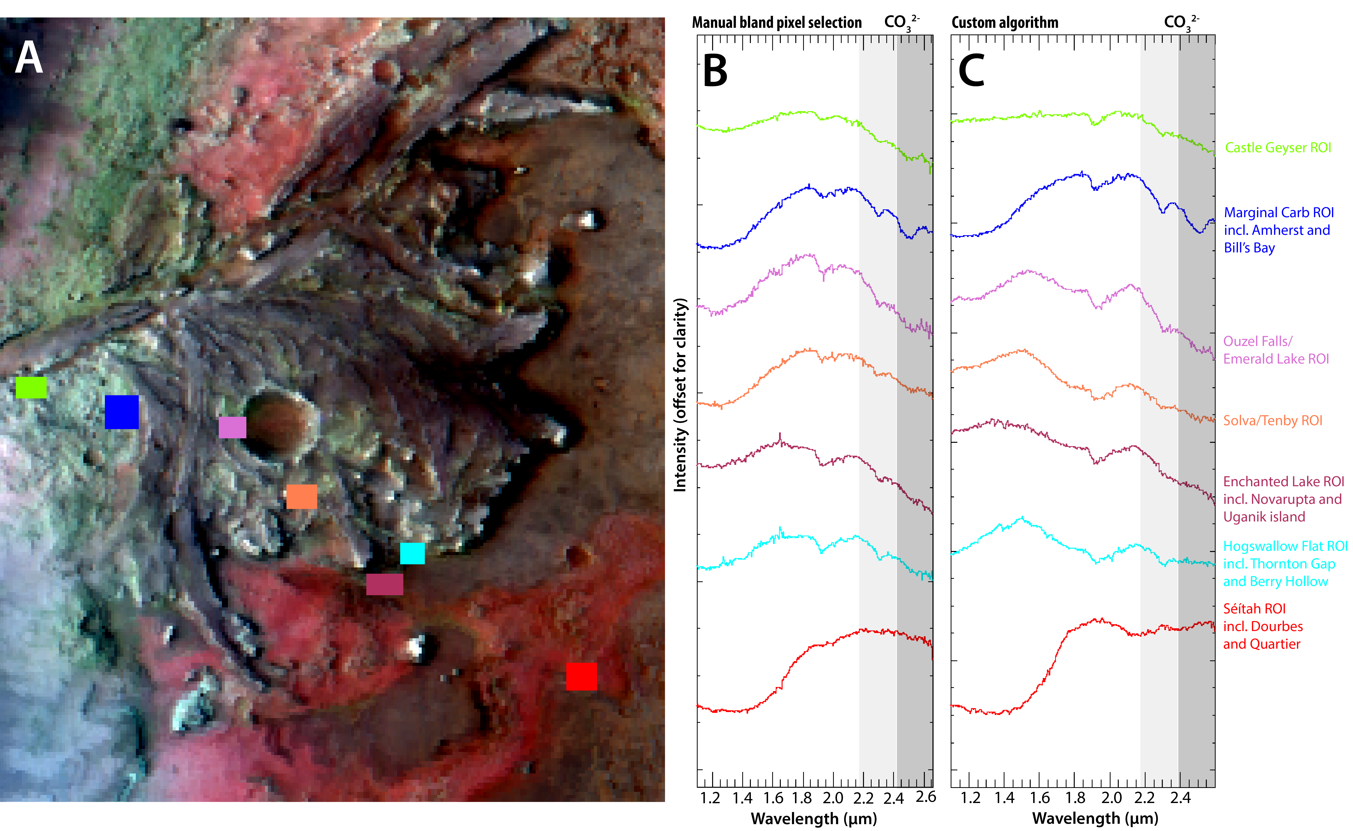
Fig. S1. Map of regions of interest (ROIs) used as the orbital representation of Perseverance rover measurement locations in CRISM image HRL000040FF. (A) Location of ROIs used for band depth study in Fig. 1 displayed on default CRISM false color image displaying 1.1 µm, 1.5 µm, and 2.6 µm as blue, green and red colors, respectively. (B) Spectra from the ROIs in panel A with matching color coordination. These spectra were processed with standard CRISM methodology utilizing a manual selection of bland pixels. (C) Same as (B) but the spectra were processed with a custom algorithm, described in Materials and methods, rather than through manual selection of bland pixels.

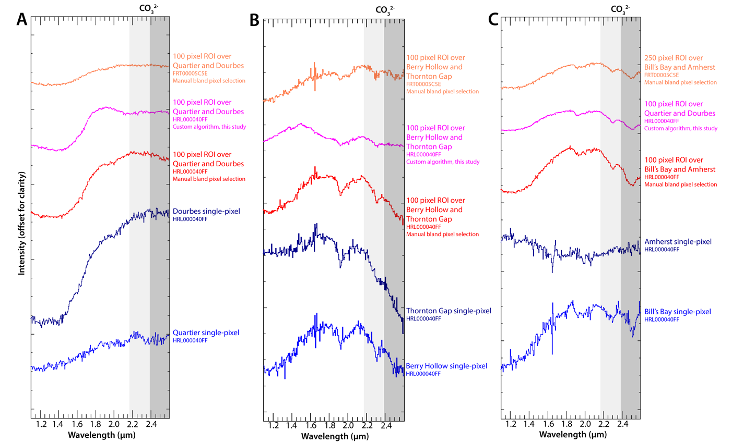

Fig. S2. Spectral variability at single-pixel and regions of interest representations of CRISM data over Perseverance rover measurement locations. Shown is the spectral variability at single-pixel and regions of interest representations of CRISM data over Perseverance rover measurement locations. Additionally, the study explores spectral variability as dependent on noise reduction methodology (manual bland pixel selection versus custom algorithm) and two different CRISM images of the same locations (HRL000040FF versus FRT00005C5E). Data from ROIs of HRL000040FF with manual bland pixel selection is used for Fig. 1 and Fig. S1. See ROI locations in Fig. S1A and single-pixel coordinates in Table S1. (A) Data covering measurements in the Séítah unit. No absorptions related to carbonate are observed across different spectral representations. (B) Data covering measurements in Jezero fan lower sedimentary beds. Weak absorptions, possibly related to carbonate, are observed in the ROI with manual bland pixel selection. In all other spectral representations, only the 2.30-2.35 µm absorption is observed. (C) Data covering measurements in the marginal carbonate unit. Both carbonate absorptions are observed in all the ROI spectra, while absorptions are weak or non-present in single-pixel spectra.

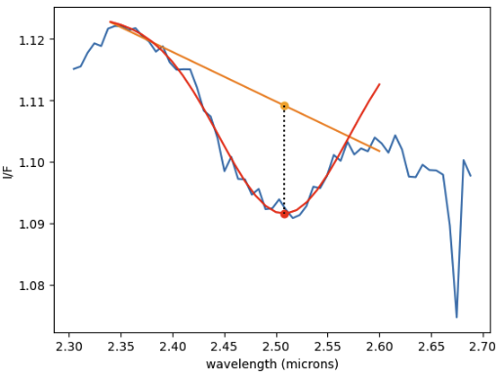

Fig. S3. Example absorption depth modeling with Gaussian function. The 2.30-2.35 and 2.50-2.55 absorptions in the ROI spectra (blue) are modelled with a linear continuum (orange) and an inverse gaussian function fitted to the absorption band (red). The band depth is calculated as the length of the stippled black line which is centered at the minimum of the inverse gaussian function. The example dataset displayed is from the Marginal Carbonate unit ROI spectra in Fig. S1.

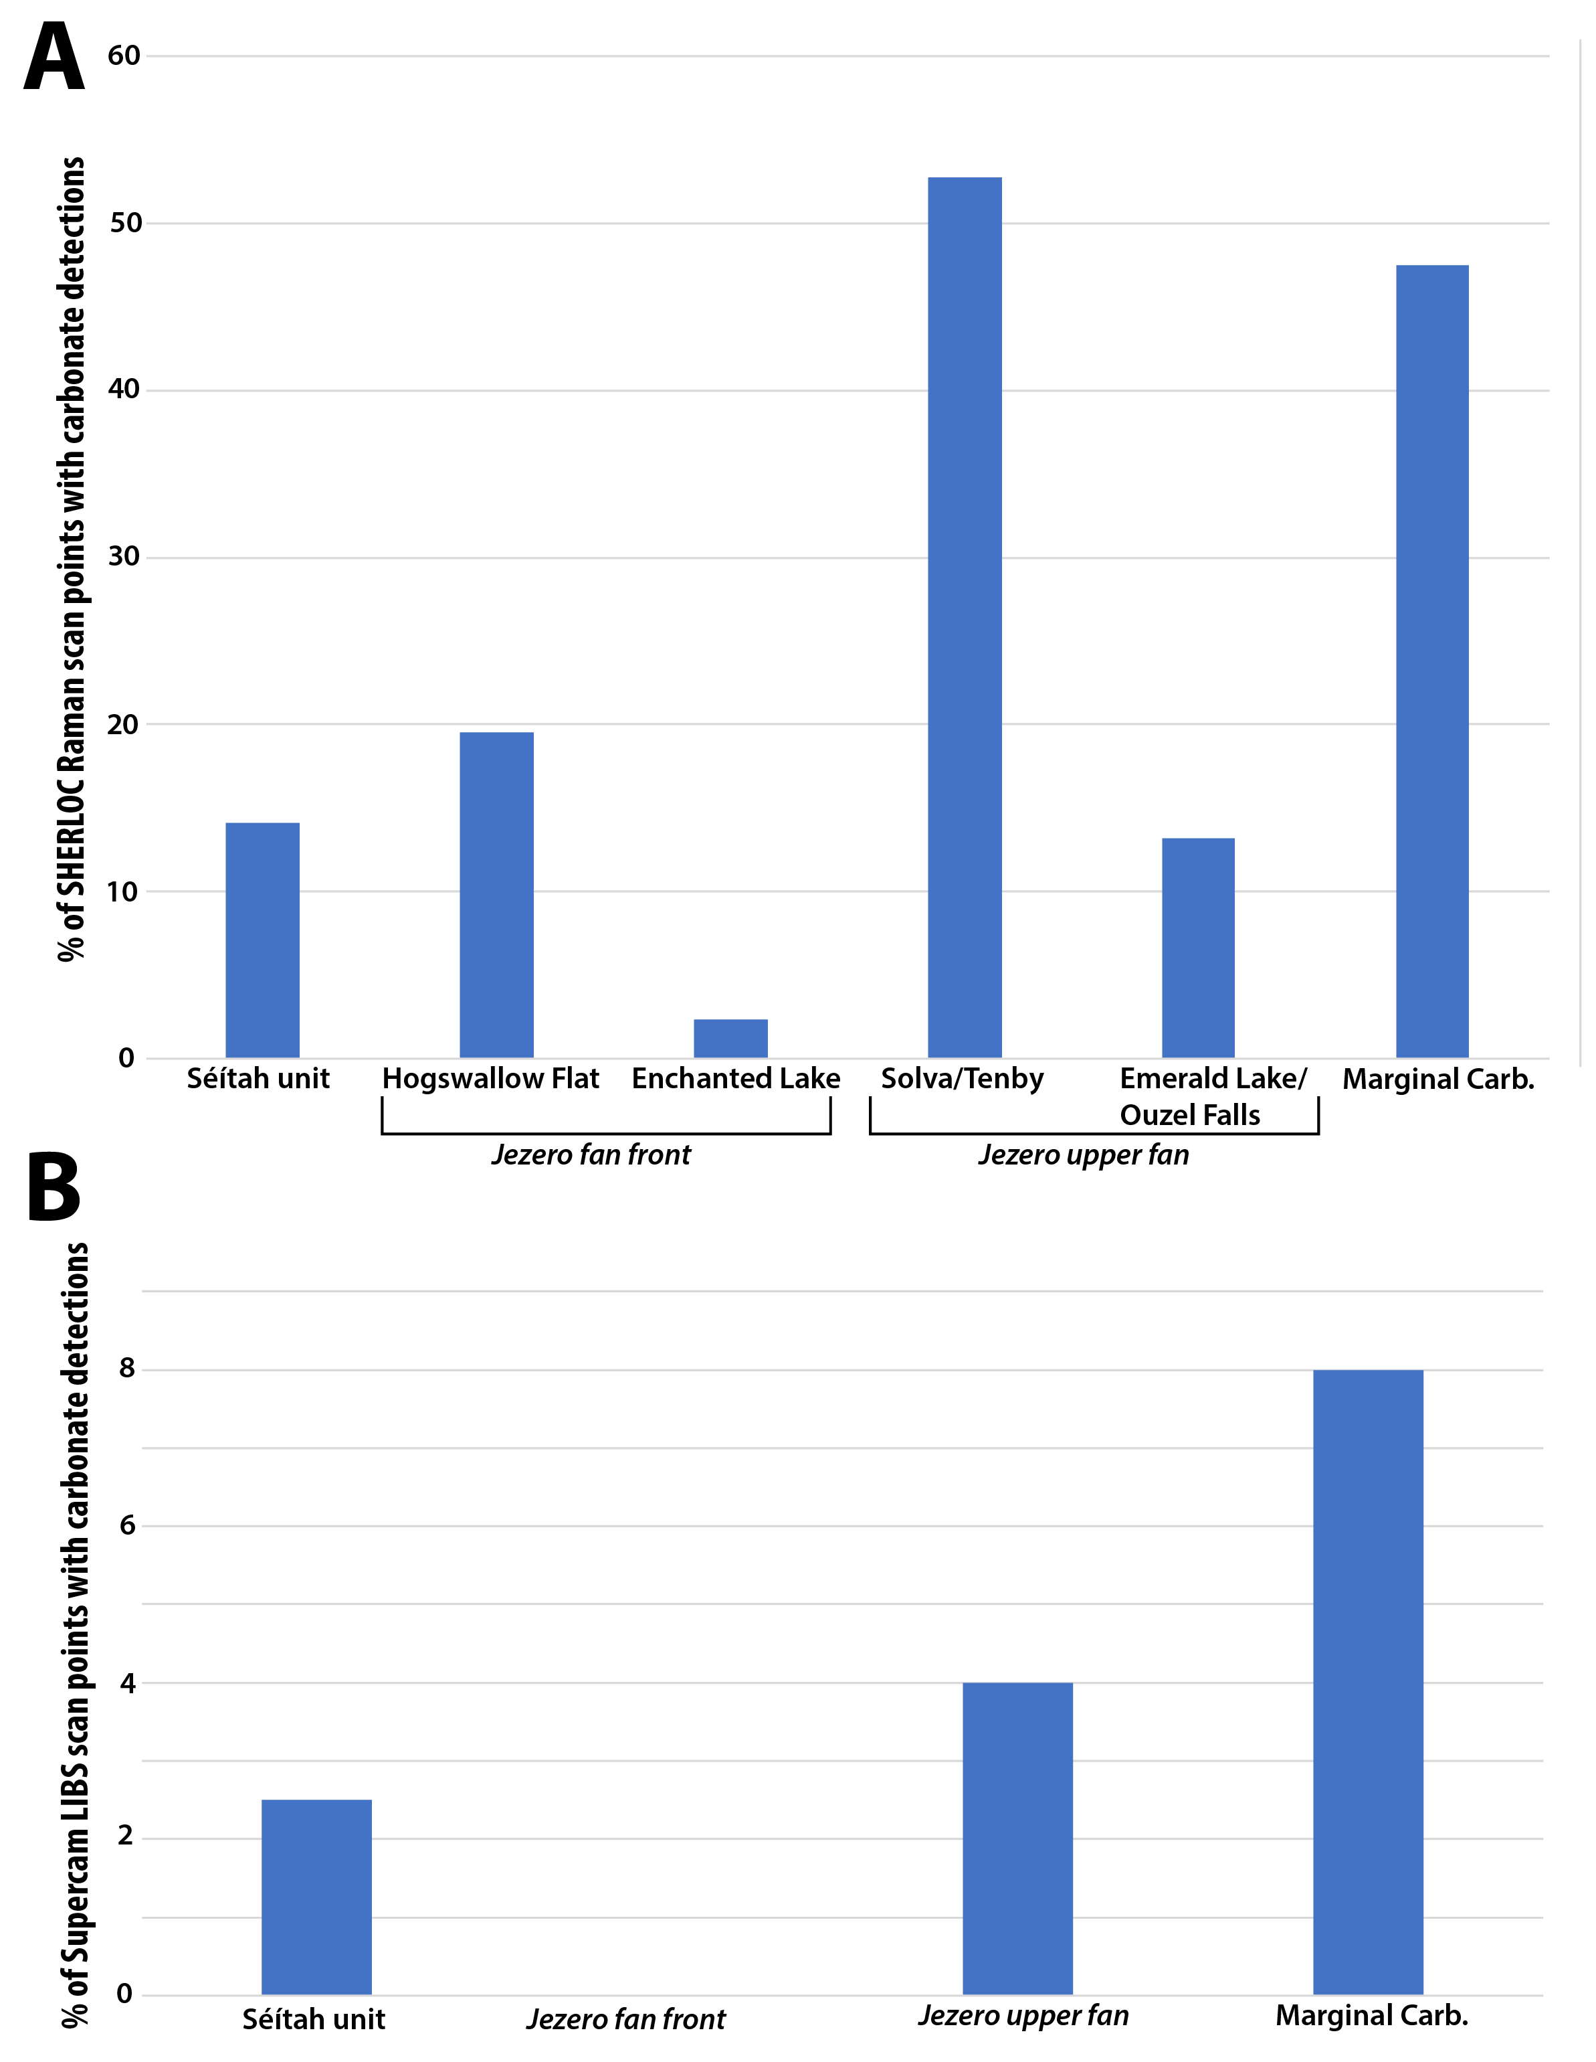

Fig. S4. Overview of % of scan points with carbonate detections as observed with UV Raman spectroscopy from the SHERLOC instrument and Laser-induced Breakdown Spectroscopy (LIBS) from the Supercam instrument. Other Perseverance rover instruments, SHERLOC and Supercam, used Raman and Laser-induced Breakdown Spectroscopy (LIBS) to detect carbonate in the same measurement areas as PIXL (Table 1). These instrumentations cannot presently be used to quantitatively reconstruct the abundance or concentration of carbonate. Rather the instruments operate their lasers in a grid structure, shooting multiple points in a target. Here, we counted the percentage of measurement points containing a carbonate spectral signature in reduced data from previously published works. (A) Percentage of UV Raman spectra containing carbonate detections across measurement areas grouped like Fig. S1. The carbonate detections were previously described in (4, 40, 46, 80) with detection methods described therein. (B) Percentage of LIBS spectra containing carbonate detections in measurement areas grouped more broadly. Carbonate detection methodology for Séítah units were described in (45), and the same methodology was deployed for subsequent measurements.

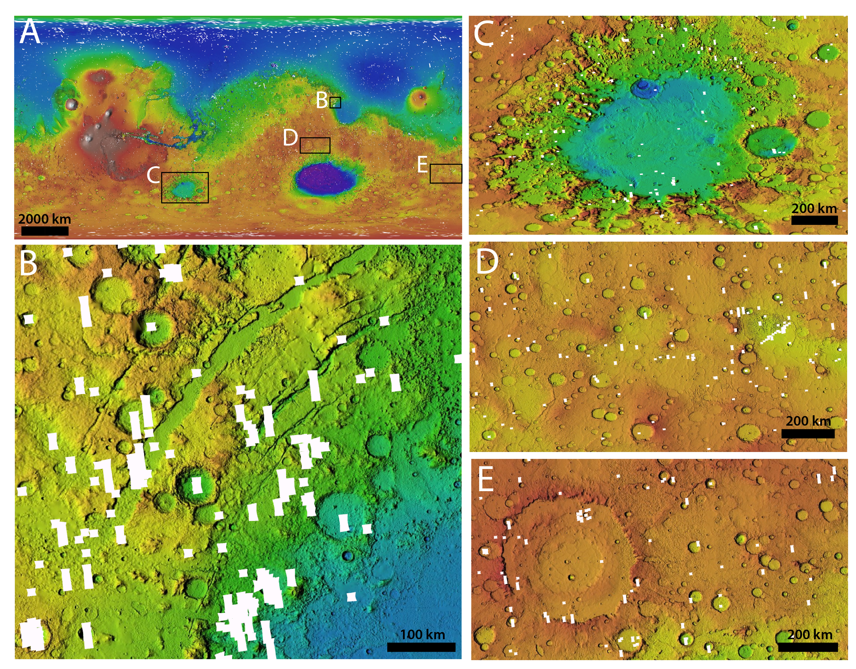
Fig. S5. Coverage map of CRISM hyperspectral image scene footprints. White polygons show the outlines of individual CRISM data scenes on top of MOLA topography basemap of Mars. Only FRT and HRL TRDR3 L-detector datasets are displayed as these are the only CRISM datasets that have the spectral resolution and wavelength coverage to measure carbonate absorptions. (A) Global view of Mars. Black rectangles outline the location of (B)-(E). (B) Nili Fossae region. (C) Argyre impact basin which contains at least one CRISM dataset with carbonate detections. (D) Terra Chimera which contains at least 5 CRISM datasets with carbonate detections. (E) Noachis Terra which contains at least 9 CRISM datasets with carbonate detections.

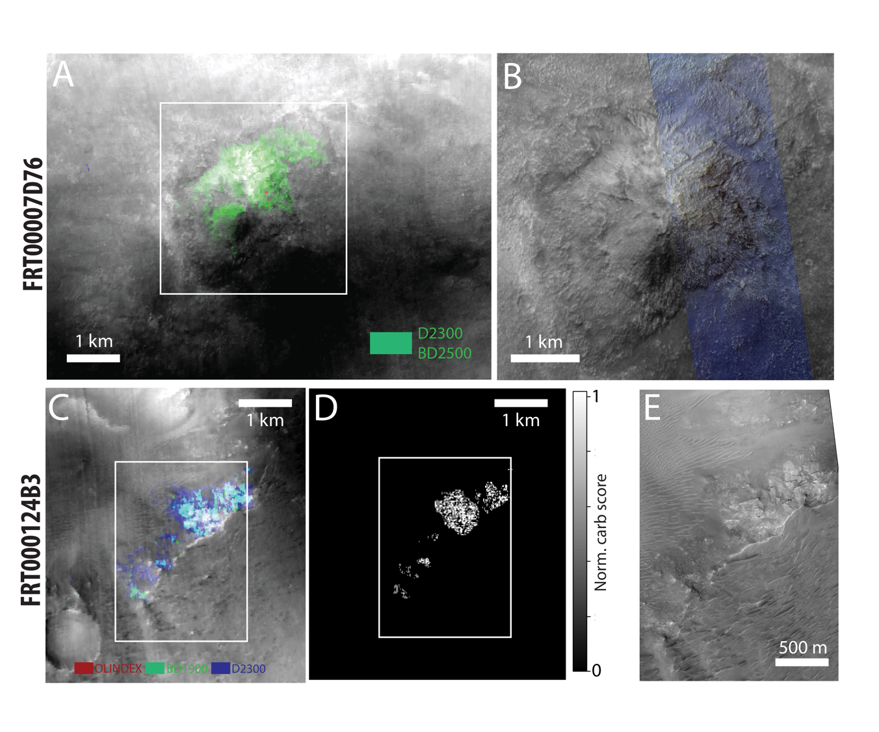
Fig. S6. Supplementary CRISM and HiRISE images of detected carbonates in Fig. 3G.
(A) CRISM band map of FRT00007D76 displaying 2300 nm and 2500 band indices in green, which searches for carbonate signatures in standard CRISM band map methodology. Spectra from the area in green were averaged together for the green spectrum in Fig. 3G. White rectangle outlines panel B. (B) HiRISE image showing a mound in the rim of Argyre basin that displays carbonate detections in panel A. (C) CRISM band map of FRT000124B3 displaying olivine index (red), 1900 nm band index (green), and 2300 nm index (blue). White rectangle outlines panel E. (C) Custom carbonate absorption map outlining identified carbonate detections over the same area as panel C. Spectra from the highlighted area were averaged together for the light blue spectrum in Fig. 3G. (E) HiRISE image over area with carbonate detections shows that they occur along an exposed brecciated crater wall.

Table S1. Parameter value ranges used for calculation of crustal carbonate reservoirs in this and previous studies (summarized in Fig. 4).
Ref | Parameter | Value | Rationale
This study | $$C_{{CO}_{3}}$$ | 5-25 wt% | Carbonate concentrations unobservable from orbit measured with Perseverance rover
This study | $$A_{{CO}_{3}}$$ | $A_{Mars}$ × 0.01 | Areal extent of ultramafic regions based on OMEGA olivine parameter map
This study | $$d_{{CO}_{3}}$$ | Dependency plot shown in Fig. 4A-B,  preferred range 5-12 km | Observed presence of aqueous mineralogy, measured seismic boundary likely related to pore closure, calculated pore closure depth, observed depth of carbonation on Earth
(22) | $$C_{{CO}_{3}}$$ | 20 wt% | Carbonate concentrations derived from modeling of orbital spectra with observed carbonate absorptions in Nili Fossae
(22) | $$A_{{CO}_{3}}$$ | 6800-300,000 km² | Minimum is the areal extent of observed carbonates from orbit in Nili Fossae.  Maximum is the areal extent of observed the olivine region in Nili Fossae.
(22) | $$d_{{CO}_{3}}$$ | 100-500 m | Based on exposure thickness of the Nili Fossae olivine-carbonate unit and carbonation diffusion modeling depths in (59)
(60) | $$C_{{CO}_{3}}$$ | 1-5 wt% | Carbonate concentrations assumed unobservable from orbit
(60) | $$A_{{CO}_{3}}$$ | $$A_{Mars}$$ | Entire surface area of Mars
(60) | $$d_{{CO}_{3}}$$ | 500 m | Assumed depth of surface sequestration
(23) | $$C_{{CO}_{3}}$$ | 4-11 wt% | Carbonate concentrations unobservable from orbit measured with Curiosity rover
(23) | $V_{{CO}_{3}}= A_{{CO}_{3}}×d_{{CO}_{3}}$ | 1.5 × 10⁶ km³ | Volume estimates of global sulfate deposits measured and reviewed in (23)

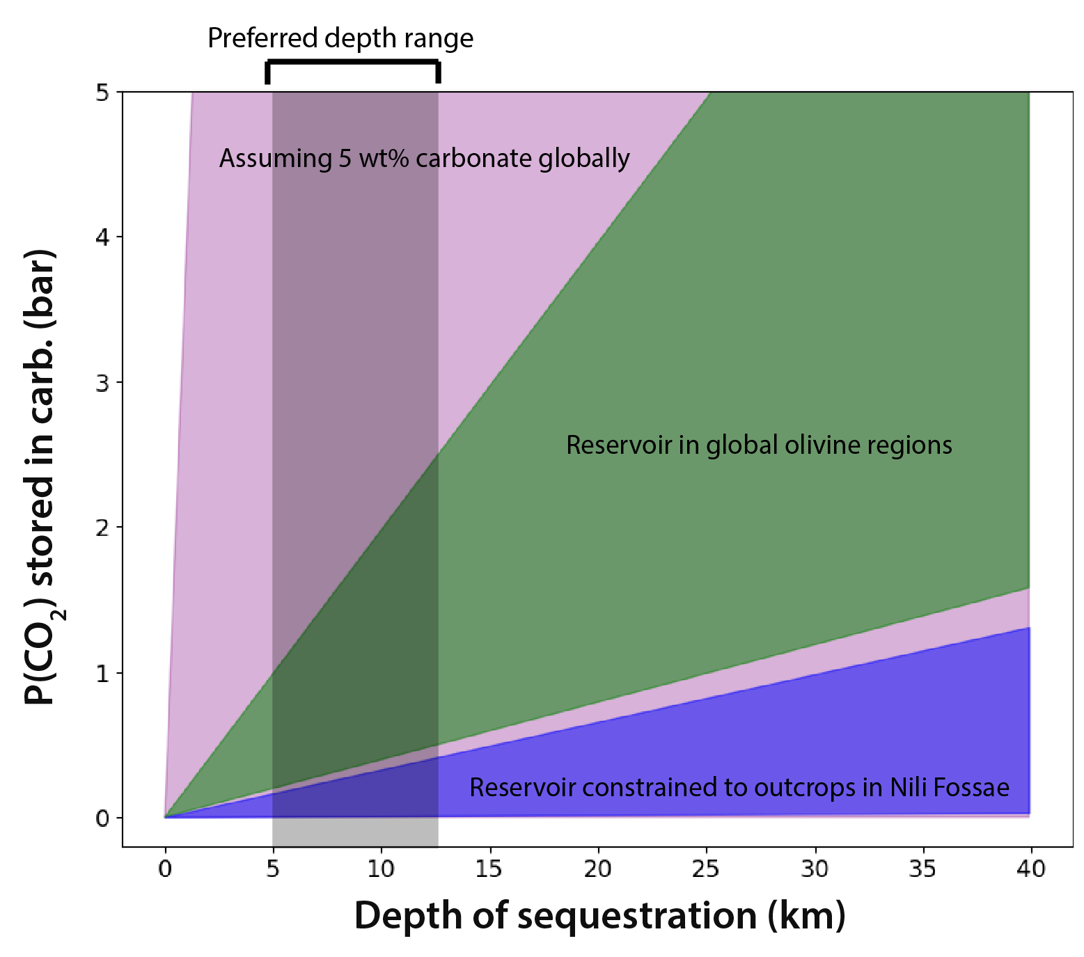
Fig. S7 Comparison of depth dependency for different assumed carbon sequestration reservoirs on Mars. Green area is the same as given in Fig. 4A. Pink area represents the carbonate reservoir assuming 5 wt% carbonate covers the entire surface of Mars as previously discussed in (60). Blue area represents carbonate reservoir size if constrained to only the Nili Fossae region as proposed in (22). The model assumptions for each of these 3 models can be found in Table 13. The preferred depth range represents the recommended consideration of 5 – 12 km depth, discussed in this study.

