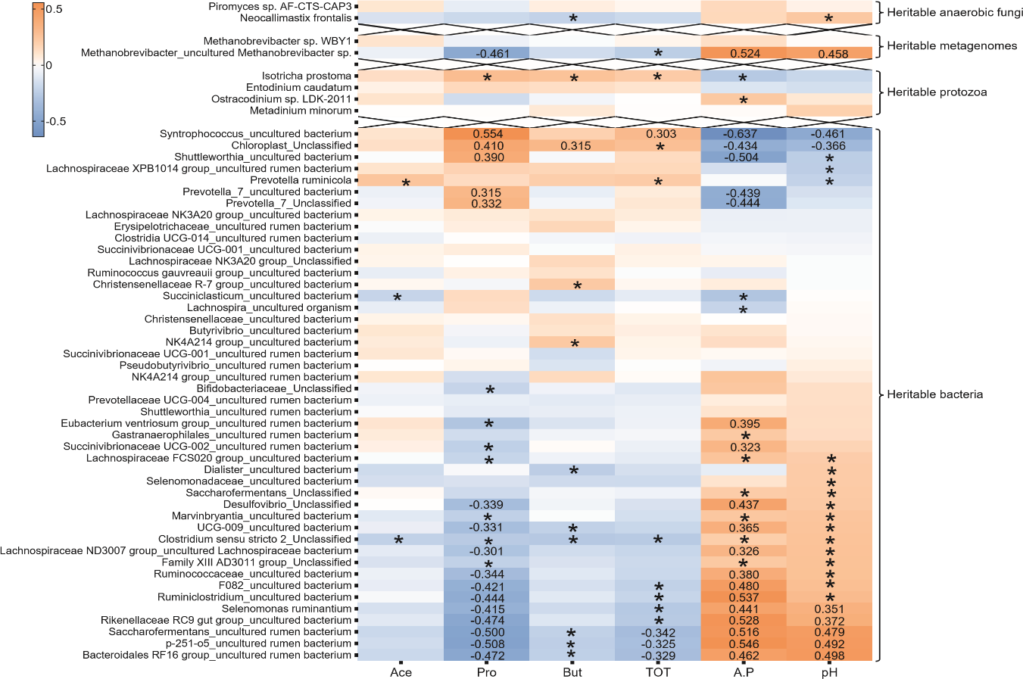

FIGURE S1. Heatmap of Spearman correlations between heritable rumen microbes and fermentation parameters. the adjusted P < 0.05 and |r| > 0.30, the numeric r value is displayed; the adjusted P < 0.05 and 0.20 < |r| ≤ 0.30, an asterisk (*) is displayed. Ace: acetic acid concentration; Pro: propionic acid concentration; But: butyric acid concentration; Tot: total SCFA concentration; A.P: acetate-to-propionate ratio; pH: rumen pH value.

