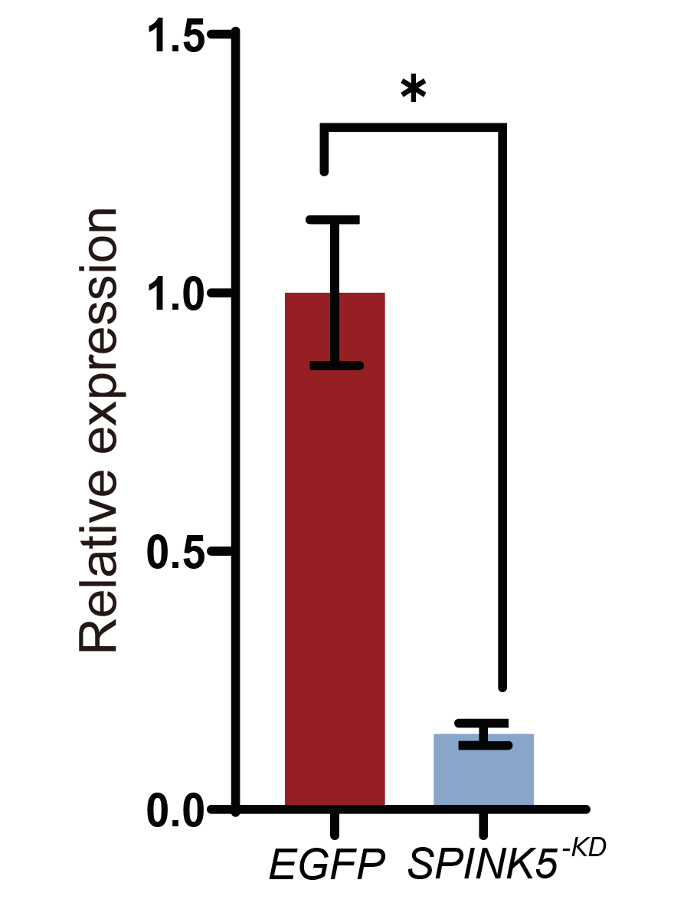

FIGURE S2. Expression of SPINK5 in a rumen epithelial cell line by shRNA-mediated knockdown, compared with the EGFP negative control. Data are presented as mean ± s.e.m. (n = 3 biological replicates).

