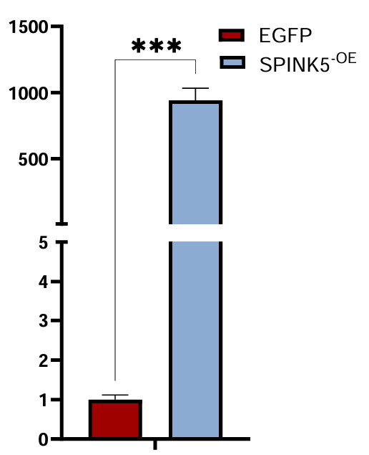

FIGURE S3. Expression of SPINK5 in a rumen epithelial cell line upon lentiviral overexpression, compared with the EGFP control. Data are presented as mean ± s.e.m. (n = 3 biological replicates).

