Electronic Supplementary Information
Current-Driven SEI and Near-Surface Structural and Chemical Evolution in Lithium Metal Batteries
Henrique D. Minami¹, Francisco A. Ospina Acevedo¹, Jorge M. Seminario^{1,2,3,*} and Perla B Balbuena,^{1,3,4,*}

¹Department of Chemical Engineering, Texas A&M University, College Station, TX 77843, USA

²Department of Electrical and Computer Engineering, Texas A&M University, College Station, TX 77843, USA

³Department of Materials Science and Engineering, Texas A&M University, College Station, TX 77843, USA

⁴Department of Chemistry, Texas A&M University, College Station, TX 77843, USA

*Corresponding authors e-mails: seminario@tamu.edu; balbuena@tamu.edu

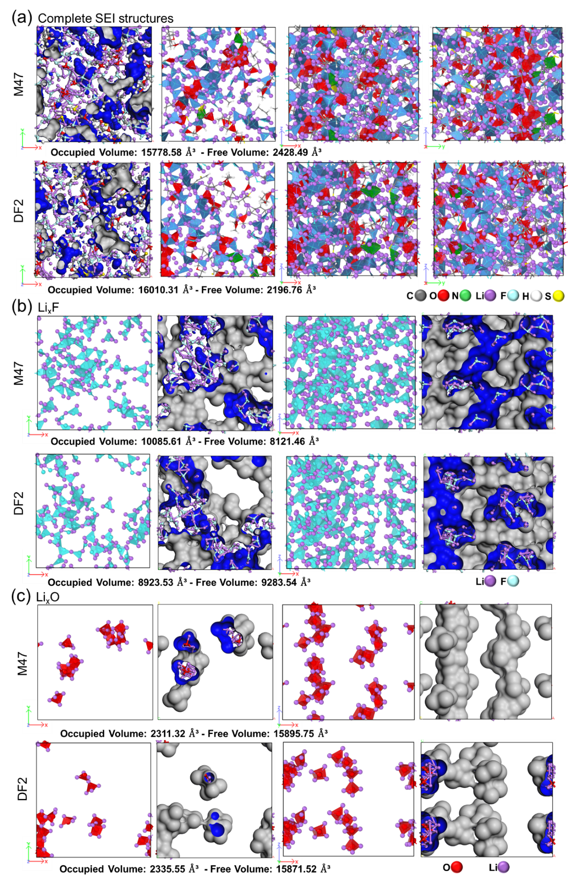
Figure S1. SEI structural characteristics from the M47 and DF2 electrolyte formulations and (a) overall organic and inorganic components distribution; (b) Li_{x}F distribution and conformality; and (c) Li_{x}O distribution and conformality.
Table S1. Mechanical properties of the SEI structures obtained via the HAIR method
Property | M47 | DF2
Bulk Modulus [GPa] | 29.830 | 40.683
Shear Modulus 1 [GPa] | 12.017 | 17.249
Shear Modulus 2 [GPa] | 4.668 | 6.915
Poisson Ratio | 0.366 | 0.359
Young's Modulus [GPa] | 31.784 | 45.339

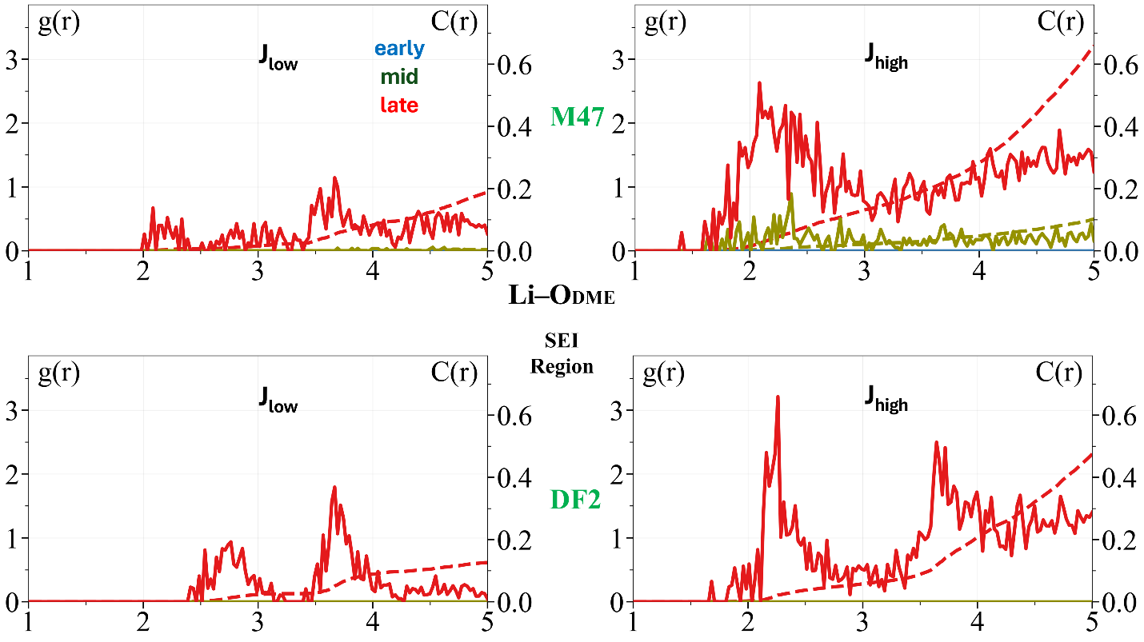
Figure S2. $g_{AB}\left(r_{k},t_{n}\right)$and $C_{AB}\left(r_{k},t_{n}\right)$ for Li-O_{DME} pairs in the SEI regions for M47 and DF2 electrolytes. Colors correspond to graphs obtained from trajectories based on different simulation times. Color code for time evolution: early: blue; green: intermediate; red: late.
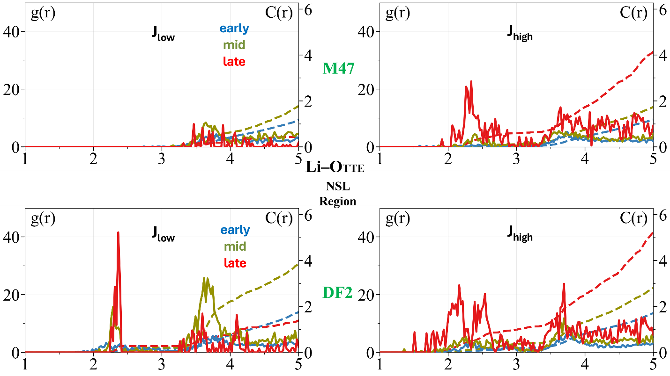
Figure S3. $g_{AB}\left(r_{k},t_{n}\right)$and $C_{AB}\left(r_{k},t_{n}\right)$ for Li-O_{TTE} pairs in the NSL regions for M47 and DF2 electrolytes. Colors correspond to graphs obtained from trajectories based on different simulation times. Color code for time evolution: early: blue; green: intermediate; red: late.

