Supplementary file
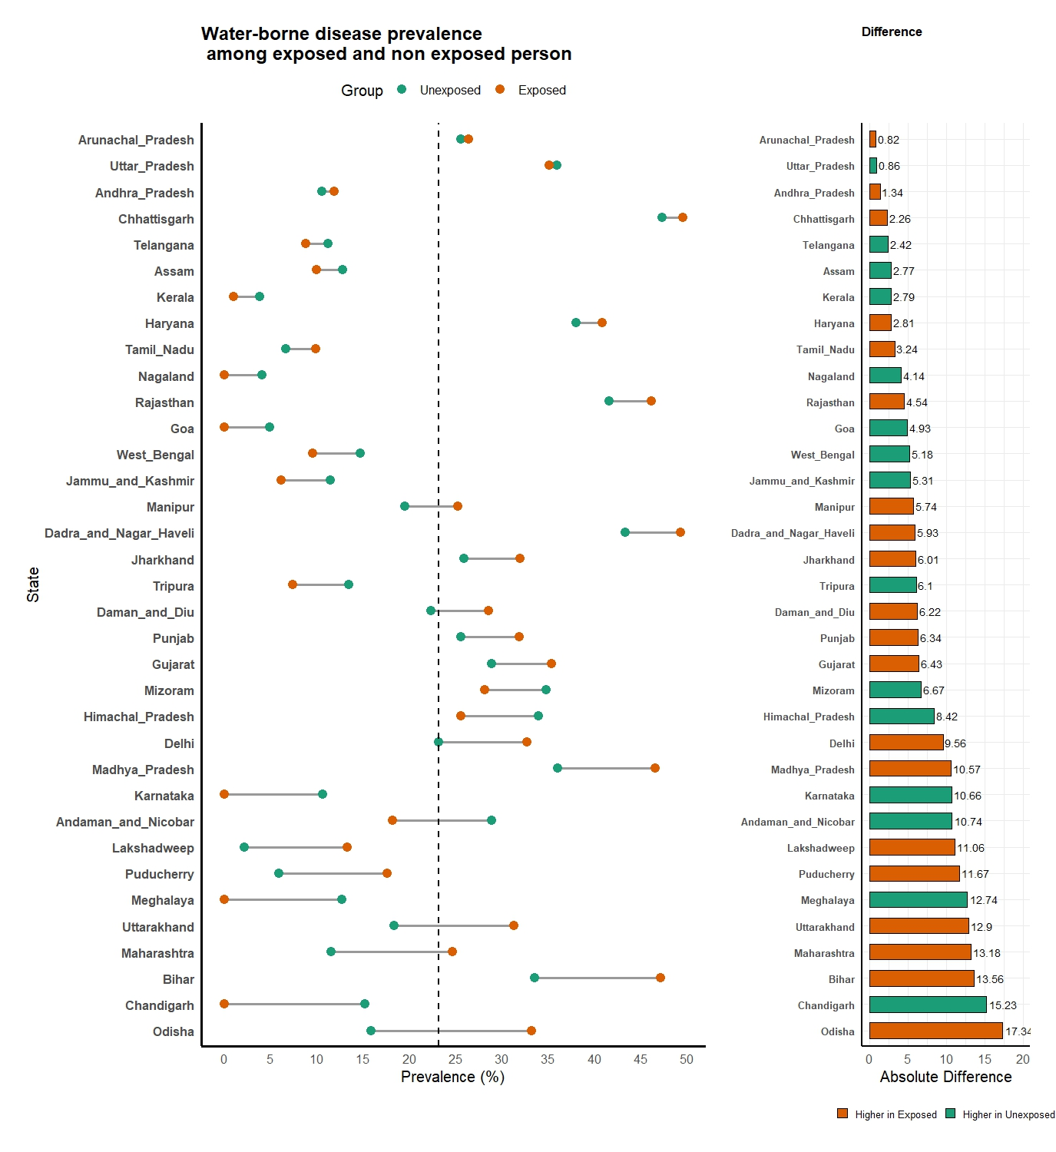
Figure S1: State-wise prevalence of water-related infectious diseases.
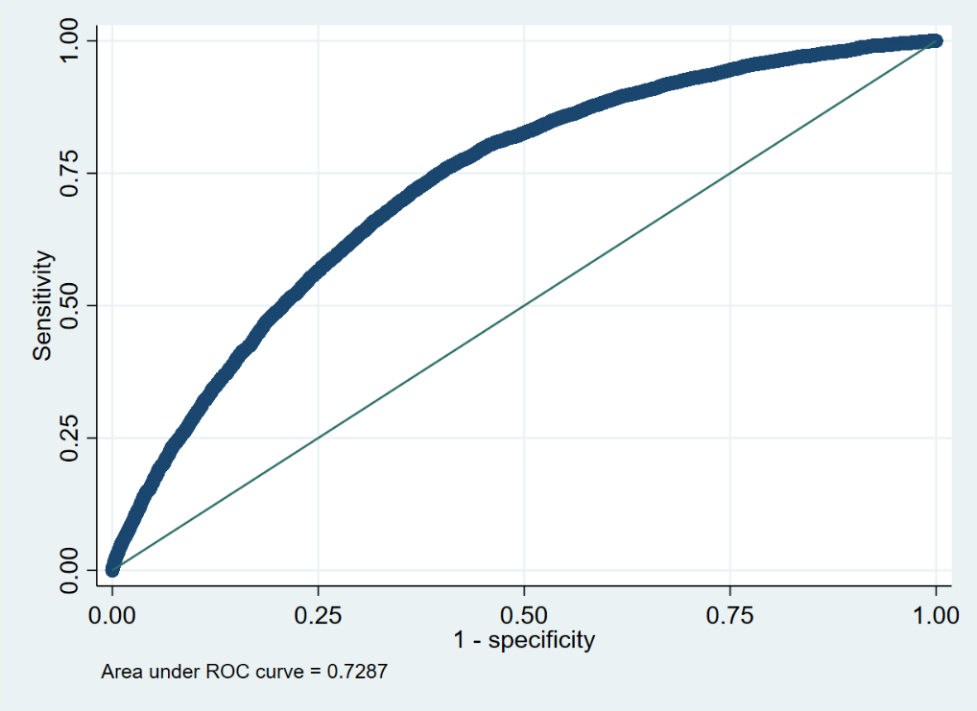
Figure S2: ROC curve of the multivariate logistic regression model.
Table S1: Socio-demographic variation of water-borne diseases amid disaster exposure
Variables | Unexposed to disaster (%) | χ² | Exposed to disaster (%) | χ² | Total (%) | χ²
Age (years)
45–54 | 20.5 | – | 27.4 | – | 21.3 | –
55–64 | 20.9 | 2.7 | 30.6 | 9.3* | 22 | 6.3*
65–74 | 21.3 | – | 30.8 | – | 22.8 | –
75+ | 20.7 | – | 27.3 | – | 21.4 | –
Place of residence
Rural | 24.1 | 669.2*** | 31.7 | 123.7*** | 25.1 | 873.9***
Urban | 15.4 | – | 17.6 | – | 15.6 | –
Year of schooling
No schooling | 24.9 | – | 32.1 | – | 25.9 | –
<5 years | 20.6 | – | 28.7 | – | 21.4 | –
5–8 years | 19 | 664.0*** | 27.5 | 73.8*** | 19.9 | 783.2***
9–12 years | 15.5 | – | 21.7 | – | 16.1 | –
>12 years | 12.9 | – | 17.6 | – | 13.2 | –
Social group
Scheduled tribe | 24.1 | – | 30.9 | – | 24.5 | –
Scheduled caste | 22.6 | 199.5*** | 29.4 | 17.2** | 23.4 | 204.6***
Other backward class | 20.8 | – | 30.2 | – | 22.1 | –
Others | 17.7 | – | 25.3 | – | 18.5 | –
Chronic illness
None | 20.6 | – | 27.8 | – | 21.5 | –
One | 21.8 | 15.6** | 29.5 | 8.6* | 22.7 | 14.3**
Two | 20.3 | – | 32 | – | 21.6 | –
2+ | 19.6 | – | 31.7 | – | 20.8 | –
Wealth quantile
Poorest | 22.1 | – | 30.7 | – | 23.1 | –
Poorer | 23.1 | – | 31.7 | – | 24 | –
Middle | 20.5 | 93.9*** | 29.6 | 19.2** | 21.5 | 110.9***
Richer | 19.9 | – | 26.7 | – | 20.6 | –
Richest | 18.7 | – | 26.1 | – | 19.5 | –
Drinking water treatment
Yes | 17.3 | 360.0*** | 24.2 | 42.0*** | 17.9 | 443.0***
No | 23.5 | – | 31.2 | – | 24.5 | –
Open defecation
Yes | 29.1 | 577.8*** | 40.3 | 227.5*** | 31.1 | 892.1***
No | 19 | – | 23.7 | – | 19.5 | –
ADL
None | 20.3 | – | 27.4 | – | 21.1 | –
One | 23.9 | 74.6*** | 36.5 | 47.7*** | 25.5 | 122***
Two | 25 | – | 34.3 | – | 26 | –
2+ | 24.6 | – | 38.4 | – | 26.7 | –
Housing dampness
Yes | 24.2 | – | 29.3 | – | 24.9 | –
No | 20 | 107.4*** | 28.8 | 2.2 | 20.9 | 106.0***
Geographical Region
Arid region | 4.19 | – | 0 | – | 4.1 | –
Plains | 18.4 | – | 36.3 | – | 20.8 | –
Plateau | 19.8 | 698.0*** | 22.7 | 130.3*** | 20 | 674.1***
Hills/Mountains | 24.8 | – | 29.5 | – | 25.4 | –
Island/coastal | 22.8 | – | 23.7 | – | 22.9 | –
Total | 20.8 | – | 28.9 | – | 21.7 | –

Table S2: Description of the variables used in the present study.
Variable Category | Variable Name | Description / Coding
Outcome Variable | Any Water-Related Infectious Disease (WRID) | Respondent was asked whether, in the past two years, they had any of the following conditions: malaria, diarrhea, typhoid, chikungunya, or dengue. Each item was coded as 1 = Yes, 0 = No. A composite WRID variable was created: 1 = reported at least one of the five diseases, 0 = reported none
Key Explanatory Variable | Water-Related Disaster (WRD) Exposure | Disaster exposure was assessed by asking: “In the last five years, has your health been severely affected by disasters such as floods, landslides, extreme temperatures, cyclones/typhoons, droughts, earthquakes, tsunamis, or any other natural calamities?” (1 = Yes, 0 = No). For this study, exposure to floods, cyclones/typhoons, or tsunamis was categorized as water-related disaster exposure. Composite variable: 1 = WRD exposed, 0 = not exposed
Socio-Demographic Variables | Age Group | Categories: 45–54 years (ref), 55–64 years, 65–74 years, ≥75 years.
 | Education Level | No schooling, <5 years, 5–8 years, 9–12 years, >12 years of schooling.
 | Social Group (Caste) | Scheduled Tribe (ST), Scheduled Caste (SC), Other Backward Class (OBC), Others (ref).
 | Household Wealth Quintile | Poorest, Poorer, Middle, Richer, Richest.
 | Place of Residence | Rural (ref), Urban.
 | Geographical Region (geo_region) | Derived from state-level classification:  1. Plains → Bihar, Haryana, Punjab, Uttar Pradesh, West Bengal, Delhi.  2. Plateau → Andhra Pradesh, Chhattisgarh, Jharkhand, Karnataka, Madhya Pradesh, Maharashtra, Telangana.  3. Hills/Mountains → Arunachal Pradesh, Assam, Himachal Pradesh, Jammu & Kashmir, Manipur, Meghalaya, Mizoram, Nagaland, Tripura, Uttarakhand. 4. Dry/Desert → Gujarat, Rajasthan.  5. Island/Coastal → Andaman & Nicobar, Dadra & Nagar Haveli, Daman & Diu, Goa, Kerala, Lakshadweep, Puducherry, Tamil Nadu, Odisha.
Daily Life Conditions | Drinking Water Treatment | Household treats drinking water: Yes / No.
 | Open Defecation | Household practices open defecation: Yes / No.
 | Housing Dampness | Presence of damp/wet walls or floors: Yes / No.
 | Chronic Illness Count | Number of chronic diseases reported: None (ref), One, Two, more than two.
 | ADL Limitations | Difficulties in Activities of Daily Living: None (ref), One, Two, more than two.

