Figure5
βactin 42kd
SDC 24kd
Figure6
βactin 42kd
SDC 24kd

Figure7
βactin 42kd
Cytosolic Cyt c 12kd
Cytosolic AIF 67kd
Tomm20 16kd
Mitochondrial Cyt c 12kd

Figure9
IB:βactin 42kd IB:Dvl 85kd
IB:SDC 85kd IB:SDC 24kd
IB:Dvl 24kd

Figure10
Cytosolic
βactin 42kd
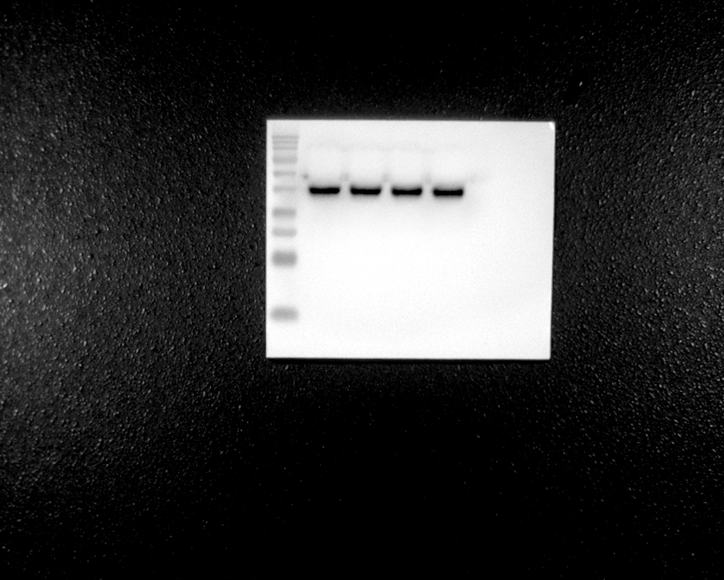
βcatenin 92kd
Axin 110kd
APC 160kd

Nuclear
βcatenin 92kd
Histone H3 17kd

