Supporting Information
Stepwise ex situ carbon-coated LMFP/C cathodes for high-energy lithium-ion batteries
Wenchong Cheng ¹, Guoqiang Song ^{1, *}, Zuming Huang ¹, Qiming Zhao³, Peng Xiong ¹, Linjun Zhang ¹, Zhentian Xu ¹, Hao Tang ¹, Ting Wei ¹, Yuxi Li ¹, Yiwen Xie ¹, Claudia Li ², Sibudjing Kawi ²
¹ School of Intelligent Materials and New Energy, Institute of Carbon Neutral New Energy, Yuzhang Normal University, Nanchang 330031, China
² Department of Chemical and Biomolecular Engineering, National University of Singapore, 4 Engineering Drive 4, Singapore 117585, Singapore
³ School of Physics and Electronic Engineering, Fuyang Normal University, Fuyang 236037, China

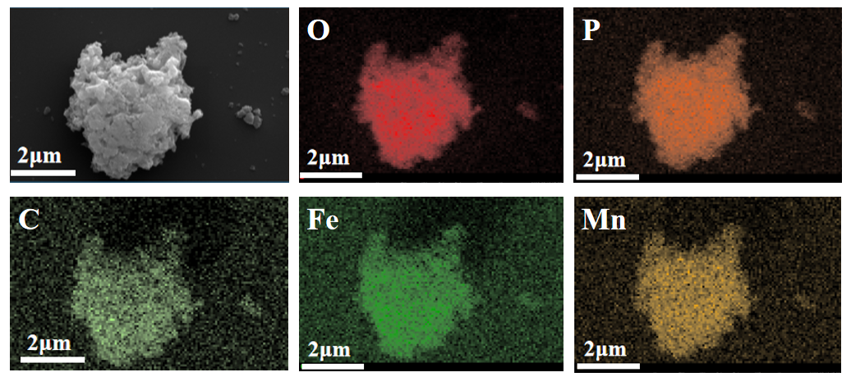
Fig. S1. the elemental mapping images of O-LMFP

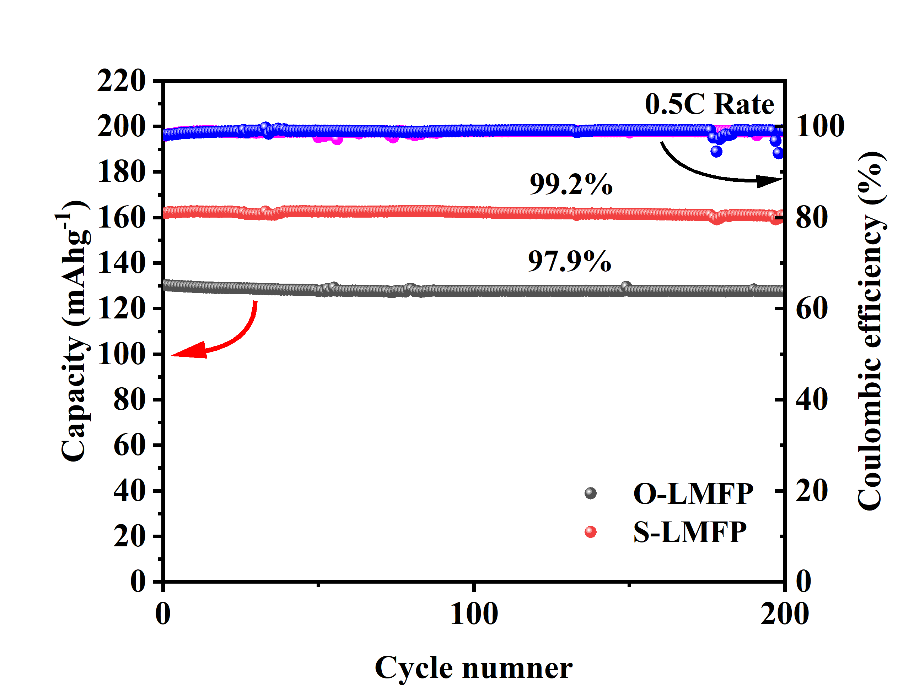
Fig. S2. Cycling performance at 0.5C of O-LMFP and S-LMFP.

