Supplement

S1. Completion of Table 2

Table S1:
Relevant data of all documented blasts in the Dürnbach quarry; location GK_M34;
N [m]...Northing – 5301000 m; E [m]...Easting + 22000 m; Z[m]… elevation; V_{t} [m3]... total volume of rock mass to be blasted; C_{t} [kg]… tatal explosive charge; Tt [s]… infrasound travel time from blast location to ISCO array center; A_{pp} [microPa]...perak-peask amplitude of 0.4 – 1.6 Hz bandpass filtered stacked infrasound signal; F[Hz]… dominant frequency of 0.4 – 1.6 Hz bandpass filtered stacked infrasound signal

Name | UTC blast | N [m] | E [m] | Z[m] | V_{t} [m³] | C_{t} [kg] | Tt [s] | A_{PP} [microPa] | F [Hz]
2023doy327 | 2023-11-23 10:49:21 | 671 | 603 | 706 | 5897 | 1809 | 00:50.8 | 20824 | 0.62
2023doy180 | 2023-06-29 11:07:32 | 776 | 543 | 707 | 5928 | 1662 | 00:46.9 | 9399 | 0.68
2022doy293 | 2022-10-20 11:08:58 | 704 | 607 | 705 | 7679 | 2332 | 00:47.6 | 24049 | 0.71
2022doy223 | 2022-08-11 11:46:56 | 712 | 599 | 706 | 10900 | 3194 | 00:47.3 | 18141 | 0.74
2022doy193 | 2022-07-12 11:48:01 | 618 | 598 | 726 | 3770 | 1209 | 00:47.9 | 2716 | 0.89
2022doy188 | 2022-07-07 10:49:49 | 773 | 568 | 706 | 8518 | 2657 | 00:48.4 | 8100 | 0.65
2024doy211 | 2024-07-29 13:34:22 | 587 | 991 | 718 | 2644 | 815 | 00:49.4 | 4780 | 0.67
2024doy190 | 2024-07-08 13:37:04 | 757 | 928 | 702 | 4050 | 1214 | 00:47.6 | 19191 | 0.81
2024doy144 | 2024-05-23 13:00:06 | 677 | 848 | 704 | 6829 | 1490 | 00:48.4 | 14325 | 0.70
2024doy011 | 2024-01-11 10:35:28 | 616 | 685 | 718 | 2852 | 870 | 00:49.4 | 13606 | 1.24
2023doy353 | 2023-12-19 10:36:56 | 651 | 744 | 705 | 2208 | 803 | 00:50.1 | 5362 | 0.52
2023doy264 | 2023-09-21 11:48:15 | 680 | 672 | 706 | 5157 | 1450 | 00:34.9 | 5821 | 0.72
2023doy257 | 2023-09-14 11:14:04 | 598 | 754 | 718 | 3570 | 1278 | 00:48.7 | 3416 | 0.63
2023doy255 | 2023-09-12 05:39:04 | 833 | 935 | 689 | 3564 | 1808 | 00:47.9 | 15778 | 0.63
2023doy248 | 2023-09-05 09:53:48 | 793 | 530 | 706 | 2191 | 872 | 00:46.6 | 11779 | 0.84
2023doy243 | 2023-08-31 11:48:15 | 682 | 664 | 705 | 5158 | 1584 | 00:48.4 | 10270 | 0.75
2023doy228 | 2023-08-16 11:16:33 | 590 | 957 | 717 | 2052 | 850 | 00:47.6 | 5375 | 0.67
2023doy220 | 2023-08-08 08:47:50 | 734 | 532 | 707 | 5335 | 1481 | 00:48.7 | 8574 | 0.67
2023doy216 | 2023-08-04 09:16:14 | 682 | 653 | 706 | 5246 | 1681 | 00:47.6 | 23469 | 0.79
2023doy202 | 2023-07-21 09:35:33 | 816 | 547 | 706 | 5695 | 1838 | 00:46.9 | 7578 | 0.70
2023doy185 | 2023-07-04 09:33:09 | 757 | 491 | 718 | 3113 | 1277 | 00:48.4 | 5274 | 0.65
2023doy151 | 2023-05-31 08:41:10 | 777 | 550 | 707 | 6745 | 1621 | 00:47.6 | 13794 | 0.65
2023doy145 | 2023-05-25 11:27:04 | 597 | 803 | 717 | 3735 | 1064 | 00:48.4 | 5369 | 0.71
2023doy143 | 2023-05-23 06:08:45 | 864 | 577 | 692 | 3168 | 1543 | 00:47.9 | 6341 | 0.65
2023doy124 | 2023-05-04 11:47:21 | 595 | 813 | 715 | 4875 | 1547 | 00:48.4 | 8750 | 0.94
2023doy117 | 2023-04-27 11:52:23 | 688 | 636 | 706 | 5897 | 1549 | 00:48.7 | 12371 | 0.58
2023doy073 | 2023-03-14 12:43:45 | 674 | 445 | 731 | 3877 | 1208 | 00:50.1 | 17198 | 0.61
2023doy038 | 2023-02-07 12:45:39 | 670 | 1067 | 730 | 8340 | 2580 | 00:50.8 | 65992 | 0.71
2023doy020 | 2023-01-20 10:03:21 | 626 | 1043 | 731 | 4485 | 1772 | 00:52.2 | 44704 | 0.70
2022doy353 | 2022-12-19 12:56:35 | 637 | 1050 | 730 | 8580 | 3363 | 00:50.8 | 31750 | 0.59
2022doy335 | 2022-12-01 13:05:56 | 829 | 583 | 700 | 6340 | 2332 | 00:48.4 | 18273 | 0.59
2022doy333 | 2022-11-29 12:11:18 | 604 | 511 | 730 | 2630 | 1132 | 00:48.4 | 8041 | 0.75
2022doy332 | 2022-11-28 10:44:33 | 592 | 1040 | 731 | 3003 | 1431 | 00:50.1 | 11365 | 0.67
2022doy312a | 2022-11-08 10:49:06 | 723 | 652 | 688 | 1000 | 348 | 00:49.4 | 3480 | 0.5
2022doy312b | 2022-11-08 12:38:05 | 763 | 558 | 707 | 10173 | 3081 | 00:47.9 | 18285 | 0.71
2022doy304 | 2022-10-31 13:05:57 | 805 | 525 | 718 | 2041 | 1078 | 00:47.3 | 6340 | 0.72
2022doy286 | 2022-10-13 12:22:00 | 570 | 982 | 731 | 3507 | 1644 | 00:49.4 | 10942 | 0.59
2022doy283 | 2022-10-10 11:46:05 | 839 | 538 | 716 | 2880 | 1181 | 00:47.6 | 7827 | 0.67
2022doy277 | 2022-10-04 09:22:30 | 700 | 1078 | 730 | 6492 | 2305 | 00:50.5 | 4425 | 0.59
2022doy272 | 2022-09-29 08:06:47 | 839 | 538 | 716 | 2587 | 749 | 00:48.7 | 7152 | 0.75
2022doy264 | 2022-09-21 11:56:42 | 734 | 1120 | 730 | 13200 | 1966 | 00:51.5 | 30794 | 0.53
2022doy259 | 2022-09-16 07:48:47 | 610 | 570 | 727 | 2297 | 571 | 00:49.0 | 3220 | 0.71
2022doy251 | 2022-09-08 06:50:22 | 867 | 1006 | 696 | 1900 | 719 | 00:48.4 | 3427 | 1.24
2022doy245 | 2022-09-02 09:30:55 | 584 | 978 | 731 | 3451 | 959 | 00:47.6 | 4524 | 0.72
2022doy236 | 2022-08-24 11:57:34 | 579 | 927 | 730 | 3243 | 1028 | 00:48.7 | 199263 | 0.94
2022doy231 | 2022-08-09 09:14:06 | 593 | 1018 | 731 | 4180 | 1265 | 00:47.9 | 13803 | 0.65
2022doy230 | 2022-08-18 09:13:16 | 582 | 917 | 730 | 5950 | 1954 | 00:47.3 | 11072 | 0.67
2022doy216 | 2022-08-04 09:33:42 | 647 | 691 | 718 | 3805 | 871 | 00:46.6 | 6965 | 0.63
2022doy209 | 2022-07-28 11:42:58 | 575 | 871 | 731 | 4300 | 1716 | 00:47.3 | 7495 | 0.84
2022doy202 | 2022-07-21 11:15:14 | 727 | 586 | 706 | 7115 | 2334 | 00:46.6 | 15370 | 0.75

S2. Photogrammetric Methods and Models

We were able to photographically document and evaluate the geometry of the final deposit of six blasts (blasts 2022doy188 to 2023doy327 listed in Table 2). The photogrammetric 3D models (Figure S1) were created from a large number of photos taken from as many different directions as possible using the colmap program (https://colmap.github.io/index.htm). This method is called Structure-from-Motion (SFM) and Multi-View Stereo (MVS). The models were oriented on the assumption that the floors are flat and horizontal. The scale was given by the known floor height.
The software Cloud Compare (https://www.cloudcompare.org) enables the extraction of profiles from 3D-models. These profiles were arranged in the 3D-models at a lateral distance of 1 m in the dominant direction of the ejected rock masses. Figure S1, right column shows the superimposition of these profiles covering the representative central area of the six blasts. In some blasts, trenches formed between the remaining quarry face and the blasted rock mass. These areas could not be captured photogrammetrically. The shape of these trenches was included in the profiles based on visual observation. The original geometry of the cut before blasting (yellow) is determined by the floor height, the overall distance from the free wall, and the inclination of the rock face. The increase of the cross-sectional area after blasting (green) is also clearly visible in Figure S1 (right column). The loosening of the rock associated with the blasting process averages 51%.

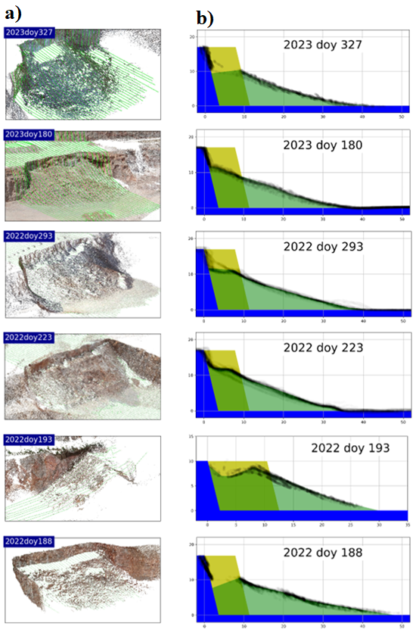
Figure S1:
a) 3D photogrammetric models of bench blasts 2023doy327, 2023doy180, 2022doy293, 2022doy223, 2022doy193, and 2022doy188.
b) Representative profiles in direction of ejection taken from the 3D models.

S3. Modeling the temporal variation of the cross-sectional area of the blasted rock mass

Knowledge of the volume of the blasted rock mass V(t) over the entire period from t=t_start (at the beginning of the detonation) to t=t_final (with deposition in the foreground) permits us to determine the temporal course of the cross-sectional area of the blasted rock by means of modeling.
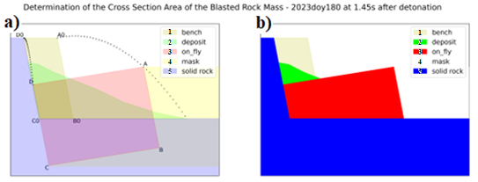

Figure S2: Simulation of the ejection of the rock mass by flight parabolas;
a) relevant planes in z-order and translucent representation;
b) same as a), but in opaque representation; see text.

Figure S2 a) shows the levels relevant for the ejection of the blasted rock in z-order and translucent representation:

1 (sand colour) - bench: Geometry of the rock to be blasted till time of blasting (t <= t_start)
2 (green colour) - deposit: Geometry of the blasted rock after completion of deposition (t >= t_final), taken from profile 2022doy180, FIGsupplement1_right column
3 (red colour) - on_fly: Blasted rock in motion, at time t = 1.45 s after detonation
4 (yellow colour) - mask: area at time t = 1.45 s before 3 - on_fly, where no deposition could take place yet
5 (blue colour) - solid_rock: solid rock remaining after blasting under or behind the crest, highwall, and toe.

At the moment of detonation t = t_start, the area 1-bench becomes 3-on_fly. We determine the movement and deformation of the parallelogram A0-B0-C0-D0 corresponding to 1-bench into the parallelogram A-B-C-D using flight parabolas. At t = t_start, the blasted rock moves normally to the highwall. The magnitude of the initial velocity at point A0 (v_front) is chosen so that the flight parabola passes through point A and reaches the foremost point of 2-deposit. The magnitude of the initial velocity at point D0 (v_rear) is chosen so that, if possible, no gap or overlap occurs between 3-on_fly and 5-solid_rock. The initial velocities for the 2022doy180 blast are v_front = 14.0 m/s and v_rear = 1.6 m/s. The flight parabola from B0 to B corresponds to that from A0 to A, and the flight parabola from C0 to C corresponds to that from D0 to D. The difference between v_front and v_rear results in a constant expansion rate of 3-on_fly.

Figure S2 b) shows the levels relevant for the ejection of the blasted rock in z-order and opaque colour. Covering the areas of red - on_fly and yellow - mask located in Figure S2 a) under the base with the blue of blue - solid_rock and changing the color of mask from yellow to white results in a physically comprehensible image of the ejection of the blasted rock mass. Given a bench height BH and total burden TB, the following applies to the time-variable cross-sectional area A(t) of the blasted rock mass:

A(t) = BH*TB*NpixelRG(t)/NpixelRG(t_start)

with NpixelRG(t) ...number of either red (R) or green (G) pixels in Figure S2 b).

