Supplementary Materials
TRIM21 drives stress-induced neuroinflammation and behavioral deficits via gasdermin D-dependent IL-1β release in a rat model of repeated social defeat
Soni Tiwari^{1,2}, Zaidan Mohammed^{1,3}, Santi Ranjan Atta^{1,4}, Aryan Tiwari¹, Ekta Yadav^{4,5}, Shweta Kaushik⁴, Amla Chopra², Itender Singh^{4,6} and Simantini Ghosh^{1*}
1. Department of Psychology, Ashoka University, Rai, India
2. Department of Zoology, Dayalbagh Education Institute, Dayalbagh, Agra, India
3. Department of Psychological Science, University of Vermont, Burlington VT, USA
4. Ambedkar Centre for Biomedical Research, Delhi University, New Delhi, India
5. Nuffield Department of Clinical Neuroscience, University of Oxford, Oxford, UK
6. Department of Neurosurgery, Washington University School of Medicine in St. Louis, St. Louis, MO, USA.
*Correspondence to Simantini Ghosh (simi@ashoka.edu.in)
Simantini Ghosh, Email ID: simi@ashoka.edu.in; ORCID: 0000-0002-0791-7255

Supplementary Figures
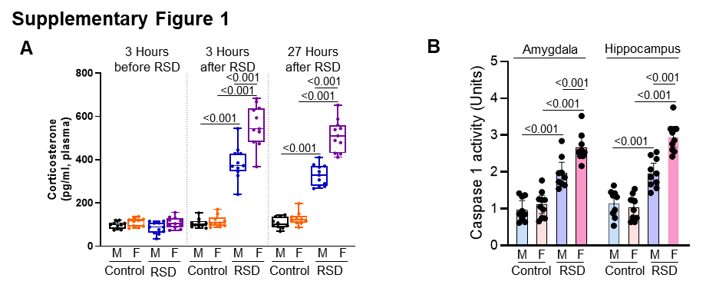
Supplementary Figure 1. RSD-induced neuroendocrine and molecular changes in SD rats. Plasma corticosterone levels in control and RSD-exposed male and female rats (n=10-11/group) (A). Quantification of caspase-1 activity in amygdala and hippocampus of SD rats (n=9-11/group) (B). Data are presented as mean with 95% CI; Data analyzed with Factorial ANOVAs; p-values are indicated for specific pairwise comparisons post-hoc.

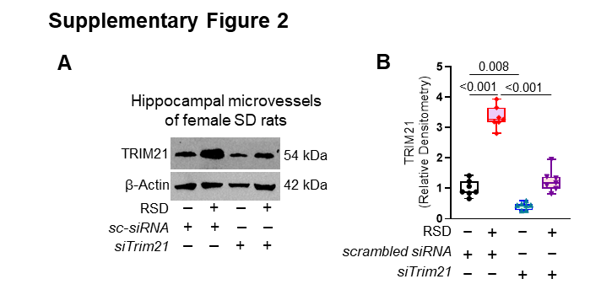
Supplementary Figure 2. Validation of in vivo TRIM21 knockdown efficiency. Validation of TRIM21 knockdown in the isolated microvessels from hippocampus of SD female rats by representative immunoblots and quantification (n=7/group) (A-B). Data are presented as mean with 95% CI; Data analyzed with Factorial ANOVAs; p-values are indicated for specific pairwise comparisons post-hoc.

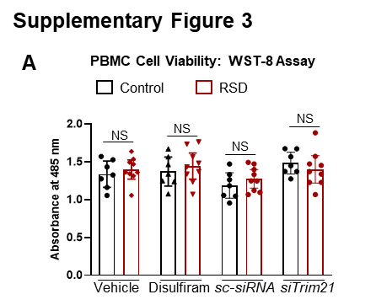
Supplementary Figure 3. RSD, TRIM21 knockdown and disulfiram do not induce cell death in PBMCs. Cell viability of PBMCs from RSD rats treated in vitro with scrabbled siRNA, Trim21 siRNA, or disulfiram, assessed by WST-8 assay (n=7-9/group) (A). Data are presented as mean with 95% CI; Data analyzed with Factorial ANOVAs.

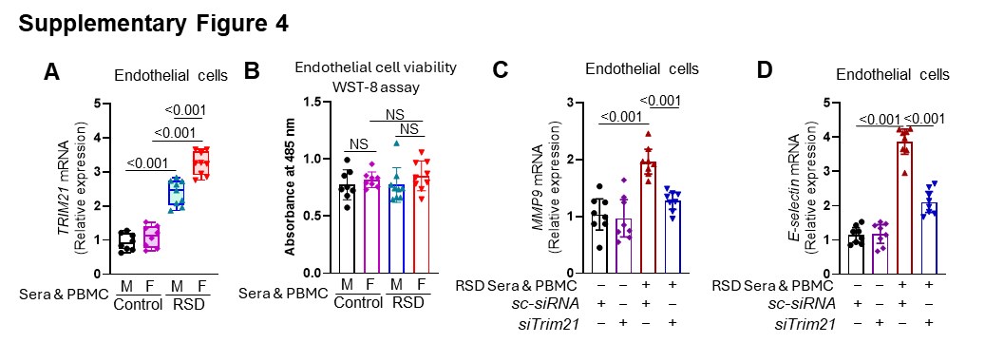
Supplementary Figure 4. TRIM21 mediates RSD-induced endothelial activation in vitro. Trim21 mRNA expression in RBECs from the in vitro model, measured by qRT-PCR (n=8-9/group) (A). Cell viability of RBECs under various treatment conditions, assessed by WST-8 assay (n=8-9/group) (B). mRNA expression of endothelial activation genes MMP9 (C) and E-selectin (D) in RBECs (n=8-9/group). Data are presented as mean with 95% CI; Data analyzed with Factorial ANOVAs; p-values are indicated for specific pairwise comparisons post-hoc.

Supplementary Methods
Antibodies
Primary antibodies: Anti-TRIM21, rabbit polyclonal, 1:1000, #PA5-120224, Thermo Fisher Scientific; Anti-cleaved GSDMD (Asp276), rabbit monoclonal, 1:1000, #10137, Cell Signaling Technology; anti-NLRP3 (D4D8T), rabbit monoclonal, 1:1000, #15101, Cell Signaling Technology; β-actin, mouse monoclonal, 1:25000, #sc-47778, Santa Cruz Biotechnology; Anti-NF-kB p65 (phospho S536), rabbit monoclonal, 1.1000, # ab76302, Abcam; Anti-NF-kB p65, mouse monoclonal, 1:2000, #sc-8008, Santa Cruz Biotechnology; Anti-ICAM1, rabbit monoclonal, 1:1000, #ab222736, Abcam; ZO-1, rabbit polyclonal, 1:2000, #61-7300, Thermo Fisher Scientific. Secondary antibodies: HRP-conjugated goat anti-rabbit IgG, 1:50000, #STAR124P, Bio-Rad Laboratories; and HRP-conjugated goat anti-mouse IgG, 1:50000, #sc-2005, Santa Cruz Biotechnology.

Quantitative real-time PCR Primer sequences
Trim21:
F: GTTGATTCCCCAGACCTGACA
R: GTCCAGCCCACAATTCCTACA

E-selectin:
F: TCCAGCAGCAGACACGATAC
R: TTCGGGGGTTGGATTCCTTG,
Claudin-5:
F: TTAAGGCACGGGTGGCACTCACG
R: TTAGACGTAGTTCTTCTTGTCG
MMP9:
F: GGATGTTTTTGATGCCATTGCTG
R: CCACGTGCGGGCAATAAGAAAG.
Gapdh:
F: GCAAGAGAGAGGCCCTCAG
R: TGTGAGGGAGATGCTCAGTG

siRNA Sequences
Control scrambled siRNAs:
1. 5’-GCTAGCTGGTCTAATATAA-3’
2. 5’-GACCCATTAGCAATTCAAA-3’
3. 5’-GCAATATAGACGACGTACT-3’
4. 5’-GGGTAGTAAGTTCACATAA-3’
siRNA sequences for Trim21 knockdown:
1. 5’-GCUGUAAUGUUCACAAUGA-3’
2. 5’-CAUCAAUGUACCAGACAUA-3’
3. 5’-GAGUUCGCACAUCAGAAUA-3’
4. 5’-GAUAUGAUGGUCAGUAACA-3’

In Vitro blood-brain barrier models
Isolation and culture of rat brain microvascular endothelial cells
RBECs were isolated from adult Sprague-Dawley rat brains according to an adapted protocol [1]. Briefly, minced cortical tissue was gently homogenized in ice-cold DMEM containing collagenase type 2 (1 mg/ml), DNase I (15 µg/ml), and gentamicin (50 µg/ml). The homogenate was filtered through a 40 µm nylon strainer to collect microvessels, which were subsequently digested in collagenase/dispase (1 mg/ml) and DNase I (5 µg/ml) for 45 minutes at 37°C. The microvascular endothelial cell fraction was purified using a 33% Percoll density gradient. Cells were cultured in DMEM supplemented with endothelial cell growth supplement on culture plates pre-coated with collagen type IV and fibronectin (0.1 mg/ml each).
PBMC-endothelial cell interaction model
To model the impact of stress-induced peripheral inflammation on the BBB, RBECs were grown to confluence on 12-well plates. Transwell-Clear inserts (12 mm diameter, 0.4 µm pore size; Corning) were placed into the wells with PBMCs (2×10⁵ cells) and 2% serum obtained from either control or RSD-stressed rats, to create "control" and "RSD" conditions, respectively. After 72 hours of co-culture, RBECs and conditioned media were collected for analysis.
Astrocyte-endothelial co-culture and barrier permeability assay
A co-culture model was established to assess functional BBB integrity [2]. Astrocytes were isolated from postnatal day 2 rat pups via tryptic digestion and mechanical dissociation, followed by filtration through a 40 µm strainer. After 3 days in culture, contaminating cells were removed by orbital shaking. Pure astrocytes were seeded in the basolateral compartment of 12-well plates, while RBECs were cultured on Transwell inserts placed above them. This co-culture system was then treated with PBMCs and serum from control or RSD rats as described above. After 72 hours, barrier function was quantified by adding 70 kDa FITC-dextran to the luminal chamber and measuring its leakage in the abluminal chamber over time using a fluorescence plate reader (490/520 nm; [3].

References
1. Sumi N, Nishioku T, Takata F, et al (2010) Lipopolysaccharide-Activated Microglia Induce Dysfunction of the Blood–Brain Barrier in Rat Microvascular Endothelial Cells Co-Cultured with Microglia. Cell Mol Neurobiol 30:247–253. https://doi.org/10.1007/s10571-009-9446-7
2. Abbott NJ, Dolman DEM, Drndarski S, Fredriksson SM (2012) An Improved In Vitro Blood–Brain Barrier Model: Rat Brain Endothelial Cells Co-cultured with Astrocytes. In: Milner R (ed) Astrocytes: Methods and Protocols. Humana Press, Totowa, NJ, pp 415–430
3. Fu BM (2022) Quantification of In Vitro Blood-Brain Barrier Permeability. Methods Mol Biol 2375:217–228. https://doi.org/10.1007/978-1-0716-1708-3_18

