Supplementary figures
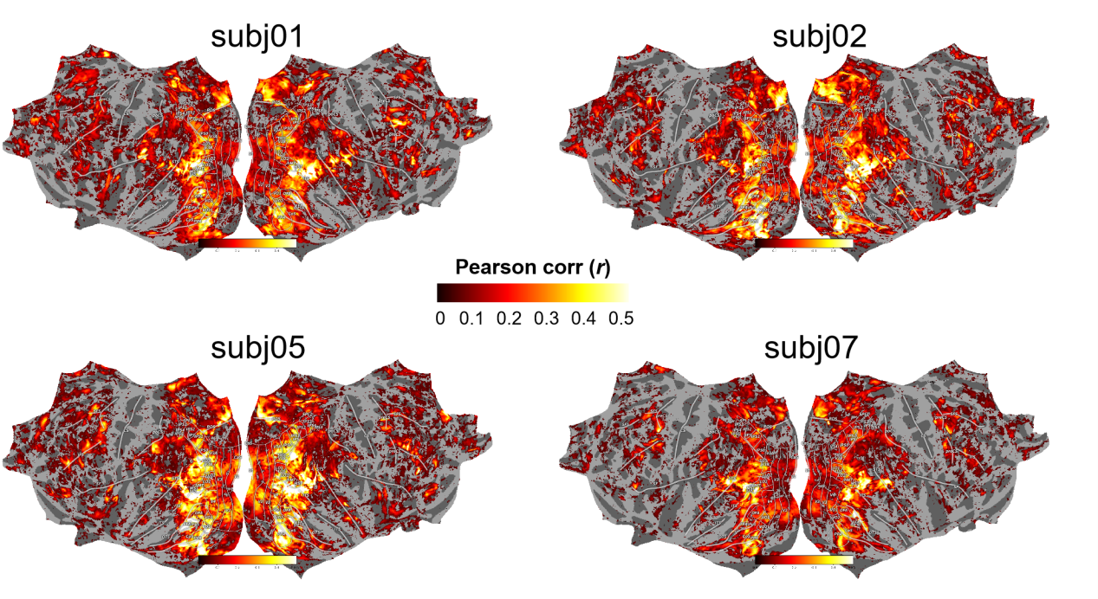
Figure S1. Individual BERT-based encoding model on four participants. The vertex-wise encoding accuracy of BERT demonstrated consistent and reliable predictions across four participants, indicating a population-label stable, linguistic representations supporting scene understanding. Notable individual differences in encoding models emerged predominantly in high-order visual cortex, extending along both dorsal and ventral visual pathways into frontoparietal regions. The spatial patterns of subject-specific BERT-based encoding models highly resembled the individual multimodal encoding models shown in Figure 7, suggesting that top-down linguistic modulation contributes substantially to individual differences in scene processing.

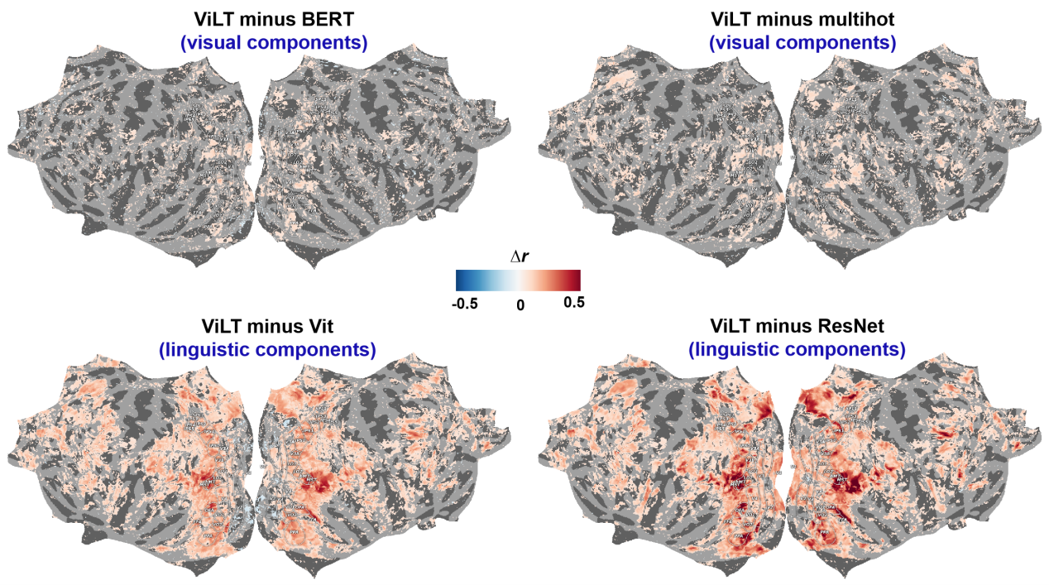
Figure S2. Relative contribution of linguistic vs visual representations to the multimodal joint embedding of natural scenes. Vertex-wise difference map illustrated the performance gain of the multimodal ViLT model over unimodal language (ViLT - BERT and ViLT - MultiHot) and vision models (ViLT - ViT and ViLT - ResNet), plotted on the fsaverage surface. ViLT demonstrated large improvements over vision-based models throughout both dorsal and ventral streams and in associated areas of frontal, parietal and temporal regions. Only a small, localized deficit appeared in early visual cortex (V1-V3) relative to ViT. Gains over language models were modest and confined to early and high-order visual areas. Similar distributions were observed whether captions or multi-hot object-label vectors were used in the language models, indicating that adding syntactic information provides limited additional benefit beyond isolated object/concept codes.
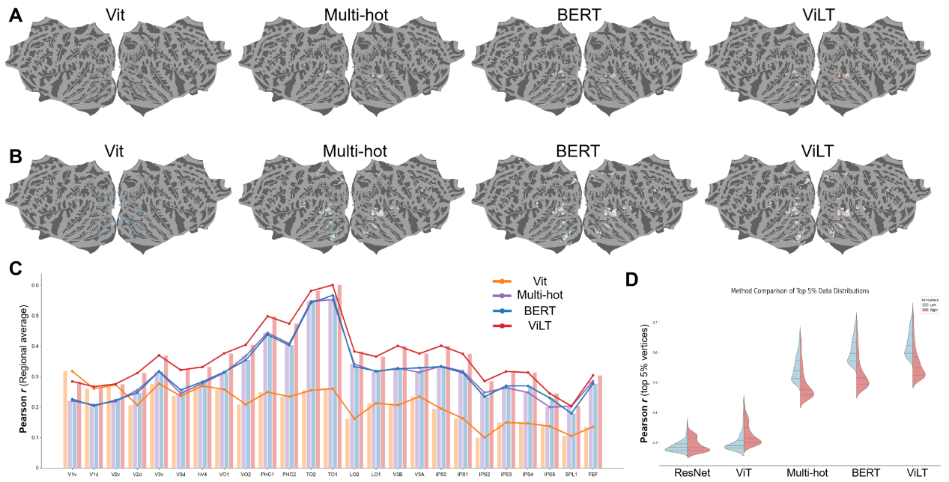
Figure S3. Cortical distribution of the best-predicted vertices for visual-, language-, and multi-modal encoding models. (A, B) Spatial maps of the top 1% and top 5% most accurately predicted vertices for each unimodal and multimodal model. (C) Regional encoding performance of visual areas defined by the Kasnter atlas. ViLT (joint image-text embedding) achieved the best encoding performance, followed by language models (MultiHot, BERT). Vision models performed the best in early visual cortex and declined along dorsal and ventral visual pathways. (D) Language and multimodal models showed clear left-hemispheric dominance, whereas vision models showed a bilateral distribution. Violet density plots (top 5% vertices only) illustrated the comparison between the left and right hemispheres for unimodal and multimodal models.
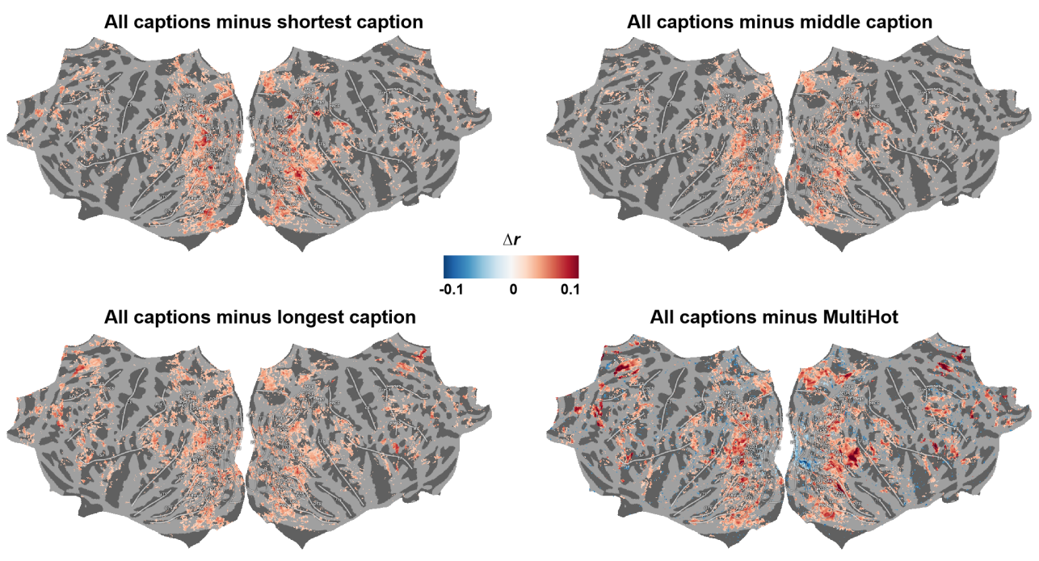
Figure S4. Cortical distribution illustrates the effect of caption length on language-based encoding models. Vertex-wise difference map illustrated the performance changes when using full five-sentence text caption instead of single captions and object-label vectors. The full-caption model demonstrated small benefits appeared in the frontal and parietal regions, and weak decrements in the superior temporal cortex. Additional contextual information improved the predictions in the dorsal and ventral streams but slightly reduced the accuracy in associated prefrontal areas. Limited benefits beyond isolated object/concept codes were observed as compared BERT with MultiHot encoding models.
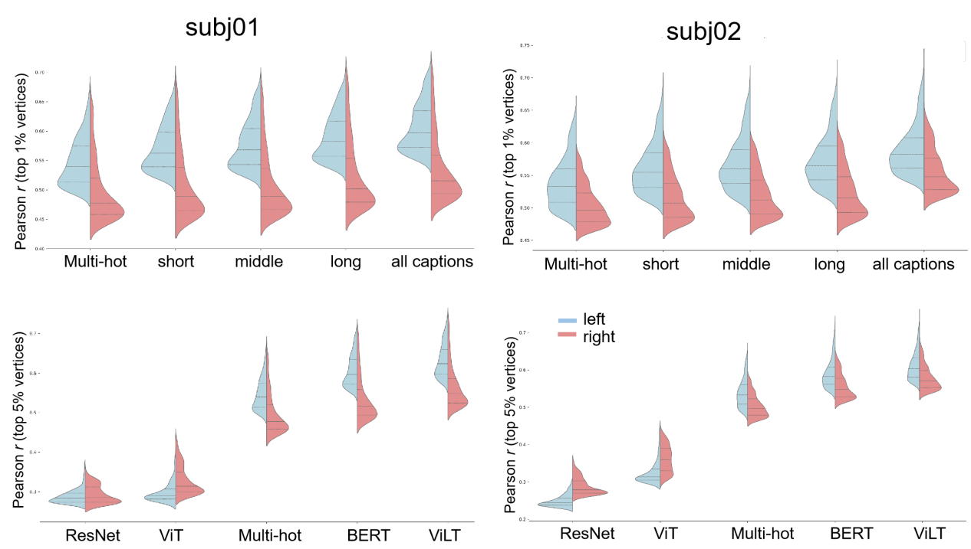
Figure S5. Hemispheric lateralization of vision-, language- and multimodal encoding models. Language and multimodal models exhibited consistent left-hemishphere lateralization across participants, caption lengths (single sentence vs. five-sentence) and text formats (object-label vectors vs. full-sentence captions), coinciding with the left-hemishphere dominance of langauge processing in the human brain. In contrast, vision-based models displayed a bilateral distribution pattern, suggesting equal engagement of both hemispheres for visual scene processing.

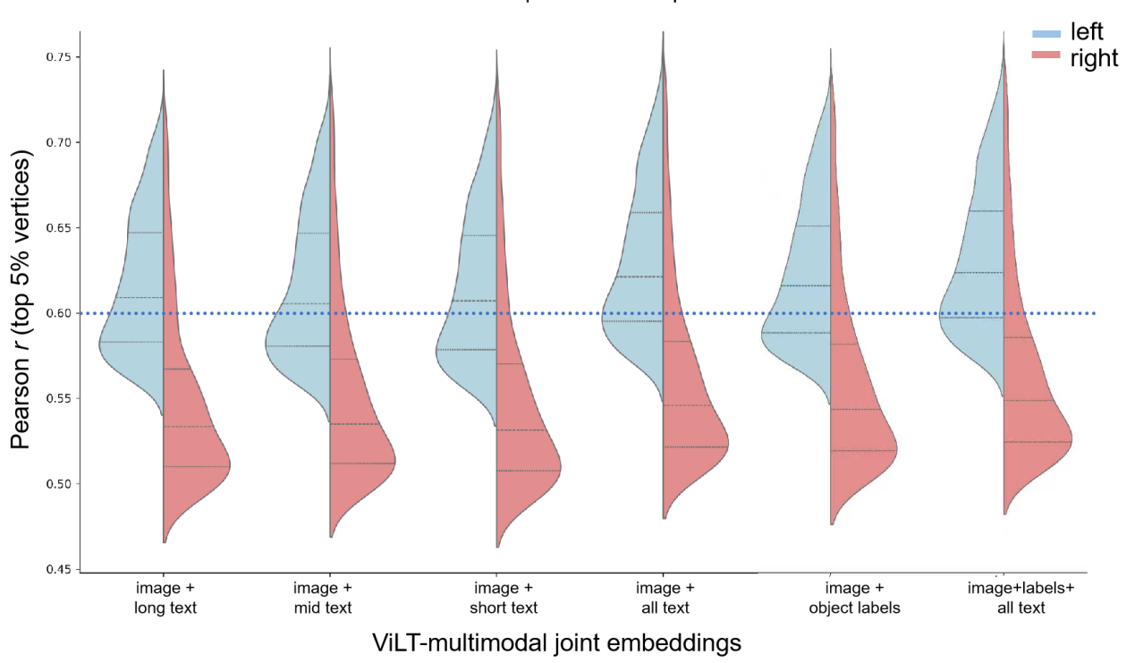
Figure S6. Hemispheric lateralization of multimodal joint embeddings of image features, object labels and text captions. The ViLT-based multimodal models exhibited consistent left-hemishphere lateralization irrespective of caption length (single caption vs. five-sentence) and text format (object-label vectors vs. full-sentence text captions). Among which, the image-text-label embeddings achieved the highest encoding accuracy in both hemispheres, but showed weaker left left-hemishphere lateralization. When only a single caption was available, the image-plus-shortest-caption embedding performed best, yet lower than joint embedding of image-plus-object-labels. Our findings suggest a crucial role of semantic embeddings in the reconstruction of linguistic and contextual information for comprehensive natural-scene understanding.

Table S1. Encoding accuracy of unimodal vision-based, language-based and multimodal models for an exemplar subject.
For each encoding model, we evaluated the minimum, median and maximum correlations (r) of the top 1% best-predicted cortical vertices. Only significant predictions (FDR-corrected p < 0.01) were reported here. We evaluated hemispheric lateralization of encoding models with the LI index, ranging from -1 (right dominant) to +1 (left dominant). Language and multimodal encoding models exhibited strong left-hemisphere lateralization, whereas visual models were bilateral or right-lateralized.
Model | Modality | Features | Dim. | %Sig. Prediction | Prediction accuracy (top 1%)
 |  |  |  |  | Minimum (r) | Median (r) | Maximum (r) | LI index  median
ResNet50-block3 | Vision | Image | 100k | 12.44% | 0.259 | 0.274 | 0.3678 | −0.0018
ViT-B/16 | Vision | Image | 768 | 23.93% | 0.276 | 0.294 | 0.442 | −0.0415
MultiHot (COCO things) | Language | Label | 80 | 42.59% | 0.461 | 0.508 | 0.671 | 0.0609
BERT-base | Language | Text | 768 | 44.26% | 0.477 | 0.533 | 0.681 | 0.0737
ViLT | Multimodal | Image +Label | 768 | 46.58% | 0.503 | 0.607 | 0.728 | 0.063
 | Multimodal | Image +Text | 768 | 51.46% | 0.507 | 0.621 | 0.738 | 0.0643
 | Multimodal | Image+Label+Text | 768 | 51.68% | 0.509 | 0.624 | 0.739 | 0.0639

