Supplementary Materials for

Unidirectional dynamic stiffness modulation enables easily insertable and conformally attachable spinal bioelectronic device

Sunguk Hong et al.

*Corresponding author. Email: sungminpark@postech.ac.kr

This PDF file includes:

Texts. S1 to S2
Figs S1 to S22
Legends for movies S1 to S3

Other Supplementary Materials for this manuscript include the following:

Movies S1 to S3

Supplementary text

Fabrication process of the VCS-NI

All fabrication processes of the VCS-NI were conducted on low-cost slide glass substrates, employing specialized techniques to integrate the water-soluble sacrificial layer, liquid metal-based conductive polymer, and the silicone. The slide glass used as the substrate underwent dual property treatment: the edges were made hydrophilic to ensure strong adhesion with the water-soluble sacrificial layer, while the central area was rendered hydrophobic to facilitate the easy peel-off of the sacrificial layer. We imparted hydrophobic properties to the central part of the slide glass by spin-coating and subsequently removing PDMS, thereby avoiding the use of toxic silane compounds (Fig. S6). The conductive polymer, created by mixing liquid metal nanoparticles with flexible silicone, was integrated into the flexible silicone substrate through a stencil process. The strong bonding between the conductive polymer and silicone, owing to their identical base materials, effectively minimized performance degradation due to active oxygen, commonly observed in flexible neural interfaces with thin-metal conductors. Immediately after the integration of the conductive polymer with the silicone substrate, the liquid metal nanoparticles within the conductive polymer were fully isolated, resulting in no initial conductivity. Consequently, an ultrasound-based activation process was employed to establish an electrical path between the liquid metal nanoparticles (Fig. S9). To prevent the destruction of patterns due to kinetic energy during the ultrasound activation process, the packaging process was conducted prior to activation, and a repackaging process was employed to minimize the risk of liquid metal leakage. Areas where conductivity was successfully induced appeared darker than non-conductive areas, directly indicating physical bonding among the liquid metal nanoparticles. The etching and peel-off of the packaging layer were performed using a laser, with a CO2 laser employed for precise etching through a metal mask (Fig. S11).

Bending and attaching mechanism of the VCS-NI in the body (Fig. S5)

Capillary force is the most dominant force that adheres a wet surface to a flexible electrode. In VCS-NI, a force of 0.06 to 0.01 N was calculated. The calculation method is as follows:

Laplace formula

$∆P= γ_{L} \left(\frac{1}{M}-\frac{1}{R}\right)≈\frac{γ_{L}}{M}$, when P $≪$ R

Geometric relationships of modeling

$$s_{1}=(2\sin{\frac{α}{2}R)\cos{\frac{α}{2}+L}}$$

$$s_{1}=\operatorname{Rsin}{α}+L$$

Where $L=\sqrt{(2M\cos\left(\frac{θ_{1}+ θ_{2}+ α}{2}\right)2-\left(2αRsin2{\frac{α}{2}}\right)2}≈2M\cos\left(\frac{θ_{1}+θ_{2}}{2}\right)$

$$M= \frac{2αR\sin{\frac{α}{2}}}{\cos{θ_{1}+\cos{{(θ}_{2}+α)}}}$$

$$s_{1}=R\sin{α}+\frac{\operatorname{Rsin}{2α}}{2(\cos{θ_{1}}+\cos{θ_{2}})}\cos{\frac{θ_{1}+θ_{2}}{2}}≈R\sin{α}≈s_{2}$$

Capillarity adhesion force

$$s_{1}=R\sin{α}+\frac{\operatorname{Rsin}{2α}}{2(\cos{θ_{1}}+\cos{θ_{2}})}\cos{\frac{θ1+θ2}{2}}≈R\sin{α}≈s2$$

$$F=∆P∙S_{2}∙EL=∆P∙R\sin{α}∙EL≈ \frac{γ_{L}}{M}∙R\sin{α}∙EL$$

$$= \frac{2γ_{L}\left(\cos{θ_{1}}+\cos{θ_{2}}\right)}{\sin{α}}$$

$$F_{electrode}=2F$$

where ${\text{γ}}_{\text{L}}$is surface tension coefficient at the water and air interface, 𝜃₁ is contact angle between the electrode and the interfacial water layer, 𝜃₂ is contact angle between the spinal tissue and the interfacial water layer, $α$ is contact angle between the spinal tissue and the electrode, R is radius of the meniscus formed by the interfacial water, L is length of the electrode in contact with water, EL is the electrode length, M is radius of meniscus, and F is force by capillary action on the electrode.
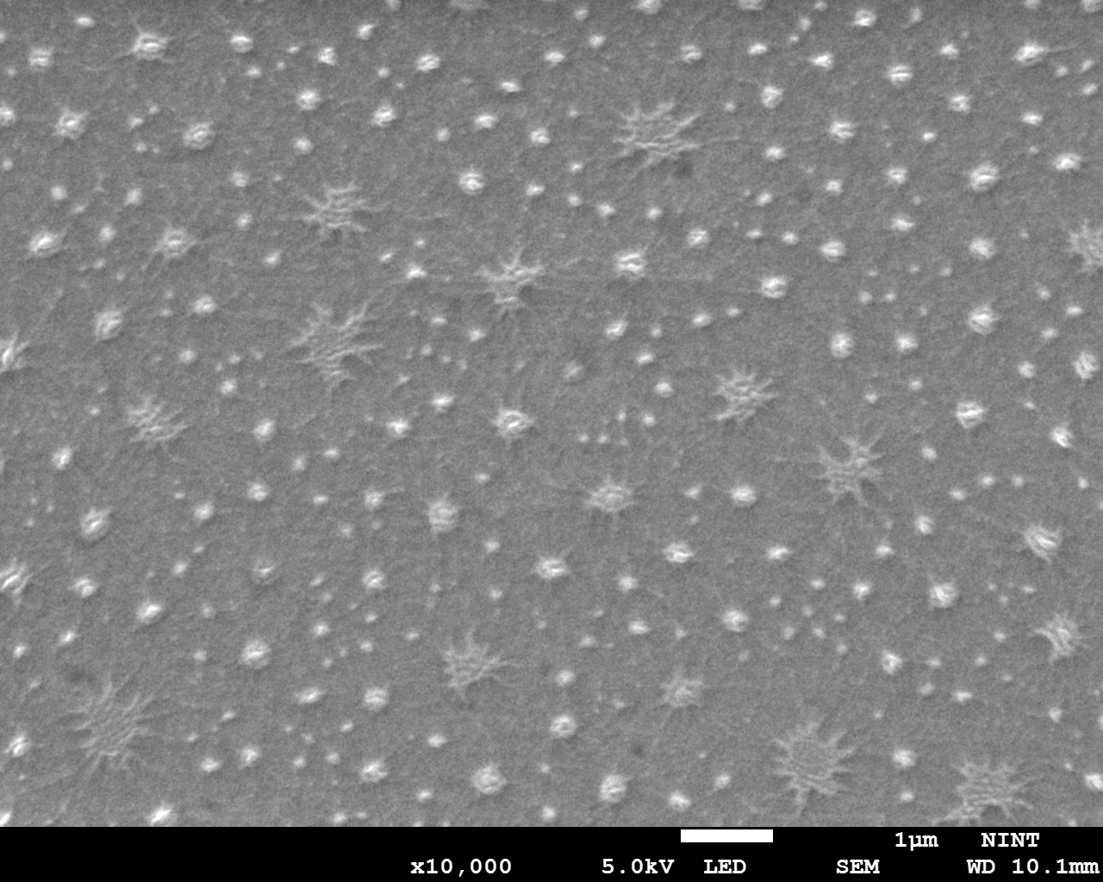
Fig. S1. SEM image of EGain nanoparticles.

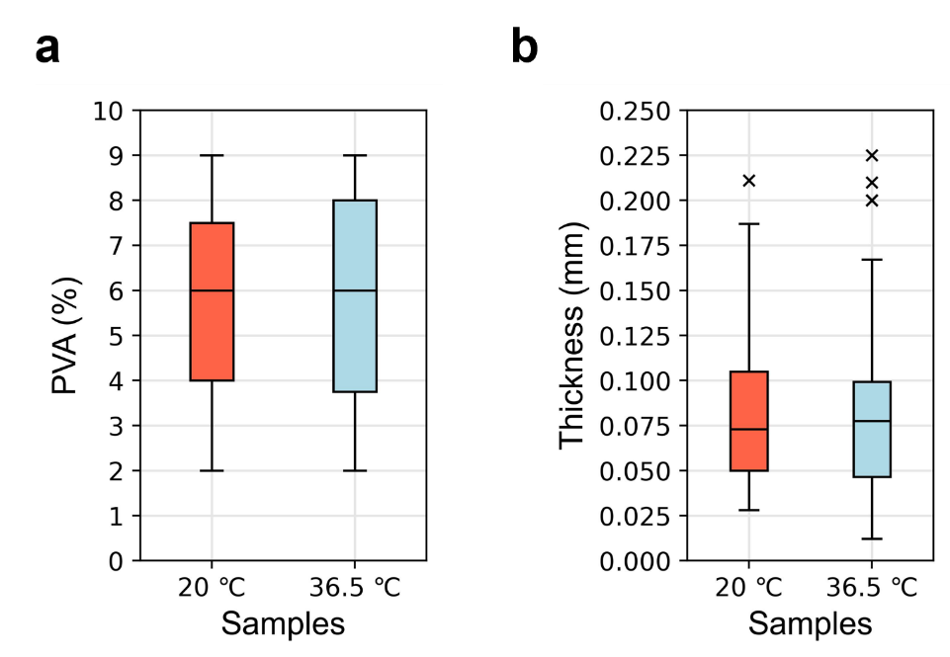
Fig. S2. Dataset comparison in PVA dissolving test. Comparison of a PVA Percentage, and b sample’s thickness at different DI water temperatures.

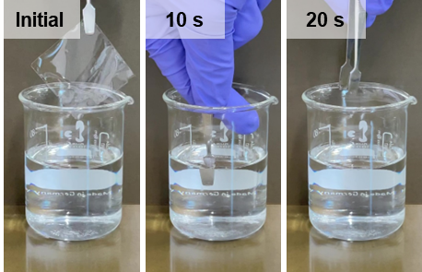
Fig. S3. Photographs of the rapid dissolution of the water-soluble sacrificial layer (PVA 2%) in deionized water at room temperature (20 °C).

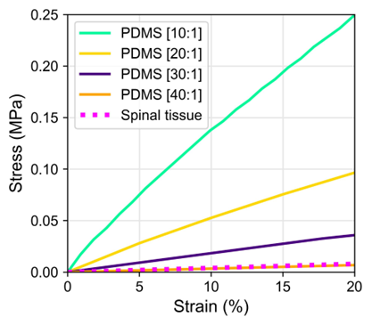
Fig. S4. Young’s modulus of PDMS depending on the mixing ratio.

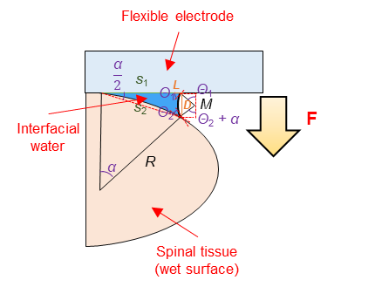
Fig. S5. Schematic illustration of electrode bending and attaching mechanism.
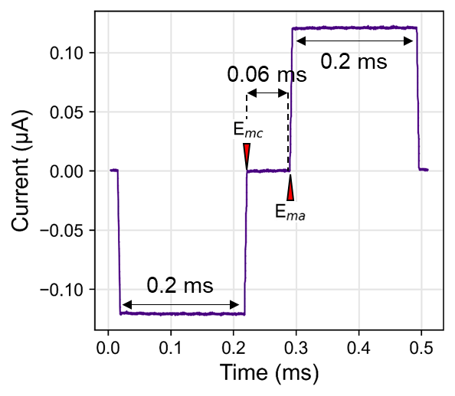
Fig. S6. Charge-balanced, biphasic current pulses injected through electrodes immersed in PBS solution.

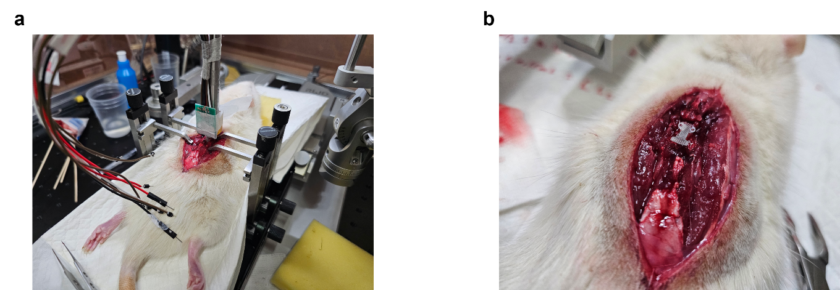
Fig. S7. Rat blood pressure modulation test. a Test setting. b VCS-NI pushed into the subdural space of spinal cord.

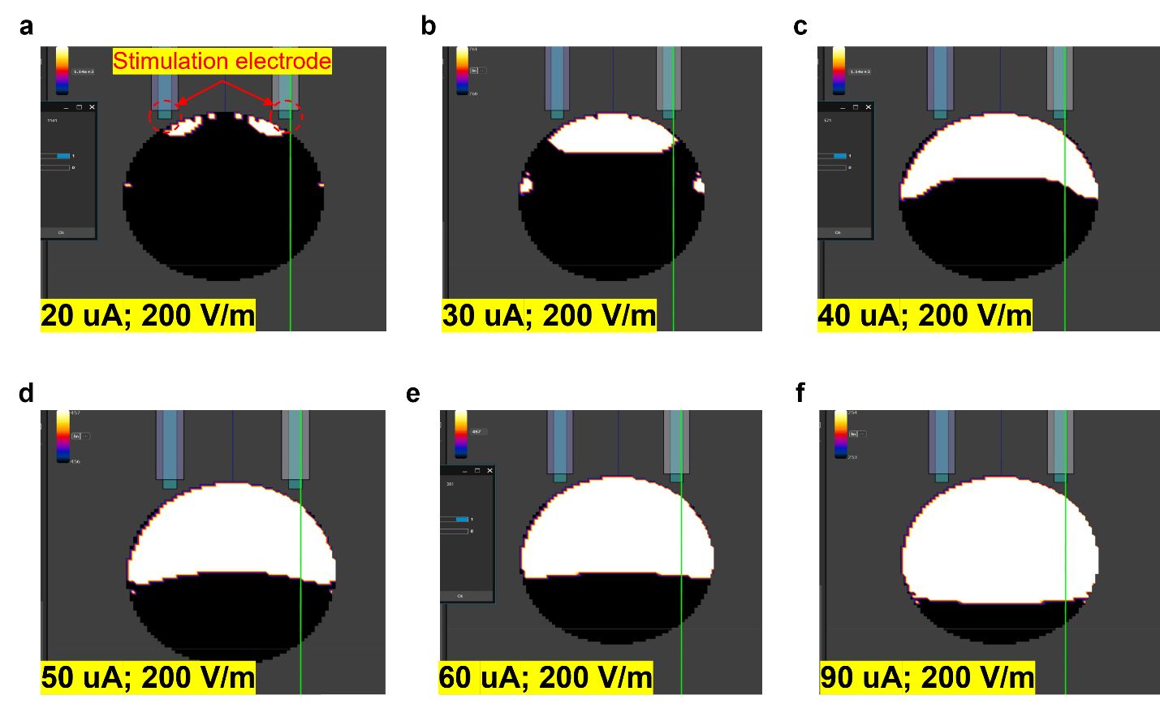
Fig. S8. E-field simulation across the spinal cord cross-section as a function of stimulation power. a 20 μA. b 30 μA. c 40 μA. d 50 μA. e 60 μA. f 90 μA.
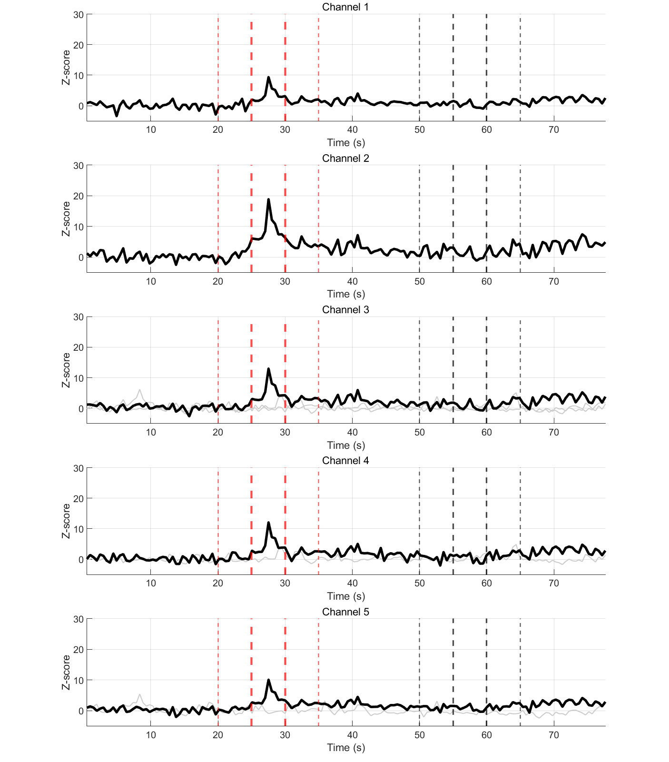
Fig. S9. Neural signal recoding results at 1-4 Hz.

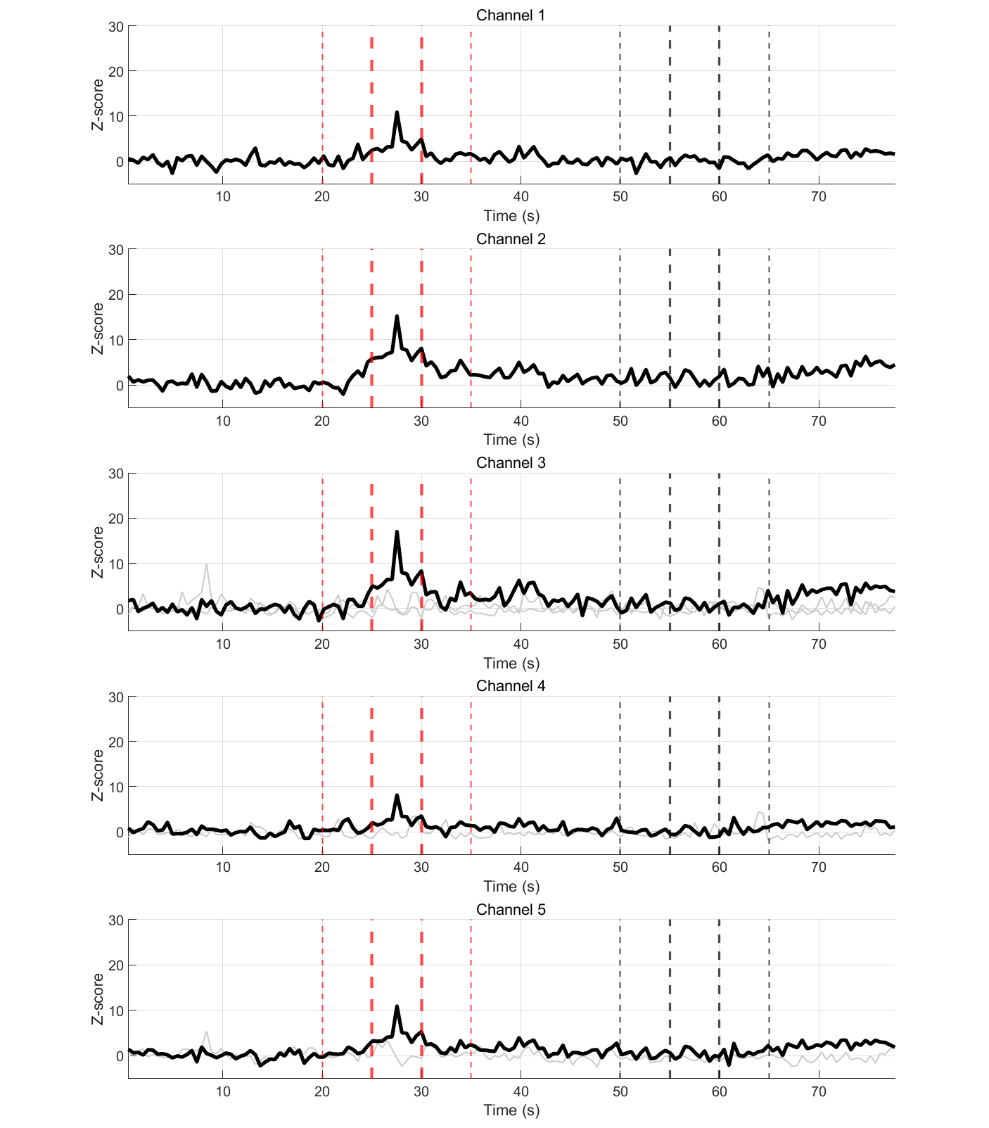
Fig. S10. Neural signal recoding results at 4-8 Hz.

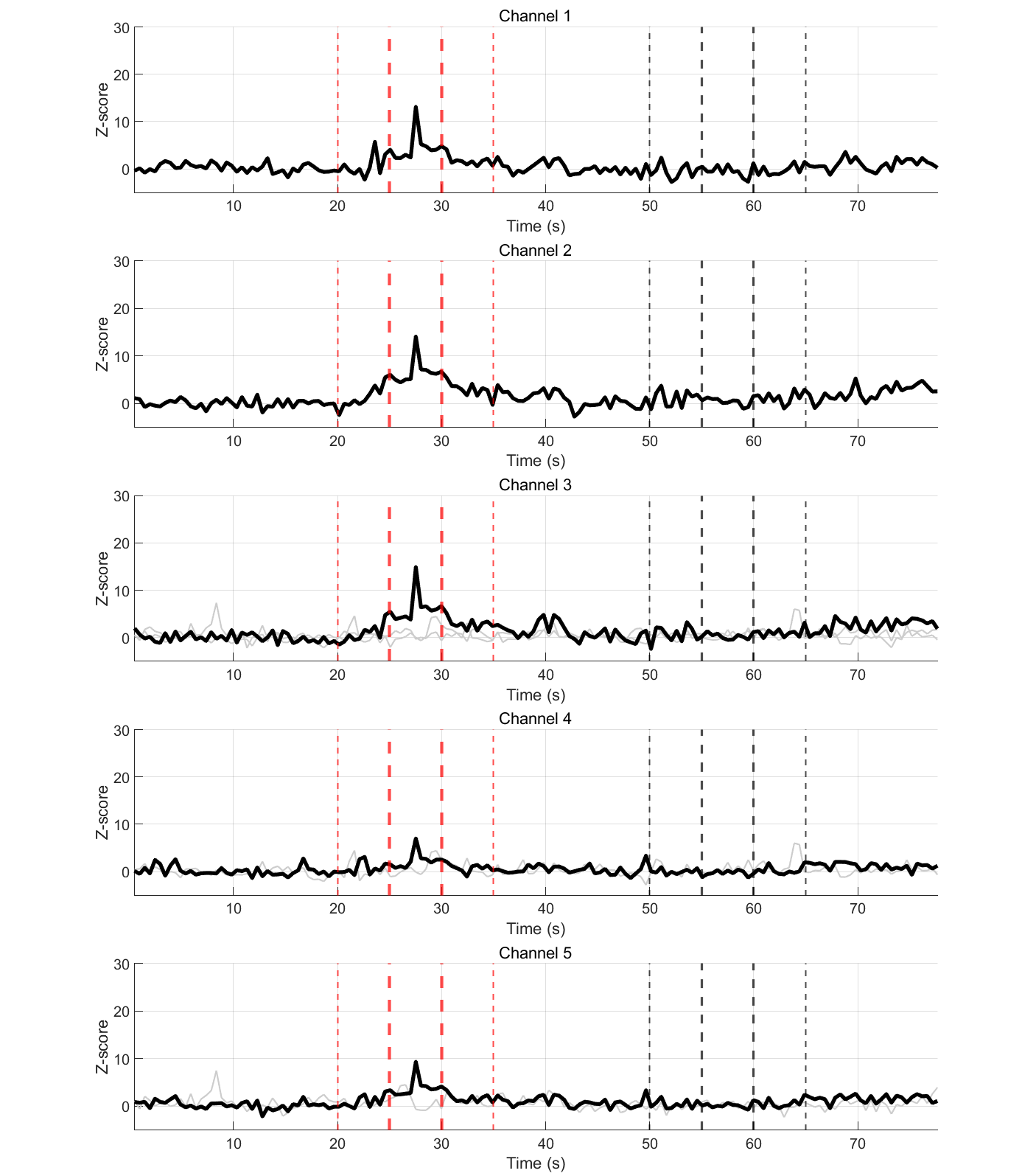Fig. S11. Neural signal recoding results at 8-13 Hz.

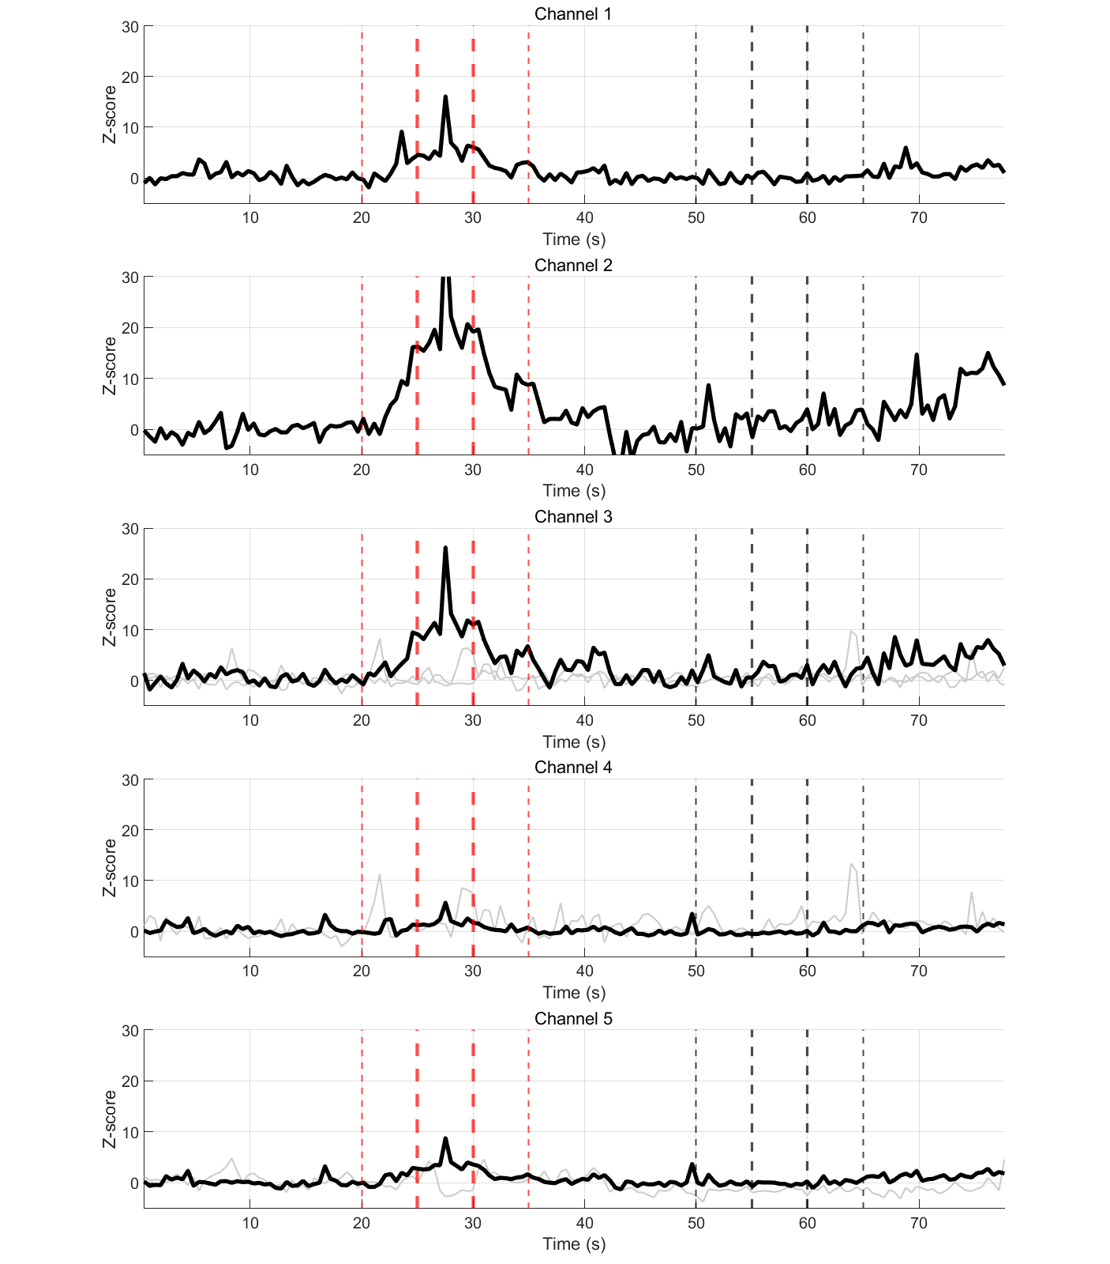
Fig. S12. Neural signal recoding results at 13-30 Hz.

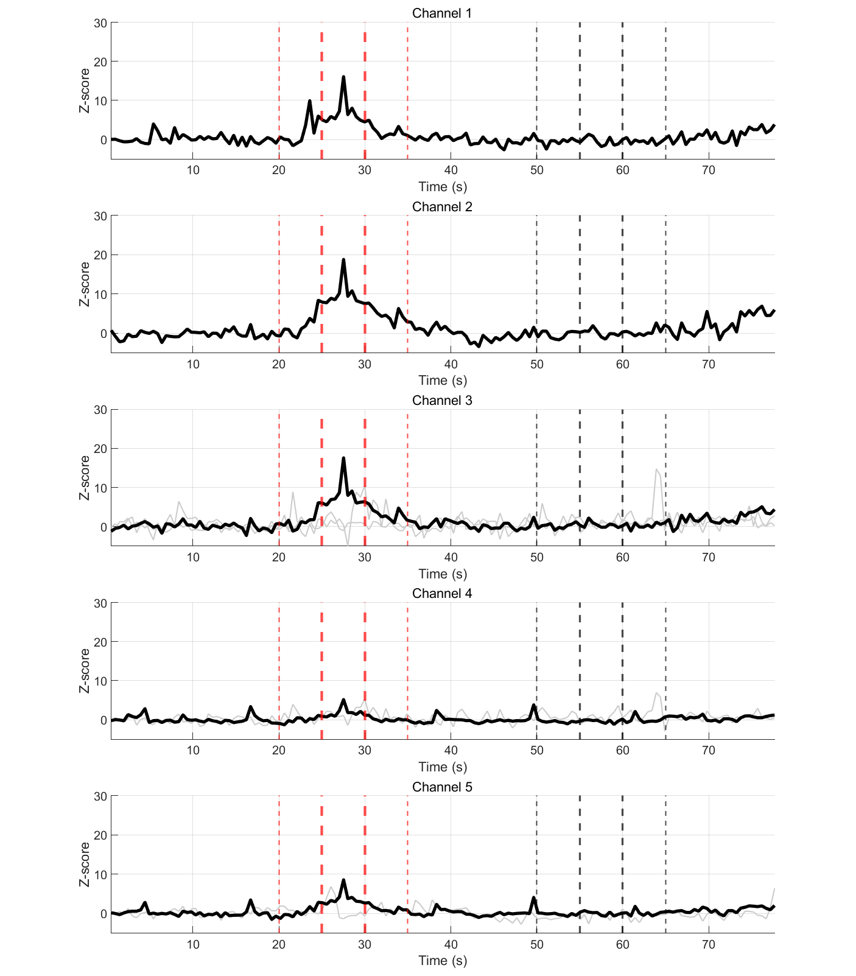Fig. S13. Neural signal recoding results at 30-50 Hz.

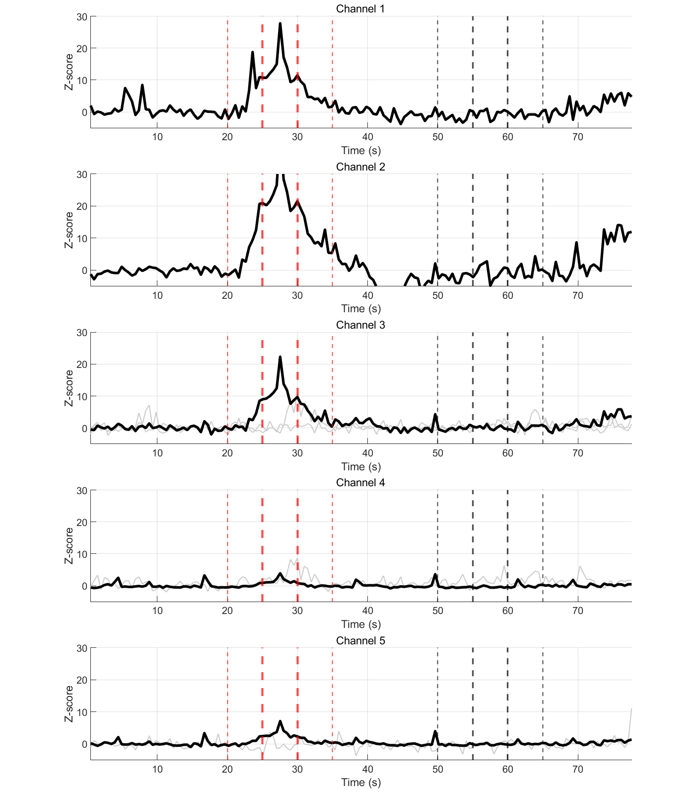Fig. S14. Neural signal recoding results at 50-100 Hz.

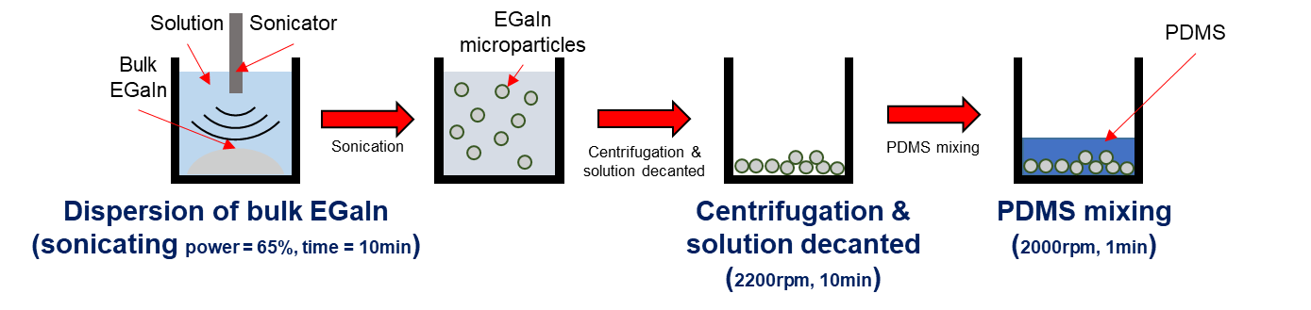
Fig. S15. Preparation of conductive polymer.
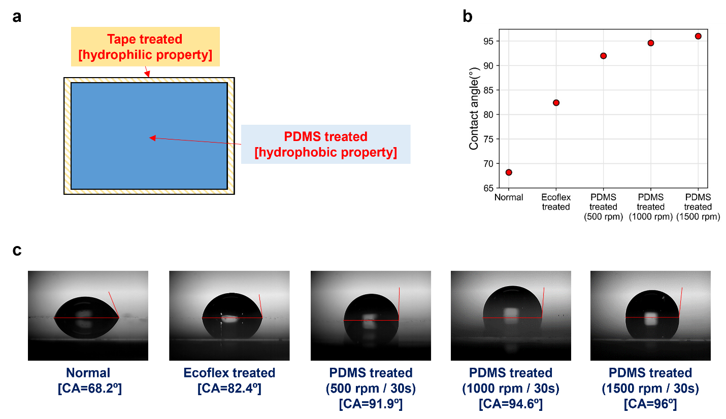
Fig. S16. Characteristics of dual-treated slide glass surface. a Schematic illustration of dual-treated slide glass. b Contact angles of normal, Ecoflex treated, and PDMS treated surfaces. c Droplet images of treated surfaces.

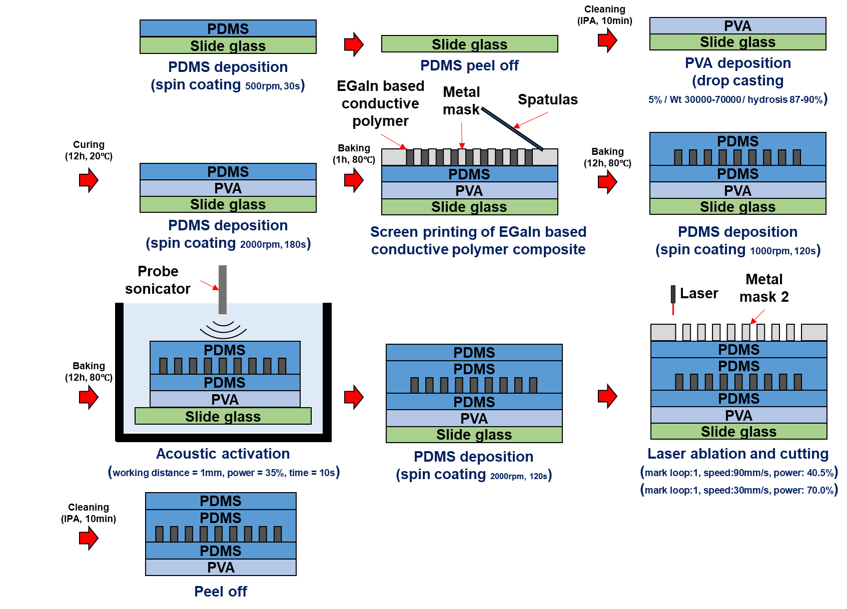
Fig. S17. Overall fabrication process.
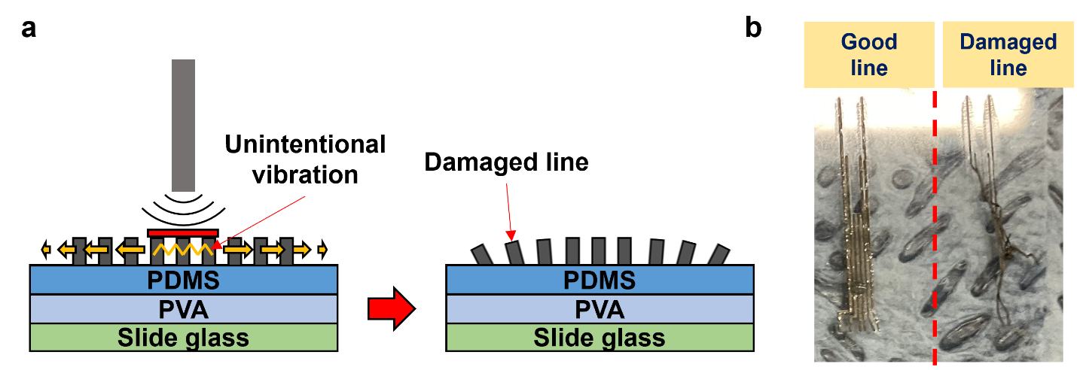
Fig. S18. Line activation process without packaging layer. a Mechanism where unintentional vibration damages the line. b Photographs of undamaged and damaged lines.

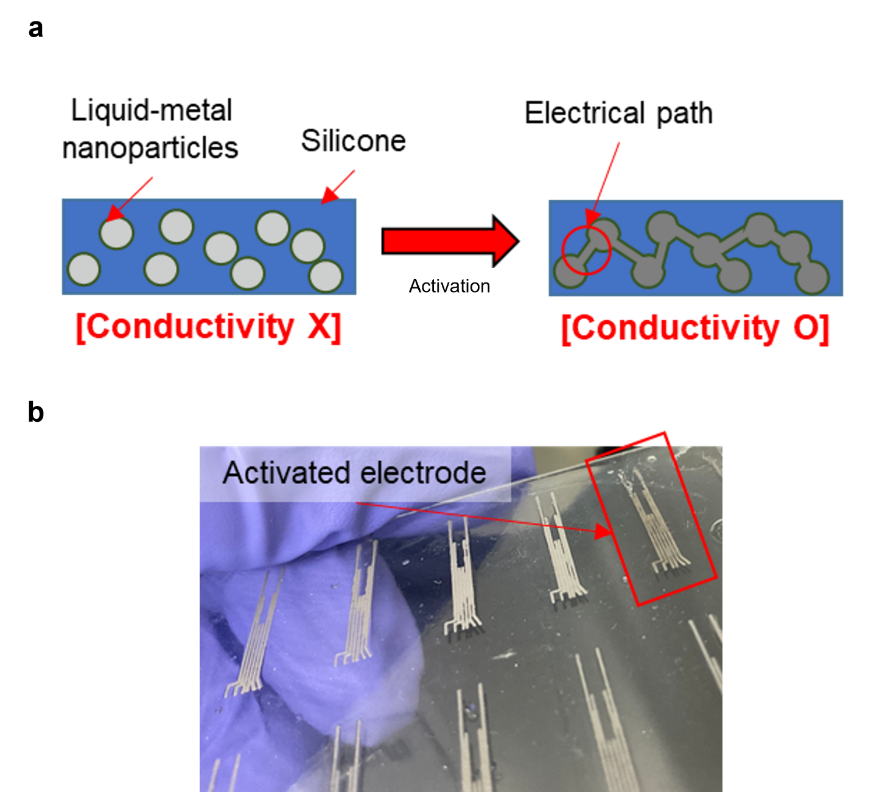
Fig. S19. Conductive polymer activation. a Schematic illustration of activation mechanism. b Activated and un-activated electrodes.

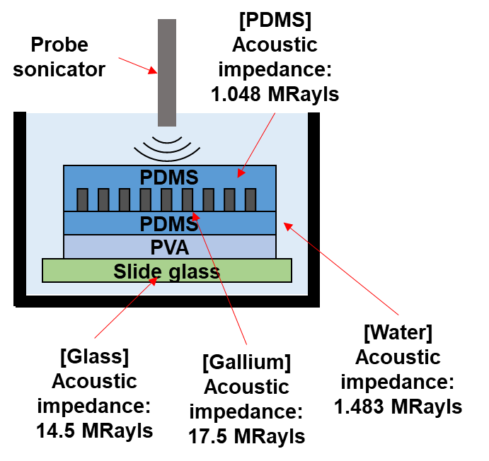
Fig. S20. Line activation process with packaging layer.

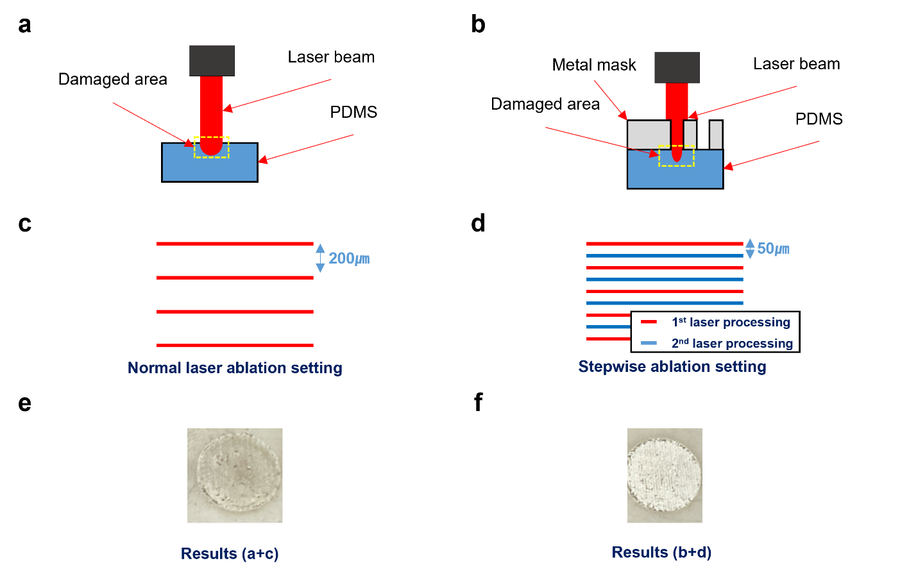
Fig. S21. Laser ablation processes for etching packaging layers. Laser beam size of a normal laser processing, and b laser processing of metal mask. Laser ablation patterns: c normal pattern, and d stepwise ablation pattern. Results of e normal laser ablation process, and f new laser ablation process with metal mask shield and stepwise laser pattern.
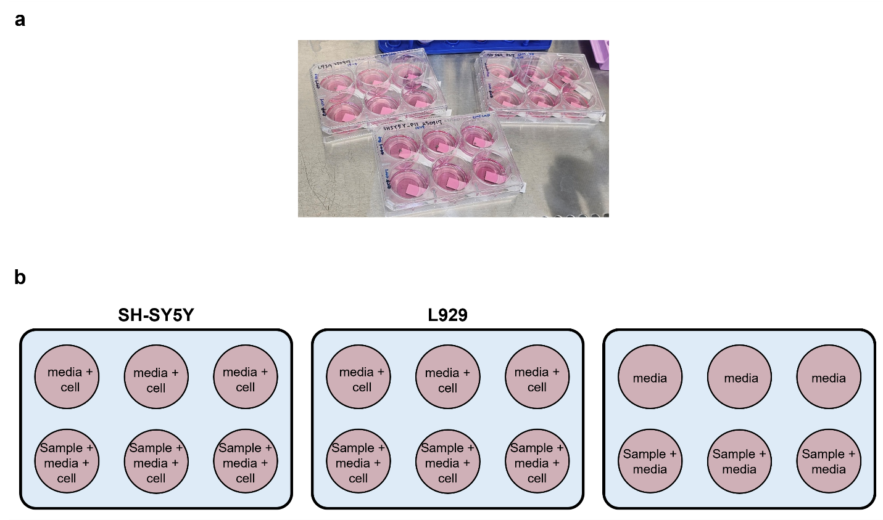Fig. S22. Experimental setup and plate map for in vitro cytotoxicity assays of the VCS-NI. a Photograph of 6-well confocal culture plates containing PDMS–EGaIn-based VCS-NI samples immersed in culture medium prior to cell seeding. b Schematic plate configuration for the Live/Dead cytotoxicity assay. SH-SY5Y and L929 cells were cultured in wells containing growth medium only (controls) and in wells containing both medium and VCS-NI samples (experimental groups). Additional wells with VCS-NI samples in culture medium but without cells were included as background controls.
Supplementary Movies
Movie S1. Pushing insertion procedure of the VCS-NI into the spinal cord
Movie S2. Combining pig skin and interface
Movie S3. Water-soluble sacrificial layer rapid dissolution

