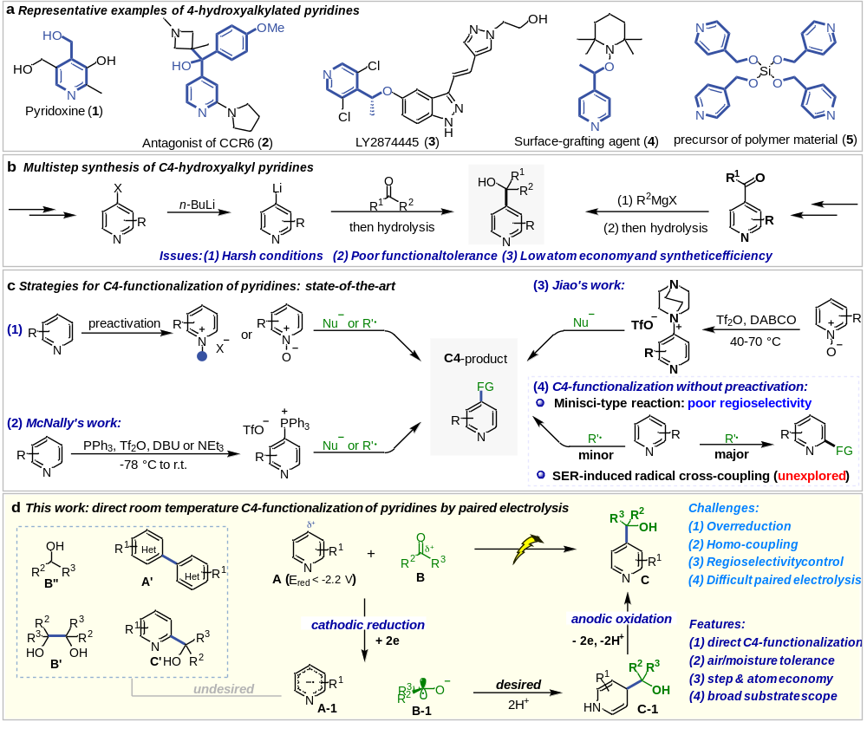
Scheme 1. Approaches for the functionalization of pyridines.

Scheme 2. Variation of ketones and aldehydes. Isolated yield of major regioisomeric products is given; the regioisomeric ratio was determined by GC-MS. Standard conditon: A (0.2 mmol), B (3 equiv.), 9 h (unless otherwise mentioned). ªUsing graphite plate as the cathode and 35 mA. ^{b}With heteroarene (3 equiv.) instead. ^{c}With 5 equiv. of B.
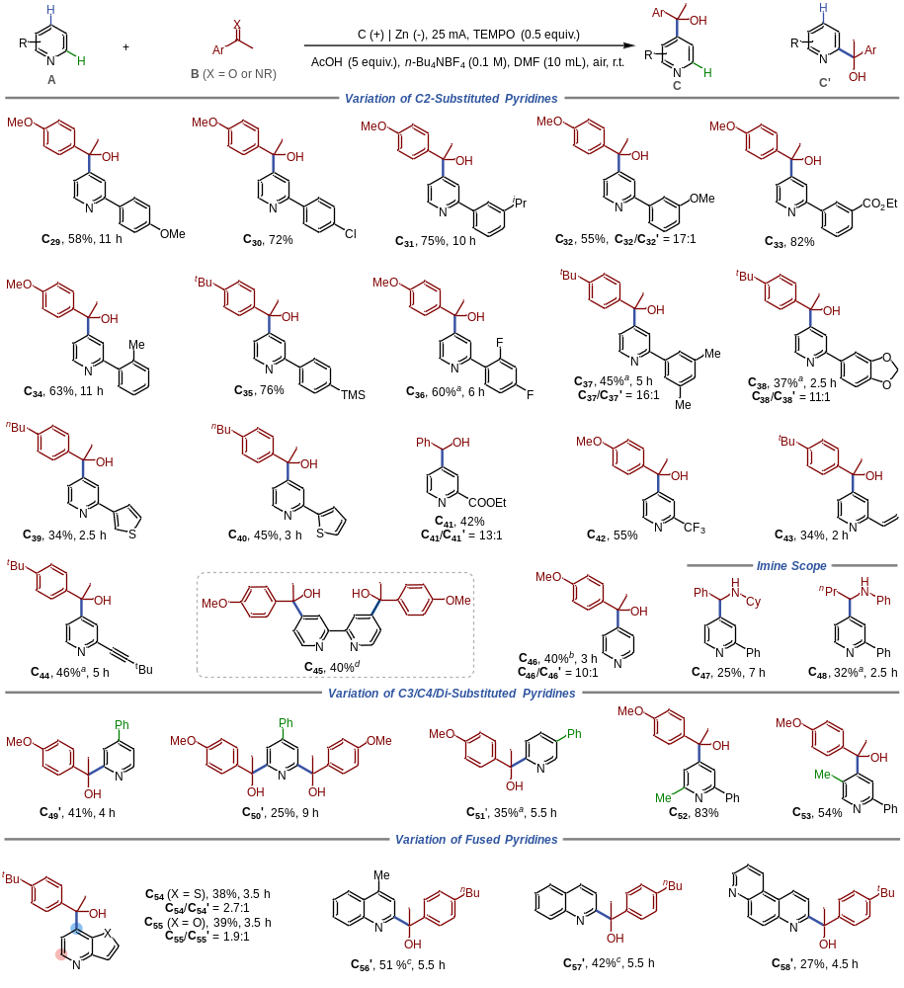
Scheme 3. Substrate variation. Standard condition: A (0.2 mmol), B (3 equiv.), 9 h. Isolated yield of major regioisomeric products is given, the regioisomeric ratio was determined by GC-MS. ªGraphite plate as cathode. ^{b}With 35 mA, graphite plate as cathode, A (3 equiv.), B (0.2 mmol), TEMPO (1 equiv.). ^{c}With 15 mA, pyridine (3 equiv.) and H₂O (5 equiv.) were used instead of AcOH. ^{d}Mixture of diastereomers.
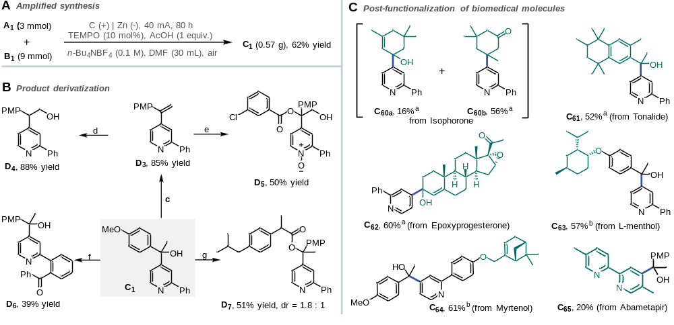
Scheme 4. synthetic applications. ªProceeds under standard conditions. ^{b}Proceeds under standard conditions but using graphite plate as cathode, 5 h. ^{c}C₁ (0.2 mmol), HCl (3 equiv.), toluene (2 mL), r.t., 20 h. then add Na₂CO₃ (5 equiv.). ^{d}D₃ (0.2 mmol), BH₃·THF (5 equiv.), THF (2 mL), r.t. 20 h. then add KOH (3 equiv.), H₂O₂ (5 equiv.). ^{e}D₃ (0.2 mmol), m-CPBA (2.5 equiv.), THF (2 mL), r.t., 20 h. then add Na₂SO₃ (3 equiv.). ^{f}C₁ (0.2 mmol), PdCl₂ (5 mol%), ^{t}BuOOH (3.0 equiv.), benzyl alcohol (3 equiv.), PhCl (0.5 mL), air, 140 ºC, 24 h. ^{g}C₁ (0.2 mmol), DL-ibuprofen (1.2 equiv.), DCC (2 equiv.), DMAP (0.2 equiv.), DCM (3 mL).

