Supporting Information
Room-Temperature Direct C4-Hydroxyalkylation of Pyridines via Paired Electrolysis
Chengqian Zhang¹, Maorui Wang^{2*}, Pierre. H. Dixneuf³, Min Zhang¹*
¹Key Lab of Functional Molecular Engineering of Guangdong Province, School of Chemistry and Chemical Engineering, South China University of Technology, Guangzhou 510641, China.
²Key Laboratory for Chemistry and Molecular Engineering of Medicinal Resources (Ministry of Education of China), Guangxi Key Laboratory of Chemistry and Molecular Engineering of Medicinal Resources, School of Chemistry and Pharmaceutical Sciences, Guangxi Normal University, Guilin 541004, People's Republic of China.
³University of Rennes, ISCR UMR CNRS 6226, 35000 Rennes, France.

Corresponding Authors
*Email: mrwang@gxnu.edu.cn, minzhang@scut.edu.cn

Table of Contents
1. General information | S2
2. Substrates scope  3. Substrate preparation | S3  S4-S5
4. Optimization of reaction conditions | S6
5. General Procedure for the hydroxyalkylation of pyridines  6. Mechanistic studies  7. Crystallographic data  8. DFT calculations | S6-S7  S7-S13  S13-S17  S17-S34
9. Amplified experiment | S34
10. Product derivatizations | S35-S37
11. Characterization of products | S37-S57
12. NMR spectra of products | S57-S138

1. General information
All the reagents that are commercially available were used directly without further purification unless otherwise noted. All electric cell and stir bar were heated to 110 ℃ in an oven for 3 hours. All electrodes were sequentially washed with 95% ethanol, oven-dried and polished with sandpaper (P400, P1500) prior to use. The electrochemical experiments were carried out with IKA ElectraSyn 2.0 under air condition unless otherwise noted. All materials of IKA ElectraSyn 2.0 including electrodes and vials were purchased from IKA company. All anhydrous solvents were purchased from Energy Chemical and used without further purification. All supporting electrolytes were used as received unless otherwise noted.
¹H NMR, ¹³C NMR and ¹⁹F NMR spectra were obtained on Bruker Advance 400 (400 MHz) or Bruker Advance 500 (500 MHz) spectrometer. Chemical shifts were reported in parts per million (ppm, δ) downfield from tetramethylsilane. Proton coupling patterns are described as singlet (s), doublet (d), triplet (t), double-doublet (dd), double-triplet (dt), multiplet (m). The residual solvent signals were used as references for ¹H NMR and ¹³C NMR spectra (δ_{H} = 7.26 ppm, δ_{C} = 77.00 ppm).
GC-MS data were obtained by Thermo Scientific Trace 1300-ISQ 7000. TLC analyses were performed using commercially prepared 600 mesh silica gel plates (GF254), and visualization was effected at 254 nm. Silica gel column chromatography was performed using silica gel (200–300 mesh). Preparative TLC was using silica gel plates prepared by 600 mesh silica gel (GF254). High-resolution mass spectra (HRMS) were recorded on a JEOL JMS-600 spectrometer with TOF. Cyclic voltammetry (CV) analysis was performed on Ingsens IGS-1030 electrochemical workstation (Ingsens Instruments (Guangzhou) Co., Ltd., China) with a conventional three electrode cell, using a glassy carbon electrode (GCE，item number GC130) (d = 3 mm) as working electrode, a Pt wire (item number Pt015) as counter electrode and saturated calomel electrode (SCE, item number R0232) as a reference electrode. Electrodes (GC130, Pt015, R0232) were purchased from Tianjin Aida Hengsheng Technology Development Co., Ltd.

2. List of full substrates
Scheme S1. Substrates employed for the functionalization of pyridines.

3. Substrate preparation
General Synthetic procedure of pyridines
A mixture of arylboronic acid (6.5 mmol, 1.3 equiv.) and Pd(PPh₃)₄ (0.15 mmol, 3 mol%) was placed in a 100 mL Schlenk tube. The vessel was sealed, purged with nitrogen (three cycles), and charged sequentially with toluene (9 mL), H₂O (9 mL), ethanol (9 mL), Na₂CO₃ (37.5 mmol, 7.5 equiv.), and 2-bromopyridine (5.0 mmol, 1 equiv.). The resulting mixture was heated to 95 °C and stirred overnight, with reaction progress monitored by TLC. Upon complete consumption of the starting material, the mixture was cooled to room temperature, transferred to a separatory funnel, and diluted with saturated aqueous NH₄Cl solution (50 mL). The aqueous layer was extracted with ethyl acetate (3 × 30 mL), and the combined organic extracts were dried over anhydrous Na₂SO₄. After filtration, the solvent was removed under reduced pressure. The residue was purified by silica gel column chromatography to afford the desired product.
Synthetic procedure of A₁-d₆
2-(phenyl-d5)pyridine (A₁-d₅): A₁-d₅ was Prepared from 2-bromopyridine and phenyl-d₅-boronic acid following the general procedure of pyridines.
Triphenyl(2-(phenyl-d₅)pyridin-4-yl)phosphonium trifluoromethanesulfonate (S1): Compound S1 was prepared according to a literature procedure. An oven-dried round-bottom flask equipped with a stir bar was charged with A₁-d₅ (2.89 g, 18.0 mmol) and PPh₃ (5.19 g, 19.8 mmol) under a nitrogen atmosphere. Dichloromethane (DCM, 180 mL) was added, and the solution was cooled to –78 °C. Triflic anhydride (Tf₂O, 3.1 mL, 18.0 mmol) was added dropwise over 5 min. After stirring for 1 h at –78 °C, triethylamine (Et₃N, 2.5 mL, 18.0 mmol) was added dropwise via syringe. The cooling bath was removed, and the reaction mixture was allowed to warm to room temperature over 30 min. The reaction was quenched by adding H₂O (180 mL), and the mixture was transferred to a separatory funnel. The mixture was diluted with additional DCM, and the organic layer was washed with H₂O (3 × 180 mL). The combined organic phase was dried over Na₂SO₄, filtered, and concentrated in vacuo to approximately 10 mL. An excess of chilled diethyl ether (Et₂O, 0 °C) was added, and the solution was stored at –20 °C overnight. The resulting suspension was filtered through a fritted funnel, and the collected solid was washed with chilled Et₂O (0 °C) and dried in vacuo to afford pure phosphonium salt S₁ (7.75 g, 76%) as a white solid.
2-(phenyl-d₅)pyridine-4-d (A₁-d₆): The preparation of A₁-d₆ was performed according to the literature procedure. An oven-dried round bottom flask equipped with a stir bar was charged with S1 (4.28 g, 7.5 mmol), K₂CO₃ (1.56 g, 11.25 mmol), and placed under a nitrogen atmosphere. A mixture of anhydrous DMF (22.5 mL)/D₂O (2.5 mL) was added at room temperature and the reaction was stirred for 15 hours. The reaction mixture was diluted with H₂O and the aqueous layer was separated and extracted with EtOAc. The combined organic extracts were washed with a saturated aqueous solution of NH₄Cl, dried over Na₂SO4, filtered, and concentrated in vacuo. The residue was purified by flash column chromatography to afford the desired product A₁-d₆ (855 mg, 73% yield) as colorless oil.
Synthetic procedure of A₂₈
An oven-dried round bottom flask equipped with a stir bar was charged with (L)-Myrtenol (288 uL, 1.8 mmol) and pyridine (25 uL, 0.306 mmol), then placed under a nitrogen atmosphere and cooled to -15 °C. Anhydrous Et₂O (2 mL) was added, followed by dropwise addition of PBr₃ (57 uL, 0.6 mmol). The reaction mixture was maintained at -15 °C for 2 hours, then warmed to room temperature and stirred for an additional 15 hours. After the reaction completion, the mixture was diluted with Et₂O (5 mL) and ice-water (3 mL), then extracted with Et₂O. The combined organic extracts were washed successively with saturated aqueous NaHCO₃ solution and brine (twice each), dried over anhydrous sodium sulfate, and filtered. The solvent was removed by rotary evaporation. The residue was purified by silica gel column chromatography to afford product S₂ (349 mg, 90% yield). Subsequently, under a nitrogen atmosphere, 2-(4-hydroxyphenyl)pyridine (172 mg, 1 mmol) was dissolved in DMF (5 mL). In a glovebox, sodium hydride (30 mg, 1.25 mmol), DMF (4 mL), and the solution of 2-(4-hydroxyphenyl)pyridine were sequentially charged into a oven-dried round bottom flask. The mixture was stirred at 0 °C for 30 minutes. A solution of S₂ (1.3 mmol in DMF, 4 mL) was then added slowly. The resulting mixture was stirred at room temperature for 12 hours. After the reaction completion, the mixture was poured into ice-water and extracted with EtOAc (25 mL × 3). The combined organic phases were dried over anhydrous Na₂SO₄, filtered, and concentrated under reduced pressure. The resultant residue was purified by silica gel column chromatography to afford A₂₈ (254 mg, 83% yield).

Synthetic procedure of B₃₄
The compound was prepared by following the literature procedure. An oven-dried round bottom flask equipped with a stir bar was charged with (L)-Menthol (0.47 g, 3.0 mmol), 4-hydroxyacetophone (0.41 g, 3.0 mmol), PPh₃ (0.94 g, 3.6 mmol) and dry THF (20 mL), then placed under a nitrogen atmosphere and cooled to 0 °C. Diisopropyl azodiformate (DIAD, 0.73 g, 3.6 mmol) was added dropwise with for a period of 5 min. The mixture was then placed at room temperature and reacted for 24 h. After the reaction completion, the solvent was removed under reduced pressure, and the resultant residue was purified by silica gel column chromatography to afford product B₃₄.

4. Optimization of Reaction Conditions
Table S1. Optimization of Reaction Conditions
Entry | Variation | C₁, yield^{b} (%)
1 | none | 81 (C₁/C₁' > 20:1)
2 | w/o electricity | N.R.
3 | w/o AcOH | N.R.
4 | w/o TEMPO | 37
5 | 15 mA, 15 h | Trace
6 | 30 mA, 7.5 h | 68
7 | AcOH (3 equiv.) | 55
8 | TEMPO (0.25 equiv.) | 64
9 | HCOOH instead of AcOH | 45
10 | Fc instead of TEMPO | Trace
11 | n-Bu₄NI instead of n-Bu₄NBF₄ | N.R.
12 | NMP or Acetone instead of DMF | 10, 21
13 | argon instead of air | 81
14 | GF (-) or Ni (-) instead of Zn (-) | 53^{c}, 71
15 | Zn (+) or Pt (+) instead of GF (+) | 15, 19
16 | 11 h | 73
17 | 8 h | 76
18 | H₂O (10 equiv.) | 74
19 | With B₁ (1.5 equiv.) | 41
20 | With A₁ (0.6 mmol), B₁ (0.2 mmol) | 57
21 | B(C₆F₅)₃ (30 mol%) or Sc(OTf)₃ (30 mol%) instead of AcOH | trace
ªConditions: undivided cell, graphite plate (GF) as anode, zinc plate (Zn) as cathode, unless otherwise stated, all the reactions were performed in DMF (10 mL) with A₁ (0.2 mmol), B₁ (0.6 mmol), TEMPO (0.5 equiv.), AcOH (5 equiv.), n-Bu₄NBF₄ (0.1 M, 1 mmol), current (25 mA) at 25 ºC for 9 h, air atmosphere, room temperature. ^{b}Isolated yield of C₁' is given, the ratio between C₁ and C₁' was determined by GC-MS. ^{c}For 4.5 h. AcOH = Acetic acid; TEMPO = 2,2,6,6-tetramethyl-1-piperinedinyloxy; NMP = N-Methyl-2-pyrrolidone; Fc = Ferrocene; Ni = nickel plate; Pt = platinum plate; N.R. = no reaction

5. General procedure for the hydroxyalkylation of pyridines
Standard method:
An undivided electrolytic cell equipped with a magnetic stir bar was subsequently charged with TEMPO (0.1 mmol, 0.5 equiv.), A (0.2 mmol, 1 equiv.), carbonyl substrate B (0.6 mmol, 3 equiv.), n-Bu₄NBF₄ (0.1 M), DMF (10 mL) and AcOH (1 mmol, 5 equiv.) under air condition. After fully stirring and dissolution, a graphite plate anode and a zinc plate cathode were installed. Then the cell was electrolyzed at room temperature under a constant current of 25 mA for 9 hours. Upon the completion of electrolysis, the resulting mixture was poured into saturated NH₄Cl solution (50 mL) and the electrodes and cell were rinsed with EtOAc, then extracted the mixture with EtOAc (35 mL × 3). The combined organic layers were dried over anhydrous Na₂SO₄, filtered, and concentrated under reduced pressure. The resultant residue was purified by preparative TLC on silica to afford hydroxyalkylated pyridines C.
(Note: Both the dimensions of graphite and zinc electrodes are approximately 5.25 cm × 0.8 cm × 0.2 cm. The effective immersion areas of graphite anode and zinc cathode are approximately 2.56 cm².)
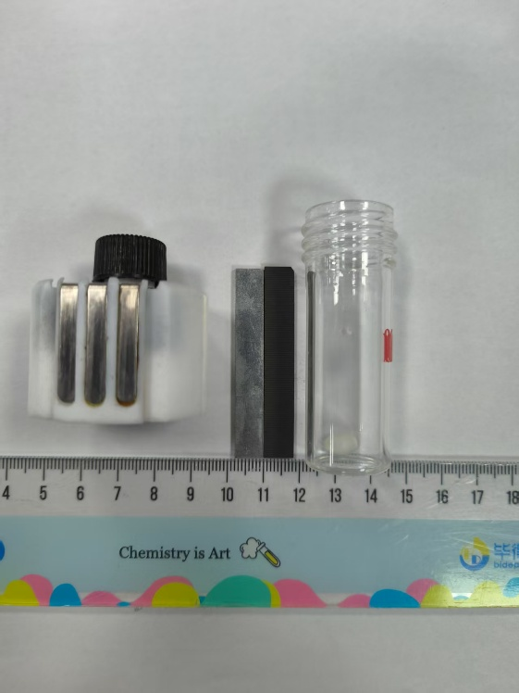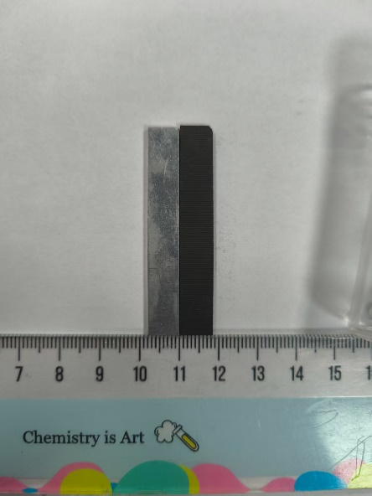
Figure S1. The employed electrodes and electrochemical apparatus
Procedure for the aminoalkylation of pyridines
An undivided electrolytic cell equipped with a magnetic stir bar, TEMPO (0.1 mmol, 0.5 equiv.), A₁ (0.2 mmol, 1equiv.), aldehyde (0.6 mmol, 3 equiv.), amine (0.6 mmol, 3 equiv.), n-Bu₄NBF₄ (330 mg, 0.1 M) was dissolved in DMF (10 mL) and stirred for 20 minutes. Subsequently, AcOH (1 mmol, 5 equiv.) was added and a graphite plate anode and a zinc plate cathode (or a graphite plate cathode) were installed. Then the cell was electrolyzed at room temperature under a constant current of 25 mA. Upon the completion of electrolysis, the resulting mixture was poured into saturated NH₄Cl solution (50 mL) and the electrodes and cell were rinsed with EtOAc, then extracted the mixture with EtOAc (35 mL × 3). The combined organic layers were dried over anhydrous Na₂SO₄, filtered, and concentrated under reduced pressure. The resultant residue was purified by preparative TLC on silica to afford desired aminoalkylated pyridines C.

6. Mechanistic Studies
Control Experiments With 2-phenylpyridine
2,2'-diphenyl-4,4'-bipyridine (D₁)
White solid; (8.4 mg, 27% yield); ¹H NMR (400 MHz, Chloroform-d) δ 8.84 (d, J = 5.1 Hz, 2H), 8.10 – 8.04 (m, 4H), 7.99 (s, 2H), 7.55 – 7.49 (m, 6H), 7.49 – 7.44 (m, 2H). ¹³C NMR (126 MHz, Chloroform-d) δ 158.6, 150.5, 146.9, 139.0, 129.4, 128.9, 127.1, 120.0, 118.6.Control Experiments With 4-methoxyacetophenone
2,3-bis(4-methoxyphenyl)butane-2,3-diol (D₂)
Colorless solid; (30.5 mg, 33% yield, mixture of diastereoisomer); ¹H NMR (500 MHz, Chloroform-d) δ 7.12 (dd, J = 17.6, 8.9 Hz, 4H), 6.80 – 6.73 (m, 4H), 3.80 (d, J = 7.3 Hz, 6H), 2.58 (s, 2H), 1.55 (s, 2H), 1.47 (s, 3H). ¹³C NMR (126 MHz, Chloroform-d) δ 158.5, 158.4, 136.0, 135.7, 128.5, 128.1, 112.5, 112.4, 78.7, 78.5, 55.2, 25.1, 25.0.
Free radical trapping experiments
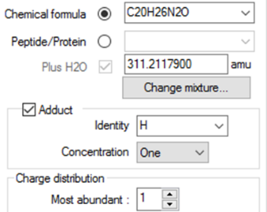
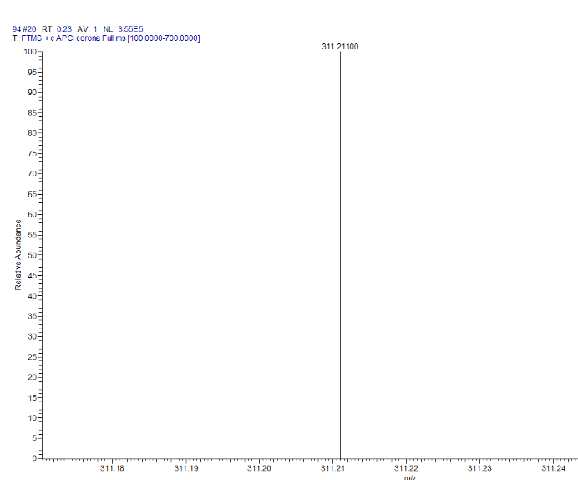
Figure S2. HPLC of [TEMPO-B₁+H]⁺ (calculated 311.2118, detected 311.2110).
Radical clock experiment
Figure S3. GC-MS analyses for the radical clock experiment.
Kinetic isotope effect (KIE) experiment
An undivided electrolytic cell equipped with a magnetic stir bar was subsequently charged with TEMPO (15.7 mg, 0.1 mmol), A₁ 15.6 mg, 0.1 mmol), A₁-d₆ (16.2 mg, 0.1 mmol), carbonyl substrate B (91 mg, 0.6 mmol), n-Bu₄NBF₄ (330 mg, 0.1 M), DMF (10 mL) and AcOH (58 uL, 1 mmol) under air condition. After fully stirring and dissolution, a graphite plate anode and a zinc plate cathode were installed. Then the cell was electrolyzed at room temperature under a constant current of 25 mA for 3 hours. Upon the completion of electrolysis, the resulting mixture was poured into saturated NH₄Cl solution (50 mL) and the electrodes and cell were rinsed with EtOAc, then extracted the mixture with EtOAc (35 mL × 3). The combined organic layers were dried over anhydrous Na₂SO₄, filtered, and concentrated under reduced pressure. The resultant residue was purified by preparative TLC on silica to afford desired product C₁ and C₁-d₅, which submitted to ¹H NMR analysis to obtain KIE values.
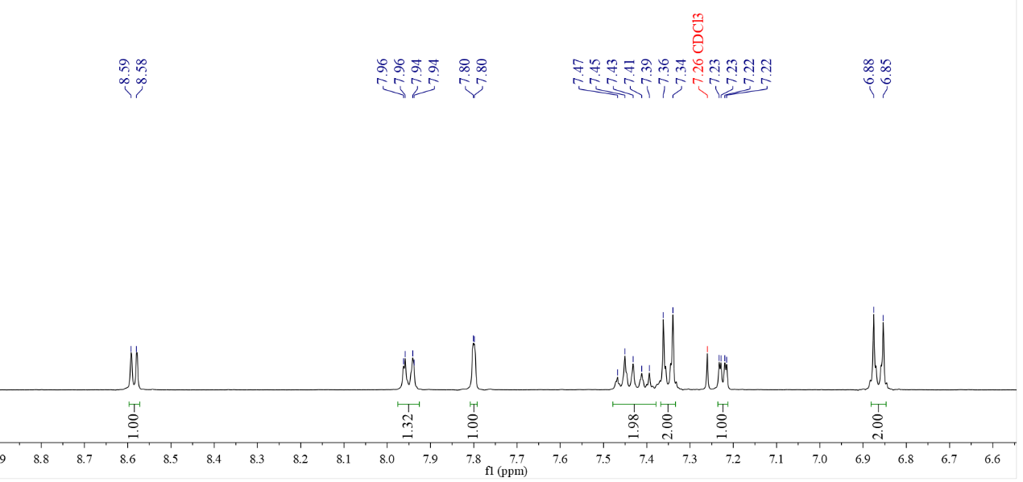
KIE = 1.32/(2-1.32) = 1.98/(3-1.98) = 1.94
H²/H³
H¹
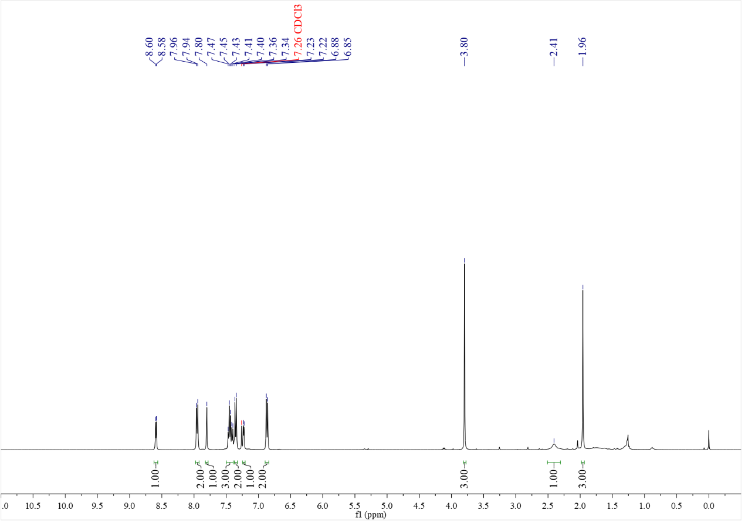
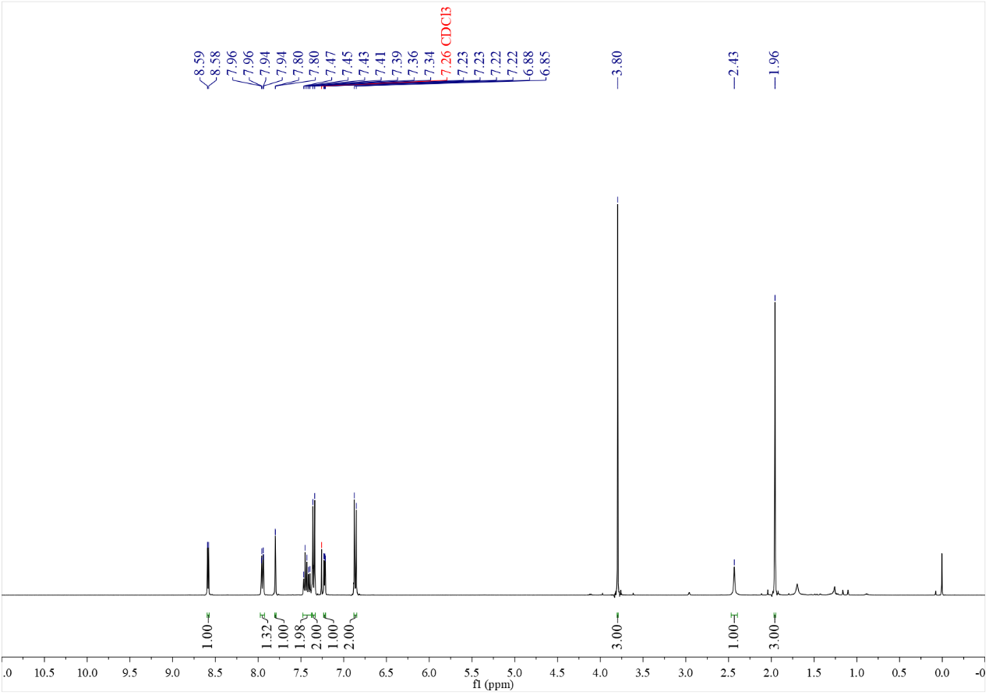
Figure S4. Intermolecular competition KIE results and ¹H NMR spectra of C₁ and C₁-d₅
Discussion: The presence of a significant primary KIE in the C4-hydroxyalkylation of A₁ and A₁-d₆, which suggests that the pyridyl C-H bond cleavage is involved in the rate determining step (Figure S10).

Cyclic Voltammetry (CV) and Open Circuit Voltage (OCV) Experiments
The general procedure for cyclic voltammetry experiments: Cyclic voltammograms were recorded with Ingsens IGS-1030 electrochemical workstation (Ingsens Instruments (Guangzhou) Co., Ltd., China) at room temperature. All cyclic voltammograms followed IUPAC convention. All cyclic voltammetry (CV) experiments were conducted in a 20 mL glass vial equipped with a magnetic stir bar, fitted with a glassy carbon as working electrode (WE, 2 mm in diameter), a saturated calomel electrode (SCE) as reference electrode, and a platinum wire as counter electrode (CE). All measurements were carried out in 20 mL anhydrous DMF with an electrolyte (n-Bu₄NBF₄, 0.1 M) under N₂, using a scan rate of 100 mV/s.
The general procedure for open circuit voltage experiments: Open circuit voltage was recorded with Ingsens IGS-1030 electrochemical workstation (Ingsens Instruments (Guangzhou) Co., Ltd., China) at room temperature. The open circuit voltage (OCV) experiments were conducted with standard reaction which was equipped a saturated calomel electrode (SCE) as reference electrode.
Figure S5. Cyclic voltammetruy of Blank: (none); AcOH: acetic acid (5 mM); A_{1:} 2-phenylpyridine (5 mM); A₁ + AcOH: 2-phenylpyridine (5 mM) + acetic acid (15 mM).
Figure S6. Cyclic voltammetruy of Blank: (none); AcOH: acetic acid (5 mM); B_{1:} 4-methoxyacetophenone (5 mM); B₁ + AcOH: 4-methoxyacetophenone (5 mM) + acetic acid (15 mM).
Figure S7. Cyclic voltammetruy of Blank: (none); A₁ + AcOH: 2-phenylpyridine (5 mM) + acetic acid (15 mM); B₁ + AcOH: 4-methoxyacetophenone (5 mM) + acetic acid (15 mM); A₁ + B₁ + AcOH: 2-phenylpyridine (5 mM) + 4-methoxyacetophenone (5 mM) + acetic acid (15 mM).

Figure S8. Open circuit voltage experiment of standard reaction.

Proposed Mechanism
Figure S9. Proposed mechanism for regioselective hydroxyalkylation of pyridine.
7. Crystallographic data of compound C₂₁
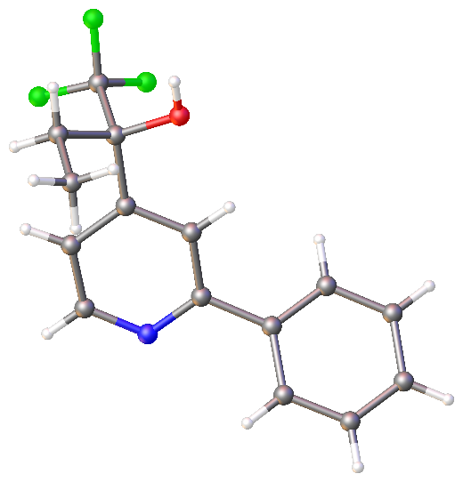
Table S2-a Crystal data and structure refinement for exp_14587_auto.
Identification code | exp_14587_auto
Empirical formula | C₁₅H₁₄F₃NO
Formula weight | 281.27
Temperature/K | 293(2)
Crystal system | monoclinic
Space group | P2₁/c
a/Å | 15.2542(19)
b/Å | 6.5561(6)
c/Å | 15.3426(18)
α/° | 90
β/° | 115.534(15)
γ/° | 90
Volume/Å³ | 1384.5(3)
Z | 4
ρ_{calc}g/cm³ | 1.349
μ/mm⁻¹ | 0.112
F(000) | 584.0
Crystal size/mm³ | 0.25 × 0.2 × 0.12
Radiation | Mo Kα (λ = 0.71073)
2Θ range for data collection/° | 5.328 to 52.998
Index ranges | -17 ≤ h ≤ 19, -8 ≤ k ≤ 8, -19 ≤ l ≤ 17
Reflections collected | 9971
Independent reflections | 2817 [R_{int} = 0.0282, R_{sigma} = 0.0300]
Data/restraints/parameters | 2817/0/183
Goodness-of-fit on F² | 1.054
Final R indexes [I>=2σ (I)] | R₁ = 0.0666, wR₂ = 0.1715
Final R indexes [all data] | R₁ = 0.0823, wR₂ = 0.1823
Largest diff. peak/hole / e Å⁻³ | 0.49/-0.23

Table S2-b Fractional Atomic Coordinates (×10⁴) and Equivalent Isotropic Displacement Parameters (Å²×10³) for exp_14587_auto. U_{eq} is defined as 1/3 of the trace of the orthogonalised U_{IJ} tensor.
Atom | x | y | z | U(eq)
F1 | 9319.6(15) | 5486(3) | 8397.1(15) | 85.8(6)
F2 | 9517.0(13) | 7256(3) | 9643.5(12) | 83.7(6)
F3 | 9994.4(12) | 8409(4) | 8617.8(14) | 85.1(6)
O1 | 7582.8(12) | 7144(3) | 8269.8(10) | 42.6(4)
N1 | 7580.8(14) | 8055(3) | 5091.5(13) | 44.2(5)
C1 | 8030.8(15) | 8302(3) | 7058.6(14) | 34.9(5)
C2 | 8470.6(18) | 9580(4) | 6646.7(17) | 46.8(6)
C3 | 8223(2) | 9396(4) | 5670.5(17) | 52.4(7)
C4 | 7145.2(15) | 6813(3) | 5484.9(14) | 34.7(5)
C5 | 7361.9(15) | 6905(3) | 6463.5(14) | 34.1(5)
C6 | 8269.4(16) | 8386(4) | 8136.1(15) | 38.5(5)
C7 | 8289(2) | 10540(4) | 8509.0(18) | 51.6(7)
C8 | 7323(2) | 11611(4) | 8008(2) | 64.6(8)
C9 | 9281(2) | 7372(5) | 8701.4(19) | 57.6(7)
C10 | 6400.0(16) | 5366(4) | 4836.5(14) | 37.1(5)
C11 | 6366(2) | 3388(4) | 5125.5(18) | 51.3(6)
C12 | 5657(2) | 2050(5) | 4528(2) | 65.2(8)
C13 | 4963(2) | 2715(5) | 3644(2) | 62.4(8)
C14 | 4988.9(19) | 4659(5) | 3354.2(19) | 59.8(8)
C15 | 5703.7(18) | 5997(4) | 3935.9(16) | 47.2(6)

Table S2-c Anisotropic Displacement Parameters (Å²×10³) for exp_14587_auto. The Anisotropic displacement factor exponent takes the form: -2π²[h²a*²U₁₁+2hka*b*U₁₂+…].
Atom | U₁₁ | U₂₂ | U₃₃ | U₂₃ | U₁₃ | U₁₂
F1 | 80.9(13) | 79.7(13) | 88.7(14) | 5.4(10) | 28.9(11) | 31.6(10)
F2 | 70.9(12) | 121.7(16) | 38.9(9) | 18.8(9) | 5.0(8) | 10.8(11)
F3 | 42.8(9) | 126.6(17) | 77.5(13) | 13.0(11) | 18.1(9) | -1.0(10)
O1 | 54.5(10) | 54.2(10) | 23.0(7) | -6.9(7) | 20.4(7) | -14.5(7)
N1 | 52.8(12) | 59.0(12) | 26.5(9) | -2.9(8) | 22.6(9) | -10.5(10)
C1 | 37.4(11) | 44.6(12) | 24.9(10) | -2.1(8) | 15.5(9) | -2.3(9)
C2 | 50.5(14) | 60.3(15) | 33.4(12) | -9.2(10) | 21.7(11) | -18.6(11)
C3 | 65.3(17) | 64.6(16) | 37.0(13) | -2.2(11) | 31.1(12) | -21.9(13)
C4 | 38.6(11) | 45.4(12) | 22.9(10) | -0.2(8) | 15.9(8) | 1.4(9)
C5 | 38.5(11) | 41.7(11) | 25.3(10) | -1.2(8) | 16.9(9) | -4.5(9)
C6 | 41.3(12) | 51.1(13) | 23.7(10) | -4.9(9) | 14.4(9) | -9.6(10)
C7 | 67.4(17) | 52.3(15) | 38.3(13) | -10.5(11) | 25.6(12) | -11.7(12)
C8 | 94(2) | 48.6(15) | 65.9(18) | 3.7(13) | 48.7(17) | 3.0(15)
C9 | 48.1(15) | 78(2) | 40.2(14) | 2.9(13) | 13.0(12) | -0.1(13)
C10 | 41.1(12) | 49.0(13) | 24.7(10) | -7.0(9) | 17.5(9) | -2.5(9)
C11 | 62.7(16) | 51.9(15) | 37.2(13) | -3.2(11) | 19.6(12) | -4.7(12)
C12 | 81(2) | 54.9(17) | 67.5(19) | -14.7(14) | 39.6(17) | -18.8(15)
C13 | 51.7(16) | 80(2) | 57.6(17) | -32.6(15) | 25.2(14) | -21.8(14)
C14 | 45.4(15) | 90(2) | 37.6(13) | -18.5(13) | 11.3(11) | -1.3(14)
C15 | 47.6(14) | 59.5(15) | 30.4(11) | -4.7(10) | 13.1(10) | 1.2(11)

Table S2-d Bond Lengths for exp_14587_auto.
Atom | Atom | Length/Å |  | Atom | Atom | Length/Å
F1 | C9 | 1.332(4) |  | C4 | C10 | 1.486(3)
F2 | C9 | 1.333(3) |  | C6 | C7 | 1.519(3)
F3 | C9 | 1.335(3) |  | C6 | C9 | 1.556(4)
O1 | C6 | 1.409(3) |  | C7 | C8 | 1.510(4)
N1 | C3 | 1.332(3) |  | C10 | C11 | 1.379(4)
N1 | C4 | 1.347(3) |  | C10 | C15 | 1.394(3)
C1 | C2 | 1.384(3) |  | C11 | C12 | 1.388(4)
C1 | C5 | 1.382(3) |  | C12 | C13 | 1.383(5)
C1 | C6 | 1.533(3) |  | C13 | C14 | 1.356(5)
C2 | C3 | 1.383(3) |  | C14 | C15 | 1.384(4)
C4 | C5 | 1.393(3)

Table S2-e Bond Angles for exp_14587_auto.
Atom | Atom | Atom | Angle/˚ |  | Atom | Atom | Atom | Angle/˚
C3 | N1 | C4 | 117.64(18) |  | C8 | C7 | C6 | 112.6(2)
C2 | C1 | C6 | 122.29(19) |  | F1 | C9 | F2 | 107.1(2)
C5 | C1 | C2 | 117.68(19) |  | F1 | C9 | F3 | 106.2(3)
C5 | C1 | C6 | 120.03(18) |  | F1 | C9 | C6 | 112.6(2)
C3 | C2 | C1 | 118.8(2) |  | F2 | C9 | F3 | 106.5(2)
N1 | C3 | C2 | 124.0(2) |  | F2 | C9 | C6 | 111.6(2)
N1 | C4 | C5 | 121.6(2) |  | F3 | C9 | C6 | 112.5(2)
N1 | C4 | C10 | 117.96(18) |  | C11 | C10 | C4 | 120.6(2)
C5 | C4 | C10 | 120.46(19) |  | C11 | C10 | C15 | 118.7(2)
C1 | C5 | C4 | 120.35(19) |  | C15 | C10 | C4 | 120.7(2)
O1 | C6 | C1 | 106.89(16) |  | C10 | C11 | C12 | 120.6(3)
O1 | C6 | C7 | 112.18(19) |  | C13 | C12 | C11 | 119.9(3)
O1 | C6 | C9 | 107.0(2) |  | C14 | C13 | C12 | 120.0(3)
C1 | C6 | C9 | 107.64(19) |  | C13 | C14 | C15 | 120.7(3)
C7 | C6 | C1 | 113.35(19) |  | C14 | C15 | C10 | 120.2(3)
C7 | C6 | C9 | 109.4(2)

Table S2-f Torsion Angles for exp_14587_auto.
A | B | C | D | Angle/˚ |  | A | B | C | D | Angle/˚
O1 | C6 | C7 | C8 | -60.1(3) |  | C4 | C10 | C15 | C14 | -177.4(2)
O1 | C6 | C9 | F1 | 59.4(3) |  | C5 | C1 | C2 | C3 | -0.1(4)
O1 | C6 | C9 | F2 | -61.2(3) |  | C5 | C1 | C6 | O1 | -10.3(3)
O1 | C6 | C9 | F3 | 179.3(2) |  | C5 | C1 | C6 | C7 | -134.4(2)
N1 | C4 | C5 | C1 | 0.6(3) |  | C5 | C1 | C6 | C9 | 104.5(2)
N1 | C4 | C10 | C11 | 138.3(2) |  | C5 | C4 | C10 | C11 | -43.3(3)
N1 | C4 | C10 | C15 | -43.6(3) |  | C5 | C4 | C10 | C15 | 134.8(2)
C1 | C2 | C3 | N1 | 0.1(4) |  | C6 | C1 | C2 | C3 | 179.3(2)
C1 | C6 | C7 | C8 | 61.0(3) |  | C6 | C1 | C5 | C4 | -179.7(2)
C1 | C6 | C9 | F1 | -55.3(3) |  | C7 | C6 | C9 | F1 | -178.8(2)
C1 | C6 | C9 | F2 | -175.8(2) |  | C7 | C6 | C9 | F2 | 60.6(3)
C1 | C6 | C9 | F3 | 64.7(3) |  | C7 | C6 | C9 | F3 | -58.9(3)
C2 | C1 | C5 | C4 | -0.2(3) |  | C9 | C6 | C7 | C8 | -178.8(2)
C2 | C1 | C6 | O1 | 170.3(2) |  | C10 | C4 | C5 | C1 | -177.7(2)
C2 | C1 | C6 | C7 | 46.2(3) |  | C10 | C11 | C12 | C13 | -1.6(4)
C2 | C1 | C6 | C9 | -75.0(3) |  | C11 | C10 | C15 | C14 | 0.8(4)
C3 | N1 | C4 | C5 | -0.6(3) |  | C11 | C12 | C13 | C14 | 1.4(4)
C3 | N1 | C4 | C10 | 177.7(2) |  | C12 | C13 | C14 | C15 | -0.2(4)
C4 | N1 | C3 | C2 | 0.3(4) |  | C13 | C14 | C15 | C10 | -0.9(4)
C4 | C10 | C11 | C12 | 178.6(2) |  | C15 | C10 | C11 | C12 | 0.5(4)

Table S2-g Hydrogen Atom Coordinates (Å×10⁴) and Isotropic Displacement Parameters (Å²×10³) for exp_14587_auto.
Atom | x | y | z | U(eq)
H1 | 7621 | 7325 | 8814 | 64
H2 | 8924 | 10545 | 7020 | 56
H3 | 8524 | 10262 | 5402 | 63
H5 | 7055 | 6022 | 6718 | 41
H7A | 8469 | 10487 | 9197 | 62
H7B | 8782 | 11322 | 8415 | 62
H8A | 7145 | 11683 | 7328 | 97
H8B | 7374 | 12966 | 8263 | 97
H8C | 6837 | 10867 | 8115 | 97
H11 | 6823 | 2947 | 5726 | 62
H12 | 5649 | 709 | 4722 | 78
H13 | 4478 | 1829 | 3249 | 75
H14 | 4522 | 5097 | 2758 | 72
H15 | 5719 | 7321 | 3725 | 57

8. Density Functional theory (DFT) Calculations
Computational details
All Density Functional theory (DFT) Calculations were performed using the Gaussian 16 software Package¹ on our lab’s supercomputer. The geometries of the reactants, transition states, and products were optimized using the M06-2X functional² and Grimme’s D3 dispersion correction³ with def2-SVPbasis set⁴ in PCM solvation model⁵ (EtOAc). Vibrational frequency calculations were performed for all the stationary points to confirm each optimized structure is a local minimum or a transition state structure. Intrinsic Reaction Coordinate (IRC) was used to check whether the transition state connected the reactant and product correctly. Single-point energy calculations were performed at the M06-2X functional and Grimme’s D3 dispersion correction with def2-TZVPP basis set⁶ using the SMD continuum solvation model⁷ (DMF). Spin density analysis was carried out using Multiwfn⁸ and visualized with VMD⁹. CYLview was used to generate high-quality molecular structure images¹⁰.
(A)
(B)
(C)
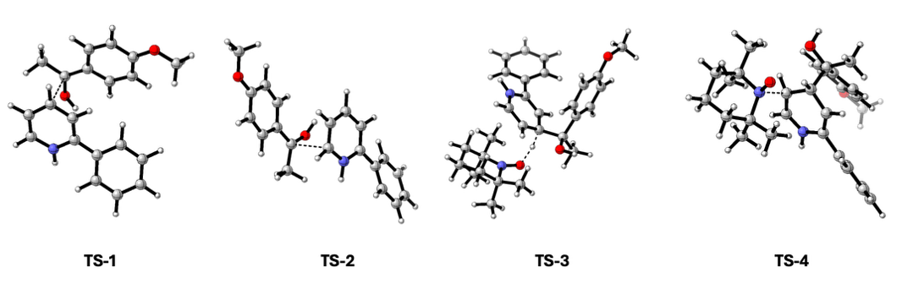
(D)
Figure S10. (A) The chemoselectivity of the reaction between INT-1 and radical B₁. (B) The reaction pathways between INT-2 and TEMPO+. (C) Optimized key transition states. All energies are calculated at M06-2X-D3/def2-TZVPP/SMD(DMF)//M06-2X-D3/def2-SVP/PCM(DMF) level of theory. Gibbs free energies are shown in the brackets. (D) The overall pathways of the hydroxyalkyaltion of pyridine.

Results and discussion
The N–N bond distance (red bond) in INT6 was scanned from 2.4 Å to 1.4 Å with a step size of 0.0250 Å. The results showed a continuous increase in energy as the N–N bond shortened. Attempts to locate the transition state for the proposed nucleophilic addition were unsuccessful. This suggests that the nitrogen atom is unlikely to attack the TEMPO⁺ species, potentially due to the steric hindrance imposed by the tetramethyl group.
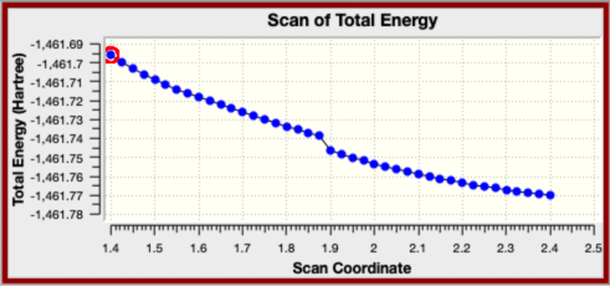
Figure S11. Scan coordinate of INT-6.

Table S3. Thermal data and coordination
Name | G_{corr} / Hartree | E / Hartree | G / Hartree
AcO⁻ | 0.0216130 | -228.6161346 | -228.5945216
AcOH | 0.0351780 | -229.1009757 | -229.0657977
radical B₁ | 0.1440760 | -499.9743803 | -499.8303043
INT-1 | 0.1453850 | -479.8907421 | -479.7453571
INT-2 | 0.3196190 | -979.9375667 | -979.6179477
INT-4 | 0.3107440 | -979.2113780 | -978.9006340
INT-5 | 0.5814730 | -1463.4562817 | -1462.8748087
Product | 0.2974000 | -978.7549996 | -978.4575996
TEMPO⁺ | 0.2285080 | -483.5136838 | -483.2851758
TEMPOH | 0.2397260 | -484.3012119 | -484.0614859
TS1 | 0.3131890 | -979.8733559 | -979.5601669
TS2 | 0.3128250 | -979.8693091 | -979.5564841
TS3 | 0.5687760 | -1463.4466028 | -1462.8778268
TS4 | 0.5760280 | -1463.4454543 | -1462.8694263

Coordinations
AcO⁻
C 0.20061600 -0.00009600 -0.00581000
O 0.79962200 -1.09524000 0.00132100
O 0.70894700 1.14157400 0.00115000
C -1.34704400 -0.04457300 -0.00211900
H -1.71735200 0.34153500 0.96045400
H -1.74413600 0.61917300 -0.78409600
H -1.72849700 -1.06337100 -0.14854900

AcOH
C -0.09236100 0.12010600 -0.00073200
O -0.63145500 1.19623400 0.00009000
O -0.78204500 -1.02685700 0.00023800
H -1.72809500 -0.80734900 0.00066200
C 1.39000700 -0.11682700 0.00006200
H 1.66642500 -0.70447100 0.88536600
H 1.66734800 -0.70420000 -0.88512800
H 1.91644600 0.84133600 0.00049200
radical B₁
C -1.16723600 -0.97294500 -0.00522000
C 0.21642000 -1.10880500 -0.00728300
C 1.08222500 0.01862800 -0.00626200
C 0.45984900 1.30174700 0.00185700
C -0.91437200 1.43324600 0.00377400
C -1.75110300 0.30137200 -0.00027700
H -1.78527700 -1.87036900 -0.00717000
H 0.65350700 -2.10676100 -0.01123300
H 1.06816500 2.20643200 0.01092100
H -1.38112100 2.41946900 0.01068300
O -3.08603000 0.53549700 0.00271600
C -3.95283900 -0.57281000 0.00144100
H -4.97375400 -0.17625200 0.00486400
H -3.80979900 -1.19471600 -0.89702700
H -3.80578800 -1.19989900 0.89565400
C 2.48965500 -0.15452700 -0.01115800
C 3.52179600 0.91881600 -0.00303500
H 4.06447900 0.94539400 0.95828700
H 4.27113800 0.73663700 -0.79170400
H 3.09216400 1.91051700 -0.17494700
O 2.93592800 -1.43659300 0.01753200
H 3.90071400 -1.45000600 -0.00333600

INT-1
C 0.71262700 0.08565100 0.01773400
C 1.48596400 1.23966100 -0.16562600
C 2.87029200 1.20366100 -0.19049400
C 3.53284000 -0.05936400 -0.01707900
C 2.78519500 -1.17773300 0.17151900
N 1.41111000 -1.12016300 0.17959500
H 3.44508200 2.11452400 -0.35092100
H 0.96952200 2.18641900 -0.32425000
H 4.61892300 -0.13818900 -0.03561300
H 3.21742400 -2.16658600 0.32193000
C -0.73861500 0.04473300 0.00373000
C -1.51242400 1.21661300 0.18611300
C -1.43843000 -1.16963700 -0.18730900
C -2.89913800 1.17136800 0.17254700
H -1.01716600 2.17147500 0.36591900
C -2.83089000 -1.20622200 -0.19360700
H -0.89513400 -2.09745500 -0.37383500
C -3.57566900 -0.04075200 -0.01454600
H -3.46419200 2.09323000 0.32219000
H -3.33782000 -2.16008900 -0.35094500
H -4.66571300 -0.07212300 -0.01859200
H 0.90078900 -1.93793500 0.48906200

INT-2
C 2.03523000 0.05321600 1.08615200
C 1.84257300 -0.97907200 0.17028800
C 2.62570000 -0.97097500 -0.99651800
C 3.55239300 0.03310800 -1.23574500
C 3.72816100 1.07167000 -0.30755700
C 2.96383800 1.07636700 0.86147300
H 1.45264300 0.06275400 2.00758200
H 2.51306100 -1.76433000 -1.73911000
H 4.15955900 0.03875400 -2.14191400
H 3.07850400 1.86320000 1.60572100
O 4.64886400 2.01093400 -0.62235300
C 4.85231300 3.07122200 0.28181700
H 5.62482600 3.71339400 -0.15409100
H 3.93134800 3.65868100 0.42510700
H 5.19773000 2.70306500 1.26105500
C 0.79827700 -2.07031300 0.41331100
C 1.46500600 -3.43873600 0.49808800
H 2.21085800 -3.43540500 1.30525500
H 0.71260200 -4.20763900 0.71994400
H 1.96850900 -3.69218500 -0.44502500
O 0.14527300 -1.87215200 1.64882200
H -0.45049100 -1.11580900 1.53918100
C -0.26714400 -2.02194300 -0.74102400
C -0.94554300 -0.67209800 -0.75230800
C -1.31738300 -3.09901000 -0.60157900
C -2.17405000 -0.47075400 -0.22031500
H -0.41462000 0.18345000 -1.17159900
C -2.53219200 -2.83445000 -0.09445600
H -1.08112000 -4.12463300 -0.88646200
H -3.27991900 -3.61058000 0.07353300
H 0.29170600 -2.16534800 -1.68051400
N -2.93922900 -1.54556800 0.19864000
H -3.82072700 -1.38476500 0.66552100
C -2.79830800 0.87285100 -0.11753400
C -2.01236400 1.99596800 0.17824800
C -4.17513300 1.04466400 -0.31982200
C -2.58765200 3.26220200 0.25542500
H -0.94482100 1.86610100 0.36692300
C -4.75030800 2.31206100 -0.23739300
H -4.80085900 0.18501900 -0.56802300
C -3.95877600 3.42448900 0.04863200
H -1.96364300 4.12586500 0.48995700
H -5.82184200 2.43061000 -0.40483200
H -4.40965000 4.41570700 0.11445700

INT-4
C -2.47130100 -0.76364000 -1.00621000
C -2.01914400 -0.88470600 0.31863000
C -2.36332400 0.11043100 1.23018300
C -3.13618000 1.21152400 0.84581000
C -3.57678900 1.32132300 -0.47612200
C -3.23831700 0.31859200 -1.40161500
H -2.21781700 -1.54170000 -1.72895600
H -2.03721200 0.05032100 2.26913900
H -3.38682500 1.96767500 1.58784500
H -3.59426100 0.41805300 -2.42760600
O -4.32292600 2.34016400 -0.94506000
C -4.68689700 3.37080600 -0.05389700
H -5.27912500 4.08881100 -0.63019300
H -5.29518400 2.98272200 0.77803900
H -3.79846000 3.87743600 0.35457100
C -1.15061500 -2.09124600 0.67642600
C -0.97778800 -2.29380800 2.18598600
H -0.39726100 -3.21029700 2.35344000
H -0.45353900 -1.45571700 2.66266100
H -1.96509200 -2.40390500 2.65725100
O -1.67864000 -3.26209900 0.09203400
H -2.57615000 -3.38616300 0.42764100
C 0.23095800 -1.90385100 0.05911900
C 0.94276900 -0.72315500 0.28355700
C 0.81841300 -2.91878400 -0.70760400
C 2.21462500 -0.55150200 -0.24920000
H 0.51328300 0.07656100 0.88782200
C 2.08047500 -2.71567300 -1.22552500
H 0.28819100 -3.84841500 -0.89837500
H 2.60223100 -3.44644900 -1.84133000
N 2.72647300 -1.56178400 -0.98892200
C 3.03024900 0.66198700 -0.05416700
C 4.42527300 0.57520900 0.05749200
C 2.40229500 1.91288300 0.02752700
C 5.18175800 1.72928200 0.24299200
H 4.92763800 -0.39409100 0.03586300
C 3.16479300 3.06264300 0.21045900
H 1.31923300 1.99054800 -0.07872200
C 4.55351200 2.97277500 0.31797800
H 6.26514700 1.65430200 0.33899600
H 2.67227200 4.03393600 0.26256500
H 5.14837900 3.87538000 0.46274600
H 3.64318100 -1.42757700 -1.41764800

INT-5
C 2.41786300 1.50125500 0.87453100
C 1.09722300 1.90886900 1.13615800
C 0.65774300 3.09437800 0.54656400
C 1.47652100 3.84555200 -0.30291100
C 2.77605200 3.40937200 -0.57367700
C 3.24234300 2.23122300 0.03167700
H 2.82394200 0.60139700 1.33882400
H -0.34739900 3.44809200 0.77393600
H 1.08855600 4.76533800 -0.73805000
H 4.26484600 1.91152700 -0.17223400
O 3.64272400 4.05191000 -1.38376800
C 3.21609600 5.24189600 -2.00732000
H 4.05412100 5.59491000 -2.61706200
H 2.34465000 5.06260000 -2.65673300
H 2.95802300 6.01271500 -1.26419100
C 0.15862500 1.08651800 2.02086900
C 0.78670400 0.80854900 3.38718700
H 0.89233200 1.76485500 3.91648300
H 0.12748800 0.15390000 3.97613800
H 1.77883100 0.34328800 3.31588200
O -1.04188700 1.78978900 2.19698900
H -1.81040800 1.17447200 2.03584800
C -0.22337100 -0.26603100 1.31309100
C 0.90220800 -1.23231500 1.18970400
C -0.97602900 0.03222200 -0.00103000
C 1.40278400 -1.65724300 0.02189100
H 1.32247500 -1.64127000 2.10996600
C -0.30302300 -0.48368600 -1.21924600
H -0.93955000 1.12228300 -0.15855600
H -0.64247500 -0.19941000 -2.21538800
H -0.95286700 -0.70700500 2.00625500
N 0.78503500 -1.17075700 -1.16475100
C 2.52561500 -2.59681500 -0.17076400
C 2.51923700 -3.51902600 -1.22682400
C 3.60562700 -2.58188600 0.72292600
C 3.57938400 -4.40911100 -1.38689400
H 1.67350400 -3.57318200 -1.91665700
C 4.65853700 -3.47838500 0.56323500
H 3.62917900 -1.85542800 1.53728400
C 4.64953100 -4.39106700 -0.49302300
H 3.56180700 -5.12549000 -2.20878200
H 5.49608400 -3.45586100 1.26121700
H 5.47866400 -5.08819300 -0.61969600
C -3.32699300 0.86170200 -0.72110200
C -2.94681100 -1.71875800 -0.15151200
C -4.82226500 0.57053700 -0.51720600
C -4.45736600 -1.80348900 0.09570900
C -5.25563400 -0.85877500 -0.78811900
H -5.36968600 1.27596200 -1.15862200
H -5.06306000 0.82148900 0.52497900
H -4.74926600 -2.84949500 -0.07728800
H -4.64657400 -1.57377000 1.15268000
H -6.32702100 -0.96051900 -0.56580900
H -5.13824900 -1.11212300 -1.85316800
N -2.53040800 -0.21173100 0.13420700
O -2.83917800 0.03101000 1.42134400
C -2.22640900 -2.60426900 0.86156500
H -2.63965600 -3.61677200 0.76487700
H -1.14731900 -2.68070800 0.66493300
H -2.40016200 -2.25507600 1.88425100
C -2.64204500 -2.25875400 -1.55154300
H -1.58915000 -2.20880500 -1.85080700
H -2.87467400 -3.33186700 -1.51216500
H -3.25997200 -1.83763900 -2.34725300
C -2.92603200 0.90340500 -2.19714400
H -2.95086200 -0.05422200 -2.72162700
H -3.64253200 1.56324000 -2.70446600
H -1.94101700 1.37075900 -2.33596800
C -3.07739700 2.25682600 -0.14322900
H -3.31260100 2.30002800 0.92368400
H -2.05929800 2.63032800 -0.31098800
H -3.75242300 2.93911500 -0.67773700
H 1.25373800 -1.38988700 -2.04807700

Product
C -2.75850300 0.20930300 1.16166400
C -1.95809600 0.85224000 0.22182100
C -1.98912800 0.39334900 -1.10461500
C -2.79022200 -0.67641200 -1.47143600
C -3.58809100 -1.32432500 -0.51347700
C -3.56943200 -0.87571600 0.80956200
H -2.75577400 0.55896000 2.19466000
H -1.36810100 0.87814300 -1.86241200
H -2.81564200 -1.03959000 -2.49950200
H -4.17704500 -1.35573900 1.57517200
O -4.33159900 -2.36153600 -0.95570600
C -5.14322300 -3.04387400 -0.02787700
H -5.65274300 -3.83959200 -0.58116400
H -4.54050600 -3.49129800 0.77837100
H -5.89515300 -2.37268500 0.41658300
C -1.10713000 2.06375800 0.60998300
C -1.80581900 3.34066800 0.15370700
H -2.80442300 3.37324600 0.60855800
H -1.24184600 4.22366500 0.48372600
H -1.91514300 3.36299100 -0.93859000
O -0.99721100 2.18072200 2.01825000
H -0.52065500 1.41189100 2.35867600
C 0.30534500 1.91876600 0.02544000
C 1.00824300 0.73171000 0.24926900
C 0.95923800 2.93044000 -0.67529800
C 2.31918500 0.59052500 -0.21917700
H 0.53016400 -0.08617800 0.79185200
C 2.27321800 2.70826000 -1.09526700
H 0.47891500 3.88204000 -0.89857100
H 2.80654100 3.49309900 -1.64026900
N 2.93813700 1.58091200 -0.87714300
C 3.09250400 -0.66604500 -0.00676700
C 2.45617400 -1.88544700 0.26509600
C 4.49207900 -0.63851800 -0.08741000
C 3.20253100 -3.04601400 0.46267100
H 1.36737100 -1.94319000 0.30122100
C 5.23729000 -1.79754800 0.11489300
H 4.98268200 0.30902000 -0.30951200
C 4.59530900 -3.00578300 0.39225100
H 2.69125800 -3.98805900 0.66598100
H 6.32614800 -1.75817900 0.05623800
H 5.17863200 -3.91444500 0.54843700

TEMPO⁺
C -1.34488900 -0.07555300 0.02299300
C 1.34488900 -0.07555200 0.02299300
C -1.24453200 1.30251300 -0.64952500
C 1.24453100 1.30251400 -0.64952500
C -0.00000100 2.08744100 -0.26328400
H -2.16274900 1.84163600 -0.37638200
H -1.26626400 1.15961000 -1.74091900
H 2.16274800 1.84163800 -0.37638300
H 1.26626300 1.15961000 -1.74091900
H -0.00000200 3.04721300 -0.79612400
H 0.00000000 2.33135300 0.80920200
N 0.00000000 -0.78099500 -0.13291000
O 0.00000100 -1.93094200 -0.36386600
C 2.39351900 -0.95214700 -0.64628900
H 2.53693800 -1.89850300 -0.11152700
H 2.13035900 -1.16055700 -1.69157600
H 3.33783200 -0.39360200 -0.62932500
C 1.62190600 0.02549100 1.53322600
H 1.47733600 -0.94243500 2.03056900
H 2.67925500 0.30491900 1.62846200
H 1.02286000 0.79275300 2.03223500
C -1.62190500 0.02549100 1.53322600
H -1.47733400 -0.94243500 2.03056900
H -1.02286200 0.79275400 2.03223400
H -2.67925600 0.30491600 1.62846200
C -2.39351900 -0.95214800 -0.64628900
H -2.13035700 -1.16056300 -1.69157500
H -2.53694100 -1.89850300 -0.11152400
H -3.33783100 -0.39360200 -0.62932900

TEMPOH
C 1.27249500 0.06121300 0.19453600
C -1.27247600 0.06107700 0.19458500
C 1.25590000 -0.88141400 -1.02237000
C -1.25579300 -0.88161700 -1.02227700
C 0.00012400 -1.75147000 -1.07052200
H 2.16567700 -1.50268100 -1.01121500
H 1.29649600 -0.26210700 -1.93306600
H -2.16547000 -1.50303100 -1.01104100
H -1.29655600 -0.26235100 -1.93299300
H 0.00014000 -2.35608200 -1.98977900
H 0.00021600 -2.47001300 -0.23472700
N -0.00004400 0.84075600 0.27555800
O -0.00024200 1.69616200 -0.86202600
H -0.00036600 2.58310600 -0.48333000
C -2.42147500 1.06631400 0.06212700
H -2.40985800 1.76568200 0.91246500
H -2.35144700 1.63997500 -0.86827600
H -3.37992600 0.52825800 0.07057200
C -1.51763800 -0.71391200 1.49731000
H -1.26301900 -0.09092200 2.36601000
H -2.58511800 -0.96852700 1.55753100
H -0.96140600 -1.65371300 1.56490000
C 1.51766500 -0.71388600 1.49718800
H 1.26292700 -0.09101500 2.36593700
H 0.96153100 -1.65375600 1.56464400
H 2.58517100 -0.96839100 1.55744200
C 2.42151100 1.06646500 0.06224700
H 2.35177000 1.63996300 -0.86827000
H 2.40963000 1.76597200 0.91246900
H 3.37996900 0.52842400 0.07108000

TS1
C 1.41742600 0.09953800 1.19698500
C 1.77514300 -1.18253500 0.71587300
C 2.95587000 -1.25746400 -0.07667900
C 3.68774100 -0.12982600 -0.38699700
C 3.29445000 1.14130800 0.07918100
C 2.15753300 1.24201700 0.88387800
H 0.55518600 0.21558000 1.85639100
H 3.28579100 -2.21947000 -0.47121900
H 4.58480300 -0.19682900 -1.00455300
H 1.83650400 2.20354600 1.28440600
O 4.07364800 2.18741800 -0.28944100
C 3.69765600 3.47234700 0.14223200
H 4.43103000 4.17314000 -0.27074100
H 2.69326900 3.74108700 -0.22439000
H 3.70617100 3.54653100 1.24177900
C 0.93100100 -2.31335800 0.94781700
C 1.33441300 -3.74172800 0.84718900
H 1.61626300 -4.14552500 1.83658200
H 0.48334300 -4.33970100 0.48607600
H 2.18361600 -3.88845900 0.17007600
O -0.23531200 -2.13578400 1.62158800
H -0.64950300 -1.30810000 1.32401900
C -0.30617700 -2.13831500 -1.42331600
C -0.67052900 -0.80203000 -1.18928200
C -1.29602200 -3.15080600 -1.19638900
C -1.89303800 -0.46215600 -0.63412700
H 0.03038900 -0.00133100 -1.42740600
C -2.49871600 -2.80795700 -0.66440900
H -1.09738200 -4.19734100 -1.42606900
H -3.28175200 -3.53197000 -0.44233700
H 0.63798200 -2.37378400 -1.91198600
N -2.80805300 -1.49179300 -0.39583500
H -3.63609200 -1.29274800 0.15106700
C -2.33248100 0.91500900 -0.37666300
C -1.39696900 1.95894600 -0.22328400
C -3.69965500 1.23694900 -0.28081500
C -1.81384700 3.26321500 0.01093100
H -0.32967500 1.73720600 -0.26249700
C -4.11227800 2.54675800 -0.03763200
H -4.46041100 0.46907300 -0.43039300
C -3.17573500 3.56805200 0.11012100
H -1.06702300 4.05030500 0.12961400
H -5.17886700 2.76818800 0.02694700
H -3.49996200 4.59160500 0.30187700

TS2
C -4.41569000 -0.08279500 -0.47325400
C -3.70700300 -0.84666800 -1.42981000
C -4.47389800 -1.73860900 -2.22896000
C -5.83861800 -1.86530600 -2.05971800
C -6.52043200 -1.10820500 -1.08751600
C -5.79514600 -0.21118600 -0.29918300
H -3.88356600 0.65066800 0.13412400
H -3.98226300 -2.35372900 -2.98411100
H -6.41771600 -2.55657800 -2.67411900
H -6.29189600 0.40542400 0.44929400
O -7.85911300 -1.30712100 -0.99683300
C -8.57138600 -0.56822600 -0.03520500
H -8.20805400 -0.77836300 0.98397300
H -8.49607600 0.51526800 -0.22271900
H -9.62026600 -0.87392800 -0.11307700
C -2.27519200 -0.78301600 -1.50089600
C -1.45285200 -1.17958600 -2.67603900
H -1.21944900 -0.30464900 -3.30943900
H -0.48526700 -1.58413400 -2.33621100
H -1.95003100 -1.92748700 -3.30437700
O -1.61741900 0.04970200 -0.64800600
H -1.93123000 -0.11095500 0.26257900
C -1.92602400 -1.65152600 1.95626700
C -0.50125600 -1.52832000 2.03035300
C -2.47611600 -2.41692500 0.92334700
C 0.29742700 -2.06478800 1.05763200
H -0.03554900 -1.03277500 2.88163900
C -1.67532700 -2.88914800 -0.09965100
H -3.55197400 -2.58298700 0.85858400
H -2.04148400 -3.52871600 -0.90111900
H -2.55475500 -1.24659900 2.74809600
N -0.29931500 -2.74231400 -0.00076900
H 0.27754300 -3.01362500 -0.78789100
C 1.77012700 -2.01443600 1.07669900
C 2.44300100 -0.94311600 1.68966800
C 2.53433100 -3.03171200 0.48045500
C 3.83311700 -0.89981300 1.71651800
H 1.86798000 -0.12567000 2.12718200
C 3.92736900 -2.98206600 0.50439200
H 2.04168500 -3.89057600 0.02040400
C 4.58325900 -1.91826000 1.12251100
H 4.33622400 -0.05699900 2.19289200
H 4.50210900 -3.78621100 0.04244300
H 5.67321500 -1.87902600 1.13879000

TS3
C -4.14623300 -1.39696900 0.02358100
C -3.66800000 1.17562700 -0.24312100
C -4.02523200 1.33240500 1.24001900
C -4.99814800 0.27659300 1.75123600
C -4.44890300 -1.12363700 1.50152900
H -3.09194100 1.27868300 1.82303900
H -4.43443100 2.34425300 1.37549700
H -5.98330900 0.39560200 1.27500500
H -3.51828800 -1.26131200 2.07589300
H -5.15854200 -1.89161300 1.84227300
N -3.31039000 -0.26151300 -0.50268200
O -2.51943900 -0.50194900 -1.42478700
C -3.37902800 -2.69980200 -0.15533600
H -3.95023700 -3.49298300 0.34525200
H -3.28221100 -2.95992300 -1.21762100
H -2.37395000 -2.66607800 0.27300000
C -5.43684500 -1.49699000 -0.81394700
H -5.20284700 -1.43663300 -1.88576000
H -5.88453100 -2.48005600 -0.61473300
H -6.18134400 -0.73572400 -0.56334600
C -2.47018000 2.04511600 -0.59928300
H -2.22665700 1.98384000 -1.66716300
H -2.71785300 3.08564200 -0.35194800
H -1.59402900 1.75255500 -0.01510500
C -4.83830200 1.57472100 -1.16361800
H -4.89691800 2.67125800 -1.17431500
H -4.65335800 1.22819000 -2.18966700
H -5.80505000 1.19294700 -0.82170900
H -1.17596600 -0.62868000 -0.97522200
H -5.16029100 0.42119900 2.82814100
C -0.15351300 -0.68626700 -0.30020700
C 0.62984900 0.52326500 -0.59350400
C -0.67420100 -0.71400900 1.06931400
C 0.82356500 1.51767600 0.31314900
H 1.08306200 0.63871600 -1.57881400
C -0.46424200 0.32567500 1.93033400
H -1.16349800 -1.60773900 1.45024400
H -0.82528400 0.31227300 2.95892400
H 0.46192900 2.12680300 2.25897200
N 0.25788700 1.41202100 1.56750500
C 1.60953900 2.74022200 0.03197900
C 2.78460800 2.66037800 -0.72742000
C 1.18154700 3.98626200 0.51044300
C 3.51642300 3.81158200 -1.00738700
H 3.13536200 1.68751700 -1.07763000
C 1.91779300 5.13560500 0.22848800
H 0.25436200 4.06775100 1.08257700
C 3.08519200 5.05070400 -0.53028900
H 4.43382400 3.73920000 -1.59283400
H 1.57226600 6.10200800 0.59749600
H 3.66117900 5.95080300 -0.74905500
C 0.49260800 -2.00622500 -0.84186700
C 0.33247100 -2.08403400 -2.35805300
H -0.73669600 -2.17383200 -2.59298200
H 0.72383200 -1.19392100 -2.86821900
H 0.86112700 -2.96334800 -2.75294100
O -0.22732300 -3.05594400 -0.23128100
H 0.14250900 -3.89508100 -0.53688200
C 1.95063900 -2.04380200 -0.38717900
C 3.00634400 -1.64625600 -1.20673900
C 2.24428600 -2.42567100 0.93142400
C 4.32405900 -1.61695600 -0.73946100
H 2.82304000 -1.34550600 -2.23944500
C 3.54522000 -2.40475600 1.41017000
H 1.43237300 -2.74910700 1.58471100
C 4.59945900 -1.99419700 0.57860200
H 5.11931300 -1.30221100 -1.41336400
H 3.77785200 -2.70306700 2.43312600
O 5.83279500 -1.99828200 1.12554800
C 6.91983400 -1.58989600 0.32661900
H 7.81473400 -1.66206400 0.95322500
H 7.03851000 -2.24341900 -0.55195800
H 6.79756900 -0.54928400 -0.01311000

TS4
C -2.88033300 -1.06204700 0.83700200
C -1.69493300 -1.78729100 1.04375400
C -1.56474500 -3.02184700 0.40871200
C -2.57209400 -3.53130300 -0.41698500
C -3.74086100 -2.79279300 -0.62095400
C -3.88637400 -1.55095300 0.01712300
H -3.02998500 -0.09561100 1.32194600
H -0.65855000 -3.60628800 0.56564700
H -2.42944700 -4.50164100 -0.89030500
H -4.80615300 -0.98780700 -0.14438000
O -4.76856300 -3.19154700 -1.40040800
C -4.66474100 -4.43383700 -2.05751300
H -5.58928500 -4.56536500 -2.62911100
H -3.80626400 -4.45117000 -2.74754400
H -4.56317900 -5.26075400 -1.33701200
C -0.56639000 -1.21743700 1.89381000
C -1.05430000 -0.78699700 3.27667500
H -1.38566000 -1.68135800 3.82054500
H -0.23184200 -0.31739600 3.83763600
H -1.89306400 -0.08078400 3.23109400
O 0.41295200 -2.22150300 2.03136200
H 1.24353400 -1.80352400 2.30496200
C 0.11562900 -0.02148800 1.14120300
C -0.66535200 1.24019400 1.10888400
C 0.66348800 -0.42989700 -0.18769700
C -0.97291100 1.89047500 -0.03134500
H -0.97442600 1.68776500 2.05442100
C 0.16324700 0.22945200 -1.33447000
H 0.79065800 -1.50029700 -0.33758500
H 0.31484800 -0.16626800 -2.34048400
H 1.03876000 0.16060400 1.77322800
N -0.56257000 1.32339900 -1.24930200
C -1.70908600 3.17000600 -0.11979200
C -1.34363400 4.13566500 -1.06803700
C -2.76926500 3.43485100 0.75755700
C -2.03022500 5.34661000 -1.13720300
H -0.50125200 3.95923200 -1.74117400
C -3.44907600 4.64797200 0.68822300
H -3.07381500 2.67953800 1.48421700
C -3.08301500 5.60508400 -0.25996500
H -1.73401100 6.09319200 -1.87488000
H -4.27674200 4.84226100 1.37133400
H -3.62047200 6.55256800 -0.31558300
C 3.33523500 -1.54542900 -0.46695000
C 3.24019700 1.09913000 -0.30548200
C 4.84695700 -1.41758700 -0.17209700
C 4.73980400 1.07324800 0.04915400
C 5.47964100 -0.09714900 -0.58435600
H 5.34236600 -2.26245800 -0.67210300
H 4.97731900 -1.55705400 0.91220800
H 5.16652200 2.03339000 -0.27627400
H 4.82776400 1.02452800 1.14528500
H 6.52929700 -0.08546100 -0.25885100
H 5.50273300 -0.00221000 -1.68034100
N 2.69811900 -0.28081900 0.17521300
O 2.70479700 -0.34810200 1.42909200
C 2.54382600 2.18384100 0.50662600
H 3.06371600 3.13124200 0.31260200
H 1.49962700 2.31456600 0.19588900
H 2.58339000 1.97963500 1.58198200
C 3.06163600 1.39498300 -1.79535800
H 2.11331100 1.04007300 -2.20809500
H 3.07567300 2.48650500 -1.91529300
H 3.86903800 0.99544700 -2.41520900
C 3.04686100 -1.67686600 -1.95806000
H 3.54835000 -0.93125700 -2.57901300
H 3.41838600 -2.66143900 -2.27244600
H 1.97048700 -1.66290700 -2.17561700
C 2.84707700 -2.80153200 0.25133700
H 2.99609700 -2.72980200 1.33376100
H 1.79920800 -3.05047400 0.04709100
H 3.46054400 -3.63373100 -0.11901400
H -0.91739100 1.74332100 -2.10803900

References:
1. Frisch, M. J.; Trucks, G. W.; Schlegel, H. B.; Scuseria, G. E.; Robb, M. A.; Cheeseman, J. R.; Scalmani, G.; Barone, V.; Petersson, G. A.; Nakatsuji, H.; Li, X.; Caricato, M.; Marenich, A. V.; Bloino, J.; Janesko, B. G.; Gomperts, R.; Mennucci, B.; Hratchian, H. P.; Ortiz, J. V.; Izmaylov, A. F.; Sonnenberg, J. L.; Williams-Young, D.; Ding, F.; Lipparini, F.; Egidi, F.; Goings, J.; Peng, B.; Petrone, A.; Henderson, T.; Ranasinghe, D.; Zakrzewski, V. G.; Gao, J.; Rega, N.; Zheng, G.; Liang, W.; Hada, M.; Ehara, M.; Toyota, K.; Fukuda, R.; Hasegawa, J.; Ishida, M.; Nakajima, T.; Honda, Y.; Kitao, O.; Nakai, H.; Vreven, T.; Throssell, K.; Montgomery Jr., J. A.; Peralta, J. E.; Ogliaro, F.; Bearpark, M. J.; Heyd, J. J.; Brothers, E. N.; Kudin, K. N.; Staroverov, V. N.; Keith, T. A.; Kobayashi, R.; Normand, J.; Raghavachari, K.; Rendell, A. P.; Burant, J. C.; Iyengar, S. S.; Tomasi, J.; Cossi, M.; Millam, J. M.; Klene, M.; Adamo, C.; Cammi, R.; Ochterski, J. W.; Martin, R. L.; Morokuma, K.; Farkas, O.; Foresman, J. B.; Fox, D. J. Gaussian 16, Rev. B.01: Wallingford, CT, 2016.

2. Zhao Y.; Truhlar D G.; The M06 suite of density functionals for main group thermochemistry, thermochemical kinetics, noncovalent interactions, excited states, and transition elements: two new functionals and systematic testing of four M06-class functionals and 12 other functionals. Theor. Chem. Acc. 2008, 120: 215-241.

3. (a) Grimme, S.; Antony, J.; Ehrlich, S.; Krieg, H. A consistent and accurate ab initio parametrization of density functional dispersion correction (DFT-D) for the 94 elements H-Pu. J. Chem. Phys. 2010, 132, 154104; b) Grimme, S.; Ehrlich, S.; Goerigk, L. Effect of the damping function in dispersion corrected density functional theory. J. Comput. Chem. 2011, 32, 1456-1465.

4. F. Weigend and R. Ahlrichs. "Balanced basis sets of split valence, triple zeta valence and quadruple zeta valence quality for H to Rn: Design and assessment of accuracy". Phys. Chem. Chem. Phys. 2005, 7: 3297.
5. Cances E, Mennucci B, Tomasi J. A new integral equation formalism for the polarizable continuum model: Theoretical background and applications to isotropic and anisotropic dielectrics[J]. The Journal of chemical physics, 1997, 107(8): 3032-3041.

6. (a) Weigend F.; Ahlrichs R. Balanced basis sets of split valence, triple zeta valence and quadruple zeta valence quality for H to Rn: Design and assessment of accuracy. Phys. Chem. Chem. Phys. 2005, 7, 3297-3305. b) WeigendF. Accurate Coulomb-fitting basis sets for H to Rn. Phys. Chem. Chem. Phys. 2006, 8, 1057-1065.

7. Marenich, A. V.; Cramer, C. J.; Truhlar, D. G. Universal solvation model based on solute electron density and on a continuum model of the solvent defined by the bulk dielectric constant and atomic surface tensions. J. Phys. Chem. B. 2009, 113, 6378-6396.

8 Lu, T.; Chen, F. Multiwfn: A multifunctional wavefunction analyzer. J. Comput. Chem, 2012, 33, 580-592.

9. Humphrey, W.; Dalke, A. and Schulten, K. VMD - Visual Molecular Dynamics. J. Molec. Graphics, 1996, 14, 33-38.

10. Legault, C. Y. CYLview20. http://www.cylview.org (accessed May 31).

9. Amplified experiment
A 40 mL equipped with a magnetic stir bar was subsequently charged with TEMPO (10 mol%), A₁ (466 mg, 3.0 mmol, 1 equiv.), carbonyl substrates B₁ (1.35 g, 9.0 mmol, 3 equiv.), n-Bu₄NBF₄ (988 mg, 0.1 M), DMF (30 mL) and AcOH (172 uL, 3.0 mmol, 1 equiv.) under air condition. After fully stirring and dissolution, a graphite plate anode and a zinc plate cathode were installed. Then the cell was electrolyzed at room temperature under a constant current of 40 mA for 80 hours. Upon the completion of electrolysis, the resulting mixture was poured into saturated NH₄Cl solution (100 mL) and the electrodes and cell were rinsed with EtOAc, then extracted the mixture with EtOAc (80 mL × 3). The combined organic layers were dried over anhydrous Na₂SO₄, filtered, and concentrated under reduced pressure. The resultant residue was purified by preparative TLC on silica to afford desired product C₁.
(Note: The electrodes employed in the scaled-up experiment maintain identical specifications to those utilized in the standard conditions. The effective immersion areas of graphite anode and zinc cathode are approximately 2.8 cm².)
10. Product Derivatizations
Figure S12. Product derivatizations.
We have carried out product derivatization to showcase the synthetic utility of these new protocols (Figure S12). Several functionalization products could be synthesized via dehydration (D₃), acylation (D₆), esterification (D₇). In addition, alkene product D₃ underwent hydroboration-oxidation reaction to form β-pyridyl alcohol species D₄, and product D₅ can be afforded through the oxidation of D₃ with m-chloroperoxybenzoic acid (m-CPBA).

4-(1-(4-methoxyphenyl)vinyl)-2-phenylpyridine (D₃): To a 10 mL round bottom flask equipped with a magnetic stir bar was charged with C₁ (61.2 mg, 0.2 mmol) and Toluene (2 mL). Then HCl (50 ul, 0.6 mmol, 12 mol/L) was added dropwise to the solution under vigorous stirring and further reacted at room temperature for 20 hours. After the reaction completion, Na₂CO₃ (106 mg, 1 mmol) was slowly added to the mixture (Caution: Care should be exercised as the reaction is exothermic and accompanied by gas evolution.). After cooling the reaction to room temperature, the mixture was stirred for an additional 3 hours. Finally, the resulting mixture was poured into saturated NH₄Cl solution (10 mL) and extracted with EtOAc (15 mL × 3). The combined organic layers were dried over anhydrous Na₂SO₄, filtered, and concentrated under reduced pressure. The resultant residue was purified by silica gel chromatography to give the desired product D₃ (49.1 mg, 85% yield).

2-(4-methoxyphenyl)-2-(2-phenylpyridin-4-yl)ethan-1-ol (D₄): To a 10 mL round bottom flask equipped with a magnetic stir bar was charged with D₃ (57.5 mg, 0.2 mmol) and dry THF (2 mL). Then BH₃·THF (1.0 ml, 1.0 mmol, 1.0 mol/L in THF) was added dropwise to the solution under vigorous stirring and further reacted at room temperature for 20 hours. After the reaction completion, KOH (33.7 mg, 0.6 mmol) and H₂O₂ (86 uL, 1 mmol, 35% wt in H₂O) was added to the mixture. The mixture was stirred for an additional 6 hours. Finally, the resulting mixture was poured into saturated NH₄Cl solution (10 mL) and extracted with EtOAc (15 mL × 3). The combined organic layers were dried over anhydrous Na₂SO₄, filtered, and concentrated under reduced pressure. The resultant residue was purified by silica gel chromatography to give the desired product D₄ (53.7 mg, 88% yield).

4-(1-((3-chlorobenzoyl)oxy)-2-hydroxy-1-(4-methoxyphenyl)ethyl)-2-phenylpyridine 1-oxide (D₅): To a 10 mL round bottom flask equipped with a magnetic stir bar was subsequently charged with D₃ (57.5 mg, 0.2 mmol), m-CPBA (86.5 mg, 0.5 mmol) and THF (2 mL). After fully stirring and dissolution, the mixture was further reacted under room temperature for 20 hours. Then Na₂SO₃ (75.6 mg, 0.6 mmol) and H₂O (1 mL) was added to the mixture. Upon the reaction completion, the resulting mixture was poured into saturated NH₄Cl solution (10 mL) and extracted the mixture with EtOAc (15 mL × 3). The combined organic layers were dried over anhydrous Na₂SO₄, filtered, and concentrated under reduced pressure. The resultant residue was purified by silica gel chromatography to give the desired product D₅ (47.3 mg, 50% yield).

(2-(4-(1-hydroxy-1-(4-methoxyphenyl)ethyl)pyridin-2-yl)phenyl)(phenyl)methanone (D₆): The preparation of D₆ was performed according to the literature procedure. To a 10 mL oven-dried seal tube equipped with a magnetic stir bar, PdCl₂ (1.8 mg, 0.01 mmol) and C₁ (61.2 mg, 0.2 mmol) were dissolved in chlorobenzene (0.5 mL). Then benzyl alcohol (0.6 mmol, 3 equiv.) and tert-butyl hydroperoxide (77.2 mg, 0.6 mmol, 70% wt. in H₂O) were sequentially added to the mixture. The tube was sealed, and the solution was stirred at 140 °C for 24 h (The reaction is less sensitive to air, no need Schlenk technique to remove the oxygen in the tube and solvent). After cooling the reaction mixture to room temperature, the mixture was filtered through a pad of silica gel and washed with ethyl acetate. The solvent was removed under reduced pressure and the residue was purified by silica gel chromatography to give desired product D₆ (31.7 mg, 39% yield). [Caution: Care should be exercised when heating solvents above their boiling point in sealed flasks. In addition to standard engineering 51 controls (goggles, fume hood sash, thick-walled reaction vessels), a blast shield should also be utilized for this procedure.)]
1-(4-methoxyphenyl)-1-(2-phenylpyridin-4-yl)ethyl 2-(4-isobutylphenyl)propanoate (D₇): To a 10 mL oven-dried seal Schlenk tube equipped with a magnetic stir bar was charged with DL-ibuprofen (49.5 mg, 0.24 mmol), C₁ (61.2 mg, 0.2 mmol) and DMAP (4.9 mg, 0.04 mmol), and placed under a nitrogen atmosphere. After dry DCM (3 mL) was added, DCC (82.5 mg, 0.4 mmol)
was slowly added to the mixture. The tube was sealed and stirred for 24 hours at room temperature. Upon the reaction completion,the resulting mixture was quenched with H₂O (20 mL) and extracted with EtOAc (30 mL × 3). The combined organic layers were dried over anhydrous Na₂SO₄, filtered, and concentrated under reduced pressure. The resultant residue was purified by silica gel chromatography to give the desired product D₇ (50.6 mg, 51% yield, dr = 1.8:1).

11. Characterization of the Obtained Products
Isolated yield of major regioisomeric products is given;The regioisomeric ratio was determined by GC-MS, the regioisomeric ratio > 20:1 unless otherwise mentioned.

1-(4-methoxyphenyl)-1-(2-phenylpyridin-4-yl)ethan-1-ol (C₁)
White solid; (49.5 mg, 81% yield); ¹H NMR (400 MHz, CDCl₃) δ 8.59 (d, J = 5.2 Hz, 1H), 7.95 (d, J = 7.4 Hz, 2H), 7.80 (s, 1H), 7.43 (dt, J = 15.1, 7.0 Hz, 3H), 7.35 (d, J = 8.7 Hz, 2H), 7.23 (d, J = 4.9 Hz, 1H), 6.87 (d, J = 8.7 Hz, 2H), 3.80 (s, 3H), 2.41 (s, 1H), 1.96 (s, 3H). ¹³C NMR (126 MHz, CDCl₃) δ 158.9, 157.9, 157.5, 149.5, 139.5, 138.6, 128.9, 128.7, 127.2, 127.0, 119.3, 117.6, 113.8, 75.3, 55.3, 30.4. Calcd. for C₂₀H₂₀NO₂ [M+H]⁺: 306.1489; found: 306.1491.
1-phenyl-1-(2-phenylpyridin-4-yl)ethan-1-ol (C₂)
White solid; (33.6 mg, 61% yield, C₂/C₂' = 16:1); ¹H NMR (400 MHz, CDCl₃) δ 8.57 (d, J = 5.2 Hz, 1H), 7.94 (d, J = 7.1 Hz, 2H), 7.81 (s, 1H), 7.48 – 7.38 (m, 5H), 7.38 – 7.27 (m, 3H), 7.23 (dd, J = 5.2, 1.8 Hz, 1H), 2.65 (s, 1H), 1.98 (s, 3H). ¹³C NMR (126 MHz, CDCl₃) δ 157.6, 149.5, 146.3, 139.4, 128.9, 128.6, 128.5, 127.6, 127.0, 125.8, 119.3, 117.6, 75.6, 30.2. HRMS (ESI): Calcd. for C₁₉H₁₈NO [M+H]⁺: 276.1383; found: 276.1384.
1-(4-butylphenyl)-1-(2-phenylpyridin-4-yl)ethan-1-ol (C₃)
White solid; (48.9 mg, 74% yield, C₃/C₃' = 16:1); ¹H NMR (400 MHz, CDCl₃) δ 8.58 (d, J = 5.2 Hz, 1H), 7.95 (d, J = 7.0 Hz, 2H), 7.82 (s, 1H), 7.47 – 7.39 (m, 3H), 7.34 (d, J = 8.3 Hz, 2H), 7.23 (dd, J = 5.2, 1.7 Hz, 1H), 7.15 (d, J = 8.3 Hz, 2H), 2.61 – 2.57 (m, 2H), 2.46 (s, 1H), 1.97 (s, 3H), 1.58 (tt, J = 7.2, 1.7 Hz, 2H), 1.39 – 1.33 (m, 2H), 0.92 (t, J = 7.3 Hz, 3H). ¹³C NMR (126 MHz, CDCl₃) δ 157.8, 157.5, 149.5, 143.6, 142.4, 139.5, 128.8, 128.6, 128.5, 127.0, 125.7, 119.3, 117.6, 75.5, 35.1, 33.4, 30.2, 22.3, 13.9. HRMS (ESI): Calcd. for C₂₃H₂₆NO [M+H]⁺: 332.2009; found: 332.2011.
1-(4-cyclohexylphenyl)-1-(2-phenylpyridin-4-yl)ethan-1-ol (C₄)
White solid; (46.4 mg, 65% yield); ¹H NMR (500 MHz, CDCl₃) δ 8.56 (d, J = 5.2 Hz, 1H), 7.95 (d, J = 7.1 Hz, 2H), 7.83 (s, 1H), 7.44 (t, J = 7.3 Hz, 2H), 7.39 (t, J = 7.3 Hz, 1H), 7.34 (d, J = 8.3 Hz, 2H), 7.23 (dd, J = 5.3, 1.7 Hz, 1H), 7.17 (d, J = 8.2 Hz, 2H), 2.79 (d, J = 57.7 Hz, 1H), 2.48 (qd, J = 7.3, 6.2, 3.2 Hz, 1H), 1.95 (s, 3H), 1.91 – 1.69 (m, 6H), 1.39 (t, J = 11.0 Hz, 4H). ¹³C NMR (126 MHz, CDCl₃) δ 157.8, 157.5, 149.4, 147.4, 143.7, 139.5, 128.8, 128.6, 127.0, 126.9, 125.8, 119.4, 117.6, 75.4, 44.1, 34.3, 30.2, 26.8, 26.1. HRMS (ESI): Calcd. for C₂₅H₂₈NO [M+H]⁺: 358.2165; found: 358.2168.
1-(4-fluorophenyl)-1-(2-phenylpyridin-4-yl)ethan-1-ol (C₅)
White solid; (37.0 mg, 63% yield, C₅/C₅' = 10:1); ¹H NMR (400 MHz, CDCl₃) δ 8.56 (d, J = 5.2 Hz, 1H), 7.92 (d, J = 6.8 Hz, 2H), 7.77 (s, 1H), 7.47 – 7.37 (m, 5H), 7.20 (dd, J = 5.2, 1.8 Hz, 1H), 7.01 (t, J = 8.7 Hz, 2H), 2.77 (s, 1H), 1.95 (s, 3H). ¹³C NMR (126 MHz, CDCl₃) δ 162.0 (d, J = 246.8 Hz), 157.6 (d, J = 28.3 Hz), 149.5, 142.3 (d, J = 3.2 Hz), 139.3, 129.0, 128.7, 127.7 (d, J = 8.2 Hz), 127.0, 119.2, 117.6, 115.3, 115.1, 75.2, 30.3. ¹⁹F NMR (376 MHz, CDCl₃) δ -114.85. HRMS (ESI): Calcd. for C₁₉H₁₇FNO [M+H]⁺: 294.1289; found: 294.1290.
1-(4-chlorophenyl)-1-(2-phenylpyridin-4-yl)ethan-1-ol (C₆)
White solid; (30.3 mg, 49% yield, C₆/C₆' = 9:1); ¹H NMR (500 MHz, CDCl₃) δ 8.61 (d, J = 5.2 Hz, 1H), 7.94 (d, J = 7.4 Hz, 2H), 7.78 (s, 1H), 7.46 (t, J = 7.4 Hz, 2H), 7.41 (d, J = 7.1 Hz, 1H), 7.38 (d, J = 8.6 Hz, 2H), 7.31 (d, J = 8.6 Hz, 2H), 7.22 (dd, J = 5.2, 1.8 Hz, 1H), 2.39 (s, 1H), 1.98 (s, 3H). ¹³C NMR (126 MHz, CDCl₃) δ 157.8, 156.9, 149.7, 144.9, 139.3, 133.5, 129.0, 128.7, 128.6, 127.3, 127.0, 119.2, 117.4, 75.3, 30.3. HRMS (ESI): Calcd. for C₁₉H₁₇ClNO [M+H]⁺: 310.0993; found: 310.0996.
1-(3-methoxyphenyl)-1-(2-phenylpyridin-4-yl)ethan-1-ol (C₇)
White solid; (37.8 mg, 62% yield); ¹H NMR (400 MHz, CDCl₃) δ 8.59 (d, J = 5.2 Hz, 1H), 7.95 (d, J = 7.0 Hz, 2H), 7.81 (s, 1H), 7.49 – 7.37 (m, 3H), 7.29 – 7.23 (m, 2H), 7.05 – 6.97 (m, 2H), 6.87 – 6.75 (m, 1H), 3.78 (s, 3H), 2.47 (s, 1H), 1.97 (s, 3H). ¹³C NMR (126 MHz, CDCl₃) δ 159.7, 157.6, 157.4, 149.6, 148.1, 139.5, 129.5, 128.9, 128.7, 127.0, 119.3, 118.2, 117.5, 112.6, 112.1, 75.6, 55.3, 30.2. HRMS (ESI): Calcd. for C₂₀H₂₀NO₂ [M+H]⁺: 306.1489; found: 306.1490.
1-(2-methoxyphenyl)-1-(2-phenylpyridin-4-yl)ethan-1-ol (C₈)
Colorless oil; (46.4 mg, 76% yield, C₈/C₈' = 18:1); ¹H NMR (400 MHz, CDCl₃) δ 8.54 (d, J = 5.2 Hz, 1H), 7.94 (d, J = 7.1 Hz, 2H), 7.73 (s, 1H), 7.51 (dd, J = 7.7, 1.7 Hz, 1H), 7.47 – 7.42 (m, 2H), 7.41 – 7.37 (m, 1H), 7.37 – 7.32 (m, 1H), 7.12 – 7.05 (m, 2H), 6.90 (d, J = 8.1 Hz, 1H), 4.67 (s, 1H), 3.60 (s, 3H), 1.85 (s, 3H). ¹³C NMR (126 MHz, CDCl₃) δ 159.7, 157.1, 156.8, 149.2, 139.6, 133.5, 129.4, 128.8, 128.6, 126.9, 126.9, 121.1, 118.6, 116.7, 112.0, 75.7, 55.5, 29.5. HRMS (ESI): Calcd. for C₂₀H₂₀NO₂ [M+H]⁺: 306.1489; found: 306.1491.
1-(2-phenylpyridin-4-yl)-1-(o-tolyl)ethan-1-ol (C₉)
White solid; (35.3 mg, 61% yield); ¹H NMR (400 MHz, CDCl₃) δ 8.56 (d, J = 5.2 Hz, 1H), 7.95 (d, J = 6.9 Hz, 2H), 7.76 (s, 1H), 7.69 – 7.62 (m, 1H), 7.48 – 7.39 (m, 3H), 7.30 – 7.27 (m, 2H), 7.17 – 7.14 (m, 1H), 7.12 (dd, J = 5.2, 1.7 Hz, 1H), 2.49 (s, 1H), 2.07 (s, 3H), 1.96 (s, 3H). ¹³C NMR (126 MHz, CDCl₃) δ 157.9, 157.4, 149.5, 142.8, 139.4, 137.6, 132.7, 128.9, 128.6, 128.3, 127.0, 126.0, 125.5, 119.0, 117.1, 76.3, 32.6, 21.4. HRMS (ESI): Calcd. for C₂₀H₂₀NO [M+H]⁺: 290.1539; found: 290.1543.

1-(3,4-dimethoxyphenyl)-1-(2-phenylpyridin-4-yl)ethan-1-ol (C₁₀)
Yellow solid; (31.5 mg, 47% yield); ¹H NMR (500 MHz, CDCl₃) δ 8.60 (d, J = 5.2 Hz, 1H), 7.95 (d, J = 7.6 Hz, 2H), 7.81 (s, 1H), 7.45 (t, J = 7.7 Hz, 2H), 7.41 (d, J = 7.3 Hz, 1H), 7.23 (d, J = 5.2 Hz, 1H), 6.96 (d, J = 7.3 Hz, 2H), 6.83 (d, J = 8.8 Hz, 1H), 3.87 (s, 3H), 3.83 (s, 3H), 2.42 (s, 1H), 1.96 (s, 3H). ¹³C NMR (126 MHz, CDCl₃) δ 157.7, 157.5, 149.5, 148.9, 148.5, 139.5, 139.0, 128.9, 128.7, 127.0, 119.3, 118.1, 117.5, 110.6, 109.6, 75.5, 55.9, 55.9, 30.5. HRMS (ESI): Calcd. for C₂₁H₂₂NO₃ [M+H]⁺: 336.1594; found: 336.1595.

ethyl 4-(1-hydroxy-1-(4-(trifluoromethyl)phenyl)ethyl)picolinate (C₁₁)
Colorless oil; (27.1 mg, 40% yield, C₁₁/C₁₁' = 11:1); ¹H NMR (400 MHz, CDCl₃) δ 8.64 (d, J = 5.0 Hz, 1H), 8.19 – 8.11 (m, 1H), 7.62 – 7.49 (m, 5H), 4.45 (q, J = 7.1 Hz, 2H), 2.84 (s, 1H), 2.00 (s, 3H), 1.42 (t, J = 7.1 Hz, 3H). ¹³C NMR (126 MHz, CDCl₃) δ 165.2, 157.4, 150.0, 149.7, 148.5, 129.9 (q, J = 32.5 Hz), 126.1, 125.5 (q, J = 3.7 Hz), 123.9 (q, J = 272.0 Hz), 123.7, 121.9, 75.1, 62.1, 30.0, 14.3. ¹⁹F NMR (376 MHz, CDCl₃) δ -62.64. HRMS (ESI): Calcd. for C₁₇H₁₇F₃NO₃ [M+H]⁺: 340.1155; found: 340.1156.
1-(2-phenylpyridin-4-yl)-1-(thiophen-3-yl)ethan-1-ol (C₁₂)
Yellow solid; (19.1 mg, 34% yield); ¹H NMR (500 MHz, CDCl₃) δ 8.61 (d, J = 4.0 Hz, 1H), 7.96 (d, J = 7.5 Hz, 2H), 7.83 (s, 1H), 7.47 (t, J = 7.2 Hz, 2H), 7.41 (t, J = 7.2 Hz, 1H), 7.32 – 7.29 (m, 1H), 7.27 – 7.25 (m, 2H), 7.02 (d, J = 5.0 Hz, 1H), 2.66 (s, 1H), 1.97 (s, 3H). ¹³C NMR (126 MHz, CDCl₃) δ 157.6, 157.0, 149.5, 148.1, 139.4, 128.9, 128.7, 127.0, 126.6, 126.4, 121.3, 119.0, 117.3, 117.3, 73.8, 30.7. HRMS (ESI): Calcd. for C₁₇H₁₆NOS [M+H]⁺:282.0947; found: 282.0949.
4-(2-phenylpyridin-4-yl)chroman-4-ol (C₁₃)
White solid; (36.1 mg, 60% yield); ¹H NMR (500 MHz, CDCl₃) δ 8.61 (d, J = 5.0 Hz, 1H), 7.96 (d, J = 7.6 Hz, 2H), 7.82 (s, 1H), 7.46 (t, J = 7.4 Hz, 2H), 7.40 (t, J = 7.2 Hz, 1H), 7.26 – 7.19 (m, 2H), 6.94 (d, J = 8.3 Hz, 1H), 6.86 (dt, J = 14.7, 7.7 Hz, 2H), 4.41 (td, J = 11.4, 2.3 Hz, 1H), 4.32 (dt, J = 11.2, 3.8 Hz, 1H), 2.59 (s, 1H), 2.37 – 2.31 (m, 1H), 2.20 (dt, J = 14.4, 3.0 Hz, 1H). ¹³C NMR (126 MHz, CDCl₃) δ 157.6, 156.9, 155.1, 149.5, 139.4, 130.2, 129.0, 129.0, 128.7, 127.1, 126.6, 121.2, 120.0, 118.2, 117.6, 71.0, 62.8, 39.1. HRMS (ESI): Calcd. for C₂₀H₁₈NO₂ [M+H]⁺: 304.1332; found: 304.1333.
1-(2-phenylpyridin-4-yl)-2,3-dihydro-1H-inden-1-ol (C₁₄)
White solid; (40.7 mg, 71% yield); ¹H NMR (500 MHz, CDCl₃) δ 8.55 (d, J = 4.1 Hz, 1H), 7.94 (d, J = 8.0 Hz, 2H), 7.80 (s, 1H), 7.41 (dt, J = 24.4, 7.7 Hz, 3H), 7.33 (q, J = 7.5 Hz, 2H), 7.23 – 7.18 (m, 2H), 7.05 (dd, J = 7.7, 3.1 Hz, 1H), 3.23 (dtd, J = 15.6, 7.5, 3.3 Hz, 1H), 3.02 (ddd, J = 16.2, 7.8, 3.4 Hz, 1H), 2.84 (s, 1H), 2.50 (td, J = 7.4, 7.0, 3.0 Hz, 2H). ¹³C NMR (126 MHz, CDCl₃) δ 157.4, 149.4, 146.9, 144.1, 139.4, 129.0, 128.9, 128.8, 128.6, 127.3, 127.0, 125.1, 123.9, 119.4, 117.7, 84.8, 44.5, 30.0. HRMS (ESI): Calcd. for C₂₀H₁₈NO [M+H]⁺: 288.1383; found: 288.1387.
1-(2-phenylpyridin-4-yl)-1-(p-tolyl)propan-1-ol (C₁₅)
White solid; (44.9 mg, 74% yield); ¹H NMR (500 MHz, CDCl₃) δ 8.56 (d, J = 5.1 Hz, 1H), 7.96 (d, J = 7.3 Hz, 2H), 7.82 (s, 1H), 7.45 (t, J = 7.4 Hz, 2H), 7.40 (t, J = 7.3 Hz, 1H), 7.34 (d, J = 8.1 Hz, 2H), 7.23 (dd, J = 5.3, 1.7 Hz, 1H), 7.15 (d, J = 7.9 Hz, 2H), 2.44 (s, 1H), 2.33 (s, 5H), 0.91 (t, J = 7.3 Hz, 3H). ¹³C NMR (126 MHz, CDCl₃) δ 157.4, 156.5, 149.3, 142.7, 139.5, 137.1, 129.1, 128.8, 128.6, 127.0, 125.9, 119.6, 117.9, 77.7, 33.9, 20.9, 7.9. HRMS (ESI): Calcd. for C₂₁H₂₂NO [M+H]⁺: 304.1696; found: 304.1699.
cyclohexyl(phenyl)(2-phenylpyridin-4-yl)methanol (C₁₆)
White solid; (41.9 mg, 61% yield, C₁₆/C₁₆' = 15:1); ¹H NMR (500 MHz, CDCl₃) δ 8.58 (d, J = 5.2 Hz, 1H), 7.97 (d, J = 7.6 Hz, 2H), 7.89 (s, 1H), 7.55 (d, J = 7.8 Hz, 2H), 7.47 (t, J = 7.5 Hz, 2H), 7.41 (t, J = 7.3 Hz, 1H), 7.33 (q, J = 6.0, 4.4 Hz, 3H), 7.23 (t, J = 7.3 Hz, 1H), 2.48 (t, J = 11.6 Hz, 1H), 2.36 (s, 1H), 1.77 (d, J = 11.3 Hz, 2H), 1.74 – 1.65 (m, 2H), 1.51 (d, J = 12.7 Hz, 1H), 1.35 – 1.29 (m, 2H), 1.21 – 1.06 (m, 3H). ¹³C NMR (126 MHz, CDCl₃) δ 157.3, 155.9, 149.3, 144.9, 139.5, 128.7, 128.5, 128.3, 126.9, 126.8, 125.5, 119.2, 117.6, 79.9, 45.3, 26.9, 26.8, 26.4, 26.4, 26.2. HRMS (ESI): Calcd. for C₂₄H₂₆NO [M+H]⁺: 344.2009; found: 344.2010.
1-phenyl-1-(2-phenylpyridin-4-yl)butan-1-ol (C₁₇)
White solid; (35.9 mg, 59% yield); ¹H NMR (500 MHz, CDCl₃) δ 8.55 (d, J = 5.2 Hz, 1H), 7.94 (d, J = 7.6 Hz, 2H), 7.80 (s, 1H), 7.44 (t, J = 7.1 Hz, 4H), 7.39 (t, J = 7.2 Hz, 1H), 7.33 (t, J = 7.6 Hz, 2H), 7.26 – 7.20 (m, 2H), 2.48 (s, 1H), 2.27 (t, 2H), 1.42 – 1.36 (m, 1H), 1.27 – 1.24 (m, 1H), 0.94 (t, J = 7.3 Hz, 3H). ¹³C NMR (126 MHz, CDCl₃) δ 157.5, 156.6, 149.4, 145.8, 139.5, 128.8, 128.6, 128.4, 127.4, 127.0, 125.9, 119.6, 117.9, 77.7, 43.6, 16.9, 14.3. HRMS (ESI): Calcd. for C₂₁H₂₂NO [M+H]⁺: 304.1696; found: 304.1699.
1-(4-fluorophenyl)-1-(2-phenylpyridin-4-yl)butan-1-ol (C₁₈)
White solid; (43.0 mg, 67% yield, C1₈/C1₈' = 16:1); ¹H NMR (500 MHz, CDCl₃) δ 8.54 (d, J = 2.8 Hz, 1H), 7.94 (d, J = 7.2 Hz, 2H), 7.78 (s, 1H), 7.47 – 7.39 (m, 5H), 7.20 (d, J = 5.0 Hz, 1H), 7.01 (t, J = 8.6 Hz, 2H), 2.64 (s, 1H), 2.24 (t, J = 8.2 Hz, 2H), 1.42 – 1.35 (m, 1H), 1.27 – 1.21 (m, 1H), 0.94 (t, J = 7.3 Hz, 3H). ¹³C NMR (126 MHz, CDCl₃) δ 162.8, 160.8, 157.5, 156.5, 149.4, 141.7, 141.6, 139.3, 128.9, 128.6, 127.7, 127.7, 127.0, 119.4, 117.8, 115.2, 115.0, 43.7, 16.8, 14.2. ¹⁹F NMR (376 MHz, CDCl₃) δ -115.15. HRMS (ESI): Calcd. for C₂₁H₂₁FNO [M+H]⁺: 322.1602; found: 322.1605.
1,2-diphenyl-1-(2-phenylpyridin-4-yl)ethan-1-ol (C₁₉)
White solid; (33.7 mg, 48% yield); ¹H NMR (500 MHz, CDCl₃) δ 8.57 (d, J = 5.2 Hz, 1H), 7.90 (d, J = 7.1 Hz, 2H), 7.75 (s, 1H), 7.50 (d, J = 7.3 Hz, 2H), 7.43 (t, J = 7.3 Hz, 2H), 7.39 (d, J = 7.0 Hz, 1H), 7.34 (d, J = 7.8 Hz, 2H), 7.28 (d, J = 7.2 Hz, 1H), 7.24 (dd, J = 3.4, 1.8 Hz, 1H), 7.20 – 7.15 (m, 3H), 6.93 (d, J = 7.5 Hz, 2H), 3.66 (q, J = 13.4 Hz, 2H), 2.55 (s, 1H). ¹³C NMR (126 MHz, CDCl₃) δ 157.4, 156.0, 149.4, 145.2, 139.5, 134.9, 130.8, 128.9, 128.6, 128.4, 128.3, 127.5, 127.1, 127.0, 126.0, 119.7, 118.1, 77.4, 47.3. HRMS (ESI): Calcd. for C₂₅H₂₂NO [M+H]⁺: 352.1696; found: 352.1697.
1,1,1-trifluoro-3-phenyl-2-(2-phenylpyridin-4-yl)propan-2-ol (C₂₀)
White solid; (30.8 mg, 45% yield, C₂₀/C₂₀' = 16:1); ¹H NMR (500 MHz, CDCl₃) δ 8.69 (d, J = 5.2 Hz, 1H), 7.95 (d, J = 7.4 Hz, 2H), 7.85 (s, 1H), 7.47 (t, J = 7.4 Hz, 2H), 7.42 (t, 1H), 7.39 (d, J = 5.4 Hz, 1H), 7.24 – 7.20 (m, 3H), 7.01 (d, J = 7.4 Hz, 2H), 3.45 (q, 2H), 2.79 (s, 1H). ¹³C NMR (126 MHz, CDCl₃) δ 157.9, 149.7, 147.0, 139.0, 132.2, 130.6, 129.2, 128.8, 128.7, 127.9, 127.1, 125.1 (q, J = 286.02 Hz), 119.6, 118.3, 76.8 (q, J = 27.72 Hz), 41.7. ¹⁹F NMR (376 MHz, CDCl₃) δ -77.75. HRMS (ESI): Calcd. for C₂₀H₁₇F₃NO [M+H]⁺: 344.1257; found: 344.1262.
1,1,1-trifluoro-2-(2-phenylpyridin-4-yl)butan-2-ol (C₂₁)
White solid; (27.0 mg, 48% yield, C₂₁/C₂₁' = 15:1); ¹H NMR (500 MHz, CDCl₃) δ 8.71 (d, J = 5.3 Hz, 1H), 8.00 (d, J = 7.6 Hz, 2H), 7.92 (s, 1H), 7.49 (t, J = 7.5 Hz, 2H), 7.43 (t, J = 7.3 Hz, 1H), 7.38 (d, J = 5.3 Hz, 1H), 2.99 (s, 1H), 2.28 – 2.21 (m, 1H), 2.13 – 2.05 (m, 1H), 0.81 (t, J = 7.5 Hz, 3H). ¹³C NMR (126 MHz, CDCl₃) δ 158.0, 149.7, 146.3, 139.1, 129.2, 128.8, 127.1, 125.4 (q, J = 286.0 Hz), 119.8, 118.4, 77.3 (q, J = 28.0 Hz), 28.2, 6.5. ¹⁹F NMR (376 MHz, CDCl₃) δ -79.47. HRMS (ESI): Calcd. for C₁₅H₁₅F₃NO [M+H]⁺: 282.1100; found: 282.1102.
1-cyclohexyl-2,2,2-trifluoro-1-(2-phenylpyridin-4-yl)ethan-1-ol (C₂₂)
White solid; (31.4 mg, 47% yield, C₂₂/C₂₂' = 16:1); ¹H NMR (500 MHz, CDCl₃) δ 8.70 (d, J = 5.2 Hz, 1H), 8.01 (d, J = 7.5 Hz, 2H), 7.91 (s, 1H), 7.49 (dd, J = 8.3, 6.9 Hz, 2H), 7.43 (t, J = 7.3 Hz, 1H), 7.38 (d, J = 5.3 Hz, 1H), 2.77 (s, 1H), 2.12 (t, J = 11.7 Hz, 1H), 2.05 (d, J = 13.0 Hz, 1H), 1.86 (d, J = 13.2 Hz, 1H), 1.67 (dd, J = 6.2, 3.0 Hz, 2H), 1.33 (qt, J = 12.9, 3.6 Hz, 2H), 1.20 – 1.06 (m, 4H). ¹³C NMR (126 MHz, CDCl₃) δ 157.8, 149.7, 147.8, 139.2, 129.2, 128.8, 127.1, 125.5 (q, J = 287.8 Hz), 119.2, 117.7, 79.7 (q, J = 27.1 Hz), 43.7, 26.49, 26.47, 26.3, 26.1, 25.8. ¹⁹F NMR (376 MHz, CDCl₃) δ -77.75. HRMS (ESI): Calcd. for C₁₉H₂₁F₃NO [M+H]⁺: 336.1570; found: 336.1573.
2-(2-phenylpyridin-4-yl)pent-3-en-2-ol (C_{23a})
Light yellow solid; (11.0 mg, 23% yield); ¹H NMR (500 MHz, CDCl₃) δ 8.63 (d, J = 5.1 Hz, 1H), 7.99 (d, J = 7.5 Hz, 2H), 7.82 (s, 1H), 7.47 (t, J = 7.5 Hz, 2H), 7.41 (t, J = 7.3 Hz, 1H), 7.29 (dd, J = 5.2, 1.8 Hz, 1H), 5.85 – 5.68 (m, 2H), 2.01 (s, 1H), 1.74 (d, J = 5.6 Hz, 3H), 1.66 (s, 3H). ¹³C NMR (126 MHz, CDCl₃) δ 157.6, 156.9, 149.5, 139.6, 136.9, 128.9, 128.7, 127.1, 125.4, 118.9, 117.3, 74.0, 29.6, 17.7. HRMS (ESI): Calcd. for C₁₆H₁₈NO [M+H]⁺: 240.1383; found: 240.1384.
4-(2-phenylpyridin-4-yl)pentan-2-one (C_{23b})
Light yellow oil; (20.7 mg, 43% yield); ¹H NMR (500 MHz, CDCl₃) δ 8.58 (d, J = 5.1 Hz, 1H), 7.96 (d, J = 7.2 Hz, 2H), 7.56 (s, 1H), 7.47 (t, J = 7.5 Hz, 2H), 7.40 (t, J = 7.3 Hz, 1H), 7.08 (dd, J = 5.2, 1.7 Hz, 1H), 3.43 – 3.33 (m, 1H), 2.81 (dd, J = 17.0, 6.5 Hz, 1H), 2.72 (dd, J = 17.1, 7.5 Hz, 1H), 2.11 (s, 3H), 1.30 (d, J = 7.0 Hz, 3H). ¹³C NMR (126 MHz, CDCl₃) δ 206.6, 157.8, 155.8, 149.8, 139.5, 128.9, 128.7, 126.9, 120.6, 119.3, 50.9, 34.7, 30.5, 21.2. HRMS (ESI): Calcd. for C₁₆H₁₈NO [M+H]⁺: 240.1383; found: 240.1384.
phenyl(2-phenylpyridin-4-yl)methanol (C₂₄)
Colorless oil; (18.1 mg, 35% yield); ¹H NMR (400 MHz, CDCl₃) δ 8.56 (d, J = 5.1 Hz, 1H), 7.93 (d, J = 7.0 Hz, 2H), 7.75 (s, 1H), 7.47 – 7.39 (m, 3H), 7.37 – 7.29 (m, 5H), 7.21 (dd, J = 5.0, 1.7 Hz, 1H), 5.81 (s, 1H), 3.09 (s, 1H). ¹³C NMR (126 MHz, CDCl₃) δ 157.6, 153.3, 149.6, 142.6, 139.3, 129.0, 128.8, 128.7, 128.2, 127.0, 126.8, 119.8, 118.1, 75.2. HRMS (ESI): Calcd. for C₁₈H₁₆NO [M+H]⁺: 262.1226; found: 262.1228.
(4-methoxyphenyl)(2-phenylpyridin-4-yl)methanol (C₂₅)
Light yellow oil; (40.7 mg, 70% yield); ¹H NMR (400 MHz, CDCl₃) δ 8.60 (d, J = 5.1 Hz, 1H), 7.95 (d, J = 7.1 Hz, 2H), 7.76 (s, 1H), 7.48 – 7.37 (m, 3H), 7.28 (d, J = 8.7 Hz, 2H), 7.22 (dd, J = 5.1, 1.6 Hz, 1H), 6.87 (s, 2H), 5.80 (s, 1H), 3.79 (s, 3H), 2.59 (s, 1H). ¹³C NMR (126 MHz, CDCl₃) δ 159.5, 157.6, 153.5, 149.5, 139.3, 134.9, 128.9, 128.6, 128.2, 127.0, 119.7, 118.0, 114.1, 74.7, 55.2. HRMS (ESI): Calcd. for C₁₉H₁₈NO₂ [M+H]⁺: 292.1332; found: 292.1333.
(2-phenylpyridin-4-yl)(p-tolyl)methanol (C₂₆)
White solid; (26.3 mg, 48% yield, C₂₆/C₂₆' = 17:1); ¹H NMR (500 MHz, Chloroform-d) δ 8.56 (d, J = 4.9 Hz, 1H), 7.93 (d, J = 8.3 Hz, 2H), 7.75 (s, 1H), 7.46 – 7.38 (m, 3H), 7.24 (d, J = 8.4 Hz, 2H), 7.20 (d, J = 5.2 Hz, 1H), 7.15 (d, J = 7.8 Hz, 2H), 5.78 (s, 1H), 3.04 (s, 1H), 2.33 (s, 3H). ¹³C NMR (126 MHz, CDCl₃) δ 157.6, 153.5, 149.5, 139.8, 139.3, 138.1, 129.5, 128.9, 128.6, 127.0, 126.8, 119.7, 118.1, 75.0, 21.1. HRMS (ESI): Calcd. for C19H18NO [M+H]⁺: 276.1383; found: 276.1387.
(4-(tert-butyl)phenyl)(2-phenylpyridin-4-yl)methanol (C₂₇)
White solid; (42.4 mg, 67% yield, C₈/C₈' = 18:1); ¹H NMR (500 MHz, CDCl₃) δ 8.63 (d, J = 5.1 Hz, 1H), 7.98 (d, J = 7.3 Hz, 2H), 7.80 (s, 1H), 7.46 (t, J = 7.4 Hz, 2H), 7.43 – 7.36 (m, 3H), 7.31 (d, J = 8.3 Hz, 2H), 7.25 (d, J = 1.4 Hz, 1H), 5.85 (s, 1H), 2.35 (s, 1H), 1.30 (s, 9H). ¹³C NMR (126 MHz, CDCl₃) δ 157.6, 153.4, 151.3, 149.5, 139.7, 139.3, 128.9, 128.7, 127.0, 126.6, 125.8, 119.8, 118.1, 75.0, 34.6, 31.3. HRMS (ESI): Calcd. for C₂₂H₂₄NO [M+H]⁺: 318.1852; found: 318.1854.
(2-phenylpyridin-4-yl)(thiophen-3-yl)methanol (C₂₈)
Yellow oil; (15.1 mg, 28% yield); ¹H NMR (500 MHz, CDCl₃) δ 8.62 (d, J = 3.0 Hz, 1H), 7.95 (d, J = 6.2 Hz, 2H), 7.77 (s, 1H), 7.46 (t, J = 7.7 Hz, 2H), 7.40 (t, J = 7.3 Hz, 1H), 7.30 (dd, J = 5.1, 2.9 Hz, 1H), 7.26 – 7.20 (m, 2H), 7.02 (t, J = 3.9 Hz, 1H), 5.92 (s, 1H). ¹³C NMR (126 MHz, CDCl₃) δ 157.76, 149.71, 149.66, 143.85, 139.22, 129.03, 128.71, 127.03, 126.87, 126.12, 122.61, 119.72, 118.08, 71.31. HRMS (ESI): Calcd. for C₁₆H₁₃NOS [M+H]⁺: 268.0791; found: 268.0792.
1-(4-methoxyphenyl)-1-(2-(4-methoxyphenyl)pyridin-4-yl)ethan-1-ol (C₂₉)
Yellow solid; (38.7 mg, 58% yield); ¹H NMR (500 MHz, CDCl₃) δ 8.51 (d, J = 5.0 Hz, 1H), 7.89 (d, J = 6.8 Hz, 2H), 7.74 (s, 1H), 7.34 (d, J = 8.7 Hz, 2H), 7.15 (d, J = 5.3 Hz, 1H), 6.96 (d, J = 8.7 Hz, 2H), 6.85 (d, J = 8.2 Hz, 2H), 3.84 (s, 4H), 3.78 (s, 3H), 2.71 (s, 1H), 1.93 (s, 3H). ¹³C NMR (126 MHz, CDCl₃) δ 160.4, 158.9, 157.9, 157.1, 149.3, 138.7, 132.1, 128.3, 127.2, 118.7, 116.8, 114.0, 113.7, 75.3, 55.3, 55.2, 30.3. HRMS (ESI): Calcd. for C₂₁H₂₂NO₃ [M+H]⁺:336.1594; found: 336.1596.
1-(2-(4-chlorophenyl)pyridin-4-yl)-1-(4-methoxyphenyl)ethan-1-ol (C₃₀)
White solid; (49.1 mg, 72% yield); ¹H NMR (400 MHz, CDCl₃) δ 8.55 (d, J = 5.2 Hz, 1H), 7.89 (d, J = 8.6 Hz, 2H), 7.78 (s, 1H), 7.40 (d, J = 8.6 Hz, 2H), 7.34 (d, J = 8.8 Hz, 2H), 7.21 (dd, J = 5.2, 1.7 Hz, 1H), 6.86 (d, J = 8.8 Hz, 2H), 3.79 (s, 3H), 2.60 (s, 1H), 1.94 (s, 3H). ¹³C NMR (126 MHz, CDCl₃) δ 158.9, 158.1, 156.3, 149.5, 138.5, 137.9, 135.0, 128.8, 128.3, 127.2, 119.6, 117.3, 113.8, 75.3, 55.3, 30.3. HRMS (ESI): Calcd. for C₂₀H₁₉ClNO₂ [M+H]⁺: 340.1099; found: 340.1102.
1-(2-(3-isopropylphenyl)pyridin-4-yl)-1-(4-methoxyphenyl)ethan-1-ol (C₃₁)
White solid; (51.9 mg, 75% yield); ¹H NMR (400 MHz, CDCl₃) δ 8.57 (d, J = 5.2 Hz, 1H), 7.85 (s, 1H), 7.80 (s, 1H), 7.71 (d, J = 7.7 Hz, 1H), 7.41 – 7.31 (m, 3H), 7.28 (d, J = 7.7 Hz, 1H), 7.20 (dd, J = 5.2, 1.7 Hz, 1H), 6.86 (d, J = 8.8 Hz, 2H), 3.79 (s, 3H), 3.05 – 2.94 (m, 1H), 2.51 (s, 1H), 1.95 (s, 3H), 1.30 (d, J = 6.9 Hz, 6H). ¹³C NMR (126 MHz, CDCl₃) δ 158.8, 157.9, 157.8, 149.4, 149.3, 139.5, 138.6, 128.6, 127.2, 126.9, 125.4, 124.6, 119.2, 117.7, 113.7, 75.3, 55.2, 34.2, 30.3, 24.0. HRMS (ESI): Calcd. for C₂₃H₂₆NO₂ [M+H]⁺: 348.1958; found: 348.1959.
1-(4-methoxyphenyl)-1-(2-(3-methoxyphenyl)pyridin-4-yl)ethan-1-ol (C₃₂)
Yellow solid; (36.8 mg, 55% yield, C₃₂/C₃₂' = 17:1); ¹H NMR (500 MHz, CDCl₃) δ 8.56 (d, J = 5.2 Hz, 1H), 7.78 (s, 1H), 7.54 (s, 1H), 7.49 (d, J = 7.7 Hz, 1H), 7.35 (t, J = 8.4 Hz, 3H), 7.22 (dd, J = 5.2, 1.7 Hz, 1H), 6.95 (dd, J = 8.2, 2.6 Hz, 1H), 6.85 (d, J = 8.9 Hz, 2H), 3.87 (s, 3H), 3.79 (s, 3H), 2.54 (d, J = 5.8 Hz, 1H), 1.94 (s, 3H). ¹³C NMR (126 MHz, CDCl₃) δ 160.0, 158.9, 157.9, 157.9, 157.3, 149.4, 141.0, 138.6, 129.6, 127.2, 119.4, 117.7, 114.9, 113.7, 112.2, 75.3, 55.4, 55.2, 30.3. HRMS (ESI): Calcd. for C₂₁H₂₂NO₃ [M+H]⁺: 336.1594; found: 336.1595.
ethyl 3-(4-(1-hydroxy-1-(4-methoxyphenyl)ethyl)pyridin-2-yl)benzoate (C₃₃)
White solid; (62.2 mg, 82% yield); ¹H NMR (500 MHz, CDCl₃) δ 8.59 (s, 2H), 8.17 (d, J = 7.8 Hz, 1H), 8.07 (d, J = 7.7 Hz, 1H), 7.87 (s, 1H), 7.52 (t, J = 7.8 Hz, 1H), 7.35 (d, J = 8.8 Hz, 2H), 7.24 (d, J = 3.6 Hz, 1H), 6.86 (d, J = 8.9 Hz, 2H), 4.40 (q, J = 7.2 Hz, 2H), 3.79 (s, 3H), 2.61 (s, 1H), 1.96 (s, 3H), 1.41 (t, J = 7.1 Hz, 3H). ¹³C NMR (126 MHz, CDCl₃) δ 166.5, 158.9, 158.2, 156.5, 149.6, 139.8, 138.5, 131.5, 130.9, 129.9, 128.7, 128.0, 127.2, 119.8, 117.6, 113.8, 75.3, 61.1, 55.2, 30.3, 14.3. HRMS (ESI): Calcd. for C₂₃H₂₄NO₄ [M+H]⁺: 378.1700; found: 378.1703.
1-(4-methoxyphenyl)-1-(2-(o-tolyl)pyridin-4-yl)ethan-1-ol (3-C₃₄)
White solid; (40.1 mg, 63% yield); ¹H NMR (500 MHz, CDCl₃) δ 8.55 (d, J = 5.6 Hz, 1H), 7.39 (s, 1H), 7.37 – 7.31 (m, 3H), 7.29 – 7.23 (m, 4H), 6.85 (d, J = 7.9 Hz, 2H), 3.79 (s, 3H), 2.79 (s, 1H), 2.28 (s, 3H), 1.91 (s, 3H). ¹³C NMR (126 MHz, CDCl₃) δ 159.7, 158.8, 157.4, 149.0, 140.4, 138.7, 135.7, 130.6, 129.6, 128.2, 127.1, 125.8, 121.2, 118.7, 113.7, 75.1, 55.2, 30.2, 20.2. HRMS (ESI): Calcd. for C₂₁H₂₂NO₂ [M+H]⁺: 320.1645; found: 320.1646.
1-(4-(tert-butyl)phenyl)-1-(2-(4-(trimethylsilyl)phenyl)pyridin-4-yl)ethan-1-ol (C₃₅)
White solid; (61.4 mg, 76% yield); ¹H NMR (500 MHz, CDCl₃) δ 8.48 (d, J = 5.2 Hz, 1H), 7.83 (d, J = 7.7 Hz, 2H), 7.72 (d, J = 1.6 Hz, 1H), 7.50 (d, J = 7.8 Hz, 2H), 7.25 (s, 4H), 7.15 (d, J = 4.1 Hz, 1H), 2.50 (s, 1H), 1.86 (s, 3H), 1.20 (s, 9H), 0.19 (s, 9H). ¹³C NMR (126 MHz, CDCl₃) δ 157.7, 157.5, 150.5, 149.5, 143.3, 141.3, 139.8, 133.7, 126.2, 125.5, 125.4, 119.4, 117.7, 75.4, 34.4, 31.2, 30.2, -1.2. HRMS (ESI): Calcd. for C₂₆H₃₄NOSi [M+H]⁺ 404.2404; found: 404.2406.

1-(2-(2,4-difluorophenyl)pyridin-4-yl)-1-(4-methoxyphenyl)ethan-1-ol (C₃₆)
White solid; (40.8 mg, 60% yield); ¹H NMR (500 MHz, CDCl₃) δ 8.57 (d, J = 5.7 Hz, 1H), 7.95 – 7.86 (m, 1H), 7.77 (s, 1H), 7.34 (d, J = 8.8 Hz, 2H), 7.27 (d, J = 3.5 Hz, 1H), 6.99 – 6.94 (m, 1H), 6.90 – 6.84 (m, 3H), 3.79 (s, 3H), 2.71 (s, 1H), 1.94 (s, 3H). ¹³C NMR (126 MHz, CDCl₃) δ 162.9 (dd, J = 251.0, 12.0 Hz), 160.4 (dd, J = 253.6, 11.4 Hz), 158.9 (d, J = 2.1 Hz), 157.7 (dd, J = 4.8, 3.2 Hz), 152.5, 149.6 (d, J = 2.6 Hz), 138.5 (d, J = 2.0 Hz), 132.2 (dd, J = 9.7, 4.5 Hz), 127.1, 124.0 (dd, J = 11.6, 3.9 Hz), 121.2 (d, J = 8.4 Hz), 119.6, 113.7, 111.8 (dd, J = 21.1, 3.7 Hz), 104.3 (dd, J = 26.6, 25.6 Hz), 75.2, 55.2, 30.3. ¹⁹F NMR (471 MHz, CDCl₃) δ -109.35, -112.72. HRMS (ESI): Calcd. for C₂₀H₁₈F₂NO₂ [M+H]⁺: 342.1300; found: 342.1304.
1-(4-(tert-butyl)phenyl)-1-(2-(3,5-dimethylphenyl)pyridin-4-yl)ethan-1-ol (C₃₇)
White solid; (32.3 mg, 45% yield, C₃₇/C₃₇' = 16:1); ¹H NMR (500 MHz, CDCl₃) δ 8.57 (d, J = 5.2 Hz, 1H), 7.82 (d, J = 1.9 Hz, 1H), 7.57 (s, 2H), 7.36 (s, 4H), 7.21 (dd, J = 5.2, 1.8 Hz, 1H), 7.05 (s, 1H), 2.47 (s, 1H), 2.39 (s, 6H), 1.98 (s, 3H), 1.31 (s, 9H). ¹³C NMR (126 MHz, CDCl₃) δ 157.8, 157.6, 150.5, 149.3, 143.3, 139.5, 138.2, 130.5, 125.5, 125.4, 124.9, 119.2, 117.6, 75.5, 34.4, 31.2, 30.2, 21.3. HRMS (ESI): Calcd. for C₂₅H₃₀NO [M+H]⁺: 360.2322; found: 360.2323.
1-(2-(benzo[d][1,3]dioxol-5-yl)pyridin-4-yl)-1-(4-(tert-butyl)phenyl)ethan-1-ol (C₃₈)
White solid; (28.0 mg, 37% yield, C₃₈/C₃₈' = 11:1); ¹H NMR (500 MHz, CDCl₃) δ 8.54 (d, J = 5.1 Hz, 1H), 7.75 (s, 1H), 7.51 – 7.45 (m, 2H), 7.36 (s, 4H), 7.19 (dd, J = 5.2, 1.5 Hz, 1H), 6.88 (d, J = 8.0 Hz, 1H), 6.00 (s, 2H), 2.35 (s, 1H), 1.96 (s, 3H), 1.30 (s, 9H). ¹³C NMR (126 MHz, CDCl₃) δ 157.5, 156.9, 150.5, 149.3, 148.3, 148.1, 143.2, 134.0, 125.4, 125.3, 121.0, 118.9, 116.8, 108.3, 107.4, 101.2, 75.4, 34.4, 31.2, 30.2. HRMS (ESI): Calcd. for C₂₄H₂₆NO₃ [M+H]⁺: 376.1907; found: 376.1907.
1-(4-(tert-butyl)phenyl)-1-(2-(thiophen-3-yl)pyridin-4-yl)ethan-1-ol (C₃₉)
Yellow solid; (23.1 mg, 34% yield); ¹H NMR (500 MHz, CDCl₃) δ 8.50 (d, J = 5.2 Hz, 1H), 7.87 (dd, J = 3.0, 1.3 Hz, 1H), 7.72 (s, 1H), 7.64 (dd, J = 5.0, 1.3 Hz, 1H), 7.36 (dd, J = 5.1, 3.0 Hz, 1H), 7.32 (d, J = 8.3 Hz, 2H), 7.15 (d, J = 8.1 Hz, 3H), 2.59 (t, 2H), 2.42 (s, 1H), 1.95 (s, 3H), 1.61 – 1.55 (m, 2H), 1.37 – 1.32 (m, 2H), 0.92 (t, J = 7.3 Hz, 3H). ¹³C NMR (126 MHz, CDCl₃) δ 157.7, 153.5, 149.4, 143.5, 142.4, 142.3, 128.5, 126.3, 126.1, 125.7, 123.6, 119.1, 117.2, 75.5, 35.2, 33.5, 30.2, 22.3, 13.9. HRMS (ESI): Calcd. for C₂₁H₂₄NOS [M+H]⁺: 338.1573; found: 338.1575.
1-(4-butylphenyl)-1-(2-(thiophen-2-yl)pyridin-4-yl)ethan-1-ol (C₄₀)
White solid; (30.4 mg, 45% yield); ¹H NMR (500 MHz, CDCl₃) δ 8.46 (d, J = 5.2 Hz, 1H), 7.78 (s, 1H), 7.57 (dd, J = 3.6, 1.1 Hz, 1H), 7.37 (d, J = 5.0 Hz, 1H), 7.32 (d, J = 8.2 Hz, 2H), 7.15 (d, J = 8.2 Hz, 2H), 7.14 – 7.07 (m, 2H), 2.59 (t, 2H), 2.33 (s, 1H), 1.95 (s, 3H), 1.60 – 1.55 (m, 2H), 1.37 – 1.32 (m, 2H), 0.92 (t, J = 7.3 Hz, 3H). ¹³C NMR (126 MHz, CDCl₃) δ 157.7, 152.6, 149.4, 145.0, 143.4, 142.5, 128.5, 127.9, 127.5, 125.7, 124.6, 119.3, 115.6, 75.5, 35.2, 33.5, 30.2, 22.3, 13.9. HRMS (ESI): Calcd. for C₂₁H₂₄NOS [M+H]⁺: 338.1573; found: 338.1575.
ethyl-4-(hydroxy(phenyl)methyl)picolinate (C₄₁)
Colorless oil; (21.7 mg, 42% yield, C₄₄/C₄₄' = 13:1); ¹H NMR (500 MHz, CDCl₃) δ 8.65 (d, J = 5.0 Hz, 1H), 8.14 (s, 1H), 7.51 (d, J = 5.0 Hz, 1H), 7.36 – 7.30 (m, 5H), 5.86 (s, 1H), 4.45 (q, J = 7.2 Hz, 2H), 2.83 (s, 1H), 1.42 (t, J = 7.2 Hz, 3H). ¹³C NMR (126 MHz, CDCl₃) δ 165.2, 153.9, 149.9, 148.3, 142.2, 129.0, 128.5, 126.8, 124.1, 122.6, 74.9, 62.0, 14.3. HRMS (ESI): Calcd. for C₁₅H₁₆NO₃ [M+H]⁺: 258.1125; found: 258.1128.
1-(4-methoxyphenyl)-1-(2-(trifluoromethyl)pyridin-4-yl)ethan-1-ol (C₄₂)
White solid; (32.7 mg, 55% yield); ¹H NMR (500 MHz, CDCl₃) δ 8.58 (d, J = 5.1 Hz, 1H), 7.77 (s, 1H), 7.47 (d, J = 5.1 Hz, 1H), 7.31 (d, J = 8.7 Hz, 2H), 6.87 (d, J = 8.7 Hz, 2H), 3.80 (s, 3H), 2.62 (s, 1H), 1.94 (s, 3H). ¹³C NMR (126 MHz, CDCl₃) δ 159.4, 159.2, 149.8, 148.2 (q, J = 34.0 Hz), 137.7, 127.2, 123.4, 121.6 (q, J = 274.4 Hz), 117.4 (q, J = 2.6 Hz), 114.0, 75.1, 55.3, 30.2. ¹⁹F NMR (376 MHz, CDCl₃) δ -67.81. HRMS (ESI): Calcd. for C₁₅H₁₅F₃NO₂ [M+H]⁺: 298.1049; found: 298.1051.

1-(4-(tert-butyl)phenyl)-1-(2-vinylpyridin-4-yl)ethan-1-ol (C₄₃)
White solid; (19.0 mg, 34% yield); ¹H NMR (500 MHz, CDCl₃) δ 8.44 (d, J = 4.8 Hz, 1H), 7.44 (s, 1H), 7.38 – 7.29 (m, 4H), 7.16 (dd, J = 5.2, 1.8 Hz, 1H), 6.79 (dd, J = 17.5, 10.8 Hz, 1H), 6.19 (dd, J = 17.5, 1.3 Hz, 1H), 5.45 (dd, J = 10.8, 1.3 Hz, 1H), 2.58 (s, 1H), 1.93 (s, 3H), 1.30 (s, 9H). ¹³C NMR (126 MHz, CDCl₃) δ 157.47, 157.46, 155.6, 150.6, 149.3, 143.3, 137.0, 125.5, 125.4, 119.7, 118.2, 75.3, 34.5, 31.3, 30.2. HRMS (ESI): Calcd. for C₁₉H₂₄NO [M+H]⁺: 282.1852; found: 282.1853.
1-(4-(tert-butyl)phenyl)-1-(2-(3,3-dimethylbut-1-yn-1-yl)pyridin-4-yl)ethan-1-ol (C₄₄)
White solid; (30.8 mg, 46% yield); ¹H NMR (500 MHz, CDCl₃) δ 8.40 (d, J = 5.2 Hz, 1H), 7.49 (d, J = 1.8 Hz, 1H), 7.34 (d, J = 8.6 Hz, 2H), 7.30 (d, J = 8.7 Hz, 2H), 7.18 (dd, J = 5.3, 1.8 Hz, 1H), 2.56 (s, 1H), 1.91 (s, 3H), 1.33 (s, 9H), 1.30 (s, 9H). ¹³C NMR (126 MHz, CDCl₃) δ 157.1, 150.6, 149.5, 143.7, 143.1, 125.5, 125.4, 123.7, 119.5, 98.5, 79.1, 75.1, 34.4, 31.2, 30.7, 30.0, 27.8. HRMS (ESI): Calcd. for C₂₃H₃₀NO [M+H]⁺: 336.2322; found: 336.2323.
1,1'-([2,2'-bipyridine]-4,4'-diyl)bis(1-(4-methoxyphenyl)ethan-1-ol) (C₄₅)
White solid; (36.7 mg, 40% yield, mixture of isomer); ¹H NMR (500 MHz, CDCl₃) δ 8.68 – 8.56 (m, 1H), 8.56 – 8.47 (m, 1H), 8.46 – 8.43 (m, 1H), 8.31 – 8.20 (m, 1H), 7.81 (d, J = 8.1 Hz, 1H), 7.37 – 7.28 (m, 5H), 6.88 – 6.79 (m, 4H), 3.78 (s, 3H), 3.77 (s, 3H), 2.86 (s, 1H), 2.64 (d, J = 61.1 Hz, 1H), 1.98 – 1.91 (m, 6H). ¹³C NMR (126 MHz, CDCl₃) δ 158.8, 158.2, 156.3, 155.91, 155.89, 154.55, 154.54, 149.14, 149.05, 147.1, 147.0, 139.2, 138.8, 134.5, 134.4, 127.2, 127.1, 120.9, 120.8, 120.7, 120.4, 118.3, 118.2, 118.00, 117.96, 113.7, 75.4, 74.73, 74.69, 55.3, 55.2, 30.8, 30.7, 30.21. HRMS (ESI): Calcd. for C₂₈H₂₉N₂O₄ [M+H]⁺: 457.2122; found: 457.2127.
1-(4-methoxyphenyl)-1-(pyridin-4-yl)ethan-1-ol (C₄₆)
White solid; (18.2 mg, 40% yield), ¹H NMR (400 MHz, CDCl₃) δ 8.49 (d, J = 5.4 Hz, 2H), 7.38 – 7.28 (m, 4H), 6.89 – 6.82 (m, 2H), 3.79 (s, 3H), 1.91 (s, 3H). ¹³C NMR (101 MHz, CDCl₃) δ 158.8, 157.6, 149.2, 138.7, 127.1, 120.8, 113.6, 74.9, 55.2, 30.2. HRMS (ESI): Calcd. for C₁₄H₁₆NO₂ [M+H]⁺: 230.1176; found: 230.1177.

N-(phenyl(2-phenylpyridin-4-yl)methyl)cyclohexanamine (C₄₇)
Yellow oil; (17.0 mg, 25% yield); ¹H NMR (500 MHz, CDCl₃) δ 8.59 (d, J = 5.0 Hz, 1H), 7.96 (d, J = 7.1 Hz, 2H), 7.80 (s, 1H), 7.46 (t, J = 7.4 Hz, 2H), 7.42 – 7.36 (m, 3H), 7.33 – 7.28 (m, 3H), 7.26 – 7.21 (m, 1H), 5.06 (s, 1H), 2.42 (s, 1H), 1.99 – 1.92 (m, 2H), 1.69 – 1.59 (m, 4H), 1.18 – 1.10 (m, 4H). ¹³C NMR (126 MHz, CDCl₃) δ 157.6, 154.4, 149.7, 139.6, 128.8, 128.7, 128.7, 127.5, 127.4, 127.0, 121.1, 119.4, 63.3, 54.3, 34.0, 33.8, 26.1, 25.04, 25.02. HRMS (ESI): Calcd. for C₂₄H₂₇N2 [M+H]⁺: 343.2169; found: 343.2172.
N-(1-(2-phenylpyridin-4-yl)butyl)aniline (C₄₈)
Brown oil; (19.5 mg, 32% yield); ¹H NMR (500 MHz, CDCl₃) δ 8.62 (d, J = 5.0 Hz, 1H), 7.98 (d, J = 7.1 Hz, 2H), 7.72 (s, 1H), 7.47 (t, J = 7.4 Hz, 2H), 7.41 (t, J = 7.3 Hz, 1H), 7.23 (d, J = 5.0 Hz, 1H), 7.10 (t, J = 7.9 Hz, 2H), 6.68 (t, J = 7.3 Hz, 1H), 6.51 (d, J = 8.5 Hz, 2H), 4.36 (t, J = 6.8 Hz, 1H), 4.13 (s, 1H), 1.84 – 1.77 (m, 2H), 1.52 – 1.40 (m, 2H), 0.97 (t, J = 7.3 Hz, 3H). ¹³C NMR (126 MHz, CDCl₃) δ 157.8, 154.5, 149.9, 146.9, 139.4, 129.2, 128.9, 128.7, 127.0, 120.2, 118.5, 117.7, 113.2, 57.5, 40.6, 19.4, 13.9. HRMS (ESI): Calcd. for C₂₁H₂₃N₂ [M+H]⁺: 303.1856; found: 303.1858.
1-(4-methoxyphenyl)-1-(4-phenylpyridin-2-yl)ethan-1-ol (C₄₉')
White solid; (25.0 mg, 41% yield); ¹H NMR (500 MHz, CDCl₃) δ 8.55 (d, J = 5.2 Hz, 1H), 7.56 (d, J = 7.5 Hz, 2H), 7.48 – 7.40 (m, 6H), 7.39 (d, J = 5.1 Hz, 1H), 6.85 (d, J = 8.6 Hz, 2H), 5.76 (s, 1H), 3.77 (s, 3H), 1.96 (s, 3H). ¹³C NMR (126 MHz, CDCl₃) δ 165.7, 158.5, 149.5, 147.7, 139.3, 138.2, 129.1, 129.1, 127.1, 127.1, 120.2, 118.1, 113.5, 74.9, 55.2, 29.4. HRMS (ESI): Calcd. for C₂₀H₂₀NO₂ [M+H]⁺: 306.1489; found: 306.1451.
1,1'-(4-phenylpyridine-2,6-diyl)bis(1-(4-methoxyphenyl)ethan-1-ol) (C₅₀')
White solid; (22.7 mg, 25% yield); ¹H NMR (500 MHz, CDCl₃) δ 7.50 (d, J = 7.2 Hz, 2H), 7.46 – 7.36 (m, 9H), 6.85 (dd, J = 8.7, 4.0 Hz, 4H), 4.75 (s, 2H), 3.79 (s, 6H), 1.99 (s, 6H). ¹³C NMR (126 MHz, CDCl₃) δ 164.2, 158.5, 138.9, 138.3, 129.12, 129.11, 129.0, 127.2, 127.08, 127.05, 116.66, 116.65, 113.5, 75.5, 75.5, 55.2, 29.6, 29.5. HRMS (ESI): Calcd. for C₂₉H₃₀NO₄ [M+H]⁺: 456.2169; found: 456.2172.

1-(4-methoxyphenyl)-1-(5-phenylpyridin-2-yl)ethan-1-ol (C₅₁')
White solid; (21.2 mg, 35% yield); ¹H NMR (500 MHz, CDCl₃) δ 8.73 (s, 1H), 7.83 (d, J = 8.2 Hz, 1H), 7.55 (d, J = 8.0 Hz, 2H), 7.47 (t, J = 7.5 Hz, 2H), 7.42 (t, J = 7.8 Hz, 3H), 7.33 (d, J = 8.2 Hz, 1H), 6.86 (d, J = 8.0 Hz, 2H), 5.70 (s, 1H), 3.79 (s, 3H), 1.95 (s, 3H). ¹³C NMR (126 MHz, CDCl₃) δ 163.9, 158.6, 145.8, 139.3, 137.4, 135.5, 135.1, 129.1, 128.1, 127.13, 127.08, 120.1, 113.5, 74.8, 55.2, 29.4. HRMS (ESI): Calcd. for C₂₀H₂₀NO₂ [M+H]⁺: 306.1489; found: 306.1451.
1-(4-methoxyphenyl)-1-(2-methyl-6-phenylpyridin-4-yl)ethan-1-ol (C₅₂)
White solid; (53.0 mg, 83% yield); ¹H NMR (500 MHz, CDCl₃) δ 7.93 (d, J = 7.7 Hz, 2H), 7.55 (s, 1H), 7.43 (t, J = 7.5 Hz, 2H), 7.38 (d, J = 7.4 Hz, 1H), 7.34 (d, J = 8.8 Hz, 2H), 7.12 (s, 1H), 6.86 (d, J = 8.7 Hz, 2H), 3.79 (s, 3H), 2.59 (s, 3H), 2.43 (d, J = 31.6 Hz, 1H), 1.92 (s, 3H). ¹³C NMR (126 MHz, CDCl₃) δ 158.8, 158.3, 158.0, 157.1, 139.9, 138.8, 128.6, 128.6, 127.1, 127.1, 118.7, 115.0, 113.7, 75.3, 55.2, 30.3, 24.8. HRMS (ESI): Calcd. for C₂₁H₂₂NO₂ [M+H]⁺: 320.1645; found: 320.1649.
1-(4-methoxyphenyl)-1-(5-methyl-2-phenylpyridin-4-yl)ethan-1-ol (C₅₃)
White solid; (34.8 mg, 54% yield); ¹H NMR (500 MHz, CDCl₃) δ 8.35 (s, 1H), 8.15 (s, 1H), 8.03 (d, J = 7.5 Hz, 2H), 7.48 (t, J = 7.5 Hz, 2H), 7.41 (t, J = 7.6 Hz, 1H), 7.25 (d, J = 8.7 Hz, 2H), 6.85 (d, J = 8.6 Hz, 2H), 3.80 (s, 3H), 2.27 (s, 1H), 1.96 (s, 3H), 1.94 (s, 3H). ¹³C NMR (126 MHz, CDCl₃) δ 158.8, 155.5, 154.6, 152.5, 139.6, 138.0, 129.6, 128.7, 128.6, 126.9, 126.8, 117.1, 113.8, 75.6, 55.3, 29.2, 17.8. HRMS (ESI): Calcd. for C₂₁H₂₂NO₂ [M+H]⁺: 320.1645; found: 320.1648.
1-(4-(tert-butyl)phenyl)-1-(thieno[3,2-b]pyridin-7-yl)ethan-1-ol (C₅₄)
White solid; (23.7 mg, 38% yield); ¹H NMR (500 MHz, CDCl₃) δ 8.61 (d, J = 4.9 Hz, 1H), 7.68 (d, J = 5.7 Hz, 1H), 7.52 (d, J = 5.6 Hz, 1H), 7.42 – 7.38 (m, 2H), 7.37 – 7.33 (m, 2H), 7.19 (d, J = 5.0 Hz, 1H), 2.60 (s, 1H), 2.08 (s, 3H), 1.30 (s, 9H). ¹³C NMR (126 MHz, CDCl₃) δ 157.5, 151.4, 151.0, 147.3, 142.1, 132.0, 129.7, 125.7, 125.4, 124.6, 115.8, 76.6, 34.5, 31.3, 29.1. HRMS (ESI): Calcd. for C₁₉H₂₂NOS [M+H]⁺: 312.1417; found: 312.1418.
1-(4-(tert-butyl)phenyl)-1-(thieno[3,2-b]pyridin-5-yl)ethan-1-ol (C₅₄')
White solid; (8.9 mg, 14% yield); ¹H NMR (500 MHz, CDCl₃) δ 8.11 (dd, J = 8.5, 0.8 Hz, 1H), 7.76 (d, J = 5.5 Hz, 1H), 7.55 (dd, J = 5.5, 0.8 Hz, 1H), 7.42 (d, J = 8.5 Hz, 2H), 7.32 (d, J = 8.5 Hz, 2H), 7.24 (d, J = 8.4 Hz, 1H), 6.08 (s, 1H), 1.98 (s, 3H), 1.28 (s, 9H). ¹³C NMR (126 MHz, CDCl₃) δ 162.8, 153.6, 149.8, 144.1, 131.5, 131.2, 131.0, 125.7, 125.1, 124.7, 116.0, 74.9, 34.4, 31.3, 29.4. HRMS (ESI): Calcd. for C₁₉H₂₂NOS [M+H]⁺: 312.1417; found: 312.1418.
1-(4-(tert-butyl)phenyl)-1-(furo[3,2-b]pyridin-7-yl)ethan-1-ol (C₅₅)
White solid; (23.0 mg, 39% yield); ¹H NMR (500 MHz, CDCl₃) δ 8.50 (d, J = 1.8 Hz, 1H), 7.74 (d, J = 2.2 Hz, 1H), 7.40 – 7.36 (m, 3H), 7.32 (d, J = 8.6 Hz, 2H), 6.92 (d, J = 2.4 Hz, 1H), 3.22 (s, 1H), 2.12 (s, 3H), 1.29 (s, 9H). ¹³C NMR (126 MHz, CDCl₃) δ 150.5, 148.2, 147.8, 146.3, 144.7, 142.6, 139.8, 125.3, 125.2, 116.0, 108.0, 74.7, 34.4, 31.2, 28.9. HRMS (ESI): Calcd. for C₁₉H₂₂NO₂ [M+H]⁺: 296.1645; found: 296.1647.
1-(4-(tert-butyl)phenyl)-1-(furo[3,2-b]pyridin-5-yl)ethan-1-ol (C₅₅')
White solid; (12.3 mg, 21% yield); ¹H NMR (500 MHz, CDCl₃) δ 7.86 (d, J = 2.3 Hz, 1H), 7.71 (d, J = 8.6 Hz, 1H), 7.40 (d, J = 8.4 Hz, 2H), 7.31 (d, J = 8.5 Hz, 2H), 7.22 (d, J = 8.7 Hz, 1H), 6.98 (dd, J = 2.5, 0.9 Hz, 1H), 5.82 (s, 1H), 1.97 (s, 3H), 1.32 (s, 3H), 1.28 (s, 9H). ¹³C NMR (126 MHz, CDCl₃) δ 161.6, 149.7, 149.3, 146.9, 145.1, 144.4, 125.6, 125.1, 119.1, 116.1, 107.9, 75.2, 34.4, 31.3, 29.7. HRMS (ESI): Calcd. for C₁₉H₂₂NO₂ [M+H]⁺: 296.1645; found: 296.1647.
1-(4-butylphenyl)-1-(4-methylquinolin-2-yl)ethan-1-ol (C₅₆')
Colorless oil; (32.4 mg, 51% yield); ¹H NMR (500 MHz, CDCl₃) δ 8.13 (d, J = 8.4 Hz, 1H), 7.95 (d, J = 8.3 Hz, 1H), 7.73 (t, J = 7.6 Hz, 1H), 7.56 (t, J = 7.6 Hz, 1H), 7.45 (d, J = 8.1 Hz, 2H), 7.17 – 7.12 (m, 3H), 6.80 (s, 1H), 2.64 (s, 3H), 2.58 (t, J = 7.8 Hz, 2H), 2.00 (s, 3H), 1.61 – 1.54 (m, 2H), 1.37 – 1.31 (m, 2H), 0.92 (t, J = 7.4 Hz, 3H). ¹³C NMR (126 MHz, Chloroform-d) δ 164.0, 145.4, 145.2, 143.7, 141.6, 129.4, 129.3, 128.2, 127.1, 126.2, 126.1, 123.5, 118.9, 74.5, 35.1, 33.4, 28.5, 22.3, 19.0, 13.8. HRMS (ESI): Calcd. for C₂₂H₂₆NO [M+H]⁺: 320.2009; found: 320.2010.
1-(4-(tert-butyl)phenyl)-1-(quinolin-2-yl)ethan-1-ol (C₅₇')
Yellow oil; (25.6 mg, 42% yield); ¹H NMR (500 MHz, CDCl₃) δ 8.11 (d, J = 8.5 Hz, 1H), 8.07 (d, J = 8.6 Hz, 1H), 7.79 (d, J = 8.1 Hz, 1H), 7.76 – 7.71 (m, 1H), 7.54 (t, J = 7.5 Hz, 1H), 7.41 (d, J = 8.3 Hz, 2H), 7.30 (d, J = 8.6 Hz, 1H), 7.12 (d, J = 8.2 Hz, 2H), 6.67 (s, 1H), 2.56 (t, J = 7.7 Hz, 2H), 1.99 (s, 3H), 1.57 – 1.52 (m, 2H), 1.35 – 1.30 (m, 2H), 0.89 (t, J = 7.4 Hz, 3H). ¹³C NMR (126 MHz, CDCl₃) δ 164.5, 145.5, 143.7, 141.8, 137.2, 129.8, 128.8, 128.3, 127.4, 127.1, 126.5, 126.1, 118.5, 74.9, 35.2, 33.5, 28.6, 22.3, 13.9. HRMS (ESI): Calcd. for C₂₁H₂₄NO [M+H]⁺: 306.1852; found: 306.1856.
1-(4-(tert-butyl)phenyl)-1-(4,7-phenanthrolin-3-yl)ethan-1-ol (C₅₈')
Light yellow solid; (19.4 mg, 27% yield); ¹H NMR (500 MHz, CDCl₃) δ 9.03 (dd, J = 4.4, 1.6 Hz, 1H), 8.86 – 8.82 (m, 2H), 8.28 (s, 2H), 7.61 (dd, J = 8.4, 4.4 Hz, 1H), 7.58 (d, J = 8.7 Hz, 1H), 7.47 (d, J = 8.5 Hz, 2H), 7.34 (d, J = 8.5 Hz, 2H), 6.38 (s, 1H), 2.05 (s, 3H), 1.28 (s, 9H). ¹³C NMR (126 MHz, CDCl₃) δ 165.2, 150.4, 150.1, 147.7, 145.2, 143.5, 132.5, 131.8, 131.6, 130.6, 125.8, 125.2, 124.5, 123.4, 121.8, 119.1, 75.0, 34.4, 31.3, 29.0. HRMS (ESI): Calcd. for C₂₄H₂₅N₂O [M+H]⁺: 357.1961; found: 357.1964.
1,4-diphenyl-1-(2-phenylpyridin-4-yl)butan-1-ol (C₅₉)
White solid; (16.3 mg, 21% yield); ¹H NMR (500 MHz, CDCl₃) δ 8.57 (d, J = 5.2 Hz, 1H), 7.92 (d, J = 7.2 Hz, 2H), 7.75 (s, 1H), 7.45 (t, J = 7.3 Hz, 2H), 7.40 (dd, J = 7.4, 1.8 Hz, 3H), 7.32 (t, J = 7.6 Hz, 2H), 7.25 (dd, J = 7.4, 5.4 Hz, 3H), 7.18 (dt, J = 5.6, 2.8 Hz, 2H), 7.12 (d, J = 6.8 Hz, 2H), 2.66 (h, J = 6.6 Hz, 2H), 2.33 (dd, J = 9.2, 7.2 Hz, 2H), 2.25 (s, 1H), 1.79 – 1.72 (m, 1H), 1.58 – 1.52 (m, 1H). ¹³C NMR (126 MHz, CDCl₃) δ 157.5, 156.3, 149.6, 145.7, 141.7, 139.5, 128.9, 128.7, 128.5, 128.4, 128.4, 127.5, 127.0, 125.9, 125.9, 119.5, 117.8, 77.7, 40.6, 35.8, 25.2. HRMS (ESI): Calcd. for C₂₇H₂₆NO [M+H]⁺: 380.2009; found: 380.2010.
3,5,5-trimethyl-1-(2-phenylpyridin-4-yl)cyclohex-2-en-1-ol (C_{60a})
Yellow oil; (9.5 mg, 16% yield); ¹H NMR (500 MHz, CDCl₃) δ 8.60 (d, J = 4.9 Hz, 1H), 7.98 (d, J = 7.0 Hz, 2H), 7.80 (s, 1H), 7.47 (t, J = 7.5 Hz, 2H), 7.40 (t, J = 7.3 Hz, 1H), 7.25 (d, J = 1.6 Hz, 1H), 5.50 (s, 1H), 1.97 (s, 1H), 1.90 – 1.85 (m, 2H), 1.83 (s, 3H), 1.66 (s, 1H), 1.17 (s, 3H), 0.97 (s, 3H). ¹³C NMR (126 MHz, CDCl₃) δ 159.1, 157.5, 149.4, 139.7, 138.4, 128.8, 128.6, 127.0, 124.0, 119.1, 117.4, 73.4, 51.2, 44.2, 31.7, 30.5, 27.2, 24.2. HRMS (ESI): Calcd. for C₂₀H₂₄NO [M+H]⁺: 294.1853; found: 294.1857.
3,3,5-trimethyl-5-(2-phenylpyridin-4-yl)cyclohexan-1-one (C_{60b})
Colorless oil; (33.0 mg, 56% yield); ¹H NMR (500 MHz, CDCl₃) δ 8.59 (d, J = 5.3 Hz, 1H), 7.97 (d, J = 7.1 Hz, 2H), 7.74 (s, 1H), 7.48 (t, J = 7.5 Hz, 2H), 7.41 (t, J = 7.3 Hz, 1H), 7.24 (dd, J = 5.3, 1.9 Hz, 1H), 3.08 (dt, J = 14.1, 2.1 Hz, 1H), 2.46 (d, J = 14.0 Hz, 1H), 2.29 (dd, J = 14.6, 11.5 Hz, 2H), 2.15 – 2.11 (m, 1H), 1.99 (d, J = 14.3 Hz, 1H), 1.40 (s, 3H), 1.07 (s, 3H), 0.44 (s, 3H). ¹³C NMR (126 MHz, CDCl₃) δ 210.5, 157.8, 157.8, 157.7, 149.7, 139.4, 129.0, 128.7, 127.0, 119.8, 118.3, 54.3, 51.0, 50.6, 42.8, 36.3, 34.4, 32.9, 28.5. HRMS (ESI): Calcd. for C₂₀H₂₄NO [M+H]⁺: 294.1853; found: 294.1855.
1-(3,5,5,6,8,8-hexamethyl-5,6,7,8-tetrahydronaphthalen-2-yl)-1-(2-phenylpyridin-4-yl)ethan-1-ol (C₆₁)
White solid, (43.2 mg, 52% yield); ¹H NMR (500 MHz, CDCl₃) δ 8.55 (dd, J = 5.2, 2.1 Hz, 1H), 7.97 (d, J = 7.8 Hz, 2H), 7.83 (dd, J = 6.7, 1.6 Hz, 1H), 7.53 (d, J = 6.1 Hz, 1H), 7.47 (t, J = 7.5 Hz, 2H), 7.41 (t, J = 7.3 Hz, 1H), 7.10 – 7.02 (m, 2H), 2.35 (s, 1H), 2.0 1(s, 3H), 1.94 (s, 3H), 1.92 – 1.83 (m, 1H), 1.72 – 1.63 (m, 1H), 1.46 – 1.38 (m, 1H), 1.36 (s, 3H), 1.31 (d, J = 10.7 Hz, 6H), 1.07 (d, J = 12.0 Hz, 3H), 1.01 (d, J = 6.8 Hz, 3H). ¹³C NMR (126 MHz, CDCl₃) δ 158.0, 157.2, 149.3, 145.77, 145.75, 141.6, 141.5, 139.7, 139.5, 134.0, 131.1, 131.0, 128.8, 128.6, 126.9, 124.1, 124.0, 119.1, 117.1, 76.3, 43.6, 43.6, 37.28, 37.26, 34.5, 34.4, 34.11, 34.10, 32.8, 32.7, 32.5, 32.3, 32.2, 32.0, 28.5, 28.2, 24.9, 24.6, 21.03, 21.02, 16.73, 16.69. HRMS (ESI): Calcd. for C₂₉H₃₆NO [M+H]⁺: 414.2791; found: 414.2796.
1-((4R,6aR,6bS,8aS,8bS,9aR,10aS,10bR)-4-hydroxy-6a,8a-dimethyl-4-(2-phenylpyridin-4-yl)-1,2,4,5,6,6a,6b,7,8,8a,9a,10,10a,10b-tetradecahydro-8bH-naphtho[2',1':4,5]indeno[1,2-b]oxiren-8b-yl)ethan-1-one (C₆₂)
Colorless oil; (58.3 mg, 60% yield); ¹H NMR (500 MHz, CDCl₃) δ 8.63 (d, J = 5.1 Hz, 1H), 7.97 (d, J = 7.3 Hz, 2H), 7.89 (s, 1H), 7.48 (t, J = 7.5 Hz, 2H), 7.41 (t, J = 7.4 Hz, 1H), 7.29 (dd, J = 5.1, 1.6 Hz, 1H), 5.33 (s, 1H), 3.69 (s, 1H), 2.36 – 2.31 (m, 1H), 2.23 – 2.14 (m, 2H), 2.02 (s, 3H), 1.96 – 1.90 (m, 2H), 1.82 – 1.79 (m, 1H), 1.66 – 1.52 (m, 4H), 1.39 – 1.32 (m, 3H), 1.22 – 1.16 (m, 2H), 1.12 (s, 3H), 1.09 – 1.03 (m, 5H), 0.93 (dd, J = 15.8, 4.8 Hz, 1H). ¹³C NMR (126 MHz, CDCl₃) δ 204.8, 157.3, 156.5, 149.2, 149.0, 139.5, 128.9, 128.8, 127.0, 123.5, 120.1, 118.3, 73.5, 70.8, 60.4, 54.7, 45.1, 41.7, 37.6, 35.8, 33.7, 33.5, 33.2, 32.3, 31.2, 29.7, 27.4, 26.0, 20.5, 18.8, 15.3. HRMS (ESI): Calcd. for C₃₂H₃₈NO₃ [M+H]⁺: 484.2846; found: 484.2850.

1-(4-(((1R,2R,4R)-2-isopropyl-4-methylcyclohexyl)oxy)phenyl)-1-(2-phenylpyridin-4-yl)ethan-1-ol (C₆₃)
White solid; (48.8 mg, 57% yield); ¹H NMR (500 MHz, CDCl₃) δ 8.57 (d, J = 5.1 Hz, 1H), 7.95 (d, J = 7.5 Hz, 2H), 7.82 (s, 1H), 7.45 (t, J = 7.5 Hz, 2H), 7.41 – 7.37 (m, 1H), 7.31 (d, J = 8.3 Hz, 2H), 7.24 (d, J = 5.2 Hz, 1H), 6.84 (d, J = 8.3 Hz, 2H), 4.61 (s, 1H), 2.53 (s, 1H), 2.06 (d, J = 16.1 Hz, 1H), 1.94 (s, 3H), 1.81 – 1.51 (m, 6H), 1.06 – 0.96 (m, 2H), 0.91 (d, J = 6.6 Hz, 3H), 0.84 (d, J = 6.7 Hz, 3H), 0.80 (d, J = 6.6 Hz, 3H). ¹³C NMR (126 MHz, CDCl₃) δ 158.0, 157.6, 157.4, 149.4, 139.5, 137.8, 128.8, 128.6, 127.2, 127.0, 119.4, 117.6, 115.3, 115.2, 75.3, 73.1, 47.7, 37.5, 34.9, 30.3, 29.2, 26.1, 24.7, 22.3, 21.0, 20.8. HRMS (ESI): Calcd. for C₂₉H₃₆NO₂ [M+H]⁺: 430.2741; found: 430.2742.
1-(2-(4-(((1R,5S)-6,6-dimethylbicyclo[3.1.1]hept-2-en-2-yl)methoxy)phenyl)pyridin-4-yl)-1-(4-methoxyphenyl)ethan-1-ol (C₆₄)
Colorless oil; (55.6 mg, 61% yield); ¹H NMR (500 MHz, CDCl₃) δ 8.51 (d, J = 5.0 Hz, 1H), 7.88 (d, J = 8.4 Hz, 2H), 7.74 (s, 1H), 7.34 (d, J = 8.7 Hz, 2H), 7.14 (d, J = 4.6 Hz, 1H), 6.96 (d, J = 8.7 Hz, 2H), 6.85 (d, J = 8.5 Hz, 2H), 5.63 – 5.59 (m, 1H), 4.46 – 4.40 (m, 2H), 3.79 (s, 3H), 2.44 – 2.40 (m, 1H), 2.36 – 2.23 (m, 3H), 2.13 – 2.10 (m, 1H), 1.93 (s, 3H), 1.30 (s, 3H), 1.21 (d, J = 8.7 Hz, 1H), 0.85 (s, 3H). ¹³C NMR (126 MHz, CDCl₃) δ 159.8, 158.9, 157.8, 157.2, 149.2, 143.7, 138.7, 131.9, 128.1, 127.2, 120.4, 118.7, 116.8, 115.0, 113.7, 75.3, 70.6, 55.2, 43.2, 40.8, 38.1, 31.5, 31.2, 30.3, 26.1, 21.1. HRMS (ESI): Calcd. for C₃₀H₃₄NO₃ [M+H]⁺: 456.2533; found: 456.2536.
1-(5,5'-dimethyl-[2,2'-bipyridin]-4-yl)-1-(4-methoxyphenyl)ethan-1-ol (C₆₅)
Yellow solid; (13.4 mg, 20% yield); ¹H NMR (600 MHz, Chloroform-d) δ 8.72 (s, 1H), 8.47 – 8.45 (m, 1H), 8.31 (s, 1H), 8.26 (d, J = 8.1 Hz, 1H), 7.61 (dd, J = 8.1, 2.3 Hz, 1H), 7.26 – 7.22 (m, 2H), 6.83 – 6.79 (m, 2H), 3.78 (s, 3H), 2.65 (s, 1H), 2.38 (s, 3H), 1.98 (s, 3H), 1.96 (s, 3H). ¹³C NMR (151 MHz, Chloroform-d) δ 158.6, 154.7, 154.3, 153.8, 152.1, 149.5, 138.3, 137.5, 133.1, 131.6, 126.8, 120.5, 117.3, 113.6, 75.8, 55.2, 30.1, 18.3, 18.0. HRMS (ESI): Calcd. for C₂₁H₂₃N₂O₂ [M+H]⁺: 335.1754; found: 335.1760.

4-(1-(4-methoxyphenyl)vinyl)-2-phenylpyridine (D₃)
Yellow oil; (49.1 mg, 85% yield); ¹H NMR (500 MHz, CDCl₃) δ 8.66 (d, J = 5.0 Hz, 1H), 7.97 (d, J = 7.5 Hz, 2H), 7.68 (s, 1H), 7.47 (t, J = 7.5 Hz, 2H), 7.41 (t, J = 7.3 Hz, 1H), 7.29 (d, J = 8.3 Hz, 2H), 7.21 (d, J = 5.1 Hz, 1H), 6.90 (d, J = 8.4 Hz, 2H), 5.56 (d, J = 16.7 Hz, 2H), 3.84 (s, 3H). ¹³C NMR (126 MHz, CDCl₃) δ 159.6, 157.6, 150.1, 149.6, 147.6, 139.3, 132.2, 129.3, 128.9, 128.7, 127.0, 121.5, 119.9, 115.3, 113.8, 55.3. HRMS (ESI): Calcd. for C₂₀H₁₈NO [M+H]⁺: 288.1383; found: 288.1387.
2-(4-methoxyphenyl)-2-(2-phenylpyridin-4-yl)ethan-1-ol (D₄)
White solid; (53.7 mg, 88% yield); ¹H NMR (500 MHz, CDCl₃) δ 8.56 (d, J = 7.9 Hz, 1H), 7.92 (d, J = 7.5 Hz, 2H), 7.59 (d, J = 3.1 Hz, 1H), 7.46 (t, J = 7.5 Hz, 2H), 7.41 (t, J = 7.3 Hz, 1H), 7.20 – 7.14 (m, 2H), 7.11 (t, J = 5.2 Hz, 1H), 6.88 (d, J = 7.7 Hz, 2H), 4.20 – 4.13 (m, 3H), 3.79 (s, 3H). ¹³C NMR (126 MHz, CDCl₃) δ 158.7, 157.6, 152.0, 149.7, 139.2, 131.7, 129.3, 129.0, 128.7, 127.0, 121.9, 120.7, 114.3, 65.5, 55.3, 52.3. HRMS (ESI): Calcd. for C₂₀H₂₀NO₂ [M+H]⁺: 306.1489; found: 306.1491.
4-(1-((3-chlorobenzoyl)oxy)-2-hydroxy-1-(4-methoxyphenyl)ethyl)-2-phenylpyridine 1-oxide (D₅)
Yellow solid; (47.3 mg, 50% yield); ¹H NMR (500 MHz, CDCl₃) δ 8.19 (d, J = 8.0 Hz, 1H), 7.90 (s, 1H), 7.79 (d, J = 7.8 Hz, 1H), 7.74 – 7.70 (m, 2H), 7.55 – 7.50 (m, 2H), 7.45 – 7.40 (m, 3H), 7.34 (tq, J = 8.8, 5.6, 4.6 Hz, 3H), 7.26 – 7.23 (m, 1H), 6.89 (d, J = 8.9 Hz, 2H), 4.86 (s, 2H), 3.80 (s, 3H). ¹³C NMR (126 MHz, CDCl₃) δ 165.1, 159.4, 148.6, 143.9, 139.9, 134.7, 133.8, 133.5, 132.2, 130.9, 129.9, 129.8, 129.7, 129.3, 128.3, 127.8, 127.5, 125.5, 122.6, 114.1, 76.2, 69.9, 55.3. HRMS (ESI): Calcd. for C₂₇H₂₃ClNO₅ [M+H]⁺: 476.1259; found: 476.1263.
(2-(4-(1-hydroxy-1-(4-methoxyphenyl)ethyl)pyridin-2-yl)phenyl)(phenyl)methanone (D₆)
White solid; (31.7 mg, 39% yield) ¹H NMR (500 MHz, CDCl₃) δ 8.29 (d, J = 5.2 Hz, 1H), 7.75 (d, J = 7.7 Hz, 1H), 7.64 – 7.57 (m, 3H), 7.55 – 7.50 (m, 2H), 7.49 (s, 1H), 7.36 (t, J = 7.5 Hz, 1H), 7.22 (t, J = 7.6 Hz, 2H), 7.15 (d, J = 8.7 Hz, 2H), 7.01 (dd, J = 5.3, 1.8 Hz, 1H), 6.81 (d, J = 8.8 Hz, 2H), 3.80 (s, 3H), 2.15 (s, 1H), 1.79 (s, 3H). ¹³C NMR (126 MHz, CDCl₃) δ 198.2, 158.9, 157.3, 156.8, 149.1, 139.8, 139.4, 138.4, 137.7, 132.2, 130.2, 129.5, 129.0, 128.9, 128.5, 127.9, 127.1, 120.1, 119.0, 113.7, 75.1, 55.3, 30.1. HRMS (ESI): Calcd. for C₂₇H₂₄NO₃ [M+H]⁺: 410.1751; found: 410.1753.
1-((4-nitrophenyl)sulfonyl)-2-phenethyl-1,2,3,4-tetrahydroquinoline (D₇)
White solid; (50.6 mg, 51% yield, dr = 1.8 : 1); ¹H NMR (500 MHz, CDCl₃) δ 8.55 (d, J = 5.2 Hz, 0.36H), 8.49 (d, J = 5.1 Hz, 0.64H), 7.88 (d, J = 7.2 Hz, 0.72H), 7.82 (d, J = 7.0 Hz, 1.28H), 7.56 (s, 0.36H), 7.47 – 7.39 (m, 3.64H), 7.23 (t, J = 8.4 Hz, 2H), 7.18 – 7.11 (m, 3.28H), 7.01 – 6.97 (m, 1H), 6.87 – 6.79 (m, 2H), 6.73 (d, J = 8.8 Hz, 0.72H), 3.77 (d, J = 8.1 Hz, 3H), 2.48 (d, J = 7.1 Hz, 2H), 2.15 (d, J = 10.2 Hz, 3H), 1.93 – 1.63 (m, 2H), 1.50 (dd, J = 7.2, 3.1 Hz, 3H), 0.90 (d, J = 6.7 Hz, 6H). ¹³C NMR (126 MHz, CDCl₃) δ 172.4, 172.2, 158.81, 158.77, 157.6, 157.5, 155.7, 155.5, 149.6, 149.5, 140.7, 140.6, 139.4, 139.3, 137.6, 137.5, 136.0, 135.6, 129.43, 129.37, 128.91, 128.86, 128.62, 128.58, 127.4, 127.3, 127.1, 127.00, 126.98, 119.0, 118.9, 117.3, 117.2, 113.6, 113.5, 83.3, 55.2, 55.1, 46.12, 46.07, 45.04, 45.01, 30.20, 30.18, 26.11, 26.06, 22.33, 22.30, 17.9, 17.7. HRMS (ESI): Calcd. for C₃₃H₃₆NO₃ [M+H]⁺: 494.2690; found: 494.2691.
2-(4-(((1R,5S)-6,6-dimethylbicyclo[3.1.1]hept-2-en-2-yl)methoxy)phenyl)pyridine (A₂₈)
Light yellow oil; (254 mg, 83% yield); ¹H NMR (500 MHz, CDCl₃) δ 8.66 (d, J = 4.7 Hz, 1H), 7.90 (d, J = 8.9 Hz, 2H), 7.70 (t, J = 7.9 Hz, 1H), 7.65 (d, J = 7.9 Hz, 1H), 7.18 – 7.15 (m, 1H), 7.00 (d, J = 8.8 Hz, 2H), 5.64 – 5.60 (m, 1H), 4.47 – 4.41 (m, 2H), 2.42 (dt, J = 8.7, 5.6 Hz, 1H), 2.36 – 2.22 (m, 3H), 2.14 – 2.10 (m, 1H), 1.30 (s, 3H), 1.22 (d, J = 8.7 Hz, 1H), 0.85 (s, 3H). ¹³C NMR (126 MHz, CDCl₃) δ 159.8, 157.1, 149.3, 143.7, 136.8, 131.6, 128.1, 121.4, 120.4, 120.0, 115.0, 70.6, 43.2, 40.8, 38.0, 31.5, 31.2, 26.1, 21.0. HRMS (ESI): Calcd. for C₂₁H₂₄NO [M+H]⁺: 306.1852; found: 306.1855.

12. NMR Spectra of Products
¹H NMR spectrum of C₁ (400 MHz, CDCl₃)
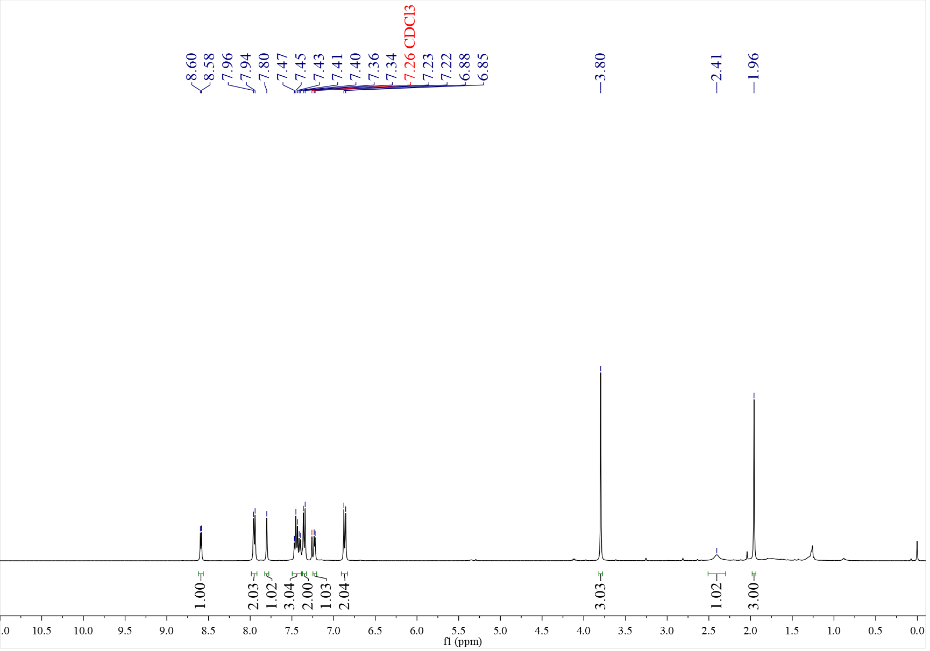

¹³C NMR spectrum of C₁ (126 MHz, CDCl₃)
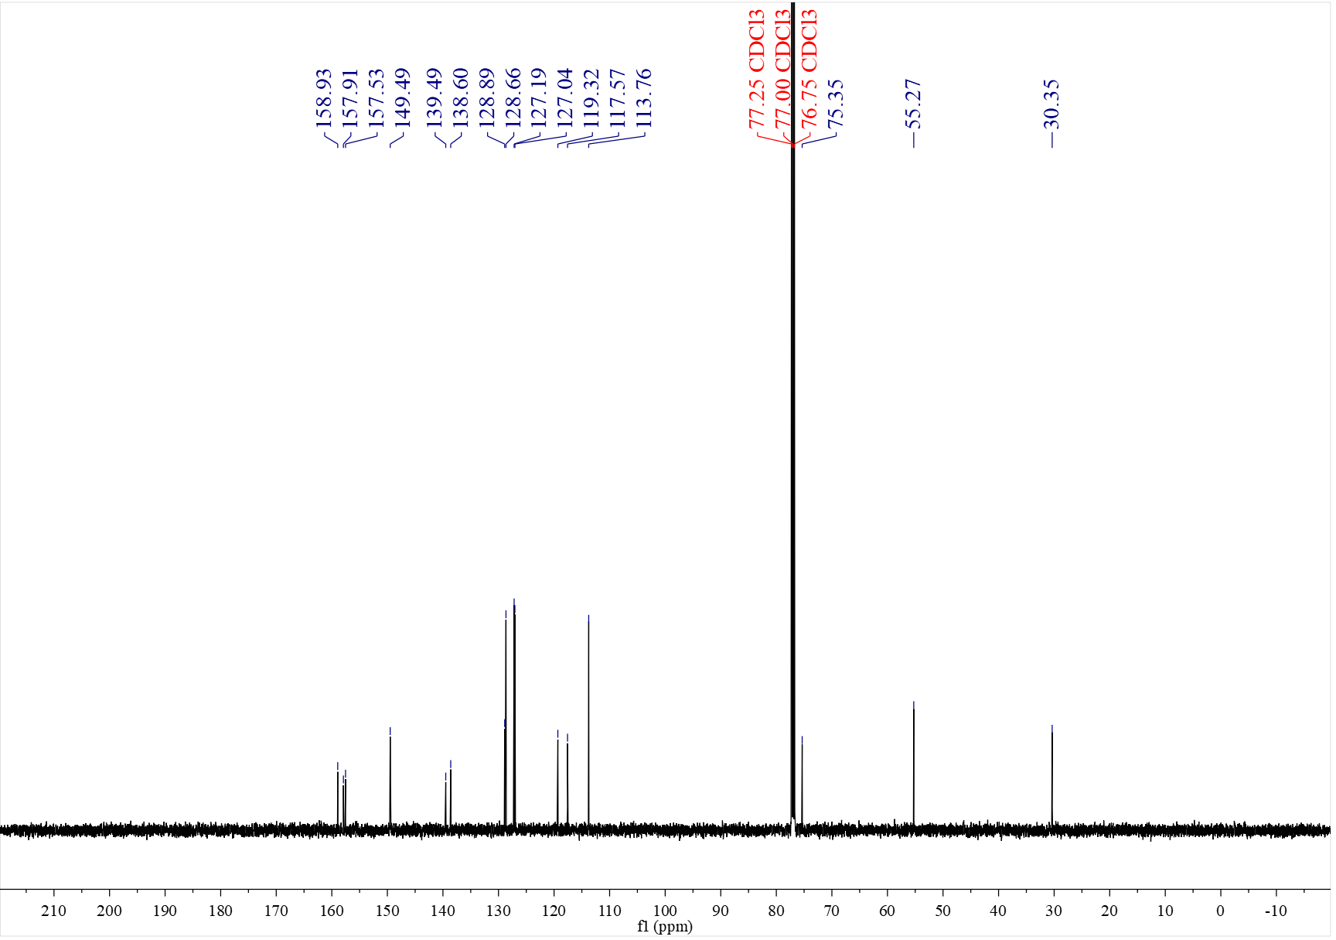

¹H NMR spectrum of C₂ (400 MHz, CDCl₃)
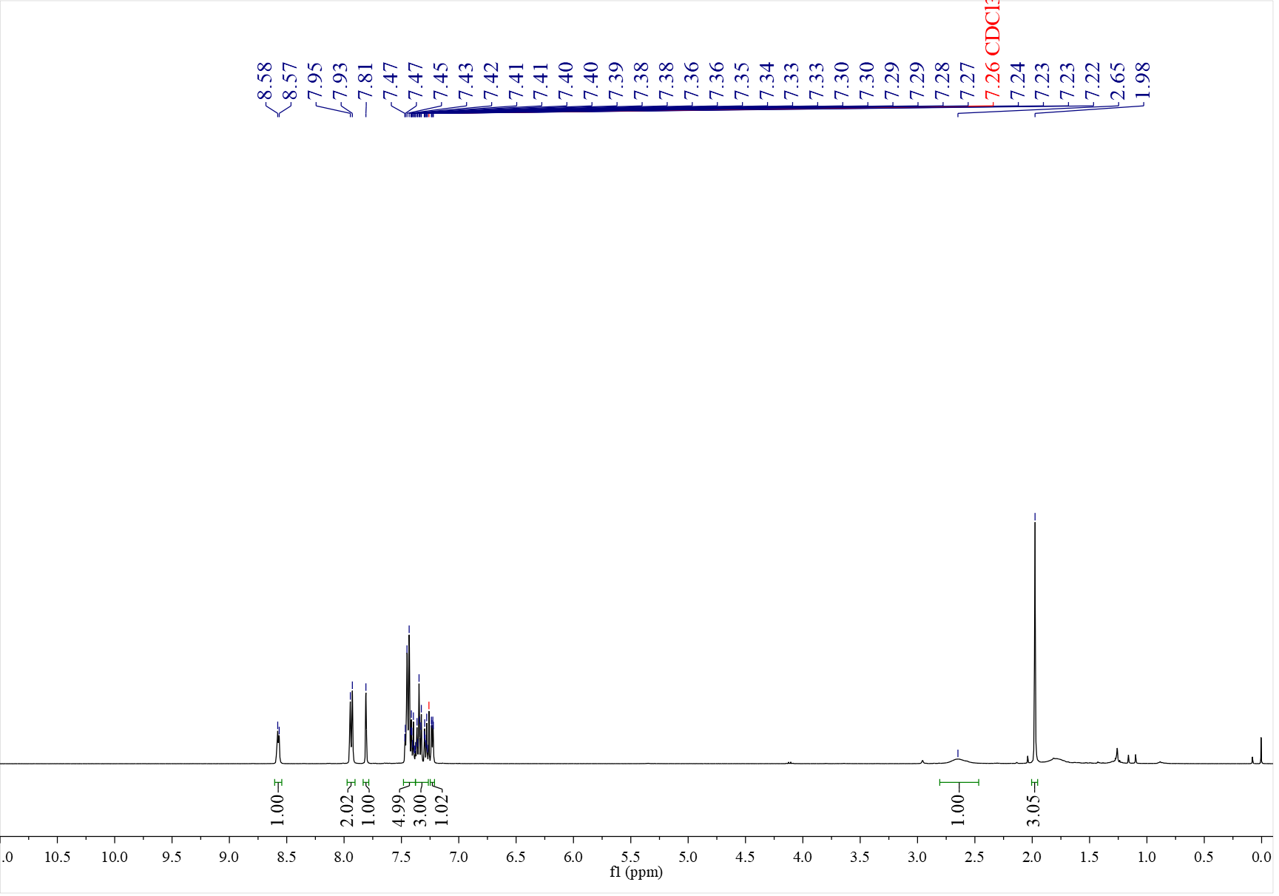

¹³C NMR spectrum of C₂ (126 MHz, CDCl₃)
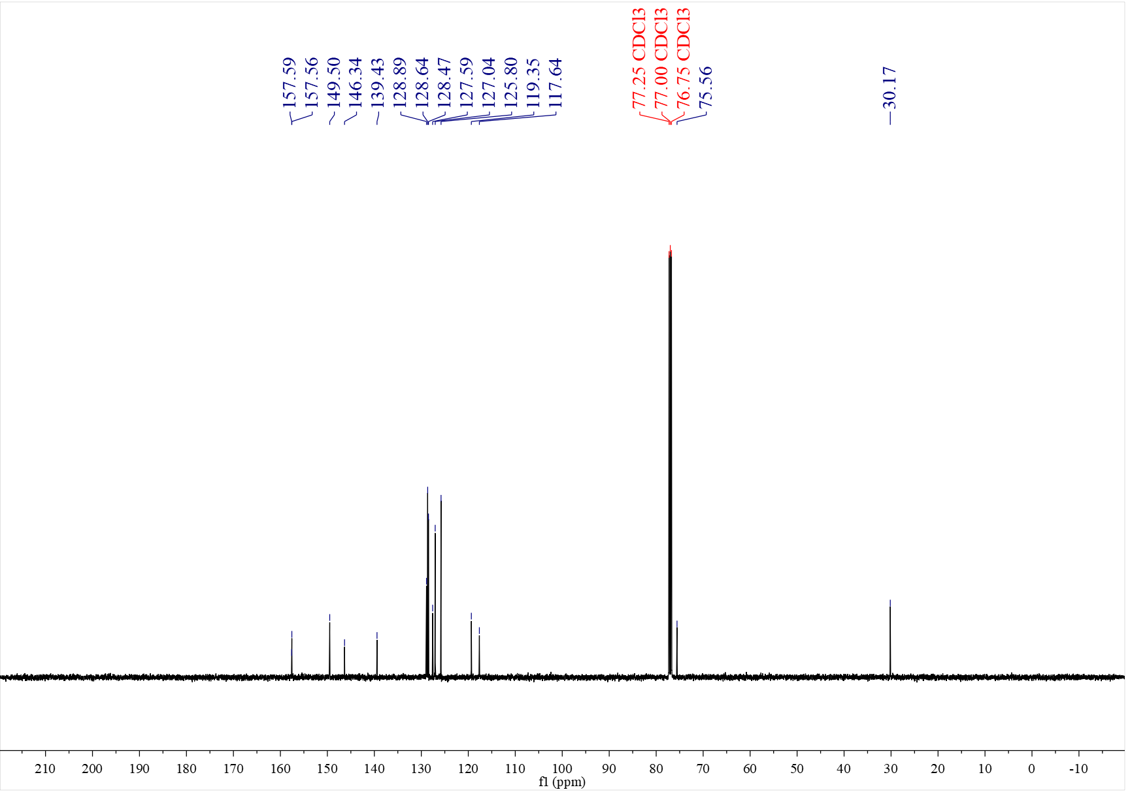

¹H NMR spectrum of C₃ (400 MHz, CDCl₃)
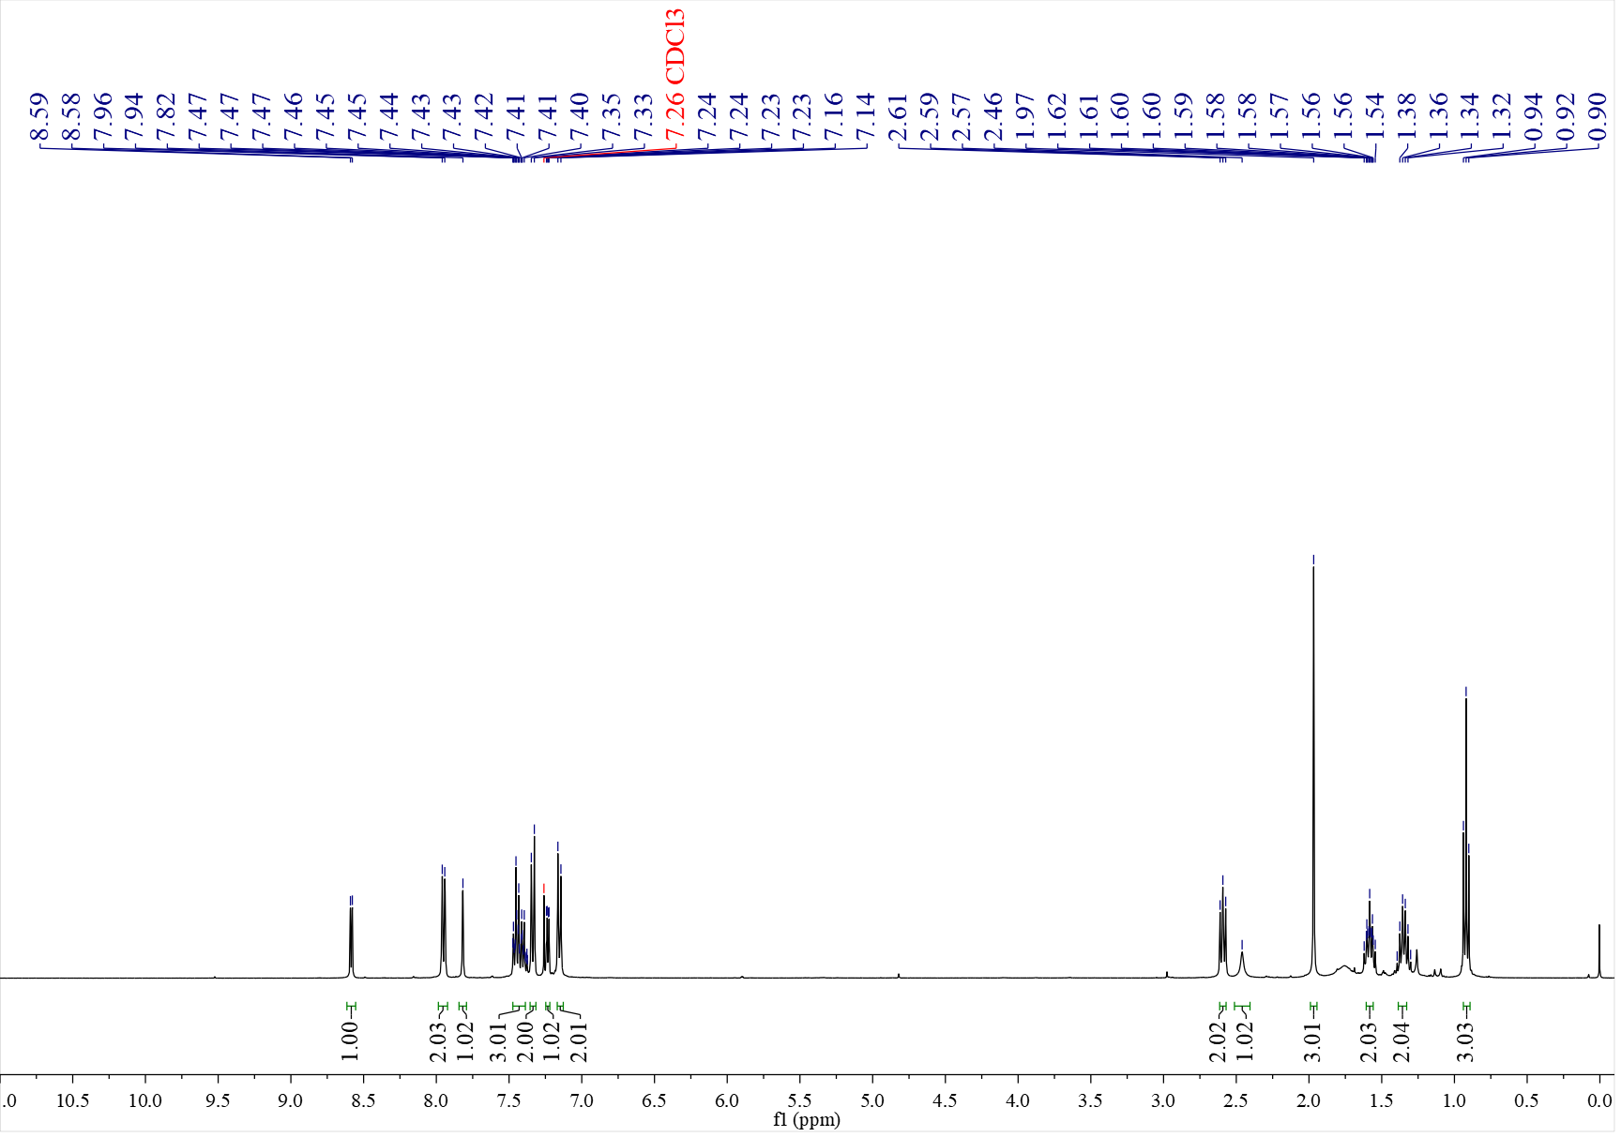

¹³C NMR spectrum of C₃ (126 MHz, CDCl₃)
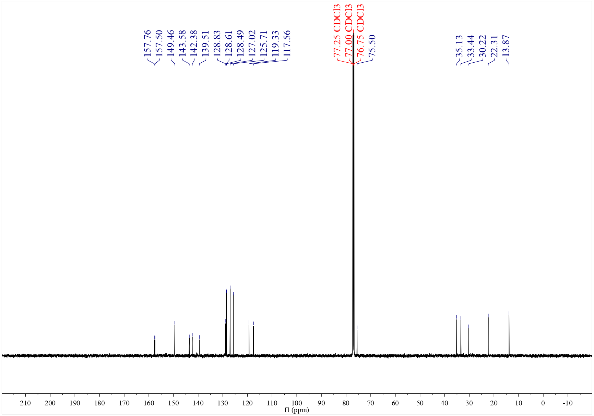

¹H NMR spectrum of C₄ (500 MHz, CDCl₃)
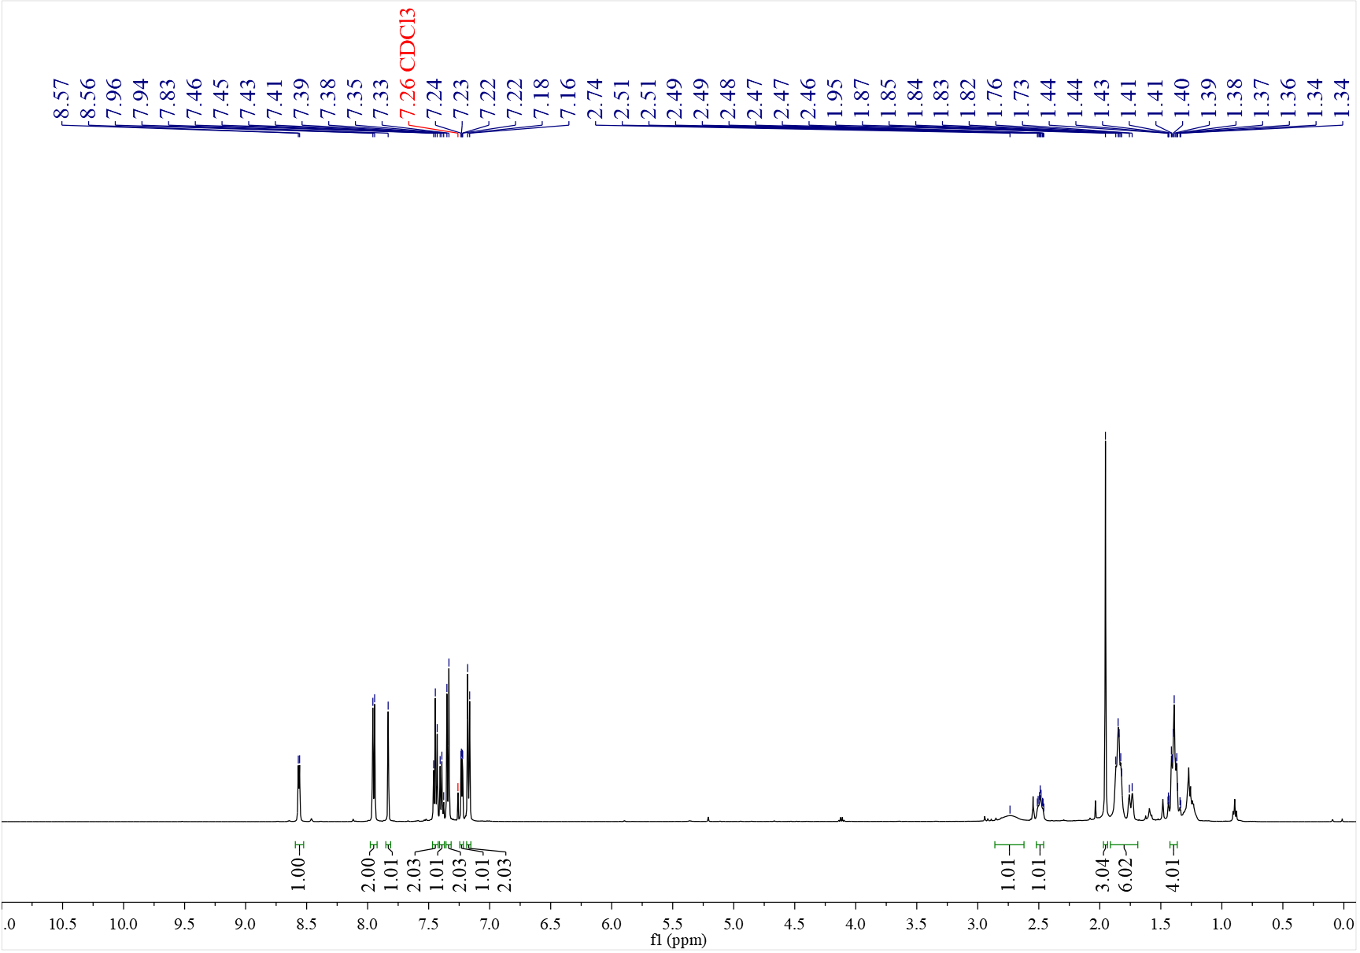

¹³C NMR spectrum of C₄ (126 MHz, CDCl₃)
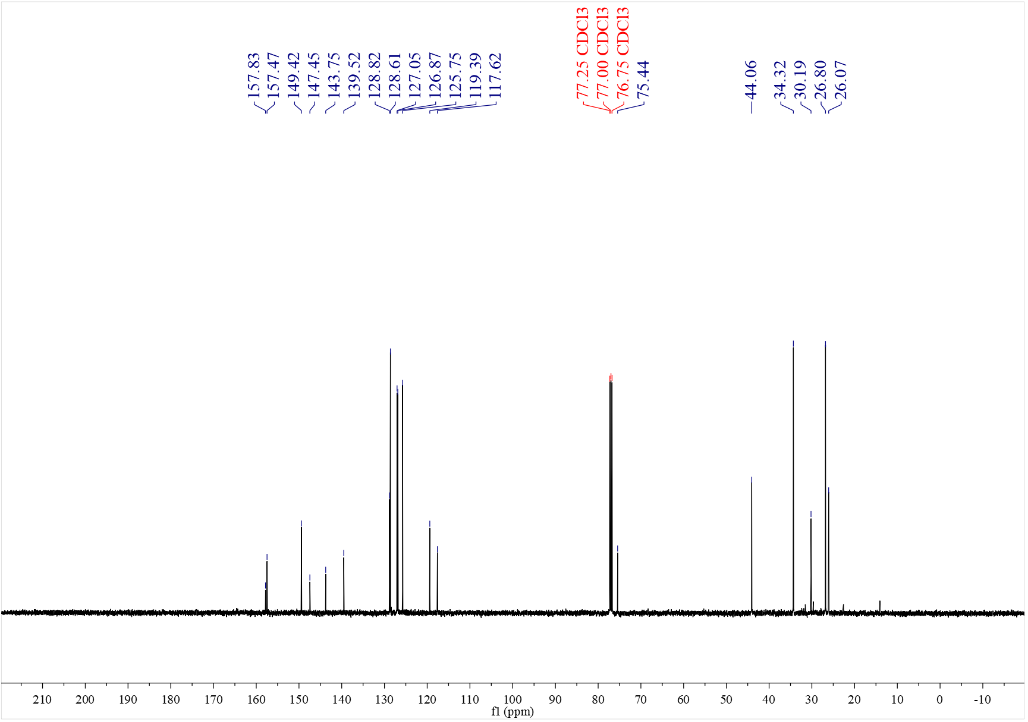

¹H NMR spectrum of C₅ (400 MHz, CDCl₃)
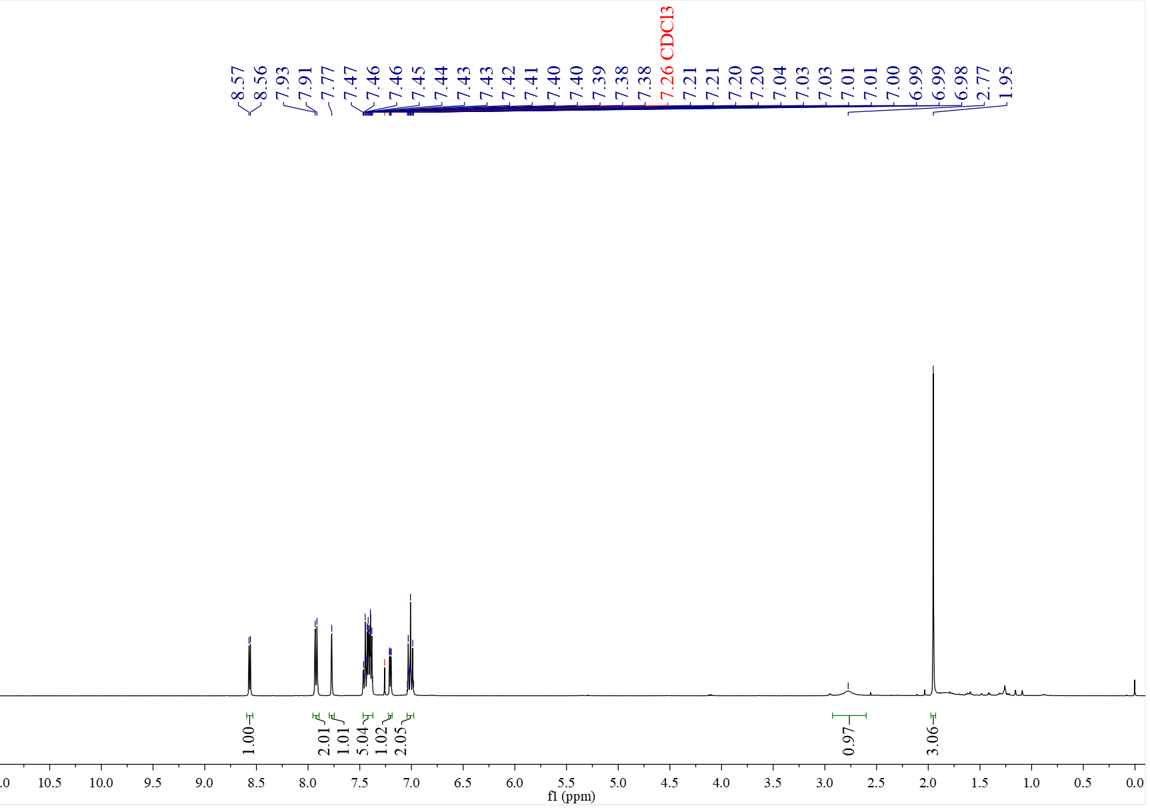

¹³C NMR spectrum of C₅ (126 MHz, CDCl₃)
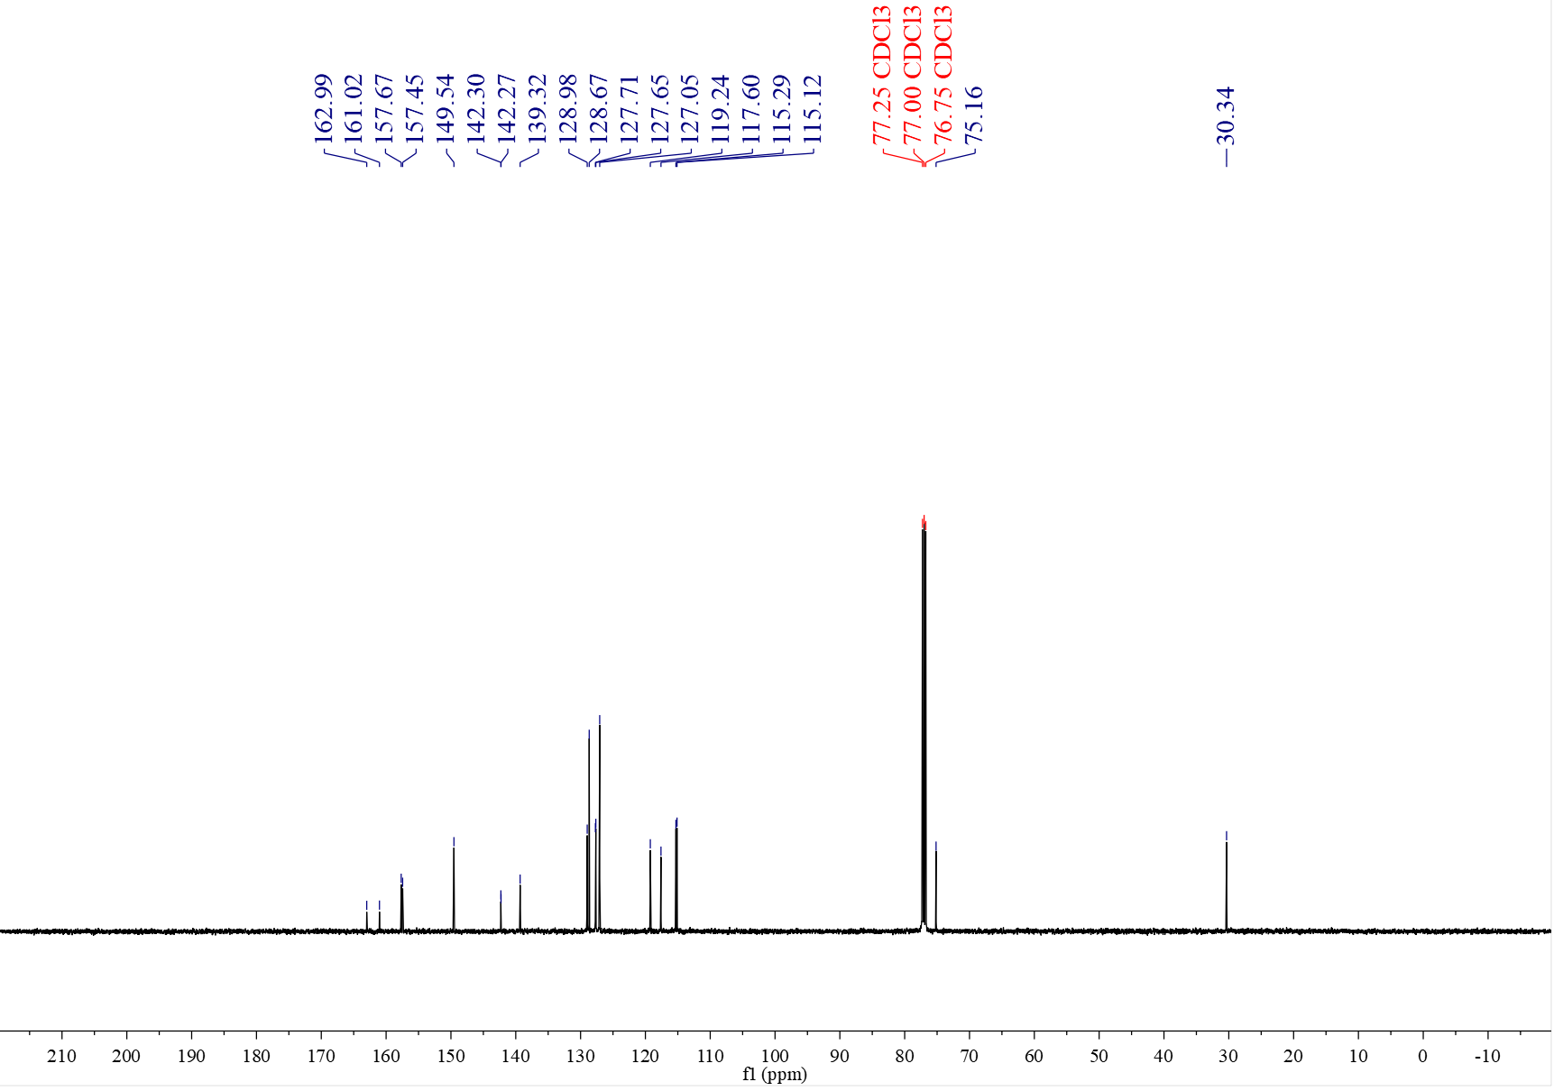

¹⁹F NMR spectrum of C₅ (376 MHz, CDCl₃)
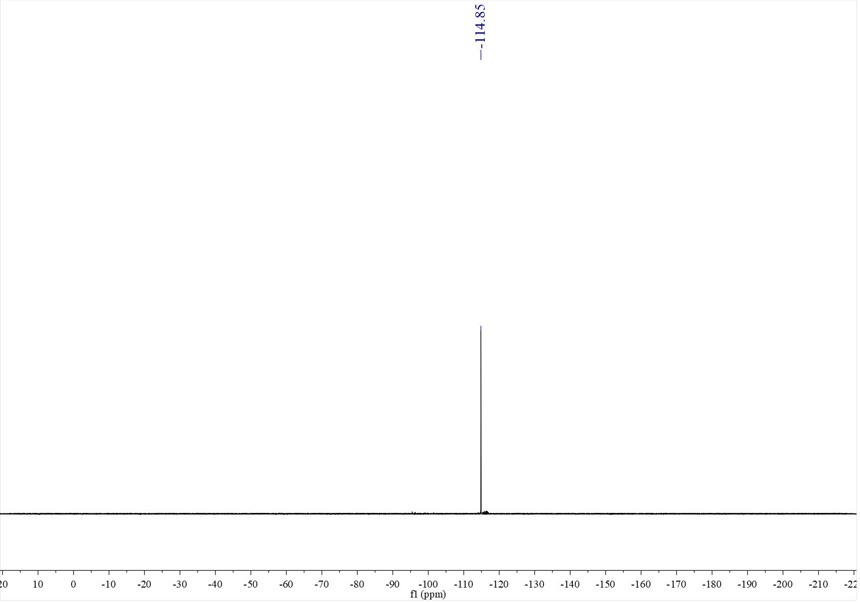

¹H NMR spectrum of C₆ (500 MHz, CDCl₃)
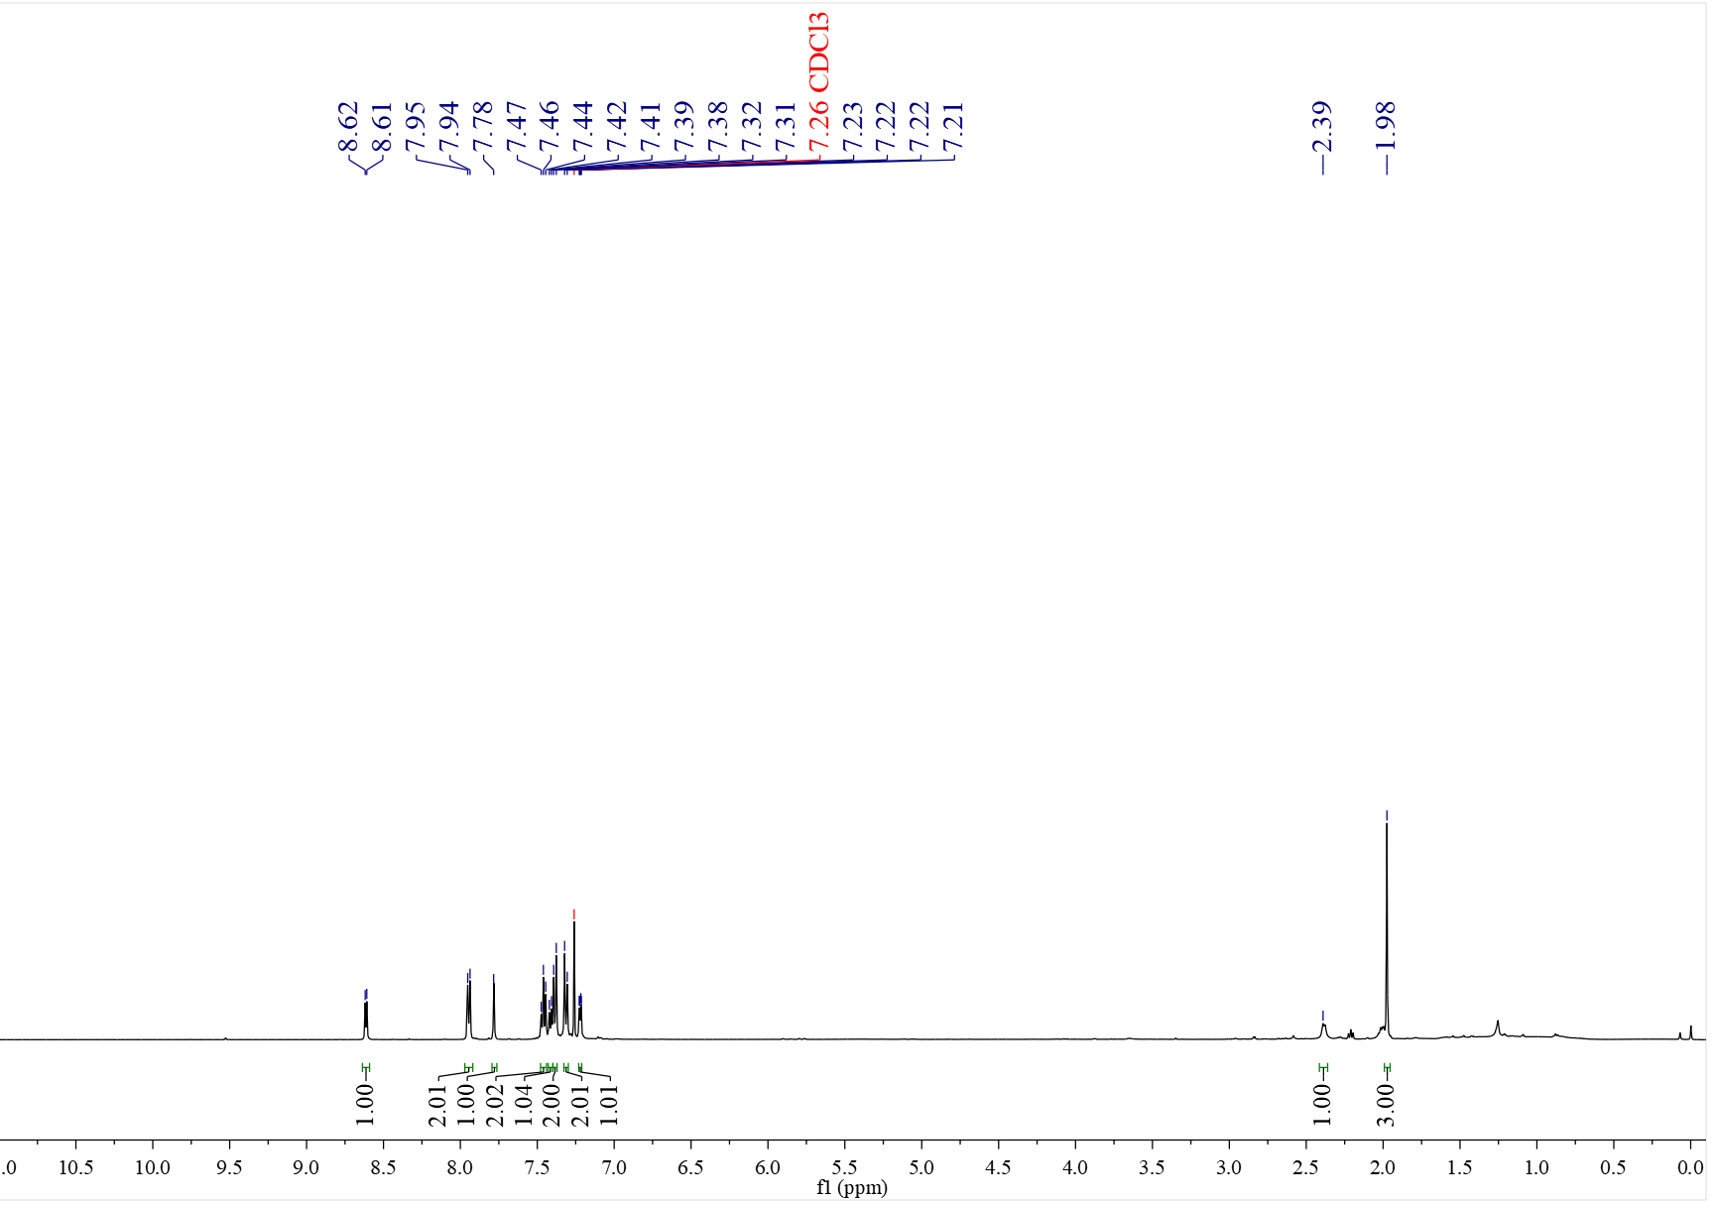

¹³C NMR spectrum of C₆ (126 MHz, CDCl₃)
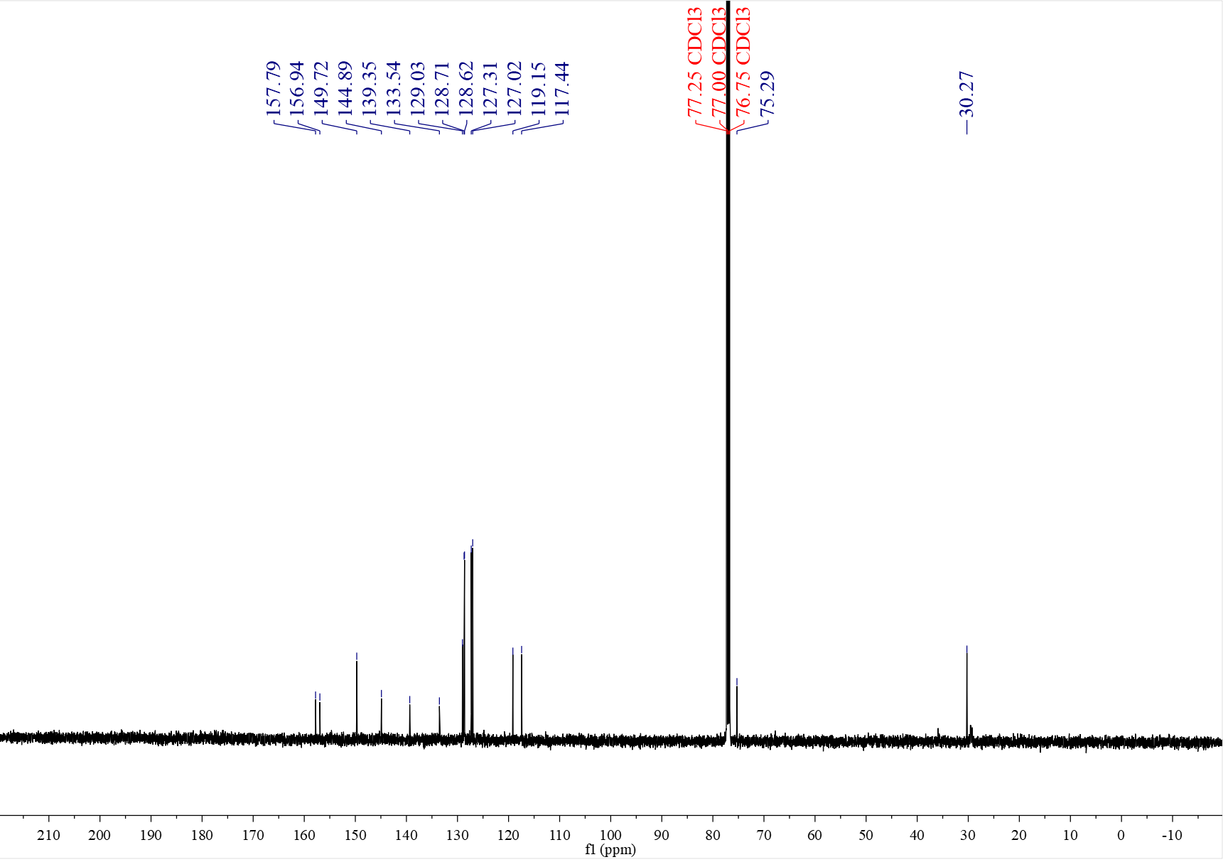

¹H NMR spectrum of C₇ (400 MHz, CDCl₃)
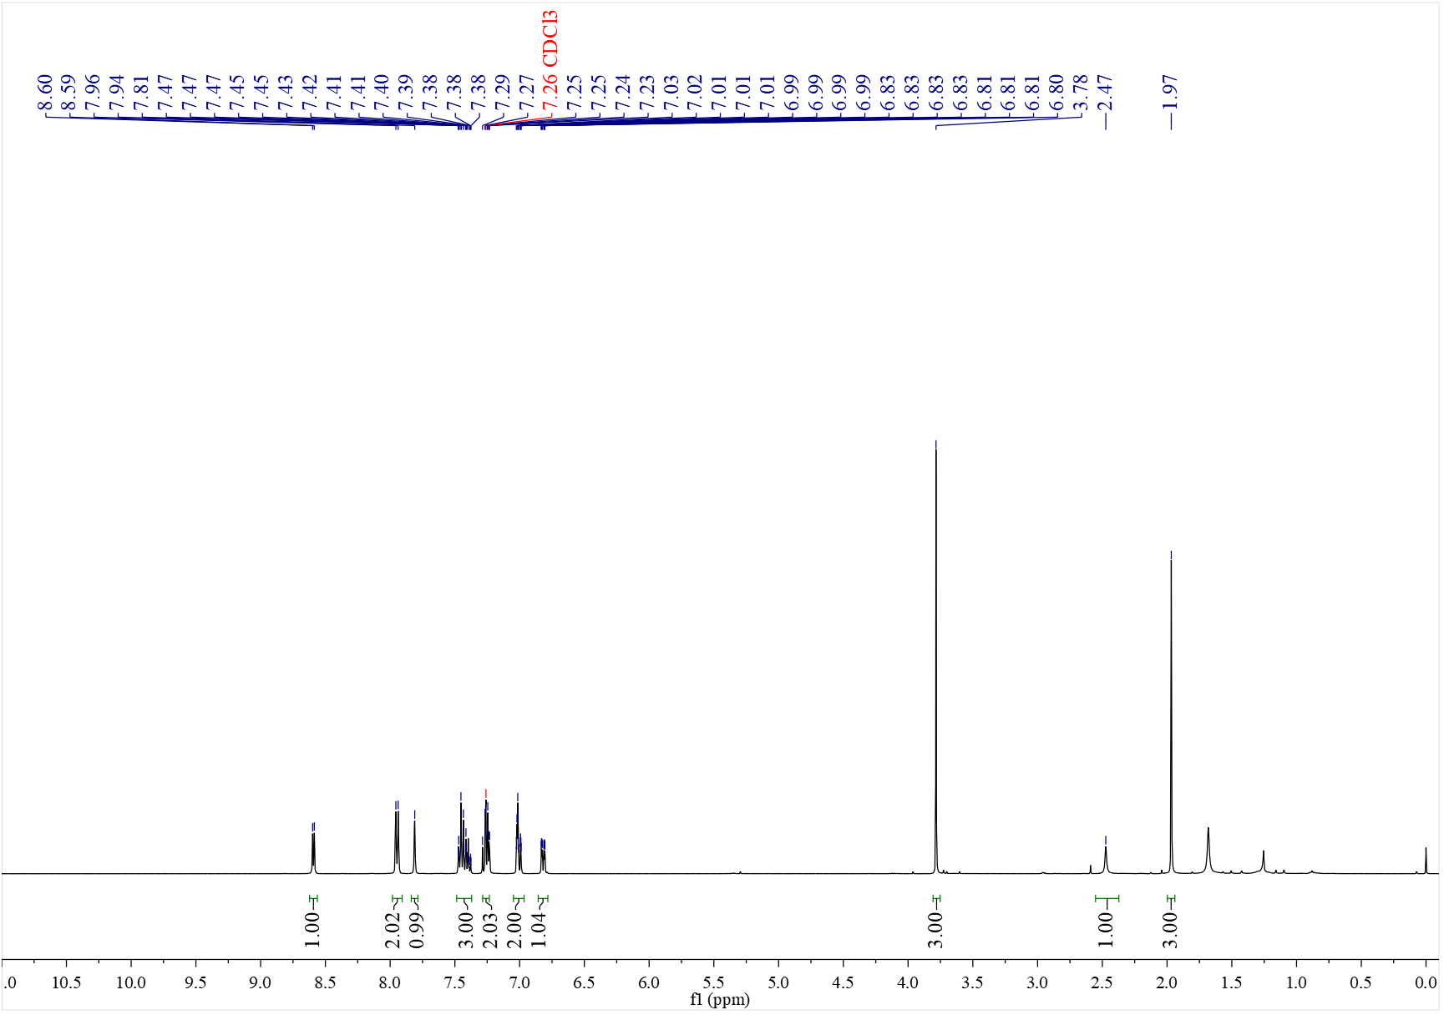

¹³C NMR spectrum of C₇ (126 MHz, CDCl₃)
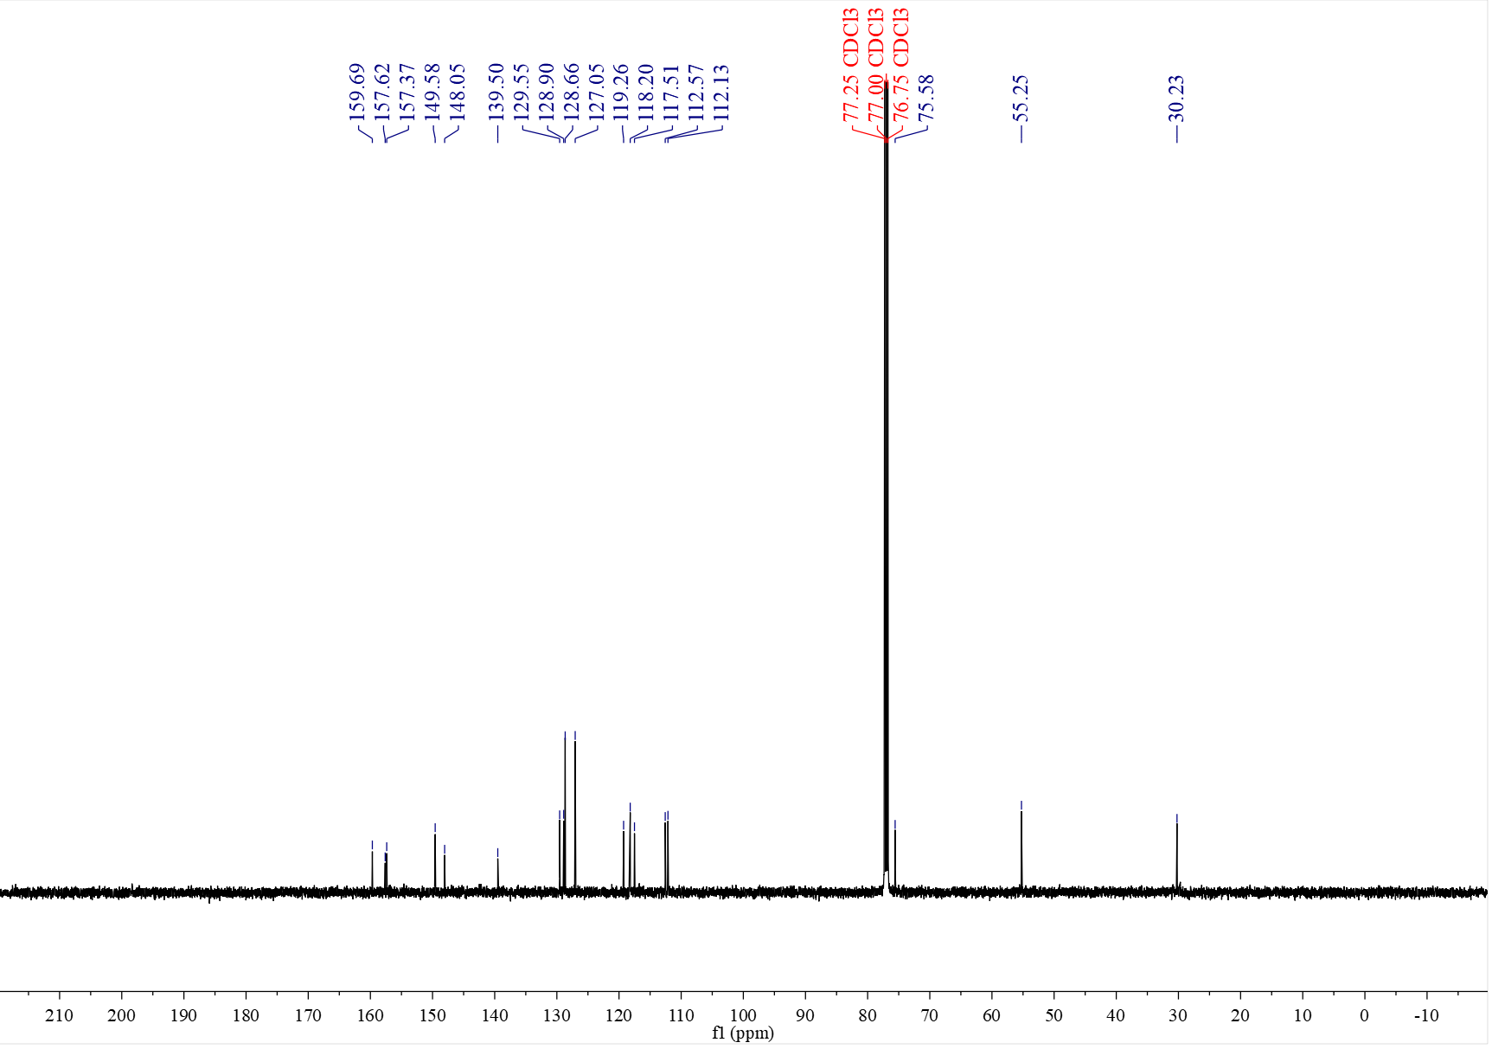

¹H NMR spectrum of C₈ (400 MHz, CDCl₃)
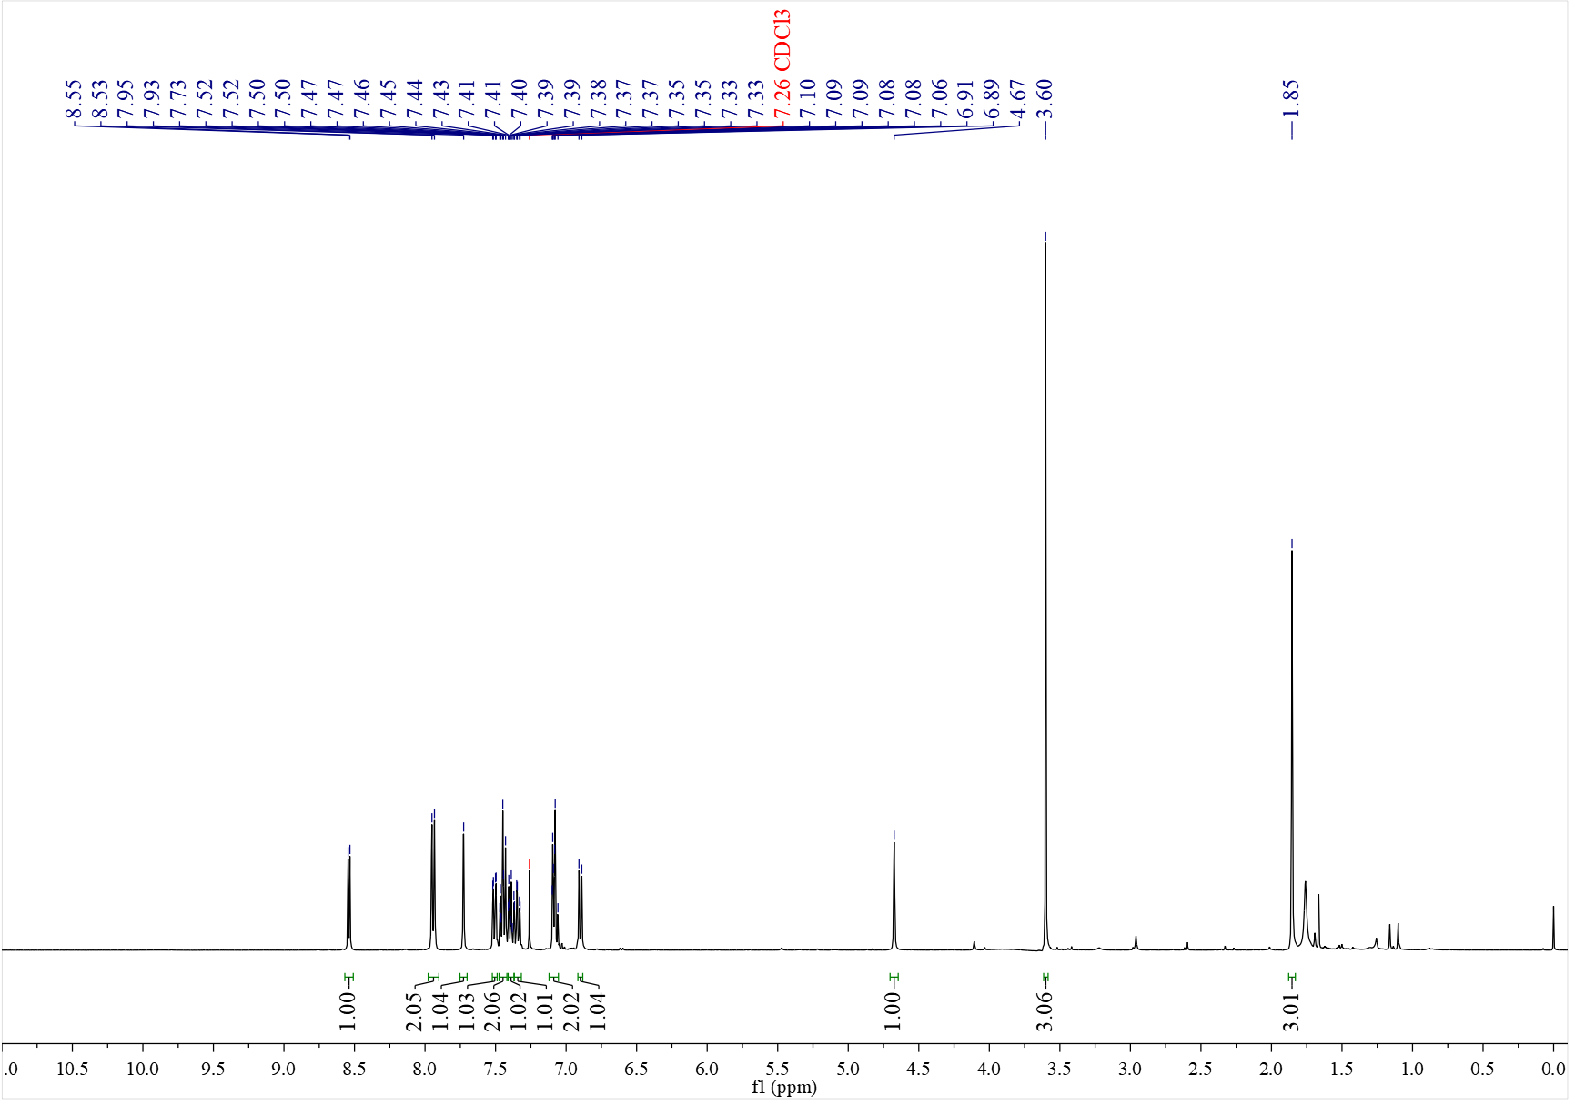

¹³C NMR spectrum of C₈ (126 MHz, CDCl₃)
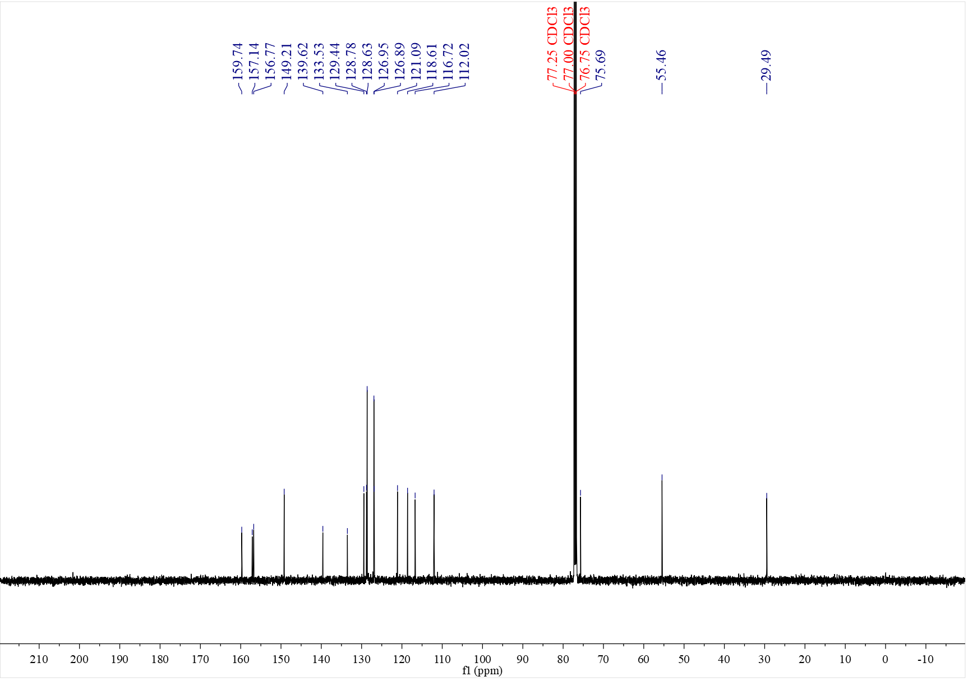

¹H NMR spectrum of C₉ (400 MHz, CDCl₃)
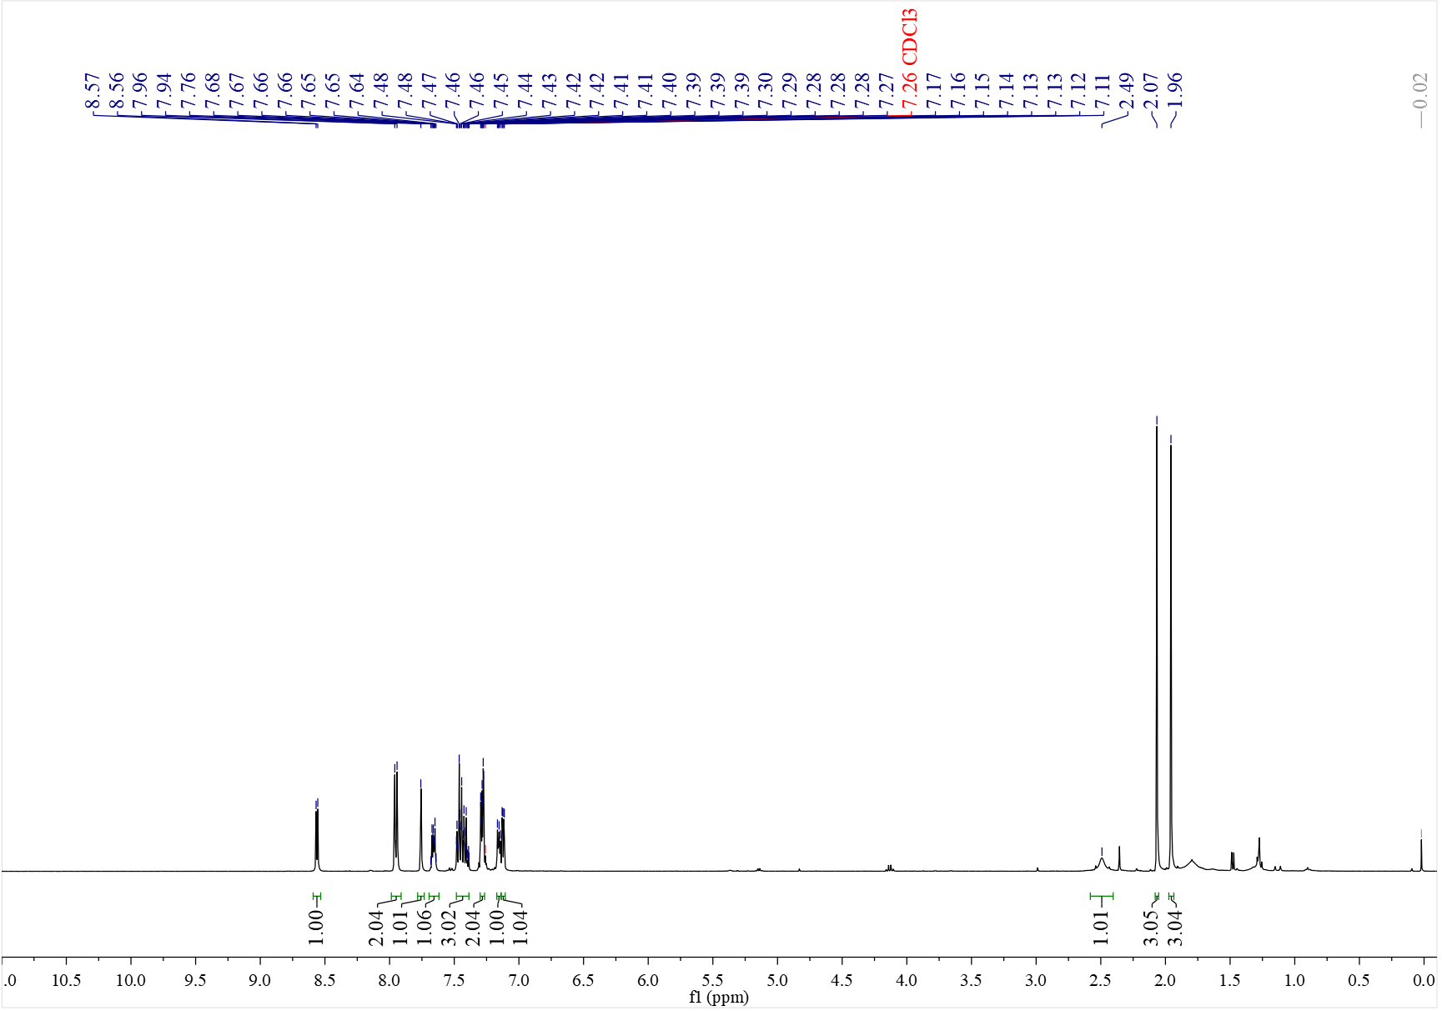

¹³C NMR spectrum of C₉ (126 MHz, CDCl₃)
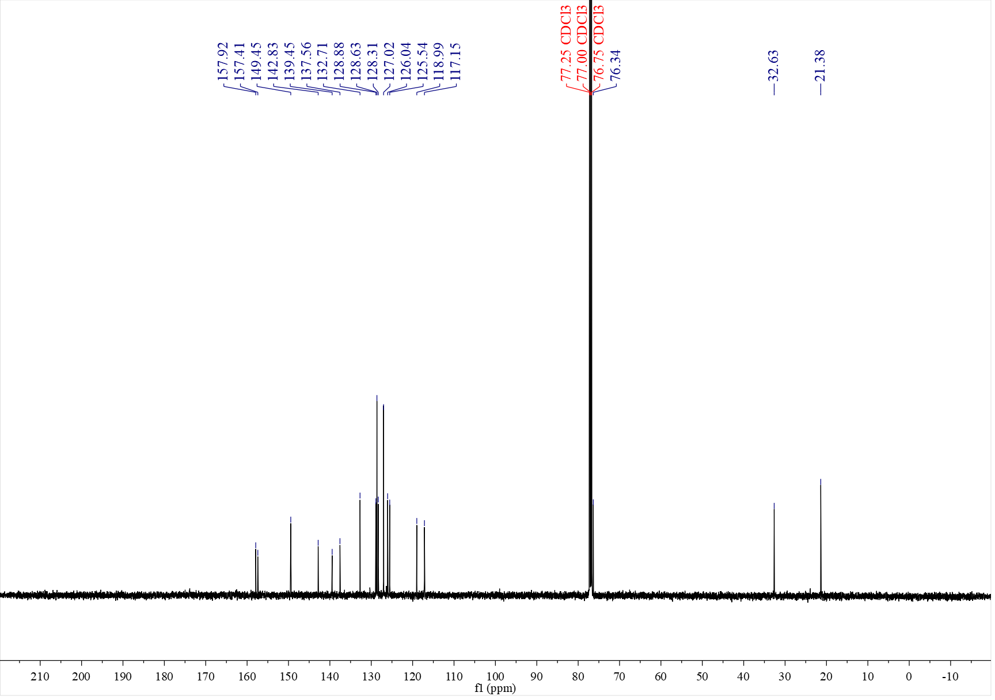

¹H NMR spectrum of C₁₀ (500 MHz, CDCl₃)
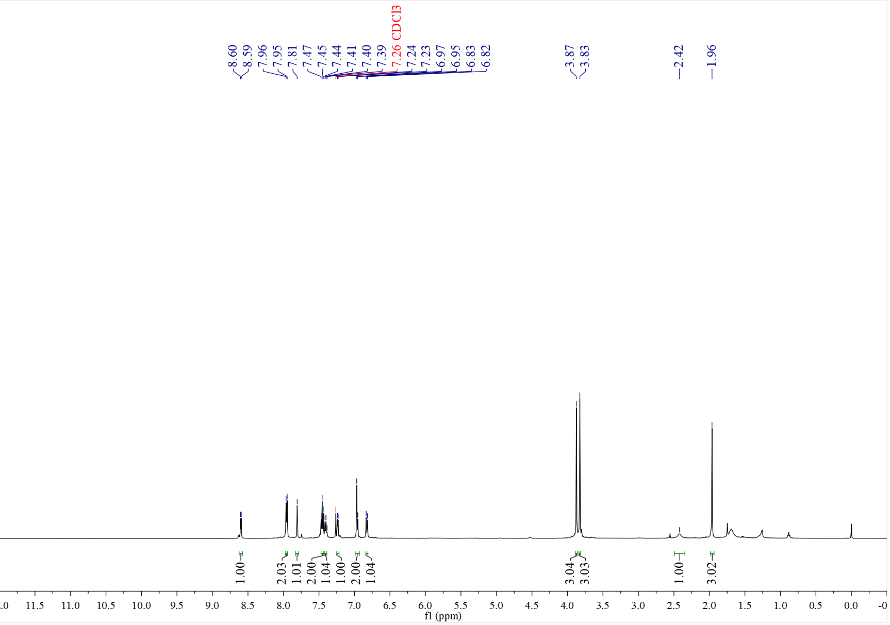

¹³C NMR spectrum of C₁₀ (126 MHz, CDCl₃)
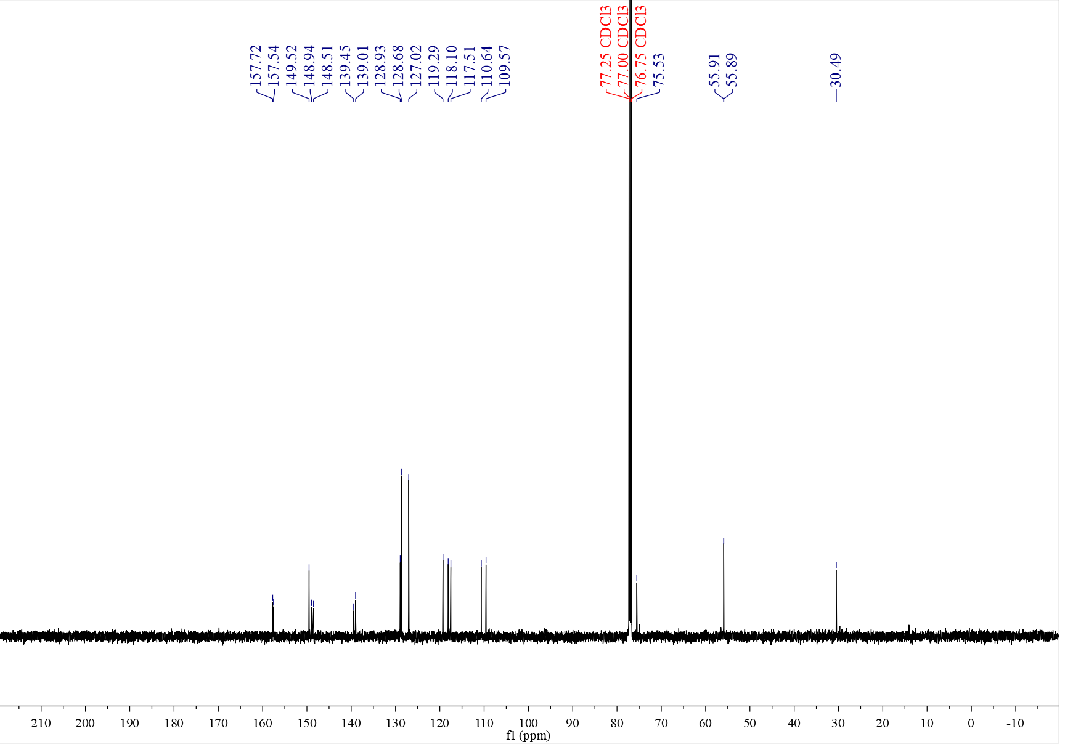

¹H NMR spectrum of C₁₁ (400 MHz, CDCl₃)
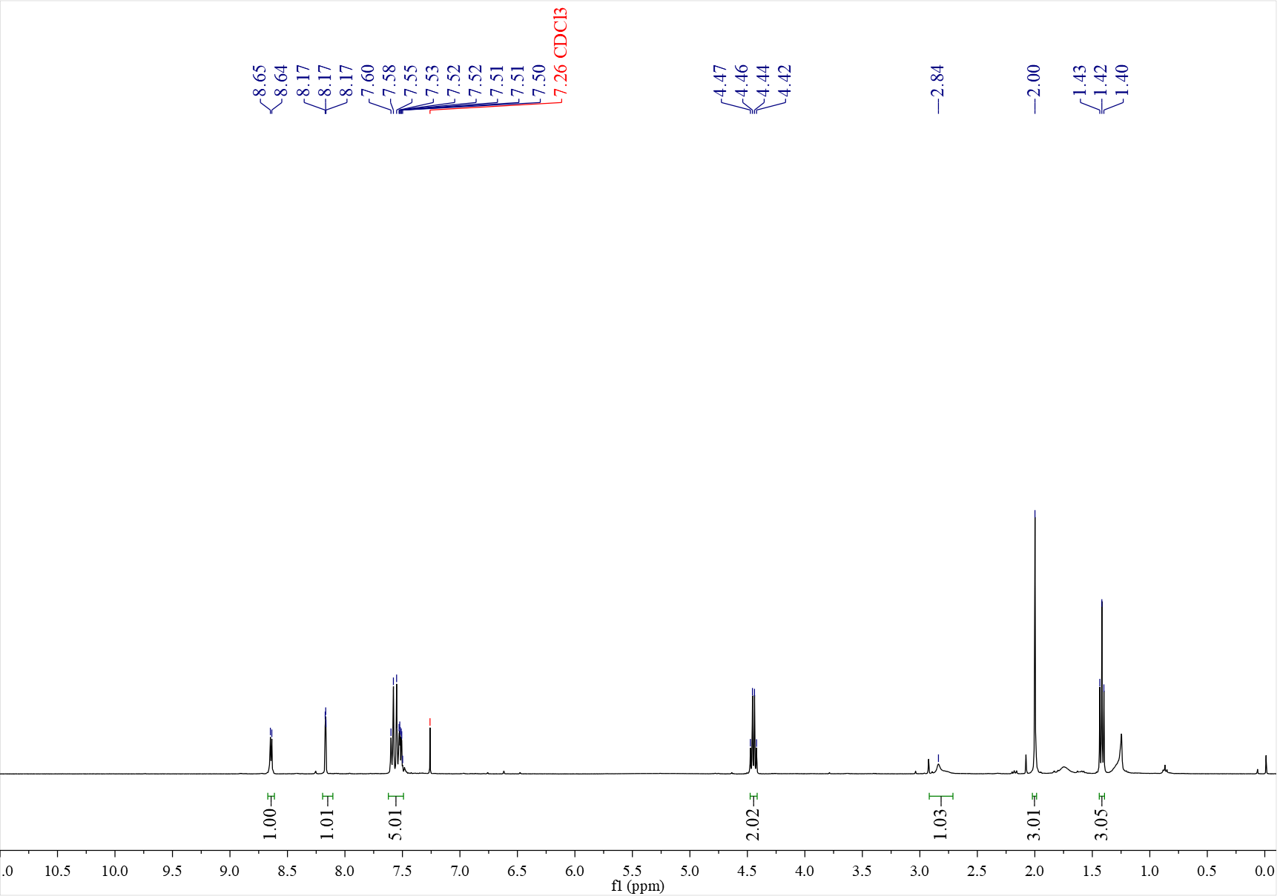

¹³C NMR spectrum of C₁₁ (126 MHz, CDCl₃)
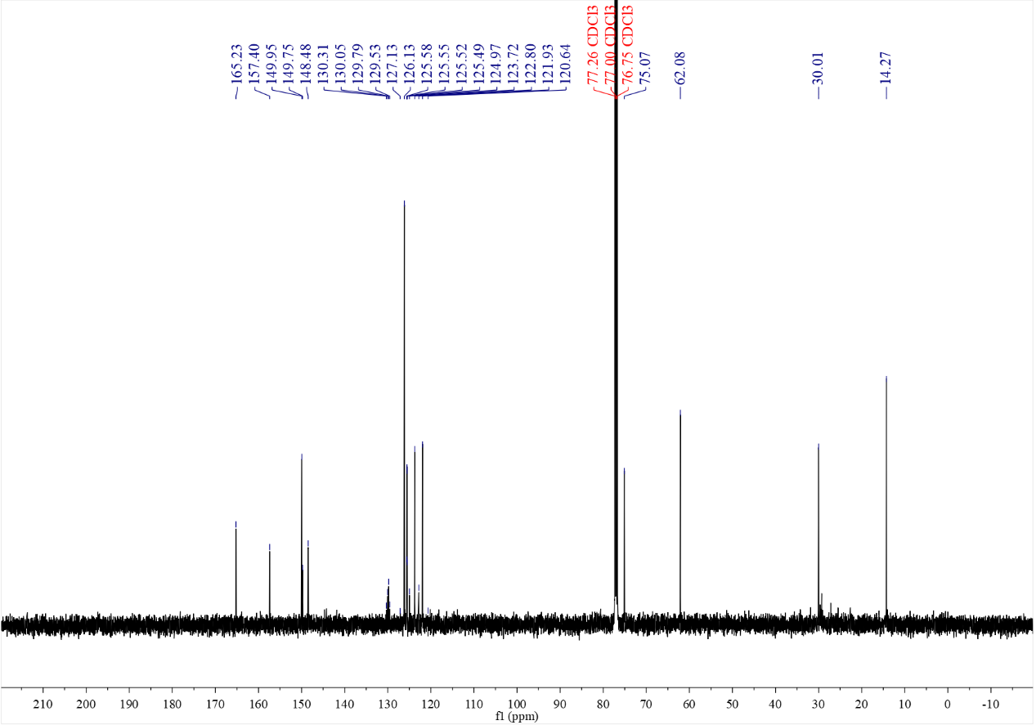

¹⁹F NMR spectrum of C₁₁ (376 MHz, CDCl₃)
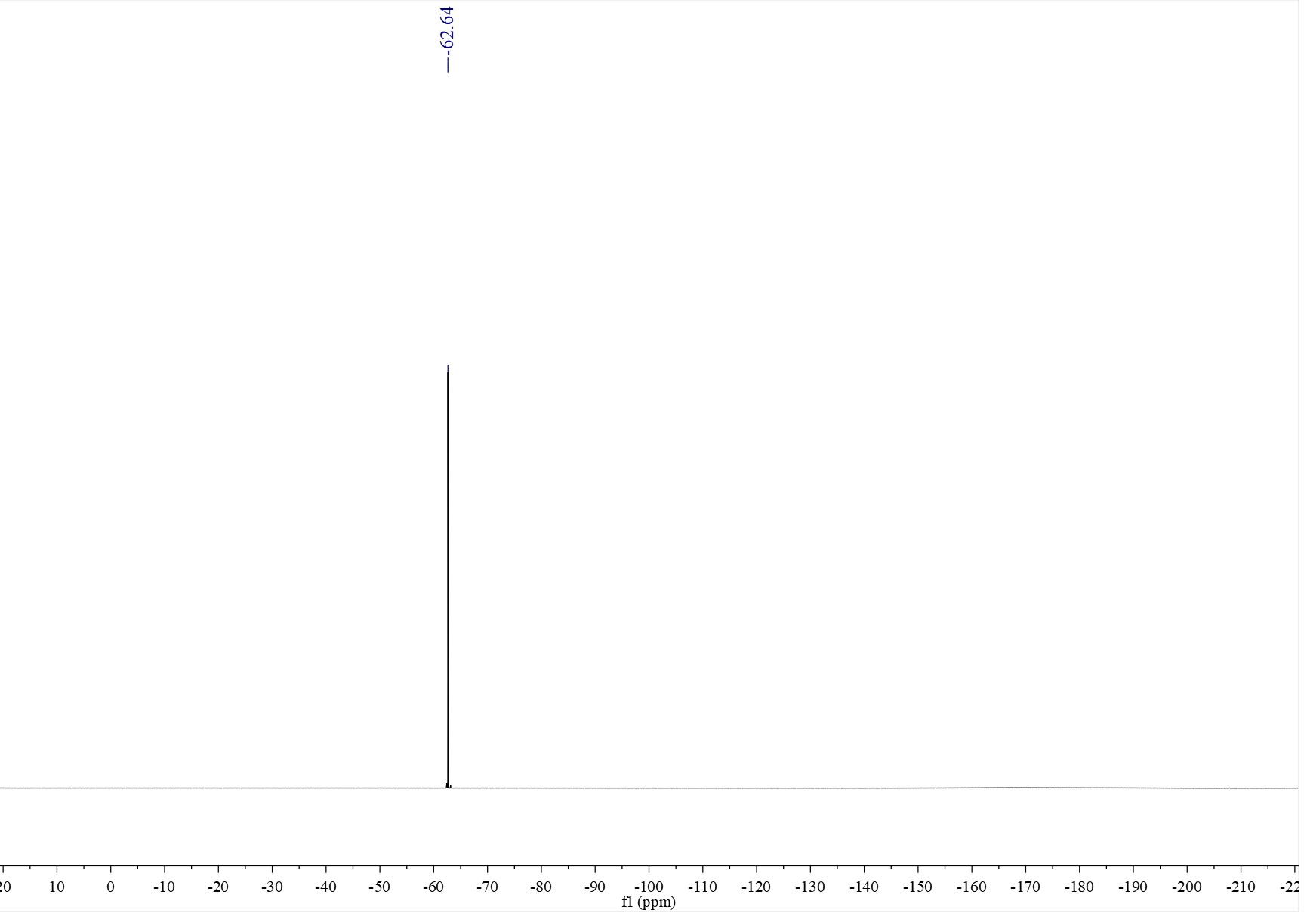

¹H NMR spectrum of C₁₂ (500 MHz, CDCl₃)
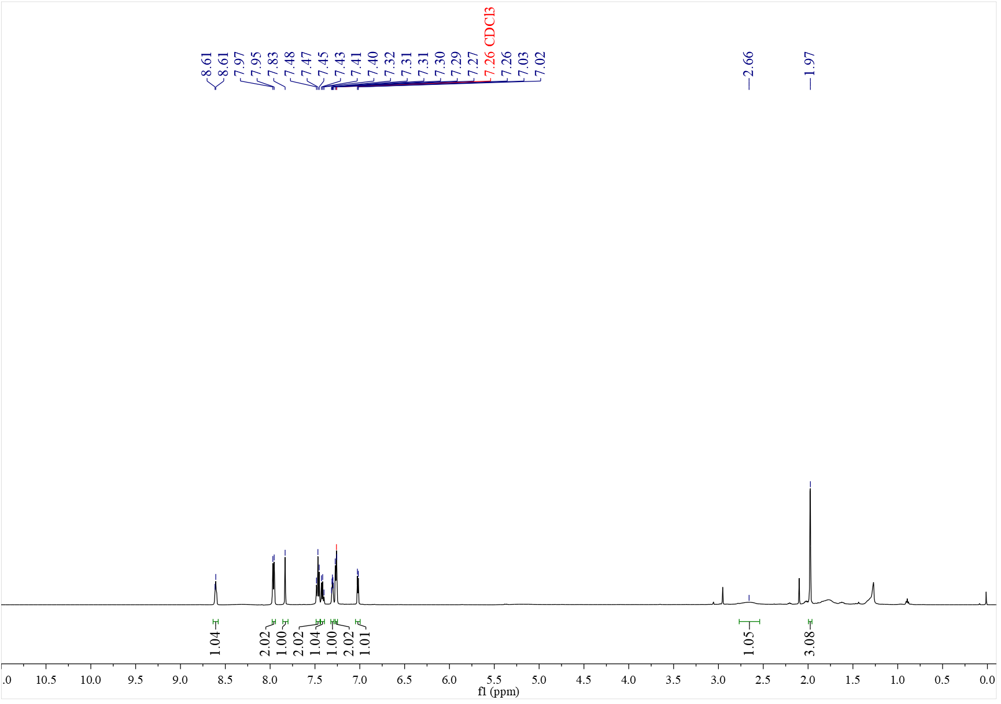

¹³C NMR spectrum of C₁₂ (126 MHz, CDCl₃)
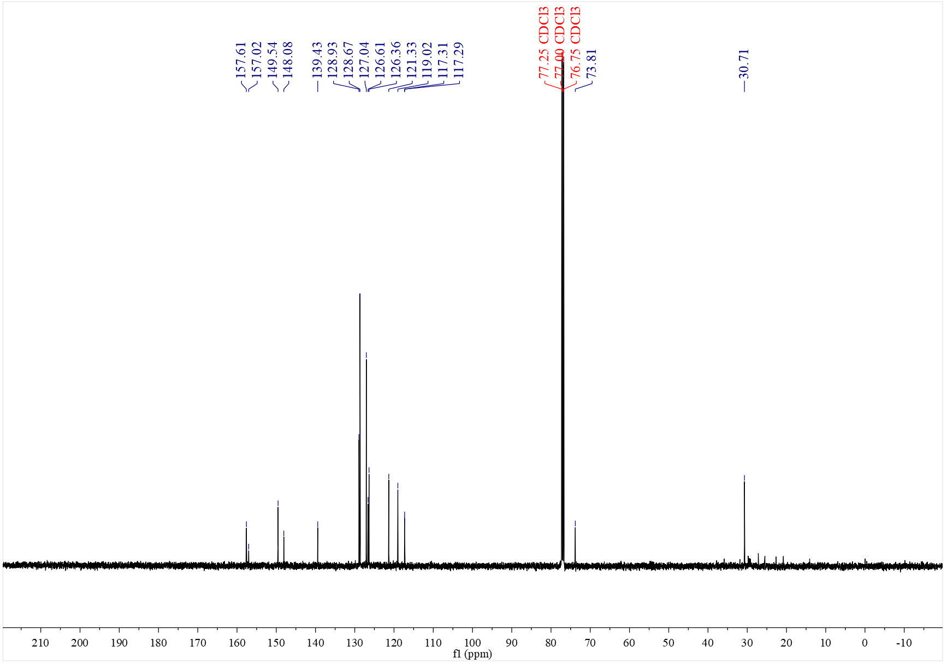

¹H NMR spectrum of C₁₃ (500 MHz, CDCl₃)
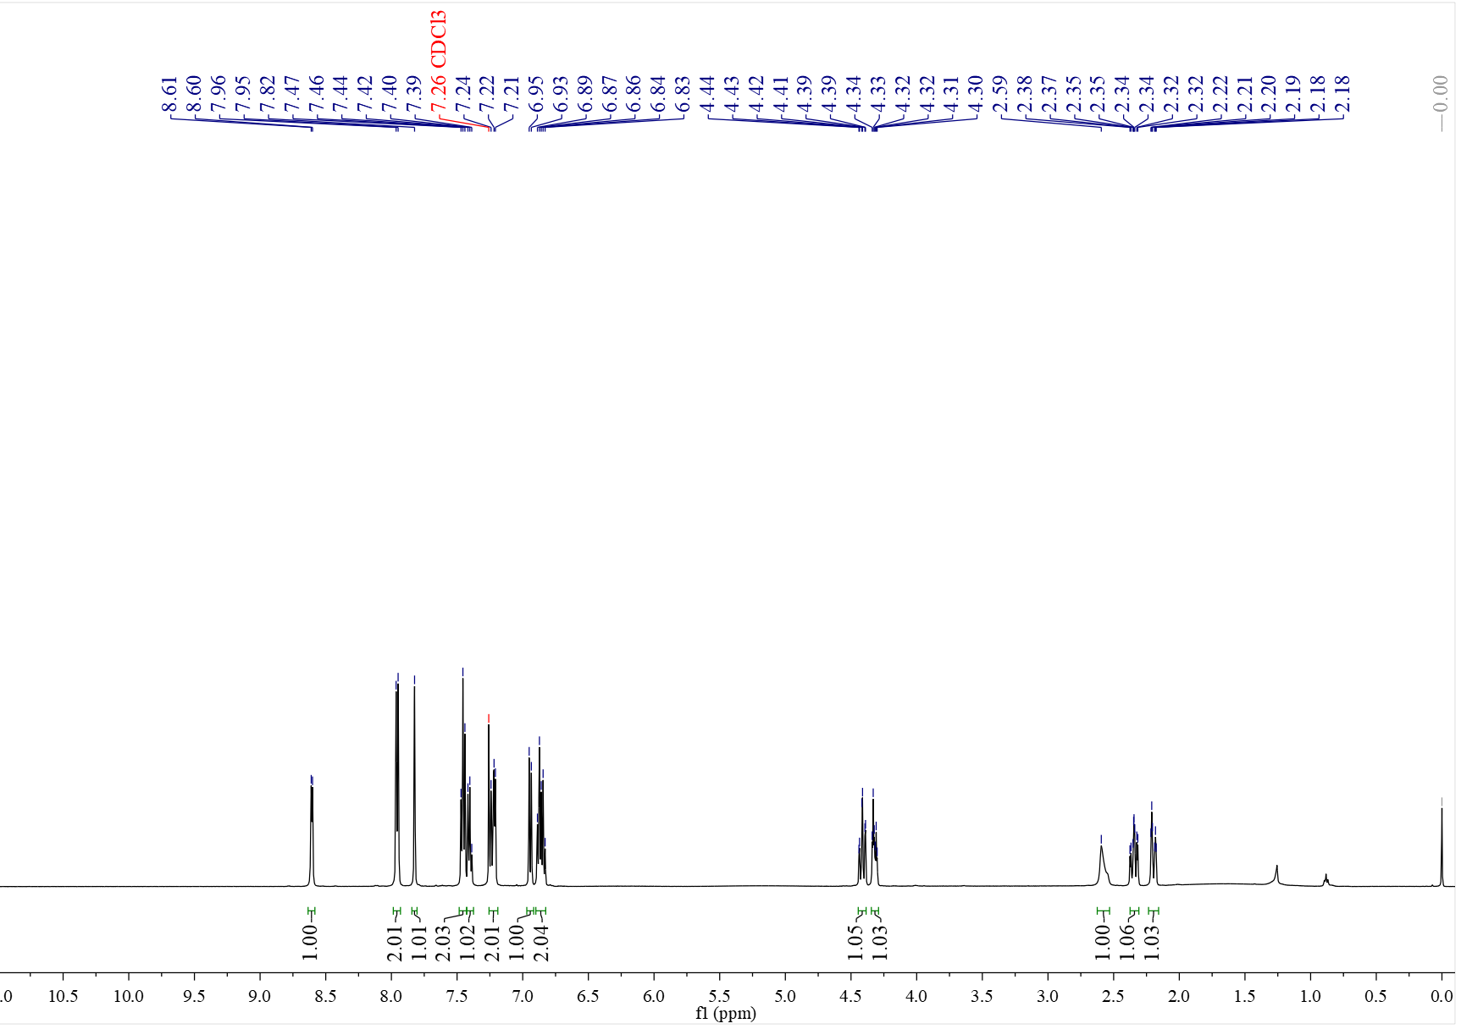

¹³C NMR spectrum of C₁₃ (126 MHz, CDCl₃)
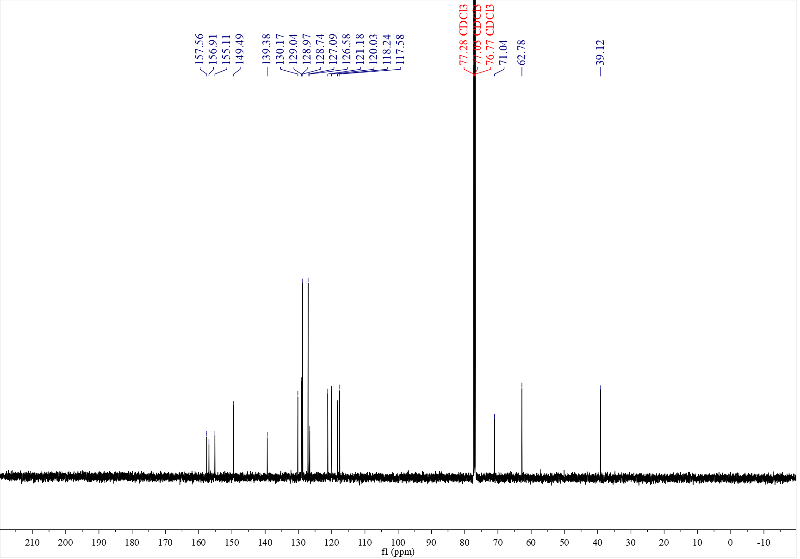

¹H NMR spectrum of C₁₄ (500 MHz, CDCl₃)
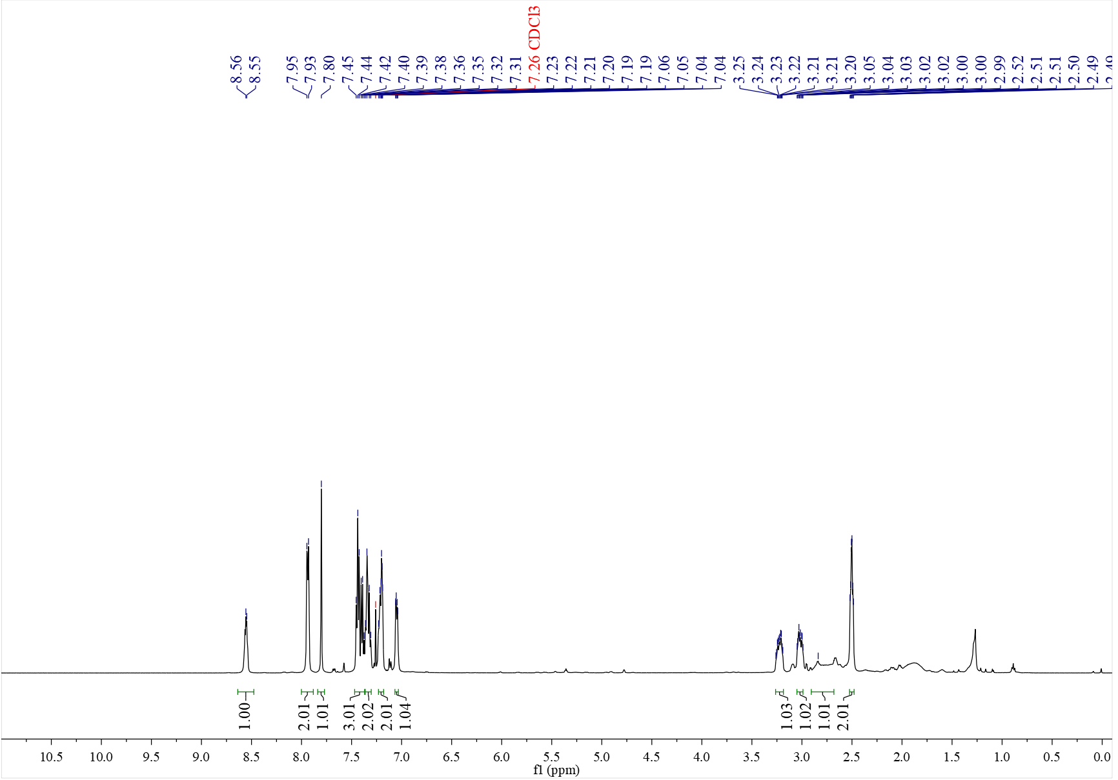

¹³C NMR spectrum of C₁₄ (126 MHz, CDCl₃)
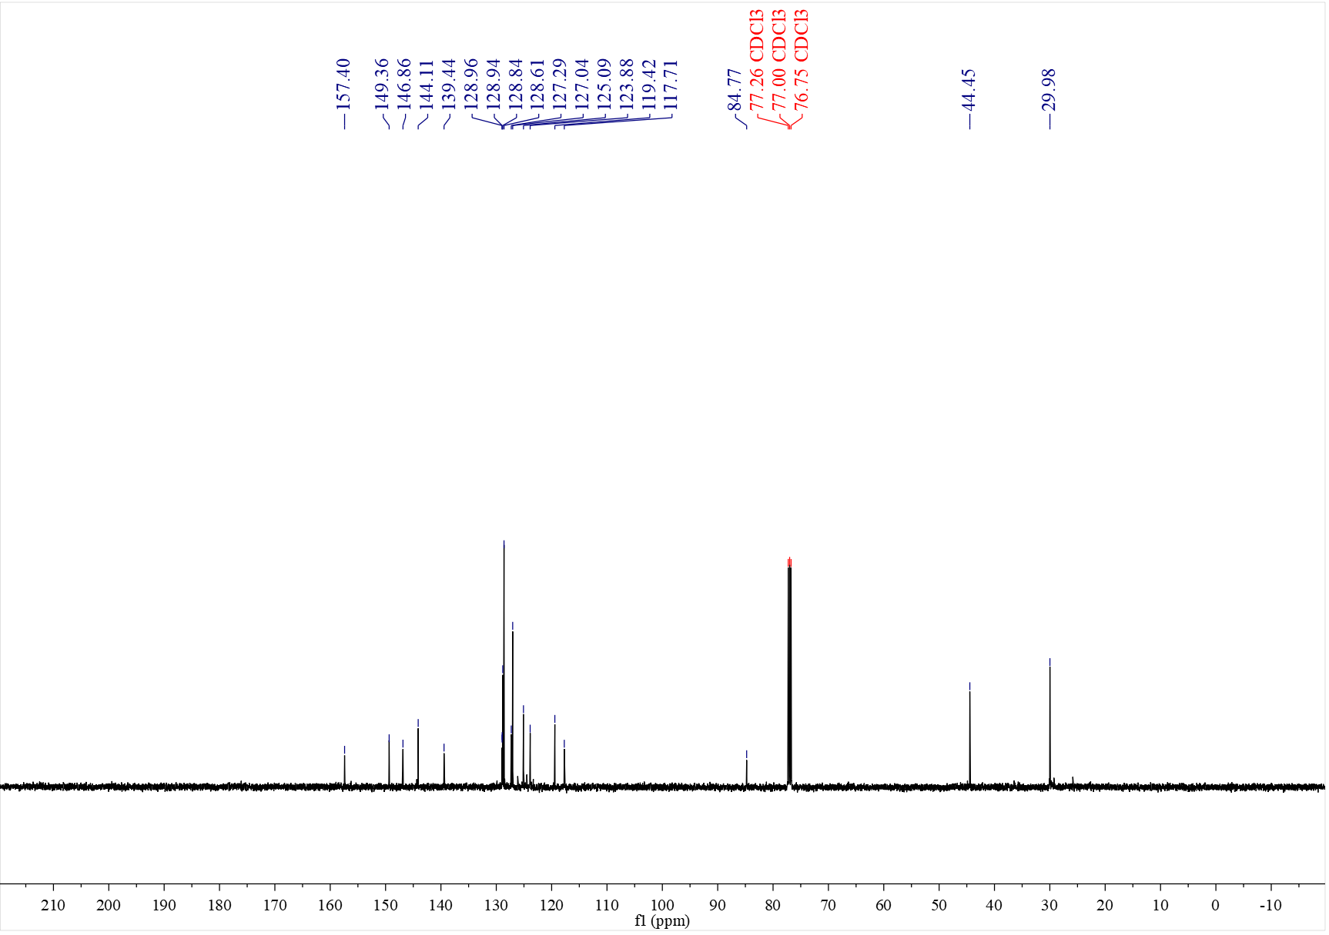

¹H NMR spectrum of C₁₅ (500 MHz, CDCl₃)
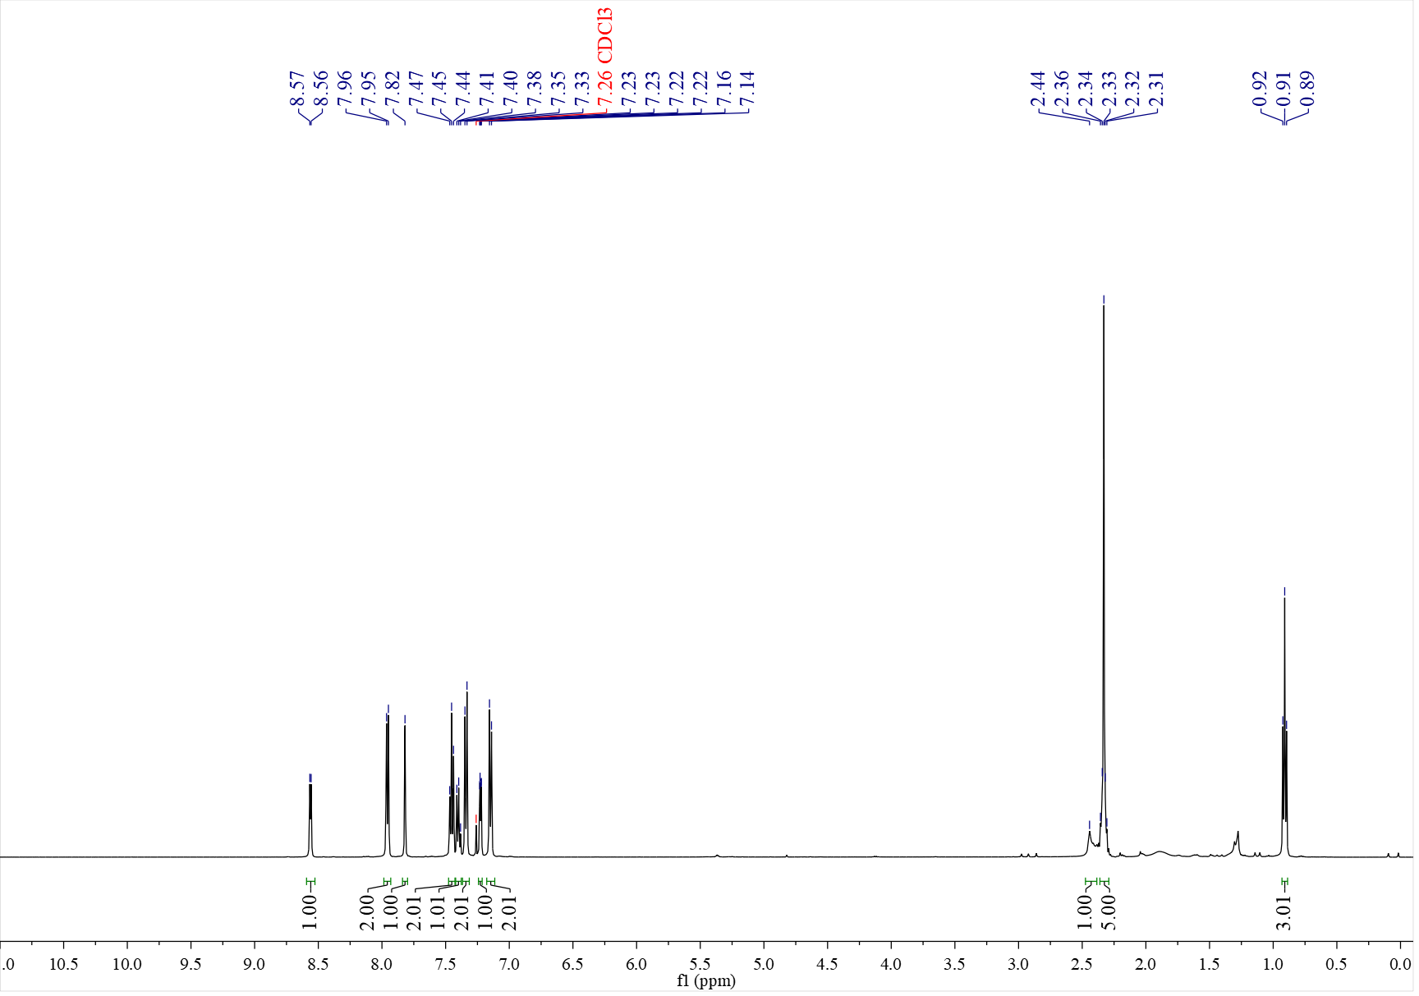

¹³C NMR spectrum of C₁₅ (126 MHz, CDCl₃)
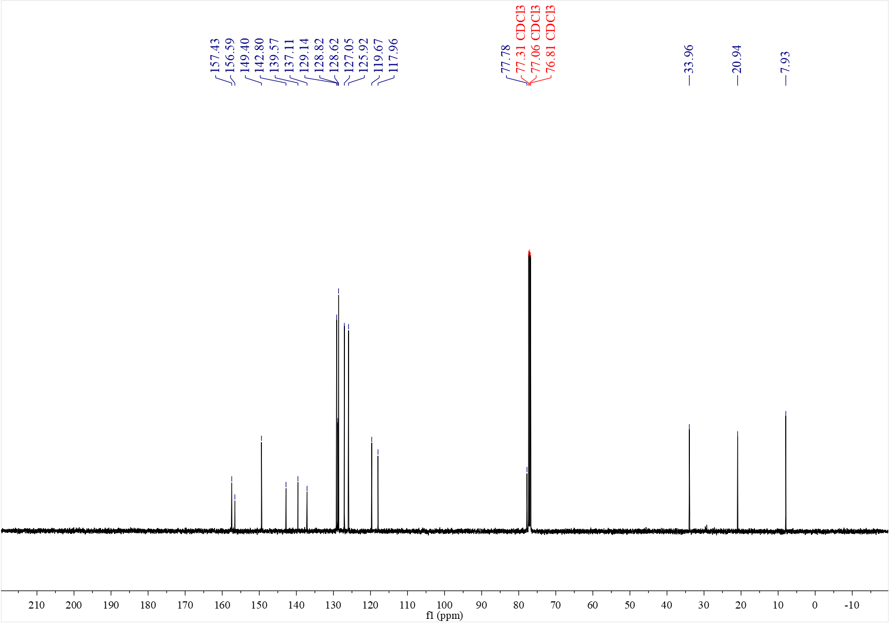

¹H NMR spectrum of C₁₆ (500 MHz, CDCl₃)
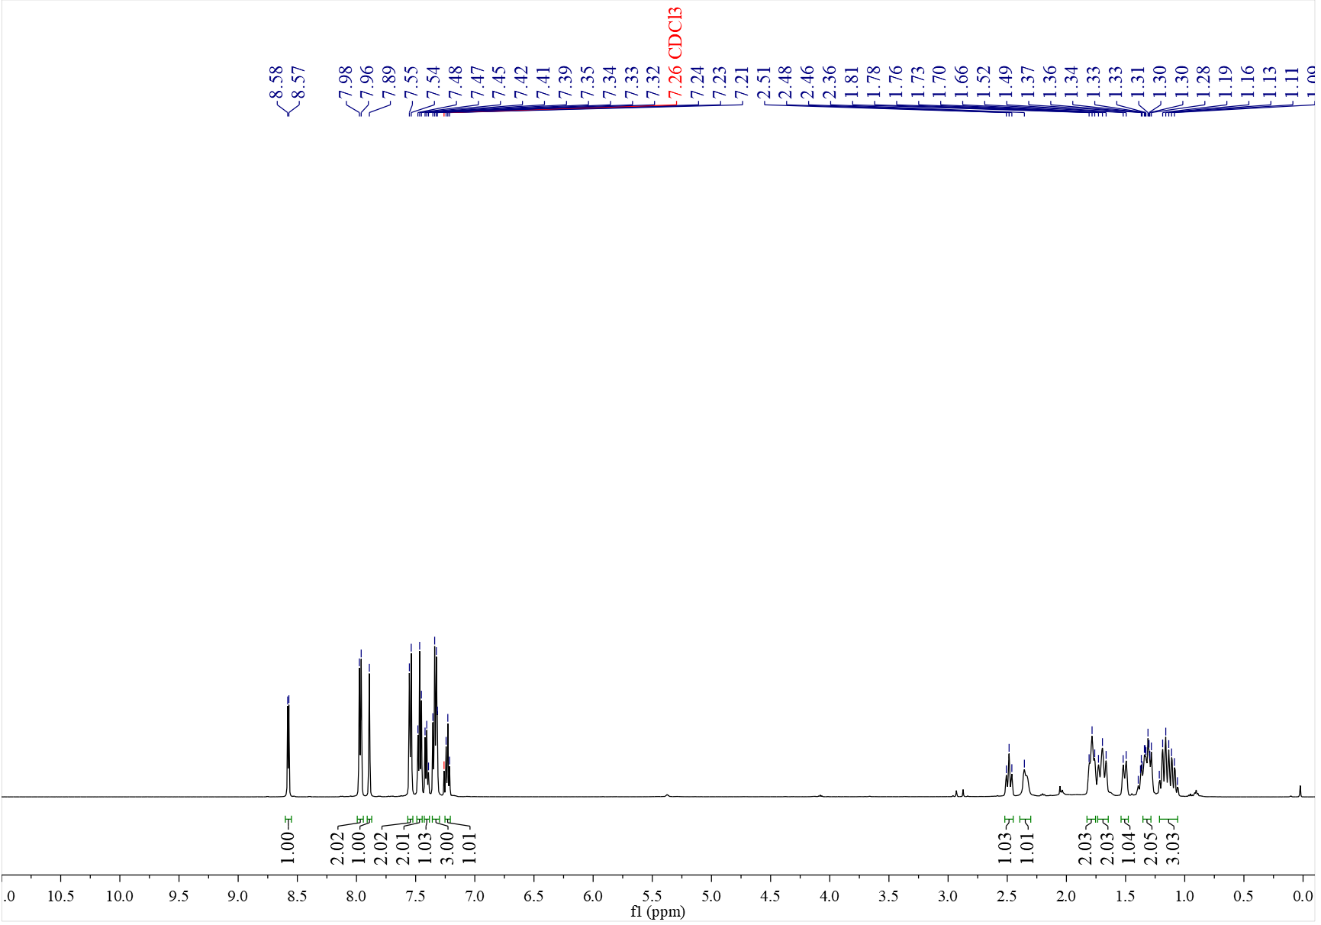

¹³C NMR spectrum of C₁₆ (126 MHz, CDCl₃)

¹H NMR spectrum of C₁₇ (500 MHz, CDCl₃)
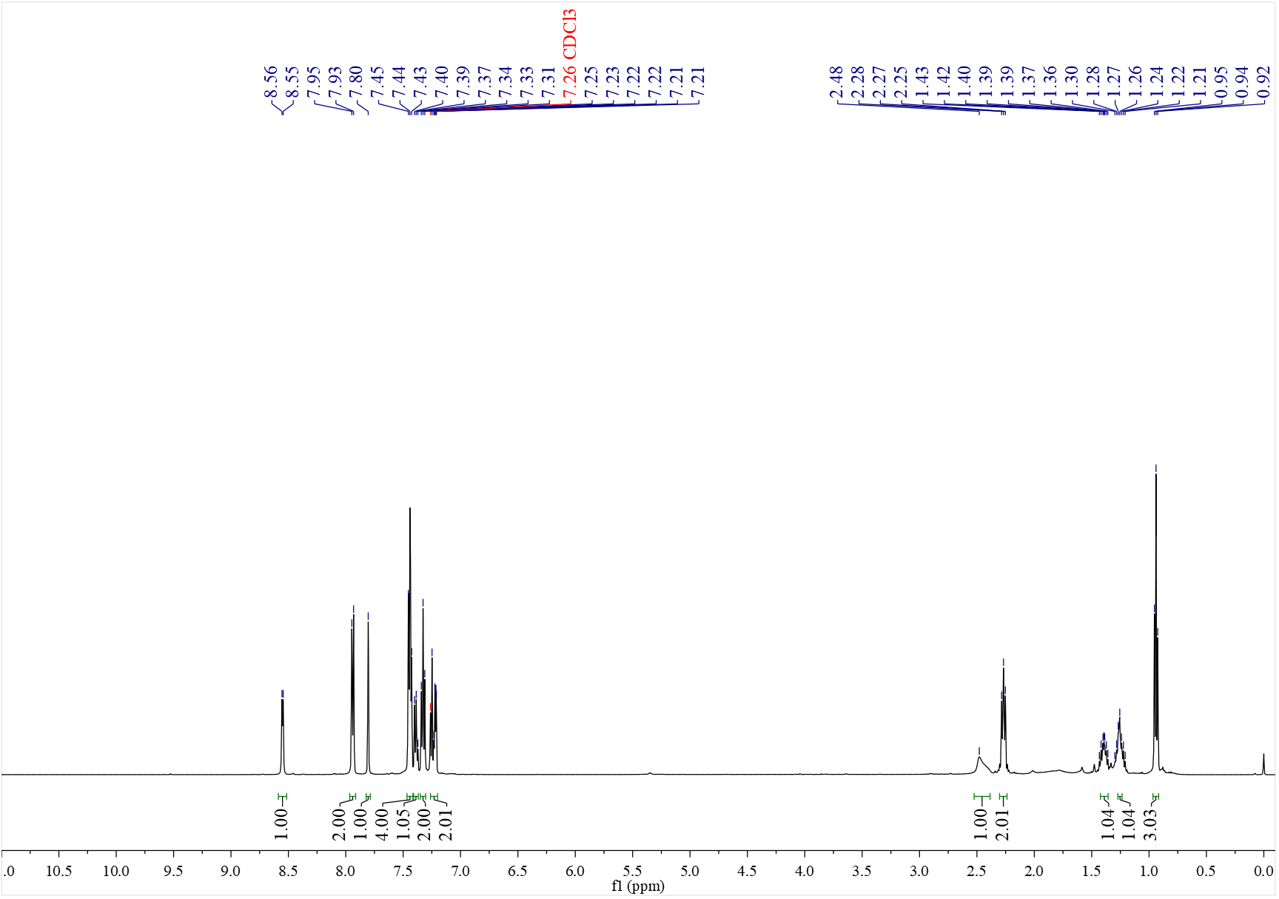

¹³C NMR spectrum of C₁₇ (126 MHz, CDCl₃)
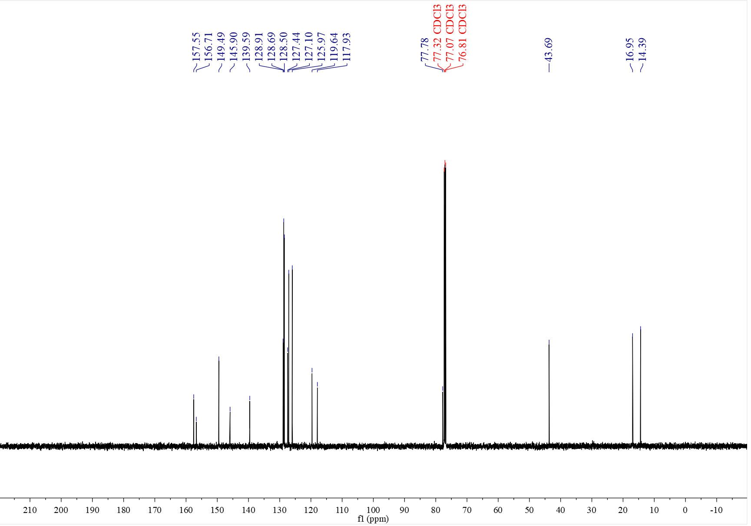

¹H NMR spectrum of C₁₈ (500 MHz, CDCl₃)
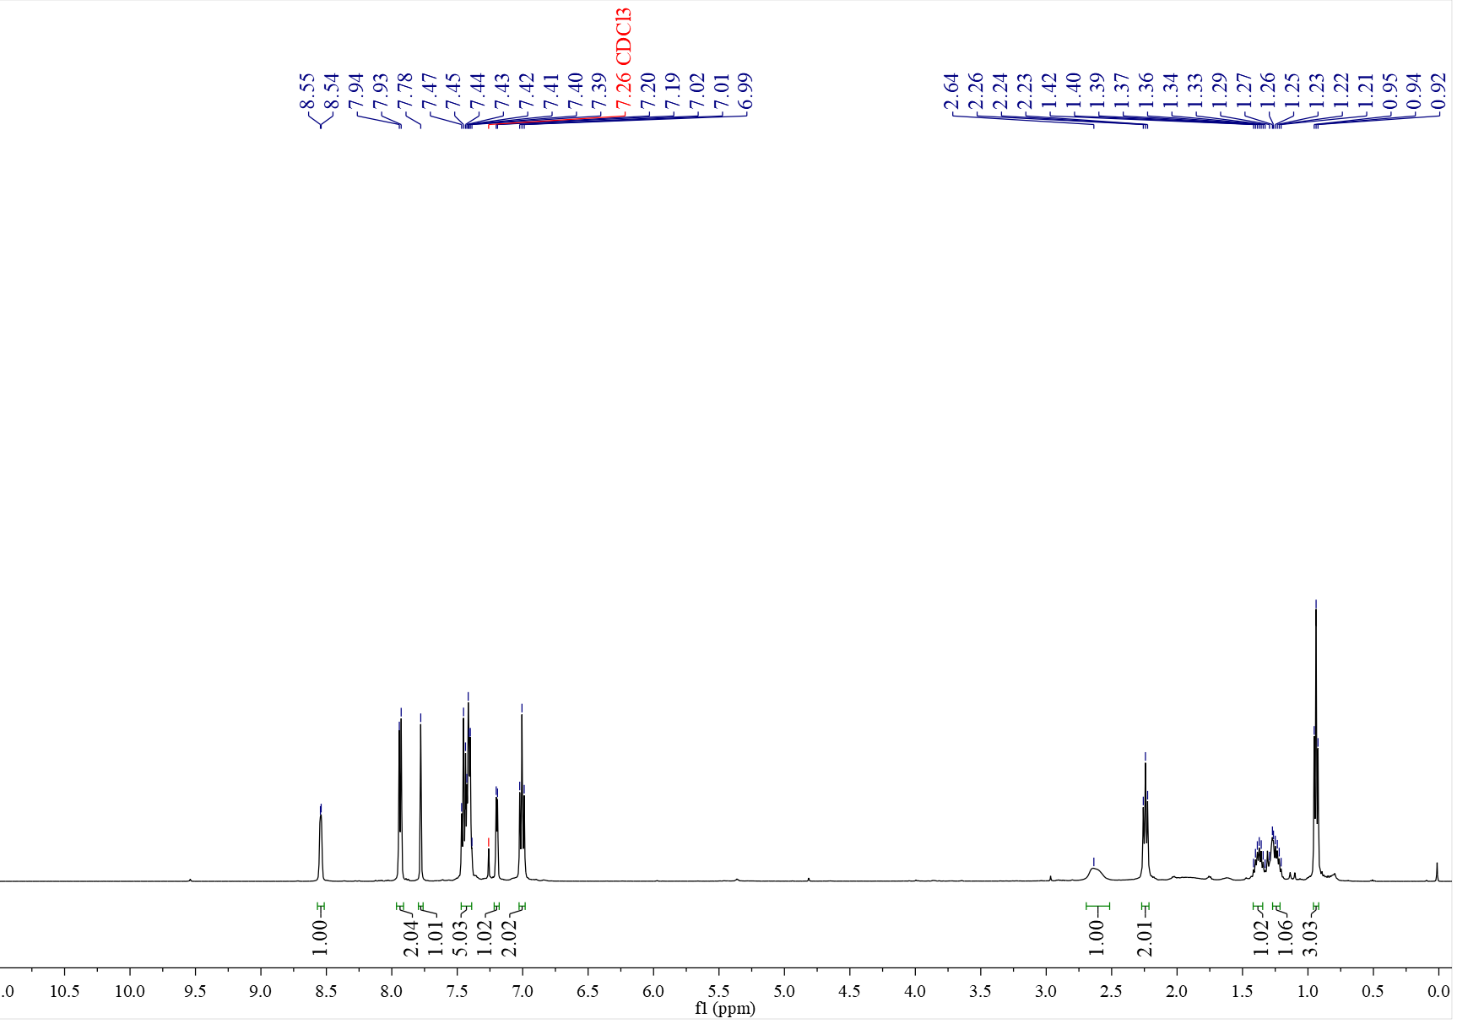

¹³C NMR spectrum of C₁₈ (126 MHz, CDCl₃)
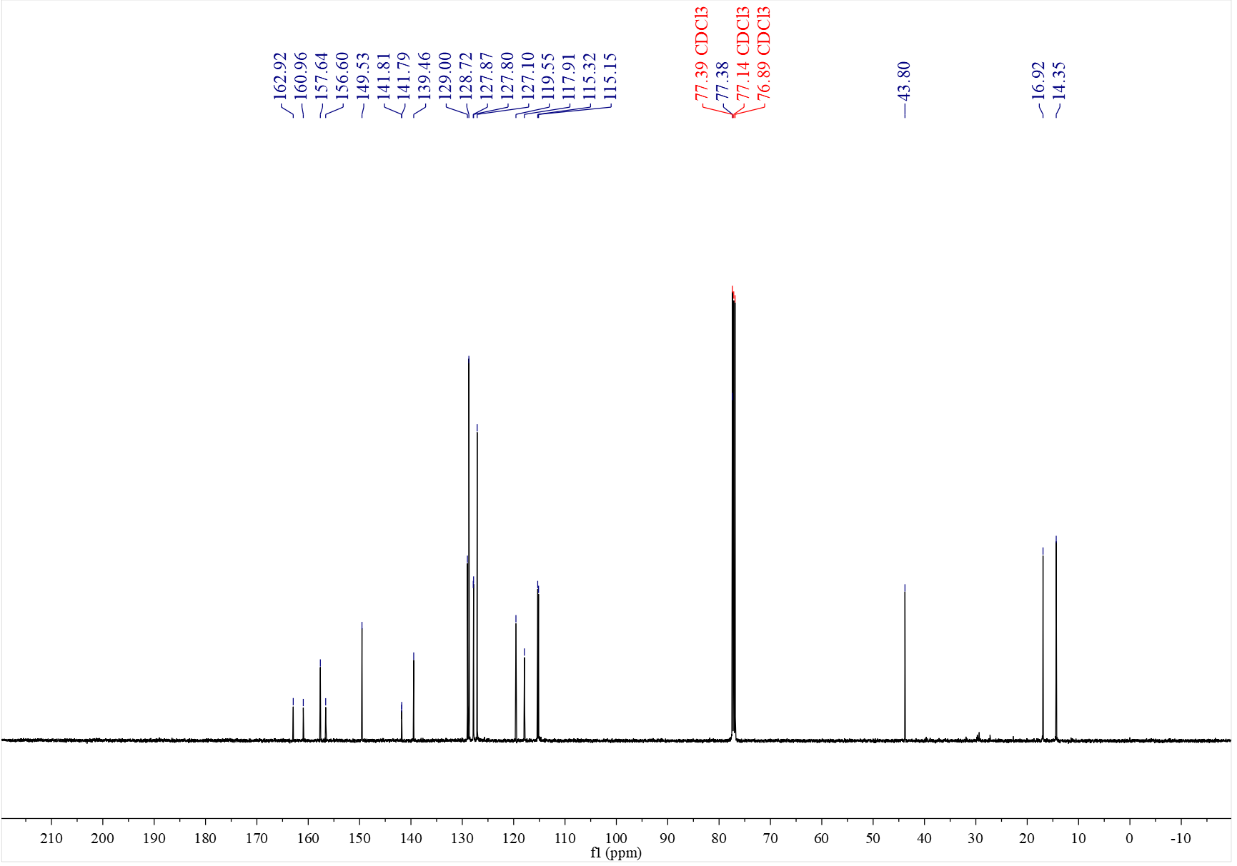

¹⁹F NMR spectrum of C₁₈ (376 MHz, CDCl₃)
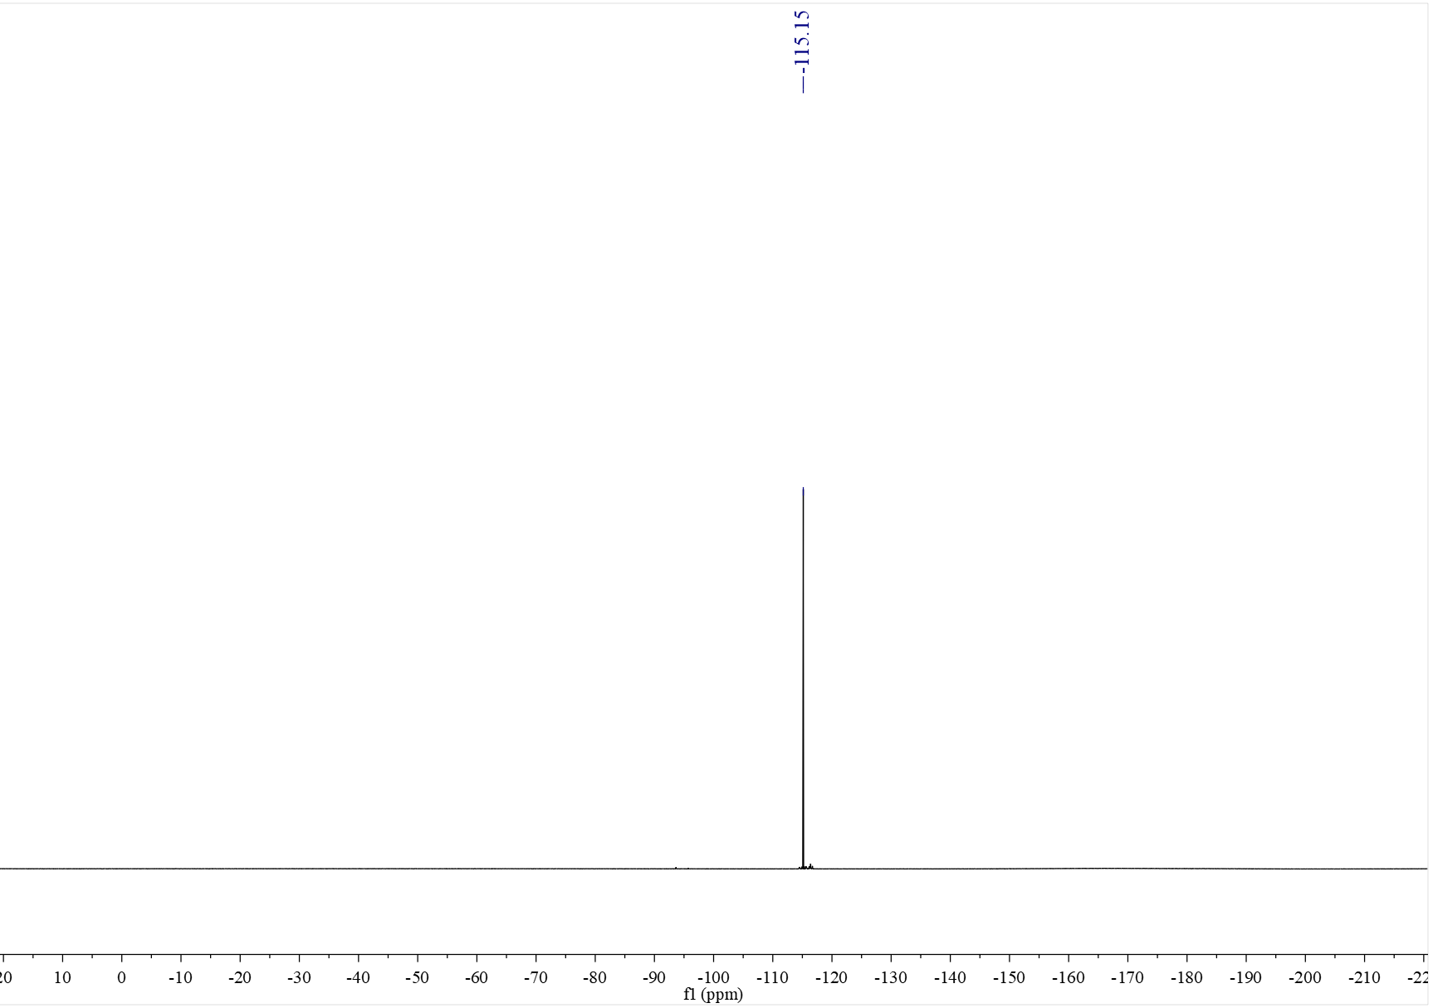

¹H NMR spectrum of C₁₉ (500 MHz, CDCl₃)
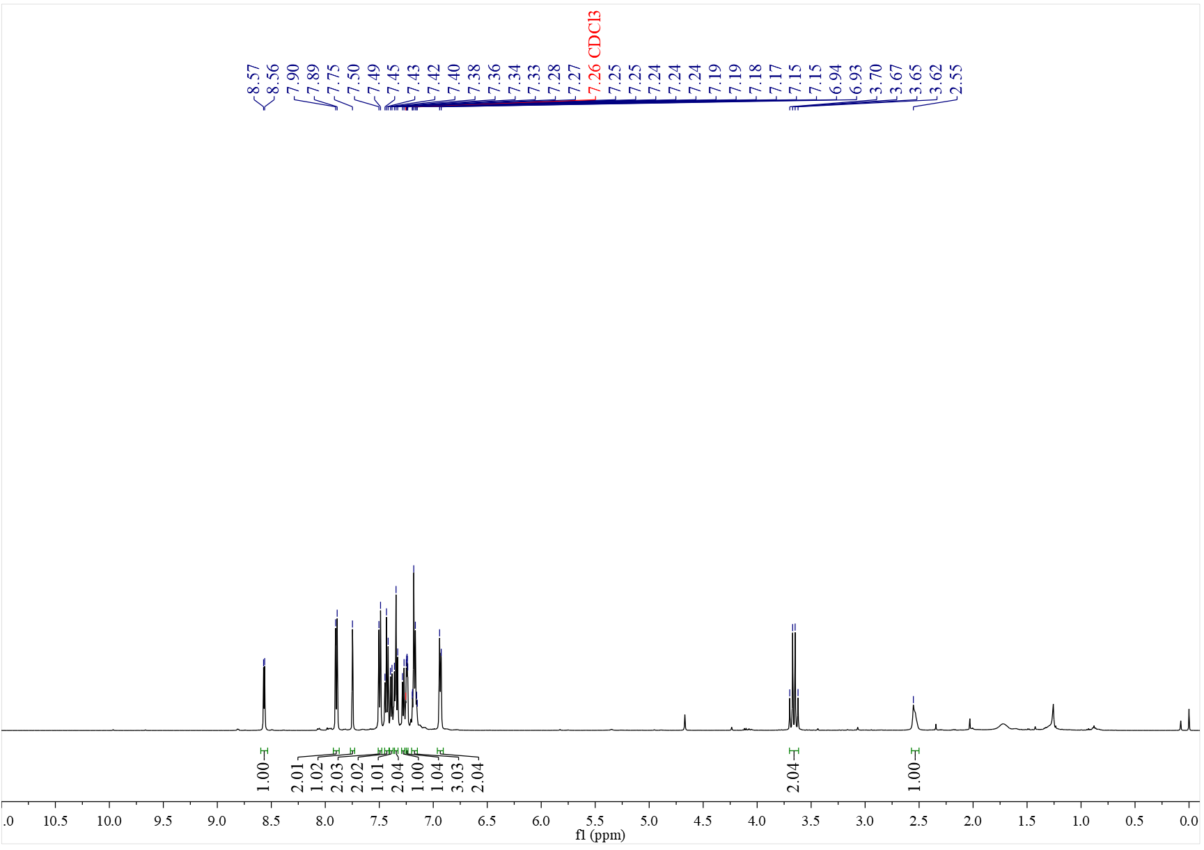

¹³C NMR spectrum of C₁₉ (126 MHz, CDCl₃)
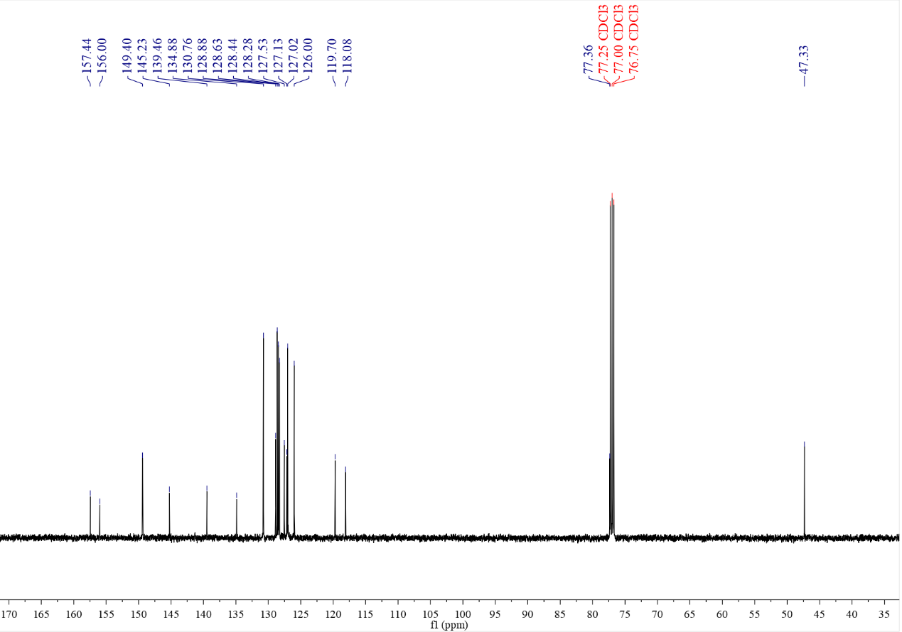

¹H NMR spectrum of C₂₀ (500 MHz, CDCl₃)
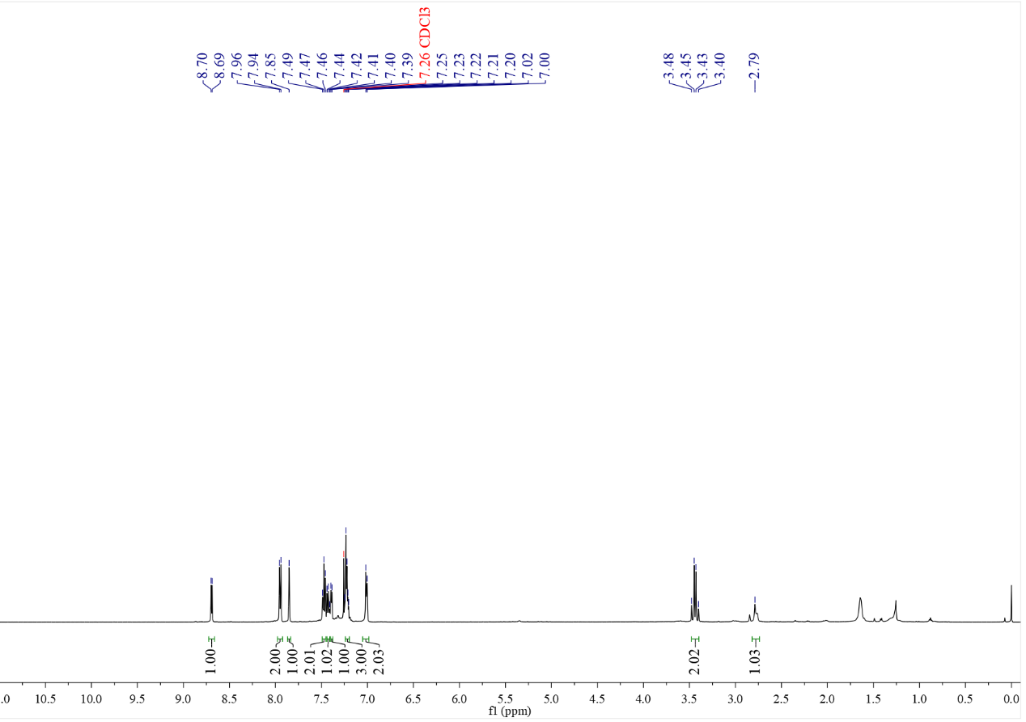

¹³C NMR spectrum of C₂₀ (126 MHz, CDCl₃)
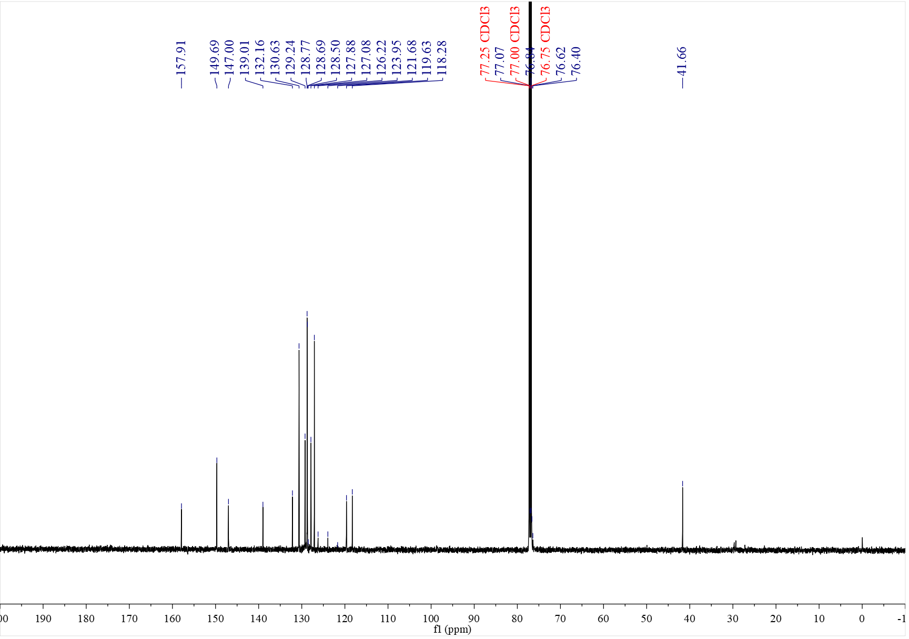

¹⁹F NMR spectrum of C₂₀ (376 MHz, CDCl₃)
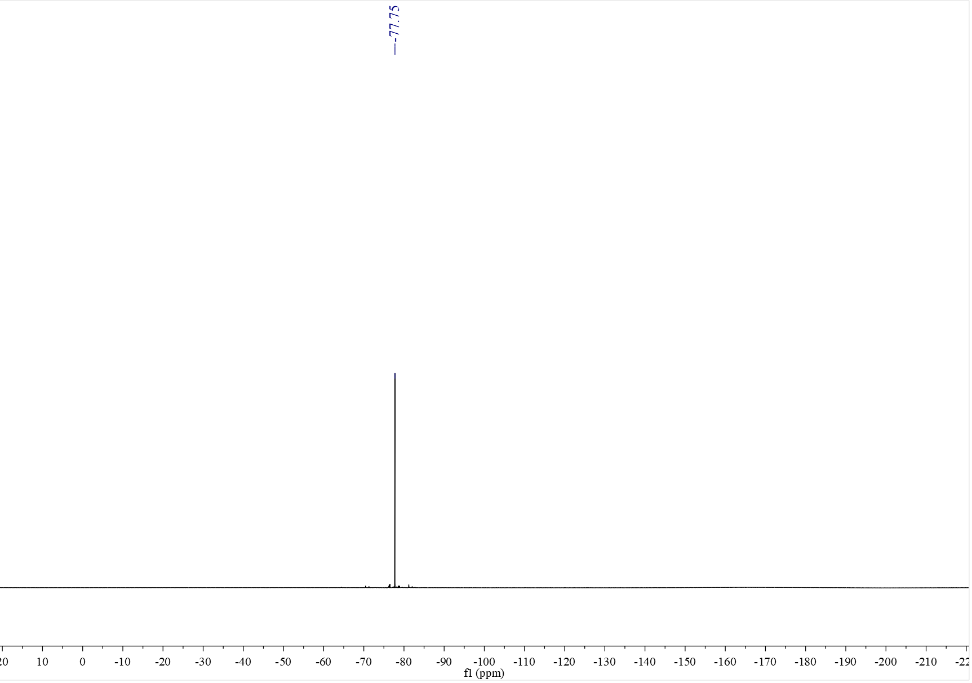

¹H NMR spectrum of C₂₁ (500 MHz, CDCl₃)
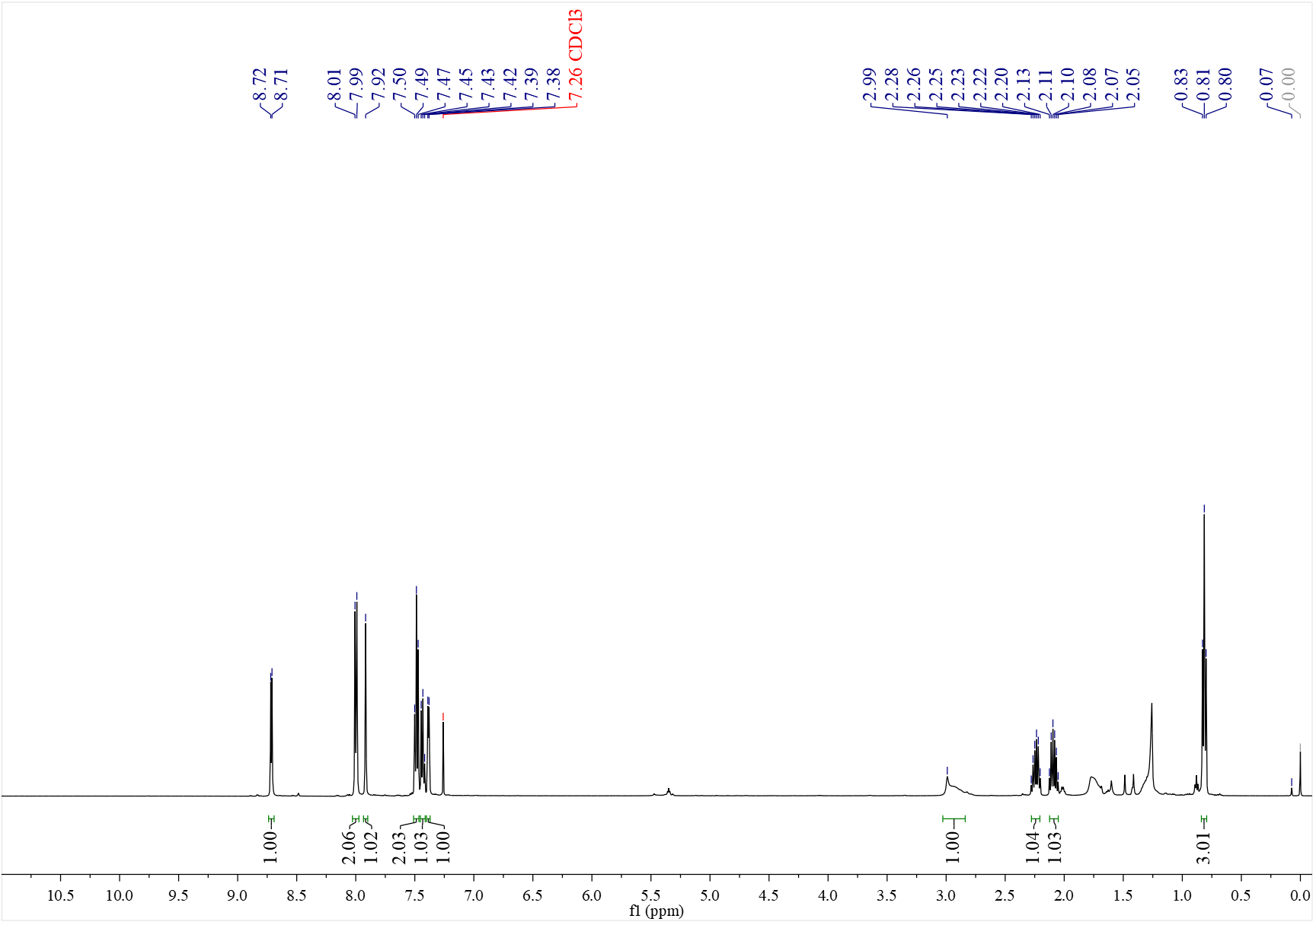

¹³C NMR spectrum of C₂₁ (126 MHz, CDCl₃)
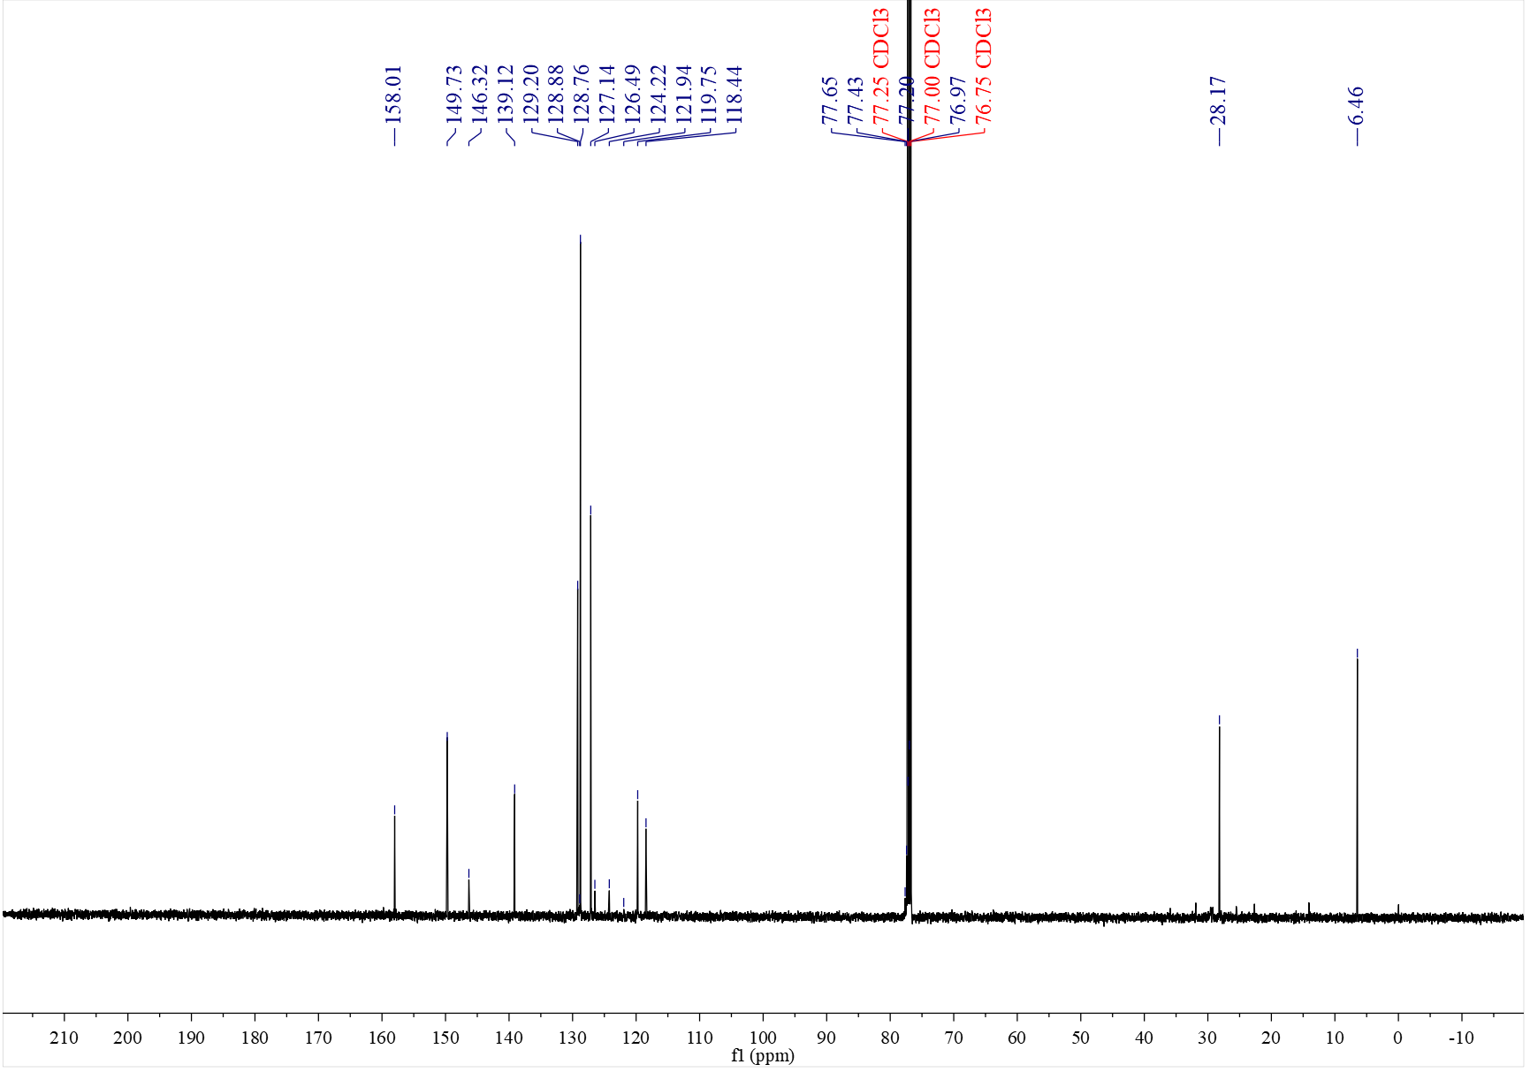

¹⁹F NMR spectrum of C₂₁ (376 MHz, CDCl₃)
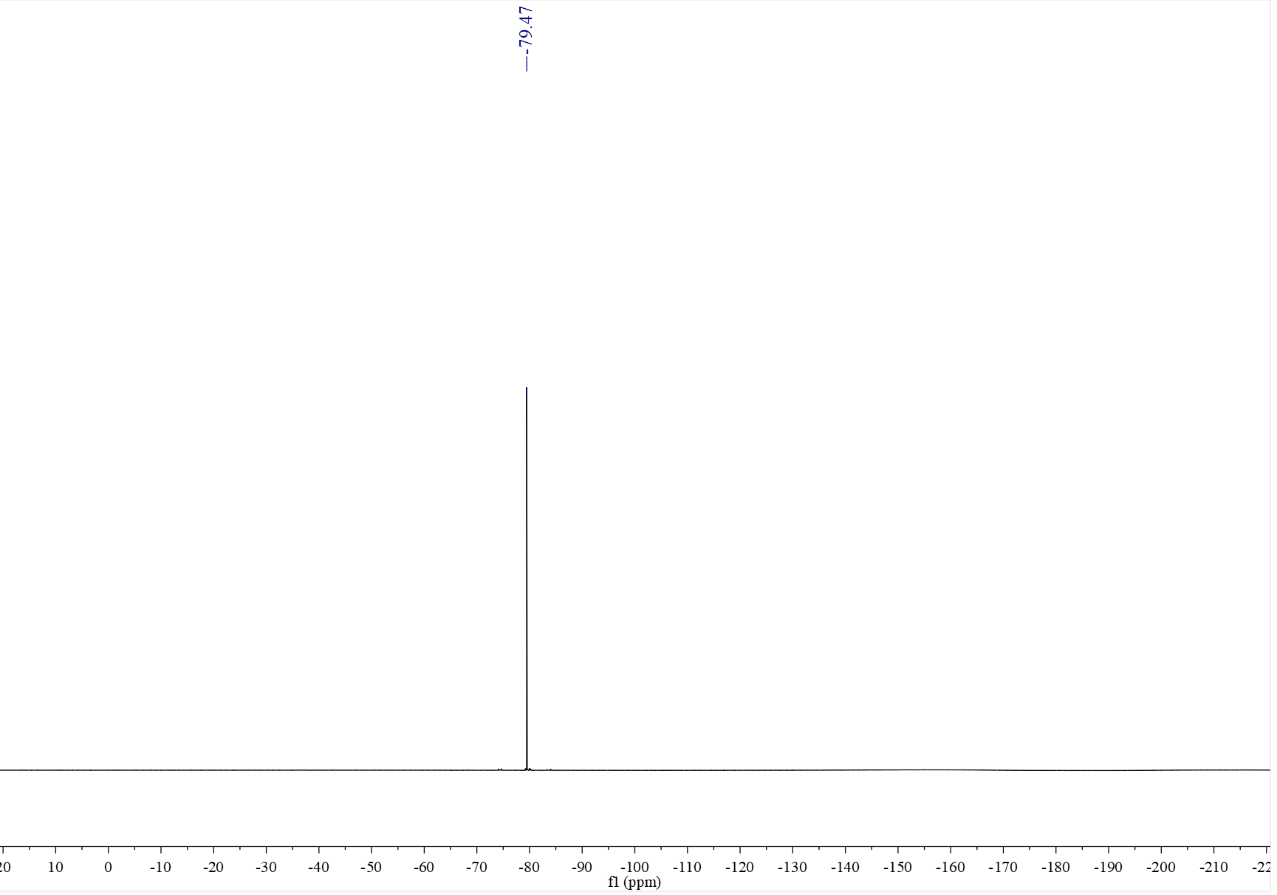

¹H NMR spectrum of C₂₂ (500 MHz, CDCl₃)
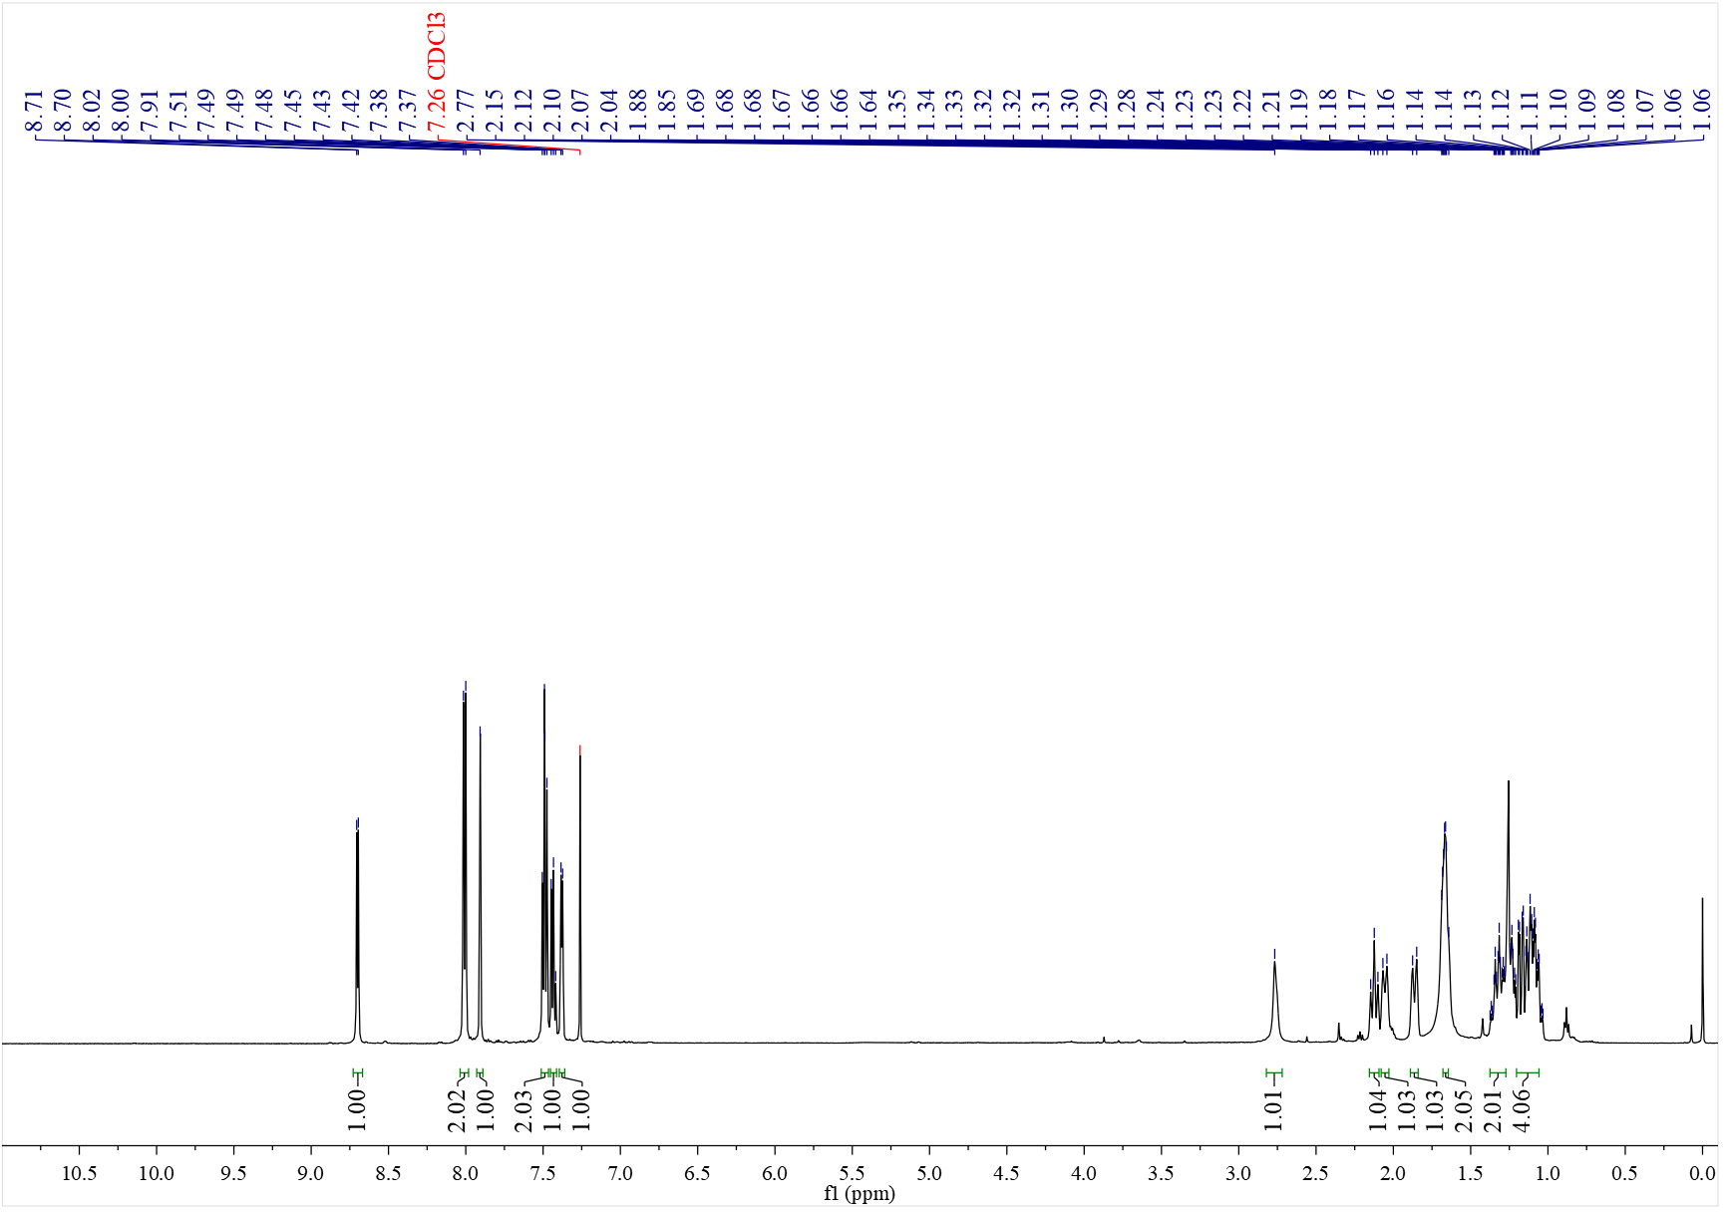

¹³C NMR spectrum of C₂₂ (126 MHz, CDCl₃)
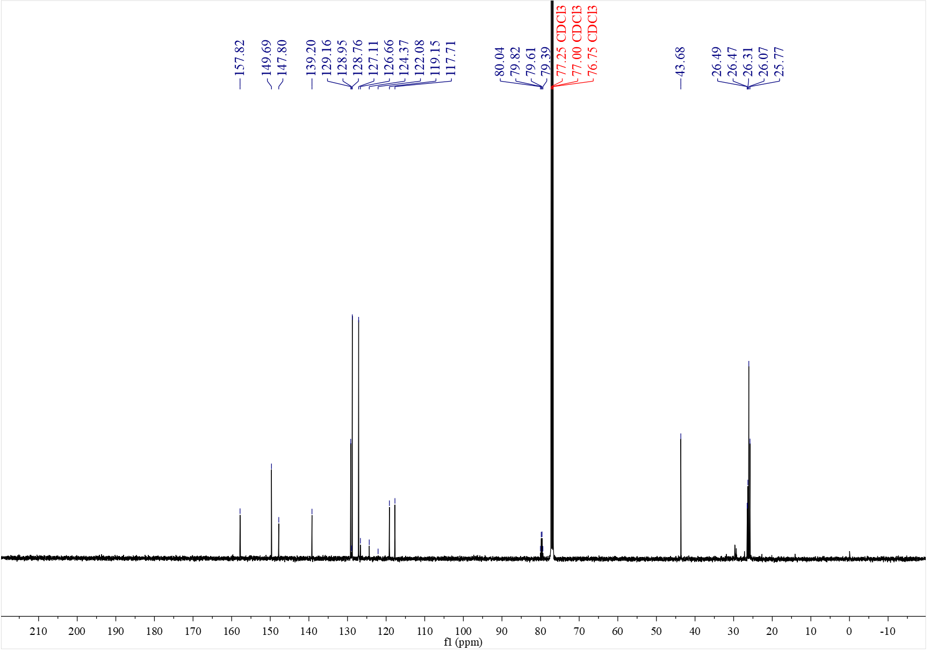

¹⁹F NMR spectrum of C₂₂ (376 MHz, CDCl₃)
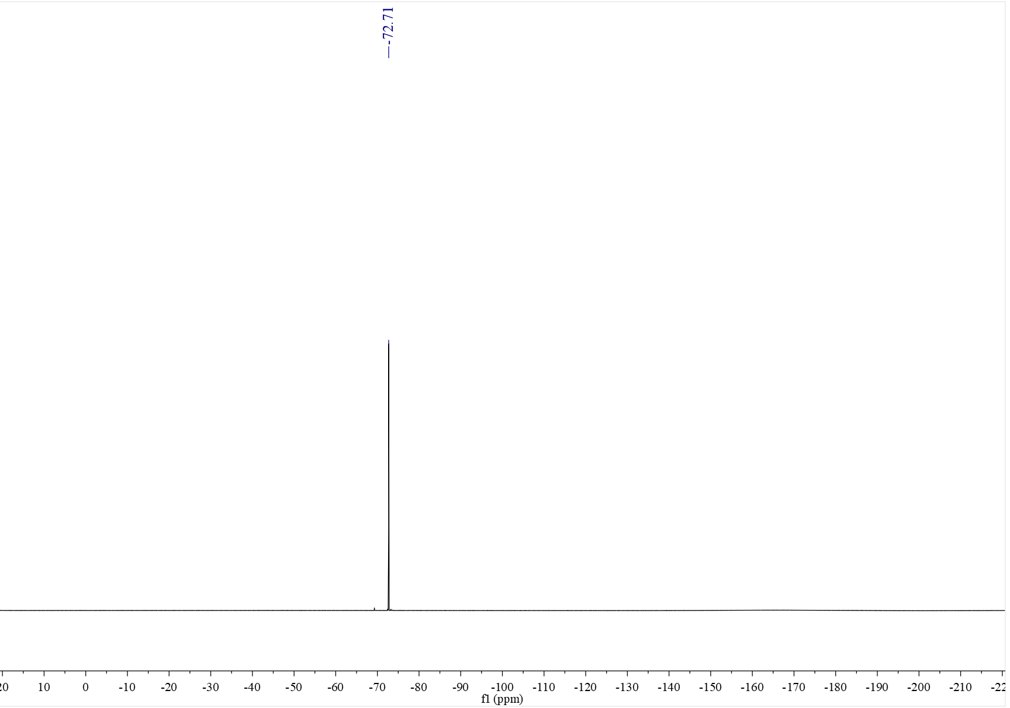

¹H NMR spectrum of C_{23a} (500 MHz, CDCl₃)
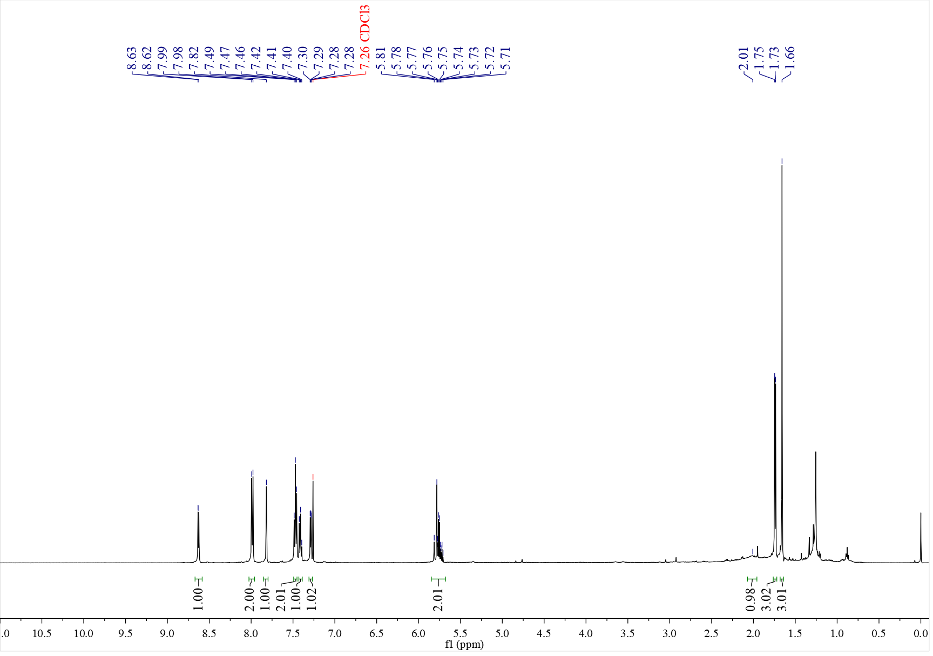

¹³C NMR spectrum of C_{23a} (126 MHz, CDCl₃)
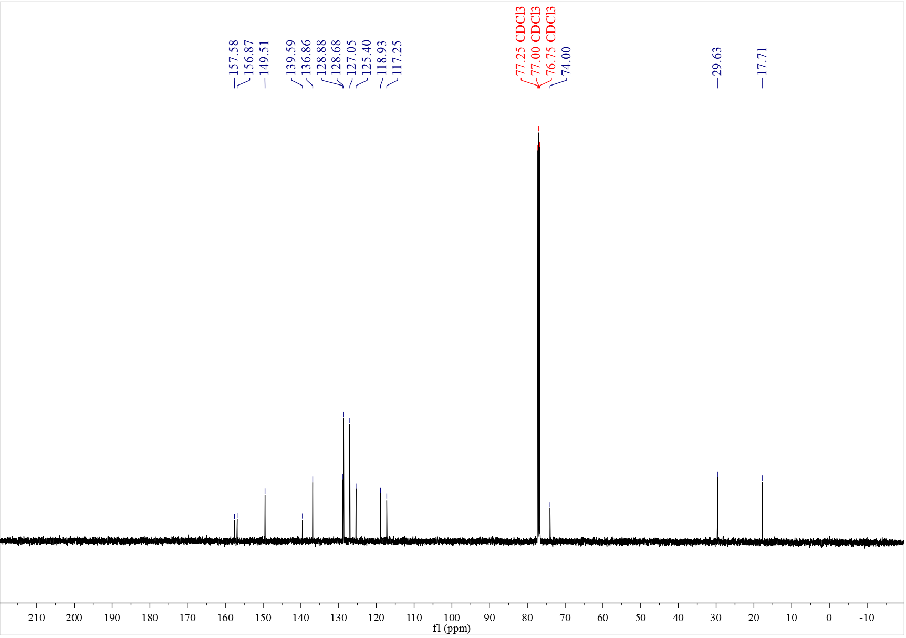

¹H NMR spectrum of C_{23b} (500 MHz, CDCl₃)
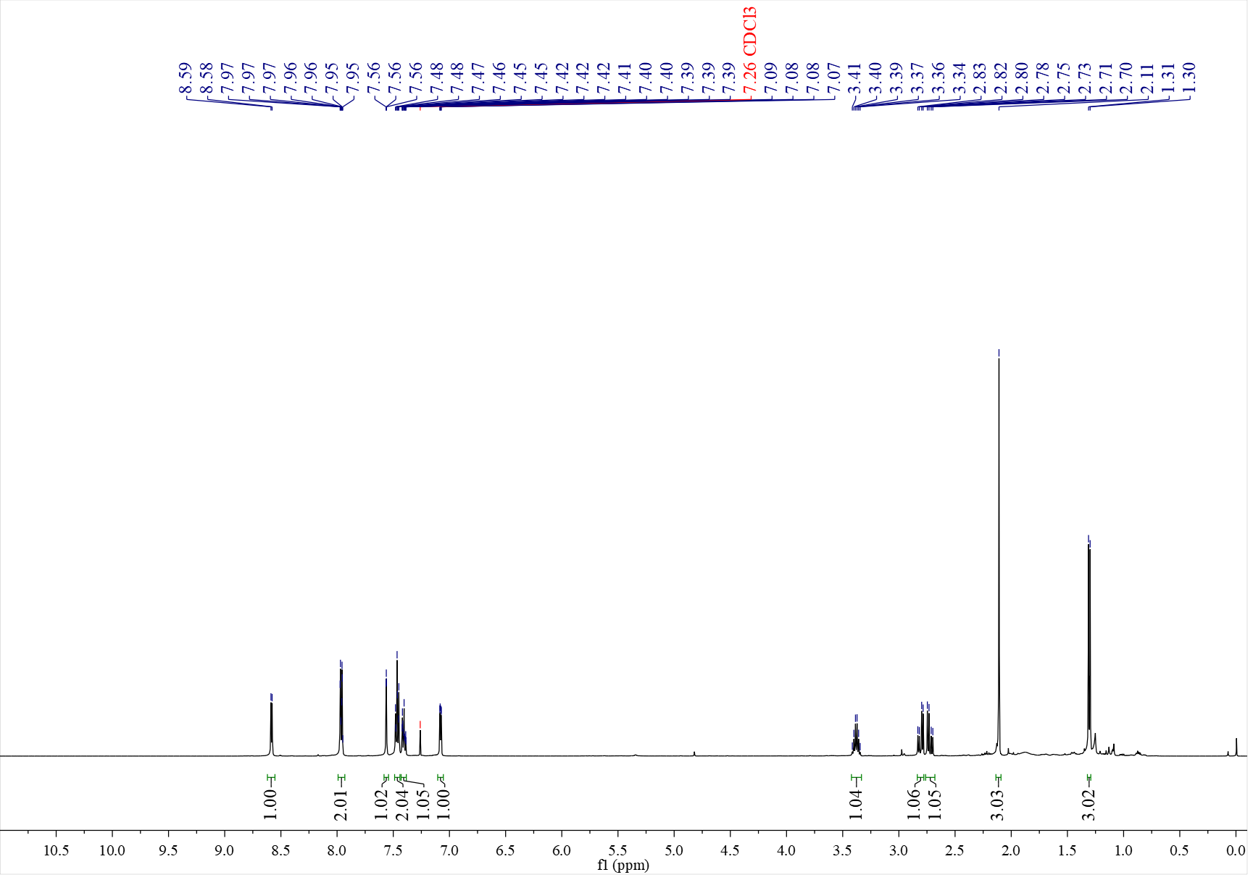

¹³C NMR spectrum of C_{23b} (126 MHz, CDCl₃)
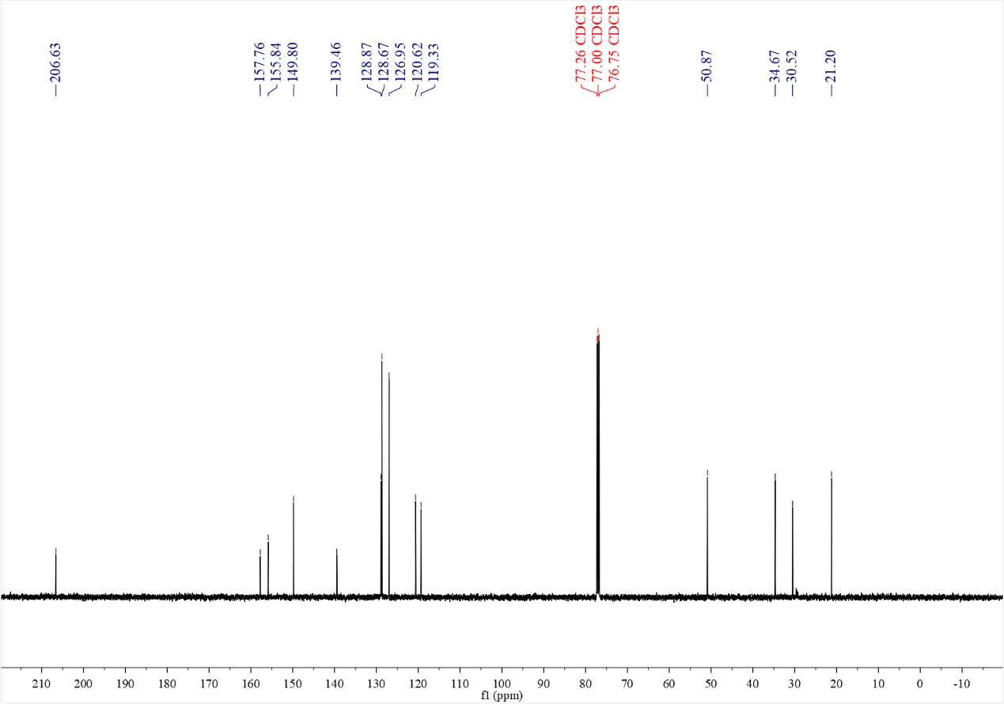

¹H NMR spectrum of C₂₄ (400 MHz, CDCl₃)
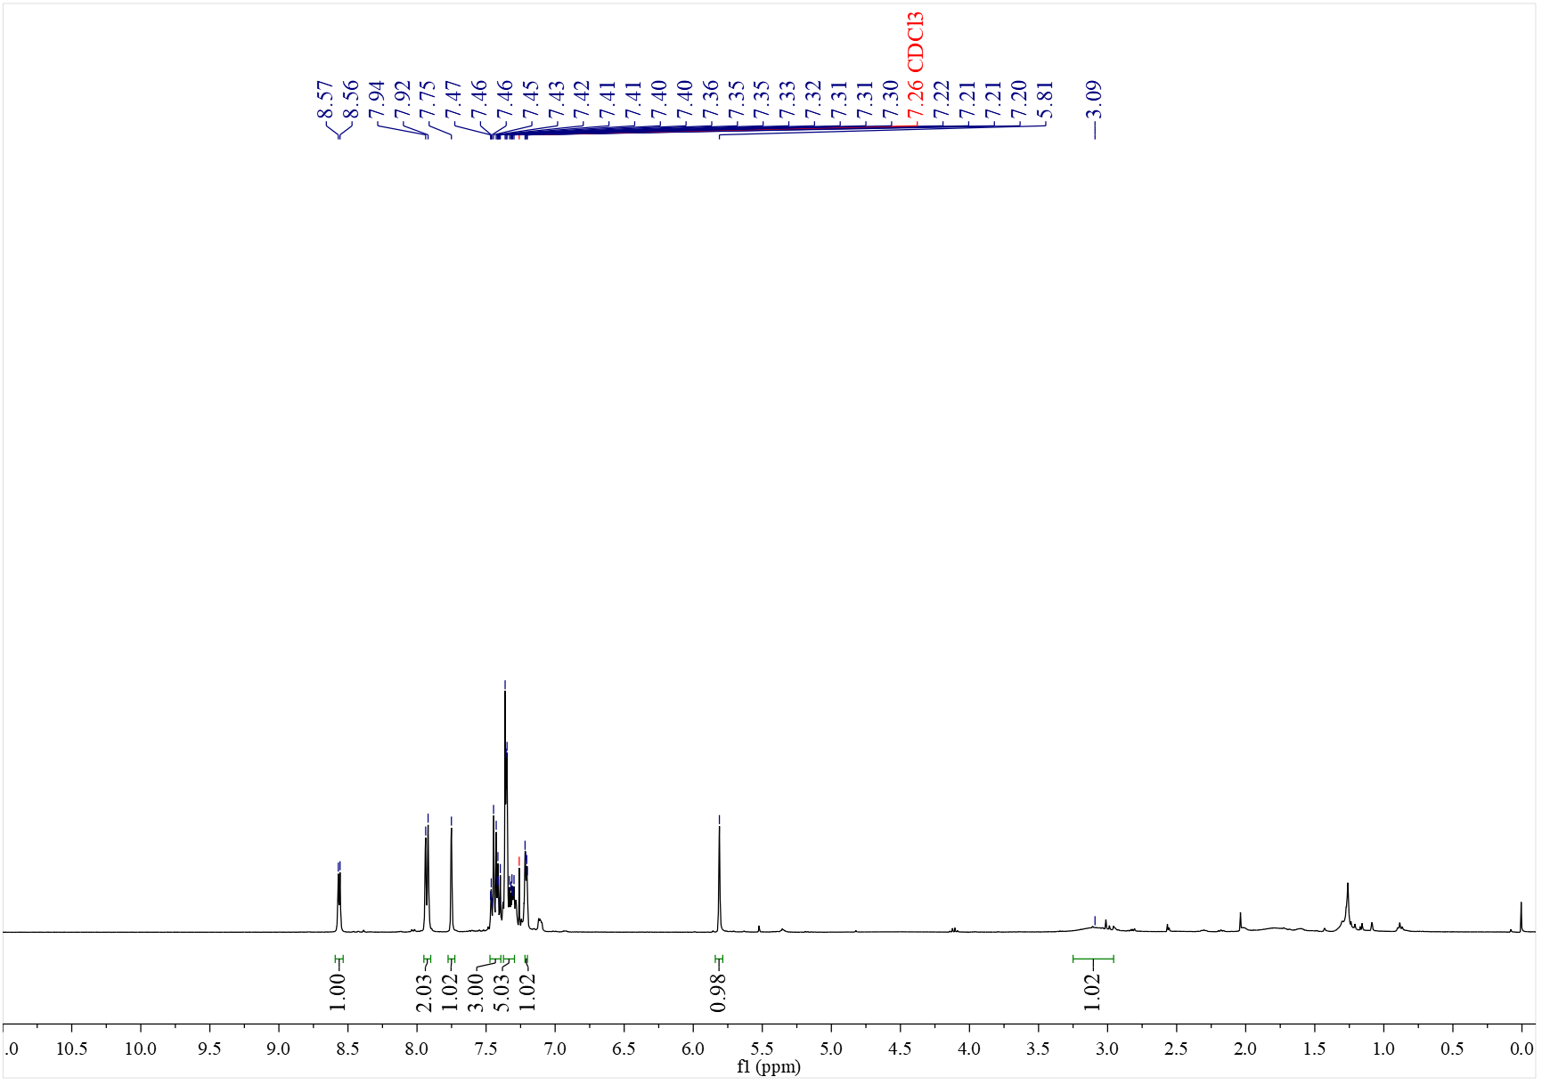

¹³C NMR spectrum of C₂₄ (126 MHz, CDCl₃)
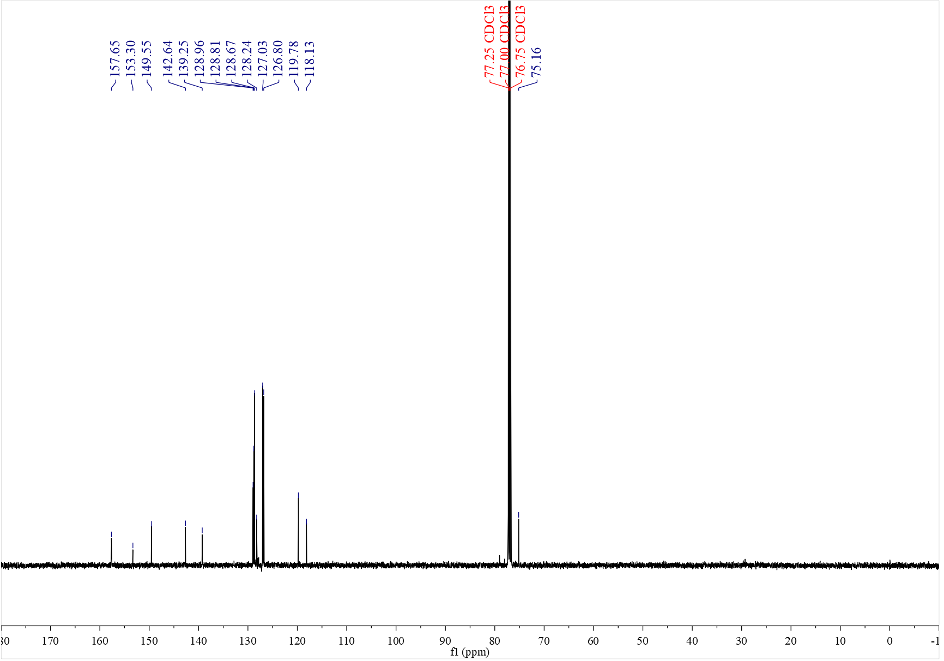

¹H NMR spectrum of C₂₅ (400 MHz, CDCl₃)
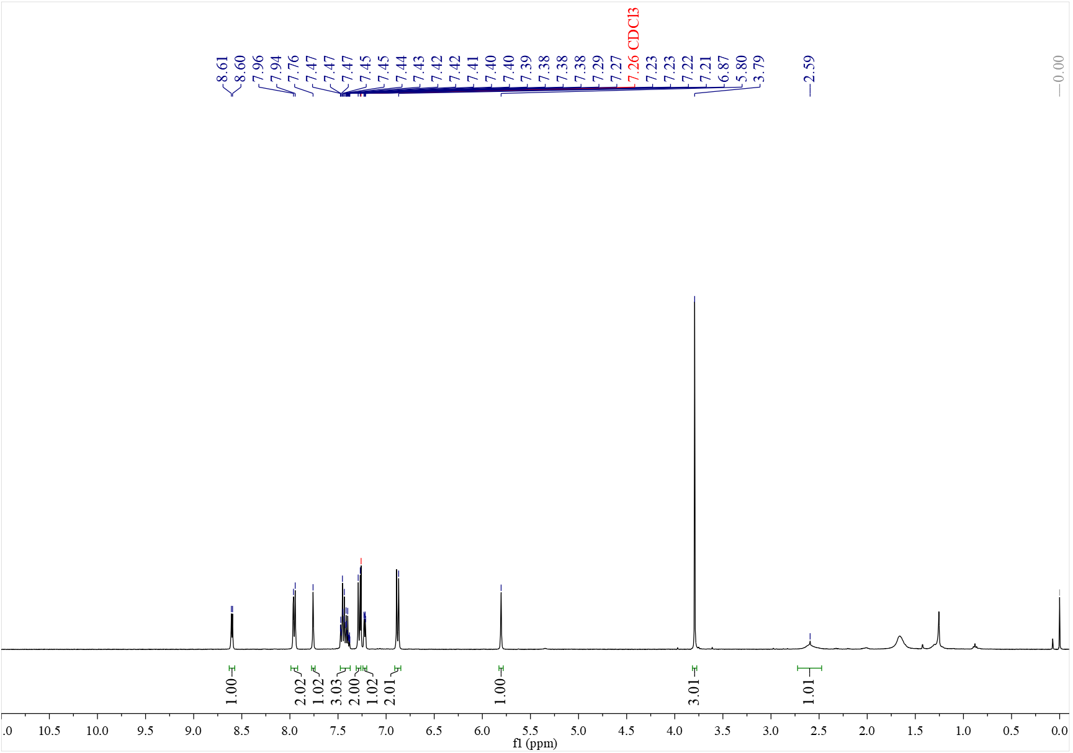

¹³C NMR spectrum of C₂₅ (126 MHz, CDCl₃)
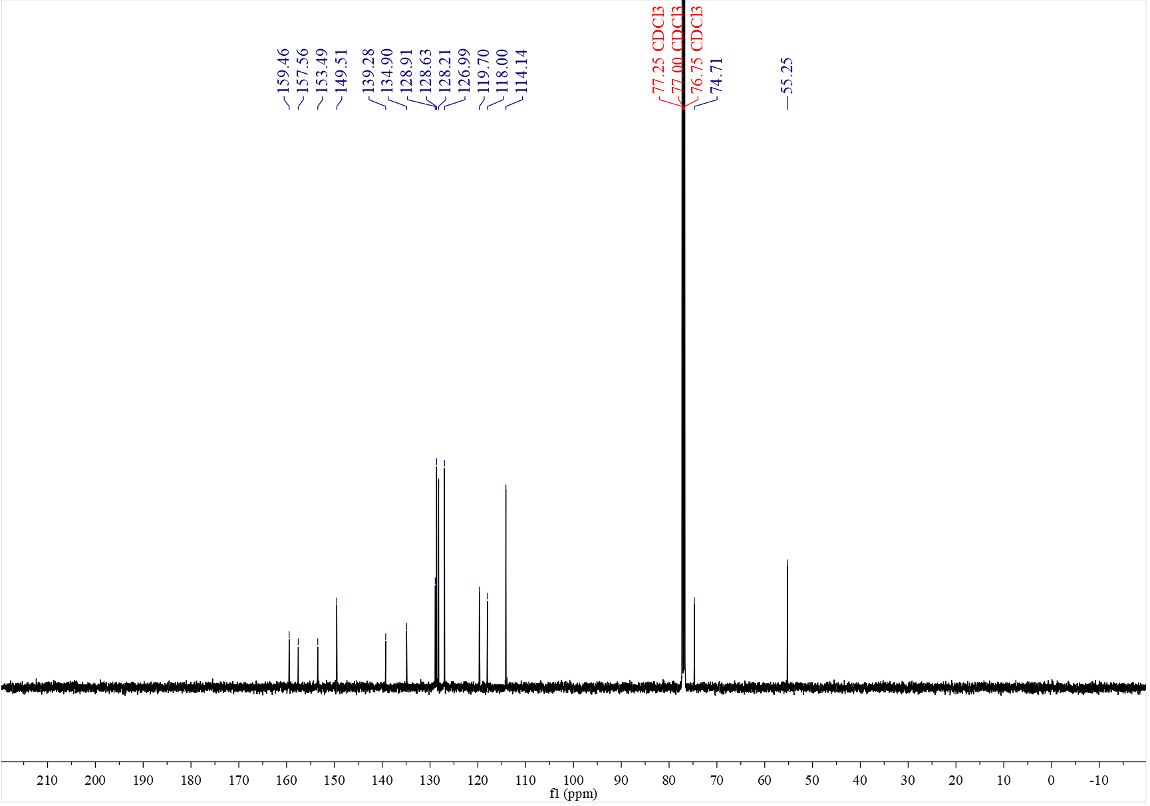

¹H NMR spectrum of C₂₆ (500 MHz, CDCl₃)
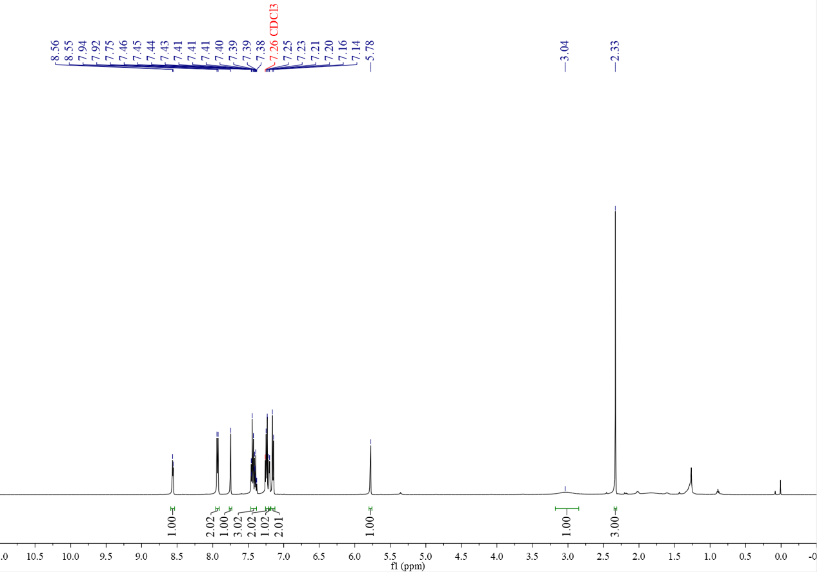

¹³C NMR spectrum of C₂₆ (126 MHz, CDCl₃)
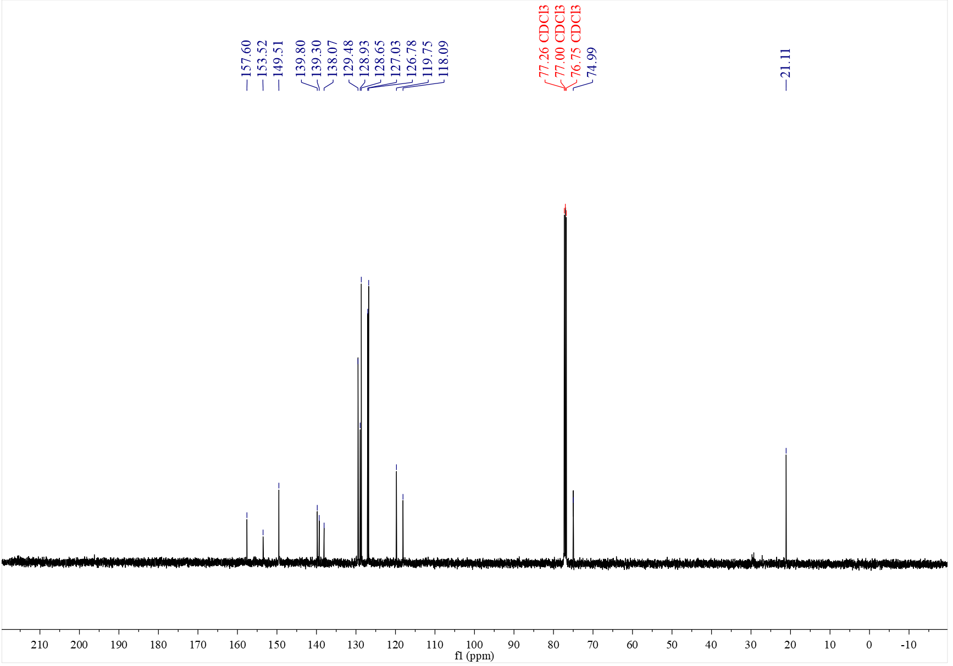

¹H NMR spectrum of C₂₇ (500 MHz, CDCl₃)
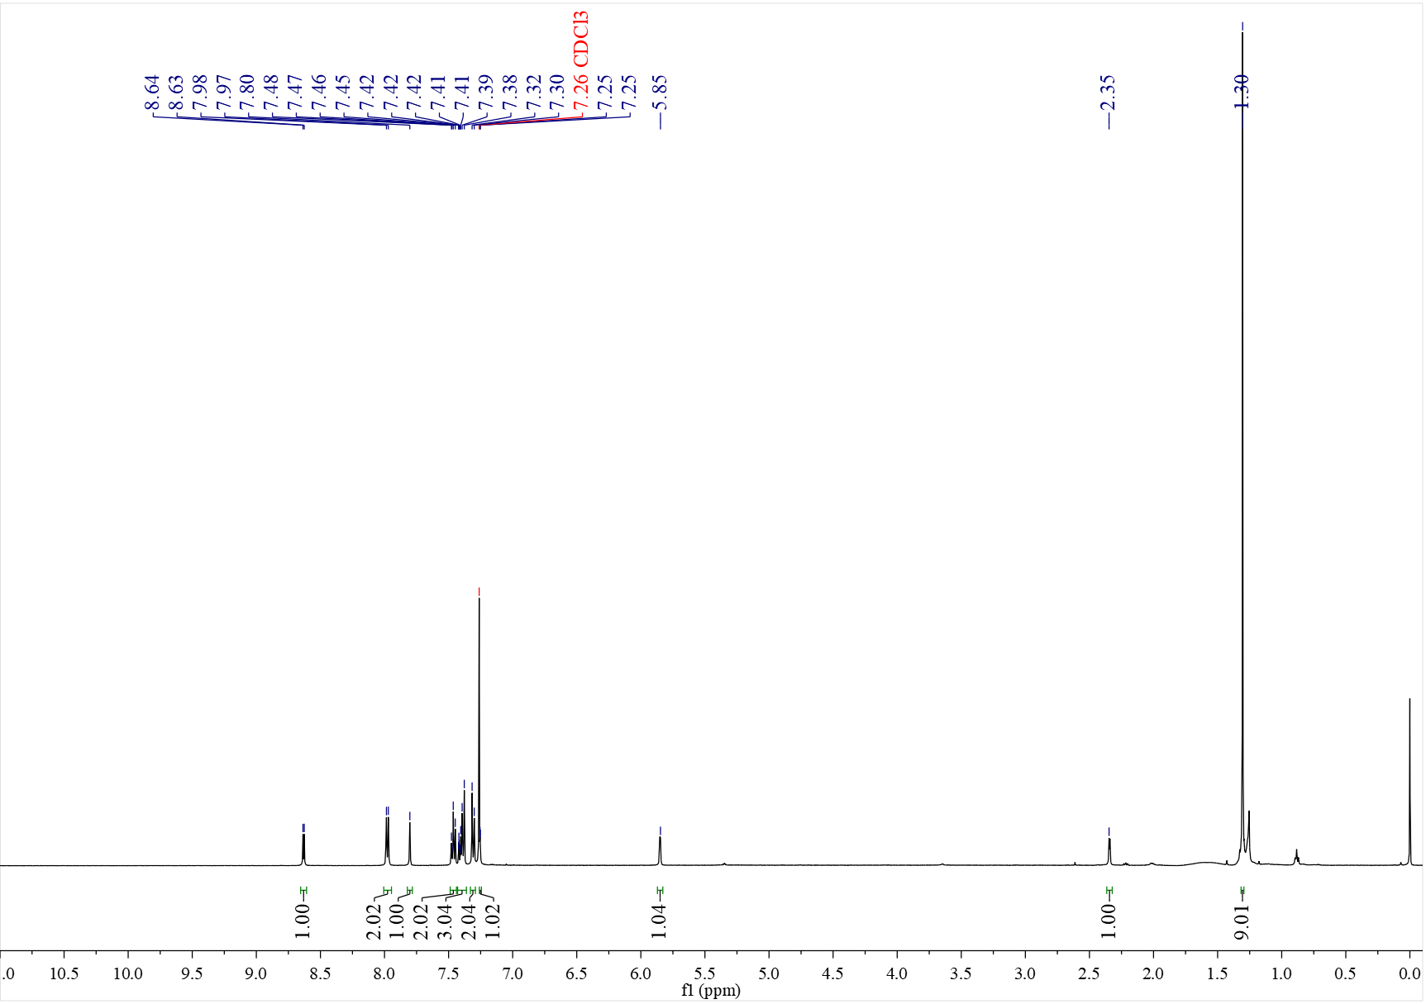

¹³C NMR spectrum of C₂₇ (126 MHz, CDCl₃)
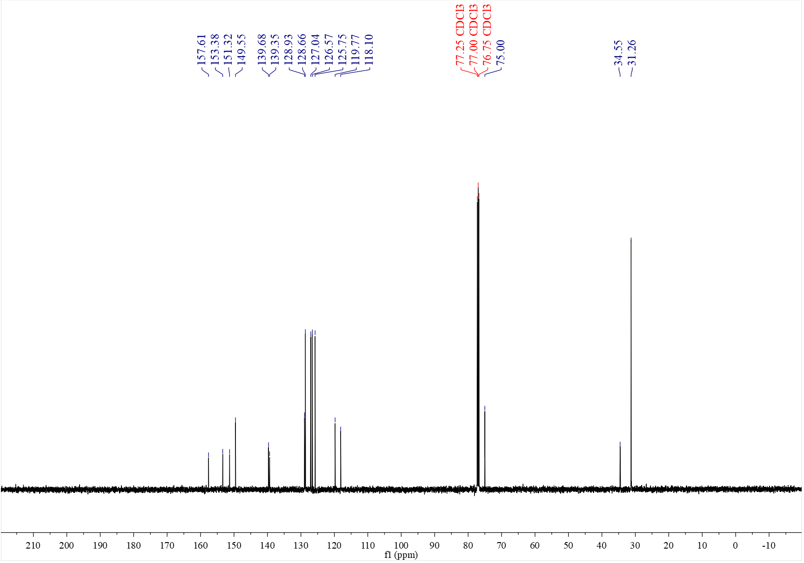

¹H NMR spectrum of C₂₈ (500 MHz, CDCl₃)
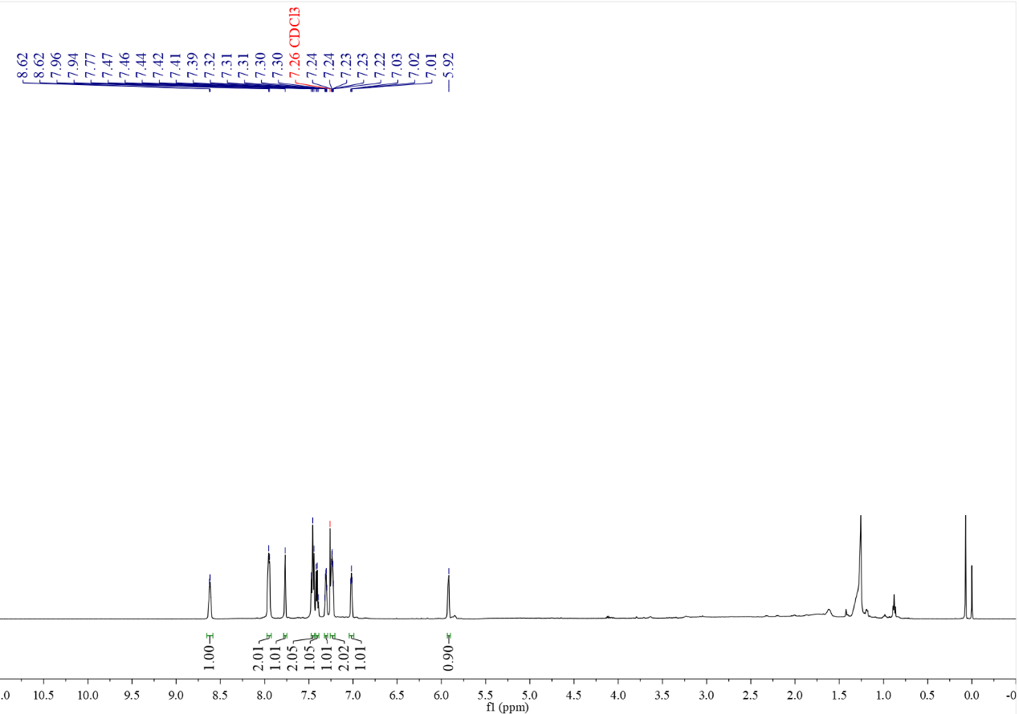

¹³C NMR spectrum of C₂₈ (126 MHz, CDCl₃)
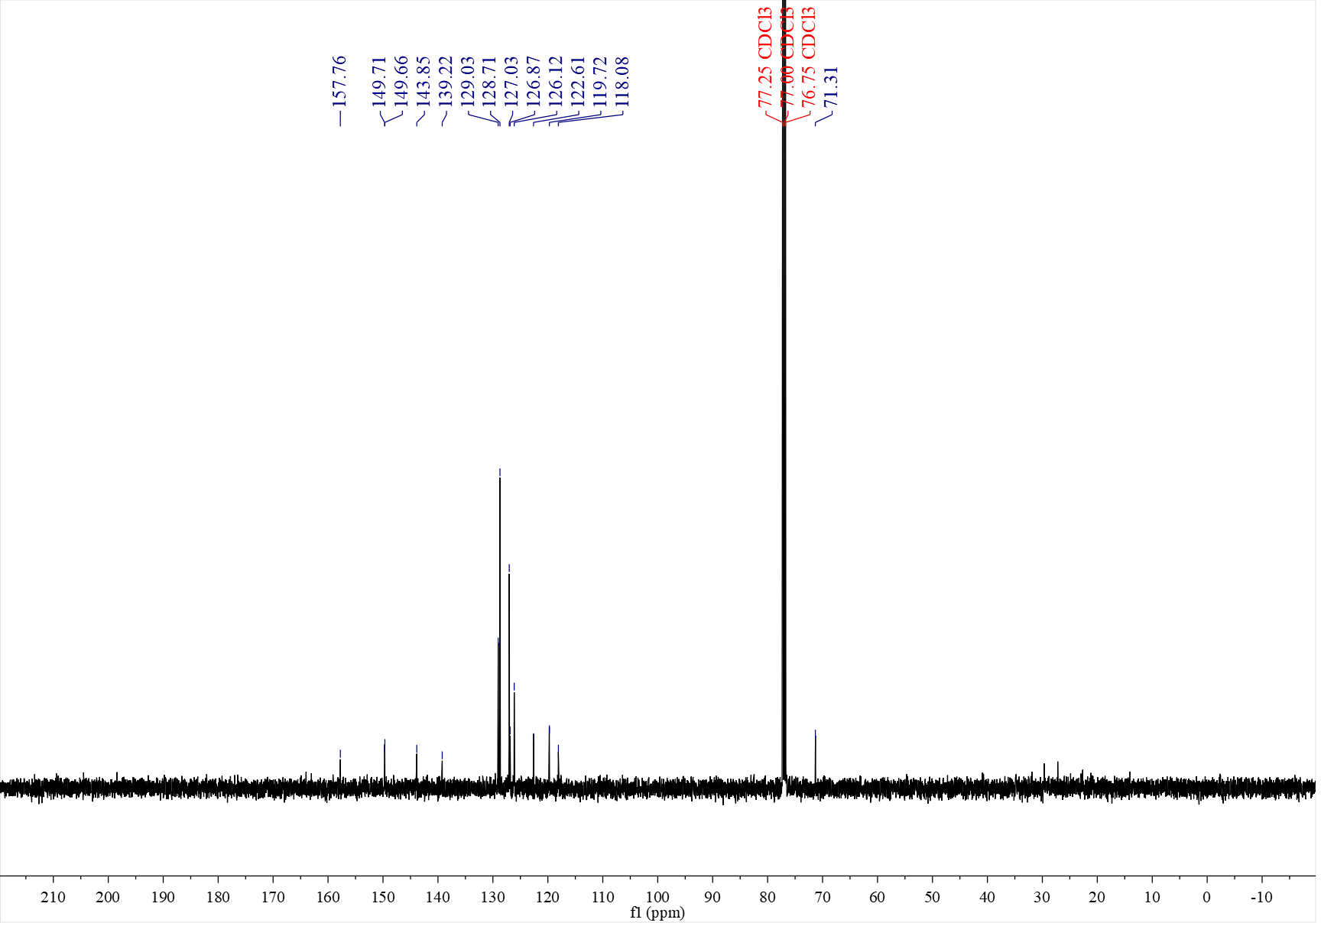

¹H NMR spectrum of C₂₉ (500 MHz, CDCl₃)
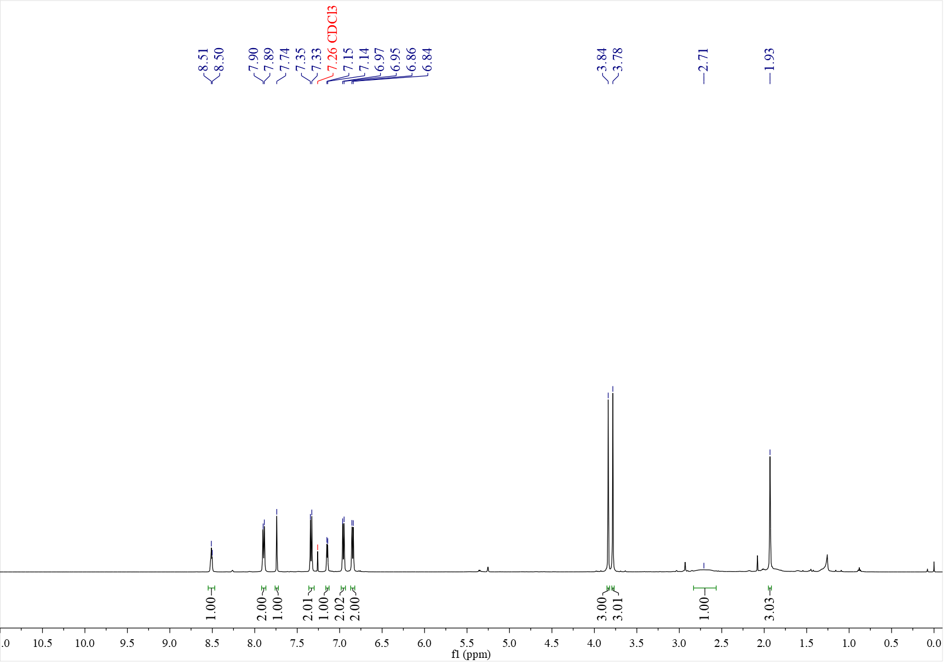

¹³C NMR spectrum of C₂₉ (126 MHz, CDCl₃)
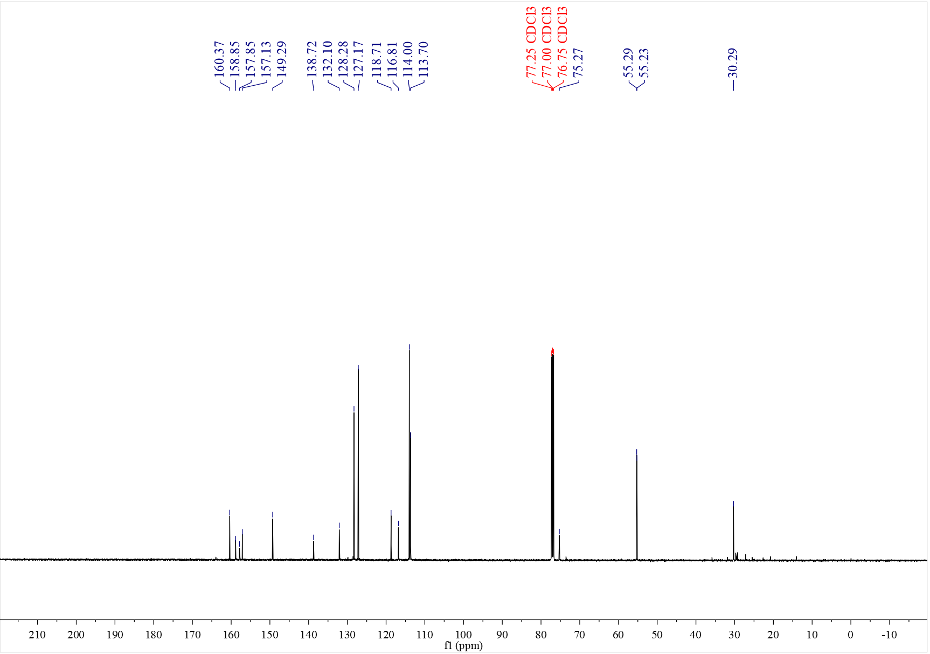

¹H NMR spectrum of C₃₀ (400 MHz, CDCl₃)
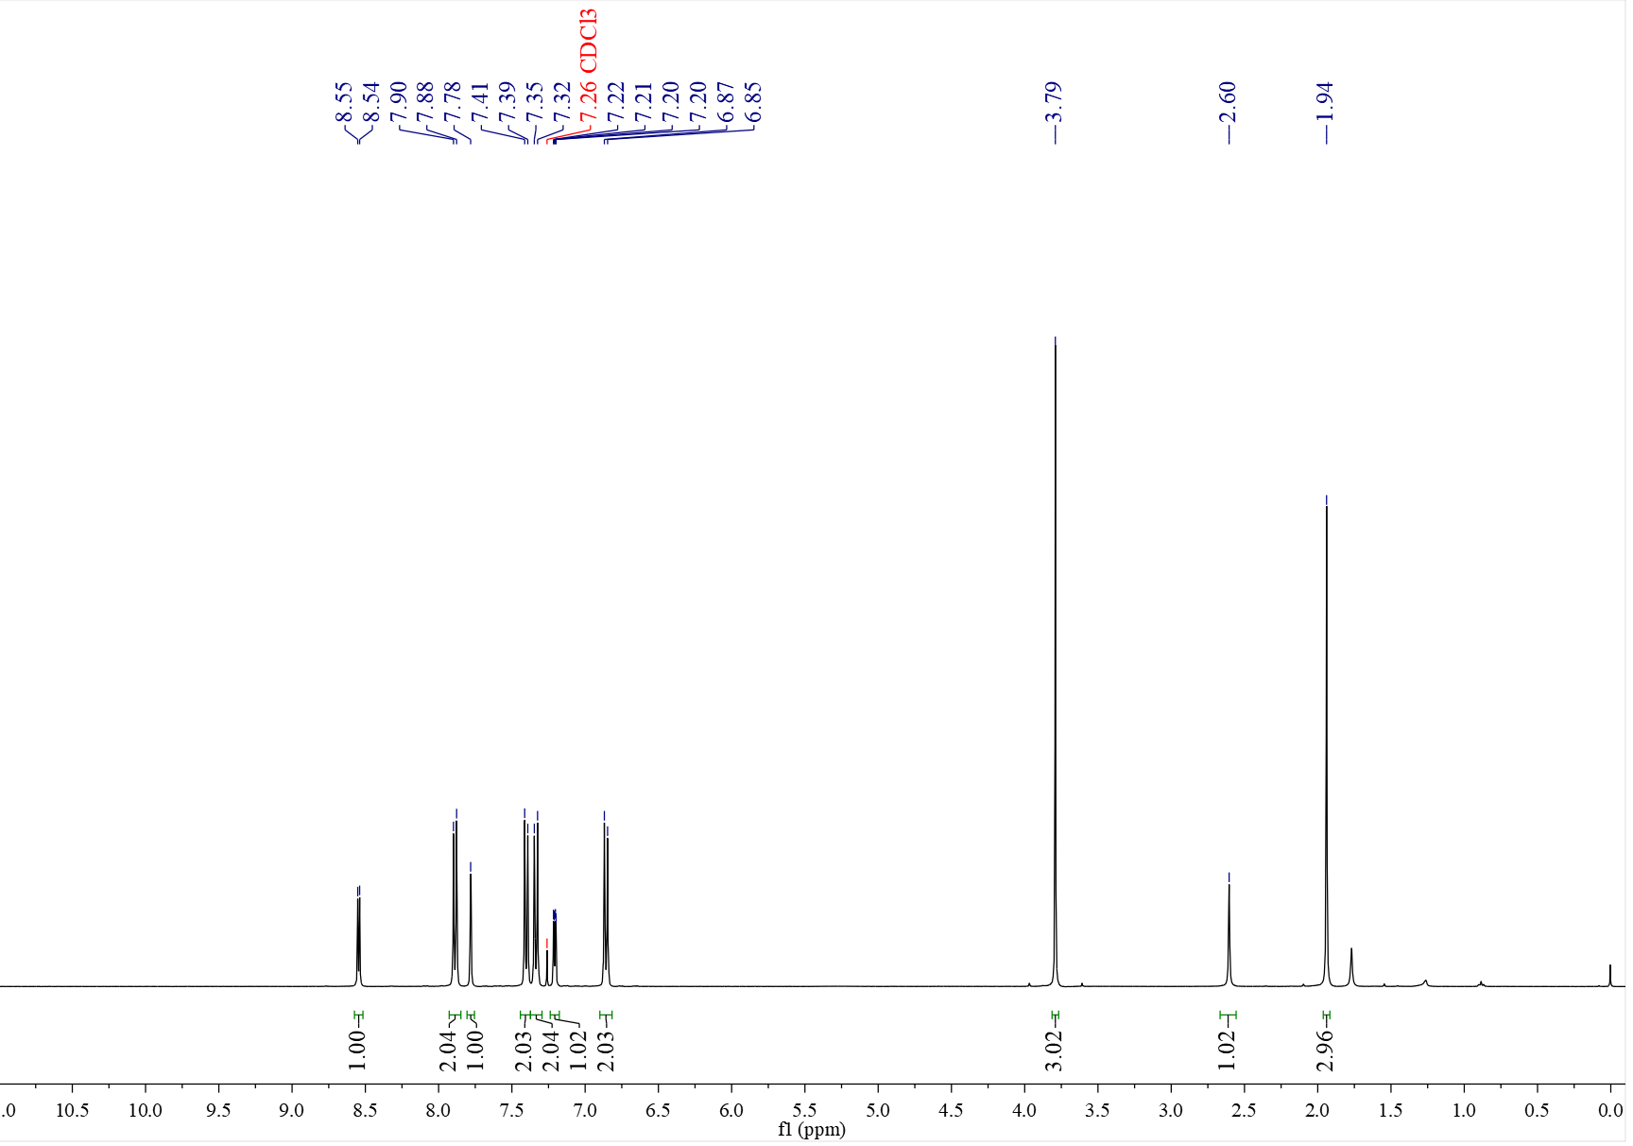

¹³C NMR spectrum of C₃₀ (126 MHz, CDCl₃)
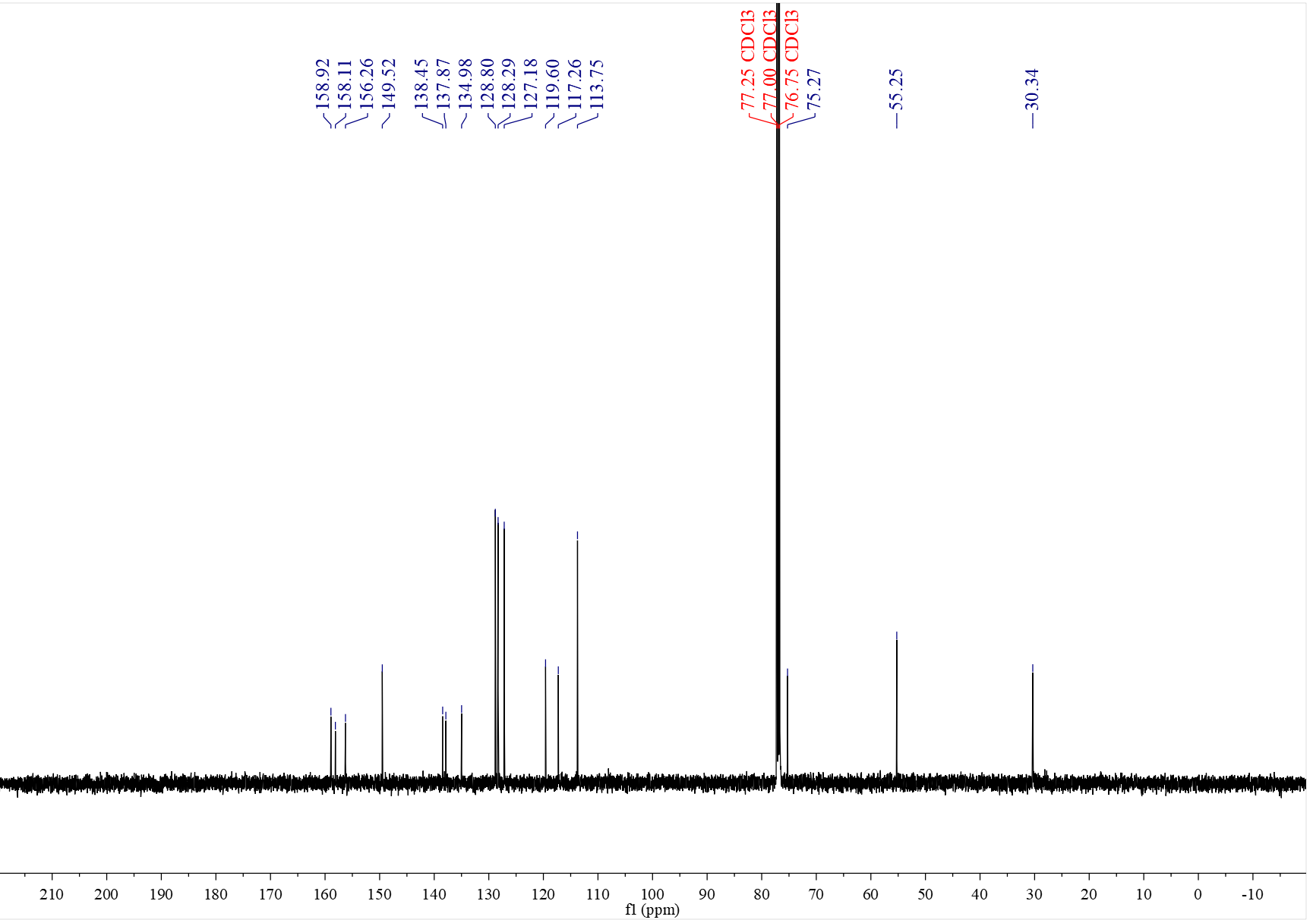

¹H NMR spectrum of C₃₁ (400 MHz, CDCl₃)
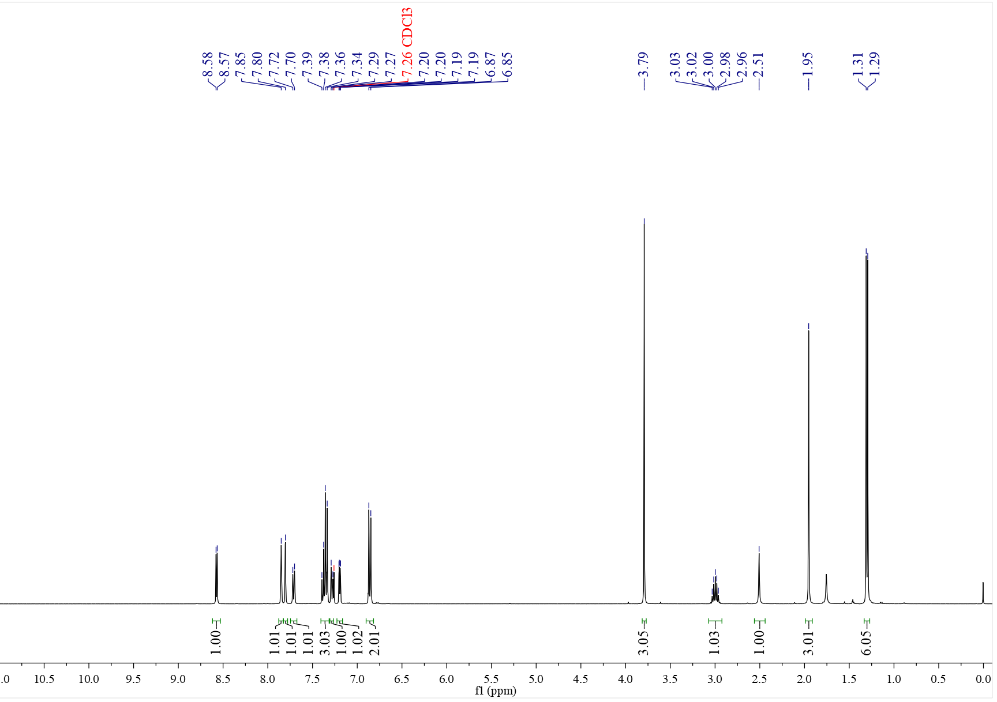

¹³C NMR spectrum of C₃₁ (126 MHz, CDCl₃)
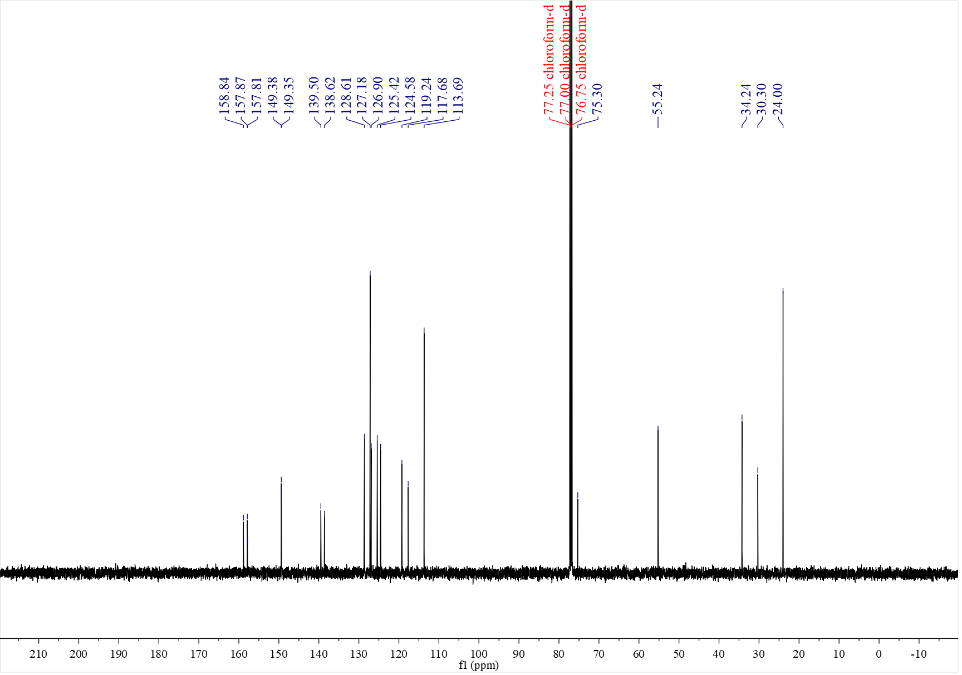

¹H NMR spectrum of C₃₂ (500 MHz, CDCl₃)
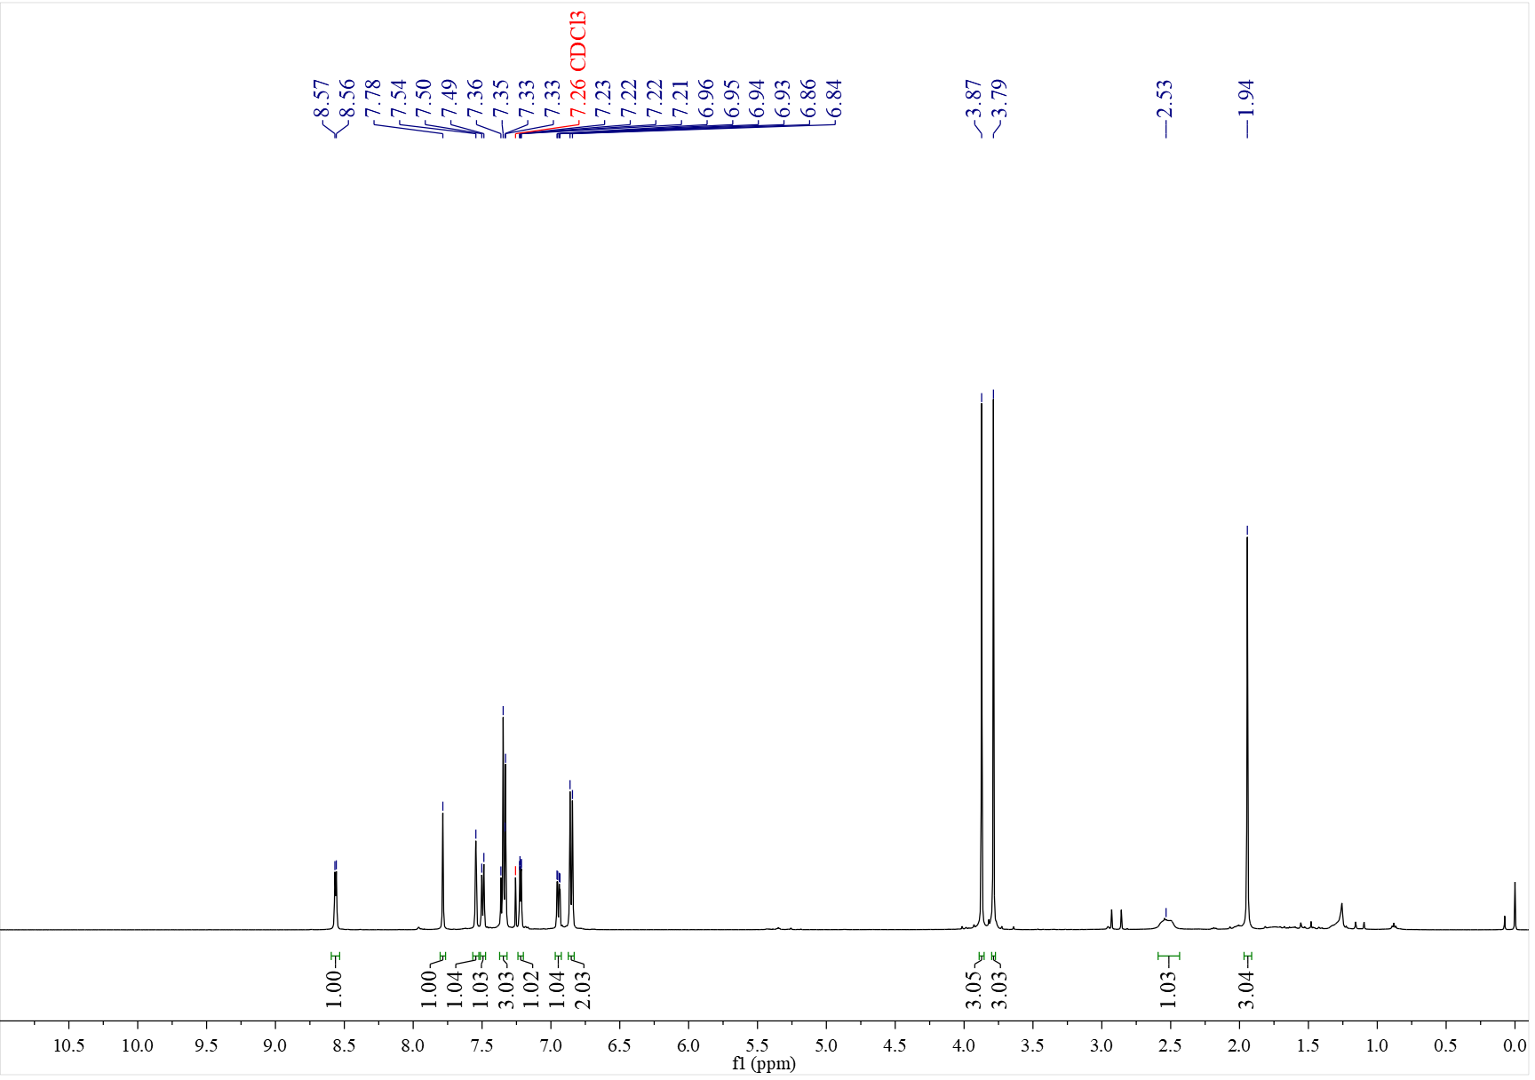

¹³C NMR spectrum of C₃₂ (126 MHz, CDCl₃)
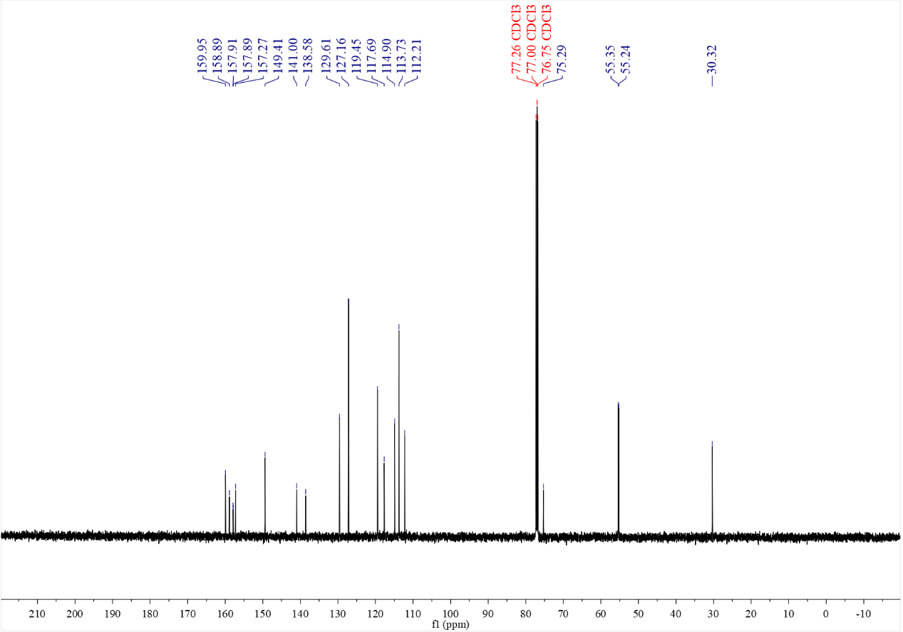

¹H NMR spectrum of C₃₃ (500 MHz, CDCl₃)
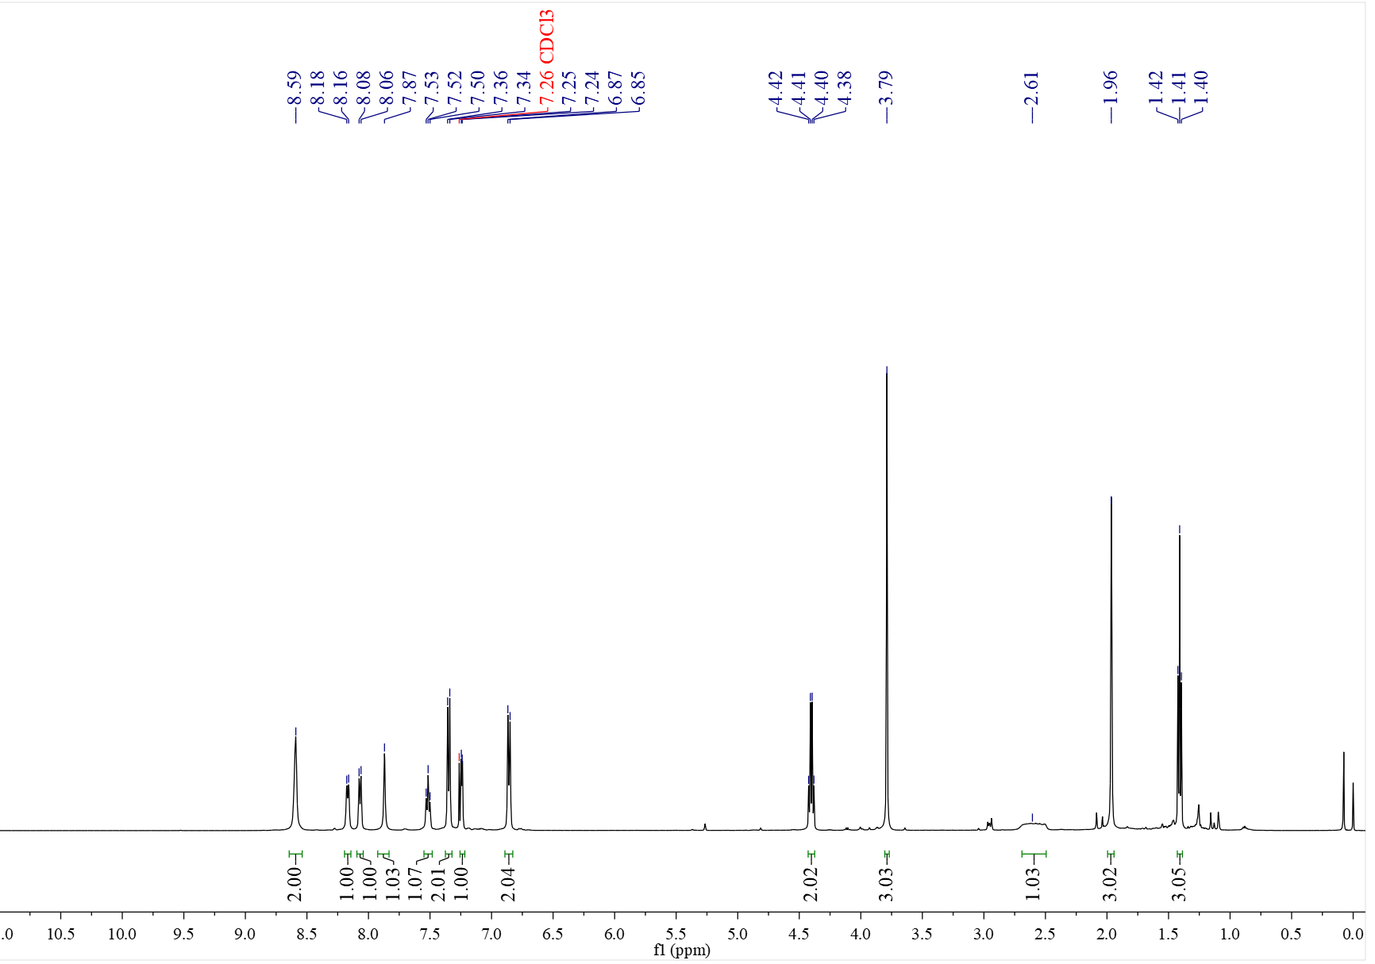

¹³C NMR spectrum of C₃₃ (126 MHz, CDCl₃)
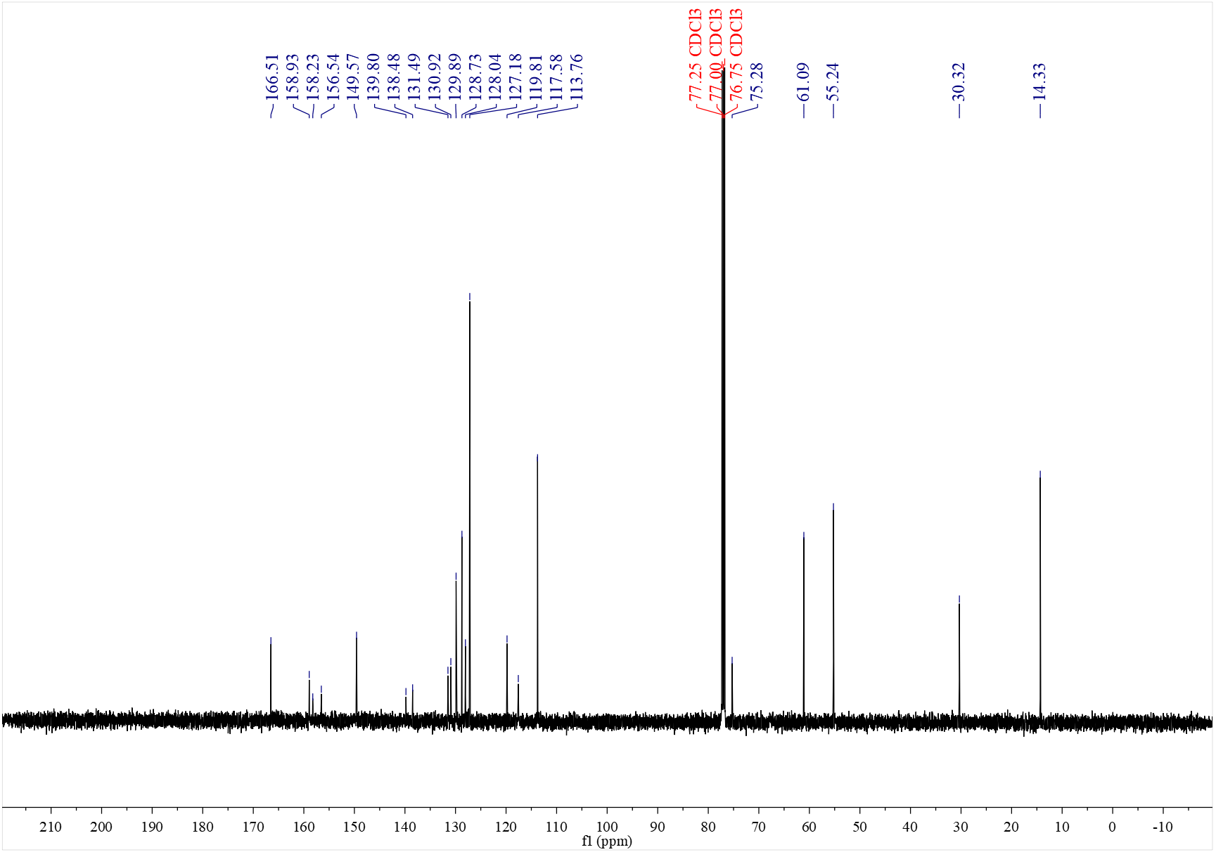

¹H NMR spectrum of C₃₄ (500 MHz, CDCl₃)
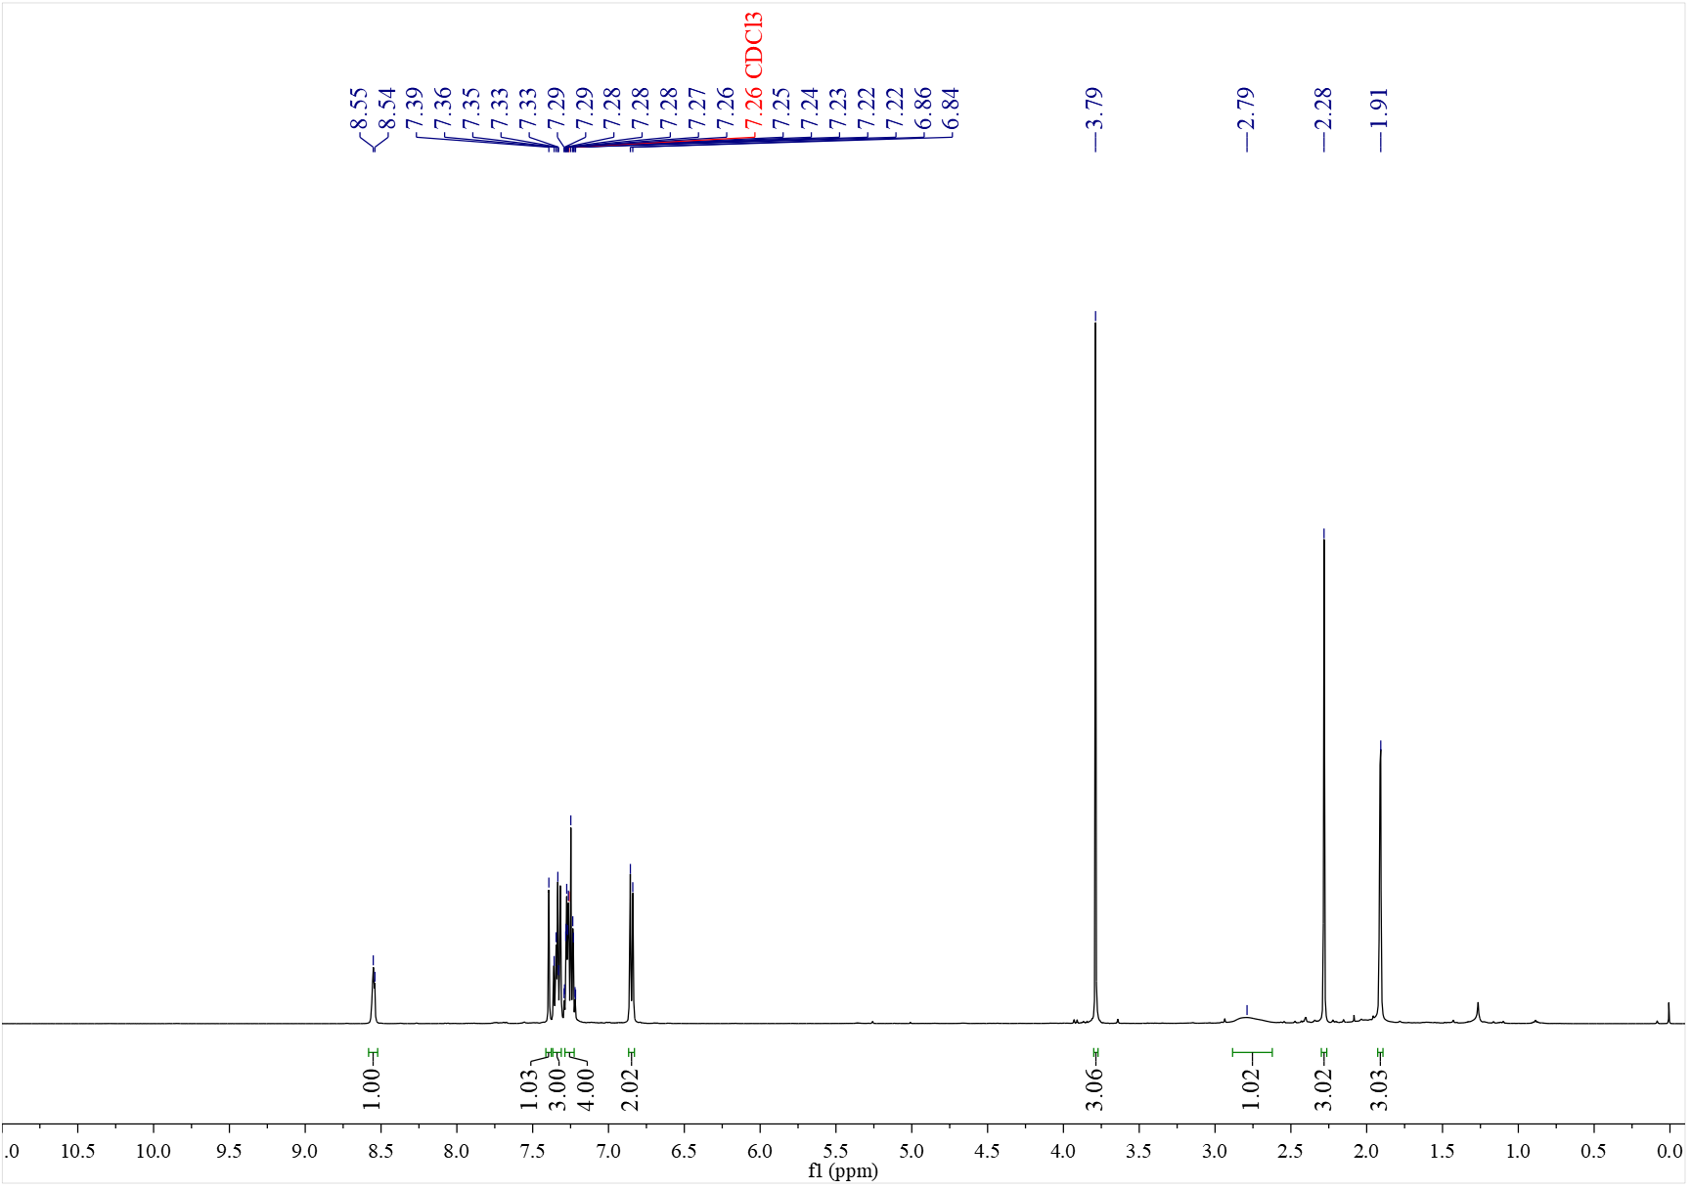

¹³C NMR spectrum of C₃₄ (126 MHz, CDCl₃)
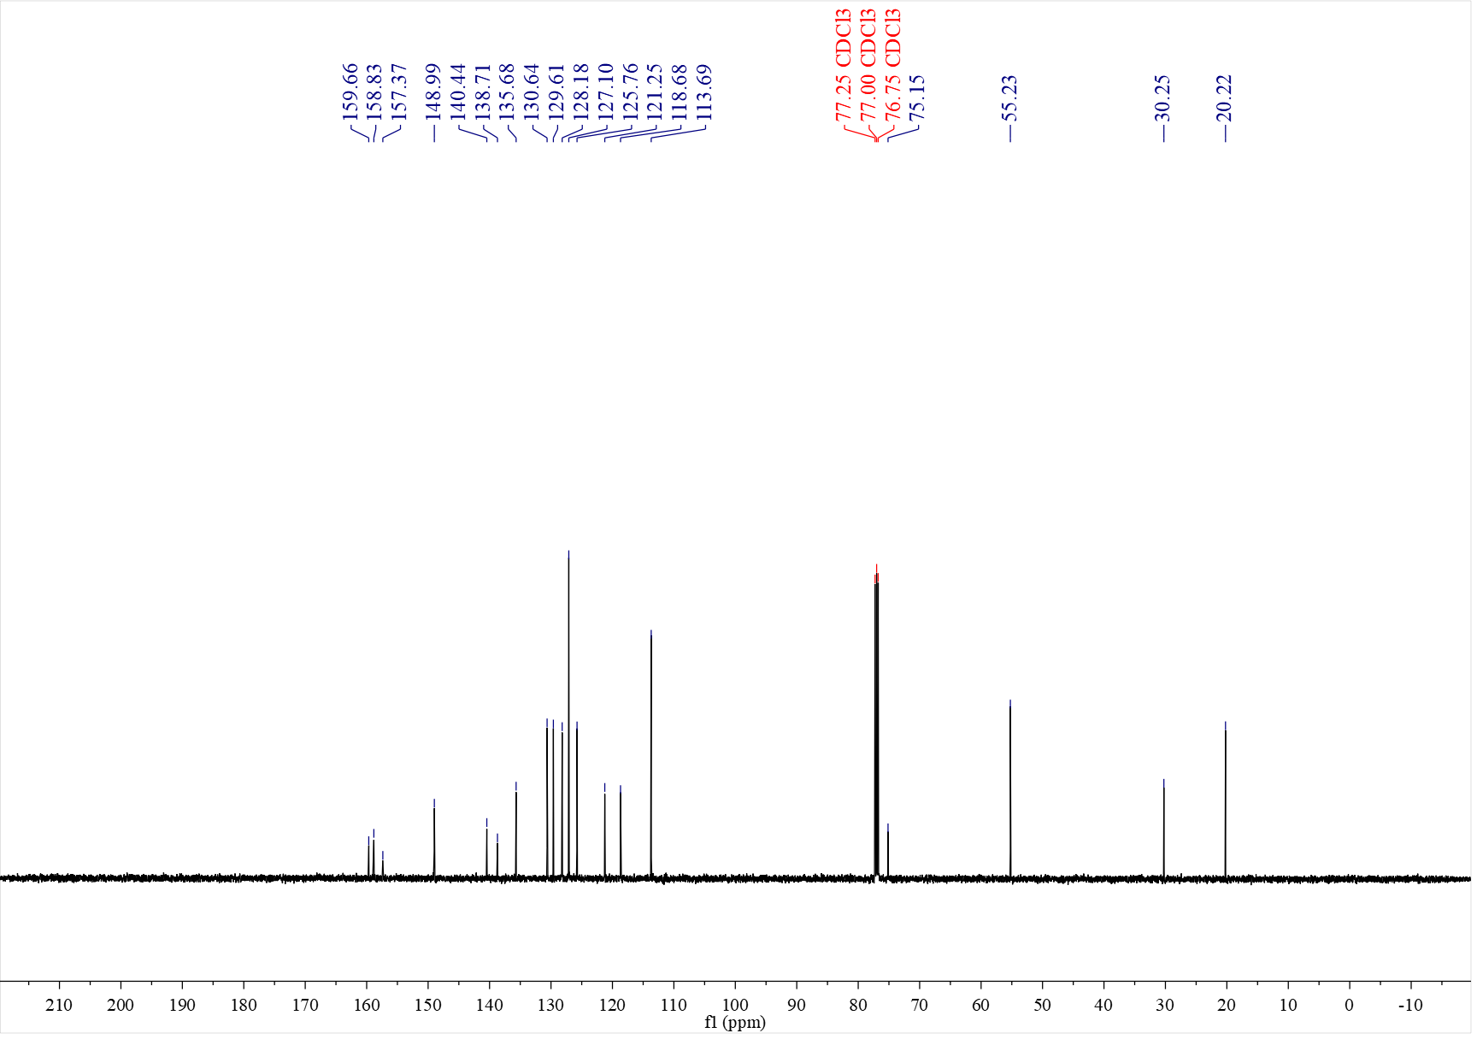

¹H NMR spectrum of C₃₅ (500 MHz, CDCl₃)
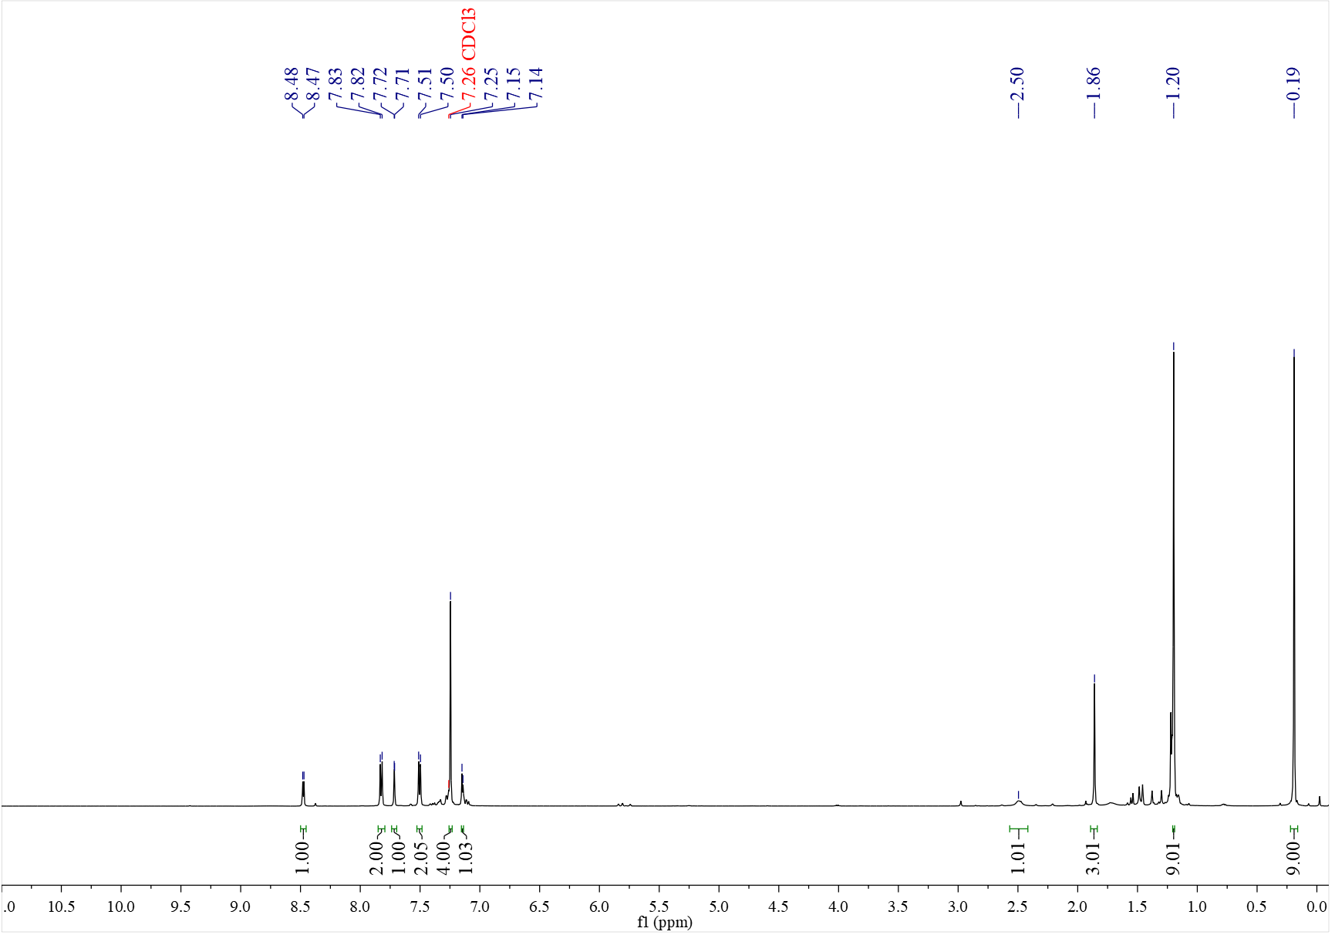

¹³C NMR spectrum of C₃₅ (126 MHz, CDCl₃)
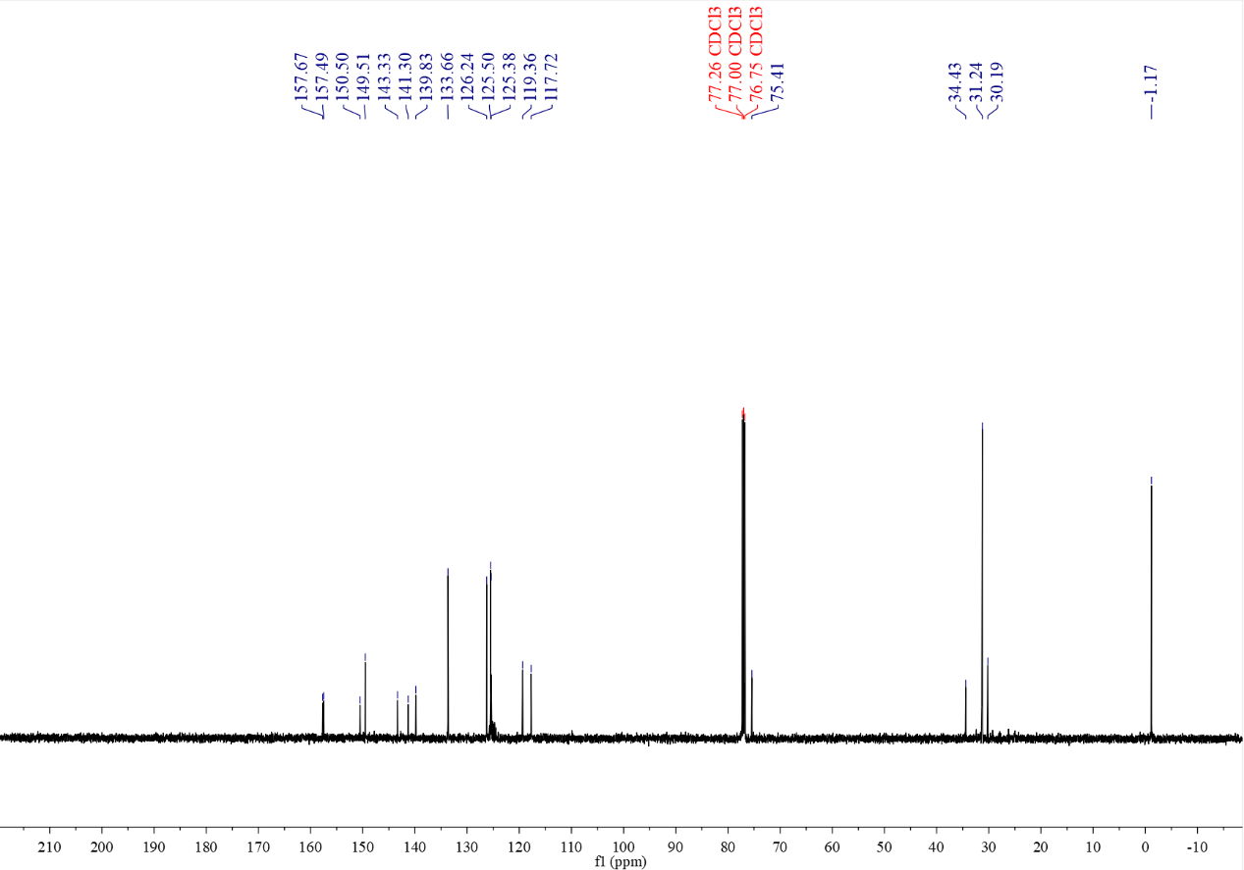

¹H NMR spectrum of C₃₆ (500 MHz, CDCl₃)
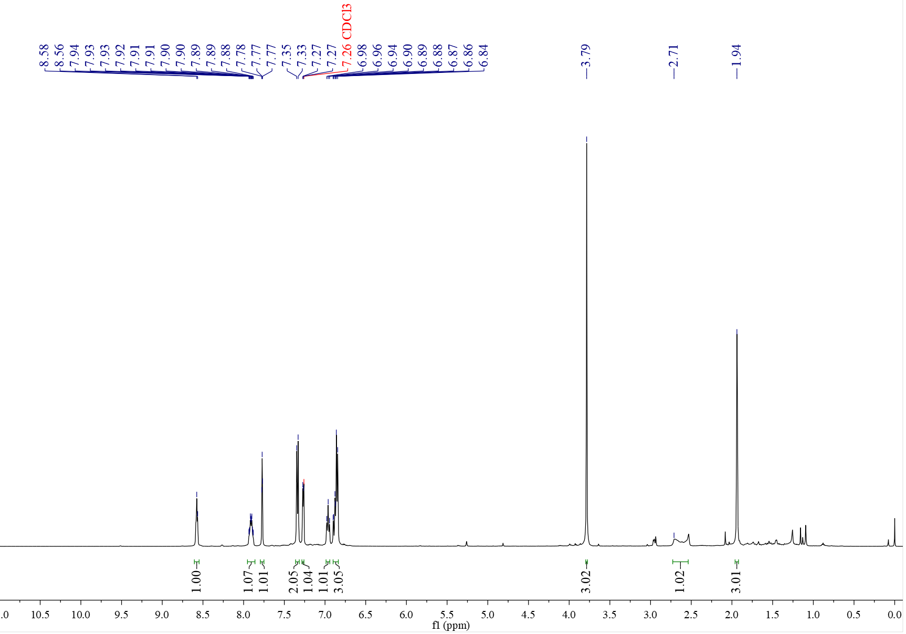

¹³C NMR spectrum of C₃₆ (126 MHz, CDCl₃)
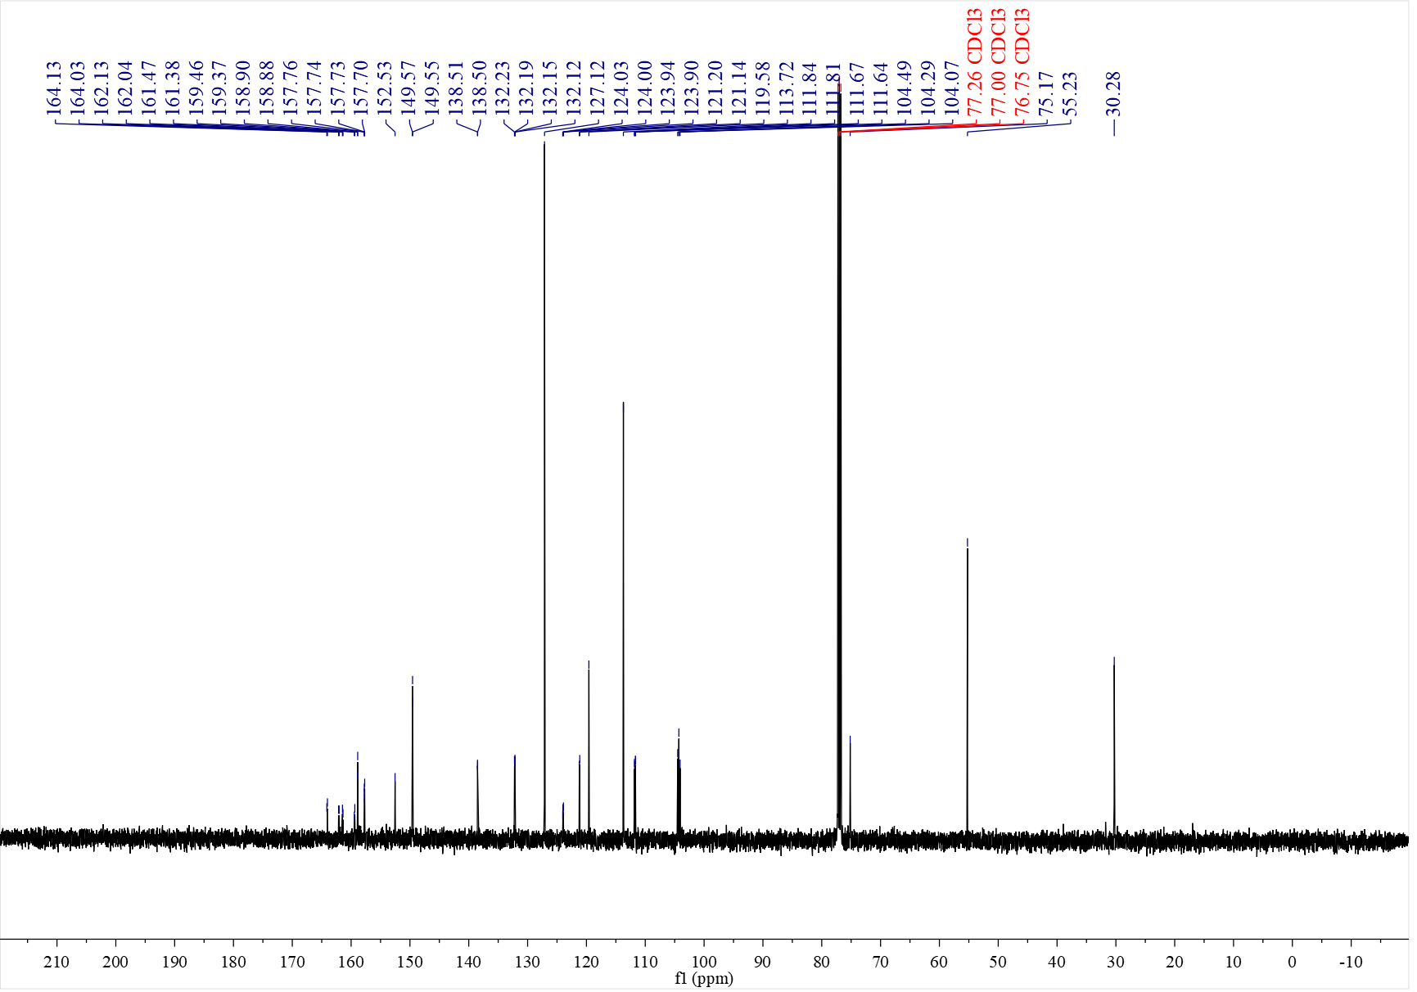

¹⁹F NMR spectrum of C₃₆ (471 MHz, CDCl₃)
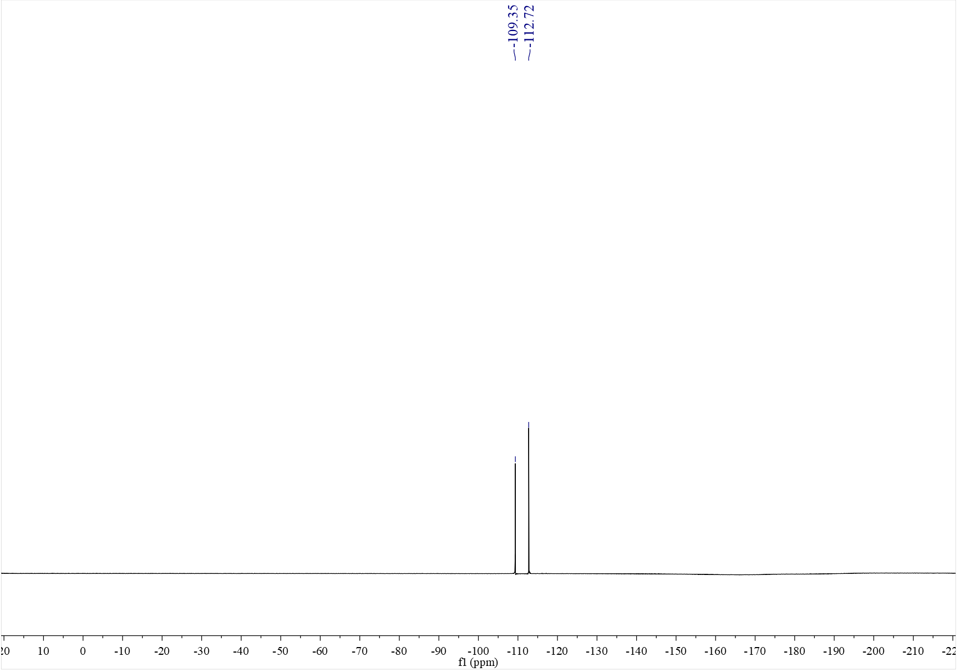

¹H NMR spectrum of C₃₇ (500 MHz, CDCl₃)
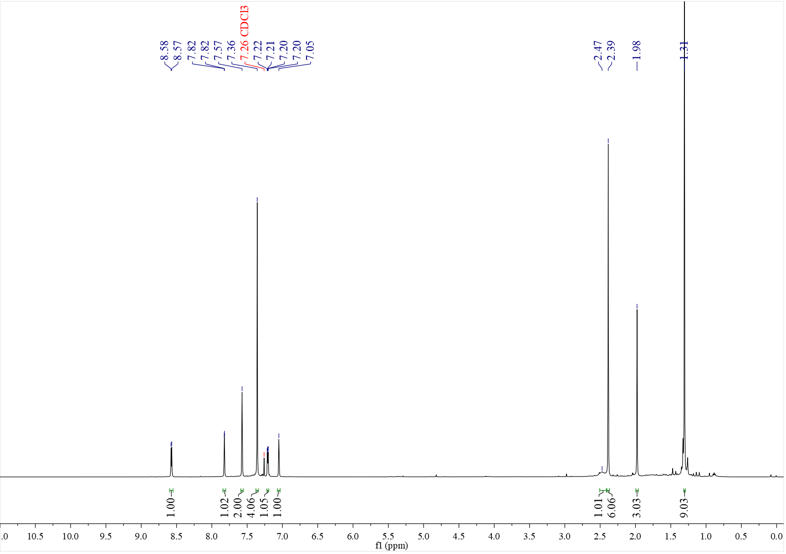

¹³C NMR spectrum of C₃₇ (126 MHz, CDCl₃)
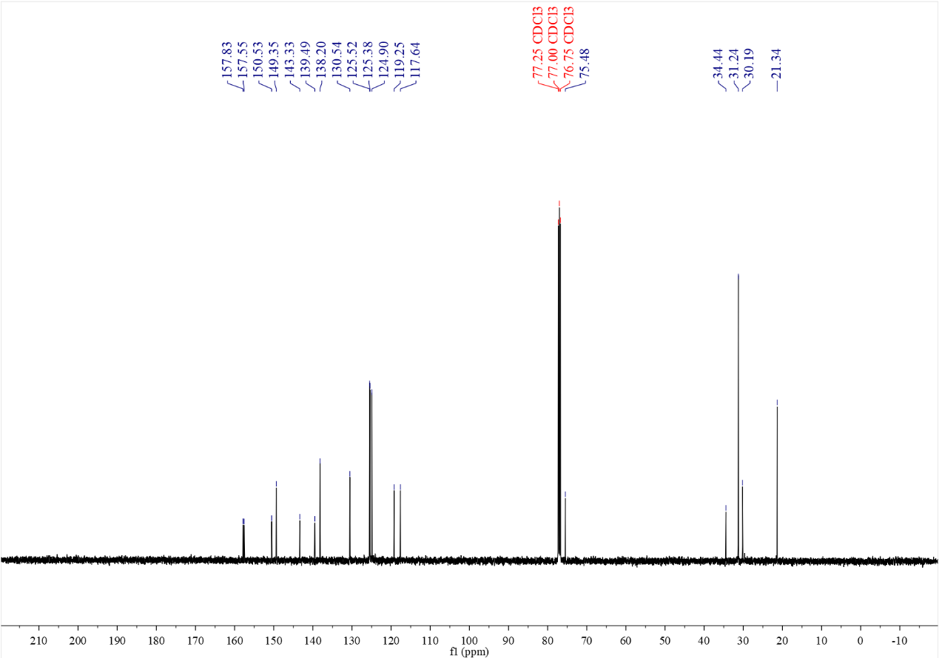

¹H NMR spectrum of C₃₈ (500 MHz, CDCl₃)
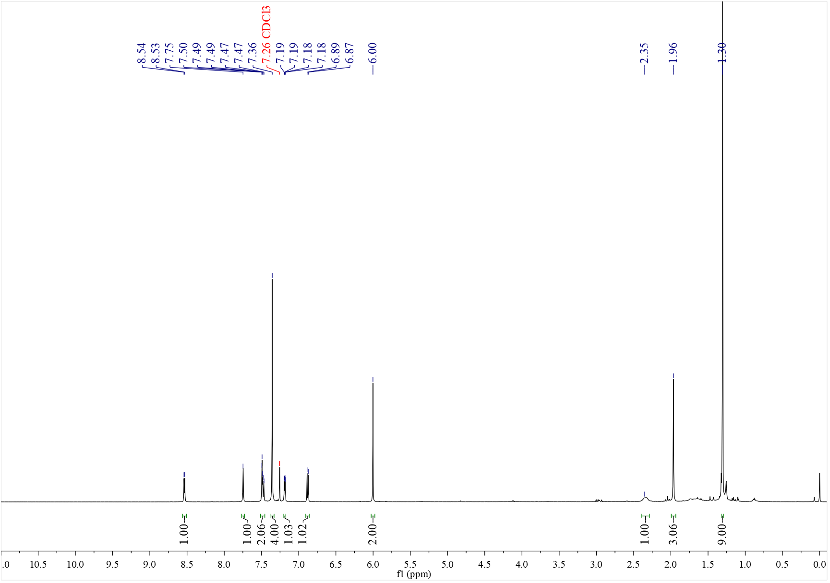

¹³C NMR spectrum of C₃₈ (126 MHz, CDCl₃)
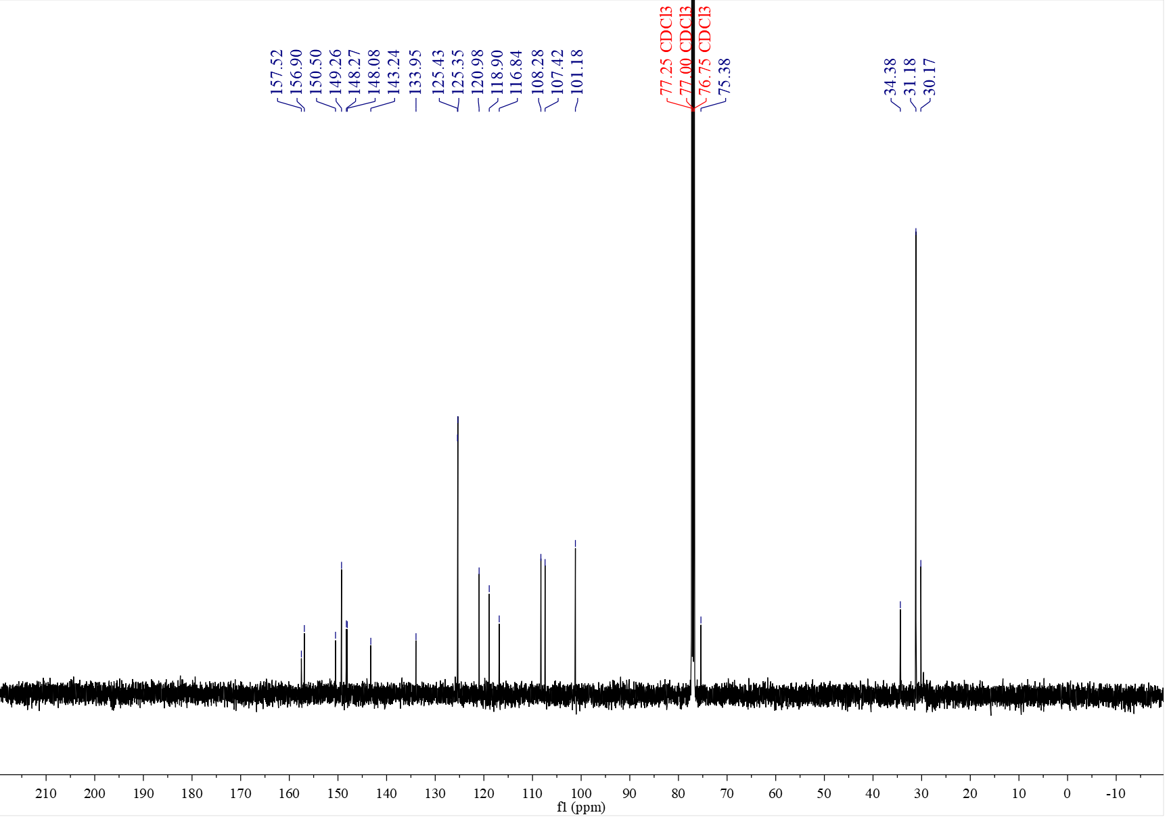

¹H NMR spectrum of C₃₉ (500 MHz, CDCl₃)
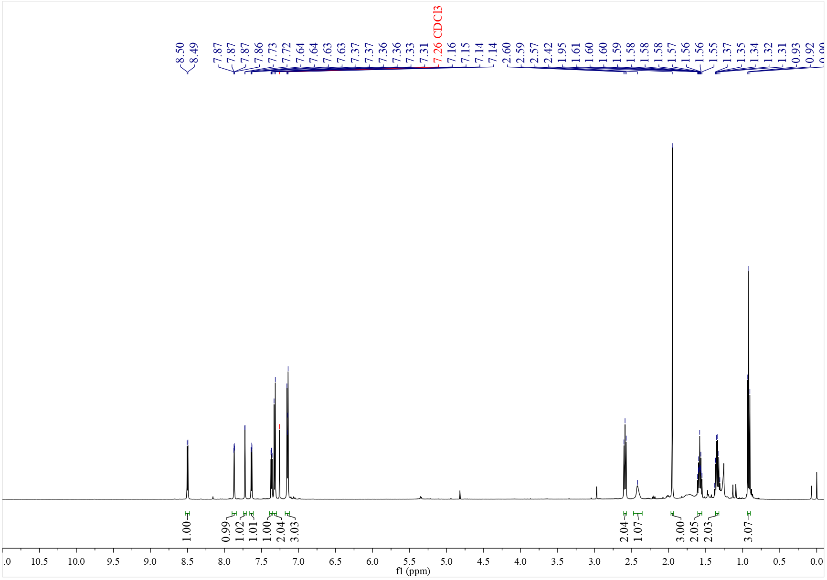

¹³C NMR spectrum of C₃₉ (126 MHz, CDCl₃)
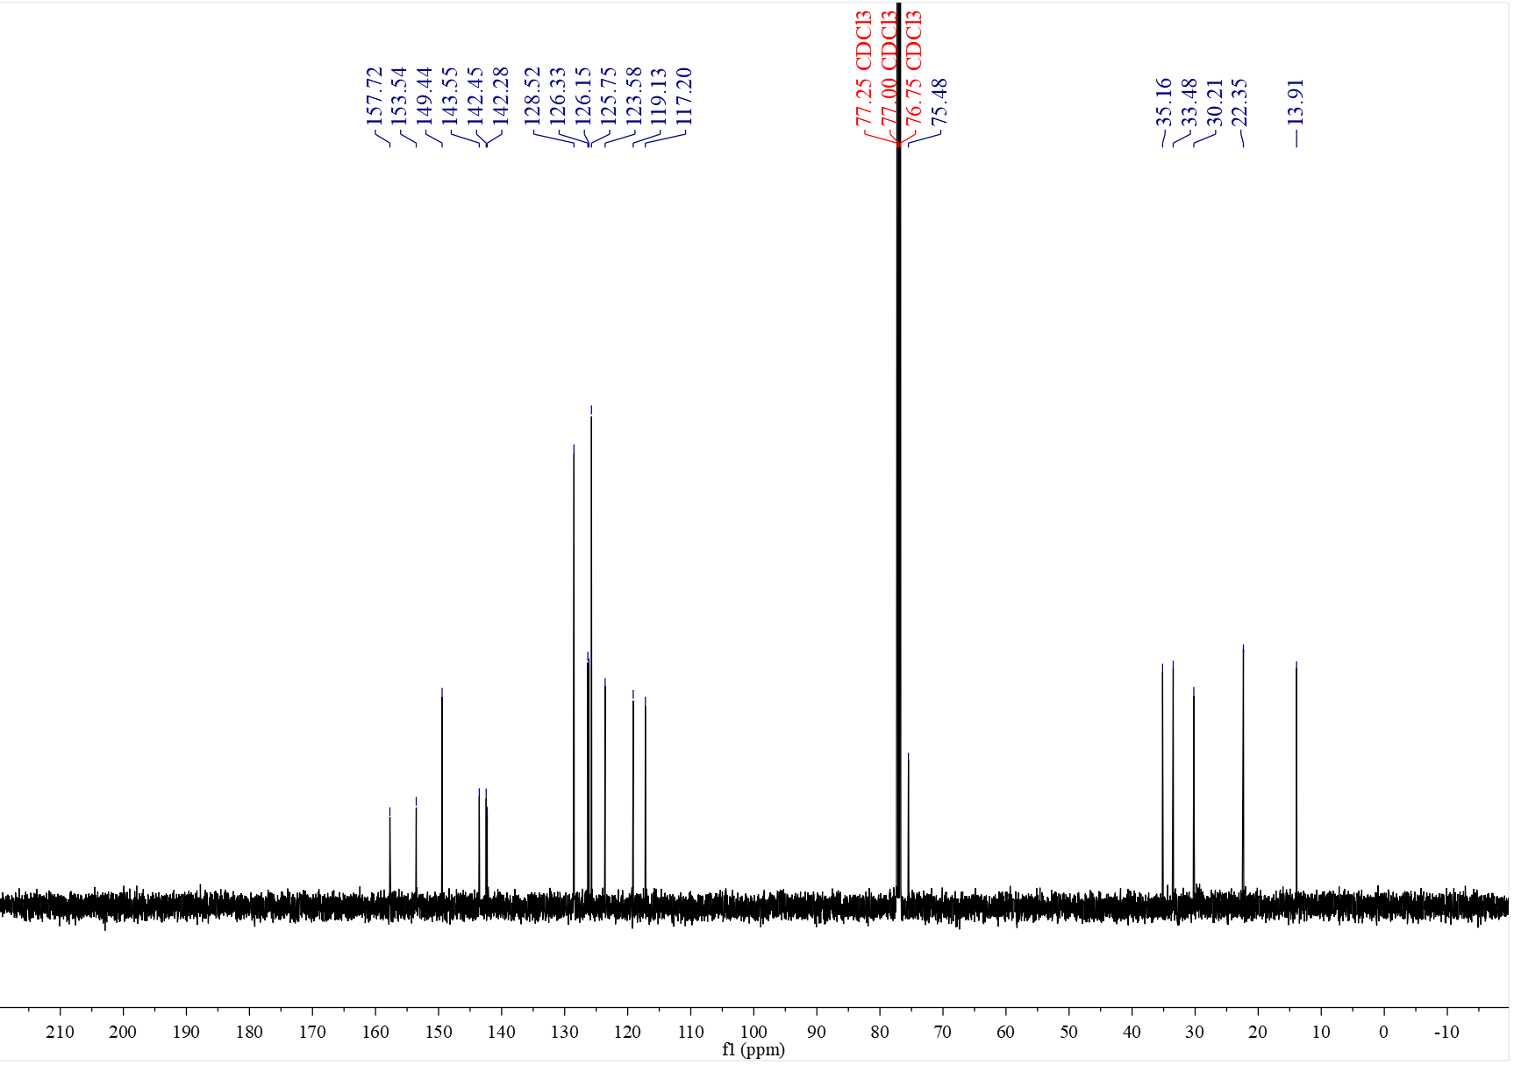

¹H NMR spectrum of C₄₀ (500 MHz, CDCl₃)
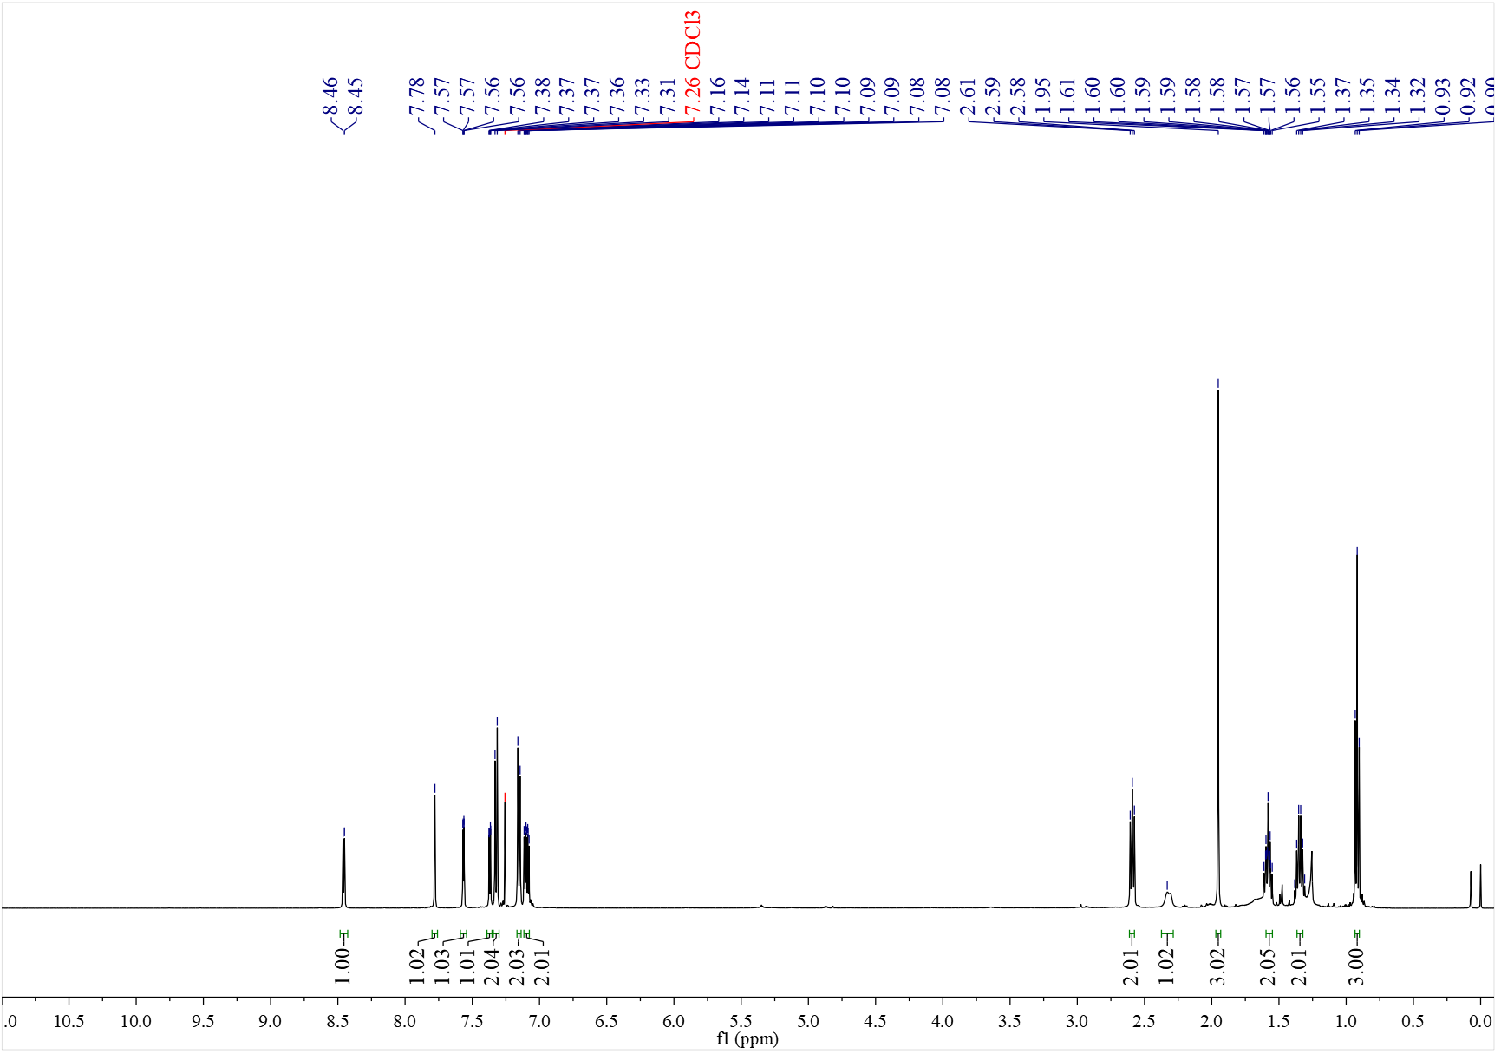

¹³C NMR spectrum of C₄₀ (126 MHz, CDCl₃)
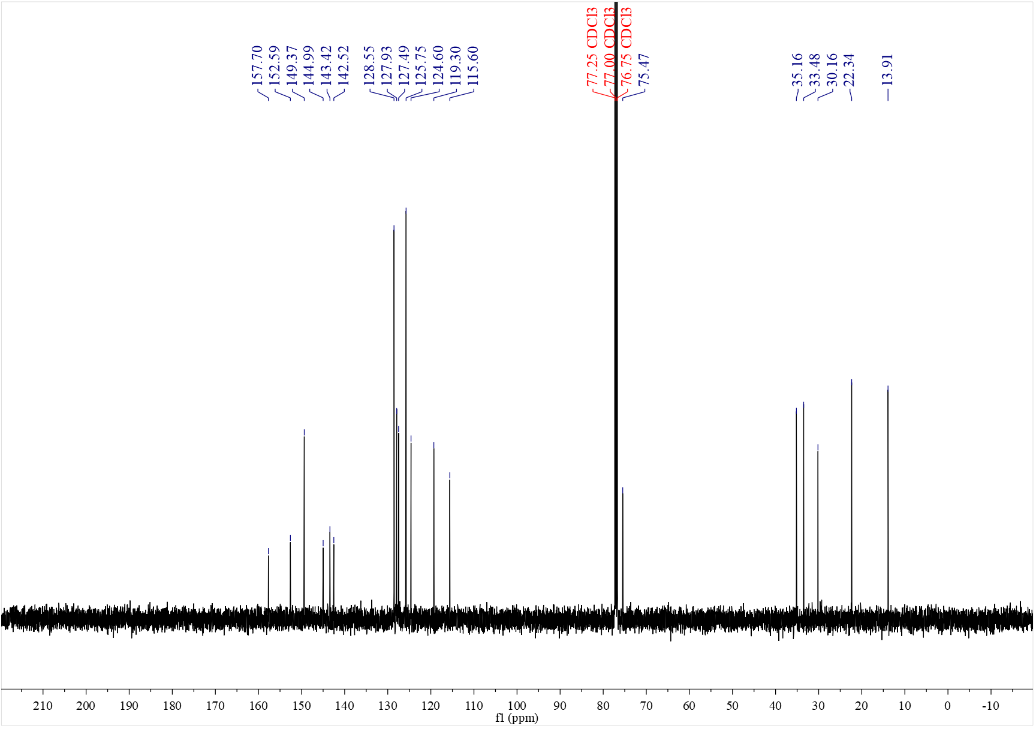

¹H NMR spectrum of C₄₁ (500 MHz, CDCl₃)
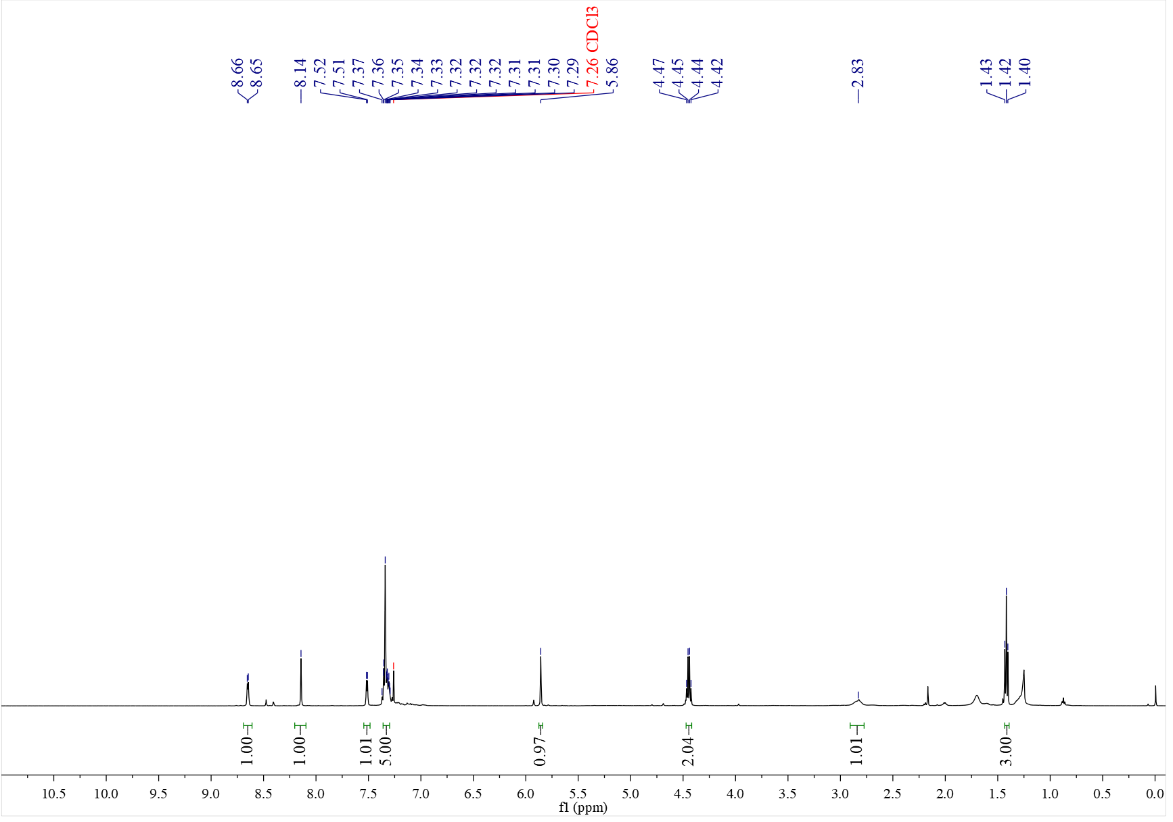

¹³C NMR spectrum of C₄₁ (126 MHz, CDCl₃)
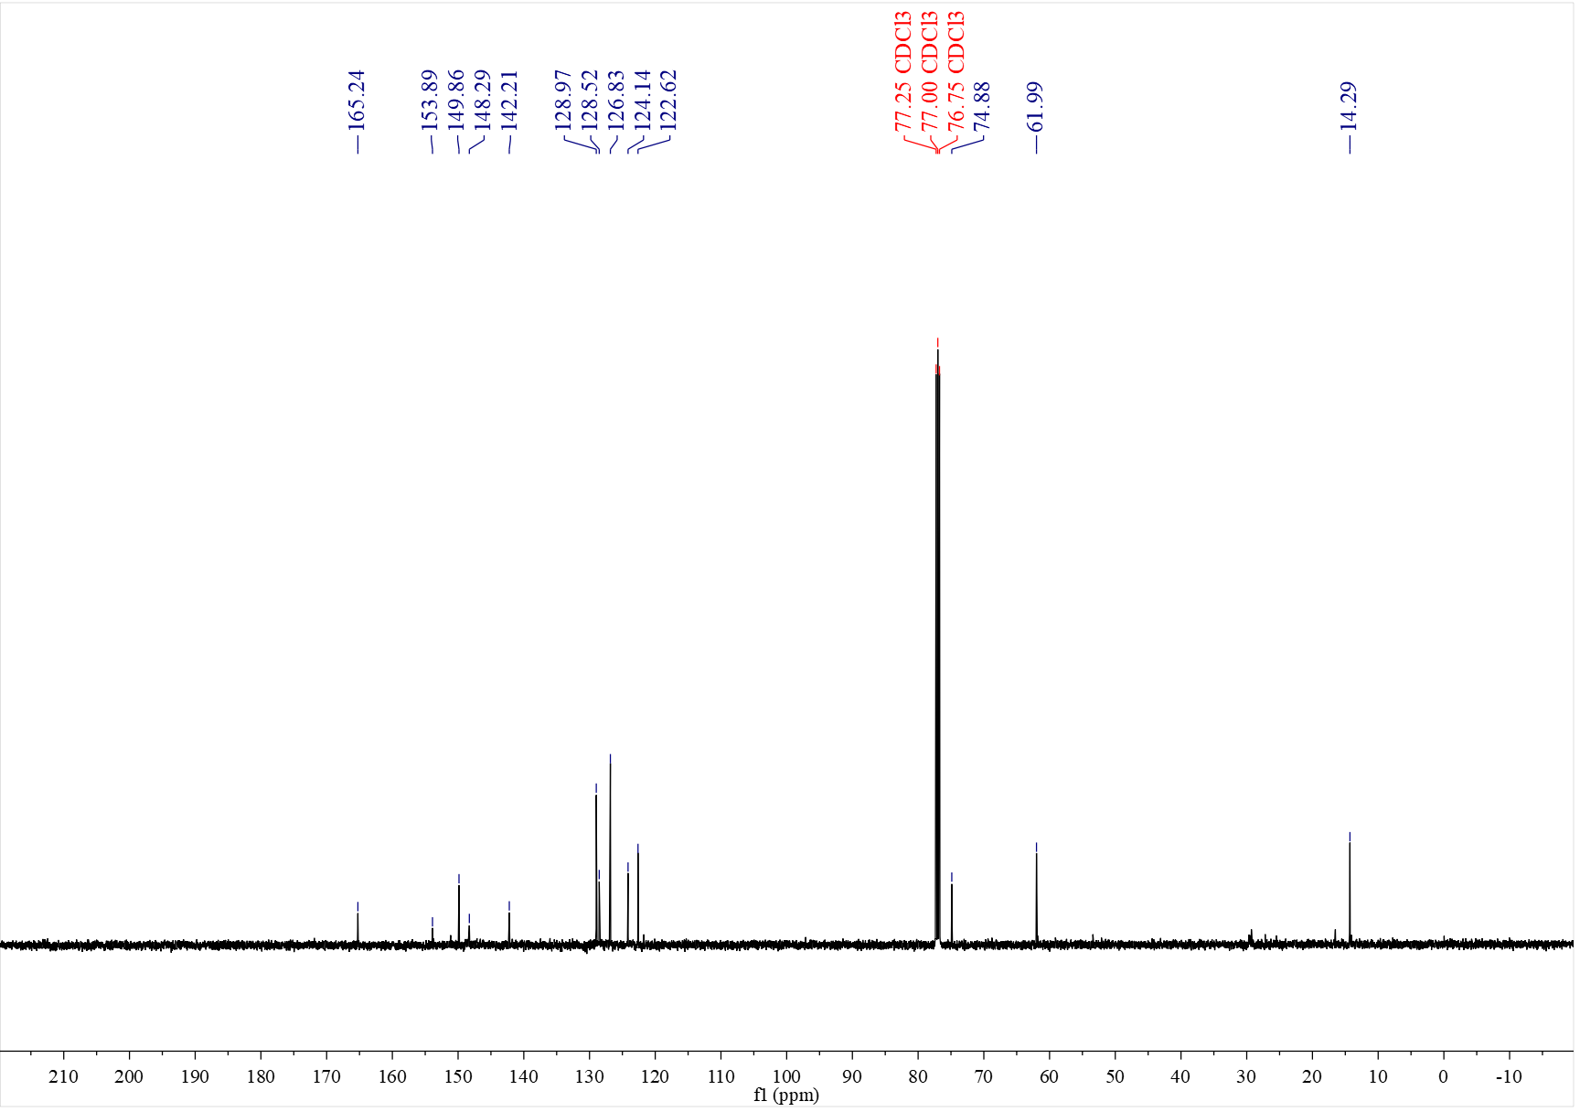

¹H NMR spectrum of C₄₂ (500 MHz, CDCl₃)
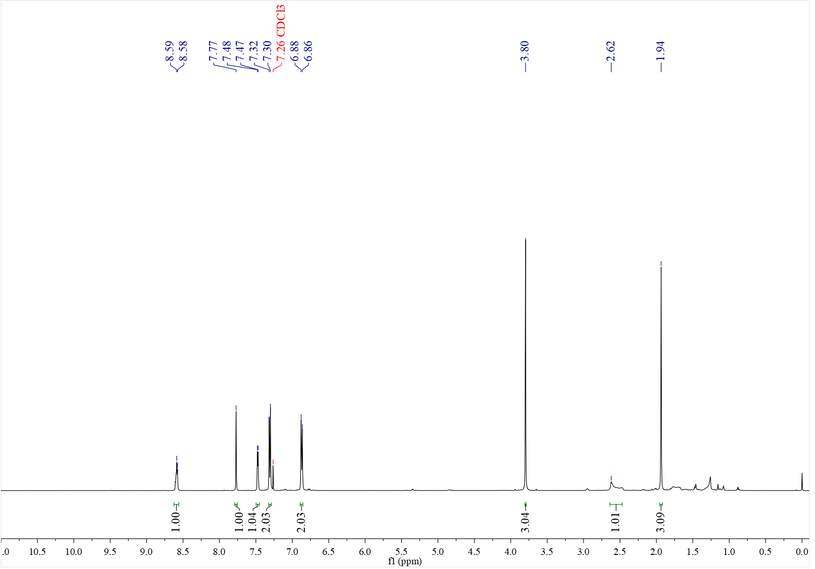

¹³C NMR spectrum of C₄₂ (126 MHz, CDCl₃)
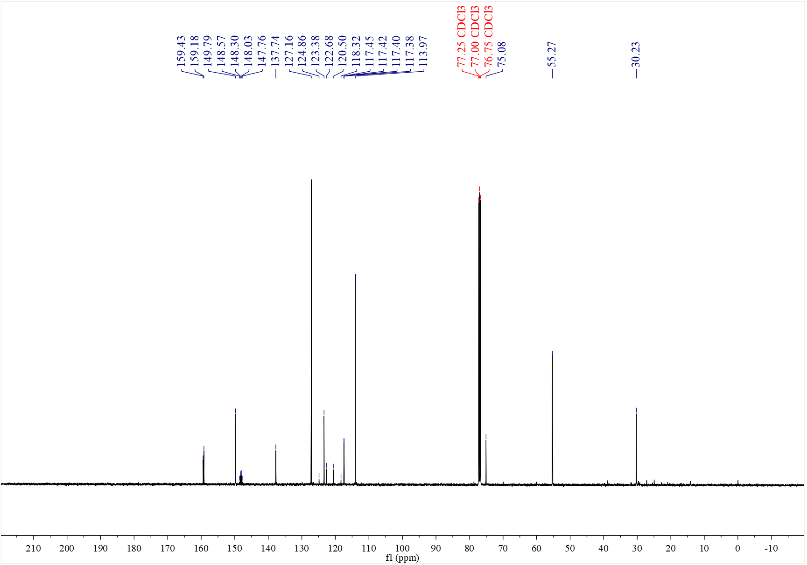

¹⁹F NMR spectrum of C₄₂ (376 MHz, CDCl₃)
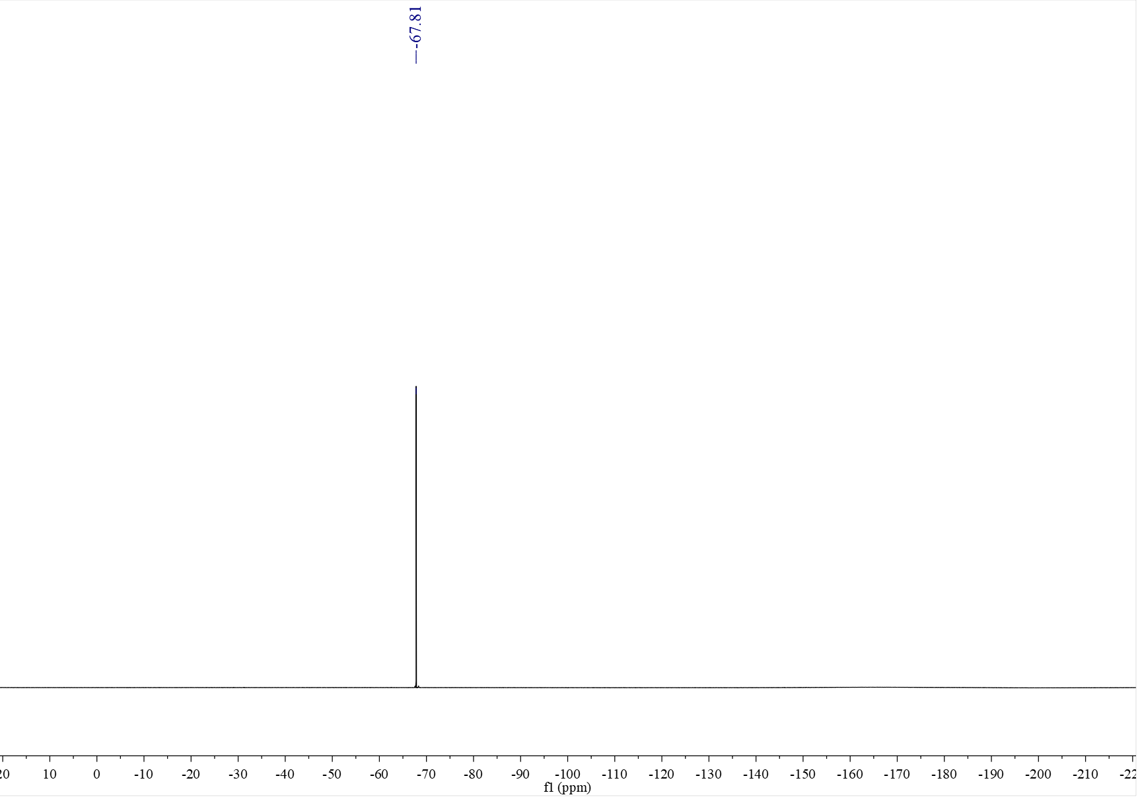

¹H NMR spectrum of C₄₃ (500 MHz, CDCl₃)
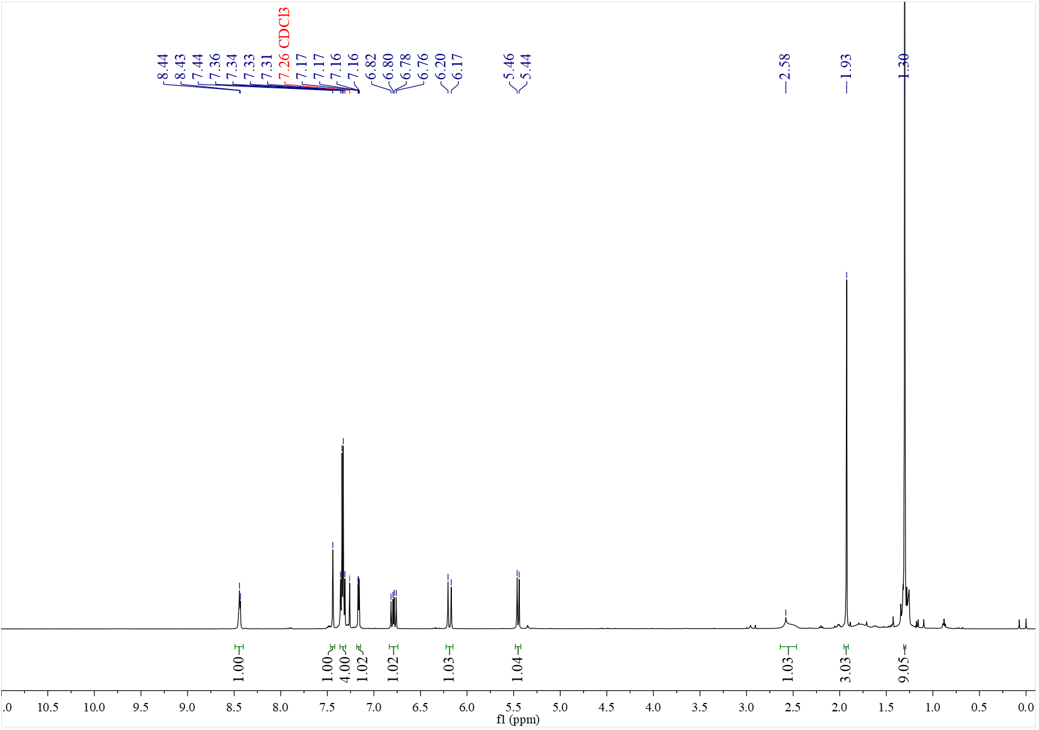

¹³C NMR spectrum of C₄₃ (126 MHz, CDCl₃)
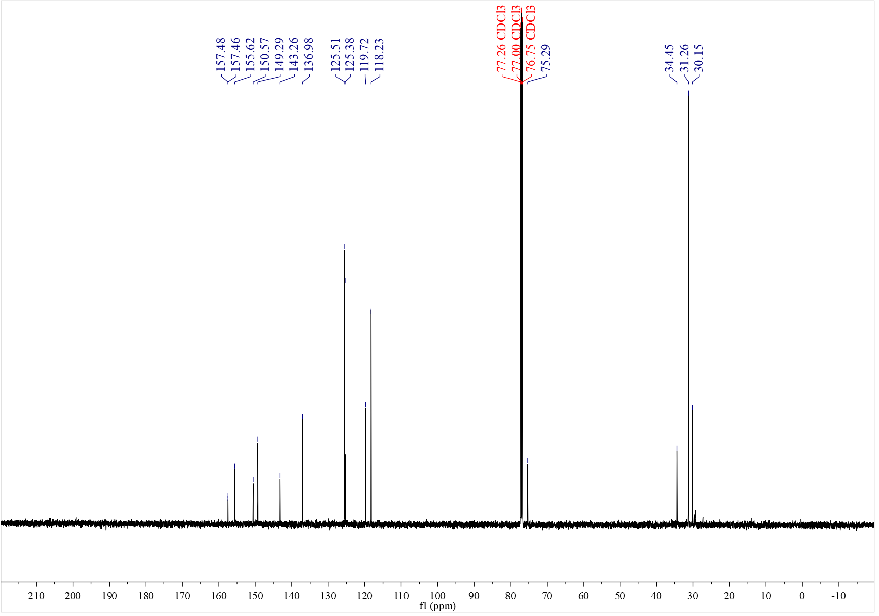

¹H NMR spectrum of C₄₄ (500 MHz, CDCl₃)
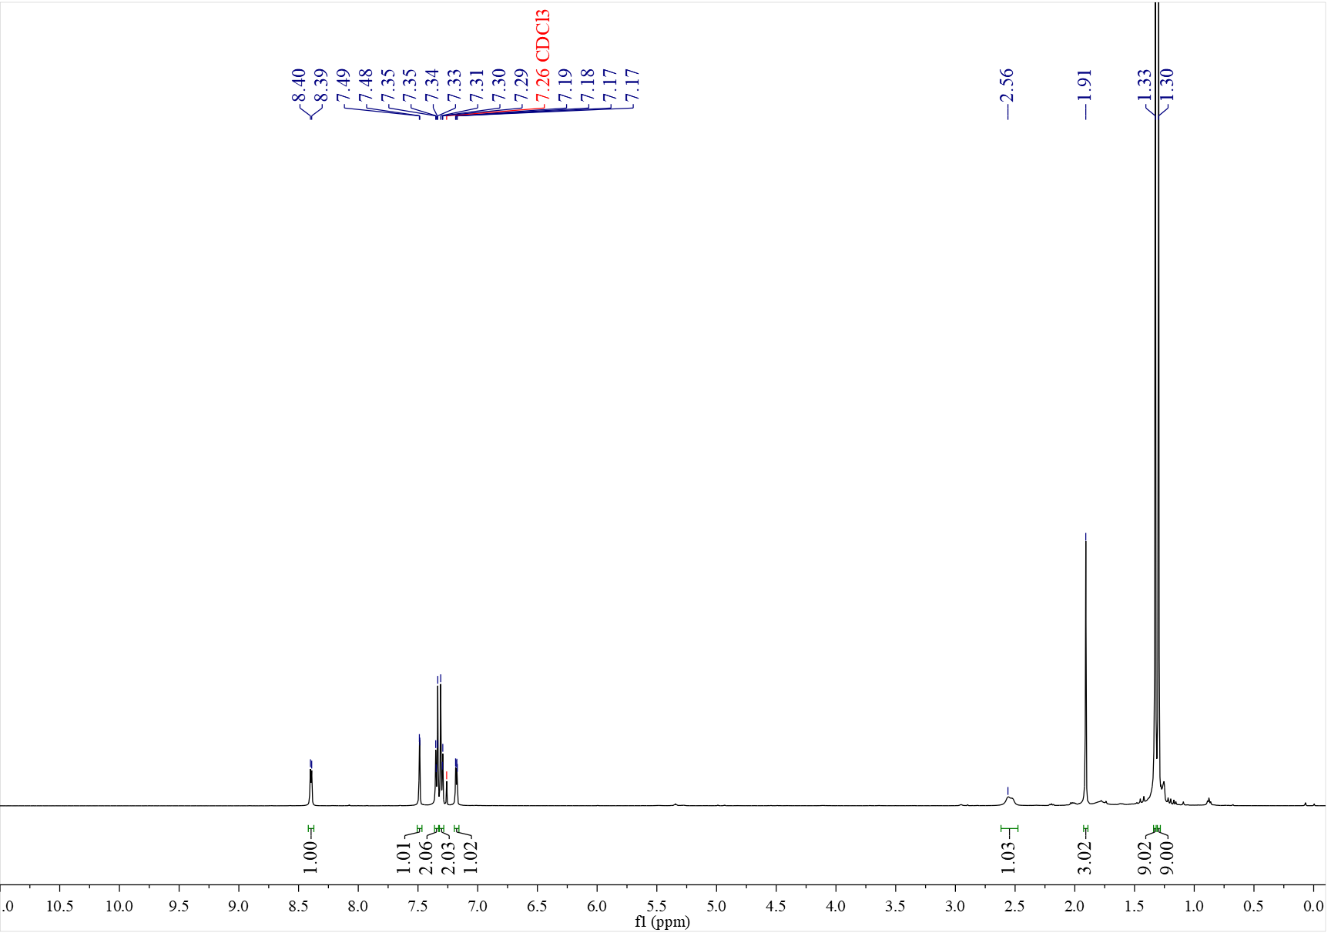

¹³C NMR spectrum of C₄₄ (126 MHz, CDCl₃)
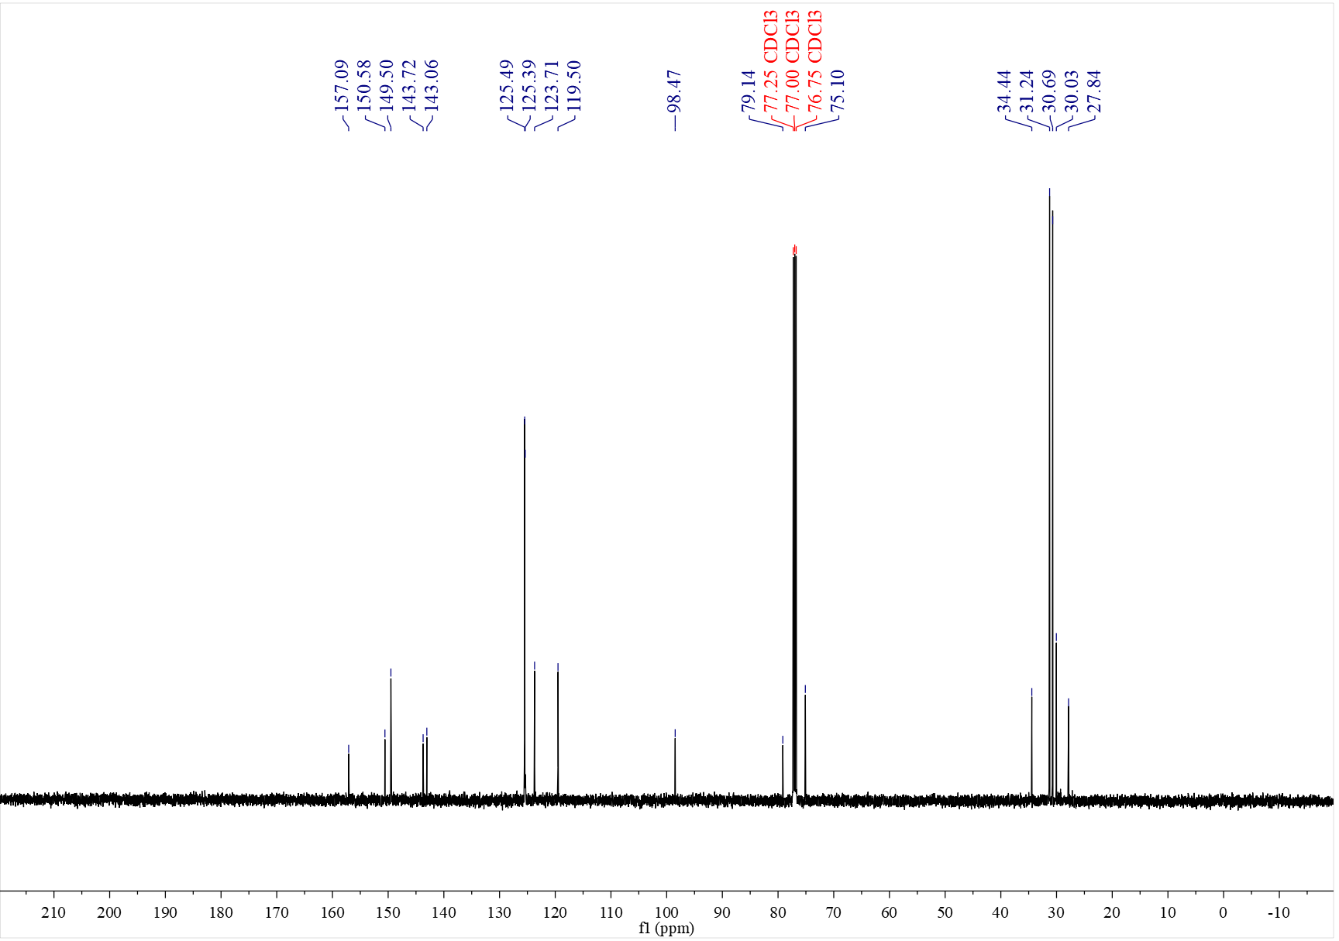

¹H NMR spectrum of C₄₅ (mixture of diastereoisomers, 500 MHz, CDCl₃)
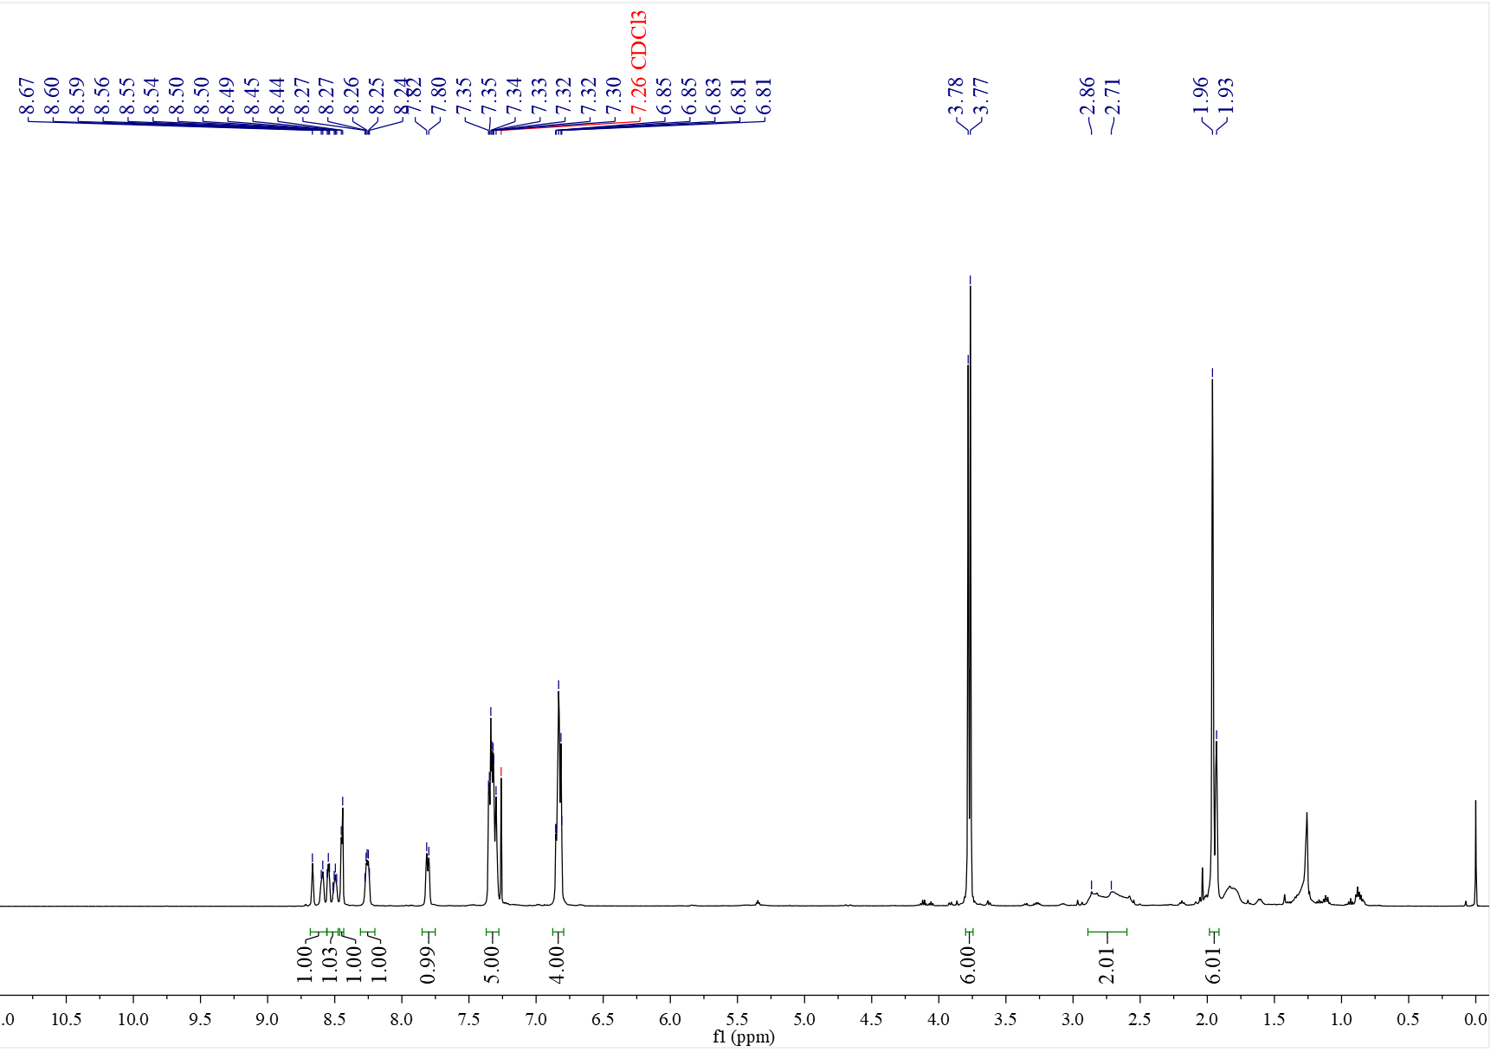

¹³C NMR spectrum of C₄₅ (mixture of diastereoisomers, 126 MHz, CDCl₃)
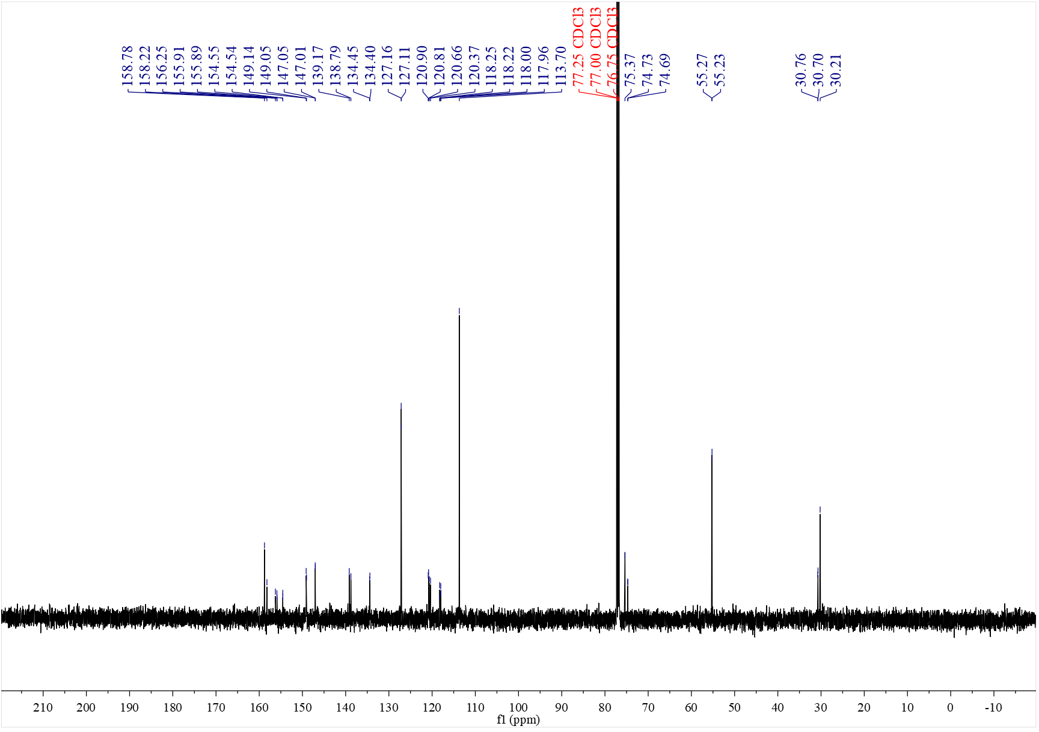

¹H NMR spectrum of C₄₆ (400 MHz, CDCl₃)
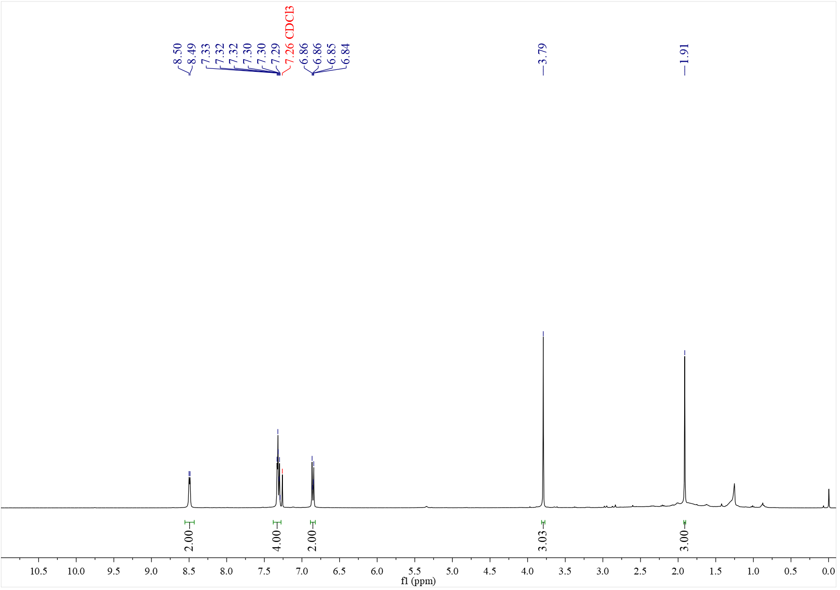

¹³C NMR spectrum of C₄₆ (101 MHz, CDCl₃)
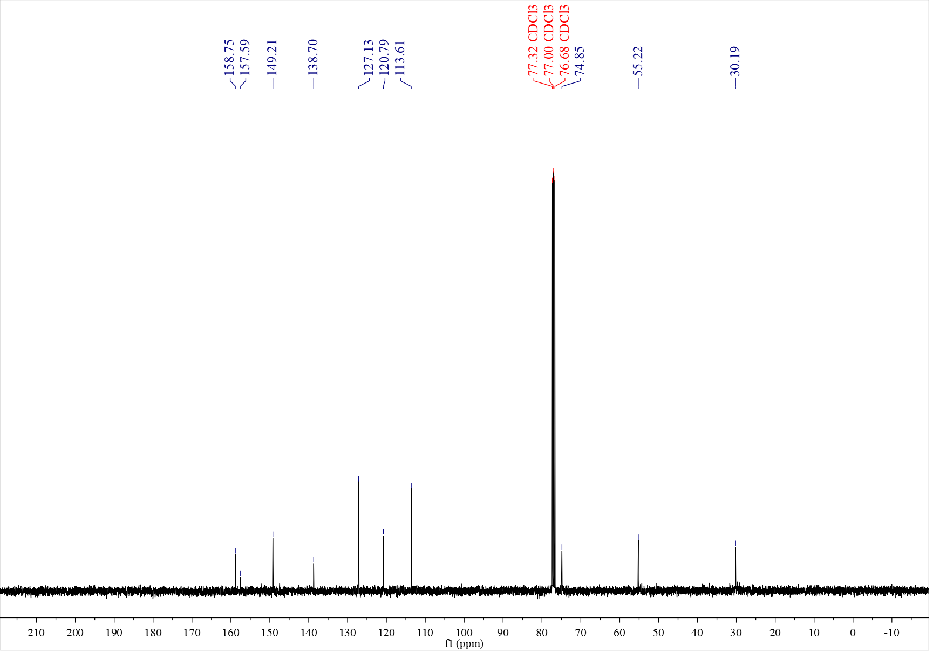

¹H NMR spectrum of C₄₇ (500 MHz, CDCl₃)
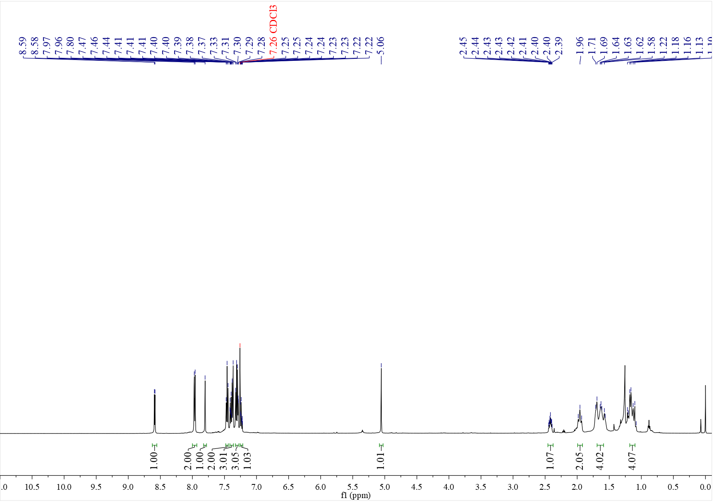

¹³C NMR spectrum of C₄₇ (126 MHz, CDCl₃)
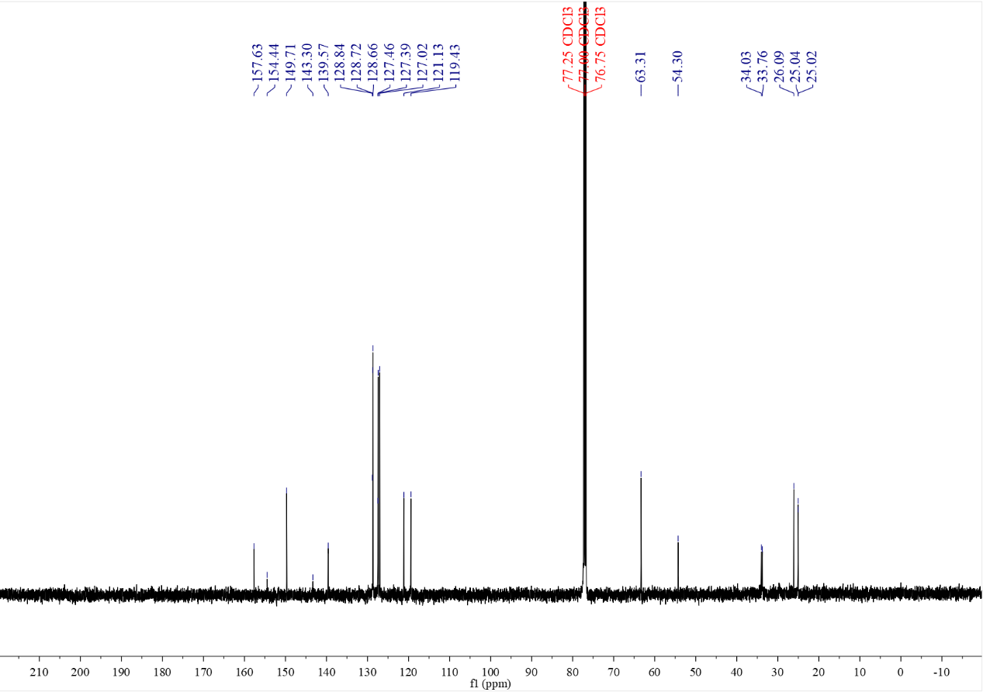

¹H NMR spectrum of C₄₈ (500 MHz, CDCl₃)
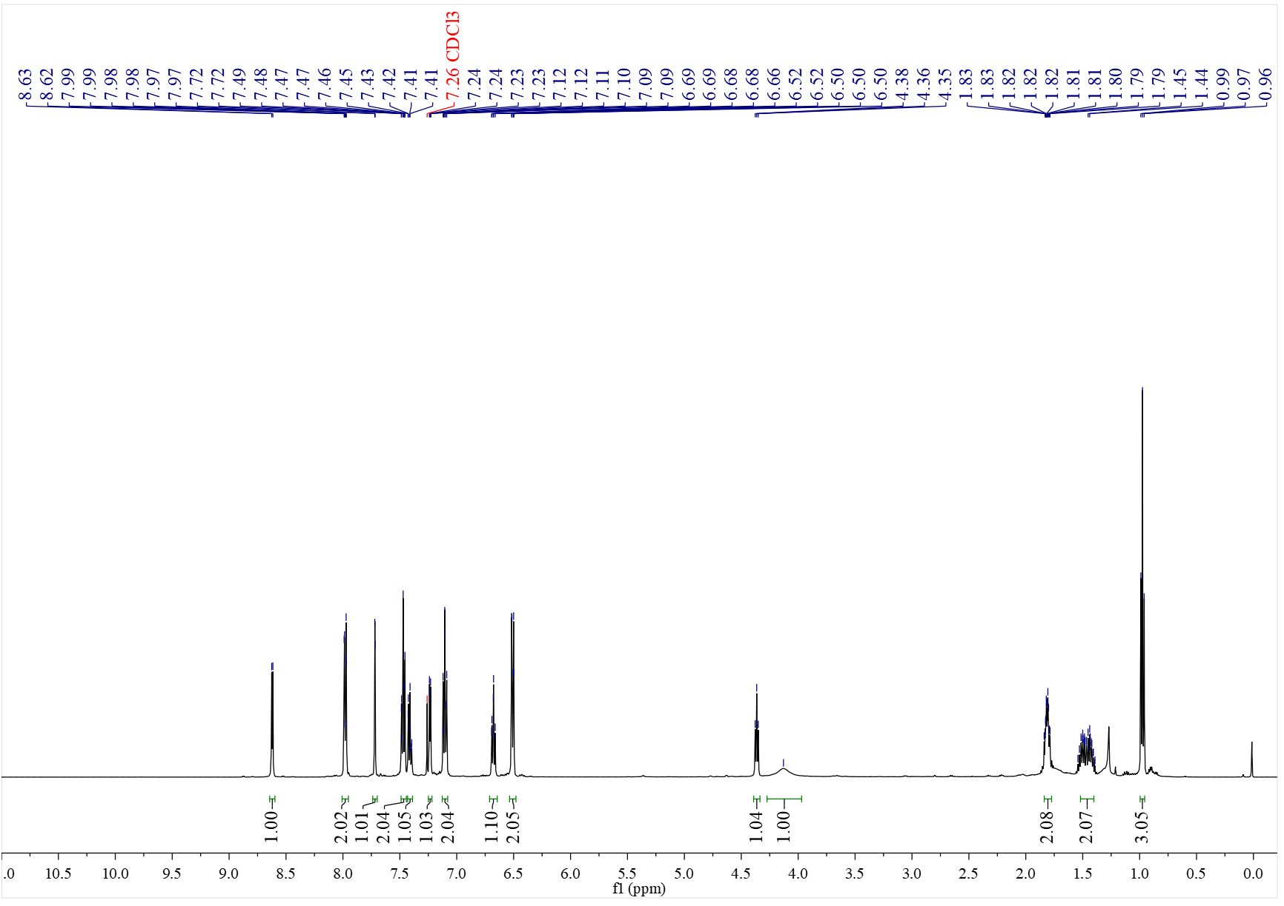

¹³C NMR spectrum of C₄₈ (126 MHz, CDCl₃)
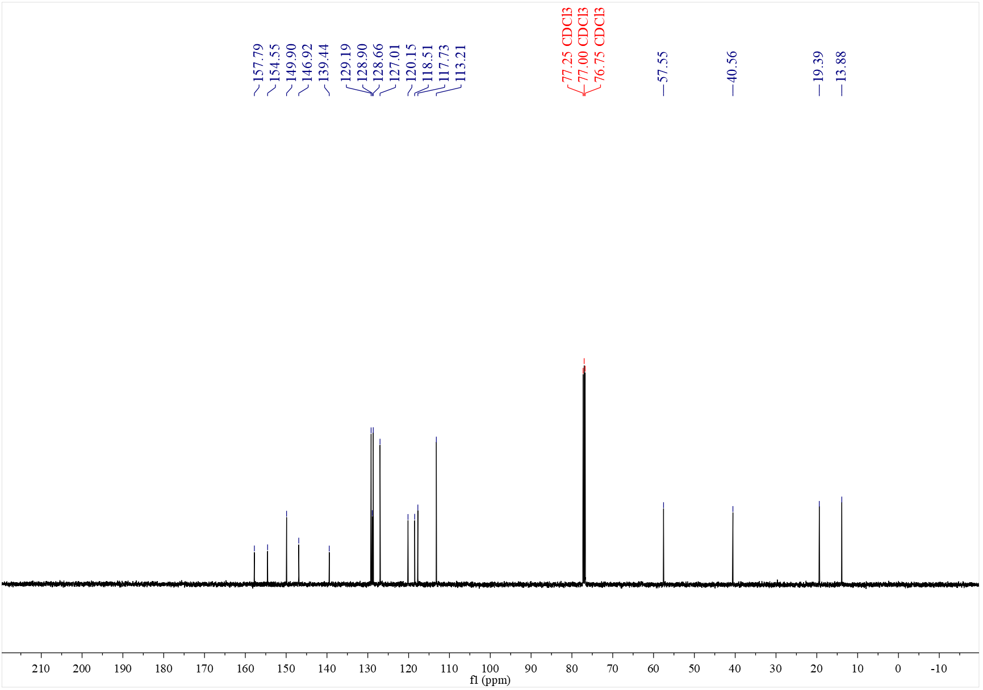

¹H NMR spectrum of C₄₉' (500 MHz, CDCl₃)
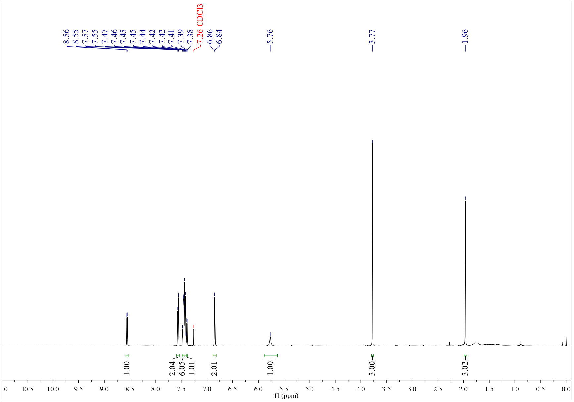

¹³C NMR spectrum of C₄₉' (126 MHz, CDCl₃)
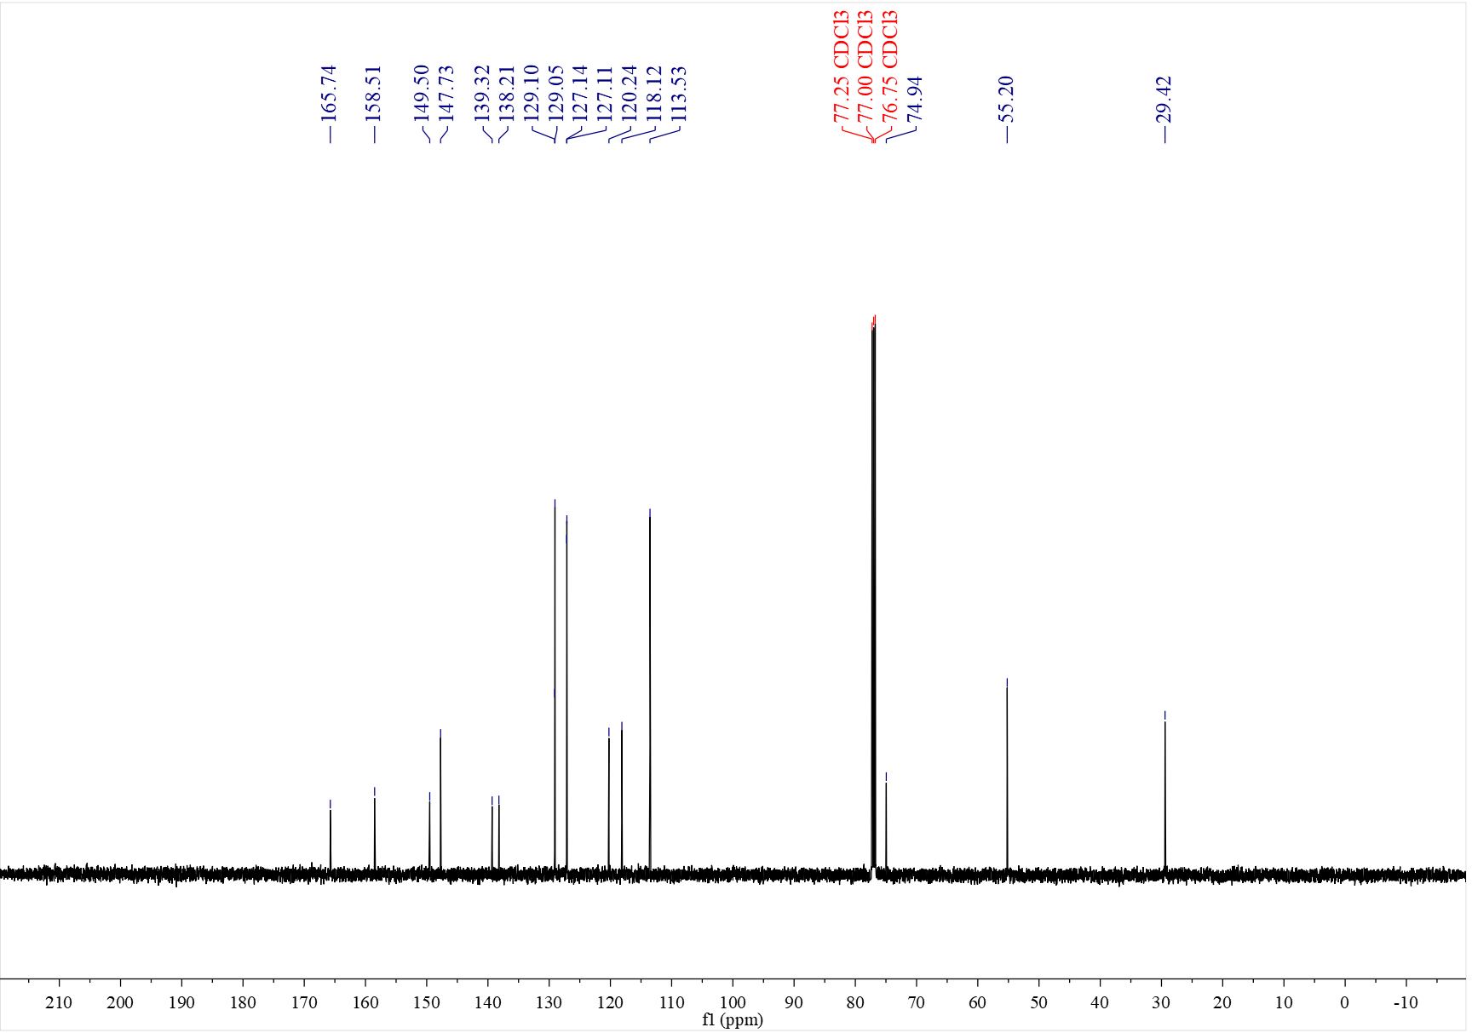

¹H NMR spectrum of C₅₀' (500 MHz, CDCl₃)
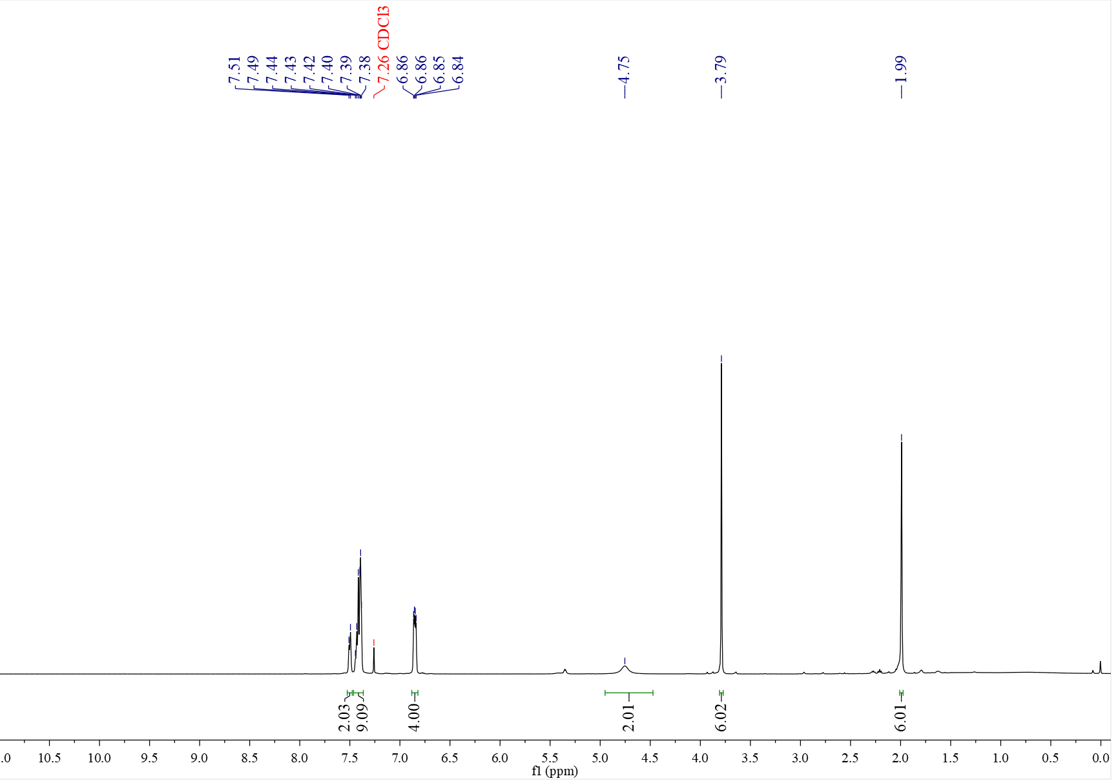

¹³C NMR spectrum of C₅₀' (126 MHz, CDCl₃)
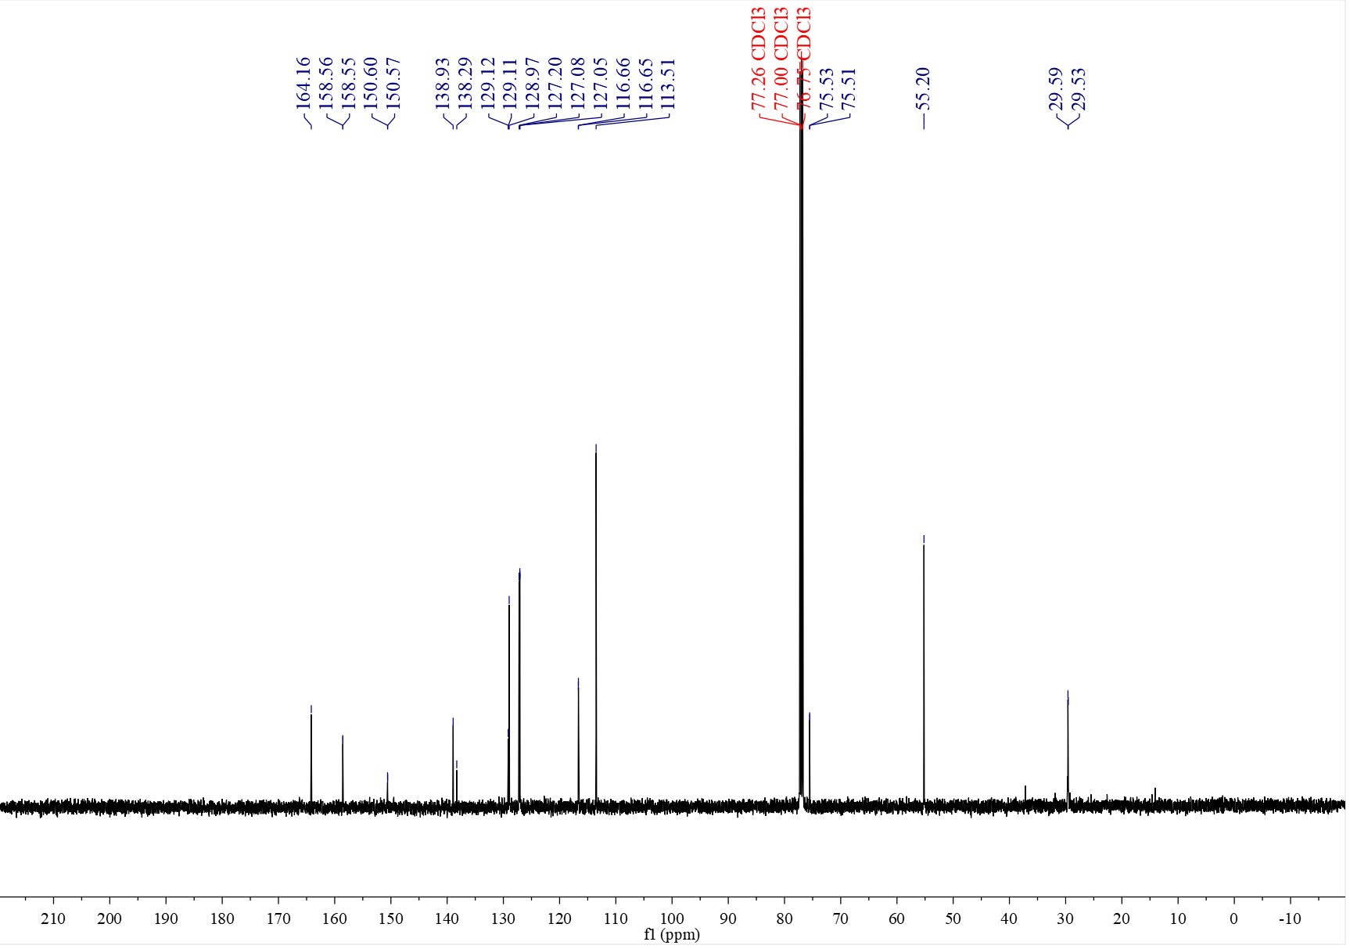

¹H NMR spectrum of C₅₁' (500 MHz, CDCl₃)
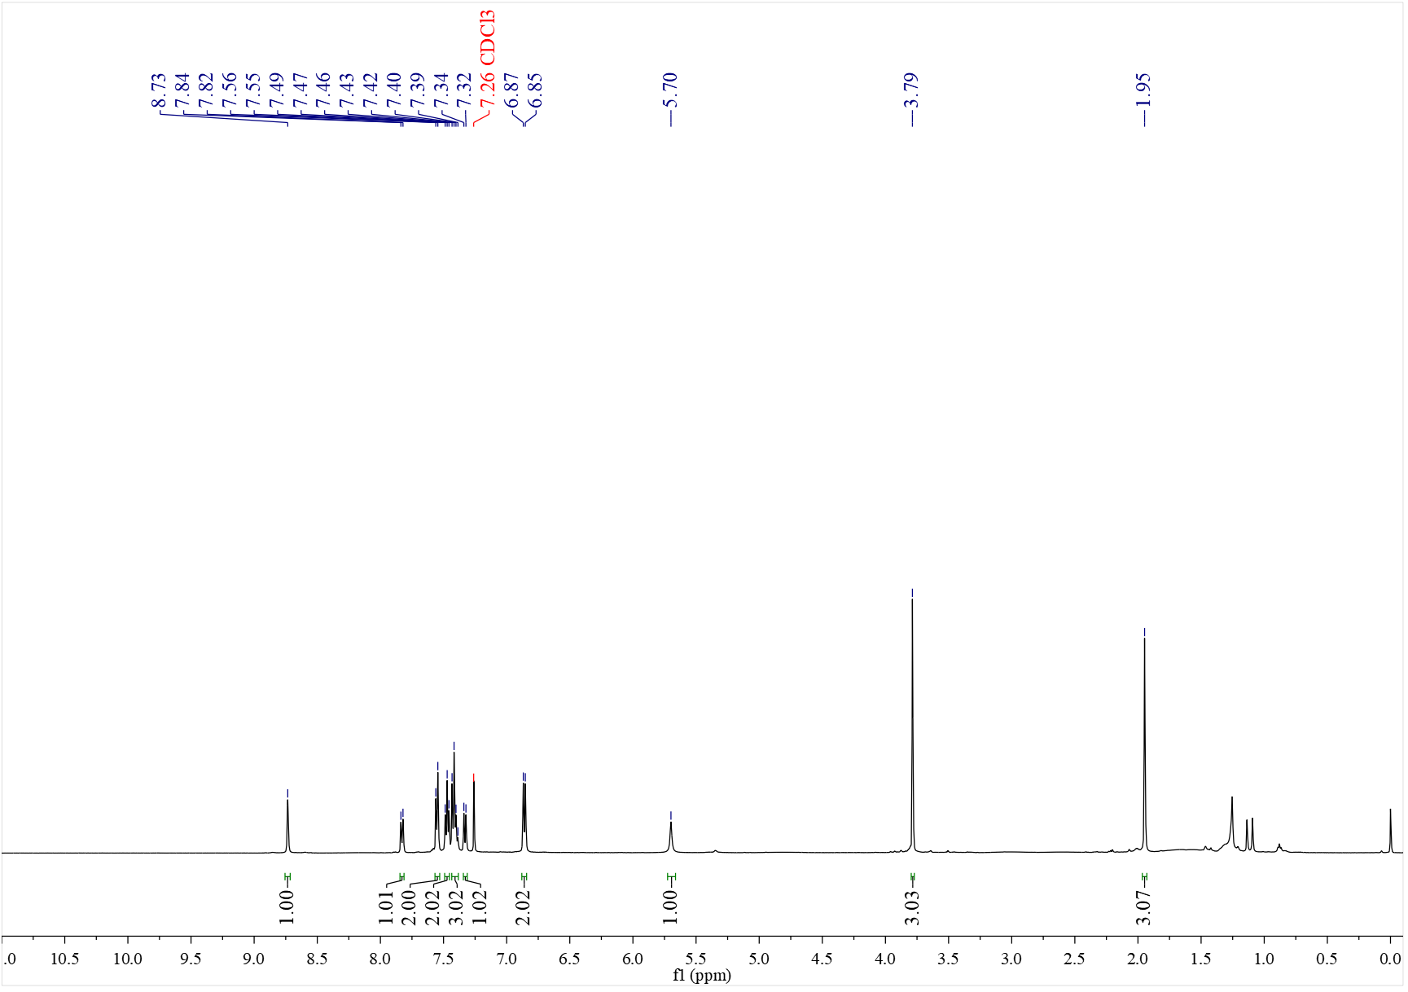

¹³C NMR spectrum of C₅₁' (126 MHz, CDCl₃)
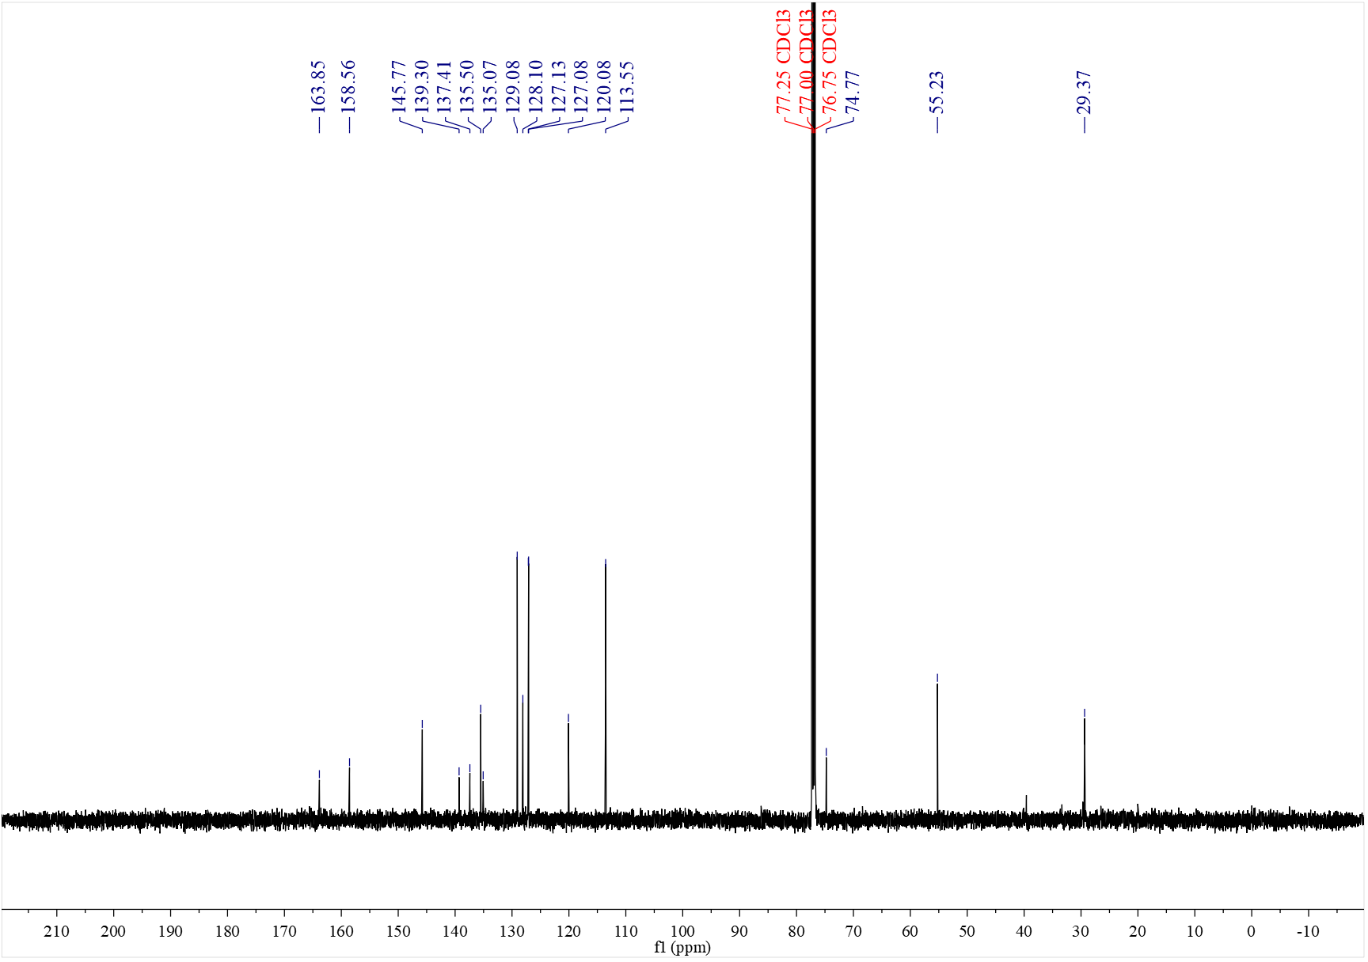

¹H NMR spectrum of C₅₂ (500 MHz, CDCl₃)
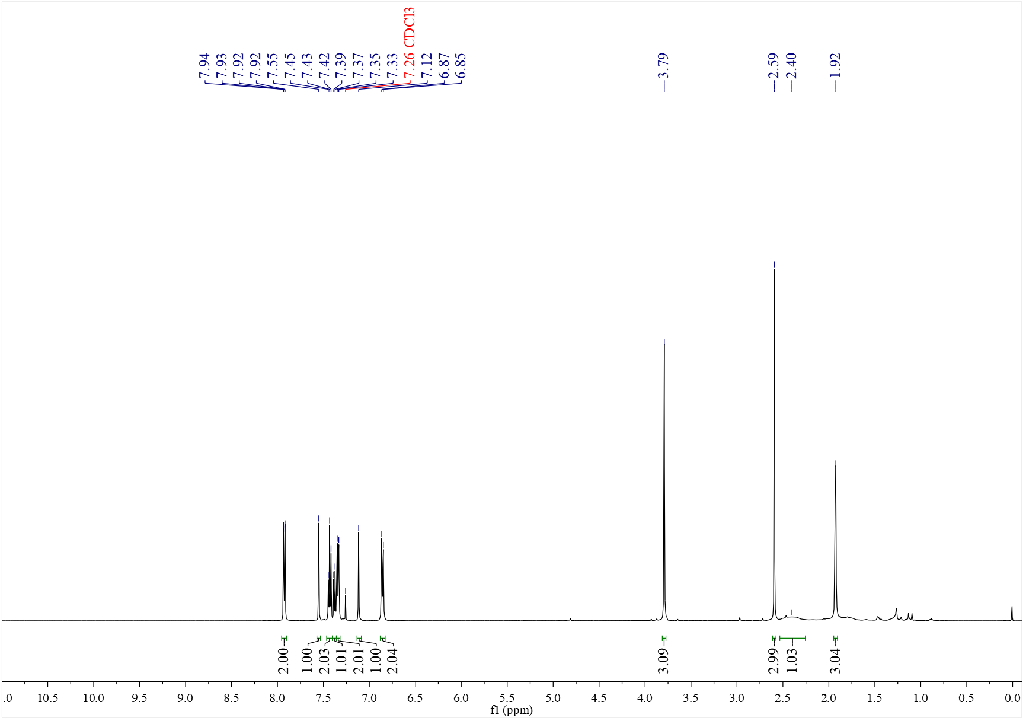

¹³C NMR spectrum of C₅₂ (126 MHz, CDCl₃)
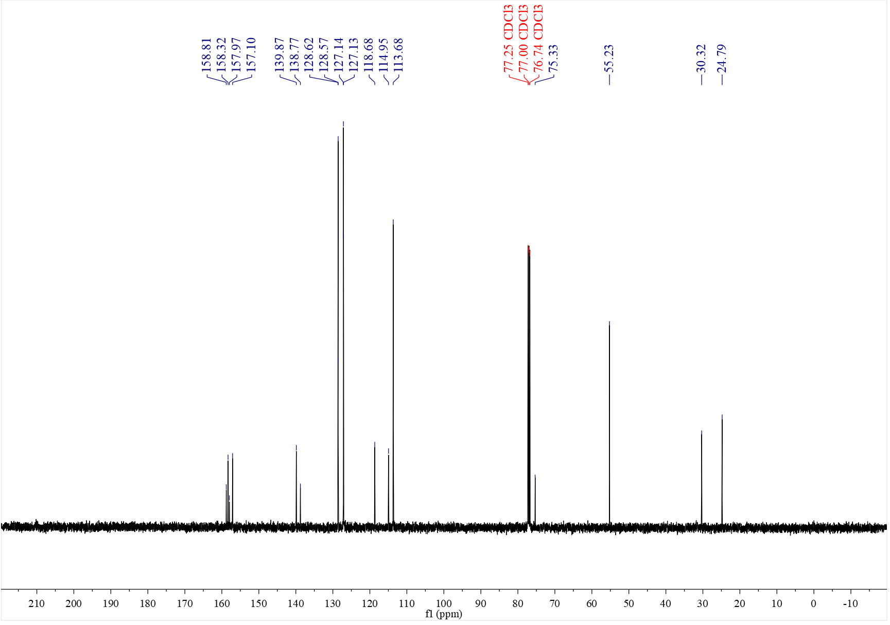

¹H NMR spectrum of C₅₃ (500 MHz, CDCl₃)
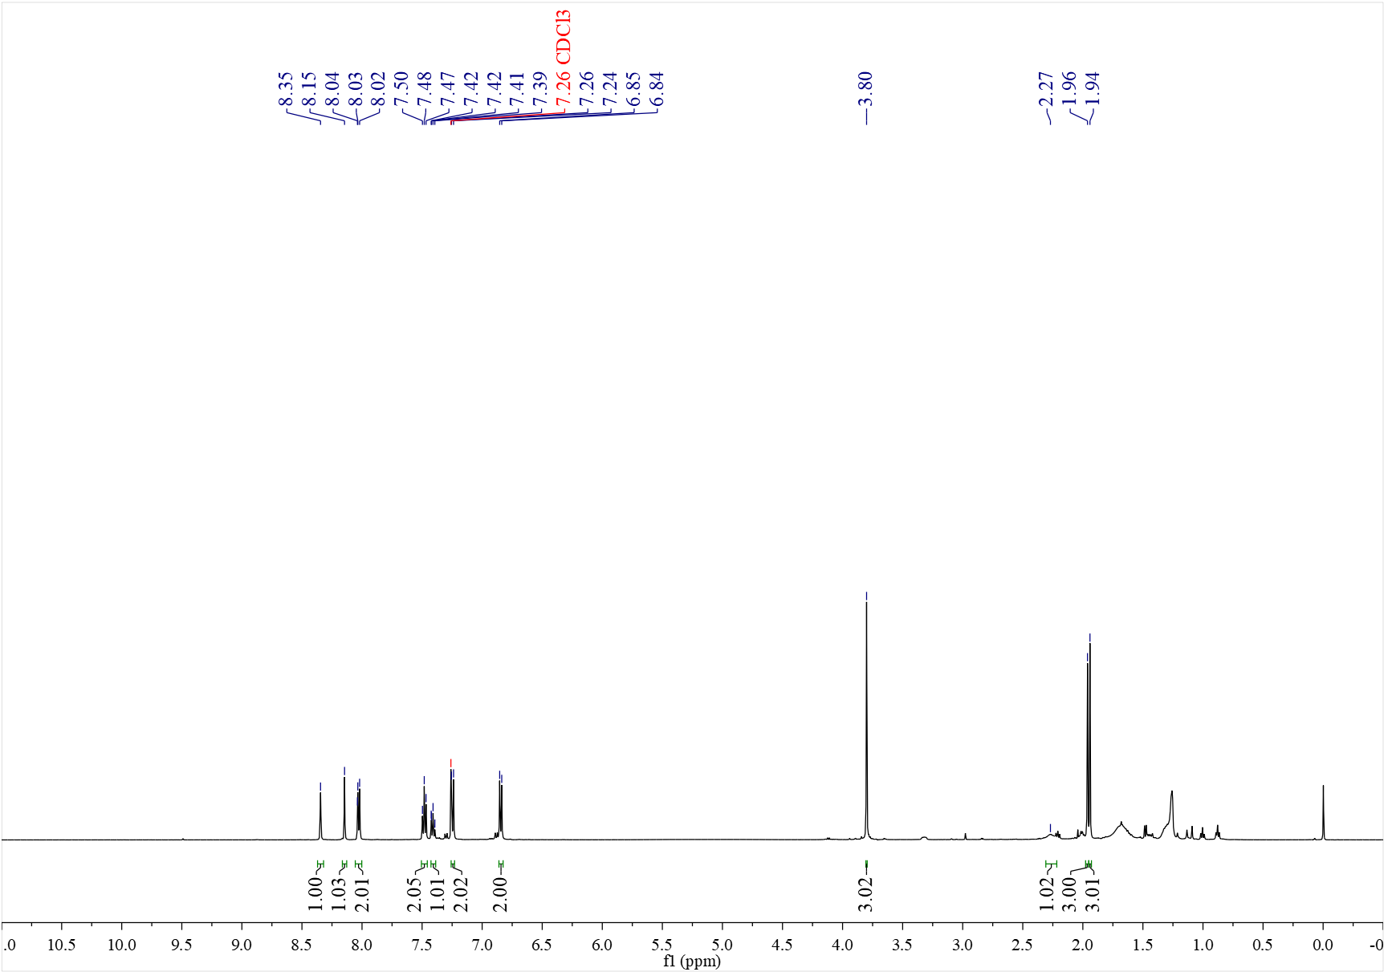

¹³C NMR spectrum of C₅₃ (126 MHz, CDCl₃)
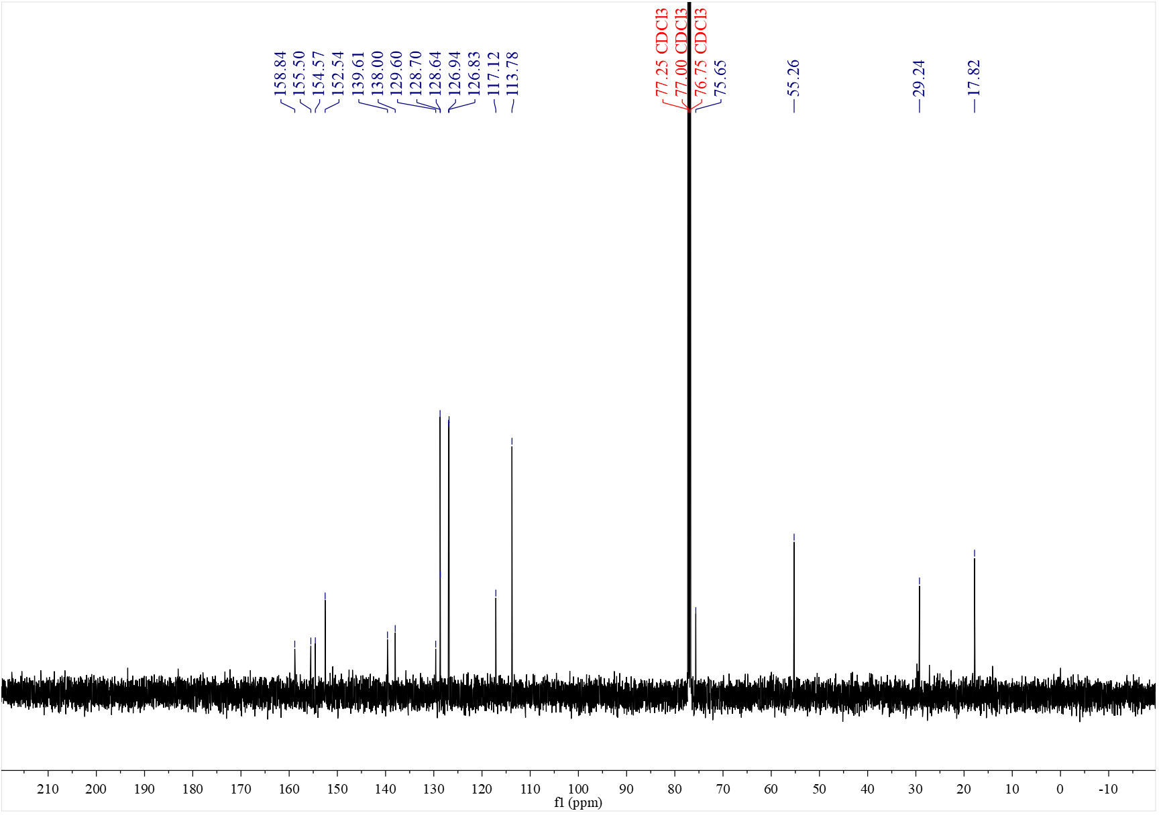

¹H NMR spectrum of C₅₄ (500 MHz, CDCl₃)
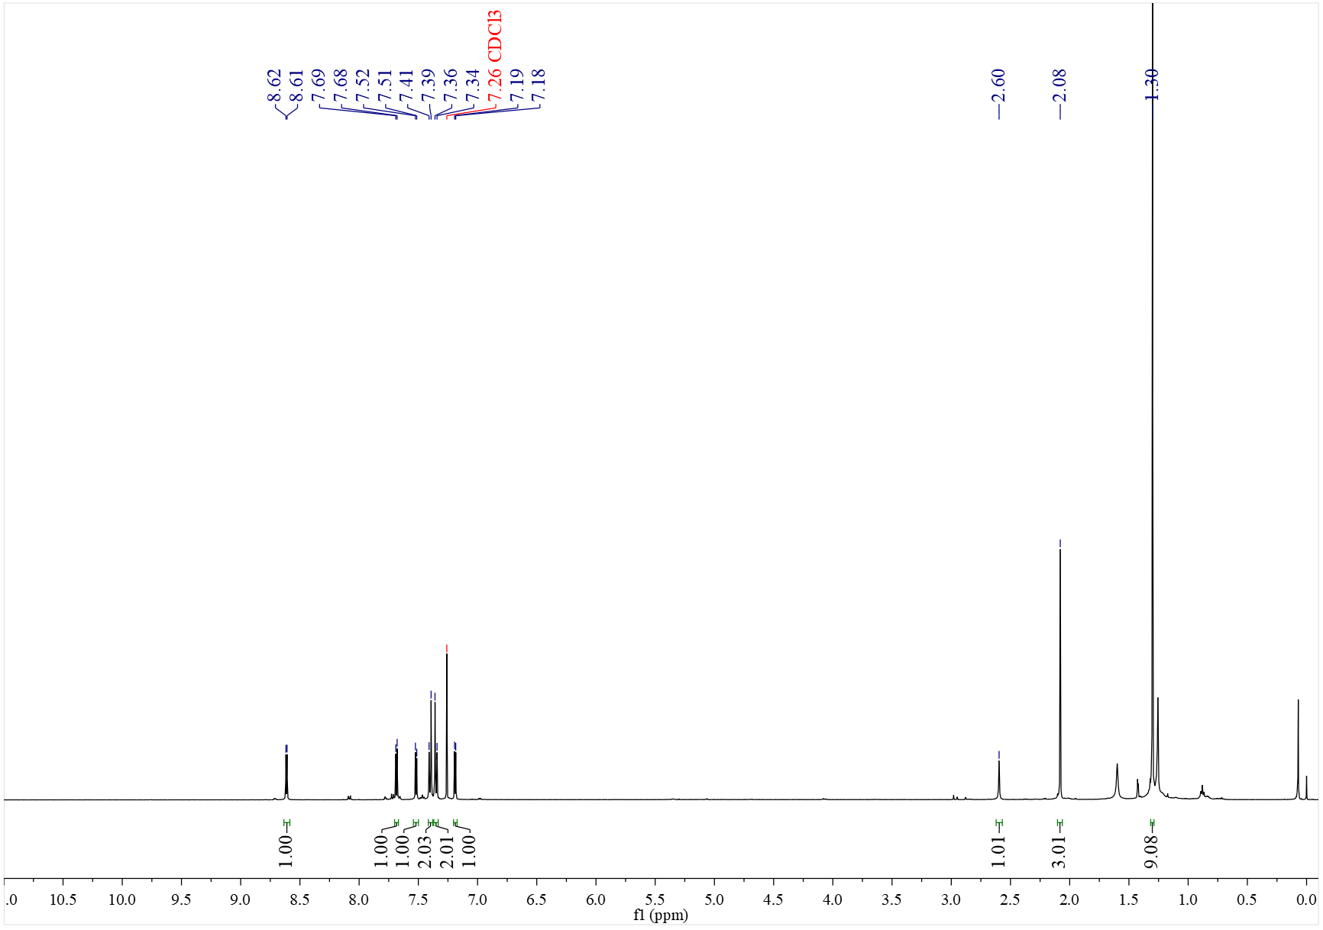

¹³C NMR spectrum of C₅₄ (126 MHz, CDCl₃)
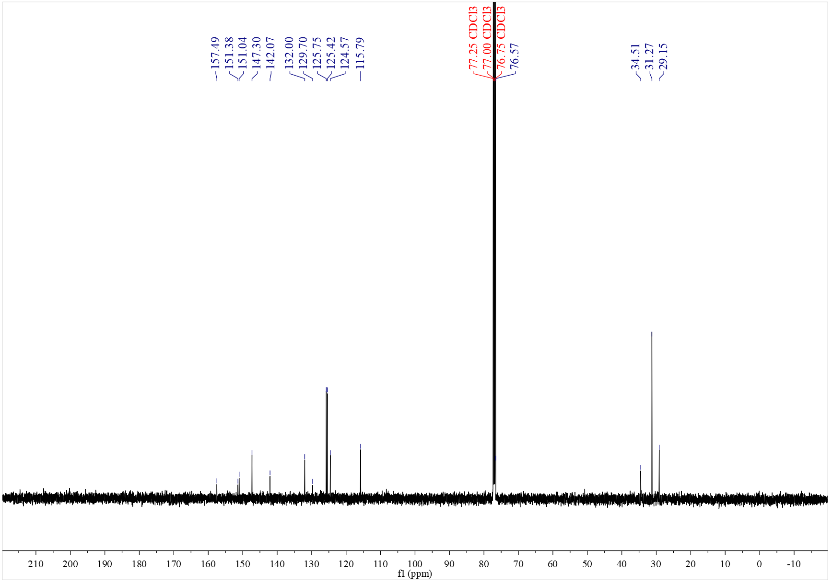

¹H NMR spectrum of C₅₄' (500 MHz, CDCl₃)
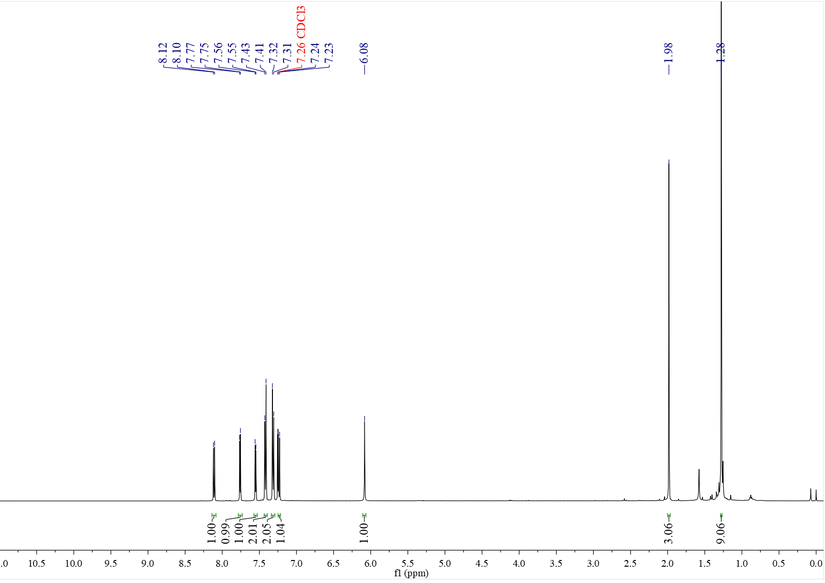

¹³C NMR spectrum of C₅₄' (126 MHz, CDCl₃)
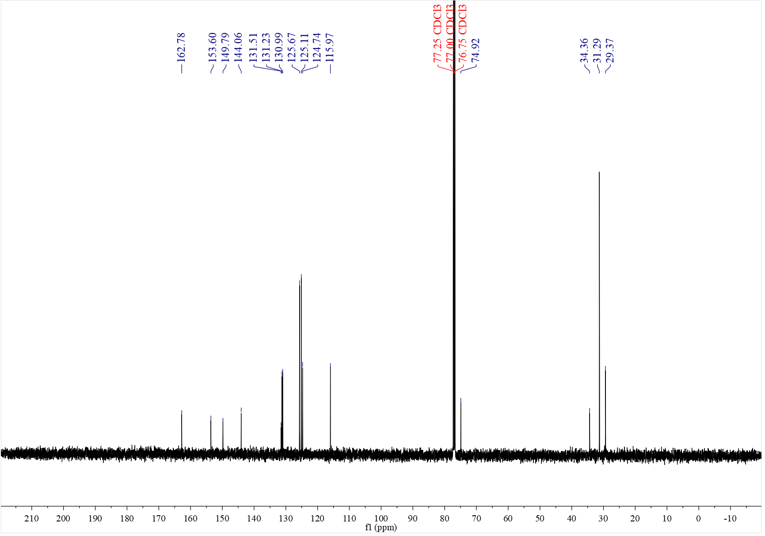

¹H NMR spectrum of C₅₅ (500 MHz, CDCl₃)
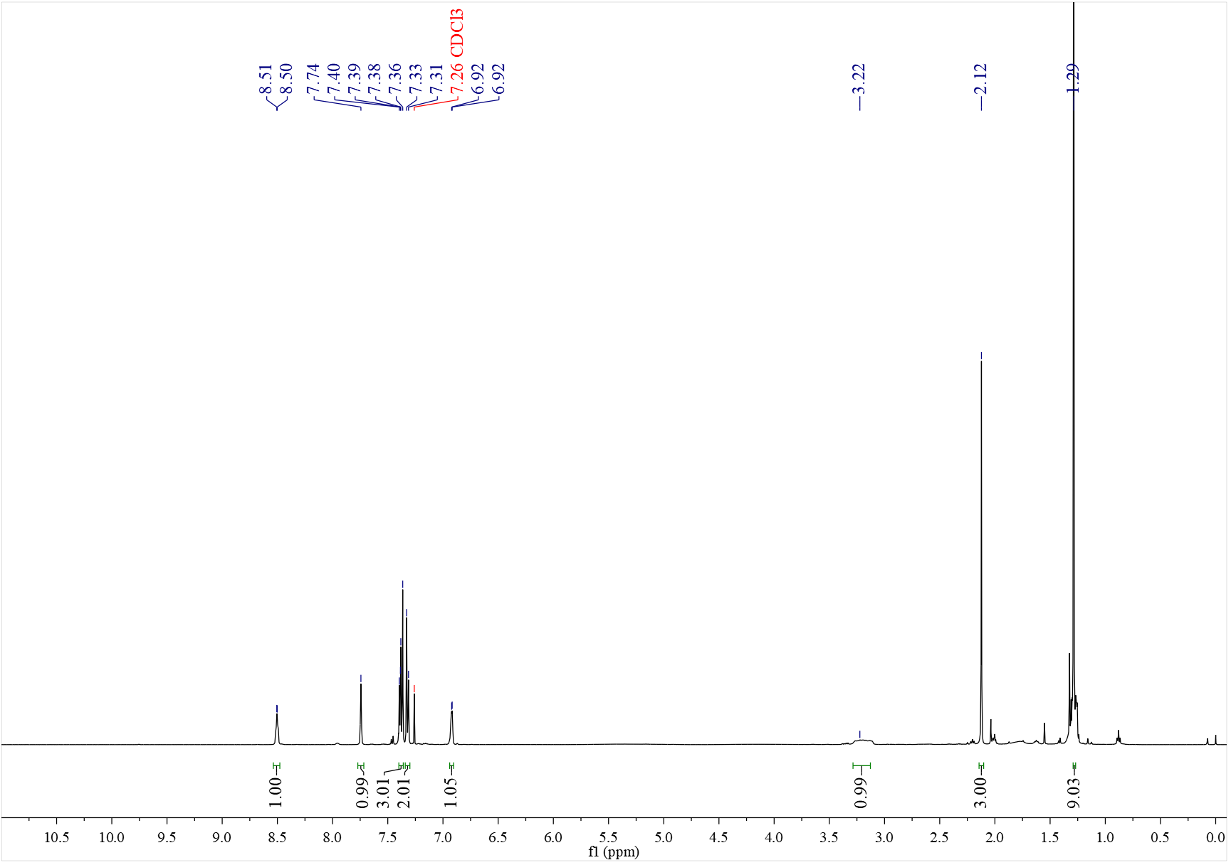

¹³C NMR spectrum of C₅₅ (126 MHz, CDCl₃)
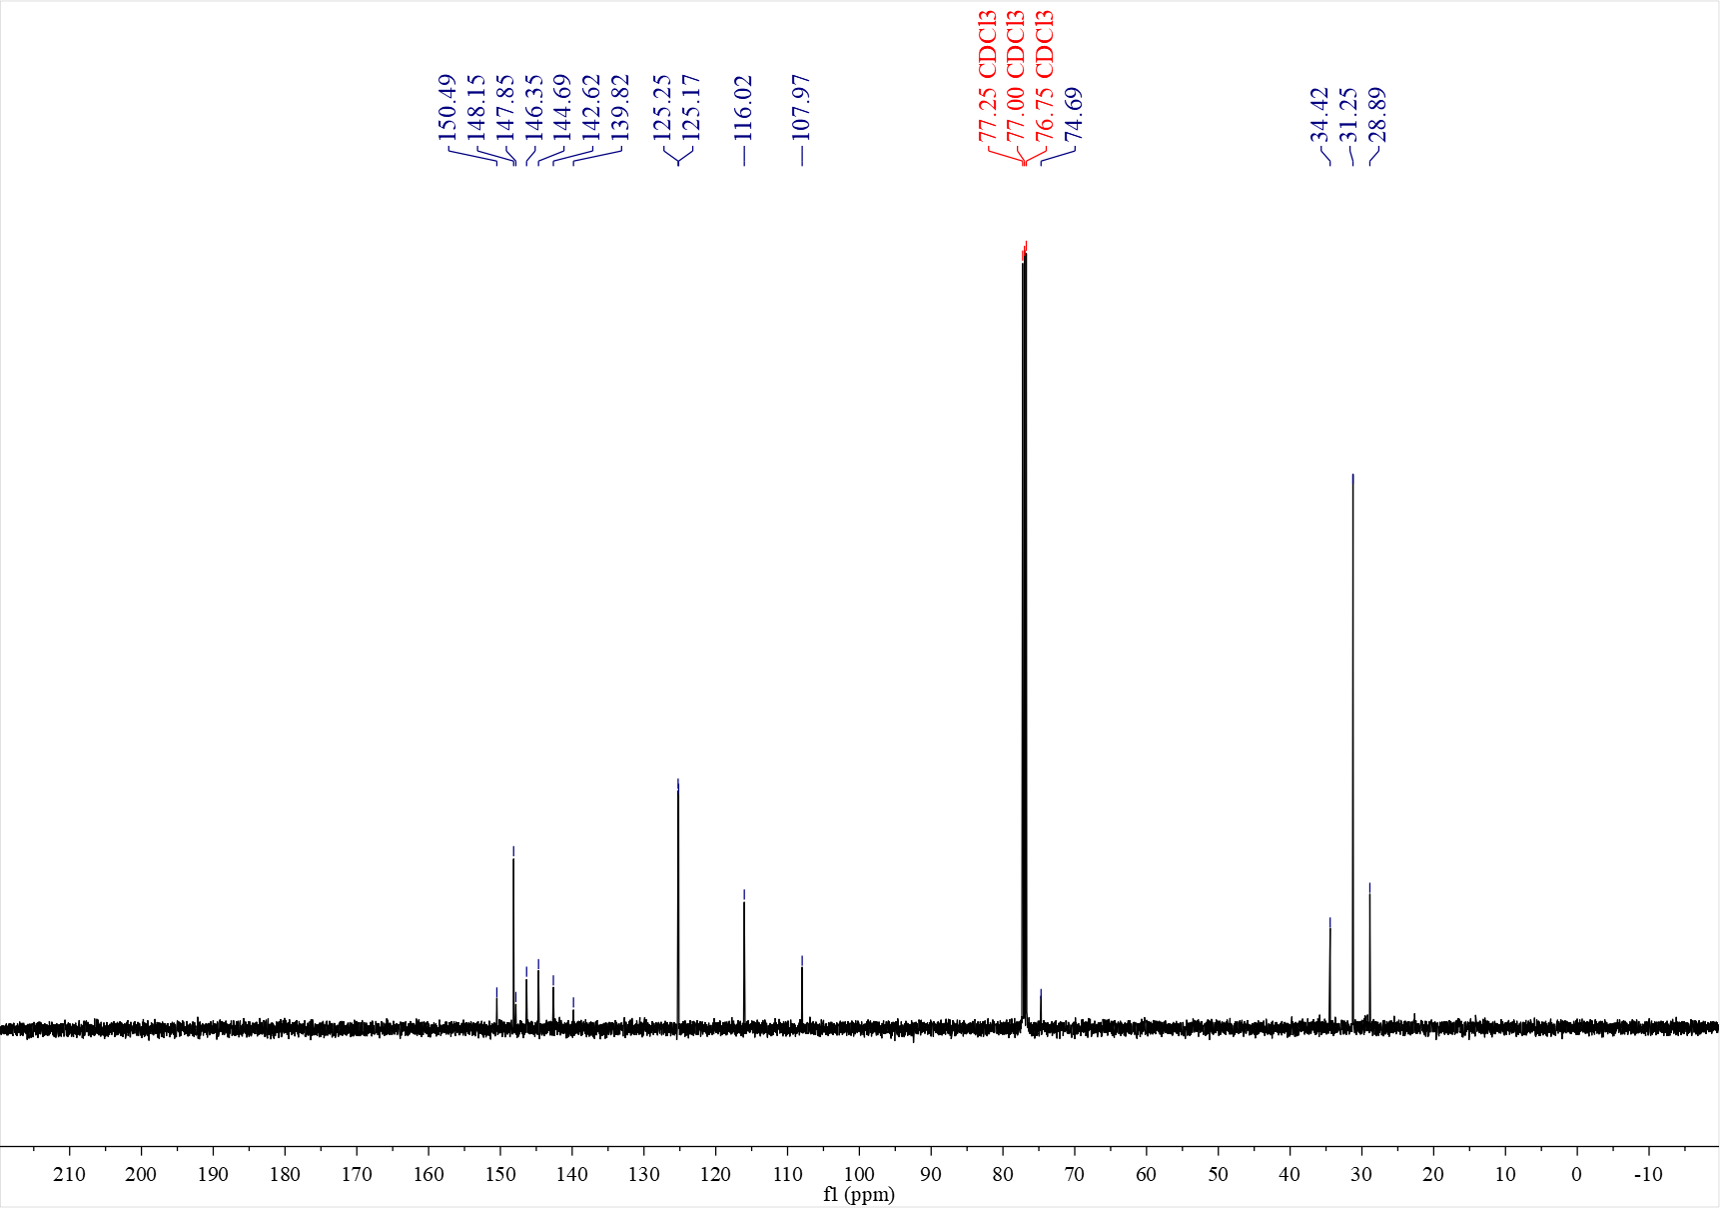

¹H NMR spectrum of C₅₅' (500 MHz, CDCl₃)
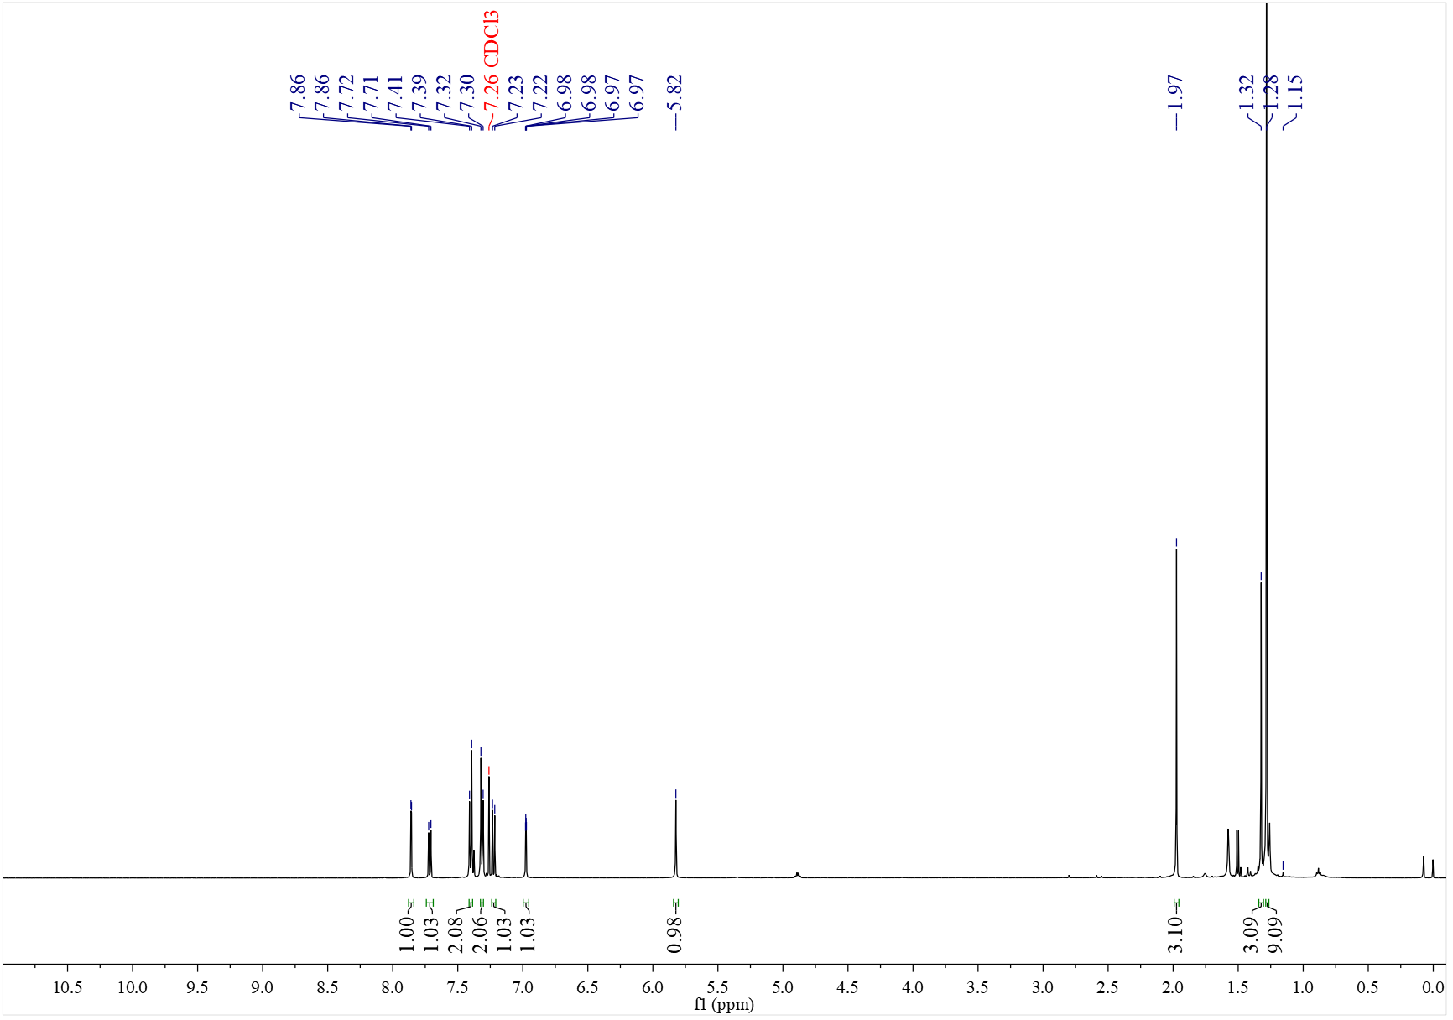

¹³C NMR spectrum of C₅₅' (126 MHz, CDCl₃)
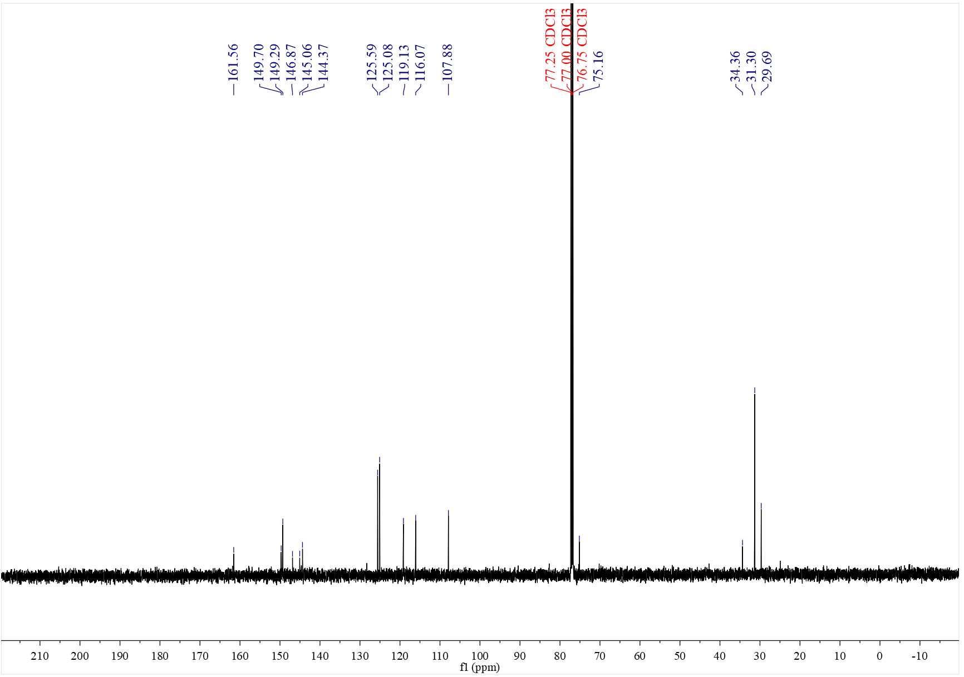

¹H NMR spectrum of C₅₆' (500 MHz, CDCl₃)
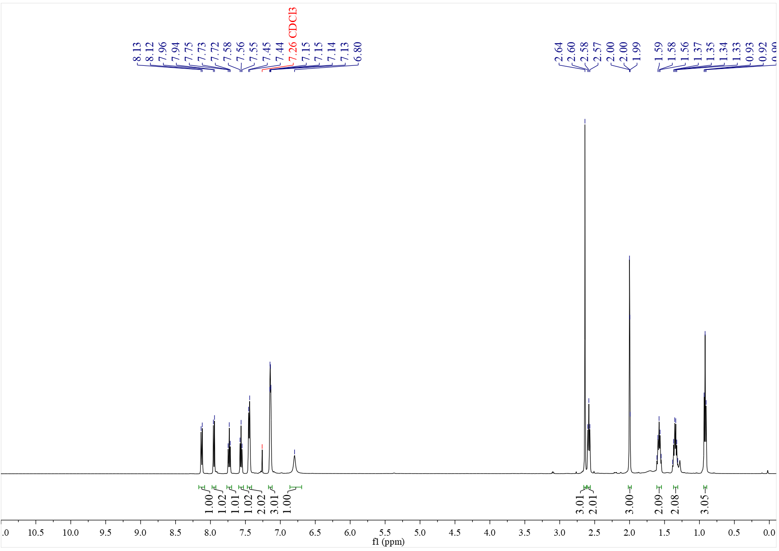

¹³C NMR spectrum of C₅₆' (126 MHz, CDCl₃)
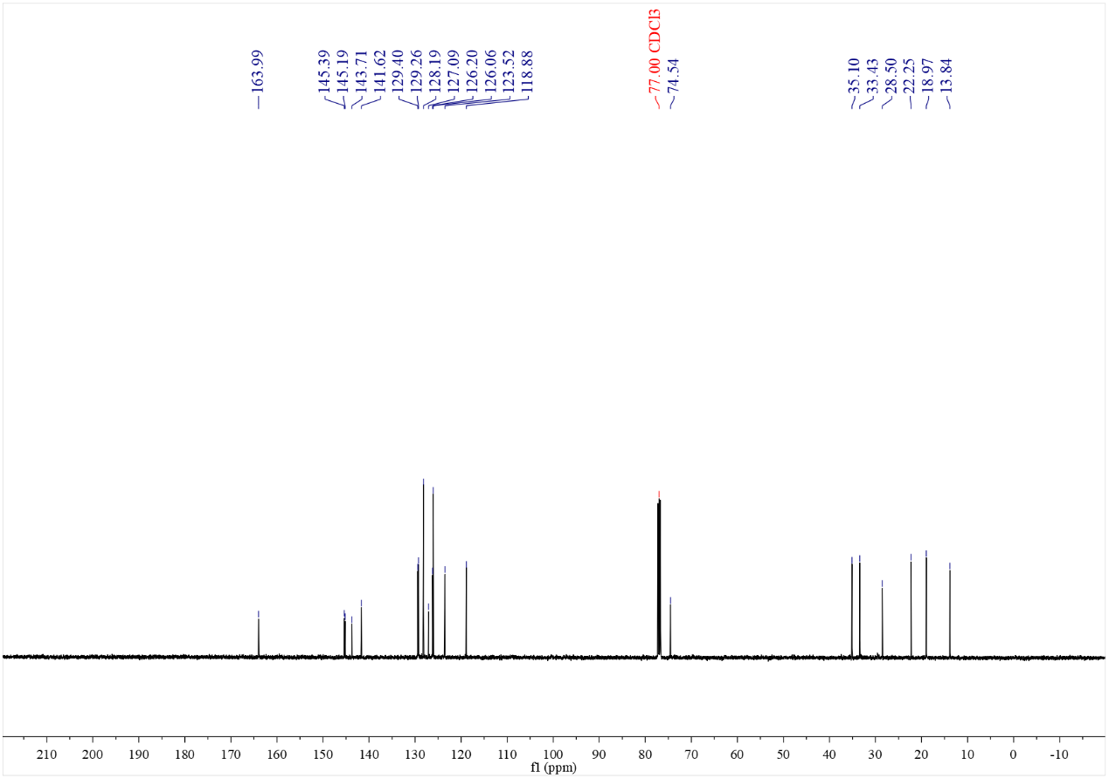

¹H NMR spectrum of C₅₇' (500 MHz, CDCl₃)
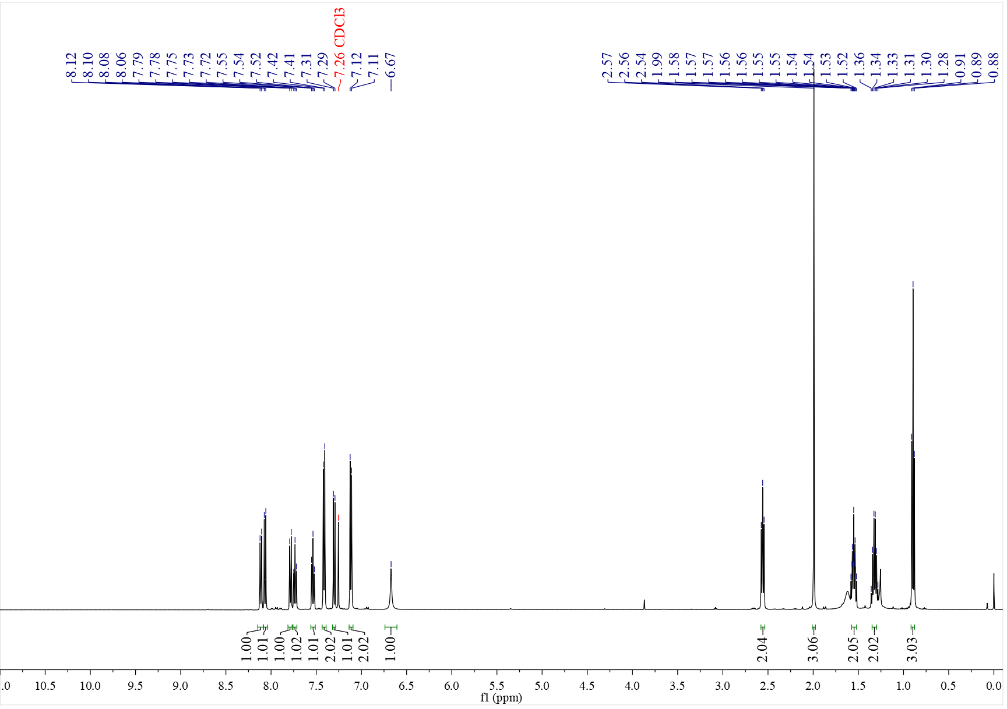

¹³C NMR spectrum of C₅₇' (126 MHz, CDCl₃)
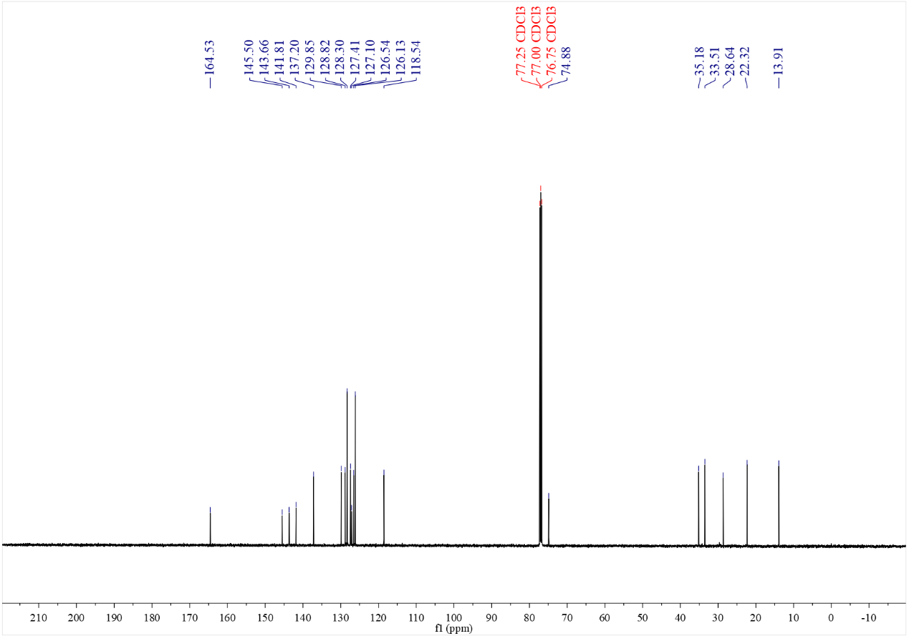

¹H NMR spectrum of C₅₈' (500 MHz, CDCl₃)
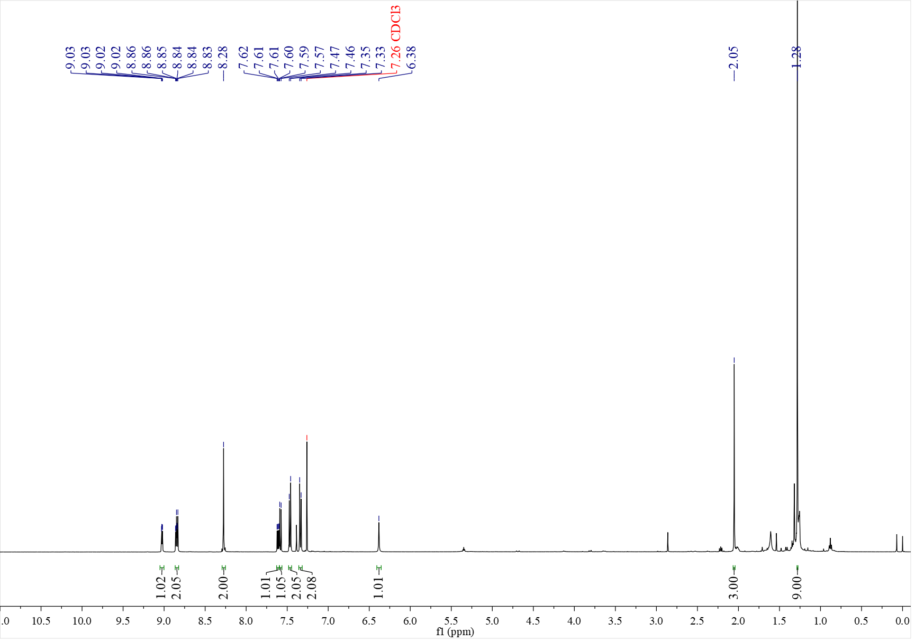

¹³C NMR spectrum of C₅₈' (126 MHz, CDCl₃)
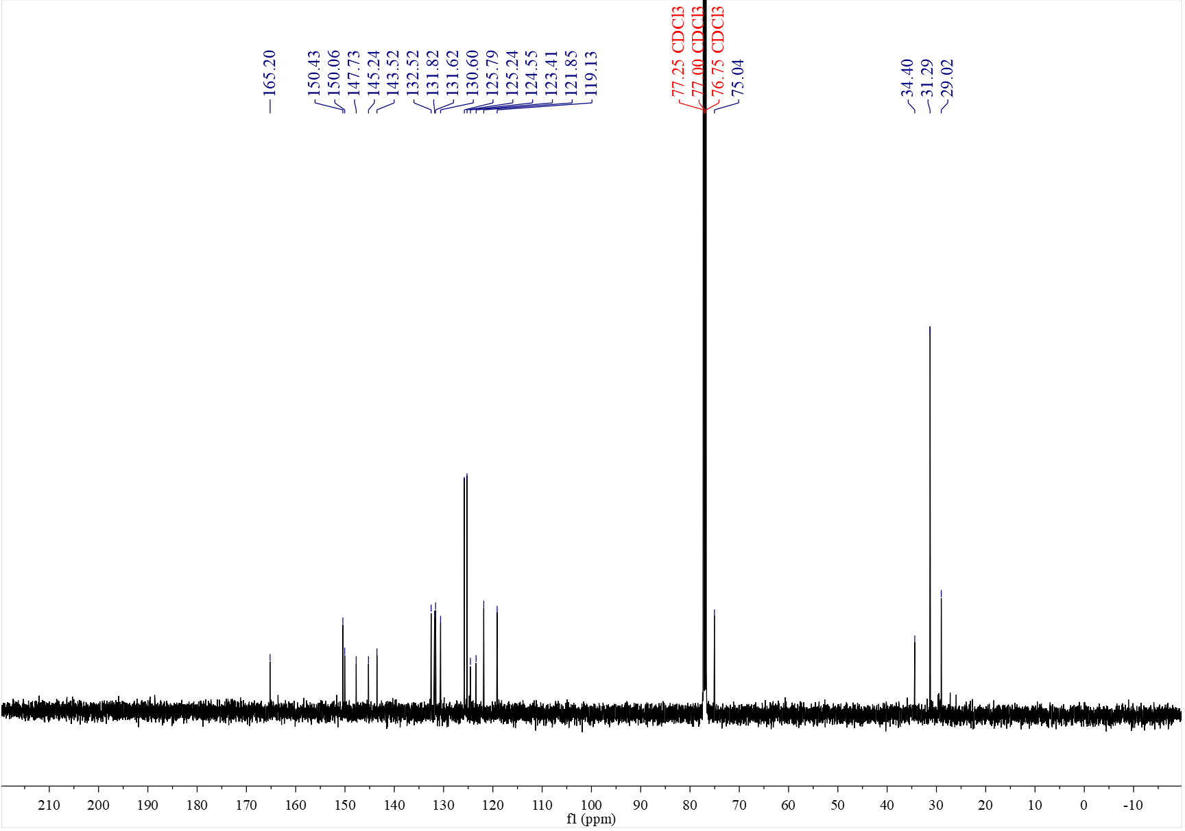

¹H NMR spectrum of C₅₉ (500 MHz, CDCl₃)
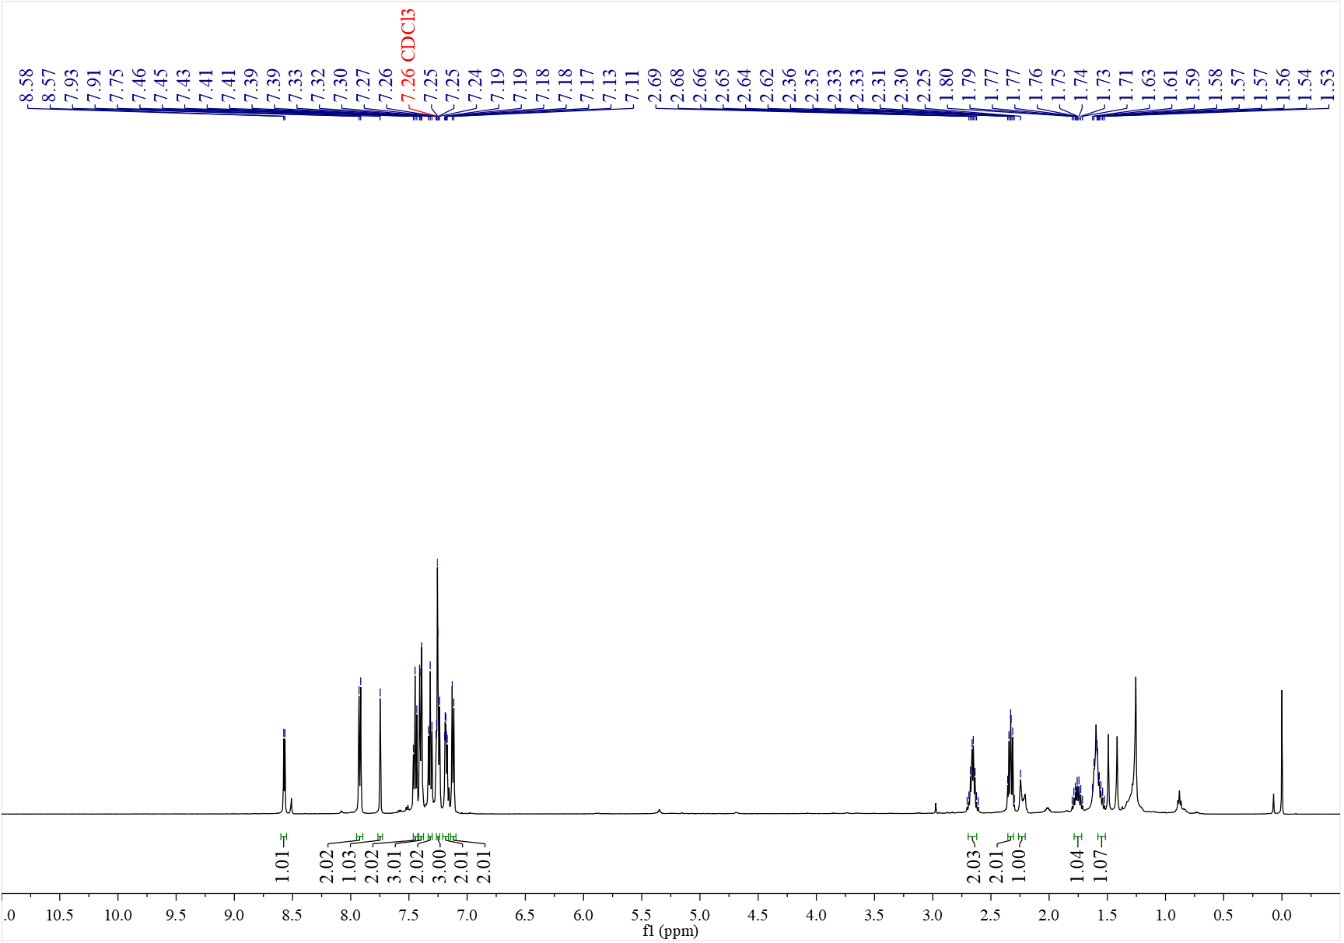

¹³C NMR spectrum of C₅₉ (126 MHz, CDCl₃)
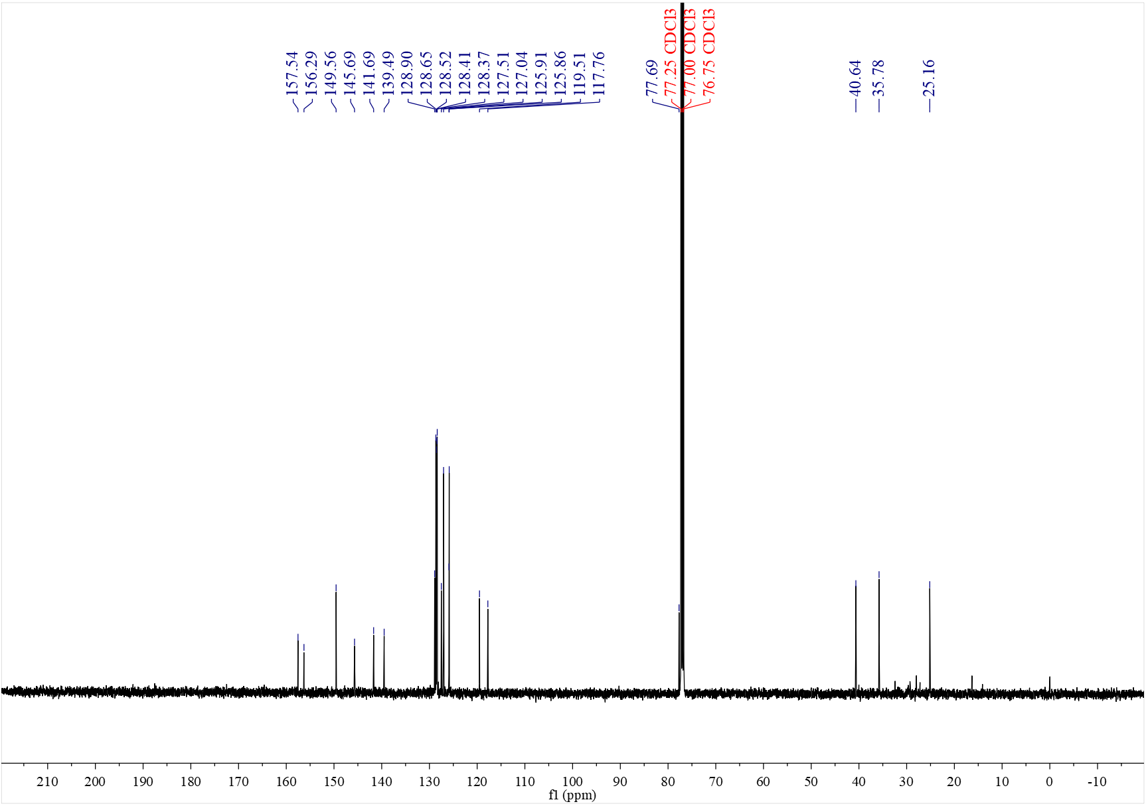

¹H NMR spectrum of C_{60a} (500 MHz, CDCl₃)
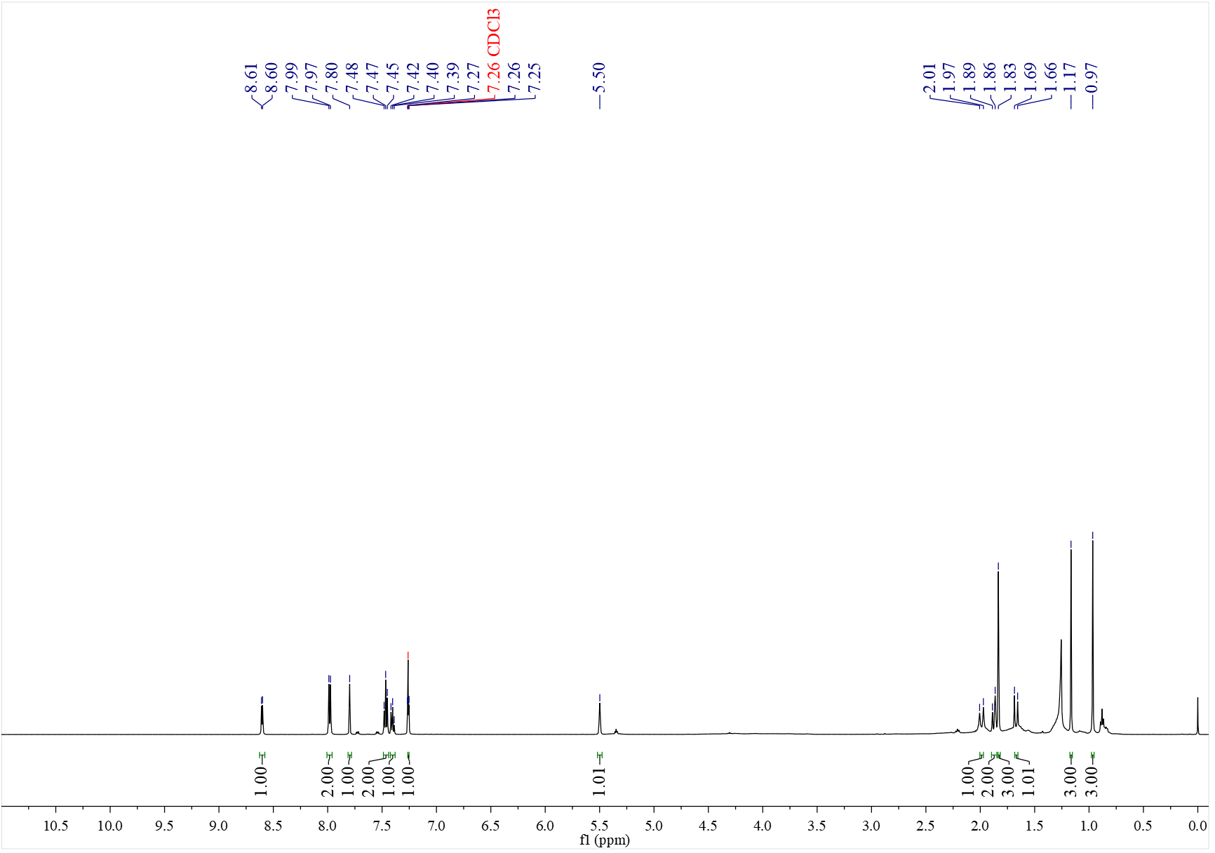

¹³C NMR spectrum of C_{60a} (126 MHz, CDCl₃)
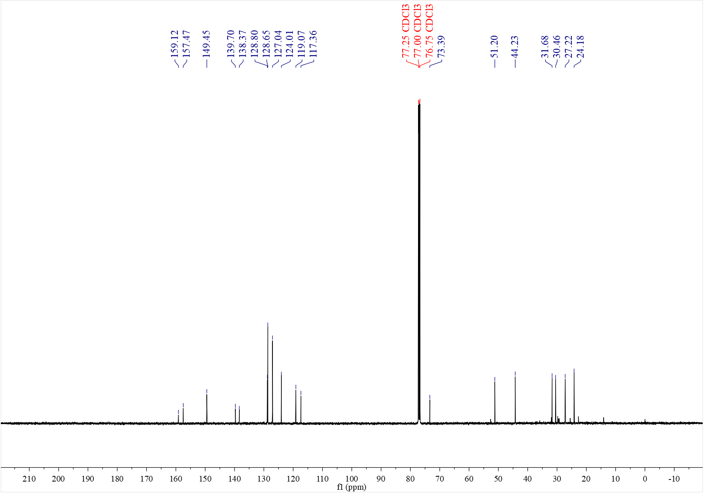

¹H NMR spectrum of C_{60b} (500 MHz, CDCl₃)
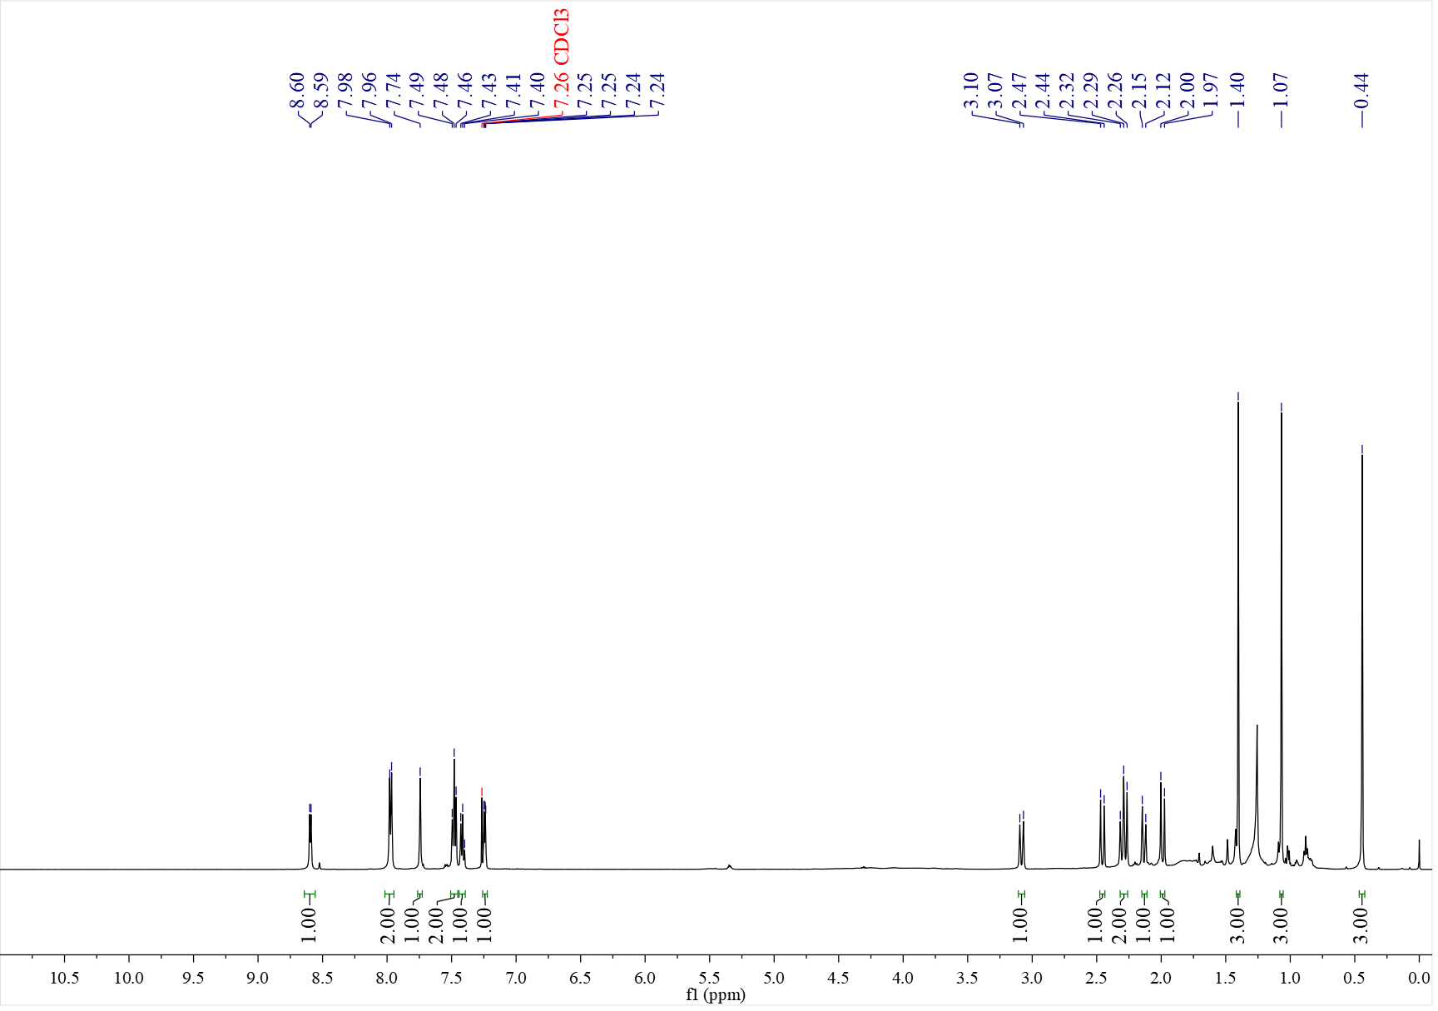

¹³C NMR spectrum of C_{60b} (126 MHz, CDCl₃)
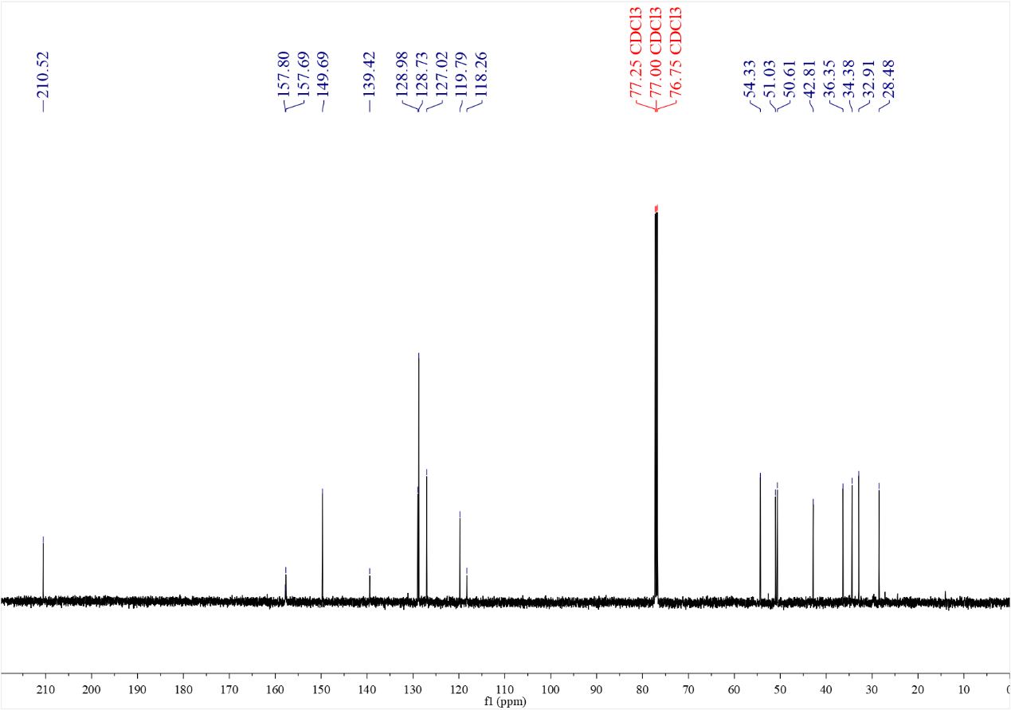

¹H NMR spectrum of C₆₁ (500 MHz, CDCl₃)
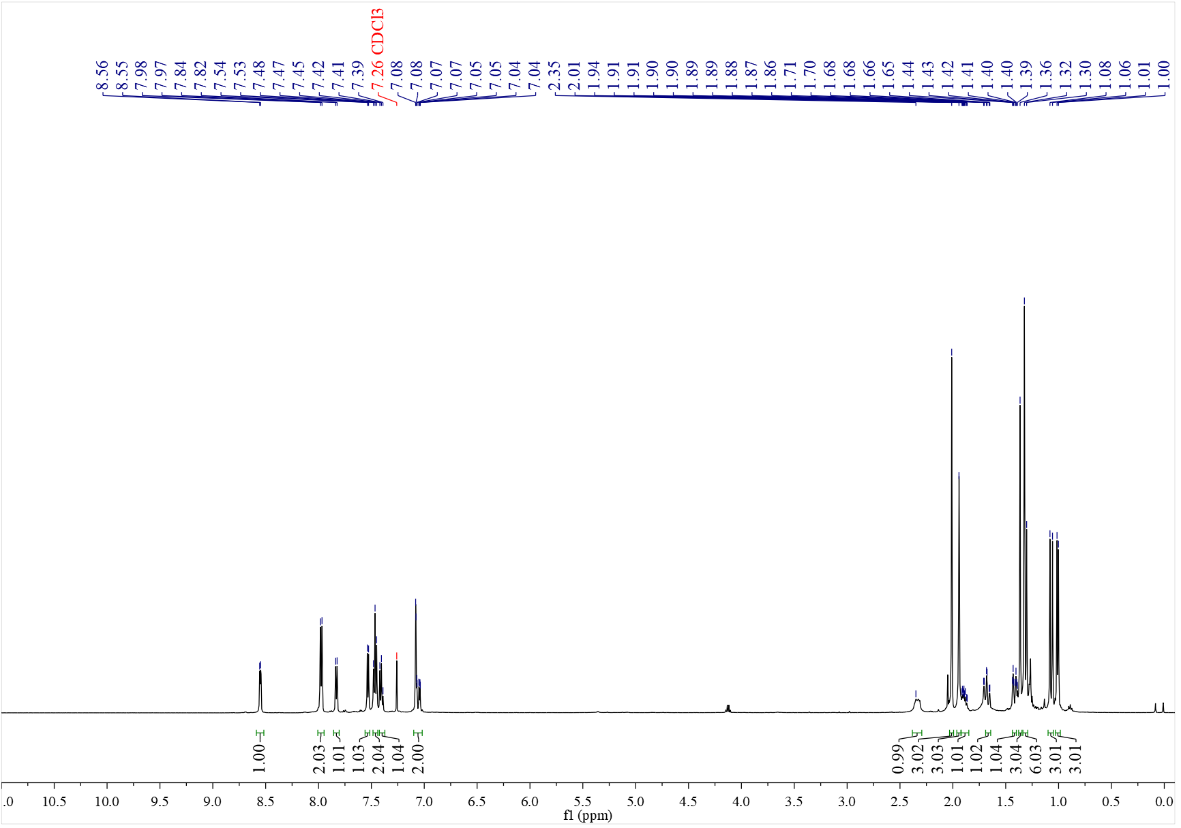

¹³C NMR spectrum of C₆₁ (126 MHz, CDCl₃)
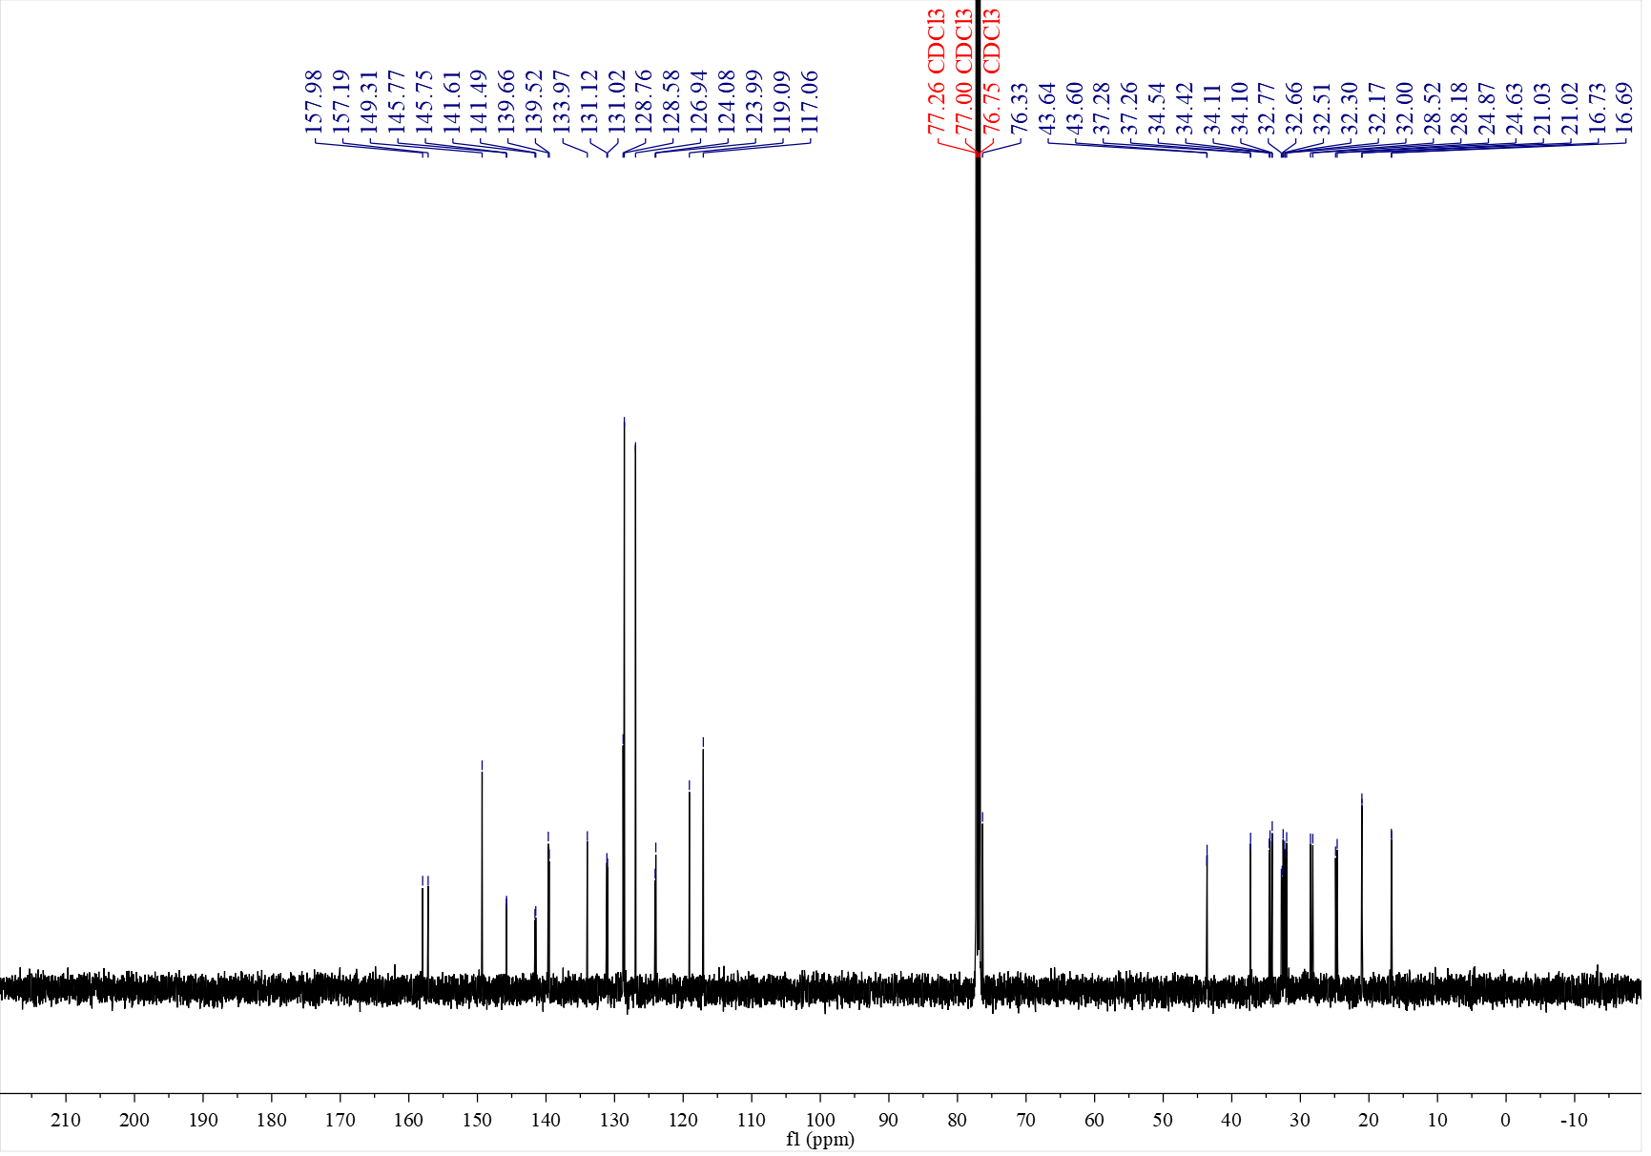

¹H NMR spectrum of C₆₂ (500 MHz, CDCl₃)
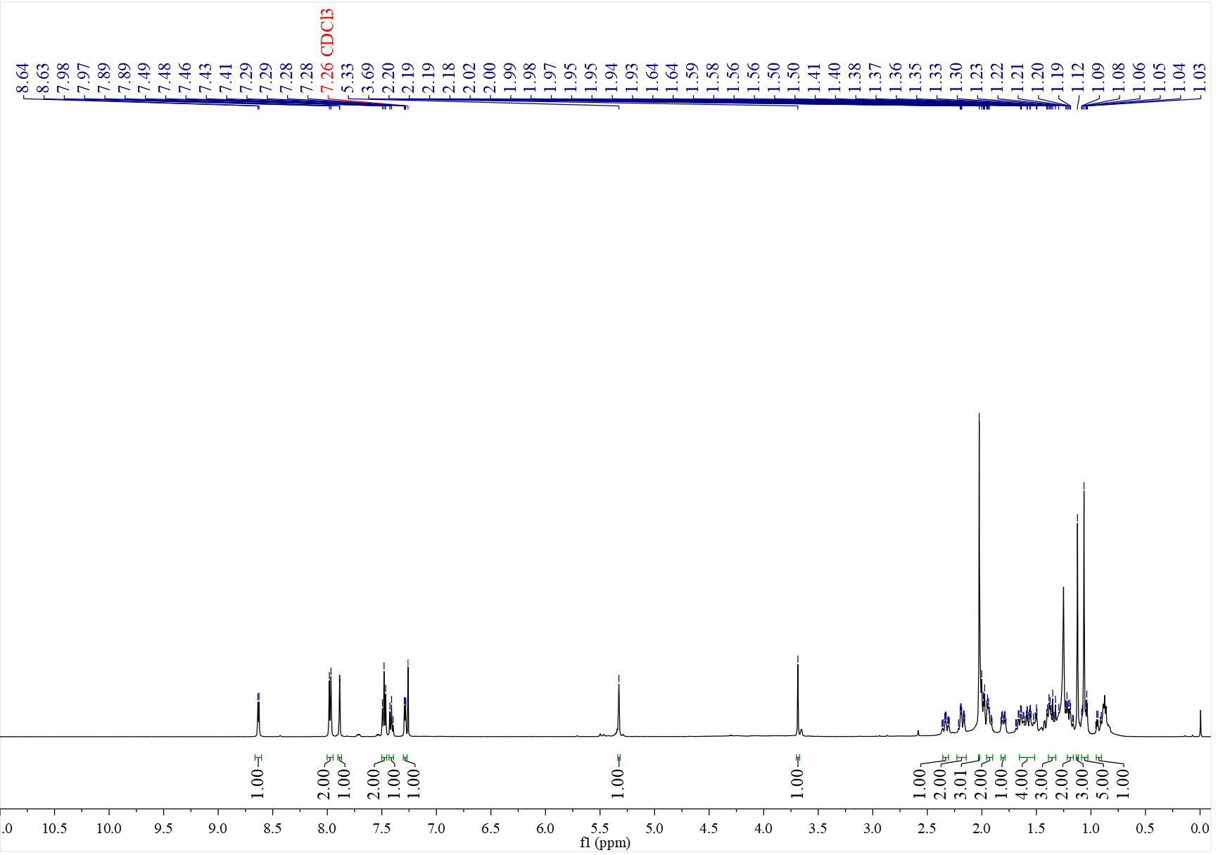

¹³C NMR spectrum of C₆₂ (126 MHz, CDCl₃)
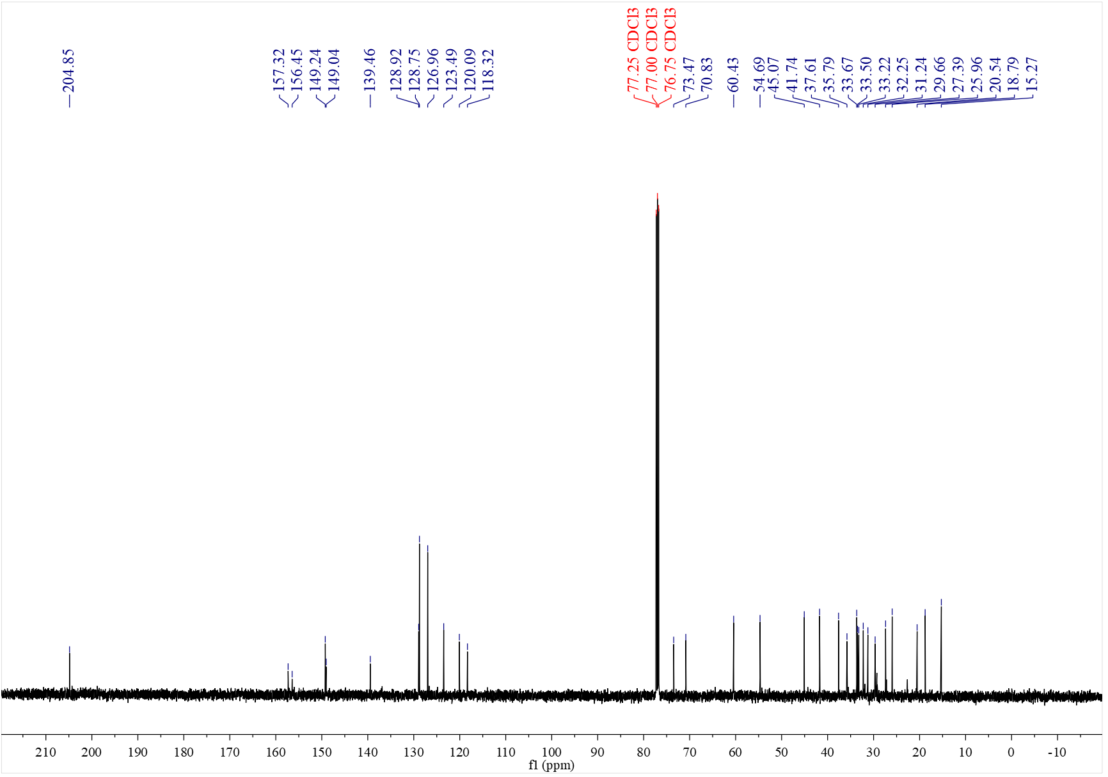

¹H NMR spectrum of C₆₃ (500 MHz, CDCl₃)
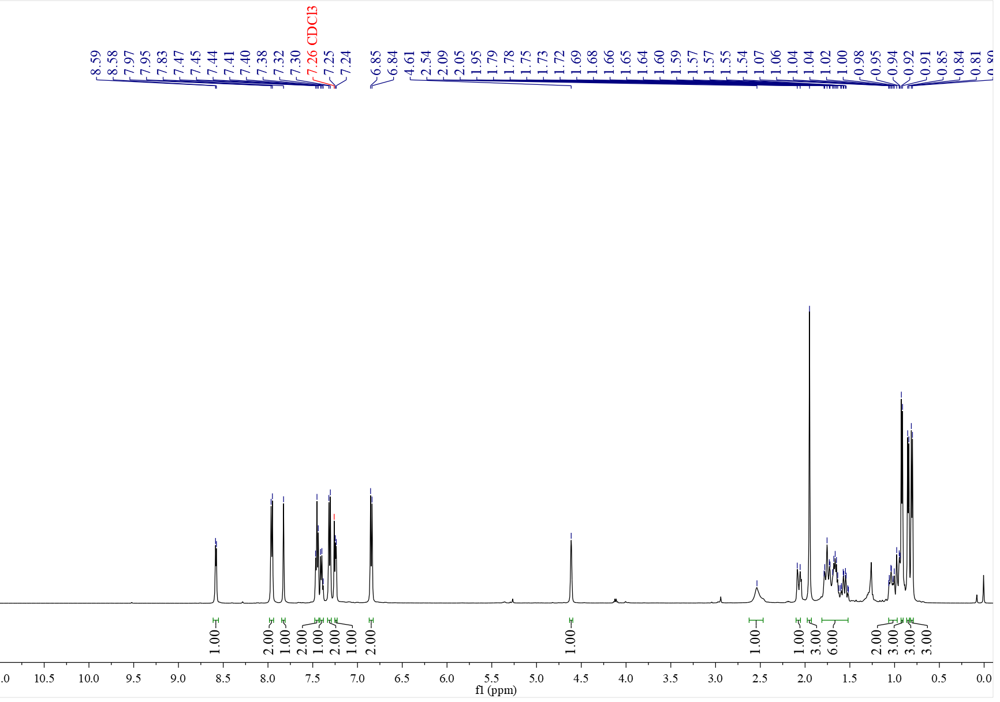

¹³C NMR spectrum of C₆₃ (126 MHz, CDCl₃)
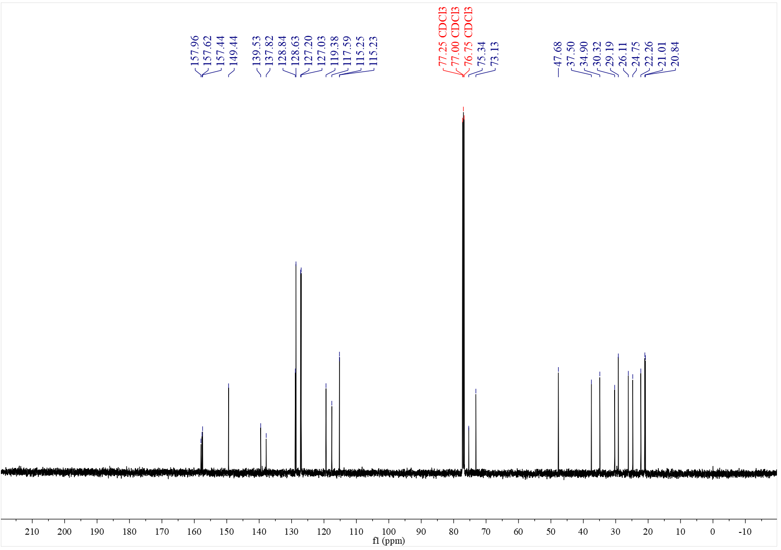

¹H NMR spectrum of C₆₄ (500 MHz, CDCl₃)
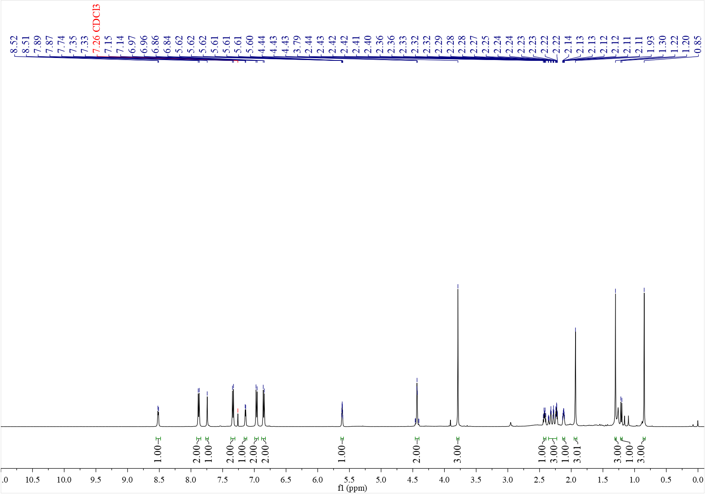

¹³C NMR spectrum of C₆₄ (126 MHz, CDCl₃)
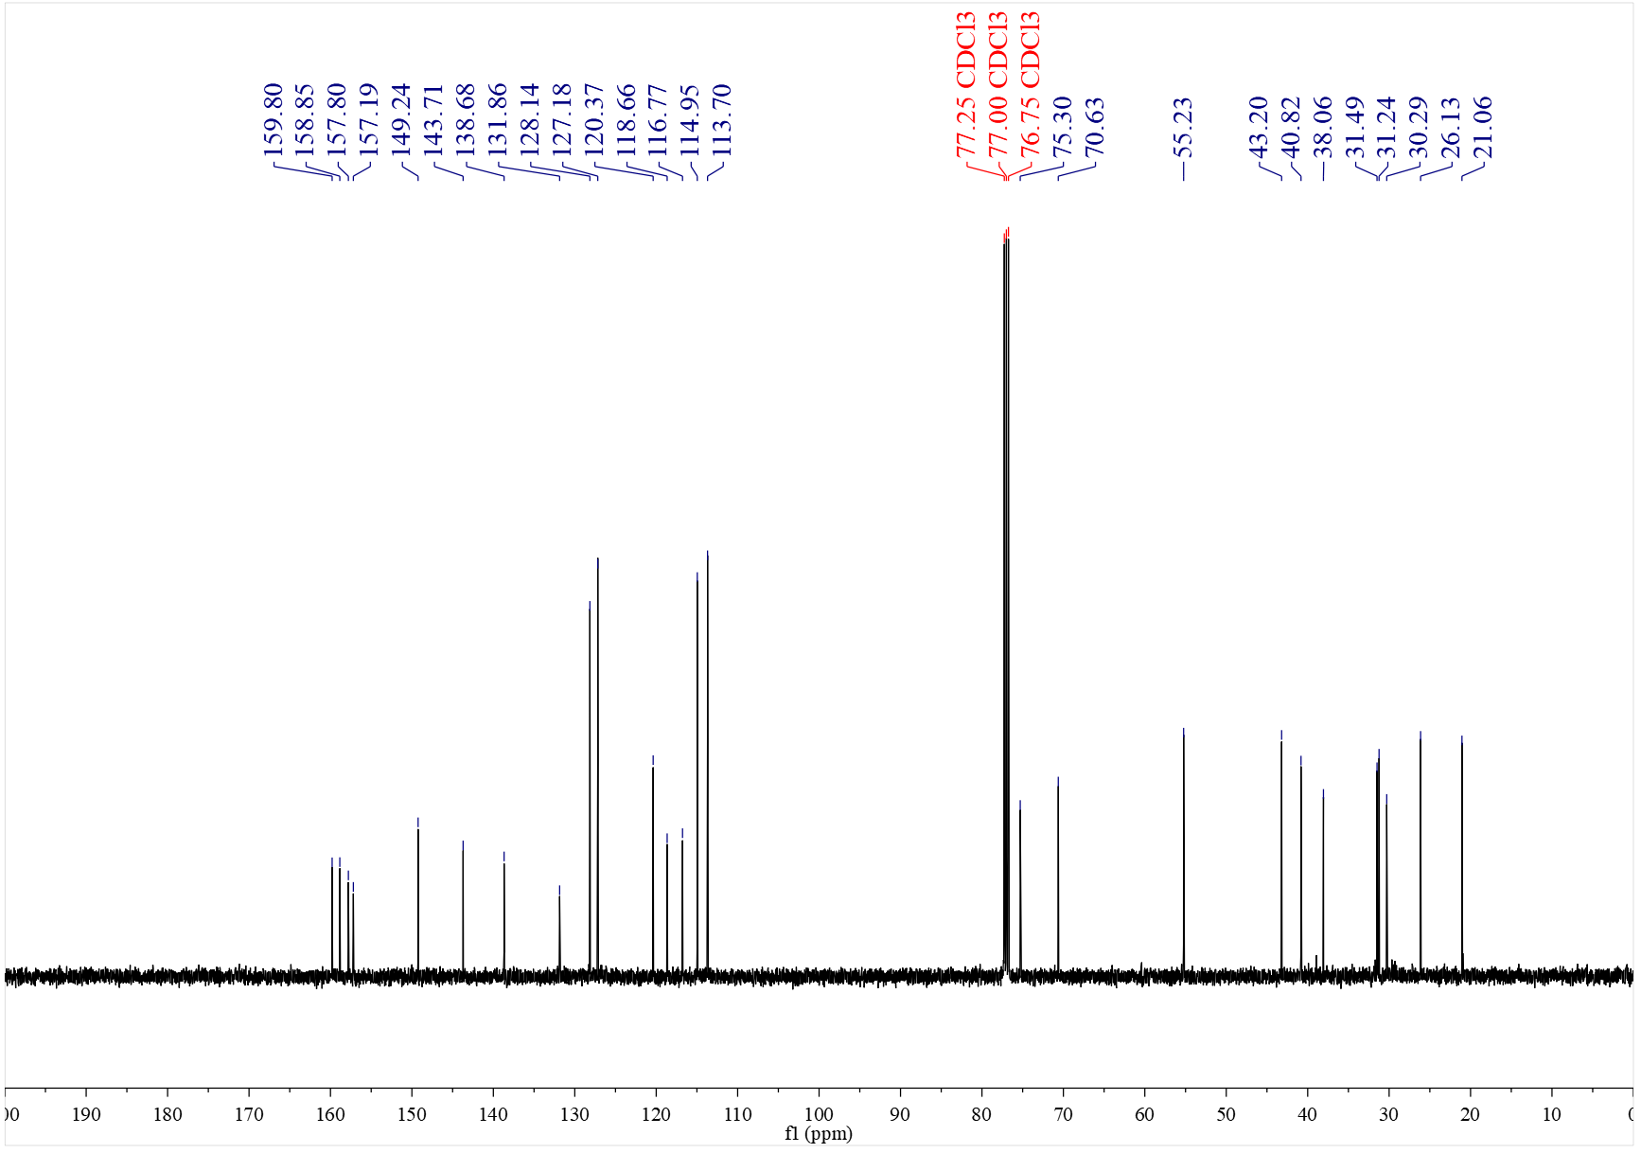

¹H NMR spectrum of C₆₅ (600 MHz, CDCl₃)
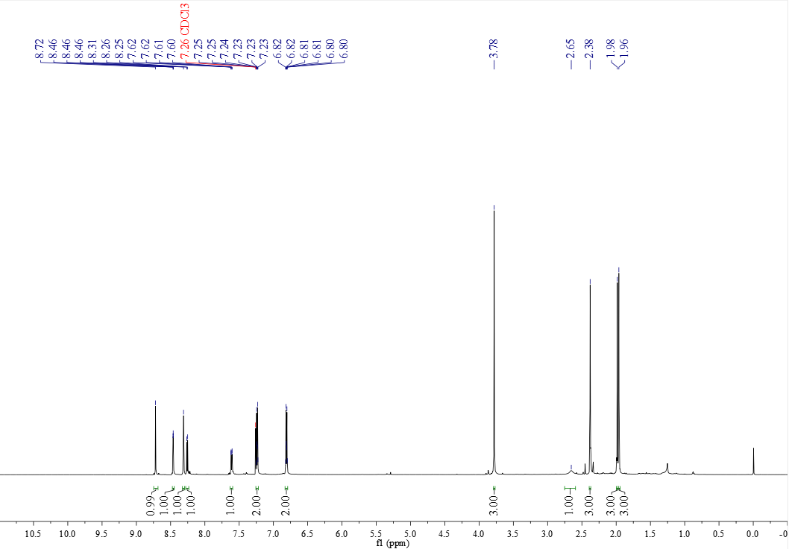

¹³C NMR spectrum of C₆₄ (151 MHz, CDCl₃)
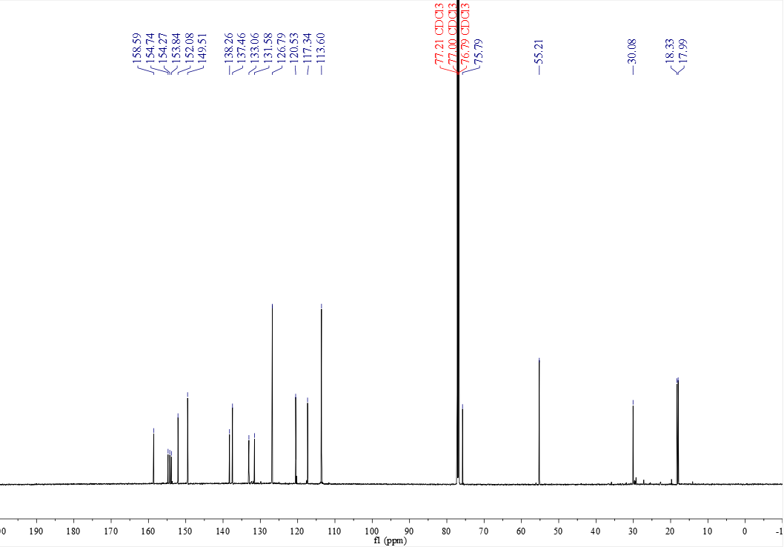

¹H NMR spectrum of D₁ (400 MHz, CDCl₃)
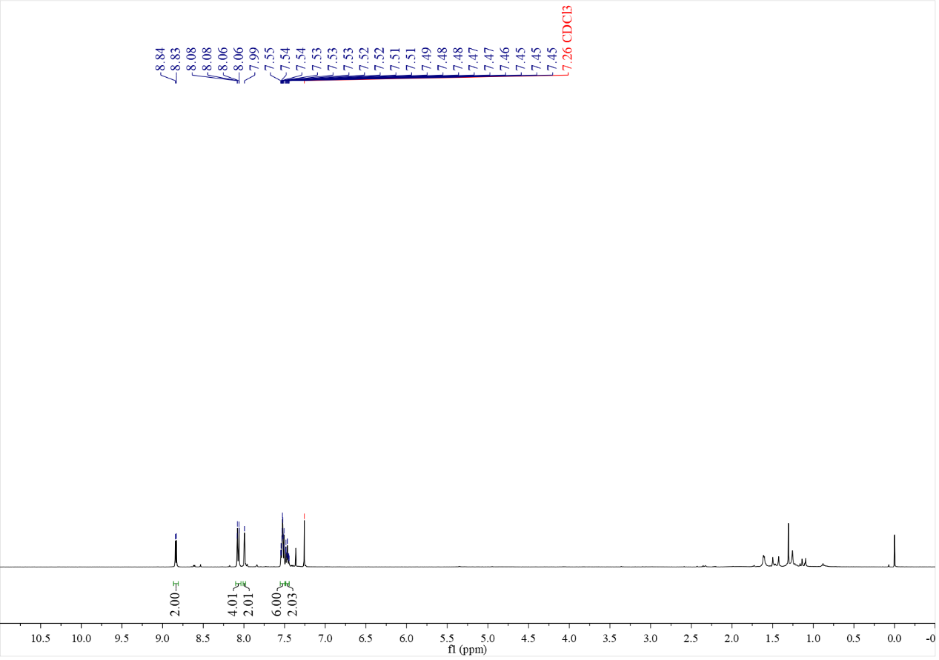

¹³C NMR spectrum of D₁ (126 MHz, CDCl₃)
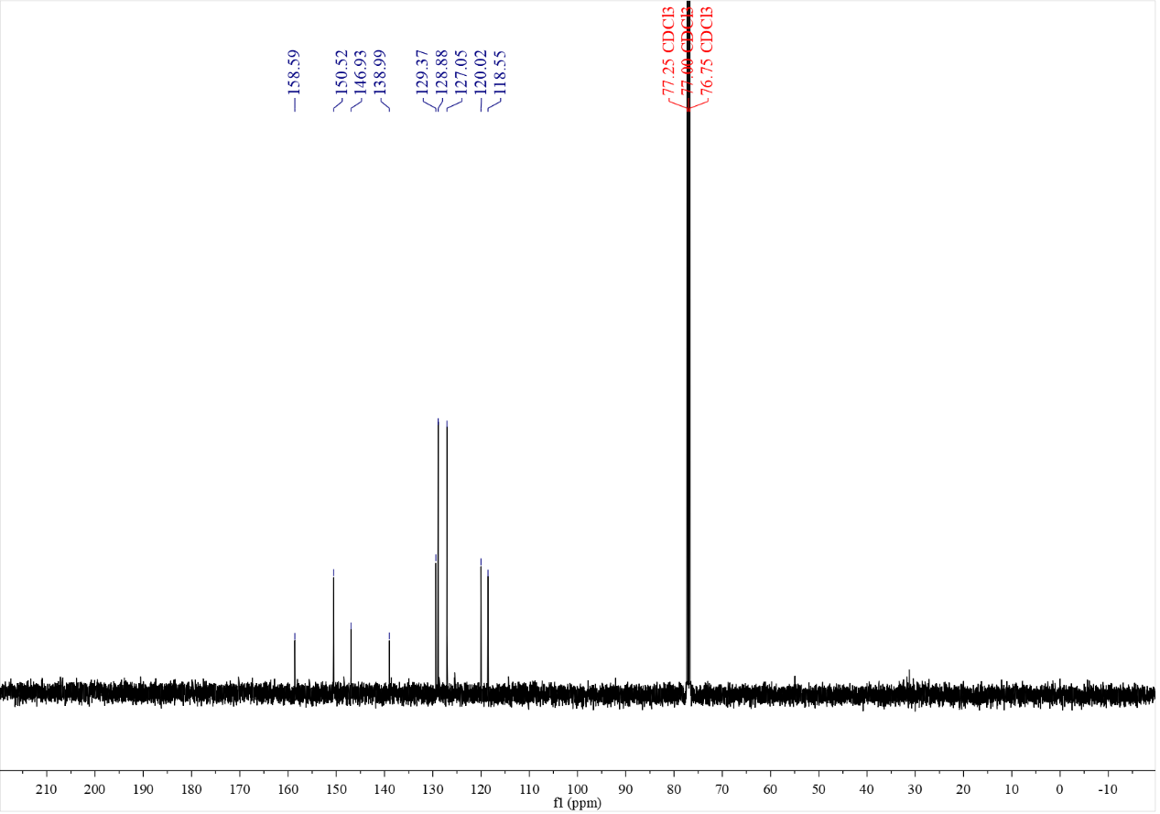

¹H NMR spectrum of D₂ (500 MHz, CDCl₃)
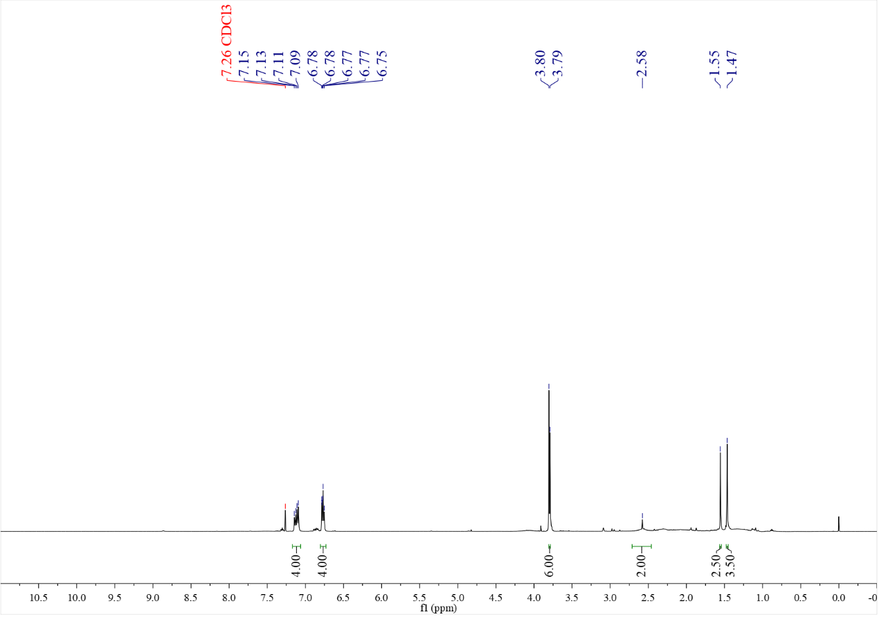

¹³C NMR spectrum of D₂ (126 MHz, CDCl₃)
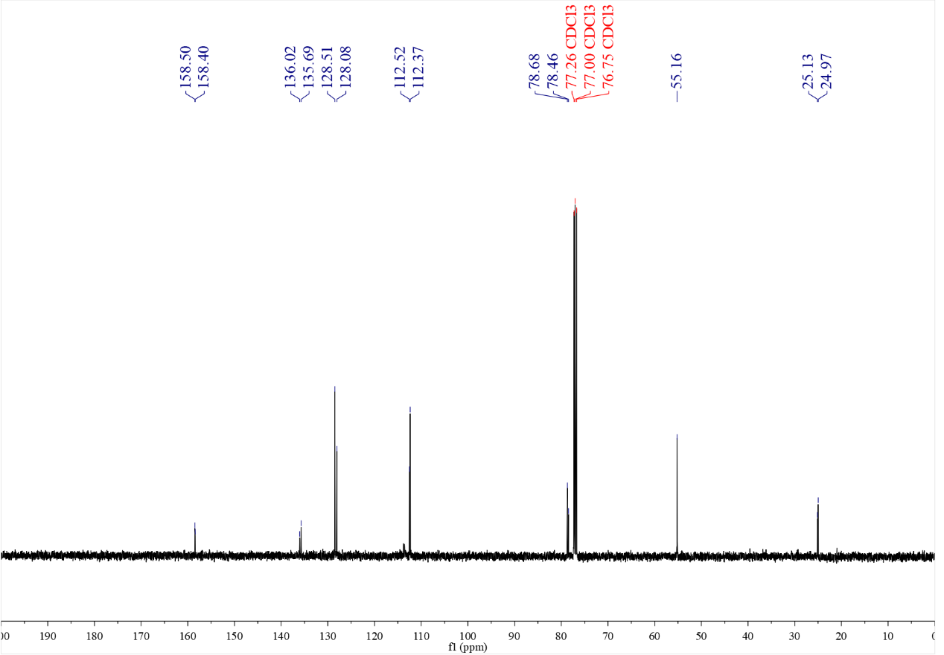

¹H NMR spectrum of D₃ (500 MHz, CDCl₃)
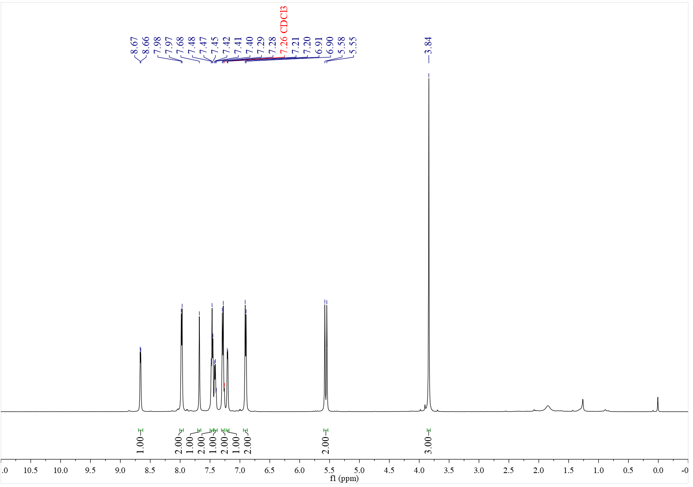

¹³C NMR spectrum of D₃ (126 MHz, CDCl₃)
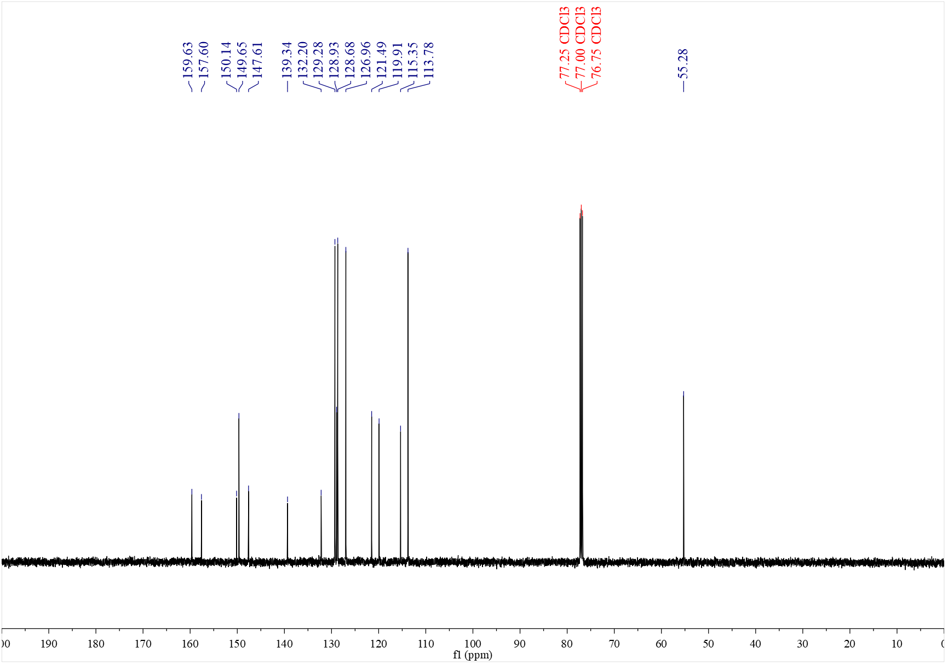

¹H NMR spectrum of D₄ (500 MHz, CDCl₃)
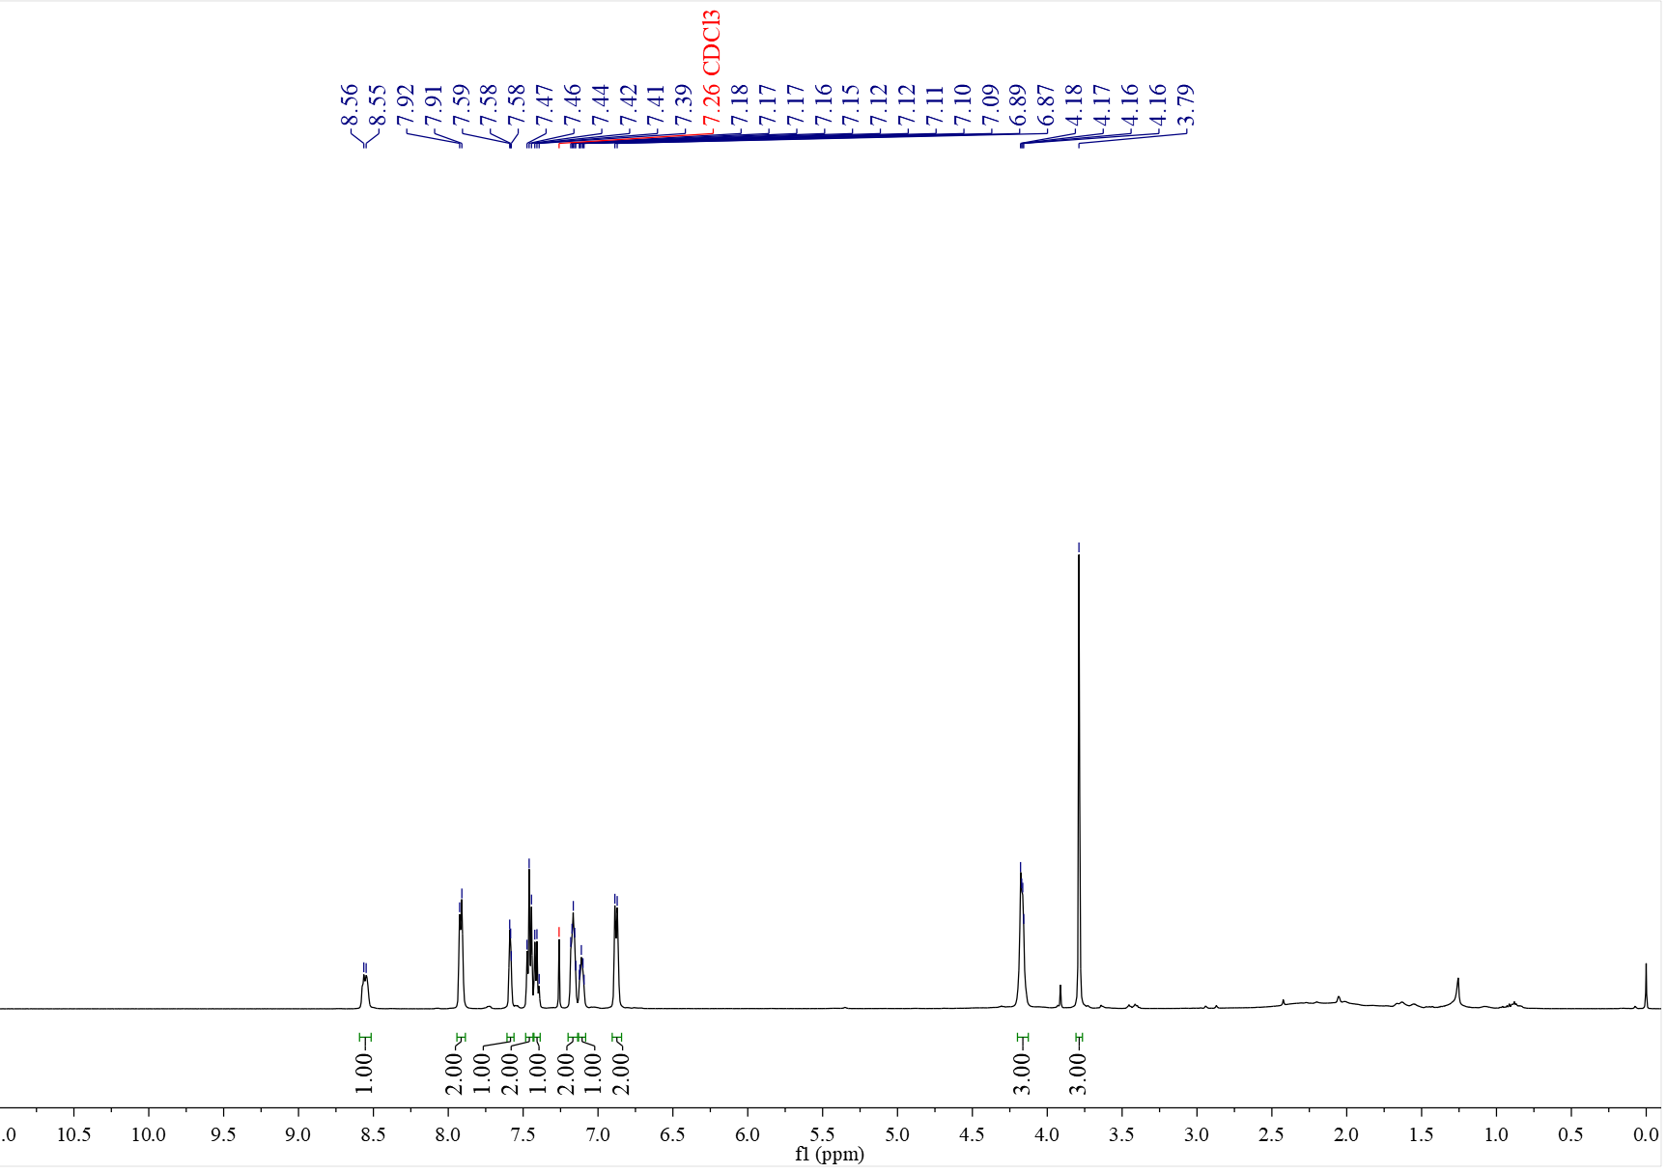

¹³C NMR spectrum of D₄ (126 MHz, CDCl₃)
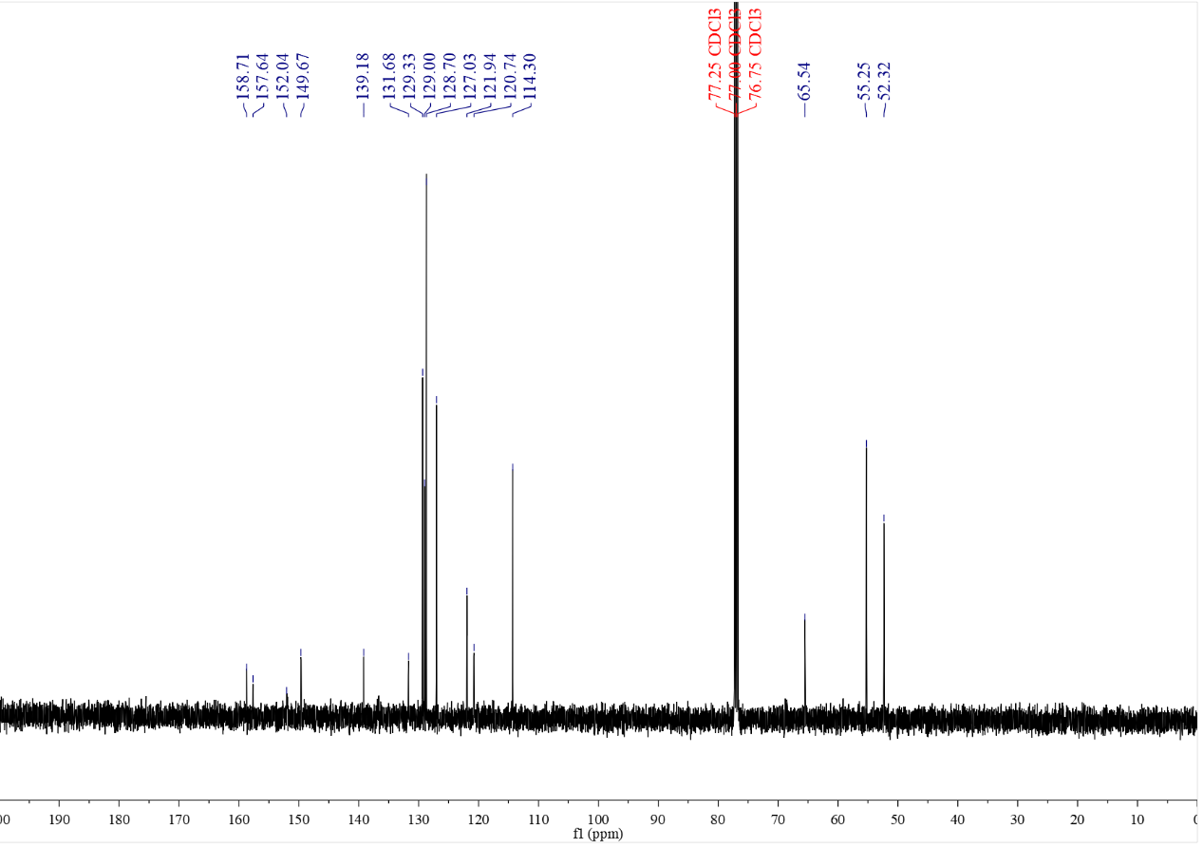

¹H NMR spectrum of D₅ (500 MHz, CDCl₃)
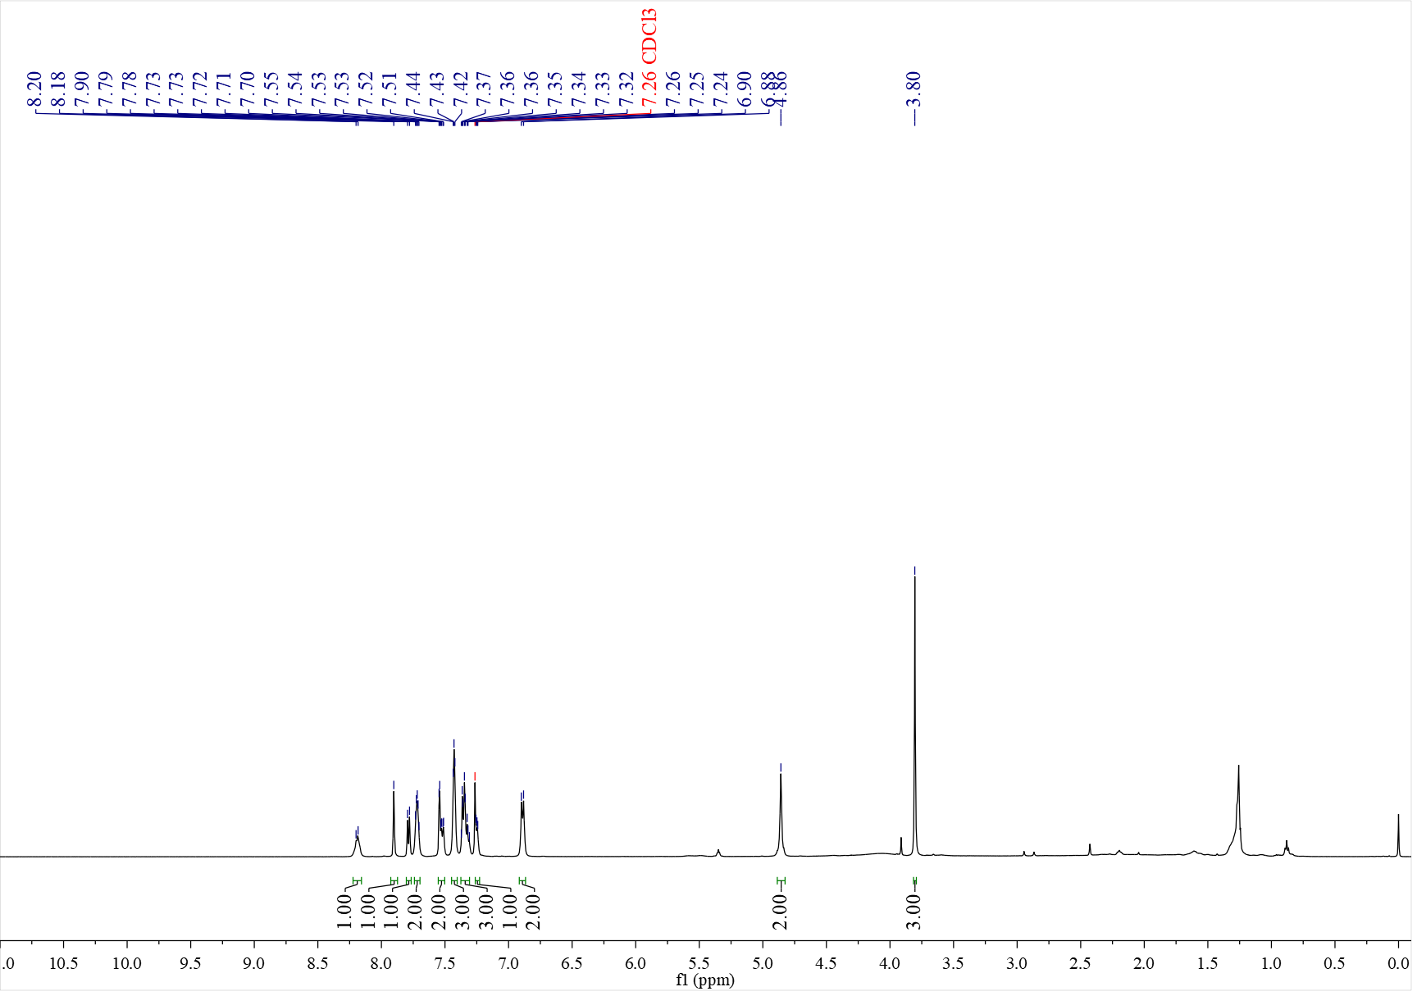

¹³C NMR spectrum of D₅ (126 MHz, CDCl₃)
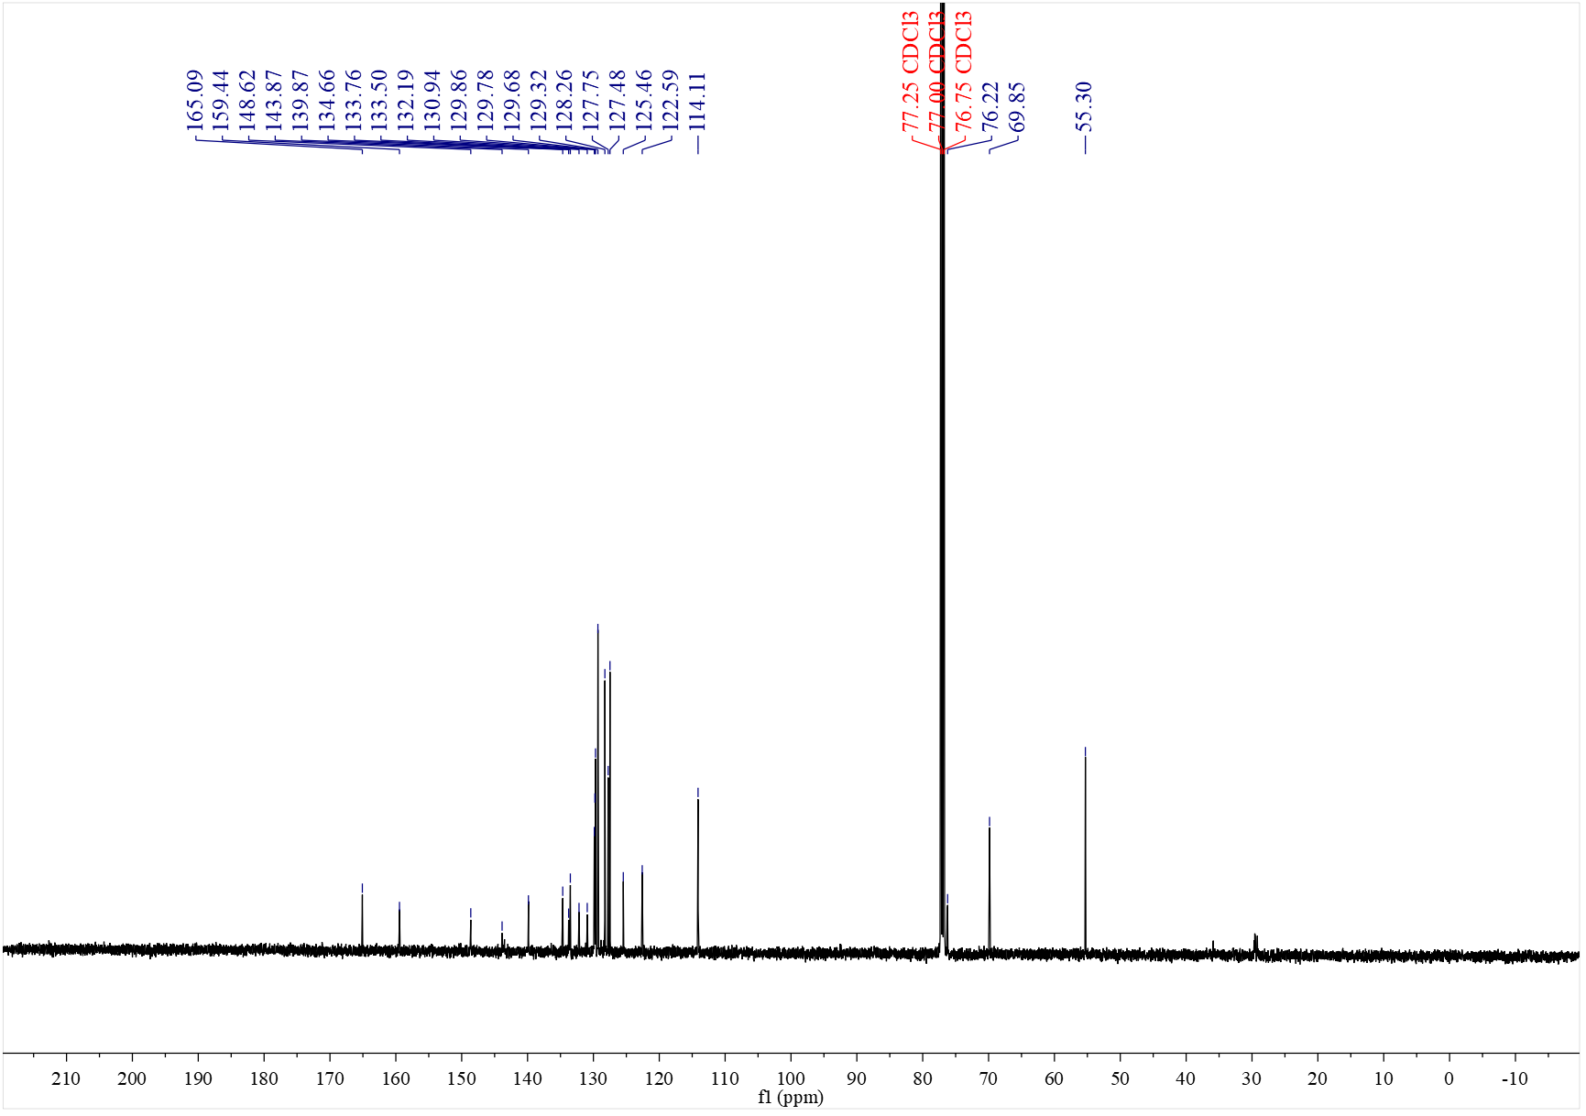

¹H NMR spectrum of D₆ (500 MHz, CDCl₃)
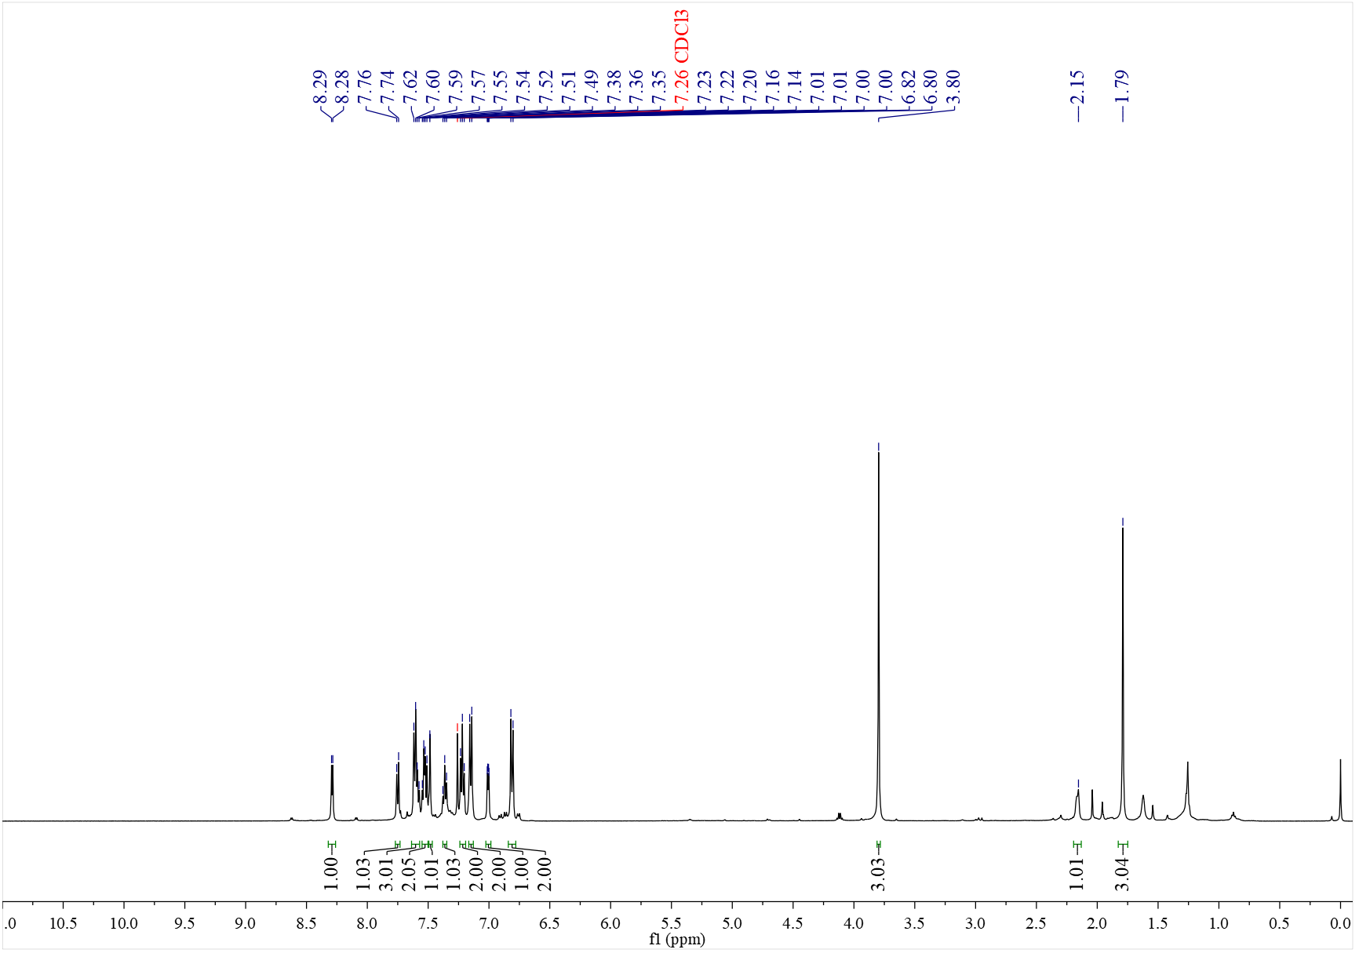

¹³C NMR spectrum of D₆ (126 MHz, CDCl₃)
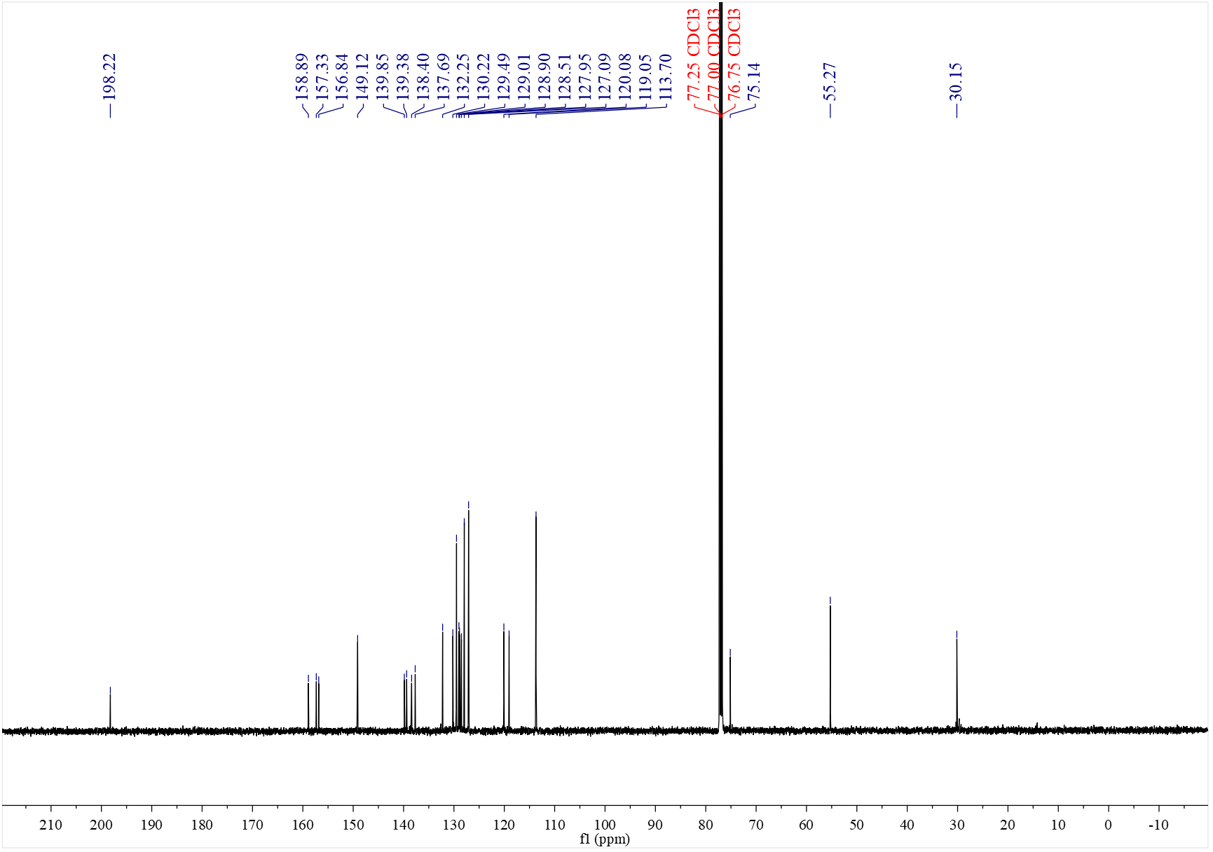

¹H NMR spectrum of D₇ (500 MHz, CDCl₃)
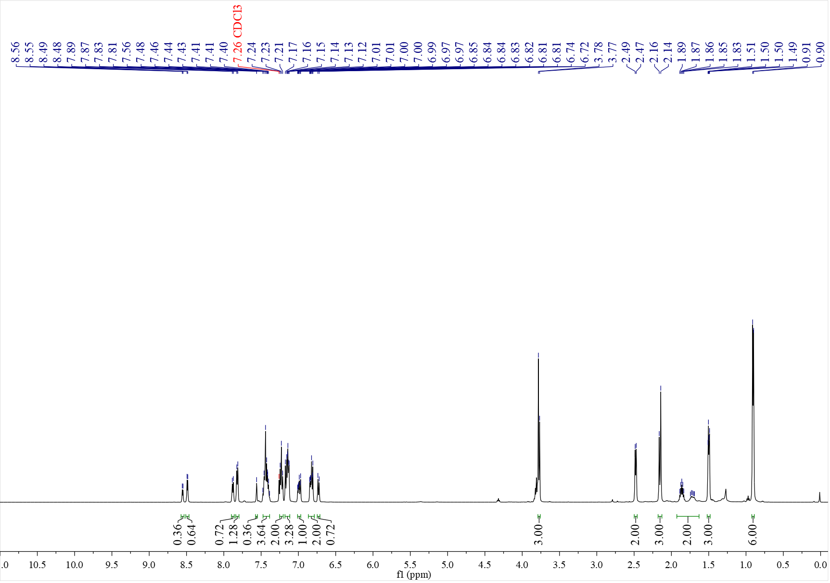

¹³C NMR spectrum of D₇ (126 MHz, CDCl₃)
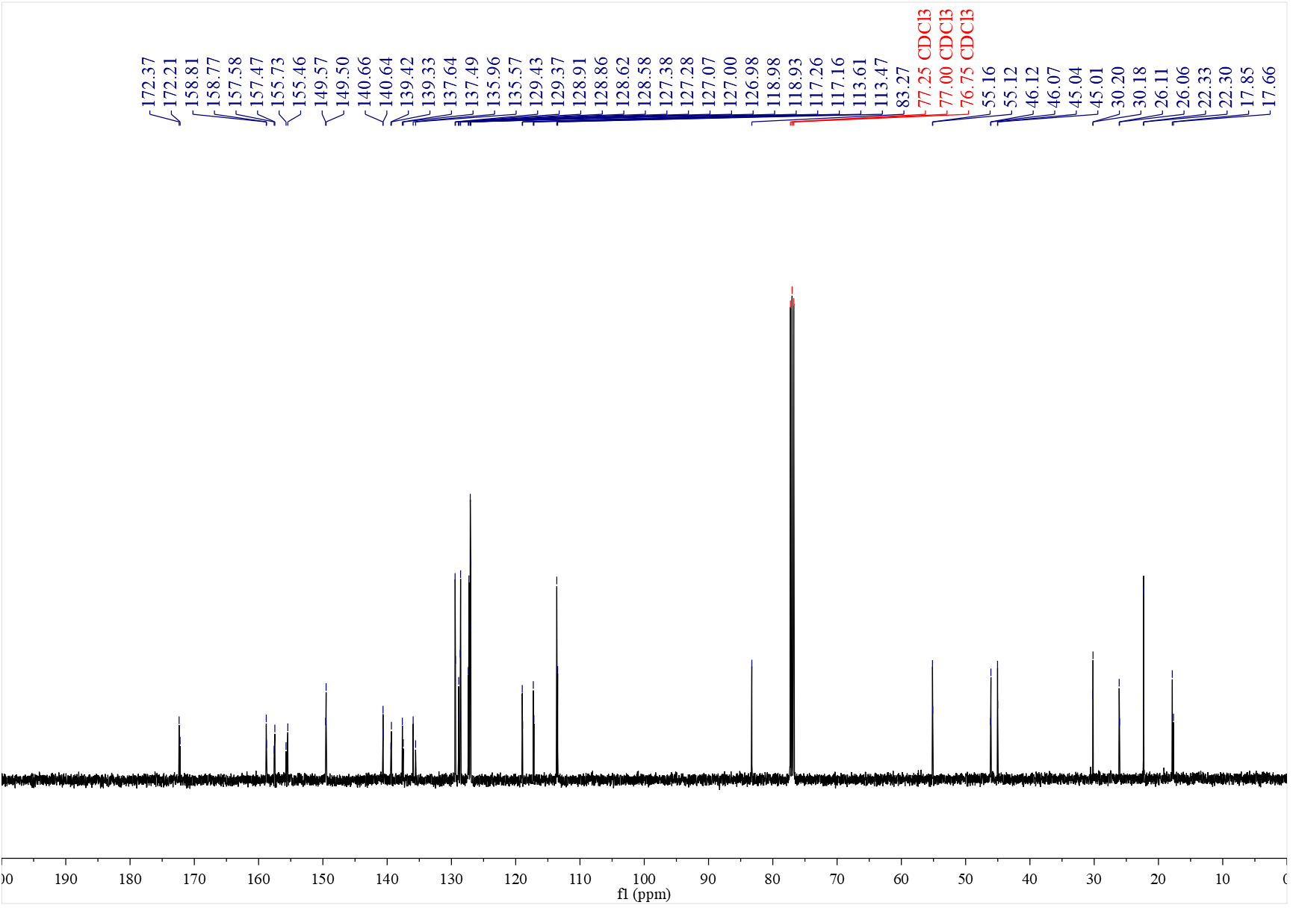

¹H NMR spectrum of A₂₈ (500 MHz, CDCl₃)
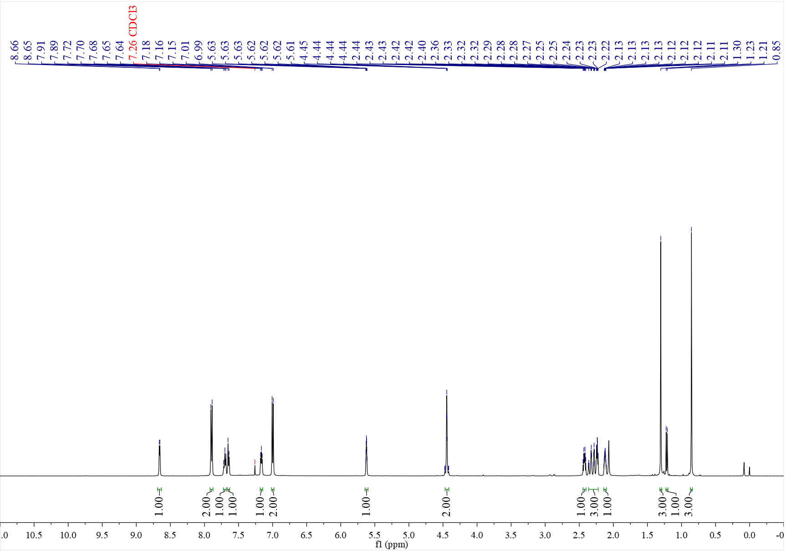

¹³C NMR spectrum of A₂₈ (126 MHz, CDCl₃)
