PVA-Coated 3D-Printed Molds for Rapid Prototyping of PDMS Microdevices for Stem Cell Culture
Yuma Abe^{1*}, Daiki Fukai^{1*}, Taro Toyoda², Naoto Fukumoto¹, Kyohei Terao¹
¹ Div. of Science for Creative Emergence, Kagawa Univ., JAPAN
² Center for iPS cell Research and Application, Kyoto Univ., JAPAN
* These authors contributed equally to this work.

Suplementary information
The characterization method of PVA coating in Section 2.1 is shown in Fig. S1. By scanning and measuring the cross-section of the PVA film, results such as those shown in Fig. S2 were obtained. It was confirmed that the film was successfully measured under the applied conditions.
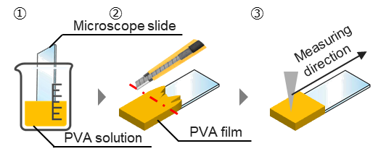
Fig. S1. Method of measuring PVA film thickness. 1) Dip-coat of the microscope slide. 2) Removal of the part of PVA for the measurement. 3) Scanning from the side of the PVA film.

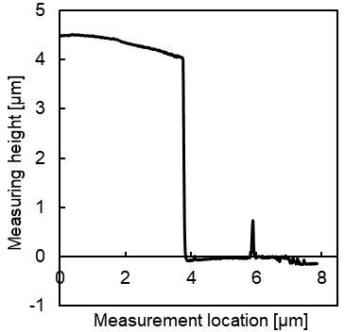
Fig. S2. Surface profile of PVA coated glass substrate for evaluating the film thickness.

The design of the 3D-printed mold used in Fig. 3(a) is shown in Fig. S3. This mold was subjected to UV post-curing and PVA coating, followed by PDMS curing, to evaluate PDMS curing inhibition. The evaluation method is illustrated in Fig. S4. The Step apparent width indicated by green arrows represents the lateral dimension of steps or grooves at the midpoint between reference planes. The Depth from reference plane indicated by red arrows denotes the distance between the reference planes. The Area indicated by the blue hatched region corresponds to the cross-sectional area. Fig. S5 presents cross-sectional SEM images of PDMS replicas for all tested conditions. The evaluation method described in Fig. S4 was applied to these images.
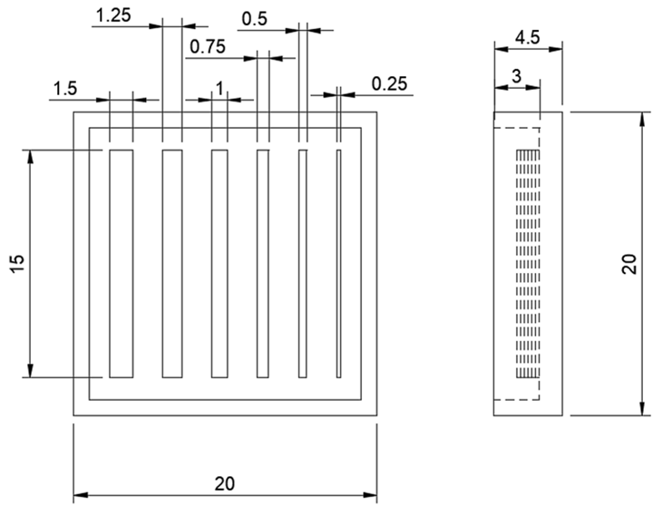
Fig. S3. Mold design values of Fig. 3(a)
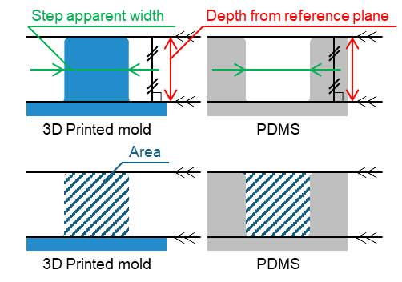
Fig. S4. Depth from reference plane, step apparent width and area.
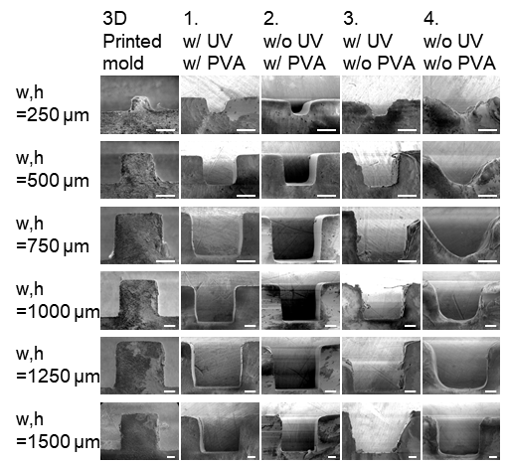
Fig. S5. SEM images of the cross sections of the PDMS replicas (scale bar: 300 µm). “UV” and “PVA” indicate the UV curing treatment for secondary hardening and PVA coating of the 3D-printed mold, respectively.

The design of the 3D-printed mold used in Fig. 4(a) is shown in Fig. S6. This mold was fabricated at a 30° and 45° tilt relative to the build platform, and the surface morphology of the replicated PDMS blocks for 30° tilt angle is presented in Fig. S7. Based on these surface profiles, the arithmetic mean roughness was calculated, as shown in Fig. S8. The arithmetic average roughness represents the mean value within the reference length. It can be derived from Eq. (S1), or approximately from Eq. (S2) [40].
$$\begin{aligned}R_{a}=\frac{1}{l}\int_{0}^{l}{\left|y\left(x\right)\right|}dx\#\left(S1\right)\end{aligned}$$
$$\begin{aligned}R_{a}=\frac{1}{n}\sum_{i=1}^{n}{\left|y_{i}\right|}\#\left(S2\right)\end{aligned}$$
l denotes the reference length, and x is the lateral variable representing the position on the surface along the evaluation length l. The term y corresponds to the deviation of the surface profile at position x, that is, the height displacement from the mean line. The parameter n represents the number of discrete measurement data points, and i denote the sample index. Consistent with the results in Section 3.3, the surface roughness decreased with increasing PVA concentration, regardless of the tilt angle.

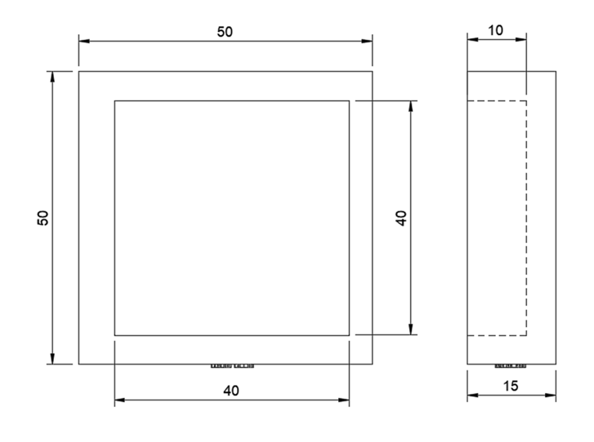
Fig. S6. Mold design values in Fig. 4(a).

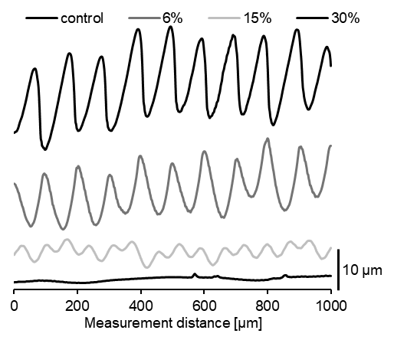
Fig. S7. Surface profile of a PDMS block transferred from a mold formed at 30 degrees.

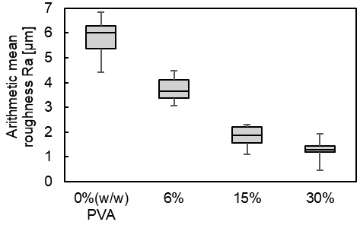
Fig. S8. Arithmetic mean roughness at 30 degrees tilt angle of the PDMS blocks coated with different PVA concentrations. Data are presented as box plots (n = 15 for each condition). In the box plots, the box represents the interquartile range (IQR), the central line indicates the median, and the whiskers denote the minimum and maximum values.

Fig. S9 shows the design of the 3D-printed mold in Fig. 5.
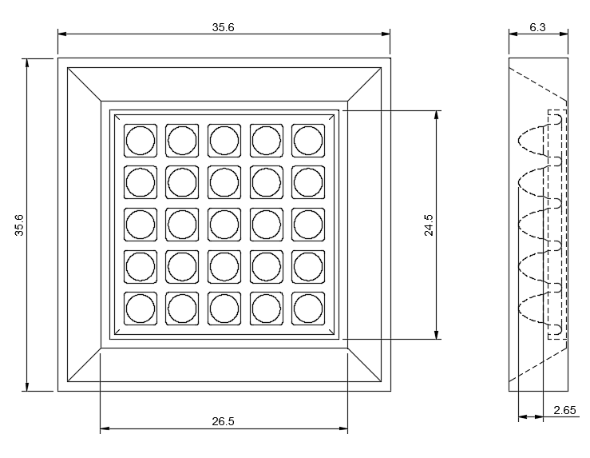
Fig. S9. Design of 5×5 EBCP.

Embryoid bodies (EBs) were formed using a non–cell-adhesive 96-well round-bottom plate (PrimeSurface, MS-9096U, Sumitomo Bakelite Co., Ltd.). Under conditions in which the initial seeding density was varied from 500 to 5000 cells per well, the diameters of the EBs were measured at different culture time points (Fig. S10).
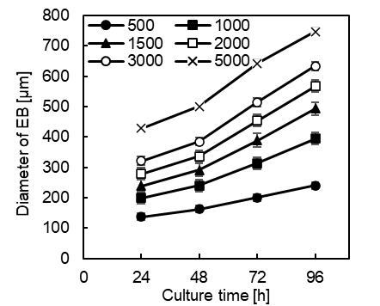
Fig. S10. Changes in EB diameter depending on culture time and the number of cells seeded. Data are presented as mean ± standard deviation (SD), with n = 16 wells measured for each condition.

