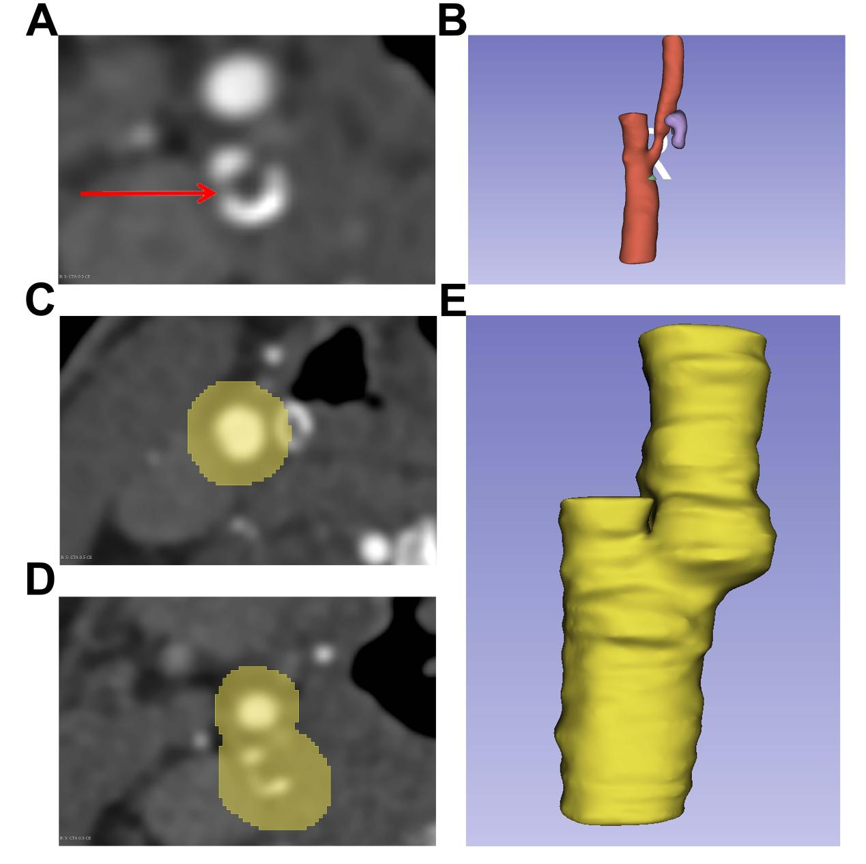
Supplementary Fig.1: Segmentation of carotid artery plaque in 3D slicer. (A) the borderline between the vascular lumen and the superficial calcification cluster. (B) the presentation of the vascular lumen and superficial calcification clusters. (C-E) the Segmentation of outer vascular wall.

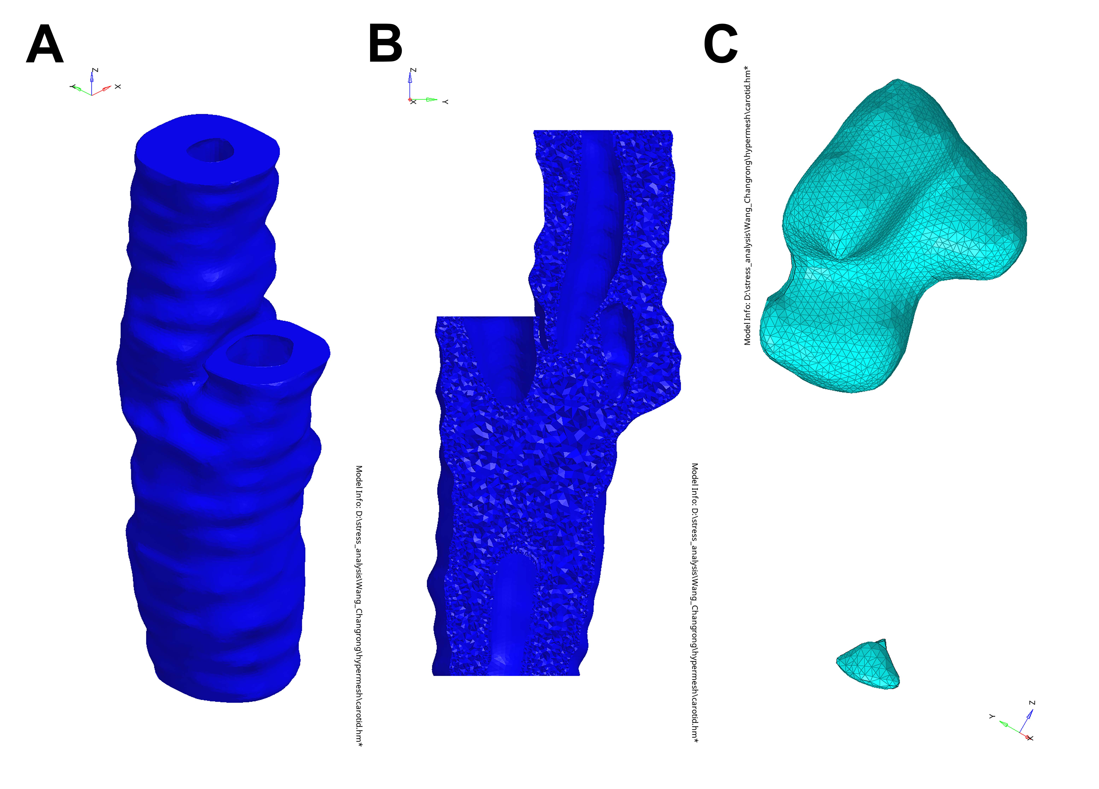
Supplementary Fig.2: 3D meshes of carotid artery wall (A) and the calcification clusters in carotid artery plaque (B).

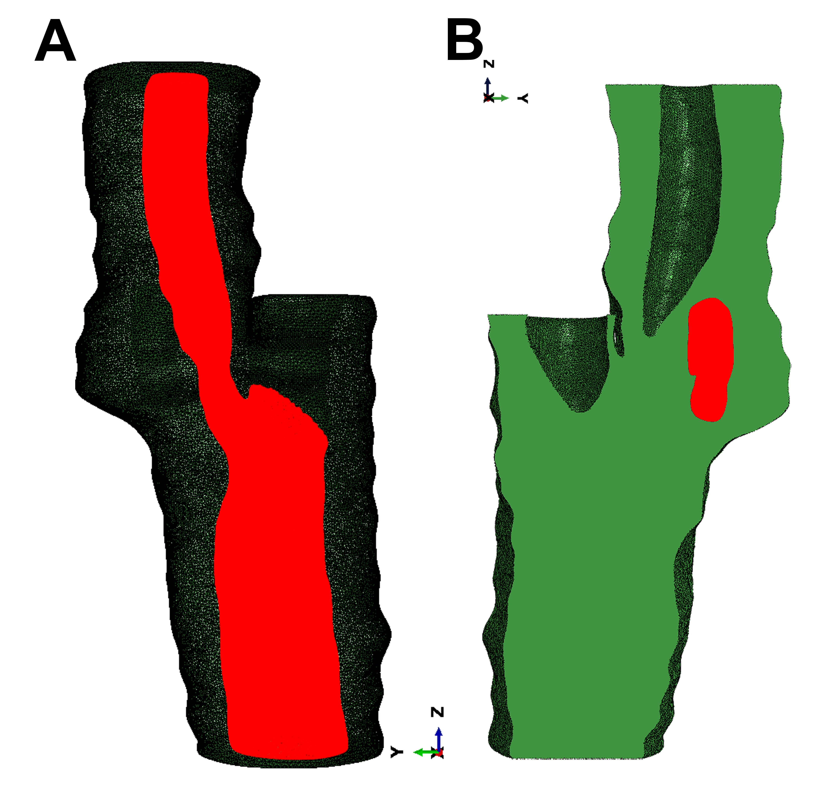
Supplementary Fig.3: The operation on Abaqus. (A) Choosing the luminal surfaces of common carotid arteries and internal carotid arteries for application of a 0.0065 MPa uniform pressure load. (B) centroids of tetrahedral elements on vascular wall surfaces contacting superficial calcification clusters

