Supplementary files Branz_Shalashova
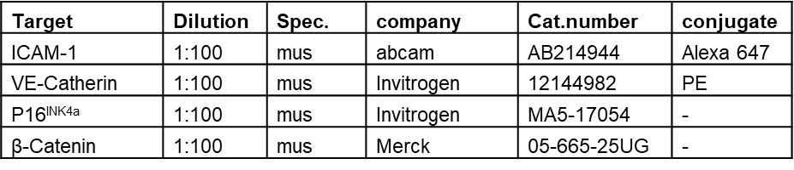
Table 1. Primary antibodies.
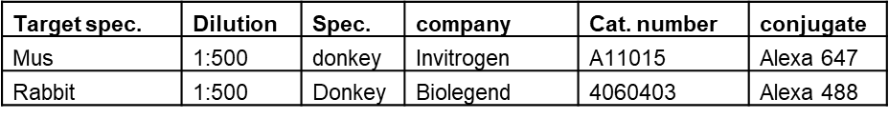
Table 2. Secondary antibodies.
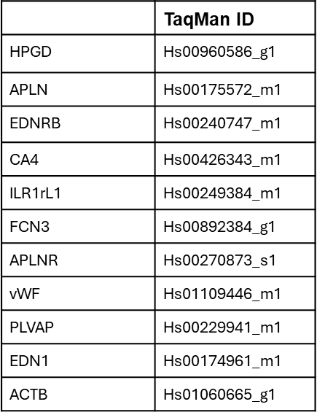
Table 3. TaqMan primers (Thermo Fisher Scientific, Waltham, MA, USA)
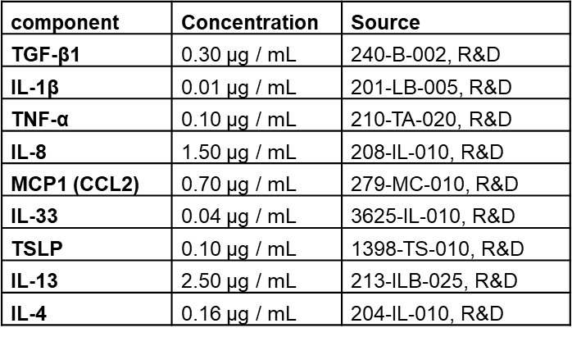
Table 4. Ingredients of 1000x IPF-RC

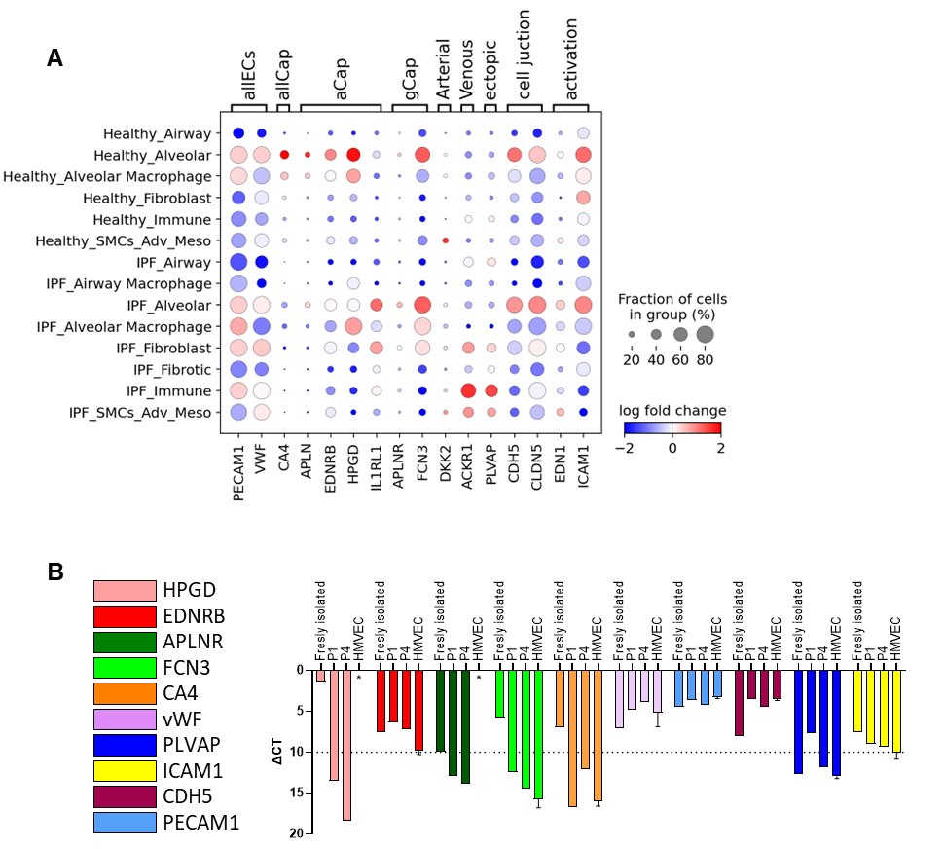
Supplementary Figure A1. A Dot plots illustrating the fold change in expression of indicated marker genes between the IPF and control groups across various cell types in the scRNA-seq data from the IPF and control patients. The dataset from Mayr et al., 2024. B Expression of microvascular cell markers in freshly isolated CD31⁺ ECs and CD31⁺ ECs at passage 1 and 4, expressed as ΔCT. The data from HMVECs are provided for comparison. Asterisks (*) indicate undetectable level of gene expression. Error bars represent the standard error of the mean, n=3.

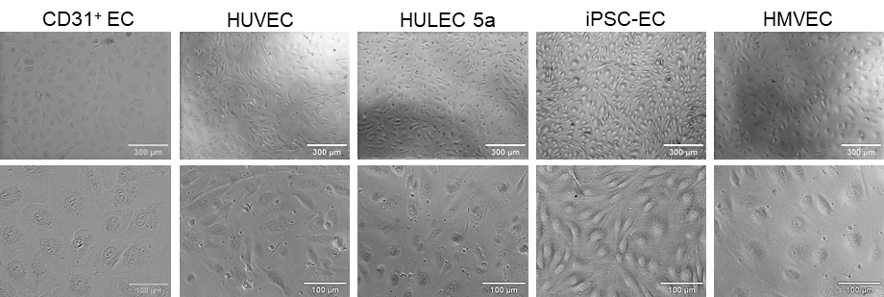
Supplementary Figure A2. Morphological comparison of primary and commercial endothelial cell lines.
Representative brightfield images of endothelial cells (primary CD31⁺ EC, HUVECs, HULEC5a, hiPSC-ECs, HMVECs).
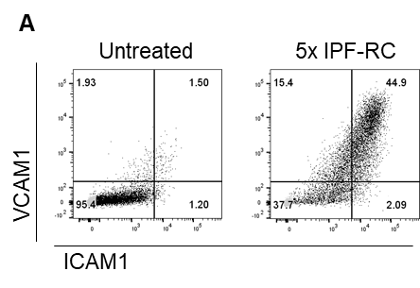
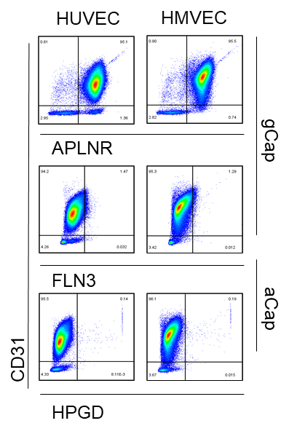
Supplementary Figure A3. Dot plots from flow cytometry analysis of HUVECs and HMVECs with anti-CD31, HPGD, FLN3, and APLNR antibodies.
Supplementary Figure A4. Dot plots from flow cytometry analysis of HMVECs treated with IPF-RC for 48 hours, followed by staining with anti-ICAM1 and anti-VCAM1 antibodies

